Supplementary Information
Supplementary Note

Supplementary Note 1

To assess tumor purity, we first examined the allelic fraction of NF2 alterations, as mutations in this gene are thought to be an early driver event in a majority of meningiomas. The allelic fraction of a given mutation represents the percentage of sequenced reads from that location which contain the alteration; large amounts of contaminating normal DNA which do not contain the alteration would reduce the fraction of reads with the mutation. Among these samples, the average allelic fraction of NF2 mutations was 60%, comparable to the cohort wide average for NF2 of 59%, and well within detection limits. Analysis of both copy-number data and the allelic fractions of all mutations genome-wide indicates the multi-sampled meningiomas had an average purity of 70%.

Supplementary Figures
Supplementary Figure 1. Heatmap of driver mutations in newly-sequenced high-grade meningiomas.

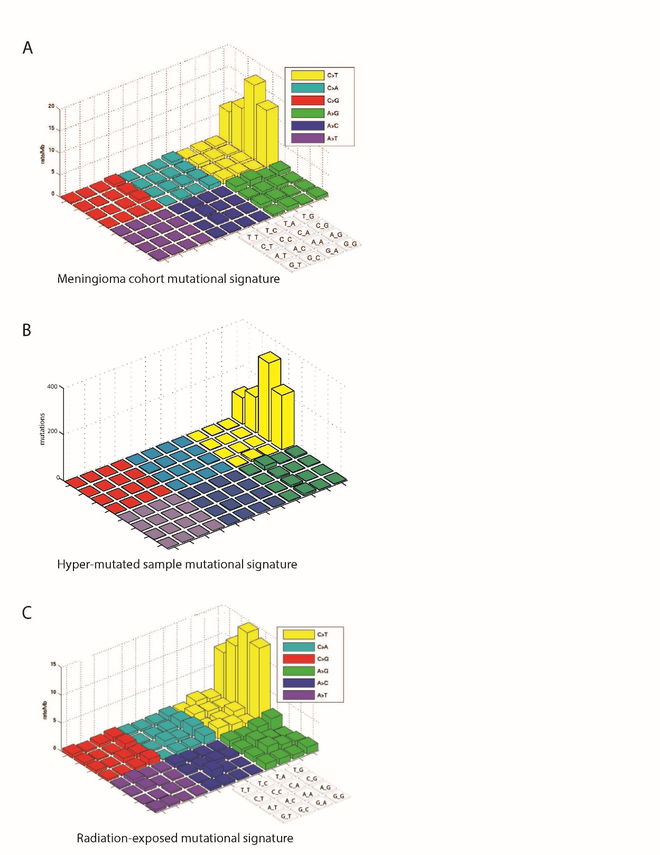

Supplementary Figure 2. Mutational patterns of meningioma. (A) Lego plot demonstrating the magnitude (z-axis) of different mutational signatures (x- and y-axis) in the high-grade meningioma cohort. (B) Lego plot demonstrating the magnitude (z-axis) of different mutational signatures (x- and y-axis) in a hyper-mutated meningioma sample (MEN0092). (C) Lego plot demonstrating the magnitude (z-axis) of different mutational signatures (x- and y-axis) across meningiomas exposed to prior radiation.

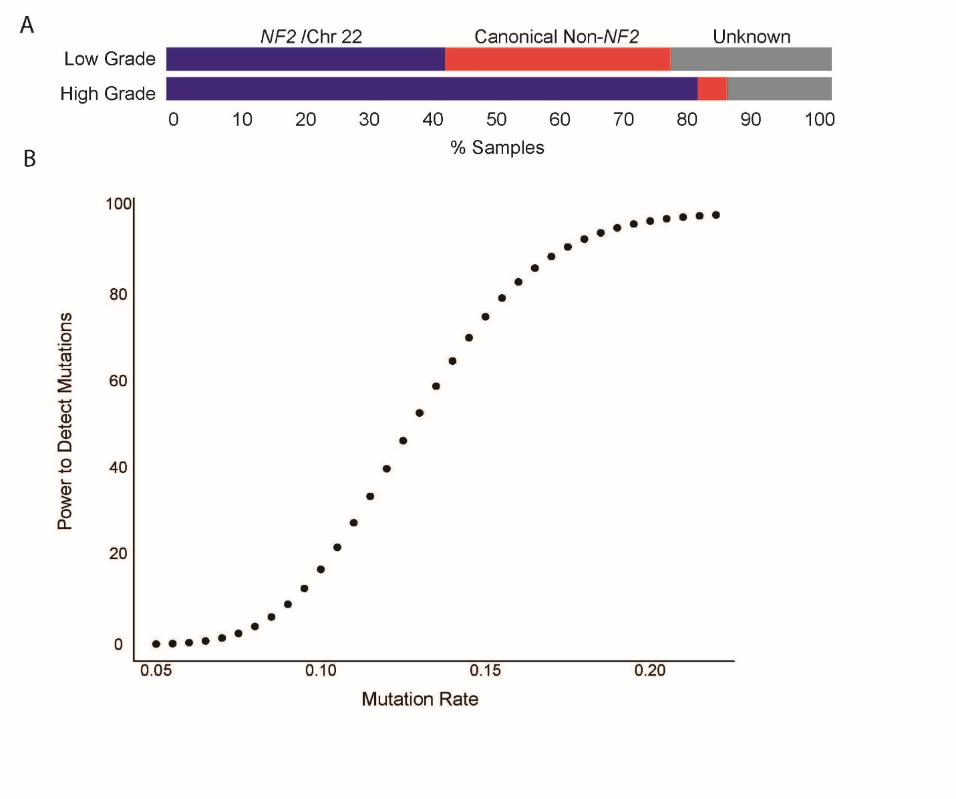Supplementary Figure 3. Mutational patterns in low- and high-grade meningioma. (A) Distribution of mutational drivers across low- and high-grade tumors. (B) Simulated data estimating the power to detect mutations (y-axis) as a function of the true mutation rate (x-axis).
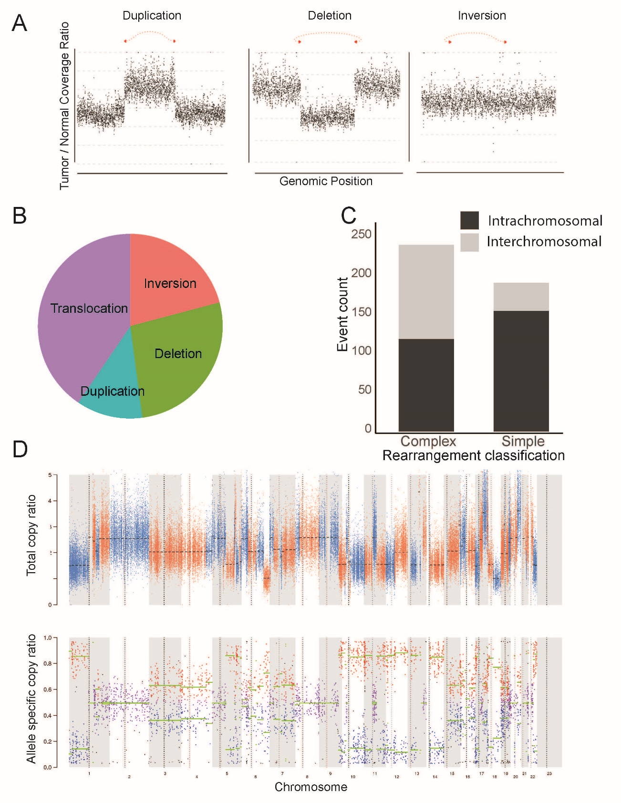
Supplementary Figure 4. Rearrangements in meningioma. (A) Sample plots demonstrating change in read coverage (y-axis) across the genome (x-axis) for duplications (left), deletions (center), or inversion (right). (B) Relative frequencies of event type (pie sectors) across the whole-genome sequenced meningioma cohort. (C) Comparison of number of rearrangements (y-axis) classified as complex or simple (x-axis) events, and stratified by intrachromosomal (black) versus interchromosomal (gray) status. (D) Copy number ratio (y-axis) across the genome (x-axis) for total copy ratio (top) and allele-specific copy ratio (bottom).
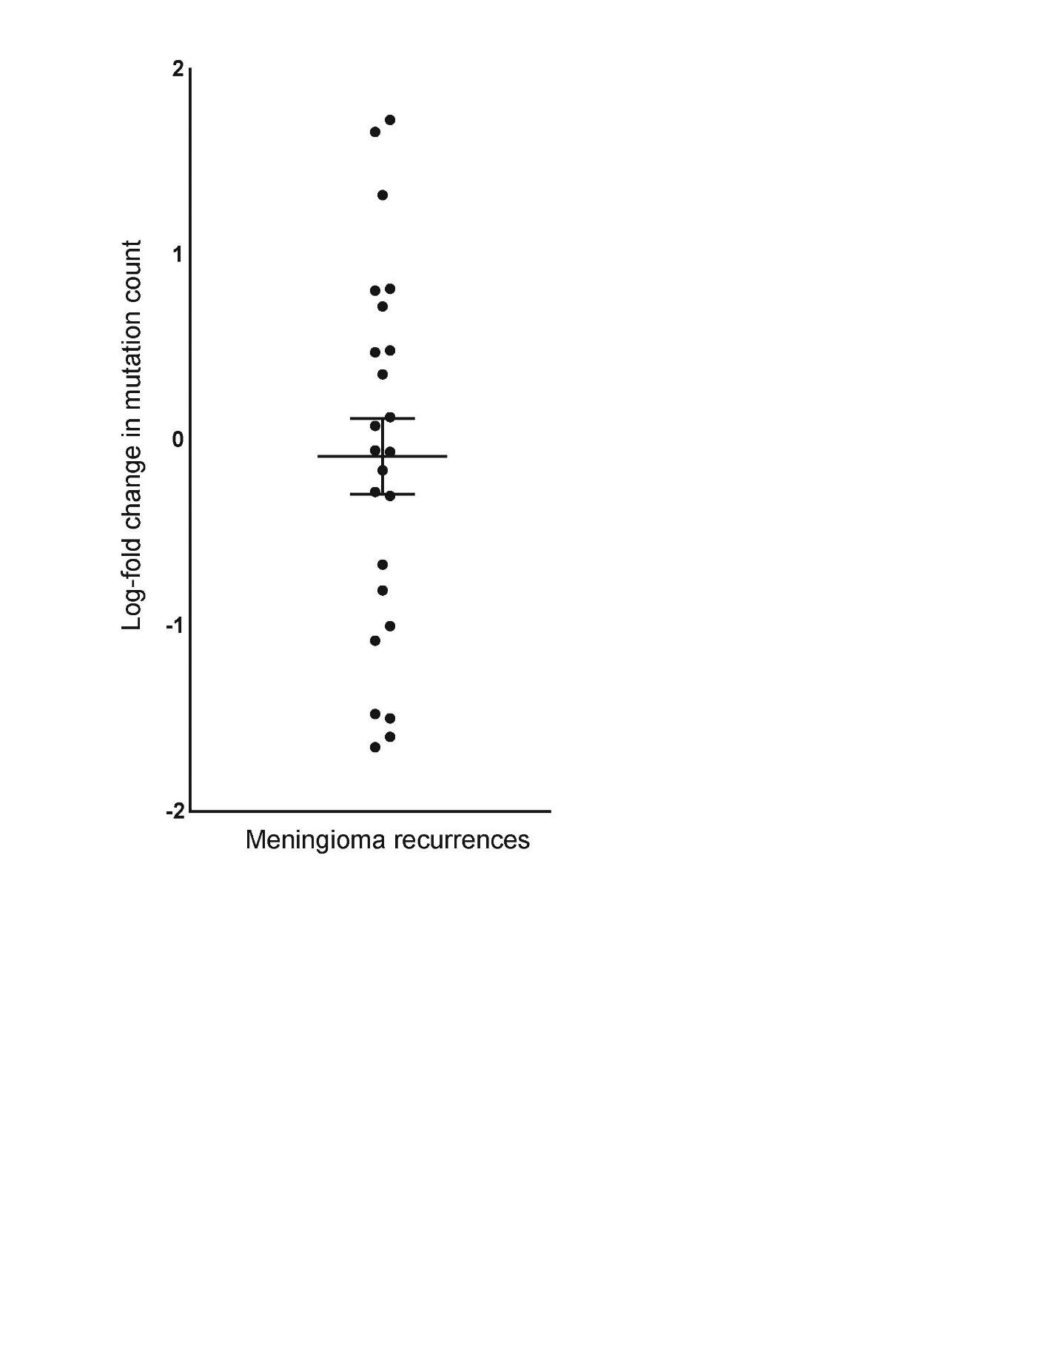
Supplementary Figure 5. Heterogeneity in meningioma recurrences. Log₂ fold change in the total number of mutations (y-axis) from subsequent recurrences of the same patient (x-axis).

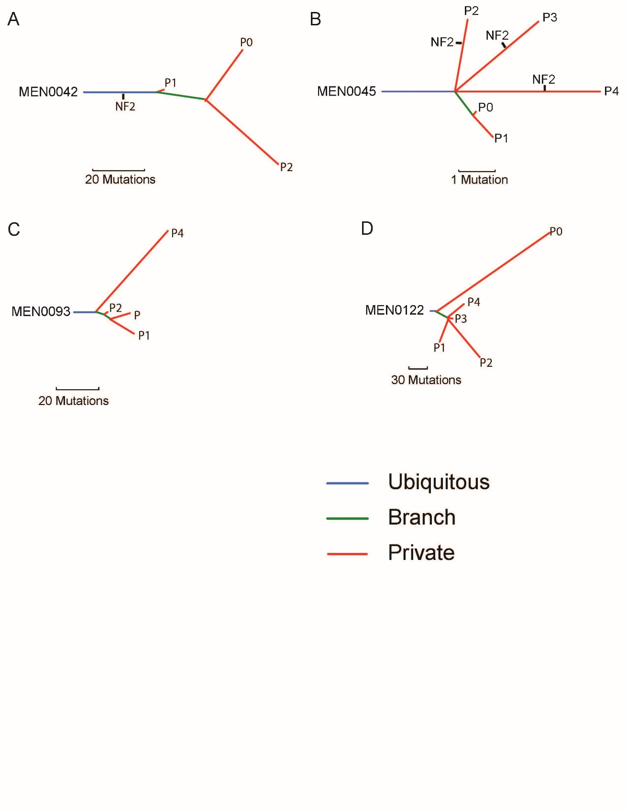Supplementary Figure 6. Temporal relationship between mutation status across meningioma recurrences. (A–D) Phylogenetic trees for patients with serial recurrences.

Supplementary Table Legends

Supplementary Table 1. Sample information of sequenced meningiomas. -, not available

Supplementary Table 2. Mutations identified from whole-exome or whole-genome sequencing.

Supplementary Table 3. Genes sequenced in targeted sequencing extension cohort.

Supplementary Table 4. Mutations identified from targeted capture sequencing.

Supplementary Table 5. (A) Rearrangements identified from whole-genome or whole-exome sequencing. (B) Genes with rearrangements in at least two samples.

Supplementary Table 6. Descriptive information for patients with multiple sequenced samples.

Supplementary Table 7. Analysis of spatial heterogeneity for samples with two separate FFPE cores of the same resection sequenced.

Supplementary Table 8. Predicted immunogenicity for mutations from whole-exome sequenced meningiomas.

