Supplementary Information

Nisselle et al. Investigating genomic medicine practice and perceptions amongst Australian non-genetics physicians to inform education and implementation.

Supplementary Table 1: Reasons for not being engaged with genomic medicine in the past year.*

Reason | Panel tests |  | Exome/genome sequencing tests
Reason | N=191¹ |  | N=233¹
Reason | n | % | n | %
I am unable to order a [gene panel/ E/GS] test in my current role/ department, e.g., lack of access to testing or funding | 5 | 3 | 7 | 3
I’m not sure how to order a [gene panel/ E/GS] test | 34 | 18 | 33 | 14
I’m not sure of the relevance of [gene panel/ E/GS] to my practice | 90 | 47 | 117 | 50
It’s not my responsibility | 2 | 1 | 1 | 0
Other (“not in routine practice”) | 1 | 1 | 3 | 1
¹ Engagement was defined as requesting a genomic test or referring patients to clinical genetics services. N is the number of respondents who indicated they neither requested or referred for a test.

Supplementary Table 2: Associations between having learnt each category of genomics education with demographics, current practice and opinions about genomic medicine.¹
Variable | Response grouping |  | (total N)  n | Genetic/genomic knowledge  (4 topics) |  | Clinical aspects  (7 topics) |  | Testing technology  (7 topics) |  | ELSI  (3 topics)
Variable |  |  | (total N)  n | χ², p  % (99%CI) for each variable response option
Demographics
Specialty | Pediatrics  Other specialties |  | (409)  81  328 | 19.65, <0.001  75.3 (60.7–85.8)  47.9 (40.8–55.0) |  | 19.65, <0.001  75.3 (60.7–85.8)  47.9 (40.8–55.0) |  | 29.85, <0.001  74.1 (59.7–84.6)  40.2 (33.4–47.4) |  | 27.33, <0.001  66.7 (52.1–78.6)  34.6 (28.3–41.8)
Career stage | Early (<10 years)  Mid (10–20 years)  Late (>20 years) |  | (409)  27  116  266 | 3.15, 0.21  40.7 (18.8–67.1)  58.6 (46.4–69.9)  52.2 (44.3–60.1) |  | 1.01, 0.60  44.4 (21.4–70.1)  55.2 (43.0–66.7)  53.4 (45.4–61.2) |  | 0.49, 0.78  40.7 (20.0–65.5)  46.6 (35.0–58.5)  47.7 (39.9–55.7) |  | 0.72, 0.70  33.3 (14.8–60.0)  41.4 (30.2–53.5)  41.7 (34.2–49.7)
Location | Metropolitan  Inner regional  Outer regional/ remote/ very remote |  | (408)  306  59  43 | 0.33, 0.85  54.2 (46.8–61.5)  50.8 (34.1–67.4)  51.2 (31.5–70.5) |  | 3.48, 0.18  54.9 (47.5–62.1)  47.5 (31.5–63.9)  51.2 (31.5–70.5) |  | 1.20, 0.55  49.7 (42.3–57.0)  40.7 (25.7–57.7)  37.2 (20.8–57.3) |  | 0.54, 0.76  42.2 (35.1–49.6)  37.3 (22.9–54.4)  39.6 (22.6–59.4)
Current practice
Engaged with genomics (requested or referred for a panel or E/GS in the past year) | Yes  No |  | (386)  208  178 | 34.5, <0.001  70.2 (61.4–77.7)  40.4 (31.4–50.2) |  | 37.0, <0.001  70.7 (61.9–78.1)  39.9 (30.9–49.7) |  | 49.7, <0.001  66.3 (57.4–74.2)  30.3 (22.2–39.9) |  | 47.5, <0.001  59.6 (50.6–68.0)  24.7 (17.3–34.0)
Perceptions
Genomic medicine will impact clinical practice within two years (proximity) | Yes  No |  | (298)  99  199 | 29.1, <0.001  82.9 (74.9–88.8)  53.5 (40.6–66.0) |  | 23.4, <0.001  81.9 (73.7–87.9)  55.6 (42.6–67.9) |  | 31.3, <0.001  75.4 (66.6–82.4)  42.4 (30.3–55.5) |  | 44.2, <0.001  69.8 (60.8–77.6)  29.3 (18.9–42.3)
Feel prepared to practice genomic medicine | Yes  No |  | (297)  73  224 | 16.7, <0.001  91.8 (78.7–97.2)  67.4 (58.8–75.0) |  | 16.7, <0.001  91.8 (78.7–97.2)  67.4 (58.8–75.0) |  | 29.1, <0.001  91.8 (78.3–97.2)  55.8 (47.1–64.2) |  | 29.1, <0.001  87.7 (73.5–94.8)  46.4 (38.0–55.1)
Overall feel confident to practice genomic medicine | Yes  No |  | (409)  252  157 | 15.5, <0.001  45.6 (37.7–53.8)  65.6 (55.2–74.7) |  | 17.1, <0.001  45.2 (37.3–53.4)  66.2 (55.8–75.3) |  | 2.2, 0.14  44.0 (36.2–52.3)  51.6 (41.3–617) |  | 1.8, 0.18  43.7 (35.8–51.9)  36.9 (27.6–47.4)
Preference for service model (‘request testing with support from genetics services’ or ‘refer to genetics services)² | Inpatients  Support  Refer  Outpatients  Support  Refer |  | (111)  43  68  (136)  49  87 | 3.8, 0.06  93.0 (72.6–98.5)  79.4 (63.5–89.5)  1.5, 0.22  87.8 (69.7–95.7)  79.3 (65.7–88.4) |  | 2.5, 0.19  90.7 (70.3–97.6)  79.4 (63.5–89.5)  4.7, 0.04  91.8 (74.2–97.8)  77.0 (63.3–86.7) |  | 5.4, 0.02  88.4 (67.8–97.5)  69.1 (52.7–81.8)  2.2, 0.14  81.6 (62.9–92.1)  70.1 (56.0–81.2) |  | 2.3, 0.13  74.4 (53.1–88.2)  60.3 (44.0–74.6)  3.9, 0.05  75.5 (56.4–88.0)  58.6 (44.5–71.4)
¹ Supplementary Table 5 lists topics within each category.
² Due to the very low frequency of respondents who indicated they preferred to initiate testing themselves in the future, this category was removed from these analyses.

Supplementary Table 3: Topics in genomics education that most respondents had learnt about, for those who were engaged with genomics (requesting or referring for a panel or E/GS test) or felt confident to practice genomic medicine¹
Engaged |  |  | Confident
% of engaged | Category | Topic | % of confident | Category | Topic
69.7 | Genetics/ genomics knowledge | Basic concepts | 45.6 | Genetics/ genomics knowledge | Basic concepts
64.9 | Genetics/ genomics knowledge | Disorders and diseases | 43.7 | Clinical pre- or post-test aspects | Recognising patients who may benefit from genomic testing
64.4 | Testing technology | Different types of genetic tests | 43.3 | Genetics/ genomics knowledge | Disorders and diseases
63.9 | Clinical pre- or post-test aspects | Recognising patients who may benefit from genomic testing | 43.3 | Testing technology | Different types of genetic tests
63.9 | Clinical pre- or post-test aspects | Communication skills with patients | 42.1 | ELSI | Ethical implications
¹ Supplementary Table 5 lists topics within each category.

Supplementary Table 4: Regression analyses predicting engagement and overall confidence from preferences for learning about genomics education topics¹ in the future, controlled for specialty
Variable | Genetics/ genomics knowledge | Clinical aspects | Testing technology | ELSI
Variable | OR (99%CI, p)
Current genomics education and practice
Engaged with genomics (requested or referred for a panel or E/GS in the past year) | 2.04  (1.14–3.66; 0.002) | 2.01  (1.12–3.62; <0.001) | 2.30  (1.28–4.11; <0.001) | 1.73  (0.99–3.04; 0.011)
Perceptions of genomic medicine
Overall feel confident to practice genomic medicine | 0.07  (0.02–0.14; <0.001) | 0.06  (0.03–0.13; <0.001) | 0.09  (0.04–0.18; <0.001) | 0.15  (0.08–0.28; <0.001)
¹ Supplementary Table 5 lists topics within each category.

Supplementary Table 5. Topics in continuing genomics education
Genetics/genomics knowledge
- Basic concepts
- Disorders and diseases
- Current applications in genomic medicine
- Emerging applications in genomic medicine
Clinical pre- or post-test aspects
- Recognising patients who may benefit from genomic testing
- Communication skills with patients
- Performing genetic risk assessments i.e., family health history risk assessments
- Referring appropriately for a genomic test
- Requesting a genomic test for a patient, e.g., pathology form, blood tubes, consent
- Interpreting genomic test results
- Identifying additional family members who may benefit from genomic testing (cascade testing)
Genetic/ genomic testing and technologies
- Different types of genetic tests, e.g., microarray, single gene tests
- Different types of genomic tests, e.g., panels, whole exome/genome sequencing
- Different applications of somatic genomic tests
- Different applications of germline genomic tests
- Clinical utility of tests, e.g., diagnosis/ prognosis/ treatment/ ongoing management, including pharmacogenomics
- Classification of genomic data during testing
- Limitations of testing, e.g., what types of mutations are not detected by tests
Ethical, legal, and social implications (ELSI) of genetic/genomic testing
- Ethical implications, e.g., incidental findings, variants of uncertain/unknown significance*, etc.
- Legal implications, e.g., data sharing, privacy, confidentiality, insurance, etc.
- Psychosocial implications, e.g., family communication of information, reproductive options, linking patients to support groups, etc.
Other (please specify)……………………

Supplementary Figure 1. Number of respondents who had previously learnt about none, some or all topics within each category of genomics education¹
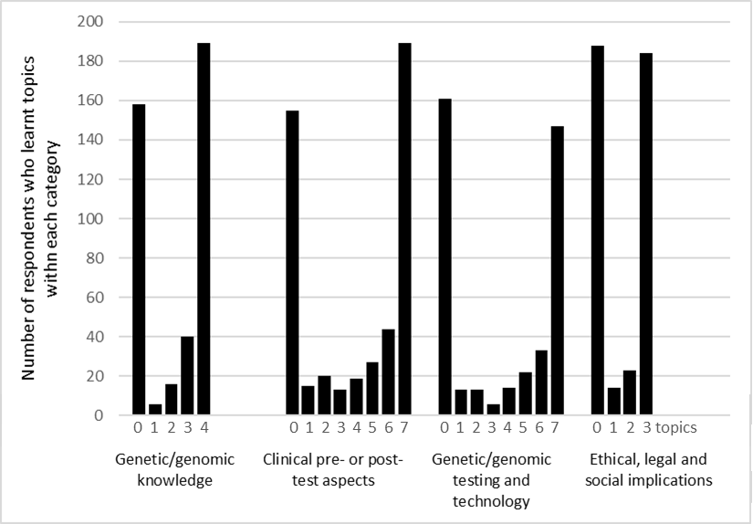
¹ Supplementary Table 5 lists topics within each category. Respondents could indicate having previously learnt no topics within a category (‘0’) or up to a maximum of four topics for ‘Genetic/genomic knowledge’, up to seven topics for ‘Clinical pre- or post-test aspects’ and ‘Genetic/genomic testing and technology’, and up to three topics for ‘Ethical, legal and social implications’.

