RNA-seq analysis in simulated microgravity unveils downregulation of the beta-rhizobial siderophore phymabactin

Golaz et al.,

Supplementary information

Supplementary Figures 1 to 3
Supplementary Tables 2 to 4
Supplementary references

Supplementary information
Supplementary Figures
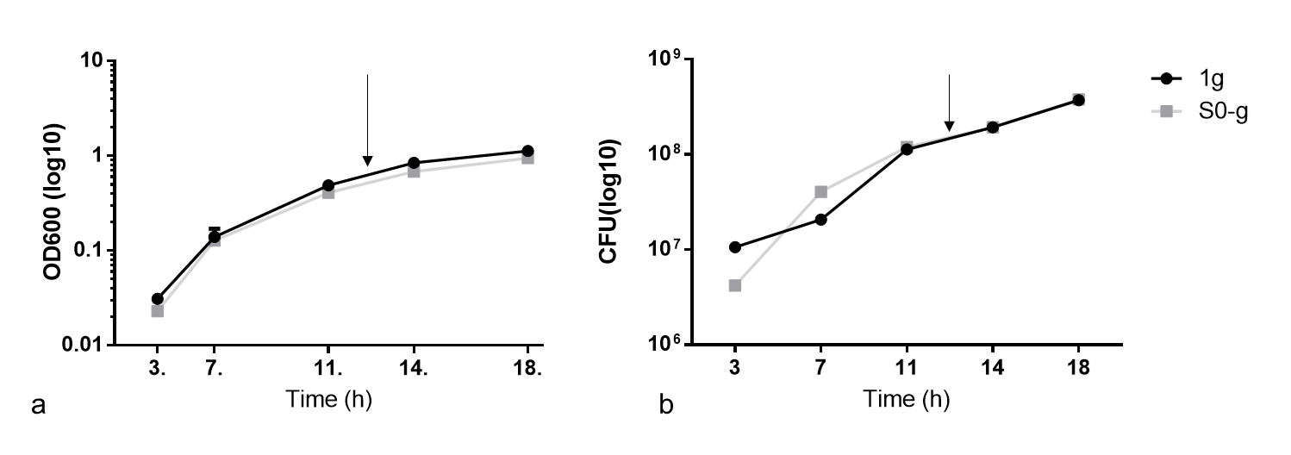

Supplementary Figure 1. Growth profile of P. phymatum wild-type grown in 1g and in s0-g according to its absorbance at OD₆₀₀ (a) or the counted colony forming units (CFU) (b). No difference in growth was observed between the cells grown in 1g and s0-g. Three (n=3) biological replicates were performed. The standard deviation is indicated as bars. The arrows indicate the sampling point.

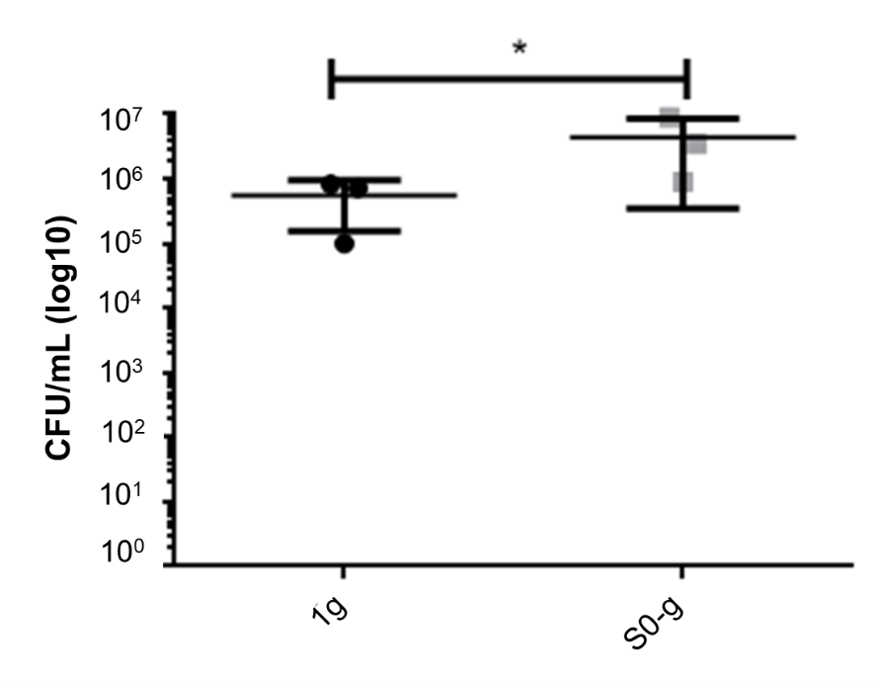
Supplementary Figure 2. Colony forming units (CFU) of P. phymatum wild-type cells subjected to H₂O₂ induced oxidative stress in 1g and s0-g. The cells grown in s0-g were more resistant to oxidative stress than the ones cultivated in 1g (*: p-value < 0.05). The standard deviation is shown as bars, and three (n = 3) biological replicates were tested. Analysis was performed using Student t-test.
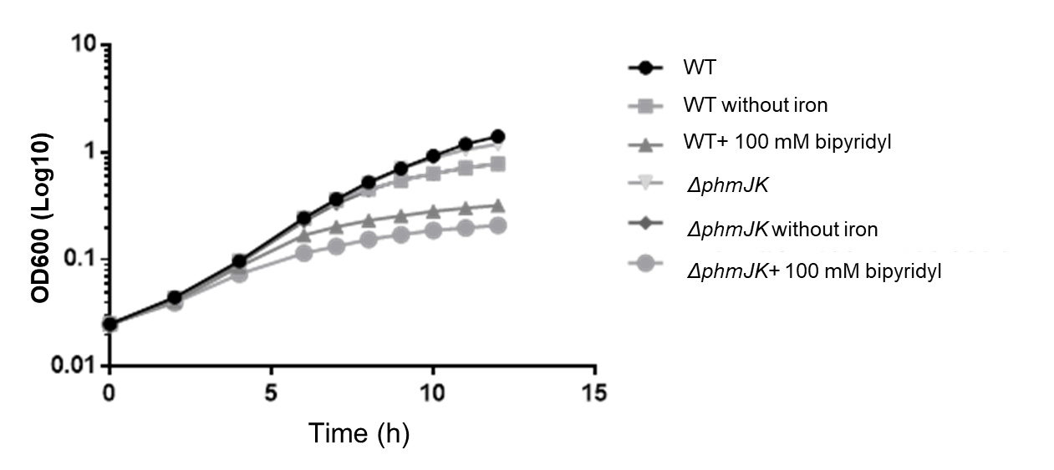
Supplementary Figure 3. Growth profile of P. phymatum wild-type (WT) and phmJK mutant (ΔphmJK) in ABS minimal medium, ABS minimal medium prepared without iron and ABS minimal medium without iron supplemented with 100 mM of the iron chelator bipyridyl. The wild-type and the mutant strain grown without iron grew alike. Data are mean ± standard deviation of three (n=3) biological replicates.

Supplementary Tables

Supplementary Table 1: see separate PDF file
Supplementary Table 2. Homologies of all the genes constituting the phymabactin gene cluster (in P. phymatum STM815) with the ornibactin gene cluster (in B. cenocepacia H111) and the malleobactin gene cluster (in B. pseudomallei 1026b).
 | P. phymatum STM815 |  | B. cenocepacia H111 |  |  | B. pseudomallei 1026b
ID in phm | gene name | similarity (a.a) | gene name | Similarity (a.a) | E. value | gene name | similarity (a.a) | E. value
Bphy_ 4047 | phmS | 100% | orbS | 69.19% | 4,00E-92 | mbaF | 67.57% | 1,00E-93
Bphy_4046 | phmH | 100% | orbH | 74.36% | 4,00E-41 | mbaG | 90.74% | 2,00E-38
Bphy_4045 | phmG | 100% | orbG | 81.99% | 0.0 | mbaH | 82.72% | 0.0
Bphy_4044 | phmC | 100% | orbC | 75.37% | 2,00E-154 | mbaI | 79.09% | 2,00E-156
Bphy_4043 | phmD | 100% | orbD | 66.95% | 0.0 | mbaJ | 67.71% | 0.0
Bphy_4042 | phmF | 100% | orbF | 55.77% | 9,00E-94 | mbaK | 55.91% | 5,00E-85
Bphy_4041 | phmB | 100% | orbB | 62.93% | 8,00E-135 | mbaL | 63.75% | 1,00E-134
 |  |  |  |  |  | mbaM
Bphy_4040 | phmE | 100% | orbE | 77.03% | 0.0 | mbaN | 75.48% | 0.0
Bphy_4039 | phmI | 100% | orbI | 62.58% | 0.0 | mbaA | 61.46% | 0.0
Bphy_4038 | phmJ | 100% | orbJ | 58.79% | 0.0 | mbaB | 59.54% | 0.0
Bphy_4037 | phmK | 100% | orbK | 45.57% | 2,00E-75
Bphy_4036 | pvdA | 100% | pvdA | 67.45% | 0.0 | mbaC | 68.74% | 0.0
 |  |  | orbA |  |  | mbaD
 |  |  | pvdF |  |  | mbaE
Bphy_4035 | phmL | 100% | orbL | 60.40% | 3,00E-140

The analysis was performed using the Burkholderia database (https://www.burkholderia.com/) and BlastP (https://blast.ncbi.nlm.nih.gov/Blast.cgi). For each cluster, there is the name of the present genes, the similarity with the orthologue gene in P. phymatum and the E. value obtained from the analysis. The gaps indicate that this gene does not have an orthologue that can be compared to any P. phymatum genes.
Supplementary Table 3. List of strains and plasmids used during the study.
Strain or plasmid | Description | Reference
E. coli
Cc18λ-pir | Δ(ara-leu) araD ΔlacX74 galE galK phoA20 thil rpsE rpoB argE(Am) recAlλpir, Strep^{R} | (Herrero et al., 1990)
Top10 | ΔlacX74 araΔ139Δ (ara-leu), Amp^{R} | Invitrogen
P. phymatum
STM 815 | Wild-type | (Moulin et al., 2001)
ΔphmJK | Deletion mutant for the phmJ and phmK genes, Trim^{R} | This study
pphm | phm-gfp reporter fusion strain, Kan^{R} | This study
pPROBE | Wild-type strain carrying the pPROBE-NT plasmid, Kan^{R} | This study
Plasmids
pRK2013 | Helper plasmid, Kan^{R} | (Figurski and Helinski, 1979)
pSHAFT2 | Suicide plasmid, Cm^{R} | (Shastri et al., 2017)
pSHAFT2-phmJK | Suicide plasmid containing 1969 bps external fragment of Bphy_4038 for mutagenesis, Cm^{R}, Trim^{R} | This study
pPROBE-NT | Broad-hoast-range promotor-probe vector, Kan^{R} | (Liu et al., 2020)
pPROBE-phm | pPROBE with Bphy_4047 promoter probe vector, Kan^{R} | This study

Supplementary Table 4. List of primers used during this study
Oligonucleotide | Sequence | Reference
Bphy_4038_up_F_EcoRI | CGCGgaattcGAACTCTTCTTGCGCGCG | This study
Bphy_4038_up_R_XhoI | CGCGctcgagTCCTGTCGTTCCTTATTGCG | This study
Bphy_4038_dn_F_NdeI | GCGCcatatgATATCGTCCCGTGTGAACTC | This study
Bphy_4038_dn_R_EcoRI | GCGCgaattcAACGTGAAGCGATGTCCGAA | This study
Bphy_4038_veri_F | GCGCCTCGTTCATCCATG | This study
Bphy_4038_veri_R | GTCGTGATCGTGCGAGAC | This study
Trim_stop_R_NdeI | GCGCCATATGGTAGATATGACGACAGGA | This study
pSHAFT_F | CTTCAGCTGATGTGTGATAACATACT | (Lardi et al., 2017)
Bphy_7808_F | GGCGTGGACTATGTGTCGTA | (Lardi et al., 2017)
Bphy_7808_R | GATGCCCTTCGAGATGTTGT | (Lardi et al., 2017; Liu et al., 2020)
rpoD_F | CAATGCTCCGTTGCTGAATA | (Lardi et al., 2020)
rpoD_R | TTCATCTTCGTCATCGTCCA | (Lardi et al., 2020)

Supplementary References
- Figurski, D.H. and Helinski, D.R., Replication of an origin-containing derivative of plasmid RK2 dependent on a plasmid function provided in trans. Proceedings of the National Academy of Sciences of the United States of America, 1979, vol. 76, pp. 1648–1652. doi:10.1073/pnas.76.4.1648.
- Herrero, M., Lorenzo, V. de and Timmis, K.N., Transposon vectors containing non-antibiotic resistance selection markers for cloning and stable chromosomal insertion of foreign genes in gram-negative bacteria. Journal of bacteriology, 1990, vol. 172, pp. 6557–6567. doi:10.1128/jb.172.11.6557-6567.1990.
- Lardi, M., Liu, Y., Hug, S., Bolzan de Campos, S., Eberl, L. and Pessi, G., Paraburkholderia phymatum STM815 σ54 Controls Utilization of Dicarboxylates, Motility, and T6SS-b Expression. Nitrogen, 2020, vol. 1, pp. 81–98. doi:10.3390/nitrogen1020008.
- Lardi, M., Liu, Y., Purtschert, G., Bolzan de Campos, S. and Pessi, G., Transcriptome Analysis of Paraburkholderia phymatum under Nitrogen Starvation and during Symbiosis with Phaseolus Vulgaris. Genes, 2017, vol. 8. doi:10.3390/genes8120389.
- Liu, Y., Bellich, B., Hug, S., Eberl, L., Cescutti, P. and Pessi, G., The Exopolysaccharide Cepacian Plays a Role in the Establishment of the Paraburkholderia phymatum - Phaseolus vulgaris Symbiosis. Frontiers in microbiology, 2020, vol. 11, p. 1600. doi:10.3389/fmicb.2020.01600.
- Moulin, L., Munive, A., Dreyfus, B. and Boivin-Masson, C., Nodulation of legumes by members of the beta-subclass of Proteobacteria. Nature, 2001, vol. 411, pp. 948–950. doi:10.1038/35082070.
- Shastri, S., Spiewak, H.L., Sofoluwe, A., Eidsvaag, V.A., Asghar, A.H., Pereira, T., Bull, E.H., Butt, A.T. and Thomas, M.S., An efficient system for the generation of marked genetic mutants in members of the genus Burkholderia. Plasmid, 2017, vol. 89, pp. 49–56. doi:10.1016/j.plasmid.2016.11.002.

