Supplementary Information for:
High yield manufacturing of fully screen printed organic electrochemical transistors
Marzieh Zabihipour¹, Roman Lassnig², Jan Strandberg², Magnus Berggren¹, Simone Fabiano¹, Isak Engquist^{1*}, Peter Andersson Ersman²

¹Laboratory of Organic Electronics, Department of Science and Technology, Linköping University, SE-601 74 Norrköping, Sweden
²RISE Acreo, Department of Printed Electronics, Bredgatan 33, SE-602 21 Norrköping, Sweden

* Corresponding author: isak.engquist@liu.se

Supplementary Figure 1 illustrates the behavior of the two sets of large OECTs (Version 1 and Version 2) in terms of transfer characteristics and dynamic switching behavior. These two sets of large OECTs modulate the current differently due to different areas of carbon pads being in direct contact with the electrolyte. According to the figure, in Large Version 1 OECTs, ON/OFF current ratios of > 3.5 orders of magnitude can be achieved, whereas in Large Version 2 OECTs I_{D,OFF} has higher values, due to increased contribution from parasitic reactions, leading to ON/OFF current ratios of ~3 orders of magnitude.
The microscope images of the two malfunctioning OECTs (both from the Large Version 2 OECT design) are shown in Supplementary Figure 2. The OECT shown in Supplementary Figure 2a has been mechanically damaged, possibly during handling after the actual printing process. The OECT shown in Supplementary Figure 2b displays complications stemming from the printing process itself, clogging in the electrolyte mesh probably reduced the dispensed ink volume, leading to an unfilled channel cavity and the collapsed behavior observed in the middle of the image. Both devices are considered in the manufacturing yield calculation, but their corresponding data were excluded from the statistical performance analysis.
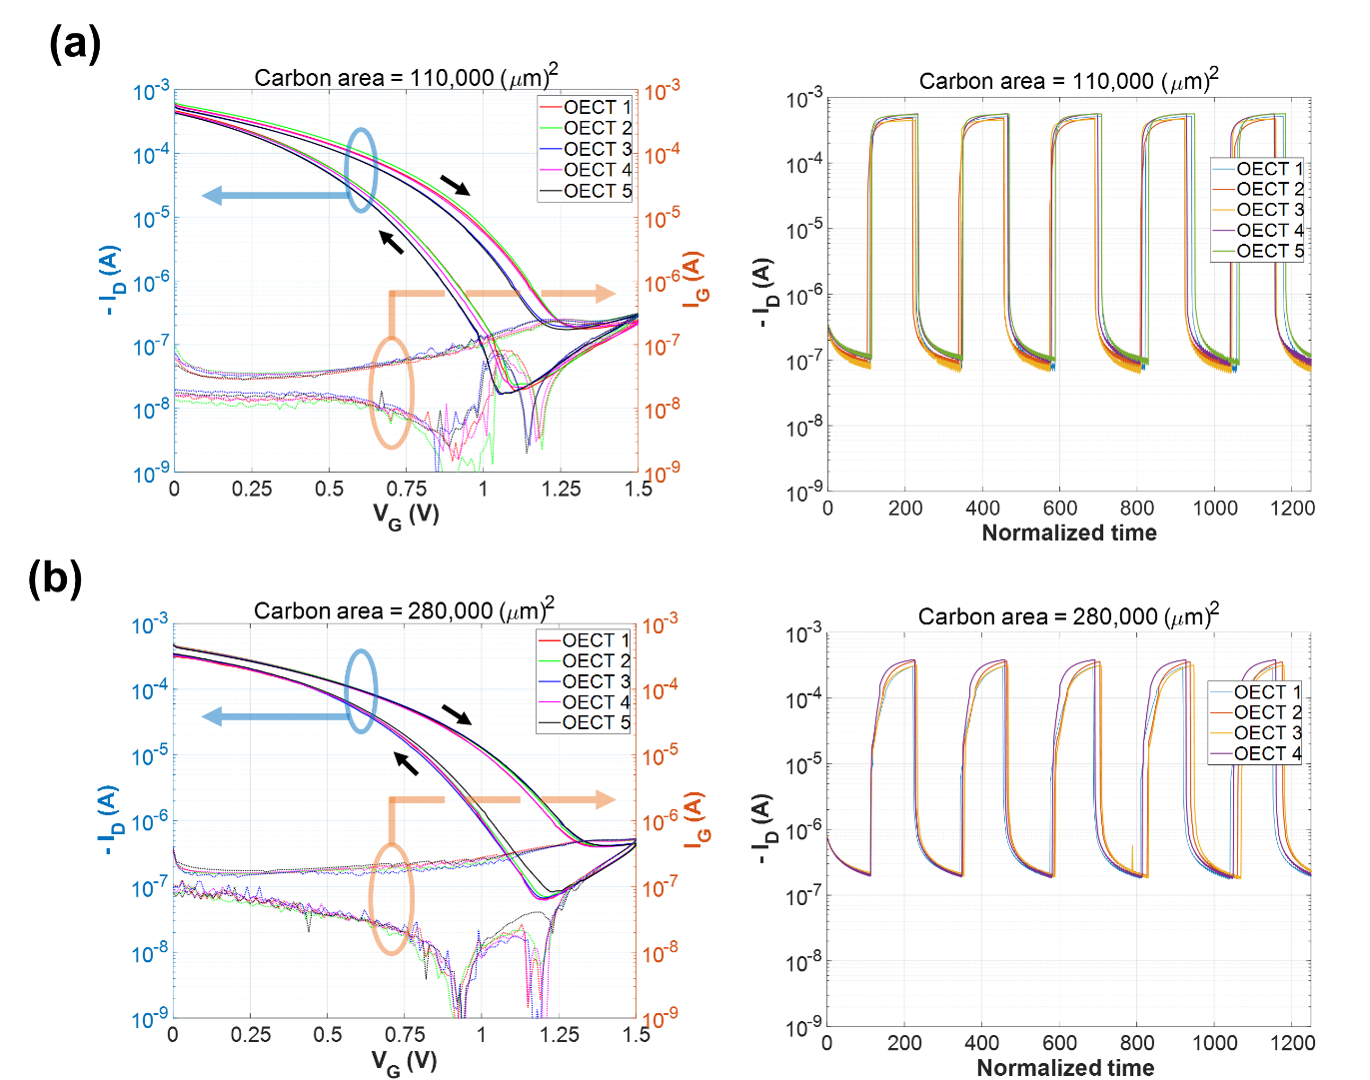
Supplementary Figure 1: Behavior of the two sets of large OECTs: (a) transfer and dynamic switching measurements of Large Version 1 OECTs, (b) transfer and dynamic switching measurements of Large Version 2 OECTs.
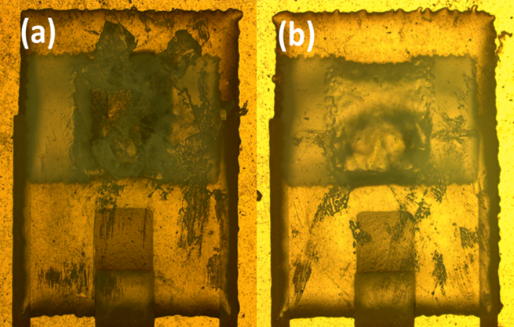
Supplementary Figure 2: Zoom-in views of the two mechanically damaged devices from the Large Version 2 OECT design under microscope.
Performance variations of OECTs with channel dimensions of 150×100 µm² (Tiny OECT design) are shown in Supplementary Figure 3.
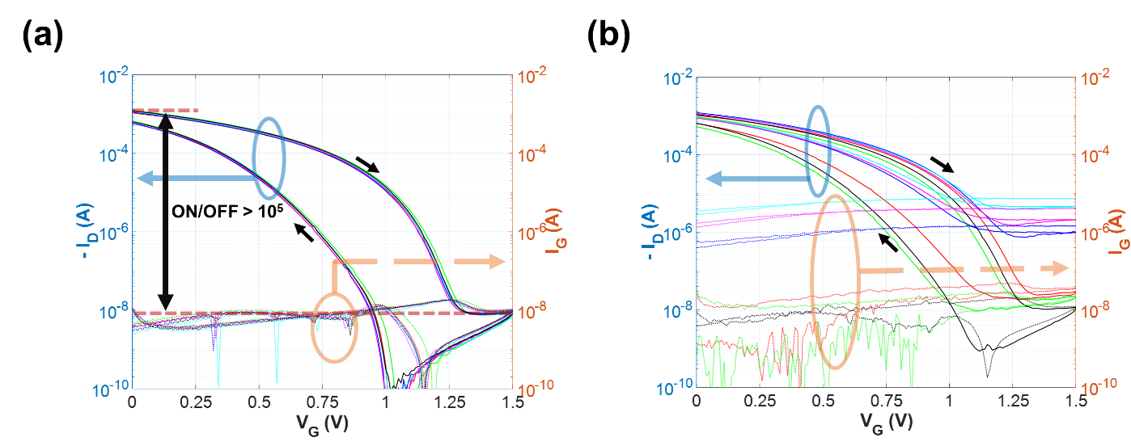
Supplementary Figure 3: Transfer sweeps of OECTs with 150×100 µm² active channel area, the OECTs were printed on the same sheet, but located in two different blocks containing six OECTs each: (a) all OECTs in one block are showing reproducible transfer characteristics and ON/OFF current ratios of ~10⁵, and (b) OECTs from another block showing variations in transfer characteristics and ON/OFF current ratios.

