Supporting Information

Passivation Behaviour of Aluminium Current Collector in Ionic Liquid Alkyl Carbonate (hybrid) Electrolytes

Sowmiya Theivaprakasam^{1,3,4}, Gaetan Girard², Patrick Howlett², Maria Forsyth², Sagar Mitra³, Douglas MacFarlane⁴.

¹IITB-Monash Research Academy, Powai, Mumbai, India 400076.
²Institute for Frontier Materials, Deakin University, Burwood, VIC 3125, Australia.
³Department of Energy Science and Engineering, Indian Institute of Technology Bombay (IITB), Mumbai 400076, India.
⁴Australian Centre for Electromaterials Science, School of Chemistry, Monash University, VIC 3800, Australia.

C₃mpyr⁺
TFSI⁻
FSI⁻
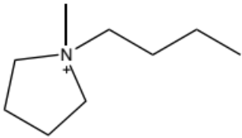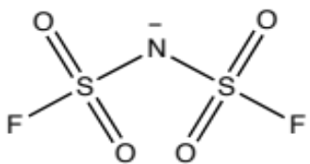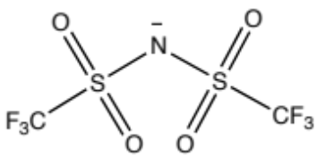
DEC, EC

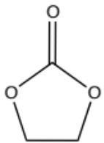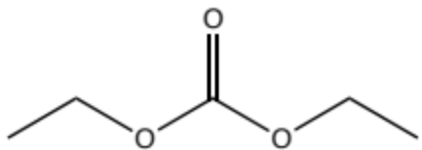

Figure S1 Chronoamperometry of the aluminium foils treated in [C₃mpyr][TFSI], [C₃mpyr] [FSI], HE 1 and HE 2.
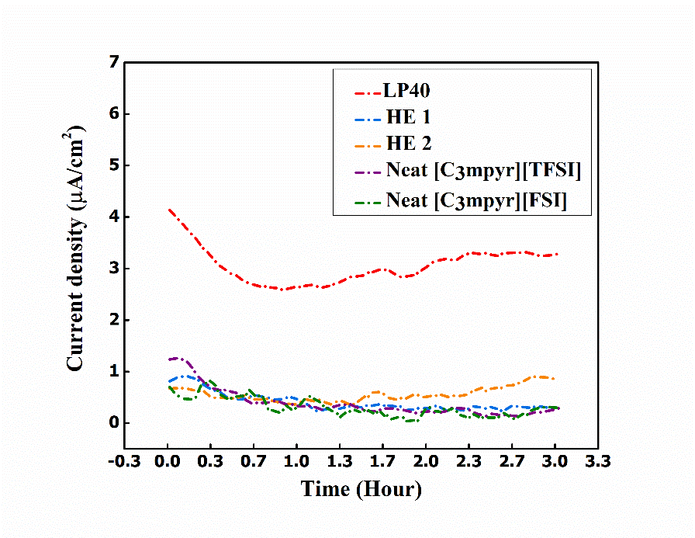
Figure S2 SEM and EDXS spectra of LP 40
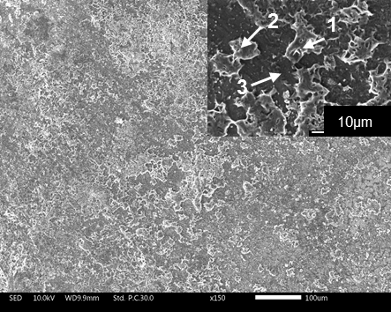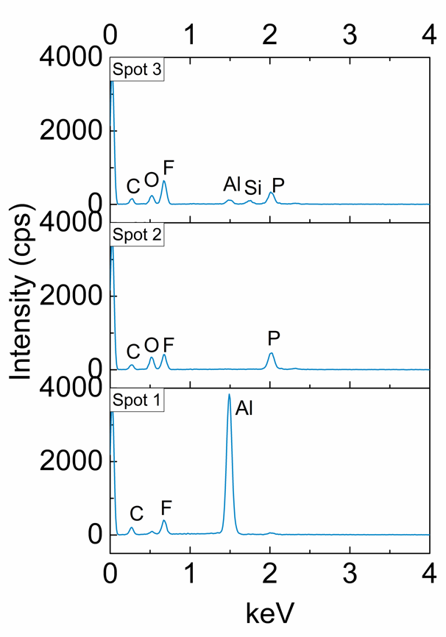
10μm
100μm

Figure S3 SEM and EDXS spectra of Neat [C₃mpyr][TFSI]
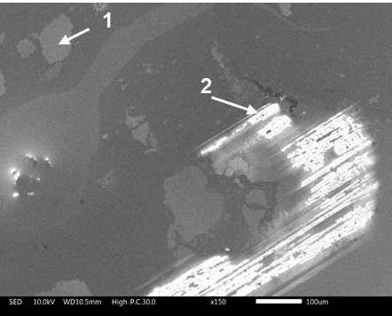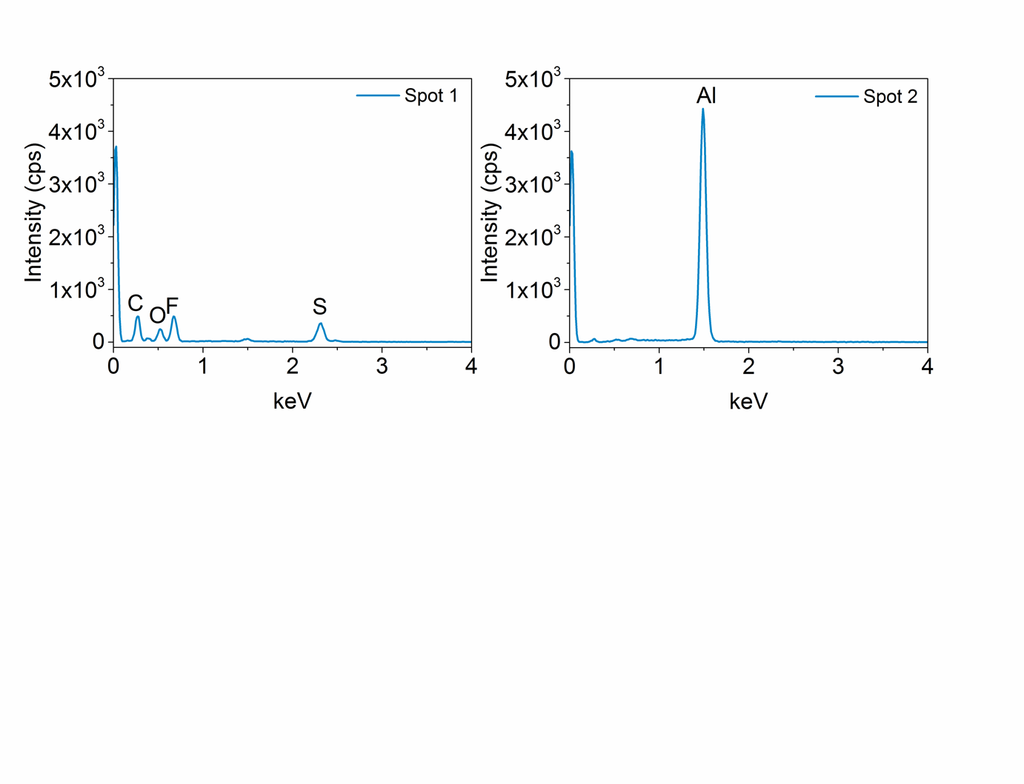
100μm

Figure S4 SEM and EDXS spectra of HE 1
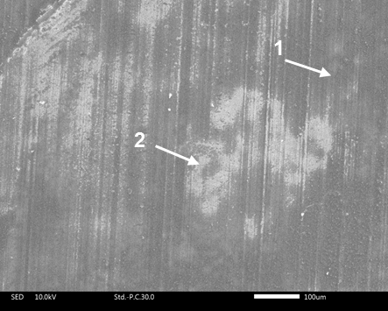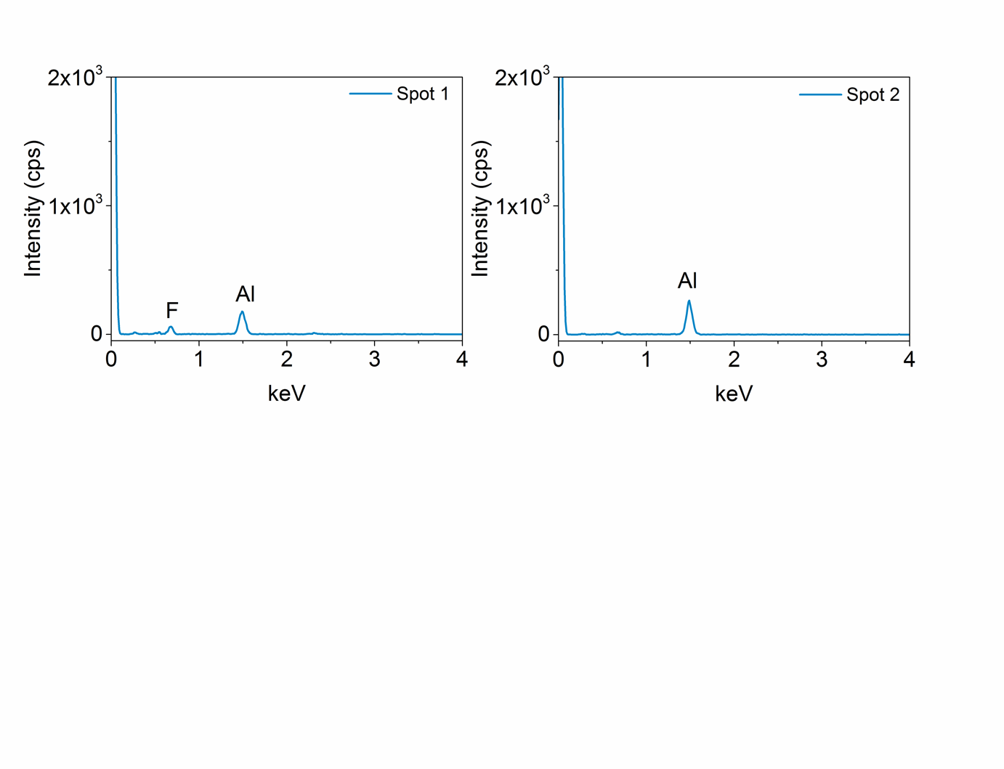
100μm

Figure S5 SEM and EDXS spectra of Neat [C₃mpyr][FSI]
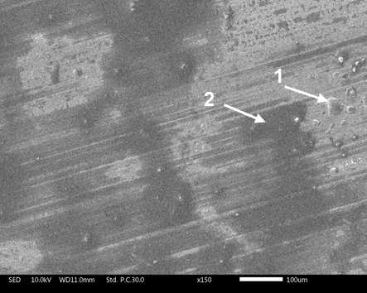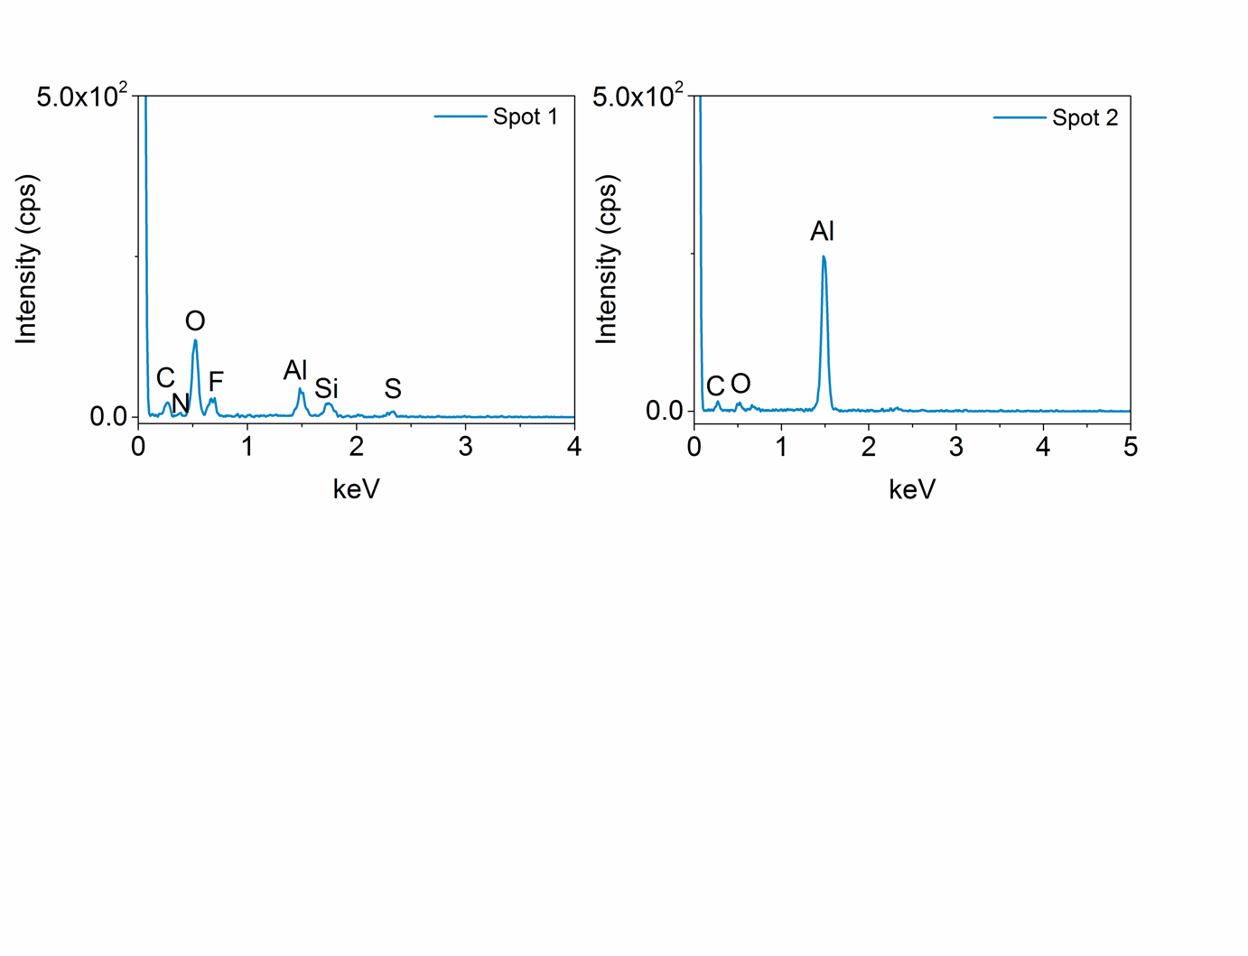
100μm

Figure S6 SEM and EDXS spectra of HE 2
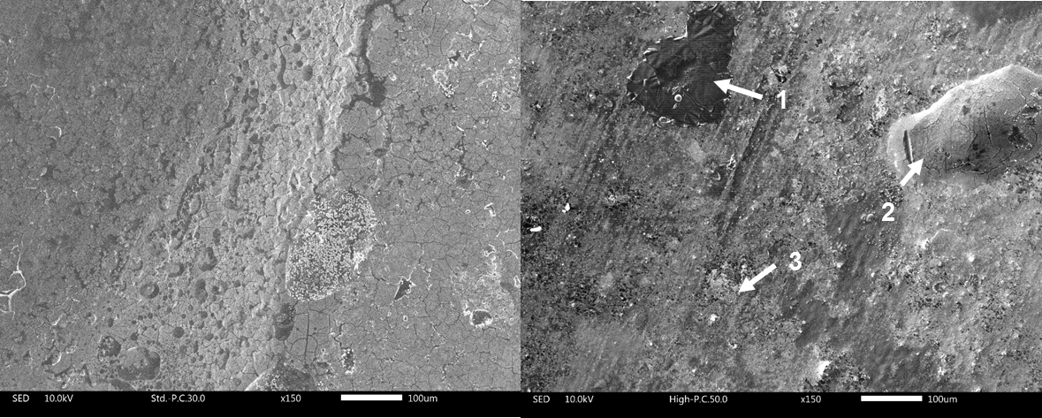
100μm
100μm
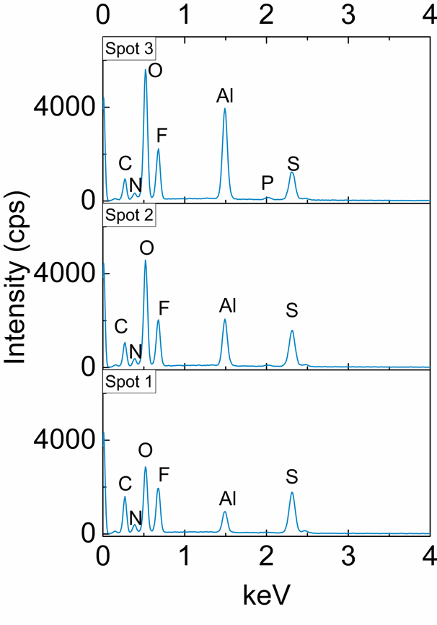

Figure S7 Average roughness of aluminium surface after anodising treatment in [C₃mpyr][TFSI], [C₃mpyr][FSI], HE 1 and HE 2 obtained by optical profilometry
Sample | S_{a} / µm (roughness average)
Neat [C₃mpyr][TFSI] | 0.52 ± 0.2
HE 1 | 0.48 ± 0.1
Neat [C₃mpyr][FSI] | 0.79 ± 0.7
HE 2 | 0.53 ± 0.01
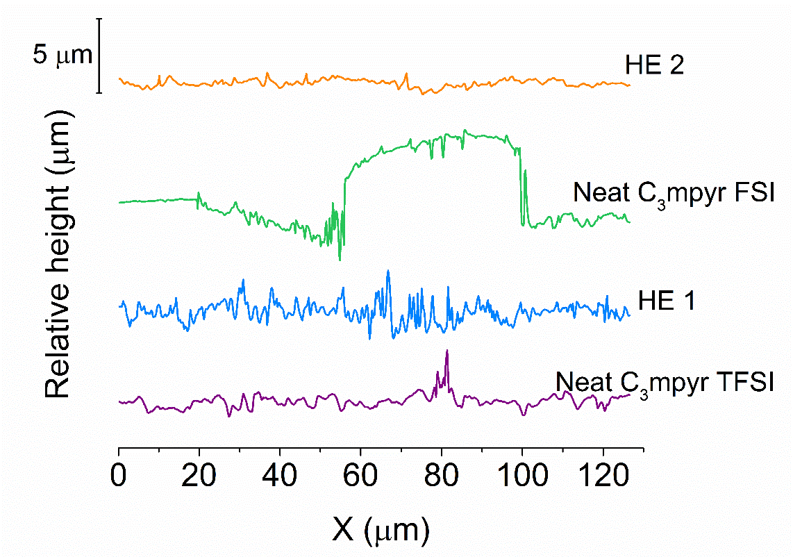

Figure S8 High resolution C 1s region spectra for the Al surfaces treated in Neat [C₃mpyr][TFSI], HE 1, Neat [C₃mpyr][FSI] and HE 2 solutions before and after etching.
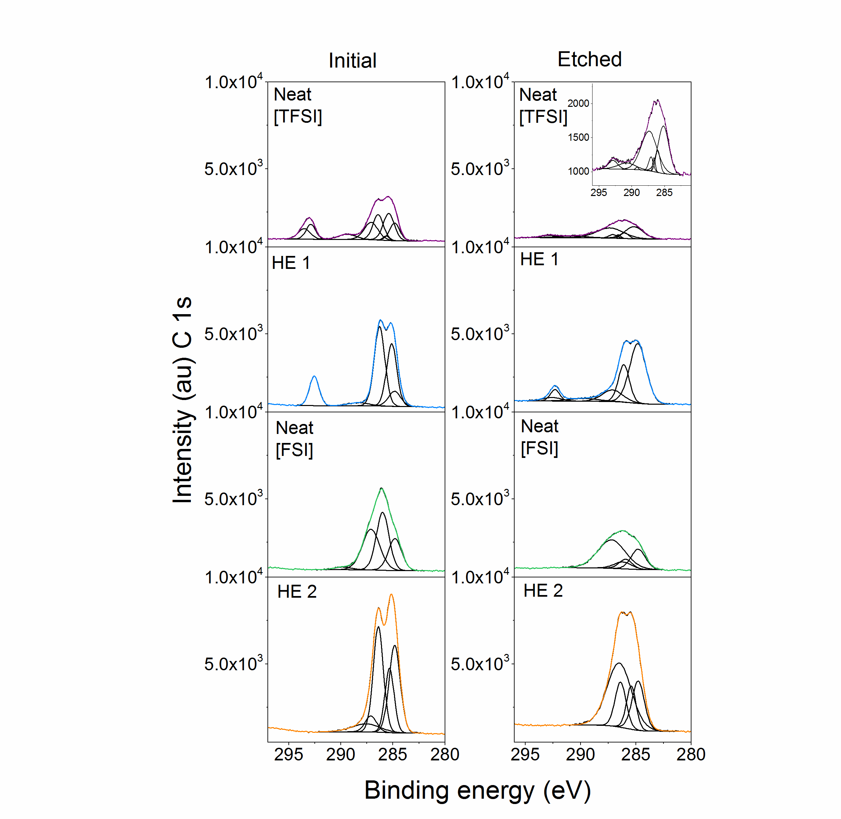

Figure S9 High resolution N 1s region spectra for the Al surfaces treated in Neat [C₃mpyr][TFSI], HE 1, Neat [C₃mpyr][FSI] and HE 2 solutions before and after etching.
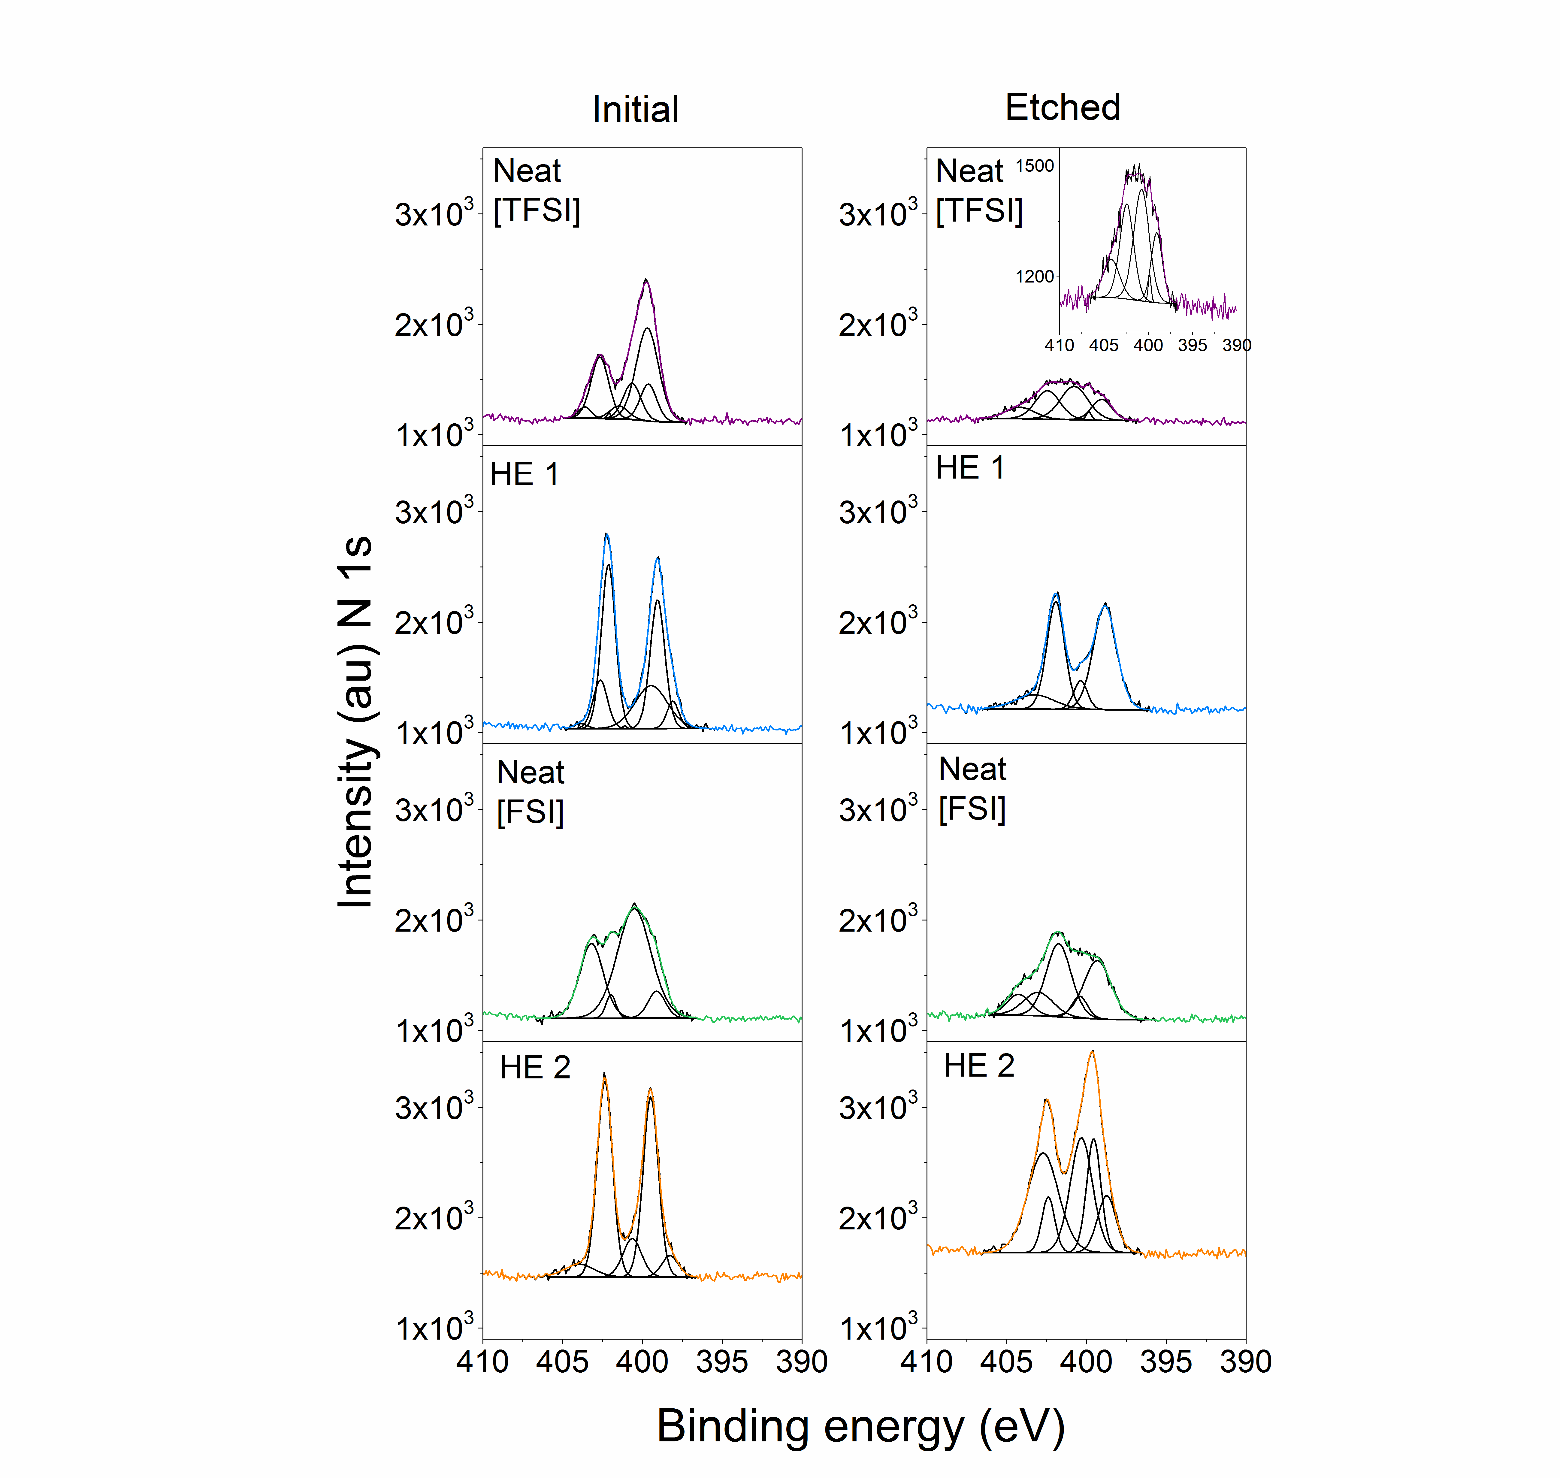

Figure S10 High resolution O 1s region spectra for the Al surfaces treated in Neat [C₃mpyr][TFSI], HE 1, Neat [C₃mpyr][FSI] and HE 2 solutions before and after etching.
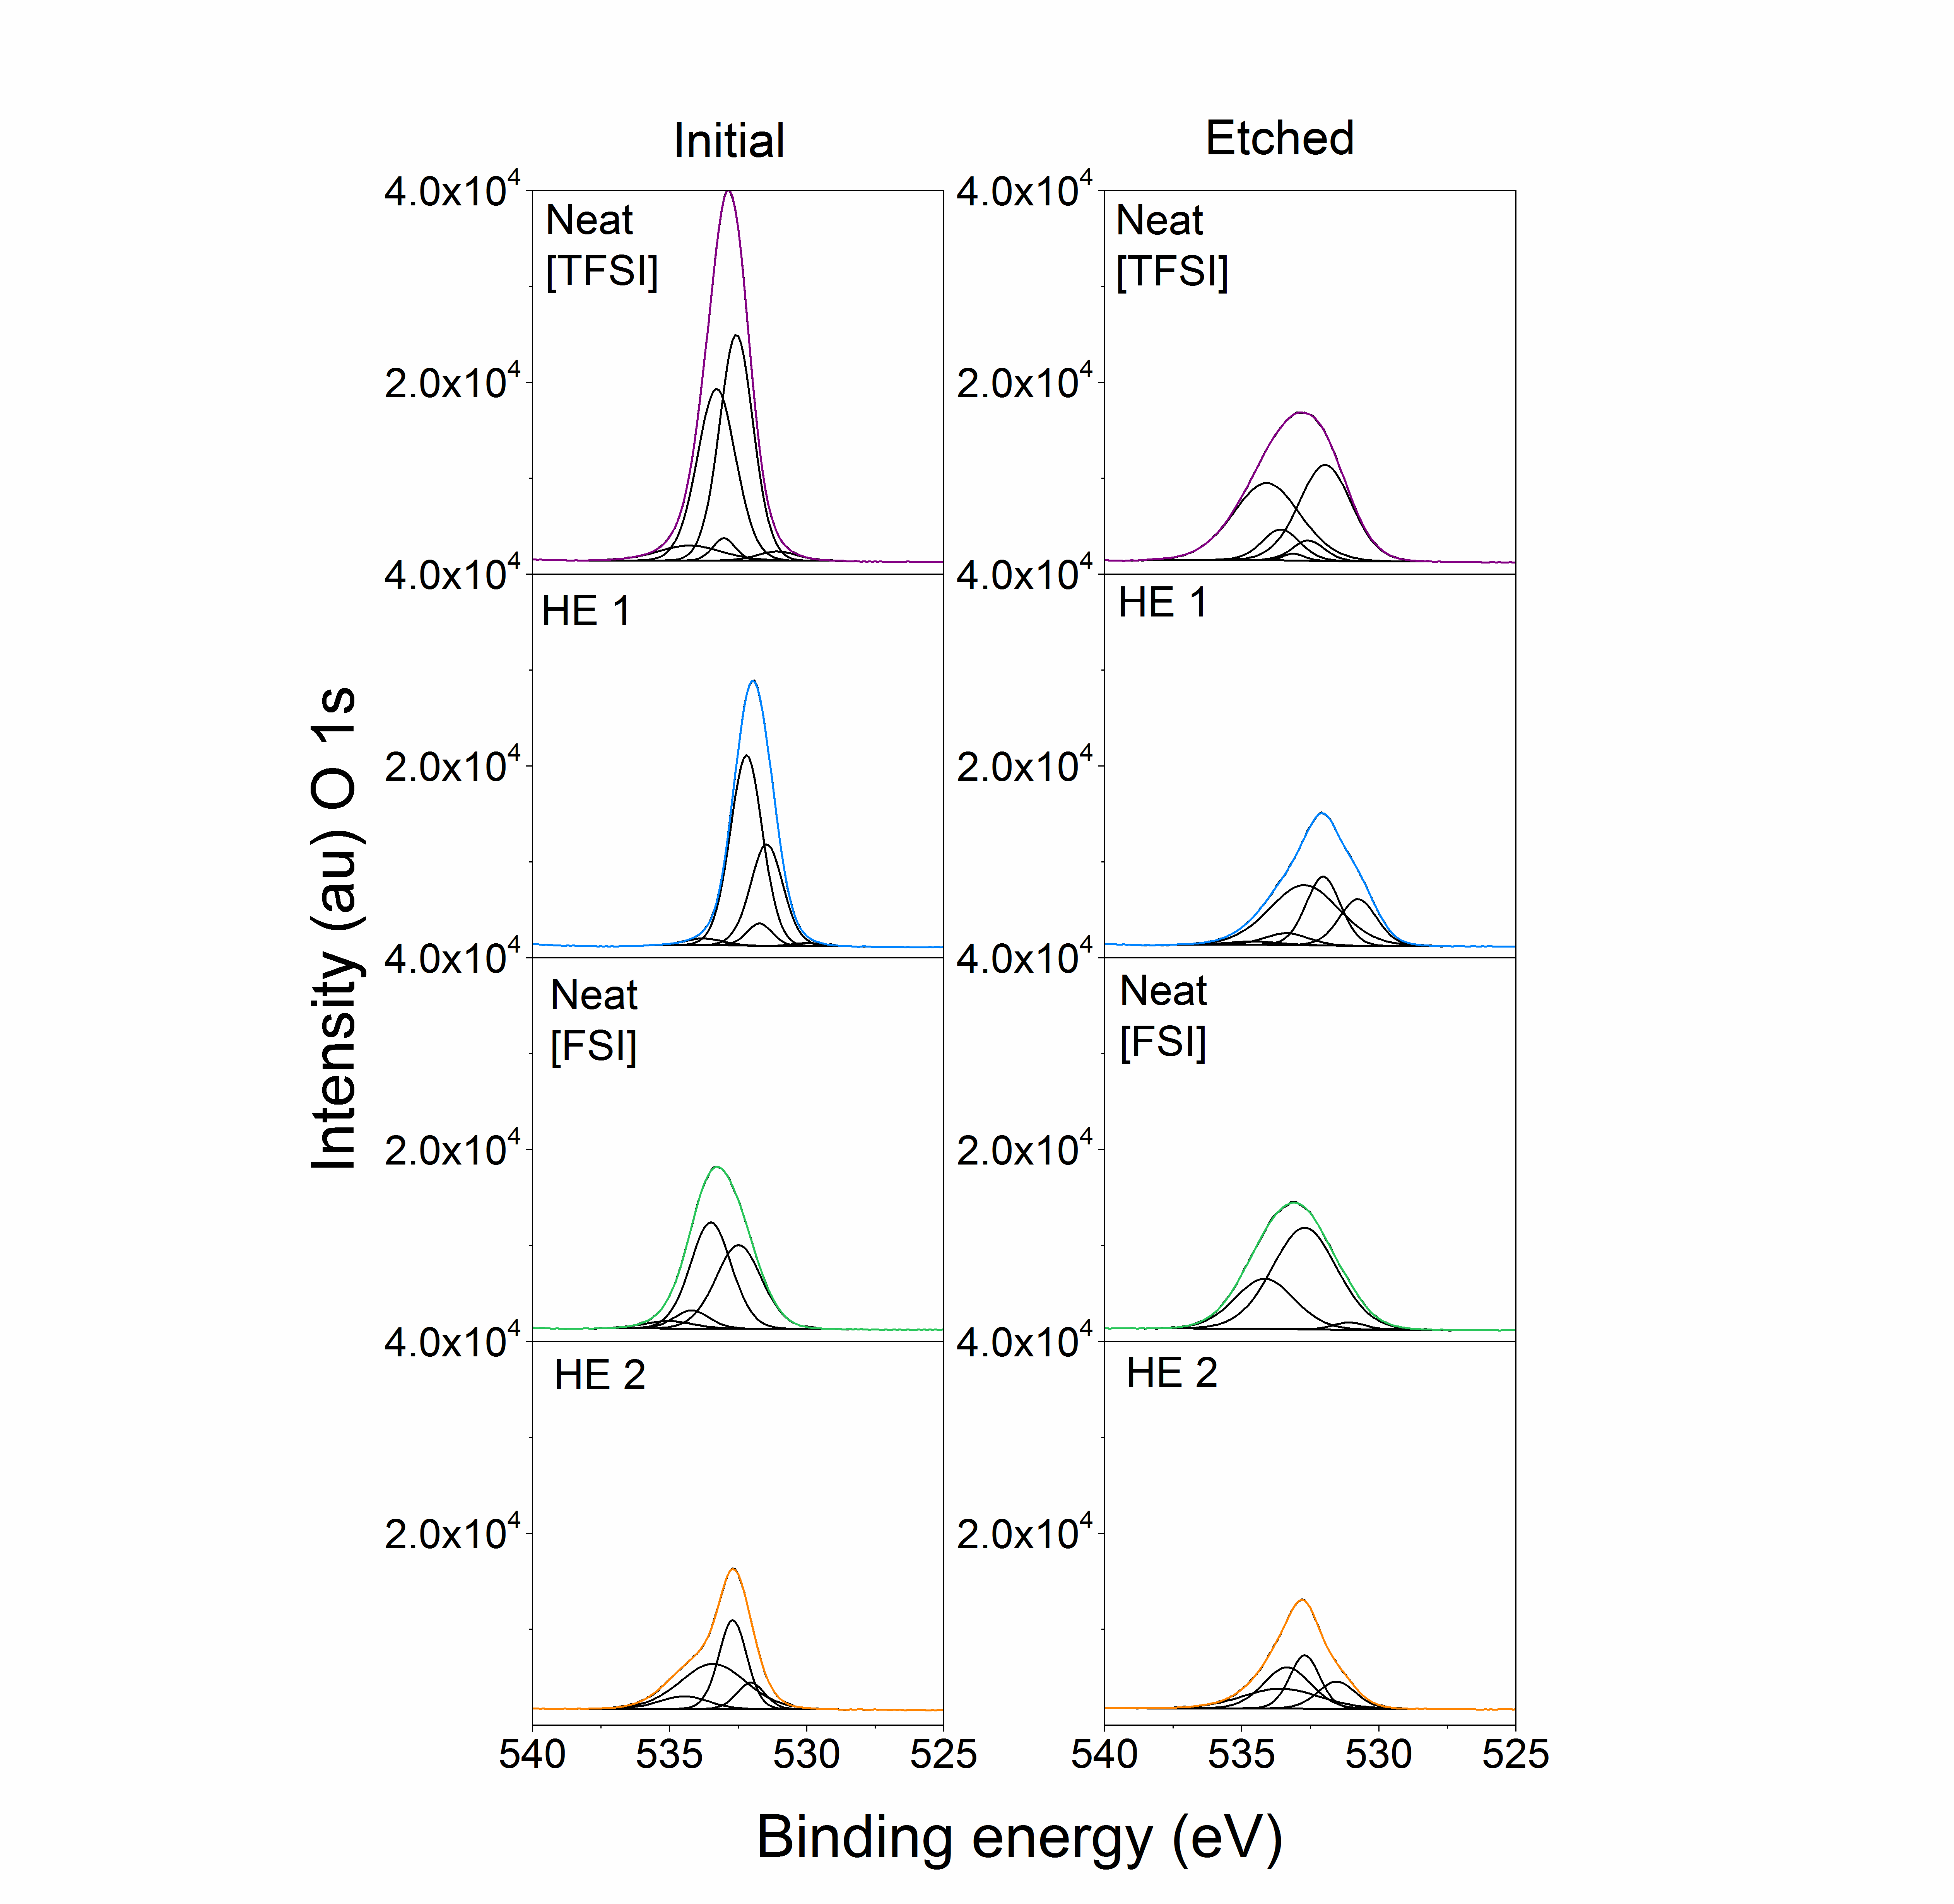

Figure S11 High resolution S 2p region spectra for the Al surfaces treated in Neat [C₃mpyr][TFSI], HE 1, Neat [C₃mpyr][FSI] and HE 2 solutions before and after etching.
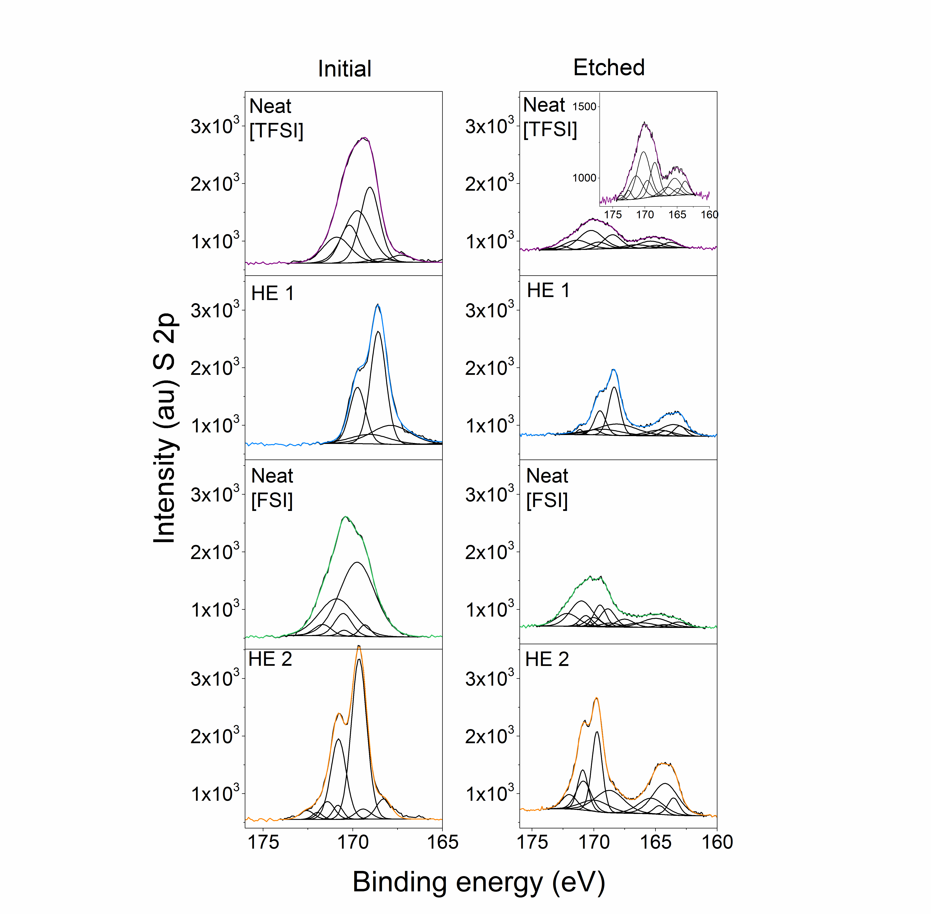

Figure S12 Schematic representation of the moieties present in the passivation layer of aluminum current collector treated with different electrolytes.
(The position or the number of moieties in the picture were chosen based on our interpretation of microscopic and spectroscopic analysis).
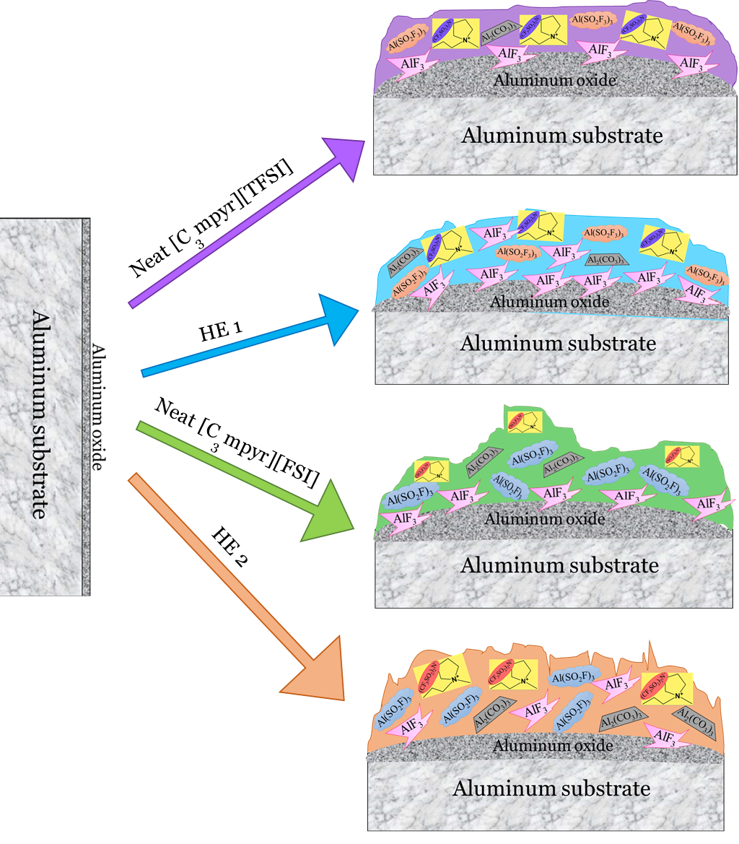

Table S1. Assignment for the FTIR spectrum data of aluminium surfaces – neat samples
(ν: stretching, δ: bending, s: strong, m: medium, w: weak, b: broad)
Assignment |  | Samples
 |  | Neat [C₃mpyr][ TFSI] | Neat [C₃mpy] [TFSI]-Al | Neat [C₃mpyr]  [FSI] | Neat [C₃mpyr] [FSI]-Al | Neat  LP40 | LP40  Al | HE 1 | HE 2 | References
1. | δ_{a}(SO₂) | 569 (s) | 570 (w) | 567 (s) | 570 |  |  | 570 | 570 | ¹
2. | ν_{s} (SNS) | 740 | 740 | 729 (b) | 745 |  |  | 740  (w) | 740 | ^{1, 2, 3, 4}
3. | ν_{a} (SNS)  & ν(SF) | 789 | 789 |  | 828 |  |  | 843 | 832 | ^{2, 4, 5}
4. | ν_{s} (R-C-R) |  |  |  |  | 835(s) | 835 (s) |  |  | ⁶
5. | ν (CO) |  |  |  |  | 1079 (s) | 1079 (s) |  |  | ⁶
6. | ν_{a} (SO₂-N-SO₂) | 1051 (s) | 1051 (s) | 1101 | 1103 |  |  | 1052 (s) | 1054 | ^{1, 5, 7}
7. | ν_{a} (R-C-R) |  |  |  |  | 1152 (s)  1189 | 1153 (s)  1189 |  |  | ⁶
8. | ν_{s} (SO₂-N-SO₂) | 1133 (s)  1175 (s) | 1133 (w)  1176 (s) | 1172  1216 | 1175  1216 |  |  | 1133  1177 (s) | 1104  1136  1174 (s) | ^{1, 5, 7}
9. | ν_{a} (SO₂) | 1330 (s) | 1329 (s) | 1360 (s) | 1360 |  |  | 1329 | 1332 (w) 1350 | ^{1, 4, 5}
10. | ν_{a} (SO₂) | 1348 (s) | 1347 (s) | 1377 (s) | 1378 |  |  | 1348 | 1381 | ^{1, 5}
11. | ν (CH₂)  ν(CH₃) | 1473 | 1472 (m) | 1471 | 1472 |  |  | 1473 | 1472 | ^{1, 8, 9}
12. | ν (C=O) from  R-O-COOR |  |  |  |  | 1763 (s) | 1764 (s) |  |  | ⁶

Assignment |  | Samples
 |  | Neat [C₃mpyr][ TFSI] | Neat [C₃mpy] [TFSI]-Al | Neat [C₃mpyr]  [FSI] | Neat [C₃mpyr] [FSI]-Al | Neat  LP 40 | LP 40  Al | HE 1 | HE 2 | References
13. | ν (CH₂) | 2889 | 2889 (w) | 2887 | 2887 |  |  | 2889 | 2888 | ^{1, 4, 7, 9}
14. | ν (CH₂) | 2950 | 2948 (w) | 2945 | 2946 | 2940 | 2940 | 2949 | 2947 | ^{1, 4, 7, 9}
15. | ν (CH₂) | 2982 | 2981 | 2980 | 2979 |  |  | 2981 | 2980 | ^{1, 4, 7, 9}
16. | ν (CH₂) |  |  |  |  | 3004 | 3008 |  |  | ^{1, 4, 9}
17. | ν (CH₂) |  | 3042 (w) |  | 3042 (w) |  |  |  |  | ⁹
18. | ν (OH) |  |  |  |  | 3630 (s,b) | 3630 (s,b) |  |  | ⁶

Table S2 Atomic percent (± 0.1 - 1 %) summary determined from the survey spectra for the aluminium surfaces before (initial) and after etching (etched) for five minutes
Element | Atomic concentration (%)
Element | Neat  [C₃mpyr][TFSI] |  | HE 1 |  | Neat  [C₃mpyr][FSI] |  | HE 2
Element | Inital | Etched | Inital | Etched | Inital | Etched | Inital | Etched
F (1s) | 16.4 | 30.9 | 18.6 | 20.7 | 9.2 | 18.8 | 10.0 | 14.2
O (1s) | 41.7 | 28.3 | 31.2 | 22.4 | 31.7 | 31.0 | 24.3 | 20.0
N (1s) | 3.6 | 1.8 | 4.3 | 3.3 | 6.0 | 3.9 | 5.4 | 6.3
C (1s) | 17.9 | 8.0 | 19.9 | 19.6 | 34.3 | 17.8 | 45.1 | 36.3
S (2p_{3/2}) | 6.2 | 2.7 | 5.1 | 3.9 | 8.8 | 5.2 | 7.6 | 8.8
P (2p_{3/2}) | - | - | 8.3 | 12.0 | - | - | - | 2.2
Al (2p) | 14.2 | 28.3 | 12.7 | 18.2 | 9.9 | 23.3 | 7.6 | 12.2

Table S3 Summary of XPS data and assignments for the aluminium surfaces of neat [C₃mpyr][TFSI] and HE 1 samples (before and after etching)
Element | Assignment | Peak position (eV)
Element | Assignment | Neat [C₃mpyr][TFSI] |  | HE 1
Element | Assignment | Inital | Etched | Inital | Etched
F (1s) | -CF₃ | 689.4 (37.7) | 688.7 (45.5)  688.2 (7.3) | 690.6 (0.4)  688.7 (35.2) | 689.9 (5.6)
F (1s) | -SO₂F | 688.9 (31.4) | 687.6 (4)  687.0 (8.4) | 688.2 (30.4) | 688.2 (41.9)
F (1s) | AlF₃  (686.3)  metal fluoride  (684-685.5) | 686.8 (8)  685.7 (23) | 686.6 (34.7) | 685.6 (14.1)  685.1 (19)  684.2 (0.8) | 686.2 (50)  684.4 (2.5)
O (1s) | O-F  (ca. 535) | 534.3 (6) | 534.1 (42.5) | - | 534.6 (1.8)
O (1s) | Organic C=O  (ca. 533) | 533.3 (41.1)  533.0 (3.2) | 533.6 (9.6)  533.1 (1.2) | 533.8 (2.3) | 533.4 (5.7)  532.7 (46.8)
O (1s) | CO₃²⁻ (531.5-532) organic C-O or SO₂⁻ | 532.6 (47.5) | 532.6 (5.4)  531.9,532 (41.4) | 532.2 (59.2)  531.7 (5.5)  531.5 (32) | 532.0 (26.3)  530.8 (19.5)
O (1s) | Al oxide  (529-530) | 531.1 (2.3) | - | 529.9 (1) | -
N (1s) | N⁺ | 403.6 (2.9)  402.7 (22.4)  402.1 (0.5)  401.5 (5.0) | 404.5 (8.5)  402.2 (47.8) | 403.9 (1)  402.6 (10.4)  402.1 (34.7)  401.1 (0.2) | 403.3 (10.7)  401.9 (36.2)
N (1s) | N⁻ | 400.7 (13.4)  399.7 (43.1)  399.6 (12.7) | 400.6 (21.2)  399.9 (2.1)  399.1 (20.5) | 399.5-20.8  399.1-28.1  398.1-4.9 | 400.4 (7.4)  398.8 (45.7)
C (1s) | -CF₃ | 293.5 (9.2)  292.9 (10.3) | 292.9 (6) | 292.6 (14.1) | 292.6 (3.5)  292.3 (5.6)
C (1s) | C_{hetero}  CO₃²⁻  O-C=O | 289.4 (6.5) | 290.8 (6.1)  288.9 (6.2) | 288.3 (3.1) | 289.7 (4.4)
C (1s) | C-O-C  (ca. 286 eV) C-N | 287.1 (17.4)  286.4 (19.4) | 286.9 (47.3) | 286.3 (41.8) | 287.1 (12.5)  286.1 (21.7)
C (1s) | C_{aliphatic}  C-C / C-H | 285.6 (1.9)  285.4 (22.1)  284.8 (13.1) | 285.9 (16.2)  284.8 (18.2) | 285.1 (31.8)  284.8 (9.2) | 284.8 (52.3)

S (2p_{3/2}) | -SO₂CF₃ | 169.7 (31.4)  170.9 (15.7)  169.0 (31.9)  170.2 (16) | 173.7 (1.4)  172.5 (2.8)  170.2 (30.6)  171.4 (15.3) | 168.6 (45.8)  169.7 (22.9) | 169.9,170 (2.9)  171.1 (1.4)  168.3 (24.8)  169.5 (12.4)
S (2p_{3/2}) | Oxidized S  (sulfone, sulfite) | 167.3 (3.4)  168.4 (1.7) | 168.5 (16.4)  169.6 (8.2) | 167.9 (19.2)  169.0 (9.6) | 168.1 (19.8)  169.2 (9.9)
S (2p_{3/2}) | Sulfide species  (160-165)  and S⁰  (164.1, 164) | - | 165.4 (11.3)  166.5 (5.7)  163.8 (5.6)  164.9 (2.8) | 163.8 (1.7)  164.9 (0.9) | 163.5 (13.8)  164.7 (6.9)  164.2 (2.7)  163.0 (5.4)
Al (2p_{3/2}) | AlF₃  (76.6) | - | 77.2 (23.1)  78.4 (11.5) | 74.8 (23)  76.6 (2.3) | 76.8 (18.8)  75.7 (37.7)
Al (2p_{3/2}) | Al oxide  on Al foil  (75.6) | 76.0 (31)  75.4 (8)  74.9 (61.3) | 75.4 (42.5)  76.6 (21.3) | - | -
Al (2p_{3/2}) | Al oxide  (74.4-74.6) | - | - | 74.4 (47.5)  74.1 (26.4) | 75.5 (14.5)  74.4 (28.9)
Al (2p_{3/2}) | Al⁰  (72.6-72.9) | - | 70.8 (1.6) | - | -

Table S4 Summary of XPS data and assignments for the aluminium surfaces of neat [C₃mpyr][FSI] and HE 2 samples (before and after etching)
Element | Assignment | Peak position (eV)
Element | Assignment | Neat [C₃mpyr][FSI] |  | HE 2
Element | Assignment | Inital | Etched | Inital | Etched
F (1s) | -CF₃ | - | - | - | -
F (1s) | -SO₂F | 688.2 (18.5)  687.6 (20.3) | 688.0 (58.4) | 688.5 (16.1)  687.9 (30.8)  687.1 (41.3) | 688.7 (0.2)  688.3 (37.3)  687.4 (34.6)
F (1s) | AlF₃  (686.3)  Metal fluoride (684-685.5) | 686.7 (61.2) | 686.6 (29.4)  685.2 (12.1) | 686.2 (3.3)  685.8 (8.6) | 686.4 (22.9)  685.1 (5.1)
O (1s) | O-F  (ca. 535) | 535.0 (3.9)  534.2 (6.9) | 534.2 (30.3) | 534.5 (8.9) | -
O (1s) | Organic C=O  (ca. 533) | 533.5 (47.4) |  | 533.4 (43.7) | 533.6 (25.1)  533.3 (31.8)
O (1s) | CO₃²⁻ (531.5-532) organic C-O or SO₂⁻ | 532.5 (41.8) | 532.7 (67.1)  531.1 (2.4) | 532.7 (36.5)  532.0 (10.8) | 532.7 (26.1)  531.5 (17)
O (1s) | Al oxide  (529-530) | - | 529.6 (0.3) | - | -
N (1s) | N⁺ | 403.2 (28.9)  401.9,402 (3.8) | 404.3 (9.8)  403.0 (14.2)  401.7 (36.9) | 403.9,404 (5.3)  402.4 (41.5) | 402.7 (34.2)  402.4 (7.9)
N (1s) | N⁻ | 400.5 (59.9)  399.1 (7.5) | 400.4 (6.9)  399.3 (32.2) | 400.6 (10)  399.5 (38.2)  398.3 (5) | 400.3 (28.3)  399.5 (18)  398.7 (11.7)
C (1s) | -CF₃ | - | - | - | -
C (1s) | C_{hetero}  CO₃²⁻  O-C=O | 289.8 (2.5)  287.1(37.1) | 287.2 (59.3) | 287.6 (7.4)  287.1 (6) | -
C (1s) | C-O-C  (ca. 286 eV) C-N | 285.9,286 (38.3) | 286.2 (9)  285.9 (9.5) | 286.4 (35.1)  285.3 (19.4) | 286.5 (50.8)  286.4 (16.1)  285.4 (13.4)
C (1s) | C_{aliphatic}  C-C / C-H | 284.8 (22.2) | 284.8 (22.1) | 284.8 (32.1) | 284.8 (19.8)

S (2p_{3/2}) | -SO₂F | 170.5 (8.4)  171.7-4.2  169.7 (55.5)  170.9 (27.8)  169.3 (2.8)  170.4 (1.4) | 170.9,171 (23.7)  172.1 (11.9)  170.3 (0.9)  171.4 (0.5)  169.5 (11)  170.6 (5.5) | 171.4 (5.3)  172.6 (2.6)  170.8 (3)  171.98 (1.5) | 170.8 (10)  171.9,172.0 (5)  169.7 (19.3)  170.9 (9.6)
S (2p_{3/2}) | Oxidized S  (sulfone, sulfite) | - | 168.9 (11.2)  170.0 (5.6)  167.5 (6)  168.6 (3) | 169.6 (51.9)  170.8 (25.9)  168.3 (6.5)  169.4 (3.3) | 168.7 (14.7)  169.9 (7.3)
S (2p_{3/2}) | Sulfide species  (160-165)  and S⁰  (164.1, 164) | - | 164.9,165 (10.2)  166.1 (5.1)  163.1 (3.7)  164.3 (1.9) | - | 164.2 (18.2)  165.3 (9.1)  163.5 (4.5)  164.7 (2.3)
Al (2p_{3/2}) | AlF₃  (76.6) | 76.1 (24.9)  77.2 (12.5) | 76.8 (37.3)  77.2 (18.7) | 77.6 (7.1)  78.8 (3.6)  75.8 (59.6)  76.9,77.0 (29.8) | 76.1 (43.8)  77.3 (21.9)  76.0 (3.6)  77.2 (1.8)
Al (2p_{3/2}) | Al oxide  on Al foil  (75.6) | 75.2 (40.9)  76.3 (20.5) | 75.1 (28.9)  76.3 (14.4) | - | 75.2 (19.2)  76.4 (9.6)
Al (2p_{3/2}) | Al oxide  (74.4-74.6) | - | - | - | -
Al (2p_{3/2}) | Al⁰  (72.6-72.9) | 71.2 (1.2) | 70.2 (0.8) | - | -

References

1. Howlett PC, Brack N, Hollenkamp AF, Forsyth M, MacFarlane DR. Characterization of the lithium surface in N-methyl-N-alkylpyrrolidinium bis(trifluoromethanesulfonyl) amide room-temperature ionic liquid electrolytes. Journal of the Electrochemical Society 2006, 153(3): A595-A606.

2. Yoon H, Best AS, Forsyth M, MacFarlane DR, Howlett PC. Physical properties of high Li-ion content N-propyl-N-methylpyrrolidinium bis(fluorosulfonyl)imide based ionic liquid electrolytes. Phys Chem Chem Phys 2015, 17(6): 4656-4663.

3. Rey I, Lassègues JC, Grondin J, Servant L. Infrared and Raman study of the PEO-LiTFSI polymer electrolyte. Electrochimica Acta 1998, 43(10–11): 1505-1510.

4. Colthup NB, Daly LH, Wiberley SE. Chapter 12 - Compounds Containing Boron, Silicon, Phosphorus, Sulfur, Or Halogen. In: Colthup NB, Daly LH, Wiberley SE (eds). Introduction to Infrared and Raman Spectroscopy (Third Edition). Academic Press: San Diego, 1990, pp 355-385.

5. Li LF, Zhou SS, Han HB, Li H, Nie J, Armand M, et al. Transport and Electrochemical Properties and Spectral Features of Non-Aqueous Electrolytes Containing LiFSI in Linear Carbonate Solvents. Journal of the Electrochemical Society 2011, 158(2): A74-A82.

6. Nyquist RA, Potts WJ. Infrared absorptions characteristic of organic carbonate derivatives and related compounds. Spectrochimica Acta 1961, 17(7): 679-697.

7. Bednarska-Bolek B, Jakubas R, Bator G, Baran J. Vibrational study of the structural phase transition in bis(pyrrolidinium)-chloride-hexachloroantimonate(V) by infrared spectroscopy. Journal of Molecular Structure 2002, 614(1–3): 151-157.

8. Adebahr J, Johansson P, Jacobsson P, MacFarlane DR, Forsyth M. Ab initio calculations, Raman and NMR investigation of the plastic crystal di-methyl pyrrolidinium iodide. Electrochimica Acta 2003, 48(14–16): 2283-2289.

9. R. A. Nyquist CLP, M. A. Leugers. Handbook of Infrared and Raman Spectra of Inorganic Compounds and Organic Salts. Academic Press, 1997.

