Supplementary information for:
Rapid assessment of structural and compositional changes during early stages of zirconium alloy oxidation
Elizabeth J. Kautz¹, Bharat Gwalani², Sten V.M. Lambeets³, Libor Kovarik³, Daniel K. Schreiber⁴, Daniel E. Perea³, David Senor⁴, Yi-Sheng Liu⁵, Anil K. Battu³, Kuo-Pin Tseng⁶,
Suntharampillai Thevuthasan³, Arun Devaraj^{2*}
¹National Security Directorate, Pacific Northwest National Laboratory, Richland, WA
²Physical and Computational Sciences Directorate, Pacific Northwest National Laboratory, Richland, WA
³Earth and Biological Sciences Directorate, Pacific Northwest National Laboratory, Richland, WA
⁴Energy and Environment Directorate, Pacific Northwest National Laboratory, Richland, WA
⁵ Advanced Light Source, Lawrence Berkeley National Laboratory, Berkeley, CA
⁶ Department of Materials Science and Engineering, University of Illinois Urbana-Champaign, Champaign, IL

Supplementary Note 1: Mass Spectra of Oxides
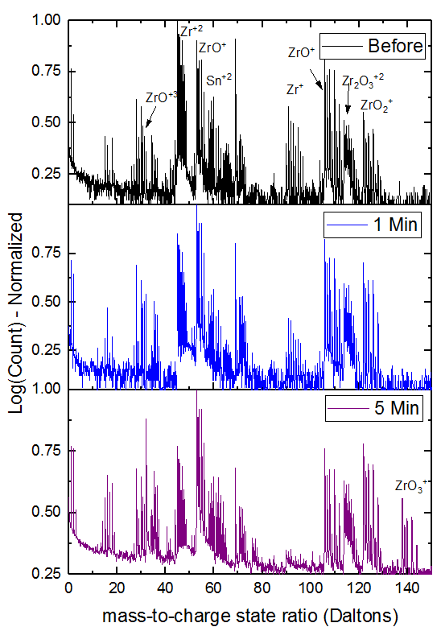
Supplementary Figure 1. Atom probe mass spectra from the oxide region before and after oxidation. Results from before oxidation and after exposure to O₂ gas for 1 and 5 minutes at 300°C–0.15 psi are provided with labelled peaks. All mass spectra are from the oxide region of each sample. Mass spectra were generated for the higher-gradient side of an oxygen isosurface with 10 at% for the native oxide (before), and 30 at% for 1 min and 5 min of oxidation. All mass spectra are displayed using a 0.1 Da bin width.

Supplementary Note 2: Hydrogen
Hydrogen in the Zircaloy-4 and oxide layers was also considered in APT analysis, because Zr-based alloys are known to readily form hydrides, and hydride formation and oxidation are interrelated. Hydrogen concentrations in the base alloy before and after 1 and 5 min oxidation were similar. There are several potential sources of H from bulk or FIB/SEM sample preparation, and/or residual gas in the APT analysis chamber.¹ Measurement of H in Zircaloy-4 base alloy and oxide layers are presented in Figure S1, and is important because oxidation and precipitation of brittle hydride phases are interrelated during water-side corrosion, which is typical in a pressurised water nuclear reactor core. Any H measured via APT is assumed to have a negligible effect on suboxide phase formation and any Sn diffusion observed.
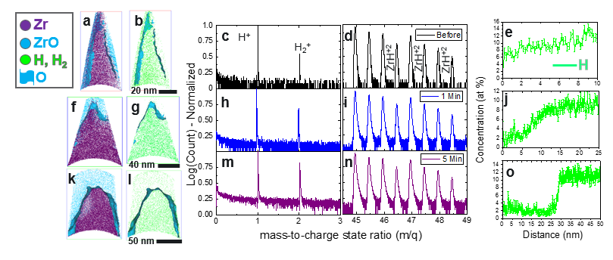
Supplementary Figure 2. Hydrogen in the atom probe mass spectrum and across the oxygen/metal interface before and after oxidation. Results from before oxidation are shown in (a,b,c,d,e). Results from after exposure to O₂ gas for 1 minute at 300°C–0.15 psi are provided in (f,g,h,i,j). Results from oxidation under these same conditions for 5 minutes are provided in (k,l,m,n,o). For each condition, the regions of the mass spectra where hydrogen is seen (1–3 Da and 44–49 Da) are compared. 1-D concentration profile plots for H (background corrected, atomic, decomposed) are shown in (e,j,o). The element distribution maps shown in (a,b,f,g,k,l) are cropped to a width of approximately 3 nm.

Supplementary Note 3: Bulk Zircaloy-4 Chemistry
Bulk chemical analysis was performed by Wah Chang Corporation (Albany, OR), on Zircaloy-4 seamless tubing with composition specification according to ASTM B353-95.

Supplementary Table 1. Measured composition from bulk wet chemical analysis averaged from six different sections, performed by Wah Chang.
Element | Specification Range (wt%) | Average (wt%) | Standard Deviation
Cr | 0.07–0.13 | 0.13 | 0.004
Fe | 0.18–0.24 | 0.23 | 0.008
Sn | 1.20–1.70 | 1.34 | 0.036
O ppm | 1,000–1,370 ppm | 1,268 ppm | 24.01
Zr | Balance

Supplementary Table 2. Specification maximum of impurity elements from Wah Chang.
Element | Specification Maximum (ppm)
Al | 75
B | 0.5
C | 270
Cd | 0.5
Co | 20
Cu | 50
H | 25
Hf | 100
Mg | 20
Mn | 50
Mo | 50
N | 80
Ni | 70
Si | 120
Ti | 50
U | 3.5
W | 100

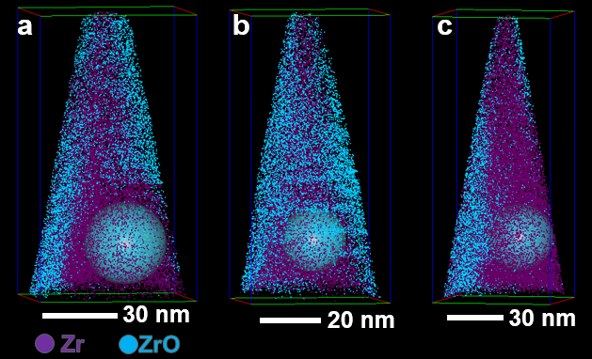
Supplementary Figure 3. Element distribution maps with spherical regions of interest placed for bulk composition analysis for three different APT reconstructions. Diameters of spheres are: (a) 30 nm, (b) 20 nm, and (c) 30 nm. The reconstructions labelled (a)–(c) correspond to the similarly labelled compositions in Table S3.

Supplementary Table 3. Composition of Zircaloy-4 base metal from APT data. Compositions from three different needles are reported below; all needles were taken from the same bulk sample. APT data sets used in analysis include 1–15 million ions. Other ions account for less than 1%.
 | a |  | b |  | c |  | Average
Element | at% | Error % | at% | Error % | at% | Error % | at% | Error %
Zr | 89.951 | 0.305 | 86.100 | 0.449 | 87.080 | 0.249 | 87.710 | 0.334
Sn | 1.181 | 0.025 | 1.058 | 0.037 | 0.904 | 0.019 | 1.048 | 0.027
Fe | 0.019 | 0.003 | 0.037 | 0.007 | 0.029 | 0.003 | 0.029 | 0.004
O | 0.902 | 0.022 | 1.175 | 0.039 | 1.616 | 0.025 | 1.231 | 0.029
H | 7.209 | 0.065 | 10.718 | 0.122 | 9.843 | 0.064 | 9.257 | 0.084
C | 0.063 | 0.006 | 0.048 | 0.008 | 0.082 | 0.006 | 0.064 | 0.006
N | 0.408 | 0.015 | 0.288 | 0.019 | 0.311 | 0.011 | 0.336 | 0.015
Ga | 0.233 | 0.011 | 0.415 | 0.023 | 0.030 | 0.003 | 0.226 | 0.013

Supplementary Methods
Supplementary Figure 3. Schematic of experimental approach for analysis of oxides and oxide/metal interfaces. High-temperature oxygen gas exposure was performed in a gas phase reaction chamber, referred to in the above schematic as the “Reactor Chamber.”

Supplementary Note 4: Ranging of Sn
Manual ranging criteria are an important consideration in the analysis of atom probe data. In the Zr alloy analysed here, a small alloying addition (~1 at%) of Sn exists in the base alloy. Sn peaks in the mass spectrum overlap with Zr oxide molecular peaks, which makes it difficult to range molecular peaks versus Sn. The ranging criteria used here were conservative when considering Sn versus oxide peak ranging so that the amount of Sn measured would not be overestimated. If Sn was incorrectly ranged, the oxide region analysed via APT would appear entirely enriched in Sn. Snapshots of the mass spectra and molecular peaks labelled with Sn isotopes are provided to show how ranging was done in regions where there were overlaps between Sn and oxide molecular species.
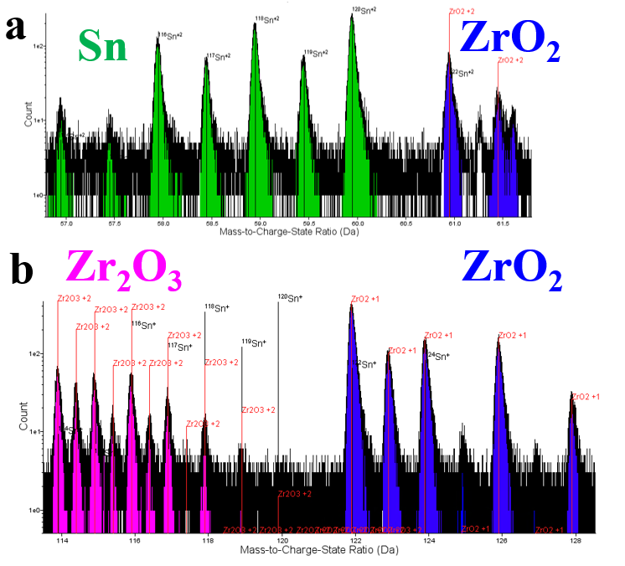
Supplementary Figure 5. Ranging criteria for select oxide molecular peaks and Sn. (a) Sn and ZrO₂ species in the 57–62 Da range, and (b) Zr₂O₃ and ZrO₂ peaks in the 114–128 Da range. Molecular peaks and Sn peaks are identified with the element overlay.

Supplementary Note 5: Gallium in APT Data Sets
An important consideration in the analysis of composition via APT data is Ga contamination from FIB milling. Ga segregation to the oxide/metal interface is observed in data sets analysed in this work. The higher concentration of Ga at the oxide/metal interface can affect interpretation of results related to chemistry at this interface, and is thus addressed here.
In Figures S6–S8, the composition across the oxide/metal interface in a specimen before oxidation (i.e., after transfer from FIB/SEM to APT) is reported. In this specimen, Ga concentration was higher on one side or region of the specimen, and affected the composition across the oxide/metal interface in this region. Cylinder ROIs were positioned in various regions in this particular needle specimen to measure local composition across the oxide/metal interface in the low-Ga region in comparison with the high-Ga region to evaluate effects of Ga on interfacial composition. Cylinder regions of interest (ROIs) are numbered, and corresponding 1-D concentration profile plots along the z-axis of these cylinders are provided. The low-Ga region reported in Figure S6 here is the oxide/metal interface reported in the body of this manuscript for compositional analysis of the native oxide formed during transfer of Zircaloy-4 needles from FIB/SEM to APT. Figure S6(a)–(d) provide element distribution maps and corresponding 1-D concentration profiles for the low-Ga region of the needle.

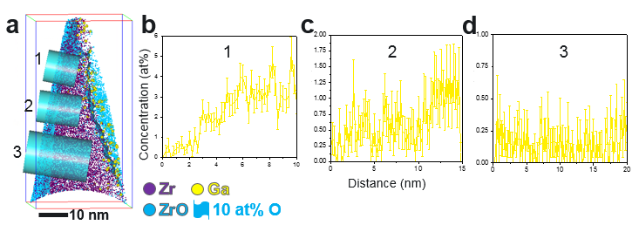 Supplementary Figure 6. Gallium concentration across the oxide/metal interface for the low-Ga side of the needle used for compositional analysis presented in the body of this manuscript. (a) 3-D element distribution map including cylinder ROIs used to measure composition across the oxide/metal interface, where cylinders numbered 1–3 are placed on the low-Ga side. (b,c,d) 1-D concentration profiles across the oxide/metal interface for cylinders numbered 1, 2, and 3, respectively. Position 0 nm corresponds to the outer edge of the needle specimen.

The 1-D concentration profile plots given in Figure S6(b)–(d), indicate that Ga contamination is minimal, ranging from less than 1 to approximately 5 at%; 5 at% was measured closest to the specimen apex (see Figure S6(b) for cylinder ROI 1). The trends reported in this “before” oxidation data set were observed in all needles analysed before oxidation; thus, results reported here are intended to be representative. Results from the low-Ga region can then be compared to those for the high-Ga region, reported in Figure S7.

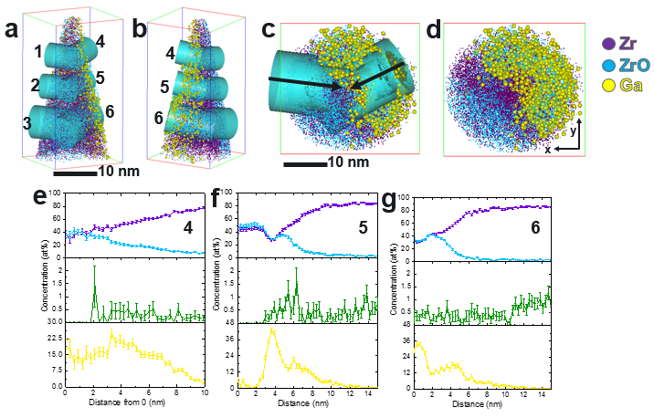 Supplementary Figure 7. Compositional analysis of Zircaloy-4 before oxidation, including Ga contamination from FIB sample preparation. (a,b,c,d) 3-D element distribution maps including cylinder ROIs used to measure composition across the oxide/metal interface, where cylinders numbered 1–3 are placed on the low-Ga side (and discussed in the main body of the manuscript), and cylinders 4–5 are placed along the side where there is high-Ga concentration. Black arrows in subfigure c show the direction along the z-axis of the cylinder where concentration was analyzed. (e,f,g) 1-D concentration profiles across the oxide/metal interface for cylinders numbered 4, 5, and 6, respectively.

Element distribution maps provided in Figure S7(a)-(d) show a noticeable difference between Ga concentrations in different regions of the reconstruction. How the high-Ga region affects measured composition across the oxide/metal interface is shown in the 1-D concentration profiles shown in Figure S7(e)-(g). In Figures S7(e) and (g), the measured Ga concentration in the oxide layer is higher than that in the base metal. In Figure S7(f), partitioning of Ga to the oxide/metal interface is seen, with a sharp increase in Ga (greater than 30 at%). This increase in Ga corresponds to a drop in both Zr and O. Ga is displacing Zr and O atoms, leading to a drop in Zr and O at% that is not a true representation of change in composition across the oxide/metal interface.
Ga concentration on this low-Ga side is low enough to ignore any effect on measured composition across the oxide/metal interface. However, the high-Ga region reflects artificial trends in composition across the oxide/metal interface that do not represent any physical phenomena such as element partitioning or depletion. Thus, Ga concentration and distribution in oxide and metal materials and at the interface must be considered in analysis of APT data sets. Ga concentration and distribution were also evaluated in APT data after oxidation. Ga clustering was observed after O₂ gas exposure at 300 °C and 0.15 psi for 5 min, and is shown in Figure S8(a)-(c).

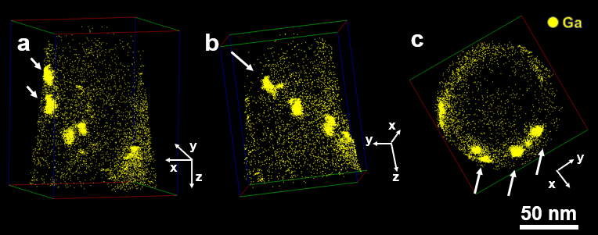Figure S8. Element distribution maps for a Zircaloy-4 needle after exposure to O₂ gas for 5 min at 300 °C and 0.15 psi. Maps shown in (a,b,c) are all of the same data set but different orientations in order to show the location of the high-Ga-concentration regions. These regions have an approximate Ga concentration of 30 at%. Bold white arrows indicate the high-Ga (~30 at%) clusters. Axis orientations are also provided with white arrows next to each 3D element distribution map.

In the high-Ga-concentration regions of the Figure S8 element distribution maps, the concentration is approximately 30 at%, which is high in comparison to Ga concentration before oxidation (previously reported in Figures S6–S7). The clustering of Ga on the edge of the needle, in enriched regions, suggests that the Ga migrates during sample oxidation at elevated temperature. The Ga in these clusters could be from high Ga contamination from FIB annular milling farther down the specimen shank that then diffused during the high-temperature (300°C) oxidation treatment. These high-Ga regions were excluded from cylinder ROIs used for composition analysis. The Ga clustering and segregation patterns are not currently well reported or understood, and we note that the Ga concentration must be addressed when analysing interfacial composition, particularly after annealing treatments of a needle after FIB milling.

Supplementary References
1. Mouton, I.; Breen, A. J.; Wang, S.; Chang, Y.; Szczepaniak, A.; Kontis, P.; Stephenson, L. T.; Raabe, D.; Herbig, M.; Britton, T. B., Quantification challenges for atom probe tomography of hydrogen and deuterium in Zircaloy-4. Microscopy and Microanalysis 2019, 25 (2), 481-488.

