Chemical characterisation of degraded nuclear fuel analogues simulating the Fukushima Daiichi nuclear accident: Supplementary Information

Hao Ding, Clémence Gausse, Malin C. Dixon Wilkins, Lucy M. Mottram, Martin C. Stennett, Daniel Grolimund, Ryan Tappero, Sarah Nicholas, Shikuan Sun, Tomooki Shiba, C. Paraskevoulakos, Neil C. Hyatt* and Claire L. Corkhill*

*Corresponding authors: c.corkhill@sheffield.ac.uk; n.c.hyatt@sheffield.ac.uk

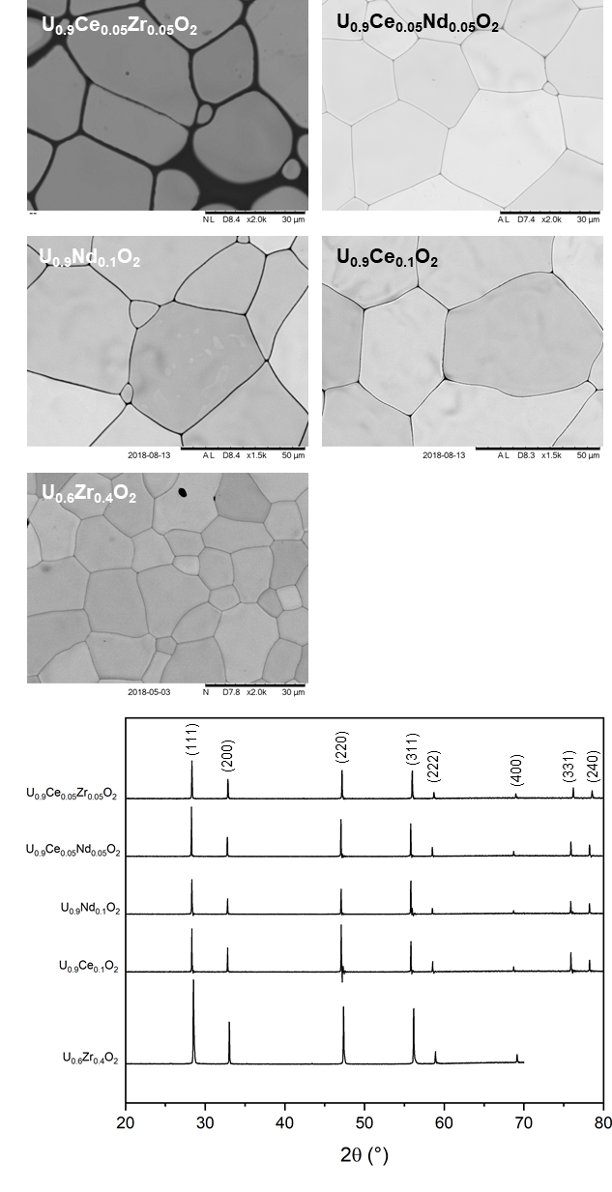
Supplementary Fig. 1. SEM images and diffraction patterns (indexed to the Fm-3m UO₂ structure) of the precursor oxide materials used in the synthesis of synthetic MCCI samples.

Supplementary Fig. 2 EDS spectrum of (a) c-(U,Zr)O₂, (b) U-Zr-O particle, (c) glass matrix; (d) BSE image and elemental mapping showing distribution of (e) Ce, (f) U, and (e) Zr.

Supplementary Fig. 3. µ-diffraction patterns of (a) c-(U_{1-x}Zr_{x})O₂; (b) m-(Zr_{1-x}U_{x})O₂; (c) t-(U_{1-x}Zr_{x})O₂; and (d) (Zr_{1-x}U_{x})SiO₄.
Supplementary Fig. 4. Correlation maps of the distribution of (a) U-Lα (red) and Zr-Lα (green), (b) Ce-Lα (blue) and Zr-Lα (green)) and (c) Fe-Kα (yellow) and Ce-Lα (blue), µ-diffraction patterns of (d) Fe-Ni; (e) Fe₃O₄; (f) FeCr₂O₄; (g) Fe₂O₃ and µ-XRF patterns of (h) Fe and (i) Ni of MCCI-1.

Supplementary Fig. 5. µ-diffraction patterns of (a) anorthite collected at single pixel and (b) summation of all pixels identified as anorthite in the scanning area.

Supplementary Fig. 6. A combined map of µ-diffraction patterns and Ce-Lα XRF signal. The crystalline phases containing Ce is determined by the Ce concentration at that point higher than the background (Counts threshold is set as 2000 based on Fig.4c).

Supplementary Table 1. EXAFS fit parameters of different crystalline phases in simulant MCCI.

 | S_{O}² | R-factor | O-Shell |  |  |  | Si-Shell
 | S_{O}² | R-factor | N1 | U(Ce)-O  (Å) | σ²  (10⁻²Å²) | N2 |  | U(Ce)-Zr(Si)  (Å) | σ²  (10⁻²Å²) | N3 | U(Ce)-U(O,Ce)  (Å) | σ²  (10⁻²Å²)
c-(U_{1-x}Zr_{x})O₂ | 0.95 | 0.021 | 8 | 2.32  ±0.01 | 0.90  ± 0.07 | 3.32  ±0.57 |  | 3.81  ±0.02 | 0.59  ± 0.05 | 8.68 ±0.57 | 3.81  ±0.02 | 0.59  ± 0.05
Zr_{1-x}U_{x}SiO₄ | 0.95 | 0.026 | 4 | 2.27  ±0.01 | 0.13  ± 0.08 | 4 |  | 3.22  ±0.03 | 0.75  ± 0.44 | 4 | 3.86  ±0.01 | 0.06  ± 0.06
 |  |  | 4 | 2.42  ±0.01 | 0.13  ± 0.08
Ce₂Si₂O₇ Point 2 | 0.90 | 0.056 | 3 | 2.38  ±0.04 | 0.94  ± 0.41 | 1 |  | 3.22  ±0.08 | 1.05  ± 1.34 | 2 | 3.46  ±0.08  3.84  ±0.08 | 1.05  ± 1.34  1.05  ± 1.34
Ce₂Si₂O₇ Point 2 | 0.90 | 0.056 | 3 | 2.44  ±0.04 | 0.94  ± 0.41 |  |  |  |  | 2 | 3.46  ±0.08  3.84  ±0.08 | 1.05  ± 1.34  1.05  ± 1.34
 |  |  | 1 | 2.73  ±0.04 | 0.94  ± 0.41
 |  |  | 1 | 3.06  ±0.04 | 0.94  ± 0.41
Ce₂Si₂O₇ Point 4 | 0.90 | 0.049 | 3 | 2.49  ±0.03 | 0.29  ± 0.28 | 1 |  | 3.28  ±0.03 | 0.29  ± 0.28 | 2 | 3.53  ±0.03 | 0.29  ± 0.28
 |  |  | 3 | 2.54  ±0.03 | 0.29  ± 0.28 |  |  |  |  | 2 | 3.91  ±0.03 | 0.29  ± 0.28
 |  |  | 1 | 2.84  ±0.03 | 0.29  ± 0.28
 |  |  | 1 | 3.17  ±0.04 | 0.29  ± 0.28

