Supplementary information

On the effect of Al on alumino-borosilicate glass chemical durability

Kamalesh Damodaran¹, Stéphane Gin¹,*, Sathya Narayanasamy¹, Jean-Marc Delaye¹
¹CEA, DES, ISEC, DPME, University of Montpellier, Marcoule, F-30207 Bagnols sur Cèze, France

*Corresponding author: Gin S. email : stephane.gin@cea; tel: +33630273760

Supplementary Table 1. Additional information about the 6 glasses of the study.
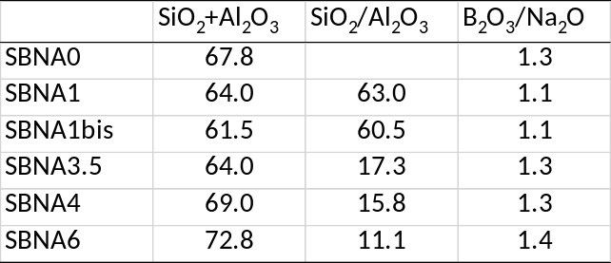

Supplementary Figure 1 – Initial dissolution rate vs %Al₂O₃ in the glass.
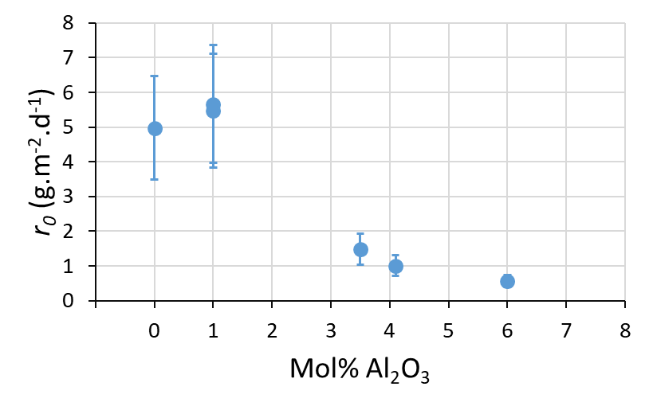

Supplementary Figure 2. The evolution of the equivalent thickness of altered glass with respect to time. Eth(i) was calculated with B, Na and Si for the 6 glasses. Experiments were performed in static mode, at 90°C, and pH 9. SBNA1_R corresponds to a duplication of the experiment carried out with the SBNA1 glass.
