Supplementary Information to:

Corrosion inhibition mechanisms of
2-mercaptobenzothiazole on AA2024 T3 aluminium alloy

Vishant Garg†, *, Maxime Magnan, Sandrine Zanna, Antoine Seyeux,
Frédéric Wiame, Vincent Maurice, Philippe Marcus*
¹ PSL University, CNRS – Chimie ParisTech, Institut de Recherche de Chimie Paris, Physical Chemistry of Surfaces Research Group,
11 rue Pierre et Marie Curie, 75005 Paris, France

† Present address: Institute of Research and Technology – Materials, Metallurgy, and Processes (IRT-M2P), 12 rue de l’Artisanat, 67120 Duppigheim, France

* Corresponding authors for the work:
vishant.garg@chimieparistech.psl.eu
philippe.marcus@chimieparistech.psl.eu

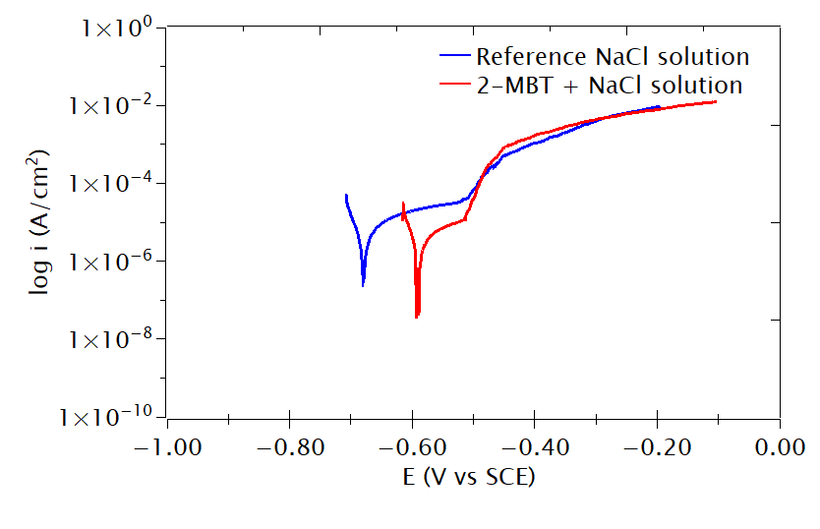
Figure S1: Anodic polarisation curves of the AA2024 T3 samples obtained after 24 hours immersion in the reference NaCl solution and the 2-MBT-containing NaCl solution. The scans were performed from -0.05 V to +0.50 V vs OCP using a scan rate of 1 mV/s.
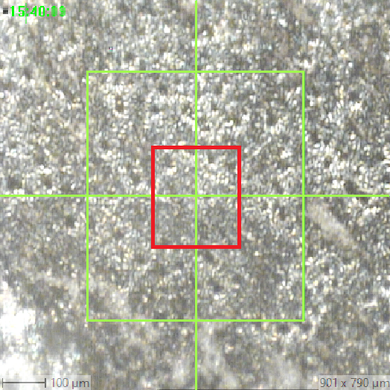
Figure S2: Image showing the area analysed by ToF-SIMS on the AA2024 alloy sample immersed in the NaCl reference solution. The green box represents the area that was sputtered during the ToF-SIMS measurements while the red box represents the area that was analysed to obtain the 3D chemical maps and the depth profiles presented in Figures 12, 13, and 14.

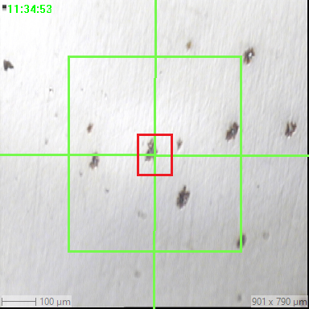
Figure S3: Image showing the area analysed by ToF-SIMS on the AA2024 alloy sample immersed in the 2-MBT containing NaCl solution. The green box represents the area that was sputtered during the ToF-SIMS measurements while the red box represents the area that was analysed to obtain the 3D chemical maps and the depth profiles presented in Figures 16, 17, 18, and 19.

