Supplementary materials:

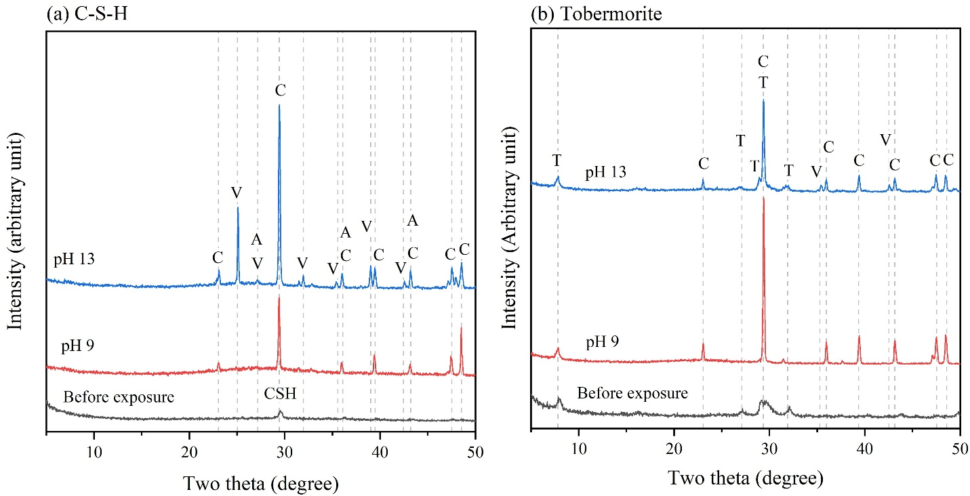

Figure S. 1: Mineralogy of the carbonation products of (a) C-S-H and (b) tobermorite before and after carbonation. Here, T: tobermorite (PDF #96-900-2245), C: calcite (PDF #96-900-0967), V: vaterite (PDF #96-150-8972), A: aragonite (PDF #96-901-3802).

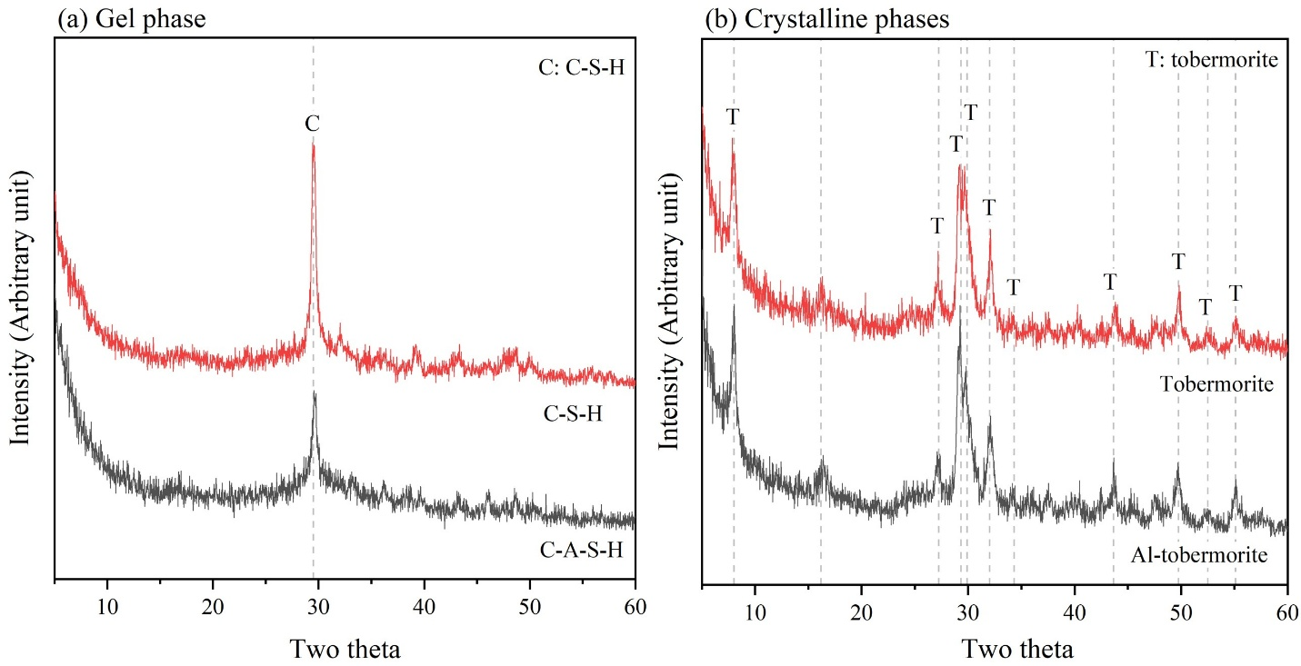
Figure S. 2: X-ray diffraction patterns of the starting materials.

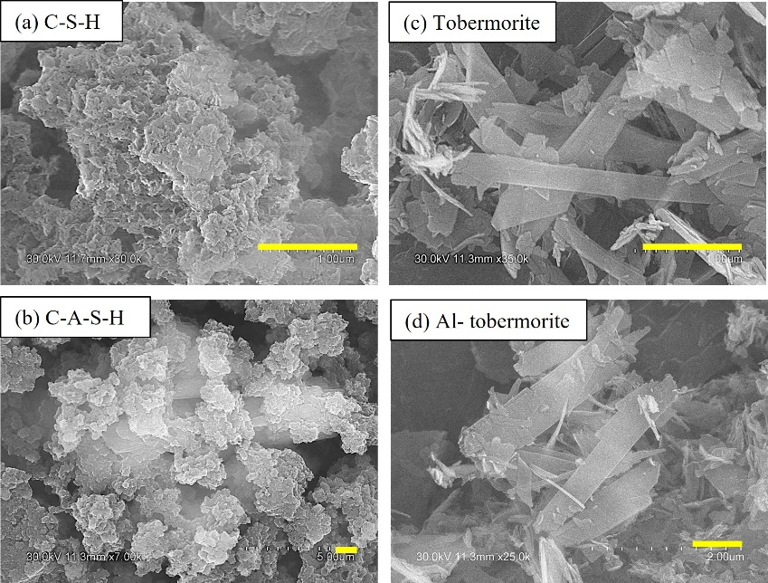
Figure S. 3: Morphology of the starting materials. The scale bar represents 1 µm.

