Supplementary Material
Supplementary Results
Image analysis
Supplementary Table 1 Association between FA-Values and UPDRS part III
Negative  Cluster | Location | Slope | Intercept | p-Value | Volume in mm³ | MNI152-Coordinates
Negative  Cluster |  | Slope | Intercept |  | Volume in mm³ | X | Y | Z
N1 | Right inferior fronto-occipital fasciculus  Right putamen | -.0005 | .28503 | < .001 | 341 | 28 | -5 | -8
N2 | Left superior longitudinal fasciculus | -.0005 | .51221 | < .001 | 330 | -39 | -39 | 14
N3 | Left V | -.0003 | .12832 | .009 | 208 | -19 | -48 | -11
N4 | Left superior frontal gyrus | -.0005 | .48711 | .027 | 186 | -19 | 31 | 25
N5 | Right inferior Frontal Gyrus | -.0004 | .39693 | .032 | 183 | 33 | 15 | 16
N6 | Right forceps minor | -.0006 | .23986 | .033 | 182 | 13 | 40 | -10
N7 | Right cingulate gyrus, anterior division | -.0005 | .27215 | .035 | 181 | 14 | 17 | 28
Supplementary Table 1. Characteristics of clusters with an association between PD patients’ FA-values and postoperative change in UPDRS part III. “Negative Cluster” denotes clusters with a negative association between patients’ FA-values and percentage difference of UPDRS part III, i.e. higher FA-values were associated with lower postoperative values. “Location” indicates the anatomical landmark comprising the majority of voxels of a cluster according to Johns Hopkins University (JHU) white matter atlas, Harvard-Oxford cortical and subcortical atlas, and University College London (UCL) cerebellar atlas. P-Values are clusterwise p-values corrected for multiple comparisons. “Volume in mm³” denotes the size of a cluster and “MNI152-coordinates” describes the coordinates of the cluster’s center of gravity in MNI152-space.

Supplementary Table 2 Association between ODI-Values and UPDRS part III
Positive  Cluster | Location | Slope | Intercept | p-Value | Volume in mm³ | MNI152-Coordinates
Positive  Cluster |  | Slope | Intercept |  | Volume in mm³ | X | Y | Z
P1 | Bilateral V | .0008 | .2511 | < .001 | 393 | -1 | -59 | -5
P2 | Left pallidum  Left putamen | .0004 | .1701 | < .001 | 360 | -22 | -8 | -8
P3 | Left insular cortex | .0005 | .1938 | < .001 | 298 | -34 | -18 | 1
P4 | Left insular cortex  Left putamen  Left inferior fronto-occipital fasciculus | .0004 | .2424 | .003 | 173 | -30 | 7 | 3
P5 | Right insular cortex | .0005 | .1883 | .003 | 172 | 33 | -17 | 3
P6 | Right putamen | .0006 | .2546 | .038 | 135 | 17 | 3 | -5
Negative Cluster
N1 | Left cerebral white matter adjacent to left middle frontal gyrus | -.0005 | .2852 | < .001 | 222 | -32 | 19 | 23
N2 | Left cerebral white matter adjacent to left cingulate gyrus | -.0003 | .1587 | .001 | 195 | -17 | 16 | 26
N3 | Left cerebral white matter adjacent to left precuneal gyrus | -.0004 | .1967 | .019 | 145 | -21 | -48 | 35
Supplementary Table 2. Characteristics of clusters with an association between PD patients’ ODI-values and postoperative change in UPDRS part III. “Positive Cluster” denotes clusters with a positive association between patients’ ODI-values and percentage differences in UPDRS part III, i.e. higher ODI-values were associated with higher postoperative values. “Negative Cluster” denotes clusters with a negative association between patients’ ODI-values and percentage difference of UPDRS part III, i.e. higher ODI-values were associated with lower postoperative values. “Location” indicates the anatomical landmark comprising the majority of voxels of a cluster according to Johns Hopkins University (JHU) white matter atlas, Harvard-Oxford cortical and subcortical atlas, and University College London (UCL) cerebellar atlas. P-Values are clusterwise p-values corrected for multiple comparisons. “Volume in mm³” denotes the size of a cluster and “MNI152-coordinates” describes the coordinates of the cluster’s center of gravity in MNI152-space.

Supplementary Table 3 Association between NDI-Values and UPDRS part III
Positive  Cluster | Location | Slope | Intercept | p-Value | Volume in mm³ | MNI152-Coordinates
Positive  Cluster |  | Slope | Intercept |  | Volume in mm³ | X | Y | Z
P1 | Left insular cortex  Left Putamen  Left inferior fronto-occipital fasciculus | .0008 | .4811 | < .001 | 237 | -35 | -18 | 0
P2 | Left insular cortex | .0008 | .3738 | .007 | 158 | -32 | 19 | -2
P3 | Right insular cortex | .0009 | .2633 | .032 | 131 | 38 | 7 | -5
P4 | Left cerebral white matter adjacent to anterior commissure | .0008 | .4519 | .037 | 129 | -13 | -10 | -10
Negative Cluster
N1 | Left superior longitudinal fasciculus | -.0005 | .5344 | < .001 | 778 | -40 | -46 | 17
N2 | Left cerebral white matter adjacent to superior parietal lobule  Left anterior thalamic radiation | -.0006 | .4971 | < .001 | 505 | -22 | -49 | 34
N3 | Left superior longitudinal fasciculus  Left middle temporal gyrus | -.0005 | .5662 | < .001 | 299 | -45 | -47 | 2
N4 | Left superior longitudinal fasciculus adjacent to precentral gyrus | -.0006 | .6200 | < .001 | 273 | -39 | -3 | 24
N5 | Left cerebral white matter adjacent to left middle frontal gyrus | -.0007 | .6071 | < .001 | 250 | -30 | 15 | 23
N6 | Left corticospinal tract  Left precentral gyrus | -.0008 | .5884 | < .001 | 243 | -23 | -9 | 41
N7 | Right forceps major  Right inferior fronto-occipital fasciculus | -.0005 | .4564 | .002 | 178 | 30 | -51 | 17
N8 | Right inferior fronto-occipital fasciculus adjacent to right precuneal cortex | -.0005 | .5205 | .004 | 166 | 15 | -62 | 40
N9 | Left cerebral white matter adjacent to left paracingulate gyrus  Left paracingulate gyrus | -.0010 | .5903 | .006 | 159 | -13 | 29 | 28
N10 | Right inferior longitudinal fasciculus adjacent to lateral occipital cortex | -.0005 | .5621 | .015 | 144 | 32 | -77 | 0
N11 | Left cerebral white matter adjacent to inferior frontal gyrus  inferior frontal gyrus | -.0007 | .5747 | .023 | 137 | -40 | 24 | 14
Supplementary Table 3. Characteristics of clusters with an association between PD patients’ NDI-values and postoperative change in UPDRS part III. “Positive Cluster” denotes clusters with a positive association between patients’ NDI-values and percentage differences in UPDRS part III, i.e. higher NDI-values were associated with higher postoperative values. “Negative Cluster” denotes clusters with a negative association between patients’ NDI-values and percentage difference of UPDRS part III, i.e. higher NDI-values were associated with lower postoperative values. “Location” indicates the anatomical landmark comprising the majority of voxels of a cluster according to Johns Hopkins University (JHU) white matter atlas, Harvard-Oxford cortical and subcortical atlas, and University College London (UCL) cerebellar atlas. P-Values are clusterwise p-values corrected for multiple comparisons. “Volume in mm³” denotes the size of a cluster and “MNI152-coordinates” describes the coordinates of the cluster’s center of gravity in MNI152-space.

Mobility specific Statistics
Supplementary Table 4 Association between microstructural metrics and time with good mobility and no dyskinesia
Fractional Anisotropy
Positive  Cluster | Location | Slope | Intercept | p-Value | Volume in mm³ | MNI152-Coordinates
Positive  Cluster |  | Slope | Intercept |  | Volume in mm³ | X | Y | Z
P1 | Left superior longitudinal fasciculus  Left postcentral gyrus  Left corticospinal tract | .0005 | .4836 | < .001 | 3311 | -34 | -13 | 29
P2 | Right corticospinal tract | .0004 | .4397 | < .001 | 684 | 21 | -25 | 35
P3 | Right inferior fronto-occipital fasciculus | .0003 | .4198 | < .001 | 509 | 26 | 25 | 8
P4 | Right insular cortex  Right inferior fronto-occipital fasciculus | .0004 | .3846 | < .001 | 474 | 36 | -10 | -1
P5 | Right frontal orbital cortex | .0005 | .3055 | < .001 | 467 | 24 | 9 | -19
P6 | Right forceps minor | .0005 | .4731 | < .001 | 395 | 19 | 35 | 1
P7 | Right superior longitudinal fasciculus  Right precentral gyrus  Right postcentral gyrus | .0005 | .4777 | < .001 | 330 | 40 | -13 | 21
P8 | Right superior longitudinal fasciculus  Right postcentral gyrus | .0005 | .5358 | < .001 | 284 | 33 | -30 | 37
P9 | Left superior longitudinal fasciculus | .0005 | .5317 | < .001 | 273 | -27 | -8 | 16
P10 | Right forceps minor  Right frontal pole | .0005 | .4543 | < .001 | 259 | 19 | 41 | -8
P11 | Left cingulate gyrus, posterior division | .0005 | .4931 | .002 | 252 | -8 | -33 | 30
P12 | Left forceps minor  Left frontal pole | .0006 | .3119 | .002 | 249 | -14 | 51 | 0
P13 | Right forceps major  Right inferior fronto-occipital fasciculus | .0006 | .4953 | .002 | 241 | 31 | -58 | 20
P14 | Left superior longitudinal fasciculus  Left paracingulate gyrus | .0005 | .2271 | .004 | 232 | -12 | 11 | 39
P15 | Left anterior thalamic radiation  Left thalamus | .0004 | .3514 | .005 | 230 | -12 | -25 | -7
P16 | Left superior longitudinal fasciculus  Left superior temporal gyrus | .0004 | .4771 | .007 | 222 | -32 | -39 | 20
P17 | Right superior longitudinal fasciculus  Right superior parietal lobule | .0003 | .4381 | .013 | 206 | 22 | -40 | 40
P18 | Right cerebral white matter adjacent to cingulate gyrus, anterior division | .0004 | .4880 | .013 | 204 | 15 | 7 | 33
P19 | Left inferior fronto-occipital fasciculus  Left insular cortex | .0003 | .4286 | .031 | 185 | -24 | 24 | 9
P20 | Right corticospinal tract | .0004 | .4921 | .045 | 176 | 27 | -23 | 23
P21 | Right superior frontal gyrus | .0009 | .4086 | .046 | 175 | 12 | 10 | 50
P22 | Left thalamus  Left anterior thalamic radiation | .0004 | .3428 | .050 | 173 | -14 | -12 | 13
Orientation Dispersion Index
Positive Cluster
P1 | Right inferior fronto-occipital fasciculus adjacent to precuneal cortex | .0002 | .1021 | < .001 | 273 | 29 | -51 | 17
P2 | Right cingulate gyrus, posterior division | .0010 | .3157 | .009 | 158 | 0 | -24 | 39
P3 | Right inferior fronto-occipital fasciculus adjacent to planum polare | .0005 | .2428 | .017 | 146 | -37 | -9 | -21
P4 | Right cingulate gyrus, posterior division | .0009 | .3354 | .024 | 141 | 1 | -34 | 39
P5 | Left superior longitudinal fasciculus adjacent to supramarginal gyrus, anterior division | .0005 | .2765 | .024 | 141 | -41 | -37 | 32
P6 | Left VI | .0007 | .3292 | .03 | 138 | -10 | -74 | -12
Negative Cluster
N1 | Right corticospinal tract | -.0003 | .1600 | < .001 | 495 | 20 | -23 | 35
N2 | Right superior longitudinal fasciculus | -.0003 | .1779 | < .001 | 396 | 28 | -2 | 18
N3 | Right superior longitudinal fasciculus adjacent to right pre- and postcentral gyrus | -.0004 | .1385 | < .001 | 262 | 34 | -15 | 33
N4 | Right inferior fronto-occipital fasciculus | -.0003 | .1145 | < .001 | 258 | 26 | -30 | 13
N5 | Left corticospinal tract | -.0003 | .1438 | < .001 | 235 | -23 | -20 | 34
N6 | Right cerebral white matter adjacent to right precuneal cortex and right cingulum | -.0004 | .1903 | .002 | 190 | 14 | -48 | 20
N7 | Right superior longitudinal fasciculus adjacent to right postcentral gyrus | -.0003 | .1195 | .002 | 188 | 36 | -31 | 29
N8 | Left anterior thalamic radiation  Left thalamus | -.0004 | .3072 | .004 | 175 | -11 | -27 | -1
N9 | Left forceps minor  Left frotal medial cortex | -.0004 | .2098 | .018 | 146 | -12 | 40 | -14
N10 | Right cerebral white matter adjacent to frontal orbital cortex | -.0004 | .2159 | .032 | 136 | 21 | 28 | -11
Neurite Density Index
Positive Cluster
P1 | Left superior longitudinal fasciculus adjacent to left postcentral gyrus | .0005 | .5494 | < .001 | 568 | -46 | -16 | 25
P2 | Left middle temporal gyrus  Left superior longitudinal fasciculus adjacent to left middle temporal gyrus | .0007 | .5078 | < .001 | 364 | -52 | -60 | 0
P3 | Right forceps major | .0005 | .3841 | < .001 | 301 | 32 | -51 | 11
P4 | Left thalamus  Left anterior thalamic radiation | .0006 | .5911 | < .001 | 244 | -11 | -10 | 9
P5 | Left superior longitudinal fasciculus adjacent to left central opercular cortex and left post- and precentral cortex | .0006 | .5727 | < .001 | 239 | -42 | -8 | 22
P6 | Middle temporal gyrus, posterior division | .0007 | .5299 | < .001 | 226 | -50 | -35 | -4
P7 | Left precentral gyrus  Left superior longitudinal fasciculus | .0009 | .5227 | < .001 | 205 | -42 | 2 | 22
P8 | Left superior longitudinal fasciculus adjacent to left pre- and postcentral gyrus | .0005 | .6022 | .003 | 168 | -31 | -18 | 39
P9 | Right frontal orbital cortex | .0012 | .4402 | .005 | 163 | 24 | 9 | -19
P10 | Left cerebral white matter adjacent to left cingulate gyrus, posterior division | .0006 | .5436 | .011 | 149 | -14 | -19 | 28
P11 | Left paracingulate gyrus | .0015 | .5512 | .012 | 147 | -10 | 11 | 39
P12 | Left inferior longitudinal fasciculus adjacent to lateral occipital cortex, superior division | .0005 | .4860 | .032 | 131 | -31 | -63 | 23
P13 | Left superior longitudinal fasciculus adjacent to precentral gyrus | .0005 | .6070 | .048 | 125 | -21 | -10 | 43
Supplementary Table 4. Characteristics of clusters with an association between PD patients’ microstructural metrics and postoperative change in time spent with good mobility and no dyskinesia (ON). “Positive Cluster” denotes clusters with a positive association between patients’ microstructural metrics and postoperative changes in time spent in ON, i.e. higher values of a specific metric were associated with higher postoperative values. “Negative Cluster” denotes clusters with a negative association between patients’ microstructural metrics and postoperative difference in time spent in ON, i.e. higher values of a specific metric were associated with lower postoperative values. “Location” indicates the anatomical landmark comprising the majority of voxels of a cluster according to Johns Hopkins University (JHU) white matter atlas, Harvard-Oxford cortical and subcortical atlas, and University College London (UCL) cerebellar atlas. P-Values are clusterwise p-values corrected for multiple comparisons. “Volume in mm³” denotes the size of a cluster and “MNI152-coordinates” describes the coordinates of the cluster’s center of gravity in MNI152-space.

Supplementary Table 5 Association between microstructural metrics and time with poor mobility
Fractional Anisotropy
Positive  Cluster | Location | Slope | Intercept | p-Value | Volume in mm³ | MNI152-Coordinates
Positive  Cluster |  | Slope | Intercept |  | Volume in mm³ | X | Y | Z
P1 | Right forceps minor | .0002 | .3379 | < .001 | 262 | 19 | 36 | 8
P2 | Left paracingulate gyrus | .0002 | .1517 | .002 | 241 | -10 | 9 | 43
P3 | Right planum temporale | .0003 | .2119 | .005 | 222 | 50 | -33 | 16
P4 | Left precentral gyrus and left superior longitudinal fasciculus adjacent to left pre- and postcentral gyrus | .0002 | .0751 | .005 | 221 | -49 | -8 | 31
P5 | Right inferior fronto-occipital fasciculus | .0001 | .3929 | .048 | 172 | 26 | 25 | 10
Negative Cluster
N1 | Left anterior thalamic radiation | -.0003 | .4682 | < .001 | 312 | -19 | -23 | 27
N2 | Left corticospinal tract | -.0003 | .3922 | .001 | 251 | -22 | -9 | 26
N3 | Corpus callosum | -.0002 | .8686 | .014 | 203 | -8 | -38 | 14
N4 | Left temporal pole | -.0003 | .3042 | .033 | 183 | -34 | -3 | -24
N5 | Right forceps major | -.0002 | .8510 | .039 | 178 | 16 | -45 | 13
Orientation Dispersion Index
Positive Cluster
P1 | Right Cingulate gyrus, posterior division | .0004 | .2835 | < .001 | 377 | 3 | -21 | 34
P2 | Left precentral gyrus  Left postcentral gyrus  Left superior longitudinal fasciculus adjacent to left pre- and postcentral gyrus | .0005 | .1738 | < .001 | 230 | -55 | -4 | 29
P3 | Right precuneal cortex  Right cingulate gyrus | .0005 | .2596 | < .001 | 213 | 8 | -55 | 31
P4 | Right inferior fronto-occipital fasciculus | .0001 | .1017 | .001 | 198 | 24 | -48 | 28
P5 | Right paracingulate gyrus | .0005 | .3507 | .001 | 195 | 5 | 38 | -8
P6 | Right frontal pole  Right forceps minor | .0004 | .2350 | .001 | 195 | 23 | 49 | 15
P7 | Left anterior thalamic radiation | .0001 | .1204 | .001 | 189 | -25 | -46 | 21
P8 | Right Heschl’s gyrus | .0003 | .2396 | .004 | 168 | 39 | -30 | 16
P9 | Left paracingulate gyrus  Left cingulate gyrus, anterior division | .0004 | .3059 | .008 | 159 | -8 | 11 | 39
P10 | Left Heschl’s gyrus | .0003 | .2769 | .010 | 156 | -53 | -14 | 3
P11 | Right middle temporal gyrus  right superior longitudinal fasciculus | .0005 | .2830 | .023 | 142 | 47 | -60 | 3
P12 | Right precentral gyrus  Right superior longitudinal fasciculus | .0001 | .1894 | .023 | 142 | 41 | -1 | 23
P13 | Left precentral gyrus  Left superior longitudinal fasciculus | .0003 | .2062 | .039 | 133 | -46 | 4 | 37
Negative Cluster
N1 | Left forceps minor adjacent to paracingulate gyrus | -.0002 | .2662 | .012 | 151 | -16 | 42 | 10
N2 | Right inferior fronto-occipital fasciculus adjacent to precuneal cortex | -.0002 | .1804 | .023 | 141 | 20 | -59 | 37
Neurite Density index
Positive Cluster
P1 | Left frontal pole  Left middle frontal gyrus  Left cerebral white matter adjacent to left frontal pole and middle frontal gyrus | .0007 | .4440 | < .001 | 219 | -32 | 32 | 18
P2 | Right planum temporal | .0005 | .3456 | .003 | 175 | 47 | -34 | 15
P3 | Right Heschl’s gyrus | .0004 | .3578 | .009 | 155 | 37 | -25 | 7
P4 | Left precentral gyrus  left superior longitudinal fasciculus adjacent to left precentral gyrus | .0004 | .3959 | .010 | 153 | -46 | 2 | 20
P5 | Right inferior temporal gyrus | .0004 | .3762 | .014 | 147 | 57 | -33 | -10
Negative Cluster
N1 | Left frontal medial cortex  Left forceps minor | -.0003 | .5958 | .049 | 125 | -17 | 32 | -14
Supplementary Table 5. Characteristics of clusters with an association between PD patients’ microstructural metrics and postoperative change in time spent with poor mobility (OFF). “Positive Cluster” denotes clusters with a positive association between patients’ microstructural metrics and postoperative changes in time spent in OFF, i.e. higher values of a specific metric were associated with higher postoperative values. “Negative Cluster” denotes clusters with a negative association between patients’ microstructural metrics and postoperative difference in time spent in OFF, i.e. higher values of a specific metric were associated with lower postoperative values. “Location” indicates the anatomical landmark comprising the majority of voxels of a cluster according to Johns Hopkins University (JHU) white matter atlas, Harvard-Oxford cortical and subcortical atlas, and University College London (UCL) cerebellar atlas. P-Values are clusterwise p-values corrected for multiple comparisons. “Volume in mm³” denotes the size of a cluster and “MNI152-coordinates” describes the coordinates of the cluster’s center of gravity in MNI152-space.

Supplementary Table 6
 |  | Baseline |  | 3-MFU |  |  | Baseline vs.  3-MFU |  | 12-MFU |  |  | Baseline vs.  12-MFU
 | n | M | SD | n | M | SD | p |  | n | M | SD |  | p
UPDRS total score | 34 | 40.7 | 14.7 | 23 | 32.0 | 12.3 | .006 |  | 27 | 31.1 | 14.6 |  | .003
UPDRS part I | 34 | 2.9 | 2.1 | 29 | 1.8 | 1.3 | .035 |  | 34 | 2.1 | 1.7 |  | .059
UPDRS part II | 34 | 8.3 | 5.4 | 29 | 7.2 | 4.7 | .185 |  | 34 | 7.8 | 5.8 |  | .288
UPDRS part III | 35 | 24.9 | 11.9 | 23 | 19.2 | 8.3 | .010 |  | 27 | 18.4 | 10.2 |  | .024
UPDRS part IV | 34 | 6.0 | 3.1 | 29 | 3.9 | 3.0 | .003 |  | 34 | 3.3 | 2.9 |  | <.001
Movement Record
ON [%] | 35 | 37.1 | 18.6 | 25 | 52.1 | 18.6 | .018 |  | 30 | 55.7 | 12.7 |  | <.001
OFF [%] | 35 | 23.9 | 15.9 | 25 | 13.5 | 16.7 | .018 |  | 31 | 7.8 | 12.5 |  | <.001
SLEEP [%] | 35 | 31.9 | 11.1 | 25 | 32.3 | 8.4 | .530 |  | 31 | 36.1 | 12.8 |  | .102
ON TD [%] | 35 | 7.0 | 12.65 | 25 | 2.1 | 3.9 | .057 |  | 31 | 2.1 | 4.9 |  | .102
PDQ-8 SI | 35 | 32.8 | 15.3 | 29 | 24.5 | 14.2 | .002 |  | 33 | 23.6 | 15.2 |  | <.001
LEDD [mg] | 35 | 964.9 | 408.3 | 29 | 614.4 | 311.8 | <.001 |  | 32 | 541.5 | 296.5 |  | <.001
LEDD DA [mg] | 35 | 266.5 | 130.7 | 29 | 216.1 | 202.2 | .02 |  | 32 | 165.9 | 129.5 |  | <.001

Supplementary Table 6: Outcome parameters at baseline and 3 as well as 12-months follow-up. Values for movement records represent percentage values. Reported p-values are corrected for multiple comparisons using Benjamini-Hochberg’s method for eight scales. Bold font highlights significant results, p<.05.
Abbreviations: 3-MFU = 3-month follow-up; 12-MFU = 12-month follow-up; LEDD = Levodopa equivalent daily dose; LEDD-DA = LEDD of Dopamine Agonists; PDQ-8 SI = 8-item Parkinson’s Disease Questionnaire summary index; SD = standard deviation; UPDRS = Unified Parkinson’s Disease Rating Scale.

Supplementary Figures
Supplementary Figure 1
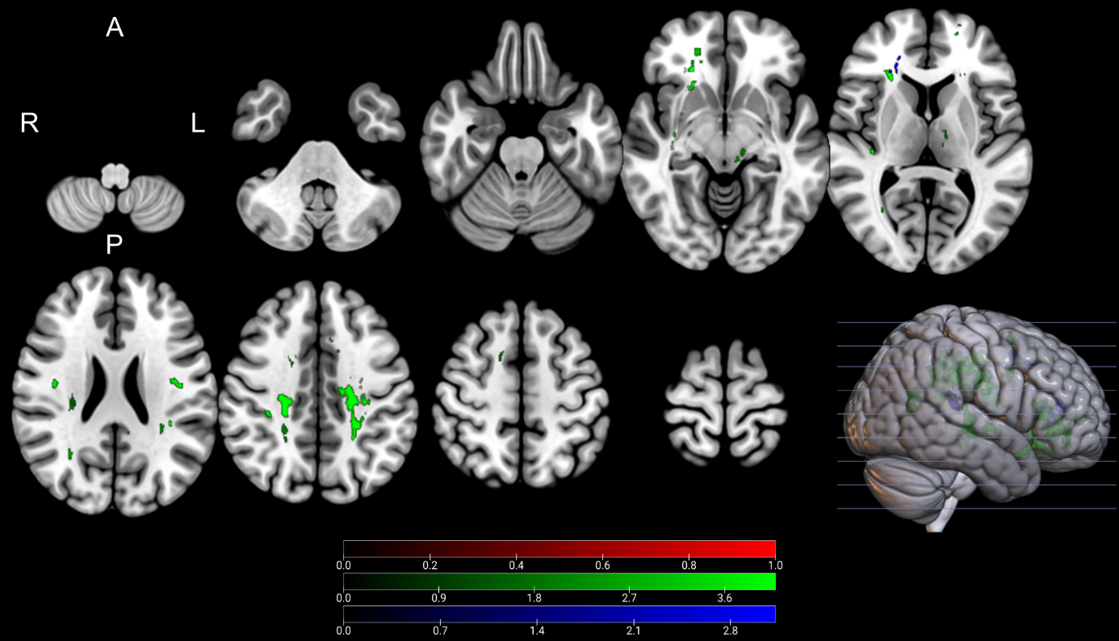
Supplementary Figure 1. Clusters with a positive association between PD patients’ FA-values and postoperative change in UPDRS (red), time spent in ON (green), and time spent in OFF (blue), as revealed by the whole brain analysis. P-Values were corrected for multiple comparisons using a permutation-based approach and shown as the negative decadic logarithm of the p-value.

Supplementary Figure 2
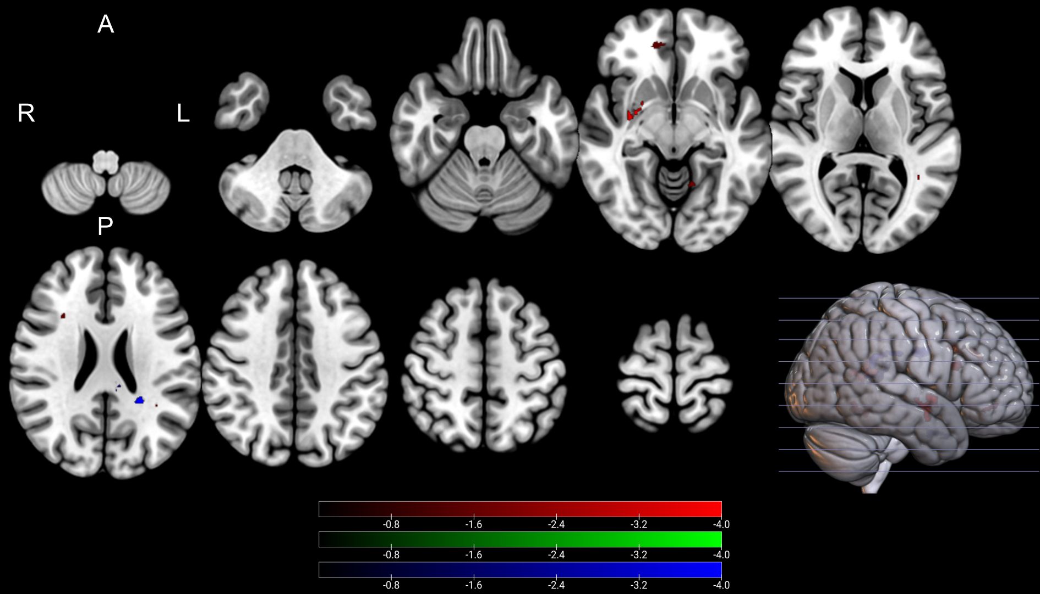
Supplementary Figure 2. Clusters with a negative association between PD patients’ FA-values and postoperative change in UPDRS (red), time spent in ON (green), and time spent in OFF (blue), as revealed by the whole brain analysis. P-Values were corrected for multiple comparisons using a permutation-based approach and shown as the negative decadic logarithm of the p-value.

Supplementary Figure 3
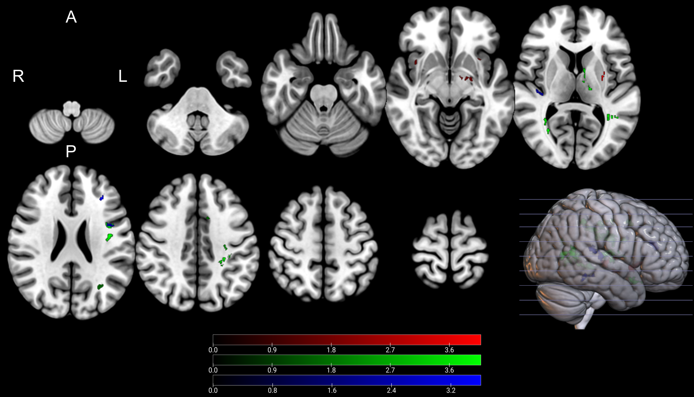
Supplementary Figure 3. Clusters with a positive association between PD patients’ NDI-values and postoperative change in UPDRS (red), time spent in ON (green), and time spent in OFF (blue), as revealed by the whole brain analysis. P-Values were corrected for multiple comparisons using a permutation-based approach and shown as the negative decadic logarithm of the p-value.

Supplementary Figure 4
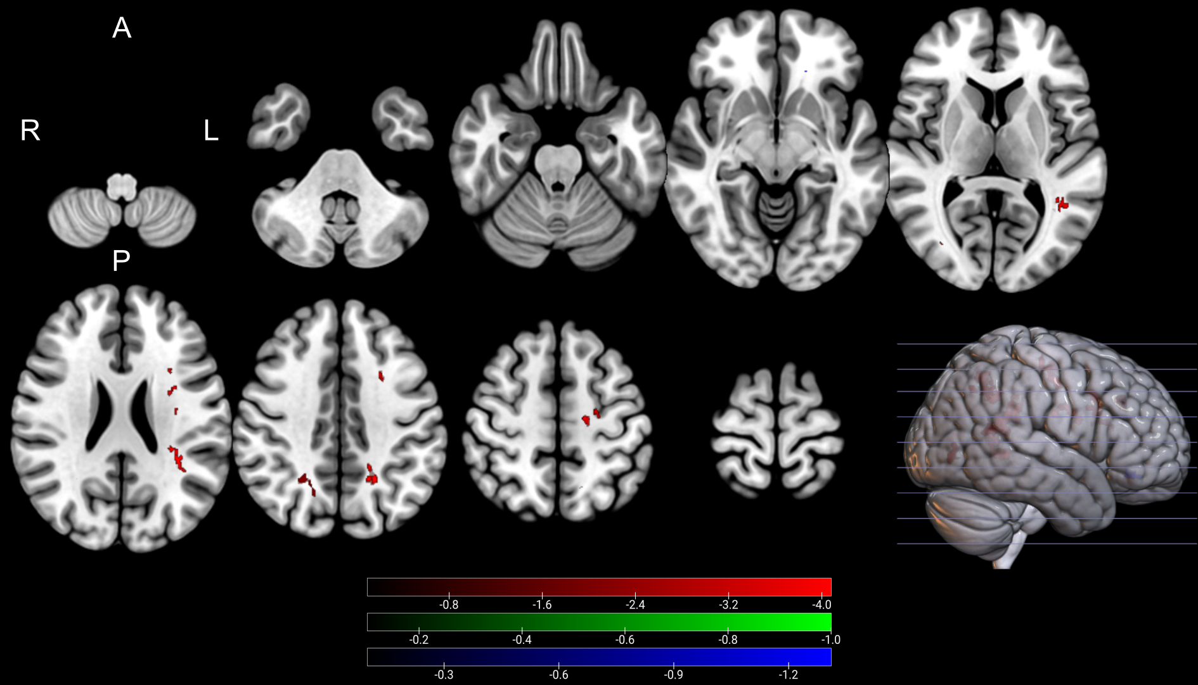
Supplementary Figure 4. Clusters with a negative association between PD patients’ NDI-values and postoperative change in UPDRS (red), time spent in ON (green), and time spent in OFF (blue), as revealed by the whole brain analysis. P-Values were corrected for multiple comparisons using a permutation-based approach and shown as the negative decadic logarithm of the p-value.

Supplementary Figure 5
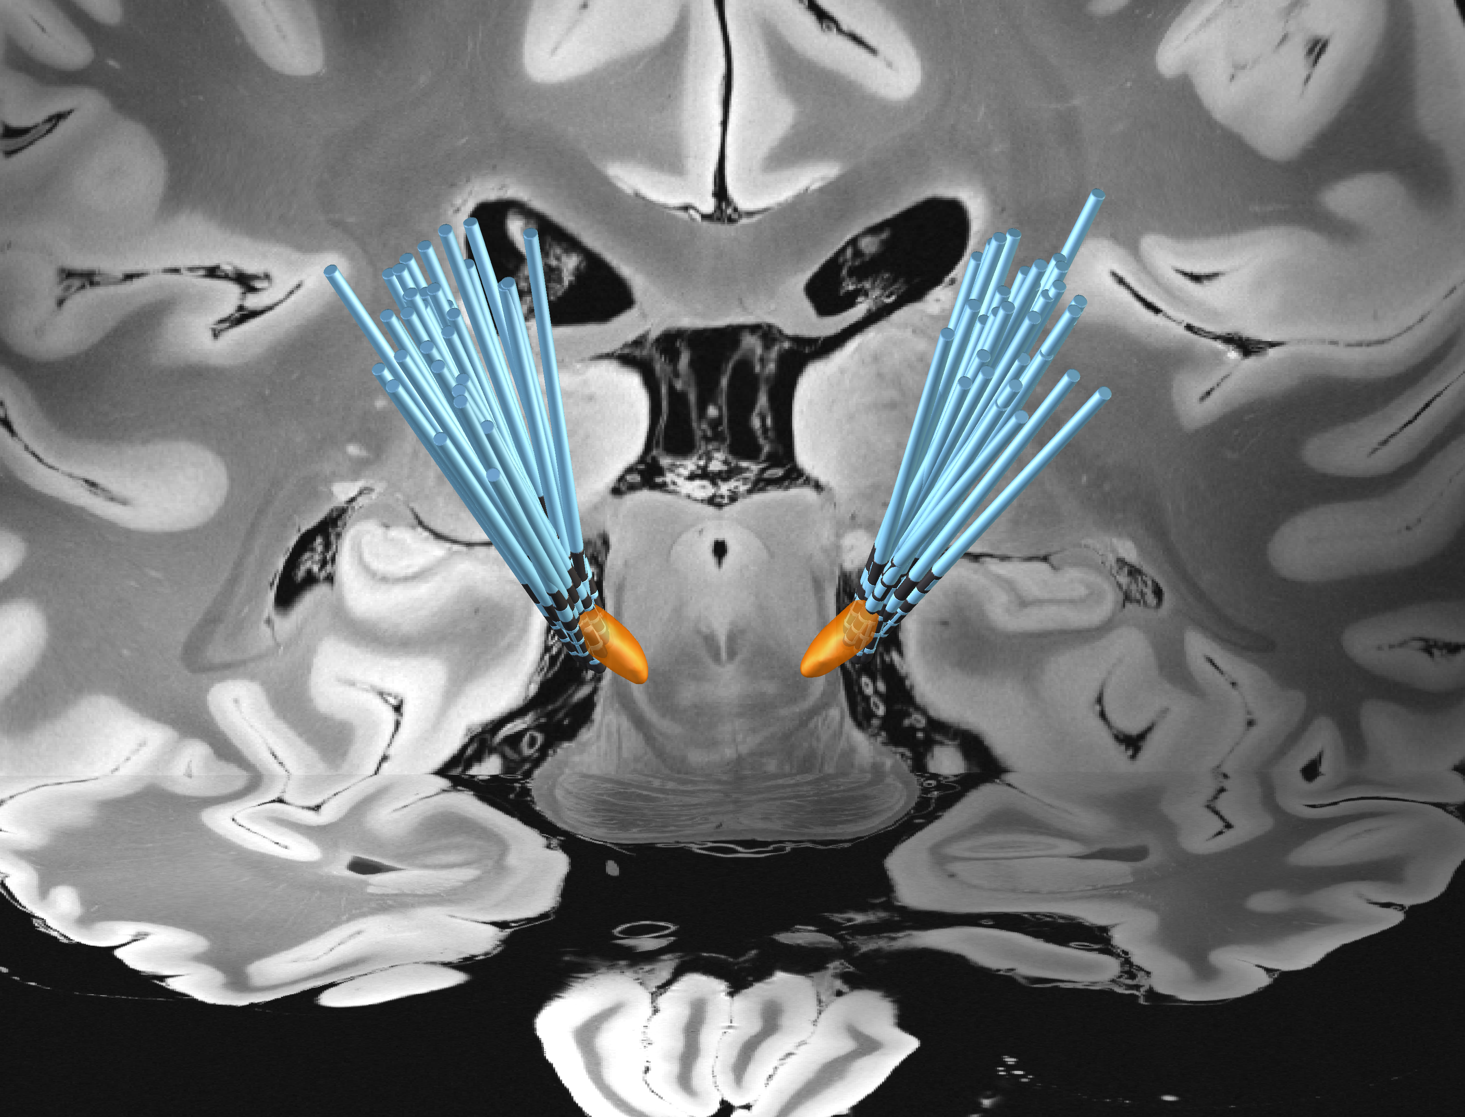
Supplementary Figure 5 Reconstruction of the electrodes for the 35 patients as calculated within the Lead-DBS toolbox.

Supplementary Figure 6
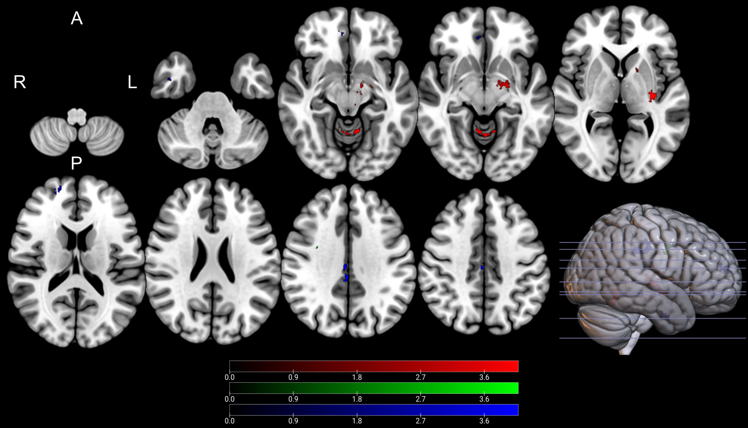
Supplementary Figure 6. Clusters with a positive association between PD patients’ ODI-values and postoperative change in UPDRS (red), time spent in ON (green), and time spent in OFF (blue), as revealed by the whole brain analysis, corrected for LEDD, age, and disease duration. Clusterwise P-Values were corrected for multiple comparisons using a permutation-based approach and shown as the negative decadic logarithm of the p-value.

Supplementary Figure 7
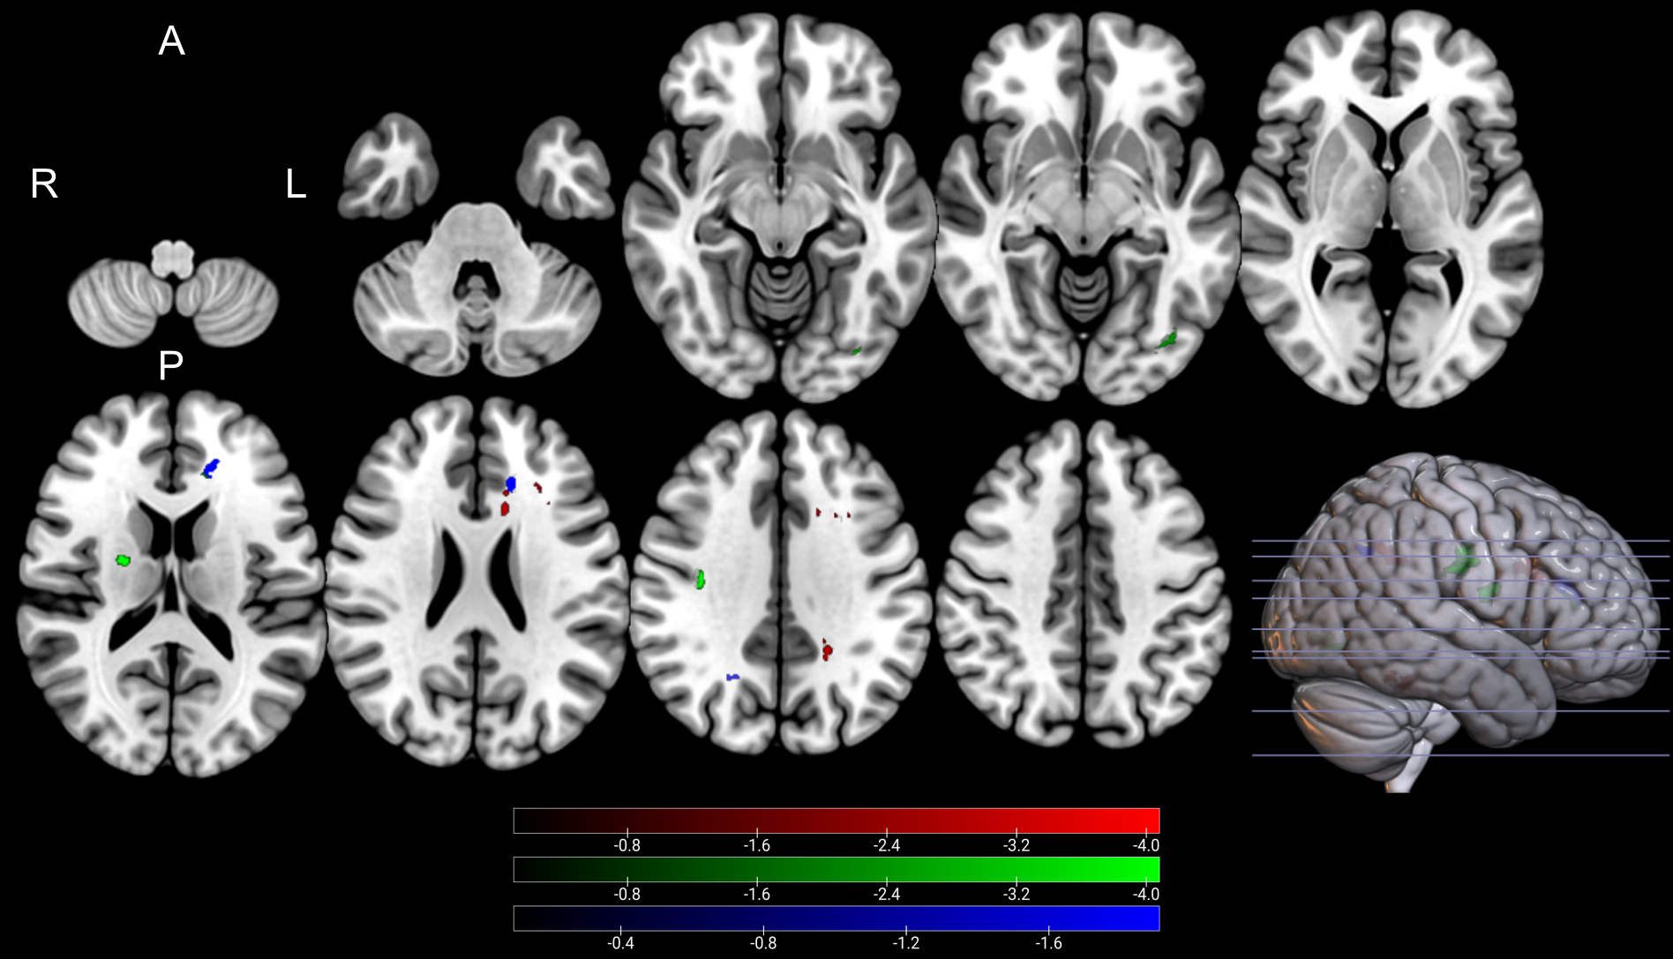
Supplementary Figure 7. Clusters with a negative association between PD patients’ ODI-values and postoperative change in UPDRS (red), time spent in ON (green), and time spent in OFF (blue), as revealed by the whole brain analysis, corrected for LEDD, age, and disease duration. P-Values were corrected for multiple comparisons using a permutation-based approach. Clusterwise P-Values were corrected for multiple comparisons using a permutation-based approach and shown as the negative decadic logarithm of the p-value.

Supplementary Figure 8
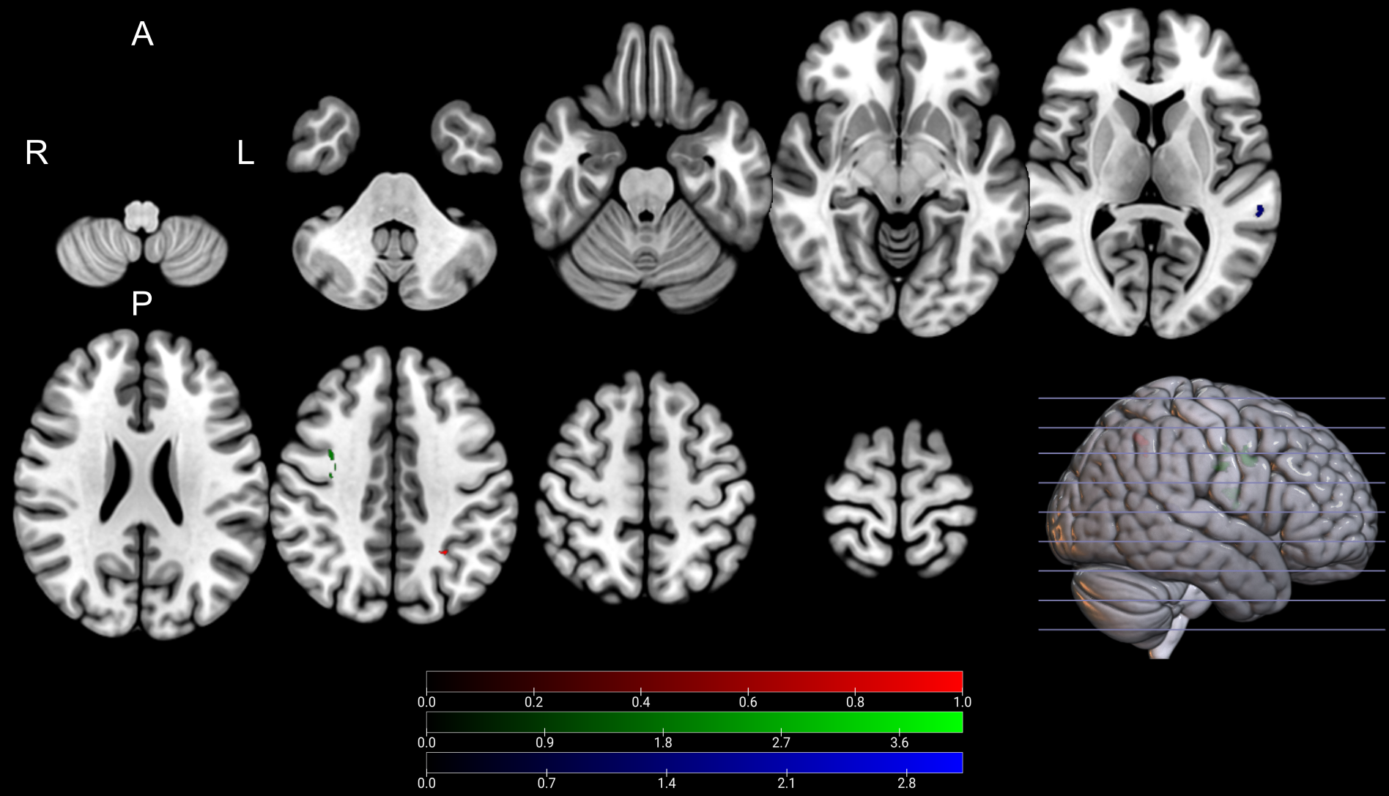
Supplementary Figure 8. Clusters with a positive association between PD patients’ FA-values and postoperative change in UPDRS (red), time spent in ON (green), and time spent in OFF (blue), as revealed by the whole brain analysis, corrected for LEDD, age, and disease duration. P-Values were corrected for multiple comparisons using a permutation-based approach and shown as the negative decadic logarithm of the p-value.

Supplementary Figure 9
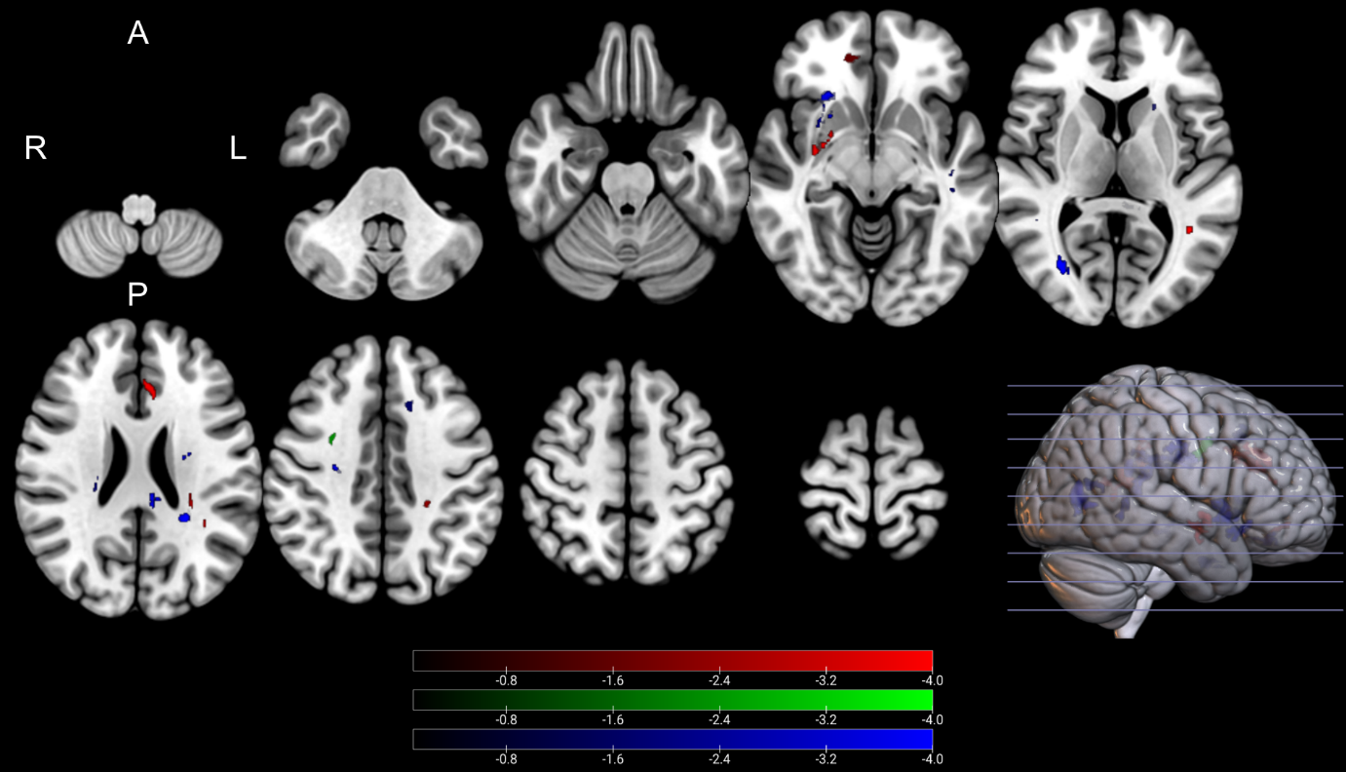
Supplementary Figure 9. Clusters with a negative association between PD patients’ FA-values and postoperative change in UPDRS (red), time spent in ON (green), and time spent in OFF (blue), as revealed by the whole brain analysis, corrected for LEDD, age, and disease duration. P-Values were corrected for multiple comparisons using a permutation-based approach and shown as the negative decadic logarithm of the p-value.

Supplementary Figure 10
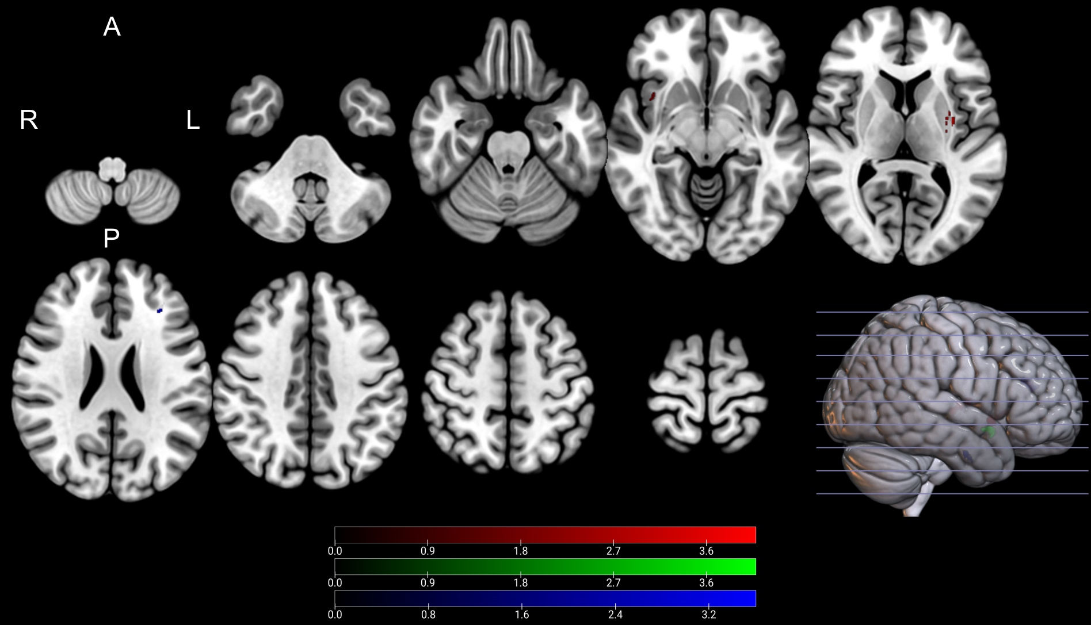
Supplementary Figure 10. Clusters with a positive association between PD patients’ NDI-values and postoperative change in UPDRS (red), time spent in ON (green), and time spent in OFF (blue), as revealed by the whole brain analysis, corrected for LEDD, age, and disease duration. P-Values were corrected for multiple comparisons using a permutation-based approach and shown as the negative decadic logarithm of the p-value.

Supplementary Figure 11
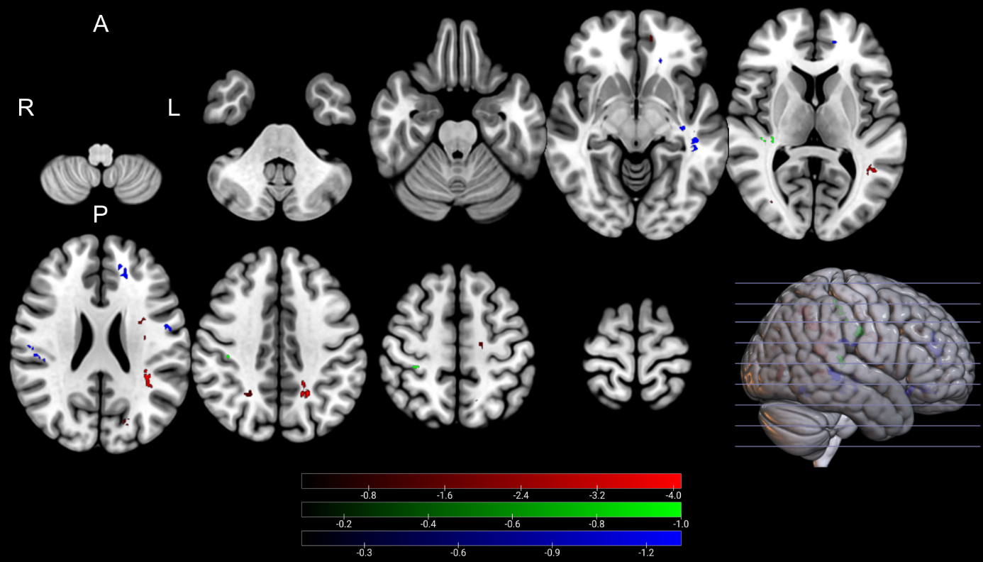
Supplementary Figure 11. Clusters with a negative association between PD patients’ NDI-values and postoperative change in UPDRS (red), time spent in ON (green), and time spent in OFF (blue), as revealed by the whole brain analysis, corrected for LEDD, age, and disease duration. P-Values were corrected for multiple comparisons using a permutation-based approach and shown as the negative decadic logarithm of the p-value.

