Supplementary Figures

An approach to characterize mechanisms of action of anti-amyloidogenic compounds in vitro and in situ

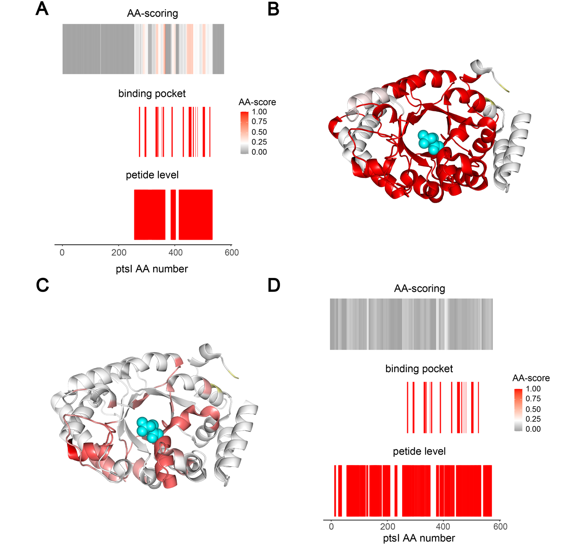
Supplementary figure 1. In silico LiP-MS of FBP-ptsI binding. To assess whether the achieved resolution of the amino acid centric analysis in FBP-ptsI binding was dependent on the specific peptides identified in this experiment, we performed an in silico LiP-MS experiment. We computed all potentially detectable peptides of ptsI upon proteinase K and trypsin digestion, with a minimal length of six amino acids and maximally one missed trypsin cleavage. Next, we defined the FBP binding pocket to include all atoms in a sphere of 10 Å radius around PEP. If a computed LiP peptide mapped to the binding pocket, we assigned it a score of 1, otherwise a score of 0. Peptides with a score of 1 are expected to change in a LiP-MS experiment. In an in silico amino acid-level analysis, we then averaged the assigned values per amino acid position. To test the sensitivity of the peptide-level and amino acid-level approaches to false positives, we assigned 5 % of the computed LiP peptides, picked randomly, as significantly changing (score of 1). A In silico amino acid centric fingerprint (top), binding pocket (middle) and peptide centric fingerprint (bottom) aligned along the ptsI sequence. B in silico peptide centric fingerprint mapped on the ptsI structure (PDB: 2xz7). C in silico amino acid centric fingerprint mapped on the ptsI structure (PDB: 2xz7). D Control in silico amino acid centric fingerprint (top)and peptide centric fingerprint (bottom) aligned along the ptsI sequence, using random peptides (5% of total peptides) assigned as significantly changing. Binding pocket defined as in A.

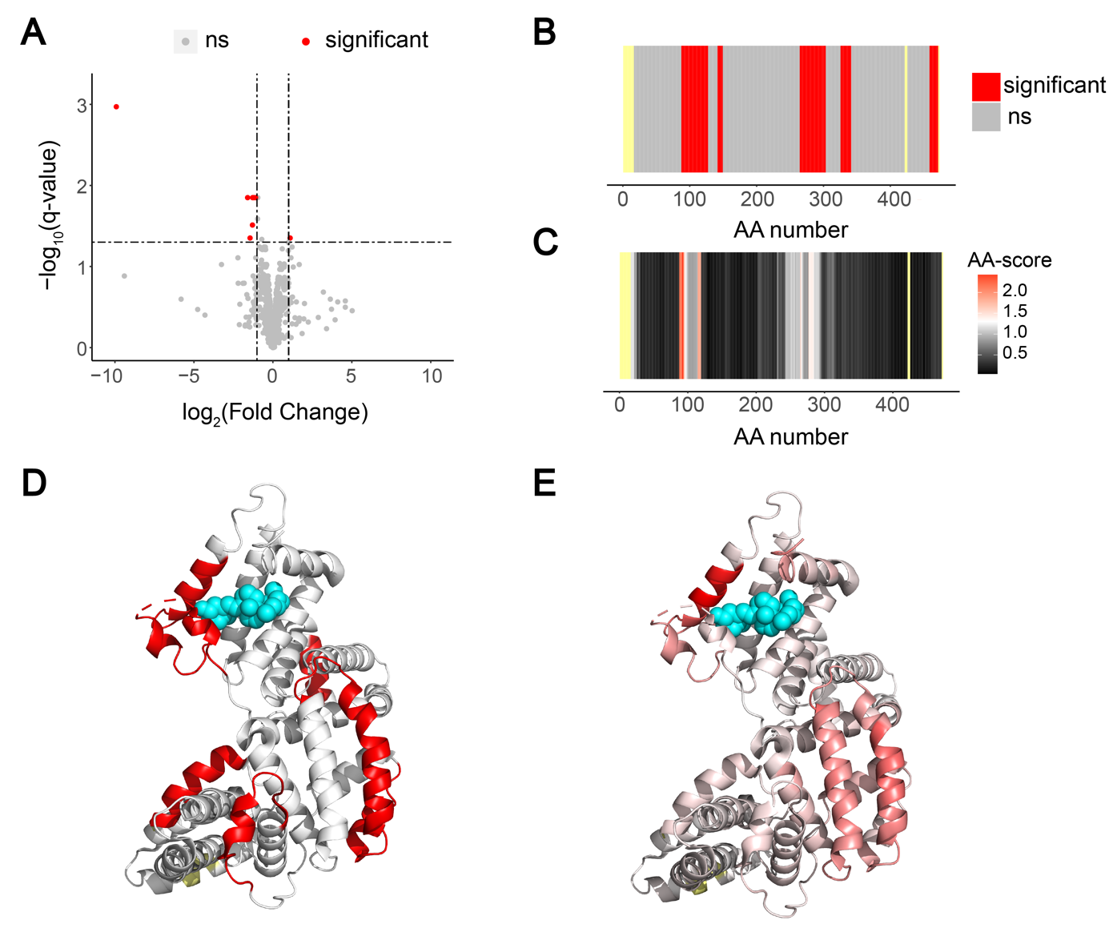
Supplementary figure 2. Vitamin D binding towards Vitamin D binding protein (GC). A volcano plot comparing peptide abundances of peptides generated in Vitamin D bound and unbound GC. B fingerprint of the classical LiP-MS data analysis pipeline. Significant regions in red, not significant in grey, not detected in yellow. C fingerprint upon scoring changes per amino acid. The scale indicates the score per amino acid. The significance threshold of -log₁₀(0.05) x log₂(2) is shown in white, with red indicating higher scores. The more intense the red colour, the higher the score. Not significant in grey. Not detected in yellow. D significant peptides mapped on the vitamin D binding protein structure (PDB: 1j78). Calcifediol in cyan. E significant amino acids of amino acid centric analysis mapped on the vitamin D binding protein structure (PDB: 1j78). Calcifediol in cyan.
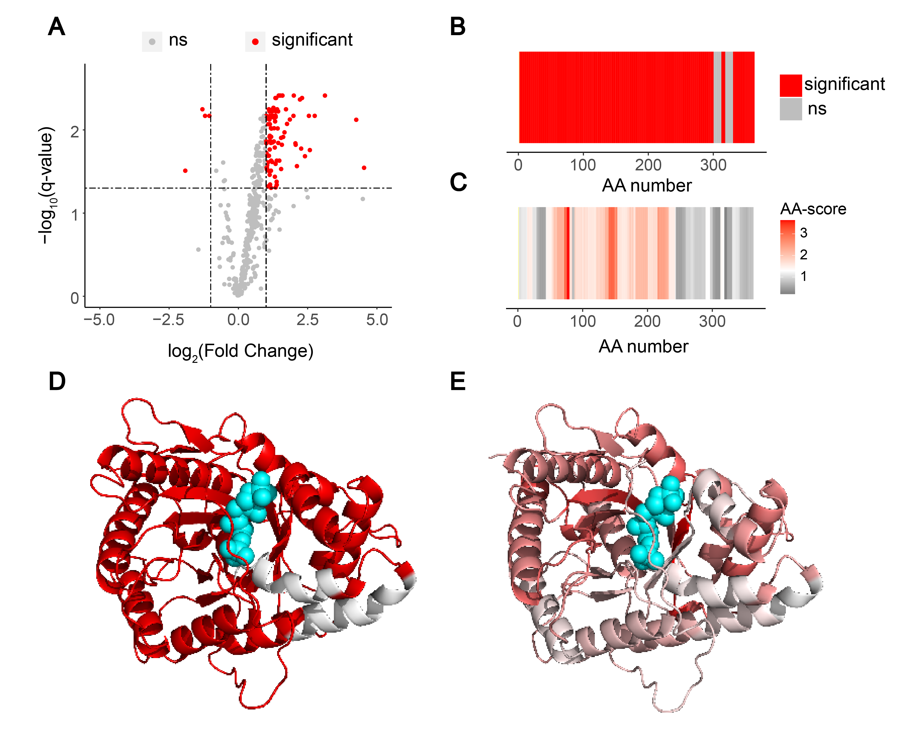
Supplementary figure 3. Fructose bisphosphate binding towards Fructose-bisphosphate aldolase A (ALDOA). A volcano plot comparing peptide abundances of peptides generated in fructose bisphosphate bound and unbound ALDOA. B fingerprint of the classical LiP-MS data analysis pipeline. Significant regions in red, not significant in grey, not detected in yellow. C fingerprint upon scoring changes per amino acid. The scale indicates the score per amino acid. The significance threshold of -log₁₀(0.05) x log₂(2) is shown in white, with red indicating higher scores. The more intense the red colour, the higher the score. Not significant in grey. Not detected in yellow. D significant peptides mapped on the ALDOA protein structure (PDB: 4ald). Fructose bisphosphate in cyan. E significant amino acids of amino acid centric analysis mapped on the ALDOA protein structure (PDB: 4ald). Fructose bisphosphate in cyan.
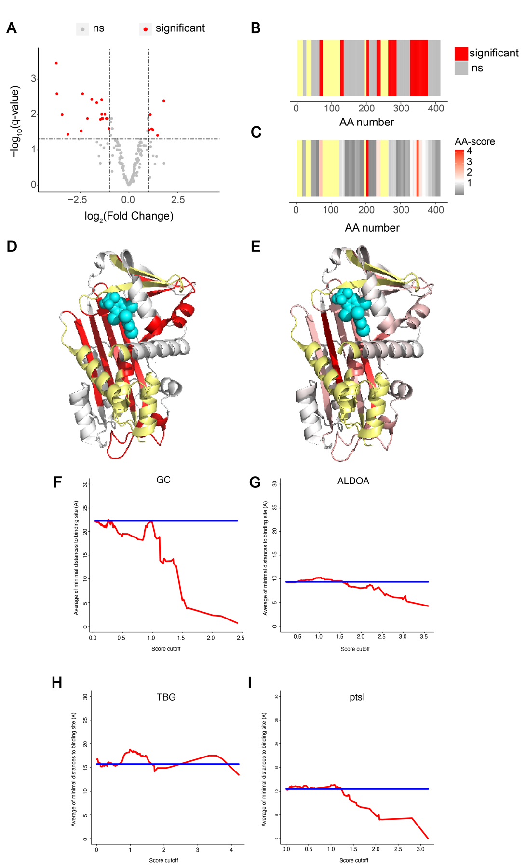
Supplementary figure 4. Thyroxine binding towards Thyroxine Binding Globulin (TBG). A volcano plot comparing peptide abundances of peptides generated in thyroxine bound and unbound TBG. B fingerprint of the classical LiP-MS data analysis pipeline. Significant regions in red, not significant in grey, not detected in yellow. C fingerprint upon scoring changes per amino acid. The scale indicates the score per amino acid. The significance threshold of -log₁₀(0.05) x log₂(2) is shown in white, with red indicating higher scores. The more intense the red colour, the higher the score. Not significant in grey. Not detected in yellow. D significant peptides mapped on the TBG protein structure (PDB: 2riw). Thyroxine in cyan. E significant amino acids of amino acid centric analysis mapped on the TPG protein structure (PDB: 2riw). Thyroxine in cyan. (F-I) The plots show the average minimal distance to the ligand binding site of amino acids with scores above the indicated threshold values, for GC (F), ALDOA (G), TBG (H), and ptsl (I) in red. The blue line shows the average minimal distance to the binding site for all amino acids in a protein.

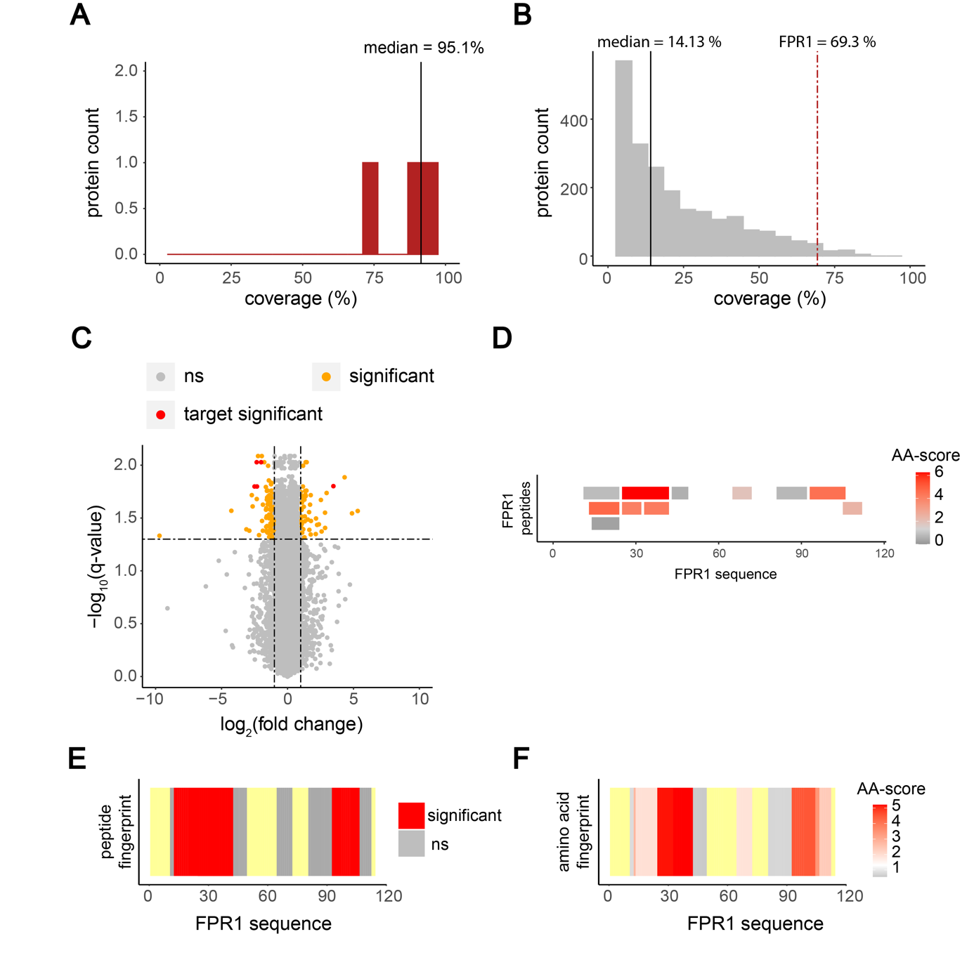
Supplementary figure 5. Amino acid centric analysis on a proteome wide scale. A Coverage of purified proteins analysed with in vitro LiP-MS (bin size of 5%). Median coverage is indicated by the black line (95.1%). B Coverage distribution of the 2417 identified proteins (bin size of 5%). Median coverage indicated by the black line (14.13 %). Coverage of FPR1 (69.3%) indicated by the red dotted line. C Volcano plot of rapamycin treated and untreated S. cerevisiae cell extracts (non-significant in light grey, significant in orange, significant and FPR1 in red). D Peptides and their corresponding scores (-log₁₀(q-value) x absolute (log₂(fold change)) mapped along the FPR1 sequence. Score values from grey to red. E Peptide-centric analysis showing significant peptides mapped along the sequence of FPR1 and onto the FK-506 bound FPR1 structure (PDB: 1yat). FK-506 in cyan. F Fingerprint upon amino acid centric analysis mapped along the sequence of FK-506 bound FPR1 (The scale indicates the score per amino acid. The significance threshold of -log₁₀(0.05) x log₂(2) is shown in white, with red indicating higher scores. The more intense the red colour, the higher the score. Not significant in grey.) and onto the FK-506 bound FPR1 structure (PDB: 1yat). FK-506 in cyan.

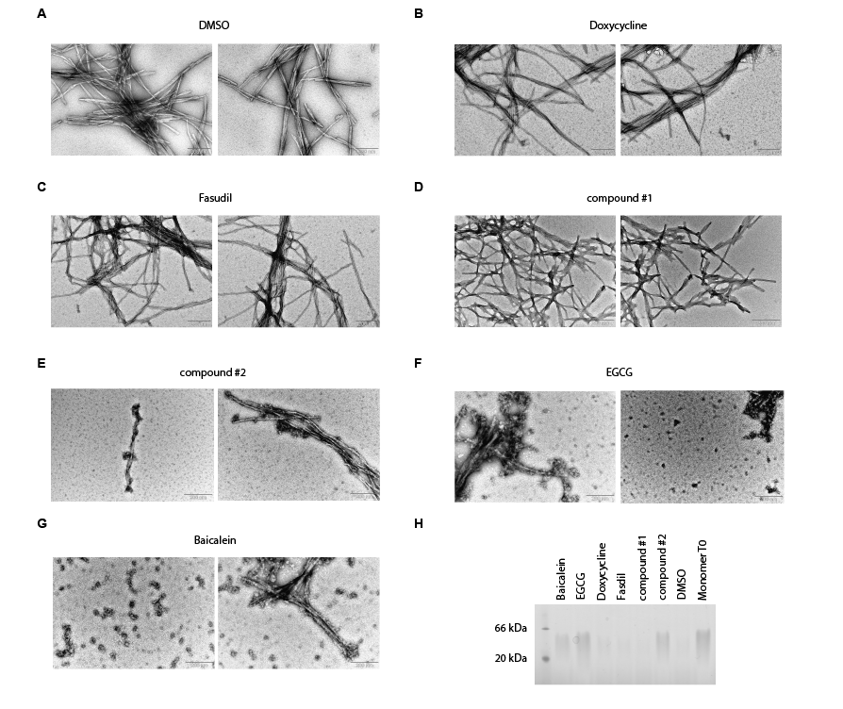
Supplementary figure 6. Transmission electron microscopy images of structures formed in the presence of compounds or DMSO after 17 hours of incubation. A DMSO control condition. B Doxycycline. C Fasudil. D compound 1. E compound 2. F EGCG. G Baicalein. H Native PAGE after 17 hours of incubation in the indicated conditions, compared to monomer at time point 0. Oligomeric and fibrillar forms are not resolved.

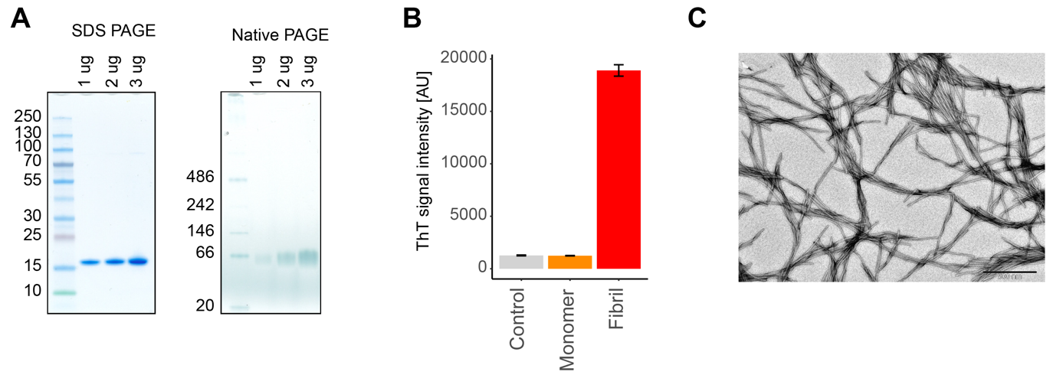
Supplementary figure 7. Quality controls α-Synuclein monomer and fibrils. A SDS PAGE and Native PAGE of monomeric α-Synuclein. B ThT intensity of Control, monomeric-and fibrillary α-Synuclein. C TEM image of the α-Synuclein fibrils used.

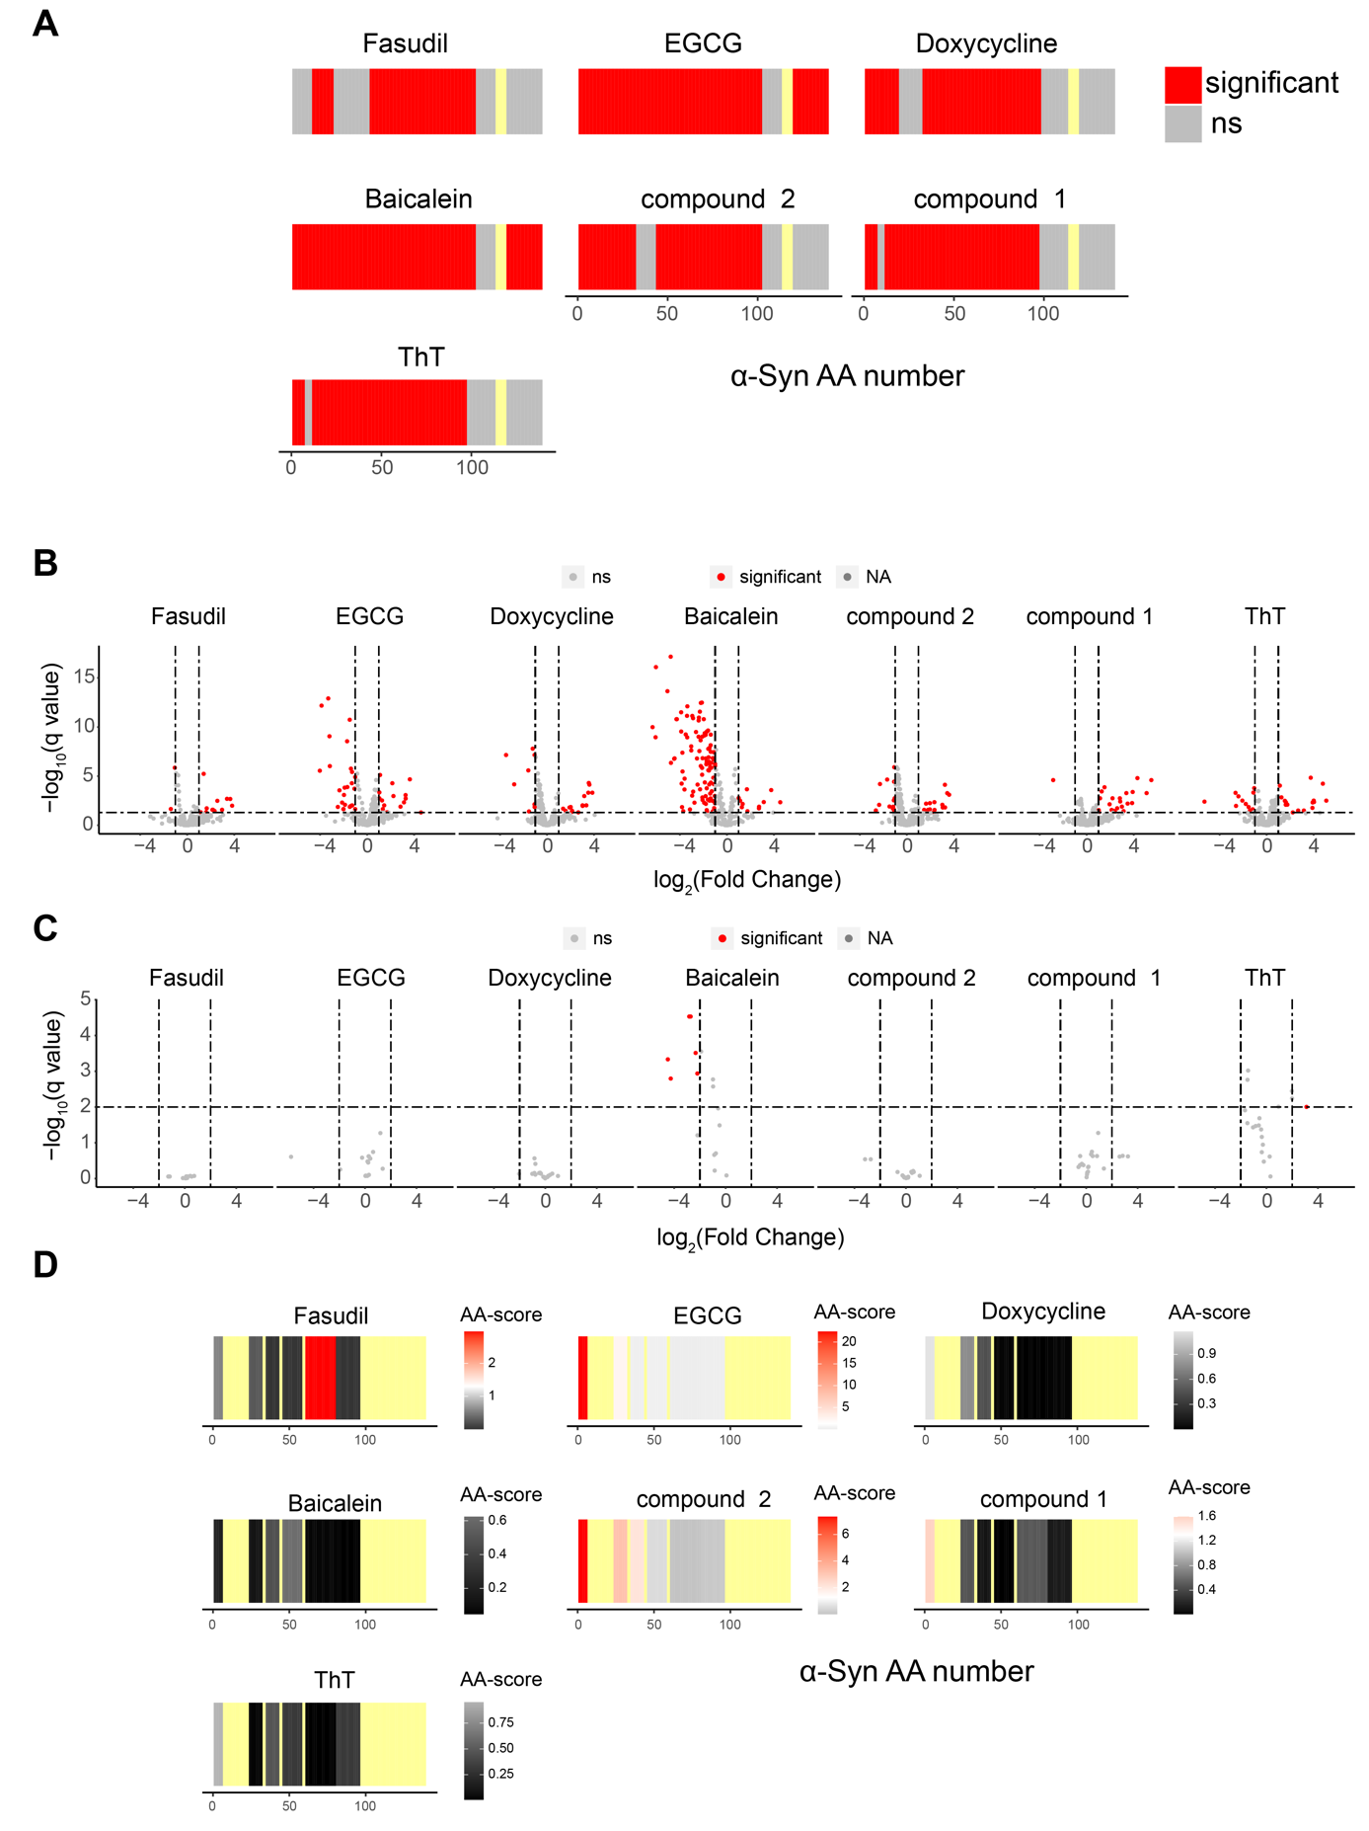

Supplementary figure 8. Compound interactions with α-Synuclein monomer. A, B LiP peptide fingerprints (non-significant in light grey, significant in red, not detected in yellow) (A) and volcano plots of LiP peptide intensities (significant in red, non-significant in grey) (B) for α-Synuclein monomer treated with compounds compared to treatment with the DMSO control. C Volcano plot comparing the control (i.e., trypsin-only) peptide intensities of compound-treated α-Synuclein monomer to DMSO-treated monomer; colours as in B. D LiP peptide fingerprints of α-Synuclein treated with compounds and normalized for the trypsin-only control data (The scale indicates the score per peptide. The significance threshold of -log₁₀(0.05) x log₂(2) is shown in white, with red indicating higher scores. The more intense the red colour, the higher the score. Not significant in grey. Not detected in yellow).

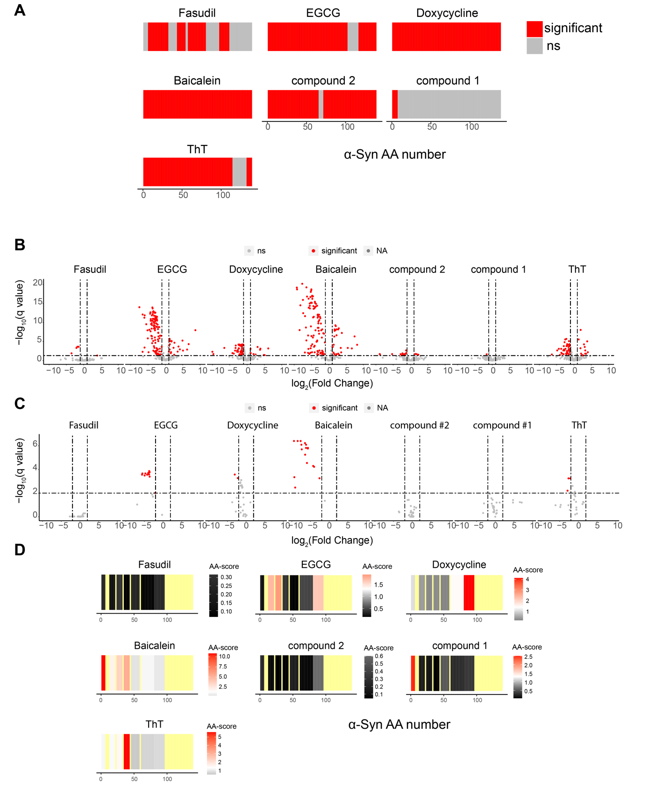

Supplementary figure 9. Compound interactions with α-Synuclein fibril. A Peptide analysis fingerprints of α-Synuclein treated with compounds (non-significant in light grey, significant in red, not detected in yellow). B Volcano plot of compound treated α-Synuclein fibril (non-significant in light grey, significant in red). C Volcano plot of the control intensities of compound treated α-Synuclein fibril (non-significant in light grey, significant in red). D Peptide fingerprint of the tryptic control normalised data (The scale indicates the score per peptide. The significance threshold of -log₁₀(0.05) x log₂(2) is shown in white, with red indicating higher scores. The more intense the red colour, the higher the score. Not significant in grey. Not detected in yellow).

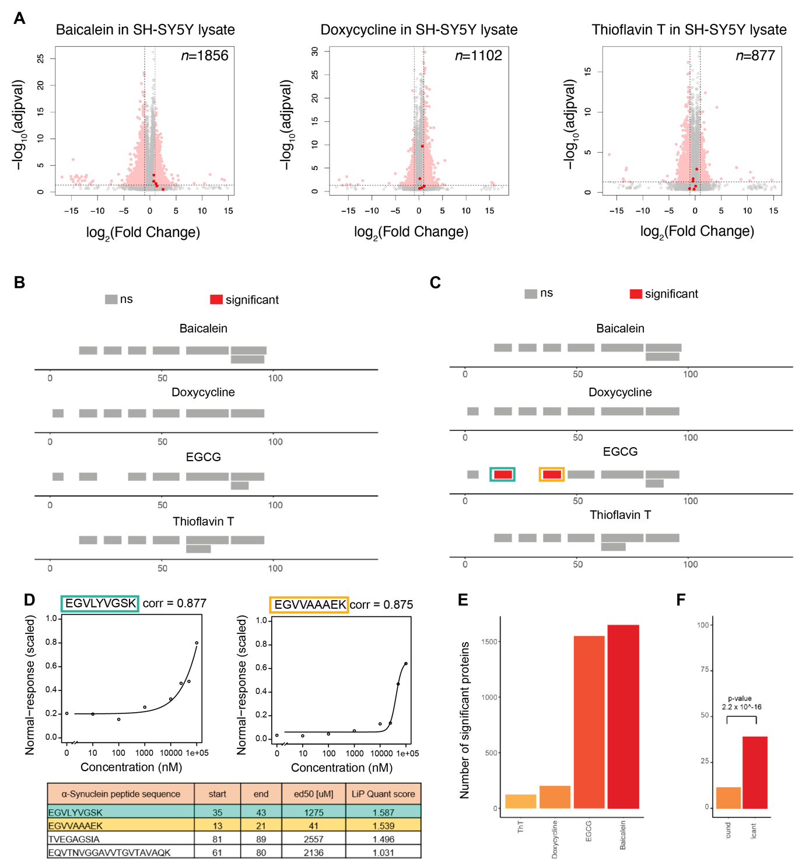

Supplementary figure 10. A. Volcano plots showing peptides with altered abundance after spike-in of the indicated compounds into cell lysates. Number of significant hits and total number of detected peptides are indicated. B, C The plots show a LiPQuant analysis of alpha-synuclein in the presence of indicated compounds, with detected peptides colored according to the LiPQuant score. Red is significant. Grey is not significant. Note that A and B are scaled differently; LiPQuant scores are shown to a threshold of 2.0 (B) and 1.5 (C). D The table shows α-Synuclein peptides and their start and end position, ec50 value and LiPQuant score. The blue and yellow colors indicate the two α-Synuclein peptides with LiPQuant score > 1.5 in the presence of EGCG . The plots show curve fits of peptide intensity versus EGCG concentration for the two α-Synuclein peptides with LiPQuant score > 1.5 in the presence of EGCG. E. Number of significant proteins in the presence of the indicated compounds, at LiPQuant score > 1.5. F. Fisher’s exact test of significant proteins (LiPQuant score > 1.5) detected in the presence of Doxycycline and in the Doxycycline pulldown experiment compared to not significant background.

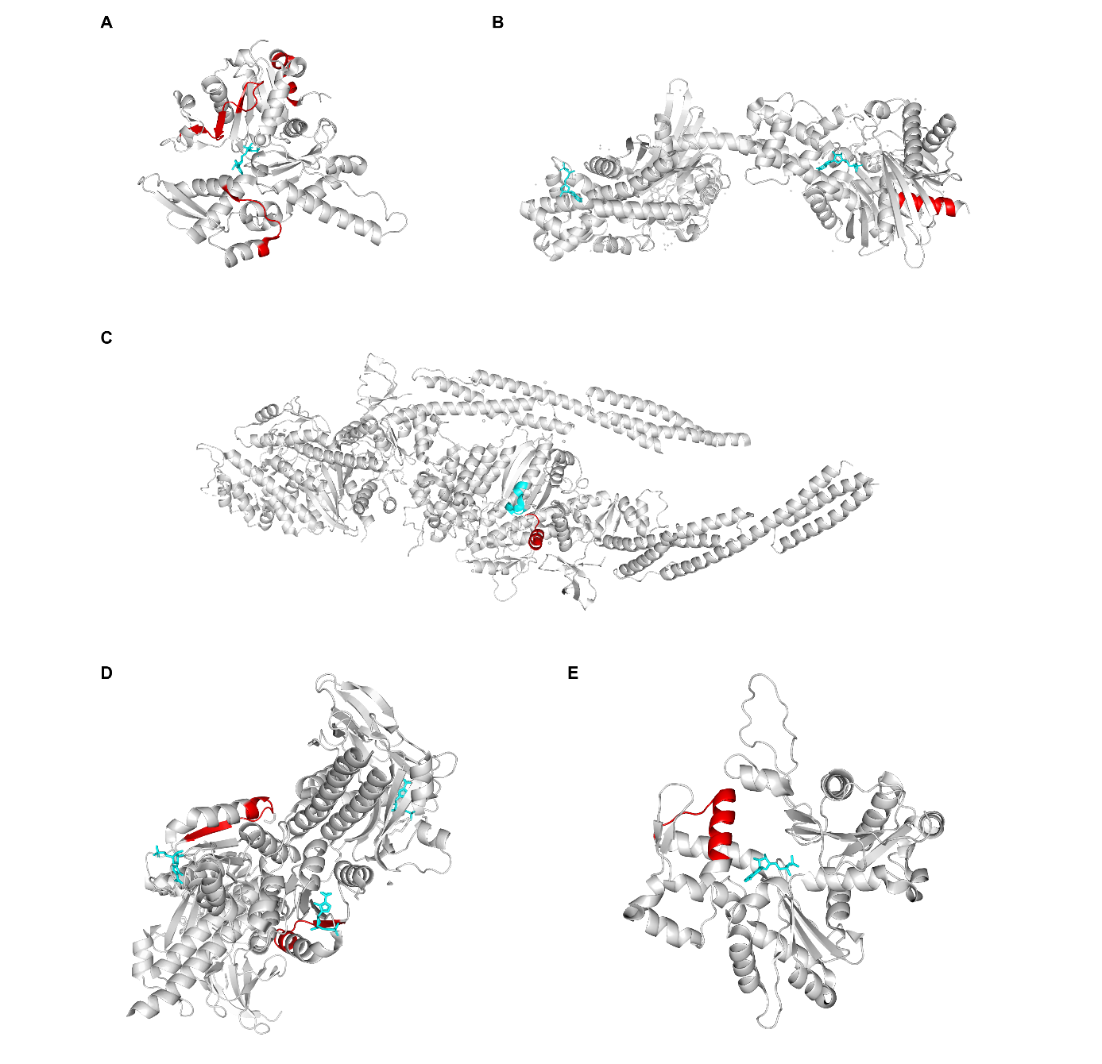
Supplementary figure 11. Significant hits with ATP/ADP/C2R bound pdb structures. A ACTR (pdb: 6uhc). Significant hits in red, ATP in cyan. B HK1 (pdb: 1dgk). Significant hit in red, ADP in blue. C MYH10 (pdb: 4pd3). Significant hit in red. ATP binding site from “uniprot.org” in cyan. D PAICS (pdb: 6yb8). Significant hit in red, C2R in cyan. E ACTB (pdb: 3j82). Significant hit in red, ADP in cyan.

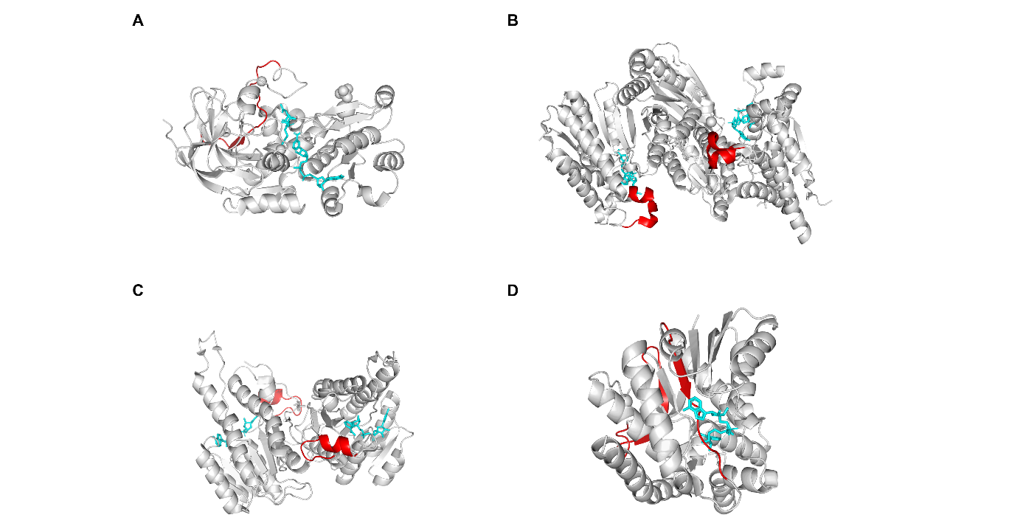
Supplementary figure 12. Significant hits with NAD/NDP bound pdb structures. A ADH5 (pdb: 1mc5). Significant hit in red, NAD and AHE in cyan. B IDH2 (pdb: 4ja8). Significant hit in red, NDP in cyan. C HSD17B10 (pdb: 2o23). Significant hit in red, NAD in cyan. D MDH2 (pdb: 2dfd). Significant hit in red, NAD in cyan.

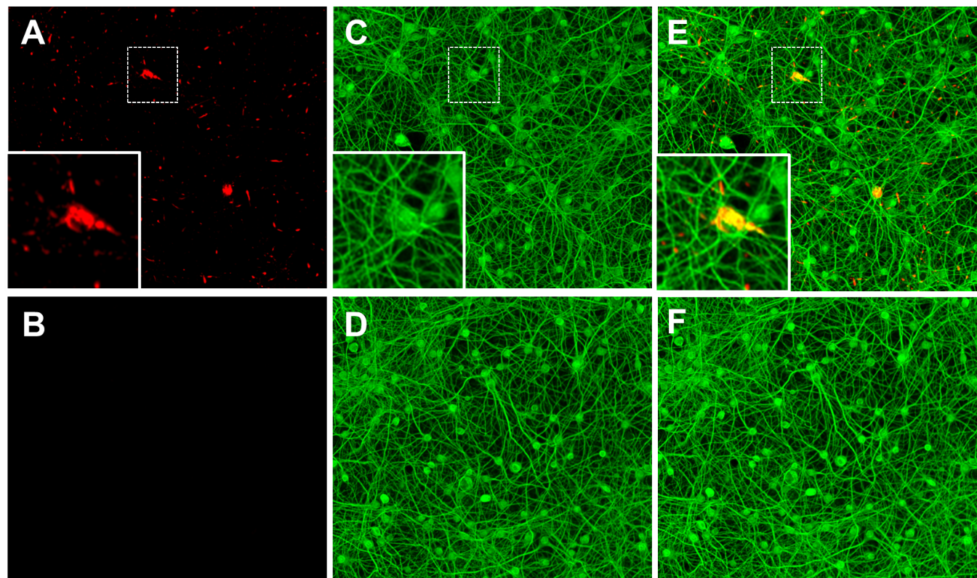
Supplementary figure 13. Fluorescence microscopy images of primary rat neurons treated with α-Synuclein PFFs. (A, B) pS129 was visualized in PFF-treated (A) and untreated (B) neurons by staining with anti pS129 α-Synuclein antibodies (1/300 dilution, ab51253). (C, D) MAP2 staining of PFF-treated (C) and untreated (D) neurons using anti-MAP2 antibodies (1/2200 dilution, ab5392). (E, F) merged view of pS129 and MAP2 channels of PFF treated (E) and untreated (F) neurons; inserts show higher magnification of area in dashed-line boxes.

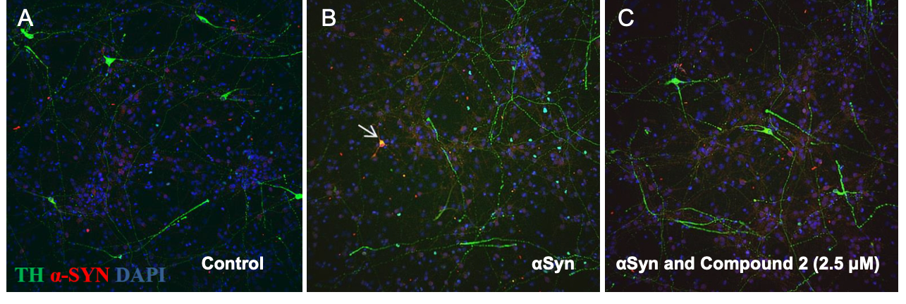
Supplementary figure 14. Fluorescence microscopy images of primary rat neurons stained with antibodies for tyrosine hydroxylase (TH) in green and α-Synuclein in red; nuclei are visualized by DAPI in blue. (A) Control, untreated neurons. (B) Neurons exposed to α-Synuclein PFFs. The arrow indicates a cell with co-localized α-Synuclein and TH. (C) Neurons exposed to α-Synuclein PFFs and treated with 2.5μM Compound 2.

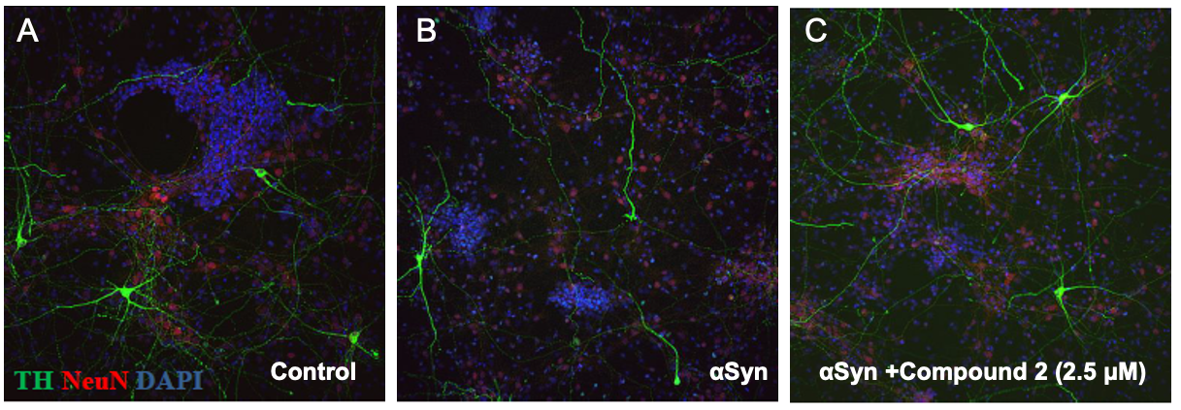

Supplementary figure 15. Fluorescence microscopy images of primary rat neurons stained with antibodies for tyrosine hydroxylase (TH) in green and NeuN in red; nuclei are visualized by DAPI in blue. (A) Control, untreated neurons. (B) Neurons exposed to α-Synuclein PFFs. (C) Neurons exposed to α-Synuclein PFFs and treated with 2.5μM Compound 2.

