Supplementary Materials
Assessing protocol change on CT estimates
To assess any potential protocol effects, we performed a statistical analysis on longitudinal cortical thickness change (DeltaCT, i.e. values at FUP minus CT values at BL) across the 31 ROIs of the DK atlas. We fitted a linear model with age and sex as covariates and protocol as effect of interest (delta CT ~ Protocol + Age + Sex). We did not observe any significant protocol differences after FDR-BH correction. Therefore, according to this analysis, we can safely confirm that the slight variations in the sequence parameters did not affect the cortical thickness values (see Table S1). In the table below, we show how many subjects are per protocol used in the study. Note the minimal changes of acquisition parameters across the three protocols, as also reported in the main manuscript.

Protocol | Total Number | MSA C | MSA P
#1:  TR 2400ms  TE 2.26ms  FA 8˚ | 20 | 14 | 6
#2:  TR 2000ms  TE 2.83ms  FA 8˚ | 3 | 1 | 2
#3:  TR 2300ms  TE 2.93ms  FA 9˚ | 13 | 10 | 3
Table S1. Number of subjects acquired for each protocol in this study.

Baseline comparison of cortical thickness and atrophy: MSA vs HC
Compared with HC, patients with MSA showed reduced cortical thickness across several DK regions (p < 0.05, uncorrected, see Figure S1 and Figure S2), including the superior frontal and lateral orbitofrontal gyri, precentral cortex, superior and inferior parietal lobules, inferior temporal, lateral occipital cortex, caudal anterior cingulate cortex, and insula. Using the Schaefer parcellation, significant group differences were observed in the somatomotor (SomMotA), limbic, dorsal attention, salience/ventral attention, frontoparietal (ContB), and default mode (DefaultA) networks. We also performed baseline volumetric group comparisons (see Figure S3), which showed significantly greater atrophy in the putamen, pons, cerebellar WM, and cerebellar GM in patients with MSA than in HC; these differences survived correction for multiple comparisons (p < 0.0125, Bonferroni-corrected).
Overall, these findings (i.e. MSA vs HC at baseline) indicate a difference in baseline cortical thickness between the two groups, although they should be interpreted with caution because they are significant at a threshold which is not corrected for multiple comparisons. Interestingly, some of the cortical areas showing cross-sectional differences (insula, precentral and superior frontal cortices; SomMotA, SalVentAttn, DMNA and CONB networks) also exhibited significant longitudinal thinning in the MSA cohort. Baseline volumetric atrophy with respect to HC was significant in all regions even with correction for multiple comparisons, consistent with previous studies identifying subcortical and infratentorial atrophy as the predominant structural changes in MSA^{1–3}. Furthermore, the significant trend we observed with this baseline comparison aligns with previous cross-sectional studies not reporting differences between patients and controls^{4–6}.

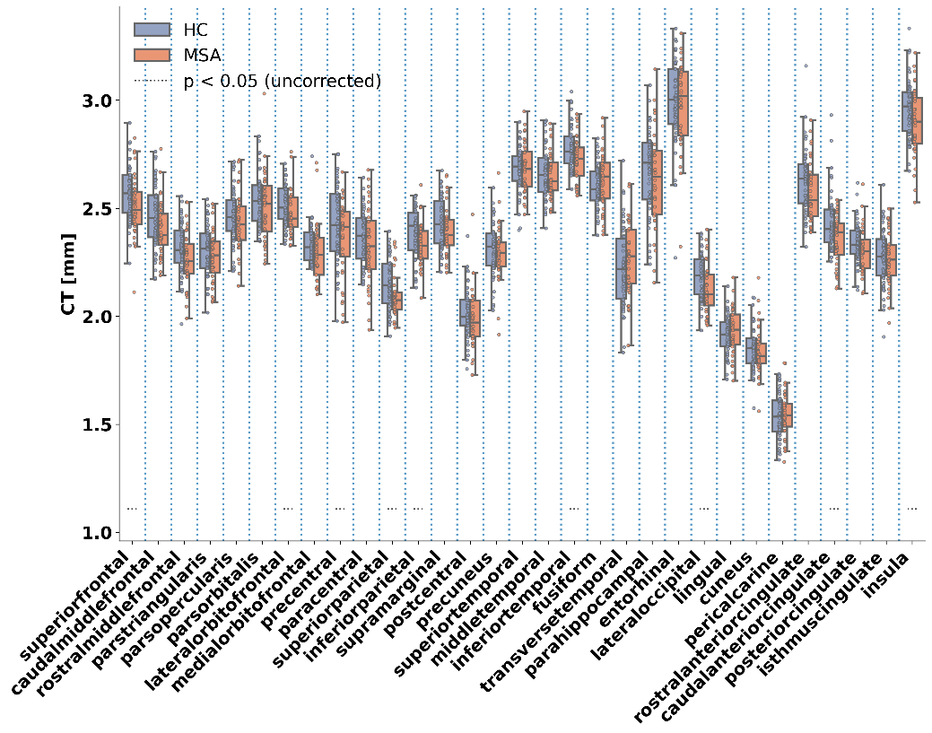
Figure S1. Baseline comparison between HC (light blue) and MSA subjects (salmon) in the region of the anatomical DK atlas.
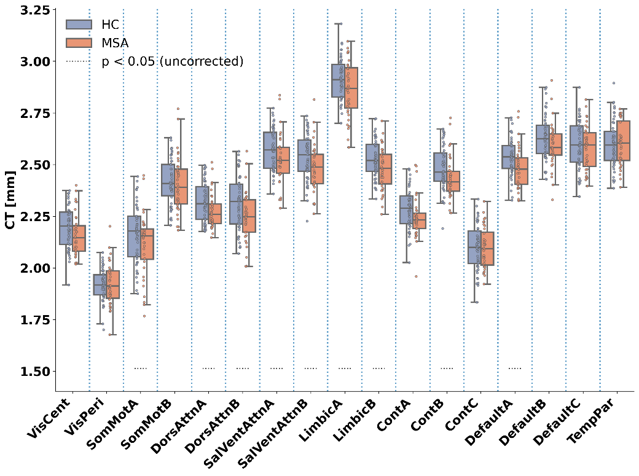
Figure S2. Baseline comparison between HC (light blue) and MSA subjects (salmon) in the region of the functional Schaefer atlas.
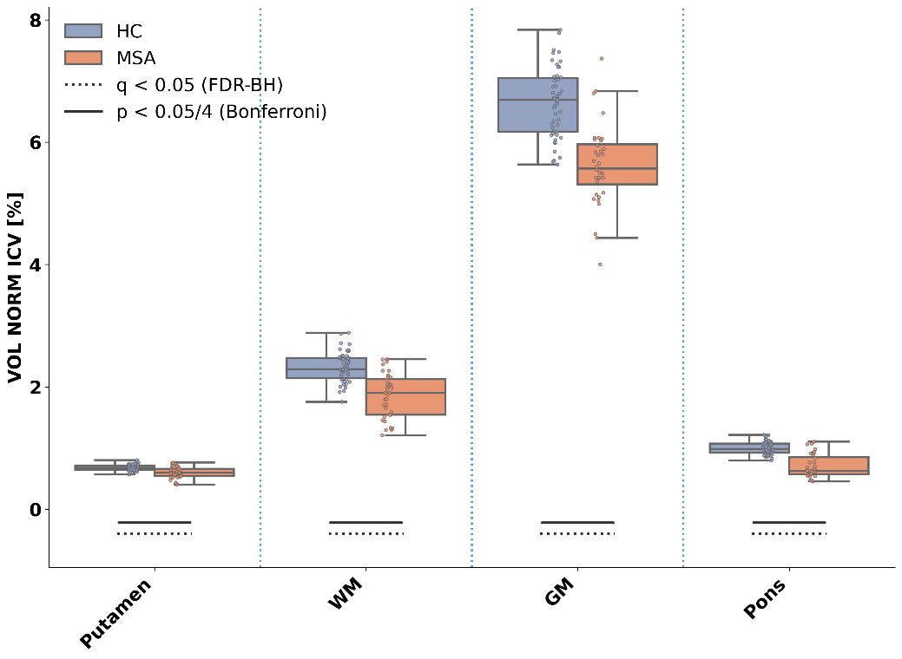
Figure S3. Baseline comparison between HC (light blue) and MSA subjects (salmon) in Putamen and infratentorial regions.

Outliers’ analysis
Given the presence of some outliers (see Manuscript), we repeated the LME analysis after excluding outlier observations. Outlier handling was performed separately for each ROI as follows:
- Baseline (BL) and follow-up (FUP) values were considered jointly for each ROI.
- Outliers were defined as observations lying below the 25th percentile minus 1.5×IQR or above the 75th percentile plus 1.5×IQR.
- If a subject was flagged for a given ROI, that subject was excluded from the longitudinal analysis of that ROI at both BL and FUP in order to preserve the repeated-measures structure and keep the ROI-specific design balanced.
We note that this procedure was applied to the pooled dataset and did not account for additional categorical variables, such as motor phenotype. Consequently, when plotting BL or FUP values stratified by such categories (i.e. motor phenotype), some remaining points may still appear outside the whiskers of subgroup boxplots (see Panel B, Figure S4). Complete LME results are reported in Tables, following the same structure of the main manuscript (see Tables S2, S3 for CT in DK and Schaefer atlas respectively and Table S4 for volumes). In these tables, we additionally reported the number of subjects contributing to each ROI after outlier exclusion.
Cortical Thickness results
Below, we show the same analysis of the manuscript with outliers’ exclusion: boxplots showing thinning over time in Figure S4 and LME results in Table S2 (DK atlas) and Table S3 (Schaefer atlas).
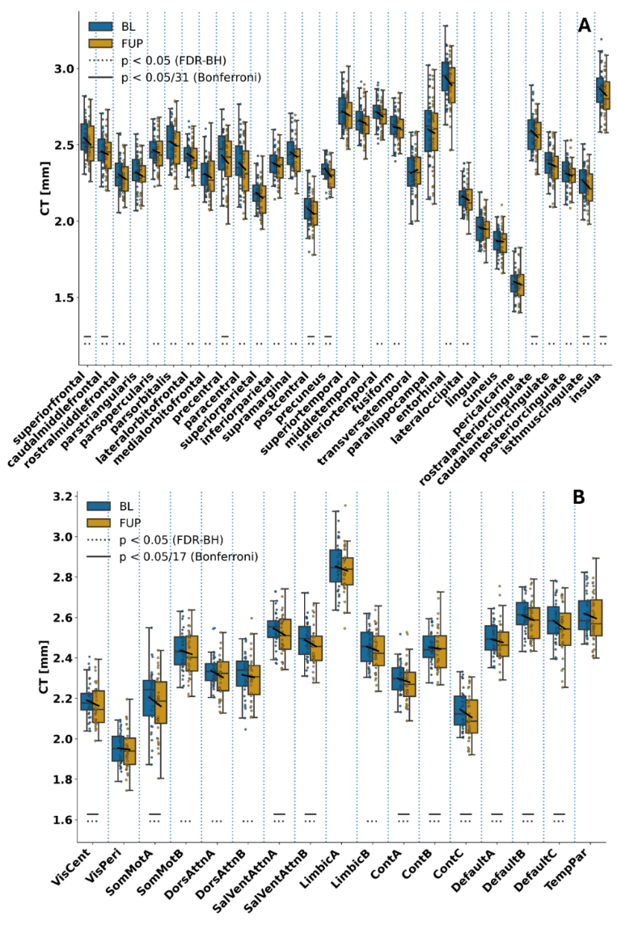
Figure S4. Cortical thinning over time. (A) DK atlas. (B) Schaefer atlas.
ROI | N | β | CI 95 % | tStat | f² Time | Change to Baseline [%] | p-Value
superiorfrontal | 36 | -0.044 | [-0.067, -0.021] | -3.82 | 0.036 | -1.73 | <0.001
caudalmiddlefrontal | 34 | -0.034 | [-0.054, -0.014] | -3.4 | 0.026 | -1.39 | 0.001
rostralmiddlefrontal | 35 | -0.02 | [-0.038, -0.002] | -2.21 | 0.01 | -0.87 | 0.030
parstriangularis | 35 | -0.017 | [-0.038, 0.003] | -1.7 | 0.007 | -0.75 | 0.094
parsopercularis | 34 | -0.025 | [-0.045, -0.005] | -2.51 | 0.016 | -1.02 | 0.015
parsorbitalis | 35 | -0.028 | [-0.05, -0.005] | -2.47 | 0.013 | -1.1 | 0.016
lateralorbitofrontal | 34 | -0.027 | [-0.044, -0.009] | -3.02 | 0.028 | -1.08 | 0.004
medialorbitofrontal | 36 | -0.024 | [-0.045, -0.004] | -2.33 | 0.017 | -1.05 | 0.023
precentral | 36 | -0.051 | [-0.082, -0.021] | -3.35 | 0.028 | -2.11 | 0.001
paracentral | 36 | -0.044 | [-0.073, -0.015] | -3.01 | 0.018 | -1.84 | 0.004
superiorparietal | 35 | -0.03 | [-0.05, -0.01] | -3.01 | 0.025 | -1.38 | 0.004
inferiorparietal | 33 | -0.028 | [-0.046, -0.01] | -3.07 | 0.022 | -1.16 | 0.003
supramarginal | 36 | -0.029 | [-0.052, -0.007] | -2.59 | 0.019 | -1.2 | 0.012
postcentral | 34 | -0.029 | [-0.044, -0.013] | -3.74 | 0.023 | -1.38 | <0.001
precuneus | 30 | -0.053 | [-0.079, -0.027] | -4.09 | 0.137 | -2.25 | <0.001
superiortemporal | 36 | -0.025 | [-0.048, -0.001] | -2.11 | 0.013 | -0.9 | 0.039
middletemporal | 34 | -0.018 | [-0.04, 0.005] | -1.57 | 0.009 | -0.67 | 0.123
inferiortemporal | 33 | -0.032 | [-0.056, -0.008] | -2.69 | 0.038 | -1.17 | 0.009
fusiform | 33 | -0.027 | [-0.05, -0.004] | -2.31 | 0.022 | -1.03 | 0.024
transversetemporal | 35 | 0.012 | [-0.019, 0.043] | 0.76 | 0.002 | 0.51 | 0.448
parahippocampal | 36 | -0.025 | [-0.054, 0.004] | -1.72 | 0.004 | -0.96 | 0.089
entorhinal | 35 | -0.044 | [-0.084, -0.004] | -2.22 | 0.026 | -1.49 | 0.030
lateraloccipital | 35 | -0.025 | [-0.043, -0.008] | -2.89 | 0.017 | -1.16 | 0.005
lingual | 36 | -0.011 | [-0.028, 0.005] | -1.35 | 0.005 | -0.56 | 0.182
cuneus | 34 | -0.012 | [-0.029, 0.006] | -1.34 | 0.005 | -0.62 | 0.186
pericalcarine | 36 | -0.015 | [-0.031, 0.00] | -2.04 | 0.007 | -0.96 | 0.045
rostralanteriorcingulate | 35 | -0.038 | [-0.059, -0.017] | -3.55 | 0.029 | -1.45 | <0.001
caudalanteriorcingulate | 35 | -0.025 | [-0.047, -0.002] | -2.19 | 0.013 | -1.03 | 0.032
posteriorcingulate | 34 | -0.027 | [-0.046, -0.008] | -2.81 | 0.022 | -1.15 | 0.007
isthmuscingulate | 36 | -0.046 | [-0.065, -0.027] | -4.85 | 0.047 | -2.02 | <0.001
insula | 35 | -0.043 | [-0.067, -0.019] | -3.56 | 0.038 | -1.49 | <0.001
Table S2. LME results for CT after outlier exclusion in the DK atlas. Rows highlighted in bold depict Bonferroni corrected results.

ROI | N | β | CI 95 % | tStat | f² Time | Change to Baseline [%] | p-Value
VisCent | 35 | -0.026, | [-0.041, -0.012] | -3.6 | 0.022 | -1.2 | <0.001
VisPeri | 35 | -0.015 | [-0.03, 0.00] | -2.03 | 0.011 | -0.77 | 0.046
SomMotA | 36 | -0.044, | [-0.066, -0.022] | -4.01 | 0.026 | -2 | <0.001
SomMotB | 34 | -0.025 | [-0.041, -0.008] | -3 | 0.018 | -1.01 | 0.004
DorsAttnA | 35 | -0.03 | [-0.05, -0.01] | -3.03 | 0.033 | -1.3 | 0.004
DorsAttnB | 34 | -0.029 | [-0.053, -0.005] | -2.43 | 0.023 | -1.25 | 0.018
SalVentAttnA | 34 | -0.041 | [-0.062, -0.02] | -3.88 | 0.061 | -1.61 | <0.001
SalVentAttnB | 34 | -0.032 | [-0.048, -0.017] | -4.29 | 0.039 | -1.31 | <0.001
LimbicA | 35 | -0.026 | [-0.055, 0.003] | -1.76 | 0.015 | -0.9 | 0.084
LimbicB | 36 | -0.023 | [-0.039, -0.007] | -2.89 | 0.02 | -0.93 | 0.005
ContA | 33 | -0.027 | [-0.042, -0.011] | -3.42 | 0.033 | -1.17 | 0.001
ContB | 34 | -0.024 | [-0.039, -0.009] | -3.14 | 0.022 | -0.97 | 0.0029
ContC | 36 | -0.039 | [-0.061, -0.016] | -3.43 | 0.042 | -1.8 | 0.001
DefaultA | 34 | -0.03 | [-0.046, -0.014] | -3.82 | 0.037 | -1.2 | <0.001
DefaultB | 34 | -0.029 | [-0.045, -0.014] | -3.78 | 0.032 | -1.13 | <0.001
DefaultC | 36 | -0.041 | [-0.064, -0.019] | -3.65 | 0.046 | -1.59 | <0.001
TempPar | 36 | -0.024 | [-0.05, 0.003] | -1.77 | 0.012 | -0.9 | 0.081
Table S3. LME results for CT after outlier exclusion in the Schaefer atlas. Rows highlighted in bold depict Bonferroni corrected results.

Volume results
Volumetric analysis for the volumes with outlier’s exclusion. Boxplots showing volumetric reduction over time in Figure S5 and LME results in Table S4 for putamen, cerebellar gray matter, cerebellar white matter and pons.
A | N | β Time | CI 95 % | T Stat |  | f² Time |  | Change to baseline  [% ICV] | p-Value
Putamen | 36 | -0.024 | [-0.032, -0.017] |  | -6.22 | 0.025 | -4.18 |  |  | <0.001
WM | 36 | -0.103 | [-0.103, -0.15] |  | -4.42 | 0.021 | -5.50 |  |  | <0.001
GM | 33 | -0.19 | [-0.19, -0.286] |  | -3.98 | 0.028 | -3.27 |  |  | <0.001
Pons | 36 | -0.046 | [-0.056, -0.035] |  | -8.61 | 0.018 | -6.21 |  |  | <0.001
B |  | β Phenotype |  |  |  | f² Phenotype | MSA-P vs MSA-C  [% ICV]
Putamen | 36 | -0.12 | [-0.18, -0.07] |  | -4.37 | 0.53 | -19.18 |  |  | <0.001
WM | 36 | 0.28 | [0.02, 0.53] |  | 2.16 | 0.13 | 16.49 |  |  | 0.030
GM | 33 | 0.19 | [-0.23, 0.61] |  | 0.9 | 0.02 | 3.39 |  |  | 0.070
Pons | 33 | 0.17 | [0.05, 0.30] |  | 2.78 | 0.22 | 27.33 |  |  | 0.010
Table S4. LME results for volumetric measures after outlier exclusion. Rows highlighted in bold depict Bonferroni corrected results.

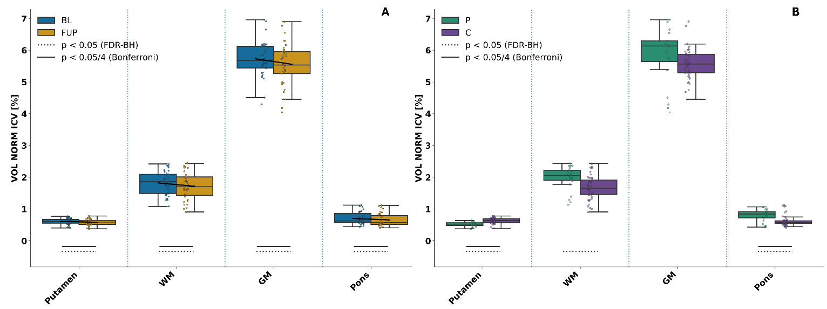
Figure S5. Volumetric atrophy over time after outlier exclusion.
Hemisphere-specific analysis of cortical thickness
We performed additional statistical analyses separately for the left (Table S5 and S6 for DK and Schafer atlas respectively) and for the right hemispheres (Tables S7 and S8 for DK and Schaefer, respectively), as well as for the putamen and cerebellar GM and WM in the volumetric analyses (Table S9 and Table S10, for left and right volumes, respectively). The overall thinning pattern showed full or partial concordance across bilateral and hemispheric-specific formulations. Only a limited number of cortical ROIs/networks showed asymmetrical longitudinal changes consistent with stronger effects in one hemisphere than the other (see Table S11, column “Formulation-specific”). For the volumetric analyses, the hemisphere-specific results were fully concordant with the bilateral findings for the putamen, cerebellar white matter, and cerebellar gray matter (see Table S11).

ROI | N | β | CI 95 % | tStat | f² Time | Change to Baseline [%] | p-Value
L superiorfrontal | 36 | -0,046 | [-0,072, -0,019] | -3,46 | 0,029 | -1,77 | <0.001
L caudalmiddlefrontal | 36 | -0,031 | [-0,057, -0,005] | -2,41 | 0,012 | -1,26 | 0.019
L rostralmiddlefrontal | 36 | -0,017 | [-0,039, 0,005] | -1,53 | 0,005 | -0,73 | 0.130
L parstriangularis | 36 | -0,008 | [-0,030, 0,015] | -0,69 | 0,001 | -0,33 | 0.496
L parsopercularis | 36 | -0,024 | [-0,049, 0,001] | -1,89 | 0,008 | -0,95 | 0.063
L parsorbitalis | 36 | -0,01 | [-0,038, 0,019] | -0,68 | 0,001 | -0,38 | 0.498
L lateralorbitofrontal | 36 | -0,025 | [-0,047, -0,004] | -2,34 | 0,018 | -1,02 | 0.022
L medialorbitofrontal | 36 | -0,036 | [-0,059, -0,012] | -3,06 | 0,024 | -1,54 | 0.003
L precentral | 36 | -0,04 | [-0,072, -0,009] | -2,54 | 0,014 | -1,63 | 0.013
L paracentral | 36 | -0,05 | [-0,081, -0,019] | -3,19 | 0,023 | -2,11 | 0.002
L superiorparietal | 36 | -0,025 | [-0,043, -0,006] | -2,7 | 0,013 | -1,12 | 0.009
L inferiorparietal | 36 | -0,035 | [-0,060, -0,009] | -2,7 | 0,022 | -1,45 | 0.009
L supramarginal | 36 | -0,02 | [-0,045, 0,005] | -1,6 | 0,008 | -0,81 | 0.114
L postcentral | 36 | -0,013 | [-0,033, 0,006] | -1,37 | 0,002 | -0,64 | 0.176
L precuneus | 36 | -0,042 | [-0,072, -0,012] | -2,77 | 0,035 | -1,79 | 0.007
L superiortemporal | 36 | -0,024 | [-0,049, 0,000] | -1,99 | 0,013 | -0,9 | 0.051
L middletemporal | 36 | -0,018 | [-0,045, 0,010] | -1,3 | 0,006 | -0,67 | 0.197
L inferiortemporal | 36 | -0,021 | [-0,051, 0,008] | -1,45 | 0,01 | -0,79 | 0.152
L fusiform | 36 | -0,032 | [-0,057, -0,006] | -2,5 | 0,021 | -1,22 | 0.015
L transversetemporal | 36 | 0,019 | [-0,022, 0,060] | 0,94 | 0,003 | 0,83 | 0.353
L parahippocampal | 36 | -0,022 | [-0,055, 0,011] | -1,32 | 0,002 | -0,82 | 0.193
L entorhinal | 36 | -0,047 | [-0,094, 0,000] | -1,98 | 0,018 | -1,61 | 0.051
L lateraloccipital | 36 | -0,015 | [-0,037, 0,006] | -1,41 | 0,006 | -0,7 | 0.163
L lingual | 36 | -0,012 | [-0,030, 0,007] | -1,23 | 0,004 | -0,59 | 0.223
L cuneus | 36 | -0,011 | [-0,035, 0,012] | -0,94 | 0,004 | -0,58 | 0.350
L pericalcarine | 36 | -0,016 | [-0,035, 0,003] | -1,7 | 0,008 | -1,02 | 0.094
L rostralanteriorcingulate | 36 | -0,038 | [-0,062, -0,014] | -3,15 | 0,02 | -1,42 | 0.002
L caudalanteriorcingulate | 36 | -0,034 | [-0,065, -0,003] | -2,21 | 0,013 | -1,38 | 0.031
L posteriorcingulate | 36 | -0,042 | [-0,066, -0,018] | -3,46 | 0,023 | -1,81 | <0.001
L isthmuscingulate | 36 | -0,052 | [-0,075, -0,029] | -4,47 | 0,038 | -2,27 | <0.001
L insula | 36 | -0,039 | [-0,065, -0,013] | -3,03 | 0,019 | -1,35 | 0.003
Table S5. LME results for the left CT ROIs in the DK atlas. Rows highlighted in bold depict Bonferroni corrected results.

ROI | N | β | CI 95 % | tStat | f² Time | Change to Baseline [%] | p-Value
L VisCent | 36 | -0,021 | [-0,041, -0,001] | -2,1 | 0,013 | -0,94 | 0.040
L VisPeri | 36 | -0,011 | [-0,028, 0,005] | -1,35 | 0,005 | -0,6 | 0.181
L SomMotA | 36 | -0,032 | [-0,057, -0,008] | -2,61 | 0,013 | -1,45 | 0.011
L SomMotB | 36 | -0,019 | [-0,040, 0,002] | -1,77 | 0,006 | -0,78 | 0.081
L DorsAttnA | 36 | -0,02 | [-0,041, 0,000] | -1,96 | 0,012 | -0,86 | 0.054
L DorsAttnB | 36 | -0,03 | [-0,053, -0,008] | -2,69 | 0,012 | -1,3 | 0.009
L SalVentAttnA | 36 | -0,04 | [-0,061, -0,018] | -3,67 | 0,038 | -1,56 | <0.001
L SalVentAttnB | 36 | -0,03 | [-0,052, -0,008] | -2,71 | 0,015 | -1,15 | 0.009
L LimbicA | 36 | -0,038 | [-0,072, -0,004] | -2,22 | 0,027 | -1,33 | 0.030
L LimbicB | 36 | -0,03 | [-0,046, -0,013] | -3,6 | 0,028 | -1,21 | <0.001
L ContA | 36 | -0,022 | [-0,039, -0,005] | -2,61 | 0,01 | -0,95 | 0.011
L ContB | 36 | -0,023 | [-0,042, -0,004] | -2,42 | 0,011 | -0,92 | 0.018
L ContC | 36 | -0,036 | [-0,060, -0,013] | -3,11 | 0,024 | -1,74 | 0.003
L DefaultA | 36 | -0,038 | [-0,056, -0,019] | -4,1 | 0,032 | -1,5 | <0.001
L DefaultB | 36 | -0,03 | [-0,047, -0,013] | -3,52 | 0,022 | -1,15 | <0.001
L DefaultC | 36 | -0,044 | [-0,067, -0,020] | -3,68 | 0,037 | -1,65 | <0.001
L TempPar | 36 | -0,015 | [-0,043, 0,013] | -1,08 | 0,004 | -0,56 | 0.286
Table S6. LME results for the left CT ROIs in the Schaefer atlas. Rows highlighted in bold depict Bonferroni corrected results.
ROI | N | β | CI 95 % | tStat | f² Time | Change to Baseline [%] | p-Value
R superiorfrontal | 36 | -0,043 | [-0,064, -0,021] | -4.00 | 0,04 | -1,69 | <0.001
R caudalmiddlefrontal | 36 | -0,049 | [-0,072, -0,027] | -4,39 | 0,034 | -2,01 | <0.001
R rostralmiddlefrontal | 36 | -0,019 | [-0,039, 0,000] | -2,02 | 0,009 | -0,85 | 0.047
R parstriangularis | 36 | -0,021 | [-0,047, 0,005] | -1,64 | 0,008 | -0,91 | 0.106
R parsopercularis | 36 | -0,027 | [-0,052, -0,001] | -2,11 | 0,009 | -1,09 | 0.038
R parsorbitalis | 36 | -0,04 | [-0,071, -0,009] | -2,59 | 0,017 | -1,56 | 0.012
R lateralorbitofrontal | 36 | -0,028 | [-0,049, -0,008] | -2,72 | 0,016 | -1,15 | 0.008
R medialorbitofrontal | 36 | -0,013 | [-0,040, 0,014] | -0,97 | 0,003 | -0,56 | 0.335
R precentral | 36 | -0,063 | [-0,099, -0,026] | -3,41 | 0,032 | -2,61 | 0.001
R paracentral | 36 | -0,037 | [-0,071, -0,004] | -2,22 | 0,011 | -1,57 | 0.030
R superiorparietal | 36 | -0,026 | [-0,056, 0,005] | -1,69 | 0,014 | -1,19 | 0.095
R inferiorparietal | 36 | -0,019 | [-0,049, 0,011] | -1,29 | 0,007 | -0,81 | 0.200
R supramarginal | 36 | -0,039 | [-0,069, -0,009] | -2,57 | 0,03 | -1,58 | 0.012
R postcentral | 36 | -0,037 | [-0,056, -0,017] | -3,77 | 0,015 | -1,75 | <0.001
R precuneus | 36 | -0,04 | [-0,067, -0,012] | -2,87 | 0,027 | -1,68 | 0.006
R superiortemporal | 36 | -0,025 | [-0,050, 0,001] | -1,94 | 0,011 | -0,91 | 0.057
R middletemporal | 36 | -0,016 | [-0,039, 0,007] | -1,39 | 0,005 | -0,59 | 0.169
R inferiortemporal | 36 | -0,027 | [-0,055, 0,000] | -1,96 | 0,017 | -1 | 0.054
R fusiform | 36 | -0,032 | [-0,056, -0,008] | -2,7 | 0,017 | -1,21 | 0.009
R transversetemporal | 36 | 0,001 | [-0,034, 0,035] | 0,03 | 0 | 0,03 | 0.972
R parahippocampal | 36 | -0,028 | [-0,060, 0,003] | -1,78 | 0,006 | -1,09 | 0.079
R entorhinal | 36 | -0,036 | [-0,077, 0,005] | -1,73 | 0,008 | -1,2 | 0.088
R lateraloccipital | 36 | -0,021 | [-0,047, 0,005] | -1,6 | 0,008 | -0,95 | 0.114
R lingual | 36 | -0,011 | [-0,028, 0,006] | -1,24 | 0,003 | -0,54 | 0.220
R cuneus | 36 | -0,012 | [-0,028, 0,003] | -1,56 | 0,002 | -0,64 | 0.123
R pericalcarine | 36 | -0,015 | [-0,033, 0,004] | -1,58 | 0,004 | -0,9 | 0.118
R rostralanteriorcingulate | 36 | -0,026 | [-0,058, 0,007] | -1,6 | 0,008 | -1,01 | 0.115
R caudalanteriorcingulate | 36 | -0,018 | [-0,040, 0,005] | -1,55 | 0,005 | -0,77 | 0.126
R posteriorcingulate | 36 | -0,024 | [-0,045, -0,003] | -2,3 | 0,014 | -1,05 | 0.024
R isthmuscingulate | 36 | -0,04 | [-0,061, -0,018] | -3,59 | 0,034 | -1,76 | <0.001
R insula | 36 | -0,043 | [-0,070, -0,016] | -3,22 | 0,023 | -1,51 | 0.002
Table S7. LME results for the right CT ROIs in the Schaefer atlas. Rows highlighted in bold depict Bonferroni corrected results.
ROI | N | β | CI 95 % | tStat | f² Time | Change to Baseline [%] | p-Value
R VisCent | 36 | -0,018 | [-0,040, 0,004] | -1,63 | 0,008 | -0,83 | 0.107
R VisPeri | 36 | -0,02 | [-0,035, -0,005] | -2,65 | 0,01 | -0,99 | 0.010
R SomMotA | 36 | -0,056 | [-0,080, -0,031] | -4,49 | 0,04 | -2,54 | <0.001
R SomMotB | 36 | -0,035 | [-0,057, -0,013] | -3,17 | 0,021 | -1,39 | 0.002
R DorsAttnA | 36 | -0,028 | [-0,056, 0,000] | -2,01 | 0,023 | -1,21 | 0.049
R DorsAttnB | 36 | -0,031 | [-0,060, -0,002] | -2,14 | 0,018 | -1,33 | 0.036
R SalVentAttnA | 36 | -0,044 | [-0,066, -0,021] | -3,86 | 0,037 | -1,69 | <0.001
R SalVentAttnB | 36 | -0,035 | [-0,053, -0,017] | -3,84 | 0,03 | -1,43 | <0.001
R LimbicA | 36 | -0,028 | [-0,062, 0,006] | -1,63 | 0,011 | -0,96 | 0.107
R LimbicB | 36 | -0,017 | [-0,040, 0,006] | -1,49 | 0,008 | -0,7 | 0.140
R ContA | 36 | -0,029 | [-0,047, -0,012] | -3,29 | 0,023 | -1,29 | 0.002
R ContB | 36 | -0,027 | [-0,043, -0,010] | -3,25 | 0,016 | -1,09 | 0.002
R ContC | 36 | -0,041 | [-0,067, -0,014] | -3,05 | 0,042 | -1,83 | 0.003
R DefaultA | 36 | -0,025 | [-0,040, -0,011] | -3,47 | 0,021 | -1,01 | <0.001
R DefaultB | 36 | -0,027 | [-0,046, -0,007] | -2,74 | 0,014 | -0,99 | 0.008
R DefaultC | 36 | -0,038 | [-0,064, -0,013] | -3,01 | 0,036 | -1,51 | 0.004
R TempPar | 36 | -0,029 | [-0,060, 0,002] | -1,87 | 0,015 | -1,11 | 0.065

Table S8. LME results for the right CT ROIs in the Schaefer atlas. Rows highlighted in bold depict Bonferroni corrected results.

A | N | β Time | CI 95 % | T Stat |  | f² Time |  | Change to baseline  [% ICV] | p-Value
L Putamen | 36 | -0,014 | [-0,019, -0,010] |  | -6,33 | 0,034 | -4,74 |  |  | <0.001
L WM | 36 | -0,054 | [-0,080, -0,028] |  | -4,18 | 0,022 | -5,74 |  |  | <0.001
L GM | 36 | -0,113 | [-0,174, -0,052] |  | -3,72 | 0,025 | -3,87 |  |  | <0.001
B |  | β Phenotype |  |  |  | f² Phenotype | MSA-P vs MSA-C  [% ICV]
L Putamen | 36 | -0,05 | [-0,080, -0,020] |  | -3,75 | 0,38 | -16,4 |  |  | <0.001
L WM | 36 | 0,13 | [0,000, 0,260] |  | 1,92 | 0,1 | 14,61 |  |  | 0.060
L GM | 36 | 0,22 | [-0,040, 0,470] |  | 1,72 | 0,08 | 7,91 |  |  | 0.090
Table S9. LME results for volumetric measures in the left hemisphere. Rows highlighted in bold depict Bonferroni corrected results.

A | N | β Time | CI 95 % | T Stat |  | f² Time |  | Change to baseline  [% ICV] | p-Value
R Putamen | 36 | -0,01 | [-0,014, -0,006] |  | -5,2 | 0,015 | -3,6 |  |  | <0.001
R WM | 36 | -0,049 | [-0,071, -0,026] |  | -4,29 | 0,017 | -5,26 |  |  | <0.001
R GM | 36 | -0,093 | [-0,148, -0,037] |  | -3,34 | 0,014 | -3,21 |  |  | 0.001
B |  | β Phenotype |  |  |  | f² Phenotype | MSA-P vs MSA-C  [% ICV]
R Putamen | 36 | -0,07 | [-0,100, -0,040] |  | -4,53 | 0,57 | -22 |  |  | <0.001
R WM | 36 | 0,15 | [0,020, 0,290] |  | 2,28 | 0,14 | 18,44 |  |  | 0.030
R GM | 36 | 0,26 | [-0,010, 0,540] |  | 1,89 | 0,1 | 9,76 |  |  | 0.060
Table S10. LME results for volumetric measures in the right hemisphere. Rows highlighted in bold depict Bonferroni corrected results.

Atlas | Correction | Fully concordant | Partially concordant | Formulation-specific | Not significant
DK | Bonferroni | bilateral+left+right: isthmuscingulate; superiorfrontal | bilateral+left: posteriorcingulate  bilateral+right: caudalmiddlefrontal; precentral  left+right: — | bilateral only: insula  left only: —  right only: postcentral | none: caudalanteriorcingulate; cuneus; entorhinal; fusiform; inferiorparietal; inferiortemporal; lateraloccipital; lateralorbitofrontal; lingual; medialorbitofrontal; middletemporal; paracentral; parahippocampal; parsopercularis; parsorbitalis; parstriangularis; pericalcarine; precuneus; rostralanteriorcingulate; rostralmiddlefrontal; superiorparietal; superiortemporal; supramarginal; transversetemporal
Schaefer | Bonferroni | bilateral+left+right: DefaultA; SalVentAttnA | bilateral+left: ContC; DefaultB; DefaultC  bilateral+right: ContA; ContB; SalVentAttnB; SomMotA  left+right: — | bilateral only: —  left only: LimbicB  right only: SomMotB | none: DorsAttnA; DorsAttnB; LimbicA; TempPar; VisCent; VisPeri
Volume | Bonferroni | bilateral+left+right: CerebellumCortex; CerebellumWhiteMatter; Putamen | bilateral+left: —  bilateral+right: —  left+right: — | bilateral only: —  left only: —  right only: — | none: —
Table S11. Hemisphere-specific recap of ROI/network significance patterns in the analysis with outliers. Fully concordant findings were significant in bilateral, left, and right analyses. Partially concordant findings were significant in two of the three possible formulations (i.e., bilateral + left, bilateral + right or left + right. Formulation-specific findings were significant in only one formulation (i.e. bilateral only, left only or right only). Not significant indicates lack of significance in bilateral, left, and right analyses. Results are shown separately for the DK atlas and Schaefer networks under FDR and Bonferroni correction.

References
1. Fabbri, M. et al. Disease Progression in Multiple System Atrophy: The ASPIRE Multi-Modal Biomarker Study. Ann. Neurol. https://doi.org/10.1002/ana.70028 (2025) doi:10.1002/ana.70028.
2. Liu, M., Wang, Z. & Shang, H. Multiple system atrophy: an update and emerging directions of biomarkers and clinical trials. Journal of Neurology vol. 271 2324–2344 Preprint at https://doi.org/10.1007/s00415-024-12269-5 (2024).
3. Wenning, G. K. et al. The Movement Disorder Society Criteria for the Diagnosis of Multiple System Atrophy. Movement Disorders vol. 37 1131–1148 Preprint at https://doi.org/10.1002/mds.29005 (2022).
4. Worker, A. et al. Cortical thickness, surface area and volume measures in Parkinson’s disease, multiple system atrophy and progressive supranuclear palsy. PLoS One 9, (2014).
5. Yao, Q. et al. Altered functional and causal connectivity of cerebello-cortical circuits between multiple system atrophy (parkinsonian type) and Parkinson’s disease. Front. Aging Neurosci. 9, (2017).
6. Kim, J. S. et al. Topographic distribution of cortical thinning in subtypes of multiple system atrophy. Parkinsonism Relat. Disord. 19, 970–974 (2013).

