Supplementary Table 1. Relation between asthma control by GINA criteria and three different modifiable factors associated with poor control.

 |  | Adequate prescription |  | Inadequate prescription |  | Total |  | OR (95%CI) | p
 |  | n | % | n | % | n | %
Asthma control | Control | 405 | 37.7 | 42 | 7.0 | 447 | 26.7 | 8.05 (5.74-11.27) | <0,0001
Asthma control | Poor control | 670 | 62.3 | 559 | 93.0 | 1229 | 73.3 | 8.05 (5.74-11.27) | <0,0001
Asthma control | Total | 1075 | 100.0 | 601 | 100 | 1676 | 100.0

 |  | Good adherence (TAI) |  | Poor adherence (TAI) |  | Total |  | OR (95%CI) | p
 |  | n | % | n | % | n | %
Asthma control (GINA) | Control | 128 | 33.8 | 306 | 24.4 | 434 | 26.5 | 1.58 (1.23-2.03) | <0,0001
Asthma control (GINA) | Poor control | 251 | 66.2 | 950 | 75.6 | 1201 | 73.5 | 1.58 (1.23-2.03) | <0,0001
Asthma control (GINA) | Total | 379 | 100.0 | 1256 | 100 | 1635 | 100.0

 |  | No errors |  | ≥1 error |  | Total |  | OR (95%CI) | p
 |  | n | % | n | % | n | %
Asthma control (GINA) | Control | 423 | 30.4 | 24 | 8.4 | 447 | 26.7 | 4.76 (3.08-7.34) | <0,0001
Asthma control (GINA) | Poor control | 967 | 69.6 | 261 | 91.6 | 1228 | 73.3 | 4.76 (3.08-7.34) | <0,0001
Asthma control (GINA) | Total | 1390 | 100.0 | 285 | 100 | 1675 | 100.0
GINA: Global Initiative for Asthma. TAI: Test of Adherence to Inhalers.
Supplementary Table 2. Relation between asthma control by GINA criteria and modifiable factors associated with poor control and these factors between them.

Modified factor |  | Control  (GINA criteria) |  | OR (95%CI) | n | p
 |  | Poor | Good
Prescription | Inadequate (A) | 559 (93.0%) | 42 (7.0%) | 8.05 (5.74-11.27) | 601 | <0.0001
Adherence (TAI) | Poor (B) | 950 (75.6%) | 306 (24.4%) | 1.58 (1.23-2.03) | 1256 | <0.0001
Critical mistakes | One or more (C) | 261 (91.6%) | 24 (8.4%) | 4.76 (3.08-7.34) | 285 | <0.0001
A+B |  | 440 (35.8%) | 27 (6.0%) | 8.66 (5.77-13.0) | 1677 | <0.0001
A+C |  | 130 (10.6%) | 1 (0.8%) | 52.7 (7.34-378.0) | 1677 | <0.0001
B+C |  | 220 (17.9%) | 18 (4.0%) | 5.19 (3.16-8.5) | 1677 | <0.0001
A+B+C |  | 108 (100.0%) | 0 (0.0%) |  | 1673 | <0.0001
GINA: Global Initiative for Asthma. TAI: Test of Adherence to Inhalers.
Supplementary Figure 1. Schematic representation of the relationship between three modifiable factors associated with poor control (data details in Supplementary Table 2).
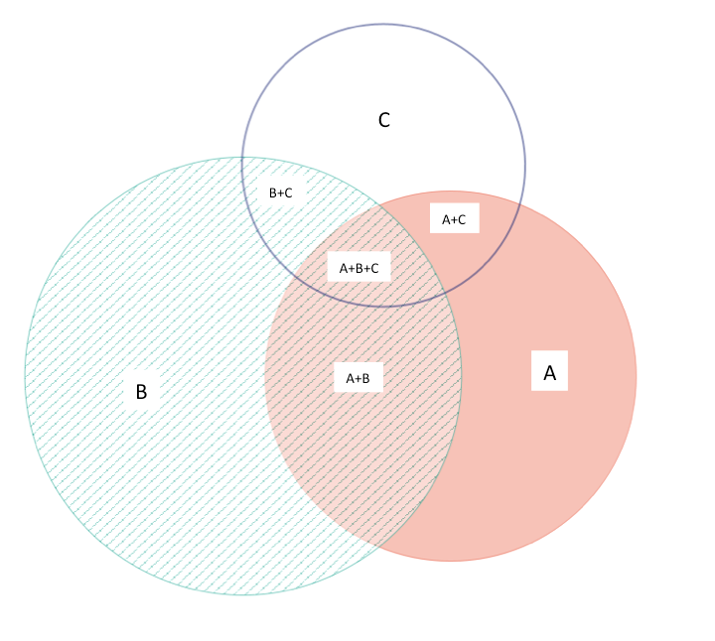
A: Inadequate prescription

B: Poor adherence

C One or more critical mistakes

Supplementary Figure 2. Binary logistic regression model with poor asthma control by GINA as dependent variable.

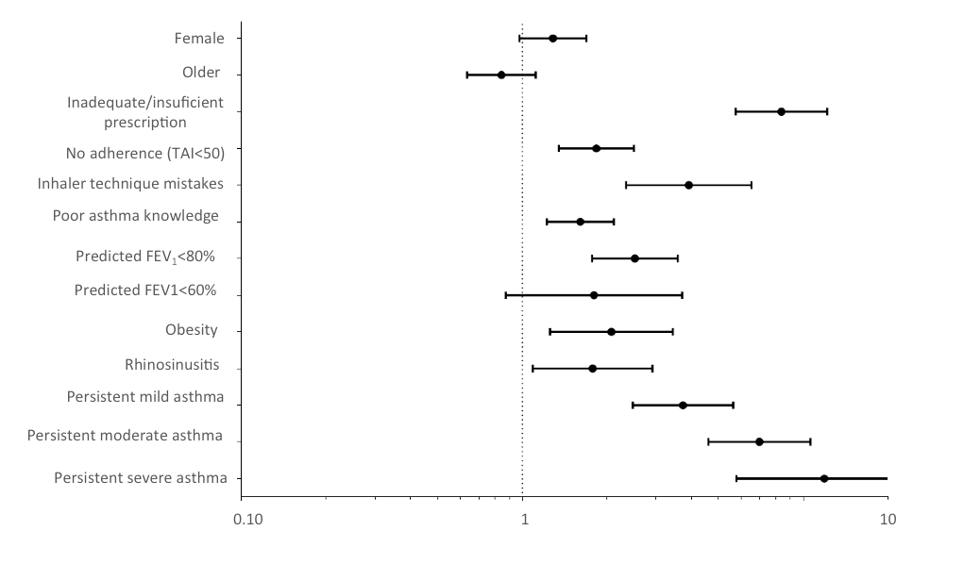

Forced Expiratory Volume in one second. GINA: Global Initiative for Asthma. TAI: Test of Adherence to Inhalers.

Supplementary Table 3. ASTHMA KNOWLEDGE QUESTIONNAIRE (Self-administered)

This questionnaire has been developed based on the self-administered asthma knowledge questionnaire included in the 2009 GEMA Educators Guide. Available from: http://www.seicap.es/gema-educadores_30428.pdf.

Is asthma a chronic disease? | Yes | No
Is asthma a curable disease? | Yes | No
Is inflammation the main characteristic of asthma? | Yes | No
Can you do sports? | Yes | No
Are bronchodilators the main treatment? | Yes | No
Do all patients have the same symptoms? | Yes | No
Are anti-inflammatories used only to treat exacerbations? | Yes | No
Can you remain stable with hardly any symptoms? | Yes | No
When you are well, can you stop the anti-inflammatory medication? | Yes | No
Should you always carry bronchodilator medication? | Yes | No

