Supplementary Information
Magnetism of graphene quantum dots
Yuanyuan Sun^{1,2}, Yongping Zheng¹, Hongzhe Pan¹, Jie Chen¹, Weili Zhang¹, Lin Fu¹, Kaiyu Zhang¹, Nujiang Tang¹ and Youwei Du¹
¹National Laboratory of Solid State Microstructures, Collaborative Innovation Center of Advanced Microstructures, Jiangsu Provincial Key Laboratory for Nanotechnology, Nanjing University, Nanjing 210093, China
²Institute of Condensed Matter Physics, School of Science, Linyi University, Linyi 276000, China
Correspondence: N.J. Tang (tangnujiang@nju.edu.cn)

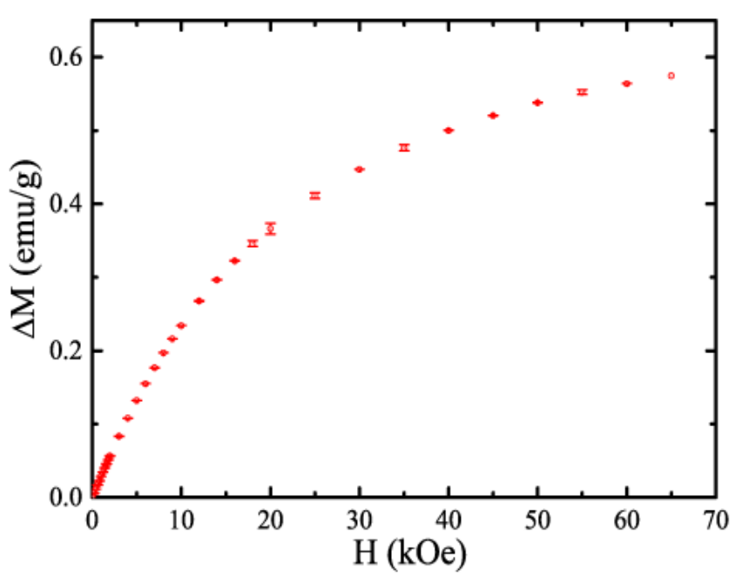
Figure S1. The ΔM–H curve of GQDs at 2 K with error bars. The error bars are given by repeating the measurements.

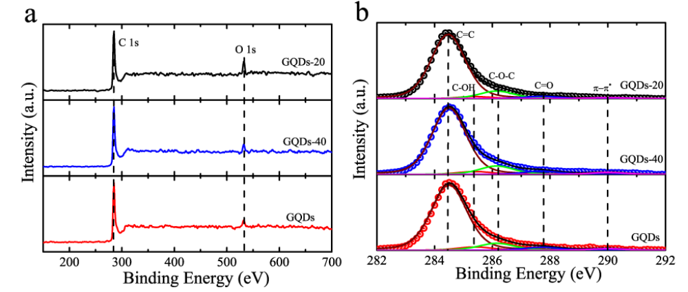
Figure S2. (a) XPS spectra over a wide range of binding energies (150–700 eV) and (b) Fine-scanned C 1s XPS spectra of GQDs-20, GQDs-40 and GQDs.

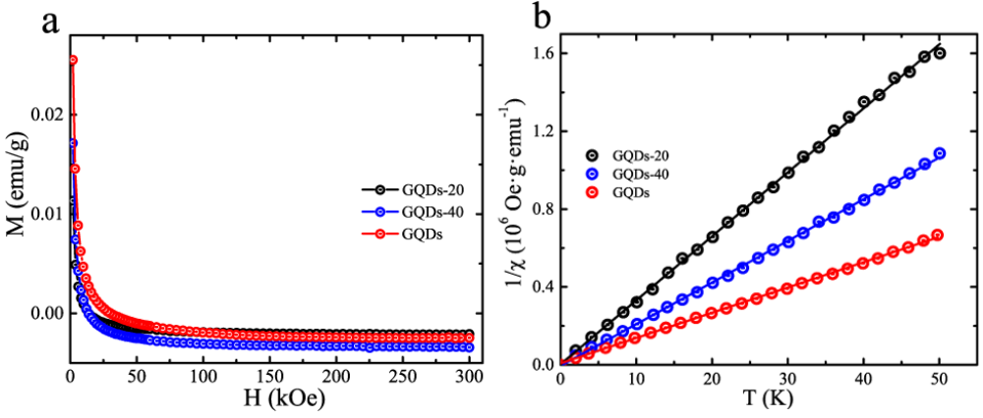
Figure S3. Magnetic properties of GQDs-20, GQDs-40 and GQDs. (a) M–T and (b) 1/χ –T under the applied field H = 1 kOe. The round symbols are the measurements and the solid lines are fitted by the Curie law.

