Supplemental Table 1. Demographics of original 12 schizophrenia and 12 control and additional 8 schizophrenia and 8 control subject pairs
Diagnosis | Sex | Age (y) | Medication | PMI (m) | pH | Rs1130214 | Rs2494732
Control | F | 74 | no antipsychotic | 180 | 6.0 | T/G | C/C
Schizophrenia | F | 74 | haloperidol | 417 | 6.3 | T/G | T/T
Control | F | 84 | no antipsychotic | 1110 | 6.21 | T/T | C/C
Schizophrenia | F | 86 | haloperidol | 1092 | 5.8 | T/G | C/T
Control | F | 78 | no antipsychotic | 600 | 6.19 | T/G | C/T
Schizophrenia | F | 77 | risperidone | 583 | 6.01 | G/G | T/T
Control | F | 80 | no antipsychotic | 285 | 6.2 | G/G | C/T
Schizophrenia | F | 80 | thiothixene, chlorpromazine | 415 | 5.8 | T/G | C/T
Control | M | 95 | no antipsychotic | 245 | 6.53 | T/G | C/T
Schizophrenia | M | 97 | haloperidol | 555 | 6.5 | T/T | C/C
Control | M | 59 | no antipsychotic | 1225 | 6.63 | G/G | C/T
Schizophrenia | M | 57 | unknown | 1220 | 6.1 | T/G | C/C
Control | F | 88 | no antipsychotic | 305 | 6.4 | G/G | T/T
Schizophrenia | F | 90 | haloperidol, olanzapine | 465 | 5.97 | G/G | C/T
Control | F | 66 | no antipsychotic | 960 | 6.51 | G/G | C/T
Schizophrenia | F | 69 | thioridazine | 820 | 6.2 | G/G | C/C
Control | M | 69 | no antipsychotic | 255 | 6.3 | T/T | C/T
Schizophrenia | M | 68 | no antipsychotic* | 534 | 6.27 | T/G | C/T
Control | M | 65 | no antipsychotic | 230 | 6.82 | G/G | T/T
Schizophrenia | M | 63 | haloperidol | 372 | 5.9 | T/G | C/C
Control | M | 72 | no antipsychotic | 720 | 6.6 | T/G | T/T
Schizophrenia | M | 73 | haloperidol  fluphenazine | 475 | 6.5 | T/G | T/T
Control | M | 66 | no antipsychotic | 454 | 6.58 | T/G | C/T
Schizophrenia | M | 66 | no antipsychotic* | 725 | 6.5 | G/G | C/C
Diagnosis | Sex | Age (y) | Medication | PMI (m) | pH | Rs1130214 | Rs2494732
Control  Schizophrenia | F  F | 79  81 | no antipsychotic  risperidone  olanzapine | 431  750 | 5.72  5.93 | T/G  T/G | T/T  C/C
Control  Schizophrenia | F  F | 86  82 | no antipsychotic  haloperidol  olanzapine | 610  530 | N/A  5.89 | T/G  G/G | C/T  C/T
Control  Schizophrenia | M  M | 64  70 | no antipsychotic  haloperidol | 624  855 | 6.12  6.49 | T/G  T/G | C/T  C/C
Control  Schizophrenia | M  M | 70  70 | no antipsychotic  thiothixene  olanzapine | 1430  1038 | 6.04  6.36 | G/G  G/G | C/C  C/T
Control  Schizophrenia | M  M | 71  73 | no antipsychotic  no antipsychotic* | 1285  430 | N/A  6.35 | G/G  T/G | C/T  C/T
Control  Schizophrenia | M  M | 73  73 | no antipsychotic  risperidone | 1264  525 | 6.94  6.15 | G/G  G/G | T/T  C/T
Control  Schizophrenia | M  M | 78  75 | no antipsychotic  no antipsychotic* | 485  345 | N/A  5.85 | G/G  T/G | T/T  U
Control  Schizophrenia | M  M | 79  77 | no antipsychotic  risperidone,  olanzapine | 964  1440 | N/A  6.4 | G/G  T/G | T/T  C/C
Abbreviations: Female (F), Male (M), years (y), minutes (m), Postmortem Interval (PMI), not available (N/A), undetermined “U”. Rs1130214 and Rs2494732 are single nucleotide polymorphisms (SNPs) of protein kinase B (AKT), G/G, T/G, T/T C/T, and C/C are the genotypes for each SNP. *indicates off all antipsychotic medications within 6 weeks of death.
Supplemental table 2. 19 peptide substrates differentially phosphorylated in schizophrenia versus control subjects on the Pamgene kinome array
Peptide  Increased | Fold  Change | Abbreviation | Uniprot  Accession
G-protein signaling modulator 2 | 1.329 | GPSM2 |  | P81274
Phosphorylase b kinase alpha M subunit | 1.295 | PHKA1 |  | P46020
Cystic fibrosis transmembrane conductance regulator | 1.263 | CFTR |  | P13569
β-2 adrenergic receptor | 1.250 | ADRB2 |  | P07550
cAMP-responsive element-binding protein | 1.221 | CREB1 |  | P16220
Macrophage colony-stimulating  factor 1 receptor | 1.217 | CSF1R |  | P07333
Annexin 1 | 1.204 | ANXA1 |  | P04083
Vasodilator-stimulated  phosphoprotein | 1.192 | VASP |  | P50552
Erythrocyte protein 4.2 | 1.185 | EPB42 |  | P16452
Protein tyrosine kinase 6 | 1.180 | PTK6 |  | Q13882
G-protein coupled receptor 6 | 1.164 | GPR6 |  | P46095
Phospholemman ion transport regulator | 1.156 | FXYD1 |  | O00168
Proto-oncogene c-Rel | 1.152 | REL |  | Q04864
Vitronectin adhesion molecule | 1.152 | VTN |  | P04004
Peptide  Decreased | Fold Change | Abbreviation | Uniprot  Accession
Ets-domain containing protein | -1.446 | ELK1 |  | P19419
Myelin basic protein | -1.300 | MBP |  | P02686
E3 ubiquitin ligase | -1.277 | CBL |  | P22681
Serine/threonine protein kinase 2 | -1.242 | CHEK2 |  | O96017
Tyrosine protein kinase | -1.173 | ZAP70 |  | P43403
14 peptides exhibited a 1.15-fold or more increase in kinase activity while 5 exhibited a 1.15-fold or more decrease in phosphorylation.

Supplemental table 3. 16 peptide substrates differentially phosphorylated in rats treated chronically with haloperidol versus untreated rats on the Pamgene kinome array
Peptide  Increased | Fold  Change | Abbreviation |  | Uniprot  Accession
NIMA-related kinase 3 | 1.18 | NEK3 |  |  | P51956
Peptide  Decreased | Fold Change | Abbreviation |  | Uniprot  Accession
Raf-1 proto-oncogene | -1.625 | RAF1 |  |  | P04049
CD27 molecule | -1.501 | CD27 |  |  | P26842
Cystic fibrosis transmembrane conductance regulator (ATP-binding cassette sub-family C, member 7) | -1.371 | CFTR |  |  | P13569
RAP1B, member of RAS oncogene family | -1.305 | RAP1B |  |  | P61224
Protein kinase C, beta | -1.287 | PRKCB |  |  | P05771-2
Vasodilator-stimulated phosphoprotein | -1.283 | VASP |  |  | P50552
Neutrophil cytosolic factor 1 | -1.252 | NCF1 |  |  | P14598
Stathmin 2 | -1.230 | STMN2 |  |  | Q93045
Annexin A1 | -1.222 | ANXA1 |  |  | P04083
Glycogen synthase 2 (liver) | -1.216 | GYS2 |  |  | P54840
histone cluster 1, H2bb | -1.213 | HIST1H2BB |  |  | P33778
microtubule-associated protein tau | -1.206 | MAPT |  |  | P10636
v-rel avian reticuloendotheliosis viral oncogene homolog | -1.777 | REL |  |  | Q04864
tyrosine hydroxylase | -1.161 | TH |  |  | P07101
vitronectin | -1.161 | VTN |  |  | P04004

1 peptide exhibited a 1.15-fold or more increase in kinase activity while 15 exhibited a 1.15-fold decrease in phosphorylation.
Supplemental Table 4. Predicted kinases and distributions for schizophrenia and haloperidol datasets
Schizophrenia
Kinase | Observed Hits | Distribution Mean | Standard Deviation | Z-score | Confidence Interval
Confidence Interval ≥ 2 STD
PAK | 12 | 3.60 | 1.63 | 5.15 | 0.34 to 6.85
PKD | 5 | 1.62 | 1.13 | 2.99 | -0.64 to 3.88
GRK | 13 | 7.03 | 2.00 | 2.99 | 3.03 to 11.02
DMPK | 10 | 5.17 | 1.90 | 2.54 | 1.37 to 8.97
CK | 7 | 3.29 | 1.50 | 2.47 | 0.28 to 6.30
PKA | 12 | 7.20 | 1.95 | 2.46 | 3.29 to 11.10
NEK | 3 | 0.88 | 0.87 | 2.44 | -0.87 to 2.62
Confidence Interval between 1.5-2.0 STD
PKC | 12 | 8.09 | 2.01 | 1.95 | 5.07 to 11.12
CHK1 | 1 | 4.04 | 1.68 | -1.81 | 1.52 to 6.55
CAMK4 | 4 | 1.91 | 1.22 | 1.71 | 0.09 to 3.74
AKT | 7 | 4.37 | 1.71 | 1.54 | 1.81 to 6.92
JNK | 6 | 9.04 | 2.01 | -1.51 | 6.02 to 12.05
PKG | 8 | 5.20 | 1.86 | 1.51 | 2.41 to 7.99
SGK | 5 | 2.81 | 1.46 | 1.50 | 0.62 to 4.99
Haloperidol
Kinase | Observed Hits | Distribution Mean | Standard Deviation | Z-score | Confidence Interval
Confidence Interval ≥ 2 STD
AKT | 10 | 3.65 | 1.59 | 3.99 | 0.46 to 6.84
PKA | 12 | 6.11 | 1.87 | 3.15 | 2.36 to 9.85
DMPK | 8 | 4.31 | 1.66 | 2.22 | 0.99 to 7.64
Confidence Interval between 1.5-2.0 STD
CDK | 5 | 8.43 | 1.88 | -1.82 | 5.61 to 11.25
RSK | 11 | 7.56 | 1.90 | 1.81 | 4.71 to 10.41
p38 | 3 | 6.10 | 1.77 | -1.75 | 3.44 to 8.76
ILK | 1 | 0.23 | 0.44 | 1.75 | -0.44 to 0.89
PKG | 7 | 4.27 | 1.66 | 1.64 | 1.77 to 6.77
CAMK2 | 8 | 5.19 | 1.73 | 1.62 | 2.60 to 7.79
CHK1 | 1 | 3.39 | 1.52 | -1.57 | 1.11 to 5.66
PRKX | 3 | 1.33 | 1.06 | 1.58 | -0.26 to 2.92
Abbreviations: Calcium/calmodulin-dependent protein kinase type 4 (CAMK4); calcium/calmodulin-dependent protein kinase type 2 (CAMK2); G-protein coupled receptor kinase (GRK); p21-activated kinase (PAK); protein kinase B (AKT); protein kinase D (PKD); casein kinase (CK); dystrophia myotonica-protein kinase (DMPK); never in mitosis gene A-related kinase (NEK); mechanistic target of rapamycin (mTOR); death-associated protein kinase (DAPK); protein kinase A (PKA); protein kinase G (PKG); protein kinase C (PKC); protein kinase, X-linked (PRKX); cyclin-dependent kinase (CDK); checkpoint kinase 1 (CHK1); c-Jun N-terminal kinase (JNK); serine/threonine-protein kinase (SGK); ribosomal s6 kinase (RSK); p38 mitogen-activated protein kinase (p38); integrin-linked kinase (ILK); standard deviation (STD).
Supplemental Table 5. IPA analyses
Schizophrenia (Molecular and cellular functions associated with kinase networks)
Functions | p-value | Associated kinases
Phosphorylation of protein | 1.99E-57 | GRK; CDK; CK; DMPK; LRRK2; JNK; PAK; PKA; PKC; RAF; CAMKK2; EGFR; MEK; ERK; PDK1; SRC; AKT; GSK3; p38; TGFBR
Organization of cytoplasm | 1.10E-25 | GRK; CK; GSK3; JNK; p38; PAK; PDK1; PKA; PKC; SRC; AKT; LRRK2; NEK; PKD;TBK1; DMPK; EGFR; MEK; ERK; PLK1; TGFBR; CDK; GIT1; RAF
Organization of cytoskeleton | 2.45E-24 | GRK; CK; GSK3; JNK; p38; PAK; PDK1; PKC; PKD; TGFBR; AKT;LRRK2; NEK; RAF; DMPK; EGFR; MEK; ERK; PKA; SRC; CDK; GIT1; TBK1
Microtubule dynamics | 2.47E-20 | AKT; DMPK; CDK5; CK; EGFR; GIT1; GSK3; LRRK2; MEK; ERK; p38; JNK; NEK; PAK; PKA; PKC; SRC; TGFBR; RAF; TBK1
Neurite growth | 6.13E-17 | AKT; CDK; CK; EGFR; GSK3; LRRK2; MEK; ERK; JNK; PAK; PKA; PKC; RAF; SRC
Neuronal differentiation | 3.7E-10 | AKT; ATM; CDK; EGFR; GSK3; MEK; ERK; p38; JNK; PAK; PKC; SRC
Long-term potentiation | 5.57E-09 | CAMKK2; EGFR; GSK3; MEK; ERK; PAK; PKA
Haloperidol (Molecular and cellular functions associated with kinase networks)
Phosphorylation of protein | 1.36E-38 | AKT; DMPK; GSK3; IKK; LRRK2; INSR; JNK; PDK1; PI3K; PKA; PKC; RAF; RIPK; SYK; SRC
cell viability | 9.06E-26 | AKT; DMPK; GSK3; IKK; INSR; LRRK2; JNK; PDK1; PI3K; PKA; PKC; RAF; RIPK; SRC; SYK; TBK1
Cell viability of B lymphocytes | 3.48E-17 | AKT; IKK; PDK1; PI3K; PKC; SYK
Platelet aggregation | 9.25E-16 | AKT; GSK3; PDK1; PI3K; PKA; PKC; SYK
Differentiation of cells | 1.57E-15 | AKT; GSK3; IKK; LRRK2; JNK; PDK1; PI3K; PKA; PKC; RAF; RIPK; SRC; SYK
Proliferation of immune cells | 4.55E-14 | AKT; GSK3; IKK; JNK; PI3K; PKA; PKC; SRC; SYK
Inflammatory response | 2.83E-13 | AKT; IKK; LRRK2; JNK; PI3K; PKA; PKC; SRC; SYK; TBK1
Cell movement of phagocytes | 6.92E-13 | AKT; IKK; LRRK2; JNK; PI3K; PKA; SYK
Schizophrenia (Canonical pathways)
Canonical signaling | p-value | Associated kinases
ErbB signaling | 3.47E-43 | AKT; ATM; EGFR; GSK3; MEK; ERK; JNK; p38; PAK; PDK1; PKC; PKD; RAF
Molecular mechanisms of cancer | 4.31E-41 | AKT; ATM; CDK; GSK3; MEK; ERK; JNK; p38; PAK; PKA; PKC; PKD; RAF; SRC; TGFBR
GNRH signaling | 1.94E-38 | EGFR; MEK; ERK; JNK; p38; PAK; PKA; PKC; PKD; RAF; SRC
Renin angiotensin signaling | 3.62E-38 | ATM; MEK; ERK; JNK; p38; PAK; PKA; PKC; PKD; RAF
Pyroxidol 5’-phosphate salvage | 5.55E-37 | AKT; CDK; CK; DMPK; MEK; ERK; JNK; NEK; PAK; PLK1; PKC
Haloperidol (Canonical pathways)
NFAT in cardiac hypertrophy | 5.9E-43 | AKT; GSK3; JNK; PI3K; PKA; PKC; RAF; SRC
RAR activation | 8.71E-41 | AKT; JNK; PDK1; PI3K; PKA; PKC; SRC
Gβγ signaling | 2.46E-38 | AKT; PDK1; PI3K; PKA; PKC; RAF; SRC
P2Y purigenic signaling | 8.19E-38 | AKT; RAF; PKC; PKA; PI3K
Gap junction signaling | 1.69 E-37 | AKT; PI3K; PKA; PKC; RAF; SRC

Ingenuity Pathway results for schizophrenia and haloperidol network kinases ranked by p-value.

Supplemental Table 6. Kinase network regulation
Schizophrenia (Kinase network regulation)
Name | Abbreviation | p-value
Tumor protein 53 | p53 | 2.94E-14 | Apoptosis; senescence; DNA repair; changes in metabolism
Amyloid precursor protein | APP | 3.76E-14 | axon cargo transport; cell adhesion; apoptosis; platelet activation
Src proto-oncogene | Src | 2.5E-11 | cell-cell adhesion; cell cycle; cell migration; proliferation
Glucocorticoid receptor α 2 | NR3C1 | 1.44E-09 | inflammatory responses; proliferation; differentiation
Harvey rat sarcoma viral oncogene | HRAS | 2.61E-09 | Actin cytoskeletal organization, apoptosis; senescence;
Phosphatase and tensin homolog | PTEN | 1.52E-08 | Apoptosis; myelin maintenance; spine morphogenesis; angiogenesis
Epidermal growth factor | EGF | 4.81E-08 | Angiogenesis; coagulation; migration; ERK signaling
Haloperidol (Kinase network regulation)
Glucocorticoid receptor α2 | NR3C1 | 1.53E-13 | inflammatory responses; proliferation; differentiation
proinsulin | Ins1 | 3.79E-09 | chaperone binding; hormone activity
Microtubule associated protein 2 | MAP2 | 5.40E-09 | microtubule assembly
Tripartite motif containing 41 | TRIM41 | 5.4E-09 | Ubiquitination; protein kinase C signaling
Tumor protein 53 | TP53 | 4.17E-08 | Apoptosis; senescence; DNA repair; changes in metabolism
Amyloid β precursor protein | APP | 4.44E-08 | axon cargo transport; cell adhesion; apoptosis; platelet activation
SRC proto-oncogene | SRC | 5.63E-08 | cell-cell adhesion; cell cycle; cell migration; proliferation
Growth factor independent 1 transcription repressor | GFI1 | 6.77E-07 | Histone modification; transcription regulation
Neural retina leucine zipper | NRL | 1.52E-06 | Transcription regulation
phospholamban | PLN | 3.09E-06 | calcium ion transport; ATPase inhibitor activity

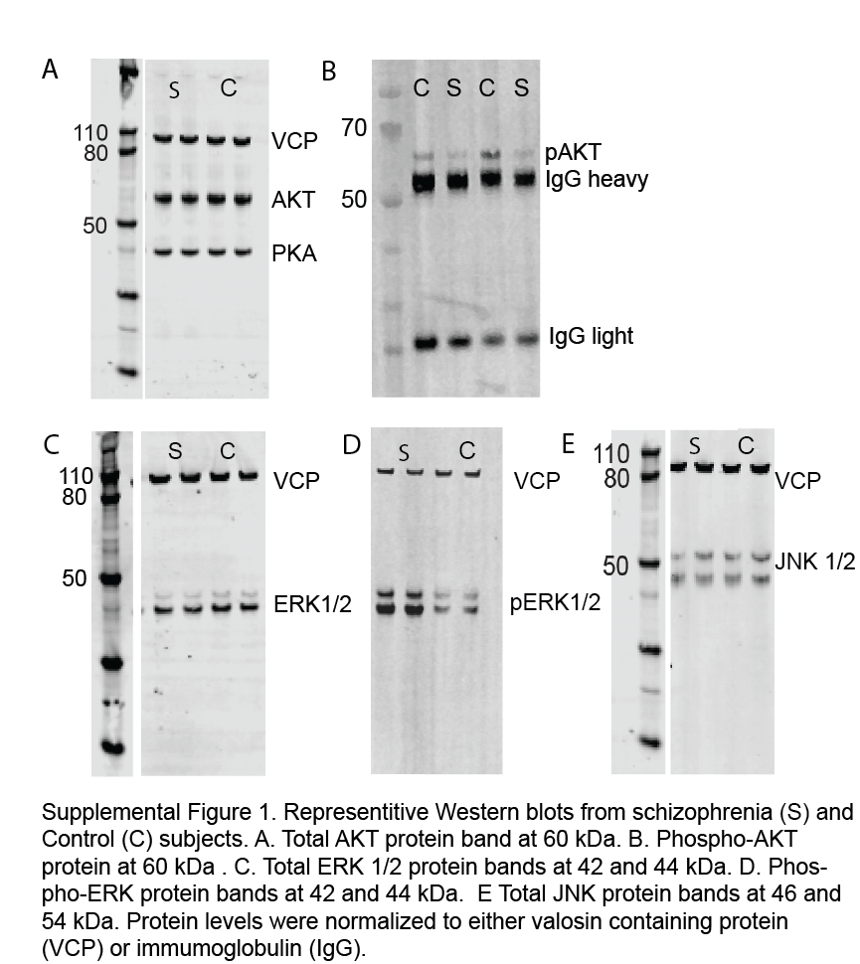

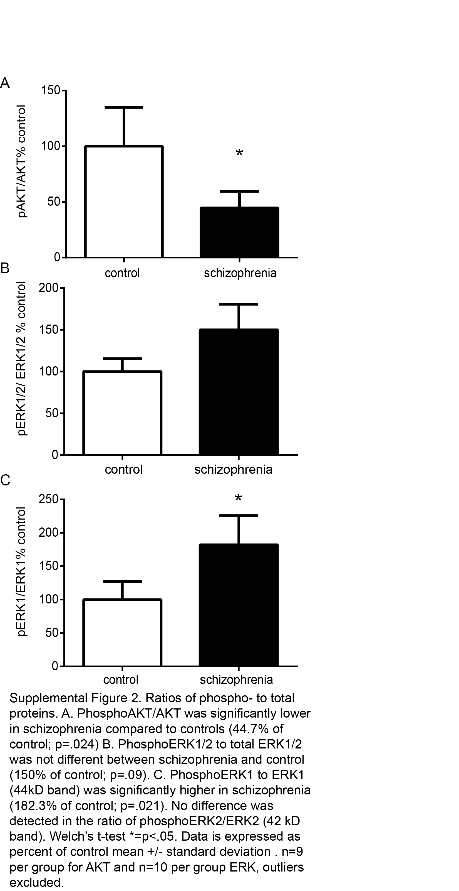
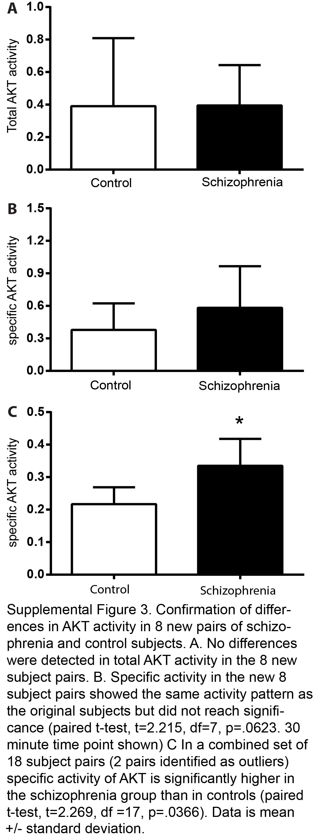
Supplemental methods.
Subjects. Subjects with schizophrenia were diagnosed with this illness for at least 30 years. The brain banking procedures were approved by the Mount Sinai School of Medicine Institutional Review Board. The medical records of the subjects were examined using a formal blinded medical chart review instrument as well as in person interviews with the subjects and/or their caregivers. Schizophrenia subjects were diagnosed based on DSM III-R criteria. Comparison subjects with no history of psychiatric or neurological disease were selected using a formal blinded medical chart review. Exclusion criteria were a history of alcoholism, death by suicide, or coma for more than 6 hours before death. Next of kin consent was obtained for all subjects. The subjects were evaluated for NINCDS-AIREN criteria for a diagnosis of vascular dementia; NINCDS, DSMIV and CERAD diagnosis of dementia; Consensus criteria for a clinical diagnosis of Probable or Possible diffuse Lewy body disease; UPDRS for Parkinson’s disease; clinical criteria for diagnosis of Frontotemporal dementia; medical history of psychiatric disease; history of drug or alcohol abuse; and other tests of cognitive function including the MMSE and CDR. In addition, each brain tissue specimen was examined neuropathologically using systematized macro- and microscopic evaluation using CERAD guidelines. Since the patients in our cohort were elderly at the time of death, many of the subjects have the cognitive impairment associated with aged subjects with schizophrenia ¹⁻³.
Kinome array rodent studies. 130 ug of tissue from the frontal pole of haloperidol-treated and control rats was manually homogenized on ice in Mammalian Protein Extraction buffer with HALT protease and phosphatase inhibitor cocktail (ThermoScientific, Rockford, IL) and stored at -80C until use. Profiling of the serine-threonine subkinome was performed using the PamStation 12 (PamGene International) and STK PamChips ⁶. Briefly, kinase activity was measured in real time using Evolve kinetic image capture software (PamGene) capturing FITC labeled anti-phospho antibodies binding to each phosphorylated substrate every 6 seconds for 90 minutes ⁷. The slope of the exposure brightness over multiple exposure times (multiplied by 100) within the 99th percentile were used to calculate minimal positive shift and data were log₂ transformed. The signal for each peptide is the log transformed spot intensity. Log transformation allows comparisons of increased and decreased kinase activity on the same scale. Signal intensities were analyzed using BioNavigator 5.2 Software (PamGene).
Supplemental References

1 Powchik, P. et al. Postmortem studies in schizophrenia. Schizophr Bull 24, 325-341 (1998).
2 Purohit, D. P. et al. Severe cognitive impairment in elderly schizophrenic patients: a clinicopathological study. Biol Psychiatry 33, 255-260 (1993).
3 Beeri, M. S. et al. Coronary artery disease is associated with Alzheimer disease neuropathology in APOE4 carriers. Neurology 66, 1399-1404, doi:10.1212/01.wnl.0000210447.19748.0b (2006).
4 McCullumsmith, R. E. et al. Decreased NR1, NR2A, and SAP102 transcript expression in the hippocampus in bipolar disorder. Brain Res 1127, 108-118, doi:10.1016/j.brainres.2006.09.011 (2007).
5 O'Donovan, S. M. et al. Glutamate transporter splice variant expression in an enriched pyramidal cell population in schizophrenia. Translational psychiatry 5, e579, doi:10.1038/tp.2015.74 (2015).
6 McGuire, J. L. et al. Altered serine/threonine kinase activity in schizophrenia. Brain Res 1568, 42-54, doi:10.1016/j.brainres.2014.04.029 (2014).
7 Jarboe, J. S. et al. Kinomic profiling approach identifies Trk as a novel radiation modulator. Radiotherapy and oncology : journal of the European Society for Therapeutic Radiology and Oncology 103, 380-387, doi:10.1016/j.radonc.2012.03.014 (2012).

