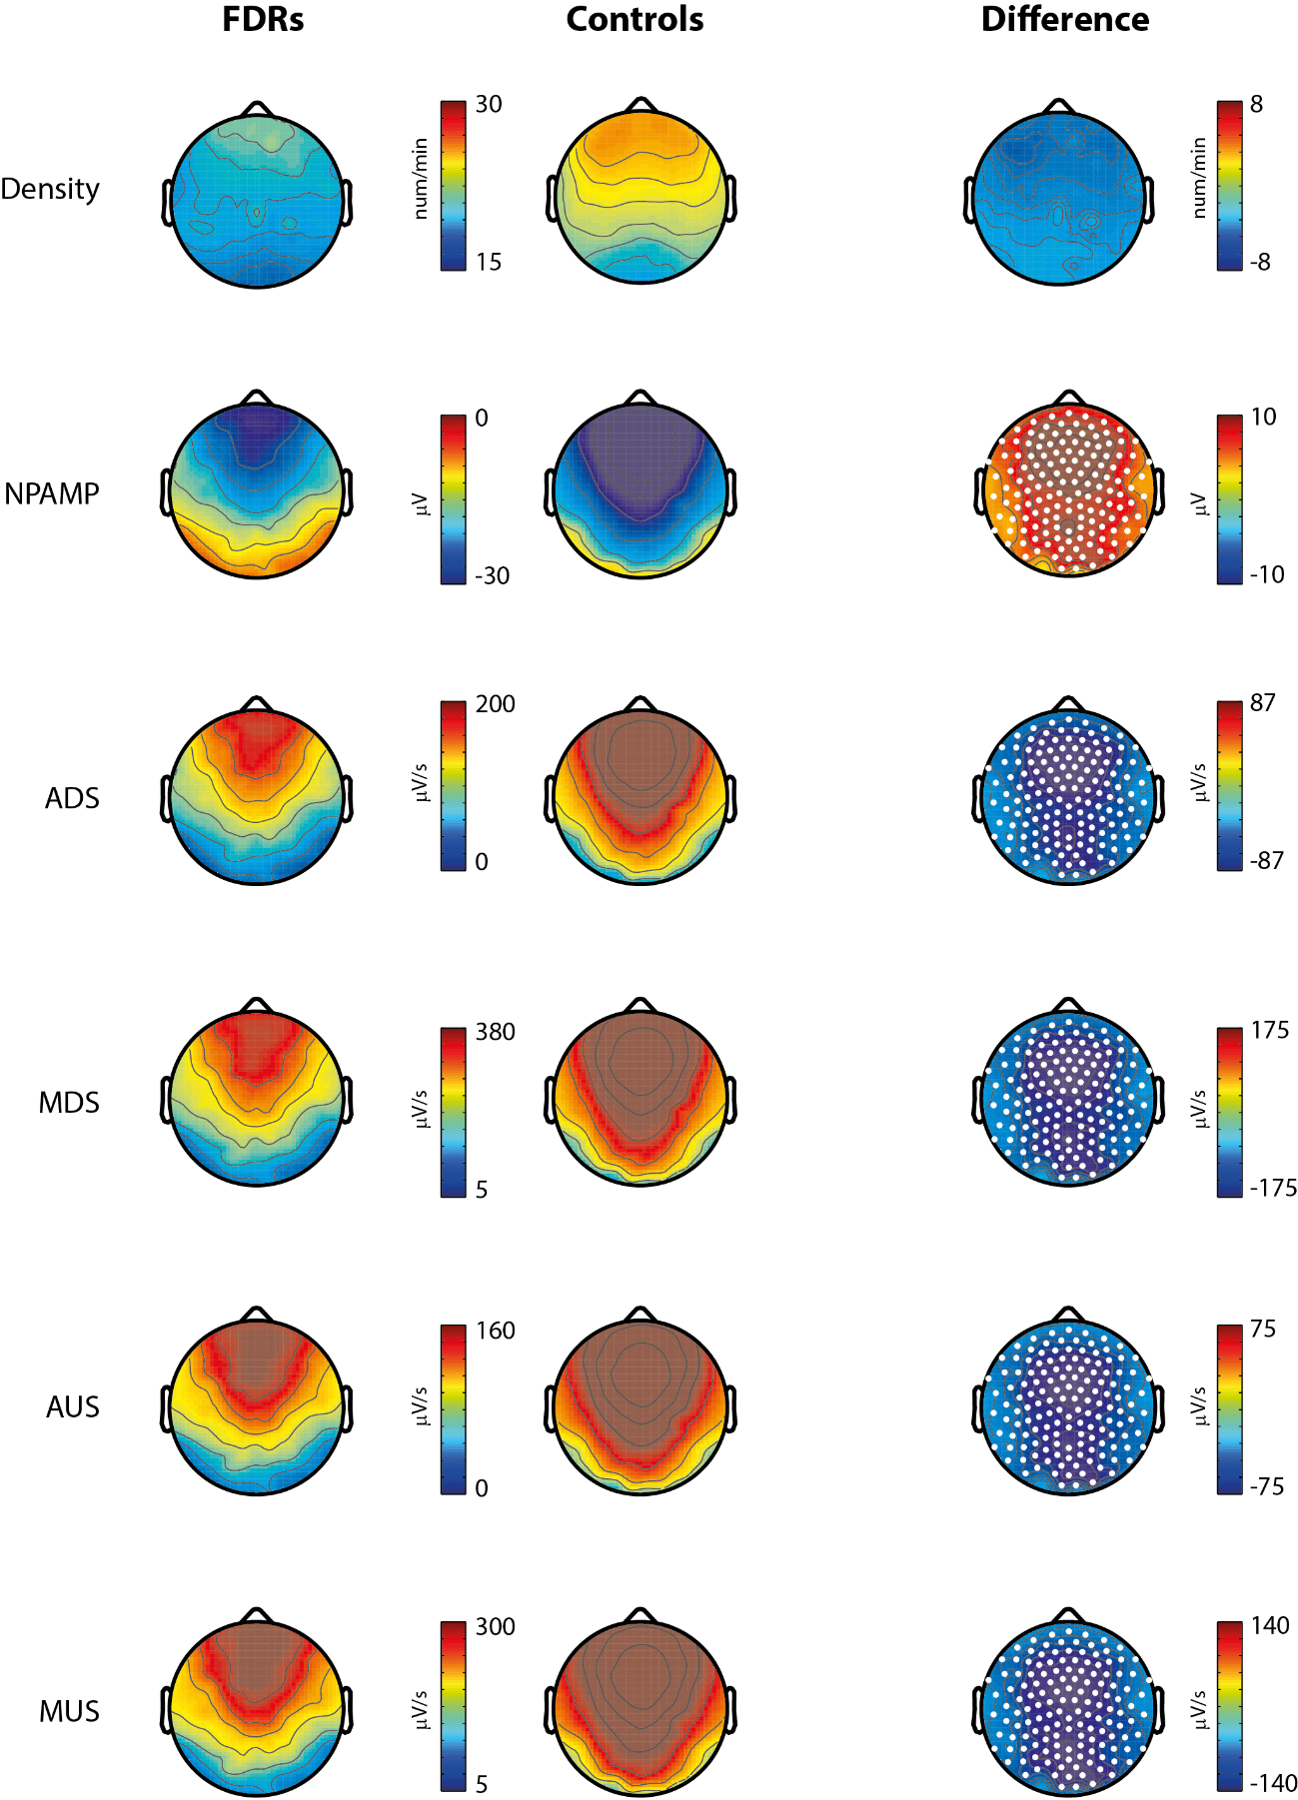
Supplementary Figure 1. Slow Wave (SW) parameters analysis – first cycle Left: Plots of each averaged parameter for FDRs in the first sleep cycle. Center: Plots of each averaged parameter for control subjects in the first sleep cycle Right: Mean group differences. Statistically significant channels are marked as white dots. NPAMP= negative peak amplitude; ADS= average down-slope; MDS= maximal down-slope; AUS= average down-slope; MUS= maximal up-slope.

