Supplementary Information

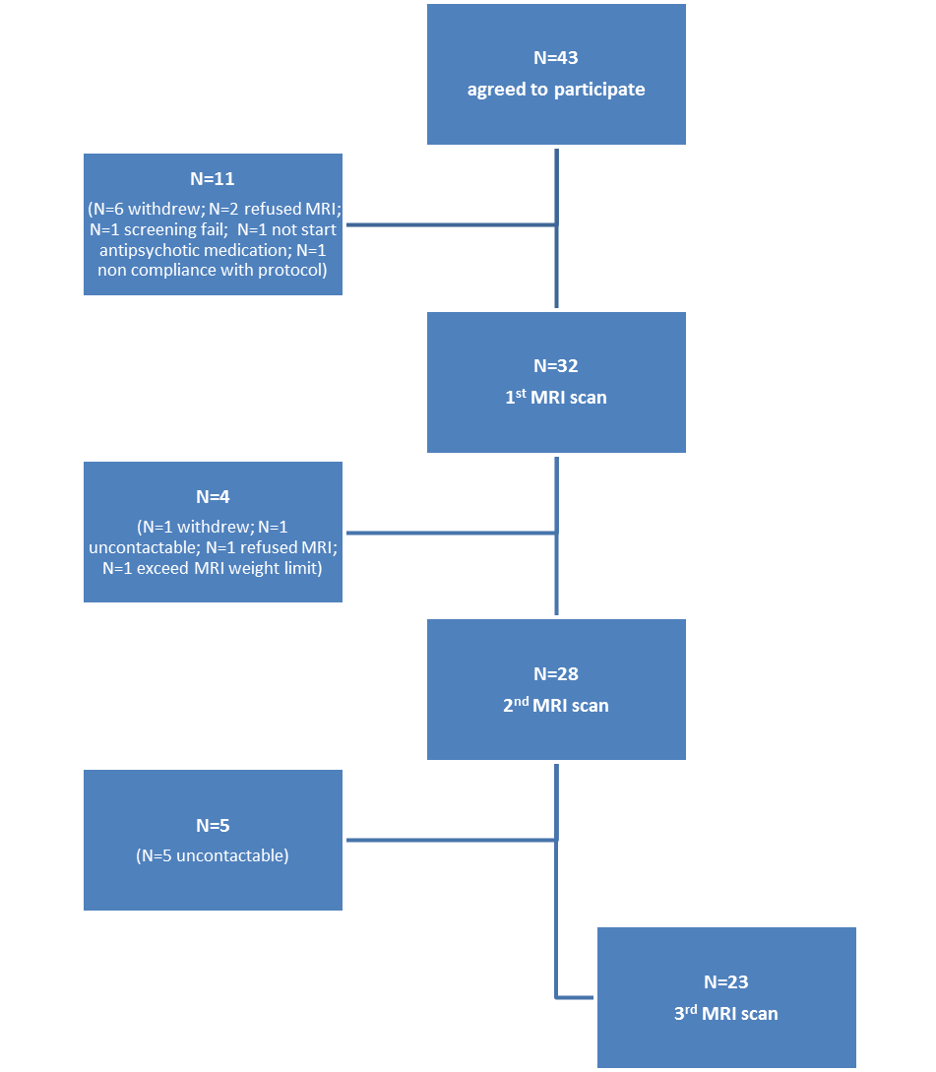

Figure 1 Flow diagram of the number of patients recruited into the study, and the number of drop outs at each scanning stage.

Supplementary Notes
Details on antipsychotic treatment
Patients were clinically managed by local early intervention services specialised for patients with first episode psychosis. These teams employed an assertive approach, with relatively frequent assessments. Patients were encouraged to remain on antipsychotic medication, even when in remission. Most participants were initially treated with amisulpride, as they were taking part in a clinical trial involving this drug (OPTiMiSE). Once the clinical trial had been completed (typically after the 2nd scan), the antipsychotic medication prescribed was selected by the patient’s clinical team.

At the time of the baseline scan, 4 patients were medication naïve and the mean duration of current antipsychotic treatment for the remaining patients was 12 days. All but one of the patients taking antipsychotic medication at baseline were receiving amisulpride. At the baseline scan patients received amisulpride at a dosage of 100-150mg (n=8), 200-250mg (n=9), 300mg (n=1) and risperidone at a dosage of 2mg (n=1).

At the 2nd scan, patients had received antipsychotic treatment for a mean of 6 weeks, with most patients (n=16) receiving amisulpride (aripiprazole n=2, quetiapine n=2, olanzapine n=1, risperidone n=1). 19 patients reported full-adherence to medication in the period between baseline and the 2nd scan. Of the remaining patients, 3 patients were delayed in initiating antipsychotic medication after the 1st scan, but were adherent for at least 1 month preceding the 2nd scan. One patient received antipsychotic medication for 1 month following the 1st scan, but stopped 7 days before the 2nd scan. At the 2nd scan patients received amisulpride at a dosage of 100-150mg (n=2), 200-250mg (n=6), 300-400mg (n=8), aripiprazole at a dosage of 5mg (n=2), risperidone at a dosage of 4mg (n=1), olanzapine at a dosage of 5mg (n=1), and quetiapine at a dosage of 200mg (n=1) and 600mg (n=1).

At the 3rd scan (9 month timepoint), the antipsychotic drug used to treat half of the patients had been changed from that at the 2nd scan on one or more occasions, whereas 10 patients received amisulpride alone for the duration of the study. 15 patients were still taking antipsychotic medication at the 3rd scan. The mean proportion of time that patients received medication between the 6 weeks and 9 month timepoints was 74%. At the 3rd scan patients received amisulpride at a dosage of 200mg (n=1), 300-400mg (n=5), aripiprazole at a dosage of 5mg (n=2), risperidone at a dosage of 4mg (n=1), olanzapine at a dosage of 5mg (n=2), 7.5 (n=1), 10mg (n=1), 12mg (n=1), and quetiapine at a dosage of 200mg (n=1).

At both follow up points, none of the patients were taking more than one type of antipsychotic, and a minority of patients were taking anxiolytics (n=8), zopiclone (n=9), and antidepressants (n=1).

Details on PANSS scores and demographic factors
The Non-Remission group showed higher PANSS negative symptom scores at baseline compared to the Remission group (P=0.045), but did not differ on the other baseline clinical measures. At 6 weeks, the Non-Remission group had significantly higher PANSS positive (P=0.022), negative (P=0.008) and total scores (P=0.018), and significantly lower PSP scores (<P=0.045) compared to the Remission group. At 9 months, the Non-Remission group had significantly higher PANSS positive (<P=0.001), negative (P=0.028), general (P=0.003) and total scores (<P=0.001), and significantly lower PSP scores (P=0.048) than the Remission group (Table 1 in manuscript).

Healthy volunteers were more likely to be currently employed and had on average more years in education than the total patient sample, but these groups did not differ significantly on the other demographic variables (Table 1 in manuscript).

 | Healthy Volunteers n=15 | FEP Patients  n=23 | Healthy Volunteers vs FEP Patients | Non Remission n=11 | Remission  n=12 | Non remission vs Remission
Current smoker Y/N | 9/6 | 14/9 | X² P=1.000 | 8/3 | 6/6 | X² P=0.400
Cigarettes/day mean (SD) | 4 (6) | 4 (5) | T (36)=-0.037; P=0.971 | 5 (5) | 4 (5) | T (21)=0.626; P=0.538
Current alcohol drinker Y/N | 12/3 | 13/10 | X² P=0.176 | 7/4 | 6/6 | X² P=0.680
Alcohol units/week mean (SD) | 5.9 (7.6) | 2.9 (4.6) | T (36)=1.527; P=0.135 | 2.6 (3.2) | 3.1 (5.7) | T (21)=-0.229; P=0.821
Cannabis in last month Y/N | 7/8 | 8/15 | X² P=0.514 | 5/6 | 3/9 | X² P=0.400
Cannabis Use  atleast 3x per month Y/N | 5/10 | 7/16 | X² P=1.000 | 5/6 | 2/10 | X² P=0.193
Cocaine in last month Y/N | 3/12 | 4/19 | X² P=1.000 | 2/9 | 2/10 | X² P=1.000
MDMA in last month Y/N | 2/13 | 1/22 | X² P=0.550 | 0/11 | 1/11 | X² P=1.000
Ketamine in last month Y/N | 1/14 | 1/22 | X² P=1.000 | 0/11 | 1/11 | X² P=1.000
Table 1 Substance use at 9 months. No significant differences in substance use were found between the Healthy Volunteer and FEP (first episode psychosis) patient group, or between the Remission and Non-Remission groups.

 | Healthy volunteers n=15 | Total patient group n=23 | Non-Remission  n=11 | Remission  n=12
Baseline 1H-MRS Scan
Anterior cingulate cortex
FWHM | 0.04 (0.01) | 0.04 (0.01) | 0.04 (0.01) | 0.04 (0.01)
SNR | 19.40 (4.26) | 20.04 (4.71) | 20.27 (5.53) | 19.83 (4.06)
Glx CRLB | 6.47 (0.51) | 7.17 (1.87) | 7.09 (2.02) | 7.25 (1.82)
Glu CRLB | 6.73 (1.16) | 6.83 (1.37) | 6.73 (1.49) | 6.92 (1.31)
NAA CRLB | 3.20 (0.41) | 3.48 (0.79) | 3.45 (0.93) | 3.50 (0.67)
Cho CRLB | 3.67 (0.62) | 3.30 (0.56) | 3.27 (0.47) | 3.33 (0.65)
mI CRLB | 5.40 (1.12) | 5.65 (1.40) | 5.36 (0.81) | 5.92 (1.78)
Cr CRLB | 3.00 (0.38) | 2.96 (0.56) | 2.91 (0.70) | 3.00 (0.43)
Included (n) | 15 | 23 | 11 | 12
Failed QC (n) | 0 | 0 | 0 | 0
Left Thalamus
FWHM | 0.05 (0.01) | 0.05 (0.01) | 0.05 (0.01) | 0.05 (0.01)
SNR | 18.33 (4.32) | 18.61 (1.85) | 18.91 (1.38) | 18.33 (2.23)
Glx CRLB | 8.93 (3.13) | 10.22 (2.35) | 10.91 (1.97) | 9.58 (2.57)
Glu CRLB | 8.73 (1.67) | 9.09 (1.83) | 9.18 (0.87) | 9.00 (2.45)
NAA CRLB | 3.33 (0.98) | 3.30 (0.56) | 3.36 (0.50) | 3.25 (0.62)
Cho CRLB | 3.33 (0.62) | 3.57 (0.59) | 3.45 (0.52) | 3.67 (0.65)
mI CRLB | 7.13 (2.26) | 7.57 (1.47) | 7.55 (1.21) | 7.58 (1.73)
Cr CRLB | 3.13 (0.35) | 3.13 (.34) | 3.18 (0.40) | 3.08 (0.29)
Included (n) | 15 | 23 | 11 | 12
Failed QC (n) | 0 | 0 | 0 | 0
6 weeks 1H-MRS Scan
Anterior cingulate cortex
FWHM | 0.04 (0.01) | 0.04 (0.01) | 0.04 (0.01) | 0.04 (0.01)
SNR | 17.93 (3.95) | 19.57 (3.93) | 19.36 (4.30) | 19.75 (3.74)
Glx CRLB | 7.00 (1.00) | 6.78 (1.28) | 6.91 (1.38) | 6.67 (1.23)
Glu CRLB | 7.53 (1.06) | 7.09 (1.47) | 7.36 (1.69) | 6.83 (1.27)
NAA CRLB | 3.40 (0.63) | 3.27 (0.46) | 3.18 (0.40) | 3.33 (0.65)
Cho CRLB | 3.67 (0.90) | 3.22 (0.60) | 3.18 (0.40) | 3.25 (0.75)
mI CRLB | 5.53 (0.64) | 5.26 (0.86) | 5.27 (0.79) | 5.25 (0.97)
Cr CRLB | 3.13 (0.35) | 3.00 (0.52) | 3.00 (0.63) | 3.00 (0.43)
Included (n) | 15 | 23 | 11 | 12
Failed QC (n) | 0 | 0 | 0 | 0
Left Thalamus
FWHM | 0.05 (0.01) | 0.05 (0.01) | 0.05 (0.01) | 0.05 (0.01)
SNR | 18.53 (3.25) | 17.78 (2.33) | 17.91 (2.51) | 17.67 (2.27)
Glx CRLB | 10.67 (3.35) | 10.91 (2.66) | 11.36 (2.54) | 10.50 (2.81)
Glu CRLB | 9.87 (3.60) | 10.09 (1.50) | 10.00 (1.41) | 10.17 (1.64)
NAA CRLB | 3.40 (0.63) | 3.39 (0.58) | 3.18 (0.40) | 3.58 (0.67)
Cho CRLB | 3.40 (0.63) | 3.65 (0.49) | 3.64 (0.50) | 3.67 (0.49)
mI CRLB | 7.07 (1.16) | 7.61 (1.53) | 7.64 (1.86) | 7.58 (1.24)
Cr CRLB | 3.27 (0.46) | 3.35 (0.49) | 3.36 (0.50) | 3.33 (0.49)
Included (n) | 15 | 23 | 11 | 12
Failed QC (n) | 0 | 0 | 0 | 0
9 month 1H-MRS Scan
Anterior cingulate cortex
FWHM | 0.04 (0.01) | 0.04 (0.01) | 0.04 (0.01) | 0.04 (0.01)
SNR | 18.93 (3.33) | 19.09 (4.12) | 18.64 (4.18) | 19.50 (4.21)
Glx CRLB | 6.93 (1.10) | 7.26 (1.48) | 7.18 (1.83) | 7.33 (1.15)
Glu CRLB | 7.13 (1.13) | 7.30 (1.58) | 7.36 (1.50) | 7.25 (1.71)
NAA CRLB | 3.27 (0.46) | 3.65 (0.71) | 3.55 (0.69) | 3.75 (0.75)
Cho CRLB | 3.60 (0.51) | 3.52 (0.59) | 3.55 (0.52) | 3.50 (0.67)
mI CRLB | 5.80 (0.86) | 5.52 (1.16) | 5.55 (1.37) | 5.50 (1.00)
Cr CRLB | 3.07 (0.26) | 3.09 (0.42) | 3.09 (0.54) | 3.08 (0.29)
Included (n) | 15 | 23 | 11 | 12
Failed QC (n) | 0 | 0 | 0 | 0
Left Thalamus
FWHM | 0.05 (0.01) | 0.06 (0.01) | 0.05 (0.01) | 0.06 (0.01)
SNR | 18.53 (3.93) | 16.52 (3.63) | 16.64 (4.54) | 16.42 (2.75)
Glx CRLB | 11.07 (3.92) | 12.17 (6.59) | 10.55 (2.16) | 13.67 (8.80)
Glu CRLB | 9.73 (3.13) | 10.0 (3.83) | 9.36 (1.91) | 10.58 (5.02)
NAA CRLB | 3.27 (0.59) | 3.26 (0.54) | 3.27 (0.65) | 3.25 (0.45)
Cho CRLB | 3.87 (1.55) | 3.87 (0.81) | 3.91 (0.83) | 3.83 (0.83)
mI CRLB | 7.80 (2.01) | 7.59 (1.53) | 7.50 (1.58) | 7.67 (1.56)
Cr CRLB | 3.27 (0.80) | 3.61 (0.72) | 3.55 (0.69) | 3.67 (0.78)
Included (n) | 14 | 14 (Glu, Glx, mI) | 10 (mI) | 11 (Glu, Glx)
Failed QC (n) | 1 (Glx) | 1 (Glu, Glx, mI) | 1 (mI) | 1 (Glu, Glx)

Table 2 1H-MRS quality measures. Data are presented as mean (SD). There were no significant differences (P < 0.05) between Healthy Volunteers and Patients, or Remission and Non-Remission groups. FWHM: Spectral line-width as full-width at half-maximum in parts per million; SNR: signal to noise ratio; CRLB Cramer Rao Lower Bounds.

 | Repeated measures ANOVA | Post hoc (time): Repeated measures ANOVA in one group only | Post hoc (group): One way ANOVA between groups at 9 month timepoint
ACC Glx
Remission n=12 | Group: F(1,21)=0.010, P=0.921  Time: F(2,42)=0.095, P=0.910  Interaction: F(2,42)=0.332, P=0.719 | - | -
Non-Remission n=11 |  | -
Healthy Volunteers n=15 | Group: F(1,36)=0.078, P=0.781  Time: F(2,72)=0.210, P=0.811  Interaction: F(2,72)=0.705, P=0.498 | - | -
Total Patient group n=23 |  | -
ACC Glutamate
Remission n=12 | Group: F(1,21)=0.209, P=0.652  Time: F(1.5,31.5)=0.456, P=0.582  Interaction: F(1.5,31.5)=0.072, P=0.882 | - | -
Non-Remission n=11 |  | -
Healthy Volunteers n=15 | Group: F(1,36)=0.146, P=0.705  Time: F(1.7,60.1)=0.530, P=0.559  Interaction: F(1.7,60.1)=1.672, P=0.200 | - | -
Total Patient group n=23 |  | -
Left thalamus Glx
Remission n=11 | Group: F(1,20)=0.121, P=0.731  Time: F(2,40)=2.541, P=0.091  Interaction: F(2,40)=4.337, P=0.020* | F(2,20)=1.849, P=0.183 | F(1,20)=5.244; P=0.033*
Non-Remission n=11 |  | F(2,20)=6.183, P=0.008**
Healthy Volunteers n=14 | Group: F(1,34)=0.021, P=0.887  Time: F(2,68)=2.429, P=0.096  Interaction: F(2,68)=0.312, P=0.733 | - | -
Total Patient group n=22 |  | -
Left thalamus Glutamate
Remission n=11 | Group: F(1,20)=0.036, P=0.852  Time: F(2,40)=7.306, P=0.002**  Interaction: F(2,40)=1.310, P=0.281 | F(2,20)=2.754, P=0.088 | -
Non-Remission n=11 |  | F(1.3,13.3)=7.961, P=0.010**
Healthy Volunteers n=15 | Group: F(1,35)=0.136, P=0.714  Time: F(2,70)=3.753, P=0.028*  Interaction: F(2,70)=1.364, P=0.262 | F(2,28)=0.606, P=0.553 | -
Total Patient group n=22 |  | F(2,42)=7.200, P=0.002**
Table 3 Repeated measures ANOVA statistics assessing glutamatergic metabolites over time in relation to remission status or clinical group. Analyses conducted for Glx and Glutamate in the anterior cingulate cortex (ACC) and left thalamus, in the i) Remission and Non-Remission groups, and ii) Healthy Volunteer and total Patient groups. Significant repeated measures ANOVA analyses are explored further by post-hoc tests. One way ANOVA analyses between groups is shown for the 9 month timepoint only, as significant results are not found at other timepoints. Significant results are highlighted in bold and represented by *=P<0.05, **= P<0.01.

Figure 2 Mean CSF-corrected Glx in the thalamus at Baseline, 6 weeks and 9 months, in the Remission and Non-Remission groups, excluding patients who were medication adherent less than 75% of the time. *Represents higher thalamic Glx levels in the Non-Remission group compared to the Remission group at 9 months (P=0.043). Error bars represent within-subjects standard deviation.
For Glx in the thalamus (Supplementary Figure 2 above), when analysis was restricted to the adherent subgroup (excluding patients who reported being adherent to antipsychotic medication less than 75% of the time), the interaction between remission status and time remained significant (F(2,26)=4.698, P=0.018, repeated measures ANOVA) and there was also a significant main effect of time (F(2,26)=5.300, P=0.012) but not remission status (F(1,13)=0.130, P=0.724). As in the larger sample, Glx levels were significantly higher in the Non-Remission than the Remission group at 9 months (F(1,13)=5.053, P=0.043, one way ANOVA), related to a main effect of time in the Non-Remission group (F(2,12)=3.894, P=0.050, repeated measures ANOVA). Time was also significant in the Remission group (F(2,14)=6.435, P=0.010, repeated measures ANOVA) due to a decrease in Glx between baseline and 6 weeks (P=0.037, Bonferroni-corrected pairwise comparisons).

 | PANSS positive score | PANSS negative score | PANSS general score | PANSS total score | PSP
Thalamus Glutamate n=22 | r=.210, P=0.348 | r=.005, P=0.983 | r=.297, P=0.179 | r=.218, P=0.330 | r=.127, P=0.573
ACC Glx n=23 | r=-.100, P=0.651 | r=.035, P=0.875 | r=.201, P=0.358 | r=.049, P=0.823 | r=.234, P=0.282
ACC Glutamate n=23 | r=-.079, P=0.720 | r=.142, P=0.518 | r=.045, P=0.837 | r=-.037, P=0.866 | r=.297, P=0.169
Table 4 Relationship between percentage change in metabolite level, and percentage change in clinical scores between the baseline and the 9 month timepoint in patients (Pearson’s bivariate correlation).

Healthy Volunteers vs Total Patient group
ACC | Metabolites x Group | F(3,108)=0.542, P=0.655
ACC | Time x Group | F(2,72)=0.447, P=0.641
ACC | Metabolites x Time | F(4.4,158.3)=0.552, P=0.714
ACC | Metabolites x Time x Group | F(4.4,158.3)=0.634, P=0.654
Thalamus | Metabolites x Group | F(2.3,80)=0.602, P=0.572
Thalamus | Time x Group | F(2,70)=3.520, P=0.010**
Thalamus | Metabolites x Time | F(4.2,146.4)=0.333, P=0.863
Thalamus | Metabolites x Time x Group | F(4.2,146.4)=1.313, P=0.267
Remission vs Non-Remission
ACC | Metabolites x Group | F(3,63)=0.340, P=0.796
ACC | Time x Group | F(2,42)=0.133, P=0.876
ACC | Metabolites x Time | F(6,126)=0.439, P=0.851
ACC | Metabolites x Time x Group | F(6,126)=0.214, P=0.972
Thalamus | Metabolites x Group | F(3,60)=0.028, P=0.994
Thalamus | Time x Group | F(2,40)=0.452, P=0.639
Thalamus | Metabolites x Time | F(3.8,75.3)=0.792, P=0.527
Thalamus | Metabolites x Time x Group | F(3.8,75.3)=0.265, P=0.890
Table 5 Repeated measures MANOVA analyses were conducted on other 1H-MRS metabolite concentrations (N-acetyl-aspartate, creatine, myo-inositol, choline) between i) Healthy Volunteers vs Patients and ii) Remission vs Non-Remission across 3 timepoints. **=P<0.01. Post-hoc tests did not find significant effects when diagnostic groups and timepoints were analysed separately.

