Supplemental Figure and legends
Figure S1 The characterization and comparison of gut microbial community between SCZF and HCF groups. (A) Alpha diversity (Chao1, Faith_pd, Shannon, Simpson, Pielou_e and Observed_species indexs) measurements distribution of bacterial communities in SCZF and HCF. (B) A Venn diagram displaying the overlaps between groups based on OTU distribution. (C) Average compositions and relative abundance of the bacterial community in SCZF and HCF groups at the phylum level. (D) 3 phylum were significantly decreased, while 2 phylum were significantly increased in SCZF group versus HCF. * p < 0.05, ** p < 0.01, *** p < 0.001.
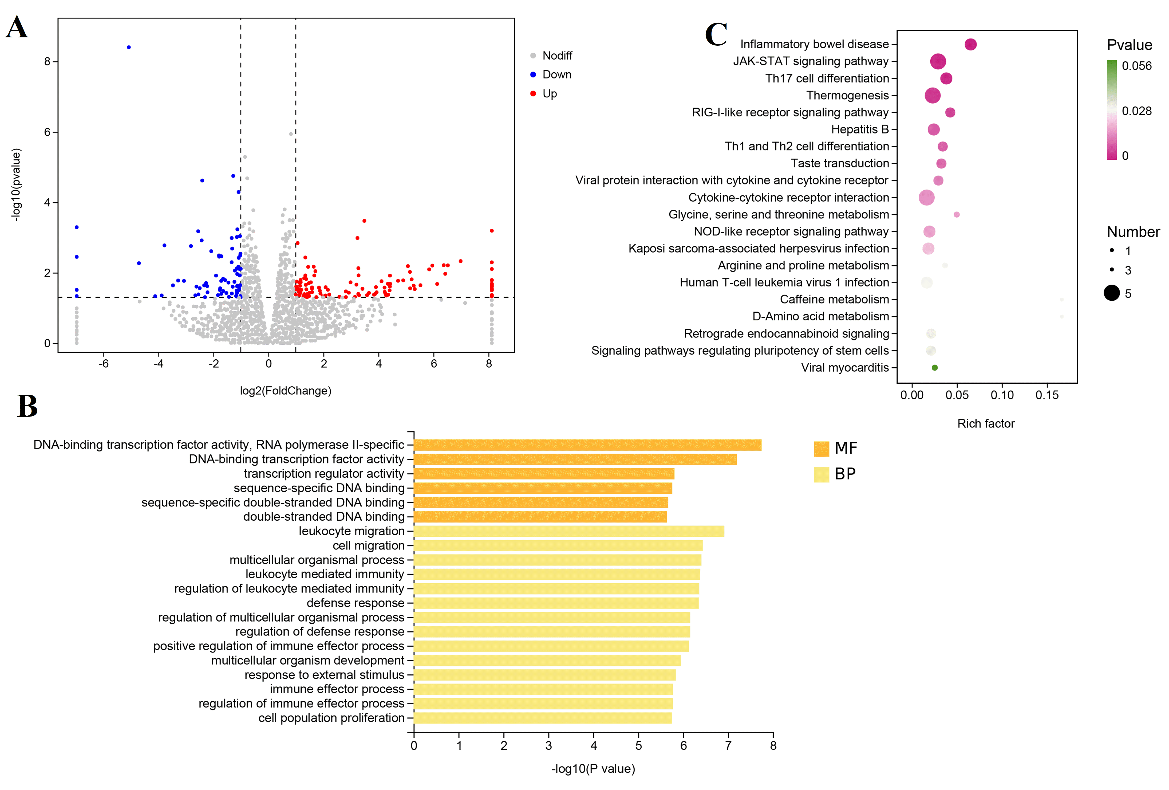
Figure S2 The effects of fecal transplantation from HC controls on transcriptome of mice brain. (A) Volcano plots of DEGs between the HC fecal microbiota-recipient mice group and PBS vehicle group. Red dots indicate up regulation. Blue dots indicate downregulation. Gray dots indicate no significant difference. (B) Heatmap displayed hierarchical cluster analysis data for DEGs in the brain of mouse from different groups. Top 20 enriched GO term assignments (C) and top 20 KEGG pathways (D) for DEGs between two group.

Supplemental Tables

Table S1 Quantitative PCR primer sets in this study
Primer (5'-3') | Gene name | Length of amplification  (bp)
F: ACAGGAGTACGAGATCGAACG | Sim1 | 220
R: CTCTGTCACAGCACTCGGAG | Sim1 | 220
F:TGAGGGTCCTGATAATGTCCTAC | Tlr1 | 153
R:AGAGGTCCAAATGCTTGAGGC | Tlr1 | 153
F:ATACTCTAGGAAGGAAGGACACC | S100a9 | 129
R:TCCATGATGTCATTTATGAGGGC | S100a9 | 129
F:GACAGCCACCACAATCAACAT | Ifitm1 | 96
R:CCCAGGCAGCAGAAGTTCAT | Ifitm1 | 96
F:TGGAGATCGCGCAGATCAG | Ghsr | 188
R:CCGGGAACTCTCATCCTTCAG | Ghsr | 188

Table S2 Alpha-diversity indexes of gut microbiome from different groups
Sample | Chao1 | Faith_pd | Observed_species | Pielou_e | Shannon | Simpson | Group
49a | 247.34 | 27.54 | 232.90 | 0.28 | 2.18 | 0.43 | SCZF
50a | 469.39 | 33.22 | 440.10 | 0.59 | 5.14 | 0.87 | SCZF
51a | 288.42 | 27.03 | 271.60 | 0.58 | 4.66 | 0.84 | SCZF
52a | 264.50 | 24.90 | 246.00 | 0.68 | 5.41 | 0.95 | SCZF
53a | 233.54 | 19.54 | 213.10 | 0.55 | 4.25 | 0.91 | SCZF
54a | 413.89 | 22.61 | 381.70 | 0.60 | 5.11 | 0.91 | SCZF
55a | 802.18 | 43.54 | 772.10 | 0.77 | 7.36 | 0.98 | SCZF
56a | 399.65 | 25.58 | 374.50 | 0.65 | 5.53 | 0.95 | SCZF
57a | 430.23 | 30.83 | 385.40 | 0.50 | 4.33 | 0.86 | SCZF
58a | 244.37 | 17.97 | 228.70 | 0.60 | 4.68 | 0.89 | SCZF
59a | 456.87 | 24.71 | 392.90 | 0.60 | 5.17 | 0.93 | SCZF
60a | 291.71 | 26.35 | 273.50 | 0.62 | 4.99 | 0.92 | SCZF
61a | 199.85 | 20.14 | 179.80 | 0.35 | 2.60 | 0.60 | SCZF
62a | 101.44 | 14.48 | 97.10 | 0.24 | 1.57 | 0.40 | SCZF
63a | 217.31 | 14.60 | 208.20 | 0.69 | 5.28 | 0.96 | SCZF
64a | 318.28 | 19.64 | 295.60 | 0.62 | 5.12 | 0.92 | SCZF
65a | 520.20 | 30.51 | 482.40 | 0.69 | 6.15 | 0.96 | SCZF
66a | 418.98 | 25.96 | 373.00 | 0.69 | 5.87 | 0.96 | SCZF
67a | 150.14 | 12.58 | 127.70 | 0.28 | 1.95 | 0.49 | SCZF
68a | 271.17 | 15.68 | 250.50 | 0.56 | 4.50 | 0.91 | SCZF
1a | 1063.96 | 41.62 | 998.10 | 0.68 | 6.81 | 0.95 | HCF
2a | 1076.48 | 48.97 | 966.40 | 0.64 | 6.39 | 0.95 | HCF
3a | 1809.66 | 60.57 | 1544.80 | 0.73 | 7.71 | 0.97 | HCF
4a | 866.06 | 31.34 | 772.90 | 0.68 | 6.53 | 0.95 | HCF
5a | 1446.64 | 42.48 | 1320.80 | 0.74 | 7.67 | 0.96 | HCF
6a | 1996.71 | 72.27 | 1783.90 | 0.77 | 8.32 | 0.99 | HCF
7a | 963.09 | 36.28 | 812.00 | 0.65 | 6.28 | 0.93 | HCF
8a | 1453.70 | 55.85 | 1268.50 | 0.73 | 7.56 | 0.97 | HCF
9a | 1699.76 | 55.42 | 1513.50 | 0.77 | 8.18 | 0.98 | HCF
10a | 1781.52 | 66.37 | 1648.40 | 0.75 | 7.99 | 0.98 | HCF
11a | 1082.37 | 52.14 | 881.60 | 0.70 | 6.85 | 0.97 | HCF
12a | 1878.09 | 74.46 | 1757.50 | 0.76 | 8.17 | 0.99 | HCF
13a | 1626.45 | 48.28 | 1467.40 | 0.78 | 8.19 | 0.99 | HCF
14a | 1190.71 | 45.24 | 1085.10 | 0.69 | 7.00 | 0.95 | HCF
15a | 1607.85 | 54.59 | 1515.30 | 0.77 | 8.08 | 0.99 | HCF

Table S3 The different degree of bacterial phylum level (p value) between the SCZF and HCF
Genus | SCZF mean | HCF mean | p value | Sig_mark
Firmicutes | 0.49420455 | 0.76850171 | 0.0034 | **
Actinobacteria | 0.30921512 | 0.0558658 | 0.0003 | ***
Proteobacteria | 0.14896003 | 0.09141755 | 0.036 | *
Bacteroidetes | 0.00517861 | 0.08110717 | <0.0001 | ****
Tenericutes | 0.00004267 | 0.00092027 | 0.0324 | *

Table S4 The different degree of bacterial genus level (p value) between the SCZF and HCF
Genus | SCZF mean | HCF mean | p value | Sig_mark
Faecalibacterium | 0.04100195 | 0.12443785 | 0.0095 | **
Shigella | 0.08461435 | 0.03175074 | 0.0061 | **
Coprococcus | 0.01109485 | 0.03820987 | 0.0159 | *
Collinsella | 0.04333916 | 0.00447164 | 0.0016 | **
Prevotella | 0.00087184 | 0.04021616 | 0.0381 | *
Haemophilus | 0.00027434 | 3.85E-02 | 0.0444 | *
Ruminococcaceae_Ruminococcus | 6.61E-03 | 0.01663821 | 0.0204 | *
Bacteroides | 0.00145125 | 0.02128986 | ＜0.0001 | ****
Oscillospira | 0.00577838 | 0.00995139 | 0.0435 | *

Table S5 Top 20 KEGG terms that are significantly enriched in SCZ fecal microbiota-recipient mice

Term description | Pathway ID |  | DEGs
Neuroactive ligand-receptor interaction |  | mmu04080 | ENSMUSG00000031340(Gabre|K05185);ENSMUSG00000024907(Gal|K05244);ENSMUSG00000020660(Pomc|K05228);ENSMUSG00000031344(Gabrq|K05192);ENSMUSG00000023964(Calcr|K04576);ENSMUSG00000037727(Avp|K05242);ENSMUSG00000056380(Gpr50|K04287);ENSMUSG00000005892(Trh|K05253);ENSMUSG00000027301(Oxt|K05243);ENSMUSG00000051136(Ghsr|K04284);ENSMUSG00000044988(Ucn3|K05257)
Cytokine-cytokine receptor interaction | mmu04060 |  | ENSMUSG00000096596(Gm10591|K16062);ENSMUSG00000071714(Csf2rb2|K04738);ENSMUSG00000027399(Il1a|K04383);ENSMUSG00000018927(Ccl6|K05510);ENSMUSG00000068105(Tnfrsf13c|K05151)
AGE-RAGE signaling pathway in diabetic complications | mmu04933 |  | ENSMUSG00000015340(Cybb|K21421);ENSMUSG00000027399(Il1a|K04383);ENSMUSG00000079465(Col4a3|K06237)
Phenylalanine metabolism | mmu00360 |  | ENSMUSG00000075296(Aldh3b2|K00129);ENSMUSG00000019102(Aldh3a1|K00129)
Glycolysis / Gluconeogenesis | mmu00010 |  | ENSMUSG00000041798(Gck|K12407);ENSMUSG00000075296(Aldh3b2|K00129);ENSMUSG00000019102(Aldh3a1|K00129)
Leishmaniasis | mmu05140 |  | ENSMUSG00000015340(Cybb|K21421);ENSMUSG00000027399(Il1a|K04383);
Histidine metabolism | mmu00340 |  | ENSMUSG00000075296(Aldh3b2|K00129);ENSMUSG00000019102(Aldh3a1|K00129)
Maturity onset diabetes of the young | mmu04950 |  | ENSMUSG00000041798(Gck|K12407);ENSMUSG00000024986(Hhex|K08024)
beta-Alanine metabolism | mmu00410 |  | ENSMUSG00000075296(Aldh3b2|K00129);ENSMUSG00000019102(Aldh3a1|K00129)
Morphine addiction | mmu05032 |  | ENSMUSG00000031340(Gabre|K05185);ENSMUSG00000032034(Kcnj5|K04999);ENSMUSG00000031344(Gabrq|K05192)
Tyrosine metabolism | mmu00350 |  | ENSMUSG00000075296(Aldh3b2|K00129);ENSMUSG00000019102(Aldh3a1|K00129)
Nicotine addiction | mmu05033 |  | ENSMUSG00000031340(Gabre|K05185);ENSMUSG00000031344(Gabrq|K05192)
Neomycin, kanamycin and gentamicin biosynthesis | mmu00524 |  | ENSMUSG00000041798(Gck|K12407)
Fat digestion and absorption | mmu04975 |  | ENSMUSG00000028749(Pla2g2f|K01047);ENSMUSG00000046008(Pnlip|K14073)
Type II diabetes mellitus | mmu04930 |  | ENSMUSG00000054667(Irs4|K17446);ENSMUSG00000041798(Gck|K12407)
Graft-versus-host disease | mmu05332 |  | ENSMUSG00000073409(H2-Q6|K06751);ENSMUSG00000027399(Il1a|K04383)
Type I diabetes mellitus | mmu04940 |  | ENSMUSG00000073409(H2-Q6|K06751);ENSMUSG00000027399(Il1a|K04383)
Retrograde endocannabinoid signaling | mmu04723 |  | ENSMUSG00000031340(Gabre|K05185);ENSMUSG00000032034(Kcnj5|K04999);ENSMUSG00000031344(Gabrq|K05192)
Drug metabolism - cytochrome P450 | mmu00982 |  | ENSMUSG00000075296(Aldh3b2|K00129);ENSMUSG00000019102(Aldh3a1|K00129)

Table S6 Overlapped genes between SCZ fecal recipient mice and SCZ patients
Genes | in the brain of SCZ fecal recipient mice (up/down) | in Brodmann area 9 of SCZ patients (up/down) | in Brodmann area 24 of SCZ patients (up/down)
Fgr | down | up | up
Clec14a | down | down | down
Cybb | down | down | down
Tnfsf10 | down | down | down
Icam1 | down | up | up
Gabre | up | up
Cartpt | up | up
Slc38a5 | down | down
Ifitm1 | down | up
Baiap3 | up |  | down
Arhgap36 | up |  | down
Col4a3 | down |  | up
Magel2 | up |  | down
Ppef1 | up |  | down
Rsad2 | down |  | down

