Supplementary information to: Determinants of Patient Satisfaction in Clozapine Users: Results from the Clozapine International Consortium (CLOZIN)
Authors: Marte Z. van der Horst*^{1,2}, Nini de Boer¹, CLOZIN collaborators^, Cynthia Okhuijsen-Pfeifer¹, Jurjen J. Luykx^{3,4,5,6,7}
¹ Department of Psychiatry, University Medical Center Utrecht, Utrecht University, Utrecht, the Netherlands
² GGNet, Warnsveld, the Netherlands
³ Department of Psychiatry, Amsterdam University Medical Center, Amsterdam, the Netherlands
⁴ GGZ inGeest Mental Health Care, Amsterdam, the Netherlands
⁵ Neuroscience Mood, Anxiety, Psychosis, Stress & Sleep Research Program, Amsterdam University Medical Center, Amsterdam, the Netherlands
⁶ Department of Psychiatry and Neuropsychology, School for Mental Health and Neuroscience, Maastricht University Medical Center, Maastricht, the Netherlands
⁷ Public Health Mental Health Research Program, Amsterdam University Medical Center, Amsterdam, the Netherlands

^ CLOZIN collaborators (ordered alphabetically by first name): Ahmet Müderrisoğlu, Alba Toll Privat, Alde Bouhuis, Alkomiet Hasan, Amy Jongkind, Ana Gonzalez-Pinto, Anna Mane Santacana, Armando D’Agostino, Aygün Ertuğrul, A. Elif Anıl Yağcıoğlu, Benedicto Crespo-Facorro, Bernhard T. Baune, Bianca Sanchez-Barbero, Carlos Spuch, Carla Lou Morgenroth, Carmen Fernandez de Pinedo, Cecilia Casetta, Chad Bousman, Christa Hohoff, Christos Pantelis, Claudia Ovejas-Catalán, Clemente Garcia-Rizo, Cynthia Okhuijsen-Pfeifer, Dan Cohen, Dragana Ignjatovic Ristic, Edwin Beld, Eila Repo-Tiihonen, Elias Wagner, Ellen Jeger-Land, Elisabet Vilella, Emilio Fernandez-Egea, Erwin Bekema, Esteban Sepúlveda, Federico Wiedenmann, Francesca Martini, Francesca Serio, Francesca Vairano, Giacomo Mercuriali, Giovanni Boido, Gökhan Yoca, Hanneke van Beek, Harm Gijsman, Heli Tuppurainen, Ian Everall, Ivona Novakovic, Inaki Zorrilla, İ. Mert Erdoğan, Jacopo Sapienza, Jan Bogers, Jari Tiihonen, Javier Vázquez-Bourgon, Jim van Os, Johannes Schneider-Thoma, Jurjen Luykx, Koen Grootens, Lorea Mar-Barrutia, Lourdes Martorell, Maarten Bak, Marco Spangaro, Marco Zierhut, Marije de Vos, Mariken de Koning, Marina Garriga, Markku Lähteenvuo, Marta Bosia, Marte van der Horst, Melih O. Babaoğlu, Mike Veereschild, Mirko Manchia, Mishal Qubad, Monika Edlinger, Paloma Fuentes-Pérez, Pasquale Paribello, Purificacion Lopez-Pena, René Kahn, Robert A. Bittner, Roberto Cavallaro, Selene Veerman, Stefan Gutwinski, Stefanie Schreiter, Stephan Ripke, Tania Rivera Baltanás, Tatiana Oviedo-Salcedo, Tero Hallikainen, Thomas Görlitz, Wouter Alink, Yavuz Ayhan.

Table of contents
Supplementary Figure 1. Questionnaire that was used to query the presence of adverse drug reactions: page 3.
Supplementary Figure 2. The Clinical Global Impression (CGI) scale that was used to assess symptom severity: page 4.
Supplementary Figure 3. The Alda-scale that was used to assess response to clozapine treatment: page 5.
Supplementary Table 1. Baseline demographic and clinical characteristics of the study population: page 6.
Supplementary Figure 4. A: Histogram of patient satisfaction, ranged on a scale of 1 to 10. The black line illustrates the normal curve. B: Stacked bar chart depicting patient satisfaction categorized into three groups (low, intermediate, and high) alongside the proportion of response levels to clozapine treatment within each group. C: Stacked bar chart depicting patient satisfaction categorized into three groups (low, intermediate, and high) alongside the proportion of symptom severity levels (as measured by the Clinical Global Impression Scale) within each group: pages 7 & 8.
Supplementary Table 2. Prevalence of clozapine-associated adverse drug reactions in our study population: page 9.
Supplementary Table 3. Results of the linear regression model with sex and age included as covariates: page 10.
Supplementary Figure 5. Boxplot showing the association between patient satisfaction on the x-axis and age on the y-axis: page 11.

Supplementary Figure 1. Questionnaire that was used to query the presence of adverse drug reactions. ** The question about the occurrence or experience of all adverse drug reactions was initially answered by the participant. If the participant was unsure or if the researcher had doubts about the reliability of the answer, the treating physician was consulted for verification.
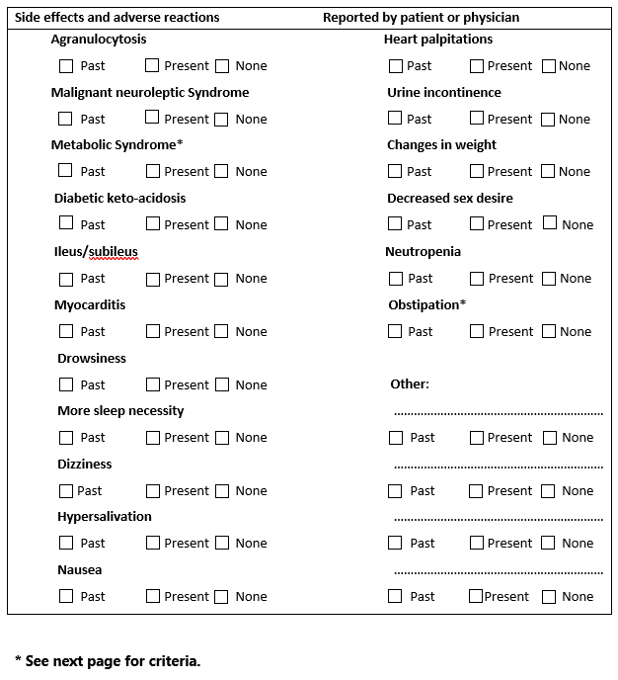
**

Supplementary Figure 2. The Clinical Global Impression (CGI) scale that was used to assess symptom severity.
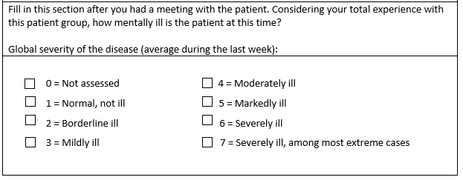

Supplementary Figure 3. The Alda-scale that was used to assess response to clozapine treatment.
*’Therapeutic range' refers to the target blood level considered appropriate for the patient.
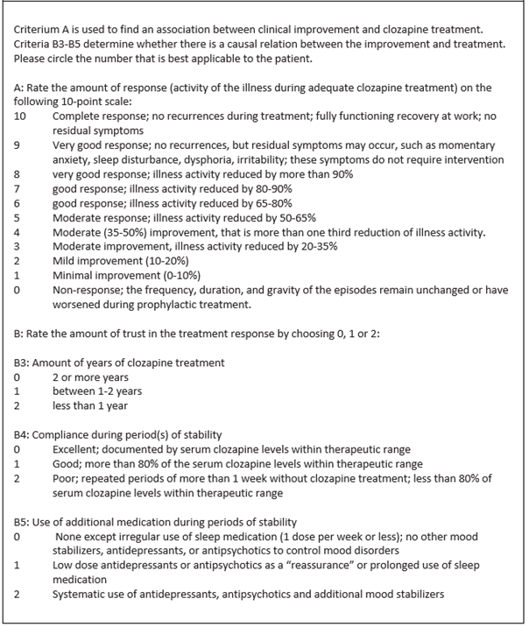

*

Supplementary Table 1. Baseline demographic and clinical characteristics of the study population.
 | N (%)
Relationship status
Single | 424 (88.9)
In a relationship | 53 (11.1)
Highest educational degree
Less than highschool | 131 (28.2)
Highschool | 171 (36.9)
Professional education | 105 (22.6)
University | 57 (12.3)
Country of residence
The Netherlands | 166 (34.6)
Germany | 76 (15.8)
Serbia | 50 (10.4)
Spain | 110 (22.9)
Italy | 42 (8.8)
Finland | 9 (1.9)
Austria | 27 (5.6)
Smoking
Yes | 238 (49.7)
No | 241 (50.3)
Cannabis use
Yes | 24 (5.1)
No | 450 (94.9)
Other recreational drug use
Yes | 12 (2.6)
No | 455 (97.4)
Symptom severity (CGI-scale)
Normal, not at all ill | 16 (3.7)
Borderline ill | 34 (7.9)
Mildy ill | 79 (18.3)
Moderately ill | 143 (33.2)
Markedly ill | 114 (26.5)
Severly ill | 40 (9.3)
Among the most ill patients | 5 (1.2)
Dose frequency
1 time/day  2 times/day  3 times/day | 232 (49.6)  122 (26.1)  114 (24.4)
Abbreviation: CGI=Clinical Global Impression.

Supplementary Figure 4. A: Histogram of patient satisfaction, ranged on a scale of 1 to 10. The black line illustrates the normal curve. B: Stacked bar chart depicting patient satisfaction categorized into three groups (low, intermediate, and high) alongside the proportion of response levels to clozapine treatment within each group. C: Stacked bar chart depicting patient satisfaction categorized into three groups (low, intermediate, and high) alongside the proportion of symptom severity levels (as measured by the Clinical Global Impression Scale) within each group.
A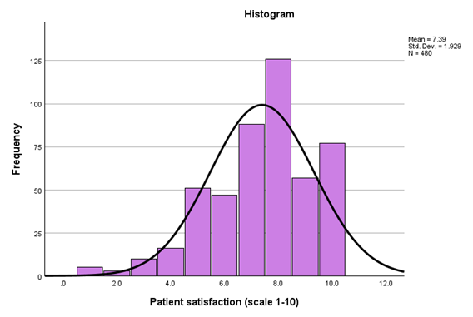
B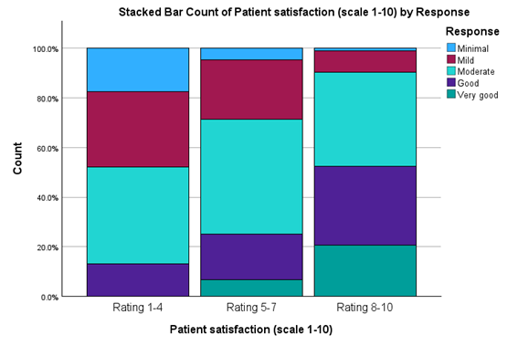
C 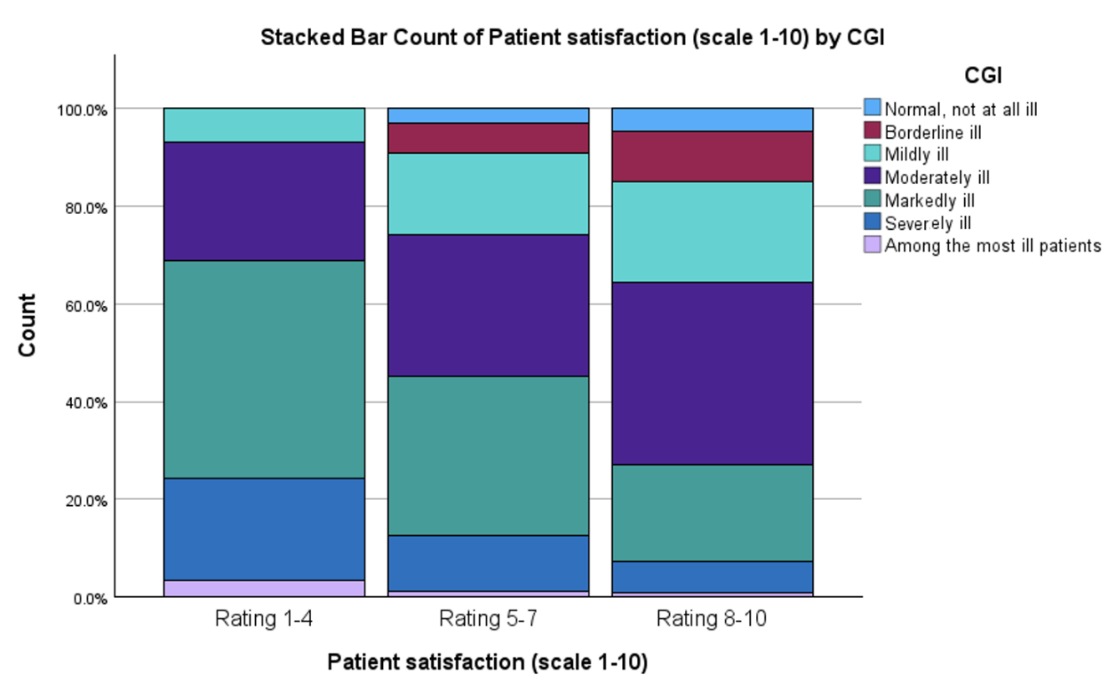

Supplementary Table 2. Prevalence of clozapine-associated adverse drug reactions in our study population.
 | Prevalance
Weight gain | 68.3%
Hypersalivation | 55.2%
Prolonged sleep duration | 50.2%
Drowsiness | 32.9%
Constipation | 28.3%
Dizziness | 27.5%
Decreased libido | 26.0%
Metabolic syndrome | 23.3%
Urinary incontinence | 15.6%
Heart palpitations | 14.4%
Nausea | 13.1%
Participant experienced a severe adverse drug reaction** | 7.1%
*Answers from participants to a single question about the presence (yes) or absence (no) of the specific ADR.
**The following clozapine-associated adverse drug reactions are considered to be severe: myocarditis, neutropenia, agranulocytosis, ileus, diabetic keto-acidosis, malignant neuroleptic syndrome.

Supplementary Table 3. Results of the linear regression model with sex and age included as covariates.
 | R² | B | 95% CI |  | p-value
Age | .021 | .019 | .004 | .033 | .011
Sex | .021 | .324 | -.049 | .697 | .089
Country of residence | .031 | .097 | .007 | .186 | .034
Relationship status | .026 | -.447 | -1.0008 | .114 | .118
Highest educational degree | .027 | -.072 | -.251 | .108 | .432
Use of recreational drugs | .050 | -1.315 | -2.007 | -.624 | 2.09x10⁻⁴
Dose frequency | .042 | .319 | .110 | .529 | .003
Use of additional medication | .030 | -.254 | 0.476 | -.033 | .024
Symptom severity | .101 | .433 | .294 | .572 | 2.06x10⁻⁹
Illness duration | .034 | .013 | -.013 | .039 | .319
Duration of clozapine treatment | .028 | .016 | -.012 | .043 | .264
Treatment compliance | .046 | -.556 | -.907 | -.205 | .002
Response | .189 | .803 | .630 | .976 | 4.67x10⁻¹⁸
Total number of side-effects | .057 | -.162 | -.237 | -.086 | 3.17x10⁻⁵
Adverse drug reactions
Hypersalivation | .056 | -.728 | -1.070 | -.385 | 3.51 x10⁻⁵
Weight gain | .028 | -.350 | -.721. | 021 | .065
Prolonged sleep duration | .042 | -.569 | -.916 | -.222 | 1.35x10⁻³
Drowsiness | .025 | -.258 | -.628 | .113 | .173
Constipation | .026 | -.303 | -.693 | .086 | .127
Dizziness | .025 | -.272 | -.657 | .112 | .164
Metabolic syndrome | .026 | -.299 | -.706 | .108 | .150
Decreased libido | .025 | -.254 | -.658 | .150 | .217
Heart palpitations | .022 | -.156 | -.646 | .334 | .531
Urinary incontinence | .030 | -.503 | -.979 | -.026 | .039
Nausea | .024 | -.308 | -.817 | .200 | .234
Severe adverse drug reaction* | .022 | -.211 | -.881 | .459 | .536
*The following clozapine-associated adverse drug reactions are considered to be severe side-effect: myocarditis, neutropenia, agranulocytosis, ileus, diabetic keto-acidosis, malignant neuroleptic syndrome.
Abbreviations: R²=explained variance, B=unstandardized beta, CI=confidence interval.

Supplementary Figure 5. Boxplot showing the association between patient satisfaction on the x-axis and age on the y-axis. The boxes represent the interquartile ranges, the whiskers the upper and lower quartiles, and the bold horizontal line the median.

