Adaptation of the Virtual Assessment of Mentalizing Ability and Evaluation of its Utility and Psychometric Properties in Chinese Individuals on the Schizophrenia Spectrum

Supplementary Materials

Appendix A: Table 1 Changes from Original VAMA to Current Adapted Version
Appendix B: Table 1. Explanation of Removed Scenarios in the current adapted VAMA
Table 2. Scenarios of the adapted version of VAMA
Appendix C: VAMA Example scenario
Appendix D: Example question of Scene 5
Appendix E: Group difference on 4 subcomponents of ToM performance in Study 2
Appendix F: Group difference on VAMA (Healthy control vs Schizophrenia patients)
Appendix G: Group difference on Yoni Task (Healthy control vs Schizophrenia patients)
Appendix H: Group difference on VAMA (Low SA vs High SA)
Appendix I: Comparison between the original VAMA and the current adapted version

Appendix A
Table 1. Changes from Original VAMA to Current Adapted Version
Aspect of VAMA | Original Version of VAMA  (Canty et al)¹ | Current Adapted Version of VAMA | Rationale for Change | Expected Differences
Perspective | First-person | Third-person | To align with ToM processes, which involve understanding others' mental states from an external viewpoint | Potential differences in neural activation and participant engagement
Background of the task | Virtual shopping mall (3D) | Real-world shopping mall (2D) | To increase authenticity and verisimilitude, making it easier to adapt for other cultural contexts | Potential differences in participant judgment due to increased realism
Task Complexity | Involved shopping tasks, ToM video clips and questions | Focused on ToM video clips and questions | To reduce cognitive load and focus on mentalising abilities | Reduced cognitive load, potentially affecting performance*
Stimuli presentation Method | Videos on laptop | Videos on laptop with headphones | To enhance experimental experience and minimize external noise disturbances | Improved focus and engagement due to reduced noise
Expert Involvement | Not mentioned | Included 4 subject matter experts | To increase content validity and ensure the relevance and accuracy of scenarios | Enhanced content validity and scenario relevance
Cultural Adaptation# | Western cultural context | Chinese cultural context | To ensure cultural appropriateness and relevance, scenarios were created to reflect Chinese collectivistic values | Improved ecological validity and cultural sensitivity
Ecological Validity | Not explicitly defined | Assessed through pilot testing and familiarity questions | To ensure scenarios are relatable and mirror real-life situations for young adults | Increased relevance and realism of scenarios
Note. *The results from the previous are mixed, further studies are needed.
#See Appendix B for more information on the removal scenario and reason for removal.
Table 1. Explanation of Removed Scenarios in the current adapted VAMA
Scenario from the original VAMA | Story Plot | Justification of removal
Scene 1 | The story is about the Test-taker meets Character A and B at a coffee shop, talking about vacation. Character C arrives at the coffee shop and dominates the conversation. | Normally, it is not common that friends would be so rude to friends in China or even Asian countries. People may easily misunderstand or overthink Character D’s behavior.
Scene 3 | The story is about Character A’s struggles with weight loss. Character C enters and boasts about his fitness, “Hey guys, I just weighted myself on those self-service scales and I lost 3 kilos”. | It is uncommon that there is a scale in a shopping mall, moreover, the behavior of Character C is lacking of humility and too rude to friends in Chinese culture.
Scene 4 | The story is about the Test-taker and Character B meets Character A at the hairdresser, where she has just had her hair cut. Character B positively jokes about Character A’s hair, saying “You need to get a new hairdresser. That looks awful.” | While this scenario is considered normal/appropriate in Western countries, it is unusual that friends will tell this kind of joke between friends in China.
Scene 6 | Character A and B are going to meet in a fortnight. Character A asked Character D if he could look after their children that night. Character D got something to do that night, so he asked Character C if he could help. | In Chinese culture, childcare is often seen as a family responsibility, and involving friends in such personal matters might be considered unusual, instead involving grandparents will be more reasonable.
Scene 7 | Character C invites Character B to the beach while B rejects it. Character A suggests going together. | Persistently insisting after a refusal can be seen as disrespectful in Chinese culture, where indirect communication and respecting others' decisions are important.
Scene 9 | Character D gets promoted, and his wife, Character A would like to prepare a surprise party for him. Character D overhears and asks for details, but Character B deflects. | In general, it is rare that people don’t know they will get promoted, instead, their spouse knows about it.
Scene 10 | Character D discusses financial strain with Character C, while Character B enters, Character D tells lies. | Discussing financial issues openly can be sensitive, and lying to a spouse might be seen as undermining family harmony and trust, which are highly valued in Chinese culture. Chinese participants may easily overthink.
Appendix B

Appendix B
Table 2. Scenarios of the adapted version of VAMA
 | Story Plot | Intended Purpose
Scene 1  (Retained from the original VAMA) | At the cinema, Character C talks exclusively to Character A about his new job as a lawyer. Character D arrives, irritated, and makes a negative remark about lawyers. Character B interrupts and directs Character D to buy tickets. | This scenario is considered culturally appropriate for Chinese culture.
Scene 2  (Retained from the original VAMA) | Character C discusses a family medical issue with Character A. Character D enters and makes an inappropriate joke about terminal illness. | This scenario is considered culturally appropriate for Chinese culture.
Scene 3 | Character C and Character D express surprise at Character A’s decision to further study while working. Character A explains her motivation, leading to a misunderstanding with Character D, who feels her comments are sarcastic. | Most of the Chinese would plan for further studying in recent years.
Scene 4 | Character C expresses surprise and disbelief when Character A mentions she is studying Chinese language and literature. Character C and Character D joke about their past experiences with literature courses, including skipping classes and manipulating attendance records. | Common study life among Chinese students.
Scene 5 | The group discusses the importance of academic results. Character B shares her experience of not having high academic qualifications but still achieving success. Character C makes a dismissive comment about her success being due to her family support, which leads to a tense exchange. | “Family support” and individual success are a unique trend among Chinese.
Scene 6 | Character A confides in Character B about the pressure from her parents to find a boyfriend. Character A shares her stress about marriage pressures, explaining her concerns about not being ready and the many considerations involved. Character A feels awkward about a blind date (/ speed dating), but Character B encourages her to consider her future. | Women will be considered "past the ideal marriage age" in traditional Chinese culture if they are not getting married at twenty to thirty years old and they will face pressure from family and society to get married.
Scene 7 | The group passes a tailor shop, and Character C is interested in a suit but hesitates to buy it. Character D arrives and makes a comment about Character C living paycheck to paycheck. Character C loudly insists he can afford the suit and boasts about his wealth, dismissing the suit's quality. The group exchanges playful but sarcastic remarks. | This story represents a common and usual Chinese signature: “Face saving”.
Scene 8 | The group is walking near a restaurant with a long queue. The group discusses the influence and earnings of internet celebrities, with Character C joking about becoming one himself. | “Internet Celebrity” is a popular term among Chinese young adults in recent years.
Scene 9  (Retained from the original VAMA) | Character B tells Character C she gave away a book Character A gifted her for her birthday. When Character A asks to borrow it, Character B lies about its whereabouts. | This scenario is considered culturally appropriate for Chinese culture.
Scene 10 | Character D jokingly suggests Character C should buy drinks for everyone. Character C agrees to buy the drinks, especially for Character A. After Character C and Character D leave, Character A confides in Character B that she thinks Character C might like her. | Afraid of hurting someone or “face” are common in Chinese.

Appendix C
VAMA Example scenario
Figure 1a.
Example scenario with questions from VAMA Scene 5
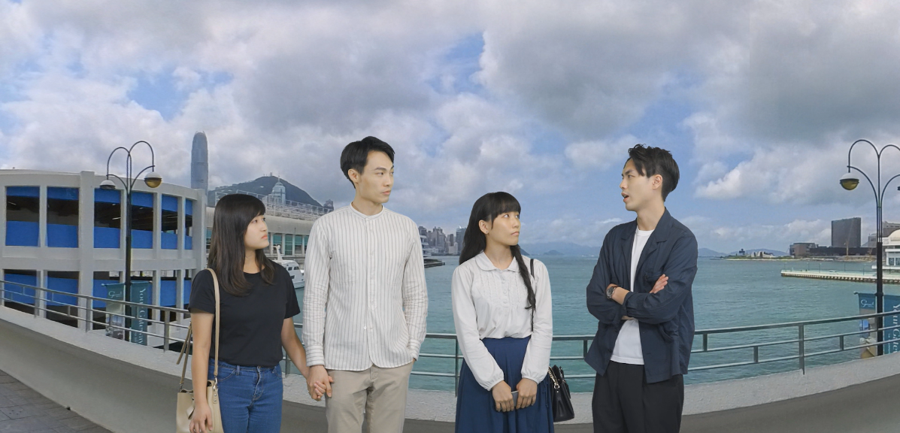
Figure 1b.
Example scenario with questions from VAMA Scene 5
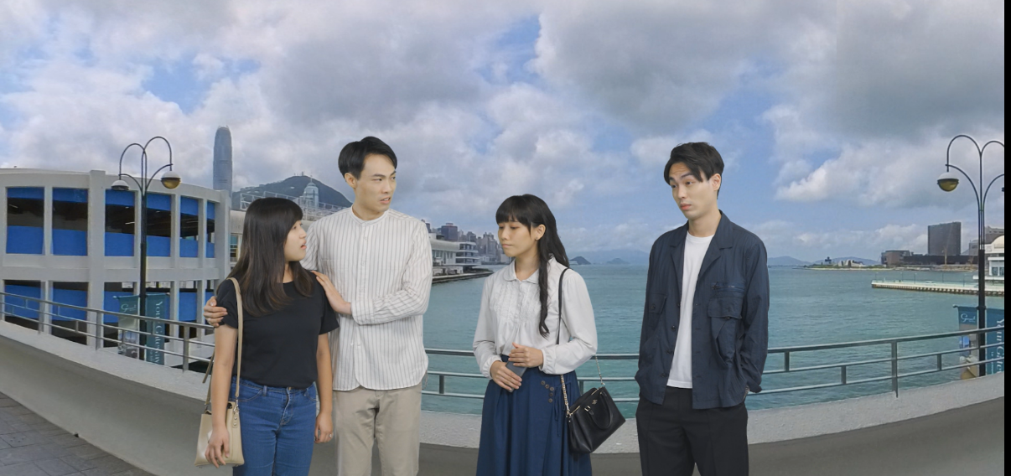

Figure 1c.
Example scenario with questions from VAMA Scene 5
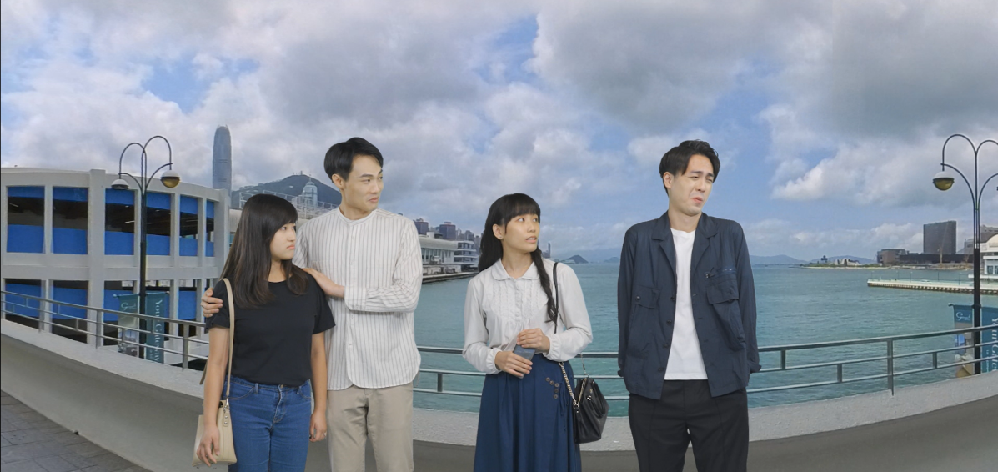

Note. Figure 1a: Tin Ho was emphasizing the importance of academic performance, but Yu Sum disagreed, stating that even though her academic performance were not good, her life was still decent. Figure 1b: Tin Ho stated that Yu Sum's comfortable life was because of her wealthy father who could support her, unlike others who had to rely on their own efforts. Upon hearing this, Yu Sum became angry and expressed strong dissatisfaction with Tin Ho 's words. She emphasized that her current achievements were a result of her own hard work and effort. Figure 1c: Man Pok and Suet Yi both agreed with Yu Sum's viewpoint, but upon hearing it, Tin Ho responded with a derisive laugh.

Appendix D
Example question of Scene 5
Question of first Cognitive: Why did Lau Tin Ho say, 'The whole world values the academic performance only!'?
A) Lau Tin Ho agrees with Chow Man Pok statement about the hardships of being a student
(Reduced ToM)
B) Lau Tin Ho not only agrees with Chow Man Pok statement but also wants to highlight his own good grades (Hypermentalising)
C) Lau Tin Ho supports the current education system (No ToM)
D) Lau Tin Ho believes that people all over the world only care about grades (Correct)
Note. An example first-order Cognitive ToM question. The example presents in English, however, the contents and questions were shown in Chinese in HKSAR and the mainland China.

Appendix E
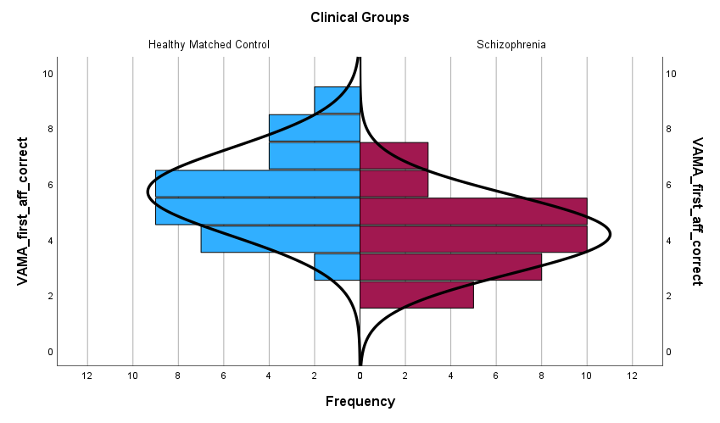
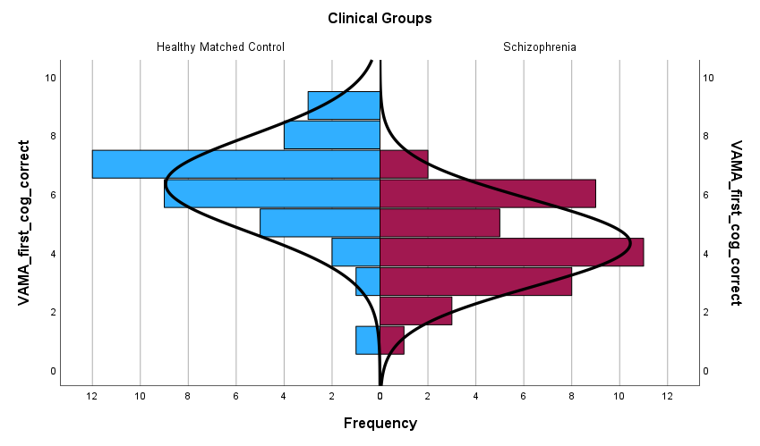
Group difference on 4 subcomponents of ToM performance in Study 2
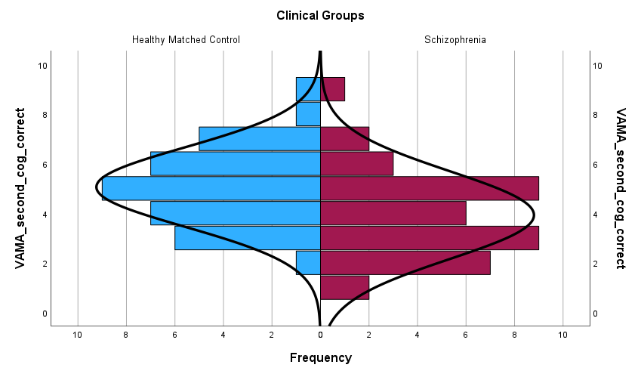

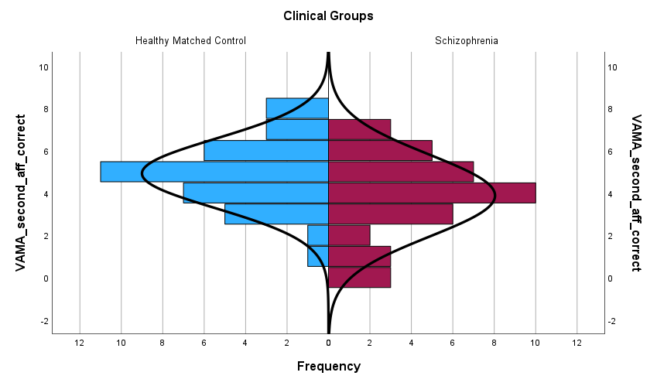

Appendix F
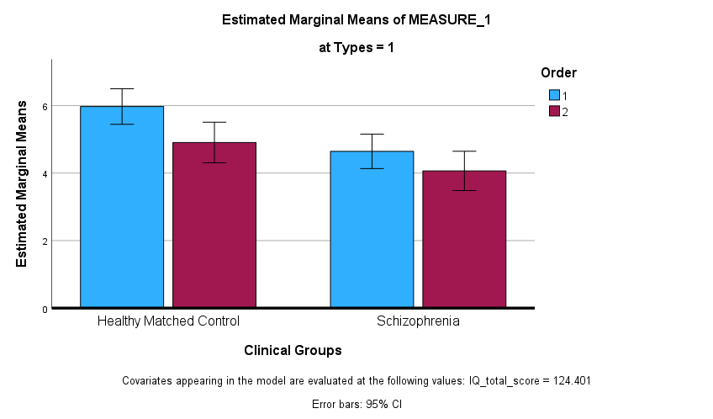
Figure 1. Performance of clinical and healthy participants on first-order and second-order Cognitive ToM as measured by the VAMA. Error bars represent 95% confidence interval (controlling the estimated IQ).

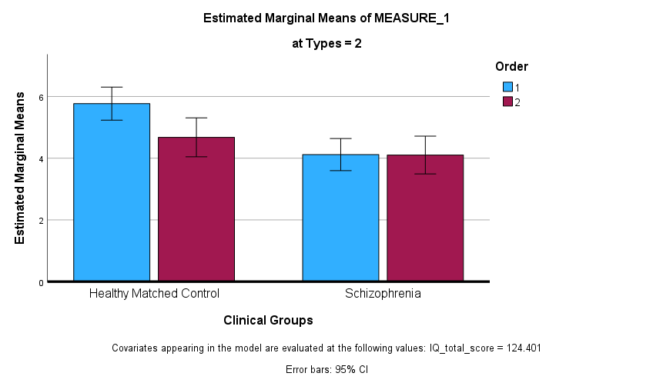
Figure 2. Performance of clinical and healthy participants on first-order and second-order Affective ToM as measured by the VAMA. Error bars represent 95% confidence interval (controlling the estimated IQ).

Appendix G
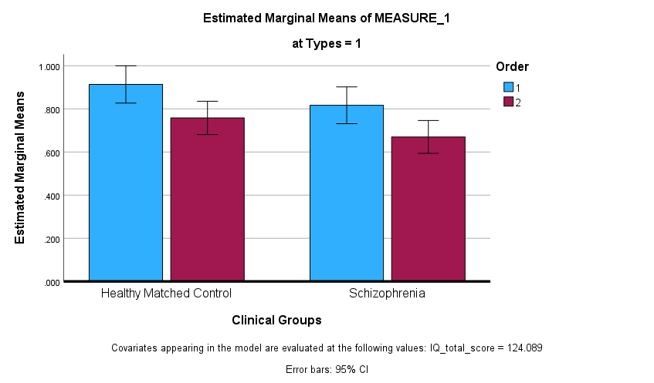
Figure 1. Performance of clinical and healthy participants on first-order and second-order Cognitive ToM as measured by the Yoni Task. Error bars represent 95% confidence interval (controlling the estimated IQ).
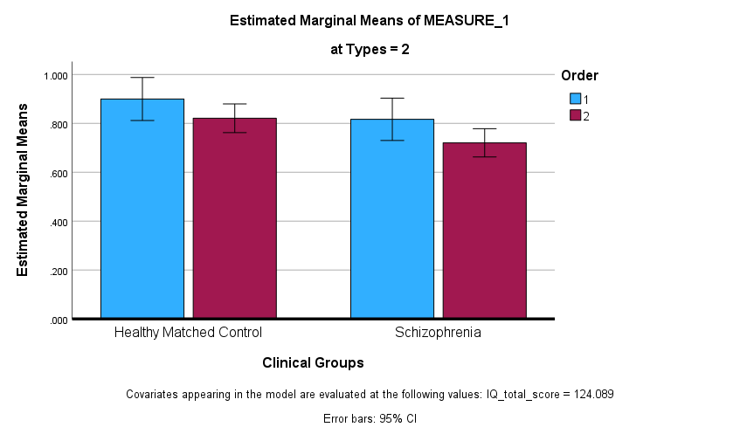
Figure 2. Performance of clinical and healthy participants on first-order and second-order Affective ToM as measured by the Yoni Task. Error bars represent 95% confidence interval (controlling the estimated IQ).

Appendix H
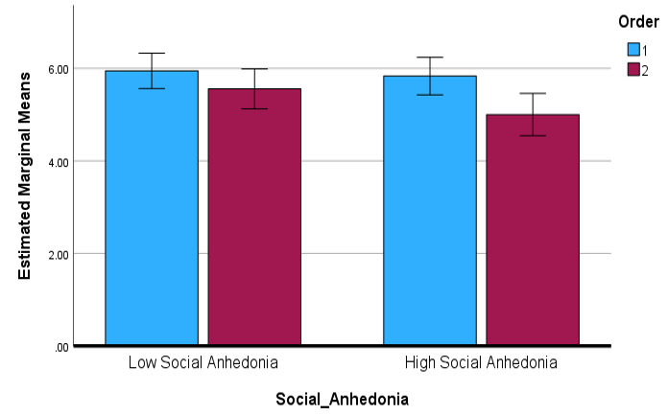
Figure 1. Performance of social anhedonia group and healthy participants on first-order and second-order Cognitive ToM as measured by the VAMA Task. Error bars represent 95% confidence interval.

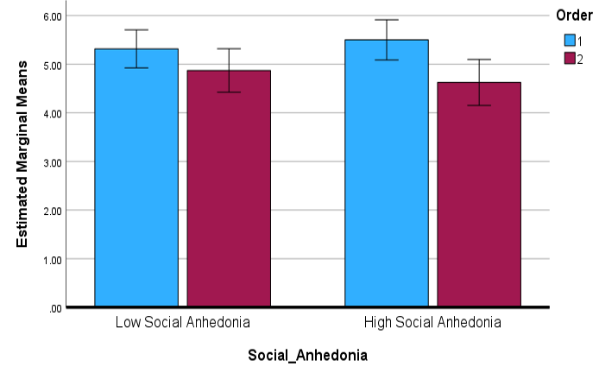
Figure 2. Performance of social anhedonia group and healthy participants on first-order and second-order Affective ToM as measured by the VAMA Task. Error bars represent 95% confidence interval.

Appendix I
Table 1. Comparison between the original VAMA and the current adapted version
 | Original VAMA  (Canty et al., 2017) | Current Adapted version (Study 1) | Original VAMA  (Canty et al., 2021) |  |  |  | Current Adapted version (Study 2)
 | Healthy#  (estimated) | Healthy | Early Schizophrenia – Control# | Early Schizophrenia Patient# | Chronic Schizophrenia – Control# | Chronic Schizophrenia Patient# | Schizophrenia patients - Control | Schizophrenia patients | High Social Anhedonia | Low  Social Anhedonia
N | 65 | 100 | 26 | 26 | 33 | 33 | 37 | 39 | 48 | 54
Country | Australia | China | Australia |  |  |  | China
Gender | 25M40F | 50M50F | 13M13F | 13M13F | 22M11F | 22M11F | 8/29 | 5/34 | 25/23 | 22/32
Age (SD) | 25.98(7.01) | 23.49 (1.13) | 23.85 (3.46) | 23.19 (2.84) | 35.09 (6.51) | 31.64 (8.97) | 27.57 (8.04) | 29.13 (9.11) | 19.83 (0.72) | 19.81 (0.70)
Age range | 18-55 | 22-28 | N.A. | N.A. | N.A. | N.A. | 19-50 | 18-51 | 18-21 | 18-21
Education years (SD) | 14.19(1.93) | 16.85(0.82) | 11.62(1.36) | 12.19(2.02) | 12.15(2.15) | 11.30(1.70) | 16.03(2.14) | 14.10(3.07) | 14.65(0.53) | 14.57(0.50)
VAMA_1st Cognitive | 7.0(2.0) | 6.19 (1.63) | 7.5(0.5) | 6.8(1.0) | 7.3(0.5) | 5.3(1.0) | 6.32(1.65) | 4.31(1.49) | 5.83(1.34) | 5.94(1.48)
VAMA_1st Affective | 8.0(2.0) | 5.60(1.50) | 8.5(0.5) | 7.0(0.8) | 7.8(0.3) | 5.5(0.5) | 5.70(1.58) | 4.18(1.41) | 5.50(1.37) | 5.31(1.52)
VAMA_2nd Cognitive | 6.0(2.0) | 5.23 (1.55) | 7.3(0.5) | 5.5(0.5) | 7.0(0.5) | 4.2 (0.5) | 5.05(1.60) | 3.92(1.77) | 5.00(1.44) | 5.56(1.72)
VAMA_2nd Affective | 4.5(2.0) | 4.67 (1.75) | 6.8(1.0) | 4.2(0.2) | 7.0(0.5) | 3.0(0.5) | 4.92(1.64) | 3.87(1.94) | 4.62(1.84) | 4.87(1.47)
#Estimations from the bar charts of Canty et al (2017; 2020).

