Supplementary Figure 1: Mean AUC scores across different values of Boruta percentile parameter, $p$.
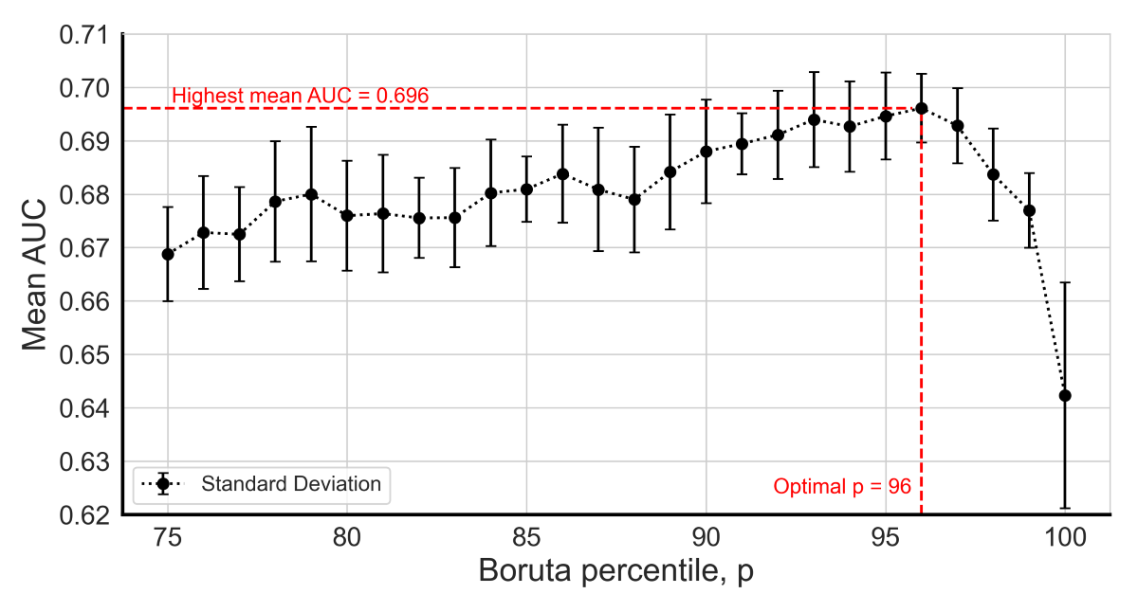
Supplementary Figure 2: Pearson correlation coefficients of highly correlated features (|$r$|>0.75). Features marked with * were removed from subsequent analyses.
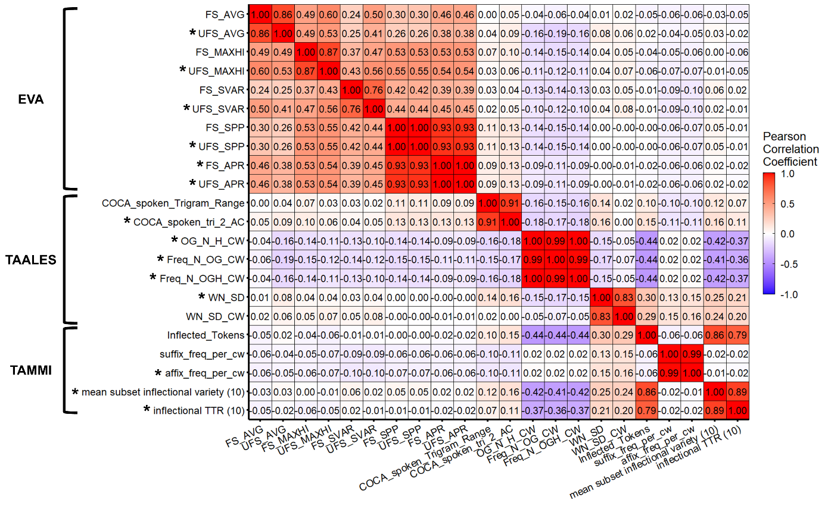

Supplementary Table 1: Class-specific performance averaged across 30 random forest classifiers at Boruta percentile parameter, $p$=96.
Performance Metric | UHR Positive | UHR Negative
Recall, mean (SD) | 0.431 (0.020) | 0.818 (0.006)
Precision, mean (SD) | 0.352 (0.016) | 0.863 (0.005)
F1, mean (SD) | 0.388 (0.018) | 0.840 (0.005)

Supplementary Table 2: Factor loading scores of shortlisted Boruta features.
Feature Set | Feature Name | Sentiment Intensity and Variability | Linguistic Register Alignment | Phonographic Uniqueness and Recognizability | Morphological Complexity and Imageability | Lexical Richness and Typicalness
EVA | FS_MAXHI | 0.83 | 0.01 | 0.05 | –0.01 | 0.04
EVA | FS_SPP | 0.78 | 0.02 | 0.05 | –0.03 | –0.06
EVA | FS_AVG | 0.67 | –0.07 | –0.01 | 0.02 | 0.16
EVA | FS_SVAR | 0.66 | –0.02 | 0.04 | 0.02 | –0.05
TAALES | COCA_Fiction_  Trigram_Range | –0.11 | 0.88 | –0.02 | –0.02 | –0.01
TAALES | COCA_spoken_  Trigram_Range | 0.02 | 0.88 | 0.11 | 0.14 | 0.02
TAALES | COCA_magazine_  tri_prop_10k | 0.01 | 0.74 | –0.09 | –0.14 | 0.11
TAALES | WN_SD_CW | 0.09 | 0.07 | 0.73 | 0.04 | –0.05
TAALES | OG_N | –0.07 | 0.02 | –0.59 | 0.10 | 0.10
TAALES | MRC_  Imageability_CW | 0.06 | –0.05 | –0.15 | 0.76 | 0.31
TAALES | LD_Mean_  Accuracy_CW | 0.12 | 0.07 | 0.20 | 0.21 | 0.73
TAALES | COCA_spoken_  tri_2_MI | 0.06 | –0.02 | 0.35 | 0.03 | –0.64
TAMMI | Inflected_Tokens | –0.13 | 0.10 | 0.45 | 0.63 | –0.07
TAMMI | suffix_freq_per_cw | –0.01 | 0.06 | 0.45 | –0.55 | 0.26
TAACO | trigram_lemma_ttr | –0.15 | –0.14 | 0.35 | 0.00 | 0.15

Supplementary Table 3: Structure and example of each prompt level. Few-shot samples were randomly selected.
Level | Structure | Example
1 | Transcript +  CDS Role +  Question +  Explanation | [Transcript] +  Please act as a clinical decision support tool. +  The transcript is from someone who is trying to win 'The Most Interesting Person’ award. Does the transcript belong to someone at ultra-high risk of psychosis? +  Answer with Yes or No, then explain why.
2 | Transcript +  CDS Role +  Question +  UHR Criteria +  Explanation | [Transcript] +  Please act as a clinical decision support tool. +  The transcript is from someone who is trying to win 'The Most Interesting Person’ award. Does the transcript belong to someone at ultra-high risk of psychosis +  as defined by the three Comprehensive Assessment of At-Risk Mental States (CAARMS) criteria for UHR? +  Answer with Yes or No, then explain why.
3 | Transcript +  CDS Role +  Question +  UHR Criteria +  Explanation +  Few-shot Samples | [Transcript] +  Please act as a clinical decision support tool. +  The transcript is from someone who is trying to win 'The Most Interesting Person’ award. Does the transcript belong to someone at ultra-high risk of psychosis +  as defined by the three Comprehensive Assessment of At-Risk Mental States (CAARMS) criteria for UHR? +  Answer with Yes or No, then explain why. +  Here are 4 examples:  [UHR Positive Transcript 1] belongs to a UHR positive participant +  [UHR Positive Transcript 2] belongs to a UHR positive participant +  [UHR Negative Transcript 1] belongs to a UHR negative participant +  [UHR Negative Transcript 2] belongs to a UHR negative participant.

