Supplementary Tables and Figures
Table S1. Definition of metabolic syndrome according to NCEP ATP III Criteria.
Table S2. Linear mixed models of metabolic components and CGI-S score by groups in the matched population using NCEP ATP III criteria.
Table S3. Between-group changes in the proportion of patients with metabolic syndromes according to age, sex, physical conditions, body mass index, duration, smoking or drinking and polypharmacy.
Table S4. Between-group changes of the number of metabolic abnormalities according to age, sex, physical conditions, body mass index, duration, smoking or drinking and polypharmacy.
Table S5. Baseline characteristics of participants in the group of low-risk SGAs according to adding or switching strategies.
Table S6. Changes in secondary outcomes from baseline to 4 weeks, 8 weeks, 3 months and 6 months in the group of low-risk SGAs according to adding or switching strategies.
Table S7. Changes in secondary outcomes from baseline to 4 weeks, 8 weeks, 3 months and 6 months in the matched population.

Figure S1. Changes in the proportion of patients with metabolic syndrome from baseline to 4 weeks, 8 weeks, 3 months and 6 months in the unmatched population prescribed one second-generation antipsychotic.
Figure S2. Changes in the number of metabolic syndrome components from baseline to 4 weeks, 8 weeks, 3 months and 6 months in the unmatched population prescribed one second-generation antipsychotic.
Figure S3. Changes in primary outcomes from baseline to 4 weeks, 8 weeks, 3 months and 6 months in the matched population using NCEP ATP III criteria. (A) Within-group changes in the proportion of patients with metabolic syndromes in the group of low-risk SGAs. (B) Within-group changes in the proportion of patients with metabolic syndromes in the group of high/intermediate-risk SGAs. (C) Between-group changes in the proportion of patients with metabolic syndromes. Changes are estimated as risk differences with 95% confidence intervals by chi square tests. (D) Within-group changes in the number of metabolic abnormalities in the group of low-risk SGAs. (E) Within-group changes of the number of metabolic abnormalities in the group of high/intermediate-risk SGAs. (F) Between-group changes of the number of metabolic abnormalities. Changes are estimated as mean differences with 95% confidence intervals by paired t-tests.
Figure S4. Changes in primary outcomes from baseline to 4 weeks, 8 weeks, 3 months and 6 months in the group of low-risk SGAs. (A) Within-group changes in the proportion of patients with metabolic syndromes in those received the adding low-risk SGAs strategy. (B) Within-group changes in the proportion of patients with metabolic syndromes in those received the switching low-risk SGAs strategy. Changes are estimated as risk differences with 95% confidence intervals by chi square tests. (C) Within-group changes in the number of metabolic abnormalities in those received the adding low-risk SGAs strategy. (D) Within-group changes of the number of metabolic abnormalities in those received the switching low-risk SGAs strategy. Changes are estimated as mean differences with 95% confidence intervals by paired t-tests.

Table S1. Definition of metabolic syndrome according to NCEP ATP III Criteria.
 | NCEP ATP III Criteria
Metabolic indicators
Central obesity | Male: Waist circumference>=90 cm  Female: Waist circumference>=80 cm
Blood pressure | Systolic blood pressure>=130 mmHg or diastolic blood pressure>=85 mmHg
Fasting blood glucose | >=5.6 mmol/L
Fasting triglyceride | >=1.7 mmol/L
Fasting HDL-C | Male: <1.03 mmol/L  Female: <1.30 mmol/L
Metabolic syndrome | Having three or more metabolic abnormalities
NCEP ATP III, National Cholesterol Education Program Adult Treatment Panel III; IDF, International Diabetes Federation; HDL-C, high density lipoprotein cholesterol.

Table S2. Linear mixed models of metabolic components and CGI-S score by groups in the matched population using NCEP ATP III criteria.
 | OR (95% CI) / RR (95% CI) / β (95% CI)
 | 4 weeks | 8 weeks | 3 months | 6 months
Metabolic syndrome¹ | 0.86 (0.61, 1.20) | 0.54 (0.37, 0.77) | 0.64 (0.43, 0.96) | 0.54 (0.36, 0.82)
Number of metabolic abnormalities² | 0.97 (0.91, 1.04) | 0.87 (0.81, 0.94) | 0.86 (0.79, 0.93) | 0.82 (0.75, 0.90)
Metabolic parameters³
Weight, kg | -0.425 (-1.262, 0.413) | -1.019 (-1.857, -0.182) | -1.475 (-2.312, -0.637) | -2.417 (-3.254, -1.579)
Waist circumference, cm | 0.792 (-1.220, 2.804) | 0.230 (-1.782, 2.242) | 0.586 (-1.426, 2.599) | -0.309 (-2.322, 1.703)
Systolic blood pressure, mmHg | -1.11 (-3.271, 1.050) | -1.674 (-3.834, 0.487) | -1.136 (-3.296, 1.025) | -0.508 (-2.669, 1.652)
Diastolic blood pressure, mmHg | 0.949 (-0.681, 2.579) | 0 (-1.630, 1.630) | -0.254 (-1.884, 1.376) | -0.229 (-1.859, 1.401)
Glucose, mmol/L | -0.040 (-0.214, 0.134) | -0.046 (-0.220, 0.128) | -0.073 (-0.247, 0.101) | -0.190 (-0.363, -0.016)
Triglyceride, mmol/L | -0.114 (-0.264, 0.035) | -0.254 (-0.403, -0.104) | -0.336 (-0.486, -0.187) | -0.364 (-0.514, -0.215)
HDL-C, mmol/L | 0.035 (-0.048, 0.119) | 0.038 (-0.046, 0.121) | 0.062 (-0.021, 0.145) | 0.035 (-0.048, 0.118)
CGI-S score³ | -0.241 (-0.394, -0.087) | -0.226 (-0.380, -0.072) | -0.121 (-0.276, 0.033) | -0.051 (-0.205, 0.103)
OR, odds ratio; RR, risk ratio; CI, confidence interval; HDL-C, high density lipoprotein cholesterol; CGI-S, Clinical Global Impressions scale-Severity.
Adjusted for dose of SGAs.
¹OR (95% CI) for generalized estimated equations with log-binomial link.
²RR (95% CI) for generalized estimated equations with log-Poisson link.
³β (95% CI) for linear mixed models.

Table S3. Between-group changes in the proportion of patients with metabolic syndromes according to age, sex, physical conditions, body mass index, duration, smoking or drinking and polypharmacy.
 | Risk difference in proportion of patients with metabolic syndrome (%)
 | Baseline | 4 weeks | 8 weeks | 3 months | 6 months
Age, y
<50 years | 1.56 (-12.55 to 15.66) | -3.7 (-17.64 to 10.23) | -17.17 (-30.93 to -3.42) | -18.22 (-31.88 to -4.57) | -22.35 (-35.97 to -8.72)
>= 50 years | -3.55 (-15.86 to 8.76) | -1.93 (-14.17 to 10.31) | -15.34 (-27.26 to -3.41) | -5.83 (-17.74 to 6.08) | -16.89 (-28.59 to -5.19)
Sex
Male | 2.67 (-9.14 to 14.47) | -4.31 (-16.03 to 7.41) | -22.41 (-33.88 to -10.94) | -17.56 (-28.98 to -6.13) | -22.59 (-33.94 to -11.25)
Female | -7.21 (-22.1 to 7.69) | 0.01 (-14.83 to 14.85) | -5.12 (-19.33 to 9.08) | -0.63 (-15.06 to 13.79) | -13.47 (-27.75 to 0.81)
Physical conditions
No | 0.18 (-12.35 to 12.71) | -3.78 (-16.08 to 8.52) | -22.72 (-34.59 to -10.86) | -19.31 (-31.01 to -7.60) | -26.71 (-38.08 to -15.34)
Yes | -2.73 (-16.37 to 10.91) | -1.04 (-14.76 to 12.68) | -8.00 (-21.64 to 5.64) | -1.15 (-14.82 to 12.52) | -9.88 (-23.53 to 3.76)
BMI
<25.7 kg/m2 | -2.78 (-14.77 to 9.22) | -7.77 (-19.86 to 4.32) | -21.85 (-33.43 to -10.28) | -17.69 (-29.17 to -6.20) | -26.00 (-37.4 to -14.60)
>=25.7 kg/m2 | 0.66 (-12.18 to 13.5) | 3.44 (-10.23 to 17.10) | -9.26 (-22.89 to 4.37) | -3.43 (-17.10 to 10.25) | -11.24 (-24.83 to 2.35)
Duration
<28.9 years | -3.63 (-15.88 to 8.62) | -6.92 (-19.06 to 5.22) | -26.58 (-38.25 to -14.92) | -15.57 (-27.57 to -3.57) | -20.31 (-32.16 to -8.45)
>=28.9 years | 1.45 (-12.72 to 15.62) | 2.96 (-11.09 to 17.02) | -2.08 (-15.97 to 11.80) | -4.93 (-18.36 to 8.51) | -17.61 (-31.05 to -4.17)
Smoking or drinking
No | 1.39 (-8.86 to 11.65) | -1.26 (-11.41 to 8.90) | -14.38 (-24.38 to -4.38) | -8.87 (-18.87 to 1.13) | -18.73 (-28.56 to -8.89)
Yes | -13.37 (-34.94 to 8.20) | -8.97 (-30.58 to 12.64) | -24.18 (-44.85 to -3.50) | -21.98 (-42.37 to -1.58) | -21.61 (-42.54 to -0.68)
Polypharmacy
No | -3.51 (-17.62 to 10.60) | -1.58 (-15.76 to 12.60) | -19.53 (-33.36 to -5.70) | -4.90 (-18.96 to 9.16) | -17.54 (-31.30 to -3.78)
Yes | 0.50 (-11.73 to 12.72) | -3.27 (-15.23 to 8.69) | -13.46 (-25.29 to -1.62) | -15.74 (-27.36 to -4.13) | -20.51 (-32.17 to -8.84)
Changes are estimated as risk differences with 95% confidence intervals by chi square tests.
BMI, body mass index.

Table S4. Between-group changes of the number of metabolic abnormalities according to age, sex, physical conditions, body mass index, duration, smoking or drinking and polypharmacy.
 | Mean difference in proportion of patients with metabolic syndrome
 | Baseline | 4 weeks | 8 weeks | 3 months | 6 months
Age, y
<50 years | 0.09 (-0.24 to 0.41) | -0.07 (-0.41 to 0.27) | -0.32 (-0.66 to 0.02) | -0.42 (-0.79 to -0.05) | -0.60 (-0.97 to -0.23)
>= 50 years | -0.06 (-0.32 to 0.20) | -0.07 (-0.36 to 0.21) | -0.33 (-0.62 to -0.05) | -0.33 (-0.60 to -0.05) | -0.46 (-0.74 to -0.18)
Sex
Male | 0.06 (-0.21 to 0.32) | -0.08 (-0.37 to 0.2) | -0.49 (-0.78 to -0.21) | -0.57 (-0.87 to -0.27) | -0.72 (-1.02 to -0.41)
Female | -0.07 (-0.39 to 0.24) | -0.05 (-0.40 to 0.29) | -0.05 (-0.38 to 0.28) | -0.04 (-0.36 to 0.28) | -0.20 (-0.52 to 0.12)
Physical conditions
No | 0.09 (-0.18 to 0.36) | -0.06 (-0.35 to 0.23) | -0.41 (-0.69 to -0.13) | -0.50 (-0.79 to -0.21) | -0.68 (-0.98 to -0.38)
Yes | -0.08 (-0.38 to 0.22) | -0.08 (-0.40 to 0.25) | -0.22 (-0.56 to 0.12) | -0.20 (-0.54 to 0.14) | -0.32 (-0.65 to 0.02)
BMI
<25.7 kg/m2 | -0.06 (-0.31 to 0.20) | -0.19 (-0.47 to 0.09) | -0.52 (-0.80 to -0.25) | -0.61 (-0.91 to -0.32) | -0.85 (-1.15 to -0.55)
>=25.7 kg/m2 | 0.09 (-0.20 to 0.38) | 0.07 (-0.25 to 0.40) | -0.09 (-0.42 to 0.24) | -0.07 (-0.39 to 0.25) | -0.13 (-0.45 to 0.18)
Duration
<28.9 years | -0.06 (-0.33 to 0.21) | -0.11 (-0.40 to 0.18) | -0.50 (-0.77 to -0.23) | -0.40 (-0.70 to -0.11) | -0.50 (-0.80 to -0.20)
>=28.9 years | 0.09 (-0.22 to 0.39) | -0.02 (-0.35 to 0.31) | -0.10 (-0.45 to 0.26) | -0.31 (-0.64 to 0.03) | -0.54 (-0.88 to -0.20)
Smoking or drinking
No | 0.06 (-0.16 to 0.28) | -0.03 (-0.26 to 0.21) | -0.27 (-0.51 to -0.03) | -0.32 (-0.56 to -0.07) | -0.48 (-0.72 to -0.24)
Yes | -0.22 (-0.77 to 0.32) | -0.27 (-0.87 to 0.32) | -0.59 (-1.10 to -0.07) | -0.61 (-1.15 to -0.07) | -0.70 (-1.29 to -0.11)
Polypharmacy
No | -0.10 (-0.43 to 0.23) | -0.03 (-0.38 to 0.32) | -0.20 (-0.54 to 0.14) | -0.21 (-0.55 to 0.13) | -0.37 (-0.70 to -0.04)
Yes | 0.09 (0.35 to 1.03) | -0.10 (0.18 to 1.13) | -0.42 (-0.14 to 1.15) | -0.48 (-0.19 to 1.20) | -0.63 (-0.32 to 1.25)
Changes are estimated as mean differences with 95% confidence intervals by paired t-tests.
BMI, body mass index.

Table S5. Baseline characteristics of participants in the group of low-risk SGAs according to adding or switching strategies.
 | Low-risk SGAs
 | Adding (n=128) | Switching (n=95) | p value
Age, y | 50.4 (11.5) | 48.7 (12.4) | 0.276
Sex |  |  | <0.001
Male | 90 (70.3) | 44 (46.3)
Female | 38 (29.7) | 51 (53.7)
Marital status |  |  | 0.291
Married | 92 (71.9) | 62 (65.3)
Not married | 36 (28.1) | 33 (34.7)
Occupation |  |  | 0.819
No | 83 (64.8) | 63 (66.3)
Yes | 45 (35.2) | 32 (33.7)
Educational level |  |  | 0.876
Primary | 33 (25.8) | 24 (25.3)
Secondary | 76 (59.4) | 59 (62.1)
Tertiary | 19 (14.8) | 12 (12.6)
Physical conditions |  |  | 0.479
No | 68 (53.1) | 55 (57.9)
Yes | 60 (46.9) | 40 (42.1)
Smoking status |  |  | 0.623
No | 106 (82.8) | 81 (85.3)
Yes | 22 (17.2) | 14 (14.7)
Alcohol consumption |  |  | 0.946
No | 121 (94.5) | 90 (94.7)
Yes | 7 (5.5) | 5 (5.3)
BMI | 25.4 (3.8) | 26.4 (3.5) | 0.044
Metabolic parameters
Weight (kg) | 69.8 (12.8) | 70.5 (10.7) | 0.650
Waist circumference (cm) | 93.5 (11.6) | 96.2 (14.5) | 0.135
Systolic blood pressure (mmHg) | 123.0 (13.6) | 128.9 (15.7) | 0.004
Diastolic blood pressure | 77.3 (8.7) | 82.7 (11.5) | <0.001
Glucose (mmol/L) | 5.2 (1.2) | 5.8 (1.6) | 0.005
Triglyceride (mmol/L) | 2.0 (1.0) | 1.9 (1.1) | 0.434
HDL-C (mmol/L) | 1.1 (0.5) | 1.2 (0.5) | 0.382
Duration | 30.1 (11.0) | 27.3 (11.9) | 0.076
CGI-S score | 4.5 (1.0) | 4.3 (1.3) | 0.219
SGA, second-generation antipsychotics; HDL-C, high density lipoprotein cholesterol; BMI, body mass index; CGI-S, Clinical Global Impressions scale-Severity.

Table S6. Changes in secondary outcomes from baseline to 4 weeks, 8 weeks, 3 months and 6 months in the group of low-risk SGAs according to adding or switching strategies.
 | Adding (n=128) |  | Switching (n=95)
 | Mean (SD) | p¹ | Mean (SD) | p¹
4 weeks
Weight, kg | 69.4 (13.5) | 0.314 | 69.9 (10.4) | 0.412
Waist circumference, cm | 92.5 (11.7) | 0.022 | 98.1 (28.5) | 0.534
Systolic blood pressure, mmHg | 123.8 (12.7) | 0.414 | 129.2 (15.7) | 0.829
Diastolic blood pressure, mmHg | 78.8 (8.2) | 0.074 | 83.9 (12.6) | 0.363
Glucose, mmol/L | 5.3 (1) | 0.500 | 5.7 (1.1) | 0.372
Triglyceride, mmol/L | 1.9 (1) | 0.130 | 1.8 (0.8) | 0.387
HDL-C, mmol/L | 1.2 (0.5) | 0.002 | 1.2 (0.7) | 0.285
CGI-S score | 4.1 (0.9) | <0.001 | 3.8 (1.1) | <0.001
8 weeks
Weight, kg | 68.7 (13.3) | 0.006 | 69.6 (10.5) | 0.26
Waist circumference, cm | 92.1 (13.2) | 0.057 | 96 (26.5) | 0.938
Systolic blood pressure, mmHg | 123.6 (12.4) | 0.551 | 128.7 (13.3) | 0.88
Diastolic blood pressure, mmHg | 78.3 (7.1) | 0.201 | 82.6 (10.8) | 0.966
Glucose, mmol/L | 5.2 (1) | 0.795 | 5.5 (1.1) | 0.049
Triglyceride, mmol/L | 1.9 (1) | 0.028 | 1.7 (0.7) | 0.113
HDL-C, mmol/L | 1.2 (0.5) | <0.001 | 1.2 (0.5) | 0.494
CGI-S score | 3.9 (0.9) | <0.001 | 3.7 (1.1) | <0.001
3 months
Weight, kg | 68.6 (12.9) | 0.004 | 69.5 (10.8) | 0.23
Waist circumference, cm | 91.6 (12.6) | 0.005 | 97.6 (24.3) | 0.608
Systolic blood pressure, mmHg | 124.3 (12.5) | 0.197 | 128.2 (14.2) | 0.681
Diastolic blood pressure, mmHg | 78.8 (7.8) | 0.081 | 81.7 (11.2) | 0.469
Glucose, mmol/L | 5.2 (0.9) | 0.642 | 5.4 (1.1) | 0.017
Triglyceride, mmol/L | 1.8 (0.9) | 0.003 | 1.7 (0.7) | 0.033
HDL-C, mmol/L | 1.2 (0.5) | 0.003 | 1.3 (0.7) | 0.171
CGI-S score | 3.9 (1) | <0.001 | 3.7 (1.2) | <0.001
6 months
Weight, kg | 67.7 (12.4) | <0.001 | 69.4 (10.5) | 0.145
Waist circumference, cm | 91 (12.3) | <.0001 | 96.1 (23.6) | 0.954
Systolic blood pressure, mmHg | 125.4 (12.8) | 0.041 | 129.7 (13.5) | 0.596
Diastolic blood pressure, mmHg | 79.9 (9) | 0.006 | 81.4 (9.6) | 0.273
Glucose, mmol/L | 5.2 (1.2) | 0.825 | 5.5 (1.1) | 0.077
Triglyceride, mmol/L | 1.7 (0.8) | <0.001 | 1.7 (0.9) | 0.137
HDL-C, mmol/L | 1.3 (0.6) | <0.001 | 1.2 (0.6) | 0.244
CGI-S score | 3.8 (1) | <0.001 | 3.6 (1.2) | <0.001
SD, standard deviation; HDL-C, high density lipoprotein cholesterol; CGI-S, Clinical Global Impressions scale-Severity.
¹P-value for difference at 4 weeks, 8 weeks, 3 months and 6 months compared with the baseline value within groups (paired t-test).

Table S7. Changes in secondary outcomes from baseline to 4 weeks, 8 weeks, 3 months and 6 months in the matched population.
 | High/intermediate -risk SGAs (n=223) |  | Low-risk SGAs (n=223) |  | Mean differences (95% CI) | p³
 | Mean (SD) | p¹ | Mean (SD) | p² | Mean differences (95% CI) | p³
4 weeks
Weight, kg | 70.4 (12.5) | 0.743 | 69.6 (12.3) | 0.214 | -0.77 (-3.03 to 1.49) | 0.505
Waist circumference, cm | 93.5 (10.7) | 0.452 | 94.9 (20.7) | 0.868 | 1.35 (-1.51 to 4.20) | 0.354
Systolic blood pressure, mmHg | 125.9 (13.0) | 0.065 | 126.1 (14.3) | 0.460 | 0.22 (-2.28 to 2.73) | 0.860
Diastolic blood pressure, mmHg | 79.3 (8.6) | 0.855 | 81 (10.6) | 0.067 | 1.64 (-0.14 to 3.42) | 0.071
Glucose, mmol/L | 5.4 (1.4) | 0.774 | 5.4 (1.1) | 0.711 | 0.04 (-0.20 to 0.28) | 0.762
Triglyceride, mmol/L | 2.0 (1.1) | 0.971 | 1.9 (1.0) | 0.113 | -0.12 (-0.31 to 0.07) | 0.226
HDL-C, mmol/L | 1.2 (0.6) | 0.339 | 1.2 (0.6) | 0.039 | 0.02 (-0.09 to 0.13) | 0.747
CGI-S score | 4.3 (0.8) | <0.001 | 4.0 (1.0) | <0.001 | -0.34 (-0.51 to -0.17) | <0.001
8 weeks
Weight, kg | 70.8 (12.3) | 0.202 | 69.1 (12.1) | 0.015 | -1.68 (-3.87 to 0.51) | 0.133
Waist circumference, cm | 93.2 (9.6) | 0.090 | 93.8 (20) | 0.501 | 0.61 (-2.11 to 3.33) | 0.658
Systolic blood pressure, mmHg | 125.8 (12) | 0.120 | 125.8 (13) | 0.732 | -0.05 (-2.27 to 2.16) | 0.962
Diastolic blood pressure, mmHg | 79.0 (7.3) | 0.746 | 80.2 (9.1) | 0.431 | 1.16 (-0.32 to 2.64) | 0.125
Glucose, mmol/L | 5.3 (1.2) | 0.326 | 5.4 (1.0) | 0.135 | 0.01 (-0.21 to 0.23) | 0.914
Triglyceride, mmol/L | 2.1 (1.2) | 0.241 | 1.8 (0.9) | 0.008 | -0.25 (-0.45 to -0.06) | 0.012
HDL-C, mmol/L | 1.2 (0.6) | 0.959 | 1.2 (0.5) | 0.029 | 0.02 (-0.08 to 0.12) | 0.691
CGI-S score | 4.2 (0.8) | <0.001 | 3.9 (1.0) | <0.001 | -0.35 (-0.54 to -0.17) | <0.001
3 months
Weight, kg | 71.1 (12.3) | 0.074 | 69.0 (12.0) | 0.009 | -2.09 (-4.30 to 0.12) | 0.063
Waist circumference, cm | 93.2 (9.8) | 0.168 | 94.2 (18.7) | 0.678 | 0.91 (-1.63 to 3.45) | 0.481
Systolic blood pressure, mmHg | 126.1 (12.3) | 0.070 | 126 (13.3) | 0.614 | -0.17 (-2.49 to 2.15) | 0.885
Diastolic blood pressure, mmHg | 79.4 (7.4) | 0.816 | 80.0 (9.5) | 0.615 | 0.65 (-0.91 to 2.20) | 0.414
Glucose, mmol/L | 5.3 (1.2) | 0.199 | 5.3 (1.0) | 0.032 | -0.04 (-0.25 to 0.18) | 0.725
Triglyceride, mmol/L | 2.1 (1.3) | 0.185 | 1.7 (0.8) | <0.001 | -0.35 (-0.55 to -0.15) | 0.001
HDL-C, mmol/L | 1.2 (0.6) | 0.158 | 1.2 (0.6) | 0.003 | 0.04 (-0.07 to 0.16) | 0.473
CGI-S score | 4.0 (0.9) | <0.001 | 3.8 (1.1) | <0.001 | -0.27 (-0.47 to -0.06) | 0.011
6 months
Weight, kg | 71.7 (12.3) | 0.003 | 68.4 (11.6) | <0.001 | -3.31 (-5.48 to -1.13) | 0.003
Waist circumference, cm | 93.4 (10.2) | 0.402 | 93.1 (18.1) | 0.193 | -0.31 (-2.83 to 2.21) | 0.808
Systolic blood pressure, mmHg | 126.7 (11.9) | 0.024 | 127.2 (13.3) | 0.061 | 0.50 (-1.86 to 2.85) | 0.677
Diastolic blood pressure, mmHg | 80.2 (8.2) | 0.194 | 80.6 (9.3) | 0.202 | 0.39 (-1.14 to 1.93) | 0.614
Glucose, mmol/L | 5.5 (1.3) | 0.086 | 5.4 (1.2) | 0.299 | -0.16 (-0.40 to 0.08) | 0.183
Triglyceride, mmol/L | 2.1 (1.3) | 0.117 | 1.7 (0.8) | <0.001 | -0.41 (-0.61 to -0.21) | <0.001
HDL-C, mmol/L | 1.2 (0.7) | 0.117 | 1.2 (0.6) | <0.001 | 0.02 (-0.10 to 0.15) | 0.717
CGI-S score | 3.9 (1.0) | <0.001 | 3.7 (1.1) | <0.001 | -0.18 (-0.39 to 0.03) | 0.088
SD, standard deviation; CI, confidence interval; HDL-C, high density lipoprotein cholesterol; CGI-S, Clinical Global Impressions scale-Severity.
^{1,2}P-value for difference at 4 weeks, 8 weeks, 3 months and 6 months compared with the baseline value within groups (paired t-test).
³P-value for difference of changes at 4 weeks, 8 weeks, 3 months and 6 months between the two groups (paired t-test).

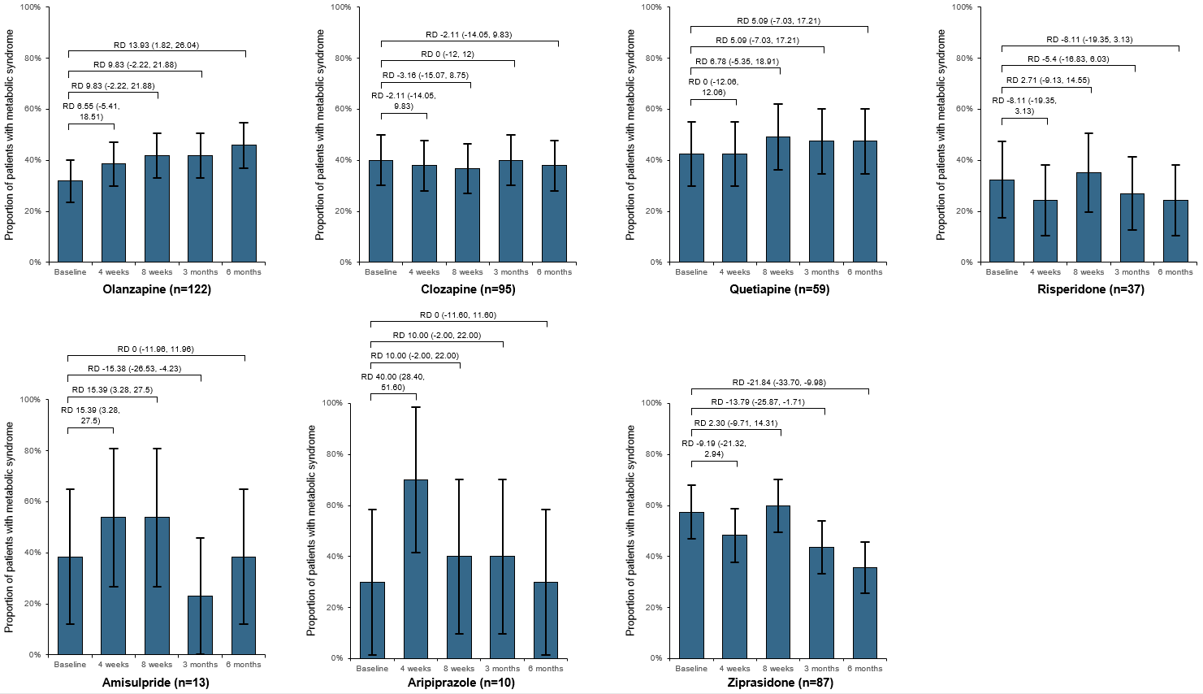
Figure S1. Changes in the proportion of patients with metabolic syndrome from baseline to 4 weeks, 8 weeks, 3 months and 6 months in the unmatched population prescribed one second-generation antipsychotic. Changes are estimated as risk differences with 95% confidence intervals by chi square tests.
RD, risk difference.
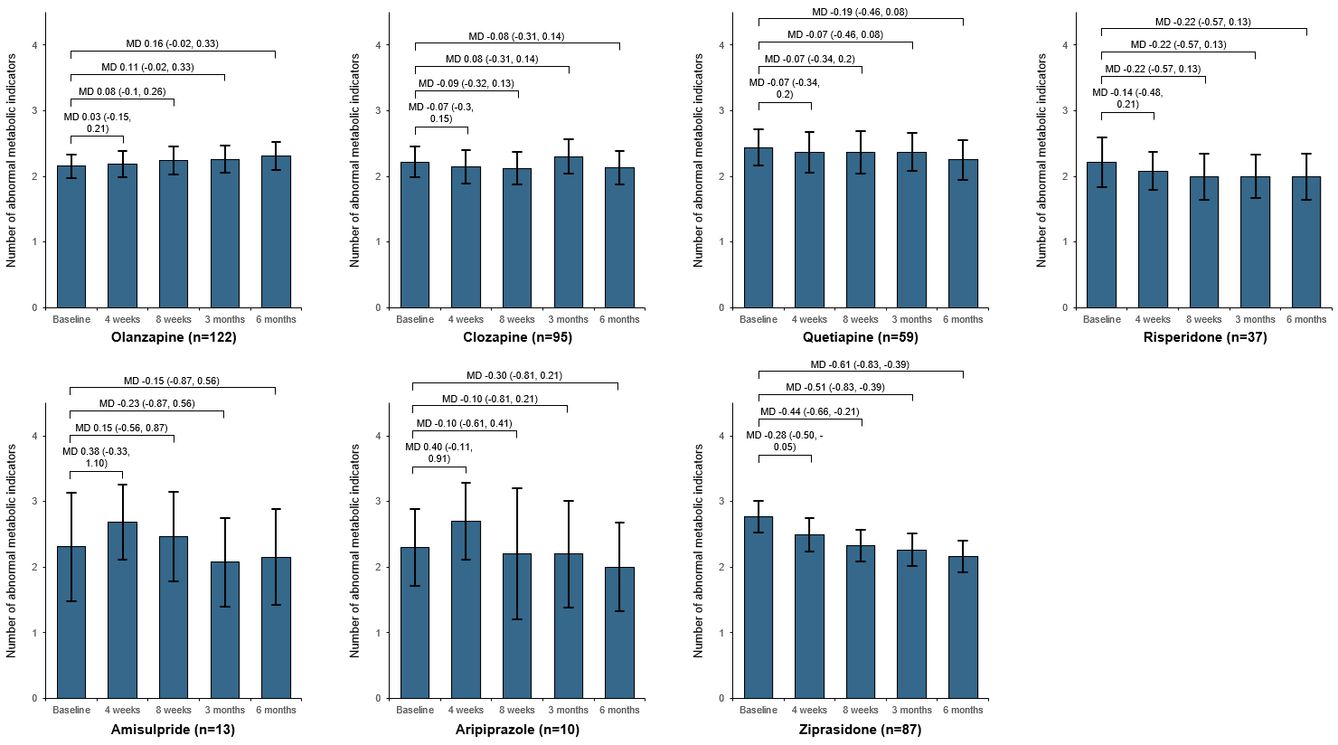
Figure S2. Changes in the number of metabolic syndrome components from baseline to 4 weeks, 8 weeks, 3 months and 6 months in the unmatched population prescribed one second-generation antipsychotic. Changes are estimated as mean differences with 95% confidence intervals by paired t-test.
MD, mean difference.
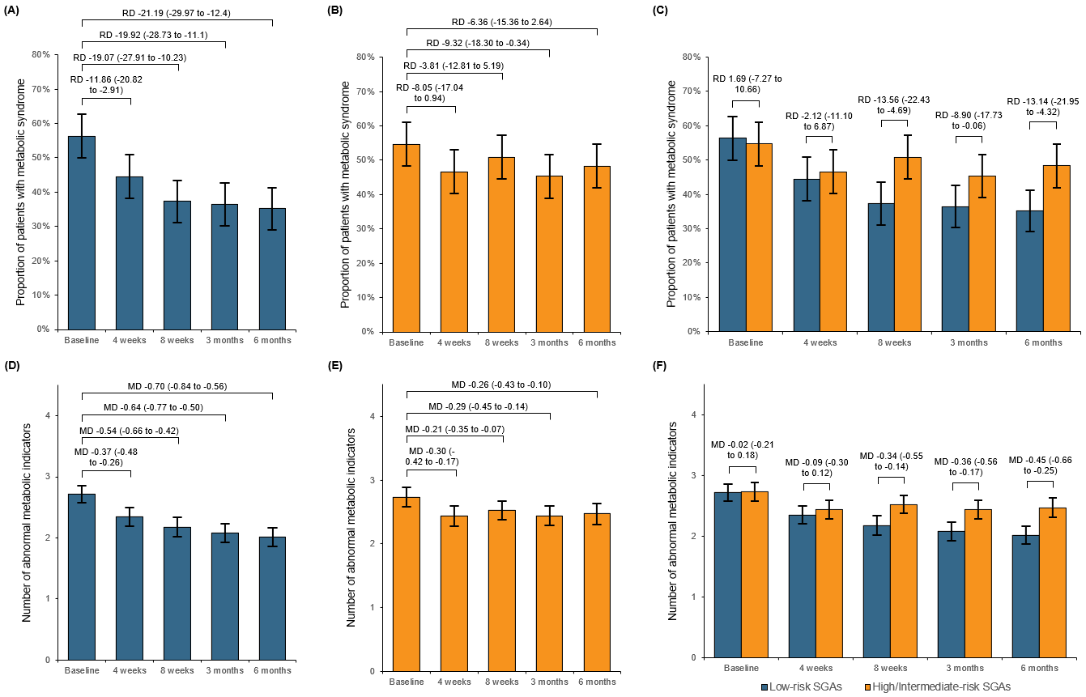
Figure S3. Changes in primary outcomes from baseline to 4 weeks, 8 weeks, 3 months and 6 months in the matched population using NCEP ATP III criteria. (A) Within-group changes in the proportion of patients with metabolic syndromes in the group of low-risk SGAs. (B) Within-group changes in the proportion of patients with metabolic syndromes in the group of high/intermediate-risk SGAs. (C) Between-group changes in the proportion of patients with metabolic syndromes. Changes are estimated as risk differences with 95% confidence intervals by chi square tests. (D) Within-group changes in the number of metabolic abnormalities in the group of low-risk SGAs. (E) Within-group changes of the number of metabolic abnormalities in the group of high/intermediate-risk SGAs. (F) Between-group changes of the number of metabolic abnormalities. Changes are estimated as mean differences with 95% confidence intervals by paired t-tests.
RD, risk difference; MD, mean difference.

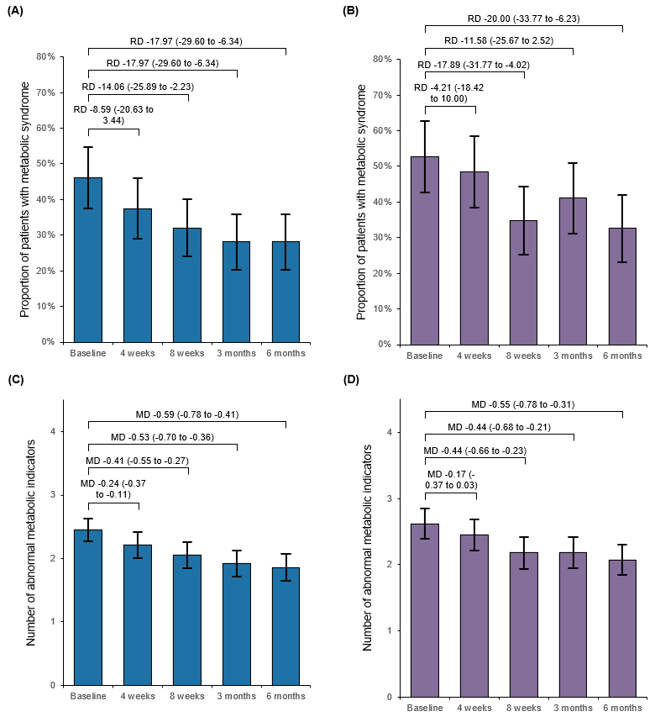
Figure S4. Changes in primary outcomes from baseline to 4 weeks, 8 weeks, 3 months and 6 months in the group of low-risk SGAs. (A) Within-group changes in the proportion of patients with metabolic syndromes in those received the adding low-risk SGAs strategy. (B) Within-group changes in the proportion of patients with metabolic syndromes in those received the switching low-risk SGAs strategy. Changes are estimated as risk differences with 95% confidence intervals by chi square tests. (C) Within-group changes in the number of metabolic abnormalities in those received the adding low-risk SGAs strategy. (D) Within-group changes of the number of metabolic abnormalities in those received the switching low-risk SGAs strategy. Changes are estimated as mean differences with 95% confidence intervals by paired t-tests.
RD, risk difference; MD, mean difference.

