Supplementary Table 1. Demographic characteristics of participants with available epigenetic measures in the NHANES 1999-2002(n=2038)ª
 |  | HEI2020 |  | AHEI |  | DASH |  | aMED |  | DII
 | Overall  (n=2038) | Q1  (n=408) | Q5  (n=407) | Q1  (n=408) | Q5  (n=407) | Q1  (n=408) | Q5  (n=407) | Q1  (n=408) | Q5  (n=407) | Q1  (n=408) | Q5  (n=407)
Age (years, mean [SE]) | 61.8 (8.5) | 60.5 (8.4) | 63.0 (8.6) | 60.5 (8.6) | 62.1 (8.5) | 60.5 (8.3) | 62.1 (8.5) | 60.6 (8.3) | 62.3 (8.3) | 62.2 (8.4) | 63.0 (8.8)
Women, n (%) | 998 (53.8) | 186 (51.7) | 204 (54.0) | 177 (49.5) | 181 (48.7) | 193 (53.0) | 195 (52.4) | 186 (52.4) | 210 (54.5) | 136 (36.0) | 230 (64.5)
Ethnicity^{b}, n (%)
Non-Hispanic White | 632 (3.7) | 100 (2.8) | 150 (4.2) | 107 (3.5) | 125 (3.1) | 119 (4.4) | 106 (2.2) | 117 (3.3) | 112 (2.9) | 129 (3.3) | 141 (5.1)
Non-Hispanic Black | 135 (6.1) | 26 (6.1) | 25 (5.9) | 32 (8.0) | 22 (4.3) | 27 (8.2) | 25 (4.2) | 29 (6.9) | 8 (2.1) | 24 (4.7) | 29 (8.0)
Mexican American | 758 (77.9) | 151 (77.2) | 156 (80.2) | 135 (73.0) | 186 (84.0) | 109 (67.4) | 217 (87.7) | 147 (77.4) | 184 (83.2) | 183 (84.5) | 114 (70.4)
Other Hispanic | 444 (8.7) | 123 (11.7) | 57 (4.9) | 126 (12.9) | 53 (4.5) | 144 (16.6) | 44 (3.2) | 107 (10.2) | 86 (8.1) | 58 (4.9) | 116 (14.0)
Others | 69 (3.5) | 8 (2.2) | 19 (4.8) | 8 (2.7) | 21 (4.1) | 9 (3.4) | 15 (2.7) | 8 (2.2) | 17 (3.7) | 14 (2.6) | 7 (2.4)
Beyond high school, n (%) | 700 (47.6) | 95 (34.2) | 190 (67.1) | 93 (32.7) | 206 (64.4) | 70 (26.2) | 213 (65.9) | 89 (30.2) | 198 (63.3) | 193 (61.9) | 74 (24.7)
<1.00 | 1498 (80.5) | 275 (72.8) | 311 (85.8) | 279 (70.7) | 315 (84.7) | 277 (72.2) | 328 (88.0) | 269 (71.6) | 330 (87.1) | 306 (82.4) | 271 (73.5)
≥1.00 | 310 (9.7) | 75 (13.9) | 51 (4.9) | 80 (17.8) | 36 (3.8) | 94 (19.8) | 28 (2.2) | 91 (16.3) | 38 (3.9) | 43 (3.8) | 82 (15.2)
Missing | 230 (9.8) | 58 (13.3) | 45 (9.3) | 49 (11.5) | 56 (11.5) | 37 (8.0) | 51 (9.8) | 48 (12.1) | 39 (9.0) | 59 (13.7) | 54 (11.3)
Smoking status, n (%)
Never | 916 (41.7) | 149 (33.8) | 218 (52.4) | 160 (37.8) | 200 (50.1) | 148 (31.9) | 194 (48.1) | 145 (34.6) | 197 (45.5) | 178 (41.7) | 178 (39.8)
Former | 776 (40.2) | 147 (36.0) | 165 (41.4) | 146 (33.3) | 173 (44.4) | 139 (32.4) | 181 (45.3) | 146 (35.5) | 172 (45.6) | 185 (49.0) | 137 (32.9)
Current | 342 (18.1) | 111 (30.3) | 24 (6.3) | 102 (28.9) | 34 (5.5) | 121 (35.7) | 32 (6.5) | 117 (30.0) | 38 (8.9) | 44 (9.3) | 91 (27.3)
Regular physical activity^{c}, n (%) | 612 (39.0) | 86 (24.5) | 150 (48.5) | 94 (30.8) | 154 (47.2) | 76 (24.0) | 172 (51.4) | 85 (26.5) | 156 (48.0) | 158 (48.3) | 94 (29.1)
BMI ≥30 kg/m², n (%) | 724 (34.0) | 154 (32.2) | 118 (26.4) | 166 (37.3) | 141 (33.2) | 169 (39.4) | 132 (31.6) | 157 (36.2) | 133 (32.0) | 110 (27.4) | 157 (34.7)
Hypertension^{d}, n (%) | 1245 (56.2) | 252 (56.5) | 243 (52.9) | 254 (55.3) | 243 (53.3) | 256 (56.8) | 239 (50.3) | 254 (57.4) | 246 (57.7) | 231 (50.9) | 259 (63.6)
CVD, n (%) | 1009 (46.7) | 206 (48.3) | 193 (39.3) | 217 (49.3) | 188 (40.6) | 202 (47.9) | 193 (41.1) | 207 (46.9) | 208 (47.6) | 181 (40.5) | 214 (49.8)
Diabetes^{e}, n (%) | 494 (17.0) | 84 (13.7) | 111 (18.6) | 83 (14.9) | 100 (15.5) | 84 (16.8) | 99 (15.4) | 96 (16.4) | 98 (18.3) | 90 (14.7) | 105 (17.9)
Cancer, n (%) | 248 (15.5) | 44 (12.5) | 60 (20.8) | 47 (11.3) | 59 (19.4) | 44 (11.6) | 65 (18.1) | 50 (13.7) | 60 (18.8) | 60 (18.7) | 44 (11.7)
Average energy intake (kcal/day, mean [SE]) | 1905.8 (729.0) | 1861.7 (771.3) | 1909.9 (687.7) | 1695.1 (707.1) | 2225.3 (685.8) | 1623.1 (646.8) | 2154.8 (694.6) | 1819.1 (742.3) | 2035.7 (691.6) | 2469.1 (670.4) | 1187.8 (460.7)
ª Data were presented as weighted means (SE) for continuous variables and unweighted sample sizes (weighted percentage, %) for categorical variables, accounting for complex survey designs.
^{b} Ethnicity was reported in fixed groups by the participants. The “Others” group included other non-Hispanic races or multiple races.
^{c} Regular physical activity was defined as engaging in ≥150 minutes of leisure-time physical activity per week.
^{d} Hypertension was determined by self-reported diagnosis by a physician, use of antihypertensive agents, or systolic blood pressure ≥140 mmHg or diastolic blood pressure ≥90 mmHg.
^{e} Diabetes was identified through self-reported physician diagnosis, use of antidiabetic agents, glycated hemoglobin A1c ≥6.5%, or fasting blood plasma ≥126 mg/dL.
Abbreviations: AHEI=Alternative Healthy Eating Index; aMED=Alternate Mediterranean Diet; BMI=body mass index; CVD=cardiovascular disease; DASH=Dietary Approaches to Stop Hypertension; DII=Dietary Inflammatory Index; HEI2020=Healthy Eating Index-2020; PIR=poverty income ratio.

Supplementary Table 2. Coefficients (95% CI) of diet scores with accelerations of PhenoAge with CRP in the NHANES 1999-2018 (n=26,995)
 | Q1 | Q2 | Q3 | Q4 | Q5 | per interquintile | P for trend
HEI2020 | ref. | -0.38 (-0.58, -0.17) | -0.66 (-0.87, -0.44) | -0.86 (-1.06, -0.67) | -1.25 (-1.44, -1.06) | -1.14 (-1.30, -0.98) | <0.001
AHEI | ref. | -0.28 (-0.49, -0.08) | -0.52 (-0.76, -0.28) | -0.78 (-0.98, -0.59) | -1.33 (-1.55, -1.11) | -1.28 (-1.45, -1.10) | <0.001
DASH | ref. | -0.29 (-0.50, -0.07) | -0.64 (-0.85, -0.43) | -0.99 (-1.21, -0.77) | -1.42 (-1.62, -1.22) | -1.41 (-1.58, -1.24) | <0.001
aMED | ref. | -0.42 (-0.62, -0.21) | -0.27 (-0.48, -0.06) | -0.69 (-0.92, -0.46) | -1.33 (-1.55, -1.12) | -1.23 (-1.39, -1.06) | <0.001
DII | ref. | 0.53 (0.33, 0.73) | 0.79 (0.60, 0.98) | 1.06 (0.83, 1.28) | 1.25 (1.00, 1.51) | 1.28 (1.09, 1.48) | <0.001
β coefficients and 95% confidence intervals for the association between diet scores and accelerations of PhenoAge with CRP were calculated using the multivariable linear regression model. All estimates accounted for complex survey designs. The full model was adjusted for age, sex, ethnicity, education, poverty-income ratio, smoking status, physical activity, body mass index, diabetes, hypertension, cardiovascular disease, cancer, and average calories. Due to the lack of C-reactive protein (CRP) data from 2011 to 2018, CRP was excluded from the main analysis in alignment with prior studies. In this sensitivity analysis, PhenoAge was recalculated to include CRP as an additional biomarker, building on the main analysis definition of PhenoAge.
Abbreviations: AHEI=Alternative Healthy Eating Index; aMED=Alternate Mediterranean Diet; CRP=C-reactive protein; DASH=Dietary Approaches to Stop Hypertension; DII=Dietary Inflammatory Index; HEI2020=Healthy Eating Index-2020.

Supplementary Table 3. Explained variation (%) in response variables and componential food groups for each previously established diet scores explained the largest variance identified using reduced rank regression
 | Response variables |  |  |  |  |  | Componential food groups
 | PhenoAgeAccel | CardiacAgeAccel | KidneyAgeAccel | LiverAgeAccel | MuscleAgeAccel | Total | Componential food groups
HEI2020 | 2.79% | 2.27% | 4.14% | 4.27% | 1.65% | 3.42% | 18.77%
AHEI | 3.76% | 3.20% | 3.81% | 4.40% | 1.68% | 3.37% | 18.01%
DASH | 4.39% | 3.22% | 4.17% | 5.15% | 1.86% | 3.51% | 24.47%
aMED | 3.74% | 3.26% | 2.52% | 3.73% | 1.77% | 2.82% | 18.13%
DII | 3.01% | 2.49% | 2.45% | 4.05% | 4.32% | 1.46% | 11.63%
Abbreviations: AHE=Alternative Healthy Eating Index; aMED=Alternate Mediterranean Diet; DASH=Dietary Approaches to Stop Hypertension; DII=Dietary Inflammatory Index; HEI2020=Healthy Eating Index-2020.

Supplementary Table 4. Adjusted HRs (95% CIs) of diet scores with mortality (n=34,282)
 | Q1 | Q2 | Q3 | Q4 | Q5 | per interquintile | P for trend
HEI2020 | ref. | 1.04 (0.92, 1.18) | 0.93 (0.81, 1.07) | 0.95 (0.83, 1.08) | 0.81 (0.71, 0.93) | 0.84 (0.75, 0.94) | 0.002
AHEI | ref. | 1.00 (0.88, 1.14) | 1.00 (0.86, 1.16) | 0.85 (0.75, 0.98) | 0.75 (0.65, 0.87) | 0.77 (0.68, 0.88) | <0.001
DASH | ref. | 1.02 (0.89, 1.16) | 1.00 (0.87, 1.16) | 0.94 (0.81, 1.10) | 0.83 (0.69, 0.99) | 0.82 (0.71, 0.96) | 0.01
aMED | ref. | 0.97 (0.85, 1.11) | 0.87 (0.76, 0.99) | 0.84 (0.73, 0.97) | 0.85 (0.74, 0.98) | 0.90 (0.79, 1.01) | 0.08
DII | ref. | 1.15 (0.99, 1.34) | 1.12 (0.95, 1.32) | 1.26 (1.07, 1.49) | 1.37 (1.15, 1.65) | 1.36 (1.17, 1.59) | <0.001
The Cox proportional hazards model accounting for complex survey design was used with the adjustment for age, sex, ethnicity, education, poverty-income ratio, smoking status, physical activity, body mass index, diabetes, hypertension, cardiovascular disease, cancer, and average calories.
Abbreviations: AHEI=Alternative Healthy Eating Index; aMED=Alternate Mediterranean Diet; DASH=Dietary Approaches to Stop Hypertension; DII=Dietary Inflammatory Index; HEI2020=Healthy Eating Index-2020.

Supplementary Table 5. Adjusted HRs (95% CIs) of aging-related diet scores with mortality (n=34,282)
 | Q1 | Q2 | Q3 | Q4 | Q5 | per interquintile | P for trend
HEI2020 | ref. | 0.95 (0.85, 1.07) | 0.92 (0.80, 1.05) | 0.85 (0.74, 0.98) | 0.68 (0.59, 0.79) | 0.71 (0.62, 0.81) | <0.001
AHEI | ref. | 0.96 (0.85, 1.08) | 0.73 (0.64, 0.83) | 0.80 (0.70, 0.91) | 0.69 (0.60, 0.81) | 0.70 (0.62, 0.80) | <0.001
DASH | ref. | 0.94 (0.81, 1.08) | 0.87 (0.76, 1.00) | 0.79 (0.67, 0.94) | 0.71 (0.60, 0.84) | 0.71 (0.62, 0.83) | <0.001
aMED | ref. | 0.95 (0.84, 1.06) | 0.89 (0.78, 1.03) | 0.77 (0.67, 0.88) | 0.79 (0.69, 0.91) | 0.77 (0.69, 0.87) | <0.001
DII | ref. | 1.12 (0.95, 1.32) | 1.30 (1.12, 1.52) | 1.29 (1.04, 1.61) | 1.76 (1.37, 2.27) | 1.83 (1.35, 2.49) | <0.001
The Cox proportional hazards model accounting for complex survey design was used with the adjustment for age, sex, ethnicity, education, poverty-income ratio, smoking status, physical activity, body mass index, diabetes, hypertension, cardiovascular disease, cancer, and average calories. The standardized intake of each food group was calculated as the sum of its product with the factor loadings. The dietary pattern factor loadings extracted by the reduced rank regression procedure could be used to calculate corresponding aging-related dietary pattern scores among adults with available dietary information. To compare and conform the dietary score and aging-related dietary score, we used the opposite number of loading and calculated the aging-related diet score.
Abbreviations: AHEI=Alternative Healthy Eating Index; aMED=Alternate Mediterranean Diet; DASH=Dietary Approaches to Stop Hypertension; DII=Dietary Inflammatory Index; HEI2020=Healthy Eating Index-2020.

Supplementary Table 6. Stratified analysis of the association between HEI2020 per interquintile and mortality
 | Level | Cases/N | HR (95% CI) | P for interaction
Age | <60 years | 1008/23,685 | 1.12 (0.90, 1.38) | <0.001
 | ≥60 years | 2950/10,597 | 0.92 (0.79, 1.07)
Sex | Men | 2285/16,515 | 0.92 (0.78, 1.08) | <0.001
 | Women | 1673/17,767 | 0.75 (0.62, 0.91)
Ethnicity | Mexican American | 624/6228 | 0.68 (0.48, 0.97) | 0.001
 | Other Hispanic | 182/2891 | 1.01 (0.68, 1.49)
 | Non-Hispanic White | 2232/15,326 | 0.84 (0.74, 0.97)
 | Non-Hispanic Black | 800/6950 | 0.84 (0.65, 1.09)
 | Others | 120/2887 | 0.96 (0.51, 1.81)
Education | ≤high school | 2545/16,284 | 0.85 (0.75, 0.97) | <0.001
 | >high school | 1413/17,998 | 0.84 (0.69, 1.02)
Smoke | Never | 1416/18,613 | 0.92 (0.76, 1.12) | <0.001
 | Former | 1517/8456 | 0.72 (0.61, 0.87)
 | Current | 1025/7213 | 0.92 (0.70, 1.22)
Family PIR | ≥1.00 | 2876/25,648 | 0.85 (0.74, 0.98) | <0.001
 | <1.00 | 741/5980 | 0.77 (0.59, 1.00)
Regular physical activity | No | 3039/22,237 | 0.90 (0.79, 1.04) | <0.001
 | Yes | 919/12,045 | 0.71 (0.58, 0.86)
BMI | <30 kg/m² | 2449/21,329 | 0.87 (0.76, 1.01) | 0.007
 | ≥30 kg/m² | 1509/12,953 | 0.78 (0.63, 0.97)
Hypertension | Hypertension | 2697/13,945 | 0.85 (0.75, 0.96) | <0.001
 | non-Hypertension | 1261/20,337 | 0.83 (0.66, 1.03)
CVD | CVD | 2442/10,863 | 0.83 (0.72, 0.96) | <0.001
 | non-CVD | 1516/23,419 | 0.85 (0.70, 1.03)
Cancer | Cancer | 713/2805 | 0.88 (0.68, 1.12) | <0.001
 | non-cancer | 3245/31,477 | 0.83 (0.72, 0.95)
Diabetes | Diabetes | 1182/5169 | 0.93 (0.73, 1.19) | 0.01
 | non-diabetes | 2776/29,113 | 0.81 (0.70, 0.93)
The Cox proportional hazards model accounting for complex survey design was used with the adjustment for age, sex, ethnicity, education, poverty-income ratio, smoking status, physical activity, body mass index, diabetes, hypertension, cardiovascular disease, cancer, and average calories except for the stratifier itself.
Abbreviations: BMI, body mass index; CVD=cardiovascular disease; HEI2020=Healthy Eating Index 2020; HR=hazard ratio; PIR=poverty-income ratio.

Supplementary Table 7. Stratified analysis of the association between AHEI per interquintile and mortality
 | Level | Cases/N | HR (95% CI) | P for interaction
Age | <60 years | 1008/23,685 | 0.91 (0.74, 1.13) | <0.001
 | ≥60 years | 2950/10,597 | 0.91 (0.78, 1.06)
Sex | Men | 2285/16,515 | 0.83 (0.72, 0.96) | <0.001
 | Women | 1673/17,767 | 0.71 (0.57, 0.90)
Ethnicity | Mexican American | 624/6228 | 0.69 (0.46, 1.04) | <0.001
 | Other Hispanic | 182/2891 | 0.79 (0.45, 1.41)
 | Non-Hispanic White | 2232/15,326 | 0.81 (0.69, 0.95)
 | Non-Hispanic Black | 800/6950 | 0.73 (0.58, 0.92)
 | Others | 120/2887 | 0.57 (0.32, 1.03)
Education | ≤high school | 2545/16,284 | 0.82 (0.70, 0.96) | <0.001
 | >high school | 1413/17,998 | 0.75 (0.62, 0.91)
Smoke | Never | 1416/18,613 | 0.92 (0.76, 1.11) | <0.001
 | Former | 1517/8456 | 0.66 (0.55, 0.80)
 | Current | 1025/7213 | 0.83 (0.64, 1.06)
Family PIR | ≥1.00 | 2876/25,648 | 0.79 (0.67, 0.92) | <0.001
 | <1.00 | 741/5980 | 0.75 (0.57, 0.99)
Regular physical activity | No | 3039/22,237 | 0.79 (0.66, 0.94) | <0.001
 | Yes | 919/12,045 | 0.75 (0.58, 0.98)
BMI | <30 kg/m² | 2449/21,329 | 0.80 (0.69, 0.93) | <0.001
 | ≥30 kg/m² | 1509/12,953 | 0.73 (0.59, 0.90)
Hypertension | Hypertension | 2697/13,945 | 0.81 (0.71, 0.92) | <0.001
 | non-Hypertension | 1261/20,337 | 0.73 (0.57, 0.93)
CVD | CVD | 2442/10,863 | 0.82 (0.71, 0.95) | <0.001
 | non-CVD | 1516/23,419 | 0.72 (0.60, 0.86)
Cancer | Cancer | 713/2805 | 1.01 (0.80, 1.28) | <0.001
 | non-cancer | 3245/31,477 | 0.73 (0.62, 0.85)
Diabetes | Diabetes | 1182/5169 | 0.81 (0.64, 1.01) | <0.001
 | non-diabetes | 2776/29,113 | 0.76 (0.65, 0.89)
The Cox proportional hazards model accounting for complex survey design was used with the adjustment for age, sex, ethnicity, education, poverty-income ratio, smoking status, physical activity, body mass index, diabetes, hypertension, cardiovascular disease, cancer, and average calories except for the stratifier itself.
Abbreviations: AHEI=Alternative Healthy Eating Index; BMI, body mass index; CVD=cardiovascular disease; HR=hazard ratio; PIR=poverty-income ratio.

Supplementary Table 8. Stratified analysis of the association between DASH per interquintile and mortality
 | Level | Cases/N | HR (95% CI) | P for interaction
Age | <60 years | 1008/23,685 | 1.24 (0.98, 1.57) | <0.001
 | ≥60 years | 2950/10,597 | 0.90 (0.76, 1.06)
Sex | Men | 2285/16,515 | 0.88 (0.74, 1.05) | <0.001
 | Women | 1673/17,767 | 0.76 (0.60, 0.97)
Ethnicity | Mexican American | 624/6228 | 0.67 (0.45, 1.00) | 0.002
 | Other Hispanic | 182/2891 | 1.43 (0.76, 2.69)
 | Non-Hispanic White | 2232/15,326 | 0.85 (0.70, 1.02)
 | Non-Hispanic Black | 800/6950 | 0.79 (0.62, 1.00)
 | Others | 120/2887 | 0.51 (0.26, 1.01)
Education | ≤` school | 2545/16,284 | 0.88 (0.73, 1.05) | <0.001
 | >high school | 1413/17,998 | 0.80 (0.63, 1.00)
Smoke | Never | 1416/18,613 | 0.92 (0.74, 1.13) | <0.001
 | Former | 1517/8456 | 0.76 (0.62, 0.93)
 | Current | 1025/7213 | 0.89 (0.67, 1.19)
Family PIR | ≥1.00 | 2876/25,648 | 0.85 (0.72, 1.00) | <0.001
 | <1.00 | 741/5980 | 0.79 (0.58, 1.06)
Regular physical activity | No | 3039/22,237 | 0.89 (0.75, 1.07) | <0.001
 | Yes | 919/12,045 | 0.70 (0.53, 0.91)
BMI | <30 kg/m² | 2449/21,329 | 0.85 (0.72, 1.01) | 0.02
 | ≥30 kg/m² | 1509/12,953 | 0.79 (0.63, 0.99)
Hypertension | Hypertension | 2697/13,945 | 0.84 (0.72, 0.98) | <0.001
 | non-Hypertension | 1261/20,337 | 0.81 (0.60, 1.09)
CVD | CVD | 2442/10,863 | 0.85 (0.71, 1.01) | <0.001
 | non-CVD | 1516/23,419 | 0.79 (0.63, 1.00)
Cancer | Cancer | 713/2805 | 0.91 (0.69, 1.21) | <0.001
 | non-cancer | 3245/31,477 | 0.80 (0.68, 0.96)
Diabetes | Diabetes | 1182/5169 | 0.91 (0.71, 1.16) | 0.02
 | non-diabetes | 2776/29,113 | 0.81 (0.68, 0.96)
The Cox proportional hazards model accounting for complex survey design was used with the adjustment for age, sex, ethnicity, education, poverty-income ratio, smoking status, physical activity, body mass index, diabetes, hypertension, cardiovascular disease, cancer, and average calories except for the stratifier itself.
Abbreviations: BMI, body mass index; CVD=cardiovascular disease; Dietary Approaches to Stop Hypertension; HR=hazard ratio; PIR=poverty-income ratio.

Supplementary Table 9. Stratified analysis of the association between aMED per interquintile and mortality
 | Level | Cases/N | HR (95% CI) | P for interaction
Age | <60 years | 1008/23,685 | 1.04 (0.83, 1.30) | <0.001
 | ≥60 years | 2950/10,597 | 1.00 (0.87, 1.15)
Sex | Men | 2285/16,515 | 0.95 (0.84, 1.09) | <0.001
 | Women | 1673/17,767 | 0.83 (0.68, 1.02)
Ethnicity | Mexican American | 624/6228 | 0.79 (0.60, 1.04) | 0.01
 | Other Hispanic | 182/2891 | 0.95 (0.62, 1.48)
 | Non-Hispanic White | 2232/15,326 | 0.91 (0.79, 1.06)
 | Non-Hispanic Black | 800/6950 | 0.92 (0.76, 1.12)
 | Others | 120/2887 | 0.81 (0.47, 1.39)
Education | ≤high school | 2545/16,284 | 0.92 (0.80, 1.05) | <0.001
 | >high school | 1413/17,998 | 0.89 (0.74, 1.07)
Smoke | Never | 1416/18,613 | 1.00 (0.83, 1.21) | <0.001
 | Former | 1517/8456 | 0.86 (0.73, 1.01)
 | Current | 1025/7213 | 0.88 (0.69, 1.11)
Family PIR | ≥1.00 | 2876/25,648 | 0.90 (0.78, 1.04) | <0.001
 | <1.00 | 741/5980 | 0.81 (0.63, 1.04)
Regular physical activity | No | 3039/22,237 | 0.89 (0.76, 1.03) | <0.001
 | Yes | 919/12,045 | 0.92 (0.74, 1.14)
BMI | <30 kg/m² | 2449/21,329 | 0.91 (0.79, 1.04) | 0.16
 | ≥30 kg/m² | 1509/12,953 | 0.88 (0.72, 1.08)
Hypertension | Hypertension | 2697/13,945 | 0.91 (0.80, 1.05) | 0.002
 | non-Hypertension | 1261/20,337 | 0.88 (0.71, 1.09)
CVD | CVD | 2442/10,863 | 0.93 (0.81, 1.07) | <0.001
 | non-CVD | 1516/23,419 | 0.85 (0.70, 1.03)
Cancer | Cancer | 713/2805 | 1.01 (0.79, 1.29) | <0.001
 | non-cancer | 3245/31,477 | 0.87 (0.76, 1.00)
Diabetes | Diabetes | 1182/5169 | 1.08 (0.87, 1.34) | 0.03
 | non-diabetes | 2776/29,113 | 0.85 (0.74, 0.97)
The Cox proportional hazards model accounting for complex survey design was used with the adjustment for age, sex, ethnicity, education, poverty-income ratio, smoking status, physical activity, body mass index, diabetes, hypertension, cardiovascular disease, cancer, and average calories except for the stratifier itself.
Abbreviations: aMED=Alternate Mediterranean Diet; BMI, body mass index; CVD=cardiovascular disease; HR=hazard ratio; PIR=poverty-income ratio.

Supplementary Table 10. Stratified analysis of the association between DII per interquintile and mortality
 | Level | Cases/N | HR (95% CI) | P for interaction
Age | <60 years | 1008/23,685 | 0.88 (0.68, 1.15) | <0.001
 | ≥60 years | 2950/10,597 | 1.35 (1.11, 1.65)
Sex | Men | 2285/16,515 | 1.24 (1.04, 1.48) | 0.14
 | Women | 1673/17,767 | 1.53 (1.22, 1.92)
Ethnicity | Mexican American | 624/6228 | 1.64 (1.11, 2.43) | <0.001
 | Other Hispanic | 182/2891 | 1.38 (0.63, 3.04)
 | Non-Hispanic White | 2232/15,326 | 1.36 (1.15, 1.62)
 | Non-Hispanic Black | 800/6950 | 1.05 (0.68, 1.61)
 | Others | 120/2887 | 1.88 (0.85, 4.16)
Education | ≤high school | 2545/16,284 | 1.30 (1.10, 1.54) | <0.001
 | >high school | 1413/17,998 | 1.40 (1.10, 1.77)
Smoke | Never | 1416/18,613 | 1.23 (0.97, 1.57) | <0.001
 | Former | 1517/8456 | 1.59 (1.25, 2.03)
 | Current | 1025/7213 | 1.10 (0.81, 1.50)
Family PIR | ≥1.00 | 2876/25,648 | 1.33 (1.13, 1.58) | <0.001
 | <1.00 | 741/5980 | 1.44 (0.94, 2.21)
Regular physical activity | No | 3039/22,237 | 1.24 (1.05, 1.46) | <0.001
 | Yes | 919/12,045 | 1.65 (1.25, 2.17)
BMI | <30 kg/m² | 2449/21,329 | 1.31 (1.09, 1.59) | <0.001
 | ≥30 kg/m² | 1509/12,953 | 1.46 (1.13, 1.88)
Hypertension | Hypertension | 2697/13,945 | 1.32 (1.10, 1.59) | <0.001
 | non-Hypertension | 1261/20,337 | 1.41 (1.06, 1.86)
CVD | CVD | 2442/10,863 | 1.31 (1.08, 1.59) | <0.001
 | non-CVD | 1516/23,419 | 1.43 (1.11, 1.82)
Cancer | Cancer | 713/2805 | 1.23 (0.93, 1.64) | <0.001
 | non-cancer | 3245/31,477 | 1.40 (1.18, 1.67)
Diabetes | Diabetes | 1182/5169 | 1.22 (0.90, 1.65) | <0.001
 | non-diabetes | 2776/29,113 | 1.41 (1.17,1.68)
The Cox proportional hazards model accounting for complex survey design was used with the adjustment for age, sex, ethnicity, education, poverty-income ratio, smoking status, physical activity, body mass index, diabetes, hypertension, cardiovascular disease, cancer, and average calories except for the stratified itself.
Abbreviations: BMI, body mass index; CVD=cardiovascular disease; DII=Dietary Inflammatory Index; HR=hazard ratio; PIR=poverty-income ratio.
Supplementary Table 11. Coefficients (95% CI) of diet scores with accelerations of phenotypic ages at systemic and organ-specific levels among participants with consistent diet with 24-h dietary recall in the NHANES 1999-2018 (n=20,926)
 | Q1 | Q2 | Q3 | Q4 | Q5 | per interquintile | P for trend
PhenoAgeAccel
HEI2020 | ref. | -0.28 (-0.51, -0.06) | -0.40 (-0.66, -0.13) | -0.73 (-0.98, -0.49) | -1.06 (-1.29, -0.83) | -1.00 (-1.18, -0.81) | <0.001
AHEI | ref. | -0.24 (-0.48, -0.01) | -0.48 (-0.74, -0.22) | -0.73 (-0.96, -0.50) | -1.25 (-1.51, -1.00) | -1.19 (-1.38, -1.00) | <0.001
DASH | ref. | -0.25 (-0.49, -0.01) | -0.58 (-0.82, -0.34) | -0.93 (-1.19, -0.67) | -1.34 (-1.57, -1.10) | -1.35 (-1.55, -1.16) | <0.001
aMED | ref. | -0.48 (-0.70, -0.25) | -0.17 (-0.40, 0.06) | -0.63 (-0.87, -0.40) | -1.30 (-1.53, -1.08) | -1.17 (-1.34, -1.00) | <0.001
DII | ref. | 0.56 (0.37, 0.75) | 0.72 (0.52, 0.92) | 1.00 (0.76, 1.24) | 1.11 (0.84, 1.38) | 1.16 (0.95, 1.38) | <0.001
CardiacAgeAccel
HEI2020 | ref. | -0.14 (-0.29, 0.02) | -0.13 (-0.29, 0.03) | -0.35 (-0.54, -0.17) | -0.48 (-0.64, -0.32) | -0.49 (-0.63, -0.34) | <0.001
AHEI | ref. | -0.14 (-0.33, 0.04) | -0.22 (-0.38, -0.07) | -0.30 (-0.46, -0.13) | -0.61 (-0.77, -0.44) | -0.58 (-0.72, -0.45) | <0.001
DASH | ref. | -0.19 (-0.34, -0.04) | -0.14 (-0.30, 0.03) | -0.35 (-0.53, -0.17) | -0.53 (-0.71, -0.36) | -0.53 (-0.67, -0.39) | <0.001
aMED | ref. | -0.26 (-0.41, -0.10) | -0.31 (-0.48, -0.14) | -0.46 (-0.62, -0.29) | -0.62 (-0.79, -0.45) | -0.52 (-0.64, -0.40) | <0.001
DII | ref. | 0.25 (0.12, 0.38) | 0.38 (0.22, 0.54) | 0.44 (0.27, 0.61) | 0.53 (0.32, 0.74) | 0.57 (0.41, 0.73) | <0.001
KidneyAgeAccel
HEI2020 | ref. | -0.15 (-0.27, -0.02) | -0.22 (-0.38, -0.07) | -0.42 (-0.56, -0.28) | -0.57 (-0.73, -0.42) | -0.52 (-0.65, -0.39) | <0.001
AHEI | ref. | -0.27 (-0.42, -0.12) | -0.45 (-0.59, -0.30) | -0.52 (-0.67, -0.37) | -0.73 (-0.88, -0.58) | -0.61 (-0.74, -0.49) | <0.001
DASH | ref. | -0.24 (-0.40, -0.09) | -0.34 (-0.51, -0.18) | -0.54 (-0.70, -0.38) | -0.68 (-0.84, -0.52) | -0.60 (-0.73, -0.47) | <0.001
aMED | ref. | -0.16 (-0.30, -0.03) | -0.30 (-0.45, -0.15) | -0.29 (-0.45, -0.14) | -0.55 (-0.70, -0.40) | -0.45 (-0.57, -0.32) | <0.001
DII | ref. | 0.30 (0.17, 0.44) | 0.44 (0.29, 0.58) | 0.71 (0.55, 0.86) | 0.93 (0.73, 1.12) | 0.87 (0.71, 1.03) | <0.001
LiverAgeAccel
HEI2020 | ref. | -0.34 (-0.57, -0.10) | -0.41 (-0.67, -0.14) | -0.72 (-0.96, -0.47) | -1.06 (-1.31, -0.81) | -0.97 (-1.18, -0.76) | <0.001
AHEI | ref. | -0.45 (-0.67, -0.23) | -0.66 (-0.93, -0.39) | -0.80 (-1.07, -0.53) | -1.33 (-1.59, -1.06) | -1.13 (-1.36, -0.90) | <0.001
DASH | ref. | -0.47 (-0.71, -0.23) | -0.54 (-0.79, -0.30) | -0.84 (-1.08, -0.59) | -1.17 (-1.42, -0.92) | -0.99 (-1.20, -0.79) | <0.001
aMED | ref. | -0.31 (-0.54, -0.08) | -0.47 (-0.67, -0.26) | -0.80 (-1.06, -0.55) | -1.10 (-1.37, -0.84) | -0.95 (-1.17, -0.73) | <0.001
DII | ref. | 0.33 (0.13, 0.53) | 0.61 (0.37, 0.85) | 0.88 (0.64, 1.12) | 1.32 (1.05, 1.58) | 1.24 (1.01, 1.48) | <0.001
MuscleAgeAccel
HEI2020 | ref. | -0.22 (-0.50, 0.07) | -0.28 (-0.57, 0.00) | -0.47 (-0.75, -0.20) | -0.44 (-0.70, -0.18) | -0.38 (-0.60, -0.17) | <0.001
AHEI | ref. | -0.14 (-0.39, 0.10) | -0.28 (-0.54, -0.01) | -0.35 (-0.59, -0.11) | -0.41 (-0.67, -0.15) | -0.41 (-0.63, -0.19) | <0.001
DASH | ref. | 0.10 (-0.16, 0.37) | -0.28 (-0.53, -0.04) | -0.39 (-0.66, -0.11) | -0.41 (-0.70, -0.13) | -0.43 (-0.67, -0.19) | <0.001
aMED | ref. | -0.43 (-0.66, -0.20) | -0.46 (-0.76, -0.17) | -0.64 (-0.95, -0.33) | -0.68 (-0.98, -0.39) | -0.48 (-0.72, -0.24) | <0.001
DII | ref. | 0.19 (-0.02, 0.41) | 0.28 (0.00, 0.56) | 0.43 (0.17, 0.69) | 0.51 (0.21, 0.81) | 0.44 (0.18, 0.70) | 0.001
β coefficients and 95% confidence intervals for the association between diet scores and accelerations of phenotypic ages at systemic and organ-specific levels were calculated using the multivariable linear regression model. All estimates accounted for complex survey designs. The full model was adjusted for age, sex, ethnicity, education, poverty-income ratio, smoking status, physical activity, body mass index, diabetes, hypertension, cardiovascular disease, cancer, and average calories.
Abbreviations: AHEI=Alternative Healthy Eating Index; aMED=Alternate Mediterranean Diet; DASH=Dietary Approaches to Stop Hypertension; DII=Dietary Inflammatory Index; HEI2020=Healthy Eating Index-2020.

Supplementary Table 12. Mediation analysis of the associations between diet scores and mortality risk mediated by GrimAge2 acceleration
Exposure | Total effect |  | Direct effect |  | Indirect effect |  | Proportion mediated
Exposure | HR (95% CI) | P value | HR (95% CI) | P value | HR (95% CI) | P value | PM (95% CI) | P value
HEI2020 | 0.990(0.983, 0.995) | <0.001 | 0.993(0.987, 0.999) | <0.001 | 0.996(0.995, 0.998) | <0.001 | 34.8(19.3, 74.5) | <0.001
AHEI | 0.989(0.982, 0.994) | <0.001 | 0.993(0.985, 0.998) | <0.001 | 0.996(0.995, 0.998) | <0.001 | 33.8(15.9, 63.4) | <0.001
DASH | 0.967(0.951, 0.984) | <0.001 | 0.978(0.961, 0.995) | <0.001 | 0.989(0.985, 0.992) | <0.001 | 33.4(18.5, 70.9) | <0.001
aMED | 0.934(0.910, 0.975) | 0.04 | 0.965(0.940, 1.003) | 0.08 | 0.968(0.958, 0.978) | <0.001 | 46.4(22.8, 98.2) | 0.04
DII | 1.134(1.090, 1.197) | <0.001 | 1.092(1.048, 1.147) | <0.001 | 1.038(1.031, 1.055) | <0.001 | 31.3(20.8, 49.9) | <0.001
Mediator model (linear regression): the mediator (GrimAge2 acceleration) regressed by each diet score, adjusting for age, sex, ethnicity, education, poverty-income ratio, smoking status, physical activity, body mass index, diabetes, hypertension, cardiovascular disease, cancer, and average calories. Outcome model (Cox regression): mortality risk regressed by each diet score, adjusting for each mediator, age, sex, ethnicity, education, poverty-income ratio, smoking status, physical activity, body mass index, diabetes, hypertension, cardiovascular disease, cancer, and average calories. Path A: effect of each diet score on each mediator. Path B: effect of GrimAge2 acceleration on mortality. Path C’ indicated the total effect of each diet score on the mortality risk without controlling for GrimAge2 acceleration. Path C indicated the direct effect of each diet score on the mortality risk controlling for GrimAge2 acceleration. The indirect Path AB shows that GrimAge2 acceleration mediated part of the effect of each diet score on the mortality risk.
Abbreviations: AHEI=Alternative Healthy Eating Index; aMED=Alternate Mediterranean Diet; DASH=Dietary Approaches to Stop Hypertension; DII=Dietary Inflammatory Index; HEI2020=Healthy Eating Index-2020; HR=hazard ratio; PM=proportion mediated.

Supplementary Table 13. Mediation analysis of the associations between diet scores and mortality risk mediated by DunedinPoAm
Exposure | Total effect |  | Direct effect |  | Indirect effect |  | Proportion mediated
Exposure | HR (95% CI) | P value | HR (95% CI) | P value | HR (95% CI) | P value | PM (95% CI) | P value
HEI2020 | 0.989(0.983, 0.994) | <0.001 | 0.991(0.985, 0.995) | <0.001 | 0.998(0.997, 0.999) | <0.001 | 15.0(6.33, 29.1) | <0.001
AHEI | 0.989(0.983, 0.994) | <0.001 | 0.990(0.984, 0.995) | <0.001 | 0.998(0.998, 0.999) | <0.001 | 14.0(5.06, 27.4) | <0.001
DASH | 0.967(0.956, 0.976) | <0.001 | 0.972(0.961, 0.981) | <0.001 | 0.995(0.993, 0.997) | <0.001 | 13.9(7.18, 23.2) | <0.001
aMED | 0.933(0.897, 0.963) | <0.001 | 0.943(0.906, 0.971) | <0.001 | 0.990(0.984, 0.995) | <0.001 | 14.7(5.52, 27.1) | <0.001
DII | 1.133(1.071, 1.180) | <0.001 | 1.115(1.055, 1.159) | <0.001 | 1.016(1.009, 1.025) | <0.001 | 13.5(6.92, 23.2) | <0.001
Mediator model (linear regression): the mediator (DunedinPoAm) regressed by each diet score, adjusting for age, sex, ethnicity, education, poverty-income ratio, smoking status, physical activity, body mass index, diabetes, hypertension, cardiovascular disease, cancer, and average calories. Outcome model (Cox regression): mortality risk regressed by each diet score, adjusting for each mediator, age, sex, ethnicity, education, poverty-income ratio, smoking status, physical activity, body mass index, diabetes, hypertension, cardiovascular disease, cancer, and average calories. Path A: effect of each diet score on each mediator. Path B: effect of DunedinPoAm on the mortality. Path C’ indicated the total effect of each diet score on the mortality risk without controlling for DunedinPoAm. Path C indicated the direct effect of each diet score on the mortality risk controlling for DunedinPoAm. The indirect Path AB shows that DunedinPoAm mediated part of the effect of each diet score on the mortality risk.
Abbreviations: AHEI=Alternative Healthy Eating Index; aMED=Alternate Mediterranean Diet; DASH=Dietary Approaches to Stop Hypertension; DII=Dietary Inflammatory Index; HEI2020=Healthy Eating Index-2020; PM=proportion mediated.

Supplementary Table 14. Coefficients (95% CIs) of planetary health diet with accelerations of phenotypic ages at systemic and organ-specific levels in the NHANES 2005-2018ª
 | Q1 | Q2 | Q3 | Q4 | Q5 | per interquintile | P for trend^{b}
Model 1^{c}
PhenoAge Acceleration | ref. | -0.36(-0.61,-0.10) | -0.76(-1.03,-0.49) | -1.31(-1.55,-1.08) | -2.03(-2.28,-1.78) | -1.90(-2.09,-1.72) | <0.001
CardiacAge Acceleration | ref. | -0.23(-0.40,-0.05) | -0.54(-0.71,-0.38) | -0.69(-0.86,-0.53) | -1.24(-1.42,-1.05) | -1.16(-1.30,-1.01) | <0.001
KidneyAge Acceleration | ref. | -0.23(-0.33,-0.12) | -0.59(-0.72,-0.47) | -0.86(-1.01,-0.71) | -1.18(-1.32,-1.04) | -1.11(-1.24,-0.98) | <0.001
LiverAge Acceleration | ref. | -0.30(-0.46,-0.14) | -0.77(-0.95,-0.58) | -1.12(-1.31,-0.94) | -1.66(-1.87,-1.45) | -1.58(-1.78,-1.38) | <0.001
MuscleAge Acceleration | ref. | -0.32(-0.52,-0.11) | -0.45(-0.64,-0.26) | -0.61(-0.81,-0.41) | -0.95(-1.15,-0.76) | -0.85(-1.02,-0.69) | <0.001
Model 2^{d}
PhenoAge Acceleration | ref. | -0.11(-0.35,0.13) | -0.32(-0.56,-0.08) | -0.64(-0.86,-0.42) | -1.02(-1.24,-0.80) | -0.95(-1.11,-0.79) | <0.001
CardiacAge Acceleration | ref. | -0.09(-0.25,0.07) | -0.28(-0.45,-0.10) | -0.30(-0.46,-0.14) | -0.57(-0.76,-0.39) | -0.53(-0.68,-0.38) | <0.001
KidneyAge Acceleration | ref. | -0.11(-0.21,-0.01) | -0.37(-0.48,-0.25) | -0.53(-0.67,-0.39) | -0.69(-0.83,-0.55) | -0.65(-0.78,-0.52) | <0.001
LiverAge Acceleration | ref. | -0.12(-0.28,0.04) | -0.41(-0.59,-0.23) | -0.62(-0.80,-0.45) | -0.95(-1.17,-0.72) | -0.92(-1.19,-0.71) | <0.001
MuscleAge Acceleration | ref. | -0.19(-0.38,0) | -0.22(-0.41,-0.03) | -0.24(-0.44,-0.04) | -0.41(-0.62,-0.21) | -0.33(-0.51,-0.16) | <0.001
ª β coefficients and 95% confidence intervals for the associations of diet scores with accelerations of phenotypic ages at systemic and organ-specific levels were calculated using multivariable linear regression model. All estimates accounted for complex survey designs.
^{b} P for trend was calculated by modeling the median value of each healthy diet score as a continuous variable.
^{c} Model 1 was adjusted for age and sex.
^{d} Model 2 was further adjusted for ethnicity, education, poverty-income ratio, smoking status, physical activity, body mass index, hypertension, cardiovascular disease, diabetes, cancer, and average calories based on Model 1.

Supplementary Table 15. Algorithms for included dietary scores
Dietary Score | Number of Components | Scoring Categories & Methods | Total Score Range | Score Interpretation
HEI2020(1) | 13 | (1) Adequacy components (higher intake is better): total fruits (0–5), whole fruits (0–5), total vegetables (0–5), greens and beans (0–5), total protein foods (0–5), seafood & plant proteins (0–5), whole grains (0–10), dairy (0–10), fatty acids (0–10)  (2) Moderation components (lower intake is better): refined grains (0–10), sodium (0–10), added sugars (0–10), saturated fat (0–10) | 0–100 | Higher scores = closer adherence to 2020–2025 Dietary Guidelines for Americans
AHEI(2) | 11 | Higher intake scored better: vegetables, fruits, whole grains, nuts, legumes, fish;  Lower intake scored better: red/processed meats, sugar-sweetened beverages, sodium.  Moderate alcohol beneficial (men: 0.5–2 drinks/day; women: 0.5–1.5 drinks/day).  Each component: 0–10 points | 0–110 | Higher scores = better adherence to healthy eating patterns
DASH(3) | 8 | Higher intake scored better: fruits, vegetables, nuts &amp; legumes, whole grains, low-fat dairy;  Lower intake scored better: sodium, red/processed meats, sweetened beverages.  Scored by intake quintiles: lowest (Q1) = 1 pt; highest (Q5) = 5 pts | 8–40 | Higher scores = better DASH adherence; beneficial for blood pressure
aMED(4) | 9 | ≥ median intake gets 1 point: vegetables, legumes, fruits (whole & 100% juice), nuts, whole grains, fish, high monounsaturated: saturated fat ratio; moderate alcohol (10–25g/day) gets 1 point.  Red/processed meats: < median = 1 point | 0–9 | Higher scores = greater adherence to Mediterranean diet
DII(5) | Various food parameters | Based on 6 inflammatory biomarkers (IL-1β, IL-4, IL-6, IL-10, TNF-α, CRP); each food parameter given an “inflammatory effect score” from global literature; individual intakes converted to z-scores & percentiles, multiplied by effect scores to get parameter-specific DII, then summed | -4.94 to 5.16 (NHANES data) | Higher scores = more pro-inflammatory diet

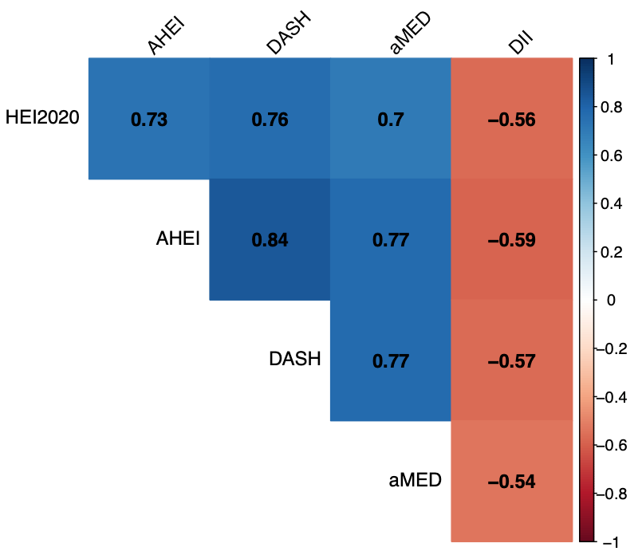
Supplementary Figure 1. Correlations of the diet scores. Weighted ρs were presented in the upper triangle heatplot. The weighted correlation between dietary scores was tested using Pearson’s correlation (weighted ρ). All P values <0.001.
Abbreviations: AHEI=Alternative Healthy Eating Index; aMED=Alternate Mediterranean Diet; DASH=Dietary Approaches to Stop Hypertension; DII=Dietary Inflammatory Index; HEI2020=Healthy Eating Index-2020.

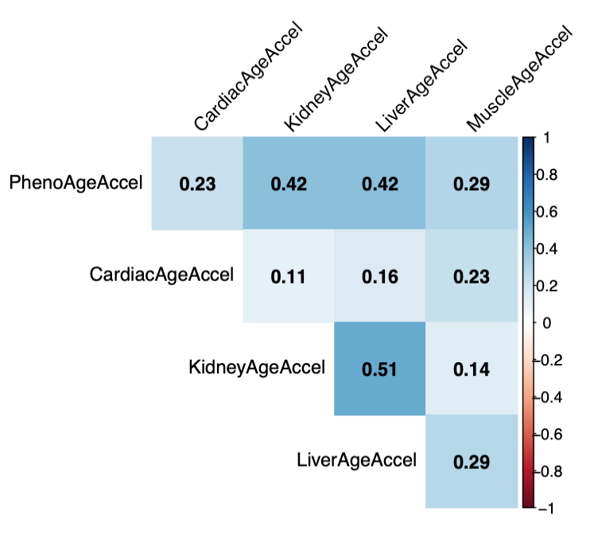
Supplementary Figure 2. Correlations of the acceleration of phenotypic ages at systemic and organ-specific levels. Weighted ρs were presented in the upper triangle heatplot. The weighted correlation between dietary scores was tested using Pearson’s correlation (weighted ρ). All P values<0.05.

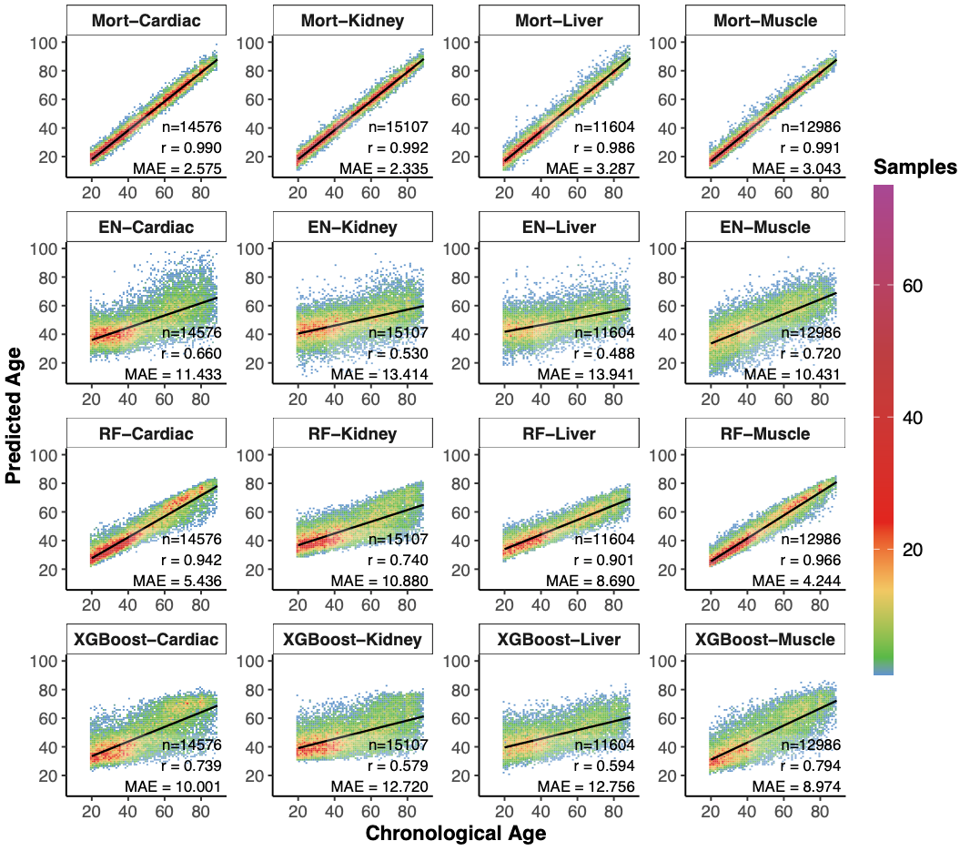
Supplementary Figure 3. Correlation of predicted age and chronological age in the training dataset (NHANES-III).
Abbreviations: EN=elastic net; Mort=mortality; RF=random forest.

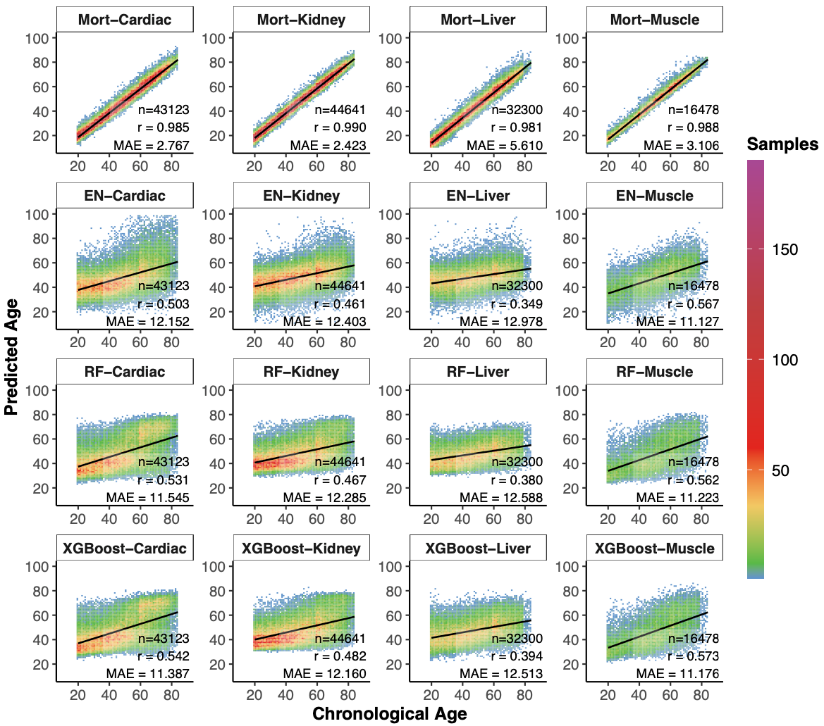
Supplementary Figure 4. Correlation of predicted age and chronological age in the test dataset (continuous NHANES 1999-2018).
Abbreviations: EN=elastic net; Mort=mortality; RF=random forest.

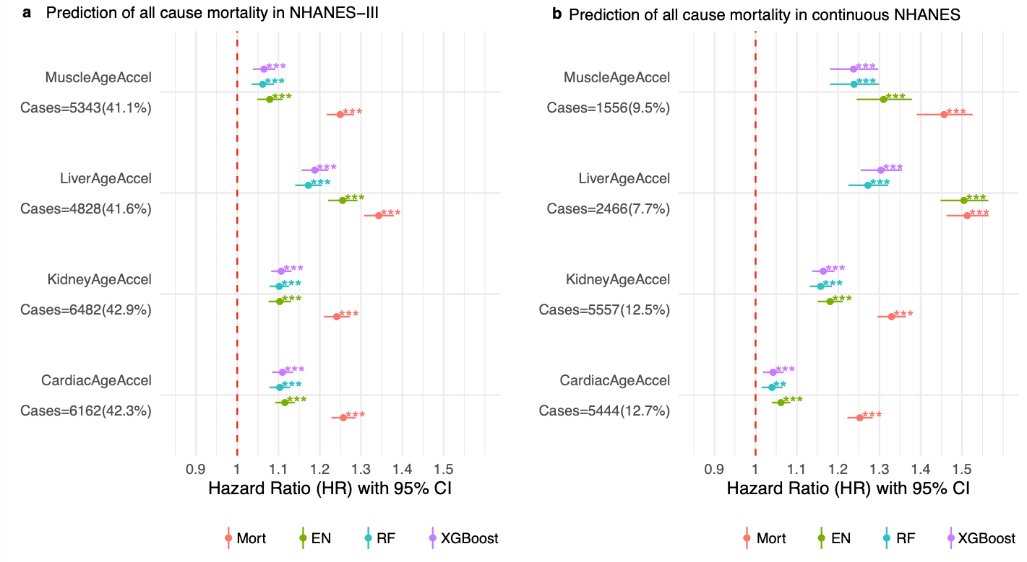
Supplementary Figure 5. Hazards ratio (HR) of accelerations of organ-specific ages per standard deviation with mortality in the (a) training dataset (NHANES-III) and the (b) test dataset (continuous NHANES, 1999-2018). The Cox proportional hazards model accounting for complex survey design was used with the adjustment for age and sex.

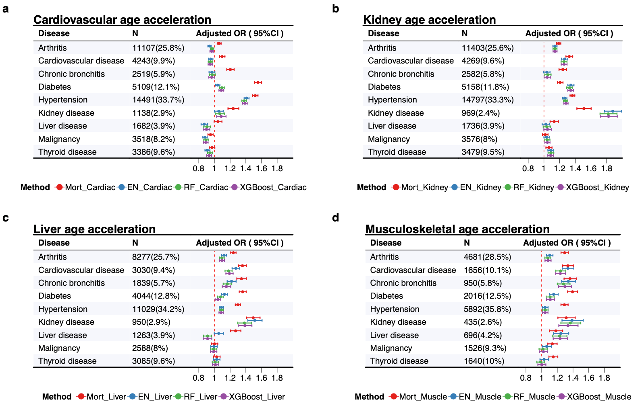
Supplementary Figure 6. Odd ratio (OR) of accelerations of organ-specific ages per standard deviation with chronic diseases in the NHANES 1999-2018. The logistic regression model accounting for complex survey design was used with the adjustment for age and sex.

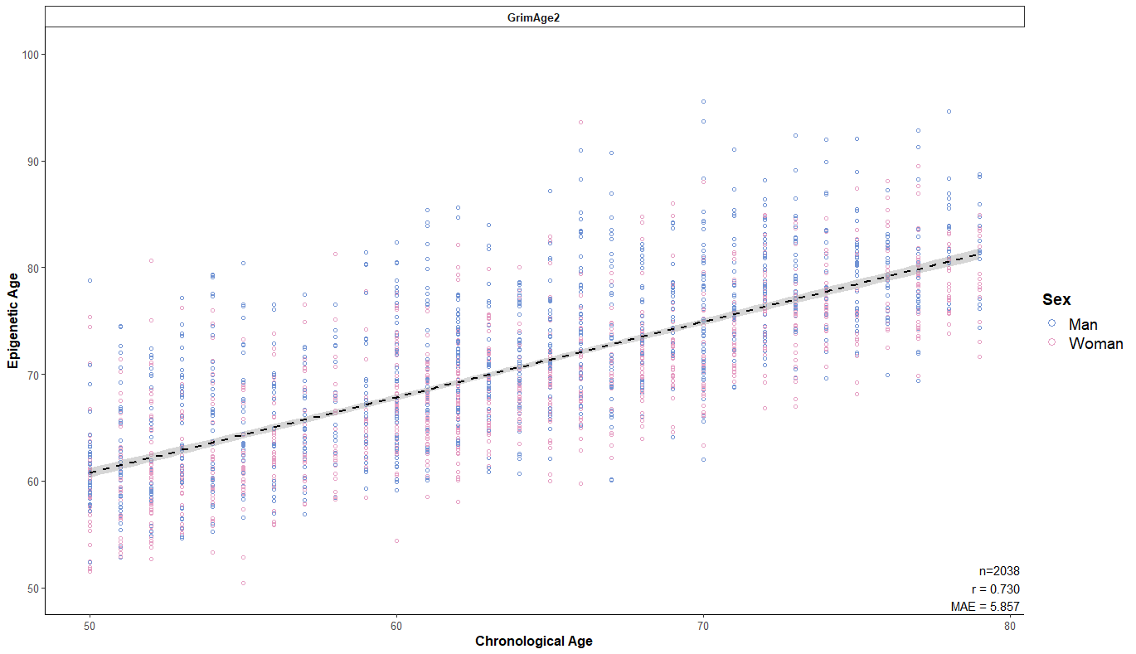
Supplementary Figure 7. Correlation of chronological age and GrimAge2 in continuous NHANES, 1999-2002.

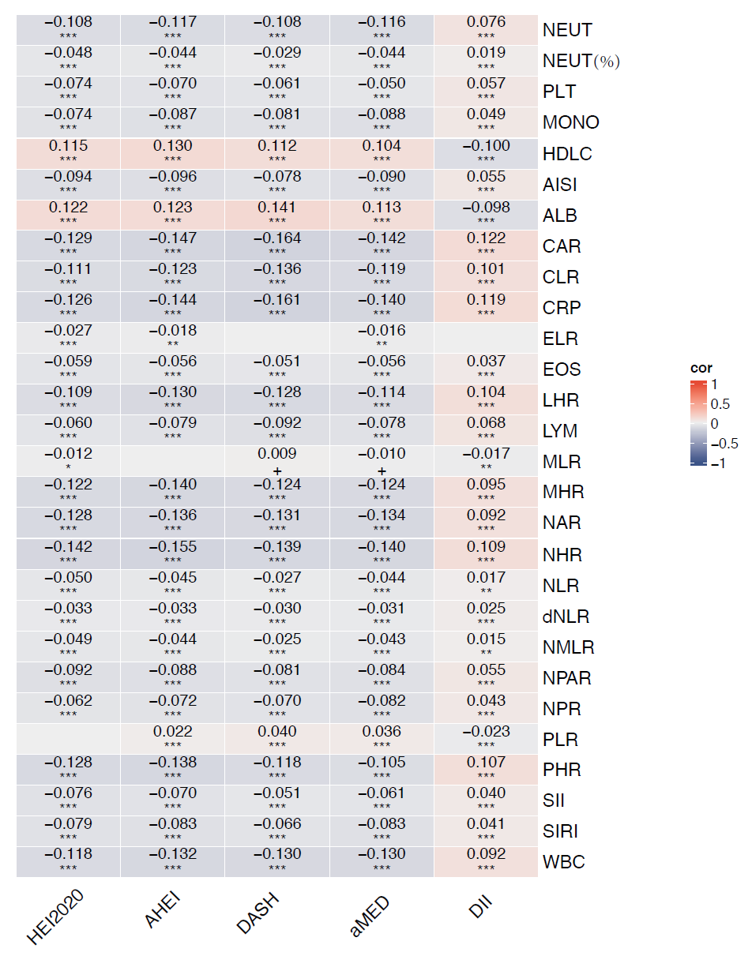

Supplementary Figure 8. Correlations of the diet scores and inflammatory indexes.
Abbreviations: AHEI=Alternative Healthy Eating Index; ALB=albumin; aMED=Alternate Mediterranean Diet; CRP=C-reactive protein; DASH=Dietary Approaches to Stop Hypertension; DII=Dietary Inflammatory Index; EOS=eosinophils number; HDLC=high density lipoprotein cholesterol; HEI2020=Healthy Eating Index-2020; LYM=lymphocyte number; MONO=monocyte number; NEUT=segmented neutrophils number; NEUT(%)=segmented neutrophils percent; PLT=platelet count; WBC=white blood cell count. Following inflammatory indexes were calculated as AISI=NEUT*PLT*MONO/ LYM; CAR=CRP/ALB; CLR=CRP/LYM; dNLR=NEUT/(WBC-LYM); ELR=EOS/LYM; LHR=LYM/HDLC; MLR=MONO/LYM; MHR=MONO/HDLC; NAR=NEUT/ALB; NHR=NEUT/HDLC; NLR=NEUT/LYM; NMLR=(MONO+NEUT)/LYM; NPAR=NEUT(%)*100/ALB; NPR=NEUT/PLT; PHR=PLT/HDLC; PLR=PLT/LYM; SII=PLT*NEUT/LYM; SIRI=NEUT*MONO/LYM.
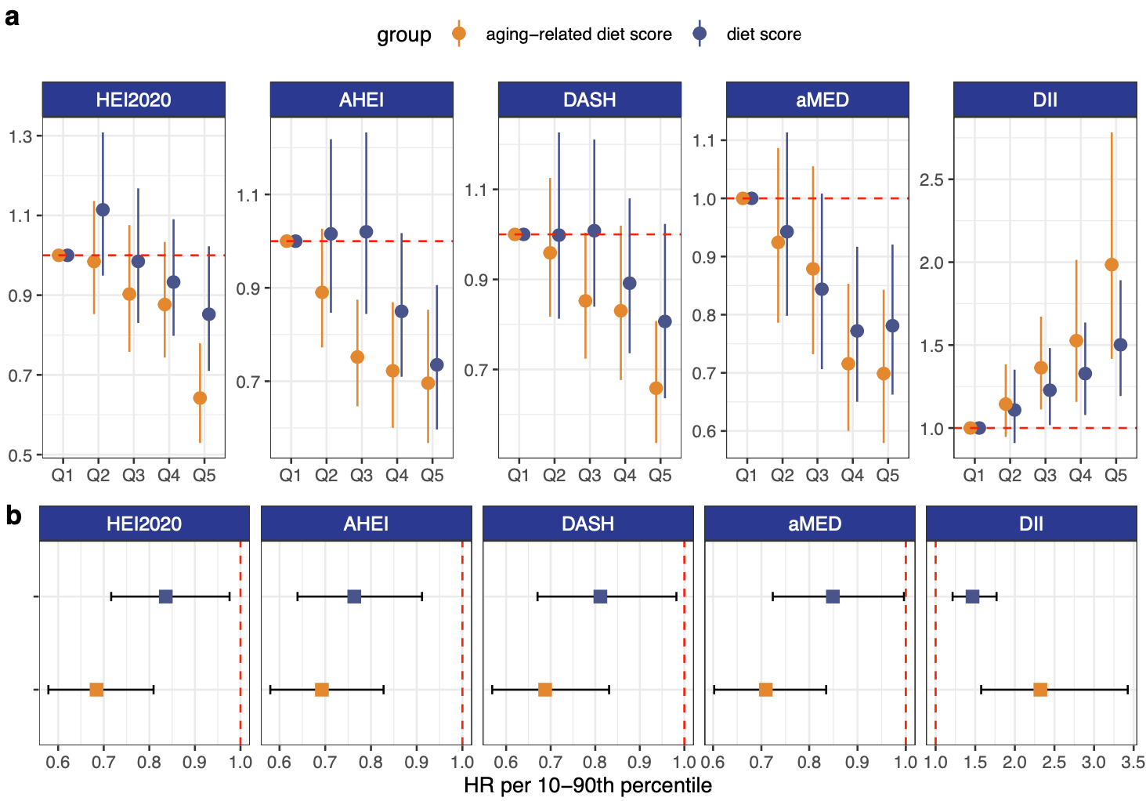
Supplementary Figure 9. Sensitivity analysis - adjusted HRs (95% CIs) of dietary scores and aging-related dietary scores with mortality among participants with consistent diet with 24-h dietary recall (n=20,903). The Cox proportional hazards model accounting for complex survey design was used with the adjustment for age, sex, ethnicity, education, poverty-income ratio, smoking status, physical activity, body mass index, diabetes, hypertension, cardiovascular disease, cancer, and average calories.
Abbreviations: AHEI=Alternative Healthy Eating Index; aMED=Alternate Mediterranean Diet; DASH=Dietary Approaches to Stop Hypertension; DII=Dietary Inflammatory Index; HEI2020=Healthy Eating Index-2020; HR=hazard ratio.
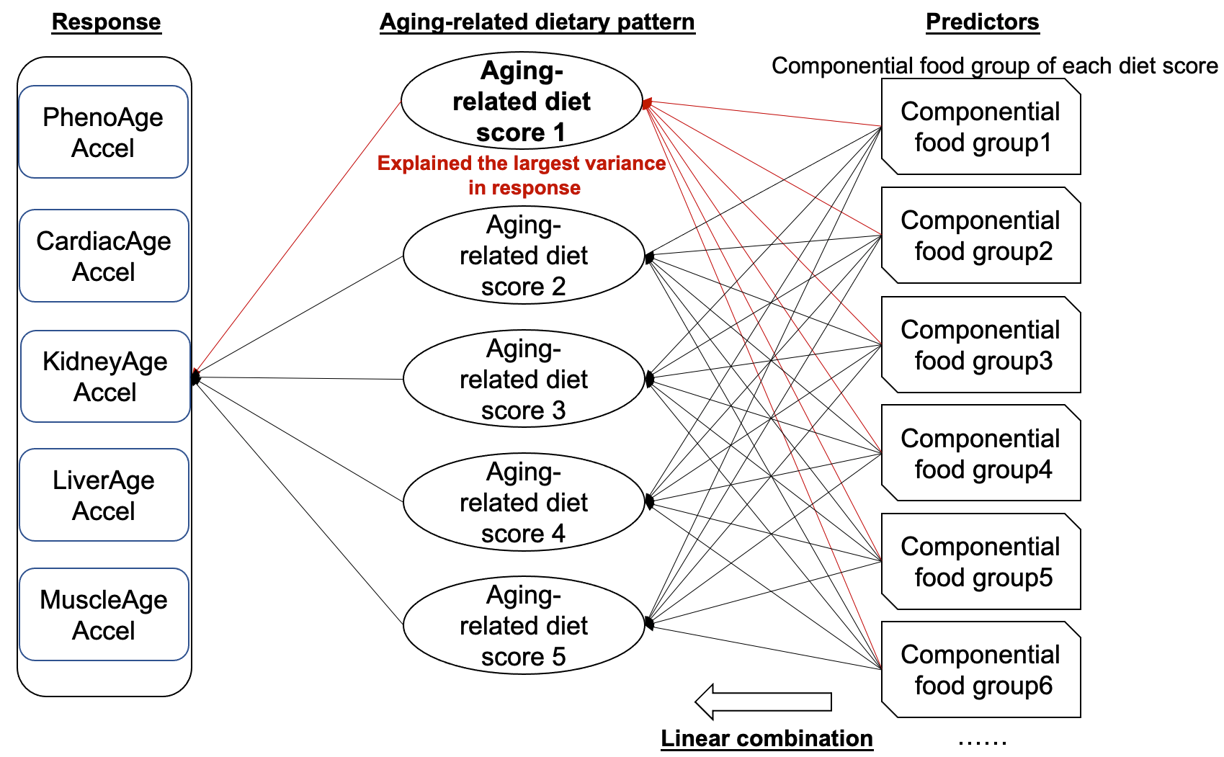
Supplementary Figure 10. Reduced rank regression (RRR) was used to identify aging-related diet scores using each componential food groups of five diet scores. Acceleration of PhenoAge and organ-specific age, including cardiovascular, kidney, liver, and musculoskeletal systems were calculated and used as response variables.
$${\hat{β}}_{OLS}={(Χ^{T}Χ)}^{-1}Χ^{T}Y$$
Singular Value Decomposition (SVD):
$${\hat{β}}_{OLS}=UΣV^{T}$$
$U$∈$R_{p*p}$, $Σ$∈$R_{p*q}$, $V^{T}$∈$R_{q*q}$

$U$∈$R_{p*p}$ is the left singular vector matrix.
$Σ$∈$R_{p*q}$ is the diagonal matrix containing singular values.
$V^{T}$∈$R_{q*q}$ is the right singular vector matrix.

Truncated SVD:
$$β_{RRR}=U_{r}Σ_{r}{V_{r}}^{T}$$
r is the rank, r<min(p, q)

The calculation of loading matrix:
$$L=β_{RRR}*A*{(A^{T}A)}^{-1}$$
$A$ is the right singular matrix ($V_{r}$)
$A^{T}$ is the transpose of the right singular matrix
References
1. Shams-White MM, Pannucci TRE, Lerman JL, Herrick KA, Zimmer M, Meyers Mathieu K, Stoody EE, Reedy J. Healthy Eating Index-2020: Review and Update Process to Reflect the Dietary Guidelines for Americans, 2020-2025. J Acad Nutr Diet Academy of Nutrition and Dietetics; 2023;123:1280–8.
2. Chiuve SE, Fung TT, Rimm EB, Hu FB, McCullough ML, Wang M, Stampfer MJ, Willett WC. Alternative dietary indices both strongly predict risk of chronic disease. J Nutr American Society for Nutrition.; 2012;142:1009–18.
3. Fung TT, Chiuve SE, McCullough ML, Rexrode KM, Logroscino G, Hu FB. Adherence to a DASH-style diet and risk of coronary heart disease and stroke in women. Arch Intern Med 2008;168:713–20.
4. Fung TT, Rexrode KM, Mantzoros CS, Manson JE, Willett WC, Hu FB. Mediterranean diet and incidence of and mortality from coronary heart disease and stroke in women. Circulation 2009;119:1093–100.
5. Shivappa N, Steck SE, Hurley TG, Hussey JR, Hébert JR. Designing and developing a literature-derived, population-based dietary inflammatory index. Public Health Nutr 2014;17:1689–96.

