Supplementary Table 1 Relative content of volatile substances in goji berry juice
before and after fermentation
Compounds | Peak area |  | Ratio  (FGJ/ UFGJ)
Compounds | UFGJ | FGJ | Ratio  (FGJ/ UFGJ)
(E, E)-2,4-nonadienal | 194.38±20.16 | 207.34±32.85 | 1.07
2-Butylfuran | 521.82±23.32 | 534.99±116.19 | 1.03
Ethyl formate | 105.75±15.06 | 128.82±54.78 | 1.22
Ethyl butyrate | 659.46±28.47 | 693.77±104.12 | 1.05
Ethyl pentanoate | 1051.20±26.17 | 1388.92±119.85 | 1.32
Diethyl malonate | 3537.22±728.46 | 4580.84±1025.73 | 1.30
2,3-Diethylpyrazine | 3389.46±482.24 | 4380.04±621.15 | 1.29
Dimethyl trisufide | 279.66±57.72 | 455.99±14.76 | 1.63
Pentyl acetate | 3529.74±980.38 | 5528.54±121.55 | 1.57
Hexanenitrile | 475.04±50.04 | 610.72±31.84 | 1.29
2,3-pentanedione | 3510.29±209.15 | 3706.93±33.95 | 1.06
3-Methyl-3-buten-1-ol | 959.22±66.66 | 1101.91±14.15 | 1.15
3-Hydroxybutan-2-one | 2581.56±467.48 | 3886.32±108.61 | 1.51
2-Hydroxybenzaldehyde | 448.67±68.38 | 557.40±10.38 | 1.24
Butyl propanoate | 515.44±50.45 | 599.80±211.98 | 1.16
2-Methylbutanoic acid | 1511.67±228.36 | 1346.75±42.56 | 0.89
Beta-cyclohomocitral | 1166.66±491.81 | 569.13±36.06 | 0.49
(Z)-3-Hexenyl isovalerate | 2602.75±203.57 | 2253.23±310.23 | 0.87
1-Penten-3-ol | 7799.30±477.18 | 3972.37±91.04 | 0.51
2,3-Butanediol | 8067.24±84.38 | 4397.17±124.63 | 0.55
Ethyl crotonate | 3530.56±127.56 | 890.97±114.64 | 0.25
1-Octen-3-one | 363.47±27.57 | 93.58±12.21 | 0.26
2-Methylpyrazine | 2924.03±249.72 | 2572.89±92.91 | 0.88
Cyclohexen-2-one | 4538.85±1038.02 | 3771.19±100.65 | 0.83
2-Methylisoborneol | 135.16±8.91 | 95.39±9.23 | 0.71
4-Hydroxy-5-ethyl-2-methyl-3(2H)  -furanone | 189.51±5.99 | 143.66±6.64 | 0.76
3-Methylbutyl 2-methylbutanoate | 382.01±28.85 | 235.23±8.08 | 0.62
Diethyl propanedioate | 250.22±27.29 | 87.36±6.02 | 0.35
2,4-Heptadienal | 110.59±11.68 | 54.09±2.61 | 0.49
Tetrahydrofurfuryl acetate | 255.00±24.43 | 213.46±16.15 | 0.84
2-Butoxyethyl acetate | 201.48±26.41 | 169.81±2.36 | 0.84
Diethyl succinate | 106.36±2.27 | 63.50±16.78 | 0.60
2,6-Dimethylpyridine | 253.39±16.81 | 112.23±18.39 | 0.44
2,5-Dimethylpyrazine | 306.22±7.06 | 151.98±2.60 | 0.50
5-Hepten-2-one, 6-methyl- | 616.00±52.16 | 491.78±4.37 | 0.80
2-Pentyl furan | 397.58±17.32 | 252.51±3.74 | 0.64
N,N-Dimethylacetamide | 692.97±74.34 | 355.12±35.39 | 0.51
Note: UFGJ, unfermented goji berry juice; FGJ, Lactobacillus paracasei-Fermented goji berry juice

Supplementary Table 2 Organ indexes of mice with different treatments
Organ index（mg/g） | Control | Model | Metformin | HFGJ | LFGJ | LP | UFGJ
Heart | 4.82±0.78 | 4.81±0.46 | 5.03±3.41 | 4.76±0.26 | 4.66±0.32 | 4.67±0.32 | 4.68±0.51
Liver | 38.48±6.75# | 48.7±4.82* | 46.48±4.21* | 42.18±2.7# | 46.61±3.14* | 44.17±6.53* | 43.72±3.62*
Spleen | 3.53±0.55# | 4.72±0.68* | 4.26±1.07# | 4.51±0.46* | 4.55±1.06* | 4.74±1.01* | 4.48±0.75*
Lung | 5.36±0.44 | 5.68±0.8 | 5.7±0.41 | 5.94±0.65 | 6.21±0.9 | 5.61±0.67 | 6.07±0.48
Kidney | 14.35±1.45 | 15.08±0.86 | 13.4±1.67 | 14.7±1.57 | 13.97±0.85 | 15.13±1.75 | 14.57±0.89
Pancreas | 5.4±1.09# | 4.44±0.59* | 4.83±0.74 | 4.72±0.66* | 4.65±0.77 | 4.68±0.52 | 4.75±0.73
Note: “*” represents P<0.05 vs. control group; “#” indicates P<0.05 vs. model group.

Supplementary Table 3 Experimental mouse grouping
Groups | High fat feed | Gavage samples | Dosage (mL)
Blank control group (Control) | No | Normal saline | 0.3
Model control group (Model) | Yes | Normal saline | 0.3
Metformin group (Metformin) | Yes | Metformin | 0.3
High dose fermented goji berry juice group (HFGJ) | Yes | Fermented goji berry juice | 0.3
Low dose fermented goji berry juice group (LFGJ) | Yes | Fermented goji berry juice diluted twice with normal saline | 0.3
Unfermented goji berry juice group (UFGJ) | Yes | Unfermented goji berry juice | 0.3
Bacterial liquid group (LP) | Yes | Bacterial liquid | 0.3

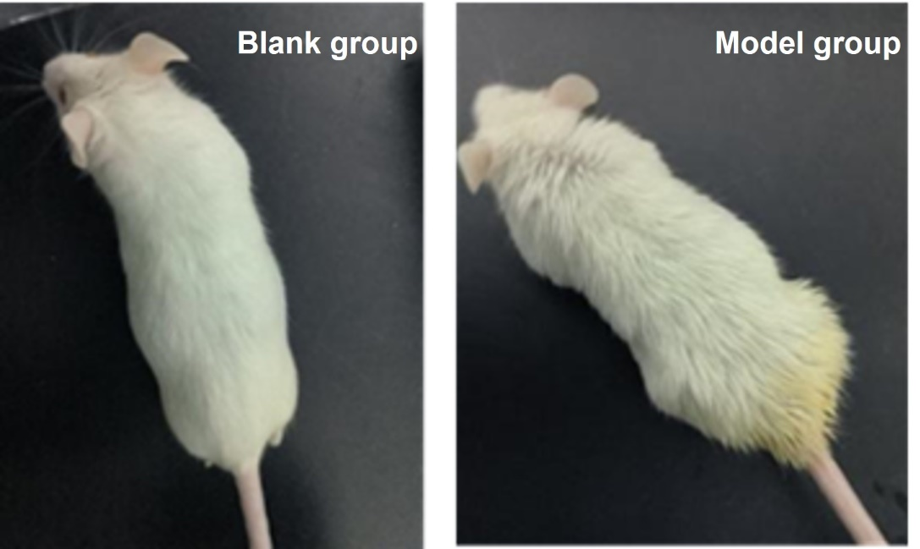
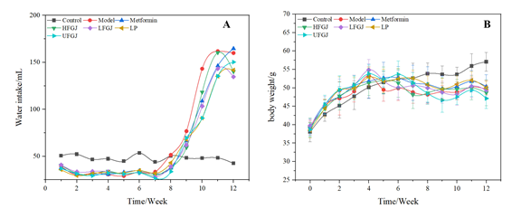
Supplementary Figure. 1 Changes in apparent state in mice
Supplementary Figure. 2 Changes in water intake (A), and body weight (B) of mice with different treatments

