Supplementary Materials
Table S1 Statistical table after sequencing bases filtering
Sample | Clean Data (bp) | Q30 (%) | N (%) | GC (%)
Con-1 | 1505554329 | 1420235711 (94.33%) | 17028 (0.0%) | 635646691 (42.22%)
Con-2 | 1462437820 | 1382641491 (94.54%) | 22312 (0.0%) | 612303901 (41.86%)
Con-3 | 1716970674 | 1623240964 (94.54%) | 19524 (0.0%) | 732954382 (42.69%)
CFS-1 | 1622551983 | 1535205551 (94.62%) | 24583 (0.0%) | 663344953 (40.88%)
CFS-2 | 1647611563 | 1554636032 (94.36%) | 25003 (0.0%) | 675192670 (40.98%)
CFS-3 | 2447286889 | 2314568926 (94.58%) | 37653 (0.0%) | 1009063822 (41.23%)

Table S2 The reads after ribosome removal match to the reference genome results
Sample | Total_  Reads | Mapping_  Ratio | Unique_Mapped | Multiple_Mapped
Con-1 | 9045814 | 94.36% | 8448368 (93.40%) | 86965(0.96%)
Con-2 | 8720392 | 96.37% | 8310575 (95.30%) | 93568(1.07%)
Con-3 | 10006338 | 96.26% | 9518758 (95.13%) | 113612(1.14%)
CFS-1 | 10207786 | 97.71% | 9878696 (96.78%) | 95039(0.93%)
CFS-2 | 10236064 | 97.85% | 9918935 (96.90%) | 97134(0.95%)
CFS-3 | 15347966 | 96.98% | 14715168 (95.88%) | 168910(1.10%)

Table S3 Primers used in qRT-PCR
Gene | primer direction | sequence (5’–3’)
16S | forward | GGGAATCTTCGGCAATGGA
16S | reverse | GACAACGCTCGGGACCTA
gpbA | forward | AAAACCGTCATCAGGCACAG
gpbA | reverse | CAGTTGAGGCTCGTTTCCC
gtfC | forward | AATGGCACCGCAGTATGT
gtfC | reverse | ATCAGGCACCCAGTCAGC
ldh | forward | GGTATTGCTGTTGCCCTTGC
ldh | reverse | ATAGCGGGCTGACCGATAAA
atpD | forward | TGGCGGGATTTCGGTATTTA
atpD | reverse | CTCCAGGCGGTTCATTCA
vicK | forward | GACCCTTCGCCTTCCTCAC
vicK | reverse | GCAAGAAGCCGTGCTCAAG

Table S4 Amplification system for qPCR
Component | Volume (µL)
cDNA | 2
Sterilized ultrapure water | to 20
Forward Primer | 6 pmol
Reverse Primer | 6 pmol
SYBR qPCR Mix | 10
Total Volume | 20

Table S5 Amplification procedures for qPCR
Step | Temperature (℃) | Time
1 | 95 | 1 min
2 | 95 | 15 s
3 | 60 | 30 s
back to step 2 for 40 cycles

Table S6 The KEGG enrichment circle diagram correspond to descriptions and differential metabolite quantities
Mode | ID | Description | Number
NEG | ko07226 | Progesterone, androgen and estrogen  receptor agonists/antagonists | 2
NEG | ko07211 | Serotonin receptor agonists/antagonists | 1
NEG | ko07224 | Opioid receptor agonists/antagonists | 1
NEG | ko01100 | Metabolic pathways | 48
NEG | ko07034 | Eicosanoids | 1
NEG | ko01060 | Biosynthesis of plant secondary metabolites | 8
NEG | ko07225 | Glucocorticoid and mineralocorticoid  receptor agonists/antagonists | 1
NEG | ko01062 | Biosynthesis of terpenoids and steroids | 3
NEG | ko01066 | Biosynthesis of alkaloids derived from  terpenoid and polyketide | 2
NEG | ko01061 | Biosynthesis of phenylpropanoids | 4
NEG | ko01070 | Biosynthesis of plant hormones | 3
NEG | ko01110 | Biosynthesis of secondary metabolites | 22
NEG | ko00121 | Secondary bile acid biosynthesis | 1
NEG | ko01065 | Biosynthesis of alkaloids derived from  histidine and purine | 1
NEG | ko01063 | Biosynthesis of alkaloids derived from  shikimate pathway | 2
NEG | ko01120 | Microbial metabolism in diverse environments | 6
POS | ko01063 | Biosynthesis of alkaloids derived  from shikimate pathway | 9
POS | ko01052 | Type I polyketide structures | 2
POS | ko00121 | Secondary bile acid biosynthesis | 3
POS | ko07024 | HMG-CoA reductase inhibitors | 1
POS | ko01110 | Biosynthesis of secondary metabolites | 29
POS | ko01060 | Biosynthesis of plant secondary metabolites | 8
POS | ko01064 | Biosynthesis of alkaloids derived from  ornithine, lysine and nicotinic acid | 2
POS | ko01070 | Biosynthesis of plant hormones | 2
POS | ko01066 | Biosynthesis of alkaloids derived  from terpenoid and polyketide | 1
POS | ko01065 | Biosynthesis of alkaloids derived  from histidine and purine | 1
POS | ko01062 | Biosynthesis of terpenoids and steroids | 1
POS | ko01061 | Biosynthesis of phenylpropanoids | 2
POS | ko01100 | Metabolic pathways | 46
POS | ko01120 | Microbial metabolism in diverse environments | 6

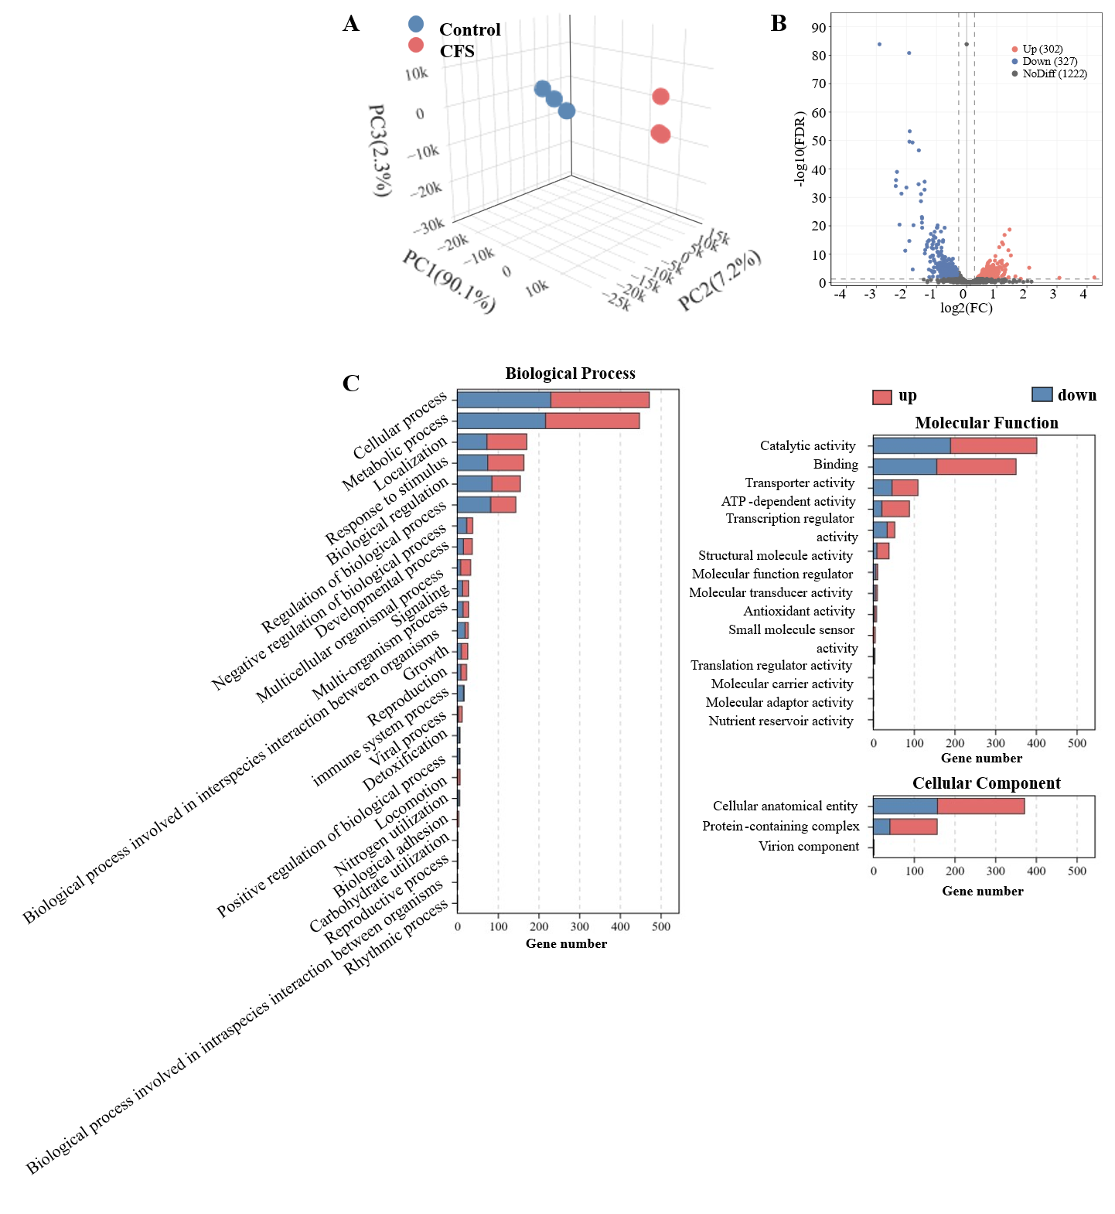
Fig. S1 Transcriptomics analysis. Ａ 3D plot of PCA scores. Ｂ Volcano plot of DEGs．C Secondary histogram of GO enrichment classification of DEGs．
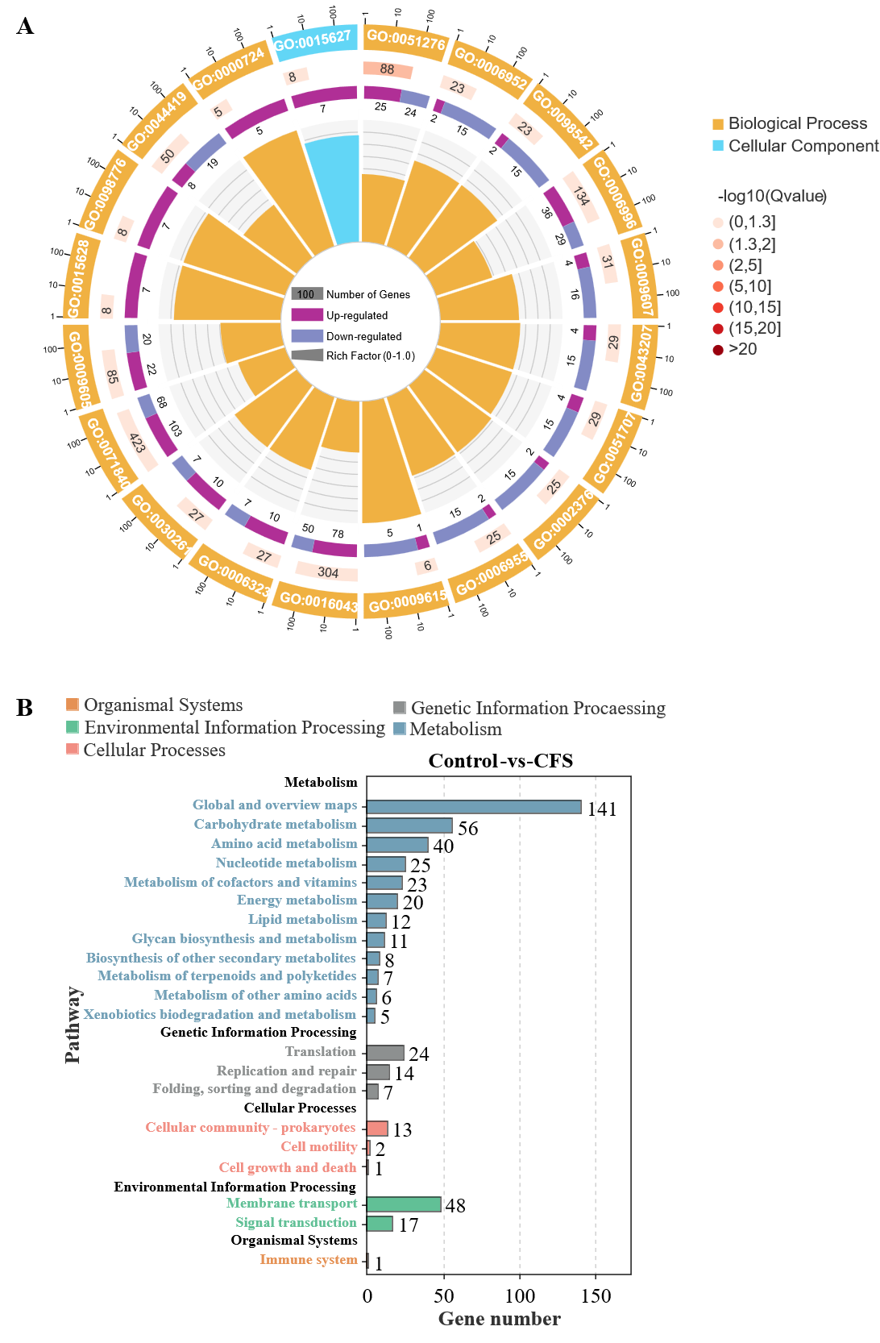
Fig. S2 Enrichment analysis of DEGs: (A) GO enrichment circle plot; (B) KEGG enrichment secondary histogram.
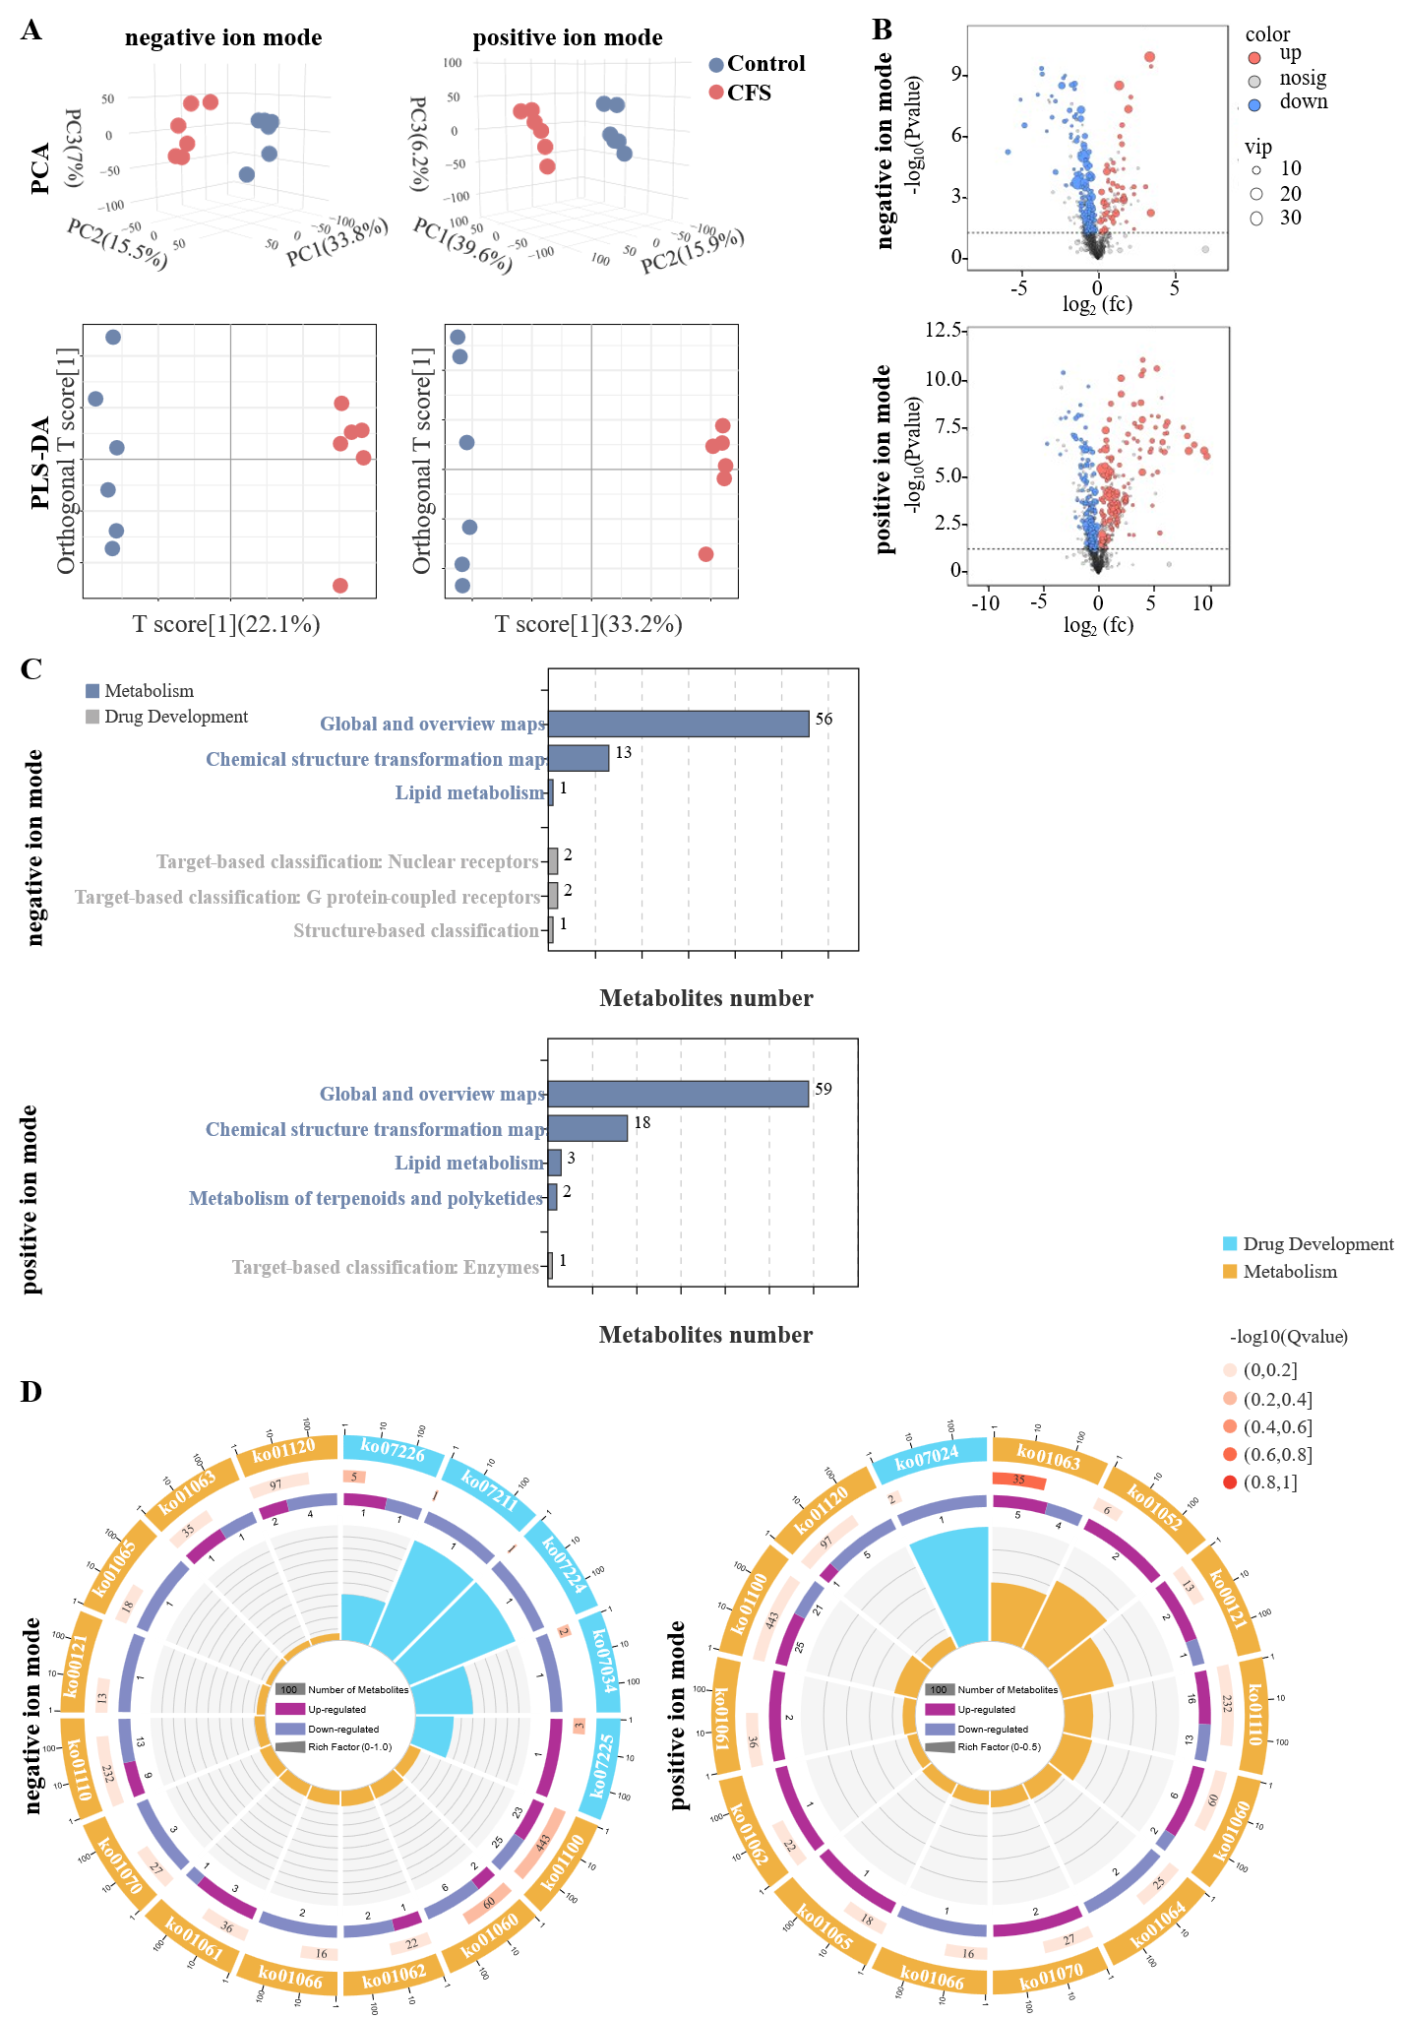
Fig. S3 Metabolomics analysis. Ａ Score plots of PCA and PLS-DA for metabolite profiles in POS and NES.Ｂ Volcano plot of differential metabolites in POS and NEG．Ｃ Secondary histogram of KEGG enrichment of differential metabolites．Ｄ Circle plot of GO enrichment of DEGs.

