Supplementary Information

A tailored small group instruction intervention in mathematics benefits low achievers
  - Rosholm, Tonnesen, Rasmussen, Overgaard, Færch, Malm, Harder

Supplementary Table 1: Robustness checks and alternative specifications, LATE effect sizes.
The table shows standardized effect sizes for alternative specifications of the model and dependent variable. Baseline results are similar to those in Figure 2. The model with extra covariates is similar to the baseline results but includes additional covariates, which are specified in Supplementary Tables 2 and 3. The model ‘estimated in first differences’ is based on the change in test results from before to after the intervention. The regression includes school fixed effects but not the pre-test score. The model with alternative SD is standardized on the standard deviation in the pretest score of all 2nd/8th graders in the participating schools, rather than just the control group. *** p<0.01, ** p<0.05, * p<0.1.
Panel A: 2nd grade
 | 1-group | 1-group with coaching | 1-1 with coaching | Pooled
Baseline results | 0.519** | .107 | 0.803*** | 0.467***
 | (0.246) | (0.260) | (0.274) | (0.151)
With extra covariates | 0.487* | 0.074 | 0.851*** | 0.458***
 | (0.251) | (0.264) | (0.279) | (0.152)
Estimated in first differences | 0.592** | 0.076 | 0.778*** | 0.475***
 | (0.247) | (0.263) | (0.275) | (0.152)
Alternative SD | 0.293** | 0.060 | 0.438*** | 0.263***
 | (0.139) | (0.147) | (0.166) | (0.086)
Panel B: 8th grade
 | 1-group | 1-group with coaching | 1-1 with coaching | Pooled
Baseline results | 0.131 | 0.565** | 0.187 | 0.303**
 | (0.247) | (0.241) | (0.261) | (0.147)
With extra covariates | 0.133 | 0.497** | 0.254 | 0.302**
 | (0.244) | (0.241) | (0.258) | (0.145)
Estimated in first differences | 0.123 | 0.561** | 0.178 | 0.297**
 | (0.251) | (0.244) | (0.265) | (0.149)
Alternative SD | 0.075 | 0.322** | 0.108 | 0.173**
 | (0.142) | (0.137) | (0.150) | (0.085)

Supplementary Table 2: Balancing tests, low performing pupils, 2nd grade.
The table shows averages of covariates in Treatment (T) and Control groups (C). The first and second columns offer raw means for T and C groups, respectively, while P-values in the third columns are obtained from a regression of the variable in question on a treatment assignment dummy and school (stratification) fixed effects. Numbers with bold text indicate a significant difference between treatments and controls at the 5% level. The ‘Other’ category in fathers and mothers labour market situation covers missing information, deceased, on sickness payments or parental leave, in education, on disability pension, or in supported employment. Cells with a ‘.’ indicate that it (either T or C) contains three observations or fewer, in which case we are not allowed to report the numbers due to confidentiality issues (none of them differ significantly between treatment and control groups).
 | 1-group |  |  | 1-group with coaching |  |  | 1-1 with coaching |  |  | Pooled
 | T  (140) | C  (68) | P- value | T  (132) | C  (68) | P- value | T  (122) | C  (59) | P- value | T  (394) | C  (195) | P-  value
Pre-test, standardized | -1.31 | -1.18 | 0.034 | -1.19 | -1.26 | 0.434 | -1.18 | -1.22 | 0.488 | -1.23 | -1.22 | 0.708
Imm./desc., western orig. | 6.4 | 5.9 | 0.968 | . | . | . | . | . | . | 6.6 | 4.1 | 0.203
Imm./desc., non-western | . | . | . | 17.4 | 16.2 | 0.828 | 9.0 | 23.7 | 0.003 | 11.7 | 14.4 | 0.371
Boy | 41.4 | 50.0 | 0.210 | 37.9 | 42.6 | 0.415 | 44.3 | 45.7 | 0.826 | 41.1 | 46.2 | 0.197
Social intervention | . | . | . | . | . | . | . | . | . | 2.8 | 1.5 | 0.283
Mothers education
- Missing | 14.3 | 14.7 | 0.926 | 15.9 | 8.8 | 0.165 | . | . | . | 13.2 | 9.2 | 0.124
- Comp. school | 15.0 | 16.2 | 0.983 | 18.2 | 16.2 | 0.521 | 18.9 | 16.9 | 0.837 | 17.3 | 16.4 | 0.651
- High school | . | . | . | 4.5 | 10.3 | 0.087 | 5.7 | 6.8 | 0.833 | 4.8 | 7.2 | 0.195
- Vocational | 25.7 | 22.1 | 0.583 | 28.8 | 30.9 | 0.954 | 24.6 | 25.4 | 0.919 | 26.4 | 26.2 | 0.753
- Short qualifying | . | . | . | . | . | . | 3.3 | 8.5 | 0.158 | 4.3 | 5.6 | 0.511
- Bachelor | 17.9 | 20.6 | 0.573 | 15.2 | 16.2 | 0.837 | 22.1 | 18.6 | 0.467 | 18.3 | 18.5 | 0.958
- Masters or PhD | 15.7 | 17.7 | 0.725 | 30.4 | 28.9 | 0.899 | 16.4 | 20.3 | 0.266 | 15.7 | 16.9 | 0.354
Fathers education
- Missing | 10.0 | 19.1 | 0.037 | 18.2 | 10.3 | 0.123 | . | . | . | 12.9 | 11.8 | 0.551
- Comp. school | 17.9 | 16.2 | 0.819 | 22.0 | 16.2 | 0.256 | 17.2 | 18.6 | 0.845 | 19.0 | 16.9 | 0.497
- High school | . | . | . | 3.8 | 2.9 | 0.861 | 4.1 | 6.8 | 0.527 | 3.6 | 4.6 | 0.571
- Vocational | 32.9 | 30.9 | 0.737 | 27.3 | 33.8 | 0.377 | 37.7 | 39.0 | 0.970 | 32.5 | 34.4 | 0.722
- Short qualifying | 10.0 | 10.3 | 0.911 | 7.6 | 13.2 | 0.116 | 4.1 | 8.5 | 0.232 | 7.4 | 10.8 | 0.118
- Bachelor | . | . | . | 10.6 | 10.3 | 0.962 | 11.5 | 6.8 | 0.451 | 10.9 | 6.7 | 0.128
- Masters or PhD | 15.7 | 16.2 | 0.958 | 10.6 | 13.2 | 0.588 | 14.7 | 15.3 | 0.701 | 13.7 | 14.9 | 0.573
Mothers labour market sit.
- Other | 16.4 | 20.6 | 0.416 | 23.5 | 19.1 | 0.347 | 14.8 | 13.6 | 0.695 | 18.3 | 17.9 | 0.737
- Employed | 70.0 | 69.1 | 0.887 | 63.6 | 69.1 | 0.294 | 69.7 | 71.1 | 0.730 | 67.8 | 69.7 | 0.444
- UI benefits or welfare | 13.6 | 10.3 | 0.472 | 12.9 | 11.8 | 0.694 | . | . | . | 14.0 | 12.3 | 0.523
Fathers labour market sit.
- Other | 9.3 | 17.6 | 0.031 | 16.7 | 13.2 | 0.433 | 9.8 | 8.5 | 0.571 | 11.9 | 13.3 | 0.689
- Employed | 85.0 | 75.0 | 0.039 | 72.7 | 72.1 | 0.994 | 79.5 | 84.7 | 0.250 | 79.2 | 76.9 | 0.616
- UI benefits or welfare | 5.7 | 7.4 | 0.649 | 10.6 | 14.7 | 0.443 | 10.7 | 6.8 | 0.373 | 8.9 | 9.7 | 0.819

Supplementary Table 3: Balancing tests, low performing pupils, 8th grade.
The table shows averages of covariates in Treatment (T) and Control groups (C). The first and second columns offer raw means for T and C groups, respectively, while P-values in the third columns are obtained from a regression of the variable in question on a treatment assignment dummy and school (stratification) fixed effects. Numbers with bold text indicate a significant difference between treatments and controls at the 5% level. The ‘Other’ category in fathers and mothers labour market situation covers missing information, deceased, on sickness payments or parental leave, in education, on disability pension, or in supported employment. Cells with a ‘.’ indicate that it (either T or C) contains three observations or fewer, in which case we are not allowed to report the numbers due to confidentiality issues (none of them differ significantly between treatment and control groups).
 | 1-group |  |  | 1-group with coaching |  |  | 1-1 with coaching |  |  | Pooled
 | T  (95) | C  (47) | P- value | T  (100) | C  (57) | P- value | T  (135) | C  (60) | P- value | T  (330) | C  (164) | P- value
Pretest, standardized | -1.25 | -1.27 | 0.818 | -1.29 | -1.34 | 0.524 | -1.22 | -1.14 | 0.563 | -1.25 | -1.25 | 0.792
Imm./desc., western orig. | . | . | . | . | . | . | 8.9 | 8.3 | 0.715 | 5.2 | 7.3 | 0.410
Imm./desc., non-western | 13.7 | 17.0 | 0.485 | 10.0 | 12.3 | 0.577 | 23.7 | 16.7 | 0.408 | 16.7 | 15.2 | 0.962
Boy | 43.2 | 40.4 | 0.800 | 38.0 | 42.1 | 0.599 | 43.7 | 45.0 | 0.945 | 41.8 | 42.7 | 0.887
Social intervention | . | . | . | . | . | . | . | . | . | 5.2 | 3.7 | 0.383
Mothers education
- Missing | 8.4 | 12.8 | 0.428 | 7.0 | 7.0 | 0.902 | 9.6 | 11.7 | 0.913 | 8.5 | 10.4 | 0.646
- Comp. school | 18.0 | 10.6 | 0.172 | 16.0 | 19.3 | 0.702 | 17.8 | 18.3 | 0.710 | 17.3 | 16.5 | 0.789
- High school | 6.3 | 8.5 | 0.731 | . | . | . | 7.4 | 6.7 | 0.902 | 6.7 | 5.5 | 0.626
- Vocational | 38.9 | 44.7 | 0.489 | 37.0 | 50.9 | 0.108 | 33.3 | 30.0 | 0.705 | 36.1 | 41.5 | 0.252
- Short qualifying | 6.3 | 0 | 0.118 | . | . | . | . | . | . | . | . | .
- Bachelor | 15.8 | 14.9 | 0.847 | 26.0 | 12.3 | 0.067 | 17.8 | 20.0 | 0.856 | 19.7 | 15.9 | 0.277
- Masters or PhD | 6.3 | 8.5 | 0.406 | 5.0 | 7.0 | 0.444 | 11.9 | 10.0 | 0.642 | 8.2 | 8.5 | 0.639
Fathers education
- Missing | 10.5 | 12.8 | 0.826 | 8.0 | 10.5 | 0.629 | 13.3 | 13.3 | 0.831 | 10.9 | 12.2 | 0.819
- Comp. school | 16.8 | 17.0 | 0.882 | 27.0 | 15.8 | 0.134 | 24.4 | 20.0 | 0.608 | 23.0 | 17.7 | 0.252
- High school | . | . | . | . | . | . | . | . | . | 6.1 | 3.7 | 0.235
- Vocational | 45.3 | 44.7 | 0.934 | 42.0 | 52.6 | 0.237 | 31.1 | 33.3 | 0.695 | 38.5 | 43.3 | 0.402
- Short qualifying | . | . | . | 4.0 | 7.0 | 0.433 | . | . | . | 5.5 | 6.1 | 0.845
- Bachelor | . | . | . | 9.0 | 7.0 | 0.822 | 8.9 | 8.3 | 0.938 | 7.6 | 7.3 | 0.945
- Masters or PhD | 8.4 | 10.6 | 0.539 | . | . | . | 11.9 | 15.0 | 0.599 | 8.5 | 9.8 | 0.496
Mothers labour market sit.
- Other | 22.1 | 21.3 | 0.955 | 12.0 | 10.5 | 0.722 | 11.9 | 16.7 | 0.383 | 14.8 | 15.8 | 0.797
- Employed | 63.2 | 61.7 | 0.881 | 80.0 | 68.4 | 0.095 | 67.4 | 70.0 | 0.569 | 70.0 | 67.1 | 0.593
- UI benefits or welfare | 14.7 | 17.0 | 0.889 | 8.0 | 21.1 | 0.013 | 20.7 | 13.3 | 0.142 | 15.2 | 17.1 | 0.674
Fathers labour market sit.
- Other | 15.8 | 17.0 | 0.967 | 12.0 | 15.8 | 0.464 | 20.0 | 20.0 | 0.990 | 16.4 | 17.7 | 0.710
- Employed | 75.8 | 70.2 | 0.544 | 78.0 | 77.2 | 0.881 | 70.4 | 75.0 | 0.370 | 74.2 | 74.4 | 0.884
- UI benefits or welfare | 8.4 | 12.8 | 0.357 | 10.0 | 7.0 | 0.503 | . | . | . | 9.4 | 7.9 | 0.471

Supplementary Table 4: Per pupil costs by intervention and grade.
The table shows the average cost of intervention per pupil in US$ by intervention and grade.
 | 2nd grade, US$ | 8th grade, US$
1-group | 392 | 479
1-group with coaching | 547 | 610
1-1 with coaching | 1273 | 910

Supplementary Figure 1: Average change in test scores from pretest to posttest.
The figures shows the average change in standardized test scores from pretest to posttest by treatment arm (as well as pooled within grade), grade, and treatment status.
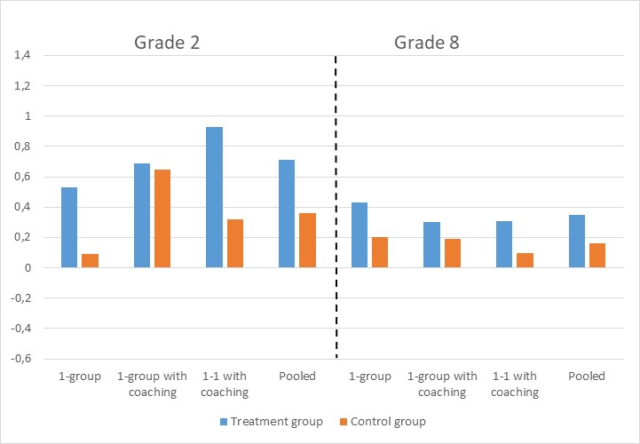

Supplementary Figure 2: Treatment effects on reading.
The figure shows standardized treatment effects in reading based on data from compulsory national reading tests. Vertical error bars are 95% confidence intervals. ITT is Intention-To-Treat effect, LATE is Local Average Treatment Effect. Outcomes for grade 2 are from the national tests conducted in the spring of grade 2, that is, around 6 months after the end of the intervention. Outcomes for grade 8 are average school leaving exam grades in Danish language in grade 9, that is, around 14 months after the end of the intervention. Both outcomes are standardized to mean 0 and standard deviation 1 in the pooled control group.
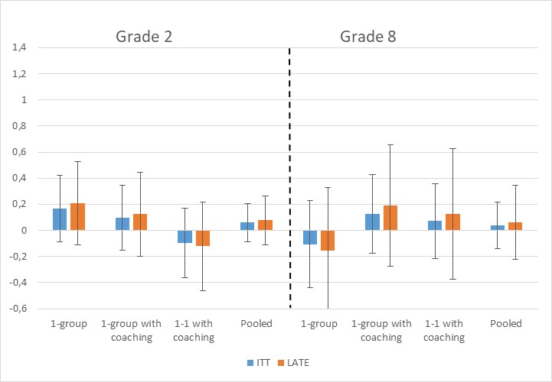

Supplementary Figure 3: Overall treatment effects on various measures of personality and school well-being.
The figure shows standardized effect sizes on various measures of personality and school well-being based on data from the compulsory national well-being surveys. Vertical error bars are 95% confidence intervals. Effects are LATE, Local Average Treatment Effects. Only effect sizes pooled across intervention arms within grades are shown due to relatively few observations caused by low response rates, especially in grade 8. Outcomes for grade 2 are from the national well-being survey conducted in the spring of grade 4, that is, slightly below 2.5 years after the end of the intervention. Outcomes for grade 8 are from the national well-being survey conducted in the spring grade 9, that is, around 10-12 months after the end of the intervention. Both outcomes are standardized to mean 0 and standard deviation 1 in the pooled control group. For grade 2 pupils, no baseline outcomes on well-being and personality were available, so these are not controlled for in the regressions. For grade 8 pupils, baseline outcomes are from the well-being survey taken in grade 7.
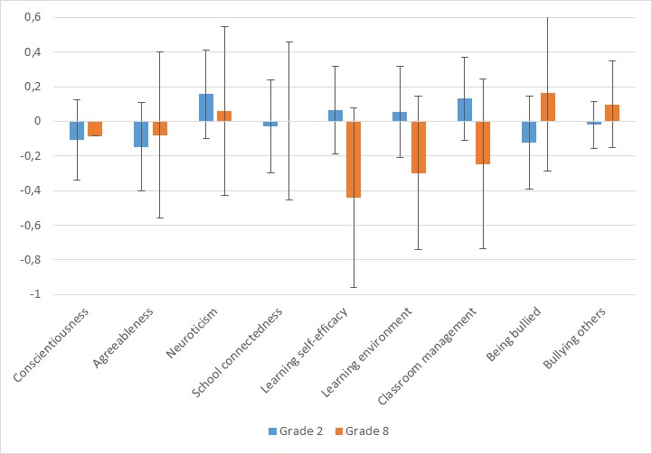

Supplementary Figure 4: Theory of change.
The figure shows a graphical representation of the theory of change. It was developed in Danish by an external consultant to the evaluation team, Dorte Stage Mølgaard, at University College Copenhagen. The current version was translated and adapted by the authors. The hypothesized long term effects are shaded in grey, as we do not yet have long term data to investigate them thoroughly.
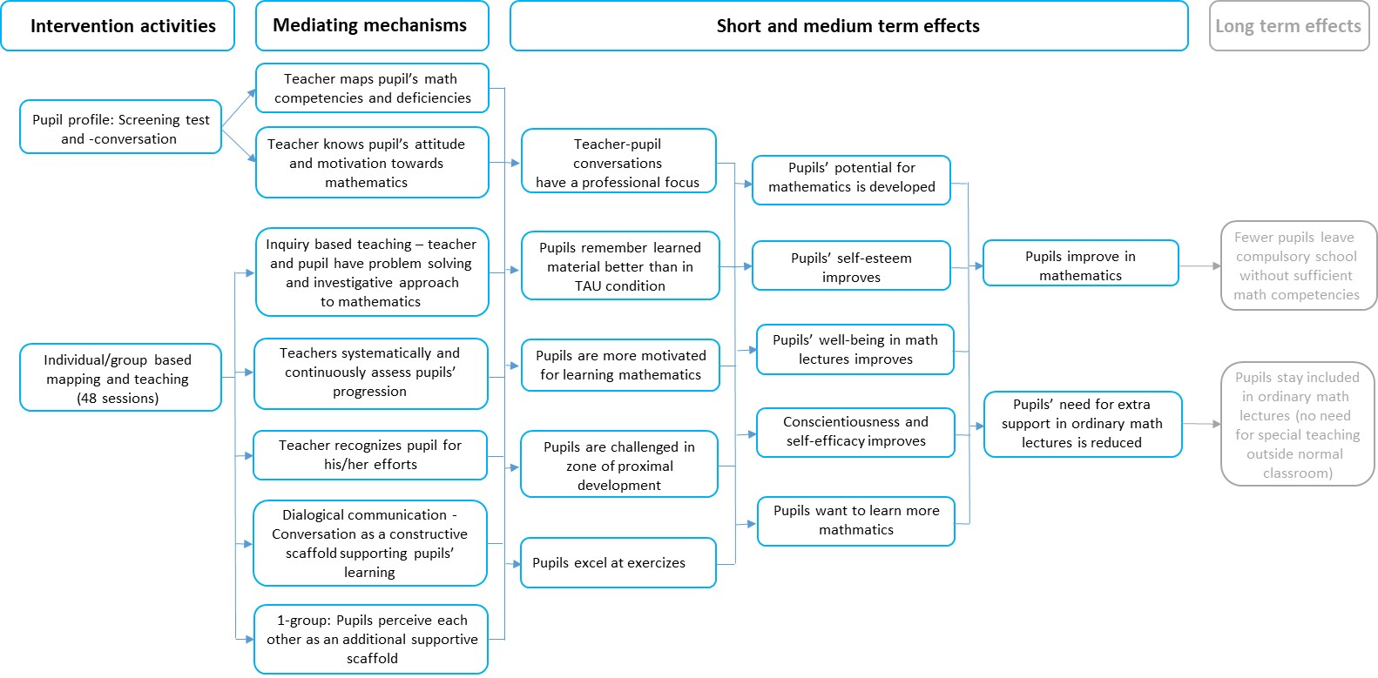

Supplementary Figure 5: Pre- and post-test distributions.
The figures show the distributions of pre- and post-test scores for all 2nd and 8th graders in participating schools. Kernel density estimate, Epanechnikov kernel.
Grade 2 | Grade 8
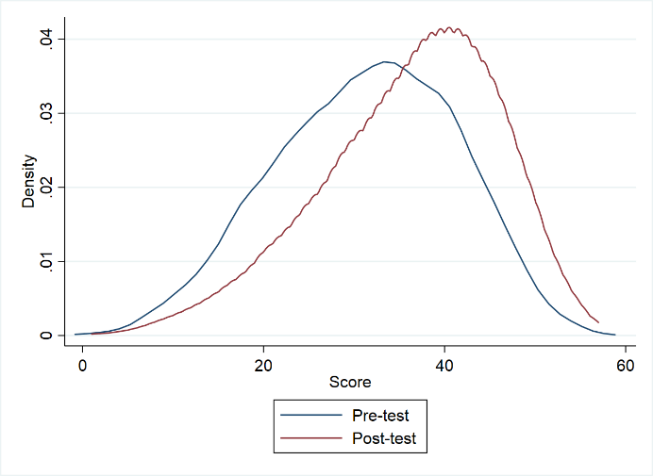 | 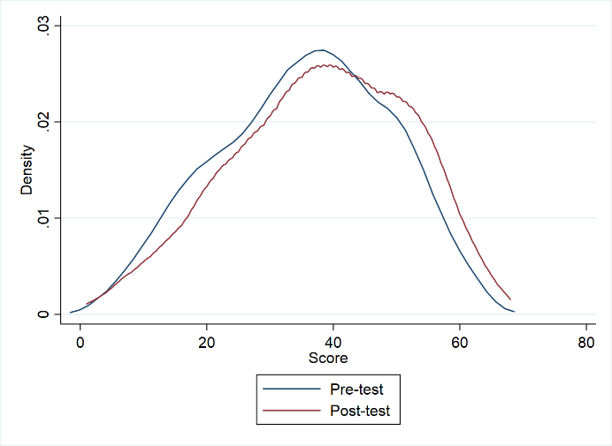

Supplementary Figure 6. Randomization strategy.
The figures shows the two-stage randomization strategy and the number of schools and pupils randomized into each group. Numbers of schools in parentheses were the number originally signed up, while those following the parentheses were those that did not withdraw their decision to participate. Numbers in white refer to grade 2, while numbers in red refer to grade 8.
