Supplementary Figure 1: Network YL-CoRegNet-1 and TF influence at the different phases
Supplementary Figure 2: Influence heatmap and network GSE29046
Supplementary Figure 3: Master regulators of genes associated with amino-acid GO terms (pvalue <0.05)
Supplementary Table 1: Transcription factors genes names and common names
Supplementary Table 2: TFs ranking according to the different phases
Supplementary Table 3: Genes list associated with lipids and amino acids retrieved form Panther
Supplementary Table 4: Co-regulators from the network

Supplementary Figure 1 Co-regulatory network of Yarrowia lipolytica inferred from a transcriptomic dataset under nitrogen limitation. Nodes represent transcription factor (TF) while grey edge represent a co-regulatory relationship. Red edges are co-regulatory relationship for which evidences were provided. The node size and colors represent the influence of the corresponding TFs during the onset of lipids accumulation. Red is associated with a positive influence whereas blue is related to a negative influence.

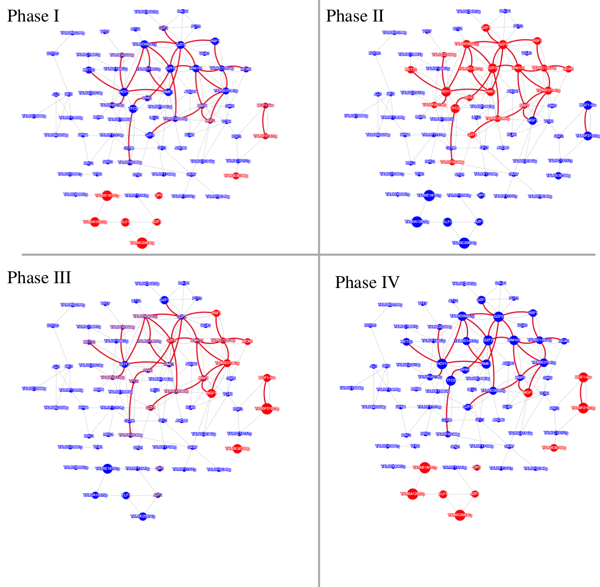

Supplementary Figure 2 YL-Coreg-2 cooperativity network and influence heatmap based on the GRN reconstructed from GSE29046 (YL-GRN-2)

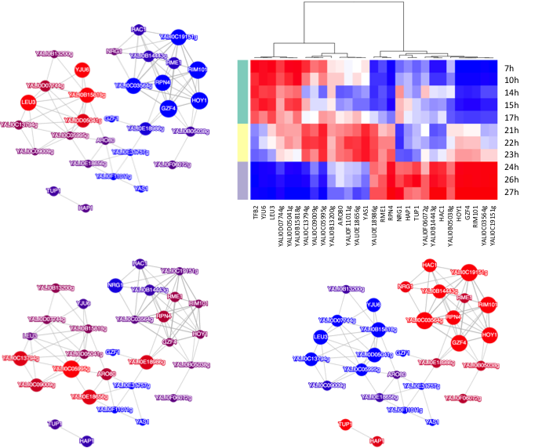

Supplementary Figure 3 Master Regulators of amino-acid associated genes

Master regulators | YALI0E07942g | GZF1 | YALI0E34925g | MGF1 | YALI0C19151g | YALI0F21923g | MGF1-like | RSF2 | MBP1
P-values | 0.00017 | 0.00135 | 0.00226 | 0.00334 | 0.00350 | 0.00552 | 0.00777 | 0.02719 | 0.04211

