Supplementary Information

A molecular systems architecture of neuromuscular junction
in amyotrophic lateral sclerosis

V.A. Shiva Ayyadurai^{1,2*}, Prabhakar Deonikar^{1,2}, and Roger D. Kamm^{3*}
¹Systems Biology Group, CytoSolve Research Division, CytoSolve, Inc., Cambridge, MA
²Open Science Institute, International Center for Integrative Systems, Cambridge, MA
³Departments of Biological Engineering and Mechanical Engineering, Massachusetts Institute of Technology, Cambridge, MA

Table of Contents

Supplementary Figures
Supplementary Tables
Supplementary References

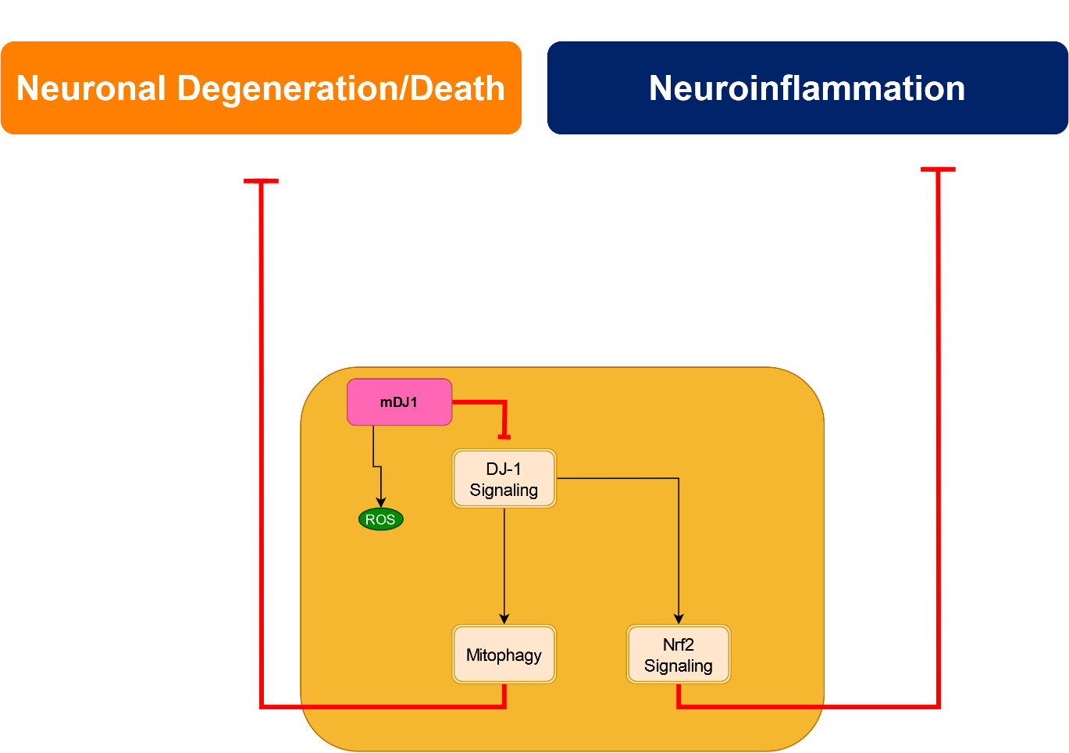
Supplementary Figure 1: DJ-1 signaling in motor neurons.

Mutation of DJ-1 dysregulates mitophagy and mitochondrial function. Additionally, this mutation also impairs the Nrf2 pathway leading to downregulation of antioxidant enzymes. DJ-1 – Protein deglycase DJ-1; mDJ-1 – Mutated protein deglycase DJ-1; NRF2 – Nuclear factor erythroid 2–related factor 2; ROS – Reactive oxygen species. Double-sided orange rectangle represents a molecular pathway within a cell; black arrow represents signal propagation; red flat arrow represents inhibition of signal propagation; and, small pink rectangle represents mutated protein/enzyme.

Supplementary Figure2: MMP-9 signaling in skeletal muscle cells.
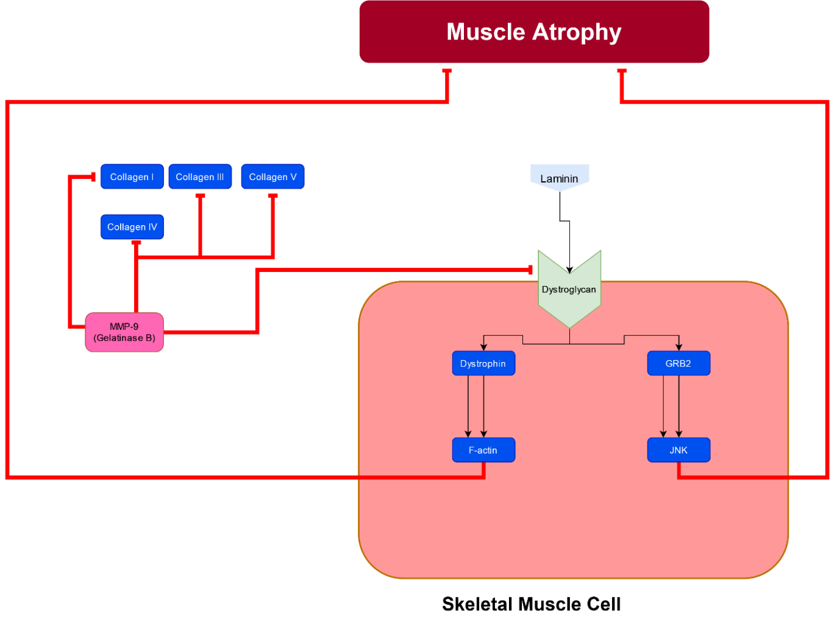

MMP-9 contributes to the ALS pathogenesis leading to muscle atrophy and alterations in the extracellular matrix. GRB2 – Growth factor receptor-bound protein 2; JNK – Jun N-terminal kinase; MMP-9 – Matrix metallopeptidase 9. The green step arrow represents the receptor. The light blue pentagram represents the ligand. The dark blue rectangle box represents the proteins. Black arrow represents signal propagation; red flat arrow represents inhibition of signal propagation; small dark blue rectangle represents a protein or enzyme; small pink rectangle represents mutated protein/enzyme; light blue pentagram represents the ligand; and, green step arrow represents a receptor.
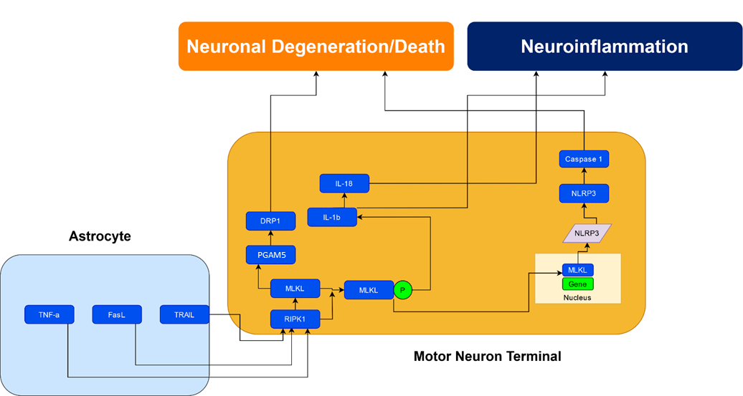
Supplementary Figure 3: RIPK/MLKL signaling in motor neurons.

RIPK/MLKL signaling initiates neuronal cell death via either IL-1β or NLRP3 inflammasome induced neuroinflammation in ALS. DRP1 – Dynamin-related protein 1; FasL – FS-7-associated surface antigen ligand; IL-1β – Interleukin-1 beta; IL-18 – Interleukin-18; MLKL – Mixed lineage kinase domain-like pseudokinase; NLRP-3 – Nucleotide-binding domain, leucine-rich–containing family, pyrin domain–containing-3; PGAM5 – Phosphoglycerate mutase family member 5; DRP1 – Dynamin related protein 1; RIPK1 – Receptor-interacting serine/threonine-protein kinase 1; TNF-a – Tumor Necrosis Factor-alpha; FasL – Fas Ligand; TRAIL – tumor necrosis factor-related apoptosis-inducing ligand. Black arrow represents signal propagation; small dark blue rectangle represents a protein or enzyme; purple lozenge represents mRNA; and dark green oval represents small molecules.
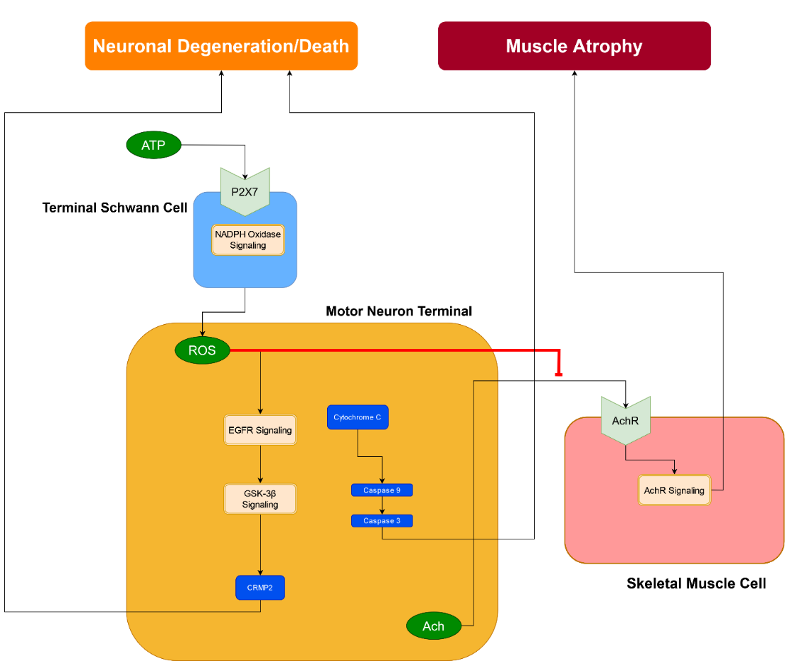
Supplementary Figure 4: NADPH oxidase signaling in terminal Schwann cells, motor neurons and muscle cells.

NADPH oxidase from the terminal Schwann cells produces reactive oxygens species (ROS), which in the motor neuron downregulate the neurotransmission of acetylcholine (Ach) thereby promoting muscle atrophy, and in promote neuronal degeneration/death via caspase3/9 pathway. Ach – Acetylcholine; AchR – Acetylcholine Receptor; ATP – Adenosine triphosphate; CRMP2 – Collapsin response mediator protein 2; EGFR – Epidermal growth factor receptor; GSK-3β – glycogen synthase kinase-3 beta; P2X7 – P2X purinoceptor 7; NADP Oxidase – nicotinamide adenine dinucleotide phosphate oxidase; ROS – Reactive oxygen species. Double-sided orange rectangle represents a molecular pathway within a cell; black arrow represents signal propagation; red flat arrow represents inhibition of signal propagation; small dark blue rectangle represents a protein or enzyme; dark green oval represents small molecules; and, green step arrow represents a receptor.

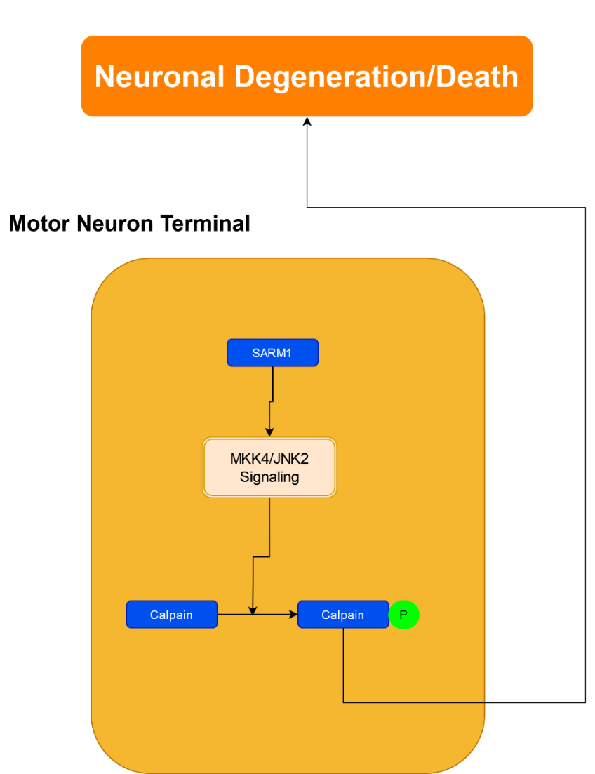
Supplementary Figure 5: SARM1 signaling in motor neurons.

Any physical or chemical damage upregulates SARM1 signaling that leads to neurodegeneration/death. JNK2 – c-Jun N-terminal kinase; MKK4 – Mitogen-activated protein kinase kinase 4; SARM1 – Sterile alpha- and armadillo-motif-containing protein. The dark blue rectangle box represents the proteins. Double-sided orange rectangle represents the signaling pathways. The bright green small circle represents the phosphorylated protein. The black arrow represents signal propagation. Double-sided orange rectangle represents a molecular pathway within a cell; black arrow represents signal propagation; small dark blue rectangle represents a protein or enzyme; and, dark green oval represents small molecules.

Supplementary Figure 6: Sema3a signaling in terminal Schwann cells and motor neurons.
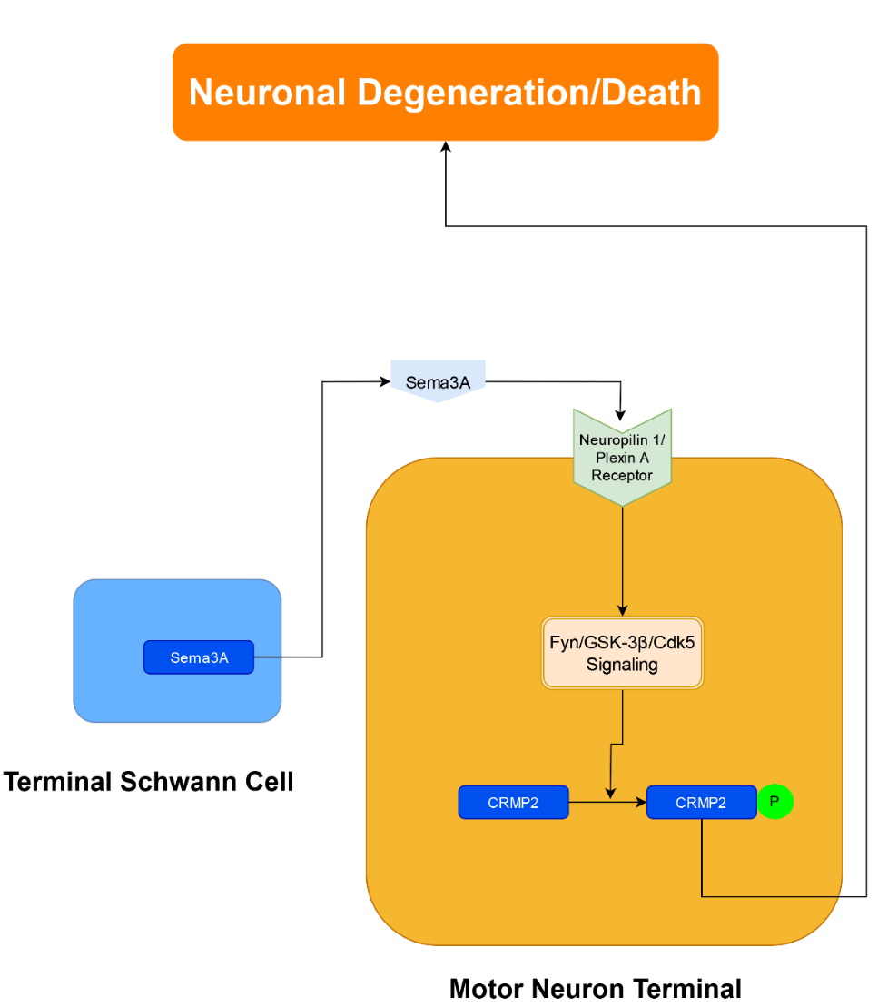

Sema3A, derived from terminal Schwann cells, leads to neuronal degeneration/death via NRP-1-Fyn-GSK-3β pathway in motor neurons. Cdk5 – Cyclin-dependent kinase 5; CRMP2 – Collapsin Response Mediator Protein 2; Fyn – tyrosine-protein kinase Fyn; GSK-3β – glycogen synthase kinase-3 beta; Sema3A – Semmaphorin 3A. Double-sided orange rectangle represents a molecular pathway within a cell; black arrow represents signal propagation; small dark blue rectangle represents a protein or enzyme; and, dark green oval represents small molecules.
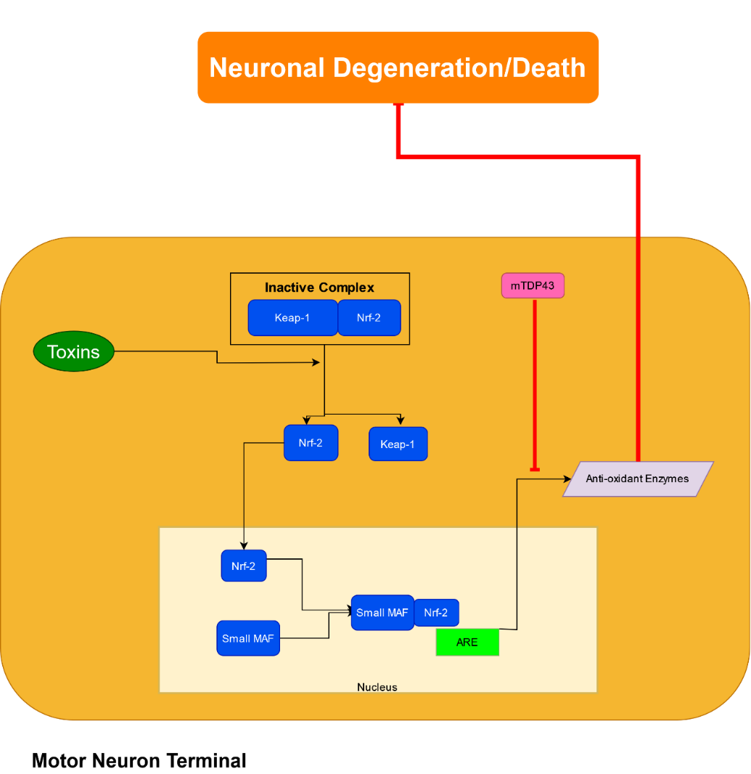
Supplementary Figure 7: Nrf2 signaling in motor neurons.

Nrf2 signaling upregulates antioxidant enzymes that prevent neurodegeneration in motor neurons. ARE – Antioxidant response element; Keap-1 – Kelch-like ECH-associated protein 1; NRF2 – Nuclear factor erythroid 2–related factor 2; Maf – musculoaponeurotic fibrosarcoma; mTDP-43 – mutated TAR DNA-binding protein 43. Black arrow represents signal propagation; red flat arrow represents inhibition of signal propagation; small dark blue rectangle represents a protein or enzyme; purple lozenge represents mRNA; and, dark green oval represents small molecules.

Supplementary Table 1: Legend of symbols used in interactome figures.
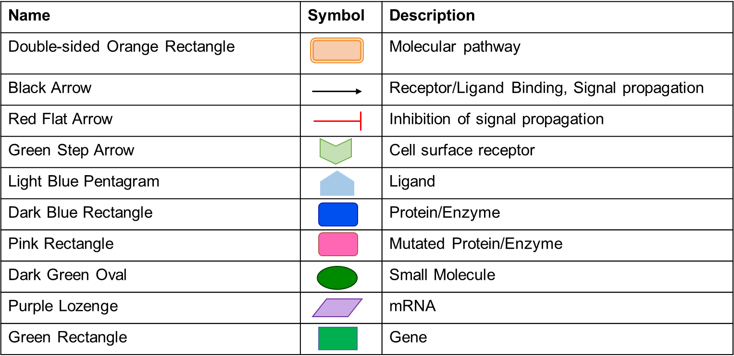

miR | Target | Outcome in ALS | Reference
miR-206 | Myogenic Transcriptional factors | Suppresses the expression levels of muscular HDAC4 | ¹
miR-23a | PGC-1α | Impaired mitochondrial biogenesis and function | ¹
miR-23a-3p | ERBB4 | Suppresses the ERBB4/AKT/GSK3b signaling pathway resulting in cellular apoptosis | ²
miR-1 | MyoD1, MyoG | Increased myogenic differentiation, a mechanism to cope with the muscular atrophy. | ³
miR-133a | MyoD1, MyoG |  | ³
miR-133b | MyoD1, MyoG |  | ³
miR-1234-3p | NLE1 | Upregulated Notch signaling | ⁴
miR-181 | Chchd10 | Impaired mitochondrial cristae maintenance and respiratory function | ⁵
miR-155 | Src homology-2 domain-containing inositol 5 phosphatase 1 (SHIP1) | Promotes pro-inflammatory pathways through targeted repression of anti-inflammatory mediators | ⁶
miR-124a | Astrocytic glutamate transporter 1 (GLT1) | Modulates synaptic activation | ⁷
miR146a | TRAF-6 and IL-1R-associated kinase | Activation of NF-kB pathway | ⁸
miR146a | NfL gene | Conversion of astrocytes and microglial cells into neurotoxic and proinflammatory states | ⁹
miR-494-3p | Sema3A | Motor neuron death | ⁸
miR-125b | A20 protein | Motor neuron degeneration | ¹
miR-132 | TDP43 | Synapse maturation, neural migration, and neural plasticity | ¹ ¹⁰
miR126-5p | Sema3A | Axon degeneration and NMJ disruption | ¹¹
miR-17 | PTEN | Motor neuron death | ¹²

Supplementary Table 2: miRNAs involved in regulation of ALS pathogenesis.

Supplementary Table 3: MeSH keywords used for computer-based screening.
MeSH keywords
ALS AND Astrocytes AND Neuromuscular Junction
ALS AND ataxin-2 AND Neuromuscular Junction
ALS AND C9ORF72 gene AND Neuromuscular Junction
ALS AND ER Stress AND Neuromuscular Junction
ALS AND FUS AND Neuromuscular Junction
ALS AND glial support cells AND Neuromuscular Junction
ALS AND Glutamate Receptor (AMPA) AND Neuromuscular Junction
ALS AND inflammatory cells AND Neuromuscular Junction
ALS AND microglial cell AND Neuromuscular Junction
ALS AND Misfolded proteins AND Neuromuscular Junction
ALS AND Motor neurons AND Neuromuscular Junction
ALS AND Neuromuscular junction
ALS AND protein recycling AND Neuromuscular Junction
ALS AND SOD1 gene AND Neuromuscular Junction
ALS AND SPTLC1 AND Neuromuscular Junction
ALS AND TDP-43 AND Neuromuscular Junction
ALS AND ubiquilin-2 (UBQLN2) AND Neuromuscular Junction

A list of Medical Subject Headings (MeSH) keywords to optimize recall and precision of peer-reviewed articles is provided in Supplementary Table 3.

Supplementary Table 4: PRISMA 2020 Checklist¹³.
Section and Topic | Item # | Checklist item | Location where item is reported
TITLE
Title | 1 | Identify the report as a systematic review. | 2, 5, and 35
ABSTRACT
Abstract | 2 | See the PRISMA 2020 for Abstracts checklist. | Supplementary
INTRODUCTION
Rationale | 3 | Describe the rationale for the review in the context of existing knowledge. | 5
Objectives | 4 | Provide an explicit statement of the objective(s) or question(s) the review addresses. | 2, 5
METHODS
Eligibility criteria | 5 | Specify the inclusion and exclusion criteria for the review and how studies were grouped for the syntheses. | 36
Information sources | 6 | Specify all databases, registers, websites, organisations, reference lists and other sources searched or consulted to identify studies. Specify the date when each source was last searched or consulted. | 35
Search strategy | 7 | Present the full search strategies for all databases, registers and websites, including any filters and limits used. | 35 ,36
Selection process | 8 | Specify the methods used to decide whether a study met the inclusion criteria of the review, including how many reviewers screened each record and each report retrieved, whether they worked independently, and if applicable, details of automation tools used in the process. | 35, 36
Data collection process | 9 | Specify the methods used to collect data from reports, including how many reviewers collected data from each report, whether they worked independently, any processes for obtaining or confirming data from study investigators, and if applicable, details of automation tools used in the process. | 35, 36
Data items | 10a | List and define all outcomes for which data were sought. Specify whether all results that were compatible with each outcome domain in each study were sought (e.g. for all measures, time points, analyses), and if not, the methods used to decide which results to collect. | NA
Data items | 10b | List and define all other variables for which data were sought (e.g. participant and intervention characteristics, funding sources). Describe any assumptions made about any missing or unclear information. | NA
Study risk of bias assessment | 11 | Specify the methods used to assess risk of bias in the included studies, including details of the tool(s) used, how many reviewers assessed each study and whether they worked independently, and if applicable, details of automation tools used in the process. | NA
Effect measures | 12 | Specify for each outcome the effect measure(s) (e.g. risk ratio, mean difference) used in the synthesis or presentation of results. | NA
Synthesis methods | 13a | Describe the processes used to decide which studies were eligible for each synthesis (e.g. tabulating the study intervention characteristics and comparing against the planned groups for each synthesis (item #5)). | NA
Synthesis methods | 13b | Describe any methods required to prepare the data for presentation or synthesis, such as handling of missing summary statistics, or data conversions. | NA
Synthesis methods | 13c | Describe any methods used to tabulate or visually display results of individual studies and syntheses. | NA
Synthesis methods | 13d | Describe any methods used to synthesize results and provide a rationale for the choice(s). If meta-analysis was performed, describe the model(s), method(s) to identify the presence and extent of statistical heterogeneity, and software package(s) used. | NA
Synthesis methods | 13e | Describe any methods used to explore possible causes of heterogeneity among study results (e.g. subgroup analysis, meta-regression). | NA
Synthesis methods | 13f | Describe any sensitivity analyses conducted to assess robustness of the synthesized results. | NA
Reporting bias assessment | 14 | Describe any methods used to assess risk of bias due to missing results in a synthesis (arising from reporting biases). | NA
Certainty assessment | 15 | Describe any methods used to assess certainty (or confidence) in the body of evidence for an outcome. | NA
RESULTS
Study selection | 16a | Describe the results of the search and selection process, from the number of records identified in the search to the number of studies included in the review, ideally using a flow diagram. | 37, Figure 15
Study selection | 16b | Cite studies that might appear to meet the inclusion criteria, but which were excluded, and explain why they were excluded. | 36
Study characteristics | 17 | Cite each included study and present its characteristics. | NA
Risk of bias in studies | 18 | Present assessments of risk of bias for each included study. | NA
Results of individual studies | 19 | For all outcomes, present, for each study: (a) summary statistics for each group (where appropriate) and (b) an effect estimate and its precision (e.g. confidence/credible interval), ideally using structured tables or plots. | NA
Results of syntheses | 20a | For each synthesis, briefly summarise the characteristics and risk of bias among contributing studies. | NA
Results of syntheses | 20b | Present results of all statistical syntheses conducted. If meta-analysis was done, present for each the summary estimate and its precision (e.g. confidence/credible interval) and measures of statistical heterogeneity. If comparing groups, describe the direction of the effect. | NA
Results of syntheses | 20c | Present results of all investigations of possible causes of heterogeneity among study results. | NA
Results of syntheses | 20d | Present results of all sensitivity analyses conducted to assess the robustness of the synthesized results. | NA
Reporting biases | 21 | Present assessments of risk of bias due to missing results (arising from reporting biases) for each synthesis assessed. | NA
Certainty of evidence | 22 | Present assessments of certainty (or confidence) in the body of evidence for each outcome assessed. | NA
DISCUSSION
Discussion | 23a | Provide a general interpretation of the results in the context of other evidence. | 12 - 32
Discussion | 23b | Discuss any limitations of the evidence included in the review. | NA
Discussion | 23c | Discuss any limitations of the review processes used. | NA
Discussion | 23d | Discuss implications of the results for practice, policy, and future research. | 33
OTHER INFORMATION
Registration and protocol | 24a | Provide registration information for the review, including register name and registration number, or state that the review was not registered. | Review was not registered
Registration and protocol | 24b | Indicate where the review protocol can be accessed, or state that a protocol was not prepared. | NA
Registration and protocol | 24c | Describe and explain any amendments to information provided at registration or in the protocol. | NA
Support | 25 | Describe sources of financial or non-financial support for the review, and the role of the funders or sponsors in the review. | 38
Competing interests | 26 | Declare any competing interests of review authors. | 38
Availability of data, code and other materials | 27 | Report which of the following are publicly available and where they can be found: template data collection forms; data extracted from included studies; data used for all analyses; analytic code; any other materials used in the review. | NA

Supplementary Table 5: PRISMA 2020 for Abstract Checklist¹³.
Section and Topic | Item # | Checklist item | Reported (Yes/No)
TITLE
Title | 1 | Identify the report as a systematic review. | Yes
BACKGROUND
Objectives | 2 | Provide an explicit statement of the main objective(s) or question(s) the review addresses. | Yes
METHODS
Eligibility criteria | 3 | Specify the inclusion and exclusion criteria for the review. | Yes
Information sources | 4 | Specify the information sources (e.g. databases, registers) used to identify studies and the date when each was last searched. | Yes
Risk of bias | 5 | Specify the methods used to assess risk of bias in the included studies. | NA
Synthesis of results | 6 | Specify the methods used to present and synthesise results. | NA
RESULTS
Included studies | 7 | Give the total number of included studies and participants and summarise relevant characteristics of studies. | Yes
Synthesis of results | 8 | Present results for main outcomes, preferably indicating the number of included studies and participants for each. If meta-analysis was done, report the summary estimate and confidence/credible interval. If comparing groups, indicate the direction of the effect (i.e. which group is favoured). | Yes
DISCUSSION
Limitations of evidence | 9 | Provide a brief summary of the limitations of the evidence included in the review (e.g. study risk of bias, inconsistency and imprecision). | NA
Interpretation | 10 | Provide a general interpretation of the results and important implications. | Yes
OTHER
Funding | 11 | Specify the primary source of funding for the review. | Yes
Registration | 12 | Provide the register name and registration number. | NA

Supplementary References
1. Koike, Y. & Onodera, O. Implications of miRNAs dysregulation in amyotrophic lateral sclerosis: Challenging for clinical applications. Front. Neurosci. 17, 1131758 (2023).
2. Liu, Y. et al. MicroRNA-23a-3p Is Upregulated in Plasma Exosomes of Bulbar-onset ALS Patients and Targets ERBB4. Neuroscience 524, 65–78 (2023).
3. Raheja, R. et al. Correlating serum micrornas and clinical parameters in amyotrophic lateral sclerosis. Muscle and Nerve 58, 261–269 (2018).
4. Freischmidt, A. et al. Serum microRNAs in sporadic amyotrophic lateral sclerosis. Neurobiol. Aging 36, 2660.e15-2660.e20 (2015).
5. Stein, C. S., McLendon, J. M., Witmer, N. H. & Boudreau, R. L. Modulation of miR-181 influences dopaminergic neuronal degeneration in a mouse model of Parkinson’s disease. Mol. Ther. - Nucleic Acids 28, 1–15 (2022).
6. Koval, E. D. et al. Method for widespread microRNA-155 inhibition prolongs survival in ALS-model mice. Hum. Mol. Genet. 22, 4127–4135 (2013).
7. Martinez, B. & Peplow, P. MicroRNA expression in animal models of amyotrophic lateral sclerosis and potential therapeutic approaches. Neural Regen. Res. 17, 728–740 (2022).
8. Valori, C. F., Sulmona, C., Brambilla, L. & Rossi, D. Astrocytes: Dissecting Their Diverse Roles in Amyotrophic Lateral Sclerosis and Frontotemporal Dementia. Cells 12, 1–27 (2023).
9. Giagnorio, E. et al. MiR-146a in ALS: Contribution to Early Peripheral Nerve Degeneration and Relevance as Disease Biomarker. Int. J. Mol. Sci. 24, (2023).
10. Freischmidt, A., Müller, K., Ludolph, A. C. & Weishaupt, J. H. Systemic dysregulation of TDP-43 binding microRNAs in amyotrophic lateral sclerosis. Acta Neuropathol. Commun. 1, 42 (2013).
11. Maimon, R. et al. miR126-5p Downregulation Facilitates Axon Degeneration and NMJ Disruption via a Non-Cell-Autonomous Mechanism in ALS. J. Neurosci. 38, 5478–5494 (2018).
12. Wang, H. Phylogenetic analysis of microRNA biomarkers for amyotrophic lateral sclerosis. BIOCELL 45, 547–561 (2021).
13. Page, M. J. et al. The PRISMA 2020 statement: an updated guideline for reporting systematic reviews. BMJ 372, (2021).

