Supplementary Figures
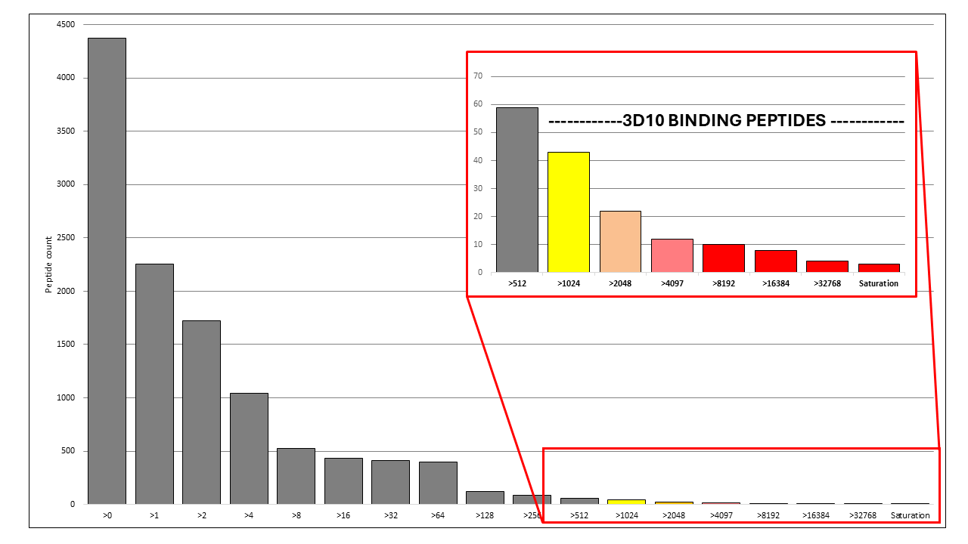
Figure S1. Peptide array reactivity and nonreactivity grouping. Total number of peptides with raw median binding above cut-off values (arbitrary units) presented as peptide count. 3D10 reactive peptides were defined as peptides with a raw median binding value of 1024 or greater. Forty-three peptides were classified as 3D10 reactive, and 4335 peptides were classified as 3D10 nonreactive.

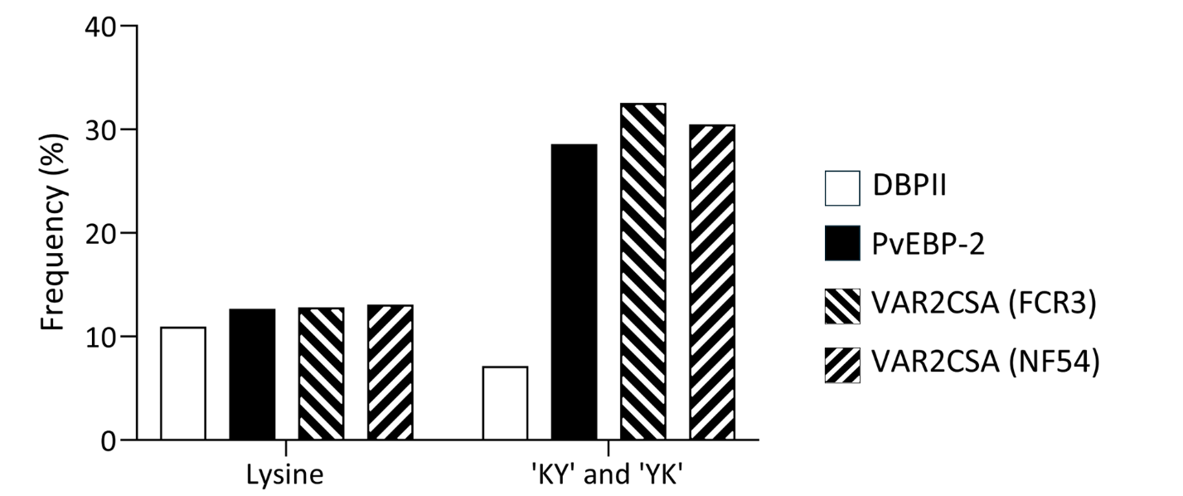
Figure S2. Frequency of sequence elements occurrence per peptide for DBPII, PvEBP2, VAR2CSA (FCR3 and NF54). The frequency of lysine to occur is presented as its proportion relative to other amino acids; lysine represents ~10% of all amino acids for each protein. The total proportion of peptides that contain either a ‘KY’ or ‘YK’ sequence pattern is indicated for each protein.

Table S1: Feature descriptions
Feature categories | Feature count | Feature category description
Single amino acid counts | 20 | Counts of all 20 amino acids
Dipeptide counts | 400 | Counts of 2 amino acid combinations
Secondary structure | 3 | Odds for a peptide segment to be an alpha helix, beta sheet, or coilᵃ
Physicochemical values | 3 | Sums of physicochemical values for every residue based on polarity^{b}, sidechain energy^{c}, and hydropathy^{d}
Charge | 3 | Counts of total positively-charged, negatively charged residues, and the sum of these two values (net charge)
Disulphide bond potential | 1 | A Boolean value denoting whether a peptide contains 2 cysteines 3 amino acids apart

Table S2: Selected features
Features | Variance feature selection | Feature utilization | Feature elimination (5) ª | Feature elimination (10)ª | Feature elimination (15) ª
Positive residue count
Hydropathy
VM count
Asparagine count
Polarity
KQ count
KY count
HL count
HM count
HF count
RE count
HA count
HV count
HI count
RD count
Side chain energy
Lysine count
Net charge
Helix probability
Coil probability
MT count
IQ count
Sheet probability
TW count
Negative residue count

ª Feature elimination reduces features to a specified value indicated in parentheses

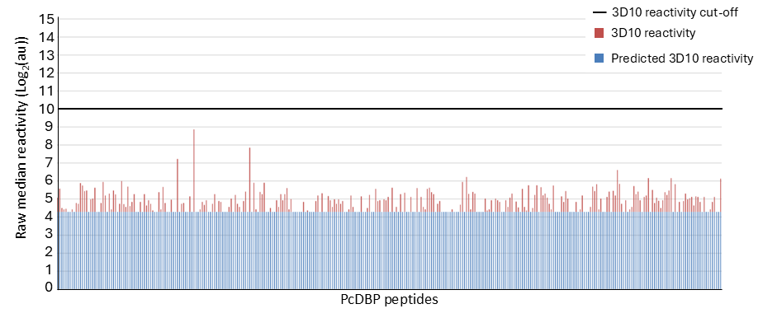
Figure S3. Model evaluation. A decision tree model was trained on DBPII, PvEBP2, and both alleles of VAR2CSA (NF54 and FCR3), and tested against a withheld dataset. The withheld dataset was derived from PcDBP, a PvDBP ortholog from Plasmodium chabaudi. The decision tree predicts peptide reactivity using discrete values based on feature values defined during training. All PcDBP peptides were placed in the same low/non-binding category. Model-predicted values are presented in blue, whereas actual binding values are presented in red. No peptides from the PcDBP dataset bound at the reactivity cut-off of 2¹⁰. The model used for these predictions is accessible in a GitHub repository described in our data availability section. The mean squared error of all predictions in this evaluation was 1020.68.

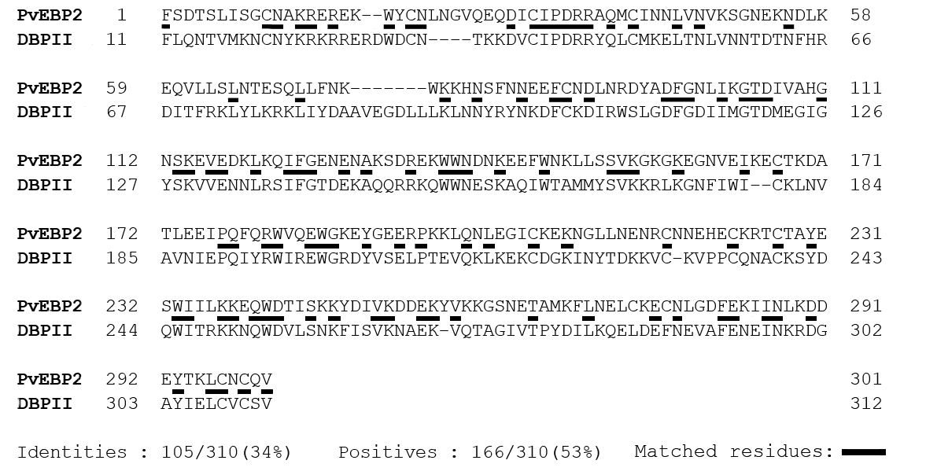
Figure S4. Sequence similarity of PvEBP2 and DBPII. Sequence similarity and identity were determined by BLAST using a compositionally adjusted score matrix ^{1,2}.

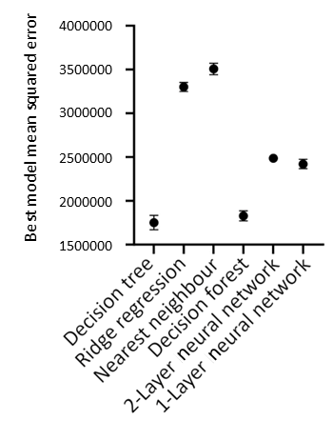
Figure S5. Model design validation. Models and hyperparameters were trained with a training-validation split of 2/3 training and 1/3 testing using a peptide array data from DBPII, PvEBP2, and both alleles of VAR2CSA (NF54 and FCR3). Models were validated for 10,000 sets of 100 random seeds. The average mean squared error of the 10,000 tournament-winning models is plotted with 95% confidence error bars.

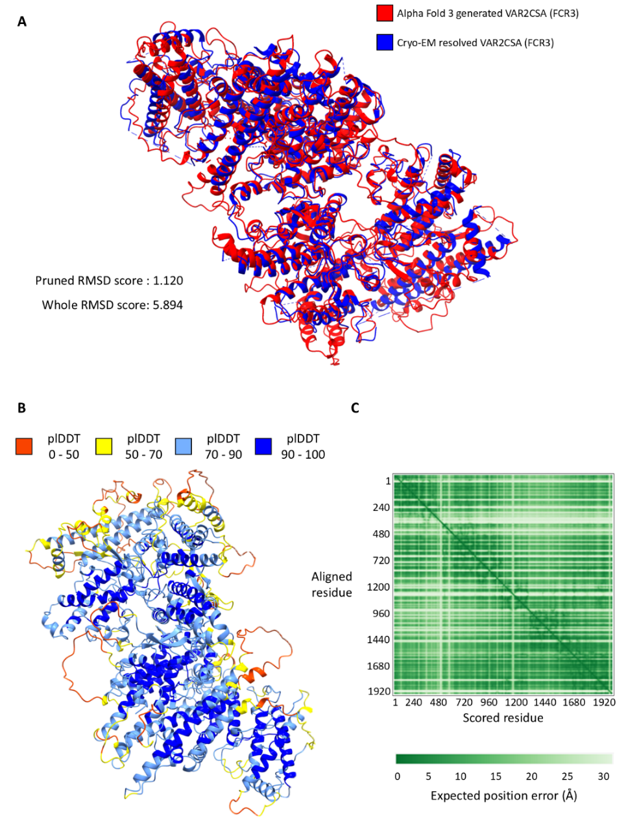
Figure S6. AlphaFold 3 generated VAR2CSA (FCR3) structure evaluation. Structures generated by AlphaFold 3 were evaluated based on their similarity to previously resolved structures (A) and prediction confidence (B, C). (A) RMSD matchmaking overlay was performed using Chimera 1.8x internal software. AlphaFold 3 predicted structure derived from the reference cryo-EM resolved VAR2CSA (FCR3) structure (PDB ID 7JGE) ³. Pruned RMSD score and whole RMSD score calculated by Chimera 1.8x and presented unaltered. (B) Per-residue confidence values, predicted local distance difference test (plDDT), are colour-coded onto respective residues of VAR2CSA (FCR3) AlphaFold 3 predicted structure. (C) Predicted aligned error plot of AlphaFold 3 predicted VAR2CSA (FCR3). Plot denotes expected positional error in a pair-wise manner to other residues.

Table S3: Bootstrapped distance probabilities between sequence elements
Boot-strapped odds of amino acid distances
Distances | Number of 'other' residues per peptide
Distances | 1 | 2 | 3 | 4 | 5 | 19
0 | 10.00% | 19.47% | 28.42% | 36.84% | 44.74% | 0.53%
1 | 9.47% | 16.43% | 21.22% | 24.15% | 25.52% | 0.00%
2 | 8.95% | 13.68% | 15.47% | 15.30% | 13.93% | 0.00%
3 | 8.42% | 11.23% | 11.00% | 9.38% | 7.33% | 0.00%
4 | 7.89% | 9.06% | 7.64% | 5.61% | 3.81% | 0.00%
5 | 7.37% | 7.19% | 5.20% | 3.34% | 2.03% | 0.00%
6 | 6.84% | 5.61% | 3.52% | 2.04% | 1.15% | 0.00%
7 | 6.32% | 4.33% | 2.41% | 1.30% | 0.68% | 0.00%
8 | 5.79% | 3.33% | 1.71% | 0.85% | 0.40% | 0.00%
9 | 5.26% | 2.63% | 1.24% | 0.54% | 0.22% | 0.00%
10 | 4.74% | 2.11% | 0.87% | 0.33% | 0.11% | 0.00%
11 | 4.21% | 1.64% | 0.58% | 0.18% | 0.05% | 0.00%
12 | 3.68% | 1.23% | 0.36% | 0.09% | 0.02% | 0.00%
13 | 3.16% | 0.88% | 0.21% | 0.04% | 0.01% | 0.00%
14 | 2.63% | 0.58% | 0.10% | 0.01% | 0.00% | 0.00%
15 | 2.11% | 0.35% | 0.04% | 0.00% | 0.00% | 0.00%
16 | 1.58% | 0.18% | 0.01% | 0.00% | 0.00% | 0.00%
17 | 1.05% | 0.06% | 0.00% | 0.00% | 0.00% | 0.00%
18 | 0.53% | 0.00% | 0.00% | 0.00% | 0.00% | 0.00%

Citations
1 Altschul, S. F. et al. Gapped BLAST and PSI-BLAST: a new generation of protein database search programs. Nucleic Acids Res 25, 3389-3402 (1997). https://doi.org:10.1093/nar/25.17.3389
2 Altschul, S. F. et al. Protein database searches using compositionally adjusted substitution matrices. FEBS J 272, 5101-5109 (2005). https://doi.org:10.1111/j.1742-4658.2005.04945.x
3 Ma, R. et al. Structural basis for placental malaria mediated by Plasmodium falciparum VAR2CSA. Nat Microbiol 6, 380-391 (2021). https://doi.org:10.1038/s41564-020-00858-9

