Supplementary Figures:
Fig. S1a. Lung ILC gating strategy
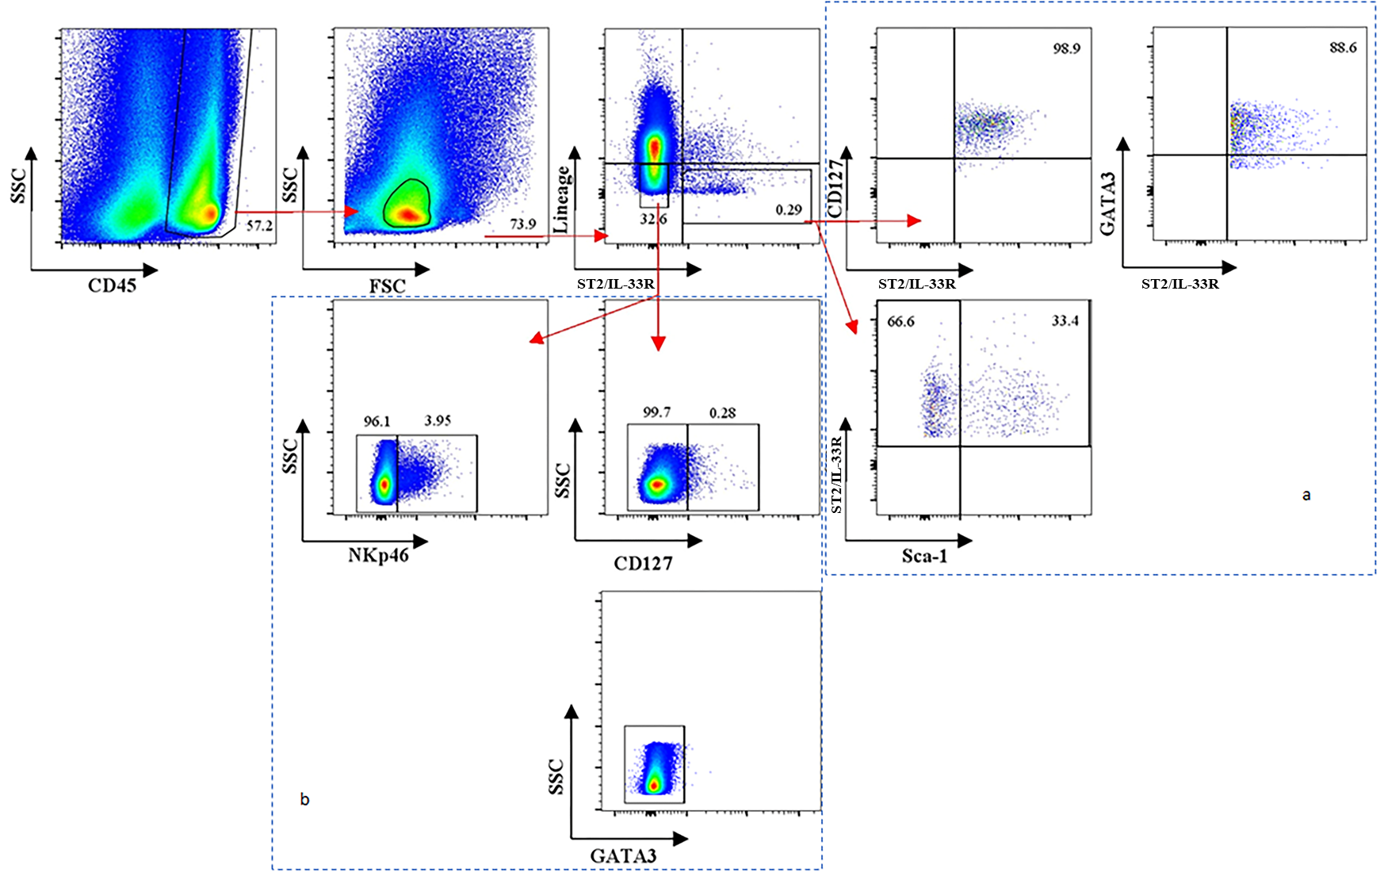
Lung ILCs from BALB/c mice were evaluated 24h post FPV-HIV immunization as per described in Materials and Methods. Firstly, from total lung cells, CD45⁺ cells and lymphocytes were gated. Next within the lymphocyte gate, ILC2 were identified as lineage⁻ ST2/IL-33R⁺ cells. When Sca-1, CD127 (IL-7R) and GATA3 expression profiles were evaluated on lineage⁻ cells, while most ST2/IL-33R⁺ cells were CD127⁺ (99%) and GATA3⁺ (88.6%), only 33% cells were found to be Sca-1⁺ (a). When the lineage⁻ ST2/IL-33R⁻ cells (ILC1 and ILC3) were stained with NKp46, 96% cells were NKp46⁻ while only 4% were NKp46⁺ (b). Interestingly, following vaccination most of the ILC1 and ILC3 cells were found to be CD127⁻ (99%) and all of the lineage⁻ ST2/IL-33R⁻ cells were GATA3⁻ (b).
These data clearly revealed that although under chronic inflammatory condition, CD127 is considered as a ubiquitous marker for fully differentiated ILCs, following acute infection or vaccination the expression of CD127 on ILC can be fluid and dependent upon the level of ILC differentiation.

Fig. S1b. Single colour controls and FMOs for lineage cells and ST2/IL-33R⁺ cells
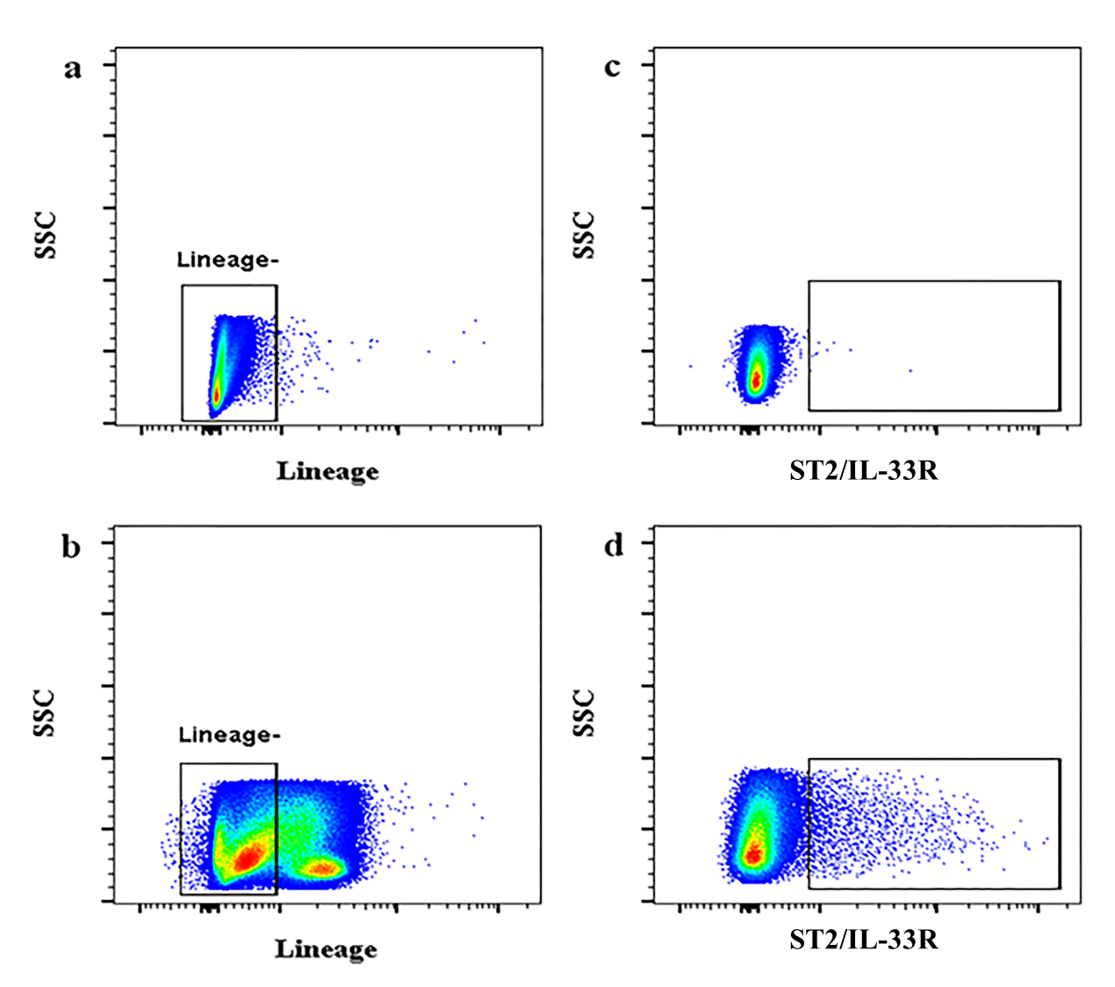
The gating strategy for lineage⁻ and ST2/IL-33R⁺ population was based on FMO and single colour controls. FMO for lineage cells (a), Lineage+ single colour control (b), FMO for ST2/IL-33R cells (c) and ST2/IL-33R single colour control (d).

Fig. S1c. Quadriceps muscle ILC gating strategy
Muscle ILCs from BALB/c mice were evaluated 24h post FPV-HIV immunization. From total muscle cells, CD45⁺ cells and lymphocytes were gated as per lung, and assessed for lineage⁻ ST2/IL-33R⁺ and lineage⁻ IL-25R⁺ cells. Data revealed that lineage⁻ ST2/IL-33R⁻ cells (ILC1& ILC3), 86% cells were NKp46⁺ while only 13% were NKp46⁻. Note that the lineage- IL-25R+ cell number in both top and bottom right FACS plots were the same.

Fig. S2. Evaluation of IL-13, IFN-γ, and IL-22 expression by different ILC subsets in naïve BALB/c mice
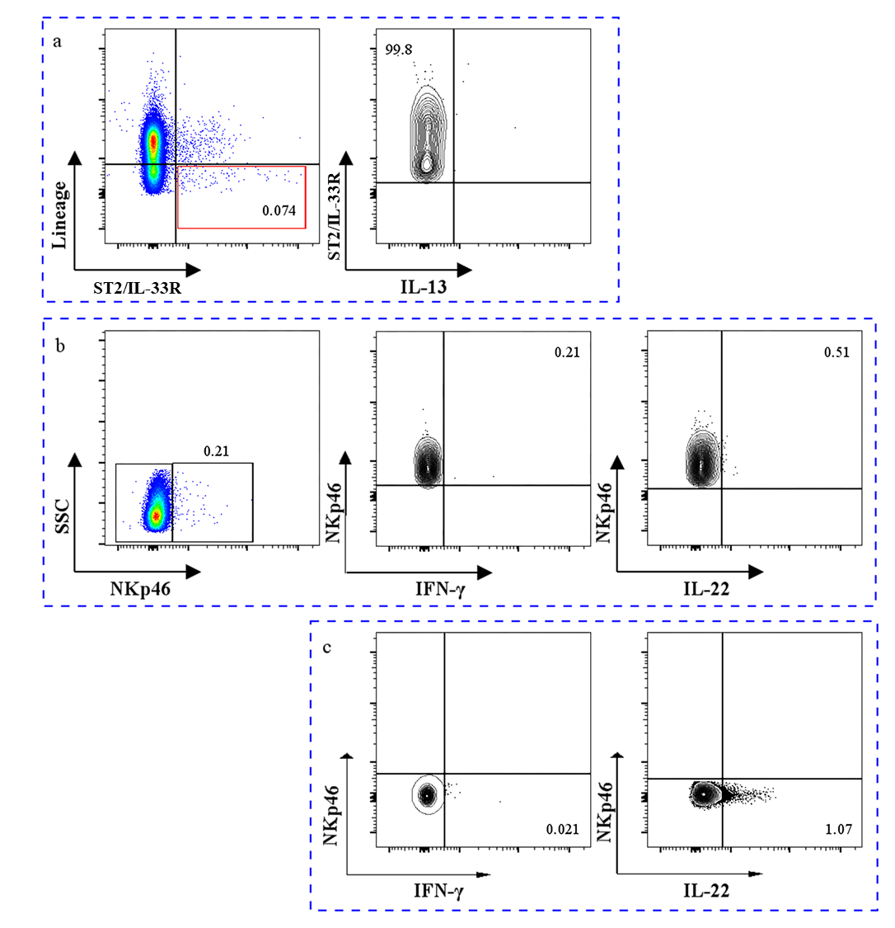
Lung ILC from naïve BALB/c mice were prepared and stained as described in Materials and Methods. In naïve mice no IL-13 expression by ILC2 cells were detected (a). Although no IFN-γ expression was detected in NKp46⁺ and NKp46⁻ ILC1 and ILC3 (b) some IL-22 expression was detected in NKp46⁻ ILC1 and ILC3 (c).

Fig. S3a. Evaluation of IL-13 expression by lung lineage⁺ ST2/IL-33R⁺ cells following i.n. rFPV immunization
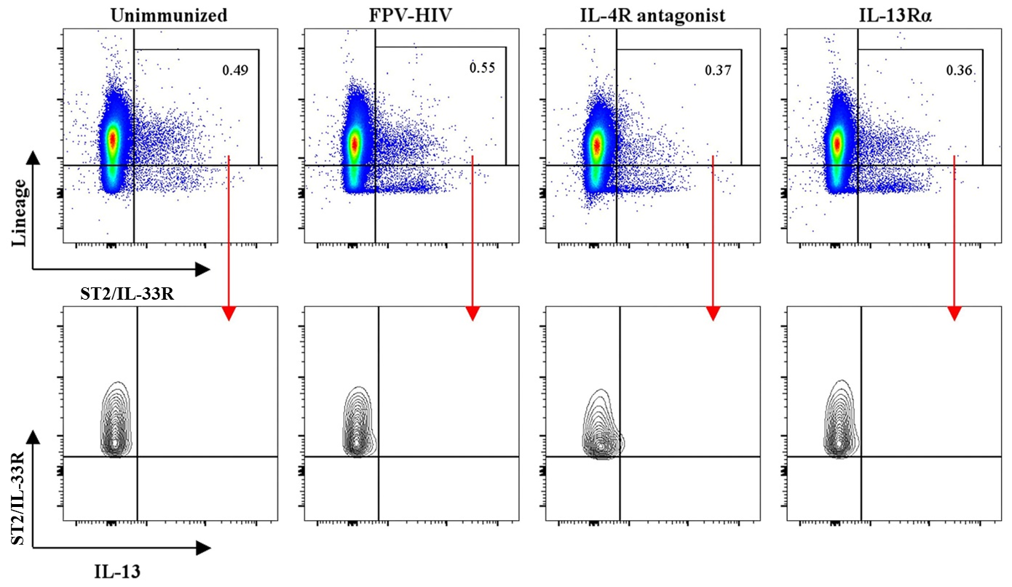
BALB/c mice were immunized intranasally with FPV-HIV, FPV-HIV-IL-4R antagonist adjuvanted, and FPV-HIV-IL-13Rα2 adjuvanted vaccines and IL-13 expression by lineage⁺ ST2/IL-33R⁺ cells were evaluated at 24h post vaccination and compared with unimmunized naïve mice. Data indicated that no IL-13 expression (0%) was detected in lineage⁺ ST2/IL-33R⁺ cells under all three vaccine conditions.

Fig. S3b. Evaluation of IL-13 and IL-4 expression by each lineage⁺ cell subset following i.n. rPFV immunization
BALB/c mice were immunized intranasally with FPV-HIV vaccine, lung cells were stained with each lineage marker separately. IL-13, and IL-4 expression were evaluated at 24h post vaccination. Data revealed that none of the lineage⁺ cell subsets expressed IL-13 or IL-4, further confirming that the ILC2 cells were not contaminated with any lineage⁺ cells.
Fig. S4. Determination of the absence of conventional NK cells in CD45⁺, lineage⁻ population
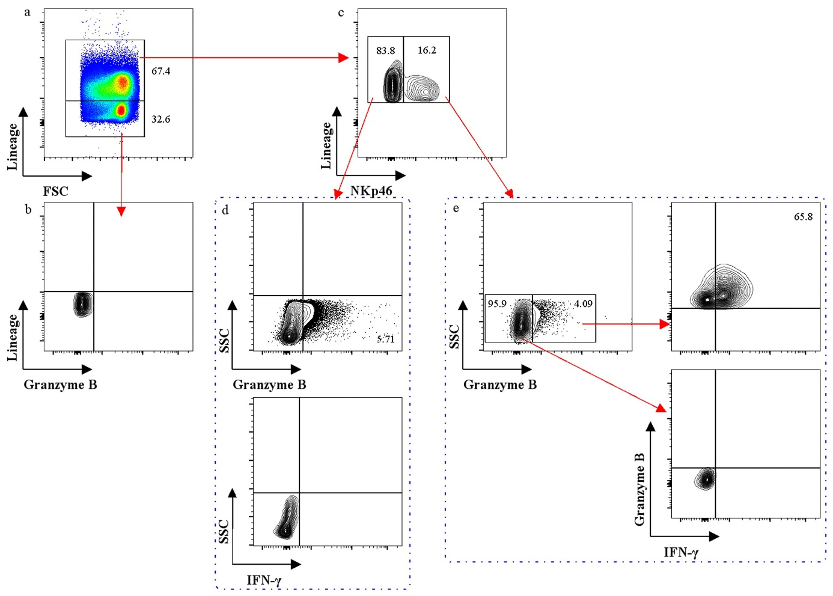
Lung cells from BALB/c mice immunized with FPV-HIV control vaccine were firstly gated on CD45⁺, FSC^{low} and SSC^{low} followed by lineage⁻ and lineage⁺ populations (a), and the granzyme B expression was evaluated on these subsets respectively (b & c). The lineage⁺ cells were further divided into NKp46⁺ and NKp46⁻ populations (c), and their granzyme B and IFN-γ production were evaluated (d & e). Data indicated that granzyme B was only expressed by lineage⁺ cells (NKp46⁺ and NKp46⁻) not lineage⁻ cells (b), and IFN-γ expression was also detected in conventional NK cells, which were determined as lineage⁺ NKp46⁺ Granzyme B⁺. Numbers on FACS plots represent cell percentage.

Fig. S5. Evaluation of IFN-γ expression by lung conventional NK cells following adjuvanted and unadjuvanted i.n. rFPV immunization
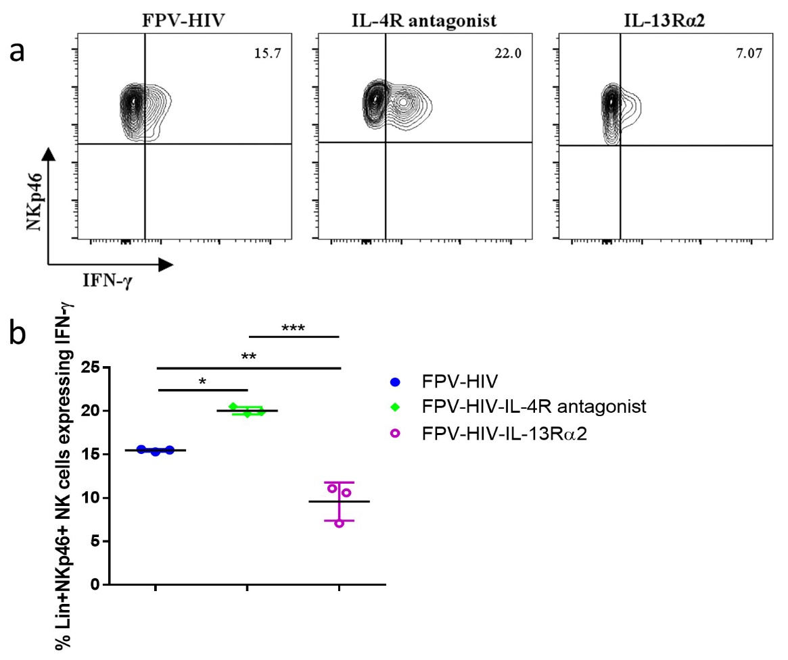
BALB/c mice were immunized intranasally with FPV-HIV, FPV-HIV-IL-4R antagonist adjuvanted, and FPV-HIV-IL-13Rα2 adjuvanted vaccines and IFN-γ expression by conventional NK cells were evaluated at 24h post vaccination in lung. Conventional NK cells were gated as CD45⁺, lineage⁺, and NKp46⁺, and their IFN-γ expression were evaluated using intracellular cytokine staining (a & b). The graphs represent the mean and standard deviation (s.d.). The p-values were calculated using GraphPad Prism software (version 6.05 for Windows). *P<0.05, **p<0.01, ****P<0.0001 (one-way ANOVA). For each time point experiments were repeated minimum three times. Data indicate that 24h post vaccination, the IL-4R antagonist adjuvanted vaccinated group showed elevated IFN-γ expression by the lung lineage⁺ NKp46⁺ (conventional NK cells) subset (~22%) compared to the control unadjuvanted (~15%) or IL-13Rα2 adjuvanted vaccine groups tested (~7%).

Fig. S6. Staining of lung tissue for different ILC2 subsets
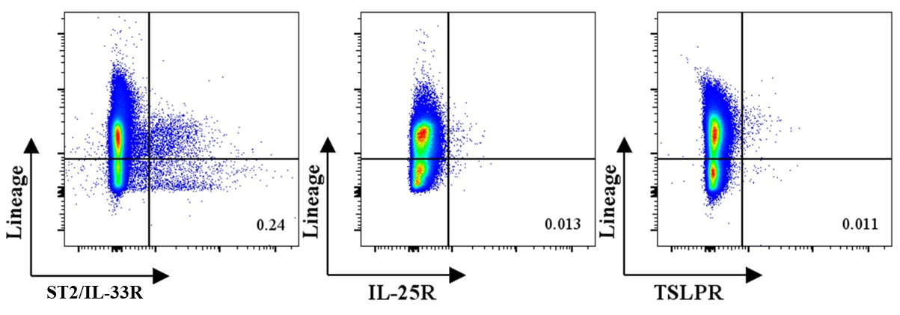
Cells were gated from CD45⁺ and lymphocytes as shown in supplementary Figure 1 and lineage⁻ ST2/IL-33R⁺, lineage⁻ IL-25R⁺, and lineage⁻ TSLPR⁺ lung ILC2 subsets were evaluated 24h post FPV-HIV immunization. Following rFPV immunization, all lung ILC2s were found to be ST2/IL-33R⁺. Numbers on FACS plots represent cell percentage.

Fig. S7. Evaluation of different ILC2 subsets in naïve mice quadriceps muscle
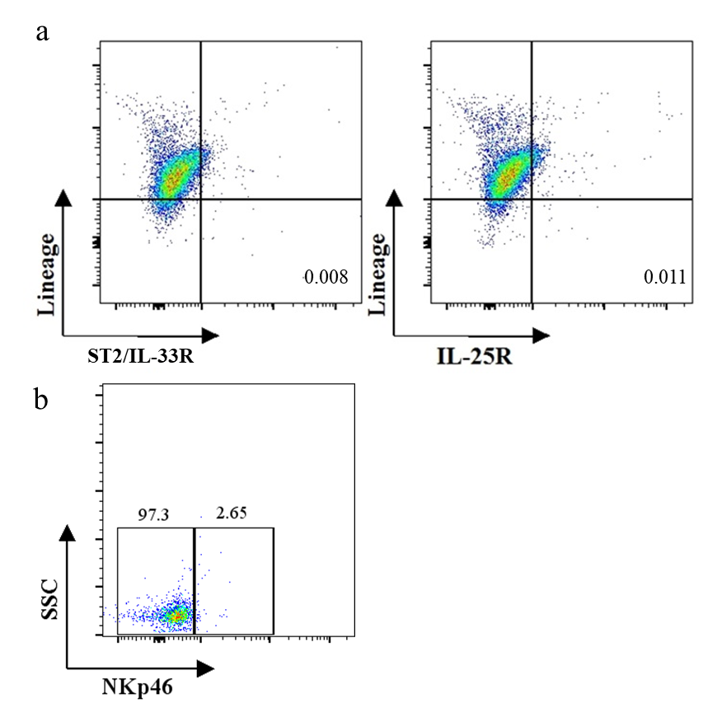
Cells were gated from CD45⁺ and lymphocytes as shown in supplementary Figure 1. No or extremely low ST2/IL-33R⁺ (0.008%) and IL-25R⁺ (0.011%) ILC2 cells were detected in quadriceps muscle in naïve BALB/c mice (a). Very low NKp46+ ILC (18.3%) were detected in quadriceps muscle in naïve BALB/c mice (b).

