Supplementary Information
Safeguarding the microbial water quality from source to tap
Jorien Favere^{a,d#}, Raquel G. Barbosa^{a,b#}, Tom Sleutels^{b}, Willy Verstraeteª, Bart De Gusseme^{a,d}, Nico Boon^{a,d*}
ªCenter for Microbial Ecology and Technology (CMET), Ghent University, Coupure Links 653, 9000 Gent, Belgium
^{b}Wetsus, European Centre of Excellence for Sustainable Water Technology, P.O. Box 1113
8900 CC Leeuwarden, The Netherlands
^{d}Centre for Advanced Process Technology for Urban Resource Recovery (CAPTURE), P.O.
Frieda Saeysstraat 1, 9000 Gent, Belgium

#Jorien Favere and Raquel Barbosa share first authorship
* Correspondence to: Nico Boon, Ghent University; Faculty of Bioscience Engineering; Center for Microbial Ecology and Technology (CMET); Coupure Links 653; B-9000 Gent, Belgium; phone: +32 (0)9 264 59 76; fax: +32 (0)9 264 62 48; E-mail: nico.boon@ugent.be; Webpage: www.cmet.ugent.be.
The Gompertz growth function is applied to different fields, for example to model the growth of tumors¹, but has also shown its relevance in the field of (microbial) ecology.^{2,3} It is an extension of the exponential growth function, and includes the condition that a certain species cannot thrive infinitely in a certain ecosystem, but is limited by the carrying capacity of the ecosystem for that species. The Gompertz growth function allows the calculation of the biomass concentration X at a certain timepoint t for a given growth rate µ, initial biomass concentration X₀ and taking into account a carrying capacity M (eq. SI.1).
$X=M*e^{\ln\left(\frac{X_{0}}{M}\right)*e^{-\left(\frac{µ}{\ln\left(M\right)}\right)*t}}$ (eq. SI.1)
To illustrate the concept of carrying capacity, three situations were modelled using Matlab (v9.9) relying on the Gompertz growth curve (eq. SI.1). As drinking water is considered to be an open ecosystem (i.e. constant supply of nutrients), the growth rate and nutrient concentration were assumed to be constant. Parameters were set at µ = 0.165 h⁻¹ and M = 10⁵ cells/mL, with initial biomass concentrations of 10⁷, 3*10⁴ and 10² cells/mL, and the biomass concentration was calculated iteratively.

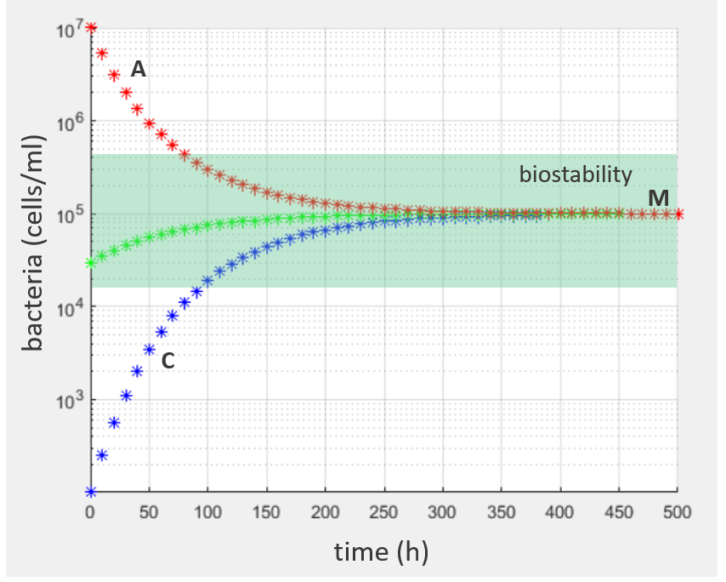
Figure SI.1 Bacterial cell concentration over time modelled using the Gompertz growth curve in three situations as illustration of the ecological concept carrying capacity (M). Two situations of biological instability are indicated (cfr. Figure 2). A (red line): A bacterial density above the carrying capacity of the ecosystem will result in die-off. C (blue line): A small amount of bacteria present and a growth-limiting factor concentration above the K/r threshold concentration will result in fast regrowth. Green line: a bacterial concentration close to the carrying capacity M avoids the occurrence of extensive regrowth, hence this situation is considered to be within the boundaries of biostability.
References
1. Neely Atkinson, E., Bartoszyński, R., Brown, B. W. & Thompson, J. R. On estimating the growth function of tumors. Math Biosci. 67 (2),145-166 https://doi.org/10.1016/0025-5564(83)90097-4 (1983)
2. Liu, F., Guo, Y. Z. & Li, Y. F. Interactions of microorganisms during natural spoilage of pork at 5 °C. J. Food Eng.72 (1) 24-29 https://doi.org/10.1016/j.jfoodeng.2004.11.015 (2006)
3. Duffy, G., Whiting, R. C. & Sheridan, J. J. The effect of a competitive microflora, pH and temperature on the growth kinetics of Escherichia coli O157:H7. Food Microbiol. 16 (3), 299-307 https://doi.org/10.1006/fmic.1998.0242 (1999)

