Supplementary Information
Sewage Leakage Challenges Urban Wastewater Management as evidenced by the Yangtze River Basin of China
Biqing Xia ^{1,2}, Sisi Li ^{1,2} *, Wangzheng Shen ^{1,2}, Menghan Mi ^{1,3}, Yanhua Zhuang ^{1,2}, Liang Zhang ^{1,2} *

¹ Key Laboratory for Environment and Disaster Monitoring and Evaluation of Hubei, Jianghan Plain-Honghu Lake Station for Wetland Ecosystem Research, Innovation Academy for Precision Measurement Science and Technology, Chinese Academy of Sciences, Wuhan 430077, China
² University of Chinese Academy of Sciences, Beijing 100049, China
³ Center for Ecological Environment Monitoring and Scientific Research, Huaihe Valley Ecology and Environment Administration, Ministry of Ecology and Environment, Bengbu 233000, China

Corresponding authors:
Sisi Li, E-mail address: lisisi@apm.ac.cn
Liang Zhang, E-mail address: lzhang@apm.ac.cn
Brief description of Supporting Information contents:
1. Supplementary Figures
Supplementary Figure 1. Comparison of nitrogen discharge load from wastewater treatment plants (WWTPs) (L_{out}), gross leakage load (L_{gross}) and pollution census load (L_{cen}) for provincial and municipal districts.
Supplementary Figure 2. Volumes of sewage discharged from domestic (V_{r}), infiltration (V_{inf}), exfiltration (V_{exf}) and entered into wastewater treatment plants (V_{in}) in all cities.
Supplementary Figure 3. (a) Comparison of infiltration volume in three sub-basins; (b) Comparison of exfiltration volume in three Sub-basins.

2. Supplementary Tables
Supplementary Table 1. Summary of data sources.
Supplementary Table 2. Literature references for regional concentrations of surface runoff.
Supplementary Table 3. Reference concentrations of infiltration (C_{inf}) for all cities in the YRB.

3. Supplementary Data
Supplementary data 1. Leakage Data. Concentrations, volumes, and per capita loads of total nitrogen from urban domestic sources, WWTPs inflow/outflow, infiltration, exfiltration. And urban population, uncollected leakage per capita, and gross/net leakage within basin at municipal scale
Supplementary data 2. Province Comparison. Total nitrogen loads from urban domestic sources, uncollected, reduction, WWTPs inflow/outflow, gross leakage, net leakage, and CSNPSC census at provincial scale
Supplementary data 3. City Comparison. Total nitrogen loads from CSNPSC census, WWTPs outflow, gross leakage, net leakage at municipal scale
Supplementary data 4. Precipitation. Precipitation and precipitation category at municipal scale
Supplementary data 5. Socio-economic factors. City size, total nighttime lighting intensity, population and economic concentration, and pipe density at municipal scale

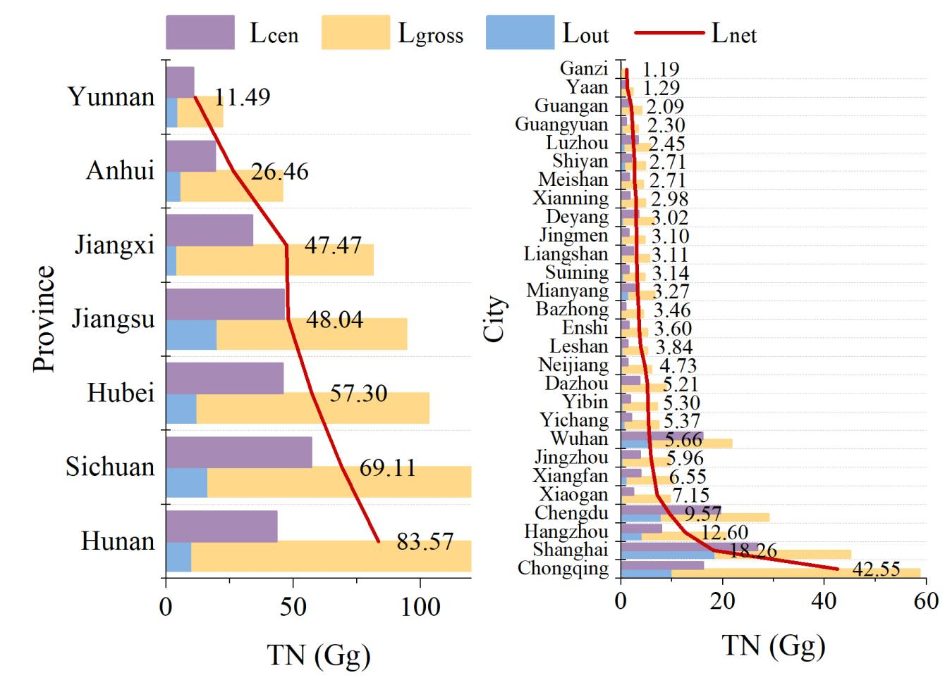
Supplementary Figure 1. Comparison of nitrogen discharge load from wastewater treatment plants (WWTPs) (L_{out}), gross leakage load (L_{gross}) and pollution census load (L_{cen}) for provincial and municipal districts.

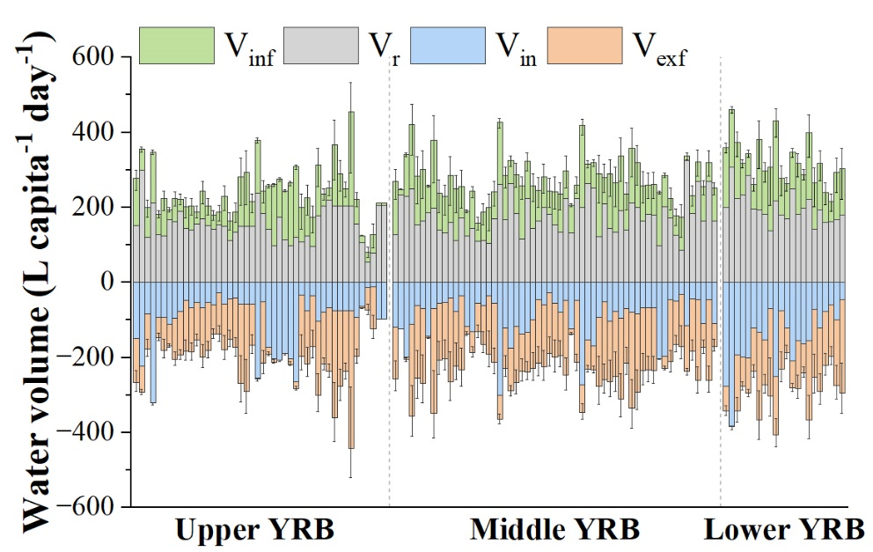
Supplementary Figure 2. Volumes of sewage discharged from domestic (V_{r}), infiltration (V_{inf}), exfiltration (V_{exf}) and entered into wastewater treatment plants (V_{in}) in all cities. The error bars represent the IQR obtained from the uncertainty analysis, which is the range between the first quartile (Q1) and the third quartile (Q3) of all volume values.

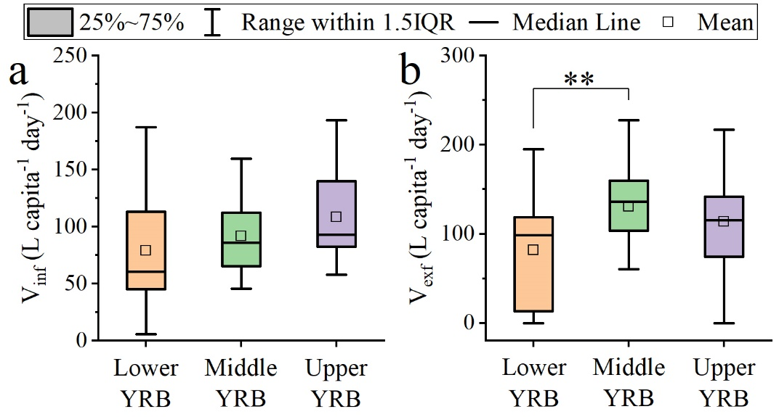
Supplementary Figure 3. (a) Comparison of infiltration volume in three sub-basins; (b) Comparison of exfiltration volume in three Sub-basins.

Supplementary Table 1. Summary of data sources. All data are annual values for 2017. The publication year of the data is indicated within parentheses in the 'Source' column.
Data | Description | Source
P_{u} | Urban population, in millions | Statistical Yearbooks at provincial and municipal levels (2018)
V_{r} | Domestic daily per capita wastewater volume, in L capita⁻¹ day⁻¹ | the Ministry of Housing and Urban-Rural Development of the People's Republic of China (MOHURD, 2018)
V_{in} /V_{out} | Daily per capita treatment volume of WWTPs, in L capita⁻¹ day⁻¹ | MOHURD (2018)
C_{in} | Influent concentration of WWTPs, in mg L⁻¹ | China Urban Water Association (CUWA, 2018a), CSNPSC (2021)
C_{out} | Outfluent concentration of WWTPs, in mg L⁻¹ | CUWA (2018b), CSNPSC (2021)
L_{cen} | Domestic source pollution load reported by the CSNPSC, in Gg | CSNPSC (2021)
PL_{r} | Daily per capita pollution load produced from domestic sources, in g capita⁻¹ day⁻¹ | Sun (2019), CSNPSC (2021)
C_{inf} | Concentration of infiltration water, in mg L⁻¹ | Supplementary Table 2
C_{exf} | Concentration of exfiltration water, in mg L⁻¹ | (C_{r} + C_{in})/2
Note: C_{inf} represents concentrations of infiltrated sewage, based on the mean value obtained from 131 literature values from 34 studies (Supplementary Table 2). C_{exf} denotes concentrations of exfiltrated or overflowed sewage, calculated as the mean between its maximum (C_{r}) and minimum (C_{in}) values, assuming a uniform change within the network.
Supplementary Table 2. Literature references for regional concentrations of surface runoff.
No. | References
1 | Chen, S. Study on characteristics of urban storm runoff in Yixing City. Master's thesis, Xi'an University of Architecture and Technology, 2016 (in Chinese).
2 | Di, W. Research on Infiltration and Reuse of Road Runoff by Artificial Soil Technology in Jiaxing City. Master's thesis, Beijing University of Civil Engineering and Architecture, 2014 (in Chinese).
3 | Dong, Z. Study on Rainwater Runoff Pollution Control in Yixing New Urban District And Beijing Liangshui River Basin. Master's thesis, Beijing Forestry University, 2018 (in Chinese).
4 | Jiang, R. Monitoring and Characteristics Analysis of Stormwater Runoff of Typical Land Surfaces in Yuelai New City, Chongqing. Master's thesis, Chongqing University, 2017 (in Chinese).
5 | Peng, L. Water Quality Characteristics of Stormwater Runoff and Correlation Analysis of Pollutants Index in Baishazhou Avenue, Wuhan. Master's thesis, Wuhan University of Science and Technology, 2013 (in Chinese).
6 | Qin, Y. Research on The Characters of Rainwater runoff Pollution in Nanning City. Master's thesis, Guangxi University, 2018 (in Chinese).
7 | Wang, B. Study on urban stormwater pollutants transportation processes. PhD thesis, Xi'an University of Architecture & Technology, 2011 (in Chinese).
8 | Wang, X. Study on Characteristics of Runoff Pollution and Integrated Control Technologies in Rapid Urbanization Region. Master's thesis, Tsinghua University, 2015 (in Chinese).
9 | Wei, Z. Study on The Influence of Different Landuse Patterns on Rainfall Runoffpollution-7typical Squares Cases of Hangzhou. Master's thesis, Zhejiang University of Technology, 2015 (in Chinese).
10 | Wu, Y. Characteristics of Runoff Pollution of Different Underlying Surfaces in Cultural and Educational Area of Xi'an. Master's thesis, Chang'an University, 2018 (in Chinese).
11 | Zhang, H. Research on Pollution Characteristics and Reduction Rate of Initial Rainwater Runoff in Sponge City Construction. Master's thesis, Chongqing University of Technology, 2019 (in Chinese).
12 | Zhang, S. Study on Rainfall Runoff Pollution Characteristics and Regional Generalization Model in Urban Industrial Area. Master's thesis, Qingdao University of Technology, 2019 (in Chinese).
13 | Ding, Q.; Wang, Q.; Zhang, Q.; Wang, X.; Mawuli, D., Analysis of runoff pollution from the main road in Yixing City, Taihu Lake Basin. Acta Scientiae Circumstantiae 2017, 37 (9), 3456-3463 (in Chinese).
14 | He, M.; Zhang, J.; Chen, C.; Qi, X.; Chen, Q., Analysis of the temporal and spatial characteristics of rainfall- runoff pollution in Dianbei basin of Shanghai. Acta Scientiae Circumstantiae 2018, 38 (2), 536-545 (in Chinese).
15 | Zhang, X.; Zhao, Z.; Qin, H.; Jiang, Y., Characteristics of Pollutants Flush on Different Types of Underlying Surface in Changzhou Acta Scientiarum Naturalium Universitatis Pekinensis 2018, 54 (3), 646-654 (in Chinese).
16 | Gong, M.; Cai, C.; Miao, H.; Hong, J.; Zhu, F.; Xu, Z.; Fang, X., Pollution Characteristic and Source Apportionment of Road Rainfall Runoff in Different Functional Zones of Lin'an. The Administration and Technique of Environmental Monitoring 2019, 31 (4), 18-22 (in Chinese).
17 | Tian, Y.; Li, T.; He, S.; Zhong, A.; Dong, L., Characteristics of Non-point Pollution of Fengqiao Industrial Park in Suzhou. China Water & Wastewater 2009, 25 (13), 89-94 (in Chinese).
18 | Feng, C.; Mi, N.; Wang, X.; Zhiwen, C.; Wenzheng, D., Analysis of Road Runoff Pollutants in Northern City Based on the Typical Rainfall. Ecology and Environmental Sciences 2015, 24 (3), 418-426 (in Chinese).
19 | Hu, Q.; Zhu, S.; Jin, Z.; Wu, A.; Chen, X.; Li, F., Using multiple isotopes to identify sources and transport of nitrate in urban residential stormwater runoff. Environ Monit Assess 2022, 194 (3), 238.
20 | Wang, X.; Lai, Q.; Du, J.; Bao, Y.; Zheng, W.; Ye, F., Analysis on Water Runoff Pollutions of Different Underlying Surfaces in Ningbo. Environmental Engineering 2016, 34, 312-316 (in Chinese).
21 | Bian, B.; Zhu, W.; Huang, F.; Bian, X., Characterizing Nutrients of Urban Stromwater Runoff in Zhenjiang. Environmental Science 2008, 29 (1), 19-25 (in Chinese).
22 | Gao, B.; Xu, Y.; Lu, M.; Lin, Z.; Xu, X., Analysis of Rainfall Runoff Pollution and Pollution Load Estimation for Urban Communities in a Highly Urbanized Region. Environmental Science 2020, 41 (8), 3657-3664 (in Chinese).
23 | Wang, L.; Duan, B.; Zhao, J.; Hua, Y.; Zhu, D., Pollution Characteristics of Surface Runoff of Typical Town in Chongqing City. Environmental Science 2015, 36 (8), 2809-2816 (in Chinese).
24 | Xu, Y.; Gong, Y.; Bi, J.; Wang, Y.; Junrui, C.; Wang, K., Analysis of Rainwater Runoff Pollution Characteristics of Various Typical Underlying Surfaces in Ningbo. Environmental Science 2020, 41 (7), 3275-3284.
25 | Zhao, Y.; Mei, S., Analysis of Urban Surface Runoff Pollutant Concentration and Pollution Characteristics in Tai Hu Basin. Environmental Science and Technology 2019, 32 (4), 52-59 (in Chinese).
26 | Kong, Y.; Feng, H.; Nie, J., Characterization of rainfall runoff pollution and discharge loads in towns and cities in Fuxian Lake basin. Environmental Science Survey 2018, 37 (5), 26-32 (in Chinese).
27 | Pan, Y. J.; Li, Z. Q.; Gao, Y. Y.; Xiong, Y. M.; Qiao, Y.; Tao, Y. Z.; Wu, Q. H.; Lin, W.; Qi, Y. Q.; Long, J. Y.; Ruan, L.; Dai, S. P.; Zang, C. F., Analysis of the Migration Characteristics of Stormwater Runoff Pollutants on Different Underlying Surfaces in Guangzhou, China. Front. Earth Sci. 2021, 9.
28 | Wang, X.; Wu, W.; Li, H., Analysis of pavement rainfall runoff in various functional areas of Suzhou Ancient City. Jiangsu Water Resources 2019, (7), 9-14 (in Chinese).
29 | Li, H.; Huang, W.; Yang, G.; Li, Z., Non-point Source Pollutant Concentration in Typical Towns of Taihu Upriver Region. Journal of Agro-Environment Science 2006, 25 (6), 1598-1602 (in Chinese).
30 | Yang, X. L.; Shen, X.; Zhu, B., Characteristics of diffuse pollution of nitrogen and phosphorous from a small town in the hilly area of the central Sichuan Basin, China. J Mt. Sci. 2016, 13, 292-301.
31 | Zhang, X., Research on Runoff Water Quality Variation under Different Rainfall Characteristics in Urban Village. Pearl River 2019, 40 (6), 105-110 (in Chinese).
32 | Wang, S.; Ma, Y.; Zhang, X.; Yu, Y.; Zhou, X.; Shen, Z., Nitrogen transport and sources in urban stormwater with different rainfall characteristics. Sci Total Environ 2022, 837, 155902.
33 | Fu, Z.; Tang, L.; Zhang, W.; Li, J.; Zhang, S.; Zhang, X.; Wang, Y.; Mo, L.; Wang, W.; Wang, X., Characteristics of runoff pollution in different surface runoff around urban drinking water sources. Science Technology and Engineering 2020, 20 (33), 13928-13935 (in Chinese).
34 | Xu, W.; Chang, S.; Zhan, Q., Runoff pollution characteristics under different underlying surfaces of typical residential areas in Tianjin City. Water Resources Protection 2017, 33 (5), 159-163 (in Chinese).

Supplementary Table 3. Reference concentrations of infiltration (C_{inf}) for all cities in the YRB.
Cities | C_{inf} (mg L⁻¹)
Cities | Mean | SD
Luoyang, Pingdingshan, Sanmenxia, Nanyang, Xinyang, Zhumadian. | 10.11 | 4.96
Xian, Baoji, Hanzhong, Ankang, Shangluo, Tianshui, Dingxi, Longnan, Gannan, Guoluo, Yushu, Haixi. | 7.40 | 4.28
Shanghai, Nanjing, Wuxi, Changzhou, Suzhou, Nantong, Huaian, Yangzhou, Zhenjiang, Taizhou, Hangzhou, Jiaxing, Huzhou, Quzhou, Hefei, Wuhu, Ma’anshan, Tongling, Anqing, Huangshan, Chuzhou, Liuan, Chizhou, Xuancheng, Nanchang, Jingdezhen, Pingxiang, Jiujiang, Xinyu, Yingtan, Ganzhou, Jian, Yichun, Fuzhou, Shangrao, Nanping, Sanming, Longyan. | 4.73 | 3.12
Wuhan, Huangshi, Shiyan, Yichang, Xiangfan, Ezhou, Jingmen, Xiaogan, Jingzhou, Huanggang, Xianning, Suizhou, Enshi, Provincial counties, Shennong, Changsha, Zhuzhou, Xiangtan, Hengyang, Shaoyang, Yueyang, Changde, Zhangjiajie, Yiyang, Chenzhou, Yongzhou, Huaihua, Loudi, Xiangxi, Guilin, Shaoguan, Qingyuan, | 2.80 | 2.60
Chongqing, Chengdu, Zigong, Panzhihua, Luzhou, Deyang, Mianyang, Guangyuan, Suining, Neijiang, Leshan, Nanchong, Meishan, Yibin, Guangan, Dazhou, Yaan, Bazhong, Ziyang, Aba, Ganzi, Liangshan, Guiyang, Liupanshui, Zunyi, Anshun, Tongren, Bijie, Qiandong, Qiannan, Kunming, Qujing, Yuxi, Zhaotong, Lijiang, Xiongchu, Dali, Nujiang, Diqing, Changdu, Naqu. | 5.50 | 3.47

