Supplementary information
Table of Contents

Supplementary Fig. 1. Cycling voltage regimes used for the in situ NMR analysis of the various phenomena occurring in the DHAQ flow battery…………………………………………………………………………………………..…………...2
Supplementary Fig. 2. In situ ¹H NMR spectra acquired during an electrochemical cycling………………………….…….3
Supplementary Fig. 3. In situ ¹H NMR and EPR spectra acquired during the electrochemical cycling………………….….4
Supplementary Fig. 4. Liquid chromatography−mass spectrometry (LC−MS) results for chemically synthesized DHA(L), electrochemically synthesized (DHA)₂, and purchased DHAQ………………………………………………………...……5
Supplementary Fig. 5. Chemical oxidation of DHA(L)²⁻...……...……………………………………….…………............. 6
Supplementary Fig. 6. DHAQ regeneration in a volumetrically unbalanced, compositionally symmetric cell……………...6
Supplementary Fig. 7. Chemical (aeration) vs. electrochemical regeneration with state of charge-restricted cycling…........7
Supplementary Fig. 8. Ferricyanide-limited recovery………………………………………………………………….….....8
Supplementary Fig. 9. Decompostion-recomposition reactions in a balanced DHAQ | Fe(CN)₆ flow cell……………...…..8
Supplementary Fig. 10. Electrochemical oxidation of (DHA)₂⁴⁻ vs. Fe(CN)₆…..…………………….……………..………9
Supplementary Fig. 11. Characterization of cycled AQDS and chemically synthesized disulfonated anthrone (anthranol) (ADS)……………………………………………………………………………………………………………………..…10
Supplementary Fig. 12. Electrochemical oxidation of disulfonated anthrone (anthranol) (ADS)………………….………11
Supplementary Fig. 13. Chemical and electrochemical oxidations of cycled AQDS and disulfonated anthrones (anthranols) (ADS)......................................................................................................................................................................................12
Supplementary Fig. 14. Electrochemical oxidation of cycled AQDS…………………………….………………………...13
Supplementary Fig. 15. A photo of the flow cell with an embedded reference electrode…………………………………..14

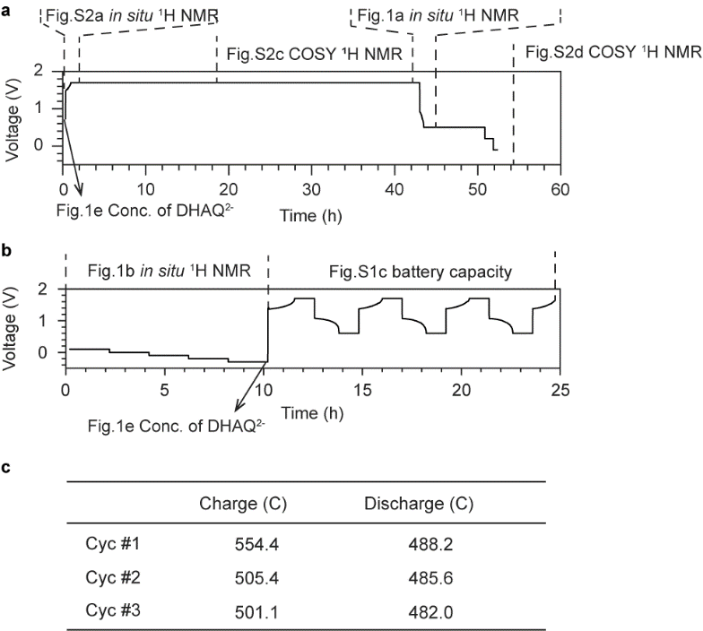
Supplementary Fig. 1. Cycling voltage regimes used for the in situ NMR analysis of the various phenomena occurring in the DHAQ flow battery. The voltage profiles are labelled with the figures that provide a more detailed analysis of the various processes. a, Voltage of the battery composed of 100 mM DHAQ²⁻ in the negolyte and a mixture of 200 mM K₄[Fe(CN)₆] and 100 mM K₃[Fe(CN)₆] in the posolyte. 1.2 M and 1 M KOH dissolved in D₂O were used as solvents for the negolyte and posolyte, respectively. Nafion 117 was used as the membrane. The battery was first charged by a constant current of 30 mA/cm², followed by holding the voltage at 1.7 V for 42 hours. It was then discharged by a constant current of −30 mA/cm², followed by holding the voltage at 0.5 V for 7.4 hours, at 0.2 V for 1 hour and at −0.1 V for 0.6 hours. After the voltage hold, the battery was set in a rest state for 36.8 hours. b, Following the rest, the voltage was decreased from 0.1 V to −0.3 V, stepping in decrements of 0.1 V, holding for 2 hours at each step. The battery was then charged by a constant current of 20 mA/cm², holding the voltage at 1.7 V for 1 hour, discharged by a constant current of −20 mA/cm² and holding the voltage at 0.6 V for 1 hour. This charge-discharge cycle was repeated three times. c, Capacities of the battery for the three charge-discharge cycles. The theoretical capacity is 481.7 C. The excess capacity during charge is due to the continual chemical oxidation of DHAQ⁴⁻, as discussed in our previous study,^{[1]} where the oxidant may be either trace amounts of oxygen gas that have permeated into the battery system or the solvent itself.

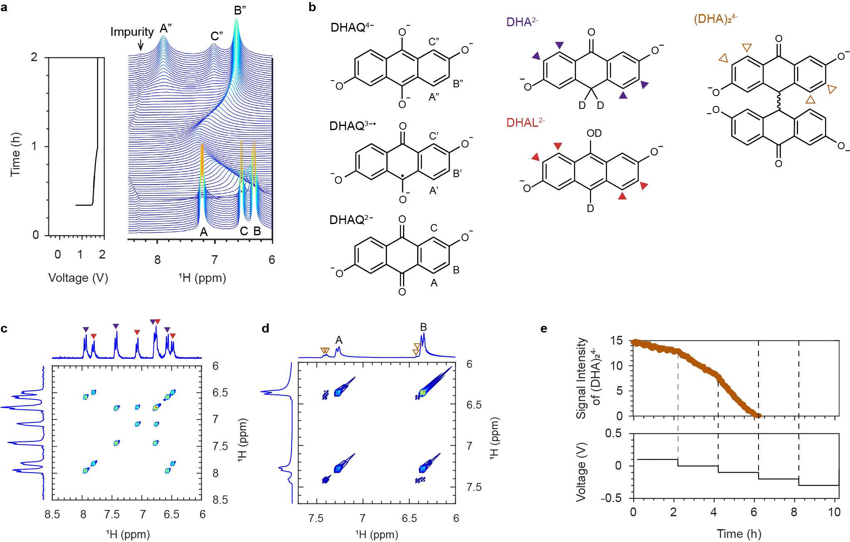
Supplementary Fig. 2. In situ ¹H NMR spectra acquired during an electrochemical cycle. a, Voltage of the battery composed of 100 mM DHAQ in the negolyte and a mixture of 200 mM K₄[Fe(CN)₆] and 100 mM K₃[Fe(CN)₆] in the posolyte. During charge, a constant current of 30 mA/cm² was applied followed by a potential hold at 1.7 V. The corresponding in situ ¹H NMR spectra of the negolyte in the aromatic region is shown on the right. The proton resonances are labelled A and B for DHAQ, with single- and double-prime labels indicating the same protons in the single and doubly reduced anions, respectively. b, Molecular structures of the DHAQ²⁻, DHAQ^{3−•}, DHAQ⁴⁻, DHA²⁻, DHAL²⁻ or (DHA)₂⁴⁻ anions. c, d, In situ COSY spectra during the voltage hold at 1.7 V and the rest period. See Supplementary Fig. 1 for the time when the spectra were acquired. The solid purple, red and hollow brown triangles highlight the signals of the decomposition products, DHA²⁻, DHAL²⁻ or (DHA)₂⁴⁻ anions, respectively. e, Proton signal intensity of (DHA)₂⁴⁻ at 7.39 ppm as a function of battery voltage. While the signal intensity of (DHA)₂⁴⁻ decreased to 0 at 6 hours, the signal intensity of DHAQ²⁻ (Fig. 2d) increased further after 6 hours. The further increase of DHAQ²⁻ concentration results from the conversion of residual DHA(L)²⁻ to DHAQ²⁻ as evidenced by the decreased signal intensity at 6.95 ppm (Fig. 2b), this signal being very weak and just visible above the baseline.

Supplementary Fig. 3. In situ ¹H NMR and EPR spectra acquired during the electrochemical cycle. a, Voltage of the battery composed of 30 mL 100 mM DHAQ²⁻ in the negolyte and 50 mL 300 mM K₄[Fe(CN)₆] in the posolyte. 1.2 M and 1 M KOH dissolved in D₂O were used as solvents for the negolyte and posolyte, respectively. Nafion 212 was used as the membrane. The battery was charged at a constant current of 30 mA/cm² to a cut-off voltage of 1.7 V. A voltage hold at 1.7 V was then applied for 20.4 hours. The voltage was then decreased to and held at –0.6 V for 1.7 hour, stepping in decrements of 0.1 V–the stepwise decrement was applied to avoid current overload. The gap in the voltage profile was caused by the current overload when a voltage hold at –0.6 V was attempted without the stepwise decrements. The voltage was finally increased to and held at 1.2 V for 2 hours, 1.4 V for 2 hours and 1.7 V for 11 hours, respectively. This voltage profile is labelled with the figures that provide a more detailed analysis of the various processes. b, In situ ¹H NMR and EPR spectra acquired during the voltage decreases. The solid purple, red and hollow brown triangles highlight the signals of the decomposition products, DHA²⁻, DHAL²⁻ or (DHA)₂⁴⁻ anions, respectively. The proton resonances are labelled A and B for DHAQ²⁻, with double-prime labels indicating the same protons in the doubly reduced anions. See Fig. 2 for the molecular structures of these anions. c, In situ ¹H NMR spectra acquired during the stepped voltage-hold experiment. d, Proton spectra in the aromatic region acquired for the fresh negolyte solution and the cycled solution at the end of the voltage hold at –0.6 V. The missing proton resonance at 6.63 ppm after regeneration is a result of H-D exchange with solvent D₂O. e, Concentrations of DHAQ²⁻ anions in a fresh negolyte solution before cycling started (left) and at the end of the voltage hold at –0.6 V (right). The concentrations were calculated from the intensities of signal A. An initial concentration of DHAQ²⁻ was measured to be 100.0 mM $±$ 0.22 mM and the concentration after electrochemical regeneration was 101.6 mM $±$ 0.58 mM. A volumetric loss of 4.7 mL from the negolyte solution (DHAQ) was measured at the end of the experiment. Taking into account this volumetric loss, a lower limit of concentrion for recovered DHAQ is 85.7 mM. Note that this volumetric loss is significantly higher than that reported in Fig. 2e. The difference is due to the thickness of membranes used in these two experiments. The thickness of Nafion 212 used in this experiment is 50.8 μm while Nafion 117 used in the experiment in Fig. 2e is 183.0 μm in thickness.
We note that the reduction/hydrogenation reaction of DHAQ⁴⁻ to form DHA(L)²⁻ is electrochemically driven, at a potential close to that for water reduction (below approximately −0.9 V vs. SHE) under basic conditions. For a closed thermodynamic loop, and given the potentials for the various DHA(L)²⁻ oxidation reactions, the reaction of DHAQ⁴⁻ to DHA(L)²⁻ likely involves both electrochemical and chemical steps.

Supplementary Fig. 4. Liquid chromatography−mass spectrometry (LC−MS) results for chemically synthesized DHA(L), electrochemically synthesized (DHA)₂, and purchased DHAQ. By controlling the electrolytic cell voltage, DHA(L) was electrochemically oxidized to obtain (DHA)₂. The DHA(L) and (DHA)₂ samples were prepared in an N₂-filled glovebox due to their air-sensitivity. However, air will unavoidably diffuse to the solutions during the LC−MS experiments, because the LC−MS measurements were implemented in air. As a result, the (DHA)₂ and DHAQ signals were also detected in DHA(L) sample over the LC measurement. The detection of DHA(L) in the (DHA)₂ sample was due to the incomplete electrochemical oxidation. An eluent containing CF₃COOH was used for the LC−MS measurement, and the m/z value of 563.0968 corresponding to the [(DHA)₂ • CF₃COO⁻] complex was detected in the mass spectrum, corroborating the formation of (DHA)₂.

Supplementary Fig. 5. Chemical oxidation of DHA(L)²⁻. Cyclic voltammograms of 10 mM pure DHA(L)²⁻ in 1 M KOH before and after addition of ferricyanide powder. Peak near −0.2 V vs. SHE is the oxidation of DHA(L)²⁻, which has diminished after addition of ferricyanide, indicating that less DHA is present in the solution. Appearance of new peak around −0.68 V corresponds to DHAQ redox peak.
Supplementary Fig. 6. DHAQ regeneration in a volumetrically unbalanced, compositionally symmetric cell. a, Potentiostatic cycling of 7 mL of 50% SOC 0.1 M DHAQ^{2−/4−} in 1.2 M KOH vs. 13 mL of 50% SOC 0.1 M DHAQ^{2−/4−} in 1.2 M KOH at ±250 mV with respect to the non-capacity limiting electrode and a current cutoff of ±1 mA/cm² for both charge and discharge, showing loss of roughly 20 C of capacity over 5 days. b, Electrochemical oxidation of capacity-limiting side (CLS) of symmetric cell after normal discharge of last cycle in part a, indicating ~40 C of lost extra capacity, of which 10 C correspond to the DHA to dimer reaction (yellow area), and roughly 30 C correspond to the dimer to DHAQ²⁻ reaction (blue area), as expected.

Supplementary Fig. 7. Chemical (aeration) vs. electrochemical regeneration with state of charge (SOC)-restricted cycling. a, Cycling of battery composed of 20 mL 500 mM DHAQ²⁻ in 2 M KOH in the negolyte and 100 mL of a mixture of 400 mM K₄[Fe(CN)₆] and 10 mM K₃[Fe(CN)₆] in 1 M KOH in the posolyte. Galvanostatic cycling at ±60 mA/cm² with potential holds at 0.9 V and 1.5 V and current cutoff of −1 mA/cm² for discharge and 4 mA/cm² for charge during normal cycles. Comparison between cycling with (red) and without (blue) aeration of negolyte. Chemical aeration of negolyte after each discharge as proposed in previous study^{[2]} improves overall fade rate from 1.1%/day to 0.36%/day. The cell was paused at 0% SOC during the 0.3−0.9 day. b, Combination of SOC-restricted cycling with chemical aeration of negolyte further improves capacity retention, with daily aeration after discharge leading to an overall fade rate of 0.25%/day. Galvanostatic cycling at ±50 mA/cm² with potential holds at 1.0 V and 1.4 V and current cutoff of ±5 mA/cm² during normal cycles. c, Electrochemical regeneration with (blue) and without (red) SOC-restriction in batteries composed of 6 mL 100 mM DHAQ²⁻ in the negolyte and a mixture of 35 mL 100 mM K₄[Fe(CN)₆] and 50 mM K₃[Fe(CN)₆] in the posolyte. Standard cycling regime consists of galvanostatic cycling at ±50 mA/cm² with potential holds at 1.0 and 1.5 V and current cutoff of ±2 mA/cm². The red data consist of this cycling regimen whereas the blue data has an additional coulombic SOC cutoff of 80% imposed between times t₁ (0.1 days) and t₂ (12.5 days). At time t₃ (12.7 days), all cells are subject to the same electrochemical regeneration treatment consisting of an additional discharge step at −2 mA/cm² until 0.0 V potential limit and a further hold until current decreases to −0.2 mA/cm². Just before this treatment step, the unrestricted cell had lost ~30% of initial capacity, whereas the restricted cell had only lost ~5% of its capacity. Both cells recover to roughly the same capacity after the electrochemical treatment, the overall fade rates are 0.37% and 0.44% for the cycling with and without SOC restriction, suggesting that the overall final loss is independent of capacity lost (and DHA formed) during cycling, and therefore that electrochemical regeneration resolves all capacity lost from primary fade mechanism.

Supplementary Fig. 8. Ferricyanide-limited recovery. a, Single electrochemical regeneration treatment of 5 mL 100 mM DHAQ²⁻ in the negolyte in two separate full cells. Regeneration treatment happened on day 4. Posolyte of cells consisted of 30 mL of 100 mM K₄[Fe(CN)₆] with or without 10 mM K₃[Fe(CN)₆] added. Galvanostatic cycling at ±50 mA/cm² with potential holds at 1.0 V and 1.5 V and current cutoff of ±1 mA/cm² during normal cycles. Cell without excess ferricyanide was unable to recover as much capacity due to becoming ferricyanide-limited by spontaneous reduction as demonstrated in a previous study.^{[3]} b, Cycling of battery composed of 6 mL 100 mM DHAQ²⁻ in the negolyte and 20 mL of a mixture of 70 mM K₄[Fe(CN)₆] and 10 mM K₃[Fe(CN)₆] in the posolyte, with 1 M KOH. Full cell with initial capacity of 111 C and theoretical capacity of 116 C (not shown) demonstrating increase in capacity regeneration after replacement of cycled posolyte with initial posolyte after 160 hours of operation.

Supplementary Fig. 9. Decompostion-recomposition reactions in a capacity-balanced DHAQ | Fe(CN)₆ cell. Left: (electro)chemical reactions in the DHAQ negolyte. Right: (electro)chemical reactions in the Fe(CN)₆ posolyte. Electrochemical reactions are in black color, spontaneous chemical reactions are in red color. Assuming that the balanced cell is a closed system, the oxygen produced from the chemical reaction in the posolyte will be circulated to electrode surface and electrochemically reduced to hydroxide ions. ORR: oxygen reduction reaction.
In a DHAQ | Fe(CN)₆ cell, DHA(L)²⁻ are over-reduced species; the electrons used for DHA(L)²⁻ formation are indirectly coming from the oxidation of Fe(CN)₆⁴⁻ to Fe(CN)₆³⁻, as shown by summing the reactions in Supplementary Fig. 9. Therefore, theoretically, there is no need for additional Fe(CN)₆³⁻ to electrochemically oxidize DHA(L)²⁻. In the present work, using excessive ferro-/ferricyanide posolyte is mainly due to the side reaction of ferro/ferricyanide itself. Páez et al. found that Fe(CN)₆³⁻ tends to be reduced to Fe(CN)₆⁴⁻ at pH 14 accompanied by the oxygen evolution reaction (OER), as the reduction potential of Fe(CN)₆³⁻ is higher than that of the OER in 1 M KOH ^{[4]}. Hence, we decided to use excessive posolyte in all experiments to minimize the influence of the unwanted side reaction in the posolyte at pH 14. It is not necessary to have the posolyte in excess for real applications, as we can simply seal the posolyte side so that the oxygen produced from the side reaction (OER) will eventually be reduced to hydrogen peroxide anions,^{[5]} which then immediately disproportionate to hydroxide ions and oxygen at high pH, thus returning hydroxide ions back to the posolyte. Alternatively, the posolyte can also be purposefully aerated with ambient air to restore any oxygen lost from the system. Therefore, overall, the system would be still balanced without accumulating extra ions.
Given that DHAQ⁴⁻ can be electrochemically reduced to DHA(L)²⁻ under extreme conditions, here to present the electrochemical (in black) and chemical (in red) reactions in both electrolytes as simply as possible, we start with a balanced flow cell with three equivalents of DHAQ²⁻ and eight equivalents of Fe(CN)₆⁴⁻. The system remains balanced without accumulating extra ions even when one starts with three equivalents of DHAQ²⁻ and six equivalents of Fe(CN)₆⁴⁻. Overall, the reaction species and electrons sum to zero in each electrolyte on each side; the electron transfer is also balanced on both sides. Therefore, ideally, it is feasible to start with a balanced cell.
Supplementary Fig. 10. Electrochemical oxidation of (DHA)₂⁴⁻ vs. Fe(CN)₆. ¹H NMR spectra of (DHA)₂⁴⁻ negolyte before and after 30-min hold at given voltages. The applied voltage value of 0.0 V is equal to the potential of a 50% SOC Fe(CN)₆ electrolyte minus the potential of (DHA)₂⁴⁻. Potential hold at −0.3 V of 0.05 M (DHA)₂⁴⁻ in 1.2 M KOH negolyte in full cell containing 50 mM K₄[Fe(CN)₆] and 50 mM K₃[Fe(CN)₆] posolyte. The bottom DHAQ²⁻ spectrum (green) serves as a control sample.
Supplementary Fig. 11. Characterization of cycled AQDS and chemically synthesized disulfonated anthrone (anthranol) (ADS). a, b, COSY and ¹H NMR of cycled AQDS shows side peaks in both aromatic and aliphatic regions. c, d, COSY and ¹H NMR of chemically synthesized ADS, there are four groups of protons, suggesting four different isomers. e, 2,6-disulfonated anthrones (anthranols) f, Both the decompostion compound in cycled AQDS and the chemically synthesized ADS were confirmed with the m/z value of 352.9795, which comes from ADS.

Supplementary Fig. 12. Electrochemical oxidation of disulfonated anthrone (anthranol) (ADS). a, Linear sweep voltammetry (LSV) and the 1st order differential LSV of ADS electrolyte indicating the potential of peak oxidation current at 1.80 V vs. SHE in 1 M H₂SO₄ at room temperature on glassy carbon electrode. b, Cyclic voltammograms of 10 mM pure ADS (black) in 1 M H₂SO₄ before and after a 1.80 V vs. SHE 10-minute potential hold with a highly porous Zoltek PXFB working electrode. The new peaks (red) match the redox peaks of AQDS (blue).

Supplementary Fig. 13. Chemical and electrochemical oxidations of cycled AQDS and disulfonated anthrones (anthranols) (ADS). a, b, ADS in the cycled AQDS and pristine ADS can both be oxidized to AQDS by CrO₃. c, d, ADS in the cycled AQDS and pristine ADS can be electrochemically oxidized to AQDS.
Electrochemical oxidation of cycled AQDS (40% conversion, >95% yield): a volumetrically unbalanced, compositionally symmetric cell with the configuration of (−) 4 mL 0.1 M A(H)QDS in 1 M H₂SO₄ | 12 mL 0.1 M A(H)QDS in 1 M H₂SO₄ (+) was prepared with initial 50% state of charge (SOC). The capacity limiting side (CLS) was treated as the negolyte, and the non-capacity limiting side (NCLS) was treated as the posolyte. The symmetric cell was cycled potentiostatically at ±0.2 V with current density cutoffs of ±1 mA/cm², for 3 days at 55 ˚C then held at 100% SOC for 4.5 days at 55 ˚C to obtain cycled AQDS with ~45% capacity loss. The electrode was baked SGL39aa with 5 cm² geometric area and the membrane was Nafion 117. FCT (fuel cell technologies) cell was used with interdigitated flow field. Electrochemical oxidation of the cycled AQDS (CLS) was conducted right after the normal discharge using a constant current constant voltage (CCCV) method. −3 or −5 mA/cm² and −1.0 V were chosen, and −1.0 V means that the potential of CLS is 1.0 V higher than that of NCLS. Aliquots were taken before (black in c, d) and after (red in c, d) the electrochemical oxidations for ¹H NMR measurements. Electrochemical oxidation of ADS (64% conversion, >95% yield): A full cell with the configuration of (−) 6.5 mL 0.1 M ADS in 1 M H₂SO₄ | 11 mL 0.3 M A(H)QDS in 1 M H₂SO₄ (+) was prepared with an embedded Ag/AgCl reference electrode on the negolyte side. An FCT cell was used with interdigitated flow field. The electrode was Zoltek PXFB carbon cloth with 5 cm² geometric area, membrane was Nafion 212 soaked in 1 M H₂SO₄. Given the capacity of the electrolytes, the ADS and AQDS side were CLS and NCLS respectively. To regenerate AQDS from ADS existing in the negolyte, the battery was first galvanostaticlly discharged at −2 mA/cm² with a cell potential hold at −1.8 V (i.e. the negolyte potential was 1.8 V higher than that of the posolyte) with a current cutoff of −1 mA/cm² or the total charge passed was more than 1.5 times what was anticipated based on the material present in the negolyte. The reason for the last stopping condition was to prevent any significant extent of water splitting reaction that may occur during the potential hold step.
The conversions of ADS in cycled AQDS and pristine ADS were calculated from the relative decrements of side peaks in ¹H NMR spectra before and after the electrochemical oxidation. The >95% yields were confirmed by LC−MS, from which only the signals of AQDS and unreacted ADS were detected. Unoptimized electrochemical oxidation conditions and different electrochemical oxidation kinetics of the four ADS isomers may lead to the low conversions, which require more studies in future.

Supplementary Fig. 14. Electrochemical oxidation of cycled AQDS at 55 ˚C. a, b, Ten cycles of normal charge/discharge was first performed under constant current of ±100 mA/cm² with potential holds (±0.2 V); subsequently, electrochemical oxidation was performed right after the 10th discharge with constant current of −3 mA/cm² until the voltage dropped to −1.0 V; last, five cycles of normal charge/discharge was performed under constant current of ±100 mA/cm² with potential holds (±0.2 V). c, Voltage profile of the electrochemical oxidation. 15 C of electrons were transferred during the electrochemical oxidation with a plateau at around −0.32 V. d, Discharge capacity of AQDS before and after the electrochemical oxidation. Discharge capacity increased by 7 C after the electrochemical oxidation, which is roughly half of the total charge transferred during oxidation. As in Supplementary Fig. 6b, this is due to the 4-electron transfer associated with ADS to AQDS conversion, and 2-electron transfer during the conversion from AQDS to AHQDS. A volumetrically unbalanced, compositionally symmetric cell with the configuration of (−) 4 mL 0.1 M A(H)QDS in 1 M H₂SO₄ | 12 mL 0.1 M A(H)QDS in 1 M H₂SO₄ (+) was prepared with initial 50% state of charge (SOC). The capacity limiting side (CLS) was treated as the negolyte, and the non-capacity limiting side (NCLS) was treated as the posolyte. The symmetric cell was cycled potentiostatically at ±0.2 V with current density cutoffs of ±1 mA/cm², for 3 days at 55 ˚C then held at 100% SOC for 4.5 days at 55 ˚C to obtain cycled AQDS with ~45% capacity loss (initial capacity: 54.5 C). The electrode was baked SGL39aa with 5 cm² geometric area and the membrane was Nafion 117. FCT cell was used with interdigitated flow field. Electrochemical oxidation of the cycled AQDS (CLS) was conducted immediately after the normal discharge using galvanostatic with potential holds at the end. −3 mA/cm² and −1.0 V were chosen, and −1.0 V means that the potential of CLS is 1.0 V higher than that of NCLS. Note that the potentials in part c and d are versus A(H)QDS, but the SOC of A(H)QDS was likely fell below 50% due to decomposition.

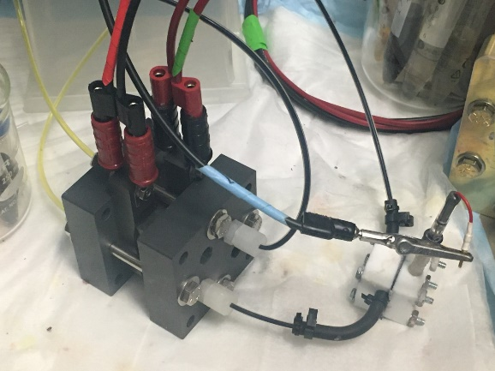
Supplementary Fig. 15. A photo of the flow cell with an embedded reference electrode. The reference electrode (RE) was positioned externally on the inlet of the negolyte stream.^{[6]} Changing the position of the RE along the inlet stream did not affect the potential measurement. This confirmed that there was not any measurable current between the RE and the negative electrode that could interfere with the potential tracking of the negative electrode separately.

References:
[1] Zhao, E. W.; Liu, T.; Jonsson, E.; Lee, J.; Temprano, I.; Jethwa, R. B.; Wang, A.; Smith, H.; Carretero-Gonzalez, J.; Song, Q.et al. In situ NMR metrology reveals reaction mechanisms in redox flow batteries. Nature, 2020, 579, 224–228.
[2] Goulet, M.-A.; Tong, L.; Pollack, D. A.; Tabor, D. P.; Odom, S. A.; Aspuru-Guzik, A.; Kwan, E. E.; Gordon, R. G.; Aziz, M. J. Extending the lifetime of organic flow batteries via redox state management. J. Am. Chem. Soc., 2019, 141, 8014–8019.
[3] Goulet, M.-A.; Aziz, M. J. Flow battery molecular reactant stability determined by symmetric cell cycling methods. J. Electrochem. Soc., 2018, 165, A1466–A1477.
[4] Páez, T.; Martínez-Cuezva, A.; Palma, J.; Ventosa, E. Revisiting the cycling stability of ferrocyanide in alkaline media for redox flow batteries. J. Power Sources 2020, 471, 228453.
[5] Huang, S.; Zhang, H.; Zhuang, J.; Zhou, M.; Gao, M.; Zhang, F.; Wang, Q. Redox-mediated two-electron oxygen reduction reaction with ultrafast kinetics for Zn-air flow battery. Adv. Energy Mater. 2022, 12, 2103622.
[6] Amini, K.; Pritzker, M. D. J. Power Sources 2020, 471, 228463.

