Table of Contents
Table 1. Compounds of transplutonium elements (Am^{3+/4+}, Cm³⁺, Bk^{4+/3+}, and Cf³⁺) that have been characterized via single crystal XRD 3
Figure 1. Deconvolution of Cm(W₅)₂ emission spectrum 5
Figure 2. Pictures of Cs-Cm(W₅)₂ and Rb-Cm(W₅)₂ samples. 6
Figure 3. Pictures of Cs-Cm(PW₁₁)₂ samples. 7
Figure 4. Pictures of Cs-Cm(BW₁₁)₂ samples. 8
Figure 5. Solution-state quantum yield measurements of Cm(W₅)_{2.} 9
Figure 6. Solution-state quantum yield measurements of Eu(W₅)₂ 9
Figure 7. Solution-state quantum yield measurements of Ln(W₅)₂ 10
Figure 8. Solid-state quantum yield measurements of Ln(W₅)₂. 11
Figure 9. Excitation spectrum of Cm(W₅)₂ in solid-state and solution-state. 12
Table 2. Americium-POM complexes absorbance properties. 13
Figure 10. NMR ³¹P spectra measured for solutions of Eu-PW₁₁ and Am-PW₁₁ solutions. 14
Figure 11. Nd-POM titration UV-VIS-NIR compilation 15
Figure 12. Er-POM titration UV-VIS compilation 16
Figure 13. Lanthanide-W₅ titration UV-VIS-NIR compilation 17
Figure 14. Lifetime decay measurements of Ln-POM solutions 18
Table 3. Eu-POM lifetime decay measurements in solution, as a function of the ratio POM:Eu, and in solid-state. 19
20
Figure 15. Lifetime decay curves of Cm(W₅)₂ in H₂O/D₂O mixtures. 20
Figure 16. Luminescence lifetime of Cm(W₅)₂ in H₂O/D₂O mixtures and extrapolation to pure D₂O. 20
Table 4. Lifetime decay measurements for curium(III)-POM solutions as a function of the ratio POM:Cm. 21
Figure 17. Curium-PW₁₁ and curium-BW₁₁ emission and excitation compilation 22
Figure 18. Curium-P₂W₁₇ titration emission and excitation compilation 23
Figure 19. Change in the excitation spectrum of Cm(BW₁₁)₂ in aqueous solution versus solid-state. 24
Figure 20. Raman spectra of Cm(W₅)₂, Cm(BW₁₁)₂, and Am(BW₁₁)₂ complexes obtained and corresponding starting materials. The pictures are examples of the actinide-POM crystals analyzed by Raman microscopy (scale in µm). 25
26
Figure 21. Raman spectra of Cm-PW₁₁ and Am(BW₁₁)₂ complexes obtained and corresponding starting materials. 26
Table 5. Compilation of fluorescence lifetimes reported for curium(III) complexes in aqueous solution. 27
28
Figure 22. Identification of Cm-BW₁₁ and Am-BW₁₁ via Raman microscopy and comparison with the corresponding lanthanide compounds. 28
Figure 23. Raman microscopy analysis of Cm-PW₁₁-Cs crystals 29
Figure 24. Eight-coordinated ionic radius of Cm³⁺ 30
Crystallographic studies 31
Table 6– part 1/2. Crystallographic information of Ln-POMs. 32
Table 6- part 2/2. Crystallographic information of Ln-POMs. 34
Table 7. Bond length (in Å) summary for Ln(III)-POM complexes with PW₁₁ and BW₁₁. 35
Table 8. Crystallographic information for CsCmPW₁₁-alpha. 36
Figure 25. Polyhedral representation of CsCmPW₁₁- 37
Table 9. Crystallographic information for CsCmPW₁₁-beta 38
Figure 26. Polyhedral representation of CsCmPW₁₁-beta 39
Table 10. Crystallographic information for CsCmBW₁₁. 40
Figure 27. Polyhedral representation of CsCmBW₁₁ 41
Table 11. Select bond lengths for Cm-POM crystals. 42
Table 12. Summary of coordination of Cm, nearest O-atoms. 42
Table 13. Summary of BVS calculations for Cm-POMs. 43
References 44

Caution! ²⁴³Am (Half-life = 7,388 years. Specific activity = 14.8 GBq/g) and ^{248/247/246}Cm isotopes (²⁴⁸Cm half-life = 3.49x10⁵ years. Specific activity =0.16GBq/g) constitute serious health hazards because of their radioactive and chemical properties. ²⁴³Am and ²⁴⁸Cm require special safety protocols, personal protective equipment, and facilities since they are alpha, gamma, neutron emitters and undergo spontaneous fissions. All experiments involving radionuclides were conducted at Lawrence Livermore National Laboratory, in facilities designed for the safe handling of long-lived and short-lived radioactive materials and associated waste.

Table 1. Compounds of transplutonium elements (Am^{3+/4+}, Cm³⁺, Bk^{4+/3+}, and Cf³⁺) that have been characterized via single crystal XRD, corresponding mass of the radioisotope used for the synthesis, molecular weight, content of actinide, coordination number, oxidation state, and nature of the bonds for the actinide ion, and reference. Relevant compounds reported with Pu and Np are also included for comparison.
Ligand | Compound | Mass of actinide used per synthesisª | M  (g/mol) | wt% Actinide | Actinide coordination number and bonds | Ref
Cm(BW₁₁)₂ | Cs₁₃H₂[Cm(BW₁₁O₃₉)₂]‧13H₂O | 0.006 mg ²⁴⁸Cm | 7526.2 | 3.3% | 8 (Cm^{III}-O bonds) | This work
Cm(α-PW₁₁)₂ | Cs₁₁Cm(α-PW₁₁O₃₉)₂‧18H₂O | 0.012 mg ²⁴⁸Cm | 7388.8 | 3.4% | 8 (Cm^{III}-O bonds) | This work
Cm(β-PW₁₁)₂ | Cs₁₁Cm(β-PW₁₁O₃₉)₂‧31.5H₂O | 0.012 mg ²⁴⁸Cm | 7632.1 | 3.2% | 8 (Cm^{III}-O bonds) | This work
Borate | Pu[B₄O₆(OH)₂Cl] | 10 mg ²³⁹PuCl₃ | 445.74 | 53.6% | 10 (8 Pu^{III}-O bonds + 2 Pu^{III}-Cl bond) | ¹
Borate | Pu₂[B₁₃O₁₉(OH)₅Cl₂(H₂O)₃] | 10 mg ²³⁹PuCl₃ | 1121.53 | 42.6% | 10 (9 Pu^{III}-O bonds + 1 Pu^{III}-Cl bond) | ¹
Borate | Am[B₉O₁₃(OH)₄]·H₂O | 6.6 mg ²⁴³AmO₂ | 626.35 | 38.8% | 9 (Am^{III}-O bonds) | ¹
Borate | Cm₂[B₁₄O₂₀(OH)₇(H₂O)₂Cl] | 5 mg ²⁴⁸CmCl₃ | 1138.91 | 43.6% | 9 and 10 (2 sites, Cm^{III}-O bonds) | ¹
Borate | Bk[B₆O₈(OH)₅] | 13 mg ²⁴⁹Bk  (For the 2 structures) | 521.86 | 47.7% | 8 (Bk^{III}-O bonds) | ²
Borate | Cf[B₆O₈(OH)₅] | 5 mg ²⁴⁹CfCl₃ | 521.86 | 47.7% | 8 (Cf^{III}-O bonds) | ³
Dipicolinate | Am₂(HDPA)₆·2H₂O | 5 mg ²⁴³Am | 1514.67 | 32.1% | 9 (6 Am^{III}-O + 3 Am^{III}-N bonds) | ⁴
Dipicolinate | Cm₂(HDPA)₆·2H₂O | 5 mg ²⁴⁸Cm | 1524.67 | 32.5% | 9 (6 Cm^{III}-O + 3 Cm^{III}-N bonds) | ⁴
Dipicolinate | Cf₂(HDPA)₆·2H₂O | 5 mg ²⁴⁹Cf | 1526.67 | 32.6% | 9 (6 Cf^{III}-O + 3 Cf^{III}-N bonds) | ⁴
Dipicolinate | [Cm(HDPA)(H₂DPA)(H₂O)₂Cl]Cl·2H₂O | 5 mg ²⁴⁸Cm | 1465.4 | 16.9% | 9 (6 Cm^{III}-O + 1 Cm^{III}-Cl +2 Cf-N bonds) | ⁵
Dipicolinate | Bk₂(HDPA)₆·2H₂O | 13 mg ²⁴⁹Bk  (For the 2 structures) | 1542.67 | 32.6% | 9 (6 Bk^{III}-O + 3 Bk^{III}-N bonds) | ²
Dithio-carbamates | Am(S₂CNEt₂)₃(N₂C₁₂H₈) | 5 mg ²⁴³AmO₂ | 867.98 | 28.0% | 8 (6 Am^{III}-S + 2 Am^{III}-N bonds) | ⁶
Dithio-carbamates | Cm(S₂CNEt₂)₃(N₂C₁₂H₈) | 5 mg ²⁴⁸Cm | 872.98 | 28.4% | 8 (6 Cm^{III}-S + 2 Cm^{III}-N bonds) | ⁶
Dithio-carbamates | Cf(S₂CNEt₂)₃(N₂C₁₂H₈)•CH₃CN | 5.0 mg  ²⁴⁹Cf(NO₃)₃·x(H₂O) | 916.10 | 27.2% | 8 (6 Cf^{III}-S + 2 Cf^{III}-N bonds) | ⁶
Pyrrolidinedithiocarbamate | NH₄[Cm(pydtc)₄]∙2CH₃OH | 4 mg ²⁴⁸Cm | 851.09 | 29.1% | 8 (Cm^{III}-S bonds) | ⁷
Mellitate | Cm₂Mellitate(H₂O)₈∙2H₂O | 3 mg ²⁴⁸Cm | 1012.31 | 49.0% | 9 (Cm^{III}-O bonds) | ⁷
Mellitate | Cf₂(Mellitate)(H₂O)₁₀·4H₂O | 5 mg ²⁴⁹Cf | 1086.39 | 45.8% | 9 (Cf^{III}-O bonds) | ⁸
Aqua- trifluoro-methane-sulfonate | [Am(H₂O)₉](CF₃SO₃)₃ | 13.8 mg ²⁴³AmO₂ | 852.34 | 28.5% | 9 (Am^{III}-O bonds) | ⁹
Aqua- trifluoro-methane-sulfonate | [Cm(H₂O)₉](CF₃SO₃)₃ | 1 mg ²⁴⁸CmCl₃ | 856.34 | 29.0% | 9 (Cm^{III}-O bonds) | ⁹
Aqua- trifluoro-methane-sulfonate | [Cm(H₂O)₉](CF₃SO₃)₃ | 15 mg ²⁴⁸Cm | 856.34 | 29.0% | 9 (Cm^{III}-O bonds) | ¹⁰
Iodate | Bk(IO₃)₃ | 4.33 mg ²⁴⁹Bk | 773.7 | 32.2% | 9 (Bk^{III}-O bonds) | ¹¹
Iodate | Bk(IO₃)₄ | 4.33 mg ²⁴⁹Bk | 948.6 | 26.2% | 8 (Bk^{IV}-O bonds) | ¹¹
Phosphite | Pu₂[(HPO₃)₃(H₂O)] | 10 mg ²³⁹PuCl₃ | 741.93 | 64.4% | 8 and 9 (2 sites, Pu^{III}-O bounds) | ¹²
Phosphite | Am₂[(HPO₃)₃(H₂O)] | 5 mg ²⁴³AmO₂ | 742.93 | 65.4% | 9 (Am^{III}-O bonds)
DOPO  (2,4,6,8-tetra-tert-butyl-1-oxo-1H-phenoxazin-9-olate) | Am(DOPO)₃ | 5 mg ²⁴³AmBr₃ | 1873.21 | 12.9% | 9 (6 Am^{III}-O + 3 Am^{III}-N bonds) | ¹³
DOPO  (2,4,6,8-tetra-tert-butyl-1-oxo-1H-phenoxazin-9-olate) | Bk(DOPO)₃ | 4.33 mg ²⁴⁹BkCl₃ | 1875.17 | 13.2% | 9 (6 Bk^{III}-O + 3 Bk^{III}-N bonds) | ¹³
DOPO  (2,4,6,8-tetra-tert-butyl-1-oxo-1H-phenoxazin-9-olate) | Cf(DOPO)₃ | 5 mg ²⁴⁹CfCl₃ | 1875.17 | 13.2% | 9 (6 Cf^{III}-O + 3 Cf^{III}-N bonds) | ¹³
Squarate-oxalate | Am₂(C₄O₄)₃(H₂O)₄ | 5 mg ²⁴³AmCl₃·xH₂O | 894.18 | 27.2% | 9 (Am^{III}-O bonds) | ¹⁴
Squarate-oxalate | Cf₂(C₄O₄)₃(H₂O)₄ | 5 mg ²⁴⁹CfCl₃·xH₂O | 906.18 | 27.5% | 9 (Cf^{III}-O bonds) | ¹⁴
Squarate-oxalate | Am₂(C₄O₄)₂(C₂O₄)(H₂O)₄ | 5 mg ²⁴³AmCl₃·xH₂O | 870.16 | 27.9% | 9 (Am^{III}-O bonds) | ¹⁴
Squarate-oxalate | Cf₂(C₄O₄)₂(C₂O₄)(H₂O)₄ | 5 mg ²⁴⁹CfCl₃·xH₂O | 882.16 | 28.2% | 9 (Cf^{III}-O bonds) | ¹⁴
Metallocene | Cf(Cp^{tet})₂Cl₂K(OEt₂)  Cp^{tet} = {C₅Me₄H}. | 2 mg ²⁴⁹Cf | 675.57 | 36.8% | 2 Cp^{tet} ligands + 2 Cf^{III}-Cl bonds. | ¹⁵
Well-Dawson POM | K₁₆Np(P₂W₁₇O₆₁)₂·42H₂O | 20 mg ²³⁷Np | 9945.0 | 2.3% | 8 (Np^{IV}-O bonds) | ¹⁶
Well-Dawson POM | K₁₂H₄Pu(P₂W₁₇O₆₁)₂·19H₂O | ~4 mg ²³⁹Pu | 9380.6 | 2.4% | 8 (Pu^{IV}-O bonds) | ¹⁶
Well-Dawson POM | K₁₀H₆Am(P₂W₁₇O₆₁)₂·30H₂O | 2.5 mg ²⁴³Am | 9506.4 | 2.4% | 8 (Am^{IV}-O bonds) | ¹⁶
Germano-tungstate POM | K₁₁[K₃(PuO₂)₃(GeW₉O₃₄)₂]12H₂O | 2.6 to 7.9 mg ²³⁹Pu | 6119.0 | 11.7% | Pu^{VI} (Plutonyl ion) coordinated to 2 [GeW₉O₃₄]¹⁰⁻ (3 different sites) | ¹⁷
a: Masses of actinide isotopes engaged in the reactions are reported here as indicated in the original publications. The formula showed in this table are not necessarily indicative of the chemical form of the reactants used to form the product.

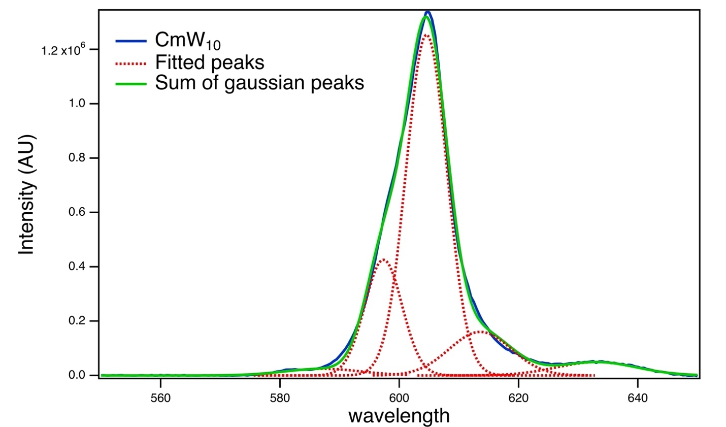
Figure 1. Deconvolution of Cm(W₅)₂ emission spectrum with five fitted Gaussian peaks at 582.6 nm, 598.0 nm, 604.6 nm, 613.6, and 633.6 nm. Lifetime measurements at 604 and 635 nm confirmed these spectral features come from the same Cm³⁺ species (lifetime = 780.5±5 µs at 604 nm and 787±5 µs at 635 nm).

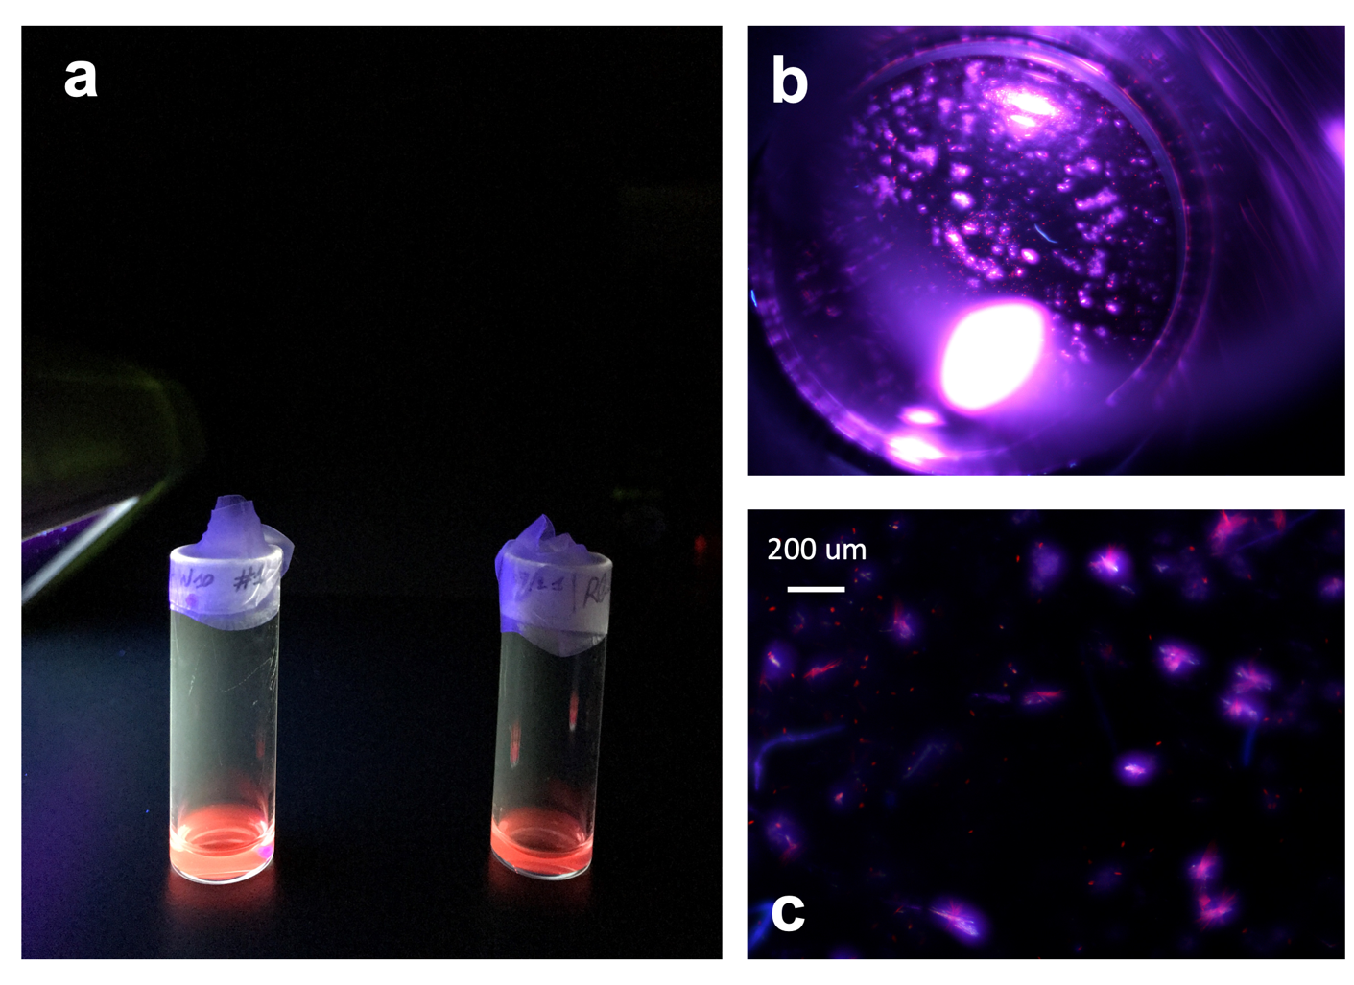
Figure 2. Pictures of Cs-Cm(W₅)₂ and Rb-Cm(W₅)₂ samples. a) Pictures of Cs-Cm(W₅)₂ (left) and Rb-Cm(W₅)₂ (right) in aqueous solution (under UV-light), before crystallization tests. b) Optical microscope picture of Cs-Cm(W₅)₂, and c) Rb-Cm(W₅)₂.

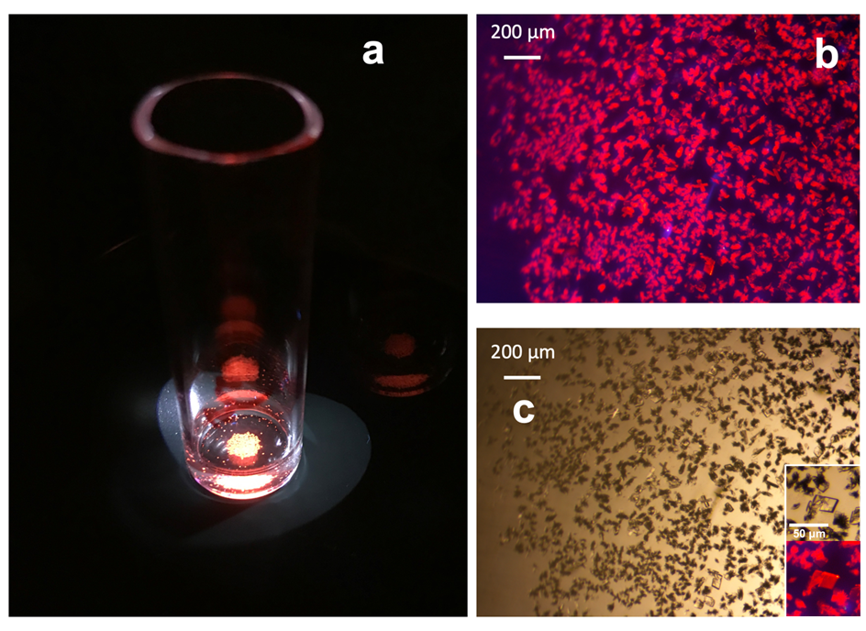Figure 3. Pictures of Cs-Cm(PW₁₁)₂ samples. a) the crystallization vial, b) Optical microscope picture of the crystals under UV-light, and c) under white light. Zoomed view in the bottom right corner. The luminescence of the crystals under UV light irradiation is due to the presence of Cm³⁺. Crystals are uncolored under ambient light.

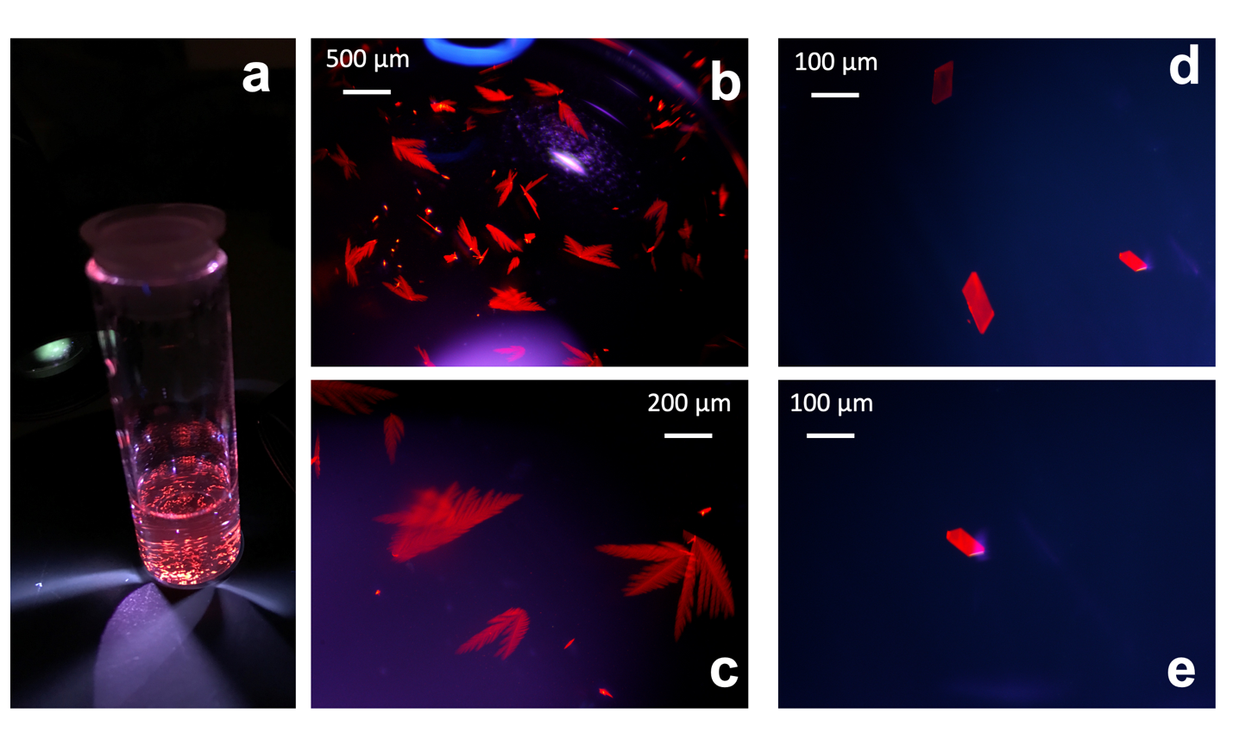
Figure 4. Pictures of Cs-Cm(BW₁₁)₂ samples. Images of Cm(BW₁₁)₂ a) the crystallization vial, b-c) Optical microscope picture of the crystals under UV-light following the first crystallization test, d-e) same test following redissolution of the crystals and recrystallization. The luminescence of the crystals under UV light irradiation is due to the presence of Cm³⁺. Crystals are uncolored under ambient light.

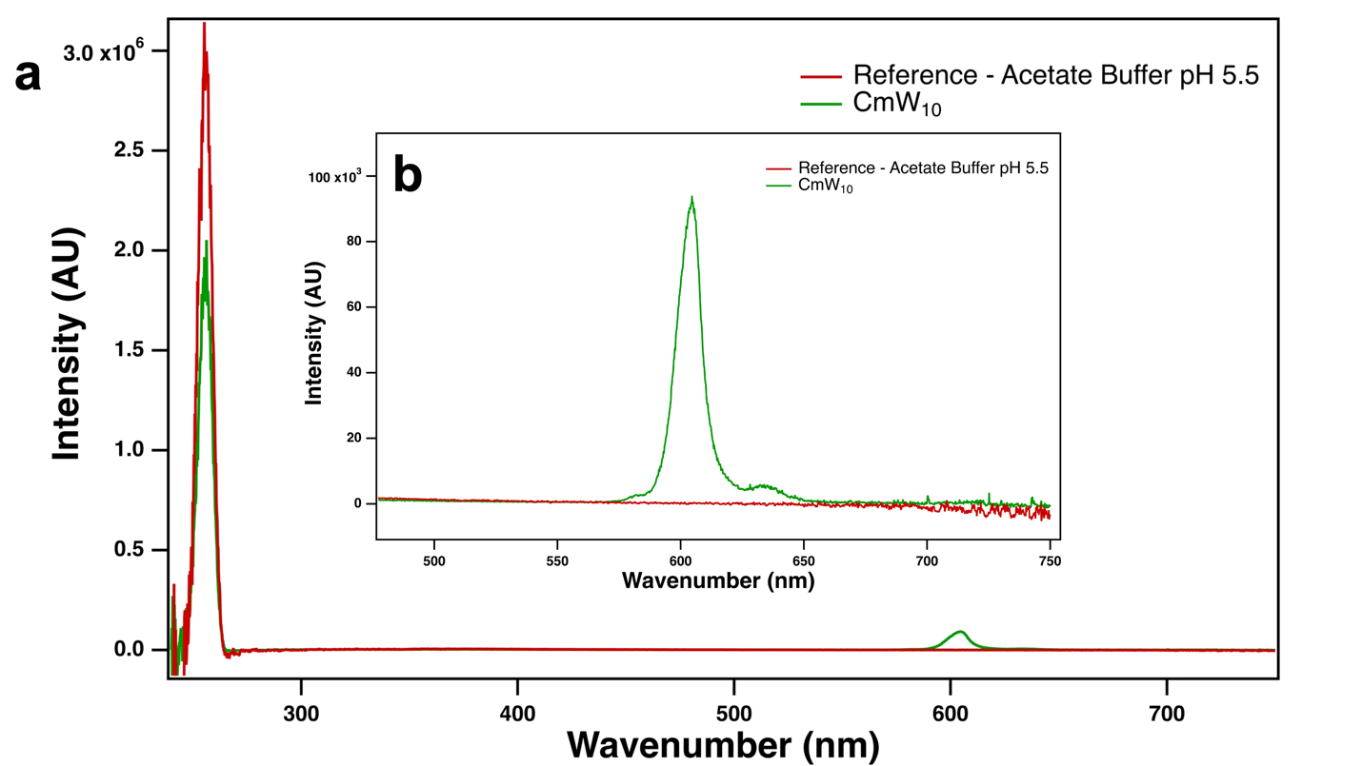
Figure 5. Solution-state quantum yield measurements of Cm(W₅)_{2.} a) full spectra, b) expanded view. Excitation at 250nm

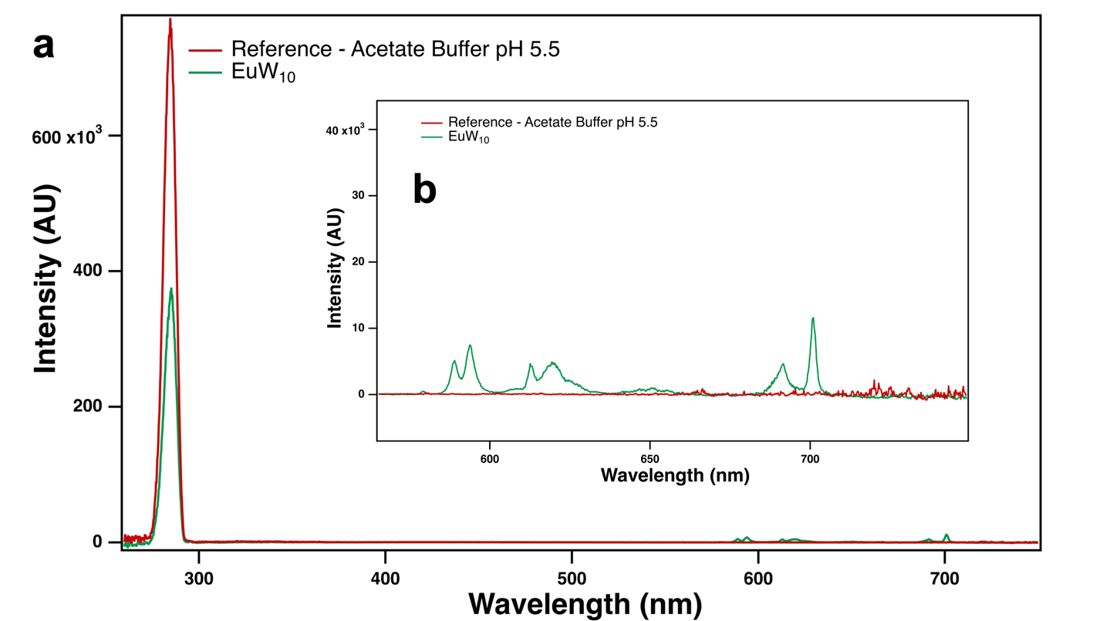
Figure 6. Solution-state quantum yield measurements of Eu(W₅)_{2.} a) full spectra, b) expanded view at 290 nm.
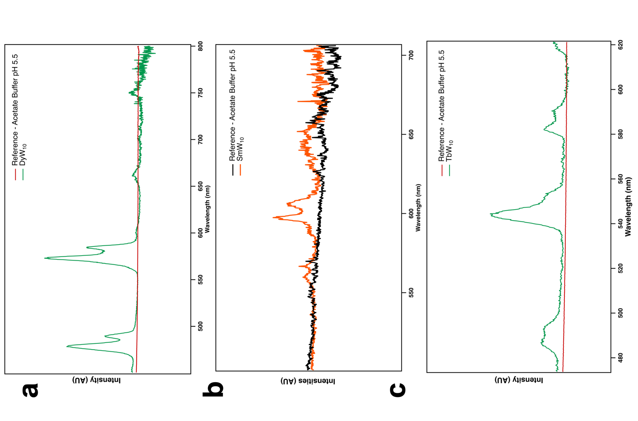
Figure 7. Solution-state quantum yield measurements of Ln(W₅)₂. a) Dy, b) Sm, and c) Tb), excitation at 290 nm.

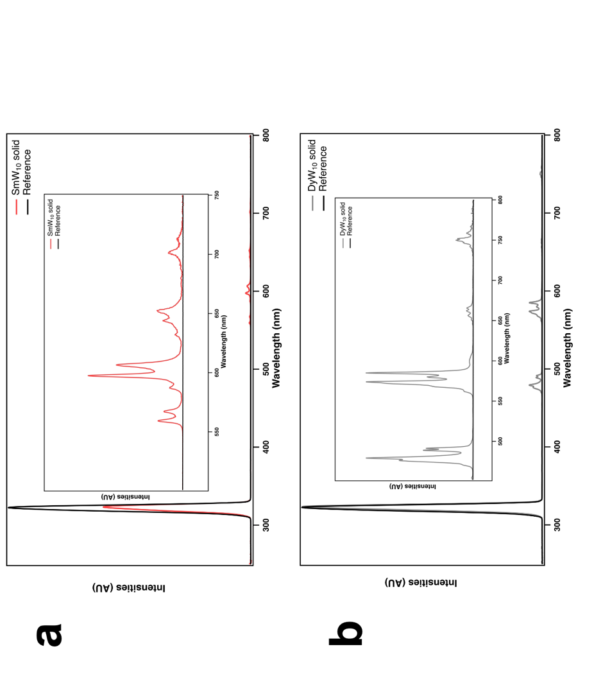
Figure 8. Solid-state quantum yield measurements of Ln(W₅)₂. a) Dy, b) Sm) excitation at 290nm.

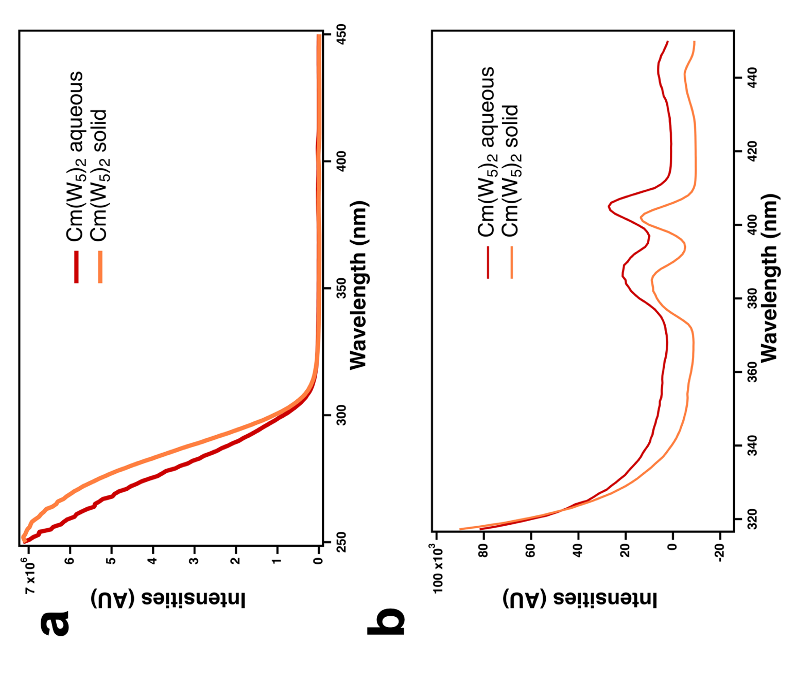
Figure 9. Excitation spectrum of Cm(W₅)₂ in solid-state and solution-state. Emission at 604 nm.

Table 2. Americium-POM complexes absorbance properties. See Fig. 3 in main manuscript for complete UV-vis absorbance spectra.

Species | λ_{max}  (nm) | epsilon  (mol⁻¹.L.cm⁻¹)
Free Am³⁺  in acetate buffer (pH 5.5) | 504.0 | 370
W₅
1:2 complex*  [Am(W₅O₁₈)₂]⁹⁻ | 511.6 | 483
PW₁₁
1:1 complex  [Am(PW₁₁O₃₉)]⁴⁻ | 509.4 | 404
1:2 complex  [Am(PW₁₁O₃₉)₂]¹¹⁻ | 515.6 | 609
BW₁₁
1:1 complex  [Am(BW₁₁O₃₉)]⁶⁻ | 508.6 | 400
1:2 complex  [Am(BW₁₁O₃₉)₂]¹⁵⁻ | 513.4 | 584
P₂W₁₇
1:1  [Am(P₂W₁₇O₆₁)]⁷⁻ | 509.7 | 351
1:2 complex  [Am(P₂W₁₇O₆₁)₂]¹⁷⁻ | 517.0 | 577
* The 1:1 complex with W₅ and actinide or lanthanide ions cannot be isolated.

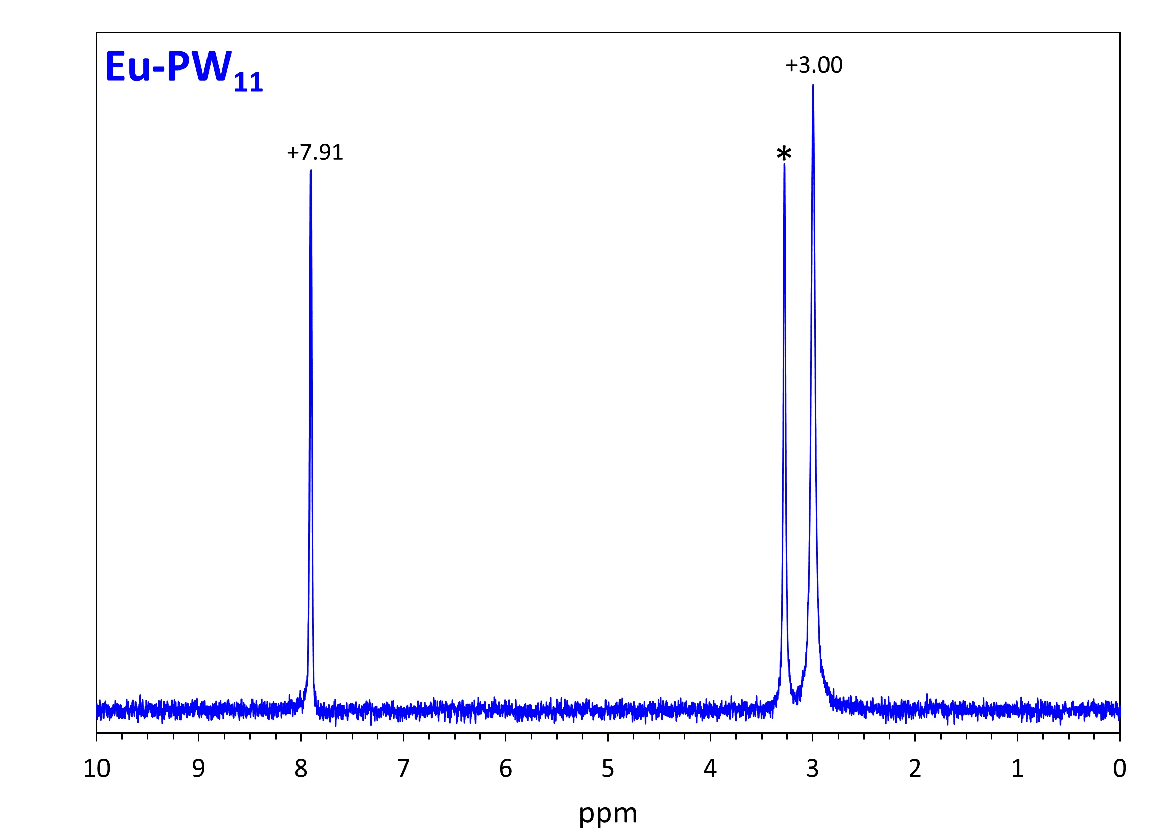

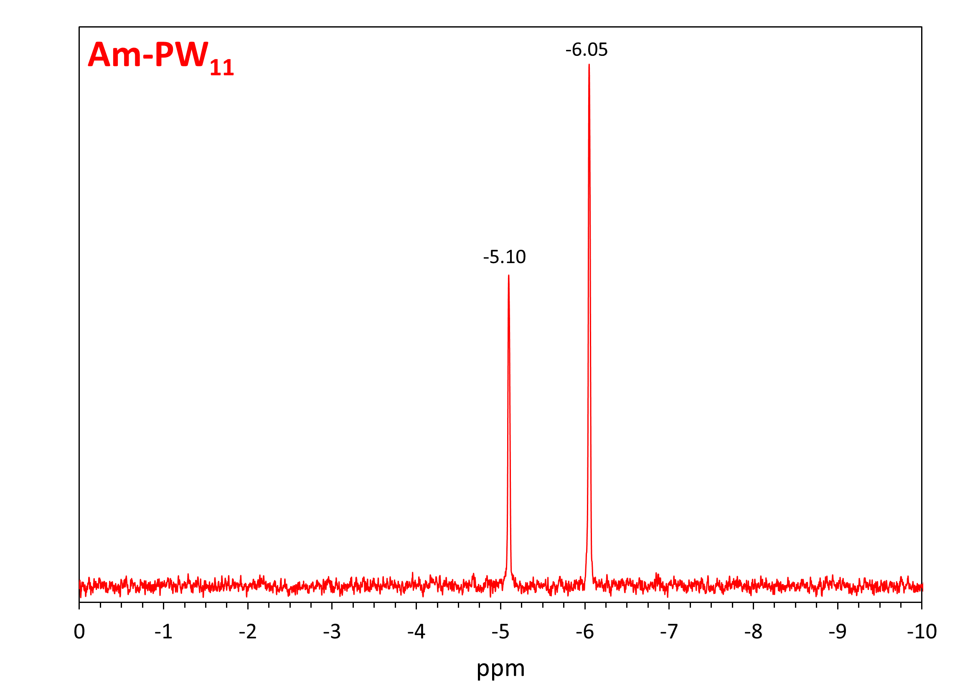
Figure 10. NMR ³¹P spectra measured for solutions of Eu-PW₁₁ and Am-PW₁₁ solutions.
Top: Eu-PW₁₁. Bottom: ²⁴³Am-PW₁₁. The presence of two NMR peaks supports the presence of two distinct complexes, i.e, [M^{III}(PW₁₁O₃₉)(H₂O)_{x}]⁴⁻ and [M^{III}(PW₁₁O₃₉)₂(H₂O)_{x}]¹¹⁻. The peak marked with a star is due to the phosphate buffer (pH = 5) used for this particular Eu sample. NMR shifts are externally referenced to H₃PO₄ (0 ppm). T = 25°C. Solvent: H₂O/D₂O (80/20). Ratio POM/M³⁺ = 2 Eq. Further details on the NMR properties of the Eu-PW₁₁ and ²⁴³Am-PW₁₁ systems will be published in a separate study. Solutions of the POM precursor, Na₉PW₉O₃₉•7H₂O, without metal and under similar conditions (pH 5, 0.1M sodium phosphate buffer) exhibit only one peak at -7.4 ppm.

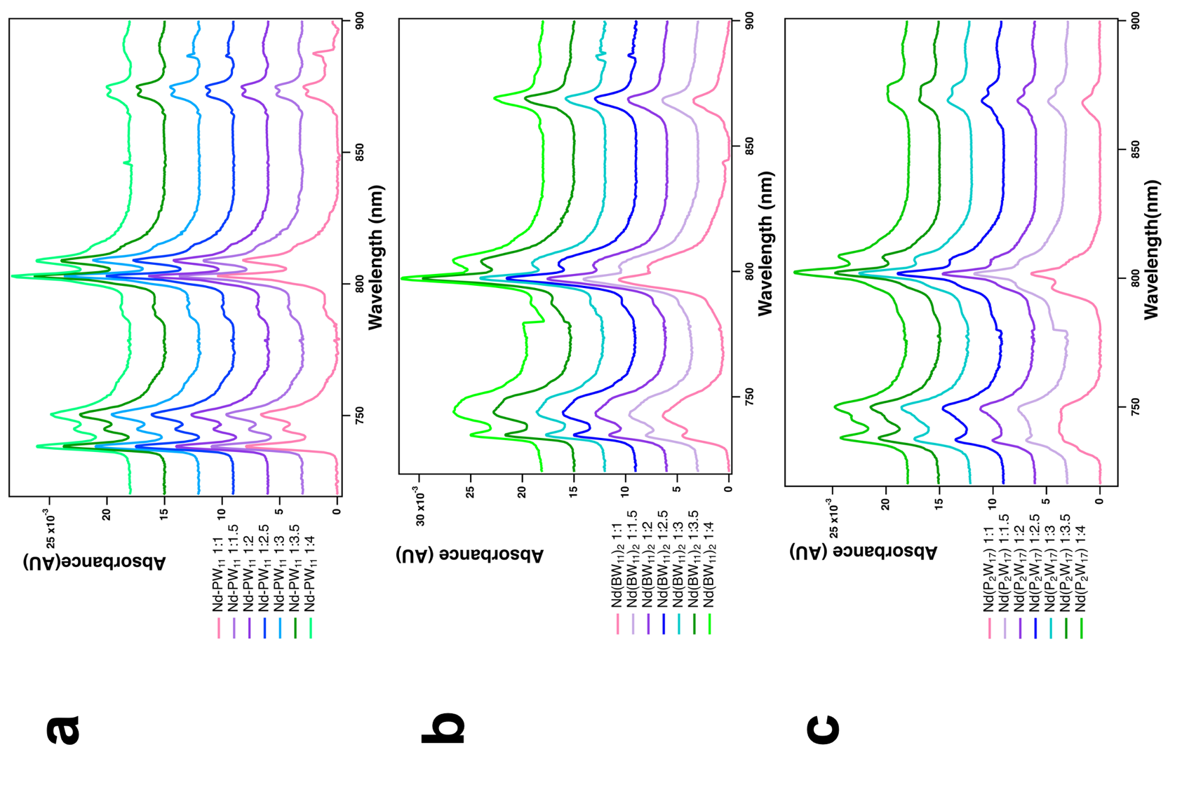
Figure 11. Nd-POM titration UV-VIS-NIR compilation a) PW₁₁, b) BW₁₁, c) P₂W₁₇

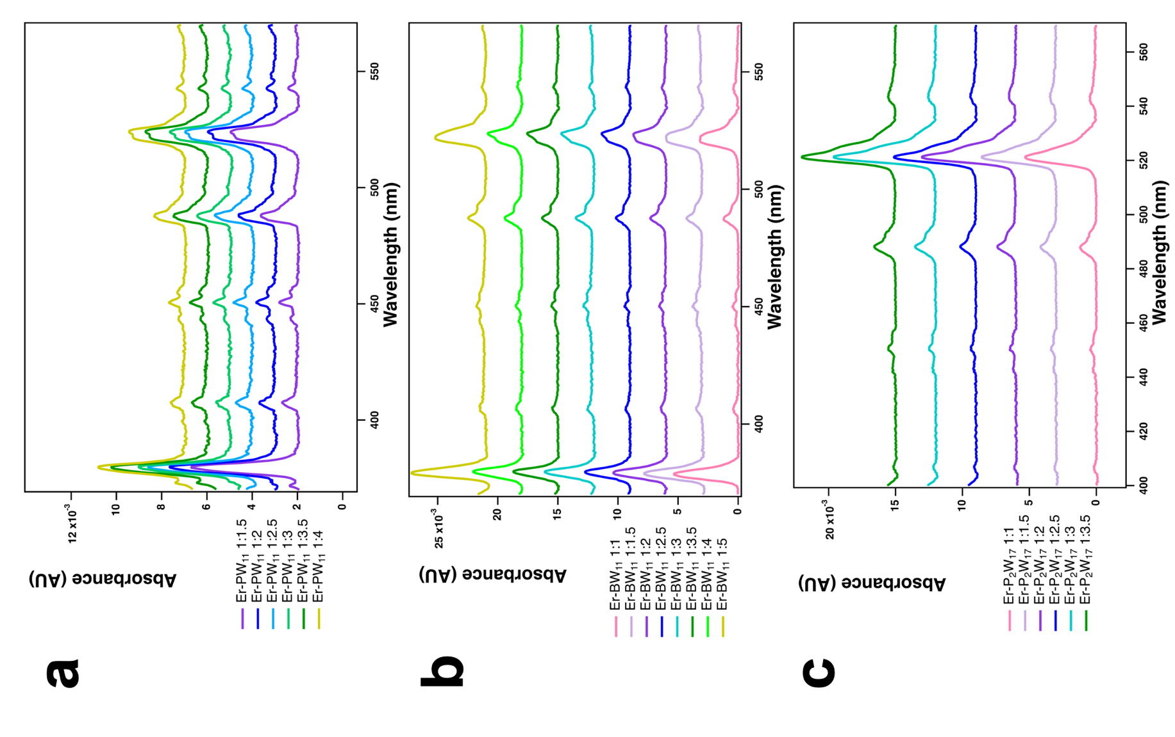
Figure 12. Er-POM titration UV-VIS compilation a) PW₁₁, b) BW₁₁, c) P₂W₁₇

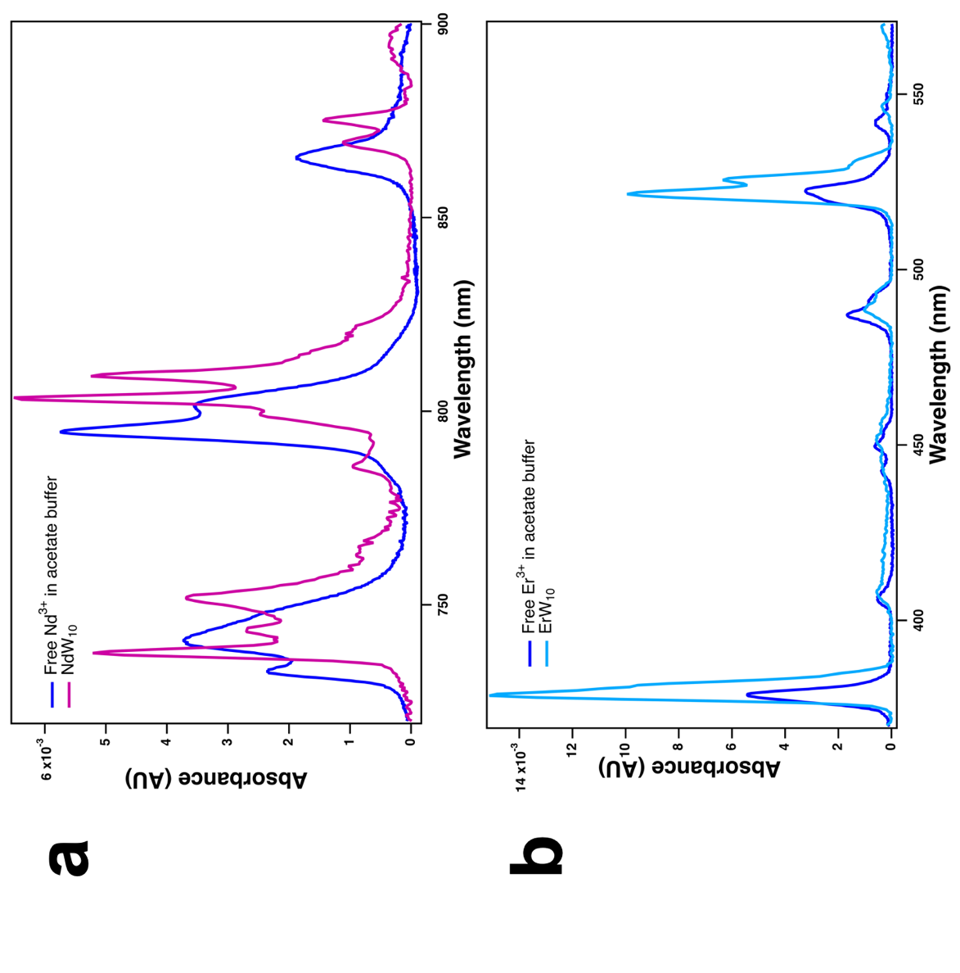
Figure 13. Lanthanide-W₅ titration UV-VIS-NIR compilation a) Nd(W₅)₂, and b) Er(W₅)₂.

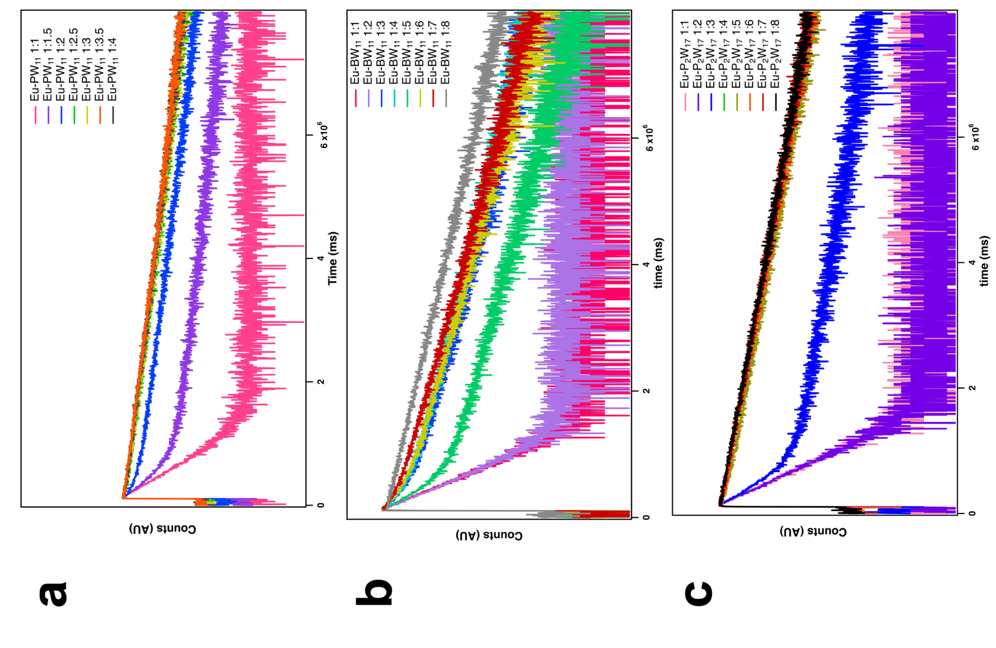
Figure 14. Lifetime decay measurements of Ln-POM solutions, at varied Eu:POM ratio. a) EuPW₁₁, b) EuBW₁₁, and c) EuP₂W₁₇, emission at 619 nm. Lifetime values are given in Tables S3.

Table 3. Eu-POM lifetime decay measurements in solution, as a function of the ratio POM:Eu, and in solid-state. Lifetimes are reported in µs. N₁ and N₂ are the numbers of water molecules calculated from Kimura’s equation.¹⁸
W₅ | T₁  (µs) | % | T₂  (µs) | % | Χ² | N₁ | N₂
Solution | 2385.22 | 100 | - | 0.97 | 0.00
Solid | 3051.36 | 100 | - | 1.08 | 0.10 | -
PW₁₁ | T₁ | % | T₂ | % | Χ² | N₁ | N₂
1:1 |  |  | 241.82 | 99.85 | 1.12 | 10.06 | 3.90
1.5:1 | 240.53 | 28.25 | 3030.57 | 71.75 | 1.07 | 3.93 | 0.09
2:1 |  |  | 3247.07 | 99.09 | 1.08 | 3.94 | 0.12
2.5:1 |  |  | 33139.36 | 99.95 | 1.03 | 6.78 | 0.41
3:1 |  |  | 3188.15 | 99.62 | 1.08 | 3.76 | 0.11
3.5:1 |  |  | 3148.16 | 99.79 | 1.06 | 1.85 | 0.11
4:1 |  |  | 3182.80 | 99.65 | 1.14 | 0.61 | 0.11
5:1 | 2990.46 | 100 | - | - | 1.05 | -0.09 | -
Solid | 3009.77 | 100 | - | 1.04 | 0.09 | -
BW₁₁ | T₁ | % | T₂ | % | Χ² | N₁ | N₂
1:1 | 226.84 | 100 | - | - | 1.17 | 4.19 | -
1.5:1 | 236.18 | 100 | - | - | 1.02 | 4.01 | -
2:1 | 229.16 | 100 | - | - | 1.20 | 4.14 | -
2.5:1 | 245.31 | 100 | - | - | 1.11 | 3.84 | -
3:1 | 240.45 | 9.84 | 1918.06 | 90.16 | 1.09 | 3.93 | 0.11
3.5:1 | 230.43 | 7.85 | 1955.58 | 92.15 | 1.09 | 4.12 | 0.10
4:1 | 229.96 | 8.06 | 2158.02 | 91.94 | 1.07 | 4.13 | 0.05
5:1 | 241.01 | 29.33 | 2011.51 | 70.67 | 1.06 | 3.92 | 0.08
6:1 | 255.05 | 8.39 | 1990.29 | 91.61 | 1,06 | 3.68 | 0.09
7:1 | 226.72 | 3.70 | 1971.69 | 96.30 | 1.07 | 4.19 | 0.09
8:1 | 2378.20 | 100 | - | - | 1.08 | 0.00 | -
P₂W₁₇ | T₁ | % | T₂ | % | Χ² | N₁ | N₂
1:1 | 235.78 | 100 | - | - | 1.08 | 4.01 | -
1.5:1 | 235.30 | 100 | - | - | 1.14 | 4.02 | -
2:1 | 237.02 | 100 | - | - | 1.03 | 3.99 | -
2.5:1 | 236.52 | 82.59 | 2023.16 | 17.41 | 1.29 | 4.00 | 0.08
3:1 | 236.28 | 36.32 | 2798.57 | 63.68 | 1.08 | 4.00 | 0.06
3.5:1 | 236.29 | 33.42 | 2789.57 | 66.58 | 1.08 | 4.00 | 0.06
4:1 | 278.93 | 1.34 | 2767.02 | 98.66 | 1.07 | 3.32 | 0.06
5:1 | 278.00 | 1.33 | 2767.02 | 98.67 | 1.07 | 3.34 | 0.06
6:1 | 2000.00 | 5.16 | 2768.32 | 94.84 | 1.06 | 0.09 | 0.06
7:1 | 2757.43 | 100 | - | - | 1.08 | -0.06 | -
8:1 | 2775.62 | 100 | - | - | 1.04 | -0.06 | -

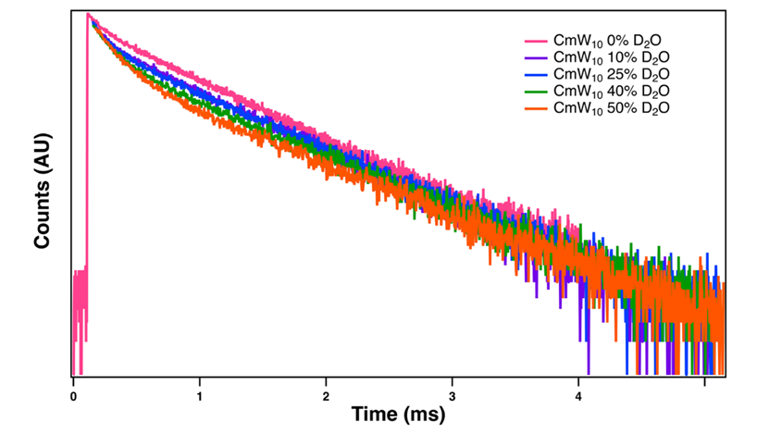
Figure 15. Lifetime decay curves of Cm(W₅)₂ in H₂O/D₂O mixtures.
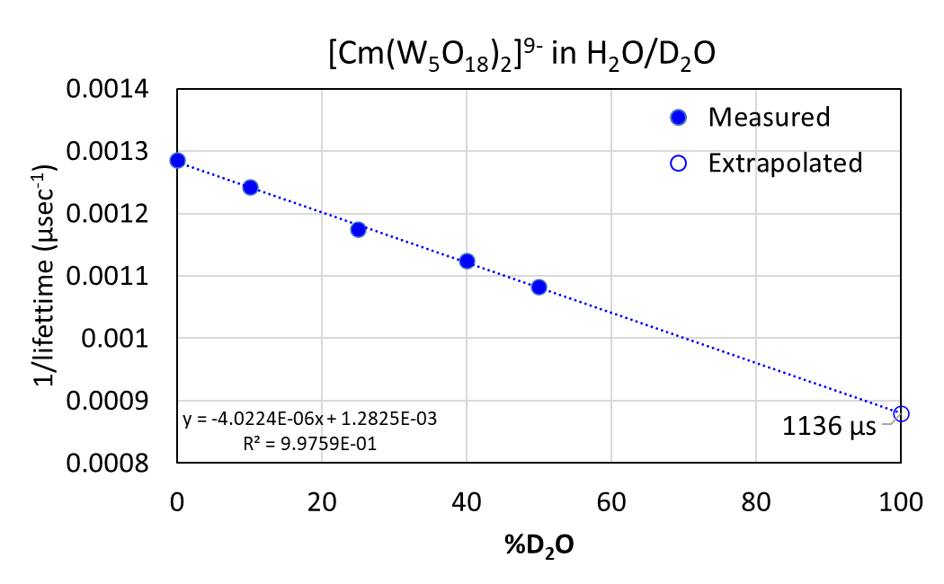
Figure 16. Luminescence lifetime of Cm(W₅)₂ in H₂O/D₂O mixtures and extrapolation to pure D₂O. The experimentally determined lifetime values are as follows: 778 µs (0% D₂O), 805 µs (10% D₂O), 851 µs (25% D₂O), 889 µs (40% D₂O), and 924 µs (50% D₂O). The extrapolated value in 100% D₂O is 1136 µs.

Table 4. Lifetime decay measurements for curium(III)-POM solutions as a function of the ratio POM:Cm.
PW₁₁ | T₁  (µs) | % | Χ² | N₁
1:1 | 88.23 | 100 | 0.93 | 6.50
1.5:1 | 86.85 | 100 | 0.80 | 6.61
2:1 | 86.62 | 100 | 0.77 | 6.63
2.5:1 | 85.62 | 100 | 0.81 | 6.71
3:1 | 84.62 | 100 | 0.77 | 6.79
3.5:1 | 84.13 | 100 | 0.76 | 6.83
4:1 | 85.00 | 100 | 0.83 | 6.76
5:1 | 83.71 | 100 | 0.46 | 6.87
6:1 | 80.92 | 100 | 0.44 | 7.12
7:1 | 79.89 | 100 | 0.72 | 7.22
8:1 | 77.99 | 100 | 0.41 | 7.41
BW₁₁ | T₁ (µs) | % | Χ² | N₁
1:1 | 75.94 | 100 | 1.01 | 7.62
1.5:1 | 85.70 | 100 | 1.14 | 6.70
2:1 | 89.92 | 100 | 1.07 | 6.37
2.5:1 | 94.82 | 100 | 1.17 | 6.01
3:1 | 94.25 | 100 | 1.04 | 6.05
3.5:1 | 97.87 | 100 | 1.21 | 5.81
4:1 | 96.60 | 100 | 1.04 | 5.90
5:1 | 97.51 | 100 | 0.81 | 5.84
6:1 | 97.01 | 76.95 | 0.80 | 5.87
7:1 | 96.65 | 82.59 | 0.79 | 5.89
8:1 | 95.69 | 88.71 | 0.78 | 5.96
P₂W₁₇ | T₁ (µs) | % | Χ² | N₁
1:1 | 86.54 | 100 | 0.88 | 6.63
1.5:1 | 85.66 | 100 | 0.85 | 6.70
2:1 | 86.12 | 100 | 0.88 | 6.67
2.5:1 | 85.05 | 100 | 0.94 | 6.76
3:1 | 83.38 | 100 | 0.77 | 6.90
3.5:1 | 84.34 | 100 | 0.87 | 6.82
4:1 | 82.49 | 100 | 0.79 | 6.98
5:1 | 83.39 | 100 | 0.78 | 6.90
6:1 | 82.46 | 100 | 0.80 | 6.98
7:1 | 81.15 | 100 | 0.83 | 7.10
8:1 | 80.64 | 100 | 0.96 | 7.15
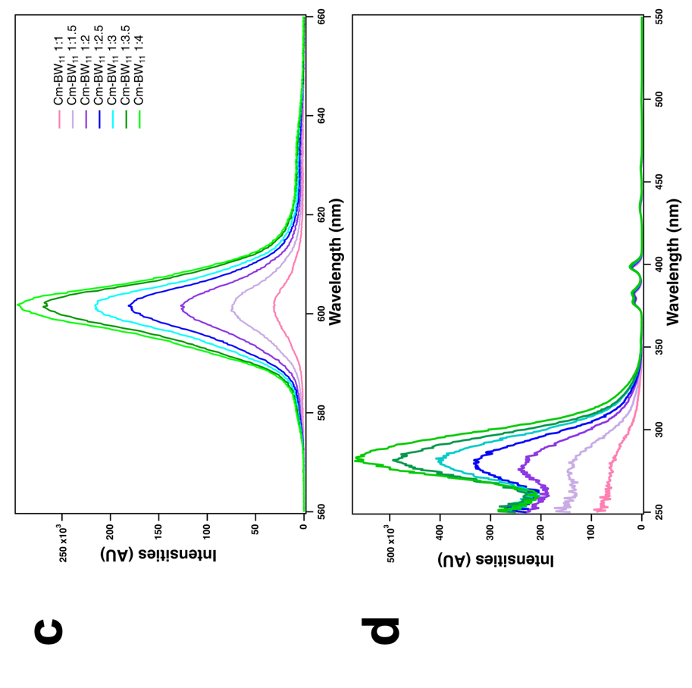
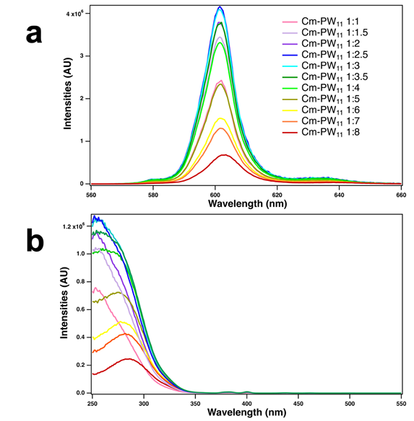
Figure 17. Curium-PW₁₁ and curium-BW₁₁ emission and excitation compilation a) emission CmPW₁₁, b) excitation CmPW₁₁, c) emission CmBW₁₁, and d) excitation CmBW_{11.}

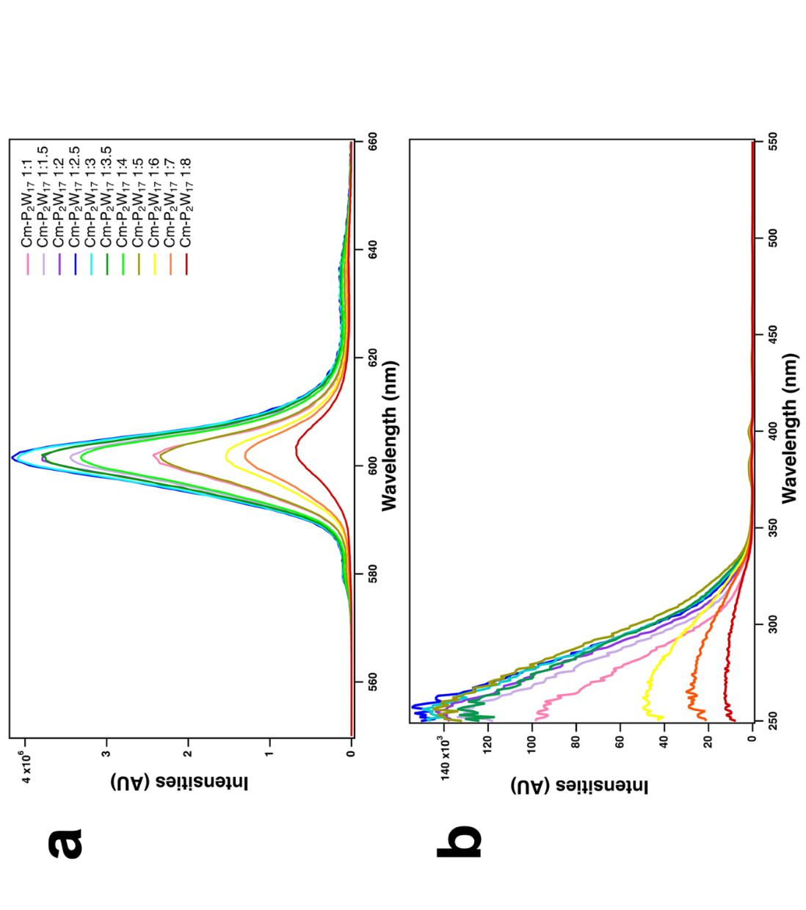
Figure 18. Curium-P₂W₁₇ titration emission and excitation compilation a) Cm-P₂W₁₇ emission, b) Cm-P₂W₁₇ excitation.

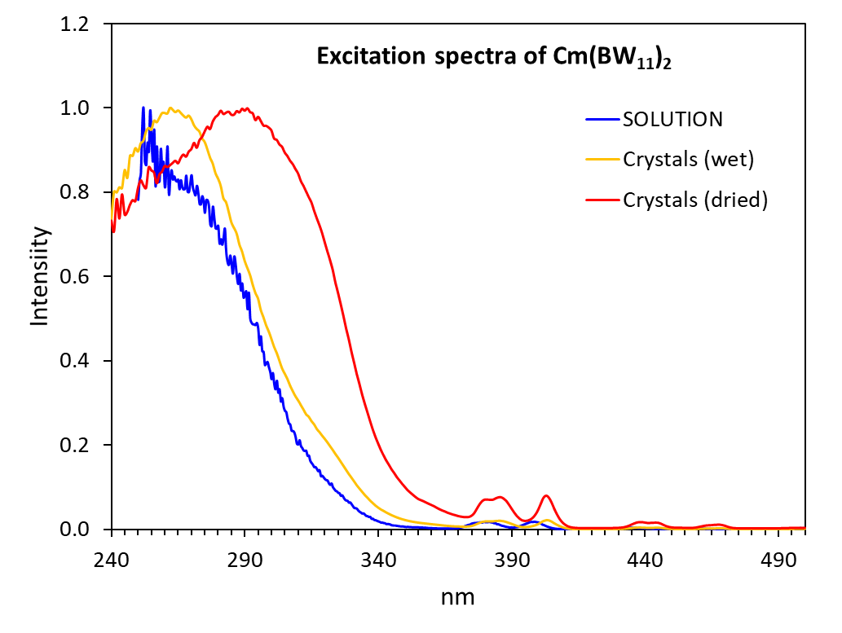
Figure 19. Change in the excitation spectrum of Cm(BW₁₁)₂ in aqueous solution versus solid-state. Emission at 610 nm. Corresponding emission spectra are given in Fig. 5c.

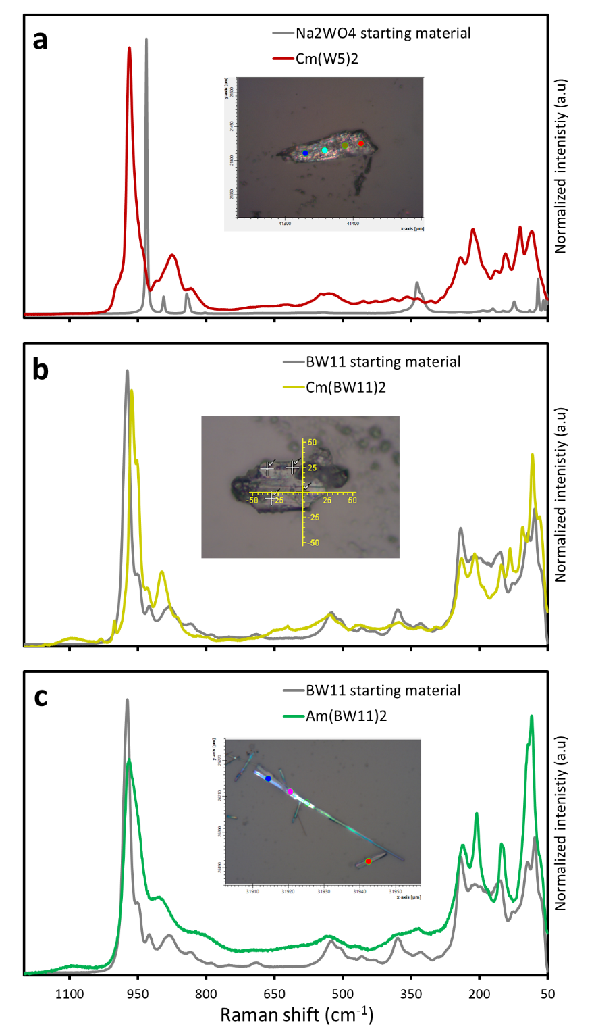
Figure 20. Raman spectra of Cm(W₅)₂, Cm(BW₁₁)₂, and Am(BW₁₁)₂ complexes obtained and corresponding starting materials. The pictures are examples of the actinide-POM crystals analyzed by Raman microscopy (scale in µm). Data for solid compounds. a) Cm(W₅)₂ = Rb₉[Cm(W₅O₁₈)₂]•nH₂O. b) Cm(BW₁₁)₂ = Cs₁₃H₂Cm(BW₁₁O₃₉)₂‧13H₂O. c) Am(BW₁₁)₂ = Cs₁₃H₂Am(BW₁₁O₃₉)₂‧nH₂O (formulated based on spectral identification and by analogy to the corresponding Cm(BW₁₁)₂ compound).
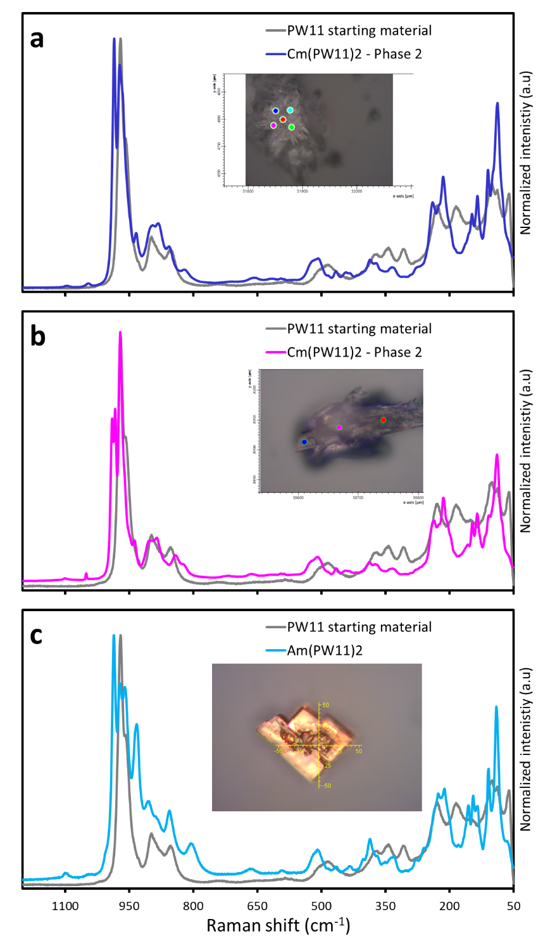
Figure 21. Raman spectra of Cm-PW₁₁ and Am(BW₁₁)₂ complexes obtained and corresponding starting materials. The pictures are examples of the actinide-POM crystals analyzed by Raman microscopy (scale in µm). Data for solid compounds. a) Cs₁₁Cm(α-PW₁₁O₃₉)₂‧18H₂O. b) Cs₁₁Cm(β-PW₁₁O₃₉)₂‧31.5H₂O. c) Am(α-PW₁₁)₂ = Cs₁₁Am(α-PW₁₁O₃₉)₂‧nH₂O (formulated based on spectral identification and by analogy to the corresponding Cm(PW₁₁)₂-α compound).

Table 5. Compilation of fluorescence lifetimes reported for curium(III) complexes in aqueous solution. The data is plotted in Fig. 5a. See main text. *H₂O omitted for clarity.
Species* | Lifetime in H₂O ( in microseconds) | Ref.
Cm(III) in 1.1 M NaHClO₄ | 67 | ¹⁹
Cm(III) in 0.001M HClO₄ | 67 | ²⁰
Cm(III) in 0.1M HClO₄ | 68 | ²¹
[CmCO₃]⁺ | 70 | ²²
Cm(III) in 0.1M NaHCO₃ | 70 | ²¹
[CmH₂PO₄]²⁺ | 73 | ¹⁹
Cm-SiW₁₁O₃₉⁻ in 0.1M HNO₃ | 75 | ²³
[Cm(PW₁₁O₃₉)₂]¹¹⁻ in solution (pH 5.5) | 87 | This work
[Cm(BW₁₁O₃₉)₂]¹⁵⁻ in solution (pH 5.5) | 90 | This work
[Cm(P₂W₁₇O₆₁)₂]¹¹⁻ (in solution pH 5.5) | 87 | This work
[CmH₂DFOB]²⁺ | 85 | ²⁴
[CmSO₄]⁺ | 88 | ²⁵
[Cm(SO₄)₂]⁻ | 95 | ²⁵
[CmPW₁₁O₃₉]⁴⁻ in 0.1M HNO3 | 95 | ²³
[Cm(CO₃)₂]⁻ | 100 | ²²
[CmCDTA]⁻ | 115 | ²¹
[CmHDFOB]⁺ | 123 | ²⁴
[CmEDTA]⁻ | 126 | ²¹
[Cm(CO₃)₃]³⁻ | 130 | ²²
Cm(III) in 0.1M Na₂CO₃ | 141 | ²¹
[Cm(Citrate)₂]⁵⁻ | 155 | ²⁶
Cm(III) in 1M Na₂CO₃ | 160 | ²¹
[Cm(SO₃-Ph-BTBP)₂]⁵⁻ | 173 | ²⁷
[Cm(SO₄)₃]⁻ | 195 | ²⁵
Cm(III)-Calmodulin | 195 | ²⁸
Cm₂Transferrin | 206 | ²⁹
Cm₃Lanmodulin | 208 | ³⁰
Cm(III)-transferrin/2N | 217 | ³¹
CmDOTHOPO | 221 | ³²
[CmDTPA]²⁻ | 223 | ³³
[CmHPyoverdin]⁻ | 229 | ³⁴
[Cm(CO₃)₄]⁵⁻ | 230 | ²²
Cm(III) in 3M K₂CO₃ | 240 | ²¹
[CmDTPA]²⁻ | 271 | ²¹
[CmDFOB] | 320 | ²⁴
[CmPyoverdin]⁻ | 330 | ³⁴
[Cm(343-LI-1,2-HOPO)]⁻ | 383 | ³⁵
[Cm(PTD)₃]³⁺ in HNO₃ | 498 | ³⁶
[Cm(PTD)₃]³⁺ in HClO₄ | 546 | ³⁶
[CmW₁₀O₃₆]⁹⁻ | 780 | This work
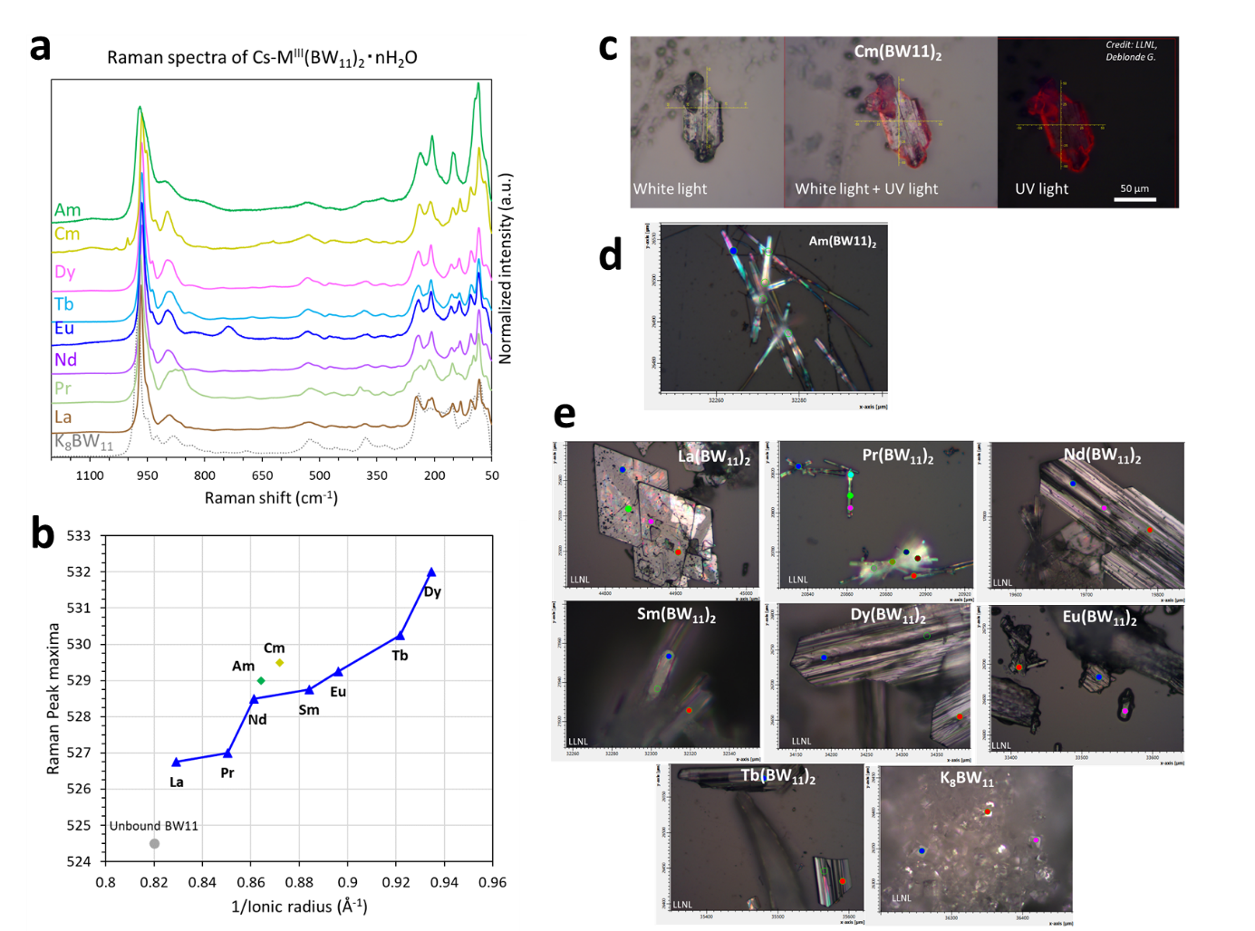
Figure 22. Identification of Cm-BW₁₁ and Am-BW₁₁ via Raman microscopy and comparison with the corresponding lanthanide compounds. a) Raman spectra of the M^{III}(BW₁₁)₂ crystals synthesized (M = Am, Cm, Dy, Tb, Eu, Nd, Pr, La) and comparison with the unbound BW₁₁ salt (HK₈BW₁₁O₃₉•13H₂O, starting material). b) Trend observed for the Raman peak at ~530 nm along the f-element series. c) Pictures of a crystal of Cs₁₃H₂Cm(BW₁₁O₃₉)₂‧13H₂O, as seen through the Raman microscope (objective x20, CCD camera), under regular illumination and illumination with a UV lamp (365 nm). d) Pictures of crystals of americium(III)-BW₁₁ crystals. e) Pictures of the corresponding lanthanide(III)-BW₁₁ crystals.

a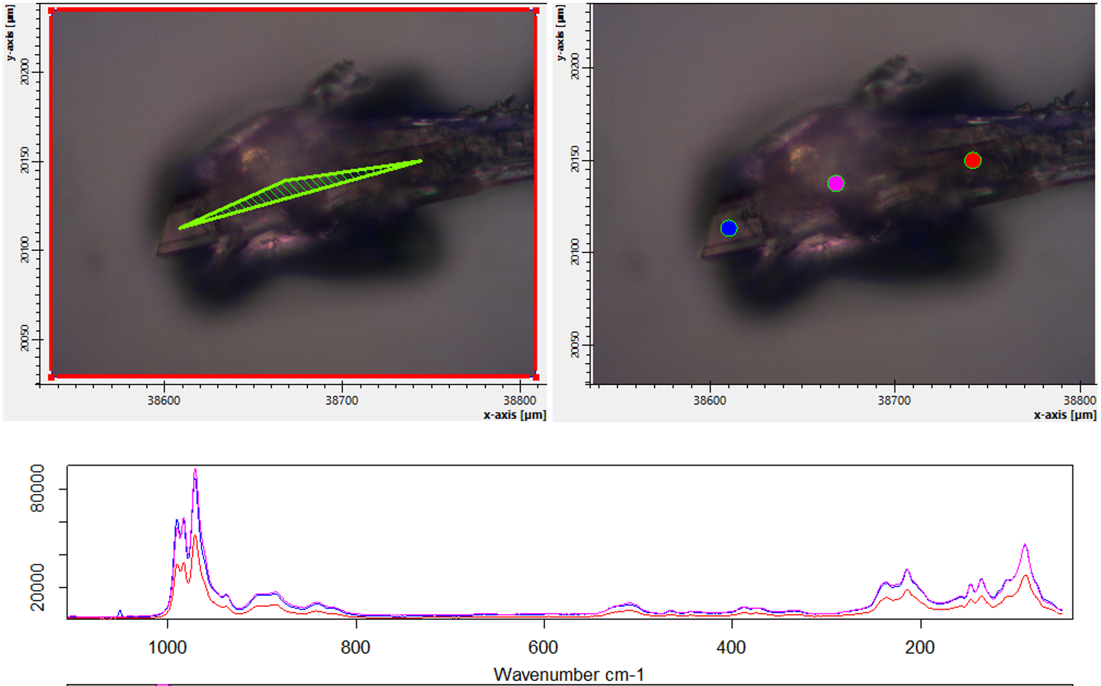
b 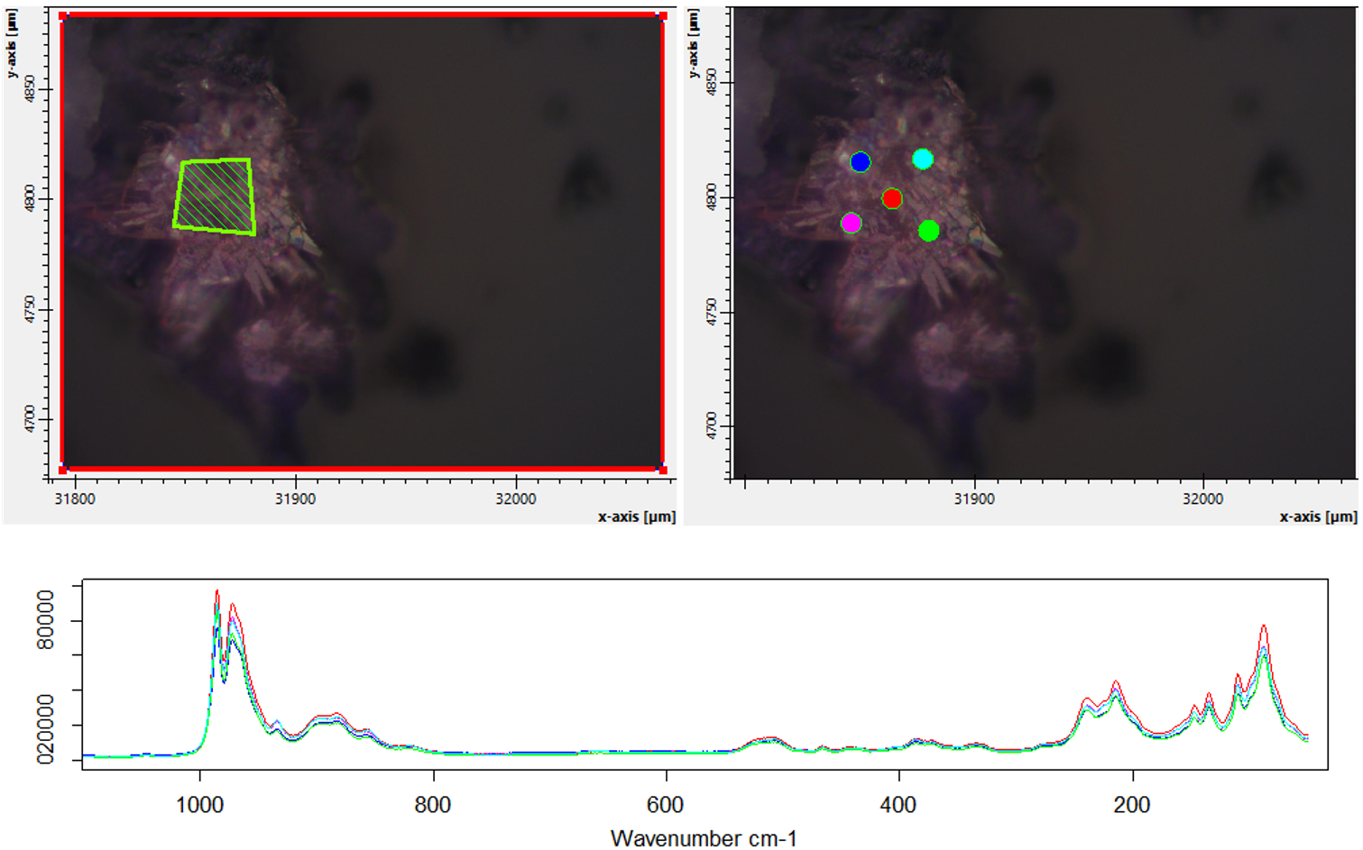
c 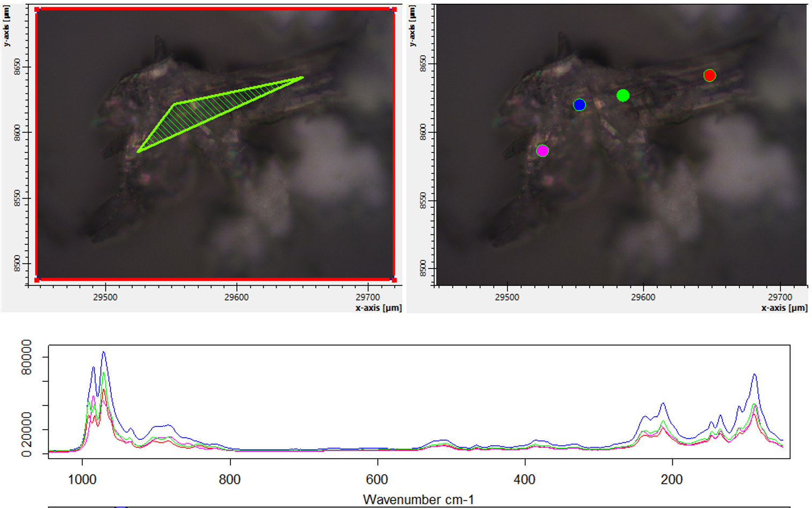
Figure 23. Raman microscopy analysis of Cm-PW₁₁-Cs crystals, showing the presence of two phases (alpha and beta). a) crystals containing the first phase. b) crystals containing the second phase. c) crystal aggregate containing both phases.

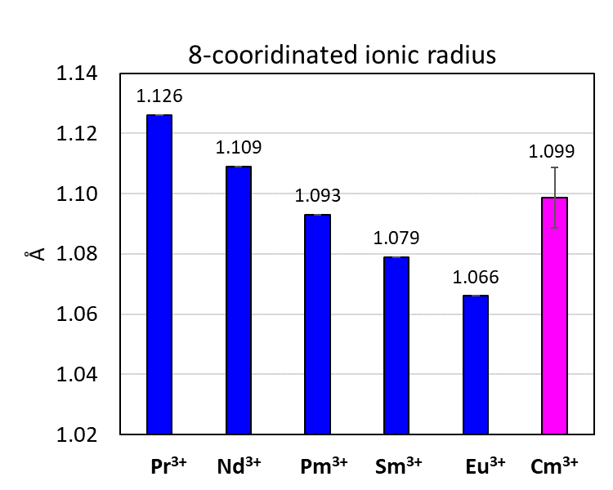

Figure 24. Eight-coordinated ionic radius of Cm³⁺ (pink bar) based on the experimentally determined SCXRD structures of Cm-PW₁₁-alpha, Cm-BW₁₁, and six analogous SCXRD structures with lanthanide ions (Nd-PW₁₁-alpha, Sm-PW₁₁-alpha, Eu-PW₁₁-alpha, Nd-BW₁₁, Sm-BW₁₁, and Eu-BW₁₁). All 8 structures are reported in the present study (CCDC numbers: 2105534, 2114774, 2105623, 2127432, 2105638, 2127430, 2127431, 2114775). The blue bars correspond to the 8-coordinated ionic radius for the Pr³⁺, Nd³⁺, Pm³⁺ Sm³⁺, and Eu³⁺ reported in Shannon’s seminal publication.³⁷ Based on the metal-oxygen distances observed in the six Ln-POM structures (3 Ln-PW₁₁-alpha + 3 Ln-BW₁₁), and the Ln³⁺ ionic radius reported by Shannon, the average oxygen radius in these structures is 1.336 Å for the three Ln-PW₁₁-alpha, and 1.337 Å for the three Ln-BW₁₁ structures. Given the average curium-oxygen bond distances determined for Cm-PW₁₁-alpha and Cm-BW₁₁ (2.442 and 2.427 Å), we estimate the ionic radius of the 8-coordinated Cm³⁺ to be 1.099±0.010 Å.

Crystallographic studies
The Ln-POM structures were collected using Rigaku Oxford SynergyS equipped with a PhotonJet S Cu source (λ=1.54178 Å) and hyPix-6000HE photon counting detector. All images were collected and processed using CrysAlis^{Pro} Version 171.40_64.53 (Rigaku Oxford Diffraction, 2018)³⁸ (1). The Cm-POM structures were collected in one of LLNL’s radiochemistry laboratories using a Rigaku Synergy Custom single crystal diffractometer, equipped with a kappa goniometer and using Mo Kα radiation (λ = 0.70932 Å) with a FWHM of ~200 μm at the sample from a MicroMax-007 HF microfocus rotating anode source. Images were recorded on a Dectris Pilatus 3R (300K – CdTe) detector and processed using CrysAlis^{Pro}. After integration both analytical absorption and empirical absorption (spherical harmonic, image scaling, detector scaling) corrections were applied³⁹. All structures were solved by Intrinsic Phasing method from SHELXT program⁴⁰, developed by successive difference Fourier syntheses, and refined by full-matrix least square on all F² data using SHELX⁴¹ via OLEX2 interface⁴².
Crystallographic information for the six reported structures can be obtained free of charge from the Cambridge Crystallographic Data Center (https://www.ccdc.cam.ac.uk/) upon referencing CCDC numbers in the crystallographic tables below.

Notes on crystal structures, refinement, modeling of disorder, and solvent void space
Due to safety protocol any curium containing crystals were collected under the MicroRT Capillaries 37 mm. Although, x-ray transparent at certain angles the background intensity increased resulting in poor signal-to-noise ratio, resulting in the use of some restraints.
As such two main A-alerts appear consistently across the structures. The first being “PLAT910_ALERT_3_B Missing # of FCF Reflection(s) Below Theta(Min)”. The low intensity of these reflections is attributed to the safety features required to collect SCXRD data on transuranic samples. The second common alert is “PLAT972_ALERT_2_A”, this alert is attributed to the high x-ray absorption of the structures that result in relatively high residual Q-peaks near heavy atoms. Absorption correction was performed using Empirical absorption correction applied before frame scaling. Several other methods were employed before ultimately using a combination of Analytical absorption correction and “Mutli-scan” using the Scale3 Abspack.⁴¹ Resulting R_{int} after absorption correction dropped for each structure by approximately 3%. Nevertheless, large residual electron density less than 1 Å away from the tungsten atoms remained.

Additionally, some crystals exhibit solvent accessible void-space, where a solvent mask was applied to calculate the electron density and this the number of disordered water molecules that could not be individually refined. In each case, the electron count was in good agreement with the solvent accessible void volume, assuming 30 - 40 Å³ per water molecule ^{43–45}. As such the electron count was used to describe the solvent mask. Any residual q-peaks are from after the application of the solvent mask.

Furthermore, individual hydrogen atoms could not be refined, as such they have been omitted in the reported molecular weight. Individual cases are discussed below.

Structure description:
Briefly, the parent Keggin structure, (PW₁₂O₄₀)³⁻ of which PW₁₁ is derived is comprised of a central tetrahedral PO₄ (or BO₄ for BW₁₁) caged by 12 octahedral WO₆ units linked to one another by the neighboring oxygen atoms (Fig. 6). Another view is by considering four sets of W₃O₁₃ trimers linked to one another. The isomeric nature of the Keggin structure comes from these trimers, were each on can be rotated by 60° leading to five potential isomers (Fig. 6b-c).

Detailed crystallographic information on the eight lanthanide-POM single crystal XRD structures reported in this work.

Table 6– part 1/2. Crystallographic information of Ln-POMs.
Identification code | NdBW₁₁ | SmBW₁₁ | NdPW₁₁ | SmPW₁₁
CCDC Number | 2127430 | 2127431 | 2105623 | 2127432
Molecular formula | H₂Cs₁₃Nd(BW₁₁O₃₉)₂  •11H₂O | H₂KCs₁₂Sm(BW₁₁O₃₉)₂  •12H₂O | Na₃Cs₈Nd(PW₁₁O₃₉)₂  •8.5H₂O | Cs₁₁Sm(PW₁₁O₃₉)₂  •5H₂O
Empirical formula | B₂Cs₁₃NdO₈₉W₂₂ | B₂Cs₁₂KO₉₀SmW₂₂ | Cs₁₆Na₆Nd₂O₁₇₃P₄W₄₄ | Cs₂₂O₁₆₆P₄Sm₂W₄₄
Formula weight | 7362.39 | 7290.69 | 13534.26 | 14094
Temperature/K | 124.8(3) | 173.00(10) | 173.00(10) | 173.15
Crystal system | triclinic | monoclinic | triclinic | triclinic
Space group | P-1 | P2₁/n | P-1 | P-1
a/Å | 13.0816(3) | 19.7019(2) | 13.0224(3) | 12.0721(3)
b/Å | 19.4910(4) | 12.95143(14) | 17.8257(4) | 19.6030(4)
c/Å | 20.9632(3) | 38.0267(4) | 22.0115(4) | 21.8204(4)
α/° | 87.784(2) | 90 | 94.692(2) | 113.6283(19)
β/° | 85.704(2) | 98.3190(10) | 102.686(2) | 95.1193(18)
γ/° | 88.108(2) | 90 | 104.340(2) | 97.8597(19)
Volume/Å³ | 5323.62(18) | 9601.10(18) | 4779.16(19) | 4627.05(19)
Z | 2 | 4 | 1 | 1
ρ_{calc}g/cm³ | 4.593 | 5.044 | 4.703 | 5.058
μ/mm⁻¹ | 81.243 | 88.05 | 76.284 | 88.159
F(000) | 6250 | 12396 | 5766 | 5978
Crystal size/mm³ | 0.264 × 0.074 × 0.043 | 0.174 × 0.095 × 0.034 | 0.112 × 0.057 × 0.027 | 0.02 × 0.01 × 0.01
Radiation | CuKα (λ = 1.54184) | Cu Kα (λ = 1.54184) | CuKα (λ = 1.54184) | CuKα (λ = 1.54184)
2Θ range for data collection/° | 4.23 to 154.194 | 4.696 to 153.352 | 4.158 to 133.202 | 4.476 to 103.548
Index ranges | -16 ≤ h ≤ 12, -24 ≤ k ≤ 24, -26 ≤ l ≤ 25 | -24 ≤ h ≤ 23, -8 ≤ k ≤ 16, -42 ≤ l ≤ 47 | -12 ≤ h ≤ 15, -21 ≤ k ≤ 21, -26 ≤ l ≤ 26 | -12 ≤ h ≤ 12, -19 ≤ k ≤ 19, -20 ≤ l ≤ 22
Reflections collected | 68043 | 64052 | 56498 | 31601
Independent reflections | 21382 [R_{int} = 0.0995, R_{sigma} = 0.0798] | 19434 [R_{int} = 0.1046, R_{sigma} = 0.0881] | 16830 [R_{int} = 0.0793, R_{sigma} = 0.0631] | 10104 [R_{int} = 0.0616, R_{sigma} = 0.0513]
Data/restraints/parameters | 21382/0/1162 | 19434/0/1178 | 16830/0/1098 | 10104/0/1096
Goodness-of-fit on F² | 1.09 | 1.07 | 1.039 | 1.038
Final R indexes [I>=2σ (I)] | R₁ = 0.0853, wR₂ = 0.2398 | R₁ = 0.1106, wR₂ = 0.2956 | R₁ = 0.0888, wR₂ = 0.2418 | R₁ = 0.0676, wR₂ = 0.1911
Final R indexes [all data] | R₁ = 0.0947, wR₂ = 0.2594 | R₁ = 0.1212, wR₂ = 0.3108 | R₁ = 0.1054, wR₂ = 0.2586 | R₁ = 0.0723, wR₂ = 0.1960
Largest diff. peak/hole / e Å⁻³ | 4.62/-7.37 | 5.36/-4.11 | 5.86/-3.16 | 4.05/-3.01
Flack parameter | - | - | - | -
Table 6- part 2/2. Crystallographic information of Ln-POMs.
Identification code | EuW₅ | NdW₅ | CsEuPW₁₁ | CsEuBW₁₁
CCDC Number | 2127433 | 2127434 | 2105638 | 2114775
Molecular formula | Na₉Eu(W₅O₁₈)₂  •34H₂O | Na₉Nd(W₅O₁₈)₂  •32H₂O | Cs₁₁Eu(PW₁₁O₃₉)₂  •3.5H₂O | H₂Na_{1.5}Cs_{11.5}Eu(BW₁₁O₃₉)₂  •16H₂O
Empirical formula | EuNa₉O₇₀W₁₀ | EuNa₉O₆₈W₁₀ | Cs₁₈Eu₂Na₄O₁₆₃P₄W₄₄ | B₈Cs₄₆Eu₄Na₆O₃₇₆W₈₈
Formula weight | 3317.37 | 3285.37 | 13609.54 | 29140.92
Temperature/K | 172.99(10) | 173.15 | 293(2) | 172.99(10)
Crystal system | triclinic | monoclinic | triclinic | monoclinic
Space group | P-1 | Cc | P-1 | P2₁/n
a/Å | 12.9376(2) | 11.44559(4) | 12.0952(2) | 12.32190(5)
b/Å | 13.0749(2) | 22.91387(8) | 19.6219(2) | 23.77369(8)
c/Å | 21.4541(3) | 23.59556(9) | 21.8356(2) | 33.66972(13)
α/° | 101.1610(10) | 90 | 113.6900(10) | 90
β/° | 103.4130(10) | 91.8236(3) | 95.1360(10) | 98.0012(4)
γ/° | 102.8900(10) | 90 | 97.9180(10) | 90
Volume/Å³ | 3324.02(9) | 6185.10(4) | 4639.98(11) | 9767.08(6)
Z | 2 | 4 | 1 | 1
ρ_{calc}g/cm³ | 3.314 | 3.528 | 4.871 | 4.954
μ/mm⁻¹ | 39.382 | 42.291 | 82.044 | 84.937
F(000) | 2924 | 5784 | 5780 | 12408
Crystal size/mm³ | 0.1 × 0.01 × 0.01 | 0.17 × 0.12 × 0.09 | 0.03 × 0.01 × 0.01 | 0.086 × 0.078 × 0.055
Radiation | Cu Kα (λ = 1.54184) | CuKα (λ = 1.54184) | CuKα (λ = 1.54184) | CuKα (λ = 1.54184)
2Θ range for data collection/° | 4.384 to 153.108 | 7.498 to 153.416 | 4.476 to 176.378 | 4.564 to 153.78
Index ranges | -16 ≤ h ≤ 15, -16 ≤ k ≤ 16, -27 ≤ l ≤ 25 | -14 ≤ h ≤ 14, -28 ≤ k ≤ 28, -29 ≤ l ≤ 26 | -15 ≤ h ≤ 15, -24 ≤ k ≤ 24, -26 ≤ l ≤ 27 | -15 ≤ h ≤ 15, -29 ≤ k ≤ 28, -41 ≤ l ≤ 42
Reflections collected | 107606 | 84168 | 142958 | 160292
Independent reflections | 13142 [R_{int} = 0.0921, R_{sigma} = 0.0368] | 11881 [R_{int} = 0.0742, R_{sigma} = 0.0353] | 19157 [R_{int} = 0.1229, R_{sigma} = 0.0418] | 20115 [R_{int} = 0.0835, R_{sigma} = 0.0358]
Data/restraints/parameters | 13142/0/791 | 11881/2/793 | 19157/0/1105 | 20115/0/1196
Goodness-of-fit on F² | 1.081 | 1.063 | 1.074 | 1.057
Final R indexes [I>=2σ (I)] | R₁ = 0.0586, wR₂ = 0.1559 | R₁ = 0.0632, wR₂ = 0.1563 | R₁ = 0.0832, wR₂ = 0.2445 | R₁ = 0.0569, wR₂ = 0.1507
Final R indexes [all data] | R₁ = 0.0606, wR₂ = 0.1572 | R₁ = 0.0632, wR₂ = 0.1564 | R₁ = 0.0850, wR₂ = 0.2524 | R₁ = 0.0588, wR₂ = 0.1543
Largest diff. peak/hole / e Å⁻³ | 4.16/-4.43 | 1.97/-5.35 | 2.65/-1.90 | 4.92/-4.98
Flack parameter | - | 0.040(7) | - | -

Table 7. Bond length (in Å) summary for Ln(III)-POM complexes with PW₁₁ and BW₁₁.

Ln(PW₁₁)₂ |  | Ln(BW₁₁)₂
Ln | Ln-O-PW₁₁  Bond Length | Ln | Ln-O-BW₁₁  Bond Length
Nd | 2.420(3) | Nd | 2.503(17)
 | 2.416(19) |  | 2.456(17)
 | 2.410(2) |  | 2.408(19)
 | 2.440(2) |  | 2.475(18)
 | 2.410(3) |  | 2.438(17)
 | 2.420(2) |  | 2.433(17)
 | 2.440(2) |  | 2.400(14)
 | 2.410(2) |  | 2.434(14)
Average | 2.421 | Average | 2.443
StdDev. | 0.013 | StdDev. | 0.034
Sm | 2.410(2) | Sm | 2.430(3)
 | 2.430(2) |  | 2.400(2)
 | 2.350(2) |  | 2.460(3)
 | 2.430(19) |  | 2.390(3)
 | 2.450(2) |  | 2.430(3)
 | 2.400(2) |  | 2.470(2)
 | 2.470(2) |  | 2.430(3)
 | 2.460(2) |  | 2.470(2)
Average | 2.425 | Average | 2.435
StdDev. | 0.039 | StdDev. | 0.030
Eu | 2.450(14) | Eu | 2.356(10)
 | 2.397(14) |  | 2.383(10)
 | 2.411(13) |  | 2.388(11)
 | 2.426(12) |  | 2.405(10)
 | 2.386(13) |  | 2.375(10)
 | 2.436(14) |  | 2.381(10)
 | 2.374(12) |  | 2.386(10)
 | 2.446(13) |  | 2.417(11)
Average | 2.416 | Average | 2.386
StdDev. | 0.028 | StdDev. | 0.018

Detailed crystallographic information on the three curium-POMs isolated in this work.

CsCmPW₁₁-alpha
Cs₁₁Cm(PW₁₁O₃₉)₂•18H₂O
With a solvent accessible void space of 671.5Å³, comprising 7.4% of the total cell volume, and with and electron density of 129.5. A total of 13 masked solvent waters were calculated, see solvent void above, plus the 5 refined waters, for a total 18 solvent waters.

Table 8. Crystallographic information for CsCmPW₁₁-alpha.
Identification code | CsCmPW₁₁-alpha
CCDC Number | 2105534
Empirical formula | CmCs₁₁O₈₃P₂W₂₂
Formula weight | 7140.65
Temperature/K | 293.0
Crystal system | monoclinic
Space group | P2₁/c
a/Å | 11.7616(4)
b/Å | 21.8755(6)
c/Å | 35.3078(13)
α/° | 90
β/° | 97.160(3)
γ/° | 90
Volume/Å³ | 9013.5(5)
Z | 4
ρ_{calc}g/cm³ | 5.262
μ/mm⁻¹ | 33.354
F(000) | 12092.0
Crystal size/mm³ | 0.03 × 0.01 × 0.01
Radiation | MoKα (λ = 0.71073)
2Θ range for data collection/° | 6.842 to 52.746
Index ranges | -14 ≤ h ≤ 14, -27 ≤ k ≤ 27, -44 ≤ l ≤ 44
Reflections collected | 103262
Independent reflections | 18384 [R_{int} = 0.2066, R_{sigma} = 0.1068]
Data/restraints/parameters | 18384/0/1076
Goodness-of-fit on F² | 0.968
Final R indexes [I>=2σ (I)] | R₁ = 0.0528, wR₂ = 0.1350
Final R indexes [all data] | R₁ = 0.0823, wR₂ = 0.1469
Largest diff. peak/hole / e Å⁻³ | 3.82/-4.26

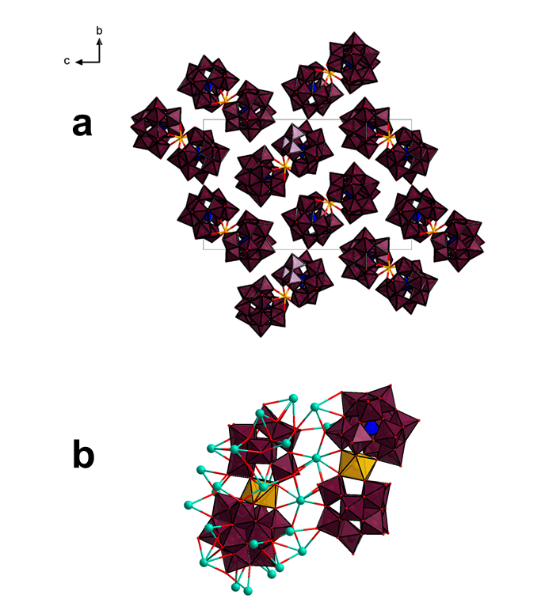
Figure 25. Polyhedral representation of CsCmPW₁₁-alpha a) along the a-axis b) View highlighting the positions of Cs⁺ ions. Cs⁺ ions both bridge the Cm-POM complexes promoting crystallization, and create a cage around the equatorial plane, shielding Cm³⁺ from solvent molecules. Color code: curium in orange, tungsten in maroon, cesium in cyan, phosphorous in blue, and oxygen in red.

CsCmPW₁₁-beta
Cs₁₁Cm(PW₁₁O₃₉)₂•31.5H₂O
This structure featured some distortion on the rotated W₃O₈-timer due to the longer P-O bonds needed to accommodate the rotation of 60˙. As such DFIX restraints were used on W9, W17, W21, W3, W13, & W2 and their oxygens, as well as W7, W11, W15’s yl-oxo, and lastly on the P2-O bonds. EADP restraints were used to model the corresponding O atoms.
With a solvent accessible void space of 1216Å³, comprising 11.6% of the total cell volume, and with and electron density of 216. A total of 22 masked solvent waters were calculated, see solvent void above, plus the 9.5 refined waters, for a total 31.5 solvent waters.

Table 9. Crystallographic information for CsCmPW₁₁-beta
Identification code | CsCmPW₁₁-beta
CCDC Number | 2105535
Empirical formula | Cm₂Cs₂₂O₁₇₇P₄W₄₄
Formula weight | 14457.30
Temperature/K | 293.0
Crystal system | monoclinic
Space group | P2₁/n
a/Å | 12.4632(3)
b/Å | 38.0105(11)
c/Å | 22.1406(9)
α/° | 90
β/° | 90.589(3)
γ/° | 90
Volume/Å³ | 10488.2(6)
Z | 2
ρ_{calc}g/cm³ | 4.578
μ/mm⁻¹ | 28.671
F(000) | 12268.0
Crystal size/mm³ | 0.098 × 0.069 × 0.04
Radiation | MoKα (λ = 0.71073)
2Θ range for data collection/° | 6.882 to 52.744
Index ranges | -15 ≤ h ≤ 13, -47 ≤ k ≤ 47, -27 ≤ l ≤ 27
Reflections collected | 76530
Independent reflections | 21090 [R_{int} = 0.1736, R_{sigma} = 0.1449]
Data/restraints/parameters | 21090/18/981
Goodness-of-fit on F² | 1.019
Final R indexes [I>=2σ (I)] | R₁ = 0.0968, wR₂ = 0.2548
Final R indexes [all data] | R₁ = 0.1521, wR₂ = 0.2890
Largest diff. peak/hole / e Å⁻³ | 3.56/-3.47

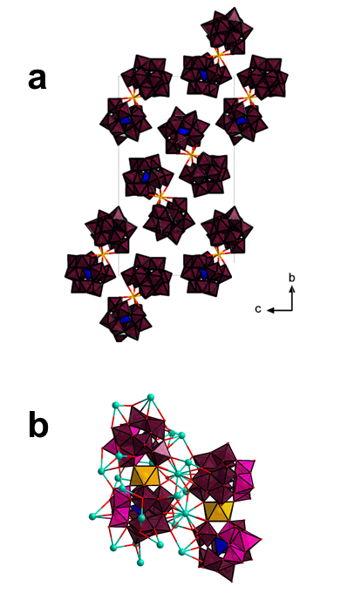
Figure 26. Polyhedral representation of CsCmPW₁₁-beta a) along the a-axis b) View highlighting the positions of Cs⁺ ions. Cs⁺ ions both bridge the Cm-POM complexes promoting crystallization, and create a cage around the equatorial plane, shielding Cm³⁺ from solvent molecules. Color code: curium in orange, tungsten in maroon (pink for rotated trimer), cesium in cyan, phosphorous in blue, and oxygen in red.
CsCmBW₁₁
Cs₁₃Cm(HBW₁₁O₃₉)₂•13H₂O
EADP restrains were used on Cs11 & Cs5.
With a solvent accessible void space of 132Å³, comprising 1.4% of the total cell volume, and with and electron density of 51. A total of 5 masked solvent waters were calculated, see solvent void above, plus the 5 refined waters, for a total 13 solvent waters.

Table 10. Crystallographic information for CsCmBW₁₁.
Identification code | CsCmBW₁₁
CCDC Number | 2114774
Empirical formula | B₂CmCs₁₃O₈₉W₂₂
Formula weight | 7462.15
Temperature/K | 293(2)
Crystal system | monoclinic
Space group | P2₁/n
a/Å | 19.8798(3)
b/Å | 12.9367(2)
c/Å | 37.8876(6)
α/° | 90
β/° | 97.778(2)
γ/° | 90
Volume/Å³ | 9654.2(3)
Z | 4
ρ_{calc}g/cm³ | 5.134
μ/mm⁻¹ | 31.859
F(000) | 12644.0
Crystal size/mm³ | 0.068 × 0.031 × 0.014
Radiation | MoKα (λ = 0.71073)
2Θ range for data collection/° | 6.764 to 52.744
Index ranges | -24 ≤ h ≤ 24, -16 ≤ k ≤ 16, -47 ≤ l ≤ 47
Reflections collected | 122469
Independent reflections | 19682 [R_{int} = 0.1270, R_{sigma} = 0.0654]
Data/restraints/parameters | 19682/0/1150
Goodness-of-fit on F² | 1.038
Final R indexes [I>=2σ (I)] | R₁ = 0.0435, wR₂ = 0.1127
Final R indexes [all data] | R₁ = 0.0577, wR₂ = 0.1195
Largest diff. peak/hole / e Å⁻³ | 3.96/-5.88

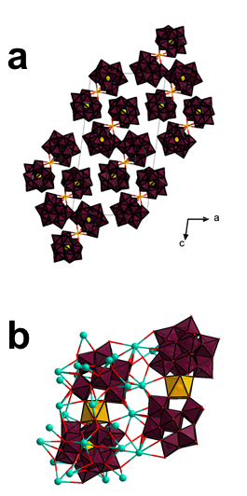
Figure 27. Polyhedral representation of CsCmBW₁₁ a) along the b-axis b) View highlighting the positions of Cs⁺ ions. Cs⁺ ions both bridge the Cm-POM complexes promoting crystallization, and create a cage around the equatorial plane, shielding Cm³⁺ from solvent molecules. Color code: curium in orange, tungsten in maroon, cesium in cyan, boron in yellow, and oxygen in red.
Table 11. Select bond lengths for Cm-POM crystals.
 | W-O | Cm-O (Å) | P-O or B-O (Å)
CsCmPW₁₁-alpha | 1.660(13)-2.550(13) | 2.373(13)-2.511(16) | 1.513(13)-1.554(13)
CsCmPW₁₁-beta | 1.710(13)-2.575(19) | 2.41(4)-2.52(3) | 1.56(2)-1.923(13)
CsCmBW₁₁ | 1.650(13)-2.535(16) | 2.411(10)-2.475(12) | 1.477(17)-1.559(17)

Table 12. Summary of coordination of Cm, nearest O-atoms.
CmPW₁₁-alpha | Cm | O | Bond Length (Å)
 | 1 | 13 | 2.373(13)
 | 1 | 40 | 2.511(16)
 | 1 | 47 | 2.475(15)
 | 1 | 54 | 2.498(19)
 | 1 | 55 | 2.406(14)
 | 1 | 70 | 2.415(15)
 | 1 | 74 | 2.446(14)
 | 1 | 80 | 2.409(13)
 | 1 | 63 (PO₄) | 3.49
 | 1 | 39 (PO₄) | 3.455
CmPW₁₁-beta | Cm | O | Bond Length (Å)
 | 1 | 10 | 2.42(3)
 | 1 | 15 | 2.43(3)
 | 1 | 32 | 2.43(2)
 | 1 | 47 | 2.41(4)
 | 1 | 48 | 2.46(3)
 | 1 | 51 | 2.52(3)
 | 1 | 60 | 2.47(2)
 | 1 | 76 | 2.49(3)
 | 1 | 74 (PO₄) | 3.459
 | 1 | 57 (PO₄) | 3.534
CmBW₁₁ | Cm | O | Bond Length (Å)
 | 1 | 10 | 2.413(10)
 | 1 | 16 | 2.443(10)
 | 1 | 28 | 2.475(11)
 | 1 | 38 | 2.455(10)
 | 1 | 76 | 2.430(10)
 | 1 | 29 | 2.343(10)
 | 1 | 61 | 2.411(10)
 | 1 | 65 | 2.448(10)
 | 1 | 12 (BO₄) | 3.594
 | 1 | 64 (BO₄) | 3.631
Bond Valence Sum

Table 13. Summary of BVS calculations for Cm-POMs. ⁴⁶
CsCmPW₁₁-alpha | Cm | O | BL (Å) | BV | BVS
 | 1 | 13 | 2.373 | 0.43919335 | 2.99285476
 | 1 | 40 | 2.511 | 0.31418698
 | 1 | 47 | 2.475 | 0.34287534
 | 1 | 54 | 2.498 | 0.32425871
 | 1 | 55 | 2.406 | 0.4053872
 | 1 | 70 | 2.415 | 0.39662768
 | 1 | 74 | 2.446 | 0.36787944
 | 1 | 80 | 2.409 | 0.40244607
CsCmPW₁₁-beta | Cm | O | BL (Å) | BV | BVS
 | 1 | 10 | 2.42 | 0.39184332 | 2.89887298
 | 1 | 15 | 2.43 | 0.38244706
 | 1 | 32 | 2.43 | 0.38244706
 | 1 | 47 | 2.41 | 0.40147045
 | 1 | 48 | 2.46 | 0.35558869
 | 1 | 51 | 2.52 | 0.30739809
 | 1 | 60 | 2.47 | 0.3470618
 | 1 | 76 | 2.49 | 0.33061652
CsCmBW₁₁ | Cm | O | BL (Å) | BV | BVS
 | 1 | 10 | 2.413 | 0.39855773 | 3.09334014
 | 1 | 16 | 2.443 | 0.37056795
 | 1 | 28 | 2.475 | 0.34287534
 | 1 | 38 | 2.455 | 0.35993038
 | 1 | 76 | 2.43 | 0.38244706
 | 1 | 29 | 2.343 | 0.47236655
 | 1 | 61 | 2.411 | 0.40049718
 | 1 | 65 | 2.448 | 0.36609795

References
1. Polinski, M. J., Grant, D. J., Wang, S., Alekseev, E. V., Cross, J. N., Villa, E. M., Depmeier, W., Gagliardi, L. & Albrecht-Schmitt, T. E. Differentiating between Trivalent Lanthanides and Actinides. J. Am. Chem. Soc. 134, 10682–10692 (2012).
2. Silver, M. A., Cary, S. K., Johnson, J. A., Baumbach, R. E., Arico, A. A., Luckey, M., Urban, M., Wang, J. C., Polinski, M. J., Chemey, A., Liu, G., Chen, K.-W., Cleve, S. M. V., Marsh, M. L., Eaton, T. M., Burgt, L. J. van de, Gray, A. L., Hobart, D. E., Hanson, K., Maron, L., Gendron, F., Autschbach, J., Speldrich, M., Kögerler, P., Yang, P., Braley, J. & Albrecht-Schmitt, T. E. Characterization of berkelium(III) dipicolinate and borate compounds in solution and the solid state. Science 353, (2016).
3. Polinski, M. J., Garner, E. B., Maurice, R., Planas, N., Stritzinger, J. T., Parker, T. G., Cross, J. N., Green, T. D., Alekseev, E. V., Cleve, S. M. V., Depmeier, W., Gagliardi, L., Shatruk, M., Knappenberger, K. L., Liu, G., Skanthakumar, S., Soderholm, L., Dixon, D. A. & Albrecht-Schmitt, T. E. Unusual structure, bonding and properties in a californium borate. Nature Chem 6, 387–392 (2014).
4. Cary, S. K., Vasiliu, M., Baumbach, R. E., Stritzinger, J. T., Green, T. D., Diefenbach, K., Cross, J. N., Knappenberger, K. L., Liu, G., Silver, M. A., DePrince, A. E., Polinski, M. J., Cleve, S. M. V., House, J. H., Kikugawa, N., Gallagher, A., Arico, A. A., Dixon, D. A. & Albrecht-Schmitt, T. E. Emergence of californium as the second transitional element in the actinide series. Nat Commun 6, 1–8 (2015).
5. Cary, S. K., Silver, M. A., Liu, G., Wang, J. C., Bogart, J. A., Stritzinger, J. T., Arico, A. A., Hanson, K., Schelter, E. J. & Albrecht-Schmitt, T. E. Spontaneous Partitioning of Californium from Curium: Curious Cases from the Crystallization of Curium Coordination Complexes. Inorg. Chem. 54, 11399–11404 (2015).
6. Cary, S. K., Su, J., Galley, S. S., Albrecht-Schmitt, T. E., Batista, E. R., Ferrier, M. G., Kozimor, S. A., Mocko, V., Scott, B. L., Van Alstine, C. E., White, F. D. & Yang, P. A series of dithiocarbamates for americium, curium, and californium. Dalton Trans. 47, 14452–14461 (2018).
7. Sperling, J. M., Warzecha, E. J., Celis-Barros, C., Sergentu, D.-C., Wang, X., Klamm, B. E., Windorff, C. J., Gaiser, A. N., White, F. D., Beery, D. A., Chemey, A. T., Whitefoot, M. A., Long, B. N., Hanson, K., Kögerler, P., Speldrich, M., Zurek, E., Autschbach, J. & Albrecht-Schönzart, T. E. Compression of curium pyrrolidine-dithiocarbamate enhances covalency. Nature 583, 396–399 (2020).
8. Sperling, J. M., Warzecha, E., Windorff, C. J., Klamm, B. E., Gaiser, A. N., Whitefoot, M. A., White, F. D., Poe, T. N. & Albrecht-Schönzart, T. E. Pressure-Induced Spectroscopic Changes in a Californium 1D Material Are Twice as Large as Found in the Holmium Analog. Inorg. Chem. 59, 10794–10801 (2020).
9. Lindqvist-Reis, P., Apostolidis, C., Rebizant, J., Morgenstern, A., Klenze, R., Walter, O., Fanghänel, T. & Haire, R. G. The Structures and Optical Spectra of Hydrated Transplutonium Ions in the Solid State and in Solution. Angewandte Chemie International Edition 46, 919–922 (2007).
10. Skanthakumar, S., Antonio, M. R., Wilson, R. E. & Soderholm, L. The Curium Aqua Ion. Inorg. Chem. 46, 3485–3491 (2007).
11. Silver, M. A., Cary, S. K., Garza, A. J., Baumbach, R. E., Arico, A. A., Galmin, G. A., Chen, K.-W., Johnson, J. A., Wang, J. C., Clark, R. J., Chemey, A., Eaton, T. M., Marsh, M. L., Seidler, K., Galley, S. S., van de Burgt, L., Gray, A. L., Hobart, D. E., Hanson, K., Van Cleve, S. M., Gendron, F., Autschbach, J., Scuseria, G. E., Maron, L., Speldrich, M., Kögerler, P., Celis-Barros, C., Páez-Hernández, D., Arratia-Pérez, R., Ruf, M. & Albrecht-Schmitt, T. E. Electronic Structure and Properties of Berkelium Iodates. J. Am. Chem. Soc. 139, 13361–13375 (2017).
12. Cross, J. N., Villa, E. M., Wang, S., Diwu, J., Polinski, M. J. & Albrecht-Schmitt, T. E. Syntheses, Structures, and Spectroscopic Properties of Plutonium and Americium Phosphites and the Redetermination of the Ionic Radii of Pu(III) and Am(III). Inorg. Chem. 51, 8419–8424 (2012).
13. Galley, S. S., Pattenaude, S. A., Gaggioli, C. A., Qiao, Y., Sperling, J. M., Zeller, M., Pakhira, S., Mendoza-Cortes, J. L., Schelter, E. J., Albrecht-Schmitt, T. E., Gagliardi, L. & Bart, S. C. Synthesis and Characterization of Tris-chelate Complexes for Understanding f-Orbital Bonding in Later Actinides. J. Am. Chem. Soc. 141, 2356–2366 (2019).
14. Brenner, N., Sperling, J. M., Poe, T. N., Celis-Barros, C., Brittain, K., Villa, E. M., Albrecht-Schmitt, T. E. & Polinski, M. J. Trivalent f-Element Squarates, Squarate-Oxalates, and Cationic Materials, and the Determination of the Nine-Coordinate Ionic Radius of Cf(III). Inorganic Chemistry 59, 9384–9395 (2020).
15. Goodwin, C. A. P., Su, J., Stevens, L. M., White, F. D., Anderson, N. H., Auxier, J. D., Albrecht-Schönzart, T. E., Batista, E. R., Briscoe, S. F., Cross, J. N., Evans, W. J., Gaiser, A. N., Gaunt, A. J., James, M. R., Janicke, M. T., Jenkins, T. F., Jones, Z. R., Kozimor, S. A., Scott, B. L., Sperling, J. M., Wedal, J. C., Windorff, C. J., Yang, P. & Ziller, J. W. Isolation and characterization of a californium metallocene. Nature 599, 421–424 (2021).
16. Sokolova, M. N., Fedosseev, A. M., Andreev, G. B., Budantseva, N. A., Yusov, A. B. & Moisy, P. Synthesis and Structural Examination of Complexes of Am(IV) and Other Tetravalent Actinides with Lacunary Heteropolyanion α2-P2W17O6110−. Inorg. Chem. 48, 9185–9190 (2009).
17. Copping, R., Talbot-Eeckelaers, C., Collison, D., Helliwell, M., Gaunt, A. J., May, I., Reilly, S. D., Scott, B. L., McDonald, R. D., Valenzula, O. A., Jones, C. J. & Sarsfield, M. J. Probing the 5f electrons in a plutonyl(VI) cluster complex. Dalton Trans. 5609–5611 (2009). doi:10.1039/B908648J
18. Kimura, T., Nagaishi, R., Kato, Y. & Yoshida, Z. Luminescence study on solvation of americium(III), curium(III) and several lanthanide(III) ions in nonaqueous and binary mixed solvents. Radiochimica Acta 89, 125–130 (2001).
19. Jordan, N., Demnitz, M., Lösch, H., Starke, S., Brendler, V. & Huittinen, N. Complexation of Trivalent Lanthanides (Eu) and Actinides (Cm) with Aqueous Phosphates at Elevated Temperatures. Inorg. Chem. 57, 7015–7024 (2018).
20. Tian, G., Edelstein, N. M. & Rao, L. Spectroscopic Properties and Hydration of the Cm(III) Aqua Ion from 10 to 85 °C. J. Phys. Chem. A 115, 1933–1938 (2011).
21. Kimura, T., Choppin, G. R., Kato, Y. & Yoshida, Z. Determination of the Hydration Number of Cm(III) in Various Aqueous Solutions. Radiochimica Acta 72, 61–64 (1996).
22. Fanghänel, T., Weger, Η. Τ., Könnecke, T., Neck, V., Paviet-Hartmann, P., Steinle, E. & Kim, J. I. Thermodynamics of Cm(III) in Concentrated Electrolyte Solutions. Carbonate Complexation at Constant Ionic Strength (1 m NaCl). Radiochimica Acta 82, 47–54 (1998).
23. Ioussov, A. & Krupa, J. C. Luminescence Properties and Stability Constants of Curium(III) Complexes with Lacunary Heteropolyanions PW11O397- and SiW11O398- in Nitric Acid Solutions. Radiochimica Acta 78, 97–104 (1997).
24. Moll, H., Glorius, M. & Bernhard, G. Curium(III) Complexation with Desferrioxamine B (DFO) Investigated Using Fluorescence Spectroscopy. BCSJ 81, 857–862 (2008).
25. Fanghänel, Th. & Kim, J.-I. Spectroscopic evaluation of thermodynamics of trivalent actinides in brines. Journal of Alloys and Compounds 271–273, 728–737 (1998).
26. Heller, A., Barkleit, A., Foerstendorf, H., Tsushima, S., Heim, K. & Bernhard, G. Curium(III) citrate speciation in biological systems: a europium(III) assisted spectroscopic and quantum chemical study. Dalton Trans. 41, 13969–13983 (2012).
27. Trumm, M., Wagner, C., Schimmelpfennig, B., Geist, A. & Panak, P. J. A closer look on the coordination of soft nitrogen-donor ligands to Cm(III): SO3-Ph-BTBP. Dalton Trans. 45, 12308–12311 (2016).
28. Drobot, B., Schmidt, M., Mochizuki, Y., Abe, T., Okuwaki, K., Brulfert, F., Falke, S., Samsonov, S. A., Komeiji, Y., Betzel, C., Stumpf, T., Raff, J. & Tsushima, S. Cm3+/Eu3+ induced structural, mechanistic and functional implications for calmodulin. Phys. Chem. Chem. Phys. 21, 21213–21222 (2019).
29. Sturzbecher-Hoehne, M., Goujon, C., Deblonde, G. J.-P., Mason, A. B. & Abergel, R. J. Sensitizing Curium Luminescence through an Antenna Protein To Investigate Biological Actinide Transport Mechanisms. J. Am. Chem. Soc. 135, 2676–2683 (2013).
30. Deblonde, G. J.-P., Mattocks, J. A., Wang, H., Gale, E. M., Kersting, A. B., Zavarin, M. & Cotruvo, J. A. Characterization of Americium and Curium Complexes with the Protein Lanmodulin: A Potential Macromolecular Mechanism for Actinide Mobility in the Environment. J. Am. Chem. Soc. 143, 15769–15783 (2021).
31. Bauer, N., Fröhlich, D. R. & Panak, P. J. Interaction of Cm(III) and Am(III) with human serum transferrin studied by time-resolved laser fluorescence and EXAFS spectroscopy. Dalton Trans. 43, 6689–6700 (2014).
32. Arnedo-Sanchez, L., Smith, K. F., Deblonde, G. J.-P., Carter, K. P., Moreau, L. M., Rees, J. A., Tratnjek, T., Booth, C. H. & Abergel, R. J. Combining the Best of Two Chelating Titans: A Hydroxypyridinone-Decorated Macrocyclic Ligand for Efficient and Concomitant Complexation and Sensitized Luminescence of f-Elements. ChemPlusChem 86, 483–491 (2021).
33. Leguay, S., Vercouter, T., Topin, S., Aupiais, J., Guillaumont, D., Miguirditchian, M., Moisy, P. & Le Naour, C. New Insights into Formation of Trivalent Actinides Complexes with DTPA. Inorg. Chem. 51, 12638–12649 (2012).
34. Moll, H., Johnsson, A., Schäfer, M., Pedersen, K., Budzikiewicz, H. & Bernhard, G. Curium(III) complexation with pyoverdins secreted by a groundwater strain of Pseudomonas fluorescens. Biometals 21, 219–228 (2008).
35. Sturzbecher-Hoehne, M., Kullgren, B., Jarvis, E. E., An, D. D. & Abergel, R. J. Highly Luminescent and Stable Hydroxypyridinonate Complexes: A Step Towards New Curium Decontamination Strategies. Chem. Eur. J. 20, 9962–9968 (2014).
36. Wagner, C., Mossini, E., Macerata, E., Mariani, M., Arduini, A., Casnati, A., Geist, A. & Panak, P. J. Time-Resolved Laser Fluorescence Spectroscopy Study of the Coordination Chemistry of a Hydrophilic CHON [1,2,3-Triazol-4-yl]pyridine Ligand with Cm(III) and Eu(III). Inorg. Chem. 56, 2135–2144 (2017).
37. Shannon, R. D. Revised Effective Ionic Radii and Systematic Studies of Interatomie Distances in Halides and Chaleogenides. Acta crystallographica A32, 751–767 (1976).
38. Bruker Analytical X-ray Systems. SAINT Plus Version 8.34a. (Bruker Analytical X-ray Systems, 2013).
39. Sheldrick, G. M. Bruker-Siemens area Detection Absorption other Correction. (2008).
40. Sheldrick, G. M. SHELXT – Integrated space-group and crystal-structure determination. Acta Cryst A 71, 3–8 (2015).
41. Sheldrick, G. M. A short history of SHELX. Acta Cryst A 64, 112–122 (2008).
42. Dolomanov, O. V., Bourhis, L. J., Gildea, R. J., Howard, J. a. K. & Puschmann, H. OLEX2: a complete structure solution, refinement and analysis program. J Appl Cryst 42, 339–341 (2009).
43. Van Der Sluis, P. & Spek, A. L. BYPASS: an effective method for the refinement of crystal structures containing disordered solvent regions. Acta Crystallographica Section A 46, 194–201 (1990).
44. Glasser, L. The effective volumes of waters of crystallization: non-ionic pharmaceutical systems. Acta Cryst B 75, 784–787 (2019).
45. Glasser, L. Effective Volumes of Waters of Crystallization: Ionic Systems. Crystal Growth & Design 19, 3397–3401 (2019).
46. Gagné, O. C. & Hawthorne, F. C. Comprehensive derivation of bond-valence parameters for ion pairs involving oxygen. Acta Cryst B 71, 562–578 (2015).

