University of Oxford & Institute of Zoology, CAS
EcoEvo Simulator: EES
Overview document

Erin E. Saupe & Huijie Qiao
2018-11-27

- Generate the configuration files (in JSON format) and run commands for the simulations.

The script was written in Java. All scripts in Java can be downloaded via a subversion repository (svn://mmweb.animal.net.cn/NicheBreadth/trunk). The function for step No.1 can be found in the following location.
package org.ioz.niche.breadth.r2016_r12
class GenerateJson
public void generateSpeciesJson()
public void generateScenarioJson()
public void generateCommand()

Json format of the configuration of virtual species:
{
"id" : 1,
//should be the same length as the environmental layers defined in the scenario configuration file
"niche_breadth" : [[v1_min, v1_max], [v2_min, v2_max], […], [vn_min, vn_max]],
//
"dispersal_ability" : [0.3,0.7,0.9,0,1.0],
"dispersal_speed" : 100,
"dispersal_method" : 2,
"number_of_path" : -1,
"speciation_years" : 10000,
"species_extinction_threshold" : 0,
"species_extinction_time_steps" : 1,
"species_extinction_threshold_percentage" : 0.8,
"group_extinction_threshold" : 0,
"initial_seeds" : [[124.5, 54.5]]
}
Json format of the configuration of virtual scenario:
{
"environments" : ["path_to_env_layer_1", "path_to_env_layer_2", "…", "path_to_env_layer_n"],
"total_years" : 120000,
"mask" : "path_to_mask_layer",
//connect the species configuration via the “species_id”.
"species" : ["species_id"],
"burn_in_year" : 0
}

Command to launch the simulation application:
> ./NB_Icesheet base_folder scenario_configuration Results_folder 800 0 0

- Launch simulations by running the commands generated in step No.1.

The simulation application was written in C++. The source code is open access and can be used under the GNU Public License. The latest source code can be downloaded via svn://mmweb.animal.net.cn/nb_icesheet/trunk. And documents regarding the code can be found via http://ecosimulation.sourceforge.io. More details about the code is provided in its documentation.

The simulation results were saved in a batch of log files in plain text, GIS raster (GTIFF) or NEXUS tree formats.

The output directory structure generated by the simulation application:
├── Map_Folder //a folder to save the distribution year by year
│ ├── 100.csv
│ ├── 200.csv
│ ├── xxx.csv
│ └── 120000.csv
├── Phylogram.html //An HTML file to show the speciation tree in browser
├── runtime.log //A log file to save the runtime information.
├── seeds.csv //Seed point of the simulation
├── stats
│ └── stat.csv //The number of speciation and extinction events in the simulation
├── suitable.tif //suitable area (potential distribution) of the virtual species in the simulation.
└── tree.new // the speciation tree in NEXUS format.

- Analyze the log files, extract the useful information, and import data to database.

The scripts were written in Java. All functions are in the following package and classes.
package org.ioz.niche.breadth.r2016_r12
class HandleResult
class MeanLat_By_Continent_NB
class MeanLat_By_Continent
class MoreMetrics
class Speciation_Convex_Stat
class Speciation_Extinction_Lat
class overAllFunctions

Class | Function | Database Table
MoreMetrics | allMetricsNoNicheBreadth() | Biome
MoreMetrics | allMetricsNoNicheBreadth() | Continent
MoreMetrics | Continent2 () | Continent2
HandleResult | generateConvexMaps() | Convex
HandleResult | generateConvexMaps() | Convex_with_year
MoreMetrics | allMetricsNoNicheBreadth() | Distribution
HandleResult | generateOriginMaps() | Diversity
HandleResult | generateOriginMaps() | Extinction
HandleResult | generateExtinctionTable() | Extinction_with_year
HandleResult | detectSpeciationExtinctionTemp2Prec_Origin() | Extinction_in_combined_environments
MoreMetrics | allMetricsNoNicheBreadth() | Lat
MoreMetrics | allMetricsNoNicheBreadth() | Lon
MoreMetrics | nicheBreadth() | Niche_breadth
HandleResult | generateOriginMaps() | Origin
Speciation_Convex_Stat | calculate_convex_speciation() | Speciation_Convex
Speciation_Convex_Stat | calculate_convex_speciation() | Speciation_Convex_E
Speciation_Extinction_Lat | speciation_extinction_by_others() | Speciation_Extinction_BIOME
Speciation_Extinction_Lat | speciation_extinction_by_others() | Speciation_Extinction_Continent
Speciation_Extinction_Lat | speciation_extinction_by_others() | Speciation_Extinction_Continent2
Speciation_Extinction_Lat | speciation_extinction_by_lat() | Speciation_Extinction_Lat
Speciation_Extinction_Lat | speciation_extinction_by_others() | Speciation_Extinction_TT
HandleResult | detectSpeciationExtinctionTemp2Prec_XXX() | Speciation_extinction_in_combined  _environments_XXX
HandleResult | insertResult_removeUnfinished() | Simulations
MoreMetrics | allMetricsNoNicheBreadth() | Temperate_Tropic
overAllFunctions | insertTree | Tree

- Extract the required data from the database, analyze the data tables, and create the figures for the manuscripts.

To install the application on Ubuntu

1. Download and install Ubuntu
http://releases.ubuntu.com/14.04/

2. Download Eclipse CPP
http://www.eclipse.org/downloads/download.php?file=/technology/epp/downloads/release/helios/SR2/eclipse-cpp-helios-SR2-linux-gtk-x86_64.tar.gz

3. Install JDK in Ubuntu
https://www.digitalocean.com/community/tutorials/how-to-install-java-on-ubuntu-with-apt-get

4. Install g++ v4.8 in Ubuntu
http://askubuntu.com/questions/271388/how-to-install-gcc-4-8
sudo apt-get install python-software-properties
sudo add-apt-repository ppa:ubuntu-toolchain-r/test
sudo apt-get update
sudo apt-get install gcc-4.8
sudo update-alternatives --install /usr/bin/gcc gcc /usr/bin/gcc-4.8 50

sudo apt-get install g++-4.8
sudo update-alternatives --install /usr/bin/g++ g++ /usr/bin/g++-4.8 50

5. Install GDAL in Ubuntu
http://www.sarasafavi.com/installing-gdalogr-on-ubuntu.html
sudo add-apt-repository ppa:ubuntugis/ppa && sudo apt-get update
sudo apt-get install libgdal1-dev libgdal-dev libgeos-c1 libspatialite3 libgdal1h libgdal1-dev libproj-dev gdal-bin
make sure that you have /usr/include/gdal/gdal.h

6. Install Subversion in Eclipse
https://eclipse.org/subversive/documentation/gettingStarted/aboutSubversive/install.php

7. Checkout NB simulation code with Subversion in Eclipse via
svn://mmweb.animal.net.cn/nb_icesheet/trunk

8. Add /usr/include/gdal/ to your Include path in Eclipse
Properties -> C/C++ General -> Paths and Symbols -> Include -> GNU C++

9. Install Boost v1.5 in Ubuntu
sudo add-apt-repository ppa:boost-latest/ppa
sudo apt-get update
sudo apt-get install libboost1.54-all-dev

10. Add -std=c++0x to Eclipse g++ Compiler
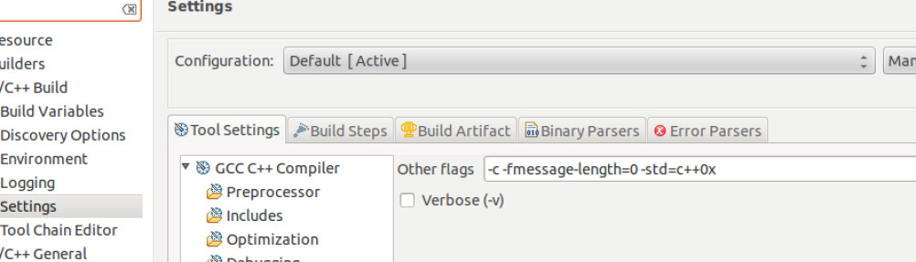

11. Compile your application in Eclipse

12. Create a folder ‘NB_Test’ for the application and copy ‘M1000’ to the folder in your virtual machine

13. Copy ‘scenario.seed_1.dispersal_good.nb_large.json’ to ‘Scenario_Configurations’ folder in ‘NB_Test’

14. Copy ‘seed_1.dispersal_good.nb_large.json’ to ‘Species_Configurations’ folder in ‘NB_Test’ in your virtual machine

15. Edit ‘scenario.seed_1.dispersal_good.nb_large.json’ to match the path of M100 folder.

16. Edit src/main.cpp in Eclipse, lines 60 and 61, point the files to ‘M1000/mask.tif’ (dirty code, needs to be modified), and recompile it

17. Create a folder ‘Results’ to save the result.

18. Run the application with the following parameters.
‘root’ ‘json’ ‘result_folder’ ‘max memory usage’ ‘is_overwrite (0:no, 1: yes)’ ‘unused, always 0’

Example:
/home/eesaupe/nb_test scenario.seed_1.dispersal_good.nb_large /home/eesaupe /nb_test/result 8000 1 0

