Supplementary material
Efficient modelling a dynamic non-linear system with recurrent neural networks
Aforementioned state-of-the-art examples of mapping sequences of driving variables (e.g. meteorological conditions) onto target variables such as CO₂ fluxes from ocean or land have considered instantaneous mapping without representation of state dynamics. Dynamic effects have either been considered by directly using observed states as predictors (e.g. vegetation state represented by reflectance) or by introducing hand-designed features. The general problem is depicted in the figure below, where the input acts on an unknown, unobservable system state, while the observable is both influenced by the past state and the current input. It is not a problem of forecasting a time series a few steps ahead, because the whole output sequence has to be predicted by the model.
As an example, in the synthetic dynamic system below (one realization in Figure Box 1) we have three forcing variables x₁, x₂, x₃ where two of them influence one (unobserved) state r according to
$r_{t+1}=f\left(x_{1,t},x_{2,t},r_{t}\right),$with
$f\left(x_{1,t},x_{2,t},r_{t}\right)={τ∙x}_{1,t}∙x_{2,t}∙e^{x1,t}+{\left(1-τ\right)∙r}_{t}$,
τ being a parameter determining the inertia of the dynamics of r, here set to 0.05. A target state y to be predicted evolves as a logistic map well known from ecology and chaos theory¹:
$y_{t+1}=\tilde{r_{t}}∙y_{t}∙\left(1-y_{t}\right)$,
where (contrary to the standard logistic map) the parameter $\tilde{r_{t}}$ is not fixed but dynamic and dependent on r as
$\tilde{r_{t}}={g( r}_{t}+x_{3,t})$,
where g simply scales $\tilde{r_{t}}$ onto the interval [2.5, 4] which implies dynamics varying with time between dampened oscillations, limit cycles and chaos. In the synthetic example 500 realizations of x₁ and x₂ as Gaussian i.i.d. variables are generated, while x₃ is always a seasonal variable as in the Figure below. Obviously x₁ and x₂ are mimicking a stochastic forcing, whereas x₃ represents a deterministic forcing (e.g. solar radiation varying diurnally and seasonally).
The lower panel shows the performance of different approaches to model the $y_{t}$ sequence given the sequences of $x_{1}…x_{3}$. With a feed-forward ANN or random forests it is hard to model the sequence $y_{t}$, even with including intuitive features which represent lagged or memory effects, such as lagged or cumulated x variables over the last 25 time steps. On the contrary, being turing-complete² a recurrent NN has the potential to describe any dynamic system, and the challenge is the parameter estimation or training. In the specific case a simple LSTM³ with 8 cells was trained on 80% of the realizations and the results are shown here for the test set. Certainly, other modelling approaches such as dynamic Bayesian approaches (e.g. hidden Markov models) exist as well for state estimation, and the relation to recurrent neural networks and deep learning is under research⁴.

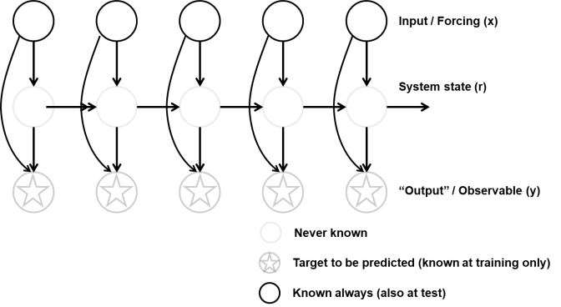
Supplementary Figure 1: Concept of modelling a dynamic system, i.e. mapping an input sequence to an output sequence, where a (hidden) dynamic state is involved.
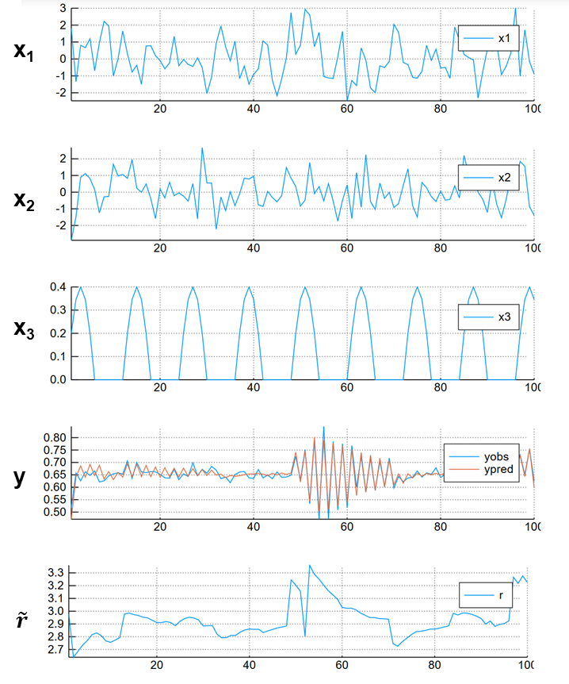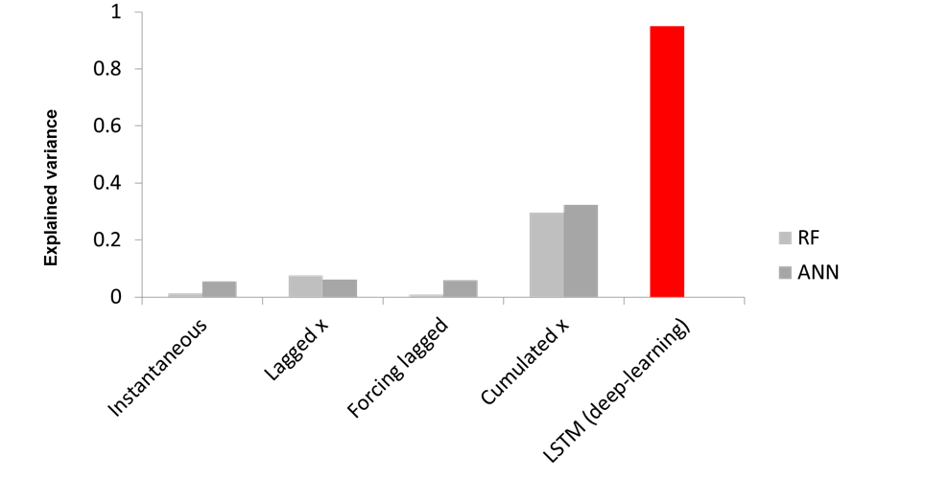
Supplementary Figure 2: Data-driven modelling of a synthetic geoscientific time-series depicted in (a) with dynamic effects. Shown are predictor variables x₁, x₂, x₃, the resulting time-series of the system state (“observed” and modelled with an LSTM), and the parameter $\tilde{r_{t}}$ of the logistic map. (b) While classical approaches including typical feature design fail to explain the dynamics (grey bars, RF = Random Forest, ANN = feedforward ANN), a deep learning approach, long-short-term-memory neural network (LSTM) is able to explain almost all variance (red), without designing any features.

Supplementary Figure 3: Cycle of hypothesis generation and testing in complex systems involving process-based models and extraction of patterns from observations. Such patterns are only a surprise, and constitute an puzzle, if state-of-the-art theory and models do not predict them. Machine learning allows to extract hidden and complex patterns, which should be confronted with modelled patterns.

References
1 May, R. M. Simple mathematical models with very complicated dynamics. Nature 261, 459-467 (1976).
2 Siegelmann, H. T. & Sontag, E. D. On the computational power of neural nets. Journal of computer and system sciences 50, 132-150 (1995).
3 Hochreiter, S. & Schmidhuber, J. Long short-term memory. Neural computation 9, 1735-1780 (1997).
4 Schmidhuber, J. Deep learning in neural networks: An overview. Neural networks 61, 85-117 (2015).

