Supplementary Notes
Supplementary Note 1: Aneuploidy in cancer
~90% of the solid tumors and ~75% of the hematologic malignancies are aneuploid⁷⁶, and >25% of the tumor genome is affected, on average, by aneuploidy^{11,12}. The process that gives rise to aneuploidy is chromosomal instability (CIN), characterized by a high prevalence of chromosome mis-segregation and other mitotic aberrations¹. Aneuploidy and CIN are associated with clinical features, such as tumor stage, differentiation status, and disease aggressiveness^{32,33}. However, our knowledge of how CIN and aneuploidy drive tumorigenesis is rather limited^{1,77}. Consequently, no existing therapeutics directly exploit this hallmark of cancer for the treatment of cancer patients.
Aneuploidy comes with a substantial fitness cost, yet is well-tolerated by cancer cells^{76,78}. The genetic or epigenetic events that lead to aneuploidy formation during tumorigenesis, or that allow cancer cells to tolerate it, may also generate unique vulnerabilities in aneuploid cells (compared to their euploid counterparts). While some aneuploidy-induced dependencies would be specific to the altered chromosome^{1,9,18,79,80}, others may be the consequence of more general cellular burdens associated with an abnormal number of chromosomes, independently of specific karyotypes. Indeed, aneuploidy elicits various types of cellular stress responses: proteotoxic, metabolic, replicative, mitotic and hypo-osmotic responses^{1,21,78,81}. Consistent with a general cellular response to aneuploidy, introduction of aneuploidy into mammalian cells activated transcriptional programs that were independent of the specific chromosome^{56,68}.
A major reason for our gap in understanding the cellular dependencies induced by aneuploidy is that aneuploidy is notoriously difficult to study: it affects multiple genes at once, it plays distinct roles in different contexts, and it is hard to engineer experimentally. Moreover, a high degree of aneuploidy is closely associated with other genomic alterations, such as whole-genome duplication (WGD) and p53 inactivation^{12,30,31}; as well as with cell division defects, such as CIN and micronuclei formation^{34,35,82}.
Supplementary Note 2: Comparison of overlapping genes between the Achilles and DRIVE RNAi data sets
Of the overlapping genes between the datasets, 17 of the 34 (50%) dependencies identified in the Achilles dataset were also identified in the DRIVE dataset, indicating high concordance between the datasets (p=1*10⁻¹⁶; Extended Data Fig. 1c).
Supplementary Note 3: Comparison of genetic dependencies between the top and bottom 10% of the aneuploidy scores
A comparison of the genetic dependencies between the 10% of the cell lines with the highest AS and the 10% of the cell lines with the lowest AS recapitulated the comparison between the top and bottom quartiles, shown in Fig. 1. BUB1B, MAD2 and KIF18A were all significantly more essential in the top aneuploidy decile compared to the bottom aneuploidy decile (Extended Data Fig. 1f,g and Extended Data Fig. 9g).
Supplementary Note 4: BUB1B and MAD2 mRNA expression levels as predictors of BUB1B and MAD2 essentiality
Among all significant expression differences between euploid and aneuploid cell lines, MAD2 was in the 11th percentile and BUB1B in the 14th percentile of the genes most downregulated in the aneuploid group (Extended Data Table 4). To test how BUB1B and MAD2 mRNA levels perform as predictors of BUB1B and MAD2 dependency, respectively, we compared those dependencies against the expression levels of all genes. BUB1B expression ranked the #3 top predictor of BUB1B dependency, and MAD2 expression ranked the #10 top predictor of MAD2 dependency (out of 19,144 genes; top 0.05%).
To ensure that the expression differences between the euploid and aneuploid groups are not affected by the cell lineage composition of each group, we performed a couple of analyses: 1) A linear regression analysis showed that the mRNA levels of MAD2 and BUB1B are highly significant predictors of dependency even when lineage is accounted for as a covariate in the model (RNAi-DRIVE dataset: p=3e-06 and p=0.0015 for MAD2 and BUB1B, respectively; RNAi-Achilles dataset: p=2e-03 and p=9e-05 for MAD2 and BUB1B, respectively). 2) A comparison of gene expression levels between euploid and aneuploid cell lines within specific lineages (focusing on the 8 lineages with the highest cell line representation) showed that MAD2 and BUB1B mRNA levels were lower in the aneuploid lines in 8/8 and 7/8 lineages, respectively (Extended Data Fig. 1k).
Supplementary Note 5: The therapeutic relevance of TTK inhibitors
As a druggable kinase that is overexpressed in some cancer types, TTK has been at the focus of drug development efforts to inhibit SAC activity⁸³. Consequently, small molecule inhibitors against this kinase have been developed and entered clinical trials, either as a single agent or in combination with chemotherapy^{28,29} (ClinicalTrials.gov identifier numbers: NCT02138812, NCT02366949, NCT02792465, NCT03568422, NCT02366949, NCT03328494, NCT03411161).
Supplementary Note 6: Analysis of the association between reversine sensitivity and genomic features
In an attempt to identify genomic features associated with the response to TTK inhibitors, we examined the relationship between cell line genomic features (gene-level expression, mutation and copy number data) and response to reversine in our PRISM screen. We did not identify any strong biomarker of drug response (Extended Data Fig. 4e), suggesting that the degree of aneuploidy is a unique predictor of reversine sensitivity.
Supplementary Note 7: A novel RPE1-based system of isogenic near-diploid and aneuploid cell lines
The increased short-term resistance to SACi in the HPT and RPT cells may be a consequence of their aneuploidy status, or it may be associated with the CIN and/or the WGD in these highly-aneuploid cell lines. Therefore, we established a third, distinct system of RPE1-based isogenic cell lines. We induced transient chromosome mis-segregation in RPE1 cells⁴⁰, and isolated stable clones of: 1) diploid cells; 2) aneuploid cells with a single trisomy; and 3) aneuploid cells with multiple trisomies. These cells did not undergo WGD, and exhibited stable karyotypes for >10 passages (Extended Data Fig. 5d). We found that the aneuploid RPE1 lines, and especially those with a complex karyotype, were significantly more resistant to the two TTK inhibitors (Fig. 2c and Extended Data Fig. 6f), as well as to siRNA-mediated KD of BUB1B, MAD2, and TTK (Fig. 2d), in 3-5 day assays. These results indicate that aneuploidy per se is a major determinant of SAC sensitivity, in line with the cancer cell line data analysis presented above.
Supplementary Note 8: Connectivity Map analysis of the transcriptional response to SACi
To ask whether aneuploid cells respond differently from diploid cells to SACi, we queried the expression profiles against the Connectivity Map database, which compares the similarity between these drugs’ transcriptional responses to those of thousands of compounds and genetic reagents⁶³. The transcriptional response to both SAC inhibitors connected strongly to perturbations related to cell cycle inhibition, indicating that the observed expression changes are biologically relevant (Extended Data Fig. 8a).
Supplementary Note 9: Discussion of the essentiality of KIF18A in RNAi vs. CRISPR screens
KIF18A comes up as common-essential in the CRISPR dataset (Extended Data Fig. 9f), but not in the RNAi datasets (Fig. 4e). This is probably because cells can generally tolerate a partial knockdown of this gene better than its complete knockout. It is common for a gene to appear as much more essential in a CRISPR screen than in an RNAi screen: for example, ATR, CDK2 and BRD4 are such genes (Supplementary Fig. 1a and Supplementary Fig. 2a-c). Many additional genes also come up as common-essential in the CRISPR screen, but not in the RNAi screens – 12 such examples are shown in Supplementary Fig. 1b.
The best way to capture differential dependency between euploid and aneuploid cell lines is to compare the distributions of their dependency scores for genes of interest. This comparison showed that aneuploid cell lines depend on KIF18A significantly more strongly than euploid cell lines (Fig. 4e; p=3e-04, two-tailed t-test;). To test in how many of these cell lines KIF18A is actually considered to be an “essential gene”, we applied the method by Dempster et al.⁶⁰ This analysis revealed that 48 out of 101 (47.5%) highly-aneuploid cell lines are dependent on KIF18A in the RNAi data shown in Fig. 4e, compared to only 18 out of 81 (22%) near-euploid cell lines (p=6e-04; two-tailed Fisher Exact test).
Supplementary Note 10: Analysis of the association between aneuploidy, KIF18A expression and KIF18A dependency
In the HCT116- and RPE1-based isogenic systems, KIF18A mRNA and protein expression levels were lower in the highly-aneuploid cells (Fig. 4a, Extended Data Fig. 9a,b and Extended Data Fig. 10j). In cancer cell lines, however, we did not observe a significant association between KIF18A mRNA or protein expression levels and aneuploidy in most tissues (Extended Data Fig. 9h,i and Supplementary Table 8). Importantly, KIF18A mRNA and protein expression levels both significantly (albeit modestly) correlate with the genetic dependency on KIF18A KD – the lower the expression of the gene the more sensitive to its perturbation cell lines tend to be (Extended Data Fig. 9j,k). The significant associations between mRNA/protein levels and dependency indicate that lower KIF18A expression levels sensitize cells to its depletion. However, the weak nature of this correlation suggests that KIF18A essentiality is not determined by its expression alone. A reduction of KIF18A levels seems to be only one way to influence the function of KIF18A and increase the vulnerability to its perturbation. Aneuploid cells can therefore become more dependent on KIF18A even in the absence of KIF18A expression changes.
Supplementary Note 11: Discussion of the common-essentiality of BUB1B and MAD2
BUB1B and MAD2 are classified as common-essential genes (www.depmap.org/portal/). Despite their common essentiality, we found that aneuploid cells were more strongly dependent on the depletion of these two genes (Fig. 1b,d, Extended Data Fig. 1b,e and Supplementary Table 2). This raises two important questions: 1) Can common-essential genes make for interesting therapeutic targets? 2) Is the variability in the dependency scores of cancer cell lines on such genes biologically meaningful? The answers to both questions are positive. Many clinically-relevant drugs, which are either already in clinical use or undergoing clinical trials, target common-essential genes, e.g. TOP2A, ATR, CDK2 and BRD4 (Supplementary Fig. 1). Moreover, despite being common-essential, the variability in their dependency scores across cell lines is associated with relevant molecular features of the cell lines, and with relevant drug response. For example, the dependency on CDK2 is strongly associated with the expression of CCNE1 (Supplementary Fig. 2a); the dependency on ATR is strongly associated with cell line response to an ATR kinase inhibitor (Supplementary Fig. 2b); the dependency on BRD4 is strongly associated with cell line response to a bromodomain inhibitor (Supplementary Fig. 2c); the dependency on KIF11 is strongly associated with cell line response to a kinesin-like spindle protein inhibitor (Supplementary Fig. 2d); and the dependency on TOP2A is strongly associated with cell line response to a topoisomerase inhibitor (Supplementary Fig. 2e). Therefore, interesting cancer targets may come up as common-essential in the DepMap, and the variability in cell line dependency scores for such genes can reveal important biology and predict drug response. Indeed, despite the SAC genes being common-essential, multiple SAC inhibitors are currently being tested in clinical trials. Therefore, the identification of aneuploidy as a potential biomarker of increased dependency to SACi may be of high therapeutic relevance.
Supplementary Note 12: A model of the evolving response of aneuploid cancer cells to SACi
Aneuploid cells have an altered spindle and altered activity of KIF18A. Aneuploid cells overcome SACi more rapidly than diploid cells, leading to their apparent reduced sensitivity to SACi, when viability is assessed early on (3-5 days post treatment). However, this results in a significant increase of aberrant mitoses, giving rise to abnormal cell fates (e.g., detrimental karyotypes, micronuclei formation, failed cytokinesis) that lead to increased cell death. Consequently, aneuploid cancer cells are more sensitive to SACi, when viability is assessed after a few cell divisions (14-21 days post treatment). The response of aneuploid cells to SACi is functionally associated with KIF18A activity, indicating an important role for this mitotic kinesin in SAC regulation in these cells (Fig. 4k).
Why are aneuploid cells initially more resistant to SACi? One possibility is that aneuploid cells have lower SAC activity to begin with, and therefore are better adapted to proliferating with a perturbed SAC. This hypothesis is supported by our findings that the mRNA and protein expression levels of BUB1B and MAD2 are lower on average in aneuploid cancer cells than they are in euploid ones (Fig. 1e and Extended Data Fig. 1h). Another possibility is that aneuploid cells are adapted to coping with chromosome mis-segregation and can therefore better tolerate it at first. This hypothesis is consistent with multiple studies that showed that aneuploid cells tend to mis-segregate chromosomes more often than euploid cells^{40,84,85}, which is also supported by our own findings (Fig. 3e,f,h and Extended Data Fig. 8e). A third possibility is that the increased short-term resistance of aneuploid cells to SACi simply reflects these cells’ broad resistance to drugs in general (Fig. 1f and Extended Data Fig. 4a); hence, the cells can survive the detrimental consequences of SACi initially, due to their general resilience (similarly to their ability to tolerate better most drug treatments). Despite their initial resistance, however, the accumulating mitotic aberrations and increasingly complex karyotypes can no longer be tolerated after a few cell divisions, resulting in the observed increase in cell cycle arrest and cell death (Fig. 3 and Fig. 4k).
Supplementary Note 13: Clinical implications of the study
Our findings may have several important implications for the clinical use of SAC inhibitors:
First, the degree of aneuploidy could potentially serve as a biomarker for predicting the response of patients to this class of drugs. As aneuploidy is not routinely assessed in clinical trials, future studies should test this hypothesis in a clinical setting.
Second, we show that the response to SACi strongly depends on the time of response assessment; therefore, standard 3-5 day-long in vitro drug response assays are insufficient for the evaluation of the long-term effect of SACi. Our findings explain observed discrepancies between genetic and pharmacological screens, and highlight the need to test drugs that target chromosome segregation and cell division over a longer time course.
Third, our findings hint at potentially different consequences of targeting different components of the SAC. We found that siRNAs against BUB1B, MAD2 and TTK similarly affected the viability and proliferation of cells, indicating that the major reason for the discrepancy between the genetic screens and the chemical screens is the time of viability assessment. We note, however, that unlike BUB1B and MAD2, TTK did not come up as a differential dependency of aneuploid cells in any of the genetic screens, and was not transcriptionally downregulated in aneuploid cells. Therefore, it is plausible that there is also a functional difference between these genes with regard to their essentiality in aneuploid cells, highlighting the need to develop inhibitors against BUB1B and MAD2 (in addition to TTK).
Fourth, the increased sensitivity of aneuploid cancer cells to the inhibition of the mitotic kinesin KIF18A suggests that aneuploidy might serve as a biomarker for predicting the response to KIF18A inhibitors^{47,86}.
Supplementary Note 14: Discussion of the link between the KIF18A and SAC dependencies
Perturbed activity of KIF18A can lead to altered microtubule structure and dynamics, as has been reported previously^{42,43}. We observed similar spindle aberrations in aneuploid cells (Fig. 4b-d and Extended Data Fig. 9d,e). The aberrant spindle could underlie the error-prone mitoses that are observed in the aneuploid cells following SACi, and their increased sensitivity to SACi. Furthermore, both KIF18A and SAC perturbation force cells to enter anaphase with unaligned chromosomes, but the kinetics of the downstream response to these two insults is different – in the presence of SACi the cells keep proliferating for a while, whereas in the presence of KIF18A perturbation they slow down due to checkpoint activation⁸⁷. The common phenotype of unaligned chromosomes at anaphase onset is therefore another connection between the two findings. Importantly, while the current study only begins to elucidate the mechanistic link(s) between the sensitivity to KIF18A depletion and to SACi, we provide functional evidence that the two are indeed connected – overexpression of KIF18A “rescues” the SAC sensitivity phenotype (Fig. 4j and Extended Data Fig. 9r).
In line with our results, a recent study reported that altering microtubule polymerization rates synergized with SACi in blocking cell proliferation⁸⁸, and another study indicates that loss of KIF18A activity leads to extended mitotic delays, multipolar spindles, and reduced proliferation in aneuploid cells⁴⁵. Similar results have now been reported in cell lines that have undergone WGD, and are almost invariably aneuploid, suggesting that the increase in chromosome number alters the spindle structure and dynamics, rendering the cells more sensitive to perturbations of both KIF18A and the SAC⁴⁶. These findings echo earlier results from yeast, which showed altered spindle geometry and increased sensitivity to perturbation of the mitotic spindle function in chromosomally-unstable tetraploids¹⁷.
Supplementary Note 15: Discussion of the dysregulation of KIF18A in aneuploid cells
An intriguing question remains whether dysregulation of KIF18A, which is observed in at least a subset of aneuploid cells, provides a selective advantage to aneuploid cells. Our results suggest two non-exclusive hypotheses. First, decreased KIF18A activity results in the formation of a longer, wider spindle that might better accommodate a large number of chromosomes. Second, altered microtubule dynamics and SAC regulation due to reduced KIF18A activity may increase the baseline proliferation capacity of aneuploid cells in the presence of mitotic errors. Importantly, however, KIF18A dysregulation also renders the cells more sensitive to further inhibition of the protein, as is evident by their increased sensitivity to KIF18A KD and KO (Fig. 4e and Extended Data Fig. 9f,g).

Supplementary Figures
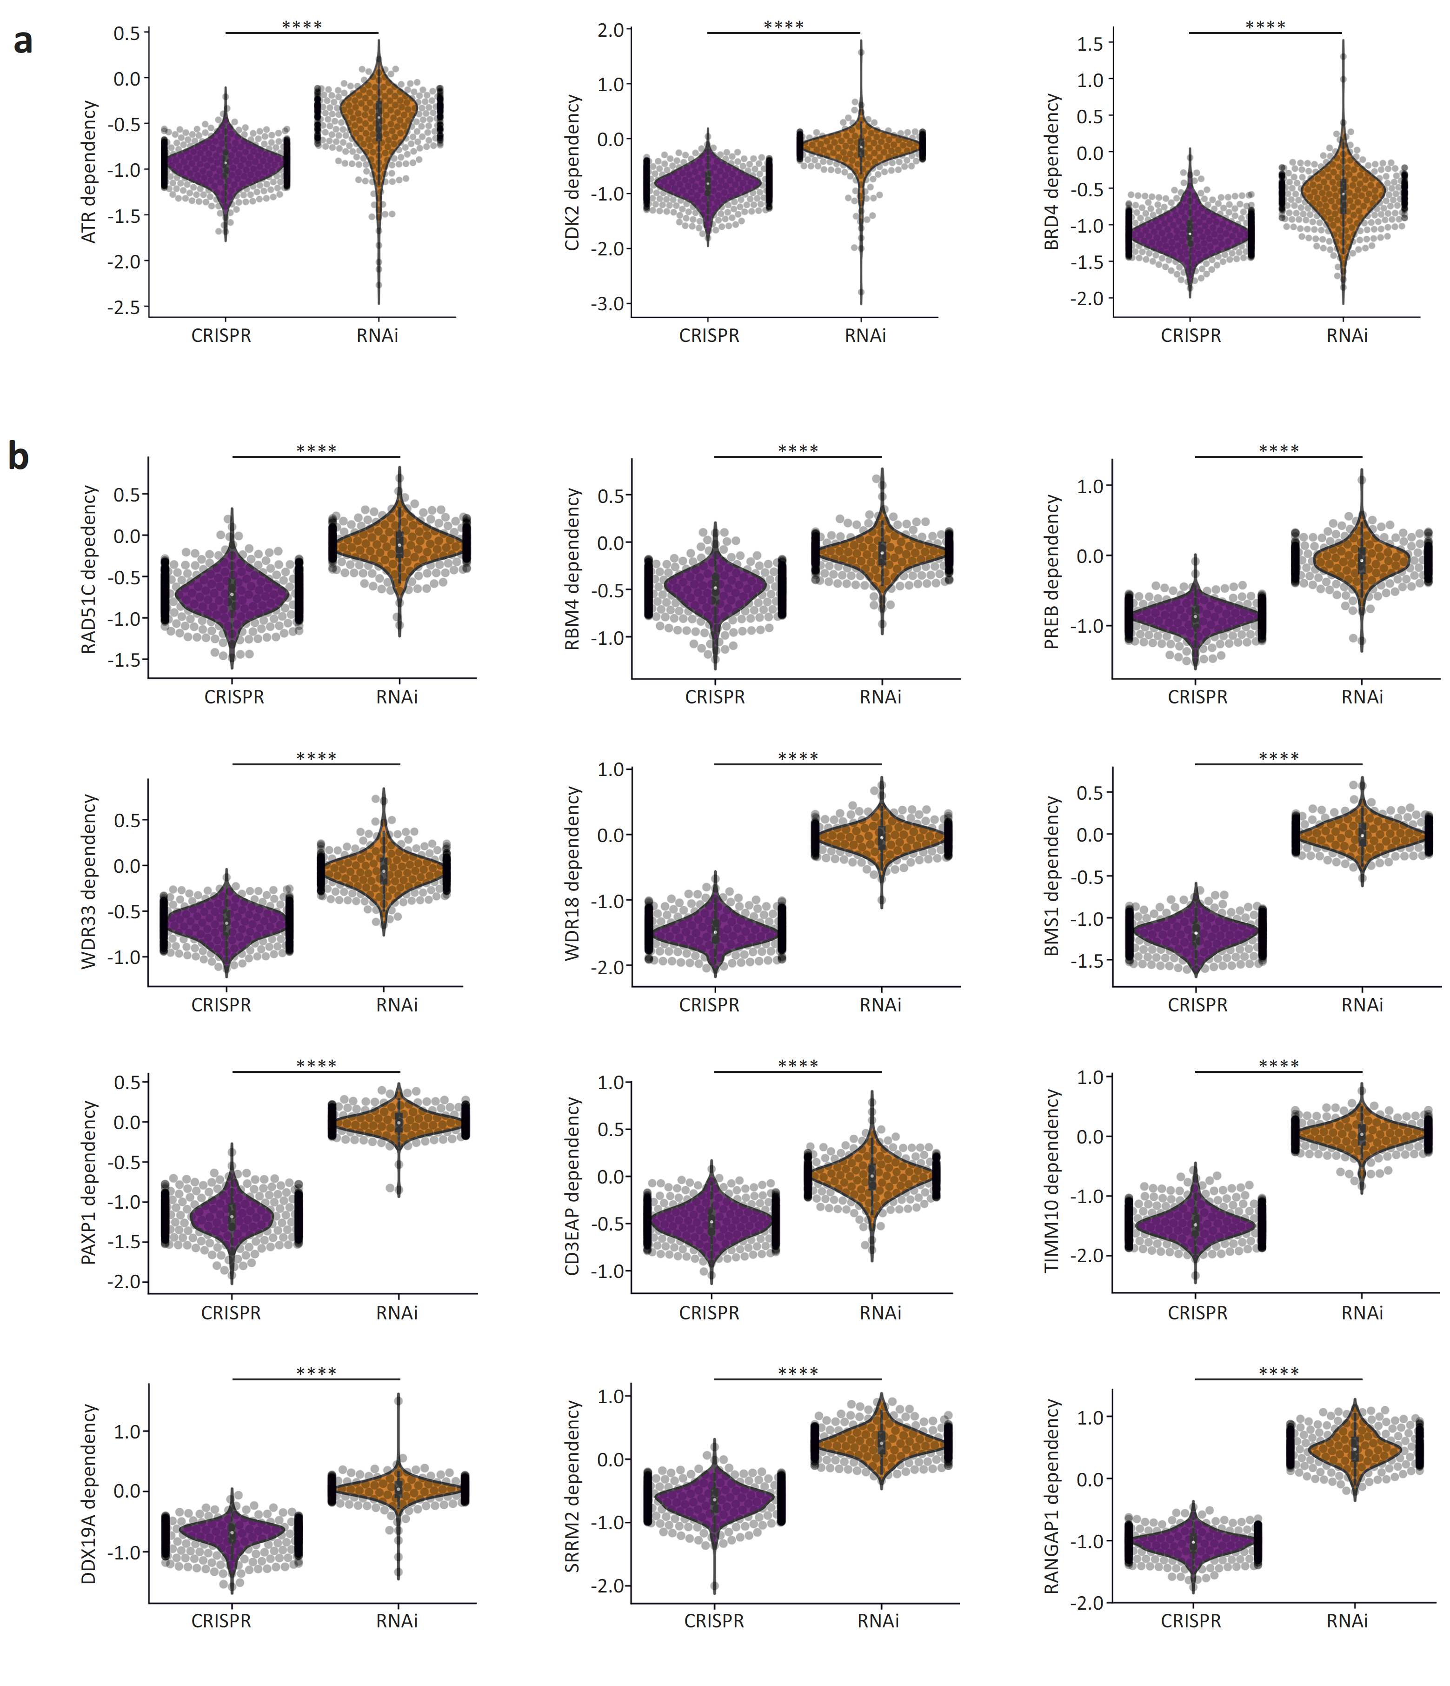
Supplementary Figure 1: Gene essentiality in RNAi vs. CRISPR screens. (a) Comparison of gene essentiality between Achilles-CRISPR and Achilles-RNAi screens. Shown are three genes for example – ATR, CDK2 and BRD4 – selected based on their clinical relevance. ****, p<1e-04; two-tailed t-test. (b) 12 examples for genes that are considered ‘common-essential’ in the CRISPR screen, but not in the RNAi screen. ****, p<1e-04; two-tailed t-test.
Supplementary Figure 2: Association between aneuploidy scores and the sensitivity to drugs targeting common-essential genes. (a) Correlation between CDK2 dependency and the mRNA expression levels of CCNE1. Spearman’s ρ=-0.26 (p=8e-12). (b) Correlation between ATR dependency and cell line response to ATR kinase inhibitor VE-821 (BRD-K26756394-001-02-2). Spearman’s ρ=0.18 (p=7e-04) and ρ=0.37 (p=2e-11) for the CRISPR and RNAi screens, respectively. (c) Correlation between BRD4 dependency and cell line response to the bromodomain inhibitor I-BET-762 (BRD-K08109215-001-06-4). Spearman’s ρ=0.15 (p=0.005) and ρ=0.2 (p=6e-04) for the CRISPR and RNAi screens, respectively. (d) Correlation between KIF11 dependency and cell line response to the kinesin-like spindle protein inhibitor K-858 (BRD-A67748489-001-10-0). Spearman’s ρ=0.12 (p=0.019) and ρ=0.44 (p=4e-15) for the CRISPR and RNAi screens, respectively. (e) Correlation between TOP2A dependency and cell line response to the topoisomerase inhibitor dexrazoxane (BRD-K07265709-003-05-6). Spearman’s ρ=0.13 (p=0.012).
Supplementary Figure 3: Example of the flow cytometry gating strategy for the cycle analysis.
Western blots for Extended Data Fig. 9a
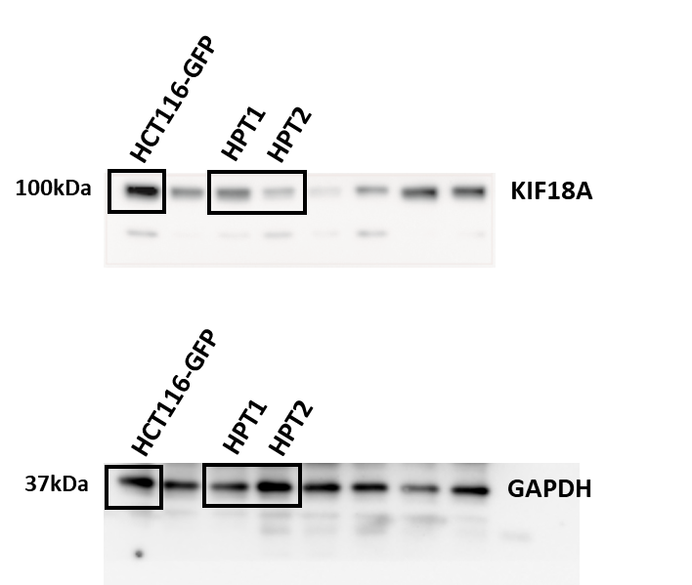
Western blots for Extended Data Fig. 9q
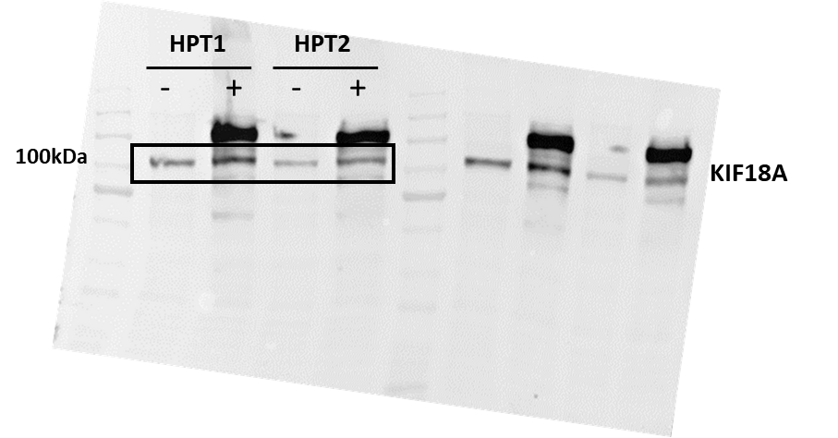

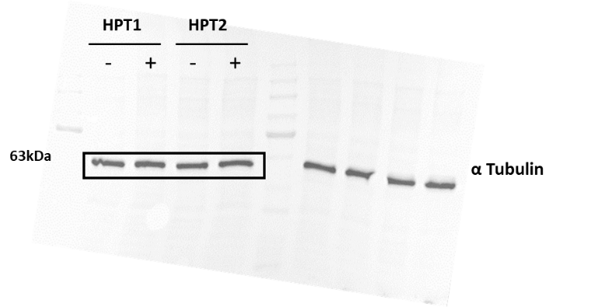

Western blots for Extended Data Fig. 10j
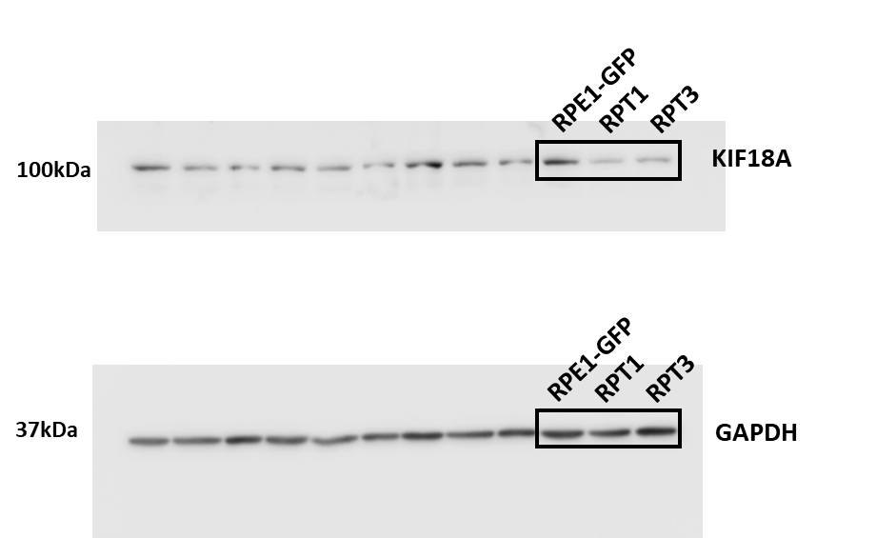

Western blots for Extended Data Fig. 10k
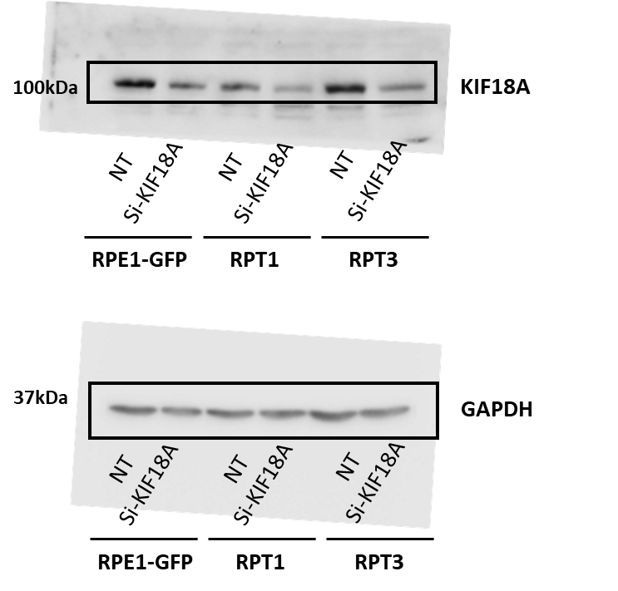
Supplementary Figure 4: Uncropped scans with size marker indications for all western blots.

Legends to Supplementary Tables
Supplementary Table 1: Chromosome-arm copy number calls and aneuploidy scores for 997 human cancer cell lines. For each cell line, the copy number status of each chromosome arm was determined by comparing the weighted median log2 copy number (wmed_CN) value of the arm to the basal ploidy of the cell line. AS were determined as the number of chromosome arms that were gained or lost in each cell line.
Supplementary Table 2: Genetic dependencies of highly-aneuploid cancer cells. The lists include all genes on which aneuploid cancer cell lines were found to be more dependent than euploid cancer cell lines (effect size<-0.1, q<0.25) in the RNAi-Achilles and RNAi-DRIVE genetic dependency screens. P-values were derived from two-sided empirical-Bayes-moderated t-statistics. Q values were computed using the Benjamini–Hochberg method.
Supplementary Table 3: Functional annotation enrichment analysis of aneuploidy-associated genetic dependencies. DAVID functional enrichment analysis was performed on the genes that came up as differentially essential between the near-euploid and highly-aneuploid cell lines, focusing on the GO_BP gene sets. Gene sets with q<0.1 are listed. P-values were derived from the modified one-sided Fisher’s exact test applied by DAVID⁵⁹. Q values were computed using the Benjamini–Hochberg method.
Supplementary Table 4: mRNA expression differences between near-euploid and highly-aneuploid cancer cells. A comparison of mRNA expression between the near-euploid and highly-aneuploid cancer cell lines, using the CCLE gene expression profiles². P-values were derived from two-sided empirical-Bayes-moderated t-statistics. Q values were computed using the Benjamini–Hochberg method.
Supplementary Table 5: Chemical sensitivities of highly-aneuploid cancer cells. The lists present the differential dug sensitivities between near-euploid and highly-aneuploid cancer cell lines, for all of the compounds tested in the CTD², GDSC and PRISM drug screens. P-values were derived from two-sided empirical-Bayes-moderated t-statistics. Q values were computed using the Benjamini–Hochberg method.
Supplementary Table 6: Cancer cell line sensitivity to the SAC inhibitor reversine. Results of a PRISM screen of reversine (at 8 doses) across 530 human cancer cell lines. Shown are the Area Under the ROC Curve (AUC) values.
Supplementary Table 7: Gene expression profiles of HCT116 and HPT cells exposed to SAC inhibitors. L1000-based expression values of 10,174 genes⁶³ in HCT116-WT, HCT116-GFP, HPT1 and HPT2 cells treated with reversine (250nM or 500nM), MPI-0479605 (250nM), positive controls (reversine at 10µM and Mitoxantrone at 10µM) or negative controls (DMSO).
Supplementary Table 8: Association between aneuploidy levels and KIF18A mRNA and protein expression levels. Comparison of CCLE mRNA and protein expression values between the near-euploid and highly-aneuploid cell line groups, across multiple tissue types. P-values are derived from a two-tailed t-test.

Supplementary References
76. Weaver, B. A. & Cleveland, D. W. The Aneuploidy Paradox in Cell Growth and Tumorigenesis. Cancer Cell (2008) doi:10.1016/j.ccr.2008.11.011.
77. Gordon, D. J., Resio, B. & Pellman, D. Causes and consequences of aneuploidy in cancer. Nat Rev Genet 13, 189–203 (2012).
78. Sheltzer, J. M. & Amon, A. The aneuploidy paradox: costs and benefits of an incorrect karyotype. Trends Genet 27, 446–453 (2011).
79. Cai, Y. et al. Loss of Chromosome 8p Governs Tumor Progression and Drug Response by Altering Lipid Metabolism. Cancer Cell 29, 751–766 (2016).
80. Viswanathan, S. R. et al. Genome-scale analysis identifies paralog lethality as a vulnerability of chromosome 1p loss in cancer. Nat. Genet. (2018) doi:10.1038/s41588-018-0155-3.
81. Zhu, J., Tsai, H. J., Gordon, M. R. & Li, R. Cellular Stress Associated with Aneuploidy. Dev Cell 44, 420–431 (2018).
82. He, B. et al. Chromosomes missegregated into micronuclei contribute to chromosomal instability by missegregating at the next division. Oncotarget 10, 2660–2674 (2019).
83. Pachis, S. T. & Kops, G. J. P. L. Leader of the SAC: Molecular mechanisms of Mps1/TTK regulation in mitosis. Open Biology (2018) doi:10.1098/rsob.180109.
84. Sheltzer, J. M. et al. Aneuploidy drives genomic instability in yeast. Science (80-. ). (2011) doi:10.1126/science.1206412.
85. Passerini, V. et al. The presence of extra chromosomes leads to genomic instability. Nat. Commun. (2016) doi:10.1038/ncomms10754.
86. Catarinella, M., Grüner, T., Strittmatter, T., Marx, A. & Mayer, T. U. BTB-1 A small molecule inhibitor of the mitotic motor protein kif18A. Angew. Chemie - Int. Ed. (2009) doi:10.1002/anie.200904510.
87. Fonseca, C. L. et al. Mitotic chromosome alignment ensures mitotic fidelity by promoting interchromosomal compaction during anaphase. J. Cell Biol. (2019) doi:10.1083/jcb.201807228.
88. Schukken, K. M. et al. Altering microtubule dynamics is synergistically toxic with spindle assembly checkpoint inhibition. Life Sci. Alliance (2020).

