Supplementary Information

Supplementary Information A. Excavation, conservation and restoration procedure…….…..2
Supplementary Information B. The Middle Stone Age lithics from Panga ya Saidi………...17
Supplementary Information C. Luminescence dating………………………………………..19
Supplementary Information D. Screening for ancient DNA in skeletal and sediment samples associated with the Panga ya Saidi hominin burial…………………………………………..52
Supplementary Information E. Thin section micromorphology and bone microscopy……...55
Supplementary Information F. Detailed morphological and metric description and comparison of the Panga ya Saidi dental remains…………………………………………... 75
Supplementary Information G. Sediment analysis…………………………………..……...103
Supplementary Information H. Faunal remains associated with the human burial…………127
Supplementary Information I. Shell analysis……………………………………………….136
Supplementary Information J. The Middle Stone Age palaeoecological context of Mtoto…140

Supplementary Information A. Excavation, conservation and restoration procedure
During the excavation of Trench 4 in 2013, it was noticed that the dense Middle Stone Age occupation Layer 18 (context 422) had an unusual dip in the western side of the south wall. Initially, this was interpreted as a more pronounced and distinct example of the common undulations that characterized the contact between Layers 18 and 19 (Supplementary Information Fig. A1). Since this was the thickest part of Layer 18, sample PYS13-OSL was taken from this area. Additionally, and to better understand this depression, a micromorphology sample (PYS 13_1) was taken through the base of the feature. Removal of the micromorphology sample revealed the presence of heavily degraded and powdery bones, including the fragment of a long bone that fell out of the section but which disintegrated upon an attempt to retrieve it. This long bone was later shown to correspond to the proximal end of a right hominin femur (Supplementary Information Fig. A2). The subsequent excavation season at PYS in 2017 reached the top of this feature in adjacent Trench 8. At the level of the 2013 OSL sample hole, which was still visible in plan view, it became apparent that there was a concentration of extremely fragile and degraded fragments of bone within this feature and that the sediment matrix was distinct from the surrounding Layer 19 (Supplementary Information Fig. A3).

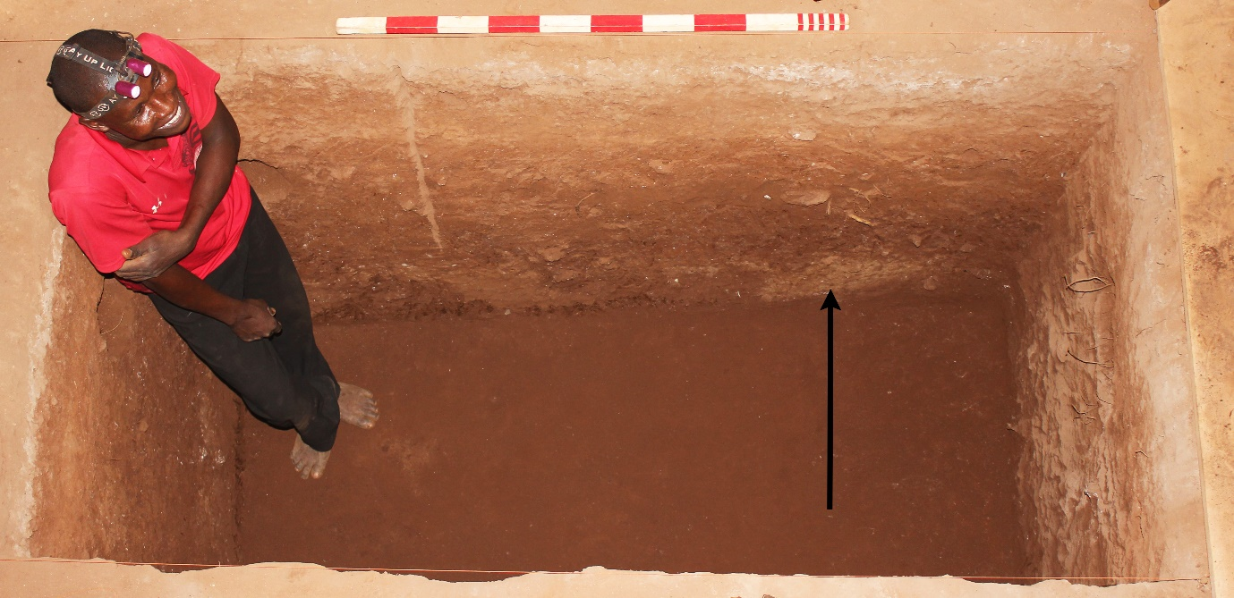
Supplementary Information Fig. A1. Trench 4 during the excavation of Layer 19 in 2013. The arrow points to the feature visible at the south profile.

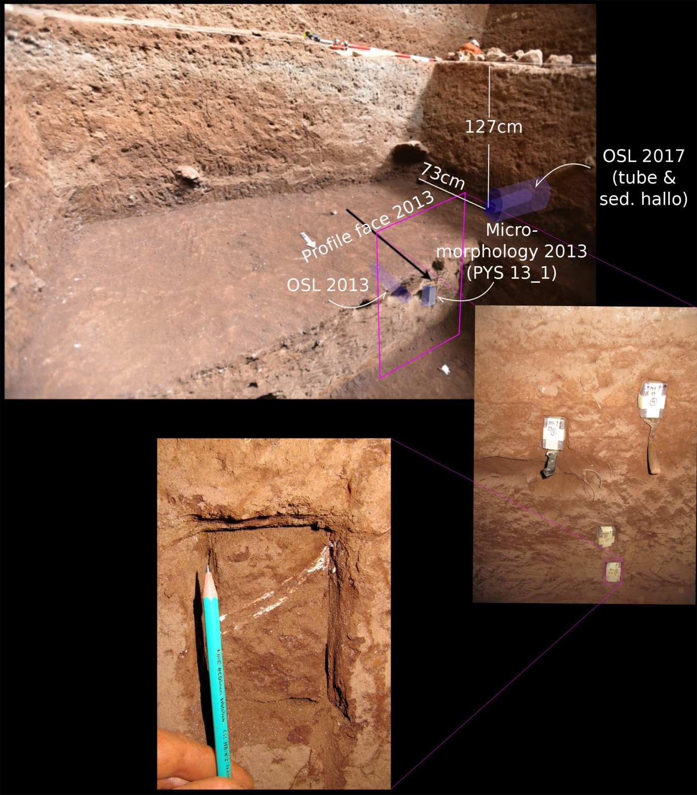
Supplementary Information Fig. A2. Trench 8 in 2017 prior to the exposure of the burial. The arrow points to the position of the burial in the profile and the holes of samples taken from the profile in 2013. Close-up of the micromorphology sample (PYS 13_1) shows the presence of a long bone that could not be recovered.

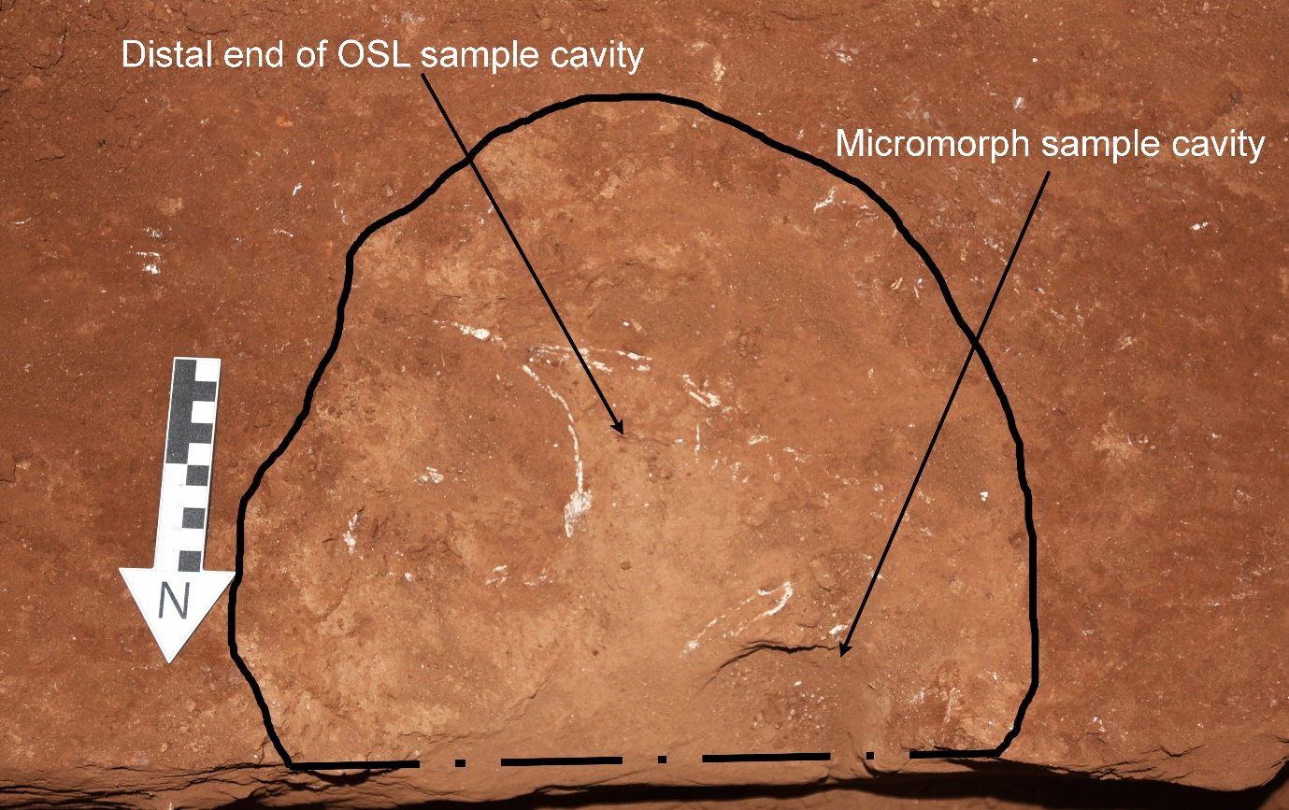
Supplementary Information Fig. A3. Plan view of the feature in 2017, showing the concentration of bones and the cavities of the OSL and micromorphology samples taken in 2013. The burial is truncated by Trench 4 on the northern edge.
After an initial attempt to recover the fragile bones by hand, it was decided to excavate them by consolidating them with acrylic resins Bedacryl® and Paraloid®. One of the working hypotheses was that the bones could represent those of a monkey. It was decided to encase the entire feature in plaster, remove it as a block (Supplementary Information Fig. A4) and excavate it at the National Museums of Kenya (NMK) preparation lab in Nairobi. Before plastering, the outline and profile of the cut together with the artefacts and bones found during the excavation of Layers 18 and 19 were plotted using the total station, enabling a 3D reconstruction of the position of the feature relative to other finds and the trench stratigraphy (Supplementary Information Fig. A4). The material excavated from the top of the feature prior to plastering was collected and a sub-sample was wet sieved and floated, revealing a significant amount of bone fragments and several lithics (Supplementary Information Fig. A4). Later, it was realised that some of the retrieved bone fragments shared the same whiter appearance as the hominin in the feature. Some of these white fragments were flat bones and may represent fragments of the crushed head. However, their poor state of preservation and fragmentation prevented their anatomical identification and, in some cases, their full recovery (Supplementary Information Fig. A4).
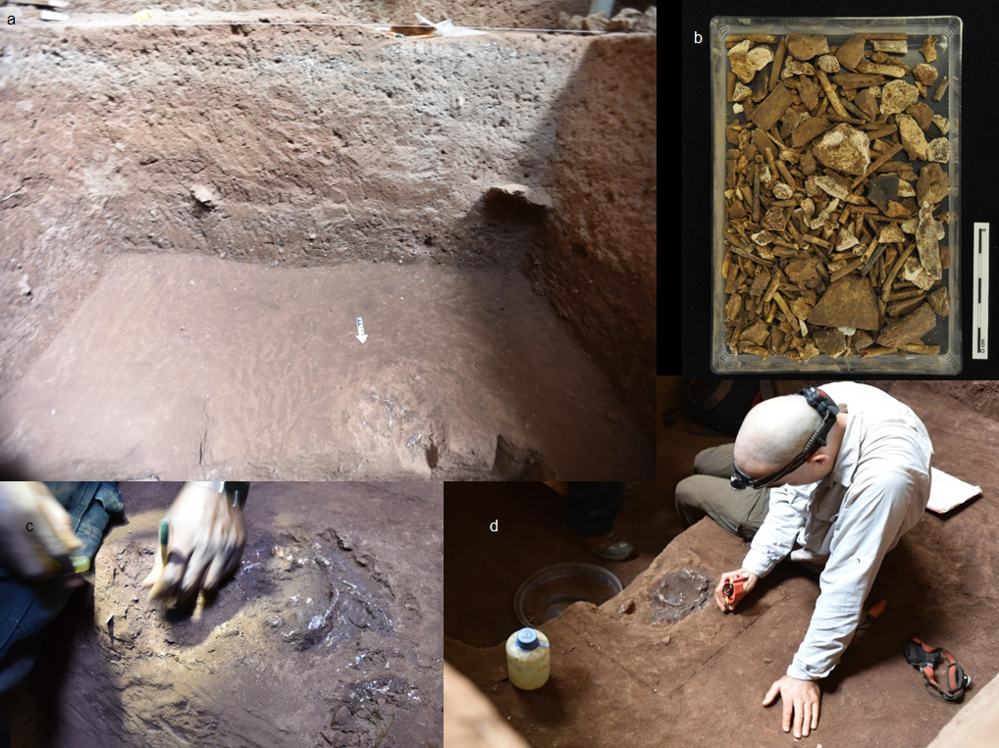
Supplementary Information Fig. A4. a) Trench 8 during the excavation with Paraloid® after removal of the surrounding sediment. b) Box containing part of the material sieved from the excavation of the top part of the feature. c) Close-up image of the initial excavation of the feature. d) Recording the plan of the burial with the total station.
The plastered block was removed from the excavation trench and then taken to the preparation laboratory at the NMK in Nairobi for further intervention and preliminary evaluation (Supplementary Information Fig. A5). The plastered cast was carefully removed at the laboratory, further revealing bones as well as two teeth at the surface, leading to the identification of the skeleton as an immature hominin. The initial sediment removal process revealed the powdery consistency of the bones, some of them barely imprints of the original element; thus, it was deemed necessary to combine mechanical and digital excavation and reconstruction of the fossil to prevent its disintegration. Internal consultations at the NMK reached the decision that the contents of the plastered cast required specialist study. In March 2018, the main block and some smaller fragments of bone and sediment coming from the feature, but detached from the block after excavation and/or transport, together with the MSA lithics and shells recovered during the initial excavation at the NMK, were hand carried to the MPI-SHH, Jena (Germany) for evaluation. Given the very poor state of preservation of the bones and the plastered material, it was realised that specialist conservation and study were required. The NMK and the MPI-SHH reached the decision that the remains should be conserved and examined at the National Research Center on Human Evolution (CENIEH) in Burgos. Permits and authorisation were provided by the NMK in the framework of the existing collaboration between the NMK and the MPI-SHH.
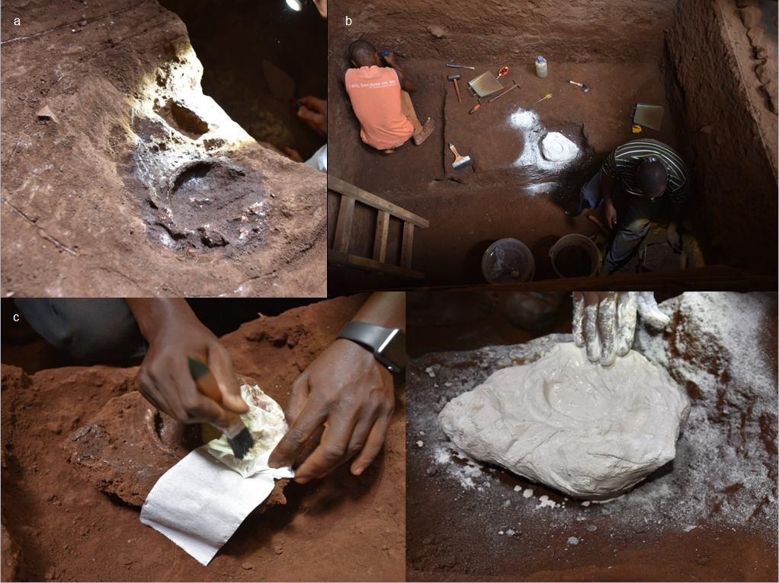
Supplementary Information Fig. A5. a) Close-up of the feature with bones and sediment darkened due to the application of Paraloid® resin. b) Upper view of Trench 8 after plastering the feature. The surrounding area of Layer 19 was excavated in order to jacketing the finding. c) Plastering of the feature.
Preliminary analyses at the Conservation and Restoration Laboratory of CENIEH detected severe mechanical degradation of the bones, despite the fact that were previously consolidated at the site. The fossils were included in a medium-hardness sediment block and upon arrival were thoroughly documented (macro-photography and microscope images) and preserved in suitable containers with controlled environment conditions. Externally, on one of the sides of the block it was possible to recognize the internal surface of the basicranium (Supplementary Information Fig. A6). On the opposite surface, the profile of a vertebral column and associated ribs was visible (Supplementary Information Fig. A6).
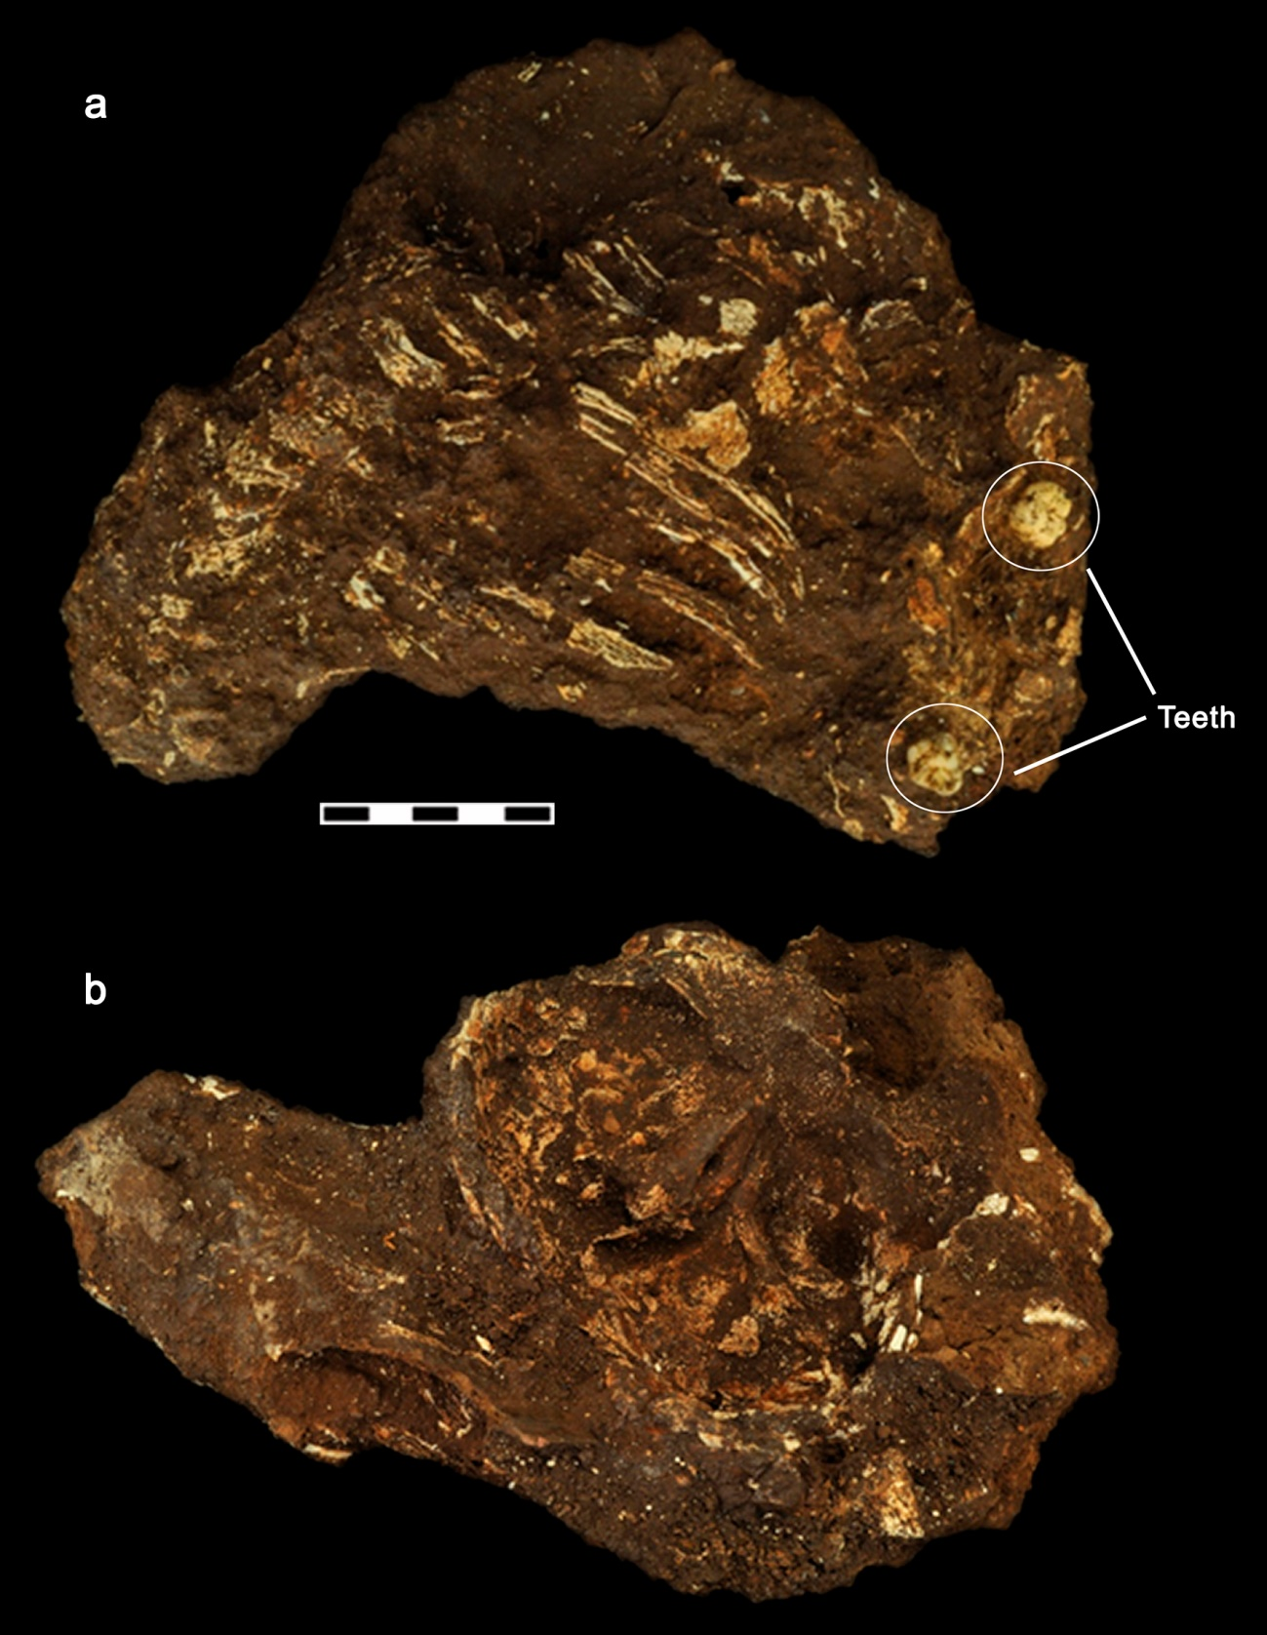
Supplementary Information Fig. A6. Initial stage, a) Inferior view of the main block upon its arrival to CENIEH and prior to restoration. The identification of two teeth on the surface allowed its initial human attribution. The profile of the articulated vertebral bodies and ribs can be easily seen on the surface. b) Superior view of the main block revealing the interior of the middle, posterior and small portion of anterior cranial fossae.
The main block was mCT scanned at the Micro-computed Tomography Laboratory of CENIEH revealing that apart from the teeth that were visible at the surface, at least two more teeth and other bony structures of low density and several shells were preserved inside the main block. The severe diagenesis of the bones affected their consistency in such a way that bone was not dense enough to allow extraction the skeleton digitally. There was not enough contrast to virtually identify and isolate the different anatomical elements (Supplementary Information Fig. A7). Thus, it was decided to combine mechanical and digital excavation and reconstruction. The mechanical excavation (restoration procedure) aimed to isolate the two main units, not only to make scientific research easier (scanning of smaller and cleaner fragments would allow better resolutions) but also to enable us to conserve the mechanically unstable skeleton. One unit included the skull and another unit included the spine and part of the articulated ribs. Each isolated element as well as individual fragments recovered in the course of restoration process were successively scanned with mCT as well as with a surface scanner.
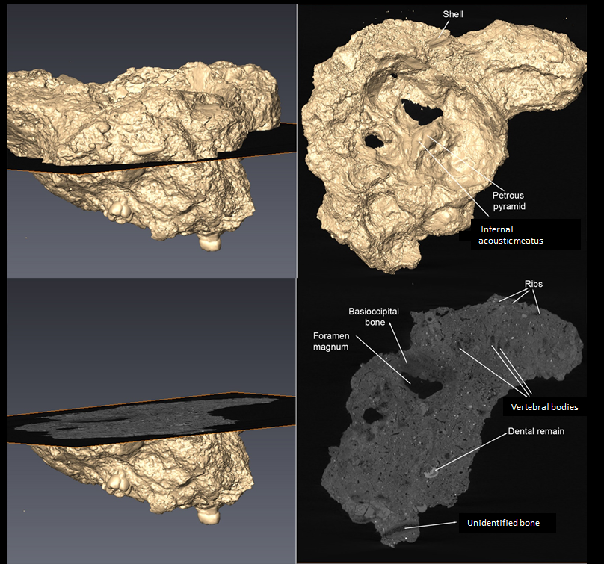
Supplementary Information Fig. A7. 3D virtual reconstruction and microCT sections of the main block revealing the low density of bones and the difficulty to virtually isolate the skeleton from the sediment.
Each stage of the restoration process was photographed, and all the sediment removed was collected and classified by date of removal and anatomical area. The restoration process started at the internal side of cranium vault by removing the superficial soil layer that included the protective yellowish coat applied at the site (Bedacryl®). Cleaning was done employing dental practice tools, wood sticks and ethyl alcohol and purified water (1:1) under stereomicroscope and magnifier. The original whiter colouration of the bone as well as several shells fragments surrounding the occipital bone were uncovered (Supplementary Information Fig. A8).
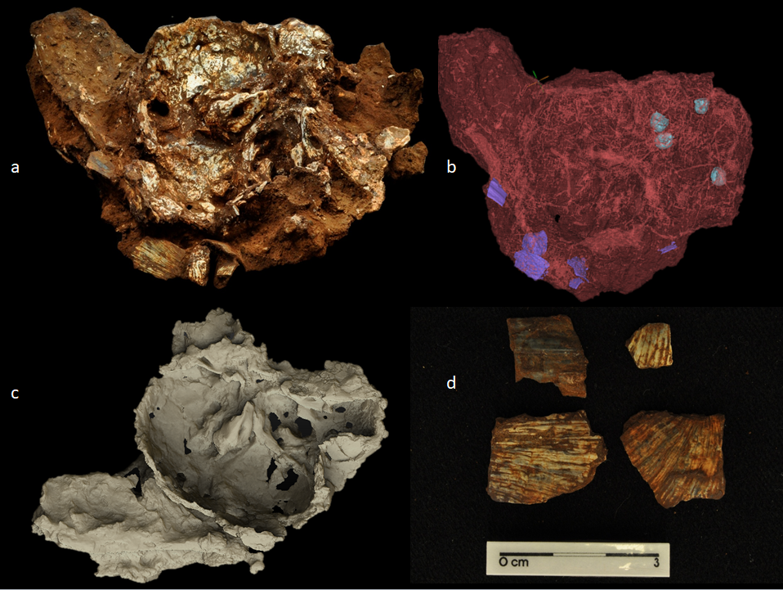
Supplementary Information Fig. A8. a) Superior view of Mtoto’s endocranium. b) MicroCT virtual reconstruction of the main sediment block (red) containing the skull and articulated spine, teeth (blue) and associated shells (purple). c) Virtual reconstruction of the 3D scan of the skull and spine before separation of both elements. d) Shells isolated from the occipital region of the child.
On the internal surface of the neurocranium the fossil preserves the middle and posterior cranial fossae (especially their left half), as well as a small portion of the anterior cranial fossa. The sphenoid bone is partially preserved, especially in the central and left portions. The clinoid processes seem to be present, but they are twisted inwards. The hypophyseal fossa (sella turcica) is probably lost. The petrosal bones are well preserved, particularly the left one. The internal nuchal crest (groove of the occipital sinus) is well preserved and reaches inferiorly the vicinity of the opistion. Superiorly it does not reach the endinion but could reach the lower lip of the left groove of the transverse sinus. No marginal sinuses are present around the foramen magnum. The left anterior hypoglossal canal is clearly visible but there is only a hint of the right one, which may be obstructed by sediment. The basilar part of the occipital bone is preserved. The atlas is articulated with the occipital condyles. The axis and part of the third cervical vertebra are also present.
Next was the extremely delicate and slow process of removing the sediment between the skull and the postcranial elements in order to separate them. Interestingly, despite the fragility, the ribs were preserving the curvature and thorax volume (Supplementary Information Fig. A9). The combination of the microCT and 3D surface scanner, together with field pictures and the Total Station data on the feature, allowed the reconstruction of the spatial relationship between the skull and the spinal column and their general position with regard to the pit (Supplementary Information Fig. A10). The isolation of the spine and associated ribs also allowed access to the external side of the cranial vault. After the isolation of the block with the spine and ribs, the external surface of the vault was accessible for further sediment removal and the two teeth previously identified in the mCT scan were exposed to the surface (Supplementary Information Fig. A11). The block relating to the facial area was inferiorly displaced in relation to the cranial vault and completely crushed, with several small and thin fragments of difficult anatomical identification. Due to mechanical instability, the facial block was isolated as a unit (Supplementary Information Fig. A12). The two teeth originally visible on the surface were also isolated at this stage.
. 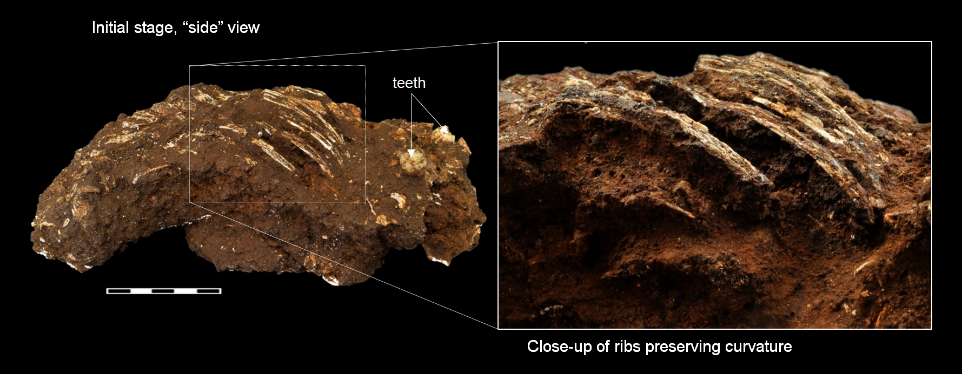
Supplementary Information Fig. A9 Lateral view of the PYS main block and detail of the ribs. Despite the fragility of the bone, the thorax maintains volume and ribs curvature, indicating a progressive infilling with sediment as decomposition advanced.

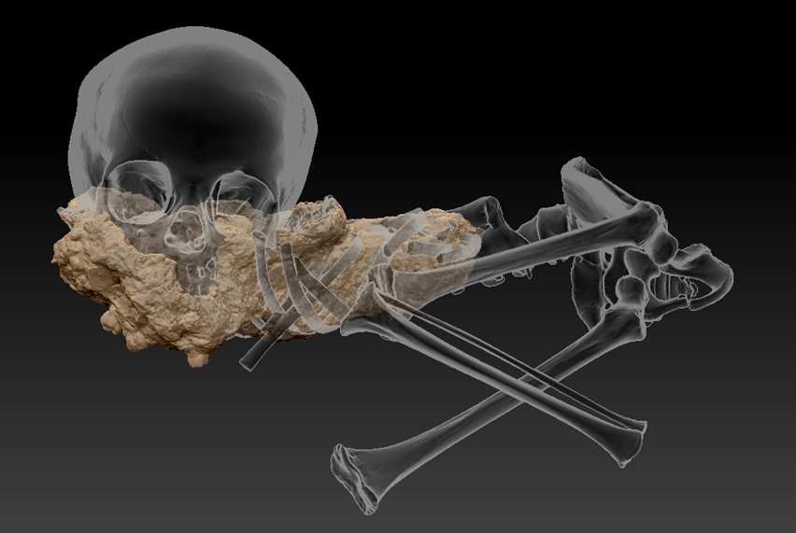
Supplementary Information Fig. A10. Virtual reconstruction of the PYS main sediment block superimposed over a transparent skeletal model to illustrate the location in the pit and the general position of the child.

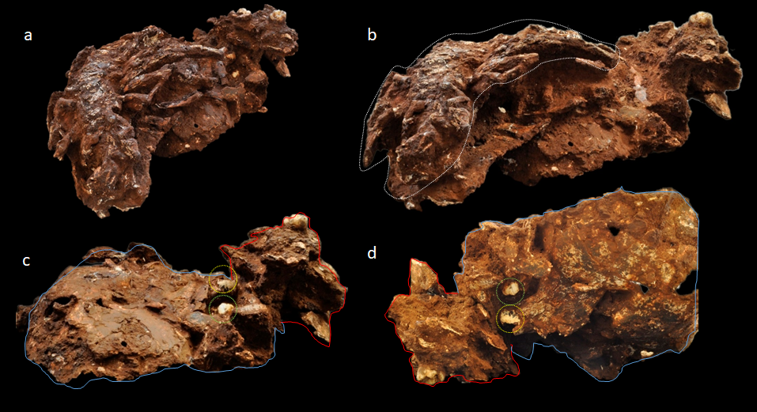
Supplementary Information Fig. A11. a) After sediment removal, the spine and cranial elements are more clearly exposed. b) The spine (circled) and the cranio-facial area are isolated as units. c) The external side of the vault (blue) and the facial region (red) are now accessible and two more teeth (yellow) are exposed. d) Despite fragility and distortion all the skeletal elements preserve their general anatomical relationship.
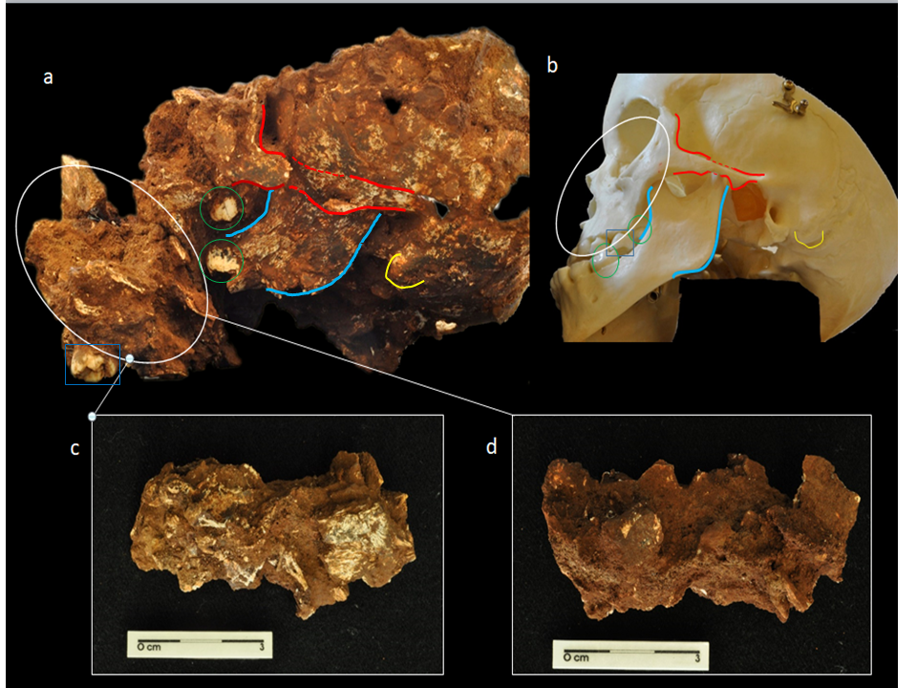
Supplementary Information Fig. A12. Lateral view of the PYS cranial segment after removal of the postcranial elements. a) Comparison with a plastic cranial model of a child. b) Identification of the same elements by colour. All the anatomical parts preserve their general spatial relationship although the face is crushed and vertically displaced likely because of the sediment weight.
The separation of the two units revealed the left hemimandible preserved in strict articulation with the base of the skull and two unerupted teeth in situ (Supplementary Information Fig. A13). On the outer surface of the occipital bone it seems that the nuchal plane is “folded” at the level of the inferior nuchal line. The preserved portion of the occipital squama reaches as high as where the external occipital protuberance is located although the poor state of preservation precludes detailed observation. The suture of the temporal squama with both the parietal and the sphenoid bone (squamosal suture) is preserved. The upper border of the temporal squama is pronouncely arched. The left side of the skull is better preserved than the right. The two ends of the zygomatic arch, the temporal end (in the zygomatic process) and the zygomatic end (in the temporal process) are preserved. The left upper ramus of the mandible is complete (except some minor loss in the gonial angle), and in articulation with the temporal bone. It shows a symmetric mandibular notch with the condylar process and the coronoid process levelled. The articular tubercle of the temporal bone is well developed. A portion of the mandibular corpus with an unerupted molar crown is also preserved. The left zygomatic bone as well as the portion of the maxillary bone with the crown of an unerupted molar are well preserved.
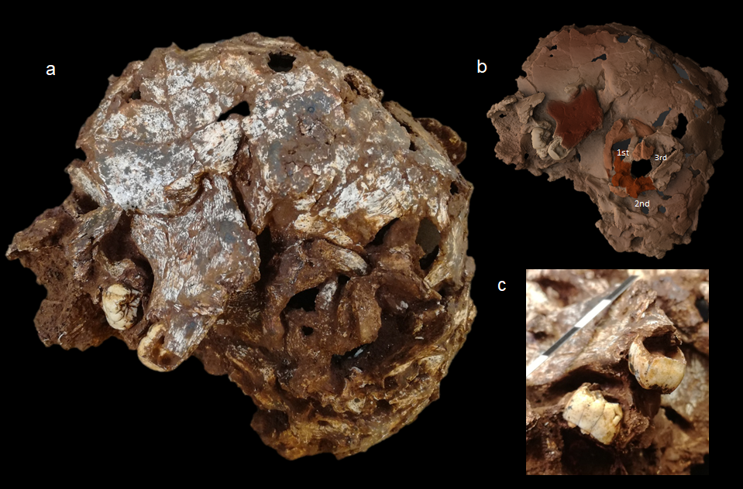
Supplementary Information Fig. A13. a) Left side of Mtoto’s skull showing the articulated ramus of the mandible with the two teeth in situ and the cervical vertebrae juxtaposed with the foramen magnum. b) 3D reconstruction of the same element highlighting in colour the mandibular ramus, and the 1st, 2nd and 3rd cervical vertebrae. c) Detail of the two unerupted molars held in place by the sediment.

The restoration procedure also revealed several bones juxtaposed with the foramen magnum. After surface outlining, these were identified as the first, second and a fragment of the third cervical vertebrae, in direct anatomical connection and in place, although rotated (Supplementary Information Fig. A13). Due to the significant taphonomical information contained in the spatial relationship of the first vertebrae and the skull, and the extreme fragility of these bones, it was decided to keep them in place and conduct surface microCT scanning for further study.
In the external part of the postcranial element, several fragments of flat and thin bones, that based on their shape and anatomical location, likely correspond to the right scapula, were lifted (Supplementary Information Fig. A14). Next, thoracic rib fragments were lifted by consolidating the surrounding sediment (Paraloid® B72 diluted 5 % in acetone was used for all consolidation procedures, if they were strictly necessary). However, due to the extreme fragility of the ribs and the importance of preserving the information regarding their curvature, i.e., the anatomical spatial association and the preservation of the intercostal space, it was decided to lift them as a block. Immediately below, the first and second right ribs (with intact intercostal space) and the distal and medial fragment of the right clavicle (in an oblique position) was found (Supplementary Information Fig. A14). The removal of the first and second rib revealed that the clavicle was complete although poorly preserved (Supplementary Information Fig. A14).
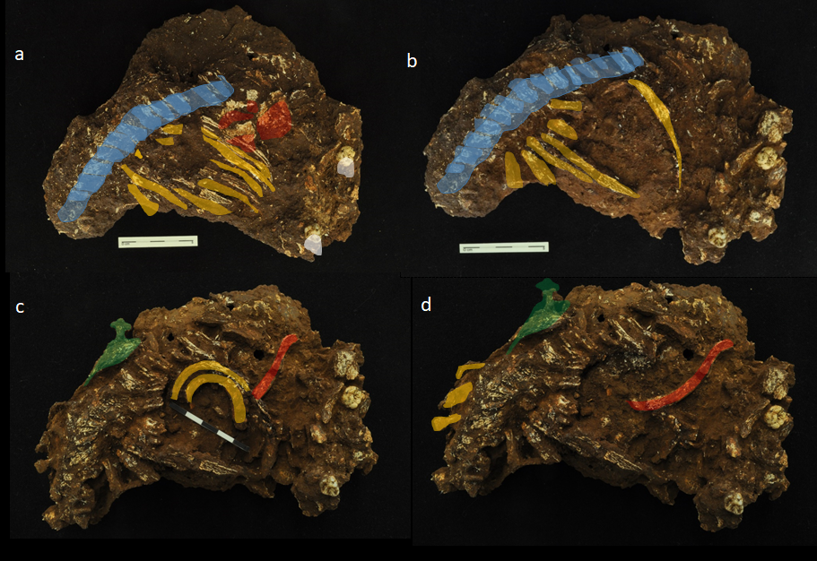
Supplementary Information Fig. A14. Different phases of restoration procedure of the PYS main sediment block illustrating how progressive uncovering of the different anatomical elements revealed minimal displacement. a) At an initial stage the articulated spine (blue), several ribs (yellow), fragments of the right scapula (red) and two teeth (white) are exposed. b) In a second stage, the scapular fragments and some thoracic ribs are lifted. c) Progressive removal of some rib fragments reveals the first and second ribs (yellow) descended into the thoracic cavity but preserving the intercostal space and the right clavicle in an oblique position (red). The left scapula is in situ and highlighted in green. d) With the removal of the first and second ribs, the complete clavicle is exposed. Note the strong rotation of the clavicle (ca. 90º) as it is typical of tightly packed or shrouded burials.
Exhaustive removal of sediment was conducted on the isolated spine, though to the level that it did not compromise its conservation. This procedure exposed the left ribs, showing pronounced curvature and deformation but preserving the intercostal space, as well as a relatively complete left scapula and a left humerus. (Supplementary Information Fig. A15). The humerus is fairly complete except for its distal and proximal ends. The scapula preserves part of the supra and infraspinous fossae, the spine and a portion of the acromion.
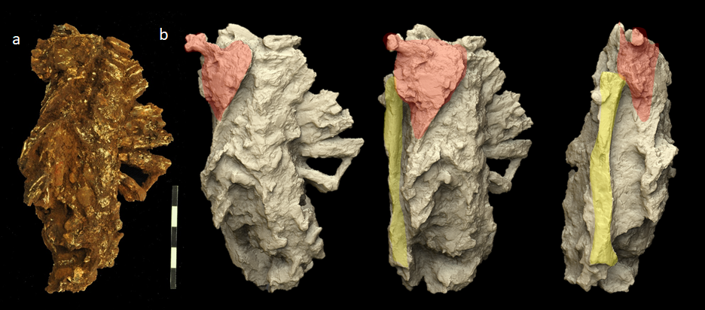
Supplementary Information Fig. A15. a) Picture of Moto’s thorax with humerus and, b) progressive rotation of the 3D surface scan of the same element showing the articulation of the spine, scapula (red) and humerus (yellow).
3D scanning of the cleaned cranial and postcranial units allowed a more precise visualisation of the spatial relationship of both elements and of the position of the child at the site (Supplementary Information Fig. A16).
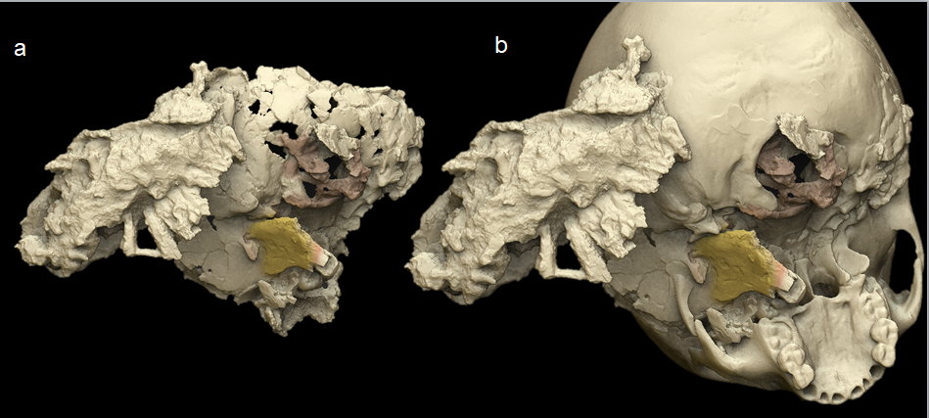
Supplementary Information Fig. A16. a) 3D virtual reconstruction of the relationship between the cranial and postcranial elements based on 3D scanning and mCT data. b) Scans of Mtoto were superimposed on the skull of a child of the same developmental age to better illustrate the original burial position.
Subsequent restoration processes of small sedimentary fragments detached from the main block allowed the identification of a part of the right radius and ulna shafts, a deformed fragment of the left parietal bone (Supplementary Information Fig. A17), several bone remains that could not be identified due to poor preservation, land snail shells and lithics.
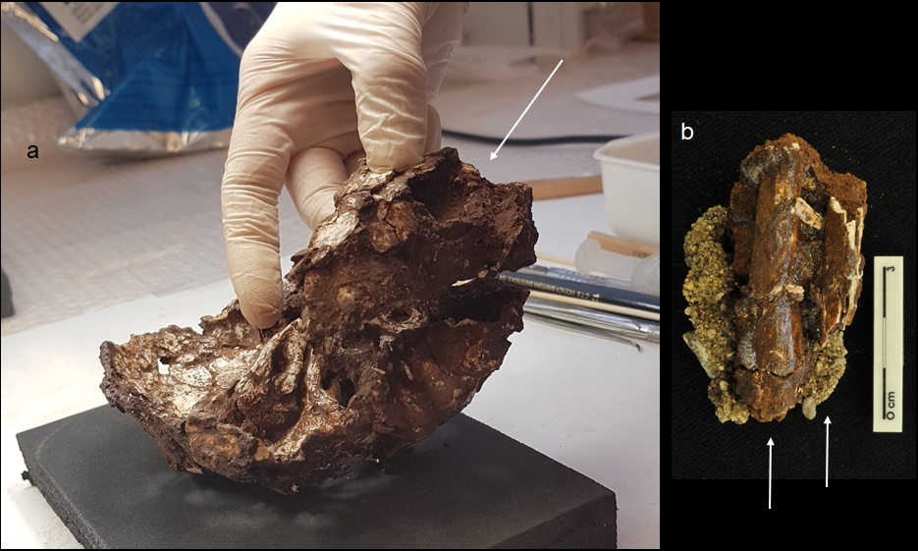
Supplementary Information Fig. A17. a) Deformed fragment of the right parietal bone and its “ideal” position with regard to the rest of the skull. b) Distal fragment of the left radius and ulna maintaining their anatomical relationship and encased in a sediment lump. Both a) and b) come from the pit but were found detached from the main block, therefore their exact position is not certain.
Finally, light consolidation of the cortical surface and sediment was applied all on all the fossils to assist with their handling and to reinforce their mechanical stability. The different elements were packaged in individual custom-made containers for each element and cushioned with inert material for safe storage and transit. All the recovered elements were returned to the National Museum of Kenya in May 2019.

Supplementary Information B. The Middle Stone Age Lithics from Panga ya Saidi
The excavation of Layers 17-19 in Trenches 3, 4, and 8 at PYS produced 2180 stone artefacts (Extended Data Fig. 1). The excavation of Trench 8 layers yielded cultural material associated with the burial. Several features of the Layer 17-19 assemblages: a) distinguish them from younger layers at PYS, and, b) situate these assemblages technologically within the broader African Middle Stone Age (MSA). A small sample of lithics (n=14) recovered directly from the burial pit is discussed here relative to the broader characteristics of Layers 17-19. No diagnostic LSA lithics were found in the burial sediment.
Raw-material selection: The dominant raw material in Layers 17-19 is a siliceous limestone that is present at frequencies of ~70-80% in all three layers. Siliceous limestone is available locally (~2-3 km from site). Chert and Quartz were also exploited in the MSA, but at much lower frequencies (Chert: ~8-17%; Quartz: ~2-11%) than limestone. All three raw materials - limestone, quartz and chert - are available today within 10 km of the site. In contrast, at the onset of the so-called LSA (Layer 16), quartz replaces limestone as the dominant raw material (~60-85%), followed by chert (20-30%) whereas frequencies of limestone are <10%. Importantly, in the lithic assemblages recovered from the sediment encompassing the burial, limestone is the dominant raw material (75%), which is expected for an MSA origin of these lithics.
Core reduction systems: The dominant use of silicified limestone in Layers 17-19 is coupled with prepared-core (Levallois-like systems) and discoidal core reduction, as well as simple single-platform flake production. MSA core reduction tended to focus on a single flake production surface, where the opposing face of the core was dedicated to the management of platform angles, and in several cases at PYS remained partially or fully cortical. More specifically, from the Trench 4 MSA material there are six cores from Layers 17-19: three single platform, one assayed cobble (less than four scars), one discoidal and one Levallois core. Among the larger flakes from Trench 4 (>2cm in max dim.), platform preparation occurs on 15% of flakes (Supplementary Information B Table 1). The small assemblage associated with the burial conforms to these patterns, with a facetted limestone flake among the artefacts recovered from the burial context. In Layers 17-19, bipolar and Levallois flakes are present in equal proportions, whereas in the LSA layers there are substantially higher frequencies of bipolar flakes than Levallois flakes (Supplementary Information Table B1).
Tool production: Retouched artefacts in the MSA at PYS are generally unstandardized in overall form, and comprise large scrapers, notched/denticulated flakes, and convergent points/pointed flakes. This spectrum of MSA tools differs abruptly from the tool corpus in younger layers, which is dominated largely by backed artefacts that are far more standardized in overall form than the tools in the MSA.
Relative product size: Levallois prepared-core and single-platform strategies on coarse-grained raw material in Layers 17-19 is coupled with a focus on the production of larger, ovate flakes (Extended Data Fig. 1). The subsequent shift in Layers 16-14 to predominantly quartz is reflected also in a significant reduction in the modal size of flakes (Supplementary Information Table B1). This size shift occurs within material types so is not simply wholly driven by constraints of nodule size. The size range of the artefacts recovered from the burial falls within the variability of the MSA artefacts.

Supplementary Information Table B1. PYS Trench 4 Large Flakes (>2cm) comparison between MSA Layers 17-19 and early LSA Layers 13-16.
Layers | Mean Flake Area in mm² (N) | Prepared Platforms | Bipolar Flakes | Levallois Flakes
13-16 | 575±293 (142) | 6 (4%) | 66 (38%) | 2 (1%)
17-19 | 1237±721 (185) | 37 (15%) | 5 (2%) | 5 (2%)

Supplementary Information C. Luminescence dating

C.1. Single-grain luminescence dating

Luminescence dating is a group of radiometric dating techniques which allow determination of the time elapsed since a sediment was last exposed to sunlight^{113,114}. Luminescence dating techniques have been applied successfully to a wide range of archaeological and Quaternary deposits^{115,116}. The method is based on the time dependant increase in the number of trapped electrons present in mineral grains (usually quartz or feldspar). These electrons become trapped due primarily to the effects of ionising radiation from naturally occurring radioisotopes within the sediment body (the ²³⁸U, ²³⁵U, ²³²Th decay series and also ⁴⁰K) and to cosmic rays. On exposure to light in antiquity, electrons are released from their traps, resetting the trapped electron population to zero. Similarly, exposure to light in the laboratory (stimulation) releases the trapped electrons, a proportion of which dissipate energy as photons (luminescence). The intensity of this luminescence signal is proportional to the trapped electron population, which is in turn proportional to the total ionising radiation dose to which the mineral grain has been exposed. The equivalent dose (D_{e}), which is a laboratory estimate of the total radiation dose to which a mineral grain has been exposed since burial (the palaeodose), is determined by measuring the luminescence signal. Typically, the ionising radiation flux (environmental dose rate, D_{r}) is assumed to be constant and hence the burial age of the mineral grain may be determined by dividing D_{e} by D_{r}. The resulting luminescence age is obtained in calendar years prior to measurement. The ages reported in this paper were produced using measurements on single grains of quartz (optically stimulated luminescence, OSL) or potassium feldspar (post-infrared, infrared stimulated luminescence, pIRIR). The datum used for calculating the ages reported here is 2015 for the OSL ages other than that for PYS13-OSL4 (from within the Mtoto burial), and 2020 for the pIRIR ages and OSL the age for PYS13-OSL4. In practice these are sufficiently similar for the ages to be treated as though determined simultaneously. All measurements, analysis and interpretation of data necessary to generate luminescence ages were performed by SJA at Royal Holloway University of London, UK. Except where otherwise stated, all uncertainty terms are given at one standard error.

C2. Introduction to the luminescence work presented in this study

A suite of seven quartz single-grain optically stimulated luminescence (OSL) ages for PYS were published in Shipton et al. (2018)⁸, including a detailed description of the luminescence measurement and data analysis techniques used (their Supplemental Note 3). These data were stratigraphically consistent, and were combined with a number of radiocarbon ages to construct an age model using Bayesian software (OxCal 4.3). The resulting chronology was internally consistent and deemed reliable. However, analysis of the single-grain data from samples located towards the base of the sedimentary sequence indicated that a high proportion of the grains were close to “saturation” i.e. they had received a natural radiation dose which was sufficiently close to the saturation dose to preclude the calculation of an accurate D_{e} value⁸. These data were excluded from calculation of the sample equivalent dose by rejecting grains where the D_{e} was greater than twice the curve fitting parameter D₀, when the growth curve was fitted using a single saturating exponential fit^{117,118}. Although the use of D₀ as a rejection criterion in this manner was not universal in single-grain OSL dating work at the time that the PYS data were analysed (2016), some studies supported this approach (e.g. Gliganic et al., 2012¹¹⁹). However, recent publications have indicated that rejecting grains where D_{e}>2*D₀ can yield erroneous ages, making this approach difficult to defend^{46,120}. Furthermore, the accuracy of estimate growth curve parameters, including D_{o}, is strongly dependent upon the maximum regenerative dose used (D_{max}) in the construction of the dose response curve and also upon the counting and instrumental errors^{121–123}. In the case of the PYS quartz samples, D_{max} was typically a little more than twice D_{e} (Supplementary Information C Table 8). Consequently, experimentally derived D_{o} values may not accurately reflect the true saturation characteristics of a grain’s dose response curve. Here, we investigate the effects of using D₀ as a rejection criterion by: a) reanalysing all published quartz OSL data⁸ and b) measuring potassium feldspar (K-feldspar) from the older luminescence samples from PYS. This latter approach is useful since K-feldspars are able to absorb far larger radiation doses than quartz before saturation occurs. Consequently, in the absence of complicating factors, quartz and K-feldspar ages should be consistent up to the point where signal saturation occurs in quartz. Beyond this point, K-feldspar ages are likely to be systematically older than quartz ages from the same sample. In addition to the above work, we present new quartz and K-feldspar luminescence data from sample PYS13-OSL4, from within the Mtoto burial.

C3. Sample collection and preparation

Samples were collected during the excavation of PYS by hammering metal tubes into cleaned section faces. These tubes were sealed with adhesive tape and wrapped in opaque plastic bags for transportation. In the laboratory, samples were processed under subdued orange light. Sunlight exposed material was removed from each end of the sample tube and retained for radioisotope concentration measurement. Quartz and K-feldspar were extracted from the portion of each sample which had not been exposed to sunlight since burial. Samples were initially wet-sieved to isolate the 212-180 µm size fraction. This removes large bedrock clasts from the sample before acid treatment, meaning that the possibility of incorporating grains liberated by dissolution of the bedrock was minimized. Carbonates and organic matter were subsequently removed from the 212-180 µm fraction using 1M HCl and H₂O₂ respectively. The resulting material was re-sieved at 180 µm. Quartz was extracted from the >180 µm fraction using density separations at 2.62 and 2.70 g/cm³ and a subsequent HF acid etch (23M HF for 60 min followed by an 10M HCl rinse). K-feldspar was extracted from the <2.62 g/cm³ fraction using density separations at 2.58 and 2.53 g/cm³ and a subsequent HF acid etch (10% for 40 min followed by an 10M HCl rinse). Etched samples were re-sieved and stored in opaque containers prior to measurement.

C4. Environmental dose rate calculations

For HF acid etched sand-sized quartz grains, the environmental dose rate consists of external beta, gamma and cosmic ray components. In addition, potassium and rubidium within sand-sized K-feldspars themselves result in an internal dose rate. A small alpha dose rate due to uranium and thorium within quartz grains has been included in several recent studies, but is here omitted¹²⁴.
External beta and gamma dose rates may be calculated from the radioisotope concentration of the host sediments and water content. Radioisotope concentrations of the host sediments were measured using Inductively coupled plasma mass spectrometry (ICP-MS) for U and Th and inductively coupled plasma atomic emission spectroscopy (ICP-AES) for K. These analyses were performed on dried, homogenised sub-samples of the light-exposed material removed from the sample tube prior to extraction of the dating sample. External dose rates were calculated using standard conversion factors¹²⁵ assuming that the present-day radioisotope concentrations had prevailed throughout the burial period. Secular equilibrium in the uranium and thorium decay series was assumed. Dose rates were corrected for the effects of HF etching¹²⁶, attenuation of beta radiation due to grain size¹²⁷ and measured present-day water content of the sample.

The time-averaged burial water content of samples from PYS is difficult to assess. Present day water contents for Layers 13-18 (including the burial) are remarkably consistent and relatively low, ranging from 5.9-7.0%. However bacterial bioerosion of Mtoto’s bones appears to have been arrested, possibly as a result of waterlogging, though the sedimentological evidence dose not support deposition within a perennial or seasonal cave pond (Supplementary Information E). Furthermore, post-depositional ferrallitic pedogenesis in the associated sediments (Supplementary Information Table E1) is interpreted as resulting from episodic, possibly seasonal waterlogging. These lines of evidence may indicate that mean water content during the burial period was higher than measured present-day values, since waterlogged sands contain ~37% water¹²⁸, and the presence of silt and clay may increase this capacity for the PYS sediments. However, microbial bioerosion occurs during the early stages of bone diagenesis and ferrallitic pedogenesis attests to the occurrence, not the duration, of episodic wetting and drying. Consequently, neither line of evidence clearly indicates that the time-averaged water content was higher than the present-day values. It is notable that the present-day values are similar to the range (7-9%) calculated based on soil moisture measurements from the southern Highveld of Zimbabwe¹²⁹. From the above reasoning it is clear that any estimate of the burial water content for PYS samples is open to counter argument. The present-day water content has been used in dose rate calculation, though we acknowledge that this may be an underestimate. All water contents were assigned a 3% uncertainty.
The internal beta dose rate to K-feldspars results from the radioactive decay of ⁴⁰K and ⁸⁷Rb held within the grains themselves. The internal dose rate to K-feldspar grains was calculated assuming a K concentration of 12±1% and a K/Rb concentration ratio of 270:1^{[130]}. The assumed K concentration encompasses (at 2σ) nearly the full range of K concentrations (9-14%) measured for single-grains of K-feldspar emitting detectable luminescence signals^{131–134} and is consistent with the widely adopted value of 12.5±1.0%^{[135]}.
Cosmic ray dose rates were calculated using site location (4°S, 39°E, 160 m elevation) and present-day sediment burial depths, assuming a sediment overburden density of 1.85 g/cm^{3[136]} and a 6 m limestone overburden with a density of 2.6 g/cm³. Because PYS is located in a narrow, steep-sided gorge, the dose due to cosmic rays from directly above the site, which do not pass through the overlying limestone, is assumed to be negligible. Dose rates are presented in Supplementary Information Table C1. Note that some of the dose rate conversion/correction factors used in this study are different from those used to produce the previous chronology⁸, though the differences in total dose rates are within uncertainties.

Supplementary Information Table C1. Sample depth, water content and dose rate for PYS samples. Depths are below present-day sediment surface, though for the purposes of calculating the cosmic ray dose rate, the site is overlain by a further 6 m of limestone (see text). Separate dose rates are presented for each mineral measured, and are indicated by the sample suffix “-Q” for quartz and “-KF” for K-feldspar. Data for sample PYS13-OSL7 (Layer 16) were not used in constructing the published chronology for PYS⁸ and have been omitted here.

Layer | Sample  (PYS13-…) | Sample  depth (m) | Moisture  Content  (%) | External dose rate  (Gy/ka) |  |  | Internal dose rate (Gy/ka) | Total dose rate, D_{r}  (Gy/ka)
 |  |  |  | Beta | Gamma | Cosmic | Internal dose rate (Gy/ka) | Total dose rate, D_{r}  (Gy/ka)
9 | OSL13-Q | 1.0±0.2 | 4.6±3 | 0.53±0.04 | 0.47±0.03 | 0.07±0.01 | - | 1.07±0.05
11 | OSL11-Q | 1.4±0.2 | 8.5±3 | 0.65±0.05 | 0.55±0.04 | 0.07±0.01 | - | 1.27±0.06
11 | OSL11-KF | 1.4±0.2 | 8.5±3 | 0.65±0.05 | 0.55±0.04 | 0.07±0.01 | 0.82±0.08 | 2.09±0.10
13 | OSL9-Q | 1.8±0.2 | 6.7±3 | 0.62±0.05 | 0.54±0.04 | 0.06±0.01 | - | 1.22±0.06
15 | OSL17-Q | 2.0±0.2 | 6.5±3 | 0.69±0.05 | 0.61±0.04 | 0.06±0.01 | - | 1.36±0.07
15 | OSL17-KF | 2.0±0.2 | 6.5±3 | 0.69±0.05 | 0.61±0.04 | 0.06±0.01 | 0.82±0.08 | 2.18±0.10
17 | OSL5-Q | 2.5±0.2 | 7.0±3 | 0.79±0.06 | 0.75±0.05 | 0.06±0.01 | - | 1.60±0.08
17 | OSL5-KF | 2.5±0.2 | 7.0±3 | 0.79±0.06 | 0.75±0.05 | 0.06±0.01 | 0.82±0.08 | 2.42±0.11
18 | OSL3-Q | 2.6±0.2 | 6.3±3 | 0.79±0.06 | 0.65±0.05 | 0.06±0.01 | - | 1.49±0.07
18 | OSL3-KF | 2.6±0.2 | 6.3±3 | 0.79±0.06 | 0.65±0.05 | 0.06±0.01 | 0.82±0.08 | 2.31±0.11
Burial | OSL4-Q | 2.6±0.2 | 5.9±3 | 0.80±0.07 | 0.53±0.04 | 0.06±0.01 | - | 1.39±0.07
Burial | OSL4-KF | 2.6±0.2 | 5.9±3 | 0.80±0.07 | 0.53±0.04 | 0.06±0.01 | 0.82±0.08 | 2.21±0.11

C5. Luminescence measurements

C5.1. Equipment

Grains of quartz or K-feldspar were mounted in aluminium discs drilled with 100 holes, each 300 µm deep and 300 µm in diameter. All luminescence measurements presented in this study were carried out using a Risø TL/OSL-DA-15 automated dating system¹³⁷, fitted with a dual laser single-grain attachment^{138,139}. Individual grains were stimulated using either a focused 10 mW Nd:YVO₄ solid-state diode-pumped green (532 nm) laser for quartz OSL or a 140 mW TTL modulated infra-red (IR, 830 nm) laser with a Schott RG 780 longpass filter mounted in the beamline for K-felspar pIRIR. Simultaneous illumination of all grains on a disc was carried out using either blue (470 nm) or IR (870 nm) light emitting diodes (LEDs). Luminescence was detected using an Electron Tubes Ltd 9235QB15 photomultiplier tube shielded by Hoya U-340 filters when measuring quartz and Schott BG3 and BG39 filters when measuring K-feldspar. Irradiation was carried out using a 1.48 GBq ⁹⁰Sr/⁹⁰Y beta source. This source is calibrated relative to the National Physical Laboratory, Teddington ⁶⁰Co γ-source (Hotspot 800)¹⁴⁰. Due to the spatial inhomogeneity of beta emitters across the active face of our ⁹⁰Sr/⁹⁰Y beta source, it was necessary to calibrate the dose rate to each individual grain position on a single-grain disc¹⁴¹. All single-grain discs were placed into the Risø instrument at the same angle relative to the ⁹⁰Sr/⁹⁰Y beta source. For the instrument used in this study, the sample discs rotated 0.04±0.03° per measurement cycle within the single-aliquot regenerative-dose method (see below). Consequently, it is possible to accurately correct for the effects of inhomogeneity in our ⁹⁰Sr/⁹⁰Y beta source by applying a grain position correction to each equivalent dose. Position-corrected equivalent doses were used in all age calculations. Where necessary, solar bleaching was carried out using a Dr Hönle UVACUBE 400 solar simulator.

C5.2. The single-aliquot regenerative-dose method applied to quartz and K-feldspar

Equivalent doses were determined using the single-aliquot regenerative-dose (SAR) method¹⁴². This method allows an independent estimate of D_{e} to be generated for each aliquot or mineral grain measured, though in practice single-grains suffer a high rejection rate. The SAR technique involves making a series of paired measurements of luminescence intensity. The first measurement in each pair gives the natural (L_{n}) or regenerated (L_{x}) luminescence intensity, while the second measurement (T_{x}) gives the luminescence intensity in response to a fixed test dose. T_{x} is used to monitor changes in sensitivity (luminescence per unit dose) during the measurement sequence. By dividing the natural or regenerated luminescence intensities by their respective test dose intensity (i.e. L_{n}/T_{n} or L_{x}/T_{x}), a sensitivity-corrected luminescence response is determined. All single-grain quartz measurements presented in this study were made using the SAR procedure and experimental conditions detailed in Supplementary Information Table C2a.
The SAR procedure for measuring pIRIR signals from K-feldspar is similar to that for quartz, but with a number of additional steps. Firstly, an elevated temperature (200 °C for 200 s) IR diode stimulation is added between the preheat and single-grain measurement steps. This procedure removes luminescence signals which are prone to “fading”, which could otherwise lead to underestimation of D_{e}^{[143,144]}. Secondly, an additional elevated temperature (325 °C for 100 s) IR diode stimulation is added after measurement of T_{x}, to ensure that the pIRIR signal is close to zero prior to commencement of the next measurement cycle. All single-grain K-feldspar measurements presented in this study were made using the SAR procedure and experimental conditions detailed in Supplementary Information Table C2b.

Supplementary Information Table C2: D_{e} measurement procedures for a) single-grain quartz and b) single-grain K-feldspar.

Step | a) Single-grain quartz OSL | b) Single-grain K-feldspar pIRIR
1 | Give regenerative dose, D_{i}ª | Give regenerative dose, D_{i}ª
2 | Preheat 1 (220 °C for 10 s) | Preheat 1 (320 °C for 60 s)
3 | Green laser stimulation (125 °C, 2 s), L_{x}^{b} | IR diode stimulation (200 °C for 200 s)
4 | Give test dose, Dt (~10 Gy) | IR laser stimulation (275 °C, 1 s), L_{x}^{b}
5 | Preheat 2 (160 °C for 0 s) | Give test dose, D_{t} (~50 Gy)
6 | Green laser stimulation (125 °C, 2 s), T_{x} | Preheat 2 (320 °C for 60 s)
7 | Return to step 1 | IR diode stimulation (200 °C for 200 s)
8 |  | IR laser stimulation (275 °C, 1 s), T_{x}^{b}
9 |  | IR diode stimulation (325 °C for 100 s)
10 |  | Return to step 1
ª In the first cycle, where the natural luminescence intensity is observed, D_{i} = 0 Gy. ^{b} The luminescence signal (L_{x} or T_{x}) was that recorded during the first 0.3 s of stimulation, with a background signal from the last 0.3 s of stimulation subtracted.

C5.3. Dose recovery experiments

The magnitude of sensitivity change during an SAR measurement sequence varies with measurement conditions. In the case of quartz, sensitivity change is strongly dependent on preheating regime, and while the SAR sensitivity correction often performs well across a wide range of preheating conditions, it is frequently observed that optimum conditions vary between samples (e.g. Murray and Wintle, 2000¹⁴²; Jacobs et al., 2008¹¹⁵). In the case of feldspar, the range of widely adopted measurement conditions is more limited. For either mineral, the most robust test of the internal consistency of the SAR technique is the dose recovery test¹⁴⁵. Dose recovery experiments involve controlled bleaching of the natural luminescence signal from a group of aliquots/grains, followed by the application of a known laboratory dose (known dose). The equivalent dose for these aliquots/grains is then determined using the SAR method. Where the known dose and the measured equivalent dose (recovered dose) are indistinguishable, there are grounds for assuming that the measurement conditions used are appropriate for that sample.

A dose recovery experiment was performed on multi-grain aliquots of quartz from a single PYS sample⁸. Prior to application of the known laboratory dose, aliquots were bleached for 100 s at room temperature using blue LEDs, followed by a 10 ks pause and a second 100 s bleach¹⁴⁶. The multi-grain dose recovery test indicated that a wide range of commonly adopted preheating regimes yielded acceptable results. On the basis of this information, a preheating regime of 220 °C held for 10 s prior to the natural/regenerated dose OSL, and a 160 °C cut heat prior to measurement of the test dose OSL (Supplementary Information Table C2a, steps 2 and 5 respectively) was selected for all single-grain quartz OSL measurements. The suitability of this preheating regime was tested by performing a single-grain dose recovery experiment on quartz grains from six of the eight samples presented here. Insufficient K-feldspar was available from any PYS sample to allow multi-grain dose recovery experiments. Instead, the measurement conditions described in Supplementary Information Table C2b were adopted for single-grain work at PYS, based on their successful application elsewhere^{48,134}. The suitability of these measurement conditions was tested by performing single-grain dose recovery experiments on three samples. For the K-feldspar dose recovery experiments, the grains were bleached for ~22 ks (~6 hours) in a Dr Hönle UVACUBE 400 solar simulator prior to application of the known laboratory dose. For all dose recovery experiments, the known dose was selected to be similar to the sample D_{e}.

C.5.4. Single-grain rejection criteria

It has been observed widely that a large proportion of quartz and K-feldspar grains either do not yield a measureable luminescence signal, or display luminescence characteristics which indicate that they are unsuitable for age determination. For example, at Denisova Cave, Southern Siberia, ~2% of quartz grains and 18% of K-feldspar grains were deemed to have properties suitable to allow their use in age determination¹³⁴. The latter figure varies between samples, ranging from <1% to >40%^{[134]}. Consequently, single-grain dating studies very commonly adopt criteria for rejecting uninformative grains, or grains displaying attributes which suggest that they may yield inaccurate equivalent doses¹⁴⁷. There is a general consensus that these criteria must exclude: 1) grains which do not yield sufficient luminescence; 2) grains where the SAR procedure does not yield reproducible results; 3) grains where a 0 Gy regeneration dose yields appreciable luminescence (termed “recuperation”); 4) grains where (L_{x}/T_{x}) ratios are too scattered to be reliably fitted with a curve; 5) grains where the natural luminescence intensity exceeds the saturation level of the dose-response curve (DRC), or is sufficiently close to that level to preclude reliable equivalent dose determination (in which case the grain is deemed to be “saturated”) and 6) in the case of quartz, grains displaying luminescence characteristics consistent with those of feldspar¹⁴⁸. However, the precise criterion/criteria used to reject grains in each of these categories varies between researchers and has evolved over time. For example, as noted in section C.2 above, the best criterion to use to reject saturated grains has become contentious, and the method used to produce the published chronology for PYS⁸ has fallen out of favour. In this section, the effects of applying the original⁸ and revised (see below) rejection criteria are explored using the quartz single-grain dose recovery data. The revised rejection criteria are subsequently applied to the K-feldspar single-grain dose recovery data.

C.5.4.1 Comparing the effects of applying different single-grain rejection criteria to quartz dose recovery data.

The published quartz OSL chronology for PYS⁸ was produced by rejecting grains where one or more of the following conditions were met:
- The natural signal from the grain is too low to distinguish it from the variability in the background signal. This criterion was met where the difference between T_{n} and the average count from the background interval is less than three times the standard deviation of the counts in the background interval, determined using the “sig. >3 sigma above BG” rejection criterion in Luminescence Analyst¹⁴⁹.
- The recycling ratio¹⁴² differs from unity by greater than 10 %.
- The IR-depletion ratio¹⁴⁸ is greater than 2σ below unity.
- Recuperation is high. This criterion was met where L_{x}/T_{x} for the 0 Gy regeneration point is greater than 5 % of L_{n}/T_{n},^{[142]}.
- The L_{n}/T_{n} ratio is statistically consistent with, or higher than, the saturation level of the corresponding DRC, so that a finite D_{e} value and error cannot be obtained, or the D_{e} is greater than twice the curve fitting parameter D₀ when the growth curve is fitted using a single saturating exponential fit in Luminescence Analyst^{117,118}. When this criterion was met, the grain was assumed to have received a natural radiation dose sufficiently close to the saturation dose to preclude the calculation of an accurate D_{e} value.
- The dose response curve shape precludes the generation of a meaningful D_{e}.
Data were analysed using Luminescence Analyst version 3.24¹⁴⁹. With the exception of the IR-depletion ratio criterion¹⁴⁸, uncertainties were not considered when rejecting grains. The curve fitting parameter D₀ was calculated in Luminescence Analyst, fitting the data using the “Exponential Fit” function, though for D_{e} estimation the saturating-exponential-plus-linear curve fit was used. This approach was necessary to ensure that the software did not approximate the higher-dose part of the growth curve with a linear component, resulting in an unrealistically low D₀ value. For each accepted grain, the standard error associated with each individual D_{e} determination was estimated using a 1000 iteration Monte Carlo simulation performed in Luminescence Analyst¹⁴⁹. The rejection criteria listed above, referred to as “Rejection Criteria A” hereafter, were applied to grains in the order listed above, and only one cause for rejection was noted per grain (Supplementary Information Table C3).

Supplementary Information Table C3. The number of individual grains which were measured, rejected and accepted during analysis of the quartz single-grain dose recovery data using Rejection Criteria A. The grains rejected due to signal saturation (criterion e) have been sub-divided to distinguish between grains where the L_{n}/T_{n} ratio is statistically consistent with, or higher than, the saturation level of the corresponding DRC (L_{n}/T_{n}>DRC) and grains where D_{e} is greater than twice the curve fitting parameter D₀ (D_{e}>2*D_{o}).

Layer | 9 | 11 | 13 | 15 | 17 | 18
Sample (PYS13-OSL...) | 13 | 11 | 9 | 17 | 5 | 3
Total number of grains measuredª
 | 800 | 700 | 500 | 800 | 800 | 800
Grains rejected for the following reasons
a) T_{n} signal <3*background | 202 | 143 | 49 | 113 | 140 | 118
b) Poor recycling ratio | 351 | 343 | 295 | 426 | 422 | 364
c) Depletion by IR | 6 | 9 | 4 | 4 | 9 | 12
d) 0 Gy dose >5% of L_{n}/T_{n} | 41 | 37 | 48 | 51 | 47 | 9
e) Signal saturation | 54 | 59 | 53 | 120 | 110 | 205
L_{n}/T_{n}>DRC | 10 | 0 | 14 | 43 | 28 | 50
D_{e}≥2*D_{o} | 44 | 59 | 39 | 77 | 82 | 155
f) Poor DRC | 48 | 37 | 13 | 16 | 20 | 36
Sum of rejected grains
 | 702 | 628 | 462 | 730 | 748 | 744
Acceptable individual D_{e} values
 | 98 | 72 | 38 | 70 | 52 | 56
ªGives the number of grain positions measured i.e. 100 per single-grain disc. In the case of quartz measurements, this figure is likely to be close to the true number of grains measured since abundant material was available, though the possibility of empty positions cannot be excluded.

In the present study, the quartz single-grain dose recovery data have also been analysed using a new set of rejection criteria, based on those used to analyse the very large dataset from Denisova Cave, southern Siberia¹³⁴. In this analysis, grains were rejected where one or more of the following conditions are met:

- The initial T_{n} signal is less than 3σ above the corresponding background count, or the relative error on T_{n} is >20%.
- The recycling ratio¹⁴² differs from unity by greater than 2σ.
- The IR-depletion ratio¹⁴⁸ is more than 2σ below unity.
- Recuperation is high. This criterion was met where L_{x}/T_{x} for the 0 Gy regeneration point is greater than 5 % of L_{x}/T_{x} for the maximum regenerative dose.
- The L_{x}/T_{x} ratios are too scattered to be reliably fitted with a curve. This criterion is met where the figure-of-merit (FOM) value^{150,151} exceeds 10%. The FOM is defined as:
$$FOM\left(\%\right)=\frac{\sum_{i=1}^{n}{\left|y_{i}^{o}-y_{i}^{f}\right|}}{\sum_{i=1}^{n}{y_{i}^{f}}}$$
where $y_{i}^{o}$ and $y_{i}^{f}$ denote the $i^{th}$ observed and fitted values respectively.
- The L_{n}/T_{n} ratio is statistically consistent with, or higher than, the saturation level of the corresponding DRC, so that a finite D_{e} value and error cannot be obtained.
- The D_{e} value is obtained by extrapolation of the fitted DRC, rather than interpolation among the regenerative dose signals.
These rejection criteria, termed “Rejection Criteria B” hereafter, potentially offer a number of advantages over Rejection Criteria A. Notably, criterion b (recycling ratio) is more statistically justifiable, criterion e (FOM) is more objective and criterion d (recuperation) does not preferentially reject grains with low D_{e} values, unlike their equivalents in Rejection Criteria A. More importantly, criterion f replaces the saturation criterion relating to the curve fitting parameter D₀ (criterion e) in Rejection Criteria A (D_{e}≥2*D₀). As noted in section C.2, this criterion has the potential to: 1) bias the distribution of accepted grains towards lower values, resulting in erroneously young ages, and 2) is only valid where accurate estimates of D₀ are available, which may not be the case for the PYS dataset.
All data analysis using Rejection Criteria B was achieved using the function calSARED() provided in the R package numOSL^{152,153}, with DRCs fitted using a general-order kinetic fit¹⁵⁴. For each accepted grain, the standard error associated with each individual D_{e} determination was estimated using a 1000 iteration Monte Carlo simulation performed using the function calc_CentralDose() provided in the R package Luminescence^{155,156}. Rejection Criteria B were applied to grains in the order listed above, and only one cause for rejection was noted per grain (Supplementary Information Table C4).
Supplementary Information Table C4. The number of individual grains which were measured, rejected and accepted during analysis of the quartz single-grain dose recovery data using Rejection Criteria B.

Layer | 9 | 11 | 13 | 15 | 17 | 18
Sample (PYS13-OSL...) | 13 | 11 | 9 | 17 | 5 | 3
Total number of grains measuredª
 | 800 | 700 | 500 | 800 | 800 | 800
Grains rejected for the following reasons
a) T_{n} signal <3*background or relative error >20% | 352 | 199 | 146 | 253 | 318 | 262
b) Poor recycling ratio | 74 | 114 | 139 | 141 | 102 | 91
c) Depletion by IR | 29 | 44 | 15 | 35 | 44 | 34
d) 0 Gy dose >5% of L_{x}/T_{x} for the maximum dose | 21 | 30 | 44 | 33 | 10 | 26
e) FOM >10% | 80 | 84 | 38 | 76 | 91 | 86
f) L_{n}/T_{n}>DRC | 26 | 28 | 21 | 78 | 67 | 89
g) D_{e} obtained by extrapolation | 10 | 9 | 10 | 13 | 13 | 34
Sum of rejected grains
 | 592 | 508 | 413 | 629 | 645 | 622
Acceptable individual D_{e} values
 | 208 | 192 | 87 | 171 | 155 | 178
ªGives the number of grain positions measured i.e. 100 per single-grain disc.

To determine the age of a sample which has been measured using single-grain lumienscence techniques, it is first necessary to analyse the distribution of individual D_{e} values in order to generate a single burial dose (D_{b}), or in the case of dose recovery data, a single recovered dose. Hereafter, D_{b} is used to signify the dose estimate which is appropriate for use in age calculation, or in the case of dose recovery data, the recovered dose. For dose recovery data, the Central Age Model (CAM, Galbraith et al., 1999¹⁵⁷) was used to calculate D_{b}. The CAM generates D_{b} on the assumption that the dispersion of measured D_{e} values is explained by the overdispersion parameter (σ_{d}, the relative standard deviation of the true paleodoses) and measurement uncertainties. This model is appropriate for samples where the luminescence signal of all constituent grains was fully bleached prior to deposition, and where no post-depositional mixing has occurred. In dose recovery experiments, grains are fully bleached prior to the administration of the known dose, and measurement occurs in an identical geometry to dosing, making the CAM an appropriate model for determining D_{b}. Dose recovery data for PYS quartz samples are given in Supplementary Information Table C5.

Supplementary Information C Table 5. Single-grain dose recovery tests performed on PYS quartz samples.

Layer | 9 | 11 | 13 | 15 | 17 | 18
Sample (PYS13-OSL…) | 13 | 11 | 9 | 17 | 5 | 3
Grains measured (n)ª | 800 | 700 | 500 | 800 | 800 | 800
Known dose (Gy) | 56.7 | 65.3 | 79.9 | 99.5 | 122 | 107
D_{max} (Gy) | 120 | 120 | 120 | 180 | 254 | 177
Rejection Criteria A
Recovered dose (Gy) | 57.1±0.6 | 63.8±0.7 | 78.4±1.5 | 97.3±1.5 | 119±2 | 107±2
Dose recovery ratio (recovered/known) | 1.01±0.01 | 0.98±0.01 | 0.98±0.02 | 0.98±0.02 | 0.98±0.01 | 1.00±0.02
Rejection Criteria B
Recovered dose (Gy) | 57.0±0.6 | 63.8±0.7 | 79.4±1.3 | 96.9±1.3 | 120±2 | 103±2
Dose recovery ratio (recovered/known) | 1.01±0.01 | 0.98±0.01 | 0.99±0.02 | 0.97±0.01 | 0.98±0.02 | 0.97±0.02
ªGives the number of grain positions measured i.e. 100 per single-grain disc.

C.5.4.2 Discussion of the quartz single-grain dose recovery data analysed using Rejection Criteria A and B.

When analysed using Rejection Criteria A, all six samples yielded dose recovery ratios consistent with unity at two standard errors (Supplementary Information Table C5). Using Rejection Criteria B, five sample yielded dose recovery ratios consistent with unity at two standard errors. Conversely, PYS13-OSL17 yielded a ratio of 0.974±0.013, marginally greater than two standard errors below unity before rounding. These data indicate that the measurement conditions outlined in Supplementary Information Table C2a were appropriate for the PYS quartz samples, irrespective of the rejection criteria used.

The largest proportion of grains are rejected by the recycling ratio criterion (criterion b) using Rejection Criteria A and the signal intensity/precision criterion (criterion a) using Rejection Criteria B. There is considerable overlap between the grains rejected by these criteria, because the recycling ratio criterion in Rejection Criteria A rejects imprecisely known ratios, whereas many of these grains will be rejected by the signal intensity/precision criterion in Rejection Criteria B. Consequently, it is probable that many of the grains rejected using criterion a in Rejection Criteria A were in fact weakly luminescent and therefore yielded imprecisely known recycling ratios. Nonetheless, 23% of grains which emit luminescence (i.e. that pass Rejection Criteria B criterion a) are rejected by the recycling ratio criterion when using Rejection Criteria B, which is a high proportion. This observation may possibly be explained if a proportion of the grains in each sample do not yield reproducible sensitivity-corrected luminescence intensities under the measurement conditions used. Such an explanation may also account for the relatively high proportion of grains rejected by other criteria when using Rejection Criteria B. However, even if this explanation is correct, both sets of rejection criteria appear to exclude these grains, yielding acceptable dose recovery ratios.

Using Rejection Criteria A, the proportion of grains rejected due to signal saturation is strongly dose dependent, ranging from ~36% (PYS13-OSL13, 57 Gy) to ~80% (PYS13-OSL3, 107 Gy) of the grains not rejected by other criteria. This trend is driven both by rejection of grains where: 1) the L_{n}/T_{n} ratio is statistically consistent with, or higher than, the saturation level of the corresponding DRC so that a finite D_{e} value and error cannot be obtained and 2) D_{e} is greater than twice the curve fitting parameter D₀. However, rejection due to the latter criterion predominates in both cases. Using Rejection Criteria B, the proportion of grains rejected due to signal saturation is also dose dependent, ranging from ~11% (PYS13-OSL13, 57 Gy) to ~33% (PYS13-OSL3, 107 Gy) of the grains not rejected by other criteria. Recent numerical simulations (Li et al., 2020) have indicated that D_{b} may underestimate the palaeodose where more than 10% of grains are identified as being fully saturated (i.e. that fail Rejection Criteria B criterion f). Whilst this effect is not observed in the dose recovery ratios produced using either set of rejection criteria, samples PYS13-OSL17, OSL5 and OSL3 all yield >30% fully saturated grains. It is possible that the dose recovery ratios for these samples remain acceptable because the grains rejected due to saturation have identical true “natural” doses to grains which are accepted. This is unlikely to be true of natural samples.

The proportion of grains which are accepted after applying Rejection Criteria B ranges from 17% (PYS13-OSL13) to 27% (PYS13-OSL11), and is far higher than the proportion accepted using Rejection Criteria A, which range from 6.5% (PYS13-OSL5) to 12% (PYS13-OSL13). In addition to yielding a higher proportion of acceptable grains, Rejection Criteria B are more objective and statistically justifiable then Rejection Criteria A (section C.5.4.1), and not susceptible to errors associated with the inaccurate estimation of D₀ or biased against higher D_{e} values (section C.2). Consequently, while the quartz dose recovery data do not provide compelling evidence that Rejection Criteria B yields better estimates of D_{b} than Rejection Criteria A, the former may nonetheless be preferable when analysing datasets from natural samples.

C.5.4.3 Single-grain quartz OSL dose recovery using a D₀ threshold

A number of studies have noted that dose recovery ratios can be improved by rejecting grains with D₀ below a threshold value. Two recent studies have shown that dose recovery ratios increased as the D₀ threshold increased, reaching a plateau consistent with unity, after which no further significant changes were observed (Thomsen et al., 2016; Guo et al., 2017). The lowest D₀ threshold included in this plateau occurred where D₀ equaled the known dose (Thomsen et al., 2016) or where the number of saturated grains reached zero (Guo et al., 2017). A similar analysis was performed on the PYS quartz dose recovery data. For each dataset, grains accepted using Rejection Criteria B (i.e. with no D₀ rejection criterion applied) were filtered, with grains below a given D_{o} threshold being excluded from analysis. D₀ values were calculated using a single saturating exponential fit in Luminescence Analyst, and for each D₀ threshold, D_{b} was calculated using the CAM. Data were analysed using D₀ thresholds in the range 0-150 Gy, in 10 Gy increments. Typical datasets are shown in Supplementary Information Fig. C1.
For the dose recovery data, D_{b} for all D_{o} thresholds is consistent with the known dose. The proportion of accepted grains decreases rapidly as the D_{o} threshold increases, leading to a reduction in D_{b} precision. These data imply that the application of a D_{o} threshold does not enhance the performance of the PYS quartz samples in dose recovery experiments.

Supplementary Information Fig. C1. CAM D_{b} (open circles) and the corresponding proportion of accepted grains (black circles) plotted as a function of the D_{o} threshold value. The proportion of accepted grains is calculated as the number of grains accepted using the threshold D_{o} divided by the number accepted where no threshold is applied. Uncertainties do not include the instrument’s beta source calibration error (3%) since these are common to all quantities being compared. The dashed lines indicate the known dose for each sample (PYS13-OSL9 = 79.9 Gy and PYS13-OSL5 = 122 Gy).

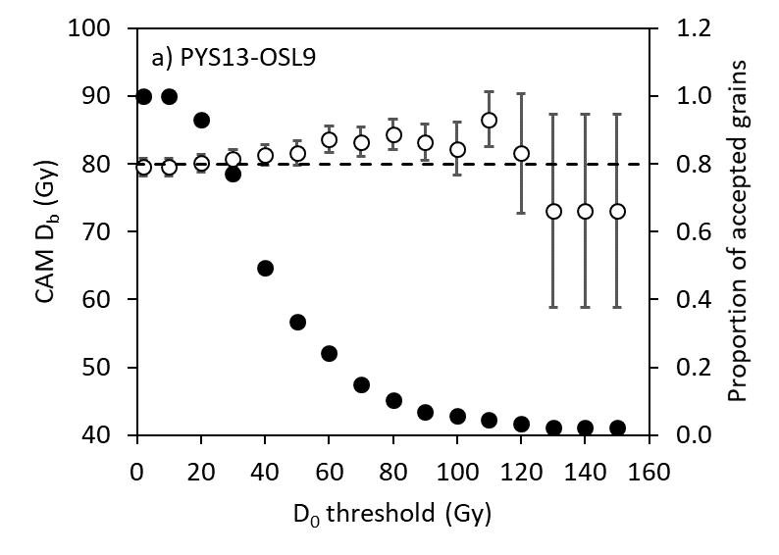 | 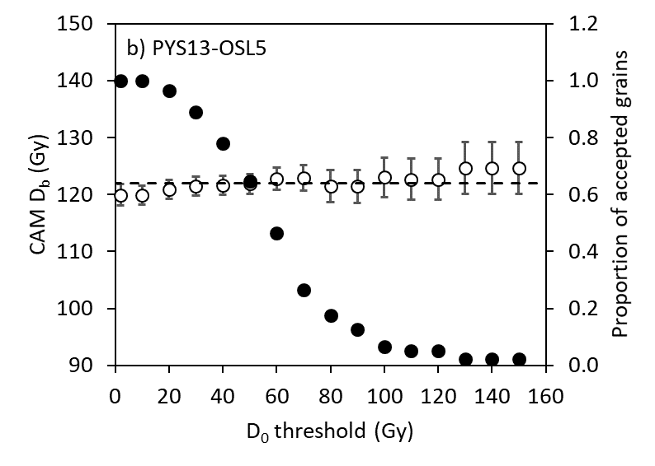

C.5.4.2 K-feldspar dose recovery data.

Single-grain dose recovery experiments were performed on three K-feldspar samples. Data were analysed using Rejection Criteria B, except that criterion c (the IR-depletion ratio) was omitted. Rejection Criteria B were applied to grains in the order listed in Section C.5.4.1 above, and only one cause for rejection was noted per grain (Supplementary Information Table C6).

Supplementary Information Table C6. The number of individual grains which were measured, rejected and accepted during analysis of the K-feldspar single-grain dose recovery data using Rejection Criteria B.

Layer | 9 | 17 | 18
Sample (PYS13-OSL...) | 13 | 5 | 3
Total number of grains measuredª
 | 800 (779) | 800 (655) | 800 (737)
Grains rejected for the following reasons
Empty grain positions | 21 | 145 | 63
a) T_{n} signal <3*background or relative error >20%^{b} | 644 | 607 | 649
b) Poor recycling ratio | 18 | 4 | 5
c) Depletion by IR | Omitted for K-feldspar
d) 0 Gy dose >5% of L_{x}/T_{x} for the maximum dose | 25 | 4 | 9
e) FOM >10% | 13 | 4 | 8
f) L_{n}/T_{n}>DRC | 0 | 0 | 0
g) D_{e} obtained by extrapolation | 0 | 1 | 1
Sum of rejected grains^{b}
 | 700 | 620 | 672
Acceptable individual D_{e} values
 | 79 | 35 | 65
ª Gives the number of grain positions measured i.e. 100 per single-grain disc. Numbers in parentheses represent the true number of grains measured, as determined using a microscope after measurement. Feldspar dose recovery experiments for samples PYS13-OSL5 and PYS13-OSL3 were performed on the limited material remaining after age determination, hence low occupancy of grain positions.
^{b} Empty grain positions excluded from this count.

Using Rejection Criteria B, the majority of rejected K-feldspar grains (>95%) fail the signal intensity/precision criterion (criterion a). The recycling ratio, recuperation and FOM criteria (criteria b, d and e) are responsible for approximately equal proportions of the remaining rejected grains. Unlike the quartz data, no K-feldspar grains were rejected because they were fully saturated (criterion f) and only two grains were rejected because D_{e} was obtained by extrapolation (criterion g). The absence of saturated grains implies that the known doses, which are approximately equal to the natural samples’ D_{b}, are well within the range where accurate D_{e} values can be determined. This is consistent with the considerable body of literature indicating that K-feldspar pIRIR signals saturate at much higher doses than those of quartz. The proportion of accepted grains ranges from 5% (PYS13-OSL5) to 10% (PYS13-OSL13), which is consistent with values in the published literature.

Supplementary Information Table C7. Single-grain dose recovery tests performed on PYS K-feldspar samples.

Layer | 9 | 17 | 18
Sample (PYS13-OSL…) | 13 | 5 | 3
Grains measured (n)ª | 800 (779) | 800 (655) | 800 (737)
Known dose (Gy) | 108 | 177 | 167
D_{max} (Gy) | 245 | 360 | 360
Rejection Criteria B
Recovered dose (Gy) | 109±1 | 172±5 | 164±3
Overdispersion (%) | 3±1 | 12±2 | 10±1
Dose recovery ratio (recovered/known) | 1.00±0.01 | 0.97±0.03 | 0.98±0.02
ª Gives the number of grain positions measured i.e. 100 per single-grain disc. Numbers in parentheses represent the true number of grains measured, as determined using a microscope prior to measurement.

The CAM¹⁵⁷ was used to calculate D_{b} for each sample. Dose recovery data for PYS K-feldspar samples are given in Supplementary Information Table C7. All three samples yield dose recovery ratios which are consistent with unity at two standard errors, indicating that the measurement conditions for K-feldspars, outlined in Supplementary Information Table C2b, are appropriate for measuring the PYS samples.

C.5.5 Burial dose and age determination using single-grain quartz OSL

OSL measurements were made on quartz from seven samples from PYS, and have previously been published⁸. These samples were measured using the procedure outlines in Supplementary Information C Table 2a and analysed using Rejection Criteria A. Of these samples six yielded finite ages and one, PYS13-OSL7 (Layer 16), showed evidence of mixing and was not included in the age model for the site. In this study we present new data from PYS13-OSL4, a sample taken from within the Mtoto burial feature, and compare the results obtained when these and previously published data are analysed using Rejection Criteria A and Rejection Criteria B. These results are discussed and preferred burial doses are presented for each sample.

C.5.5.1 Comparison of results obtained using Rejection Criteria A and B

The results of applying Rejection Criteria A and Rejection Criteria B to PYS quartz single-grain data are presented in Supplementary Information Tables C8 and C9 respectively.

Supplementary Information Table C8. The number of individual grains which were measured, rejected after application of Rejection Criteria A, and accepted for inclusion in the calculation of the burial dose.

Layer | 9 | 11 | 13 | 15 | 17 | 18 | Burial
Sample (PYS13-OSL...) | 13 | 11 | 9 | 17 | 5 | 3 | 4
D_{max} (Gy) | 120 | 120 | 180 | 180 | 250 | 220 | 220
Total number of grains measuredª
 | 2300 | 2400 | 2400 | 2200 | 2400 | 2400 | 3000
Grains rejected for the following reasons
T_{n} signal <3*background | 459 | 417 | 263 | 291 | 496 | 361 | 499
Poor recycling ratio | 1146 | 1344 | 1439 | 1213 | 1202 | 1262 | 1729
Depletion by IR | 19 | 16 | 14 | 19 | 8 | 18 | 31
0 Gy dose >5% of L_{n}/T_{n} | 102 | 110 | 146 | 127 | 159 | 162 | 59
Signal saturation | 195 | 164 | 339 | 398 | 416 | 520 | 573
L_{n}/T_{n}>DRC | 53 | 43 | 147 | 201 | 220 | 292 | 279
D_{e}≥2*D_{o} | 142 | 121 | 192 | 197 | 196 | 228 | 294
Poor DR curve | 64 | 110 | 26 | 31 | 37 | 26 | 24
Sum of rejected grains
 | 1985 | 2161 | 2227 | 2079 | 2318 | 2349 | 2915
Acceptable individual D_{e} values
 | 315 | 239 | 173 | 121 | 82 | 51 | 85
ªGives the number of grain positions measured i.e. 100 per single-grain disc.

Supplementary Information Table C9. The number of individual grains which were measured, rejected after application of Rejection Criteria B, and accepted for inclusion in the calculation of the burial dose.

Layer | 9 | 11 | 13 | 15 | 17 | 18 | Burial
Sample (PYS13-OSL...) | 13 | 11 | 9 | 17 | 5 | 3 | 4
Total number of grains measuredª
 | 2300 | 2400 | 2400 | 2200 | 2400 | 2400 | 3000
Grains rejected for the following reasons
a) T_{n} signal <3*background or relative error >20% | 839 | 747 | 595 | 644 | 924 | 709 | 1042
b) Poor recycling ratio | 306 | 303 | 611 | 381 | 277 | 229 | 577
c) Depletion by IR | 83 | 85 | 117 | 127 | 100 | 116 | 125
d) 0 Gy dose >5% of L_{x}/T_{x} for the maximum dose | 56 | 86 | 157 | 59 | 95 | 78 | 108
e) FOM >10% | 262 | 267 | 279 | 235 | 288 | 267 | 293
f) L_{n}/T_{n}>DRC | 100 | 192 | 226 | 331 | 362 | 538 | 411
g) D_{e} obtained by extrapolation | 54 | 151 | 62 | 86 | 73 | 157 | 168
Sum of rejected grains
 | 1700 | 1831 | 2047 | 1863 | 2119 | 2094 | 2724
Acceptable individual D_{e} values
 | 600 | 569 | 353 | 337 | 281 | 306 | 276
ªGives the number of grain positions measured i.e. 100 per single-grain disc.

The general patters of grain rejections is using the two sets of criteria is similar to that for the quartz dose recovery data (Section C.5.4.1). The largest proportion of grains are rejected by the recycling ratio criterion (criterion b) using Rejection Criteria A and the signal intensity/precision criterion (criterion a) using Rejection Criteria B. A high proportion (30%) of the grains which emit luminescence (i.e. that pass Rejection Criteria B criterion a) are rejected by the recycling ratio criterion when using Rejection Criteria B. Using Rejection Criteria A, the proportion of grains rejected due to signal saturation is strongly dose dependent, ranging from ~38% (PYS13-OSL13) to ~80% (PYS13-OSL3) of the grains not rejected by other criteria. This trend is driven both by rejection of grains where: 1) the L_{n}/T_{n} ratio is statistically consistent with, or higher than, the saturation level of the corresponding DRC so that a finite D_{e} value and error cannot be obtained and 2) D_{e} is greater than twice the curve fitting parameter D₀. However, rejection due to the former criterion predominates at higher doses, unlike the dose recovery data where the latter criterion predominates in all cases. Using Rejection Criteria B, the proportion of grains rejected due to signal saturation is also dose dependent, ranging from ~14% (PYS13-OSL13) to ~61% (PYS13-OSL3) of the grains not rejected by other criteria. In all cases >10% of grains are identified as being fully saturated (i.e. they fail Rejection Criteria B criterion f), beyond which proportion numerical modelling suggests that D_{b} may underestimate the true burial dose (Li et al., 2020). The proportion of grains which are accepted after applying Rejection Criteria B ranges from 9% (PYS13-OSL4) to 26% (PYS13-OSL13), and is far higher than the proportion accepted using Rejection Criteria A, which range from 2.1% (PYS13-OSL3) to 14% (PYS13-OSL13).
C.5.5.2 Single-grain quartz OSL burial dose using a D₀ threshold

The effect of analyzing the grains accepted by Rejection Criteria B using a D₀ threshold^{46,120} were investigated using the method outlined in section C.5.4.3. This involves calculation of D_{b} using the CAM, which is thought to be appropriate for the PYS samples (see section C.5.5.3), but will not be appropriate for all samples. Data for all seven PYS quartz samples are shown in Supplementary Information Fig. C2.

Supplementary Information Fig. C2. CAM D_{b} (open circles) and the corresponding proportion of accepted grains (black circles) plotted as a function of the D_{o} threshold value. The proportion of accepted grains is calculated as the number of grains accepted using the threshold D_{o} divided by the number accepted where no threshold is applied. D_{b} was calculated using n=600 (OSL13) (a), 569 (OSL11) (b), 353 (OSL9) (c), 337 (OSL17) (d), 281 (OSL5) (e), 306 (OSL3) (f) and 276 (OSL4) (g) single-grain D_{e} estimates where no D_{o} threshold is applied. D_{b} uncertainties are presented at 1 standard error, and do not include the instrument’s beta source calibration error (3%) since this is common to all quantities being compared. The dashed lines indicate D_{b} where no grains are rejected due to D₀ i.e. the value obtained applying Rejection Criteria B.

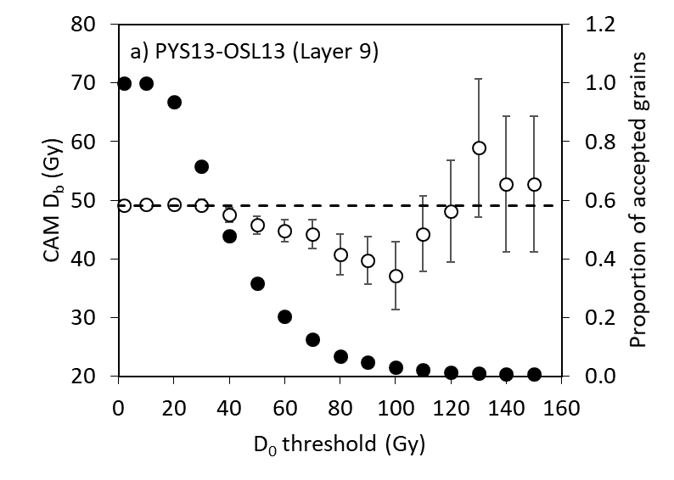 | 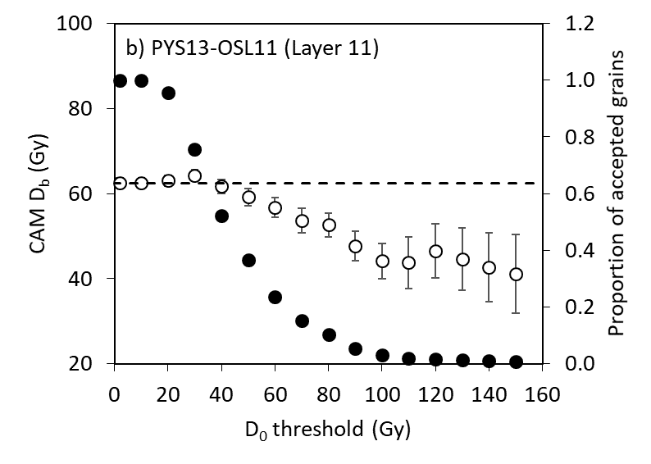
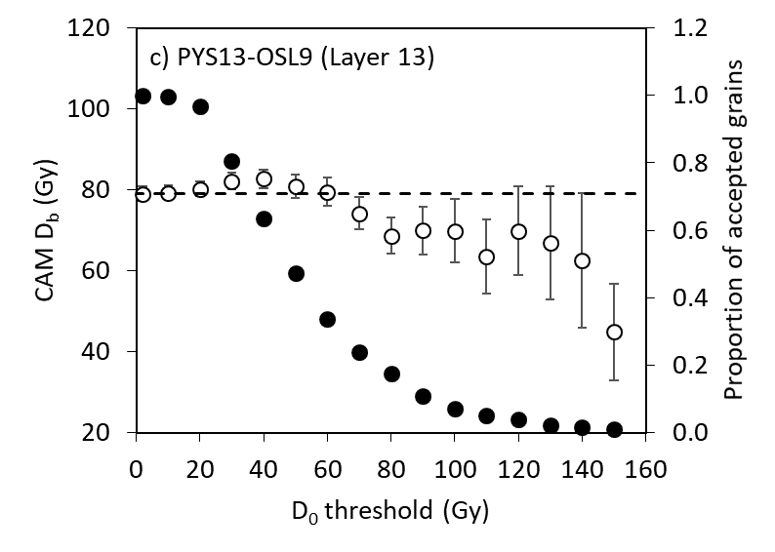 | 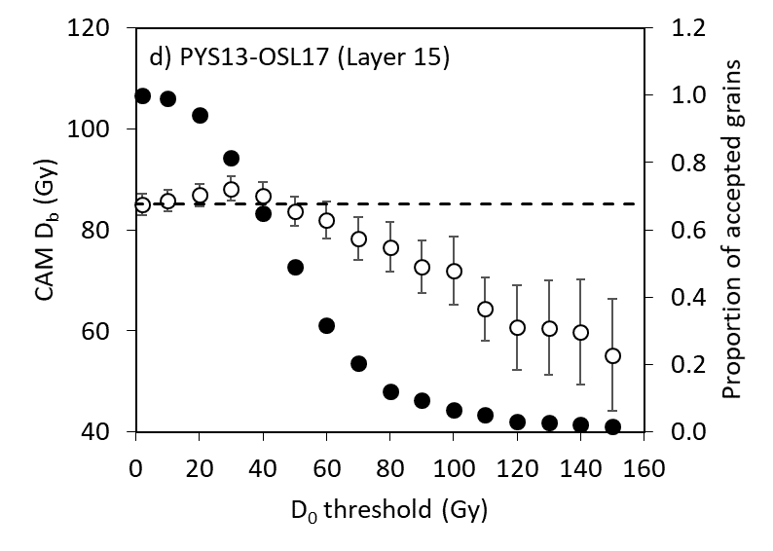
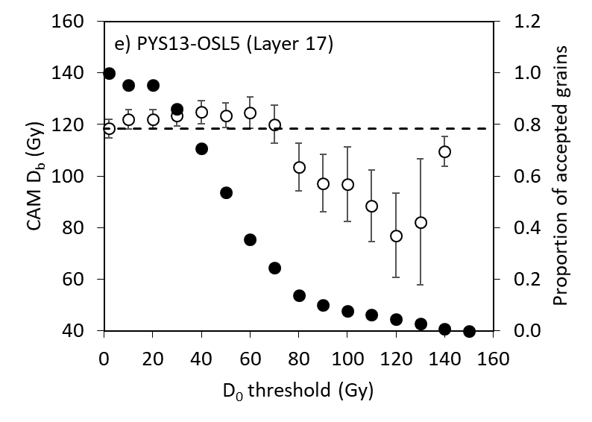 | 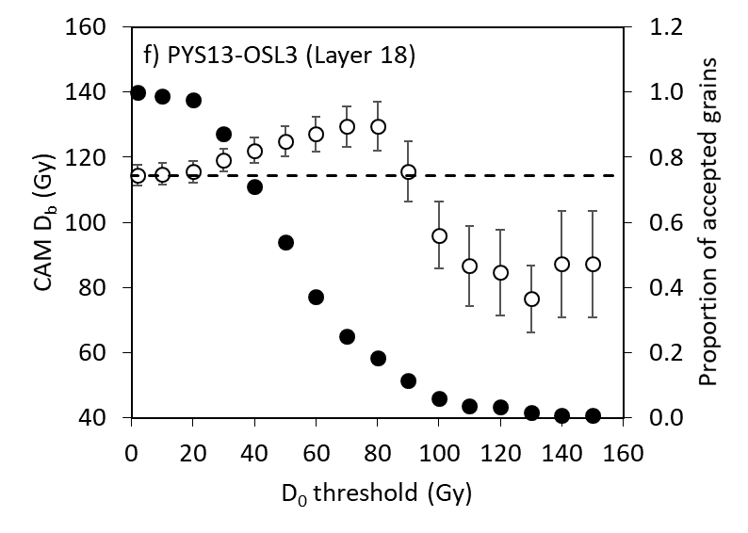
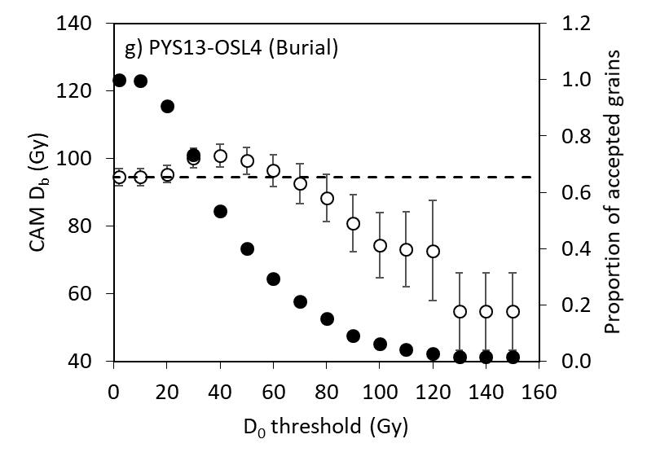

For the natural samples, considerable variation in D_{b} is observed as the D_{o} threshold is increased. For the lower dose samples (Layers 9-15), a plateau in D_{b} is apparent between threshold values of 0-50 Gy, after which values generally decline as the D₀ threshold increases. For the higher dose samples (Layers 17, 18 and the burial), D_{b} increases as D₀ threshold increases to ~60 Gy, after which D_{b} decreases. Although most individual D_{b} values are consistent (at 2 σ) with the value obtained where no threshold is applied, the patterns are sufficiently consistent to imply that they are meaningful.

No sample displays the behavior noted in the literature^{46,120}, where D_{b} increases as the D₀ threshold increases, eventually reaching a plateau. Instead, all samples show a general decrease in D_{b} at higher D₀ thresholds. This pattern may be an artefact of inaccurate D₀ estimates, a possibility which is supported by the relatively low D_{max} used to construct dose response curves and the difficulty in accurately estimating D₀ (see section C.2). However, visual inspection of the dose response curves for the higher dose samples did not reveal any obviously poor fits. Whatever the cause of the decline in D_{b} at higher D₀ thresholds, the pattern of change at lower D₀ thresholds is more consistent with that in the literature. For the lower dose sample, the D_{b} plateau across D₀ thresholds from 0-50 Gy implies that all accepted grains are capable of accurately recording the palaeodose. Conversely, for the higher dose samples, the increase in D_{b} as the D₀ threshold increases suggests that the lower D₀ grains are not capable of accurately recording the palaeodose. However, for these samples there is no clear D_{b} plateau, making is difficult to propose a justifiable D₀ threshold with which to analyse data from these samples. It is not possible to define the optimal D₀ threshold at D_{b}¹²⁰ since the latter is too variable. Based on the reasoning above, D_{b} for all subsequent analyses was calculated using no D_{o} threshold when applying Rejection Criteria B. This approach should yield accurate D_{b} values for the lower dose samples (Layers 9-15) but may produce underestimates for the higher dose samples (Layers 17, 18 and the burial).

C.5.5.3 Quartz OSL burial doses and ages

As noted in Section C.5.4.1, the Central Age Model is appropriate for the calculation of D_{b} for samples where the luminescence signal of all constituent grains was fully bleached prior to deposition, and where no post-depositional mixing has occurred. Other methods for calculating D_{b} for single-grain datasets include the minimum age model (MAM, Galbraith and Laslett, 1993¹⁵⁸) and the finite mixture model (FMM, Galbraith and Green, 1990¹⁵⁹). The MAM, as applied to luminescence datasets, is intended to obtain an accurate value for D_{b} from a sample containing both grains which were fully bleached on deposition and grains which were incompletely bleached. The FMM was developed to identify separate, fully bleached, populations within a single-grain dataset. This approach is appropriate for samples containing more than one population of grains (e.g. samples mixed by bioturbation during burial). Visual inspection of dose distributions for the PYS quartz samples (Supplementary Information Fig. C3) does not suggest that any sample is partially bleached or contains more than one population of grains. Consequently, D_{b} was calculated using the CAM applied to grains which passed Rejection Criteria A and Rejection Criteria B (Supplementary Information Table C10).

Supplemental Information Fig. C3. Single-grain quartz D_{e} distributions for obtained using Rejection Criteria B for the samples PYS13-OSL13 (a), PYS13-OSL11 (b), PYS13-OSL9 (c), PYS13-OSL17 (d), PYS13-OSL5 (e), PYS13-OSL3 (f) and PYS13.OSL4 (g). Each point represents an individual grain. The grey bars are centered on the CAM D_{b} and all points that lie within the bars are consistent (at 2 σ) with this dose.

with this dose.
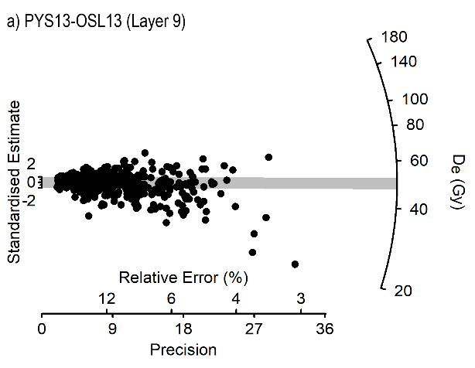 | 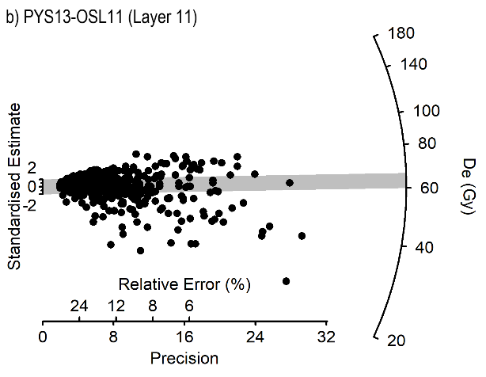
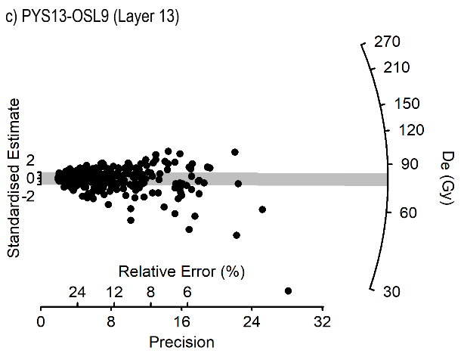 | 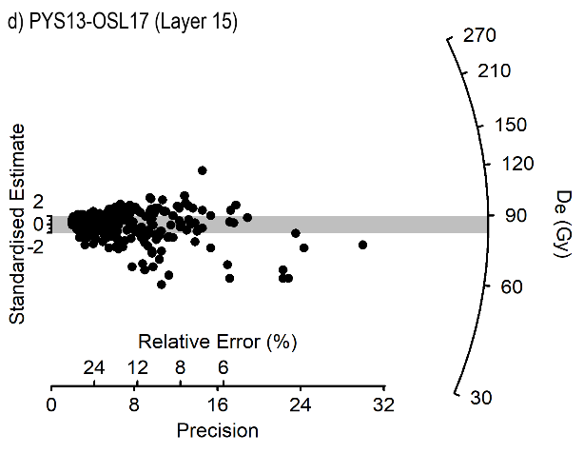
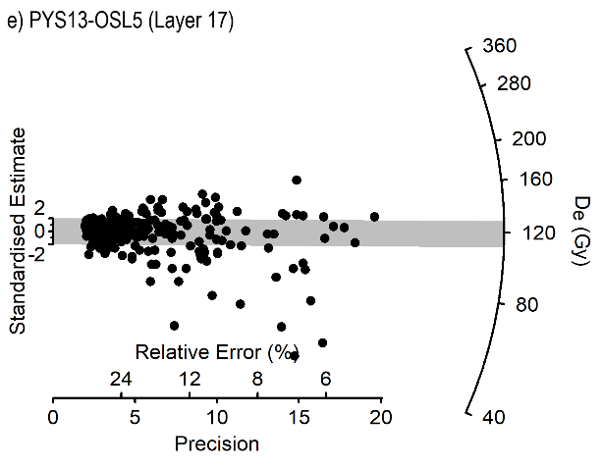 | 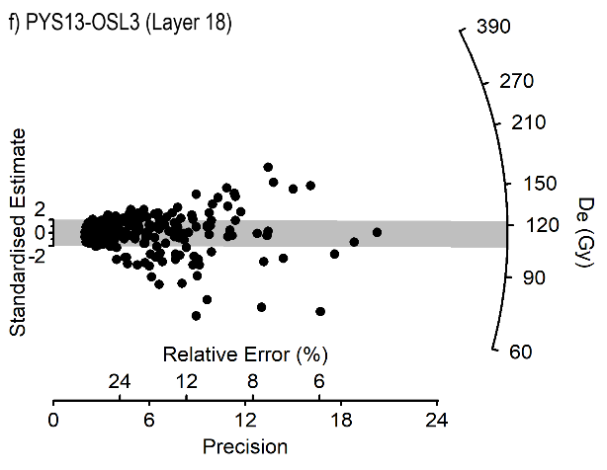
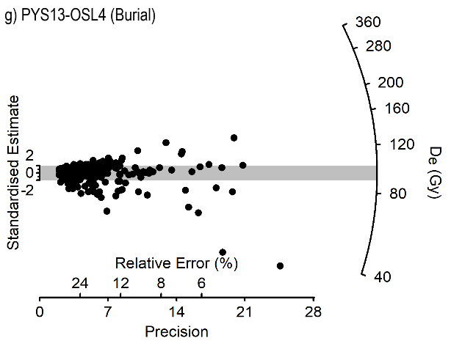

Supplementary Information Table C10. Single-grain burial doses calculated using the CAM applied to grains which passed Rejection Criteria A and Rejection Criteria B. Uncertainties on D_{b} do not include the instrument’s beta source calibration error (3%) since these are common to all quantities being compared.

Layer | Sample  (PYS13-OSL…) | D_{max} (Gy) | Rejection Criteria A |  |  | Rejection Criteria B |  |  | Ratio (A/B)
Layer | Sample  (PYS13-OSL…) | D_{max} (Gy) | n | D_{b} (Gy) | σ_{d} (%) | n | D_{b} (Gy) | σ_{d} (%) | Ratio (A/B)
9 | 13 | 120 | 315 | 47.0±0.9 | 30±1 | 600 | 49.1±0.8 | 37±2 | 0.96±0.02
11 | 11 | 120 | 239 | 59.3±1.3 | 32±2 | 569 | 62.5±1.2 | 39±2 | 0.95±0.03
13 | 9 | 160 | 173 | 75.1±2.1 | 34.2 | 353 | 79.1±1.8 | 39±2 | 0.95±0.03
15 | 17 | 180 | 121 | 77.7±2.7 | 34±3 | 337 | 85.1±2.2 | 41±2 | 0.91±0.04
17 | 5 | 205 | 82 | 115±4 | 29±3 | 281 | 118±4 | 41±2 | 0.97±0.05
18 | 3 | 224 | 51 | 107±4 | 24±3 | 306 | 114±3 | 41±2 | 0.93±0.05
Burial | 4 | 205 | 85 | 96.4±3.9 | 32±4 | 276 | 94.5±2.6 | 37±2 | 1.02±0.05

With the exception of sample PYS13-OSL4, D_{b} values are higher using Rejection Criteria B than using Rejection Criteria A. This pattern differs from that observed with dose recovery data (section C.5.4.2) but is consistent with the suggestion that rejecting grains where D_{e}>2*D_{o} biases the analysis against grains with larger palaeodoses. However, the magnitude of difference between D_{b} calculated using the two sets of rejection criteria does not appear to be dose dependent, as might be expected.

C.5.6 Burial dose and age determination using single-grain feldspar pIRIR.

Single-grain measurements were performed on five K-feldspar samples. Data were analysed using Rejection Criteria B, except that criterion c (the IR-depletion ratio) was omitted. Rejection criteria were applied to grains in the order listed in section C.5.4.1 above, and only one cause for rejection was noted per grain (Supplementary Information Table C11).

Supplementary Information Table C11. The number of K-feldspar grains which were measured, rejected after application of Rejection Criteria B, and accepted for inclusion in the calculation of the burial dose.

Layer | 11 | 15 | 17 | 18 | Burial
Sample (PYS13-OSL...) | 11 | 17 | 5 | 3 | 4
Total number of grains measuredª
 | 800  (775) | 1000  (973) | 1000  (952) | 1100  (1078) | 1800 (1753)
Grains rejected for the following reasons
Empty grain position | 25 | 27 | 48 | 22 | 47
a) T_{n} signal <3*background or relative error >20%^{b} | 648 | 908 | 858 | 969 | 1701
b) Poor recycling ratio | 21 | 9 | 11 | 15 | 3
c) Depletion by IR | Omitted for K-feldspar
d) 0 Gy dose >5% of L_{x}/T_{x} for the maximum dose | 12 | 3 | 6 | 10 | 3
e) FOM >10% | 6 | 2 | 4 | 9 | 3
f) L_{n}/T_{n}>DRC | 0 | 0 | 0 | 0 | 0
g) D_{e} obtained by extrapolation | 0 | 0 | 0 | 1 | 0
Sum of rejected grains
 | 687 | 922 | 879 | 1004 | 1710
Acceptable individual D_{e} values
 | 88 | 51 | 73 | 74 | 43
ªGives the number of grain positions measured i.e. 100 per single-grain disc. Numbers in parentheses represent the true number of grains measured, as determined using a microscope after measurement.
^{b} Empty grain positions excluded from this count.

The pattern of grain rejections for natural-feldspar samples is similar to that for the dose recovery experiments (section C.5.4.2). The majority of rejected K-feldspar grains (>95%) fail the signal intensity/precision criterion (criterion a), with far smaller proportions failing the recycling ratio, recuperation and FOM criteria (criteria b, d and e). No K-feldspar grains were rejected because they were fully saturated (criterion f) and only one grain was rejected because D_{e} was obtained by extrapolation (criterion g). The proportion of accepted grains ranges from 2% (PYS13-OSL4) to 12% (PYS13-OSL11), which is consistent with values in the published literature. As with the quartz OSL data, the CAM¹⁵⁷ was used to calculate D_{b} for each sample (Supplementary Information Table C12). Equivalent dose distributions are shown for the K-feldspar samples in Supplementary Information Fig. C4.

Supplementary Information Table C12. Single-grain K-feldspar burial doses calculated using the CAM applied to grains which passed Rejection Criteria B.

Layer | Sample  (PYS13-OSL…) | D_{max} (Gy) | Rejection Criteria B
Layer | Sample  (PYS13-OSL…) | D_{max} (Gy) | n | D_{b} (Gy) | σ_{d} (%)
11 | 11 | 506 | 88 | 98.0±5.0 | 37±3
15 | 17 | 506 | 51 | 132±8 | 35±4
17 | 5 | 408 | 73 | 188±10 | 38±3
18 | 3 | 506 | 74 | 182±10 | 37±3
Burial | 4 | 506 | 43 | 168±14 | 49±6

Supplemental Information Fig. C4. Single-grain K-feldspar D_{e} distributions for obtained using Rejection Criteria B for samples PYS13-OSL11 (a), PYS13-OSL17 (b), PYS13-OSL5 (c), PYS13-OSL3 (d) and PYS13-OSL4 (e). Each point represents an individual grain. The grey bars are centered on the CAM Db and all points that lie within the bars are consistent (at 2 σ) with this dose.

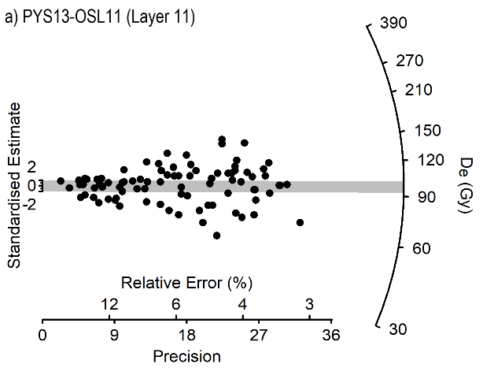 | 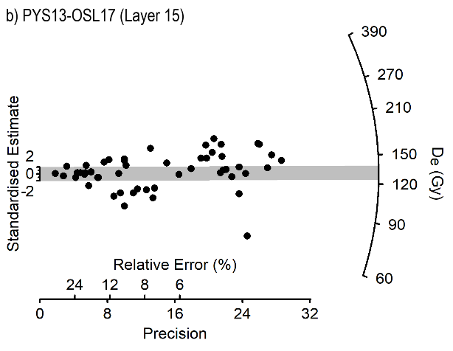
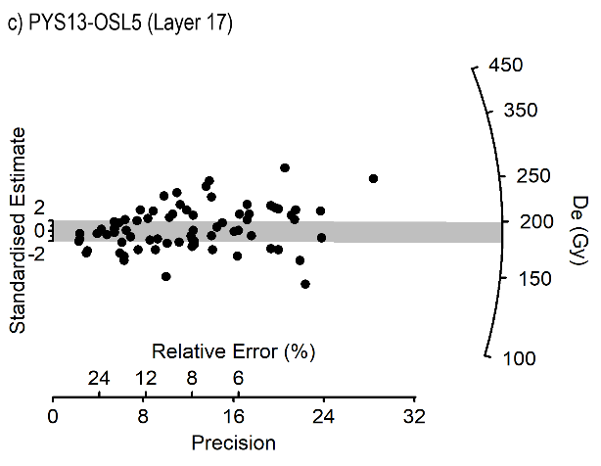 | 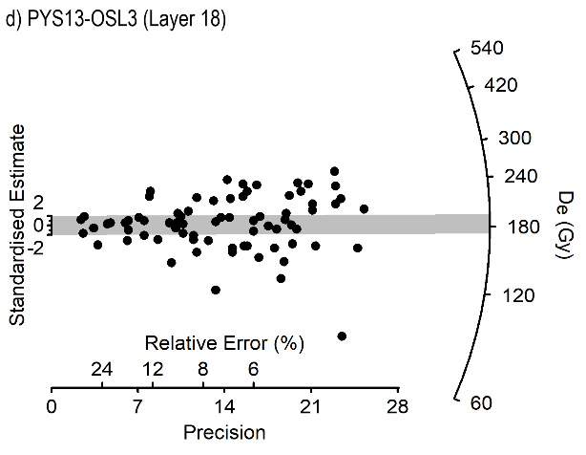
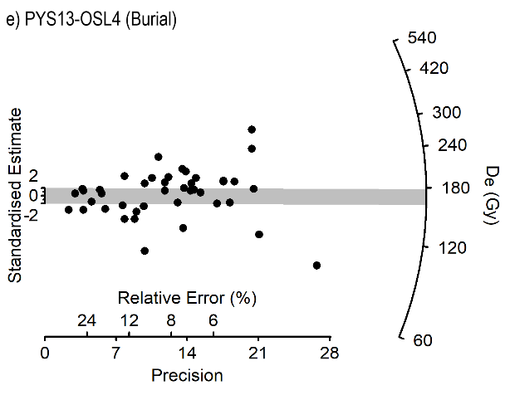

C.5.6.1 Fading tests

Feldspars are prone to athermal (anomalous) fading^{143,144}, which may require correction to avoid age underestimation. Although the pIRIR measurement method is intended to access signals which to not experience fading, we measured the fading rates for individual grains from three samples (PYS13-OSL11, PYS13-OSL3 and PYS13-OSL5). After measurement of the DRC, discs were given a ~62 Gy regenerative dose, preheated and stored in the dark at room temperature for 4 days. After this delay, discs were measured using the standard measurement sequence, and a second regeneration dose of ~62 Gy was administered and measured promptly. The ratio of the delayed to promptly measured sensitivity corrected (L_{x}/T_{x}) pIRIR was calculated for each grain and is termed the “fading ratio” hereafter. If fading of the pIRIR signal occurred during storage, then the fading ratio will be significantly below unity¹³⁴. Since we are primarily interested in the fading rate of the grains which contribute to our estimate of D_{b}, weighted mean fading ratios were calculated for each sample using only grains which passed Rejection Criteria B. The ratios for individual grains are shown in Supplemental Information C Fig. 5. Weighted mean fading ratios for the three samples were 0.99±0.01 (PYS13-OSL3 and OSL11) and 1.00±0.01 (PYS13-OSL5). These data indicate that on average the pIRIR signal signals measured in this study do not fade significantly, so no fading correction was applied to the calculated K-feldspar ages.

Supplemental Information Fig. C5. Ratios of delayed to prompt pIRIR signals (‘fading ratios’) for individual grains of K-feldspar from three PYS samples: PYS13-OSL11 (a), PYS13-OSL5 (b) and PYS13-OSL3 (c). Only grains used in the calculation of D_{b} are shown, and each point represents an individual grain. The grey bars are centered on a fading ratio of 1 (no fading) and all points that lie within the bars are consistent (at 2 σ) with this dose.

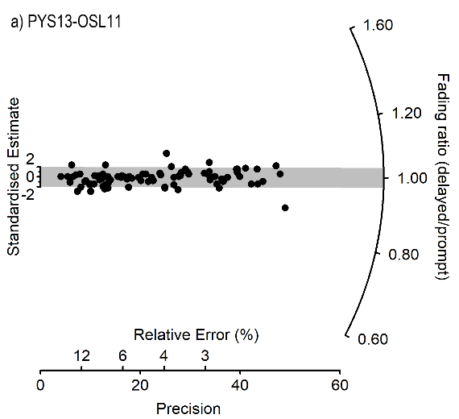 | 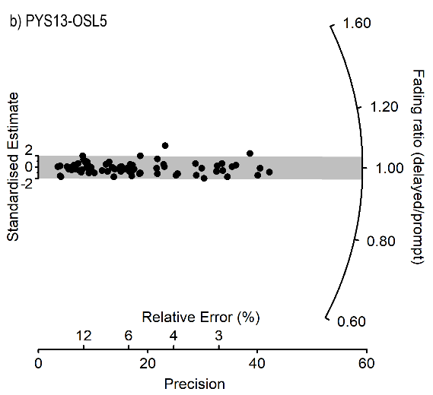
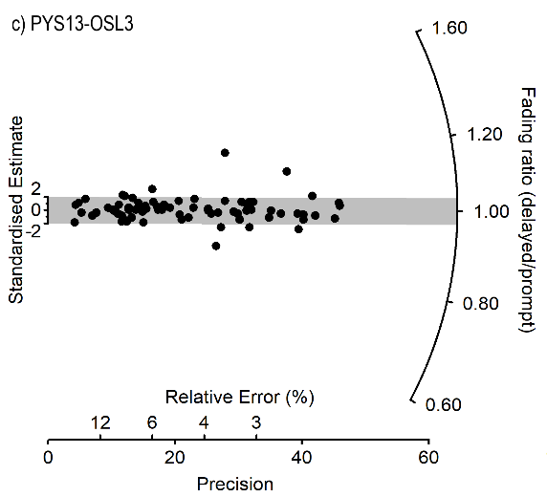

C.6 Ages

Burial doses, dose rates and ages are presented for all samples in Supplementary Information C Table 13

Supplementary Information Table C13. Burial doses, dose rates and ages for the PYS13 luminescence samples.

Layer | Sample  (PYS13-OSL…) | Published age (ka) | n | D_{b} (Gy) | D_{r} (Gy/ka) | Age (ka)
9 | OSL13-Q | 45.9±2.7 | 600 | 49.1±1.7 | 1.07±0.05 | 46.0±2.7
11 | OSL11-Q | 49.0±3.0 | 569 | 62.5±2.2 | 1.27±0.06 | 49.4±3.0
11 | OSL11-KF | - | 88 | 98.0±5.0 | 2.09±0.10 | 47.0±3.3
13 | OSL9-Q | 64.2±4.1 | 353 | 79.1±3.0 | 1.22±0.06 | 64.7±4.0
15 | OSL17-Q | 59.9±4.0 | 337 | 85.1±3.4 | 1.36±0.07 | 62.8±3.9
15 | OSL17-KF | - | 51 | 132±8 | 2.18±0.10 | 60.8±4.7
17 | OSL5-Q | 74.9±5.1 | 281 | 118±5 | 1.60±0.08 | 73.9±4.9
17 | OSL5-KF | - | 73 | 188±10 | 2.42±0.11 | 77.7±5.6
18 | OSL3-Q | 73.8±5.2 | 306 | 114±5 | 1.49±0.07 | 76.3±4.8
18 | OSL3-KF | - | 74 | 182±10 | 2.31±0.11 | 78.6±5.7
Burial | OSL4-Q | - | 276 | 94.5±3.8 | 1.39±0.07 | 68.1±4.5
Burial | OSL4-KF | - | 43 | 168±14 | 2.21±0.11 | 76.0±7.4

The ages calculated in this study are all in stratigraphic order, with no statistically significant age inversions. Each of the ages produced in this study, including both those calculated after reanalyzing the published quartz data using new rejection criteria (Rejection Criteria B) and the new K-feldspar data, are consistent with the published ages⁸. This comparison is slightly flattered by our recalculation of the environmental dose rates (section C.4), which yielded higher values than those used to calculate the published ages, and offsets some of the increase in D_{b} (Supplementary Information Table C10) resulting from the application of new rejection criteria. Lastly, where paired quartz and K-feldspar age estimates were produced for the same sample, the two ages are consistent with one another.

The paired quartz and K-feldspar ages for layers 11 (PYS13-OSL11) and 15 (PYS13-OSL17) yield useful insights into the luminescence chronology for PYS as a whole. The similarity in paired ages strongly suggests that mineral grains within each sample were exposed to sufficient sunlight prior to deposition to reduce both OSL and pIRIR signals to negligible levels. Since the pIRIR signal “bleaches” several orders of magnitude more slowly than the OSL signal, this implies prolonged sunlight exposure, thereby meeting a key requirement for successful application of the CAM to a single-grain dataset. This provides circumstantial evidence supporting the use of the CAM throughout the PYS dataset, though it does not guarantee that all samples experienced prolonged sunlight exposure prior to deposition. Comparison of the paired ages throughout the dataset also provides useful information. For the two lower dose samples (PYS13-OSL11 and PYS13-OSL17), the quartz and K-feldspar ages are statistically consistent but in both cases the quartz ages are older. Conversely, for the three higher dose samples (PYS13-OSL3-5) the paired ages are statistically consistent, but the K-feldspar ages are older. In the case of the letter samples, this pattern is consistent with the measured quartz burial dose underestimating the true palaeodose, due to the proximity of the natural signal to the saturation level of the dose-response curve. The proportion of quartz grains rejected by the saturation criterion for these samples is much higher than the ~10% threshold above which numerical modelling suggests age underestimation will occur (Li et al., 2020). This is also true for the lower dose samples, though in the case of PYS13-OSL11 and PYS13-OSL17, the K-feldspars yield younger ages than their paired quartz samples, implying that the D_{b} values obtained from the latter are not underestimates of the true palaeodose.
Based on the analysis above, we have constructed a Bayesian age-model for PYS using both quartz and K-feldspar ages for layers 9-15, and K-feldspar ages alone for layers 17-18 and the burial itself.

C.6.1 Age of the burial

The K-feldspar ages for the PYS13-OSL4, the sample within the burial, are consistent with those for the surrounding sediments (PYS13-OSL3 and OSL5). If the burial pit had been dug into much older sediments and then infilled using those sediments, some grains would probably have had their luminescence signal reset during the process. This might be expected to yield a younger age for the burial infill than the surrounding sediments, which is not the case for the K-feldspar ages. These ages are believed to be more accurate for the higher dose samples at PYS, though since K-feldspar bleaches more slowly than quartz, they may be less sensitive to brief exposure and reburial. Nonetheless, the overdispersion of the quartz data is similar for samples PYS13-OSL3-5. This suggests the burial occurred sufficiently shortly after deposition of layers 17 and 18 that bleaching of grains during the excavation and infilling processes did not increase the scatter of equivalent doses. The similarity in K-feldspar ages and quartz overdispersion between samples PYS13-OSL3-5 does not unequivocally demonstrate that the burial infill is contemporaneous with Layers 17 and 18, since if the pit was backfilled with spoil this might have occurred under subdued light conditions leading to poor luminescence signal resetting. Also, given the ~7-10% uncertainties on individual K-feldspar ages, archaeologically important differences in age could go unnoticed. Nonetheless, the absence of a discrepancy between the ages and overdispersion of the burial infill and surrounding sediments suggests that the burial is contemporaneous with Layers 17/18, at least at the temporal resolution achievable using luminescence techniques.

Supplementary Information Table C14. Date ranges derived from the application of the Bayesian model with all available determinations from Layers 18 to 9 from PYS. In bold are the chronometric data used in the model, in italics are probability distributions produced for undated events, such as the age of the transition between one layer from the other. Unmodelled refers to calibrated ages in the case of radiocarbon data. Produced using OxCal v. 4.4.2. Ranges rounded to nearest 50.
 | Unmodelled (BP) |  |  |  | Modelled (BP)
 | From | to | From | to | from | to | from | To
 | 68.2 |  | 95.4 |  | 68.2 |  | 95.4
End of Layer 9 |  |  |  |  | 33450 | 30500 | 33700 | 25400
OxA-30146 | 33800 | 33200 | 34150 | 32900 | 33800 | 33200 | 34150 | 32900
OxA-29431 | 33650 | 32900 | 33800 | 32250 | 33650 | 32950 | 33850 | 32250
OSL-13-Q | 48800 | 43200 | 51400 | 40600 | 45050 | 40250 | 46600 | 32900
Layer 9
Transition 10/9 |  |  |  |  | 46800 | 42450 | 47650 | 33250
Layer 10
Transition 11/10 |  |  |  |  | 47700 | 46150 | 48150 | 44450
OxA-29984 | 47250 | 46150 | 48000 | 45900 | 47900 | 46800 | 48200 | 46150
OxA-29986 | 48500 | 47100 | 49500 | 46600 | 48200 | 47150 | 48800 | 46700
OxA-29985 | 48650 | 47350 | 49500 | 46800 | 48300 | 47200 | 48850 | 46800
OSL-11-KF | 50400 | 43600 | 53600 | 40400 | 48450 | 46750 | 49900 | 45500
OSL-11-Q | 52500 | 46300 | 55400 | 43400 | 48500 | 46800 | 50200 | 45800
Layer 11
Transition 12/11 |  |  |  |  | 49200 | 47400 | 51750 | 46950
Layer 12
Transition 13/12 |  |  |  |  | 61550 | 53200 | 63550 | 48700
OSL-9-Q | 68850 | 60550 | 72700 | 56700 | 63000 | 57500 | 65500 | 54650
Layer 13
Transition 15/13 |  |  |  |  | 64400 | 59150 | 66900 | 56350
OSL-17-KF | 65650 | 55950 | 70200 | 51400 | 65700 | 60500 | 68350 | 57950
OSL-17-Q | 66850 | 58750 | 70600 | 55000 | 65750 | 60650 | 68300 | 58150
Layer 15
Transition 16/15 |  |  |  |  | 67550 | 61750 | 71050 | 59000
Layer 16
Start boundary16 |  |  |  |  | 72400 | 64750 | 76750 | 61650
End boundary 17 |  |  |  |  | 76700 | 69000 | 80550 | 65450
OSL-5-KF | 83500 | 71900 | 88900 | 66500 | 78400 | 71200 | 81800 | 68000
Layer 17
Transition 18/17 |  |  |  |  | 80100 | 72600 | 83700 | 69250
Burial |  |  |  |  | 82100 | 73900 | 86350 | 69900
OSL-4-KF | 83650 | 68350 | 90800 | 61200 | 82000 | 74000 | 85850 | 70200
OSL-3-KF | 84500 | 72700 | 90000 | 67200 | 82100 | 74150 | 85850 | 70350
Layer 18
Start of PYS sequence |  |  |  |  | 84350 | 74700 | 89700 | 70150

OxCal code

Options()
{
Resolution=50;
Plot()
{
Outlier_Model("General",T(5),U(0,4),"t");
Sequence("Panga Ya Saidi")
{
Boundary("Start of PYS sequence");
Phase("Layer 18")
{
Age("OSL-3-KF", N(78600,5700))
{
Outlier("General", 0.05);
};
Age("OSL-4-KF", N(76000,7400))
{
Outlier("General", 0.05);
};
Date("Burial");
};
Boundary("18/17");
Phase("Layer 17")
{
Age("OSL-5-KF", N(77700,5600))
{
Outlier("General", 0.05);
};
Date("17");
};
Boundary("End 17");
Boundary("Start 16");
Phase("Layer 16")
{
Date("16");
};
Boundary("16/15");
Phase("Layer 15")
{
Age("OSL-17-Q", N(62800,3900))
{
Outlier("General", 0.05);
};
Age("OSL-17-KF", N(60800,4700))
{
Outlier("General", 0.05);
};
Date("15");
};
Boundary("15/13");
Phase("Layer 13")
{
Age("OSL-9-Q", N(64700,4000))
{
Outlier("General", 0.05);
};
Date("13");
};
Boundary("13/12");
Phase("Layer 12")
{
Date("12");
};
Boundary("12/11");
Phase("Layer 11")
{
Age("OSL-11-Q", N(49400,3000))
{
Outlier("General", 0.05);
};
Age("OSL-11-KF", N(47000,3300))
{
Outlier("General", 0.05);
};
R_Date("OxA-29985",45700,500)
{
Outlier("General", 0.05);
};
R_Date("OxA-29986",45550,550)
{
Outlier("General", 0.05);
};
R_Date("OxA-29984",44500,450)
{
Outlier("General", 0.05);
};
Date("11");
};
Boundary("11/10");
Phase("Layer 10")
{
Date("10");
};
Boundary("10/9");
Phase("Layer 9")
{
Age("OSL-13-Q", N(46000,2700))
{
Outlier("General", 0.05);
};
R_Date("OxA-29431",28780,180)
{
Outlier("General", 0.05);
};
R_Date("OxA-30146",28970,190)
{
Outlier("General", 0.05);
};
Date("9");
};
Boundary("9/8");
};
};
};

Supplementary Information D. Screening for ancient DNA in skeletal and sediment samples associated with the Panga ya Saidi hominin burial
Results
The total number of DNA molecules extracted and converted to sequencing library varies between 3.56x10⁸ and 1.24x10⁹ for the 12 sediment samples and between 1.22x10⁸ and 4.06x10⁸ for the 8 undiagnosed skeletal fragments. These figures are higher than those of negative controls (Supplementary Information Table D1).
Libraries of 2 undiagnosed skeletal fragments and 6 sediment sample were enriched for mtDNA of 242 mammalian taxa (Supplementary Information Table D1). The sequencing of libraries enriched for mammalian mtDNA generated between 1.2x10⁶ and 2x10⁶ DNA sequences, from which between 793 and 61,795 are unique mammalian mtDNA sequences (Supplementary Information Table D1). For each library, the species identification shows highest-ranking matches for Homo sapiens (modern humans) with 77.8% to 100% of the sequences (100% in the negative control) and Sus scrofa (Eurasian pig) with 1.6% to 22.1% of the sequences.
Although the mammalian mtDNA probe set include human mtDNA, in most sediment samples the abundance of animal mtDNA lowers the sensitivity to detect the less abundant traces of hominin ancient mtDNA⁶². We therefore specifically enriched libraries from 6 undiagnosed skeletal fragments and 6 sediment samples using probes targeting exclusively human mtDNA (Supplementary Information Table D1). This produced between 11 and 8,818 unique human mtDNA sequences attributed to modern humans (seen also in negative in the control) (Supplementary Information Table D1).
The ends of ancient DNA molecules tend to carry uracil (U) residues, which arise over time through deamination of cytosine residues (C)¹⁶⁰. During DNA amplification, the U are read by DNA polymerases as thymines (T). The presence of ancient DNA in a library is assessed by an increase (> 10%) of the frequency of C to T mismatches to the reference at the 5’- and 3’- ends of the DNA sequences assigned to a specific taxon¹⁶¹. None of the taxa identified in the 20 libraries show such an increase of the C to T frequency, suggesting that there is no detectable ancient DNA molecules present (Supplementary Information Table D1). This result is further supported by the observation that the few DNA fragments that carry C to T substitutions at one end show no increase of the frequencies of C to T substitution at the other end¹⁶². The DNA molecules extracted from the samples and assigned to human and pig mtDNA are of recent origins and have contaminated the samples during the handling of the material post excavation and the analyses in the laboratory.

Conclusion
The screening for ancient human or other mammalian DNA in 20 sediment and undiagnosed skeletal samples shows that there is no evidence for ancient DNA preservation in the archaeological material associated with the child’s burial at PYS.

 |  |  | mtDNA human capture |  |  |  |  |  | mtDNA mammalian Capture
Samples | mg used for extraction | Total number of molecules in the library | Total number of sequence generated | Unique hominid sequences  >=35 bp MQ>25 | Average duplication rate | 5'C to T frequency | 3'C to T frequency | Ancient human mtDNA detected | Total number of sequence generated | Unique Mammalian sequences >=35bp MQ>25 | Average duplication rate | Ancient mammalian taxa detected | Modern mammalian taxa detected (% of sequences assigned to the taxa)
PYS Fragmented long bone | 47 | 3.87E+08 | 417640 | 2042 | 58.18 | 1.8 | 0.8 | None | - | - | - | - | -
PYS Undiagnosed bone Fragment 1 | 45.7 | 3.06E+08 | 423698 | 495 | 252.66 | 4.6 | 2 | None | - | - | - | - | -
PYS Undiagnosed bone Fragment 2 | 51.4 | 2.05E+08 | 383974 | 174 | 688.94 | 7.1 | 1.9 | None | - | - | - | - | -
PYS Undiagnosed bone Fragment 3 | 31.9 | 2.36E+08 | 445784 | 259 | 482.66 | 6.6 | 1.5 | None | - | - | - | - | -
PYS Undiagnosed bone Fragment 4 | 52.7 | 1.22E+08 | 515191 | 140 | 1151.37 | 5 | 3.8 | None | - | - | - | - | -
PYS Undiagnosed bone Fragment 5 | 41.3 | 2.87E+08 | 371361 | 68 | 1068.3 | 5.3 | 4.3 | None | - | - | - | - | -
PYS Undiagnosed bone Fragment 6 | 43.9 | 1.57E+08 | - | - | - | - | - | - | 2055694 | 793 | 35.5 | None | Hominidae (99.5%)
PYS Undiagnosed bone Fragment 7 | 34.5 | 4.06E+08 | - | - | - | - | - | - | 1479036 | 2690 | 29.8 | None | Hominidae(99.6%)
PYS Sediment 1 | 69.4 | 9.65E+08 | - | - | - | - | - | - | 1363882 | 1112 | 20.6 | None | Hominidae(97.8%)
PYS Sediment 2 | 49.1 | 8.80E+08 | 401961 | 671 | 154.93 | 1.1 | 0.6 | None | - | - | - | - | -
PYS Sediment 3 | 54.7 | 4.36E+08 | 496800 | 3376 | 50.3 | 0.9 | 1.4 | None | - | - | - | - | -
PYS Sediment 4 | 48.1 | 3.80E+08 | 445668 | 1239 | 106.49 | 1.8 | 2.1 | None | - | - | - | - | -
PYS Sediment 5 | 49 | 8.19E+08 | 446604 | 5674 | 25.14 | 1.2 | 0.2 | None | - | - | - | - | -
PYS Sediment 6 | 43.5 | 4.84E+06 | 388650 | 11 | 2.9 | 0 | 0 | None | - | - | - | - | -
PYS Sediment 7 | 65.1 | 3.82E+08 | 411224 | 8818 | 15.82 | 0.7 | 0.2 | None | - | - | - | - | -
PYS Sediment 8 | 53.8 | 1.24E+09 | - | - | - | - | - | - | 1419269 | 61795 | 3.9 | None | Hominidae(100.0%)
PYS Sediment 9 | 52.8 | 3.56E+08 | - | - | - | - | - | - | 1470674 | 4507 | 20.2 | None | Hominidae(97.2%). Suidae(2.8%)
PYS Sediment 10 | 49.8 | 8.72E+08 | - | - | - | - | - | - | 1293487 | 15687 | 9.6 | None | Hominidae(77.8%). Suidae(22.1%)
PYS Sediment 11 | 53.8 | 5.33E+08 | - | - | - | - | - | - | 1677265 | 15041 | 11.3 | None | Hominidae(97.9%). Suidae(1.6%)
PYS Sediment 12 | 45.9 | 6.84E+08 | - | - | - | - | - | - | 1149178 | 8908 | 11.9 | None | Hominidae(94.8%). Suidae(5.2%)
Negative control | - | 9.50E+07 | - | - | - | - | - | None | 200453 | 33 | 26.5 | None | Hominidae(100.0%)
Negative control | - | 1.05E+08 | 62060 | 879 | 24.88 | 0 | 0.5 | None | - | - | - | - | -

Supplementary Information Table D1. Ancient DNA screening of skeletal and sediment samples associated to the PYS child’s burial. Mg = milligramme; bp = base pair; MQ = Map Quality; C to T = Cytosine to Thymine substitution due to cytosine deamination; mtDNA = mitochondrial DNA.

Supplementary Information E. Thin section micromorphology and bone microscopy

1. Sediment micromorphology
The small samples of sediment from the burial pit are resolved into two microfacies: a dark, highly ferruginous microfacies (MF-fer), and a lighter, buff-beige carbonate microfacies (MF-carb) (Supplementary Information Table E1). Differences in grain size notwithstanding, these two microfacies are very similar to those about 20 cm up-profile, in the upper part of Layer18 and lower part of Layer 17 (Supplementary Information Table E2).
The ferruginous microfacies, MF-Fer, is a dark-brown, ferruginous sandy silty clay, with a porphyric (matrix-supported) coarse to fine (c/f)-related distribution (Extended Data Fig. 4 a). The sand fraction (between 10-20%) is in the medium- to fine-sized range. It consists of angular (including many etched) quartz grains, abundant, mostly rounded Fe-Mn pisoliths (see below), a few other, heavily altered minerals, and rare limestone and speleothem clasts. A few angular fragments of mammalian bone are also present (<2%; mainly coarse sand-sized; up to 1660μm). These are fully embedded in the ferruginous silty clay matrix and were not introduced as a result of the sampling procedure. They are frequently stained with Fe oxide and appear to be derived from small-bodied vertebrates (Extended Data Fig. 4). Fe oxide deposition notwithstanding, their colour, birefringence and histological attributes are similar to small-bodied vertebrate bone fragments further up-profile. With the possible exception of a single ferruginised pseudomorph (leaf?), plant remains are absent. Fe oxide nodules are present at various stages of separation from the matrix (from rounded anorthic/dysorthic nodules to only partly separated orthic nodules and relatively diffuse Fe and Mg enrichment spots).
The carbonate microfacies, MF-carb, consists of an admixture of rounded and angular Fe oxide nodules, rare quartz grains, angular MF-fer fragments (intraclasts), and a few angular bone fragments (as described), set in a mosaic of calcite crystals. The latter are of variable crystal size, shape and optical properties. This microfacies is devoid of microcharcoal, other charred organics, rip-up clasts, or any other recognisable burning residue. It is therefore, very unlikely, that MF-carb originated from recrystallisation of ash deposits around the cadaver. The diversity of crystal forms and the relatively high intercrystal porosity suggest that this calcite mosaic was probably a pore-water precipitate, formed after several cycles of dissolution and precipitation.
Sediment adhering on bone (human and non-human).
Sediment adhering on (and/or filling skeletal pores in) bone fragments is mainly MF-carb, or MF-fer with high carbonate content. Some loosely packed, finer-grained MF-fer variants are also present in primary skeletal pores. Calcite speleothem encrusts a fracture across one heavily altered (putative) human bone fragment (Extended Data Fig. 4, f). This (small) sample of sediment matrix is devoid of microcharcoal, other burning by-products or knapping residue.
Sediment deposition
Both microfacies of the pit sediment are finer-grained variants of sediment occurring about 20 cm up-profile – the level from which the burial pit was excavated (Supplementary Information Table E2). The ferruginous sandy clay (MF-fer) is interpreted as backfill, originating in colluvial deposits on the cave floor. Particularly fine-grained MF-fer variants may have been infiltrated between the bones as Mtoto skeletonised. Some – perhaps the bulk –of its Fe-Mn nodules originated outside the cave (where mature latosols with lags of Fe-Mn nodules abound¹⁶³). The presence of seemingly orthic (i.e. in situ forming) nodules and non-separated domains of Fe enrichment, nevertheless, suggests that ferrallitic pedogenesis, driven by cycles of wetting and drying and mediated by microbial activity, affected the intraskeletal matrix postdepositionally.
In the absence of sample orientation, and given the very small sample size, it is difficult to ascertain the depositional microenvironment(s) of the carbonate microfacies (MF-carb). MF-fer intraclasts in the carbonate mosaic suggest that some MF-carb lumps may be fragments of cemented cave ground (incorporated in the backfill). In the main, however, MF-carb calcite precipitated from percolating pore water (underneath the cave floor), after deposition of MF-fer sediment matrix. Centimetre-scale authigenic carbonate nodules were indeed noted in this and lower stratigraphic levels during the 2017 fieldwork.
Bacterial mediation in the precipitation of MF-carb carbonate is probable, but whether carbonate precipitation was linked with the decomposition of Mtoto’s body is unknown. MF-carb crusts around bone tenuously hint at a causal link: local regimes of pore water circulation and chemistry, perhaps linked with mineralogical alteration of the bone itself, may have promoted saturation re CaCO₃ and deposition of calcite³¹.
The absence of (identifiable) microscopic human inputs from either microfacies suggests that human presence at this part of the cave was sporadic – an inference consistent with earlier interpretations of the PYS stratigraphy⁷.
2. Bone microscopy
The Mtoto section contains about 21 large (≥0.2 cm) fragments of cortical and cancellous bone, and a few smaller fragments. Most of the larger fragments are likely human (María Martinón-Torres, pers. com. 2019). Two among these provide sections from cortical and cancellous bone tissue. Based on the absence of osteonal microanatomy (which is ubiquitous in human bone¹⁶⁴), one of the larger fragments is identified as non-human (small-bodied vertebrate?). This bone departs quite remarkably from the diagenetic ‘norm’ of the (very small) sample.
Bone diagenesis
On excavation, it was noted that bone in the basal stratigraphic levels of PYS is soft, friable and degraded. Notwithstanding the small size and random anatomical position of the bone fragments that make up the examined thin section, microscopy reveals a complex picture, with remarkable variation in type, intensity and spatial patterning of diagenetic change (bioerosion, mineral alteration, oxide impregnation, ‘clouding’, fissuring). Our observations are summarised in Extended Data Table 2 and Supplementary Inforrmation Table E1). Mtoto’s bioerosion appears to be remarkably variable. This is not unexpected: variation of bioerosion patterns between bones of the same skeleton – even between different parts of the same bone – has been documented in the taphonomic literature^{165,166}. Experimental work suggests that this variability sets early, in the early months to years post-mortem¹⁶⁷. Most confirmed and putative human bone fragments rank in General Histological Index (GHI) grades 3-2; a few rank in GHI grades 1-0. Diagenetic diversity notwithstanding, confirmed and putative human bone differs starkly from non-human bone fragments embedded in sediment matrix and, also, from mammalian bone in compositionally similar Layers 18 and basal 17 (Extended Data Fig. 4b). Non-human bone is more lightly-altered (GHI ≥3), and is virtually free from clouding. This suggests that human and non-human bone followed distinct taphonomic trajectories.
Bioerosion
Traces of microbial bioerosion (microscopical focal destruction [MFD]) may be particularly significant: resulting from microbial scavenging of bone collagen (by bacteria, fungi, cyanobacteria) and the dissolution and recrystallization of bone mineral (hydroxyapatite) in the process, many MFD types are thought to develop in the early stages of bone diagenesis²⁹. They, therefore, have the potential to record the early taphonomic history of the cadaver^{72,73,165,168,169}. This may be especially the case for MFD attributed to putrefactive and soil bacteria (non-Wedl MFD). Branching tunnelling (Wedl MFD) may result from fungal/cyanobacterial boring, but the extent to which fungi destroy bone remains unresolved (see discussion in Galligani et al. 2019¹⁷⁰). Alongside microbes, a host of other organisms (dermestid beetles, termites, etc.) can leave marks on bone at different stages of decomposition and its long aftermath^{171–174}.
In the Mtoto section, the typology, spatial patterning and intensity of bioerosion vary (Supplementary Information Table E3). The most frequent type of bioerosion in Mtoto’s bone is non-Wedl: mainly enlarged and amalgamating osteocyte lacunae, enlarged canaliculi and fewer linear longitudinal and budded tunnels (Extended Data Fig. 4 c–g). In bones with cancellous tissue, areas of non-Wedl bioerosion are localised between histologically unaltered or only lightly-altered bone. Wedl tunnelling, commonly attributed to fungal activity, is rare: it occurs mainly in the periosteal region and, much less frequently, in circumferential laminae around haversian canals. Wedl tunnels are often filled with Fe-Mn oxides. Alongside these, there are larger bioerosion foci that may have resulted from coalescence of budding tunnels or other MFD (Extended data Fig. 4 f), as well as larger-scale surface pitting, possibly by arthropods.
Bioerosion, from ‘typical’ MFD to smaller-scale (<5 μm), diffuse porosity, is associated with bone ‘clouding’: loss or masking of primary skeletal microstructure, and milky, featureless, limpid or low-birefringence aspect in XPL. In cortical tissue, pervasive ‘clouding’ makes the intensity and typology of bioerosion difficult to assess.
Enlarged canaliculi (diameter: ca. 0.8-1.2 μm), present as empty or Fe-Mn oxide-filled branching tunnels (Extended Data Fig. 4 e). Their development is predominantly across the bone’s lamellar grain, although longitudinal branches are also present. Unlike ‘typical’ type 2 Wedl tunnels¹⁷⁵, in Mtoto’s bone, enlarged canaliculi do not seem to radiate from haversian canals. On one fragment, canaliculi enlargement is markedly more pronounced in periosteal regions, forming a 60-100 μm-thick porous cortex. Evidently, tunnelling progressed from the bone surface to the interior. A similar type of cortical tunnelling, reported from experimental burial sites in temperate and tropical regions, is attributed to soil microorganisms^{176,177}. Canalicular enlargement can also result from Staphylococcus aureus invasion of living bone in the course of chronic osteomyelitis¹⁷⁸. More work is needed to access this intriguing possibility.
Mineral and structural alteration
Besides bioerosion, other diagenetic features are also remarkably variable in this very small sample. At optical microscopy resolution (up to X400), the three most frequent types of compositional change in human bone are calcification, ‘clouding’, and Fe and Mn oxide impregnation (Extended Data Fig. 4 c,d,f,h).
Calcification manifests as, a) replacement of bone hydroxyapatite (mainly in the periosteal region); and, b) deposition of clear calcite microspar in skeletal pores (haversian canals, resorption bays, pores between cancellous bone tissue) and fissures.
Clouding is the most widespread textural alteration in confirmed and putative human bone. It manifests as diffuse (or, in a few fragments, sharply demarcated) domains where lamellar bone microstructure has been replaced with (or occluded by?) opaque microcrystalline material (Extended Data Fig. 4 c,d,f). Bone clouding is spatially associated with bioerosion (amalgamating lacunae and other non-Wedl MFD and, possibly, finer-scale microtunnelling). In fragments with both cortical and cancellous tissue, clouding is markedly more advanced in the former, and is especially dense around haversian canals. In other putative human bone fragments, it can be haphazard, with clouded regions following interlamellar boundaries.
SEM/EDX analysis demonstrated that clouded bone consists of cryptocrystalline or amorphous calcium phosphate, with variable concentrations of P and Ca and minor participation of other elements (Fe, Al, Mg: Extended Data Fig. 5; Supplementary Information Table E4). The Ca/P ratio of clouded bone records enrichment in Ca: Ca/P values are higher than the stoichiometric Ca/P ratio of hydroxyapatite (2.16¹⁷⁹) and significantly higher than the mean Ca/P value in healthy adult human rib bone (2.33±0.34¹⁸⁰); (p=0.031). We interpret bone clouding as an authigenic calcium phosphate, resulting from recrystallization of bone hydroxyapatite (or another authigenic precursor?). The soft and friable consistency of Mtoto’s bones on excavation may be due to this recrystallization. Cyclical/elliptical areas of dense (permineralised) and porous (bioeroded?) bone (lighter and darker grey areas, respectively, in SEM images) suggest a causal link between bioerosion and HAP recrystallization. This requires further investigation.

Sesquioxide impregnation is common in all bone types, including non-human bone. Mn oxides are present as both impregnation spots, and as dendrites propagating from the periosteum inwards across the lamellar grain. Mn oxide deposition is markedly more frequent in bones that also exhibit extensive bioerosion, clouding and fissuring (GHI: ≤2; Extended Data Fig. 4 f).

Hydroxyapatite dissolution was noted in a few bone fragments (Extended Data Fig. 4 f). In the main, dissolution follows the lamellar grain and enlarges longitudinal fissures (see below), although a small number of solutionally enlarged cavities oblique to the lamellar grain are also present. Surface pitting of some bones is also indicative of hydroxyapatite dissolution (Extended Data Fig. 4 h)
Mechanical disintegration
Longitudinal (parallel to the lamellar grain) and oblique fissures are more frequent in bone of advanced diagenesis (GHI ≥ 3). Some longitudinal fissures were enlarged by dissolution and/or filled with clear calcite microspar. Transverse fissures are present in cancellous human bone. Radial fissures, radiating from haversian canals, are also common. These are identical to the ‘central radial cracks’ reported on dinosaur bone and interpreted as resulting from surface exposure before (ultimate) burial¹⁸¹. In PYS, however, where waterlogging and drying were recurrent (see below), these fissures probably formed under sediment cover.
There is a single instance of demonstrably diagenetic (i.e. pre-sampling) breakage: a transverse fracture across putative human bone, with the fracture plane encrusted with calcite speleothem (Extended Data Fig. 4 f). Encrustation (and, by implication, fracturing), may have taken place on the cave floor, or, if pore space was present around the bone, in the shallow underground, under sediment cover.
Discussion
Burial of a fleshed cadaver?
Considered together with the partly articulated state of the skeleton and its association with a shallow depression on the cave floor, and by reference to the histological record from burial contexts in other parts of the world, Mtoto’s bioerosion is tenuously consistent with burial of a fleshed body, rather than exposure on the cave floor: the latter would have probably resulted in rapid defleshing from scavenging, disarticulation and, possibly, less extensive development of non-Wedl bioerosion. This inference, is qualified by two caveats:

a) The identification of bacterial (non-Wedl) bioerosion in defleshed (cooked) archaeological bone in subtropical soils^{170,182}, and of spongiform tunnelling by soil bacteria on sterilised bone in burial experiments¹⁷⁷; b) The specificity of PYS’s burial environment: a cave floor that received excremental inputs from vertebrate cave fauna (bats, birds and other vertebrates: confirmed from further up-profile) and was subjected to recurrent but seasonal/episodic wetting and drying⁷. Gut bacteria may have abounded in this environment, and their activity may have responded to cyclical changes in soil moisture, Eh and pH. Experimental evidence from relevant (guano-rich, seasonally waterlogged) burial contexts is, nonetheless, unavailable.
Unlike many buried cadavers where, once initiated, bacterial bioerosion progresses to the destruction of skeletal microstructure, bioerosion of Mtoto’s bones appears to be in an arrested state. This could be accounted for by, 1) relatively rapid defleshing of Mtoto’s small body (e.g. by arthropod scavengers?), and/or, 2) changes in the oxygen level and pH of the burial environment. Field and micromorphological evidence suggests that episodic or seasonal waterlogging has been recurrent in the basal part of the PYS stratigraphy (deeper than Layer 16). In situ Fe oxide nodules in interbone matrix and Fe/Mn oxide impregnation of Mtoto’s bones provide further confirmation to this. Temporary anoxia of the burial environment may have thus reset the bioerosion clock.
If post-mortem, canalicular enlargement may have resulted from soil bacteria (including soil-dwelling Staphylococcus aureus¹⁷⁷), and/or the synergy of soil bacteria and fungi¹⁸³, attacking Mtoto’s bones after skeletonisation.
Microbial activity, bone clouding and calcination
The spatial association between bacterial microtunnelling and bone clouding suggests that bacterial bioerosion may have also had a role in the recrystallization of Mtoto’s bone, perhaps by removing collagen and producing the pore network through which soil fluids circulated. Bacteria may have also actively mediated sorption of Ca and sesquioxides observed in clouded bone. Fine-grained nanotunnelling cum calcination is reported from Holocene human bone from Europe and Northern Africa¹⁸⁴. Our working hypothesis, testable with high-resolution (SEM) microscopy, is that pervasive recrystallization of bone hydroxyapatite into a Ca-enriched, cryptocrystalline or amorphous Ca-P phase took place along the network of small-scale (0.1-1μm) porosity¹⁸⁵ that originated from bacterial bioerosion.
Calcite enrichment of this authigenic Ca-P phase, and microspar deposition in skeletal pores and secondary fissures, may have also been bacteria-mediated: crystalline calcite deposition in cancellous bone by bacterial biofilms has been demonstrated experimentally^{186,187}. The timing of this deposition in relation to Mtoto’s decomposition is difficult to resolve: experimental evidence suggests that calcite deposition can be conterminous with putrefaction; however, this type of calcination may also be a later diagenetic development, mediated by soil bacteria.
Was Mtoto buried deliberately?
PYS is an exhumed hypogene cave without links with the area’s surface drainage¹⁶³. The part of the cave where Mtoto’s skeleton was found is reconstructed as partly unroofed and receiving colluvial inwash by the time of Mtoto’s death. In this context, two plausible hypotheses of rapid inadvertent burial can be advanced:
a) Mtoto’s body was deposited at the bottom of a (seasonal?) cave pond and buried by subaqueous sediment. It was the pond’s hypoxia that prevented the body from rapid decomposition and allowed it to maintain its anatomical integrity.
b) Mtoto’s body was deposited in a depression on the cave floor. Soon after death it was covered with fine-grained deposits of ferruginous sandy clay, washed in during a flood or a mass flow event.
Both hypotheses would be consistent with the diagenetic signature of seasonal waterlogging present in the sediment matrix and with what little we can glimpse from sediment texture. The first hypothesis (seasonal pond) would probably entail that fine-grained, suspension deposits would be present in Mtoto’s burial layers. Nothing of the sort was noted in the field (but later bioturbation could have rendered these deposits unrecognisable). The stark contrast in diagenetic state between Mtoto’s bones and bones of other mammals from the same layers/micromorphology sample is also difficult to reconcile with the hypothesis of a common (hypoxic) depocenter (that would have probably imparted a common diagenetic trajectory). The second hypothesis would entail that flood facies are recognised in the burying sediment. Flood deposits can take many forms; yet, the ferruginous sandy clay that makes up the burying matrix (and Layer 18) lacks many of the diagnostic features of flood or other mass flow deposits in cave entrance facies (e.g. scour surfaces – unless the floor pit where Mtoto laid was one; a broader range of grain size, pebble lags, imbricated clasts or other palaeocurrent structures, graded bedding^{188–193}.
Although we cannot exclude the possibility that the sediment burying Mtoto was deposited in a single flood event soon after Mtoto’s death, on the weight of the current evidence it would be more parsimonious to interpret this sediment as backfill, scooped from the colluvial deposits that made up the Layer 18 cave floor. In other words, our interpretation is that Mtoto was buried deliberately.
Conclusions
Notwithstanding the limitations of this investigation (small sample size, absence of a micromorphology sample across the burial pit floor), a number of tentative conclusions are reached:
1. The erruginous sediment encasing Mtoto’s bones is compositionally similar to Layer 18 colluvium about 20 cm up-profile. It may have been deposited as backfill over the body. Finer-grained variants of this facies may have infiltrated between the bones post-burial. Pedogenic carbonate crusts and (rare) speleothems were also deposited in pore spaces around the bones post-burial.
2. Mtoto’s bones present in a variety of preservation states, as indicated by the significant variation in the general histological index.
3. The dominant types of bone alteration are clouding (recrystallization into an amorphous or cryptocrystalline, Ca-enriched authigenic calcium phosphate, with variable concentrations of Fe, Al, Mg) and enlargement of osteocyte lacunae and canaliculi. More ‘typical’ non-Wedl bioerosion foci are less frequent, and tend to be located in the deeper periosteal-mesosteal regions.
4. The spatial correlation of clouding with bioerosion, and its prevalence in deeper periosteal-mesosteal regions, suggest that clouding may have been mediated by bacterial activity.
5. Bacterial bioerosion appears arrested. This may have been a corollary of, 1) the rapid defleshing of Mtoto’s small body; and/or, 2) seasonal waterlogging and anoxia (known to have taken place diachronously in the lower parts of the PYS profile). Decomposition would have accelerated further if Mtoto’s body was unwrapped, or if any (organic) wrapping perished rapidly in this burial environment.
6. An interpretation of the available evidence is that Mtoto was deposited in a pit as a fleshed cadaver and was covered with sediment rapidly enough for bacterial putrefaction to leave a mark on the skeleton. The fine-grained texture of the intraskeletal matrix may be representative of the original composition of the burying sediment, or it may have resulted from infiltration of the sediment between the bones post-burial, as the cadaver skeletonised.
7. Based on the (apparent) absence of recognisable flood or mass flow deposits on the profile, the most parsimonious interpretation of the current microscopic evidence is that Mtoto’s fleshed body was buried deliberately.

Supplementary Information Table E1. Sediment microfacies associated with Mtoto’s bones. PPL: pane polarised light; XPL: cross-polarised light; OIL: oblique incident light.

Microfacies | Relationship with bone | Interpretation
Ferruginous (MF-fer)  Dark brown/opaque (PPL), non-birefringent (PPL), rusty red (OIL) sandy silty clay. Matrix-supported (open porphyric c/f related distribution).  Microstructure: Poorly developed blocky angular (but sample size is inadequate for assessment).  Coarse mineral fraction: ≤40%. Quartz (including pitted grains); Fe/Mn nodules (angular and well rounded); indeterminate altered minerals (rare). Max grain: 500μm; Most sand grains ca. 200μm.  Fine mineral fraction: ferruginous clay.  Biogenic inclusions: sand-sized angular bone fragments – probably from small bodied vertebrates (common). One ferruginised plant organ fragment (leaf?).  Pedogenic alteration: Fe/Mn oxide impregnation (spots to orthic/dysorthic nodules); calcite deposition. | Inter-bone matrix.  Adhering on bone (rare). | Pit backfill, originating in colluvium on the cave floor. Post-deposition, it underwent further ferrallitic pedogenesis (due to episodic/seasonal waterlogging).  Finer variants were infiltrated around the skeleton.
Carbonate (MF-carb)  Porous mosaic of dull calcite microspar enclosing intraclasts of MF-fer.  Microstructure: unknown; sample size too small for assessment.  Coarse mineral fraction: ≤50%. MF-fer intraclasts; Fe/Mn nodules (well rounded); quartz sand grains (rare).  Crystal mosaic: rhombic and prismatic crystals, botryoids.  Biogenic inclusions: sand-sized angular bone fragments – probably from small bodied vertebrates (rare). | Adhering on bone; filling skeletal pores (cancellous bone); isolated lumps (original relationships unknown)  Sharp boundary with MF-fer (e.g. S3) | In the main, ‘pedogenic’ carbonate, postdating deposition of MF-fer. Deposition from supersaturated pore water, as carbonate crusts around bone.  Some isolated lumps may represent cemented cave ground reworked in the backfill (but the evidence is insufficient).

Supplementary Information Table E2. Ferruginous (MF-fer) microfacies in Mtoto’s pit compared with ferruginous sediment in the upper part of Layer18 (the nearest sample currently available).

 | MF-fer | PYS 17/18 (ferruginous)
Texture | Sandy clay-clayey sand | Clayey sand
Sand content | ≤ 35% | 20-40%
Max clast | 500-600 μm (quartz)  900 μm (ferricrete) | 750-875μm (quartz)  1600 μm (pissolith)
Microstructure | Massive; non-separated | Blocky-angular; crumb; granular
Coarse to fine-related distribution | Open to close porphyric. | Close, fine to equant enaulic; chitonic.
Animal remains | Angular bone fragments; up to 3000 μm, with light alteration (GHI: 4). | Angular bone fragments; up to 1500 μm, with light alteration (GHI: 4-5).  Snail fragments
Plant remains | Possible ferruginised leaf fragment – very rare.  No microcharcoal. | Possible microcharcoal (but hard to confirm) – very rare.

Supplementary Information Table E3. Diagenesis of identifiable and putative human bone in Mtoto’s section. lld: linear-longitudinal MFD; bd: budded MFD; lam: lamellate MFD; HAP: hydroxyapatite; Cc: calcite.

Observations | Implications
Bone with cortical and cancellous tissue – Homo sapiens (juvenile)

Occurrence: 1-2cm, angular fragments, some with adhering sediment (mainly MF-carb).

Histology: cortical tissue with haversian systems (± primary osteons); cortical to cancellous in large fragments.

Colour: Light beige (incident light); orange yellow (PPL); cloudy limpid, 1st order orange-brown, 1st order grey in periosteum (XPL).

GHI: 1- 3; variable within the same fragment.

Bioerosion  Few, localised distinctive MFD (principally linear-longitudinal, budded): bacterial  Enlarged osteocyte lacunae: some amalgamating: bacterial  Type 2 Wedl tunnelling (periosteum: common; haversial canals: rare): Fungal?  Jugged periosteal surface: Unknown – bacterial?  Superficial pitting: insects? | ‘Arrested’ bacterial bioerosion. Rapid defleshing? Seasonal/episodic waterlogging?  Early stages of bacterial bioerosion. Arrested  Early stages of fungal bioerosion: fungi spread mainly from the soil into the bone.  Unknown. Post-skeletonisation  Post-skeletonisation
Mineral/textural alteration  Extensive ‘clouding’ ((Ca-enriched, amorphous/cryptocrystalline calcium phosphate)): mainly in cortical bone.  HAP to clear calcite in periosteum  Clear calcite crystals in osteon canals, primary pores in cancellous tissue.  Re-precipitated phosphatic mineral (HAP?) in fissures  Fe, Mn oxide impregnation. | Recrystallization of HAP (on bacterially bioeroded bone? <1μm pores?); microbially mediated?  HAP dissolution => calcite deposition from percolating pore water  Calcite deposition from percolating pore water. Microbially mediated?  Fluctuating pH/pore water chemistry  Wetting/drying cycles; bacterially mediated chelation
Physical deformation  Transverse fissuring (across lamellar grain)  Radial fissuring, radiating from haversian canals | From sediment overload, or during sampling or processing  Wetting/drying cycles
Cortical bone – Homo sapiens (juvenile)
Occurrence: 0.2-2cm, angular fragments, some with adhering sediment (mainly MF-carb). The most frequent type of bone fragments.

Histology: cortical tissue; lamellar bone with haversian and Volkman canals; woven bone?

Colour: chalky white, often with distinct beige periosteal rim (incident light); clear to dark grey (PPL); 1st order grey, 1st order orange brown, cloudy greenish, limpid (XPL).

GHI: 1-3 (0-1 in two fragments)

Bioerosion  MFD (mainly non-Wedl). Extend hard to assess due to pervasive clouding  Enlarged osteocyte lacunae; enlarged canaliculi (d: ca. 1-1.2 μm): very frequent near the bone surface. Agent unknown; probably fungal?  Coalescent budded MFD  Superficial pitting: insects? | Bacterial bioerosion did take place. Extend unknown – perhaps variable across bones.  Action of soil fungi (+bacteria)? Timing unknown timing; perhaps diachronous during putrefaction/skeletonisation?  Bacterial bioerosion  Post-skeletonisation
Mineral/textural alteration  Extensive clouding (Ca-enriched, amorphous/cryptocrystalline calcium phosphate): mainly in the bone interior, following lamellar bone structure.  Clear calcite in dissolution pores  HAP dissolution (mainly along lamellate grain)  Reprecipitation of phosphatic mineral  Fe, Mn oxide impregnation (diffuse domains, spots, dendrites)  Calcite speleothem encrustation on fracture (one fragment) | Recrystallization of HAP (on bacterially bioeroded bone? <1μm pores?); microbially mediated?  Calcite deposition from percolating pore water. Microbially mediated?  Fluctuating pH/pore water chemistry  Fluctuating pH/pore water chemistry  Wetting/drying cycles; bacterially mediated chelation  Speleothem deposition post-fracturing => exposure on the cave floor, or shallow underground?
Physical alteration  Longitudinal fissuring (parallel to lamellar grain)  Transverse fracturing. Fractures encrusted with calcite spelepothem (one fragment) | Desiccation in shallow underground?  Unknown. Surface exposure or shallow underground?

Supplementary Information Table E4. Indicative SEM-EDS spectra of in bone-encrusting sediment (MF-carb: spectrum 19) and clouded bone (spectra 20-23).

Spectrum 19: MF-carb crust
Element | Line Type | Apparent Concentration | k Ratio | Wt% | Wt% Sigma | Standard Label | Factory Standard
C | K series | 32.14 | 0.32140 | 37.10 | 0.27 | C Vit | Yes
O | K series | 25.04 | 0.08427 | 34.69 | 0.31 | SiO2 | Yes
Al | K series | 0.30 | 0.00217 | 0.18 | 0.03 | Al2O3 | Yes
Si | K series | 0.55 | 0.00434 | 0.30 | 0.03 | SiO2 | Yes
P | K series | 4.99 | 0.02793 | 1.81 | 0.04 | GaP | Yes
Ca | K series | 51.02 | 0.45582 | 25.66 | 0.17 | Wollastonite | Yes
Fe | K series | 0.38 | 0.00385 | 0.25 | 0.05 | Fe | Yes
Total: |  |  |  | 100.00
Ca/P | 14.1768

Spectrum 20; clouded bone
Element | Line Type | Apparent Concentration | k Ratio | Wt% | Wt% Sigma | Standard Label | Factory Standard
C | K series | 16.65 | 0.16653 | 35.13 | 0.31 | C Vit | Yes
O | K series | 17.93 | 0.06034 | 28.77 | 0.31 | SiO2 | Yes
Na | K series | 0.40 | 0.00168 | 0.27 | 0.04 | Albite | Yes
P | K series | 25.52 | 0.14273 | 10.07 | 0.10 | GaP | Yes
Ca | K series | 45.30 | 0.40472 | 25.75 | 0.18 | Wollastonite | Yes
Total: |  |  |  | 100.00
Ca/P | 2.5571

Spectrum 21: clouded bone
Element | Line Type | Apparent Concentration | k Ratio | Wt% | Wt% Sigma | Standard Label | Factory Standard
C | K series | 55.35 | 0.55346 | 57.89 | 0.28 | C Vit | Yes
O | K series | 18.24 | 0.06139 | 22.41 | 0.29 | SiO2 | Yes
Na | K series | 0.26 | 0.00109 | 0.12 | 0.03 | Albite | Yes
Mg | K series | 0.20 | 0.00130 | 0.11 | 0.03 | MgO | Yes
Al | K series | 0.29 | 0.00208 | 0.14 | 0.02 | Al2O3 | Yes
Si | K series | 0.35 | 0.00278 | 0.16 | 0.02 | SiO2 | Yes
P | K series | 15.36 | 0.08589 | 4.61 | 0.06 | GaP | Yes
Ca | K series | 33.00 | 0.29484 | 14.34 | 0.12 | Wollastonite | Yes
Fe | K series | 0.41 | 0.00414 | 0.23 | 0.05 | Fe | Yes
Total: |  |  |  | 100.00
Ca/P | 3.1106

Spectrum 22: clouded bone
Element | Line Type | Apparent Concentration | k Ratio | Wt% | Wt% Sigma | Standard Label | Factory Standard
C | K series | 22.49 | 0.22488 | 39.37 | 0.30 | C Vit | Yes
O | K series | 20.71 | 0.06970 | 29.23 | 0.30 | SiO2 | Yes
Na | K series | 0.40 | 0.00167 | 0.24 | 0.04 | Albite | Yes
Mg | K series | 0.23 | 0.00152 | 0.15 | 0.03 | MgO | Yes
Al | K series | 0.29 | 0.00210 | 0.17 | 0.03 | Al2O3 | Yes
Si | K series | 0.36 | 0.00284 | 0.20 | 0.03 | SiO2 | Yes
P | K series | 22.80 | 0.12750 | 8.24 | 0.08 | GaP | Yes
Ca | K series | 42.89 | 0.38318 | 22.20 | 0.16 | Wollastonite | Yes
Fe | K series | 0.28 | 0.00284 | 0.19 | 0.05 | Fe | Yes
Total: |  |  |  | 100.00
Ca/P | 2.6942

Spectrum 23: clouded bone
Element | Line Type | Apparent Concentration | k Ratio | Wt% | Wt% Sigma | Standard Label | Factory Standard
C | K series | 24.65 | 0.24655 | 45.78 | 0.80 | C Vit | Yes
O | K series | 15.86 | 0.05337 | 26.11 | 0.82 | SiO2 | Yes
P | K series | 20.04 | 0.11210 | 8.10 | 0.22 | GaP | Yes
Ca | K series | 34.12 | 0.30482 | 20.02 | 0.39 | Wollastonite | Yes
Total: |  |  |  | 100.00
Ca/P | 2.4716

Supplementary Information F. Detailed morphological and metric description and comparison of the Panga ya Saidi dental remains

Dental age and age at death
The immature PYS individual preserves five teeth: the deciduous left upper molar (dm²), as well as the permanent left and right upper (M¹) and lower (M₁) molars. The left M¹ and M₁ are in situ, so for the estimation of the dental age we employed information from the three isolated teeth. A substantial part of the root of the dm² is missing (see below). The dm² exhibits minimal wear enamel facets affecting the tip of some of the cusps (degree 2 of the Molnar’s standard [1971]⁸²) indicating that this tooth was in contact for a minimal time.
The unerupted permanent molars of the PYS individual had completed the formation of the crown. These teeth did not reach the stage D of the Demirjian et al. (1973)¹⁹⁴’s classification; that is, the beginning of the root formation, in the form of a spicule, is not present yet in these teeth. In order to estimate the dental age of the PYS individual we employed the data obtained by Reid and Dean (2006)¹⁹⁵ in their study of the crown time formation of two recent human samples of European and South African origin. Their results showed that South African specimens had slightly shorter crown formation times than the European ones. For this study, we compared the dental age of the PYS individual against the Southern African sample, assuming that because they are less derived in their dental development they may be closer to the dental developmental pattern of the population the PYS individual belonged to. The South African molar sample comes from a collection of 727 teeth representing 13 population groups. The specimens were collected between 1986 and 1987 at the Dental Hospital of the University of Witwatersrand and curated in the School of Anatomical Sciences¹⁹⁵. In order to obtain their results, these authors used 60-80 µm-thick histological sections through the buccolingual plane established by Reid et al. (1998)¹⁹⁶. For the upper molars, the plane intersected the protocone and paracone, whereas for the lower molars the plane intersected the protoconid and metaconid. Among other data, investigators¹⁹⁵ have obtained cuspal enamel formation times using the linear thickness of the cuspal enamel, and the daily enamel cross striations in the inner, middle, and outer portions of this part of the crown. They also obtained the number of daily cross striations between adjacent long-period striae of Retzius in the lateral enamel (the periodicity of the long-period striae). The mean periodicities were 8.7 for the M¹s and 8.6 for the M₁s. Their results for these teeth are summarized in Supplementary Information F Table 1. As we can observe in this Table, the range of the dental age for the crown of the M1s is between 2.41 and 3.2 years. The mean obtained for each of the values give an age range between 2.69 and 3.04 years.

Supplementary Information Table F1. Days and years for completion of the crown of the M1 and M1 in a sample of Southern African individuals. The data are from Reid and Dean (2006)¹⁹⁵.
Tooth | Cusp | Days for completion  of the crown | Age range (in years)
M¹ | Paracone | 1047 ± 77 | 2.65 - 3.08
 | Protocone | 1096 ± 60 | 2.83 - 3.16
M₁ | Protoconid | 1117 ± 55 | 2.89 - 3.20
 | Metaconid | 936 ± 55 | 2.41 - 2.71
Mean |  |  | 2.69 - 3.04

Using a similar methodology, some authors have estimated values of M1 crown formation for fossil hominins just below or at the lower limit of the range of modern humans for fossil hominins^{197,198}. Thus, Lacruz and colleagues (2006)¹⁹⁸ obtained a time of 2.74 years for the formation of the crown of M¹ of Stw 402 (Australopithecus africanus), whereas Dean et al. (2001)¹⁹⁷ obtained a time of 2.5 years for the paracone and protocone of the M¹ of Sangiran S7-37 (H. erectus).
Here we work with the assumption that PYS individual had similar formation times for the deciduous and permanent molars than recent H. sapiens. Considering the information supplied by the permanent M1s, and that initiation of the crown of these teeth occurs around birth^{195,199}, we conclude that the age at death of the PYS individual could be between 2.5 and 3.0 years; that is, between two years and six months and three years.
Metrics
The MD and BL dimensions of the PYS right M¹ and M₁ (Supplementary Information Table F2) are not particularly large and they are similar to those of recent modern humans. They are smaller than those obtained in the North African Pleistocene hominins and the Neanderthals. The measurements of the PYS M₁ are similar to the averages obtained in the African and European Late Pleistocene and Mesolithic populations. The low CI index confirms that the PYS right M₁ is mesiodistally elongated. Similar or even smaller values of this index are observed in some North African Pleistocene specimen, as well as in the M₁s from the Klasies River, Die Kelders Cave, and Equus Cave sites. In contrast, the Qafzeh specimens, as well as those of Taforalt and Afalou (North African Mesolithic) tend to be larger in the buccolingual dimension, with an average of around 100 for the CI index. The CI index of the M¹ shows a high variability in the compared specimens and no clear trends can be inferred from the data.
Although there is less information about the dimensions of the deciduous teeth from the Middle and Late Pleistocene hominins, the size of the PYS dm² is not particularly striking and also similar to those of recent modern humans (Supplementary Information Table F3). The average of the MD and BL in the dm² of the Neanderthals is also greater in Neanderthals. However, other samples exhibit dimensions of the two teeth very similar to those of the PYS individual. Similarly, we did not find substantial differences for the crown index.

Site | Tooth |  | n | MD |  | n | BL |  | n | CI
Panga ya Saidi | M¹ |  | 1 | 10.9 |  | 1 | 11.7 |  | 1 | 107.3
Rabat (Northern Africa, Middle Pleistocene) |  |  | 1 | 12 |  | 1 | 12.8 |  | 1 | 106.6
Thomas III (Northern Africa, Middle Pleistocene) |  |  | 1 | 12.5 |  | 1 | 14 |  | 1 | 112
Tighenif (isolated) (Northern Africa, Middle Pleistocene) |  |  | 1 | 12 |  | 1 | 14.1 |  | 1 | 120
Neanderthals from Europe and Near East² |  | Mean | 31 | 11.5 |  | 31 | 12.7 |  | 31 | 105.8
Neanderthals from Europe and Near East² |  | SD |  | 1 |  |  | 0.7 |  |  | 7.4
Jebel Irhoud 11/21 (Northern Africa, Middle Pleistocene) |  |  | 1 | 12.2 |  | 1 | 12.7 |  | 1 | 104.1
Qafzeh (Western Asia, early Late Pleistocene) |  | Mean | 9 | 11.2 |  | 8 | 12.6 |  | 8 | 112.7
Qafzeh (Western Asia, early Late Pleistocene) |  | SD |  | 0.4 |  |  | 0.7 |  |  | 4.8
Misliya-1 (Western Asia, Middle Pleistocene) |  |  | 1 | 10.4 |  | 1 | 12.3 |  | 1 | 118.3
Bou VP 16/6 (Herto) (Eastern Africa, late Middle Pleistocene) |  |  | 1 | 12.1 |  | 1 | 11.8 |  | 1 | 97.5
Early Upper Paleolithic from Europe |  | Mean | 24 | 10.7 |  | 24 | 12.3 |  |  | 114.93³
Early Upper Paleolithic from Europe |  | SD |  | 0.8 |  |  | 0.7
Late Upper Paleolithic from Europe |  | Mean | 24 | 10.4 |  | 24 | 11.8 |  |  | 113.5²
 |  | SD |  | 0.5 |  |  | 0.6
Mesolithic from Afalou and Taforalt sites (Northern Africa) |  | Mean | 50 | 10.6 |  | 50 | 11.8 |  | 50 | 116.4
Mesolithic from Afalou and Taforalt sites (Northern Africa) |  | SD |  | 0.5 |  |  | 0.6 |  |  | 5.8
Mesolithic from Muge, Portugal |  | Mean | 3 | 10.6 |  | 37 | 12 |  |  | 113.2²
 |  | SD |  | 0.5 |  |  | 0.5
Mesolithic from Wadi Halfa, Sudan |  | Mean | 8 | 11.3 |  | 8 | 12.3 |  | 8 | 107.2
 |  | SD
Nazlet Khater, Egytp |  |  | 1 | 10.5 |  | 1 | 11.9 |  | 1 | 113.3
Gran Canaria (males) |  | Mean | 170 | 10.7 |  | 170 | 11.9 |  | 170 | 111.6
Gran Canaria (males) |  | SD |  | 0.6 |  |  | 0.6 |  |  | 4.4
Gran Canaria (females) |  | Mean | 168 | 10.4 |  | 168 | 11.5 |  | 168 | 111
Gran Canaria (females) |  | SD |  | 0.5 |  |  | 0.5 |  |  | 4.3
 | M₁
Panga ya Saidi |  |  | 1 | 12 |  | 1 | 10.9 |  | 1 | 90.8
Rabat (Northern Africa, Middle Pleistocene) |  |  | 1 | 12 |  | 1 | 11 |  | 1 | 91.6
Thomas III (Northern, Middle Pleistocene) |  |  | 1 | 14 |  | 1 | 13 |  | 1 | 92.8
Tighenif I¹ (Northern Africa, Middle Pleistocene) |  |  | 1 | 13.2 |  | 1 | 12.6 |  | 1 | 95.4
Tighenif I² (Northern, Middle Pleistocene) |  |  | 1 | 14 |  | 1 | 13 |  | 1 | 92.8
Tighenif III¹(Northern Africa, Middle Pleistocene) |  |  | 1 | 12.4 |  | 1 | 12 |  | 1 | 96.8
Casablanca¹ (Northern Africa, Middle Pleistocene) |  |  | 1 | 13 |  | 1 | 11.6 |  | 1 | 89.2
OH22¹ (Eastern Africa, Middle Pleistocene) |  |  | 1 | 12.8 |  | 1 | 11.4 |  | 1 | 89.1
KNM-BK 8518 (Eastern Africa, Middle Pleistocene) |  |  | 1 | 12.5 |  | 1 | 12 |  | 1 | 96
Neanderthals from Europe and Near East² |  | Mean | 47 | 11.8 |  | 43 | 11 |  | 43 | 93.5
Neanderthals from Europe and Near East² |  | SD |  | 0.8 |  |  | 0.7 |  |  | 5.5
Jebel Irhoud 11/21 (Northern Africa, Middle Pleistocene) |  |  | 1 | 12.5 |  | 1 | 12.2 |  | 1 | 96.1
Qafzeh (Western Asia, early Late Pleistocene) |  | Mean | 5 | 12.1 |  | 5 | 12.1 |  | 5 | 100.8
Qafzeh (Western Asia, early Late Pleistocene) |  | SD |  | 0.8 |  |  | 0.5 |  |  | 5.4
Die Kelders KD1 AP 6242 (Southern Africa, early Late Pleistocene) |  |  | 1 | 12.2 |  | 1 | 10 |  | 1 | 81.9
Die Kelders KDK1 AP 6277 (Southern Africa, early Late Pleistocene) |  |  | 1 | 13.3 |  | 1 | 11.2 |  | 1 | 84.2
Equus Cave EQ H3 (Southern Africa, Late Pleistocene) |  |  | 1 | 10.6 |  | 1 | 9.8 |  | 1 | 92.4
Equus Cave EQ H5 (Southern Africa, Late Pleistocene) |  |  | 1 | 13.3 |  | 1 | 11.1 |  | 1 | 83.4
Early Upper Paleolithic from Europe |  | Mean | 26 | 11.6 |  | 27 | 11 |  |  | 94.8²
 |  | SD |  | 0.9 |  |  | 0.6
Late Upper Paleolithic from Europe |  | Mean | 33 | 11.1 |  | 35 | 10.9 |  |  | 94.8²
 |  | SD |  | 0.7 |  |  | 0.6
Mesolithic from Afalou and Taforalt sites (Northern Africa, Late Pleistocene) |  | Mean | 41 | 11.4 |  | 41 | 11.3 |  | 41 | 99.2
 |  | SD |  | 0.5 |  |  | 0.5 |  |  | 4.1
Mesolithic from Muge, Portugal |  | Mean | 55 | 11.4 |  | 55 | 11 |  |  | 96.5²
Mesolithic from Muge, Portugal |  | SD |  | 0.5 |  |  | 0.4
Mesolithic from Wadi Halfa, Sudan |  | Mean | 9 | 12.1 |  | 9 | 11.5 |  | 9 | 95.3
Mesolithic from Wadi Halfa, Sudan |  | SD
Gran Canaria |  | Mean | 504 | 11.2 |  | 504 | 10.7 |  | 504 | 96.1
Gran Canaria |  | SD |  | 0.7 |  |  | 0.5 |  |  | 4.3

Supplementary Information Table F2. Mesiodistal (MD) and buccolingual (BL) measurements, and crown index (CI: BL/MD x 100) in the PYS permanent teeth and in some fossil specimens and hominin samples. n: number of specimens; S.D.: standard deviation. Sources 1: Authors; 2: See references in Table 3 of Bermúdez de Castro (1986)²⁰⁰; 3: These values result from dividing the averages for the BL and MD measurements; Jebel Irhoud: Hublin et al. (2017)²⁰¹; Klasies River Mouth KRM 13400: Grine (2012)²⁰²; Misliya-1: Hershkovitz et al. (2018)²⁰³. Herto: in Hershkovitz et al., (2018)²⁰³; Die Kelders: Grine et al., (1991)²⁰⁴; Equus Cave: Grine and Klein (1985)²⁰⁵; Qafzeh: Vandermeersch (1981)²⁰⁶; Rabat: Thoma and Vallois (1977)²⁰⁷; Thomas III: Ennouchi (1976)²⁰⁸; Thomas I: Sausse (1975)²⁰⁹; Casablanca: Howell (1960)²¹⁰; KNM-BK 8518: Wood and Van Noten (1986)²¹¹; Afalou and Taforalt: Bermúdez de Castro (1991)²¹²; Early and Late Paleolithic from Europe: Frayer (1977)²¹³; Mesolithic from Muge, Portugal: Lefèvre (1973)⁸³; Mesolithic from Wadi Halfa: Green et al. (1967)²¹⁴; Nazlet Khater (Pinhasi, 1998)²¹⁵; Gran Canaria (recent modern humans from the Canary Isles) (Bermúdez de Castro, 1985)²¹⁶.

Supplementary Information Table F3. Mesiodistal (MD) and buccolingual (BL) measurements, and crown index (CI: BL/MD x 100) in the PYS deciduous tooth and in some fossil specimens and hominin samples. n: number of specimens; X: average; S.D.: standard deviation.
Site | Tooth |  | n | MD |  | n | BL |  | n | CI
Panga ya Saidi | dm² |  | 1 | 9 |  | 1 | 10.2 |  | 1 | 113.3
Blombos SAM-AP 8971 (South Africa, early Late Pleistocene) |  |  | 1 | 9.3 |  | 1 | 9.9 |  | 1 | 106.4
Die Kelders DK1 AP 6243 (South Africa, early Late Pleistocene) |  |  | 1 | 9.4 |  | 1 | 10.5 |  | 1 | 111.7
Die Kelders DK1 AP 6244 (South Africa, early Late Pleistocene) |  |  | 1 | 8.8 |  | 1 | 9.6 |  | 1 | 109.1
Die Kelders DK1 AP 6257 (South Africa, early Late Pleistocene) |  |  | 1 | 9.5 |  | 1 | 10.3 |  | 1 | 108.4
Neanderthals from Europe and Near East² |  | Mean | 23 | 9.9 |  | 23 | 10.6 |  |  | 107.1³
Neanderthals from Europe and Near East² |  | SD |  | 0.7 |  |  | 0.5
Calcolithic from Inamgaon |  | Mean | 34 | 9.4 |  | 32 | 10.0 |  |  | 106.4³
Calcolithic from Inamgaon |  | SD |  | 0.6 |  |  | 0.7
European Upper Paleolithic |  | Mean | 5 | 9.6 |  | 10 | 10.5 |  |  | 109.43
European Upper Paleolithic |  | SD |  | 0.8 |  |  | 0.5
Gran Canaria |  | Mean | 51 | 9.1 |  | 51 | 10.2 |  |  | 112.3
Gran Canaria |  | SD |  | 0.5 |  |  | 0.5
Sources. 1: Authors; 2: The data from the Neanderthal sample were compiled from Wolpoff (1979)²¹⁷; Madre-Dupouy (1985)²¹⁸; (Table III) Madre-Dupouy (1992)²¹⁹, Mallegni and Ronchitelli (1989)²²⁰, and Quam et al. (2009)²²¹. The data of Jebel Irhoud 3 and Qafezh 4 are also included in Table III of Madre-Dupouy (1985)²¹⁸. Other data: Sangiran PCG.2: Zanolli et al. (2012)²²²; Blombos Cave: Grine and Henshilwood (2002)²²³; Die Kelders: Grine et al. (1991)²⁰⁴; Grine (2000)²³; European Upper Paleolithic (maxillary teeth): Trinkaus (1983)²²⁴. Gran Canaria (recent modern humans from the Canary Islands): Bermúdez de Castro (1985)²¹⁶. 3: These values result from dividing the averages for the BL and MD measurements.
Morphology: classic and geometric morphometric analysis
The immature PYS individual preserves 5 teeth: the deciduous left upper lower second molar (dm²), as well as the permanent left and right upper (M¹) and lower (M₁) molars (Extended Data Fig. 8). The left M¹ and left M₁ are in situ so they were virtually extracted. These teeth were compared against a large sample of fossil and contemporary H. sapiens as well as Neanderthals as an external group to assess how derived they are (Supplementary Information Table F4).

Supplementary Information Table F4. List of all molars included in this study used for metric and morphological analyses.
Tooth | Samples | Origin | SITE | Metrics  (N total) | GM  (N total) | References
dm² | North African Homo | Africa | Tighenif | 1 |  | Zanolli et al., 2010²²⁵
 | Neanderthal | Europe | Las Palomas | 1 |  | Bayle et al., 2017²²⁶
 |  |  | Krapina | 6 | 5 | Fornai et al., 2014²²⁷  Original data from this studyª
 |  |  | Roc de Marsal | 2 | 1 | Fornai et al., 2014²²⁷; Bayle et al., 2009²²⁸  Original data from this studyª
 |  |  | Pech de L’Azé | 1 |  | Fornai et al., 2014²²⁷
 |  |  | Subalyuk | 1 |  | Fornai et al., 2014²²⁷
 | Fossil H. sapiens | Levant | Qafzeh |  | 3 | Original data from this studyª
 | Early and Upper Paleolithic H. sapiens | Europe | Dolní Věstonice | 1 |  | Bayle et al., 2017²²⁶
 | Early and Upper Paleolithic H. sapiens | Europe | La Rochette | 1 |  | Bayle et al., 2017²²⁶
 | Middle Stone Age H. sapiens | Africa | Panga ya Saidi | 1 | 1 | Original data from this study^{b}
 | Modern humans | Europe |  | 14 | 5 | Bayle, 2008²²⁹; Bayle et al., 2017²²⁶;  Fornai et al., 2014²²⁷  Original data from this study^{c}
M¹ | Neanderthal | Europe | Engis | 1 |  | Olejniczak et al., 2008⁸⁶
 |  |  | El Sidrón | 1 |  | Olejniczak et al., 2008⁸⁶
 |  |  | Le Moustier | 1 |  | Olejniczak et al., 2008⁸⁶
 |  |  | Scladina | 1 |  | Olejniczak et al., 2008⁸⁶
 |  |  | Krapina | 2 | 2 | Martín-Francés et al., 2018¹⁷⁶  Original data from this studyª
 |  |  | La Quina | 1 | 2 | Martín-Francés et al., 2018²³⁰  Original data from this studyª
 |  |  | Le Moustier |  | 2 | Original data from this studyª
 | Fossil H. sapiens | Levant | Qafzeh |  | 2 | Original data from this studyª
 | Middle Stone Age H. sapiens | Africa | Panga ya Saidi | 1 | 2 | Original data from this study^{b}
 | Aterian H. sapiens | Africa | Contrebandiers | 2 |  | Hublin et al., 2012¹⁷⁷
 | Modern humans | Europe and Africa |  | 56 | 12 | Smith et al., 2006²³¹ and pers com.; Martín-Francés et al., 2018²³⁰  Original data from this study^{b,c}
M₁ | Neanderthal | Europe | Abri Bourgeois-Delaunay | 1 | 1 | Olejniczak et al., 2008⁸⁶  Original data from this studyª
 |  |  | Abri Suard | 3 | 3 | Olejniczak et al., 2008⁸⁶  Original data from this studyª
 |  |  | Roc de Marsal | 2 | 2 | Olejniczak et al., 2008⁸⁶  Original data from this studyª
 |  |  | Engis | 1 | 1 | Olejniczak et al., 2008⁸⁶  Original data from this studyª
 |  |  | Ehringsdorf | 1 | 1 | Olejniczak et al., 2008⁸⁶  Original data from this studyª
 |  |  | El Sidrón | 2 |  | Olejniczak et al., 2008⁸⁶
 |  |  | Le Moustier | 1 |  | Olejniczak et al., 2008⁸⁶
 |  |  | Regourdou | 1 |  | Olejniczak et al., 2008⁸⁶
 |  |  | Scladina | 1 |  | Olejniczak et al., 2008⁸⁶
 |  |  | Krapina | 4 | 2 | Olejniczak et al., 2008⁸⁶  Original data from this studyª
 |  |  | Combe Grenal | 1 |  | Olejniczak et al., 2008⁸⁶
 |  |  | Gibraltar |  | 2 | Original data from this studyª
 | Fossil H. sapiens |  | Lagar Velho | 1 |  | Martín-Francés et al., 2018²³⁰
 |  |  | Qafzeh |  | 2 | Original data from this studyª
 |  |  | Equus Cave |  | 1 | Original data from this studyª
 | Middle Stone Age H. sapiens | Africa | South Africa | 3 |  | Smith et al., 2006b²³²
 |  |  | Panga ya Saidi | 1 | 2 | Original data from this study^{b}
 | Modern humans | Europe and Africa |  | 75 | 12 | Smith et al., 2006²³¹ and pers com.; Martín-Francés et al., 2018²³⁰  Original data from this study^{b,c}

ª NESPOS© data base / ^{b}AMIS microCT / ^{c} CENIEH microCT /

Deciduous left upper second molar (dm²)
Except for some longitudinal fissures and the superficial erosion of the lingual aspect of the protocone, the crown of the dm² is well preserved. Most of the lingual and mesial roots are missing. The part of the root that is preserved measures about 4mm and it is extensively cracked. Minimum wear facets (only visible using binocular lens) appear at the enamel surface of the protocone (lingual slope), paracone and hypocone (grade 2), suggesting a limited contact with the lower opposing tooth. In occlusal view, this tooth exhibits a rounded rhomboidal outline (Extended Data Fig. 8). The metacone and hypocone show a relative lingual displacement, so that the hypocone protrudes in the lingual side. Compared to contemporary H. sapiens, the occlusal outline of this tooth is slightly skewed although it does not reach the pronounced rhomboidal contour usually found in Neanderthals (e.g. Chateauneuf 2, Roc de Marsal and Krapina specimens) and some Middle Pleistocene specimens (Arago 12 and 27, Pontnewydd PN4). Unlike Neanderthals, the distance between the tips of the lingual cusps is equal or shorter than the distance between the tips of the buccal cusps.
The cusp size sequence is the one typically found in modern humans. The protocone is the largest cusp, followed by the paracone and metacone, which have a similar area. The hypocone is the smallest of all the cusps but still classified as large (grade 4) according to ASUDAS for permanent teeth. This tooth expresses a prominent Carabelli’s trait, grade 5 at least for the OES⁷⁶ and grade 6 for the EDJ²³³, expressed by a deep groove at the mesiolingual aspect of the protocone that adopts the shape of a moderate tubercle with attached apex at the dentine level (Extended Data Fig. 8). An accessory cusp 5 or metaconule (grade 3 of the ASUDAS classification for permanent teeth) is present in both the OES and the EDJ. Furthermore, two well-developed marginal accessory cusps are also present at the mesial aspect of the paracone at both the OES and the EDJ. The paracone is particularly complicated by the deflection of its essential ridge and the pronounced elevation of the supplementary ridges at the buccal aspect of the EDJ (Extended Data Fig. 8). The crista obliqua is continuous (at both the OES and the EDJ) but depressed at its central point.
Overall, the OES and EDJ are complicated by the expression of several crenulations and mesial accessory tubercles that make the aspect of this tooth more complicated than that of other fossil H. sapiens dm²s (e.g. Qafzeh 4, DX32 and DX33 from Daoxian). The C5 is absent in Daoxian specimens but present in Qafzeh’s dm². The Carabelli’s trait contributes to the complexity of the tooth morphology and its degree of expression is similar to that of Qafzeh 15 and the Aterian specimen from Grotte des Contrebandiers T2 (Ctb 2), and lower than in one of the Daoxian dm²s (DX33), Qafzeh 4 and SAM-AP 6243 from Die Kelders. Like in Ctb 2, the Carabelli’s cusp is continuous with the hypocone, but the occlusal surface of PYS is comparatively more complicated and the occlusal outline is more skewed. The dm² recovered in Die Kelders are two worn to assess morphological details but in general the crown has a more squared (SAM-AP 6244, SAM-AP 6243) and trapezoidal (SAM-AP 6257) outline²³ than PYS.
The bgPCA derived from the GM analysis of the dentine clearly differentiates three groups in the space, with the PYS specimen falling within the modern human group. The bgPC1 accounts for the 69.61% of the morphological variation of the dm². Specimens on the negative bgPC1 values are characterized by a relative distal displacement of the lingual cusps, especially the hypocone, conferring a rectangular morphology to the occlusal polygon opposed to the more quadrangular morphology of the specimens on the positive values. Fossil and contemporary H. sapiens, as well as PYS fall on the positive values of the PCA. The EDJ morphology on these specimens is characterized by the marked quadrangular morphology of the occlusal polygon due to the alignment of the lingual and buccal cusps (protocone and hypocone in front of the paracone and metacone, respectively). The bgPC2 accounts for the 29.89% of the dm² morphological variation. The bgPC2 morphology corresponds mainly to the compression of the occlusal polygon and the variation of the oblique crest. That is, specimens on the positive value include all fossil modern humans and two Neanderthals (Roc de Marsal and Krapina D188). On these specimens, the morphology of the trigon is more triangular due to the obtuse angle of the oblique crest at its lingual aspect (protocone dentine horn) and the shorter distance between the protocone and paracone. On the negative values of the bgPC2 the specimens present a more quadrangular shape of the trigon. Especially, three of the modern human specimens and PYS individual EDJ surfaces are characterized by the enlargement of the protocone-paracone distance, the presence of accessory tubercles on the mesial marginal ridge and the oblique crest running more parallel from the protocone to the metacone with almost straight angles on bot lingual buccal ridges.
The Pearson’s correlation test for allometry resulted in p<0.05 and p>0.05 values for the bgPC1 and bgPC2 respectively. There is a significant relationship between size and shape for the bgPC1. On the other hand, for the bgPC2 there is no size dependent shape variation.
Overall, the morphology of the PYS dm² is consistent with H. sapiens although its morphology is relatively more complex than in contemporary populations. The expression of extensive crenulations and the slightly more rhomboidal contour of the OES make it also different from other fossil H. sapiens such as Qafzeh, Die Kelders, Daoxian and Contrabandiers.

Permanent right and left upper first molars (M¹)
The M¹s are very well preserved (Extended Data Fig. 8). Some longitudinal fissures are also observed along the height of the entire crown in both teeth. The crown is totally formed, without signs of root growth. No occlusal wear is observed (grade 1), confirming that these teeth were inside their alveolar crypt at the time of death of Mtoto. The morphology of the permanent molars partially mimics that of the dm¹. In occlusal view, this tooth shows a clear rounded rhomboidal outline although the displacement and protrusion of the hypocone is less pronounced than in a typical Neanderthal molar. The cusps are bulbous and they are delimited from each other by deep buccal and lingual grooves. The occlusal polygon is rhomboidal, although unlike Neanderthals, the line joining the protocone and hypocone tips is shorter than the one that joins the paracone and metacone.
Like in the deciduous dm², the well-developed hypocone (grade 5 of the ASUDAS classification) protrudes in the lingual contour. The protocone is the largest cusp (21.82, 26.6%), and no substantial size differences are observed in the other cusps: paracone (21.40, 26.1%); metacone (19.16, 23.4%); hypocone (19.59, 23.9%). Therefore, the size relationship between the cusps is: Pr=Par>Met=Hy, in between the typical modern human-like sequence (Pr>Pa>Met>Hy) and the Neanderthal and Qafzeh one (Pr>Pa>Hy>Met). The metacone is classified as grade 4 (ASUDAS). The occlusal morphology is complicated by the bifurcation of the main grooves and the expression of several accessory ridges and crenulations. There are three distinct mesial marginal accessory tubercles in the right M1 and two in the left M1. The central tubercle of the right M1 is elongated and reaches the central fossa. These tubercles are reflected at the EDJ surface and express their own tip at the marginal ridge. The broad crista obliqua is discontinuous at the OES (grade 0) but continuous and low at the EDJ (grade 1). The Carabelli trait is represented by a deep groove at the OES (grade 1/2), and a small depression at the EDJ in both molars (grade 1, Ortiz et al., 2012²³³).
No cusp 5 is present (grade 0) in this M¹. A fissure-like posterior fovea is present between the essential ridge of the metacone and the distal border. Although there is apparently a C5 at the crenulated OES, this cusp is absent at the dentine in both cases.
The occlusal polygon area measures 27.4 mm², which represents 33.42% of the TCBA. This value is similar to the averages obtained by previously (Bailey 2004⁸⁵, Table 9) for H. erectus, early anatomically modern humans, and Upper Paleolithic modern humans, and outside the range of variation of Neanderthals (24.4-30.5). One investigator⁸⁵ considers that a relative small occlusal polygon area (unlike PYS) may be a uniquely derived feature of H. neanderthalensis. In addition, the distance between the lingual cusps (AD=4.48 mm) is smaller than the distance between the buccal cusps (CB=5.44).
The angles obtained in the M1 of Mtoto are the following: A: 118º; B: 56º; C: 119º; D: 68º. According to Bailey (2004)⁸⁵, angle C is relatively larger and angles B and D are relatively smaller in Neanderthals than all other groups. Interestingly, PYS values for C are the largest of all the groups means²³⁴ and PYS values for angles B and D are the smallest of the comparative sample, following the pattern of Neanderthals with this regard. Unlike PYS, the angles of other anatomically modern humans such as Misliya, Qafzeh, Daoxian are more H. sapiens-like than PYS.
The bgPCA resultant of the GM analysis clearly differentiates three groups in the space, with the PYS specimen falling within the modern human group. The bgPC1 accounts for the 66.73% of the morphological variation of the EDJ of the M¹. Specimens on the negative bgPC1 values are characterized by a triangular shape of the trigon and the relative lingual displacement of the hypocone. PYS and all the modern human specimens except two are on the negative values of the bgPC1. In these specimens, the protocone is more distally placed and in most cases, the oblique crest runs to the lingual marginal ridge. In addition, the hypocone is lingually placed, in some cases even more lingual than the protocone conferring a highly bulging contour of the lingual surface. All the Neanderthal specimens, but two Krapina specimens, as well as the two fossil H. sapiens and two modern humans are on the positive values of the space. These specimens are characterized by the enlargement of the hypocone area, and the alignment of the buccal and lingual dentine horns conferring a more quadrangular morphology to the general contour.
The bgPC2 accounts for the 32.69% of the M¹ morphological variation. The bgPC2 morphology corresponds mainly to the size of the protocone area and its position. Six modern human specimens and the two fossil H. sapiens from Qafzeh are on the positive values of the bgPC2. The EDJ morphology of these specimens are characterized by the bulging protocone due to its lingual position. All Neanderthals specimens together with six modern humans and the PYS specimen are on the negative values of the space. These specimens are characterized by a larger hypocone area and an oblique crest that connects the protocone and metacone with obtuse angles, resulting in a more triangular morphology of the trigon.
The Pearson’s correlation test for allometry resulted in p>0.05 values for both the bgPC1 and bgPC2. Therefore, the shape variation along both bgPC is not size dependent.
We can conclude that the general morphology of the PYS M1s falls within the range of variation of modern humans although in some features, they depart from the typical H. sapiens pattern. In particular, PYS resemble the Aterian groups in the pronounced Carabelli expression, the non-reduction and even exceptionally large and subdivided hypocones (H7 from Grotte des Contrebandiers and H9 from Dar es-Soltan) and the expression of large mesial accessory marginal tubercles (Ctb T3b) that provide an unusual primitive morphology to these teeth. Additionally, the occlusal polygon is more rhomboidal than in fossil and contemporary H. sapiens, but not as skewed as in Neanderthals^{85,235}. PYS lacks the compressed occlusal polygon typical of Neanderthals but the size cusp sequence is in between contemporary and Upper Paleolithic H. sapiens on one hand, and Neanderthals and Qafzeh on the other. Due to all this, its morphology is less unequivocally modern-like than that of Misliya or Qafzeh, despite their earlier chronology.
Permanent right and left lower first molars (M₁)
The M₁s are very well preserved (Extended Data Fig. 8). The extracted M₁ (right) shows minimal post-mortem breaks and erosions of the border of the cervical crown edges (Extended Data Fig. 8). Like in the extracted M¹, some longitudinal fissures are also observed along the height of the entire crown. The isolated M₁ has its crown totally formed, but there are no signs of root formation. The tooth was not affected by occlusal wear (grade 1) as it was still inside the alveolar crypt at the time of death of the PYS individual. In occlusal view, the M₁ exhibits a mesiodistally elongated pentagonal outline. The cusps show a bulbous aspect and they are well delimited by buccal, lingual, and distal grooves. The five main cusps are well developed. The respective areas are the following: protoconid 21.86 (23.2%); metaconid: 19.20 (20.4%); Hypoconid: 19.10 (20.3%); Entoconid: 17.66 (18.7%); Hypoconulid: 16.34 (17.4%). Therefore, the size relationship between the cusps are Prd>Med=Hyd>End>Hld. This pattern may be intermediate between the Pr>Met>Hy>Ent usually found in H. habilis, Asian H. erectus, H. antecessor, H. heidelbergensis and early H. sapiens (Qafzeh H4, Les Rois, Abri Pataud and Doini Vestonice DV14 and the Pr>Met>Ent>Hyp commonly found in H. neanderthalensis and contemporary H. sapiens²⁵. Despite the hypoconulid is the smallest cusp it is very large (ASUDAS, grade 5) and placed in a bucco-central position. No C6 and C7 are present in this tooth (grade 0). Nevertheless, the morphology of the M1 is complicated by the presence of profuse accessory grooves and ridges at the internal slopes of all cusps. The essential ridge of the metaconid is deflected in a L-shape and contacts the hypoconid delimiting a deflecting wrinkle, particularly visible at the EDJ of the right one. In the right antimere, the essential ridge of the metaconid is delimited by a groove parallel to the sagittal one and takes the appearance of a small central cusp, complicating the morphology of the occlusal surface. The cusps are arranged in a Y-pattern. No mid-trigonid crest or distal trigonid crests are present (type D at OES and type 4 at EDJ²³⁶. The absence of crests is the condition more frequently found in fossil and contemporary H. sapiens, in contrast with the high frequency of continuous mid-trigonid crests and distal trigonid crests found in the Neanderthal lineage^{80,236,237}. The mesial marginal ridge is complicated by the expression of up to four marginal accessory tubercles, particularly visible at the EDJ of the right antimere. At the EDJ of the right M1 an entoconid ridge (talonid crest type 4²³⁸) can be detected. This feature has been interpreted as a primitive trait and so far was not identified in permanent lower molars of H. sapiens²³⁸ although from visual inspection of the figures included in Hublin et al. (2012)²³⁹ may be also present in Dar es Soltane II-H4 (left side) and one of the Contrabandiers individuals. The anterior fovea is lineal and sinuous. No expression of the protostylid is observed at the buccal face (grade 0).
The bgPCA analysis differentiates three groups in the space, with the PYS specimen falling closer to the Neanderthal group than to the H. sapiens groups. The bgPC1 and bgPC2 account for the 68.2% and 30.87% of the morphological variation of the EDJ, respectively. The bgPC1 morphological variation mainly corresponds to the positions of the lingual cusps (metaconid and entoconid) and the hypoconulid, either conferring a more rectangular or a more rounded contour. All the H. sapiens specimens, except the fossil specimen from Equus cave, are on the negative values of the space. These specimens are characterized by the position of the metaconid and entoconid on the along the marginal rim and a more buccal position of the hypoconulid. The fossil H. sapiens from Equus Cave, the complete Neanderthal sample and the two PYS specimens are on the positive values of the space. These molars are mainly characterized by a more centered (inwards/in the occlusal basin) position of dentine horns of the lingual cusps as well as more distally positioned hypoconulid. In particular, the EDJ of PYS specimen is closer to that of the Roc de Marsal tooth.
The bgPC2 morphological variation corresponds to the position of the metaconulid and the bulging hypoconulid. The three fossil H. sapiens specimens cluster at the upper extreme of the bgPC2 axis due to the expression of the C7 and confers a more rounded contour at the buccal side. Seven out of the 12 Neanderthals specimens together with the two PYS specimens and only one modern human are also at the positive area of the space. These specimens show a more circular shape of the lingual marginal rim due to the centered position of the metaconid. All modern human specimens except for one are at the negative area of the bgPC2. These are characterized by a quadrangular morphology of the lingual marginal rim as a consequence of a more lingual position of the metaconid and the entoconid and a distally placed hypoconulid.
The Pearson’s correlation test for allometry resulted in p<0.05 and p>0.05 values for the bgPC1 and bgPC2 respectively. There is a significant relationship between size and shape for the bgPC1. On the other hand, for the bgPC2 there is no size dependent shape variation.
Overall, the morphology is compatible with that of H. sapiens, although the profuse crenulation of the enamel makes the PYS teeth more complicated than contemporary modern humans and some fossil H. sapiens such as those from Die Kelders in South Africa, Dolni Vestonice and Pavlov in Europe, Qafzeh in the Near East and Daoxian and Tubo in China^{23,24}. The GM analyses also highlights its more ‘atypical’ conformation with more compressed occlusal polygon than most H. sapiens. The degree of crenulation is similar or more pronounced than in the Aterian sample²³⁹.

Dental tissue proportions
2D results of deciduous molar
Table SI F5 shows the calculated 2D measurements for the PYS deciduous maxillary specimen. The PYS upper deciduous molar exhibit thick average and relative enamel as result of the combination of low values of both EDJ length (e) and percentage of dentine (b/a*100).
PYS maxillary values of enamel and dentine area (c and d, respectively) as well as the EDJ length (e) are between the reported low values for Neanderthals^{226,227} and the high modern humans values²²⁶. Specifically, for the variable of enamel area the PYS upper molar is closer to modern humans²²⁶ and for the dentine area and EDJ length is closer to the values of Upper Paleolithic H. sapiens^{226,227}. Both the average and the relative enamel thickness (AET and RET, respectively) are between the low Neanderthal values^{226,227} and the high values of Upper Paleolithic H. sapiens^{226,227}. PYS maxillary values for 2D AET and 2D RET are within both the Neanderthal and modern human range of variation, but outside the Upper Paleolithic H. sapiens variation range. Although PYS maxillary m2 is within the Neanderthal and modern human variation range, if we do not consider the outlier of the modern human population, for the 2D RET value the specimen from Kenya is located on the higher extreme of the Neanderthal variation and outside the modern human range (Supplementary Information F Table 5). The adjusted Z-score results for the upper PYS deciduous m2 confirmed what we described above (Supplementary Information Fig. F1). PYS upper m2 falls within the 95% of variation of Neanderthals and modern humans for the three variables, 2D AET and RET and b/a*100. For the 2D AET, the PYS max m2 closer resembles the modern human condition, however for the 2D RET and b/a*100 variables PYS specimen closely resembles the Neanderthal pattern.
Supplementary Information Fig. F1. PYS human dental tissue comparison. a, Adjusted Z-scores of 2D and 3D, complete crown and lateral enamel, variables. Z-score graphs for the crown average enamel thickness (2D and 3D AET and 3D LAET), relative enamel thickness (2D and 3D RET and 3D LRET), and percentage of dentine and pulp (2D Acdp/Ac, 3D Vcdp/Vc and 3D LVcdp/LVc) in the three PYS molars in comparison with the variation expressed in Neanderthals (blue triangles) and recent modern humans (red circles). The solid line passing through zero represents the mean, and the -1 and 1 values correspond to the 95% limit of variation of the two comparative samples. b, Enamel thickness cartographies of the PYS upper and lower molars compared with those of extinct and extant specimens. Topographic thickness variation is rendered by a pseudo-colour scale ranging from thinner (dark-blue) to thicker (red). (O=occlusal, B=buccal). Ldm2 (first row): PYS, NEA=Neanderthal (Roc de Marsal), FHS=fossil H. sapiens (Qafzeh 10) and MH=modern human of European origin. RM1 (central row): PYS, NEA=Neanderthal (La Quina), FHS=fossil H. sapiens (Qafzeh 15) and MH=modern human of European origin. RM1 (central row): PYS, NEA=Neanderthal (Abri Suard), FHS=fossil H. sapiens (Qafzeh 15), and MH=modern human of European origin.

2D results of permanent molars.
PYS maxillary and mandibular first molars display a combination of low values of b/a*100 and EDJ length (e) resulting in 2D average (AET) and relative (RET) thick enamel (Supplementary Information Table F5 and Extended Data Fig. 8). In the PYS maxillary M1, the calculated values of the enamel (c) and dentine cap (b) areas are closer to the Neanderthal mean values^{86,230} and out of the range of variation given for modern humans (Smith et al., 2006²³¹ and Smith pers. comm.). Conversely, PYS values for 2D AET, RET and b/a*100 are closer to the modern human mean values (Smith et al., 2006¹⁷⁸ and Smith pers. comm.) than to those of the Neanderthals^{86,230} and of the Aterian²³⁹ populations. Moreover, the PYS values for these three variables only fall within the modern human range of variation. On the contrary, PYS specimens fall outside the range of variation of both Neanderthals, on the higher extreme, and Aterian, on the lower extreme, populations (Supplementary Information Table F5).
Adjusted Z-score statistical analysis (Supplementary Information Fig. F1) confirms the results above. The graph shows that although the PYS maxillary M1 specimen is within the 95% of variation of both Neanderthals and modern human groups, for the three variables (2D AET, RET and b/a*100) PYS closely resembles de modern human condition.
The PYS mandibular M1 values for the enamel (c) and dentine (b) areas, as well as for the 2D AET, RET and b/a*100 variables (Supplementary Information Table F5), are closer to the mean values given for modern humans (Smith et al., 2006²³¹ and Smith pers. comm.) in comparison to those of Neanderthals^{86,230} and Middle Stone Age H. sapiens²³². The PYS mandibular values of 2D AET, RET and b/a*100 fall within the Neanderthal and modern human variation range (Supplementary Information Table F5). However, the values recorded in PYS are closer to the mean values reported for modern humans (Smith et al., 2006²³¹ and Smith pers. comm.) in comparison to those of Neanderthals^{86,230}.
The adjusted Z-score analyses (Supplementary Information Fig. F1) show that PYS the mandibular specimens are within the 95% of variation of both Neanderthals and modern human for the three variables (2D AET, RET and b/a*100), although closely resembles the modern human pattern.
3D results of deciduous molars
Enamel thickness complete crown
Supplementary Information Table F5 shows the results of the maxillary 3D enamel thickness of the complete crown. The average and relative thick enamel exhibited by the PYS deciduous maxillary and mandibular molar results from the small dentine area (Vcdp) and the overall small percentage of dentine (Vcdp/Vc) in the cap complex.
The PYS maxillary m2 values of enamel (Ve) and dentine (Vcdp) volume as well as the area of the EDJ (SEDJ) are smaller than the mean values giving for Neanderthals (Bayle et al., 2009²²⁸, Bayle et al., 2017²²⁶ and original data from Nespos) and larger than those of modern humans (Bayle, 2008²²⁹, Bayle et al., 2017²²⁶ and original data). On the other hand, the PYS maxillary m2 values for these three measurements are lower compared to the values given for the African isolated specimen from Tighenif²²⁵. The PYS value of Vcdp/Vc is similar to both the specimen from Tighenif (Zanolli et al., 2010²²⁵) and the modern human mean value (Bayle, 2008²²⁹, Bayle et al., 2017²²⁶ and original data). On the contrary, PYS Vcdp/Vc value is out of the Neanderthal variation range (Bayle et al., 2009²²⁸, Bayle et al., 2017²²⁶ and original data from Nespos). As for the value of 3D AET, PYS maxillary molar is close to both modern human mean value (Bayle, 2008²²⁹, Bayle et al., 2017²²⁶ and original data) and the Tighenif specimen²²⁵. Although PYS maxillary molar falls within the Neanderthal range of variation for 3D AET, the PYS value is at the higher extreme of the Neanderthal variation (Supplementary Information Table F5). When computing the dentine volume, the PYS maxillary 3D RET value is only within the modern human variation range (Bayle, 2008²²⁹, Bayle et al., 2017²²⁶ and original data), on the low extreme, and out of the Neanderthal range (Bayle et al., 2009²²⁸, Bayle et al., 2017²²⁶ and original data from Nespos). Similarly, the PYS maxillary 3D RET value is higher than the reported value for Tighenif isolated specimen²²⁵.
The results obtained from the statistical analysis Adjusted-Z score are in agreement of what we described above (Supplementary Information Fig. F1). Overall PYS maxillary specimen closer resembles the modern human condition of thick enamel. The PYS maxillary deciduous m2 is within the 95% modern human variation for the three variables (3D AET, RET and Vcdp/Vc). Similarly, PYS maxillary m2 is within the 95% the Neanderthal variation for the 3D AET and 3D RET, but not for the percentage of dentine.

Lateral enamel thickness
Supplementary Information Table F5 shows the results of the measurements and calculated variables for the PYS specimen and comparative material. The absolute and relative thick lateral enamel (3D LAET and LRET) exhibited by the maxillary m2 results from the combination of a small area of the lateral EDJ (LSEDJ) and low percentage of dentine (LVcdp/LVc).
For all the measurements, lateral volume of the enamel (LVe) and dentine (LVcdp) as well as LSEDJ, the maxillary m2 from Kenya exhibit values that are intermediate between the mean of the two comparative populations, Neanderthals and modern humans (Supplementary Information Table F5).
PYS maxillary m2 value of 3D LAET is higher than the mean value of Neanderthals and modern humans (Supplementary Information Table F5), but within the range of variation of both populations. When computing the dentine, the PYS max m2 value for 3D LRET is higher than the mean value calculated for Neanderthals and close to the mean of modern humans. For both 3D LRET and the percentage of dentine (LVcdp/LVc) PYS maxillary m2 is outside the range of variation of Neanderthals. On the contrary, PYS specimens falls within the modern human variation for both 3D LRET and LVcdp/LVc but on the low extreme (Supplementary Information Table F5).
The results of the Adjusted Z-score for the maxillary deciduous m2 from PYS (Supplementary Information Fig. F1) indicates that the specimen from Kenya better fits the thick modern human condition in comparison to the thin Neanderthal signal. The PYS maxillary m2 is within the 95% of variation of the modern human population for the three variables (3D LAET, LRET and LVcdp/LVc). While it is only within the 95% of the Nenaderthal variation for two (3D LAET and LRET) out of the three variables.

3D results of permanent molars
Enamel thickness complete crown
Overall, the results obtained for the 3D complete crown enamel thickness on permanent molars resemble those obtained and described for the 2D enamel thickness analysis. PYS mandibular and maxillary exhibit 3D average (AET) and 3D relative (RET) thick enamel results from the combination of a low percentage of dentine (Vcdp/Vc) and small EDJ surface (SEDJ).
The PYS maxillary enamel (Ve) and dentine (Vcdp) volume values are closer to the Neanderthal mean values and outside the range of modern human variation (Olejniczak et al., 2008⁸⁶ and this study) (Supplementary Information Table F5). The PYS maxillay molar presents the lowest value of Vcdp/Vc variable compared to the mean value of Neanderthal and modern humans (Olejniczak et al., 2008⁸⁶ and this study). PYS specimen falls in the lowest extreme of the modern human variation and outside of the Neanderthal variation for the Vcdp/Vc variable (Supplementary Information Table F5). The combination of small SEDJ and low value of percentage of dentine in PYS maxillary molar results in the high 3D AET and 3D RET values compared to Neanderthal and modern human mean values (Olejniczak et al., 2008⁸⁶ and this study), only falling within the modern human variability for the two variables (Supplementary Information Table F5).
The PYS mandibular value of Ve is closer to the reported Neanderthal mean value⁸⁶. However, for the Vdcp variable PYS value is closer to the mean value given for modern humans (Olejniczak et al., 2008⁸⁶; Martín-Francés et al., 2018²³⁰ and this study) (Supplementary Information Table F5). Despite this, the PYS mandibular values for the two variables (Ve and Vcdp) fall within the range of Neanderthals and modern humans (Olejniczak et al., 2008⁸⁶; Martín-Francés et al., 2018²³⁰ and this study). Again, the PYS low values of SEDJ and percentage of dentine result in high 3D AET and 3D RET values (Supplementary Information Table F5). In particular, PYS value of Vcdp/Vc is significantly low falling outside the Neanderthal range of variation and in the low extreme of the modern human population. For 3D AET and 3D RET variables, PYS exhibit the highest values compared to the mean values given for Neanderthals⁸⁶, African Middle Stone Age specimens²³² and modern humans (Olejniczak et al., 2008⁸⁶; Martín-Francés et al., 2018²³⁰ and this study). The 3D AET and 3D RET values obtained for PYS specimen are closer to the specimen of Lagar Velho (original data from this study). Despite PYS 3D RET high value, this is within the limit of Neanderthal and modern human population variability (Supplementary Information Table F5). On the contrary, PYS 3D AET value is only outside the variation range of modern humans.
The Adjusted Z-score analysis corroborates the results on the maxillary and mandibular molars (Supplementary Information Fig. F1). PYS max specimen is within the 95% of variation of modern humans for the three variables (3D AET, RET, and Vcdp/Vc), and Neanderthals for the 3D RET and Vcdp/Vc variables. The maxillary specimen from Kenya closely resembles the modern human condition, compared the Neanderthal. As for the mandibular molar, the PYS specimen is within the 95% of variation of Neanderthals and modern humans for the three variables. However, PYS mand molar resembles the modern human condition in two variables (3D RET and Vcdp/Vc), while only is closer to the Neanderthal condition for the 3D AET.

Lateral enamel thickness
In line with the described results for the enamel thickness of the complete crown, PYS thick 3D lateral enamel aligns it with the modern human condition (Supplementary Information Table F5). Thick enamel in PYS is mainly the result of the reduced amount of percentage of dentine (VLcdp/VLc) in the crown complex.
PYS maxillary molars values for the VLe, VLcdp, SLEDJ are smaller than the Neanderthal mean values²³⁰, although within the variation range but at the lower extreme. On the contrary, PYS values for the three variables are larger than modern human mean values²³⁰, and for the VLe and VLcdp even out of the variation range. The large VLe value in the PYS maxillary M1 combined with the SLEDJ area results in the 3D LAET high value (Supplementary Information Table F5). Indeed, the PYS 3D LAET values is the highest of the mean value of the comparative sample²³⁰, and out of the modern human range and just at the limit of the Neanderthal variation. When incorporating the low dentine value (VLcdp), PYS specimen exhibits the highest 3D LRET value compared to the mean values of Neanderthals and modern humans²³⁰, surpassing the Neanderthal variation range and just in the upper limit of the modern human variation (Supplementary Information Table F5).
PYS mandibular M1 exhibit high values for VLe, VLcdp and SLEDJ close to the given mean Neanderthal value and higher than the mean modern human and the Lagar Velho specimen (Martín-Francés et al., 2018²³⁰ and this study). While PYS mandibular values for these three variables are at the lower Neanderthal variation range, these are on the upper extreme of the modern human variation. In PYS mandibular M1 the smaller SLEDJ, in the lower range of Neanderthals, results in the highest value of 3D LAET compared to Neanderthal and modern human mean values, as well as the Portuguese specimen from Lagar Velho. Although PYS mandibular molar 3D LAET value falls within the variation range of Neanderthals and modern humans, it is on the high extreme of both populations. Similarly, when computing the low VLcdp value on PYS mandibular molar, it results in the highest 3D LRET value of the comparative sample, including the mean value given for the Neanderthal and modern human populations and the Lagar Velho specimen (Martín-Francés et al., 2018²³⁰ and original data from this study).
The results of the Adjusted Z-score for the maxillary and mandibular molars from PYS (Supplementary Information Fig. F1) indicates that while the maxillary specimen from Kenya better fits the Neanderthal pattern, the mandibular molar is closer to the modern human pattern. The maxillary molar from Kenya is within the 95% of variation of both populations, Neanderthals and modern humans, for all three variables (3D LAET, LRET and LVcdp/LVc) except for the 3D LAET for modern humans. On the contrary, although the mandibular molar from PYS is within the 95% of variation of both populations for all the variables (3D LAET, LRET and LVcdp/LVc), the PYS specimen closer resembles the thick enamel condition of the modern human population for the 3D LRET and LVcdp/LVc variables.

Cartographic maps
The chromatic maps of PYS deciduous and permanent maxillary and mandibular molars reflect the similar taxonomic signal than what we described for the thickness proportions (Supplementary Information Fig. F1). That is, the PYS deciduous and permanent molars approximate the modern human figure in terms of the absolute thickness, and in their relative distribution of enamel, with a similar pattern of enamel thickness distribution on the cusps and on the buccal and lingual surfaces.

Geometric Mophometric of the EDJ
Upper deciduous second molar (dm²)
Extended Data Fig. 8 illustrates the morphological variation of the dm² along the first two principal components. The bgPCA analysis clearly differentiates three groups in the space, with the PYS specimen falling within the modern human group. The bgPC1 accounts for the 69.61% of the morphological variation of the dm². Specimens on the negative bgPC1 values are characterized by a relative distal displacement of the lingual cusps, especially the hypocone, conferring a rectangular morphology to the occlusal polygon opposed to the more quadrangular morphology of the specimens on the positive values.
H. sapiens, fossil and modern, as well as the specimen under study (PYS) fall on the positive values of the space. The EDJ morphology on these specimens is characterized by the marked quadrangular morphology of the occlusal polygon due to the alignment of the lingual and buccal cusps (protocone and hypocone in front of the paracone and metacone), so the angles are more acute between the cusps, and the long distance between the lingual and buccal cusps.
The bgPC2 accounts for the 29.89% of the Udm2 morphological variation. The bgPC2 morphology corresponds mainly to the compression of the occlusal polygon and the variation of the oblique crest. That is, specimens on the positive value include all fossil modern humans and two Neanderthals (Roc de Marsal and Krapina D188). On these specimens, the morphology of the trigon is more triangular due to the obtuse angle of the oblique crest at its lingual aspect (protocone dentine horn) and the shorter distance between the protocone and paracone. On the negative values of the bgPC2 the specimens present a more quadrangular shape of the trigon. Especially, three of the modern human specimens and PYS individual EDJ surfaces are characterized by the enlargement of the protocone-paracone distance, the presence of accessory tubercles on the mesial marginal ridge and the oblique crest running more parallel from the protocone to the metacone with almost straight angles on bot lingual buccal ridges. The Pearson’s correlation test for allometry resulted in p<0.05 and p>0.05 values for the bgPC1 and bgPC2 respectively. There is a significant relationship between size and shape for the bgPC1. On the other hand, for the bgPC2 there is no size dependent shape variation.

Permanent upper first molar (M¹)
Extended Data Fig. 8 illustrates the morphological variation of the UM1 along the first two principal components. The bgPCA analysis clearly differentiates three groups in the space, with the PYS specimen falling within the modern human group. The bgPC1 accounts for the 66.73% of the morphological variation of the M¹. Specimens on the negative bgPC1 values are characterized by a triangular shape of the trigon and the relative lingual displacement of the hypocone. All the modern human specimens, except two, including the PYS specimen and the two Neanderthals from Krapina are on the negative values of the bgPC1. In these specimens, the protocone is more distally placed and in most cases, the oblique crest runs to the lingual marginal ridge. In addition, the hypocone is lingually placed, in some cases even more lingual than the protocone conferring a highly bulging contour of the lingual surface. All the Neanderthal specimens, but the two Krapina specimens, as well as the two fossil H. sapiens and two modern humans are on the positive values of the space. These specimens are characterized by the enlargement of the hypocone area, and the alignment of the buccal and lingual dentine horns conferring a more quadrangular morphology to the general contour.
The bgPC2 accounts for the 32.69% of the M¹ morphological variation. The bgPC2 morphology corresponds mainly to the size of the protocone area and its position. Six modern human specimens and the two fossil H. sapiens from Qafzeh are on the positive values of the bgPC2. The EDJ morphology of these specimens is characterized by the bulging protocone due to its lingual position. All Neanderthals specimens together with six modern humans and the PYS specimen are on the negative values of the space. These specimens are characterized by a larger hypocone area and an oblique crest that connects the protocone and metacone with obtuse angles, resulting in a more triangular morphology of the trigon. The Pearson’s correlation test for allometry resulted in p>0.05 values for both the bgPC1 and bgPC2. Therefore, the shape variation along both bgPC are not size dependent.

Permanent lower M1 (M₁)
Extended Data Fig. 8 illustrates the morphological variation of the LM1 along the first two principal components. The bgPCA analysis differentiates three groups in the space, with the PYS specimen falling closer to the Neanderthal group than to the H. sapiens groups. The bgPC1 and bgPC2 account for the 68.2% and 30.87% of the morphological variation, respectively.
The bgPC1 morphological variation mainly corresponds to the positions of the lingual cusps and the hypoconulid, either conferring a more rectangular or rounded marginal morphology. The H. sapiens, all except the fossil specimen from Equus cave, are on the negative values of the space. These specimens are characterized by the position of the metaconid and entoconid on the along the marginal rim and a more buccal position of the hypoconulid. The fossil H. sapiens from Equus Cave, the complete Neanderthal sample and the two specimens from Kenya are on the positive values of the space. These molars are mainly characterized by the most centered (inwards/in the occlusal basin) position of the the metaconid and entoconid (lingual cusps) dentine horns, as well as the distally positioned hypoconulid. In particular, PYS specimen is closer to EDJ morphology of the Neanderthal specimen from Roc de Marsal (France).
The bgPC2 morphological variation corresponds to the expression of the metaconulid and the bulging hypoconulid. The three specimens of fossil H. sapiens cluster on the upper extreme of the bgPC2 positive load due to the expression of the C7 (score/grade 4), conferring a more rounded contour. Seven out of the 12 Neanderthals specimens together with the two PYS specimens and only one modern human are also on the positive values of the space. These specimens show a more circular shape of the lingual marginal rim due to the centered (on the occlusal surface) position of the metaconid. All modern human specimens except for one are on the negative values of the bgPC2. These are characterized by a quadrangular morphology of the lingual marginal rim as consequence of the more lingually placed metaconid and entoconid (those are aligned on the lingual marginal rim) and the more distally placed hypoconulid.
The Pearson’s correlation test for allometry resulted in p<0.05 and p>0.05 values for the bgPC1 and bgPC2 respectively. There is a significant relationship between size and shape for the bgPC1. On the other hand, for the bgPC2 there is no size dependent shape variation.

Discussion
In terms of enamel thickness, the Kenya specimen from PYS exhibits thick average and relative enamel on both deciduous and permanent molars in the 2D and 3D analyses, a primitive condition shared with H. sapiens and the majority of the fossil record except for the Neanderthals. As observed in modern humans, the thick condition in PYS individual results from a lower percentage of dentine in the cap complex is accompanied by a shorter EDJ length. When examining the results individually, we observed that the 3D analysis better depicts/represents the relationship between the PYS individual and the comparative sample. One study (Olejniczak and colleagues 2008b²⁴⁰) already pointed out that the 3D analysis better casts the molar structure than the linear/2D analysis. Our 3D estimates on PYS molar specimens emphasizes both the closer similarities between the PYS individual and the (contemporary) modern humans and the greater distance between the PYS individual and Neanderthals.
The PYS estimated values in deciduous and permanent molars approximate the condition documented in contemporary modern humans and is in contrast to the Neanderthal signal. Regarding the deciduous molar, compared to the sample of fossil H. sapiens, the PYS individual closely resembles the values obtained for the Skhul specimen (Israel). Finally, the thick condition in the PYS individual differs from that of anatomically modern humans from the European Upper Paleolithic and Neolithic groups. That is, while the Upper Paleolithic specimens exhibit thicker enamel, the Neolithic population present thinner enamel compared to the PYS values. As for the permanent molars, the PYS individual differs from the thick condition documented in the Aterian population. The (lower) values obtained in the PYS individual fall outside the variation range of this population. Instead, the PYS individual closely approximates the South African Middle Stone Age estimates. The PYS value for enamel thickness are within the variability of this South African population. Similarly, the PYS molar enamel distribution maps reveal a pattern similar to the modern human condition, characterized by thicker cuspal enamel, rather than that of Neanderthals and fossil H. sapiens.

Supplementary Information Table F5. 2D and 3D (complete and lateral crown) enamel thickness of PYS specimen (bold) and the comparative sample.
Sample | N | dm² |  | 2D AET (mm) | 2D RET | b/a (%)
PYSª | 1 |  |  | 0.68 | 11.34 | 72.69
NEA^{b} | 10 |  | Mean | 0.61 | 10.18 | 75.70
 |  |  | SD | 0.08 | 1.21 | 2.81
 |  |  | Range | 0.48-0.75 | 8.74-12.80 | 69.68-80.16
UPHS^{c} | 2 |  | Mean | 0.94 | 15.33 | 66.89
 |  |  | SD | 0.04 | 0.39 | 0.96
 |  |  | Range | 0.91-0.96 | 15.05-15.60 | 66.21-67.57
MH^{d} | 9 |  | Mean | 0.68 | 12.39 | 71.11
 |  |  | SD | 0.04 | 0.52 | 1.00
 |  |  | Range | 0.64-0.77 | 11.12-12.96 | 70.13-73.02
 |  | M¹
PYSª | 1 |  |  | 1.19 | 17.67 | 62.56
NEA^{b} | 5 |  | Mean | 1.03 | 15.50 | 65.68
 |  |  | SD | 0.10 | 1.22 | 1.88
 |  |  | Range | 0.93-1.19 | 13.80-16.93 | 63.87-68.03
AHS^{e} | 2 |  | Mean | 1.42 | 19.6
 |  |  | Range | 1.25-1.58 | 18.3-20.9
MH^{d} | 37 |  | Mean | 1.22 | 18.75 | 62.85
 |  |  | SD | 0.12 | 2.08 | 2.67
 |  |  | Range | 0.98-1.50 | 13.95-23.86 | 57.16-68.98
 |  | M₁
PYSª | 1 |  |  | 1.08 | 18.07 | 61.22
NEA^{b} | 13 |  | Mean | 1.00 | 15.88 | 65.61
 |  |  | SD | 0.06 | 1.69 | 2.59
 |  |  | Range | 0.92-1.18 | 13.76-20.45 | 60.48-69.27
MSA^{f} | 3 |  | Mean | 1.17 | 19.37
 |  |  | Range | 0.96-1.47 | 16.29-23.28
MH^{d} | 55 |  | Mean | 1.07 | 16.99 | 64.48
 |  |  | SD | 0.13 | 2.29 | 3.073
 |  |  | Range | 0.80-1.40 | 11.76-22.62 | 59.19-72.65
Sample | N | dm² |  | 3D AET (mm) | 3D RET | Vcdp/Vc (%)
PYSª | 1 |  |  | 0.79 | 13.39 | 60.09
NAH^{g} | 1 |  |  | 0.75 | 11.71 | 61.98
NEA^{b} | 6 |  | Mean | 0.69 | 10.95 | 65.00
 |  |  | SD | 0.09 | 0.94 | 1.25
 |  |  | Range | 0.59-0.84 | 10.01-12.59 | 62.72-66.13
MH^{d} | 11 |  | Mean | 0.79 | 14.21 | 59.42
 |  |  | SD | 0.08 | 1.06 | 2.15
 |  |  | Range | 0.71-0.90 | 12.78-16.16 | 55.59-63.55
 |  | M¹
PYSª | 1 |  |  | 1.38 | 20.22 | 50.97
NEA^{b} | 4 |  | Mean | 1.14 | 16.39 | 55.36
 |  |  | SD | 0.07 | 2.20 | 3.39
 |  |  | Range | 1.07-1.20 | 13.93-18.41 | 51.25-58.77
MH^{d} | 13 |  | Mean | 1.14 | 18.61 | 54.54
 |  |  | SD | 0.20 | 3.67 | 4.68
 |  |  | Range | 0.84-1.58 | 12.63-23.52 | 47.57-61.52
 |  | M₁
PYSª | 1 |  |  | 1.37 | 20.60 | 50.57
NEA^{b} | 12 |  | Mean | 1.13 | 16.29 | 58.47
 |  |  | SD | 0.21 | 3.48 | 3.65
 |  |  | Range | 0.81-1.63 | 11.79-24.01 | 52-63.51
LV^{h} | 1 |  |  | 1.33 | 20.14 | 51.95
MSA^{f} | 3 |  | Mean | 1.33 | 18.86
 |  |  | Range
MH^{d} | 19 |  | Mean | 1.14 | 17.97 | 52.64
 |  |  | SD | 0.13 | 2.65 | 3.10
 |  |  | Range | 0.92-1.36 | 14.46-22.21 | 46.37.57.35
Sample | N | dm² |  | 3D LAET (mm) | 3D LRET | LVcdp/LVc (%)
PYSª | 1 |  |  | 0.52 | 9.19 | 79.26
NEA^{b} | 5 |  | Mean | 0.47 | 7.87 | 82.28
 |  |  | SD | 0.07 | 0.85 | 0.89
 |  |  | Range | 0.35-0.53 | 6.40-8.47 | 81.51-83.59
MH^{d} | 5 |  | Mean | 0.49 | 9.54 | 79.42
 |  |  | SD | 0.09 | 1.29 | 2.78
 |  |  |  | 0.36-0.61 | 7.60-10.96 | 75.53-83.37
 |  | M¹
PYSª | 1 |  |  | 0.72 | 11.15 | 76.48
NEA^{b} | 6 |  | Mean | 0.66 | 9.86 | 77.49
 |  |  | SD | 0.07 | 0.85 | 2.21
 |  |  | Range | 0.53-0.72 | 8.99-10.93 | 74.82-80.39
MH^{d} | 13 |  | Mean | 0.56 | 9.91 | 77.65
 |  |  | SD | 0.05 | 0.80 | 2.19
 |  |  | Range | 0.46-0.64 | 8.30-11.43 | 74.77-81.74
 |  | M₁
PYSª | 1 |  |  | 0.72 | 11.55 | 76.34
NEA^{b} | 10 |  | Mean | 0.58 | 8.67 | 80.15
 |  |  | SD | 0.11 | 1.30 | 2.78
 |  |  | Range | 0.39-0.79 | 6.59-11.65 | 73.84-85.06
LV^{h} | 1 |  |  | 0.56 | 9.04 | 81.26
MH^{d} | 21 |  | Mean | 0.54 | 9.70 | 79.13
 |  |  | SD | 0.08 | 1.09 | 2.03
 |  |  | Range | 0.39-0.73 | 7.54-11.68 | 75.81-83.00
2D analysis. Maxillary deciduous molars. ªPYS: Panga ya Saidi, Kenya (original data from this study); ^{b}NEA: Neanderthals (Fornai et al., 2014²²⁷; Bayle et al., 2017²²⁶). ^{c}UPHS: Upper Paleolithic H. sapiens (Bayle et al., 2017²²⁶); ^{d}MH: modern humans (Bayle et al., 2017²²⁶). Maxillary permanent molars. ªPYS: Panga ya Saidi, Kenya (original data from this study); ^{b}NEA: Neanderthals (Olejniczak et al., 2008⁸⁶; Martín-Francés et al., 2018²³⁰); ^{e}AHS: Aterian H. sapiens (Hublin et al., 2012²³⁹); ^{f}MSA: Middle Stone Age (Smith et al., 2006b²³²); ^{d}MH: modern humans (Smith et al., 2006²³¹, and Smith pers. comm.). Mandibular permanent molars. ªPYS: Panga ya Saidi, Kenya (original data from this study); ^{b}NEA: Neanderthals (Olejniczak et al., 2008⁸⁶; Martín-Francés et al., 2018²³⁰); ^{f}MSA: Middle Stone Age (Smith et al., 2006b²³²); ^{d}MH: modern humans (Smith et al., 2006²³¹, Smith pers. comm.).
3D analysis, complete crown. Maxillary deciduous molars. ªPYS: Panga ya Saidi, Kenya (original data from this study); ^{g}NAH: North African Homo (Zanolli et al., 2010²²⁵); ^{b}NEA: Neanderthals (Bayle 2008²²⁹; Bayle et al., 2009²²⁸; Bayle et al., 2017²²⁶, and original data from Nespos); ^{d}MH: modern humans (Bayle et al., 2017²²⁶; and original data). Maxillary permanent molars. ªPYS: Panga ya Saidi, Kenya (original data from this study); ^{b}NEA: Neanderthals (Olejniczak et al., 2008⁸⁶; Martín-Francés et al., 2018²³⁰). ^{d}MH: modern humans (Olejniczak et al., 2008⁸⁶ and original data from this study). Mandibular permanent molars. ªPYS: Panga ya Saidi, Kenya (original data from this study); ^{b}NEA: Neanderthals (Olejniczak et al., 2008⁸⁶). ^{h}LV: Lagar Velho (original data from this study); ^{f}MSA: Middle Stone Age (Smith et al., 2006b²³²); ^{d}MH: modern humans (Olejniczak et al., 2008⁸⁶; Martín-Francés et al., 2018²³⁰ and original data from this study).
3D analysis, lateral crown. Maxillary deciduous molars. ªPYS: Panga ya Saidi, Kenya (original data from this study); ^{b}NEA: Neanderthals (original data from NESPOS website); ^{d}MH: modern humans (original data from this study). Maxillary permanent molars. ªPYS: Panga ya Saidi, Kenya (original data from this study); ^{b}NEA: Neanderthals (Martín-Francés et al., 2018²³⁰). ^{d}MH: modern humans (Martín-Francés et al., 2018²³⁰ and this study). Mandibular permanent molars. ªPYS: Panga ya Saidi, Kenya (original data from this study); ^{b}NEA: Neanderthals (Martín-Francés et al., 2018²³⁰). ^{h}LV: Lagar Velho (original data from this study). ^{d}MH: modern humans (Martín-Francés et al., 2018²³⁰ and original data from this study).

Supplementary Information G. Sediment Analysis

The samples analysed are extensively described in the Methods section and in Supplementary Information G Tables 1-3 and Supplementary Information G Figures 1-4.
Supplementary Information Table G1. Analyses performed on sediment samples from Layers 17, 18 and 19.
Sample code | Trench | Column | Depth (cm) | Layer | OM | p-EDXRF | XRD | Particle Sizing
PYS-2017-200127 | 3 | II | 70-72 | L17 | x | x |  | x
PYS-2017-200128 | 3 | II | 72-74 | L17 | x | x | x | x
PYS-2017-200129 | 3 | II | 74-76 | L17 | x | x |  | x
PYS-2017-200130 | 3 | II | 76-78 | L17 | x | x |  | x
PYS-2017-200131 | 3G | II | 78-80 | L17 | x | x | x | x
PYS-2017-200132 | 3 | II | 80-82 | L17 | x | x |  | x
PYS-2017-200133 | 3 | II | 82-84 | L17 | x | x |  | x
PYS-2017-200135 | 3 | II | 86-88 | L17 | x | x | x | x
PYS-2017-200136 | 3 | II | 88-90 | L17 | x | x |  | x
PYS-2017-200137 | 8 | II | 90-92 | L17 | x | x | x | x
PYS-2017-200138 | 8 | II | 92-94 | L18 |  | x | x | x
PYS-2017-200139 | 8 | II | 94-96 | L18 | x | x | x | x
PYS-2017-200141 | 8 | II | 98-100 | L18 |  | x | x | x
PYS-2017-200142 | 8 | II | 104-106 | L18 |  | x |  | x
PYS-2017-200144 | 8 | II | 108-110 | L18 |  | x | x | x
PYS-2017-200145 | 8 | II | 110-112 | L19 | x | x |  | x
PYS-2017-200146 | 8 | II | 112-114 | L19 |  | x | x | x
PYS-2017-200147 | 8 | II | 114-116 | L19 | x | x |  | x
PYS-2017-200148 | 8 | II | 118-120 | L19 |  | x |  | x
PYS-2017-200149 | 8 | II | 120-122 | L19 |  | x | x | x
PYS-2017-200150 | 8 | II | 122-124 | L19 |  | x |  | x
PYS-2017-200151 | 8 | II | 124-126 | L19 | x | x |  | x
PYS-2017-200152 | 8 | II | 126-128 | L19 |  | x | x | x
PYS-2017-200153 | 8 | II | 128-130 | L19 | x | x |  | x
OM: optical microscopy; p-EDXRF: portable energy dispersive X-ray fluorescence; XRD: X-ray diffraction

Supplementary Information Table G2. Analyses performed on sediment samples from the burial pit.
Sample code | Description | Location | OM | p-EDXRF | XRD | Particle sizing
PYS-2017-MAX | Brown-reddish sediment | Close to the maxilla | x | x | x | x
PYS-2017-FAC | Brown-reddish sediment | Close to the face | x | x |  | x
PYS-2017-ICV | Brown-reddish sediment | Inside the cranial vault | x | x | x | x
PYS-2017-IOB | Brownish sediment | Close to the occipital bone | x | x |  | x
PYS-2017-PCP | Brownish sediment | Postcranial perimeter | x | x | x | x
OM: optical microscopy; p-EDXRF: portable energy dispersive X-ray fluorescence; XRD: X-ray diffraction

Supplementary Information Table G3. Analyses performed on reddish agglomerates associated with the child remains.
Sample code | Excavation sampling area | Dimensions (µm) | DM | Raman | SEM-EDS
18053-01_12 | Face | 1300x700G | x | x | x
18053-01_13 | Face | 950x625 | x | x | x
18053-01_19 | Face | 750x660 | x | x | x
18053-01_28 | Face | 870x520 | x | x | x
18053-02_1 | Internal skull vault | 700x400 | x | x | x
18053-02_4 | Internal skull vault | 700x290 | x | x | x
18053-02_5 | Internal skull vault | 770x460 | x | x | x
18053-02_7 | Internal skull vault | 600x315 | x | x | x
18053-03_1 | Maxillary | 360x300 | x | x | x
18053-03_2 | Maxillary | 1700x100 | x | x | x
18053-03_4 | Maxillary | 1600x1300 | x | x | x
18053-03_5 | Maxillary | 880x700 | x | x | x
18053-04_1 | Face | 800x570 | x | x | x
18053-04_2 | Face | 970x600 | x | x | x
18053-04_3 | Face | 500x430 | x | x | x
18053-06 | Close to ribs and vertebral bodies | 10900x5500 | x | x | x
18053-07 | Close to ribs and vertebral bodies | 2720x1940 | x | x | x

Supplementary Information Fig. G1. DM micrographs of selected micro-agglomerates. a: 18053-01_12; b: 18053-01_13; c: 18053-01_19; d: 18053-01_28; e: 18053-02_1; f: 18053-02_4; g: 18053-02_5; h: 18053-02_7; i: 18053-03_1; j: 18053-03_2; k: 18053-03_4; l: 18053-03_5; m: 18053-04_1; n: 18053-04_2; o: 18053-04_3. Scale in all micrographs is 500 µm.
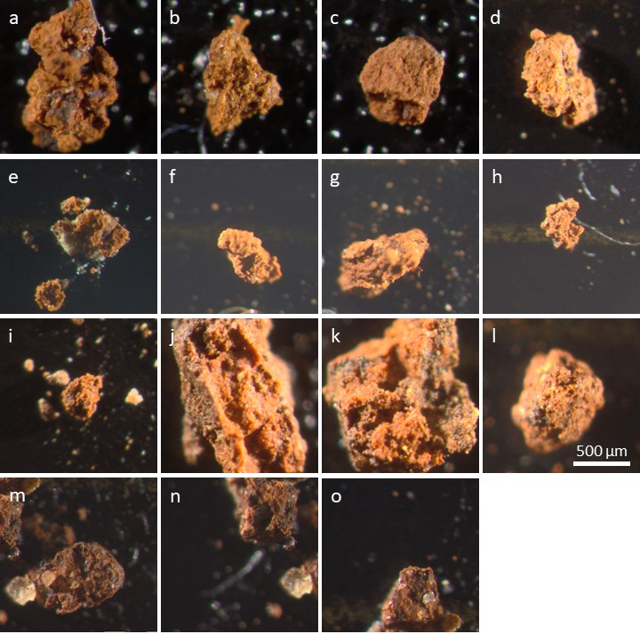

Supplementary Information Fig. G2: DM micrographs of red fragments; a: 18053-06; b: 18053-07.
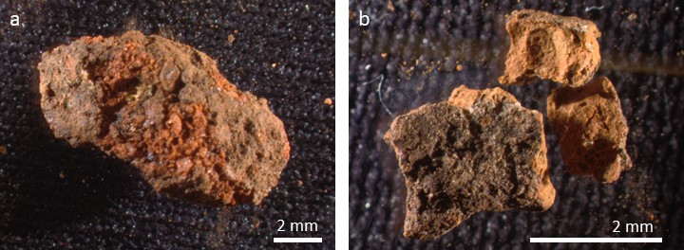

Supplementary Information Fig. G3. SEM micrographs of the analyzed material. From the top to the bottom and from left to right: 18053-04_1; 18053-03_2; 18053-03_4; 18053-03_5; 18053-06; 18053-07; 18053-01_12; 18053-01_13; 18053-01_19; 18053-01_28; 18053-02_1; 18053-02_4; 18053-02_5; 18053-02_7; 18053-03_1; 18053-04_2; 18053-04_3.

Supplementary Information Fig. G4. Typical SEM-EDS analysis of a micro-agglomerate. Top left: photo of micro-agglomerate 18053-04-3 with location of areas 1-3 analyzed at 1200x and 2400x; Top right: Area 1 showing a zircon (bright particle); middle and bottom SEM micrograph of an area at 2400x and its mapping.
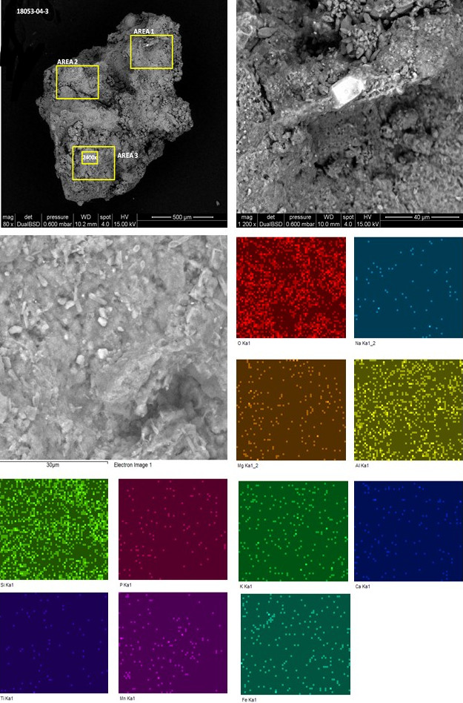

Sediment analysis from archaeological layers and the burial pit

The particle size analysis identifies substantial differences between Layers 17, 18 and 19. Sediment from Layer 19 is much finer than that composing the other two layers (Fig. 4 a, Supplementary Information Table G4). The clay fraction represents, in this layer, more than 60% of the total sediment, and features a high content of very fine particles with a mode around 0.3 µm (> 30%). This mode is also present in the other la yers, but in much lower proportion (<20% for Layer 17 and <25% for Layer 18). Layers 17 and 18 are coarser, with higher amount of silt and sand. The results of the multimodal decomposition show that the modes of sand and silt are mainly the same for the three layers (Supplementary Information Fig. G5, Supplementary Information Table G5). However, the relative proportions gradually change throughout the sedimentary sequence. Only two samples (PYS-2017-200138 and PYS-2017-200139), located at the top of Layer 18, contradict this pattern. They differ from all other sediment samples for their low content of clay and higher content in silt and sand (Fig. 4 a). The five sediment samples retrieved from the burial pit are much coarser than all the others and feature higher proportion of both sand and silt. They lack, with the only exception of PYS-2017-IPP, the very fine clays mode found in the other samples, and are characterized by two prominent sand modes (Supplementary Information Fig. G5). They share with the two samples from the top of Layer 18 (PYS-2017-200138 and PYS-2017-200139) the same modes of silt, fine, medium and coarse sand, and similar proportions of silts (Fig. 4 b).
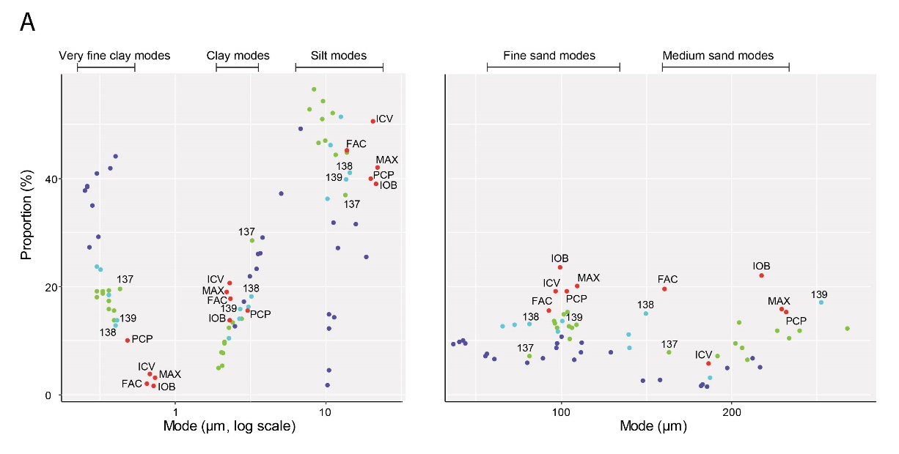
Supplementary Information Fig. G5. Proportions of the different size grains modes calculated by multimodal decomposition.

Supplementary Information Table G4. Particle size parameters and distribution of sediment from the burial pit and encasing Layers 17, 18 and 19
Sample | D10 (µm) | D25 (µm) | D50 (µm) | D75 (µm) | D90 (µm) | % Sand (2000-63 µm) | % Silt (63-7 µm) | % clay (<7 µm)
PYS-2017-200127 | 0,4213 | 2,5471 | 8,8574 | 52,2422 | 159,0668 | 23,2887 | 32,2804 | 44,43
PYS-2017-200128 | 0,2833 | 2,0214 | 6,9366 | 32,1005 | 159,81 | 19,9745 | 29,7934 | 50,23
PYS-2017-200129 | 0,3855 | 2,3933 | 9,6689 | 53,4486 | 167,205 | 23,3637 | 33,7223 | 42,91
PYS-2017-200130 | 0,3006 | 1,899 | 8,0248 | 53,3315 | 176,7616 | 23,5051 | 29,498 | 47
PYS-2017-200131 | 0,3223 | 1,6271 | 7,3754 | 36,3132 | 139,1664 | 20,3451 | 30,7479 | 48,91
PYS-2017-200132 | 0,3366 | 1,9249 | 7,1992 | 24,7953 | 130,504 | 17,4272 | 33,2497 | 49,32
PYS-2017-200133 | 0,2998 | 1,7728 | 7,9464 | 28,4972 | 116,6575 | 17,2008 | 35,6588 | 47,14
PYS-2017-200135 | 0,2751 | 1,7797 | 6,7197 | 23,8262 | 112,9716 | 16,853 | 32,109 | 51,04
PYS-2017-200136 | 0,3534 | 2,7801 | 11,0074 | 47,6085 | 198,1567 | 22,6338 | 38,2452 | 39,12
PYS-2017-200137 | 0,3729 | 1,5136 | 6,3864 | 16,8426 | 87,7644 | 12,3609 | 35,5015 | 52,14
PYS-2017-200138 | 0,45 | 3,4732 | 12,0631 | 54,8493 | 123,2472 | 23,2881 | 40,267 | 36,44
PYS-2017-200139 | 0,4314 | 3,011 | 12,1398 | 79,6824 | 214,6881 | 27,1448 | 35,0506 | 37,8
PYS-2017-200141 | 0,3284 | 2,0394 | 7,6496 | 25,6136 | 90,198 | 15,2069 | 37,0327 | 47,76
PYS-2017-200142 | 0,2662 | 1,0744 | 7,4934 | 22,4781 | 83,0333 | 13,0821 | 38,4076 | 48,51
PYS-2017-200144 | 0,2423 | 0,9819 | 6,5408 | 27,2241 | 97,6805 | 16,4337 | 32,0243 | 51,54
PYS-2017-200145 | 0,2073 | 0,4145 | 5,3556 | 23,6887 | 100,6494 | 16,3217 | 28,0524 | 55,63
PYS-2017-200146 | 0,2374 | 0,4064 | 5,0744 | 18,6924 | 106,7284 | 15,0418 | 28,6601 | 56,3
PYS-2017-200147 | 0,1935 | 0,3054 | 3,5793 | 19,8322 | 107,3525 | 15,4114 | 23,9091 | 60,68
PYS-2017-200148 | 0,1751 | 0,2746 | 2,6934 | 11,7933 | 60,7806 | 9,613 | 24,0033 | 66,38
PYS-2017-200149 | 0,1704 | 0,2663 | 2,7306 | 13,5417 | 69,4423 | 11,21 | 23,3323 | 65,46
PYS-2017-200150 | 0,1676 | 0,2639 | 2,9232 | 13,2036 | 65,6696 | 10,4579 | 24,5602 | 64,98
PYS-2017-200151 | 0,1981 | 0,2985 | 2,4924 | 14,206 | 63,6424 | 10,108 | 25,5865 | 64,31
PYS-2017-200152 | 0,2848 | 0,3579 | 1,5487 | 13,8887 | 36,5961 | 6,3348 | 29,5112 | 64,15
PYS-2017-200153 | 0,2625 | 0,3515 | 2,3441 | 13,9968 | 45,4918 | 7,8118 | 29,2737 | 62,91
PYS-2017-FAC | 1,8317 | 5,0907 | 16,734 | 91,4277 | 143,9011 | 31,7949 | 37,7483 | 30,46
PYS-2017-IOB | 2,297 | 10,5478 | 44,0343 | 131,2367 | 202,2432 | 42,628 | 37,3591 | 20,01
PYS-2017-PCP | 0,6592 | 5,3518 | 20,9438 | 92,0215 | 191,5747 | 31,3077 | 40,5006 | 28,19
PYS-2017-ICV | 1,4294 | 4,6063 | 18,1541 | 58,9728 | 116,8729 | 23,5834 | 46,0092 | 30,41
PYS-2017-MAX | 1,5304 | 5,6013 | 27,9358 | 107,3227 | 194,6636 | 35,78 | 36,9053 | 27,31

Supplementary Information Table G5. Results of multimodal decomposition of the particle size distribution of sediment from the burial pit and encasing Layers 17, 18 and 19.

Sample | Layer | Mode (µm) | Mode (phi) | Proportion (%)
PYS.2017.200127 | 17 | 204,12 | 2,29 | 13,30
 |  | 95,85 | 3,38 | 13,60
 |  | 9,92 | 6,66 | 46,90
 |  | 2,27 | 8,78 | 12,40
 |  | 0,39 | 11,33 | 13,80
PYS.2017.200128 | 17 | 233,52 | 2,10 | 10,50
 |  | 96,03 | 3,38 | 13,20
 |  | 7,81 | 7,00 | 52,80
 |  | 2,05 | 8,93 | 5,40
 |  | 0,30 | 11,68 | 18,00
PYS.2017.200129 | 17 | 226,40 | 2,14 | 11,80
 |  | 101,62 | 3,30 | 14,90
 |  | 11,56 | 6,43 | 44,30
 |  | 2,39 | 8,71 | 13,40
 |  | 0,39 | 11,32 | 15,50
PYS.2017.200130 | 17 | 239,70 | 2,06 | 11,80
 |  | 103,68 | 3,27 | 15,30
 |  | 8,96 | 6,80 | 46,60
 |  | 2,07 | 8,92 | 7,70
 |  | 0,33 | 11,56 | 18,70
PYS.2017.200131 | 17 | 202,12 | 2,31 | 9,50
 |  | 106,13 | 3,24 | 12,40
 |  | 9,48 | 6,72 | 50,90
 |  | 2,03 | 8,94 | 7,90
 |  | 0,36 | 11,43 | 19,30
PYS.2017.200132 | 17 | 205,94 | 2,28 | 8,60
 |  | 104,89 | 3,25 | 10,30
 |  | 9,60 | 6,70 | 54,20
 |  | 2,11 | 8,89 | 9,50
 |  | 0,36 | 11,45 | 17,40
PYS.2017.200133 | 17 | 208,94 | 2,26 | 6,40
 |  | 104,39 | 3,26 | 12,60
 |  | 11,11 | 6,49 | 52,10
 |  | 2,13 | 8,87 | 9,80
 |  | 0,33 | 11,55 | 19,10
PYS.2017.200135 | 17 | 191,56 | 2,38 | 7,20
 |  | 97,47 | 3,36 | 12,40
 |  | 8,29 | 6,91 | 56,50
 |  | 1,93 | 9,02 | 4,90
 |  | 0,30 | 11,68 | 19,10
PYS.2017.200136 | 17 | 267,91 | 1,90 | 12,30
 |  | 109,13 | 3,20 | 13,00
 |  | 13,72 | 6,19 | 44,70
 |  | 2,75 | 8,51 | 14,10
 |  | 0,36 | 11,43 | 15,80
PYS.2017.200137 | 17 | 163,27 | 2,61 | 7,90
 |  | 81,56 | 3,62 | 7,20
 |  | 13,43 | 6,22 | 36,90
 |  | 3,22 | 8,28 | 28,50
 |  | 0,43 | 11,20 | 19,50
PYS.2017.200138 | 18 | 149,43 | 2,74 | 15,00
 |  | 81,54 | 3,62 | 13,10
 |  | 14,42 | 6,12 | 41,00
 |  | 3,18 | 8,30 | 18,20
 |  | 0,40 | 11,27 | 12,80
PYS.2017.200139 | 18 | 252,26 | 1,99 | 17,10
 |  | 100,68 | 3,31 | 13,60
 |  | 13,53 | 6,21 | 39,80
 |  | 2,70 | 8,53 | 15,80
 |  | 0,41 | 11,25 | 13,80
PYS.2017.200141 | 18 | 140,11 | 2,84 | 8,60
 |  | 72,58 | 3,78 | 13,00
 |  | 10,66 | 6,55 | 46,10
 |  | 2,67 | 8,55 | 14,00
 |  | 0,36 | 11,44 | 18,40
PYS.2017.200142 | 18 | 187,35 | 2,42 | 3,20
 |  | 98,13 | 3,35 | 11,70
 |  | 12,53 | 6,32 | 51,40
 |  | 2,26 | 8,79 | 10,50
 |  | 0,32 | 11,61 | 23,10
PYS.2017.200144 | 18 | 139,57 | 2,84 | 11,10
 |  | 65,55 | 3,93 | 12,70
 |  | 10,25 | 6,61 | 36,20
 |  | 3,04 | 8,36 | 16,20
 |  | 0,30 | 11,72 | 23,70
PYS.2017.200145 | 19 | 197,24 | 2,34 | 5,00
 |  | 111,99 | 3,16 | 9,60
 |  | 55,61 | 4,17 | 7,10
 |  | 10,22 | 6,61 | 1,80
 |  | 6,75 | 7,21 | 49,20
 |  | 0,27 | 11,85 | 27,30
PYS.2017.200146 | 19 | 216,59 | 2,21 | 5,10
 |  | 129,03 | 2,95 | 7,80
 |  | 56,51 | 4,15 | 7,60
 |  | 11,96 | 6,39 | 27,10
 |  | 3,45 | 8,18 | 23,30
 |  | 0,31 | 11,65 | 29,20
PYS.2017.200147 | 19 | 212,06 | 2,24 | 6,70
 |  | 111,45 | 3,17 | 7,80
 |  | 42,58 | 4,55 | 10,00
 |  | 11,28 | 6,47 | 14,30
 |  | 3,66 | 8,09 | 26,10
 |  | 0,28 | 11,82 | 35,00
PYS.2017.200148 | 19 | 100,07 | 3,32 | 10,70
 |  | 36,64 | 4,77 | 9,40
 |  | 10,51 | 6,57 | 12,30
 |  | 3,81 | 8,03 | 29,10
 |  | 0,26 | 11,89 | 38,50
PYS.2017.200149 | 19 | 181,98 | 2,46 | 1,70
 |  | 97,62 | 3,36 | 9,50
 |  | 43,78 | 4,51 | 9,50
 |  | 10,51 | 6,57 | 14,90
 |  | 3,55 | 8,14 | 26,00
 |  | 0,26 | 11,93 | 38,40
PYS.2017.200150 | 19 | 182,92 | 2,45 | 1,90
 |  | 97,14 | 3,36 | 8,70
 |  | 40,41 | 4,63 | 9,70
 |  | 10,42 | 6,58 | 4,60
 |  | 5,02 | 7,64 | 37,20
 |  | 0,25 | 11,96 | 37,80
PYS.2017.200151 | 19 | 185,67 | 2,43 | 1,50
 |  | 107,65 | 3,22 | 6,50
 |  | 61,01 | 4,03 | 6,60
 |  | 11,14 | 6,49 | 31,80
 |  | 2,48 | 8,65 | 12,70
 |  | 0,30 | 11,71 | 40,90
PYS.2017.200152 | 19 | 147,94 | 2,76 | 2,60
 |  | 80,09 | 3,64 | 5,90
 |  | 18,51 | 5,76 | 25,50
 |  | 3,11 | 8,33 | 21,90
 |  | 0,40 | 11,30 | 44,10
PYS.2017.200153 | 19 | 158,08 | 2,66 | 2,70
 |  | 89,18 | 3,49 | 6,70
 |  | 15,79 | 5,98 | 31,50
 |  | 2,84 | 8,46 | 17,20
 |  | 0,37 | 11,40 | 41,90
PYS.2017.MAX | Burial Pit | 229,40 | 2,12 | 15,80
 |  | 109,31 | 3,19 | 20,10
 |  | 21,92 | 5,51 | 42,00
 |  | 2,20 | 8,83 | 19,00
 |  | 0,73 | 10,42 | 3,10
PYS.2017.IOB | Burial Pit | 217,31 | 2,20 | 22,00
 |  | 99,09 | 3,34 | 23,60
 |  | 21,48 | 5,54 | 39,00
 |  | 2,30 | 8,77 | 13,70
 |  | 0,72 | 10,44 | 1,60
PYS.2017.ICV | Burial Pit | 186,30 | 2,42 | 5,80
 |  | 96,70 | 3,37 | 19,20
 |  | 20,50 | 5,61 | 50,60
 |  | 2,29 | 8,77 | 20,60
 |  | 0,68 | 10,52 | 3,80
PYS.2017.PCP | Burial Pit | 231,88 | 2,11 | 15,30
 |  | 103,40 | 3,27 | 19,10
 |  | 19,84 | 5,66 | 39,90
 |  | 3,00 | 8,38 | 15,60
 |  | 1,70 | 9,20 | 0,00
 |  | 0,48 | 11,03 | 10,10
PYS.2017.FAC | Burial Pit | 160,67 | 2,64 | 19,50
 |  | 92,67 | 3,43 | 15,50
 |  | 13,81 | 6,18 | 45,20
 |  | 2,71 | 8,53 | 0,00
 |  | 2,31 | 8,76 | 17,80
 |  | 0,65 | 10,59 | 2,00

The elemental analysis of the sediment samples retrieved along the sequence identifies an anomaly corresponding to the top of Layer 18 and the base of Layer 17 (Fig. 4 c, Supplementary Information Table G6). The three samples covering this depth (PYS-2017-200137 to 139) are characterised by a substantial increase in SiO₂, and a concomitant decrease in K₂O, CaO, TiO₂, Fe₂O₃, Zn, Ga, As, Y and Ba. Sediment samples from the burial pits display an elemental composition remarkably similar to these three samples. However, these last samples differ from those from the burial pit for their lower content in Mn. Multivariate analysis of clr values (Fig. 4 d) highlights that the sediment from the burial pit differs from that of Layers 17, 18, and most of that from Layer 19 for its higher content in CaO, Mn and Zn.
The sediment from the archaeological layers and the burial pit are mainly composed of quartz, calcium carbonate, hydroxylapatite, muscovite and, to a lower degree, dolomite, aragonite, hematite and kaolinite (Supplementary Information Fig. G6, Supplementary Information G7). The sediment from the burial pit shares with that from the top of the Layer 18 (PYS-2017-200138 and PYS-2017-200139), a relatively high content in calcium carbonate, only found in high proportions in these two layers, and a relatively low content in dolomite, hematite, hydroxylapatite, and kaolinite. The abundance of these last minerals and the concomitant low proportion of calcium carbonate in sediment samples from Layer 19 (PYS-2017-200146, PYS-2017-200149, PYS-2017-200152) indicates that the pit sediment does not come from Layer 19 and may in part proceed from the top of Layer 18.

Supplementary Information Table G6. Elemental composition of sediment from the burial pit and encasing Layers 17, 18 and 19 obtained by p-EDXRF *
Code | Measurement | SiO₂ | K₂O | CaO | TiO₂ | MnO | Fe₂O₃ | Zn | Ga | As | Rb | Y | Zr | Ba
FAC | PYS-2017-FAC_01 | 25,3 | 1,11 | 16,2 | 0,657 | 2,6 | 10,6 | 652 | 18 | 16 | 33 | 51 | 910 | 286
FAC | PYS-2017-FAC_02 | 26,1 | 1,12 | 16,4 | 0,666 | 2,7 | 10,5 | 647 | 18 | 15 | 32 | 53 | 908 | 277
FAC | PYS-2017-FAC_03 | 25,2 | 1,13 | 15,9 | 0,655 | 2,6 | 10,5 | 643 | 18 | 15 | 32 | 50 | 905 | 291
ICV | PYS-2017-ICV_01 | 26,8 | 1,22 | 13,7 | 0,746 | 2,4 | 11,6 | 577 | 19 | 23 | 33 | 50 | 1602 | 360
ICV | PYS-2017-ICV_02 | 26,6 | 1,21 | 13,8 | 0,814 | 2,6 | 11,5 | 608 | 19 | 22 | 32 | 54 | 1009 | 341
ICV | PYS-2017-ICV_03 | 26,8 | 1,22 | 13,6 | 0,733 | 2,5 | 11,6 | 616 | 19 | 21 | 35 | 54 | 2028 | 329
IOB | PYS-2017-IOB_01 | 25,2 | 1,15 | 16,7 | 0,697 | 2,4 | 11,0 | 576 | 18 | 19 | 34 | 58 | 1087 | 340
IOB | PYS-2017-IOB_02 | 25,4 | 1,15 | 16,7 | 0,836 | 2,4 | 11,3 | 579 | 18 | 20 | 36 | 56 | 871 | 327
IOB | PYS-2017-IOB_03 | 24,6 | 1,16 | 16,4 | 0,829 | 2,5 | 11,2 | 597 | 19 | 18 | 35 | 59 | 842 | 310
MAX | PYS-2017-MAX_01 | 24,3 | 1,11 | 18,0 | 0,738 | 2,6 | 11,7 | 581 | 18 | 20 | 33 | 49 | 853 | 324
MAX | PYS-2017-MAX_02 | 24,3 | 1,11 | 18,2 | 0,755 | 2,4 | 11,2 | 576 | 17 | 21 | 34 | 50 | 666 | 313
MAX | PYS-2017-MAX_03 | 23,8 | 1,12 | 17,7 | 0,747 | 2,4 | 11,2 | 571 | 17 | 19 | 35 | 53 | 909 | 342
PCP | PYS-2017-PCP_01 | 26,8 | 1,19 | 15,1 | 0,770 | 2,4 | 11,9 | 570 | 19 | 19 | 38 | 56 | 1396 | 380
PCP | PYS-2017-PCP_02 | 26,2 | 1,18 | 15,2 | 0,743 | 2,4 | 12,0 | 574 | 19 | 18 | 37 | 50 | 1172 | 383
PCP | PYS-2017-PCP_03 | 26,3 | 1,19 | 15,2 | 0,747 | 2,4 | 11,9 | 569 | 19 | 17 | 39 | 54 | 1377 | 376
127 | PYS-2017-200127_01 | 27,1 | 1,32 | 12,4 | 0,771 | 2,4 | 11,7 | 541 | 19 | 16 | 34 | 53 | 1556 | 505
127 | PYS-2017-200127_02 | 27,1 | 1,33 | 12,5 | 0,777 | 2,5 | 11,8 | 574 | 19 | 21 | 32 | 56 | 1570 | 478
127 | PYS-2017-200127_03 | 26,9 | 1,33 | 12,7 | 0,750 | 2,3 | 11,7 | 489 | 19 | 22 | 32 | 56 | 1302 | 545
128 | PYS-2017-200128_01 | 27,3 | 1,34 | 13,4 | 0,751 | 2,3 | 12,0 | 542 | 19 | 23 | 39 | 55 | 1250 | 456
128 | PYS-2017-200128_02 | 27,2 | 1,33 | 12,1 | 0,759 | 2,3 | 11,4 | 537 | 20 | 20 | 36 | 53 | 1333 | 427
128 | PYS-2017-200128_03 | 27,6 | 1,34 | 12,2 | 0,781 | 2,2 | 11,5 | 510 | 19 | 20 | 36 | 53 | 1059 | 462
129 | PYS-2017-200129_01 | 27,7 | 1,33 | 11,3 | 0,788 | 2,3 | 11,9 | 505 | 20 | 23 | 33 | 54 | 1373 | 484
129 | PYS-2017-200129_02 | 27,8 | 1,33 | 11,2 | 0,804 | 2,4 | 11,6 | 535 | 20 | 22 | 33 | 56 | 1292 | 447
129 | PYS-2017-200129_03 | 27,2 | 1,34 | 11,6 | 0,778 | 2,4 | 12,0 | 549 | 20 | 23 | 33 | 51 | 1227 | 451
130 | PYS-2017-200130_01 | 28,5 | 1,31 | 12,9 | 0,751 | 2,3 | 11,7 | 507 | 19 | 17 | 36 | 59 | 1064 | 460
130 | PYS-2017-200130_02 | 28,3 | 1,34 | 12,5 | 0,744 | 2,2 | 11,8 | 497 | 19 | 20 | 35 | 54 | 1407 | 528
130 | PYS-2017-200130_03 | 28,1 | 1,34 | 12,2 | 0,881 | 2,3 | 12,1 | 558 | 20 | 21 | 38 | 55 | 1194 | 427
131 | PYS-2017-200131_01 | 27,2 | 1,33 | 11,8 | 0,781 | 2,2 | 12,2 | 504 | 20 | 21 | 34 | 59 | 1600 | 529
131 | PYS-2017-200131_02 | 27,6 | 1,33 | 11,9 | 0,788 | 2,3 | 12,1 | 524 | 20 | 21 | 34 | 56 | 1404 | 490
131 | PYS-2017-200131_03 | 27,7 | 1,34 | 11,8 | 0,832 | 2,7 | 11,7 | 596 | 20 | 20 | 33 | 55 | 1914 | 398
132 | PYS-2017-200132_01 | 27,2 | 1,33 | 11,8 | 0,781 | 2,2 | 12,2 | 573 | 22 | 25 | 36 | 54 | 1509 | 439
132 | PYS-2017-200132_02 | 27,4 | 1,34 | 11,2 | 0,831 | 2,5 | 12,5 | 593 | 21 | 25 | 35 | 52 | 1869 | 394
132 | PYS-2017-200132_03 | 27,6 | 1,32 | 11,6 | 0,797 | 2,4 | 12,5 | 554 | 21 | 24 | 37 | 56 | 1621 | 438
133 | PYS-2017-200133_01 | 28,0 | 1,36 | 10,8 | 0,799 | 2,4 | 12,8 | 583 | 21 | 24 | 35 | 60 | 1127 | 466
133 | PYS-2017-200133_02 | 27,6 | 1,33 | 10,9 | 0,908 | 2,3 | 12,6 | 525 | 21 | 24 | 35 | 59 | 1895 | 500
133 | PYS-2017-200133_03 | 27,8 | 1,35 | 10,9 | 0,921 | 2,3 | 12,7 | 511 | 21 | 23 | 34 | 57 | 1088 | 518
135 | PYS-2017-200135_01 | 27,2 | 1,33 | 11,4 | 0,781 | 2,5 | 12,7 | 620 | 21 | 24 | 35 | 61 | 1196 | 421
135 | PYS-2017-200135_02 | 27,3 | 1,33 | 10,8 | 0,788 | 2,6 | 12,1 | 564 | 21 | 23 | 32 | 57 | 1108 | 405
135 | PYS-2017-200135_03 | 27,6 | 1,33 | 11,6 | 0,787 | 2,3 | 12,8 | 559 | 21 | 24 | 35 | 57 | 1347 | 464
136 | PYS-2017-200136_01 | 28,1 | 1,32 | 11,9 | 0,785 | 2,3 | 12,5 | 526 | 20 | 24 | 35 | 61 | 1296 | 478
136 | PYS-2017-200136_02 | 26,7 | 1,33 | 11,6 | 0,804 | 2,4 | 12,2 | 558 | 20 | 22 | 34 | 59 | 1325 | 453
136 | PYS-2017-200136_03 | 26,3 | 1,33 | 11,5 | 0,788 | 2,5 | 12,5 | 599 | 21 | 24 | 34 | 60 | 1392 | 418
137 | PYS-2017-200137_01 | 24,0 | 1,26 | 13,9 | 0,803 | 2,5 | 11,9 | 604 | 20 | 20 | 37 | 55 | 740 | 345
137 | PYS-2017-200137_02 | 23,7 | 1,24 | 14,1 | 0,744 | 2,5 | 11,6 | 533 | 19 | 22 | 34 | 51 | 880 | 366
137 | PYS-2017-200137_03 | 23,9 | 1,25 | 13,4 | 0,741 | 2,6 | 11,7 | 599 | 20 | 23 | 33 | 54 | 1150 | 334
138 | PYS-2017-200138_01 | 23,0 | 1,17 | 16,7 | 0,683 | 2,2 | 11,0 | 479 | 17 | 19 | 33 | 56 | 1370 | 397
138 | PYS-2017-200138_02 | 24,1 | 1,16 | 17,5 | 0,673 | 2,2 | 11,2 | 512 | 17 | 17 | 35 | 55 | 1093 | 370
138 | PYS-2017-200138_03 | 22,5 | 1,17 | 16,1 | 0,669 | 2,1 | 10,4 | 505 | 17 | 17 | 31 | 44 | 1042 | 389
139 | PYS-2017-200139_01 | 24,5 | 1,24 | 15,0 | 0,710 | 2,1 | 11,2 | 486 | 18 | 19 | 36 | 54 | 1166 | 441
139 | PYS-2017-200139_02 | 25,0 | 1,25 | 15,6 | 0,730 | 2,1 | 11,4 | 498 | 18 | 20 | 36 | 54 | 1265 | 452
139 | PYS-2017-200139_03 | 24,8 | 1,24 | 16,0 | 0,733 | 2,1 | 11,4 | 493 | 17 | 21 | 35 | 53 | 1037 | 457
141 | PYS-2017-200141_01 | 25,1 | 1,31 | 11,3 | 0,807 | 2,5 | 11,7 | 585 | 20 | 23 | 33 | 51 | 1074 | 406
141 | PYS-2017-200141_02 | 26,9 | 1,32 | 11,8 | 0,785 | 2,4 | 12,2 | 583 | 20 | 23 | 36 | 59 | 2060 | 458
141 | PYS-2017-200141_03 | 27,9 | 1,33 | 12,0 | 0,768 | 2,2 | 12,1 | 519 | 19 | 22 | 37 | 56 | 2189 | 508
142 | PYS-2017-200142_01 | 26,6 | 1,29 | 12,6 | 0,755 | 2,3 | 12,2 | 564 | 20 | 25 | 33 | 56 | 830 | 431
142 | PYS-2017-200142_02 | 26,1 | 1,28 | 12,7 | 0,752 | 2,3 | 12,5 | 566 | 20 | 24 | 35 | 58 | 989 | 452
142 | PYS-2017-200142_03 | 25,2 | 1,29 | 12,9 | 0,790 | 2,4 | 12,4 | 592 | 20 | 23 | 35 | 56 | 1210 | 450
144 | PYS-2017-200144_01 | 26,7 | 1,28 | 13,6 | 0,758 | 2,3 | 12,4 | 599 | 20 | 24 | 43 | 62 | 1559 | 370
144 | PYS-2017-200144_02 | 25,8 | 1,27 | 13,5 | 0,843 | 2,1 | 12,5 | 518 | 19 | 24 | 40 | 57 | 1291 | 508
144 | PYS-2017-200144_03 | 25,7 | 1,27 | 13,4 | 0,831 | 2,3 | 12,3 | 582 | 20 | 23 | 40 | 61 | 1262 | 383
145 | PYS-2017-200145_01 | 26,8 | 1,30 | 11,4 | 0,813 | 2,4 | 12,5 | 586 | 21 | 24 | 41 | 58 | 3049 | 400
145 | PYS-2017-200145_02 | 27,4 | 1,31 | 12,2 | 0,790 | 2,4 | 12,7 | 599 | 21 | 23 | 41 | 66 | 1453 | 417
145 | PYS-2017-200145_03 | 28,1 | 1,30 | 12,1 | 0,798 | 2,4 | 12,8 | 617 | 21 | 24 | 42 | 63 | 2060 | 401
146 | PYS-2017-200146_01 | 27,5 | 1,31 | 10,8 | 0,805 | 2,2 | 12,8 | 566 | 21 | 18 | 42 | 58 | 1172 | 466
146 | PYS-2017-200146_02 | 27,2 | 1,32 | 11,6 | 0,808 | 2,3 | 13,2 | 629 | 22 | 26 | 43 | 63 | 960 | 447
146 | PYS-2017-200146_03 | 27,5 | 1,33 | 11,2 | 0,806 | 2,4 | 13,1 | 644 | 22 | 25 | 42 | 63 | 1291 | 412
147 | PYS-2017-200147_01 | 27,3 | 1,30 | 10,1 | 0,812 | 2,1 | 13,1 | 550 | 21 | 20 | 42 | 62 | 1696 | 513
147 | PYS-2017-200147_02 | 28,0 | 1,33 | 10,6 | 0,831 | 2,2 | 13,5 | 579 | 22 | 27 | 42 | 58 | 1398 | 487
147 | PYS-2017-200147_03 | 28,3 | 1,32 | 10,7 | 0,830 | 2,3 | 13,5 | 593 | 21 | 28 | 41 | 65 | 1443 | 465
148 | PYS-2017-200148_01 | 28,3 | 1,33 | 10,3 | 0,809 | 2,3 | 12,9 | 574 | 21 | 19 | 40 | 58 | 1160 | 483
148 | PYS-2017-200148_02 | 31,0 | 1,35 | 10,6 | 0,797 | 2,2 | 13,3 | 581 | 21 | 27 | 43 | 67 | 1123 | 467
148 | PYS-2017-200148_03 | 28,5 | 1,33 | 10,9 | 0,798 | 2,4 | 13,3 | 653 | 21 | 27 | 43 | 66 | 1090 | 401
149 | PYS-2017-200149_01 | 27,2 | 1,31 | 9,3 | 0,832 | 2,3 | 12,9 | 653 | 22 | 20 | 39 | 62 | 1595 | 421
149 | PYS-2017-200149_02 | 27,5 | 1,32 | 9,8 | 0,820 | 2,5 | 13,1 | 693 | 23 | 26 | 41 | 58 | 1281 | 374
149 | PYS-2017-200149_03 | 28,4 | 1,32 | 10,1 | 0,847 | 2,4 | 13,5 | 675 | 23 | 26 | 43 | 61 | 1324 | 416
150 | PYS-2017-200150_01 | 28,7 | 1,35 | 8,6 | 0,928 | 2,1 | 13,2 | 562 | 22 | 26 | 40 | 70 | 1357 | 503
150 | PYS-2017-200150_02 | 29,0 | 1,33 | 10,0 | 0,795 | 2,3 | 13,3 | 641 | 22 | 28 | 42 | 69 | 1408 | 430
150 | PYS-2017-200150_02 | 29,6 | 1,37 | 8,8 | 0,952 | 2,2 | 13,4 | 597 | 22 | 29 | 40 | 67 | 1425 | 497
151 | PYS-2017-200151_01 | 28,2 | 1,30 | 8,6 | 0,801 | 2,4 | 13,4 | 636 | 23 | 28 | 36 | 66 | 2236 | 438
151 | PYS-2017-200151_04 | 29,7 | 1,32 | 9,1 | 0,793 | 2,2 | 13,7 | 575 | 22 | 30 | 38 | 65 | 2188 | 510
151 | PYS-2017-200151_05 | 27,5 | 1,31 | 8,8 | 0,777 | 2,4 | 13,8 | 640 | 23 | 30 | 37 | 65 | 2206 | 446
152 | PYS-2017-200152_01 | 28,7 | 1,34 | 8,4 | 0,844 | 2,4 | 13,1 | 625 | 22 | 27 | 38 | 65 | 1432 | 437
152 | PYS-2017-200152_02 | 29,7 | 1,38 | 8,6 | 0,861 | 2,2 | 13,2 | 553 | 22 | 27 | 37 | 63 | 1213 | 539
152 | PYS-2017-200152_03 | 29,1 | 1,35 | 8,7 | 0,848 | 2,3 | 13,3 | 590 | 22 | 28 | 37 | 66 | 1397 | 487
153 | PYS-2017-200153_01 | 28,2 | 1,36 | 8,1 | 0,800 | 2,5 | 13,2 | 565 | 22 | 28 | 33 | 64 | 1640 | 536
153 | PYS-2017-200153_02 | 29,7 | 1,37 | 8,4 | 0,803 | 2,9 | 13,6 | 665 | 23 | 30 | 34 | 66 | 2092 | 445
153 | PYS-2017-200153_03 | 29,9 | 1,36 | 8,3 | 0,810 | 2,9 | 13,3 | 671 | 23 | 28 | 33 | 65 | 2062 | 448
* Oxides are given in mass percentages, trace elements in parts per million.

Supplementary Information Fig. G6. Mineralogical analysis of sediment from the archaeological layers L17, L18 and L19 and the burial pit (ICV, MAX, PCP). 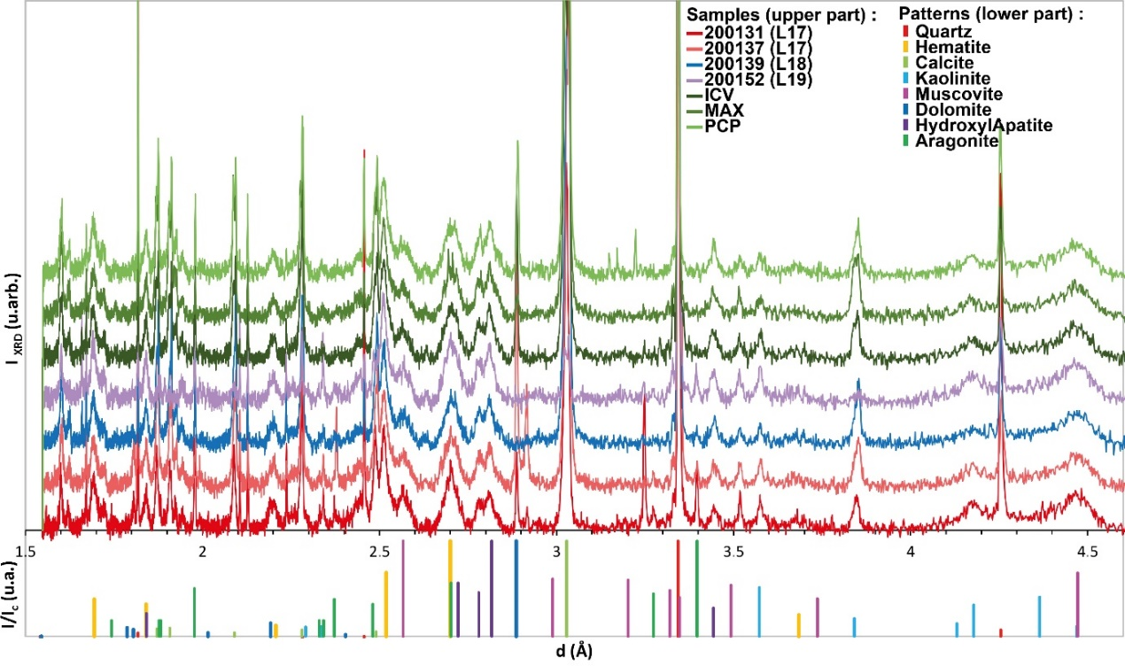

Supplementary Information Table G7. Semi-quantitative analyses (%) obtained by X-ray diffraction of selected sediment samples from the burial pit and Layers 17, 18 and 19 *
 | Compound (PDF2004 reference pattern)
Sample | Aragonite  (41-1475) | Calcium Carbonate  (85-1108) | Dolomite  (89-5862) | Hematite  (33-0664) | Hydroxylapatite  (89-4405) | Kaolinite  (80-0886) | Muscovite  (82-0576) | Quartz  (46-1045)
200128 (L17) | 5,5 | 18,9 | 7,0 | 4,6 | 13,2 | 3,5 | 8,4 | 39,0
200131 (L17) | 7,3 | 11,1 | 2,8 | 3,2 | 9,7 | 3,0 | 7,7 | 55,2
200135 (L17) | 6,2 | 11,6 | 7,2 | 3,9 | 10,4 | 3,6 | 16,8 | 40,3
200137 (L17) | 6,7 | 17,9 | 10,7 | 4,5 | 16,0 | 4,0 | 8,8 | 31,3
200138 (L18) |  | 28,9 | 5,2 | 4,2 | 13,9 | 2,6 | 17,1 | 28,2
200139 (L18) | 3,4 | 29,2 |  | 4,5 | 14,5 | 2,9 | 9,4 | 36,2
200141 (L18) |  | 13,9 | 8,2 | 4,8 | 17,0 | 4,3 | 15,1 | 36,6
200144 (L18) |  | 10,0 | 2,6 | 3,3 | 12,5 | 2,9 | 10,8 | 57,9
200146 (L19) |  | 10,8 | 9,8 | 5,7 | 20,9 | 4,3 | 16,1 | 32,5
200149 (L19) |  | 6,2 |  | 5,3 | 20,8 | 4,9 | 23,7 | 39,0
200152 (L19) |  | 3,7 |  | 6,4 | 23,6 | 7,1 | 20,1 | 39,0
ICV |  | 13,7 | 6,0 | 3,8 | 13,7 | 3,8 | 11,8 | 47,2
MAX |  | 25,5 | 1,4 | 4,3 | 16,5 | 3,3 | 14,8 | 34,2
PCP |  | 21,4 | 5,4 | 3,6 | 13,5 | 2,9 | 8,8 | 44,4
* Colors indicate the concentration of a given mineral (from dark red for the highest to light green for the lowest).
Reddish micro-agglomerates associated with the child remains
The micro-agglomerates are composed of reddish grains. Both bulk chemical estimations obtained with SEM-EDS at 1200x and 2400x provide virtually identical results, suggesting a common origin (Supplementary Information Tables G8 and G9). Although substantial variability is observed in the proportion of the more represented elements, the micro-agglomerates are roughly composed of 16% Al₂O₃, 43% SiO₂, and 25% Fe₂O₃. Other compounds present in all specimens are CaO (~5%), MgO (~3%), K₂O (~3%), and TiO₂ (~2%). P₂O₅ and MnO, normally averaging 2%, are not systematically present, but account in some samples for up to 10% and 6% of the composition respectively.

Supplementary Information Table G8. Elemental composition of 17 reddish agglomerates obtained by SEM-EDS by averaging results from 6 to 9 areas analyses at 1200x. Results by compound wt. %, normalized to 100%.
 | MgO | Al₂O₃ | SiO₂ | P₂O₅ | K₂O | CaO | TiO₂ | MnO | Fe₂O₃
MEAN | 3 | 16 | 42,9 | 1,9 | 2,7 | 5 | 1,7 | 1,9 | 24,8
MEDIAN | 2,8 | 16,7 | 41,7 | 0,9 | 2,7 | 3,4 | 1,6 | 1,1 | 23,8
STD DEV | 1,2 | 3,5 | 11,3 | 2,5 | 1,2 | 5,1 | 0,7 | 1,7 | 6,7
MAX | 5,8 | 22,6 | 69,5 | 9,9 | 4,7 | 20,3 | 3,1 | 5,5 | 38,2
MIN | 1,5 | 10,8 | 23,7 | bdl | 0,4 | 0,4 | 0,9 | bdl | 10,5

Supplementary Information Table G9. Elemental composition of 17 reddish micro-agglomerates obtained by SEM-EDS by averaging results from 6 to 9 areas analyses at 2400x. Results by compound wt. %, normalized to 100%.

 | MgO | Al₂O₃ | SiO₂ | P₂O₅ | K₂O | CaO | TiO₂ | MnO | Fe₂O₃
MEAN | 3,1 | 17 | 42,8 | 1,6 | 3,5 | 5,1 | 1,3 | 1,9 | 23,6
MEDIAN | 2,9 | 18,1 | 43,1 | 0,9 | 3,2 | 2,6 | 1,5 | 1,5 | 23,9
STD DEV | 1,3 | 3,8 | 10,6 | 1,9 | 2,1 | 7,5 | 1,1 | 2,2 | 9,3
MAX | 5,4 | 22,5 | 63,8 | 6 | 10,1 | 28,5 | 3,8 | 7 | 50,5
MIN | bdl | 9,5 | 21,4 | bdl | 0,6 | bdl | bdl | bdl | 11,4

Supplementary Information Fig. G7. SEM micrographs of micro-agglomerates. a) typical texture and large aluminium silicate grains; b) typical morphology of calcium carbonate crystals (1200x) ; c) Zircon crystal; d) detail of a P-Ca-rich crystal; e) detail of Fe oxides (bright particles). Note the difference in size between these and other particles; f) detail of calcium carbonates and clay grains.

Phase analyses identify quartz, aluminium silicates, abundant iron oxides and calcium carbonates (Supplementary Information Fig. G7 a and b). The silicates and carbonates often appear in the form of large and well-formed crystals (10-50 µm or larger) (Supplementary Information Fig. G7 a and b) frequently arranged in clusters. The iron oxides, comparatively small (<10 µm), generally present sub-rounded shapes and are dispersed within the matrix (Supplementary Information Fig. G7 c). Small amounts (~1-2%) of MgO, MnO and TiO₂ are often associated with the iron oxides. Mineral phases rich in manganese and titanium oxides (~16% MnO and ~40% TiO₂) are sporadically detected. Much less abundant minerals, but seen in almost all specimens, are zircon (Supplementary Information Fig. G4 c). In addition to the overall description, scant Ca-rich crystals in specimens 18053-03-04 and 18053-04-03 contain some S, element which is absent in the Ca-rich crystals within the other specimens. Another exception is the presence of two rich metal micro-particles – one containing 75 wt.% Ni while the other is a copper zinc alloy (57 wt.% Cu, 27 wt.% Zn). In all probability, the latter is the result of modern contamination.
XRD measurements confirm the presence of quartz, calcite, phyllosilicates (muscovite and kaolinite), feldspars and hematite (Supplementary Information Table G10). There are other less abundant minerals such as rutile, and hydroxylapatite, the last possibly due to the presence of bone micro-fragments.

Supplementary Information Table G10. Results of XRD analyses performed on reddish agglomerates from the burial pit*.
Sample code | Quartz | Calcite | Hematite | Muscovite | Kaolinite | Feldespar | Rutile | Hydroxylapatite
18053-01 | xx | (x) | x | xx | x | _ | _ | (x)
18053-02 | xx | (x) | x | xx | x | _ | _ | _
18053-03 | xx | x | x | xxx | _ | (x) | _ | _
18053-06 | xx | x | x | xxx | _ | _ | (x) | _
18053-07 | x | xx | x | xx | _ | x | _ | _
*There was not enough material to perform XRD analyses on sample 18053-04. xxx= very abundant (> 40%); xx= major (~20-40%); x= minor (~5-20%); (x)= trace (detected <5%); _= not detected.

Supplementary Information Table G11. Results of Raman analyses of red agglomerates and fragments associated with the child remains.
Sample code | Number of analysis | Morphology | Grain color | Identified compounds/minerals
18053-01_12 | 7 | Agglomerate | Dark orange | Hematite (rutile, Mn oxide, calcite)
18053-01_13 | 6 | Agglomerate | Red | Rutile (maghemite, quartz)
18053-01_19 | 6 | Agglomerate | Red | Hematite (rutile, quartz)
18053-01_28 | 6 | Agglomerate | Dark orange | Maghemite (hematite, magnetite, quartz, calcite)
18053-02_1 | 7 | Agglomerate | Brown | Hematite (maghemite, rutile, quartz)
18053-02_4 | 6 | Agglomerate | Orange | Hematite (maghemite, albite, rutile, Mn oxide, quartz)
18053-02_5 | 6 | Agglomerate | Orange | Hematite (rutile, maghemite, quartz)
18053-02_7 | 6 | Agglomerate | Dark red | Hematite (maghemite, calcite)
18053-03_1 | 6 | Agglomerate | Brown | Hematite (quartz, rutile, Mn oxide)
18053-03_2 | 6 | Agglomerate | Orange red | Rutile (hematite, calcite, Mn oxide, quartz)
18053-03_4 | 6 | Agglomerate | Dark red | Hematite (calcite, Mn oxide, quartz, rutile)
18053-03_5 | 6 | Agglomerate | Dark red | Hematite (quartz, calcite)
18053-04_1 | 7 | Agglomerate | Orange brown | Quartz (rutile, calcite, hematite)
18053-04_2 | 6 | Agglomerate | Dark orange | Hematite (quartz, calcite, Mn oxide, rutile)
18053-04_3 | 7 | Agglomerate | Orange brown | Hematite (rutile, calcite, quartz)
18053-06 | 24 | Sub-rounded irregular grains | Red | Hematite (calcite, quartz, rutile, Mn oxide)
18053-07 | 18 | Agglomerate | Orange brown | Hematite (rutile, calcite, aragonite, Mn oxide)

The mineralogical analysis carried out with Raman are consistent with those stemming from the elemental characterisation by SEM-EDS (Supplementary Information Table G11). They confirm the presence – both in the residues and the red fragments – of minerals such as quartz, feldspar, calcite, hematite and rutile, identified by XRD and whose presence is also suggested by SEM-EDS results (Supplementary Information Table G12). Other minerals, such as manganese oxides and aragonite, were also detected in Raman spectroscopy. Analyses detect in both the reddish micro-agglomerates and the red fragments the presence of hematite, with differences in the relative intensity of characteristic bands (Supplementary Information Fig. G8). Most samples present a fairly strong band at 660 cm⁻¹. The spectrum of a perfect hematite crystal should not present any signal near 660 cm⁻¹ (Bikiaris et al., 2000²⁴¹). However, many studies attribute this band to impurities or lack of long-range order, the so-called disorder related line^{242–244}. Some other iron oxides were identified within the reddish residues. Maghemite is reasonably abundant, present in all specimens; magnetite was only identified in a single agglomerate. The Ca crystals rich in S typically seen in micro-agglomerates 18053-03 and 18053-04 are probably gypsum. Micro-aggregate 18053-07 has yielded an elongated crystal rich in calcium (46%), which Raman analysis has identified as aragonite (Supplementary Information Fig. G7 f).

Supplementary Information Fig. G8. Raman spectra of different red and orange grains present in the micro-agglomerates sampled close to the child remains.
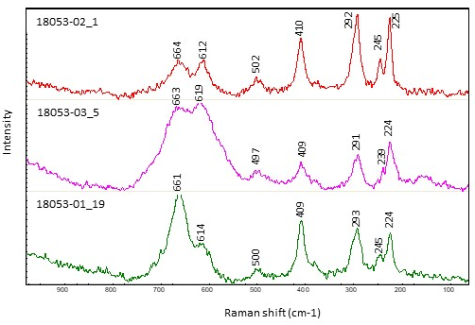

Supplementary Information Table G10. Results of SEM-EDS analyses conducted on reddish agglomerates and fragments adhering to the child remains.

Sample code | BSE contrast | >20% | 10-20% | 3-10% | >3-0.5% | Interpretation
18053-01_12 | light grey | Al2O3, SiO2, Fe2O3 | — | MgO, K2O | CaO, TiO2, MnO | Aluminosilicate with iron oxides
18053-01_13 | grey | Al2O3, SiO2 | Fe2O3 | K2O | Na2O, MgO, TiO2 | Aluminosilicate with iron oxides
18053-01_19 | grey | SiO2 | Al2O3, Fe2O3 | MgO, K2O | P2O5, TiO2 | Aluminosilicate with iron oxides
18053-01_28 | grey | Al2O3, SiO2, Fe2O3 | — | — | MgO, P2O5, K2O, CaO, TiO2, MnO | Aluminosilicate with iron oxides
18053-02_1 | grey | SiO2, Fe2O3 | Al2O3 | P2O5 | MgO, K2O, CaO, TiO2, MnO | Aluminosilicate with iron oxides
18053-02_4 | light grey | SiO2, Fe2O3 | Al2O3 | MgO, K2O, CaO,MnO | — | Aluminosilicate with iron oxides
18053-02_5 | light grey | SiO2, Fe2O3 | Al2O3 | TiO2 | Na2O, MgO, K2O, CaO | Aluminosilicate with iron oxides
18053-02_7 | grey | SiO2 | Al2O3, Fe2O3 | CaO | MgO, K2O, TiO2 | Aluminosilicate with iron oxides
18053-03_1 | light grey | SiO2, Fe2O3 | Al2O3 | P2O5, CaO, MnO | MgO, K2O | Aluminosilicate with iron oxides
18053-03_2 | light grey | Al2O3, SiO2 | Fe2O3 | MgO, K2O | P2O5, CaO, TiO2 | Aluminosilicate with iron oxides
18053-03_4 | light grey | SiO2 | Al2O3, Fe2O3 | MgO, K2O, MnO | Na2O, P2O5, CaO, TiO2 | Aluminosilicate with iron oxides
18053-03_5 | light grey | SiO2, Fe2O3 | Al2O3 | P2O5, CaO | MgO, K2O, MnO | Aluminosilicate with iron oxides
18053-04_1 | light grey | Al2O3, SiO2, Fe2O3 | — | MgO, K2O | CaO, TiO2, MnO | Aluminosilicate with iron oxides
18053-04_2 | light grey | SiO2, CaO | Al2O3, Fe2O3 | MgO, MnO | P2O5, K2O | Aluminosilicate with iron oxides
18053-04_3 | light grey | SiO2, Fe2O3 | Al2O3 | MgO, K2O | Na2O, P2O5, CaO, TiO2 | Aluminosilicate with iron oxides
18053-06 | light grey | SiO2, Fe2O3 | Al2O3 | MgO, K2O, CaO, MnO | — | Aluminosilicate with iron oxides
18053-07 | light grey | SiO2, CaO | Al2O3, Fe2O3 | MgO, P2O5, MnO | K2O, TiO2 | Aluminosilicate with iron oxides

Conclusion
Particle size, elemental and mineralogical analysis of the sediment from the burial pit and encasing Layers 17, 18 and 19 identify a strong similarity between the former and the sediment samples from the top of Layer 18 and the base of Layer 17, and a significant difference between the grave backfill and Layer 19. The lower proportion of clay in the pit infilling can be due to the milder pedogenesis to which sediment was submitted after being buried or to infiltration of coarser sediment to fill in a vacuum. The higher content in CaO that characterizes the infilling may results from the decomposition of the skeleton. A higher proportion of Mn is likely due to higher concentration of Mn-oxidizing micro-organisms in the pit^{19,20} and likely related to the decomposition of the child’s body. The overall pattern indicates that the top of Layer 18 (92-96 cm) and the base of Layer 17 (depth of 90-92 cm) were already in place or under deposition when the pit was excavated and that sediment from these layers was used to bury the body. This conclusion is consistent with the OSL age obtained for the pit, which is very similar to those obtained for Layers 17 and 18. This does not explain, however, why after excavating a pit in Layer 19 and perhaps the base of Layer 18, the removed sediment was apparently not, or only minimally, used to backfill after the deposition of body. A possibility is that sediment around the grave cut was preferred to fill in the grave cut instead of that coming from Layer 19. Another possibility is that the grave was dug during deposition of the top of Layer 18 and that little or no sediment was used to cover the body. In this case, the grave cut would have been gradually filled during the deposition of this layer thus taking its geochemical signature.
SEM-EDS, XRD, and Raman spectroscopy analyses point out that the reddish agglomerates adhering to the child remains are composed of quartz, carbonates, silicates, aluminium silicates and a small amount of iron oxides, the latter likely resulting from weathering of Fe-rich minerals – mostly hematite and maghemite. Research on ancient ceramics have introduced diagnostic criteria – based on size, shape and distribution of the inclusions – to differentiate naturally occurring and artificially added inclusions^{245–248}. Based on these studies, naturally occurring inclusions in ceramic paste tend be smaller, rounded, and regularly distributed – if well sorted – often saturating the clay. Therefore, the small size of the particles (1-10 µm) and their sub-rounded shape suggests in our case a natural origin. This interpretation is also supported by the polymetallic nature of the samples, which systematically contain other oxide minerals such as manganese oxides as well as zircon and rutile. In conclusion, the association of red micro-agglomerates with the child remains should not be necessarily interpreted as resulting from the deliberate use of ochre in the burial practice. It is more parsimoniously explained by with the hypothesis that iron-rich minerals are naturally present in the sediment in which the child body was deposited.

Supplementary Information H. Faunal remains associated with the human burial

Faunal remains were analysed from two sets of contexts at PYS: first, from the burial fill in Trench 8, Layer 19; and second, from Layers 17-19 in Trenches 3 and 4, which are located adjacent to Trench 8, and thus provide relevant zooarchaeological context. Results of each sub-assemblage are first presented separately, then discussed together. Additional information on the broader faunal assemblage from PYS is published elsewhere^{7,8}.

Results: burial fill
A total of 1002 faunal specimens were recovered from the burial fill, of which 651 (64.9%) were identified (Number of Identified Specimens, NISP) (Supplementary Information H Table 1). Bats represent the most common taxa, accounting for 89.5% of NISP. Both fruit bats (Megachiroptera, 15.6% of bat remains) and insectivorous bats (Microchiroptera, 17.8% of bat remains) were recovered. A total of 32 leaf-nosed bat (Hipposideridae) specimens (MNI= 6) were identified mainly from maxilla and mandible fragments as well as isolated teeth. In comparison, 27 fruit bat (Pteropodidae) dental elements, representing either the genus Rousettus or Epomophorus were recorded. However, two-thirds (66.5% NISP) of bat remains consist of postcranial elements that cannot be assigned to taxon.

Supplementary Information Table H1. Faunal taxonomic representation in two sub-assemblages at PYS: remains from the fill of the burial in Trench 8; and remains from Layers 17-19 in Trenches 3 and 4. NISP, Number of Identified Specimens; MNI, Minimum Number of Individuals.

 | Trench 8, Burial fill |  | Trenches 3-4, Layers 17-19
Taxonomic Attribution | NISP | MNI | L17 | L18 | L19 | Total NISP | MNI
Aves/Indeterminate
Bird indeterminate | 4 | 1 | 1 |  |  | 1 | 1
Small bird indeterminate | 3 | 2
Amphibia/Anura
Frog/toad indeterminate | 23 | 4
Mammalia/Artiodactyla
Bovidae
cf. Sylvicapra grimmia (bush duiker) |  |  | 2 |  |  | 2 | 1
Tragelaphus scriptus (bushbuck) |  |  | 1 |  |  | 1 | 1
Bovid Size 1 (dik-dik to duiker-sized) | 2 | 1 | 3 | 2 |  | 5 | -
Bovid Size 1-2 (bush duiker-sized) |  |  | 1 |  | 1 | 2 | -
Bovid Size 2 (bushbuck-sized) |  |  |  |  | 1 | 1 | -
Bovid Size 3 (waterbuck-sized) |  |  | 4 |  | 1 | 5 | 1
Bovid Size 3-4 (waterbuck- to buffalo-sized) |  |  | 1 |  |  | 1 | -
Suidae
Suid, indeterminate |  |  | 8 |  | 1 | 9 | 1
Mammalia/Carnivora
Small carnivore | 1 | -
Mammalia/Chiroptera
cf. Microchiroptera (small bats) | 72 | - | 1 | 1 |  | 2 | 1
cf. Hipposideridae | 32 | 6
cf. Megachiroptera (big bats) | 64 | -
cf. Pteropodidae (fruit bats and flying foxes) | 27 | 1 | 14 | 38 | 4 | 56 | 21
Chiroptera indeterminate, Aff. Pteropodidae |  |  | 82 | 18 | 23 | 123 | -
Chiroptera indeterminate | 388 | - | 2 | 4 |  | 6 | -
Mammalia/Hyracoidea
Hyracoidea cf. Dendrohyrax validus (tree hyrax) | 1 | 1 | 2 |  |  | 2 | 1
Mammalia/Macroscelidea
Elephant shrew indeterminate |  |  | 3 |  |  | 3 | 1
Mammalia/Pholidota
Smutsia temminckii (ground pangolin) |  |  |  | 2 | 1 | 3 | 1
Mammalia/Primata
Colobus sp. (colobus monkey) |  |  |  | 1 |  | 1 | 1
Colobus sp. or large Cercopithecini |  |  | 8 |  | 1 | 9 | -
Cercopithecidae, cf. Colobinae (Colobus?) | 2 | 1
Cercopithecini (cercopithecine monkeys) |  |  |  | 9 |  | 9 | 1
Medium-sized primate indeterminate |  |  | 1 | 1 |  | 2 | 1
Mammalia/Rodentia
Muridae (gerbils, rats and mice) |  |  | 12 |  |  | 12 | 1
cf. Muridae | 8 | 2
Mammalia/Soricomorpha
cf. Soricomorpha (shrew) | 1 | -
Mammalia/Indeterminate
Small primate or carnivore |  |  |  |  | 2 | 2 | -
Small mammal indeterminate (gerbil/shrew to hyrax) | 197 | -
Intermediate mammal indeterminate (small bovid/carnivore/primate) | 137 | -
Large mammal indet (large bovid) | 17 | -
Mammal Size 0.5 (hyrax-sized) |  |  | 9 | 7 | 5 | 21 | -
Mammal Size 0.5-1 (hyrax/duiker-sized) |  |  | 2 | 72 | 7 | 81 | -
Mammal Size 1 (suni/duiker-sized) |  |  | 39 | 12 | 6 | 57 | -
Mammal Size 1-2 (bush duiker-sized) |  |  | 1 | 17 | 17 | 35 | -
Mammal Size 2 (bushbuck/bushpig-sized) |  |  | 11 | 1 | 16 | 28 | -
Mammal Size 2-3 |  |  | 11 | 18 | 2 | 31 | -
Mammal Size 3 (waterbuck-sized) |  |  |  | 1 | 4 | 5 | -
Mammal Size 3-4 |  |  |  |  | 1 | 1 | -
Mammal size indeterminate |  |  |  | 4 |  | 4 | -
Reptilia/Crocodilia
Crocodylus niloticus (Nile crocodile) |  |  | 2 |  |  | 2 | 1
Medium reptile Aff. Crocodylus niloticus (Nile crocodile) |  |  | 1 | 1 |  | 2 | -
Reptilia/Squamata
Snake indet. | 3 | 1 | 2 | 1 |  | 3 | 1
cf. Colubridae | 3 | 1
cf. Pythonidae | 1 | 1
Lizard indeterminate | 16 | -
Reptilia/Testudines
Testudinidae (tortoise) or Cf. Testudinidae |  |  | 1 | 2 | 3 | 6 | 1
Reptilia/Indeterminate
Small reptile indeterminate |  |  |  | 1 |  | 1 | 1
Indeterminate
Microvertebrate indeterminate |  |  |  |  | 1 | 1 | -
Small vertebrate indeterminate |  |  | 15 |  | 4 | 19 | -
Medium vertebrate indeterminate |  |  |  |  | 2 | 2 | -
Large vertebrate indeterminate |  |  |  |  | 10 | 10 | -
TOTAL | 1002 | 22 | 240 | 213 | 113 | 566 | 38

Most specimens from the burial fill appear to represent the cave’s natural faunal communities. In addition to bats, these include frogs and toads (3.5% NISP), lizards (2.5% NISP), birds (1.1% NISP) and snakes (1.1% NISP). Rodents (1.3% NISP) and monkeys (a colobine monkey, possibly Colobus represented by an isolated lower M1 and upper P4) were also recorded, as well as a duiker-sized bovid. One hyrax tooth fragment was also noted. Supplementary Information Table H2 summarizes the skeletal elements of the different animal taxa identified in the burial fill. All bat skeletal elements were recorded, further supporting the idea that they represent animals roosting in the cave.

Supplementary Information Table H2. Skeletal element representation of the different animal taxa identified from the fill of the burial in Trench 8 at PYS
 | Cranial | Isolated Teeth | Rib/Flat | Girdle | Vertebrae | Long bone/shaft | NISP
Aves | - | - | - | 1 | - | 6 | 7
Anura | - | - | - | 1 | 1 | 21 | 23
Reptilia | 4 | - | - | 1 | 14 | 4 | 23
Chiroptera | 31 | 41 | 11 | 7 | 21 | 472 | 583
Rodentia | 2 | 3 | - | 1 | - | 2 | 8
Sociomorpha | 1 | - | - | - | - | - | 1
Hyracoidea | - | 1 | - | - | - | - | 1
Primata | - | 2 | - | - | - | - | 2
Carnivora | - | 1 | - | - | - | - | 1
Bovidae | - | 1 | - | - | - | 1 | 2

The burial fill also yielded 351 non-diagnostic bone fragments, 56.1% of which were from micro/small mammals (gerbil to hyrax size). Seventeen bone fragments were identified to represent larger mammals (bushbuck or bigger). These fragments were soft, powdery and leached, showing evidence of chemical dissolution.
Faunal remains from the burial fill were fragmented and poorly preserved (Extended Data Table 2). Even micromammal remains were fragmented: for instance, 94.2% of the small mammal appendicular skeletal elements had less than 50% of the original length preserved. Most of the breaks were diagenetic, and could be due to sediment pressure or trampling. Anthropic or carnivore modifications were not recorded in any specimens, because of poor preservation of the cortical surface, as well as small size.

Results: relevant nearby contexts
A total of 1056 grams of bone were recovered from Layers 17-19 in Trenches 3 and 4. Approximately 70% of this subsample (by weight) was identified. In total, 566 specimens (NISP) were identified and estimated to derive from a minimum number of 38 individuals (MNI). While these values are elevated relative to some more recent archaeological occupations at PYS⁵, the high NISP and MNI values in Layers 17-19 are driven primarily by small fauna. As noted for the burial fill, many of these small fauna are thought to represent the cave’s natural faunal communities.
As is the burial fill, bats are the most common group: Chiroptera account for nearly three-quarters of identified mammalian remains in Layers 17-19 (excluding specimens only identified to size class). Bats are mainly represented by fragmentary postcrania not identifiable to taxon, and were in most cases the size of fruit bats (Cf. Pteropodidae), with just a few Microchiroptera represented. This contrast in taxonomic representation with the burial fill is likely due to identifiability of remains.
The second most abundant group is primates, with at least one smaller cercopithecine monkey (Cercopithecini) and a larger colobine monkey (Colobini) represented. Additionally, a medium-sized primate was recovered and could not be further identified, but is not thought to be human. A likely candidate is baboon (Papio sp.), identified in more recent contexts.
Besides bats and monkeys, other small fauna were identified that are broadly comparable to those of the burial fill. These include a small indeterminate reptile, snake (Serpentes), small rodents (Muridae), hyrax (Hyracoidea), elephant shrew (Macroscelidea), and pangolin (Smutsia temminckii). While these are interpreted as likely the natural inhabitants of the cave, it is notable that cutmarks are found on a few monkey and hyrax remains in more recent contexts at Panga ya Saidi⁸.
Larger fauna include bovids, identified as likely bush duiker (cf. Sylvicapra grimmia), bushbuck (Tragelaphus scriptus), and a large bovid, the size of a waterbuck (Kobus ellipsiprymnus), a taxon often identified in overlying contexts. Remains of suid were also identified. Both warthog (Phacochoerus sp.) and bushpig (Potamochoerus cf. larvatus) are found in overlying contexts.
A surprising find in Layer 17 is the presence of crocodile (Crocodylus sp.), represented by two isolated phalanges. Crocodiles are known to den in caves near water bodies, but PYS is not immediately next to a water source. Given that these are the only remains in the sequence, and in the absence of bone surface modifications, it is difficult to speculate further on this presence.
As is also noted for the burial fill, faunal remains in the Layer 17-19 subsample were heavily fragmented and often poorly preserved. Some specimens (n=15) appeared to have been exposed to water and/or acidic burial conditions: several were soft, powdery, and leached, with worn edges, indicative of incipient chemical dissolution, while others were worn smooth (without exhibiting microstriations indicative of anthropogenic polish). Many specimens (n=45) had biochemical pitting resulting from bacteria in the burial environment²⁴⁹. At least three specimens had been modified by insects, showing star-shaped marks and bore holes¹⁷¹, like those observed on the human remains in the burial (Supplementary Information Fig. H1).
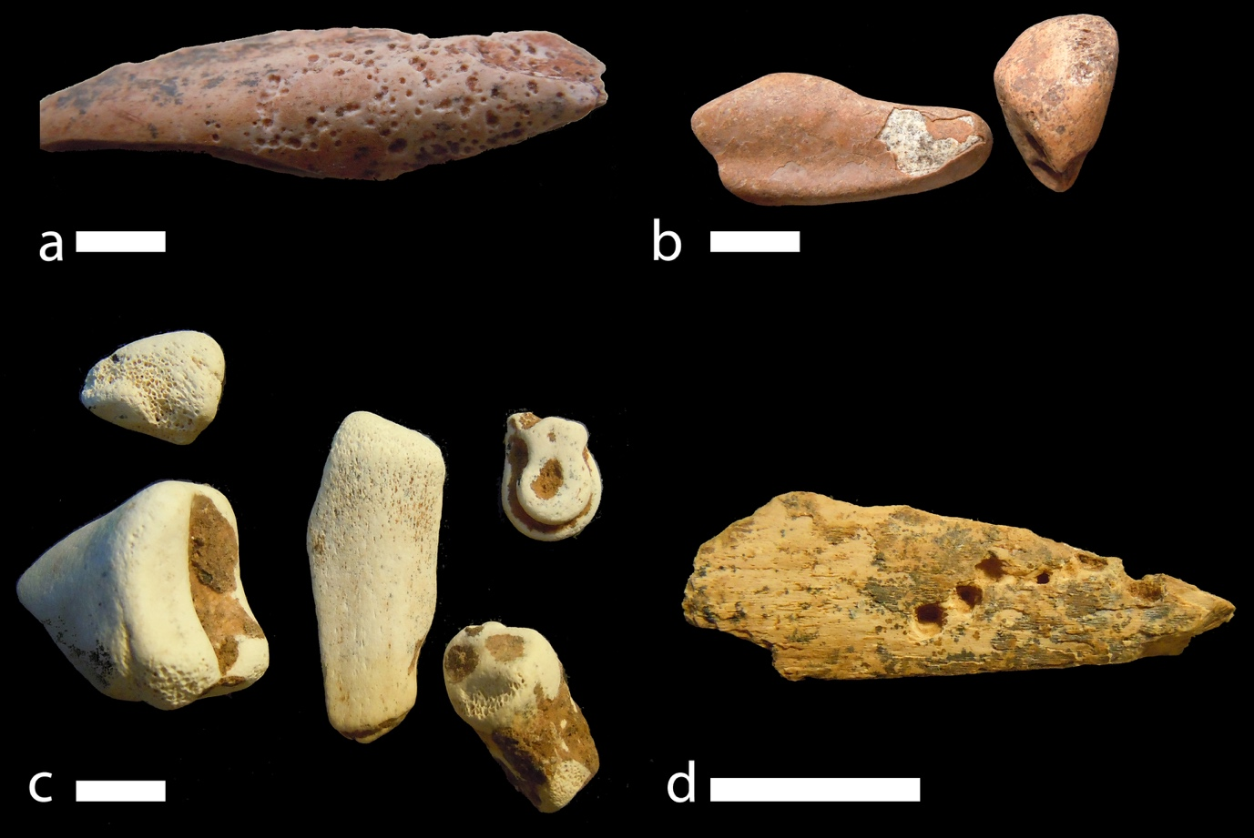
Supplementary Information Fig. H1. Examples of taphonomic processes observed on faunal remains in Trenches 3 and 4 at PYS: a) biochemical pits likely made by bacteria in the burial environment; b) polished bone suggestive of water action; c) powdery, leached bone indicative of incipient dissolution; d) bore holes indicative of insect activity. All scale bars = 1 cm, and scales for images a-c are identical. Not all photographed specimens come from Layers 17-19, but they are representative of the modifications observed in these layers.

A close up image of Mtoto’s occipital bone shows modifications compatible with gastropod radula marks (Supplementary Information Fig. H2) (see Backwell, 2020¹⁸, Dirks et al., 2015³⁹)

Supplementary Information Fig. H2. Close-up microscopic image of Mtoto’s occipital surface. Note the multiple small parallel striations interpreted as gastropod radula damage.
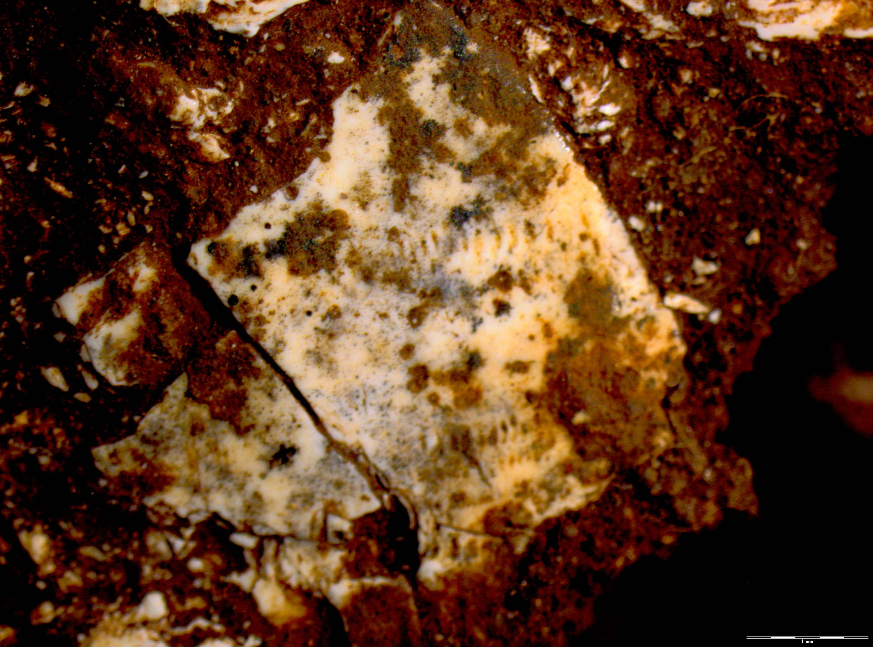

Despite this, most specimens (56%) had good cortical preservation, with the entire surface visible, enabling detection of bone surface modifications, in contrast with the remains of the burial fill. Abrasion marks were common (n=20, 6.8% of macromammalian bone NISP), suggesting some bones were left exposed and trampled. Some remains had been gnawed by rodents (n=10, 3.4%), and three possible carnivore tooth marks were detected (1%). Cut marks were identified on at least 13 specimens (4.5%; excludes ambiguous marks). This indicates a clear human agent of accumulation for at least some fauna in the subsample. Cut marks were identified primarily on limb shafts of dik-dik- to duiker-sized mammals; one was identified on the limb shaft of a waterbuck-sized mammal. Some specimens were burnt (n=7, 2.4%), all belonging to a medium-sized mammal.

Interpretation
Taken together, faunal samples from the burial fill and from Layers 17-19 in nearby trenches speak to relatively low levels of human activity during MIS 5 at PYS. Both assemblages are dominated by taxa that were likely living naturally in the cave environment: bats, monkeys, hyrax, rodents, shrew, and small amphibians and reptiles. There are also a few remains of larger fauna known to dwell in caves – crocodile and pangolin, neither of which is found later in the PYS equence. The faunal data suggest periods of abandonment, an interpretation corroborated by other lines of evidence – including lithic artefact density, geomorphology, and magnetic susceptibility data – that indicate less intensive occupation at PYS during MIS 5⁷. This stands in contrast to later occupations, where abundant bovid and suid remains, higher frequencies of cut-marked and burnt bone, and greater lithic artefact density, attest to active human use of the cave^{7,8}.
The sample of faunal remains from Trenches 3 and 4 does, however, testify to at least sporadic use of the cave by foragers during MIS 5. Remains of larger and smaller bovids and a suid, and the low but clear signal of cut-marked and burnt bone, indicates at least some human agency in faunal assemblage accumulation. The macromammalian taxa represented in Layers 17-19 are broadly indicative of a semi-closed habitat, as is typical of the coastal forest mosaic today; this interpretation is supported by carbon and oxygen stable isotope data generated from samples in these contexts⁸.
Taphonomic conditions and faunal preservation are strongly similar in the burial fill and nearby contexts. Heavy fragmentation (observed in both subsamples), high frequencies of diagenetic breakage (observed in the burial fill), and abrasion marks (observed in Trenches 3 and 4) jointly suggest that faunal remains may have been left exposed and trampled prior to burial, and/or were subjected to excessive pressure following burial. In both subsamples, the remains of larger mammals show signs of chemical dissolution, as expected in a wet and/or acidic burial environment; notably, bat guano – especially that of insectivorous bats – tends to produce highly acidic burial conditions²⁵⁰. The presence of insect marks in Trenches 3 and 4 also bears strong parallels to those observed on the buried human remains in Trench 8, suggesting both contexts were subject to some similar conditions. Nonetheless, there are also key contrasts with the human remains. For example, the fauna – in both the burial fill, and in Trenches 3 and 4 – are much more fragmented than the human remains, suggesting the faunal remains may have been exposed for long periods, in contrast with rapid human burial.

Supplementary Information I. Shell Analysis

Taxonomic identification, age class, MNI, fragments size

Contextual and analytical information on the Achatina sp. shell fragments is provided in Supplementary Information Table I1. Although the small size of the fragments and loss of coloration prevent firm taxonomic identification to species level, growth line morphology, shell thickness and curvature, strongly suggest the fragments come from the body whorl of adult Achatina (Lissachatina), here attributed to Achatina cf. fulica (Bowdich, 1822; Rowson 2007²⁵¹), best known as the giant African land snail.
Adult individuals of A. fulica have thicker and less curved body whorls and more pronounced growth lines on their outer surface. We also noticed that in adult individuals, growth lines located in prominent areas of the body whorl become smoothed and polished, particularly on the right and left side. This natural wear, probably due to rubbing against vegetation, is observed on specimen PYS-2017-200406.
The action of four taphonomic processes was detected on the fragments associated with the child remains and retrieved from feature 809: fracture, root etching, ancient and recent markings (Supplementary Information Table I1). The fractures of the fragments attached to the human remains do not differ in colour and patina from the remainder of the fragments’ surface, and in some places are covered with hardened sediment. This pattern indicates that the fractures are ancient and likely older or penecontemporaneous to their deposit in the sediment close to the human remains. Root etching affects the inner surface of PYS-2017-200407, PYS-2017-200404, and PYS-2017-200405.
Achatina fulica is generally regarded to be endemic to coastal areas of eastern Africa (such as Kenya and Tanzania), although this taxon is not confined to tropical forests, having now become well established as an invasive species in southern Japan, Brazil, India, China, Hawaii, the Philippines, Mauritius, Sri Lanka and Malaysia²⁵². The snail is a macrophytophagous herbivore, consuming a wide range of plant material, fruit and vegetables²⁵². It will sometimes eat sand, very small stones, and bones from carcasses. The exploitation of Achatina fulica for consumption is attested in Africa since the Middle Stone Age^{253–256}. A symbolic use of this species in a burial context needs to be considered and is consistent with the identification of ancient engraved lines indicating that a fragment may have been anthropogenically modified, ancient fractures and a refitting, possibly produced by humans before the fragments were incorporated in the burial pit, and their close proximity to the child occipital (Extended Data Fig. 6 and Supplementary Information A). It is worth recalling, in this respect, that the only known immature individual dating to the Middle Stone Age, the neonate from Border Cave, South Africa, is associated with a marine shell, a perforated and ochred Conus ebraeus³⁰. A shell fragment of this species, interpreted as engraved with a criss-cross pattern, was recently found at Txina-Txina, Southern Mozambique, in layers dated to 27.4-26.8 ky cal BP²⁵⁷.
At the end of the Holocene circular beads made of Achatina fulica become very popular, and are found at many Eastern Africa sites located in tropical and sub-tropical regions²⁵⁸. A whole Achatina shell was found in the burial of two children from the Mapungubwe K2 burial site, dated to c. 1000-1300 AD, and beads made of Achatina shells are associated with individuals from the Mapungubwe K2 and Schroda burial sites. Achatina shell beads are present in the 26% of the burials from Iron Age burial sites of the Limpopo region²⁵⁹. A recent ethnomalacological survey of Achatina sp. in East Africa²⁶⁰ involving evaluation of recent mortuary sites and ethnological investigation, reveals that complete Achatina shells were used by two ethnic groups, the Shambaa and the Zigua, to adorn human graves. Single or multiple shells are used by the same groups as offerings left at spirit dwellings. Informants mention the use of large land snail shells modified at their apex to call snakes, seen as representing nature spirits and ancestors. Achatina shells are also ritual implements to conduct healing and alleged witchcraft among the Pare, Shambaa, and the Zigua.
The results of our analysis, however, do not support a symbolic interpretation for the Achatina fragments found in the burial pit and attached to the child remains. Fragments of this genus, including many bearing traces of heating, are also very abundant in penecontemporaneous Layer 18. The substantial difference in size between the two assemblages (Extended Data Fig. 6 f) is likely due to the fact that Achatina fragments present in the infilling were more preserved from breakage than those exposed to trampling on the habitation surface. The identification of a refitting between two fragments (Extended Data Fig. 6 b) is consistent with the hypothesis that the fragments in the grave pit were subjected to a limited displacement. The higher degree of dark concretion cover recorded on the fragments from the infilling may have resulted from the higher Mn content of sediment from the pit (Fig. 4, Supplementary Information E and G) and the presence of insects, which have left perforation on the child skull and are known, in Africa, to leave hard dark residues on objects incorporated in their mounds¹⁷¹.
Supplementary Information Table I1. Shell Analysis. Contextual and analytical information recorded on the fragments recovered in close association with the skeleton and in the sediment from the grave pit.
Specimen number (*) | Taxon | Refitting | Size |  |  |  |  | Incising |  | Ext. Data Figure
 |  |  | Lengh (mm) | Width (mm) | Fractures | Root etching |  | Rec. | Anc.
PYS-2017-200405 | Acathina sp. |  | 9.00 | 7.93 | ancient | X |  |  |  | a
PYS-2017-200406 | Acathina sp. |  | 13.68 | 14.03 | ancient |  |  | X |  | a
PYS-2017-200404 | Acathina sp. | X | 22.75 | 15.67 | ancient | X |  |  | X | a
PYS-2017-200407 | Acathina sp. | X | 22.22 | 19.55 | ancient | X |  |  |  | a
PYS-2017-200086.D | Acathina sp. |  | 23.34 | 19.29 | ancient |  |  |  |  | e n1
Lab. Block n 1 | Acathina sp. |  | 30.18 | 22.7 | ancient |  |  |  |  | e n2
Lab. Block n 2 | Acathina sp. |  | 33.53 | 25.03 | ancient |  |  |  |  | e n3
Lab. Block n 3 | Acathina sp. |  | 28.6 | 15.68 | ancient |  |  |  |  | e n3
Lab. Block n 4 | Acathina sp. |  | 20.45 | 15.63 | ancient |  |  |  |  | e n4
Lab. Block n 5 | Acathina sp. |  | 24.42 | 22.12 | ancient |  |  |  |  | e n5
Lab. Block n 6 | Acathina sp. |  | 31.65 | 20.27 | ancient |  |  |  |  | e n6
Lab. Block n 7 | Acathina sp. |  | 23.73 | 23.8 | ancient |  |  |  |  | e n7
Lab. Block n8 | Acathina sp. |  | 12.06 | 10.24 | ancient |  |  |  |  | e n8
Lab. Block n9 | Acathina sp. |  | 17.61 | 10.28 | ancient |  |  |  |  | e n9
Lab.Block n10 | Acathina sp. |  | 11.88 | 10.23 | ancient |  |  |  |  | e n10
Lab. Block n11 | Acathina sp. |  | 26.26 | 16.14 | ancient |  |  |  |  | e n11
Lab. Block n12 | Acathina sp. |  | 29.77 | 27.73 | ancient |  |  |  |  | e n12
* lab. block refers to fragments recovered during the excavation of the feature 809 at the CENIEH, Burgos
Rec., Recent; Anc., Ancient

Supplementary Information J. The Middle Stone Age palaeoecological context of Mtoto

General palaeoenvironmental context
The 2.5-3 year-old child burial is located in Layer 19 placing it in Marine Isotope Stage 5. General consensus of palaeoclimatic and palaeoenvironmental records in eastern Africa indicate that this was a time of marked humidity and Blome et al. (2012)²⁶¹ note high lake levels between 80 and 65 ka in palaeolakes from the Old Njorowa Gorge area, Lake Magadi in Kenya, Lake Natron in Tanzania, as well as lakes in the Horn of Africa in Somalia^{262–264}. Interpretation of a humid climate at this time is also consistent with palynological analysis from offshore marine cores²⁶⁵ and has been interpreted as a period when the Southwestern Monsoon dominated the Northeastern Monsoon in the Indian Ocean^{261,264}. From 65 ka, it has been argued that there is the onset of more arid conditions in eastern Africa. Some have argued that this was stimulated by the Toba eruption c. 74 ka²⁶⁶, although there is no empirical evidence for this²⁶⁷. While ‘mega-drought’ periods have been noted in eastern African lakes from c. 70 ka²⁶⁸, these are considered less extreme than those found further to the south²⁶¹.
Recent, Late Pleistocene palaeoenvironmental research in eastern²⁶⁹, as well as southern^{115,270}, Africa has, however, encouraged the study of local contexts of habitat change in regions with archaeological activity. In particular, beyond lake core and marine core records, that are often located at some distance from the terrestrial environments inhabited by human populations, there has been growing emphasis on the production of ‘on-site’ palaeoenvironmental records that are directly associated with changes in human occupation intensity, material culture, and technological strategies. This is particularly important in areas such as eastern Africa where variable environment gradients, ranging from arid grasslands in the interior to moist tropical coastal forests⁷, may have had diverse responses to broader climate changes, with important ramifications for human adaptations. In the below, we present an evaluation of novel and published palaeoenvironmental data from PYS, alongside other regional records, in order to understand the prevalent environmental conditions in this part of eastern Africa during the life of Mtoto. This includes the presentation of phytolith analysis from the burial context, and a review of existing zooarchaeological and stable isotope datasets.

Phytolith analysis
Three sediment samples from the encasing burial matrix in contact with, or surrounding, the human bones were processed for phytoliths following protocols available within the Federated Research Data Repository (doi 10.20383/101.0123) and utilized for recent phytolith research at the site⁷. Three samples included sediments (10g) attached to the face of the buried individual, from around the occipital region, as well as around postcranial remains. The pH of the samples consistently measured at 8.1, thus slightly alkaline. Because of the high amount of iron and clay in the samples, we subdivided them in two subsets of 5g each to be deflocculated in parallel with two dispersant agents, 0.1%, EDTA disodium salt (C₁₀H₁₄N₂Na₂O₈) and sodium hexametaphosphate (NaPO₃). This was followed by sonication (15 minutes) and overnight orbital shaking plus decantation. Samples were rinsed and dried. Then, they received 10mL equal parts 3N hydrochloric (HCl) and nitric acid (HNO₃) to be rinsed / centrifuged at 3,000 rpm. Drying followed on a petri dishes, then, on a hot plate (70ºC) samples received 10mL of hydrogen peroxide (H₂O₂) (30%) to remove organics. Rinsing, drying, and weighing followed. Phytolith separation was done by transferring this fraction to 15mL centrifuge tubes, to which 5mL sodium polytungstate ‎(HNa₆O₄₀W₁₂) ~2.4 s.g. was added.
Samples were vortexed for five minutes at 3,000 rpm. The supernatant was removed. A gradual decrease in specific gravity over the course of three subsets (subfractions 1, 2, 3) was used. Samples were rinsed with de-ionized water before centrifuging twice more, followed by two cycles of high centrifugation (4,500 rpm). The aliquot extracted for phytolith analysis weighed approximately 0.001g. It was mounted with Entellan New and inspected while fresh; allowing particles to be rotated in three dimensions under the microscope. Two system, polarizing microscopes (Olympus BX51, Motic BA410E) allowed us to confirm the opal silica’s isotropy and tally phytoliths at 400x, following the International Code for Phytolith Nomenclature 1.0 to name and describe specimens²⁷¹. Optical properties of the aliquot were excellent, and noise from clay was minimal to nil. All samples studied were very poor in phytolith content, but were not barren. The number of phytoliths per analyzed aliquot was always < 10 and therefore insufficient for palaeoethnobotanical interpretation. However, we did not observe dissolution or poor preservation in the phytoliths that were preserved. The morphotypes identified include globular granulate, globulose, thick tabular types, tabular facetate, and vessel laminate. These types may derive from both monocot and dicot plants, and do not have taxonomic value per se. As a consequence, the phytolith analysis did not allow palaeoenvironmental reconstruction for the burial context.
Previous phytolith work on the PYS sequence⁷ showed phytogenic silica accumulations in Units III and IV, overlying the burial sediments studied here. For those younger units, phytoliths denoted forested/wooded environments without an interlocking canopy as shown by grass and palm recurrence. A very significant proportion of the phytolith assemblages from the layers capping Mtoto derived from woody taxa common in dense Miombo woodlands, such as globular granulate and blocky phytoliths, along with large tabular dendritic types. Comparison of PYS phytoliths with those from reference collections in Zambezian woodlands²⁷² documented the presence of trees from the Bignoniaceae, Burseraceae, Clusiaceae, and Euphorbiaceae. Wet adapted grasses and herbs included bamboos and the arrowroot family, but the openings in the landscape did favor other grasses adapted to more xeric conditions. In conclusion, the published phytolith work demonstrates forest/woodland mosaics which might also apply to the period during which Mtoto lived, as is further supported by the zooarchaeological and stable isotope data available.

Zooarchaeology and stable isotope data
Late Pleistocene zooarchaeological, palaeontological, sedimentological, and biogeochemical evidence from eastern Africa has documented the domination of semi-arid C₄ grassland environments with seasonal precipitation and a reliance on perennial water bodies during MIS5^{273–275}. Stable isotope research on sediments and mammalian tooth enamel at Rusinga and Mfangano Islands in eastern Lake Victoria, Kenya has been used to argue that there was an expansion of C₄ grasslands across eastern and tropical Africa between 100-45 ka that supported large and medium sized mammals²⁷⁶. Robinson (2017)²⁶⁹, however, has demonstrated there to be significant regional and temporal variability in environmental conditions in eastern Africa during the Late Pleistocene, and particularly across the Middle Stone Age to Later Stone Age transitions c. 65 ka. He uses stable carbon and oxygen isotope data from animal tooth enamel at a number of sites to demonstrate a trend towards increased aridity during this time at sites at Lukenya Hill, Kenya. Potential aridity identified through the same parameters is only noted after the initial transition to Later Stone Age technologies further to the south at Kalemba Falls, Zambia, however²⁶⁹.
PYS is a particularly important site in such discussions given that it represents a unique occurrence of MSA to LSA occupation in a coastal tropical forest habitat⁷. Analysis of zooarchaeological remains and stable isotope analysis of these remains has provided additional resolution into the palaeoenvironmental context of humans, such as Mtoto, living at the site from c. 78-0.4 ka. Zooarchaeological data has identified taxa that are mostly indicative of semi-closed to closed environments, including a dominance of Cephalophini and Neotragini in the bovid assemblage⁸, as well as a prominence of browsing suids such as the bushpig (Potamochoerus larvatus). Primates are also present, albeit in smaller numbers⁸. While overall the zooarchaeological and stable isotope data is generally indicative of the consistent utilization of tropical forest/woodland and grassland biomes throughout the period of occupation, including through a transition from MSA to LSA technological industries and the later arrival of agriculture in the region⁸, some subtle environmental shifts are noted that are of relevance for understanding the ecological context of Mtoto relative to subsequence occupants.
Zooarchaeological and stable carbon and oxygen isotope data from the MSA (c. 78-75 ka) of site occupation in which Mtoto is found, indicates the dominance of fauna relying on tropical forest/wooded habitats⁸. From c. 65 ka there then appears to be a subtle shift towards increasing aridity and a greater presence of grazers and grassland habitats, something also noted in zooarchaeological data from the same period⁸. This persists until the Terminal Pleistocene and Holocene when taxonomic proportions of different fauna and stable carbon isotope data indicates the increasing dominance of closed and open tropical forest at the expense of grassland biomes in the vicinity of the site once again. These data fit with the other regional datasets discussed above that are indicative of drying in eastern Africa between c. 70-65 ka^{261,268}, but also indicate consistently wetter habitats c. 78-0.4 ka than those found in the interior of eastern Africa^{272–274}. Environmental shifts between MIS5 and MIS4 also seem to be relatively dampened at PYS, relative to other proximate records and regions^{7,261,268}, likely due to the mesic influence of the coast at the equator. Moreover, they imply that the MSA-LSA transition, at least at this locale, is unlikely to have been driven by extreme climate shifts.

Summary
Together, a review of the available eastern African palaeoenvironmental literature, as well as novel phytolith datasets and published zooarchaeology and stable isotope datasets from the site of PYS itself, indicates that Mtoto lived and died at PYS during a time of the dominance of tropical forest and woodland environments. This causes us to question traditional narratives of the evolution of our species that emphasize the importance of grassland and marine habitats in stimulating technological shifts, the emergence of symbolic material culture, and increasing social networks^{35,43,277–280}. Indeed, it is becoming increasingly evident that our species evolved in a complex manner across the African continent, and likely within a host of different environments^{3,281,282}, and that adaptation to environmental and climatic diversity is what truly characterizes our species ecologically²⁸¹. In this context, it is interesting to note that the earliest human burial to date is situated in a coastal tropical forest environment, associated with predominant exploitation of tropical forest resources, encouraging a further shift of narratives away from assumptions in relation to uniformly attractive environments for social experimentation and human adaptation.

SI References

113. Huntley, D. J., Godfrey-Smith, D. I. & Thewalt, M. L. W. Optical dating of sediments. Nature 313, 105–107 (1985).
114. Aitken, M. J. An Introduction to Optical Dating. (Oxford University Press, 1998).
115. Jacobs, Z. et al. Ages for the Middle Stone Age of southern Africa: implications for human behavior and dispersal. Science 322, 733–735 (2008).
116. Wintle, A. G. Luminescence dating: where it has been and where it is going. Boreas 37, 471–482 (2008).
117. Wintle, A. G. & Murray, A. S. A review of quartz optically stimulated luminescence characteristics and their relevance in single-aliquot regeneration dating protocols. Radiat. Meas. 41, 369–391 (2006).
118. Durcan, J. A. Luminescence dating of sediments in Punjab, Pakistan: implications for the collapse of the Harappan Civilisation. (Aberystwyth University, 2013).
119. Gliganic, L. A., Jacobs, Z., Roberts, R. G., Domínguez-Rodrigo, M. & Mabulla, A. Z. P. New ages for Middle and Later Stone Age deposits at Mumba Rockshelter, Tanzania: Optically Stimulated Luminescence dating of quartz and feldspar grains. J. Hum. Evol. 62, 533–547 (2012).
120. Thomsen, K. J. et al. Testing single-grain quartz OSL methods using sediment samples with independent age control from the Bordes-Fitte rockshelter (Roches d’Abilly site, Central France). Quat. Geochronol. 31, 77–96 (2016).
121. Grün, R. & Rhodes, E. J. On the selection of dose points for saturating exponential ESR/TL dose response curves. Anc. TL 9, 40–46 (1991).
122. Grün, R. & Rhodes, E. J. Simulations of saturating exponential ESR/TL dose response curves – weighting of intensity values by inverse variance. Anc. TL 10, 50–56 (1992).
123. Li, B., Jacobs, Z., Roberts, R. G., Galbraith, R. F. & Peng, J. Variability in quartz OSL signals caused by measurement uncertainties: problems and solutions. Quat. Geochronol. 41, 11–25 (2017).
124. Vandenberghe, D., DeCorte, F., Buylaert, J.-P. & Kučera, J. On the internal radioactivity in Fig
125. Guérin, G., Mercier, N. & Adamiec, G. Dose-rate conversion factors: update. Anc. TL 29, 5–8 (2011).
126. Bell, W. T. Attenuation factors for the absorbed radiation dose in quartz inclusions for thermoluminescence dating. Anc. TL 8, 1–12 (1979).
127. Brennan, B. J. Beta doses to spherical grains. Radiat. Meas. 37, 299–303 (2003).
128. Duller, G. A. T. The age of the Koputaroa dunes, southwest North Island, New Zealand. Palaeogeogr. Palaeoclimatol. Palaeoecol. 121, 105–114 (1996).
129. Armitage, S. J. & King, G. E. Optically stimulated luminescence dating of hearths from the Fazzan Basin, Libya: a tool for determining the timing and pattern of Holocene occupation of the Sahara. Quaternary Geochronology 15, 88–97 (2013).
130. Mejdahl, V. Internal radioactivity in quartz and feldspar grains. Anc. TL 5, 10–17 (1987).
131. Lamothes, M., Balescu, S. & Auclair, M. Natural IRSL intensities and apparent luminescence ages of single feldspar grains extracted from partially bleached sediments. Radiat. Meas. 23, 555–561 (1994).
132. Neudorf, C. M., Roberts, R. G. & Jacobs, Z. Sources of overdispersion in a K-rich feldspar sample from north-central India: insights from De, K content and IRSL age distributions for individual grains. Radiat. Meas. 47, 696–702 (2012).
133. Gaar, D., Lowick, S. & Preusser, F. Performance of different luminescence approaches for the dating of known-age glaciofluvial deposits from northern Switzerland. Geochronometria 41, 65–80 (2014).
134. Jacobs, Z. et al. Timing of archaic hominin occupation of Denisova Cave in southern Siberia. Nature 565, 594–599 (2019).
135. Huntley, D. J. & Baril, M. R. The K content of the K-feldspars being measured in optical dating or in thermoluminescence dating. Anc. TL 15, 11–13 (1997).
136. Prescott, J. R. & Hutton, J. T. Cosmic ray and gamma ray dosimetry for TL and ESR. Nucl. Tracks Radiat. Meas. 14, 223–227 (1988).
137. Bøtter-Jensen, L., Andersen, C. E., Duller, G. A. T. & Murray, A. S. Developments in radiation, stimulation and observation facilities in luminescence measurements. Radiat. Meas. 37, 535–541 (2003).
138. Duller, G. A. T., Bøtter-Jensen, L., Murray, A. S. & Truscott, A. J. Single grain laser luminescence (SGLL) measurements using a novel automated reader. Nucl. Instrum. Methods Phys. Res. B. 155, 506–514 (1999).
139. Duller, G. A. T., Bøtter-Jensen, L. & Murray, A. S. Combining infrared- and green-laser stimulation sources in single-grain luminescence measurements of feldspar and quartz. Radiat. Meas. 37, 543–550 (2003).
140. Armitage, S. J. & Bailey, R. M. The measured dependence of laboratory beta dose rates on sample grain size. Radiat. Meas. 39, 123–127 (2005).
141. Ballarini, M., Wintle, A. G. & Wallinga, J. Spatial variation of dose rate from beta sources as measured using single grains. Anc. TL 24, 1–32 (2006).
142. Murray, A. S. & Wintle, A. G. Luminescence dating of quartz using an improved single-aliquot regenerative-dose protocol. Radiat. Meas. 32, 57–73 (2000).
143. Thomsen, K. J., Murray, A. S., Jain, M. & Bøtter-Jensen, L. Laboratory fading rates of various luminescence signals from feldspar-rich sediment extracts. Radiat. Meas. 43, 1474–1486 (2008).
144. Li, B., Jacobs, Z., Roberts, R. G. & Li, S.-H. Review and assessment of the potential of post-IR IRSL dating methods to circumvent the problem of anomalous fading in feldspar luminescence. Geochronometria 41, 178–201 (2014).
145. Roberts, R. G., Galbraith, R. F., Yoshida, H., Laslett, G. M. & Olley, J. M. Distinguishing dose populations in sediment mixtures: a test of single-grain optical dating procedures using mixtures of laboratory-dosed quartz. Radiat. Meas. 32, 459–465 (2000).
146. Murray, A. S. & Wintle, A. G. The single aliquot regenerative dose protocol: potential for improvements in reliability. Radiat. Meas. 37, 377–381 (2003).
147. Jacobs, Z., Duller, G. A. T. & Wintle, A. G. Optical dating of dune sand from Blombos Cave, South Africa: II—single grain data. J. Hum. Evol. 44, 613–625 (2003).
148. Duller, G. A. T. Distinguishing quartz and feldspar in single grain luminescence measurements. Radiat. Meas. 37, 161–165 (2003).
149. Duller, G. A. T. Assessing the error on equivalent dose estimates derived from single aliquot regenerative dose measurements. Anc. TL 25, 15–24 (2007).
150. Balian, H. G. & Eddy, N. W. Figure-of-merit (FOM), an improved criterion over the normalized Chi-squared test for assessing goodness-of-fit of gamma-ray spectral peaks. Nucl. Instrum. Methods 145, 389–395 (1977).
151. Peng, J., Pagonis, V. & Li, B. On the intrinsic accuracy and precision of the standardised growth curve (SGC) and global-SGC (gSGC) methods for equivalent dose determination: a simulation study. Radiat. Meas. 94, 53–64 (2016).
152. Peng, J. & Li, B. Single-aliquot regenerative-dose (SAR) and standardised growth curve (SGC) equivalent dose determination in a batch model using the R package ‘numOSL’. Anc. TL 35, 32–53 (2017).
153. Peng, J., Dong, Z., Han, F.-Q., Long, H. & Liu, X.-J. R package numOSL: numeric routines for optically stimulated luminescence dating. Anc. TL 31, 41–48 (2013).
154. Guralnik, B. et al. Radiation-induced growth and isothermal decay of infrared-stimulated luminescence from feldspar. Radiat. Meas. 81, 224–231 (2015).
155. Kreutzer, S., Schmidt, C., Fuchs, M. C., Dietze, M. & Fuchs, M. Introducing an R package for luminescence dating analysis. Anc. TL 30, 1–8 (2012).
156. Dietze, M. et al. A practical guide to the R package Luminescence. Anc. TL 31, 11–18 (2013).
157. Galbraith, R. F., Roberts, R. G., Laslett, G. M., Yoshida, H. & Olley, J. M. Optical dating of single and multiple grains of quartz from Jinmium rock shelter, northern Australia: part I, experimental design and statistical models. Archaeometry 41, 339–364 (1999).
158. Galbraith, R. F. & Laslett, G. M. Statistical models for mixed fission track ages. Nucl. Tracks Radiat. Meas. 21, 459–470 (1993).
159. Galbraith, R. F. & Green, P. F. Estimating the component ages in a finite mixture. Nucl. Tracks Radiat. Meas. 17, 197–206 (1990).
160. Briggs, A. W. et al. Patterns of damage in genomic DNA sequences from a Neandertal. Proc. Natl. Acad. Sci. 104, 14616–14621 (2007).
161. Krause, J. et al. A complete mtDNA genome of an early modern human from Kostenki, Russia. Curr. Biol. 20, 231–236 (2010).
162. Meyer, M. et al. Nuclear DNA sequences from the Middle Pleistocene Sima de los Huesos hominins. Nature 531, 504–507 (2016).
163. Kourampas, N. et al. Geoarchaeological reconnaissance of Pleistocene–Holocene sites in coastal Kenya: caves and rockshelters of the Dzitsoni Uplands, and the Kwa Kipoko homestead. (2014).
164. Hillier, M. L. & Bell, L. S. Differentiating human bone from animal bone: a review of histological methods. J. Forensic Sci. 52, 249–263 (2007).
165. Smith, C. I., Nielsen-Marsh, C. M., Jans, M. M. E. & Collins, M. J. Bone diagenesis in the European Holocene I: patterns and mechanisms. J. Archaeol. Sci. 34, 1485–1493 (2007).
166. Kontopoulos, I., Penkman, K., Liritzis, I. & Collins, M. J. Bone diagenesis in a Mycenaean secondary burial (Kastrouli, Greece). Archaeol. Anthropol. Sci. 11, 5213–5230 (2019).
167. Kontopoulos, I., Nystrom, P. & White, L. Experimental taphonomy: post-mortem microstructural modifications in Sus scrofa domesticus bone. Forensic Sci. Int. 266, 320–328 (2016).
168. Booth, T. The rot sets in: low-powered microscopic investigation of taphonomic changes to bone microstructure and its application to funerary contexts. in Human Remains: Another Dimension (eds. Thompson, T. & Errickson, D.) 7–28 (Elsevier, 2017).
169. Nielsen-Marsh, C. M. et al. Bone diagenesis in the European Holocene II: taphonomic and environmental considerations. J. Archaeol. Sci. 34, 1523–1531 (2007).
170. Galligani, P., Sartori, J. & Barrientos, G. Bacterial bioerosion in human and animal bones from subtropical environments (northern Pampa/middle Paraná River Basin, República Argentina). J. Arch. Sci. Rep. 25, 561–574 (2019).
171. Backwell, L. R., Parkinson, A. H., Roberts, E. M., d’Errico, F. & Huchet, J. B. Criteria for identifying bone modification by termites in the fossil record. Palaeogeogr. Palaeoclimatol. Palaeoecol. 337–338, 72–87 (2012).
172. Tappen, M. Bone weathering in the tropical rain forest. J. Archaeol. Sci. 21, 667–673 (1994).
173. Trueman, C. N. G., Behrensmeyer, A. K., Tuross, N. & Weiner, S. Mineralogical and compositional changes in bones exposed on soil surfaces in Amboseli National Park, Kenya: diagenetic mechanisms and the role of sediment pore fluids. J. Archaeol. Sci. 31, 721–739 (2004).
174. Huchet, J.-B., Deverly, D., Gutierrez, B. & Chauchat, C. Taphonomic evidence of a human skeleton gnawed by termites in a Moche-civilisation grave at Huaca de la Luna, Peru. Int. J. Osteoarchaeol. 21, 92–102 (2011).
175. Trueman, C. N. & Martill, D. M. The long-term survival of bone: the role of bioerosion. Archaeometry 44, 371–382 (2002).
176. Fernandez-Jalvo, Y., Pesquero, M. D. & Tomo, L. Now a bone, then calcite. Palaeogeogr. Palaeoclimatol. Palaeoecol. 444, (2016).
177. Turner-Walker, G. Light at the end of the tunnels? The origins of microbial bioerosion in mineralised collagen. Palaeogeogr. Palaeoclimatol. Palaeoecol. 529, 24–38 (2019).
178. de Mesy Bentley, K. L. et al. Evidence of Staphylococcus aureus deformation, proliferation, and migration in canaliculi of live cortical bone in murine models of osteomyelitis. J. Bone Miner. Res. 32, 985–990 (2017).
179. Kyriazis, V. & Tzaphlidou, M. Skeletal calcium/phosphorus ratio measuring techniques by neutron activation and x-ray absorptiometry. J. Radioanal. Nucl. Ch. 265, 521–527 (2005).
180. Tzaphlidou, M. & Zaichick, V. Calcium, phosphorus, calcium-phosphorus ratio in rib bone of healthy humans. Biol. Trace Elem. Res. 93, 63–74 (2003).
181. Pfretzschner, H.-U. & Tütken, T. Rolling bones – taphonomy of Jurassic dinosaur bones inferred from diagenetic microcracks and mineral infillings. Palaeogeogr. Palaeoclimatol. Palaeoecol. 310, 117–123 (2011).
182. Morales, N. S., Catella, L., Oliva, F., Sarmiento, P. L. & Barrientos, G. A SEM-based assessment of bioerosion in Late Holocene faunal bone assemblages from the southern Pampas of Argentina. J. Arch. Sci. Rep. 18, 782–791 (2018).
183. Worrich, A. et al. Mycelium-mediated transfer of water and nutrients stimulates bacterial activity in dry and oligotrophic environments. Nat. Commun. 8, 15472 (2017).
184. Dal Sasso, G., Maritan, L., Usai, D., Angelini, I. & Artioli, G. Bone diagenesis at the micro-scale: bone alteration patterns during multiple burial phases at Al Khiday (Khartoum, Sudan) between the Early Holocene and the II century AD. Palaeogeogr. Palaeoclimatol. Palaeoecol. 416, 30–42 (2014).
185. Turner-Walker, G., Nielsen-Marsh, C. M., Syversen, U., Kars, H. & Collins, M. J. Sub-micron spongiform porosity is the major ultra-structural alteration occurring in archaeological bone. Int. J. Osteoarchaeol. 12, 407–414 (2002).
186. Carpenter, K. Experimental investigation of the role of bacteria in bone fossilization. Neues Jahrb. Geol. P. M. 2005, 83–94 (2005).
187. Daniel, J. C. & Chin, K. The role of bacterially mediated precipitation in the permineralization of bone. Palaios 25, 507–516 (2010).
188. Farrand, W. R. Sediments and stratigraphy in rockshelters and caves: a personal perspective on principles and pragmatics. Geoarchaeol. 16, 537–557 (2001).
189. Gilbertson, D. D. et al. Past human activity and geomorphological change in a guano-rich tropical cave mouth: initial interpretations of the Late Quaternary succession in the Great Cave of Niah, Sarawak. Asian Perspect. 44, 16–41 (2005).
190. Karkanas, P. et al. Evidence for habitual use of fire at the end of the Lower Paleolithic: site-formation processes at Qesem Cave, Israel. J. Hum. Evol. 53, 197–212 (2007).
191. Šroubek, P., Diehl, J. F. & Kadlec, J. Historical climatic record from flood sediments deposited in the interior of Spirálka Cave, Czech Republic. Palaeogeogr. Palaeoclimatol. Palaeoecol. 251, 547–562 (2007).
192. Martini, I. Cave clastic sediments and implications for speleogenesis: new insights from the Mugnano Cave (Mmntagnola Senese, Northern Apennines, Italy). Geomorphol. 134, 452–460 (2011).
193. Kourampas, N. et al. Late Quaternary speleogenesis and landscape evolution in a tropical carbonate island: Pango La Kuumbi (Kuumbi Cave), Zanzibar. Int. J. Speleol. 44, 293–314 (2015).
194. Demirjian, A., Goldstein, H. & Tanner, J. M. A new system of dental age assessment. Hum. Biol. 45, 211–227 (1973).
195. Reid, D. J. & Dean, M. C. Variation in modern human enamel formation times. J. Hum. Evol. 50, 329–346 (2006).
196. Reid, D. J., Beynon, A. D. & Ramirez Rozzi, F. V. Histological reconstruction of dental development in four individuals from a medieval site in Picardie, France. J. Hum. Evol. 35, 463–477 (1998).
197. Dean, C. et al. Growth processes in teeth distinguish modern humans from Homo erectus and earlier hominins. Nature 414, 628–631 (2001).
198. Lacruz, R. S., Rozzi, F. R. & Bromage, T. G. Variation in enamel development of South African fossil hominids. J. Hum. Evol. 51, 580–590 (2006).
199. Dean, M. C. & Beynon, A. D. Histological reconstruction of crown formation times and initial root formation times in a modern human child. Am. Lab. 86, 215–228 (1991).
200. Bermúdez de Castro, J. M. Dental remains from Atapuerca (Spain) I. J. Hum. Evol. 15, 265–287 (1986).
201. Hublin, J.-J. et al. New fossils from Jebel Irhoud, Morocco and the pan-African origin of Homo sapiens. Nature 546, 289–292 (2017).
202. Grine, F. E. Observations on Middle Stone Age human teeth from Klasies River main site, South Africa. J. Hum. Evol. 63, 750–758 (2012).
203. Hershkovitz, I. et al. The earliest modern humans outside Africa. Science 359, 456–459 (2018).
204. Grine, F. E., Klein, R. G. & Volman, T. P. Dating, archaeology and human fossils from the Middle Stone Age levels of Die Kelders, South Africa. J. Hum. Evol. 21, 363–395 (1991).
205. Grine, F. E. & Klein, R. G. Pleistocene and Holocene human remains from Equus Cave, South Africa. Anthropology 8, 55–98 (1985).
206. Vandermeersch, B. Les Hommes Fossiles de Qafzeh (Israël). (Centre National de la Recherche Scientifique, 1981).
207. Thoma, A. & Vallois, H.-V. Les dents de l’homme de Rabat. Bull. Mém. Soc. Anthropol. Paris 4, 31–58 (1977).
208. Ennouchi, E. Un deuxième archanthropien à la carrier Thomas III (Maroc). Bull. Mus. Natn. Hist. Nat. 397, 273–296 (1976).
209. Sausse, F. La mandibule atlanthropienne de la carriere Thomas I (Casablanca). L´Anthropologie 79, 81–112 (1975).
210. Howell, F. C. European and northwest African Middle Pleistocene hominids. Curr. Anthropol. 1, 195–232 (1960).
211. Wood, B. A. & van Noten, F. L. Preliminary observations on the BK 8518 mandible from Baringo, Kenya. Am. J. Phys. Anthropol. 69, 117–127 (1986).
212. Bermúdez de Castro, J. M. La denture de la population Mésolithique d´Afrique du Nord et l´hypothèse ‘Afro-European sapiens’. L´Anthropologie 95, 201–218 (1991).
213. Frayer, .W. Metric dental change in the European Upper Paleolithic and Mesolithic. Am. J. Phys. Anthropol. 46, 109–120 (1977).
214. Greene, D. L., Ewing, G. H. & Armelagos, G. J. Dentition of a Mesolithic population from Wadi Halfa, Sudan. Am. J. Phys. Anthropol. 27, 41–55 (1967).
215. Pinhasi, R. An odontometric investigation of the affinities of the Nazlet Khater specimen to prehistoric, protohistoric and modern African populations. Dent. Anthropol. 12, 1–10 (1998).
216. Bermúdez de Castro, J. M. La dentición de los pobladores prehistóticos de la Islas Canaria: estudi Antropológico. (Universidad Complutense, 1985).
217. Wolpoff, M. H. The Krapina dental remains. Am. J. Phys. Anthropol. 50, 67–113 (1979).
218. Madre-Dupouy, M. Les dents déciduales de l’enfant néanderthalien du Roc de Marsal, Dordogne, France. Etude analytique et comparative. Deuxième partie: étude de la dentition inférieure. L´Anthropologie 89, 93–109 (1985).
219. Madre-Dupouy, M. Les Dents Déciduales de l’Enfant Néanderthalien du Roc de Marsal, Dordogne, France: Etude Analytique et Comparative. (Le Centre National de la Recherche Scientifique, 1992).
220. Mallegni, F. & Ronchitelli, A. T. Deciduous teeth of the Neandertal mandible from Molare Shelter, near Scario (Salerno, Italy). Am. J. Phys. Anthropol. 79, 475–482 (1989).
221. Quam, R., Bailey, S. & Wood, B. Evolution of M1 crown size and cusp proportions in the genus Homo. J. Anat. 214, 655–670 (2009).
222. Zanolli, C. et al. Two human fossil deciduous molars from the Sangiran Dome (Java, Indonesia): outer and inner morphology. Am. J. Phys. Anthropol. 147, 472–481 (2012).
223. Grine, F. E. & Henshilwood, C. S. Additional human remains from Blombos Cave, South Africa: (1999–2000 excavations). J. Hum. Evol. 42, 293–302 (2002).
224. Trinkaus, E. The Shanidar Neanderthals. (Academic Press, 1983).
225. Zanolli, C., Bayle, P. & Macchiarelli, R. Tissue proportions and enamel thickness distribution in the early Middle Pleistocene human deciduous molars from Tighenif, Algeria. C. R. Palevol 9, 341–348 (2010).
226. Bayle, P., Le Luyer, M. & Robson Brown, K. A. The Palomas dental remains: enamel thickness and tissue proportions. in The People of Palomas: Neandertals from the Sima De Las Palomas Del Cabezo Gordo, Southeastern Spain (eds. Trinkaus, E. & Walker, M. J.) 115–137 (Texas A&M University, 2017).
227. Fornai, C. et al. Enamel thickness variation of deciduous first and second upper molars in modern humans and Neanderthals. J. Hum. Evol. 76, 83–91 (2014).
228. Bayle, P., Braga, J., Mazurier, A. & Macchiarelli, R. Dental developmental pattern of the Neanderthal child from Roc de Marsal: a high-resolution 3D analysis. J. Hum. Evol. 56, 66–75 (2009).
229. Bayle, P. Analyses quantitatives par imagerie à haute résolution des séquences de maturation dentaire et des proportions des tissus des dents déciduales chez les Néanderthaliens et les Hommes modern. (Université Toulouse, 2008).
230. Martín-Francés, L. et al. Tooth crown tissue proportions and enamel thickness in Early Pleistocene Homo antecessor molars (Atapuerca, Spain). PLoS One 13, e0203334 (2018).
231. Smith, T. M., Olejniczak, A. J., Reid, D. J., Ferrell, R. J. & Hublin, J.-J. Modern human molar enamel thickness and enamel–dentine junction shape. Arch. Oral Biol. 51, 974–995 (2006).
232. Smith, T. M. et al. Molar crown thickness, volume, and development in South African Middle Stone Age humans. S. Afr. J. Sci. 102, 513–517 (2006).
233. Ortiz, A., Skinner, M. M., Bailey, S. E. & Hublin, J.-J. Carabelli’s trait revisited: an examination of mesiolingual features at the enamel–dentine junction and enamel surface of Pan and Homo sapiens upper molars. J. Hum. Evol. 63, 586–596 (2012).
234. Martinón-Torres, M. et al. Talonid crests expression at the enamel–dentine junction of hominin lower permanent and deciduous molars. C. R. Palevol 13, 223–234 (2014).
235. Gómez-Robles, A. et al. A geometric morphometric analysis of hominin upper first molar shape. J. Hum. Evol. 53, 272–285 (2007).
236. Martínez de Pinillos, M. et al. Trigonid crests expression in Atapuerca-Sima de los Huesos lower molars: internal and external morphological expression and evolutionary inferences. C. R. Palevol 13, 205–221 (2014).
237. Bailey, S. E., Skinner, M. M. & Hublin, J.-J. The mid-trigonid crest of Neandertals and modern humans: concordance between the enamel and dentine surfaces. Am. J. Phys. Anthropol. 141, 59 (2010).
238. Martinón-Torres, M. et al. Morphometric analysis of molars in a Middle Pleistocene population shows a mosaic of ‘modern’ and Neanderthal features. J. Anat. 223, 353–363 (2013).
239. Hublin, J.-J. et al. Dental evidence from the Aterian human populations of Morocco. in Modern Origins: A North African Perspective (eds. Hublin, J.-J. & McPherron, S. P.) 189–204 (Springer, 2012).
240. Olejniczak, A. J., Tafforeau, P., Feeney, R. N. M. & Martin, L. B. Three-dimensional primate molar enamel thickness. J. Hum. Evol. 54, 187–195 (2008).
241. Bikiaris, D. et al. Ochre-differentiation through micro-Raman and micro-FTIR spectroscopies: Application on wall paintings at Meteora and Mount Athos, Greece. Spectrochim. Acta A 56, 3–18 (2000).
242. Zoppi, A., Lofrumento, C., Castellucci, E. M. & Migliorini, M. G. The raman spectrum of hematite: possible indicator for a compositional or firing distinction among terra sigillata wares. Annali di Chimica 95, 84–98 (2005).
243. Román, R. S., Bañón, C. B. & Landete Ruiz, M. D. Analysis of the red ochre of the El Mirón Burial (Ramales de la Victoria, Cantabria, Spain). J. Archeol. Sci. 60, 84–98 (2015).
244. Schwaminger, S. P. et al. Formation of iron oxide nanoparticles for the photooxidation of water: Alteration of finite size effects from ferrihydrite to hematite. Sci. Rep. 7, 12609 (2017).
245. Rye, O. Pottery technology: Principles and reconstruction. vol. 4 (Taraxacum, 1981).
246. Freestone, I. C. & Tite, M. S. Refractories in the Ancient and Preindustrial World. in High-Technology Ceramics: Past, Present, and Future-The Nature of Innovation and Change in Ceramic Technology (ed. Kingery, W. D.) vol. 3 35–63 (The American Ceramic Society, 1986).
247. Braun, G. Technological choices: Ceramic manufacture and use at the Antrex site (AjGv-38). Ontario Archaeol. 89, 69–96 (2010).
248. Kulkova, M. & Kulkov, A. The identification of organic temper in Neolithic pottery from Russia and Belarus. The Old Potter’s Almanack 21, 2–12 (2016).
249. Domínguez-Rodrigo, M. & Barba, R. New estimates of tooth mark and percussion mark frequencies at the FLK Zinj Site: the Carnivore-Hominid-Carnivore hypothesis falsified. J. Hum. Evol. 50, 170–194 (2006).
250. Shahack-Gross, R., Berna, F., Karkanas, P. & Weiner, S. Bat guano and preservation of archaeological remains in cave sites. J. Archaeol. Sci. 31, 1259–1272 (2004).
251. Rowson, B. Land molluscs of Zanzibar Island (Unguja), Tanzania, including a new species of Gulella (Pulmonata: streptaxidae). J. Conchol. 39, 425 (2007).
252. Mead, A. R. The Giant African Snail: A Problem in Economic Malacology. (University of Chicago Press, 1962).
253. Plug, I. Resource exploitation: animal use during the Middle Stone Age at Sibudu Cave, Kwazulu-Natal, Sibudu Cave. S. Afr. J. Sci. 100, 151–158 (2004).
254. Badenhorst, S. & Plug, I. The faunal remains from the Middle Stone Age levels of Bushman Rock Shelter in South Africa. S. Afr. Archaeol. Bull. 67, 16–31 (2012).
255. Shipton, C. et al. Reinvestigation of Kuumbi Cave, Zanzibar, reveals Later Stone Age coastal habitation, early Holocene abandonment and Iron Age reoccupation. Azania 51, 197–233 (2016).
256. Faulkner, P. et al. Long-term trends in terrestrial and marine invertebrate exploitation on the eastern African coast: insights from Kuumbi Cave, Zanzibar. J. Island Coast. Archaeol. 14, 479–514 (2019).
257. Bicho, N. et al. Portable art and personal ornaments from Txina-Txina: a new Later Stone Age site in the Limpopo River Valley, southern Mozambique. Antiquity 92, e2 (2018).
258. Miller, J. M., Sawchuk, E. A., Reedman, A. L. R. & Willoughby, P. R. Land snail shell beads in the sub-saharan archaeological record: when, where, and why? Afr. Archaeol. Rev. 35, 347–378 (2018).
259. Steyn, M. & Nienaber, W. C. Iron Age human skeletal remains from the Limpopo Valley and Soutpansberg area. Goodwin Series 8, 112–116 (2000).
260. Walz, J. Toward an ethnoarchaeomalacology of Achatina in East Africa. Ethnobiol. Lett. 8, 90–96 (2017).
261. Blome, M. W., Cohen, A. S., Tryon, C. A., Brooks, A. S. & Russell, J. The environmental context for the origins of modern human diversity: a synthesis of regional variability in African climate 150,000–30,000 years ago. J. Hum. Evol. 62, 563–592 (2012).
262. Hillaire-Marcel, C., Carro, O. & Casanova, J. 14C and Th/U dating of Pleistocene and Holocene stromatolites from East African paleolakes. Quatern. Res. 25, 312–339 (1986).
263. Voigt, B., Gabriel, B., Lassonczyk, B. & Ghod, M. Quaternary events at the Horn of Africa. Berliner Geowiss. Abh. A 120, 679–694 (1990).
264. Trauth, M. H., Deino, A. L., Bergner, A. G. N. & Strecker, M. R. East African climate change and orbital forcing during the last 175 kyr BP. Earth Planet. Sci. Lett. 206, 297–313 (2003).
265. Van Campo, E., Duplessy, J. C. & Rossignol-Strick, M. Climatic conditions deduced from a 150-kyr oxygen isotope–pollen record from the Arabian Sea. Nature 296, 56–59 (1982).
266. Ambrose, S. H. Late Pleistocene human population bottlenecks, volcanic winter, and differentiation of modern humans. J. Hum. Evol. 34, 623–651 (1998).
267. Lane, C. S., Chorn, B. T. & Johnson, T. C. Ash from the Toba supereruption in Lake Malawi shows no volcanic winter in East Africa at 75 ka. Proc. Natl. Acad. Sci. 110, 8025–8029 (2013).
268. Cohen, A. S. et al. Ecological consequences of early late Pleistocene megadroughts in tropical Africa. Proc. Natl. Acad. Sci. 104, 16422–16427 (2007).
269. Robinson, J. R. Thinking locally: environmental reconstruction of Middle and Later Stone Age archaeological sites in Ethiopia, Kenya and Zambia based on ungulate stable isotopes. J. Hum. Evol. 106, 19–37 (2017).
270. Roberts, P. et al. Climate, environment and early human innovation: stable isotope and faunal proxy evidence from archaeological sites (98-59ka) in the Southern Cape, South Africa. PLoS One 11, e0157408 (2016).
271. Madella, M., Alexandre, A. & Ball, T. International code for phytolith nomenclature 1.0. Ann. Bot. 96, 253–260 (2005).
272. Mercader, J., Bennett, T., Esselmont, C. & Simpson, S. Phytoliths in woody plants from the Miombo woodlands of Mozambique. Ann. Bot. 104, 91–113 (2009).
273. Assefa, Z. Faunal remains from Porc-Epic: paleoecological and zooarchaeological investigations from a Middle Stone Age site in southeastern Ethiopia. J. Hum. Evol. 51, 50–75 (2006).
274. Tryon, C. A. et al. The Pleistocene archaeology and environments of the Wasiriya Beds, Rusinga Island, Kenya. J. Hum. Evol. 59, 657–671 (2010).
275. Faith, J. T. et al. Paleoenvironmental context of the Middle Stone Age record from Karungu, Lake Victoria Basin, Kenya, and its implications for human and faunal dispersals in East Africa. J. Hum. Evol. 83, 28–45 (2015).
276. Garrett, N. D. et al. Stable isotope paleoecology of Late Pleistocene Middle Stone Age humans from the Lake Victoria Basin, Kenya. J. Hum. Evol. 82, 1–14 (2015).
277. Ambrose, S. H. Small things remembered: origins of early microlithic industries in Sub-Saharan Africa. in Thinking Small: Global Perspectives on Microlithization (eds. Elston, R. G. & Kuhn, S. L.) 9–29 (American Anthropological Association, 2002).
278. Marean, C. W. et al. Early human use of marine resources and pigment in South Africa during the Middle Pleistocene. Nature 449, 905–908 (2007).
279. Shea, J. J. & Sisk, M. L. Complex projectile technology and Homo sapiens dispersal into western Eurasia. Paleoanthropol. 2010, 100–122 (2010).
280. Marean, C. W. The transition to foraging for dense and predictable resources and its impact on the evolution of modern humans. Phil. Trans. R. Soc. B 371, 20150239 (2016).
281. Roberts, P. & Stewart, B. A. Defining the ‘generalist specialist’ niche for Pleistocene Homo sapiens. Nat. Hum. Behav. 2, 542–550 (2018).
282. Will, M., Kandel, A. W. & Conard, N. J. Midden or molehill: the role of coastal adaptations in human evolution and dispersal. J. World Prehist. 32, 33–72 (2019).

