Supplementary Information: Evidence for an Unconventional Mechanism of Superconductivity in MATBG

Table of contents:

- Additional tunneling and Andreev spectroscopy measurements between $ν$ = -2 and $ν$ = -3
- Analysis of the tunneling gaps & possible pairing symmetries for -3 < $ν$ < -2
- Locality of the DT-PCS method
- Method and accuracy of DT-PCS measurements
- Blonder-Tinkham-Klapwijk (BTK) fitting of the Andreev spectrum between $ν$ = -2 and $ν$ = -3
- Temperature-dependence of the excess current in PCS data
- Spatial dependence of tunneling spectroscopy on AA sites and AB/BA sites
- Pseudogap regime for -3 < $ν$ < -2 at high temperatures
- Topographic analysis of MATBG aligned to hBN
- Zero-field Chern insulator in moiré-commensurate MATBG aligned to hBN
- Summary of the superconducting states in six devices
- Tunneling and PCS parameters for main text figures

A. Additional tunneling and Andreev spectroscopy measurements between $ν$ = -2 and $ν$ = -3
In the main text, we discussed the presence of a V-shaped tunneling gap that appears at the same density as an Andreev reflection spectrum acquired at the same location in an unaligned MATBG sample. We observed this gap at millikelvin temperatures five times in four devices, showing slight variations in shape and size. However, none of these observed gaps take the shape of an isotropic s-wave superconducting gap. Fig. S1 shows dI/dV(V_{s}, V_{g}) displaying the $ν$ = -2 gap and the -3 < $ν$ < -2 gap for Device E (angle : 1.10°) and Device F (angle : 1.10°, strain : 0.1%).
The set of 5 total observations of this STS phenomenology in the valence flat band (two depicted in main text Fig. 1, one depicted in main text Fig. 2, and two depicted in Fig. S1) shows similar realizations of the same basic phase diagram of MATBG (i.e. a correlated insulator near $ν$ = -2 and a superconductor between $ν$ = -2 and $ν$ = -3). Theoretically, interlayer strain, which is practically unavoidable among devices fabricated with any variation of the classic “tear-and-stack” method, is thought to strongly influence coupling in various pairing channels of different symmetries¹, which may explain some of the more detailed difference in spectroscopy in each sample. However, our ability to topographically disentangle the roles of the twist angle, the interlayer relative strain, and the hBN alignment allows for us to identify the most robust spectroscopic signatures of unconventional superconductivity in MATBG.
In Fig. S2, we show DT-PCS measurements in Device D that show Andreev reflection. Using BTK-model fits (Fig. S2c; see also Section E) for a nodal superconducting order parameter, the Andreev gap in this device reaches an optimal value of $Δ_{AR}$ = 0.71 meV at filling $ν$ = -2.44. In contrast to the data from Device A’ in main text Fig. 2, this data shows a suppression of the zero-bias conductance, which is common in PCS junctions with larger barrier strength $Z$.²

B. Analysis of the tunneling gaps & possible pairing symmetries for -3 < $ν$ < -2
To capture the tunneling spectra, we compare our data to that of the density of states (DOS) calculated using a modified BCS model, which includes the effect of quasiparticle lifetime, as introduced by Dynes³, as well as the possibility of anisotropic and nodal gaps. The Dynes model for the DOS for an isotropic s-wave superconductor is given by:
$$ρ\left(E\right) =ρ_{N}Re\left[\frac{|E-iΓ|}{\sqrt{(E-iΓ)^{2}-Δ^{2}}}\right]$$
where the quasiparticle broadening $Γ$ and the superconducting gap size $Δ$ can be free fitting parameters. We model the background normal-state DOS $ρ_{N}$ as either a constant or a linear function of energy. To include the possibility of a nodal gap in this model, we introduce the angular-dependent factor
$$Δ\left(θ\right)= Δ_{0}\cos{(lθ)}$$
where $l$ is the orbital angular momentum quantum number for the pair wavefunction (i.e. $l=1, 2, 3$ for p-, d-, and f-wave superconducting order parameters, respectively)⁴. The energy dependence of the DOS for a nodal superconductor is obtained by integrating the DOS at a given energy over all angles⁴:
$$ρ\left(E\right)= \frac{ρ_{N}}{2π}\int_{0}^{2π}{dθ Re\left[\frac{E-iΓ}{\sqrt{{\left(E-iΓ\right)}^{2}-∆{\left(θ\right)}^{2}}}\right]}$$
For nonzero angular momentum scenarios ($l>0$), we can simplify the equation to the following form:
$$ρ\left(E\right)= \frac{ρ_{N}}{2π}\int_{0}^{2π}{dθ Re\left[\frac{E-iΓ}{\sqrt{{\left(E-iΓ\right)}^{2}-∆_{0}^{2}\cos^{2}{(lθ)}}}\right]}= \frac{ρ_{N}}{2π}\int_{0}^{2π}{dθ Re\left[\frac{E-iΓ}{\sqrt{{\left(E-iΓ\right)}^{2}-Δ_{0}^{2}\cos^{2}{θ}}}\right]}$$
Thus, the tunneling conductance measured between the STM tip and a superconducting sample is
$$\frac{dI}{dV}\left(V\right)∝\int_{-∞}^{∞}{dE{\left.\frac{df\left(ε\right)}{dε}\right|}_{ε=E-eV}} ρ\left(E\right)ρ_{tip}$$
where $ρ_{tip}$ is the tip DOS, which we assume to be an energy-independent constant. In Supplementary Section E below, where we discuss Andreev reflection, we will extend this discussion to include the spin orientation of Cooper pairs and its impact on tunneling and Andreev spectroscopy.
The main text Figs. 3a,b show the nodeless s-wave and nodal Dynes-formula fitting analyses for the gap observed at V_{g} = -25.8 V in Device A (this gate voltage was chosen because it has the least asymmetric background as the van Hove singularity shifts through E_{F}). Using a least-squares regression procedure, we obtain the best fit using $Δ=$ 0.90 meV for the nodal model (red curve).
The nodal-superconductor fit closely matches our experimental results, aptly capturing the sharp V-shaped dip in the spectrum near zero bias and the sloped coherence-peak structures observed at the edges of the tunneling gap. In contrast, the nodeless s-wave fits poorly capture these two aspects of the observed tunneling gap. The quasiparticle lifetime broadening required for the best fit to the nodeless s-wave model (red curve in main text Fig. 3a;$Γ$ = 0.20 meV) is much larger than that required for the nodal case ($Γ$ = 0.07 meV). Generally, one expects s-wave superconductors to be more robust against impurity scattering effects than superconductors with sign-changing order parameters, making the larger $Γ$ for the s-wave scenario anomalous (see for comparison, the superconducting gap of Al(100) in Fig. S3c). We have found no evidence for impurity scattering in our measurements to justify the large broadening needed for the s-wave model. In main text Fig. 3a (gray curve), we show the fit to our experimental data using the isotropic Dynes formula for $Γ$ fixed to the same lifetime broadening as used for the fit to the nodal model ($Γ$ = 0.07 meV). The comparison between main text Fig. 3a (both nodeless fits) and main text Fig. 3b (the nodal fit) clearly shows the superiority of the nodal model in capturing the features of our data.
We also performed the same analysis on the tunneling spectrum in Device B and Device F (Figs. S3a and S3b). In both cases, the nodal-superconductor fits capture the features in the experimental curves better than for the s-wave fits. As with Device A, fits to the s-wave model for the data from these devices require large lifetime broadening parameters ($Γ \sim 0.3 Δ$).
We note that the electron-hole symmetry present in the lower panels of main text Figs. 1e,g is not present throughout the gate-voltage range of the gap. When analyzing spectroscopy as a function of gate voltage in both main text Fig. 1d from Device A and main text Fig. 1f from Device B, we observe a van Hove singularity (vHs) below the Fermi level at fillings $ν$ > -2, appearing at negative V_{s}. At fillings near $ν$ = -3, this vHs appears at positive V_{s}, having passed through the Fermi level between $ν$ = -2 and $ν$ = -3. This high DOS feature is responsible for causing electron-hole asymmetry in the normal-state DOS, upon which the tunneling gap is superimposed at these fillings.
In main text Fig. 3a, we chose to analyze a spectrum that is electron-hole symmetric out of convenience: we can fit this spectrum to a modified BCS DOS spectrum without needing to make assumptions about the normal-state DOS. At other gate voltages, the spectrum still appears V-shaped, but has significant electron-hole asymmetry that makes the fitting analyses less straightforward. Nevertheless, we can still do fitting analyses despite this electron-hole asymmetry by fitting only the low-energy portion of the spectroscopic gap (Fig. S4). A similar analysis to ours was used in STS studies of the high-temperature cuprate superconductors, where electron-hole asymmetry is consistently seen⁵. In Fig. S4, the nodal fits are consistently superior to the s-wave fits, with each nodal fit having a lower $χ^{2}$ value than the s-wave fit to the same spectrum.

C. Locality of the DT-PCS method
DT-PCS is a highly spatially local method that is most sensitive to the region directly underneath the tip. Here we present experimental observations and an idealized model that support the idea that regions far away from the tip do not contribute significantly to the DT-PCS signal.
First, the side-by-side STS-PCS of Device A’ in main text Fig. 2g shows an unambiguous correspondence between spectroscopic gaps in tunneling dI/dV(V_{g}) and resistance features in point-contact G(V_{g}). This remarkable correspondence occurs despite significant spatial inhomogeneity in Device A’, from which measurements in main text Fig. 1c (1.13°), main text Fig. 2 (1.01°), and main text Fig. 3e (0.99°) are derived. A Nomarski differential interference contrast (DIC) image of Device A’ in Fig. S5b shows a sample with an area that is roughly 4400 μm² (the twisted graphene covers the entire hBN substrate). If PCS was a measurement that averaged over the entire sample, the correspondence between STS and PCS seen in Fig. 2g of the main text would be absent.
Second, Figs. S5c,d show two PCS G(V_{g}) data sets at V_{s} = 0 V, obtained roughly 200 nm away from each other in Device C. These two data sets show different transport phenomenology near $ν$ = -1. The electronic structure of moiré heterostructures is highly sensitive to properties such as twist angle, strain, and moiré-commensurability that can spatially vary across a sample. Here we have demonstrated that PCS can detect an insulating state at $ν$ = -1 in the region probed in Fig. S5d while not detecting an insulating state only 200 nm away in Fig. S5c.
Third, we can understand the locality of DT-PCS by considering an idealized model on an azimuthally symmetric sample (schematic diagram in Fig. S5a). While this model is idealized, it nevertheless provides a reasonable explanation for why regions far from the tip have little influence on the PCS signal. Consider a two-dimensional, circular sample of radius $R$ centered at the origin (0,0) and an STM tip touching the origin with point-contact radius $R_{0} << R$. Consider a voltage $V$ applied to the metallic STM tip, while the outer edge of the sample is held at ground $V=0$. What is the voltage drop across a sample of resistivity $ρ(r,θ)≡ρ(r)$ as a function of radius?
Kirchoff’s current law requires that the total current passing through every radial ring around the origin must be the same. Thus, for a radially symmetric current density distribution $J(r)$ at two radii $r_{1},{ r}_{2}$, we know that
$$I_{1}=r_{1}\int_{0}^{2π}{J\left(r_{1}\right)dθ}=r_{2}\int_{0}^{2π}{J\left(r_{2}\right)dθ}=I_{2} .$$
Using Ohm’s law ($E(r)=ρ(r) J(r)$), we find a relationship between the electric field at these two radii:
$$\frac{r_{1}E(r_{1})}{ρ(r_{1})}=\frac{r_{2}E(r_{2})}{ρ\left(r_{2}\right)} .$$
Thus, the voltage at a point in the sample at radius $r$ is as follows:
$$ΔV≡V\left(R_{0}\right)-V\left(r\right)=-\int_{R_{0}}^{r}{E\left(r^{'}\right)dr^{'}}=-\frac{R_{0 }E\left(R_{0}\right)}{ρ\left(R_{0}\right)}\int_{R_{0}}^{r}{\frac{ρ\left(r^{'}\right)}{r^{'}}dr^{'}} .$$
The radial factor in the denominator of the integral is key to the locality of this technique. Regions near the tip (i.e. small $r'$) contribute the most to this integral.

D. Method and accuracy of DT-PCS measurements
i. Additional details for DT-PCS method
To perform PCS measurements using the STM, the STM tip is first placed within tunneling range of the sample using a closed current feedback loop configuration (setpoint parameters: V_{s} = -98 mV, I = 10 pA). The back gate of the sample is set to a voltage for which the MATBG sample is metallic. We often use a very large negative gate voltage (e.g. for a Si-gated device, V_{g} ~ -60 V), which places the chemical potential of MATBG deep within the metallic remote band below the flat bands. This will be used later to determine whether or not tip-sample contact has been made. After some time (~10 minutes), once the piezoelectric scanner drift has reduced significantly, the current feedback loop is opened and the sample voltage is reduced to 1 - 2 mV. Then, the tip is manually displaced in the z-direction by a few nanometers, in increments of one angstrom at a time, until the current I increases to a value of tens of nanoamps and is stable over several minutes. The exact value of I is logged and used as a benchmark for achieving the same transparent barrier conditions for PCS measurements in different locations with the same tip.
ii. Accuracy of DT-PCS
For tunneling and PCS measurements, we use a passive voltage divider (1:100 for the DC component of V_{s} and 1:1000 for the V_{rms} lock-in modulation) for increasing the energy resolution by reducing the voltage noise from voltage sources. In the circuit diagram depicted in Fig. S7a, we use resistors for the voltage divider. For tunneling measurements, since the tip-sample junction resistance R_{J} is on the order of gigaohms, the voltage-divider output is well-approximated by
$$V_{out}≈\frac{R_{2}}{R_{1}+R_{2}}V_{source} ,$$
for R₂ = 1 kΩ. For the PCS measurement, however, the junction resistance R_{J} becomes comparable to R₂, so the voltage across the total device resistance R_{T} (contact resistance R_{C} + junction resistance R_{J}) is
$$V_{T}=\frac{R_{2}R_{T}}{\left(R_{1}+R_{2}\right)\left(R_{T}+R_{cable}\right)+R_{1}R_{2}}V_{source} ,$$
where R_{cable} is the cryostat cable resistance (there are two 200 Ω stainless steel cables to and from the device in the dilution refrigerator).
Comparing $V_{T}$ to the voltage expected from a simple voltage divider
$$V_{s}=\frac{R_{2}}{R_{1}+R_{2}}V_{source} ,$$
the voltage error in the limit $R_{1}/R_{2}≫1$ is as follows:
$$Error =\frac{V_{S}-V_{T}}{V_{S}} =\frac{\left(R_{1}+R_{2}\right)R_{cable}+R_{1}R_{2}}{\left(R_{1}+R_{2}\right)\left(R_{T}+R_{cable}\right)+R_{1}R_{2}}≈\frac{R_{cable}+R_{2}}{R_{T}+R_{cable}+R_{2}} .$$
Fig. S7b analyzes the R_{T}-dependence of this voltage error. In our measurements, R_{T} is between 10 kΩ ~ 25 kΩ, indicating that the Andreev gaps $Δ_{AR}$ may be overestimated by as much as ~10%.
iii. Tip-induced pressure and strain
Pressure⁶ and strain⁷ influence the electronic properties of twisted bilayer graphene. For example, Yankowitz et al.⁶ showed that GPa pressures are able to induce superconductivity in a non-magic-angle sample (1.27°) that did not superconduct at zero pressure. In principle, because the narrow magic-angle condition arises from fine-tuning of the energies of the interlayer and intralayer hopping processes⁸, it is possible that applied pressure converts a superconducting magic-angle sample into a sample without superconductivity. Hence, it is important to consider whether pressure and strain induced by the tip during a PCS measurement affects the electronic properties of MATBG. In our study, we can identify that our sample is magic-angle through STM topography and spectroscopy, and yet the point-contact measurement still shows Andreev reflection, indicating that pressure from the tip did not extinguish superconductivity in our devices. Moreover, Fig. S6a shows that the Andreev energy scale does not change even when we push the STM tip 5 nm deeper into the sample.
We note that the remarkable correspondence between DT-STS and DT-PCS in main text Fig. 2g seems to indicate that pressure and strain from the tip does not have a significant effect on the overall phase diagram of our device. This can be explained by the fact that the easily deformable STM tip (the apex of which is mostly copper) bends into the surrounding empty space as the tip is pushed into the sample.
Mesple et al.⁹ documents the influence of tip-induced strain in twisted bilayer graphene in the tunneling regime. Figs. 3a, b, and c in Mesple et al. show a series of topographic images at different tunnel resistances (1.75 GΩ, 0.55 GΩ, and 0.15 GΩ) to demonstrate the impact of bringing the tip closer to the surface. Under our tip conditions (see Methods for information on how we prepare our STM tip), we do not observe the tip-induced strain reported by Mesple et al. Fig. S16 shows topographic images at tunneling resistances 20 GΩ and 0.02 GΩ that are essentially identical-looking.

E. Blonder-Tinkham-Klapwijk (BTK) fitting of the Andreev spectrum between $ν$ = -2 and $ν$ = -3
To fit PCS spectra, we employ a modified version of the Blonder-Tinkham-Klapwijk (BTK) fitting function, which can also include the possibility of an anisotropic superconducting order parameter. Because the Andreev reflection process is sensitive to the phase of the superconducting order parameter, the propagation direction of impinging electrons upon a normal-superconductor junction, with respect to the crystallographic axes of the superconductor, greatly affects the theoretically predicted PCS spectrum. MATBG is a 2D system, and the tip-sample junctions in PCS are only made along the axis that is normal to the plane (the so-called “c-axis”). This forbids contributions of any sign-changing Andreev reflection processes towards the measured Andreev spectrum¹⁰.
Andreev reflection spectra of an anisotropic superconductor are characterized by the BTK formula^{10,11}, which gives the normalized, dimensionless conductance $σ_{R}(E)$ at the quasiparticle energy $E$ as a function of the quasiparticle lifetime broadening $Γ$ at a given incident angle $θ$ of an electron:
$$σ_{R}\left(E\right)= \frac{1+τ_{N}{\left|Γ_{+}\right|}^{2}+(τ_{N}-1){\left|Γ_{+}Γ_{-}\right|}^{2}}{{\left|1+(τ_{N}-1)Γ_{+}Γ_{-}\exp\left(iφ_{-}-iφ_{+}\right)\right|}^{2}} .$$
Here $Γ_{±}=\frac{(E-iΓ)-Ω_{±}}{\left|∆_{±}\right|}$ , and $Ω_{±}=\sqrt{(E-iΓ)^{2}-{\left|Δ_{±}\right|}^{2}}$. $Δ_{+}$ and $Δ_{-}$ are effective pair potentials, which are felt by hole-like quasiparticles and electron-like quasiparticles, respectively, and$φ_{+}$ and $φ_{-}$ are their corresponding phases. We use the 1D-BTK limit, where the barrier transparency parameter contains no geometrical factors:
$$τ_{N}=\frac{1}{1+Z^{2}} .$$
In the c-axis PCS analysis, $Δ_{+}=Δ_{-}$, $φ_{+}=φ_{-}$ and $Γ_{+}=Γ_{-}$. In the nodeless s-wave case (Fig. S9b, left panel), the order parameter is isotropic, so pair potentials become $Δ_{+}=Δ_{-}=Δ_{0}$. In the nodal d-wave case (Fig. S9b, right panel), the order parameter is anisotropic, so the effective pair potential is $π$-periodic in the azimuthal plane:
$Δ_{+}=Δ_{-}=Δ_{0}\cos{(2ϕ)}$.
The total conductance is obtained via integration over azimuthal angles:
$$σ\left(E\right)=\frac{\int_{0}^{2π}{σ_{R}τ_{N}dϕ}}{\int_{0}^{2π}{τ_{N}dϕ}} .$$
For the spin-triplet case, we consider a 2 x 2 matrix form for the gap function^{12,13}:
$$\hat{∆}\left(k\right)=\left(\begin{matrix}∆_{↑↑}(k) & ∆_{↑↓}(k) \\ ∆_{↓↑}(k) & ∆_{↓↓}(k)\end{matrix}\right) .$$
In an equal-spin-pairing (ESP) spin-triplet (or ferromagnetic) superconductor,$∆_{↑↑}\left(k\right)$ or$∆_{↓↓}\left(k\right)=Δ_{0}(k)$and $∆_{↑↓}\left(k\right)=∆_{↓↑}\left(k\right)=0$. In this situation, the DOS of one spin population is given by the Bogoliubov-quasiparticle DOS, while the DOS of the other spin population is given by the normal-state DOS.
In an ESP superconductor, the tunneling conductance in the gap is due to the existence of the normal-state tunneling channel. This makes the conductance minimum no smaller than half of the normal-state DOS. By the same analogy, Andreev reflection occurs only for electrons of one spin-type, so the maximum conductance of the Andreev reflection spectrum in the gap cannot exceed 1.5 times the normal-state conductance. This is in contrast to the zero-bias conductance doubling expected for spin-singlet superconductors.
In main text Figs. 1e and 1g, the zero-bias conductance of the tunneling gap is much lower than half of the background conductance, while in the PCS spectroscopy in Fig. S9c, the maximum conductance of the normalized conductance is more than 50% larger than the background conductance. These observations rule out an ESP triplet superconductor scenario in MATBG. Thus, in the spin-triplet case, we use the opposite spin pairing (OSP) gap function,
$\hat{∆}\left(k\right)=\left(\begin{matrix}0 & ∆(θ) \\ ∆(θ) & 0\end{matrix}\right)$.
The dimensionless conductance $σ_{R↑,↓}\left(E\right)$ for each spin and the total conductance $σ\left(E\right)$ are¹²
$$σ_{R↑}\left(E\right)=σ_{R↓}\left(E\right)= \frac{1+τ_{N}{\left|Γ_{+}\right|}^{2}+(τ_{N}-1){\left|Γ_{+}Γ_{-}\right|}^{2}}{{\left|1+(τ_{N}-1)Γ_{+}Γ_{-}\exp\left(iφ_{-}-iφ_{+}\right)\right|}^{2}} ,$$

$$σ\left(E\right)=\frac{\int_{0}^{2π}{(σ_{R↑}+σ_{R↓})τ_{N}dϕ}}{\int_{0}^{2π}{{2τ}_{N}dϕ}} .$$
We use the gap function $Δ_{+}=Δ_{-}=Δ_{0}\cos{ϕ}$ for the p-wave case and $Δ_{+}=Δ_{-}=Δ_{0}\cos{(3ϕ)}$ for the f-wave case. The functional form becomes analytically equal to that of the d-wave case for a c-axis PCS measurement. Since the d-wave Dynes function fully captures the tunneling spectrum calculated from a d-wave BTK theory, the p- or f-wave Dynes function used in Supplementary Section B also provide a reasonable model to analyze the tunneling data.
At finite temperature, the point-contact conductance of the superconducting state $σ_{S}\left(V\right)$ can be represented by:
$$σ_{S}\left(V\right)=σ_{N}\int_{-∞}^{∞}{dE{\left.\frac{df\left(ε\right)}{dε}\right|}_{ε=E-eV}} σ\left(E\right) .$$
We compensate for the normal-state tip-sample resistance and non-ohmic electrode-sample contact resistances (or ‘spreading resistance’) by normalizing each spectrum using data obtained when the sample is in the normal state at B = 0.5 T > B_{c}. The normalized conductance can be represented as:
$$\frac{G\left(V\right)}{G_{N}\left(V\right)}=\frac{σ_{S}\left(V\right)}{σ_{N}\left(V\right)}⋅\frac{σ_{N}+σ_{C}}{σ_{S}+σ_{C}} ,$$
where $σ_{S}$, $σ_{N}$, $σ_{C}$ and $G$ are the tip-sample junction conductance in the superconducting state, the tip-sample junction conductance in the normal state, sample-electrode contact conductance, and the total (contact + junction) conductance, respectively.
We can acquire the normalized point-contact conductance $σ_{S}/σ_{N}$ and rule out contact conductance effects (that is, omitting the second multiplicative factor above) when the contribution of the contact conductance is dominant in the second multiplicative factor above.
We show the tip-sample junction conductance to be much smaller than the sample contact conductance by using the normalized zero-bias conductance as a direct indicator of the quality of our sample contact. In the limit of a perfectly transparent tip-sample junction ($Z$ = 0) at T = 0 and $Γ$ = 0,
$σ_{S}(V=0 )/σ_{N}(V = 0)=2$.
Experimentally, we find a smaller value for this ratio:
$σ_{S}(V=0 )/σ_{N}(V = 0)≈1.6$.
Thus, in the worst-case scenario, $σ_{C}>3σ_{N}$, which indicates that contact conductance dominates junction conductance in the second multiplicative factor, and normalized conductance
$$\frac{G\left(V\right)}{G_{N}\left(V\right)}≈\frac{σ_{S}\left(V\right)}{σ_{N}\left(V\right)} .$$
A comparison between the nodeless s-wave fit and the nodal-superconductor fit is depicted Fig. S9c. There are two dip features near V_{s} = ±0.5 mV that are not captured by the BTK model, which are thought to originate from critical current effects¹⁴. Besides this shared discrepancy, both fits match the measured data at large bias voltages, but only the nodal fit matches near zero bias. Thus, these fits of the Andreev spectrum, considered in conjunction with fits of the tunneling spectra presented in previous sections and in the main text, indicate a nodal nature of the superconducting order parameter in this system.

F. Temperature-dependence of the excess current in PCS data
For a perfectly transparent ($Z$ = 0) point-contact junction between a normal-metal tip and a superconducting sample, Andreev reflection results in a two-fold increase in the conductance at zero-bias, measured with respect to the normal state, due to the conversion of impinging electrons into transmitted Cooper pairs and reflected holes at the boundary. In the point-contact measurement in ballistic limit, this process enhances the current flowing through the circuit when $V>Δ$, which is called the “excess current”¹⁵. According to the BTK theory, the excess current in an isotropic BCS superconductor should be proportional to $Δσ_{N}$, which is determined by the barrier strength parameter $Z$. The data in main text Fig. 3c shows a temperature-dependent dip in the normal conductance around V_{s} = ±0.75 mV, which makes it difficult to extract the excess current contribution directly from the measured sample current. In addition, we would like to neglect critical current effects described in Section E at higher bias voltages, which would also impede the extraction of the pure excess current from Andreev reflection.
In order to remove the combined conductance contribution from the normal-state and the critical current effect in the excess current, we estimate the excess current at V_{s} = $2Δ_{AR}$, as extracted from the BTK fit performed at optimal doping, base temperature, and zero magnetic field. The excess current, shown in main text Fig. 3c, makes use of an estimate of the normal-state conductance via a linear interpolation between two spectra taken when MATBG is metallic: one taken at 200 mT and 299 mK, and one taken at 0 T and T = 1.3 K (Fig. S10a). These spectra do not show signatures of Andreev reflection. By subtracting each linearly interpolated normal conductance estimate from each Andreev spectrum at a given temperature, and subsequently integrating this new spectrum from V_{s} = 0 V to V_{s} = $2Δ_{AR}$, the excess current is calculated as follows:
$$I_{exc}\left(V_{s}\right)=I_{S}\left(V_{s}\right)-I_{N}\left(V_{s}\right)=\int_{0}^{V_{s}}{(σ_{S}\left(V^{'}\right)-σ_{N}\left(V^{'}\right)dV^{'}} .$$
This plot shows a linear temperature-dependence of the excess current in MATBG $I_{exc}∼\left(1-\frac{T}{T_{C}}\right),$ which does not agree with the isotropic BCS expectation, where $I_{exc, BCS}∼\sqrt{1-\frac{T}{T_{C}}}$. To confirm that this linearity shown in main text Fig. 3d does not come from the normal-state conductance interpolation, we plot the $I_{S}(V_{s}=2Δ_{AR}$) in Fig. S10b, which also shows a linear-in-T dependence of the excess current.
In addition, we extract the energy gap $Δ_{AR}$ using a BTK fitting analysis of the temperature-dependent point-contact spectra shown in Fig. 2d of the main text. We employ a similar background subtraction to the second method discussed above, this time dividing by the linearly interpolated normal-state conductance spectrum for each Andreev spectrum (the BTK model accepts the dimensionless input $G/G_{N}(V)$). We fix the barrier transparency parameter $Z$ = 0.1, which was extracted from the base-temperature Andreev spectrum (Fig. S10c). Fig. 3d of the main text show $Δ_{AR}$ extracted from this BTK fitting analysis, where error bars represent one standard deviation. We find excellent agreement between the Andreev energy gap estimate of T_{c} $≈$ 1.1 K and the linear excess current estimate of T_{c} $≈$ 1.15 K, which provides internal consistency for our interpretation.
We note that the temperature values in Fig. 2d of the main text are readings from a calibrated RuO₂ thermometer embedded in the STM head a few centimeters away from the sample. The T = 1.3 K and T = 300 mK PCS measurements are steady-state temperatures. However, the PCS measurements at intermediate temperatures are not steady-state, but are acquired while slowly cooling the microscope from 1.3 K to base temperature (i.e. spectra for intermediate temperatures are acquired without settling at each individual temperature). However, as soon as the thermometer value reached 300 mK, the measured PCS zero-bias conductance immediately stopped increasing in intensity (i.e. the Andreev spectrum stopped changing), implying good agreement between the sample and thermometer temperatures.

G. Spatial dependence of tunneling spectroscopy on AA sites and AB/BA sites
To examine the spatial dependence of the tunneling spectroscopy, we acquired STS on different AA sites within a region of our device with a uniform twist angle and strain condition. The tunneling spectra in Fig. S12 b-e do not show significant spatial dependence. The energy and the shape of the tunneling gaps are similar to each other. These are indicative of the homogeneity of our spectroscopic measurements across the moiré superlattice, and helps us correlate our measurements to those of global transport measurements. We also measured tunneling spectra on AB/BA sites in Device B (Fig. S13a and S13b). Tunneling spectroscopy on AB sites also show a tunneling gap between -3 < $ν$ < -2 that is quite similar to that observed on AA sites. Figs. S13c-e show the results of a spectroscopy line cut across an AA site (from an AB site to a BA site). The size of the -3 < $ν$ < -2 tunneling gap is independent of the spatial position.

H. Pseudogap regime for -3 < $ν$ < -2 at high temperatures
At millikelvin temperatures, we observe a V-shaped gap in STS that is coincident with an Andreev reflection spectrum in PCS within the superconducting density regime of MATBG. In several samples, we have identified a suppression of the DOS at the Fermi level in this density range at temperatures above the critical transition temperature of MATBG. Figs. S14a-c show tunneling dI/dV(V_{s},V_{g}) acquired at high temperatures, all above 4.1 K, that show a suppression in the valence band at E_{F}. We interpret this suppression as a signature of a high-temperature pseudogap phase.

I. Topographic analysis of MATBG aligned to hBN
We acquired STM topographic images (main text Fig. 5b) at various values of the sample bias and gate voltage in order to distinguish the G-G and G-hBN moiré patterns. When the MATBG flat bands are emptied (V_{g} = -8 V), topographic images of the filled states highlight the G-hBN moiré (main text Fig. 5b; bottom left). This image shows the typical triangular lattice of darkened regions (carbon-boron sites) that are seen when monolayer graphene is aligned to hBN^{16–20}, while the AA sites of the G-G moiré are significantly less prominent because the spectral weight of the flat bands (which are empty) are highly localized to the AA sites. On the other hand, when the MATBG valence flat band is filled (V_{g} = 0 V), the AA sites of the G-G moiré are highly prominent (main text Fig. 5b, top right). This image shows the typical triangular lattice of bright regions (AA sites) that is seen in twisted bilayer graphene. From the moiré length scale seen in these images, we deduce that the G-G twist angle is 1.08°, while the G-hBN twist angle is 0.5 ± 0.1° (assuming a graphene-hBN atomic lattice constant ratio of 1.017²¹).
Overall, these topographic images show that when the G-G and G-hBN moiré length scales are similar, perfect commensurability between the two moiré patterns is a physically possible scenario, in contrast to the formation of a super-superlattice documented previously²². Theoretical studies^{21,23,24} have suggested that moiré-commensurability is important for realizing a zero-magnetic-field Chern insulating state, which we discuss in Section J.

J. Zero-field Chern insulator in moiré-commensurate MATBG aligned to hBN
In the main text, we noted that the insulating gap at $ν$ = +3 has a Chern number C = 1. We provide evidence for this claim here through a method presented in Refs.^{25,26}. Figs. S15a,d show two dI/dV(V_{s}, V_{g}) data sets (acquired on AAb sites) from two similar regions of Device C that are both moiré-commensurate, and Figs. S15b,c are zoomed-in dI/dV(V_{s}, V_{g}) near $ν$ = +3. Fig. S15e shows the $ν$ = +3 gap moving to higher gate voltages as the out-of-plane magnetic field is increased from 0 T to 4 T. Since $\frac{dn}{dB}=\frac{σ_{xy}}{e}=\frac{C}{Φ_{0}}$ (where $Φ_{0}$ is the magnetic flux quantum) for an insulating phase²⁷, we conclude the $ν$ = +3 gap corresponds to a C = +1 insulating phase at zero magnetic field, in agreement with a previous transport study²⁸. In addition, we also observe an insulating phase with C = -2 of unknown origin.

K. Summary of the superconducting states in six devices
A summary of the experimental data of the superconducting states shown in this study are listed here:

Device | Angle (°) | V_{g} (V) | T_{c} (K) | B_{c} (mT) | 2Δ_{T} (meV) | 2Δ_{AR} (meV)
A | 1.13 | -25.8 |  |  | 1.8
A' | 1.01 | -22.8 | 1.2 | 50 | 2.8  (2Δ_{T}/k_{B}T_{c} = 27) | 0.6  (2Δ_{AR}/k_{B}T_{c} = 5.8)
B | 1.06 | -25.6 |  |  | 2.9
D | 1.06 | -30.5 |  | 200 |  | 1.4
F | 1.1 | -25.6 |  |  | 1.3
G | 1.17 | -30 | 1.2 | 75 |  | 0.6

L. Tunneling and PCS parameters for main text figures
The tunneling setpoint and PCS parameters for the main text figures are listed here:

Figure | V_{s} (mV) | I (nA) | V_{g} (V) | V_{rms} (mV) | f_{rms} (Hz) | T (mK) | B (T)
1b | -70 | 0.3 | -25.8
1c | -80 | 0.8 |  | 0.5 | 1262.7 | 250 | 0
1d | -80 | 1.8 |  | 0.15 | 1262.7 | 200 | 0
1e (upper) | -80 | 1.8 |  | 0.15 | 1262.7 | 200 | 0
1e (lower) | -80 | 1.8 |  | 0.05 | 1262.7 | 200 | 0
1f | -80 | 1.5 |  | 0.2 | 4121 | 200 | 0
1g (both) | -80 | 1.5 |  | 0.06 | 4121 | 200 | 0
2b, 2c, 2e, 2g-PCS |  |  |  | 0.05 | 381.7 | 270
2d, 2f |  |  |  | 0.05 | 381.7 |  | 0
2g-STS | -80 | 0.5 |  | 0.5 | 1262.7 | 280 | 0
3e | -100 | 0.5 |  | 0.5 | 381.7 | 4.1 | 0
4a | -80 | 1.8 |  | 0.15 | 1262.7 | 200 | 0
 | -70 | 1.7 |  | 0.15 | 1262.7 | 185 | 0.5
 | -80 | 1.5 |  | 0.15 | 1262.7 | 250 | 1
4b | -80 | 1.5 |  | 0.2 | 4121 | 200 | 0
 | -80 | 1.5 |  | 0.2 | 4121 | 200 | 3
 | -80 | 1.0 |  | 0.2 | 4121 | 200 | 6
5a | -400 | 0.1 | 8
5b | -300 | 0.01 | 0
 | -100 | 0.01 | 0
 | -300 | 0.01 | -8
 | -100 | 0.01 | -8
5c-STS | -80 | 1.5 |  | 1 | 381.7 | 190 | 0
5c-PCS |  |  |  | 0.2 | 381.7 | 255 | 0

References

1. Wu, F. & Das Sarma, S. Identification of superconducting pairing symmetry in twisted bilayer graphene using in-plane magnetic field and strain. Phys. Rev. B 99, 220507 (2019).
2. Deutscher, G. Andreev--Saint-James reflections: A probe of cuprate superconductors. Rev. Mod. Phys. 77, 109–135 (2005).
3. Dynes, R. C., Narayanamurti, V. & Garno, J. P. Direct Measurement of Quasiparticle-Lifetime Broadening in a Strong-Coupled Superconductor. Phys. Rev. Lett. 41, 1509–1512 (1978).
4. Ozyuzer, L., Zasadzinski, J. F., Gray, K. E., Kendziora, C. & Miyakawa, N. Absence of pseudogap in heavily overdoped from tunneling spectroscopy of break junctions. Europhys. Lett. 58, 589–595 (2002).
5. Fischer, Ø., Kugler, M., Maggio-Aprile, I., Berthod, C. & Renner, C. Scanning tunneling spectroscopy of high-temperature superconductors. Rev. Mod. Phys. 79, 353–419 (2007).
6. Yankowitz, M. et al. Tuning superconductivity in twisted bilayer graphene. Science 363, 1059 (2019).
7. Huder, L. et al. Electronic Spectrum of Twisted Graphene Layers under Heterostrain. Phys. Rev. Lett. 120, 156405 (2018).
8. Bistritzer, R. & MacDonald, A. H. Moiré bands in twisted double-layer graphene. Proc. Natl. Acad. Sci. 108, 12233 (2011).
9. Mesple, F. et al. Heterostrain Determines Flat Bands in Magic-Angle Twisted Graphene Layers. Phys. Rev. Lett. 127, 126405 (2021).
10. Kashiwaya, S., Tanaka, Y., Koyanagi, M. & Kajimura, K. Theory for tunneling spectroscopy of anisotropic superconductors. Phys. Rev. B 53, 2667–2676 (1996).
11. Daghero, D., Tortello, M., Pecchio, P., Stepanov, V. A. & Gonnelli, R. S. Point-contact Andreev-reflection spectroscopy in anisotropic superconductors: The importance of directionality (Review Article). Low Temp. Phys. 39, 199–210 (2013).
12. Yamashiro, M., Tanaka, Y., Tanuma, Y. & Kashiwaya, S. Theory of tunneling conductance for normal metal/insulator/triplet superconductor junction. Phys. C Supercond. 293, 239–243 (1997).
13. Li, H. & Yang, X. Tunneling spectrum in triplet p-wave superconductor-silicene junctions. Eur. Phys. J. B 92, 275 (2019).
14. Sheet, G., Mukhopadhyay, S. & Raychaudhuri, P. Role of critical current on the point-contact Andreev reflection spectra between a normal metal and a superconductor. Phys. Rev. B 69, 134507 (2004).
15. Blonder, G. E., Tinkham, M. & Klapwijk, T. M. Transition from metallic to tunneling regimes in superconducting microconstrictions: Excess current, charge imbalance, and supercurrent conversion. Phys. Rev. B 25, 4515–4532 (1982).
16. Xue, J. et al. Scanning tunnelling microscopy and spectroscopy of ultra-flat graphene on hexagonal boron nitride. Nat. Mater. 10, 282–285 (2011).
17. Decker, R. et al. Local Electronic Properties of Graphene on a BN Substrate via Scanning Tunneling Microscopy. Nano Lett. 11, 2291–2295 (2011).
18. Jung, J., DaSilva, A. M., MacDonald, A. H. & Adam, S. Origin of band gaps in graphene on hexagonal boron nitride. Nat. Commun. 6, 6308 (2015).
19. Freitag, N. M. et al. Electrostatically Confined Monolayer Graphene Quantum Dots with Orbital and Valley Splittings. Nano Lett. 16, 5798–5805 (2016).
20. Yankowitz, M., Watanabe, K., Taniguchi, T., San-Jose, P. & LeRoy, B. J. Pressure-induced commensurate stacking of graphene on boron nitride. Nat. Commun. 7, 13168 (2016).
21. Shi, J., Zhu, J. & MacDonald, A. H. Moiré commensurability and the quantum anomalous Hall effect in twisted bilayer graphene on hexagonal boron nitride. Phys. Rev. B 103, 075122 (2021).
22. Wong, D. et al. Local spectroscopy of moiré-induced electronic structure in gate-tunable twisted bilayer graphene. Phys. Rev. B 92, 155409 (2015).
23. Zhang, Y.-H., Mao, D. & Senthil, T. Twisted bilayer graphene aligned with hexagonal boron nitride: Anomalous Hall effect and a lattice model. Phys. Rev. Res. 1, 033126 (2019).
24. Lin, X., Su, K. & Ni, J. Misalignment instability in magic-angle twisted bilayer graphene on hexagonal boron nitride. 2D Mater. 8, 025025 (2021).
25. Nuckolls, K. P. et al. Strongly correlated Chern insulators in magic-angle twisted bilayer graphene. Nature 588, 610–615 (2020).
26. Choi, Y. et al. Correlation-driven topological phases in magic-angle twisted bilayer graphene. Nature 589, 536–541 (2021).
27. Streda, P. Theory of quantised Hall conductivity in two dimensions. J. Phys. C Solid State Phys. 15, L717–L721 (1982).
28. Serlin, M. et al. Intrinsic quantized anomalous Hall effect in a moiré heterostructure. Science (2019) doi:10.1126/science.aay5533.

SUPPLEMENTARY FIGURE S1

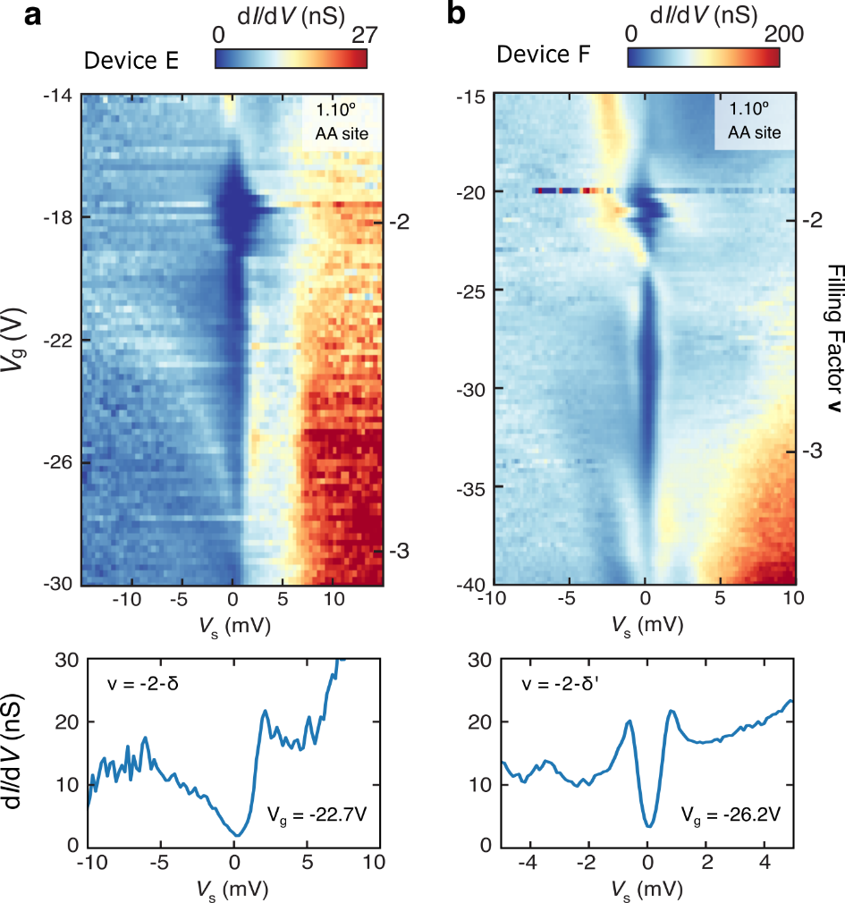

Figure S1 | Two additional observations of the tunneling gaps near $ν$ = -2 and between -3 < $ν$ < -2. a, Tunneling dI/dV(V_{s}, V_{g}) and spectroscopy line cut at V_{g} = -22.7 V acquired at the center of an AA site in Device E (angle : 1.10°) at zero magnetic field. An insulating gap with Coulomb charging effects opens near V_{g} = -15 V and closes near V_{g} = -19 V (i.e. surrounding $ν$ = -2). A second gap reopens below $ν$ = -2 and persists to near $ν$ = -3. The gap between -3 < $ν$ < -2 is less clear due to the slightly compromised tip condition. b, Similar tunneling dI/dV(V_{s}, V_{g}) and spectroscopy line cut at V_{g} = -26.2 V acquired at the center of an AA site in Device F (angle : 1.10°, strain : 0.1%) at zero magnetic field. A gap with Coulomb charging effects opens near V_{g} = -18 V and closes near V_{g} = -23 V (i.e. surrounding $ν$ = -2). A second gap reopens below $ν$ = -2 and persists to near $ν$ = -3. Between -3 < $ν$ < -2, spectra show prominent coherence peaks that flank both sides of the gap. In both spectroscopy line cuts in a and b, the tunneling gaps do not show conventional s-wave features.

SUPPLEMENTARY FIGURE S2

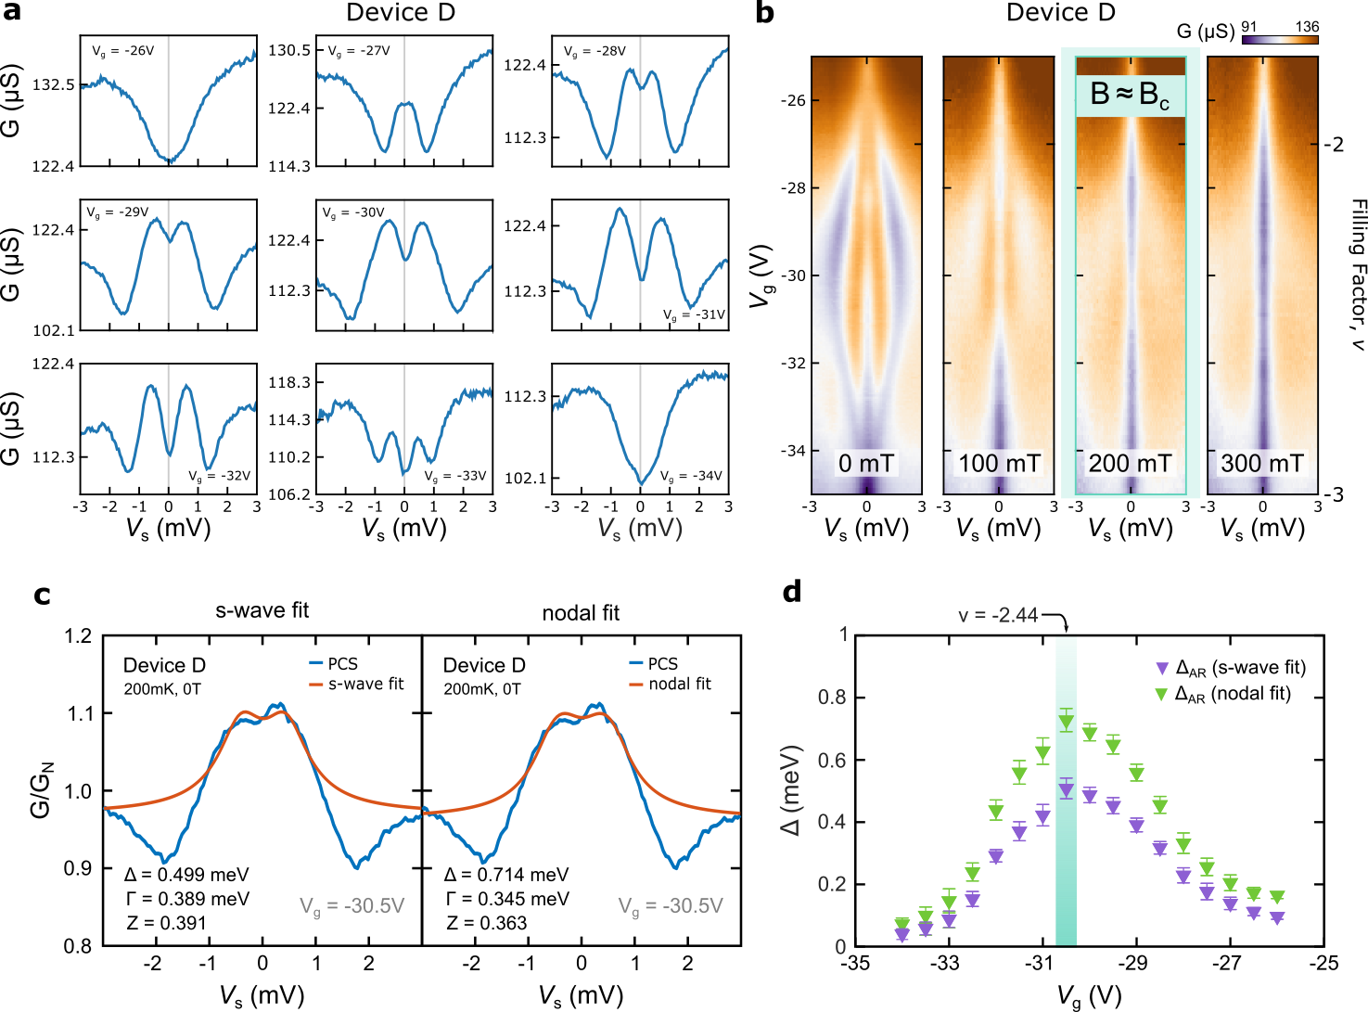

Figure S2 | Large Andreev energy gap in point-contact spectroscopy in Device D. a, Point-contact spectra G(V_{s}) in Device D (angle : 1.06°) at T = 200 mK, B = 0 T, and at nine gate voltages between V_{g} = -26 V and V_{g} = -34 V. In this device, the Andreev spectrum onsets smoothly, widening in energy to an optimal doping near V_{g} = -30.5 V, and then closes. b, Point-contact spectroscopy G(V_{s},V_{g}) in Device D at four magnetic-field strengths between 0 T and 300 mT. The critical magnetic field, as measured by the Andreev spectrum, is slightly higher than 200 mT. A persistent zero-bias suppression at 300 mT may indicate residual resistance in either the tip-sample junction or the sample contact electrode. c, BTK fitting analysis of the normalized zero-field Andreev spectrum at optimal doping, fit with s-wave and nodal gap symmetries. d, Extracted Andreev energy gaps $Δ_{AR}$ as a function of gate voltage V_{g} from s-wave and nodal fits, which show an expected dome shape. The gap in this device reaches an optimal value of $Δ_{AR, s-wave}$ = 0.50 meV and $Δ_{AR, nodal}$ = 0.71 meV at filling $ν$ = -2.44.

SUPPLEMENTARY FIGURE S3

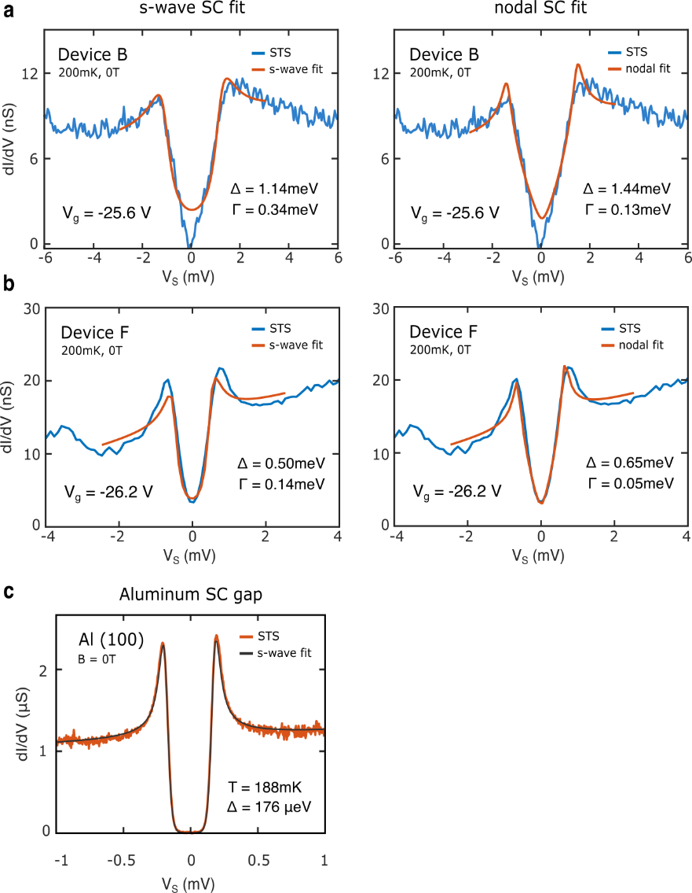

Figure S3 | Dynes-function fitting analysis of the tunneling gap between -3 < $ν$ < -2. a, s-wave-superconductor fit (left) and nodal-superconductor fit (right) of the tunneling spectrum dI/dV(V_{s}) at V_{g} = -25.6 V in Device B using the Dynes function. The energy gap $Δ$ and the quasiparticle lifetime broadening $Γ$ are free parameters. b, same as a, but at V_{g} = -26.2 V in Device F. In both cases, nodal-SC fits capture spectroscopic features better than the s-wave fits. c, BCS s-wave fit of tunneling data on a superconducting Al(100) surface at base temperature using the Dynes function. $Δ$, $Γ$, and T are all free fitting parameters. Aluminum has a superconducting transition temperature similar to MATBG. The broadening observed in this tunneling spectra was used as a calibration of the energy resolution (~50 μeV) of our homebuilt dilution-refrigerator STM.

SUPPLEMENTARY FIGURE S4

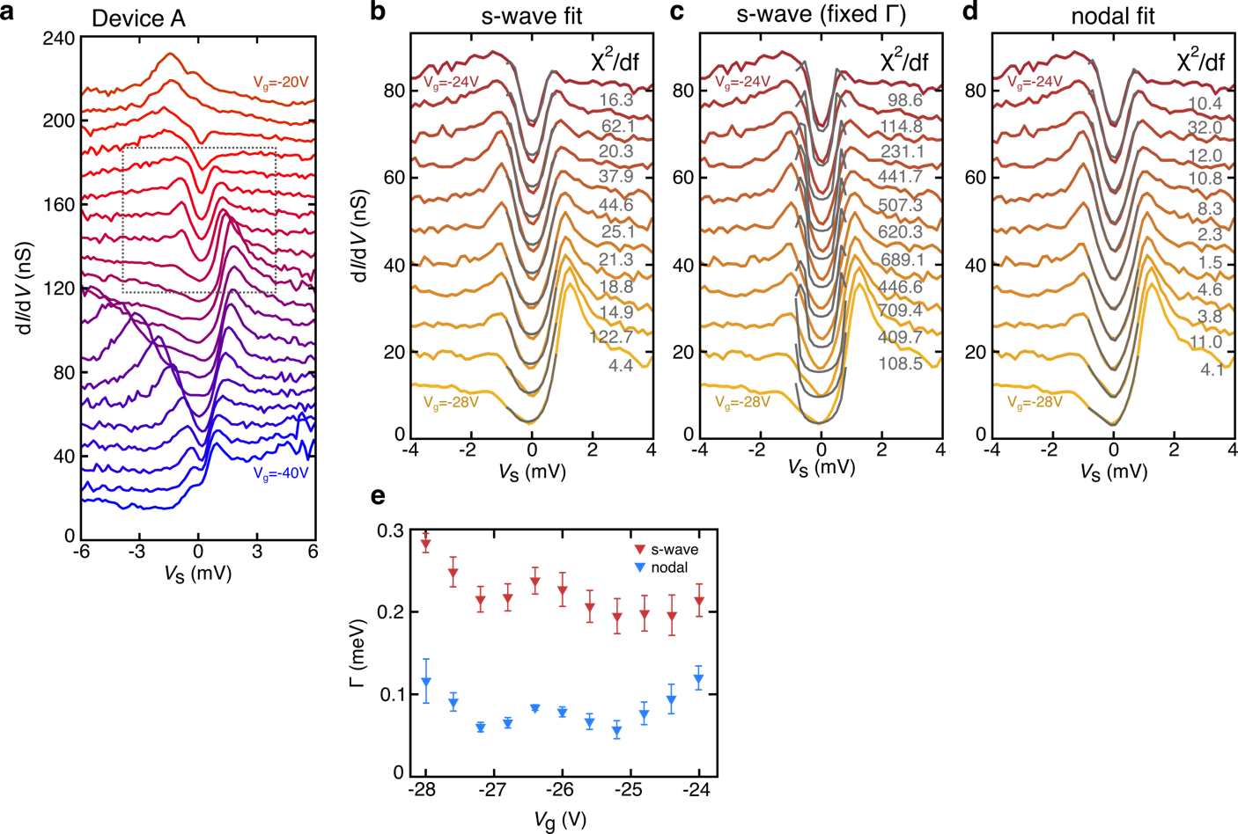

Figure S4 | Dynes-function fitting analysis of the low-energy parts of tunneling spectra at various gate voltages throughout the -3 < $ν$ < -2 gap. a, Tunneling dI/dV(V_{s}) spectra on an AA site in Device A at 200 mK and zero magnetic field, shown for gate voltages between V_{g} = -20 V and V_{g} = -40 V. Curves are offset by 10 nS for clarity. The dashed-line box highlights a set of gaps between -3 < $ν$ < -2. b, s-wave superconductor fits and c, nodal-superconductor fits of the low-energy part of eleven tunneling spectra taken from a from V_{g} = -24 V to V_{g} = -28 V. Curves are offset by 6.7 nS for clarity. For evaluating the goodness of each fit, $χ^{2}$ divided by the number of degrees of freedom ($χ^{2}/df$) is evaluated for each curve. When comparing s-wave and nodal fits performed on the same spectrum at every gate voltage, the nodal fits are consistently superior, with each nodal fit showing a lower $χ^{2}/df$ value than the corresponding s-wave fit. d, same as b, but with quasiparticle lifetime broadening $Γ$ of nodal fit for corresponding V_{g}. e, quasiparticle lifetime broadening factors $Γ$ estimated from s-wave fits and nodal fits.

SUPPLEMENTARY FIGURE S5

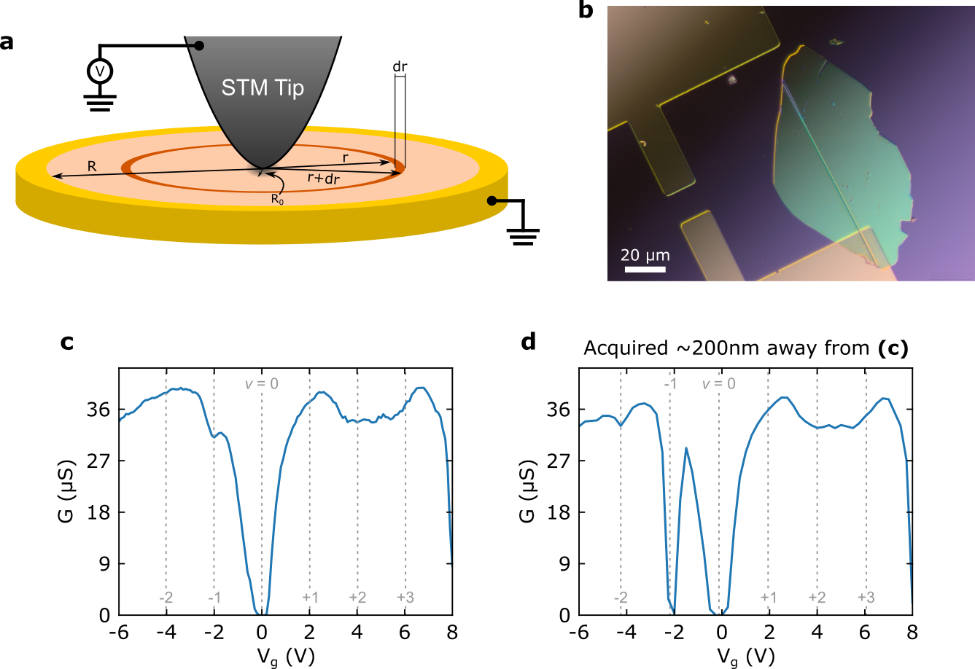

Figure S5 | The local nature of density-tuned point-contact spectroscopy (DT-PCS). a, Schematic diagram of the simple intuition model for the locality of our PCS method. A voltage $V$ is placed on an STM tip of contact radius $R_{0}$, which touches the center of a circular sample of radius $R$, whose outer perimeter is held at ground ($V=0$ V). b, Nomarski differential interference contrast image of Device A. c, Point-contact G(V_{g}) at V_{s} = 0 V, taken in aligned Device C. A very weak suppression of the conductance is observed at $ν$ = -1 at this location. d, Point-contact G(V_{g}) at V_{s} = 0 V, taken in aligned Device C. A strong, nearly complete suppression of the conductance is observed at $ν$ = -1 at this location, roughly 200 nm away from the data location in c.

SUPPLEMENTARY FIGURE S6

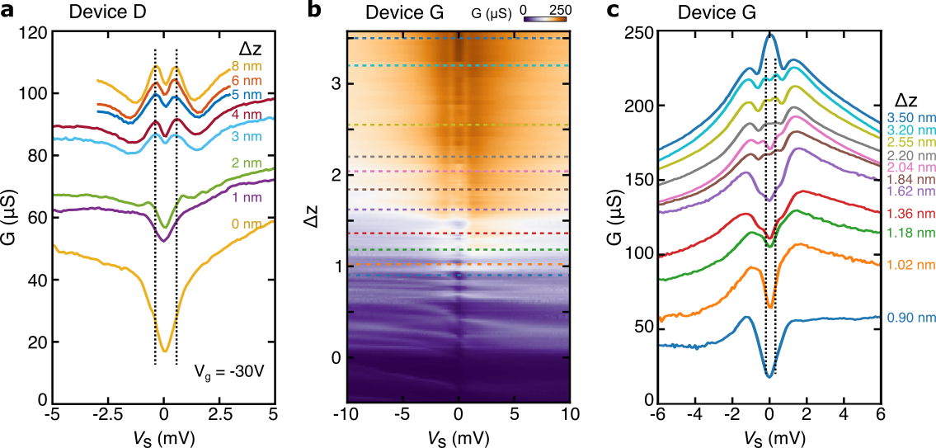

Figure S6 | Point-contact measurement vs. tip depth. a, Point-contact spectra G(V_{s}) obtained at V_{g} = -30 V, B = 0 T, and T = 200 mK in Device D. Between each spectrum, the STM was vertically displaced by 1-2 nm. Here, Δz is the tip height relative to the bottom curve (i.e., the largest tip-sample separation shown). As the STM tip comes into contact with the superconducting MATBG sample, the V-shaped dip transforms into a double-peaked Andreev spectrum. The barrier strength parameter Z for this tip contact is larger than that of main text Fig. 2 but similar to that of Fig. S2. The energy difference of the two peaks of the Andreev spectral feature which is around ~2Δ_{c} and is independent of the vertical tip displacement over Δz ~ 5 nm (spectra labeled “3 nm” to “8 nm”). b, Point-contact spectra G(V_{s}) obtained at V_{g} = -30.4 V, B = 0 T, and T = 265 mK in Device G. Larger values of $Δz$ correspond to the tip displaced deeper into the surface. The evolution of the PCS with $Δz$ is nonmonotonic, possibly because the tip deforms as it is pressed into the surface. c, PCS line cuts at select values of $Δz$ indicated by the dashed lines in b.

SUPPLEMENTARY FIGURE S7

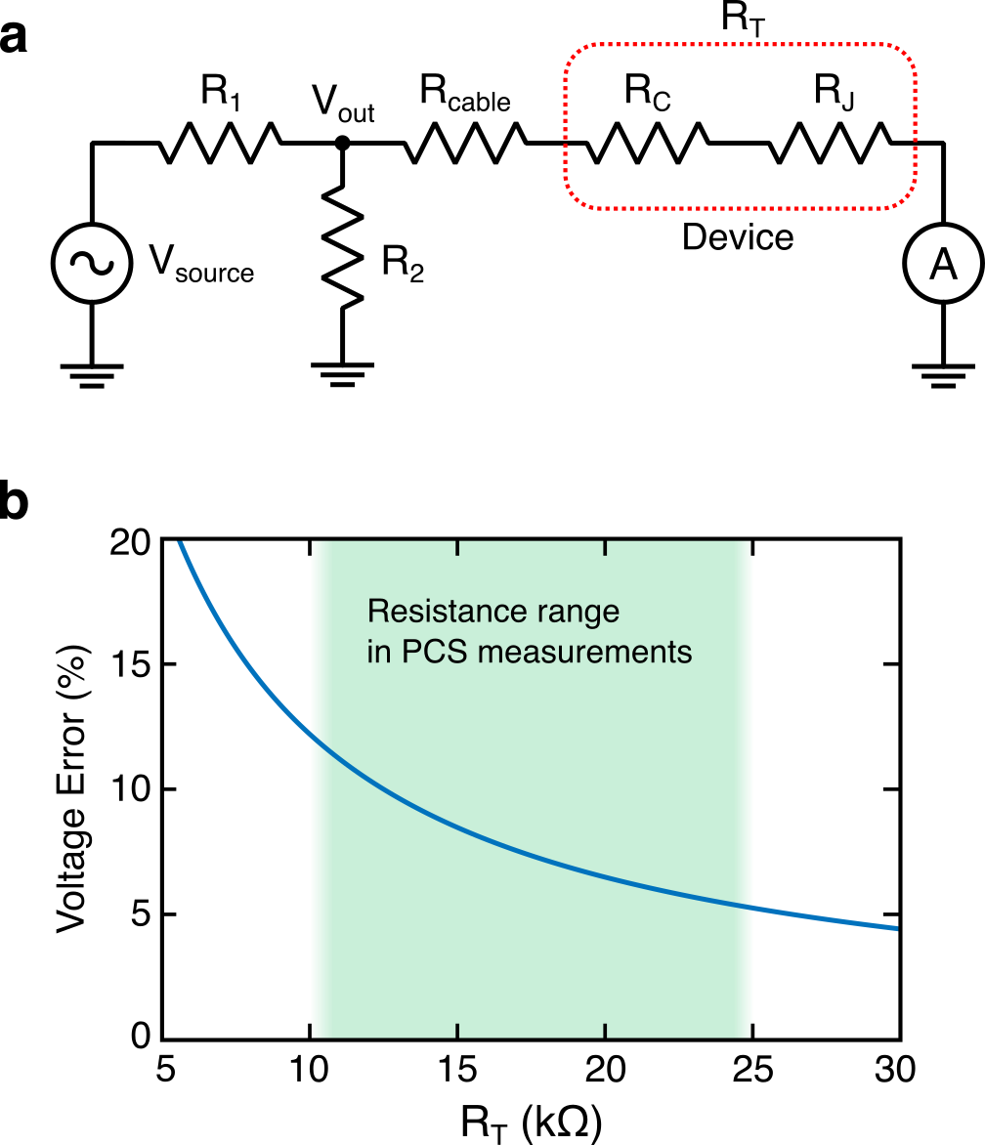

Figure S7 | Circuit diagram for the point-contact measurement. a, Circuit diagram for the point-contact measurement. R₁ = 100 kΩ and R₂ = 1 kΩ for the 1:100 voltage divider for the DC source voltage V_{source}, R_{cable} = 400 Ω is the cryostat cable resistance, and R_{C} and R_{J} are the electrode-device contact resistance and the tip-sample junction resistance, respectively. We refer to the series combination of R_{C} and R_{J} as R_{T}. In PCS, R_{T} is comparable to R₂, so the output voltage of the voltage divider V_{out} can be smaller than 1/100 of the source voltage. b, The voltage error with respect to the expected sample bias voltage V_{s} = V_{source}/100, plotted as a function of R_{T}. In our measurements, R_{T} falls within the range between 10 kΩ and 25 kΩ, which may cause overestimation of Andreev energy gaps by ~10%.
SUPPLEMENTARY FIGURE S8

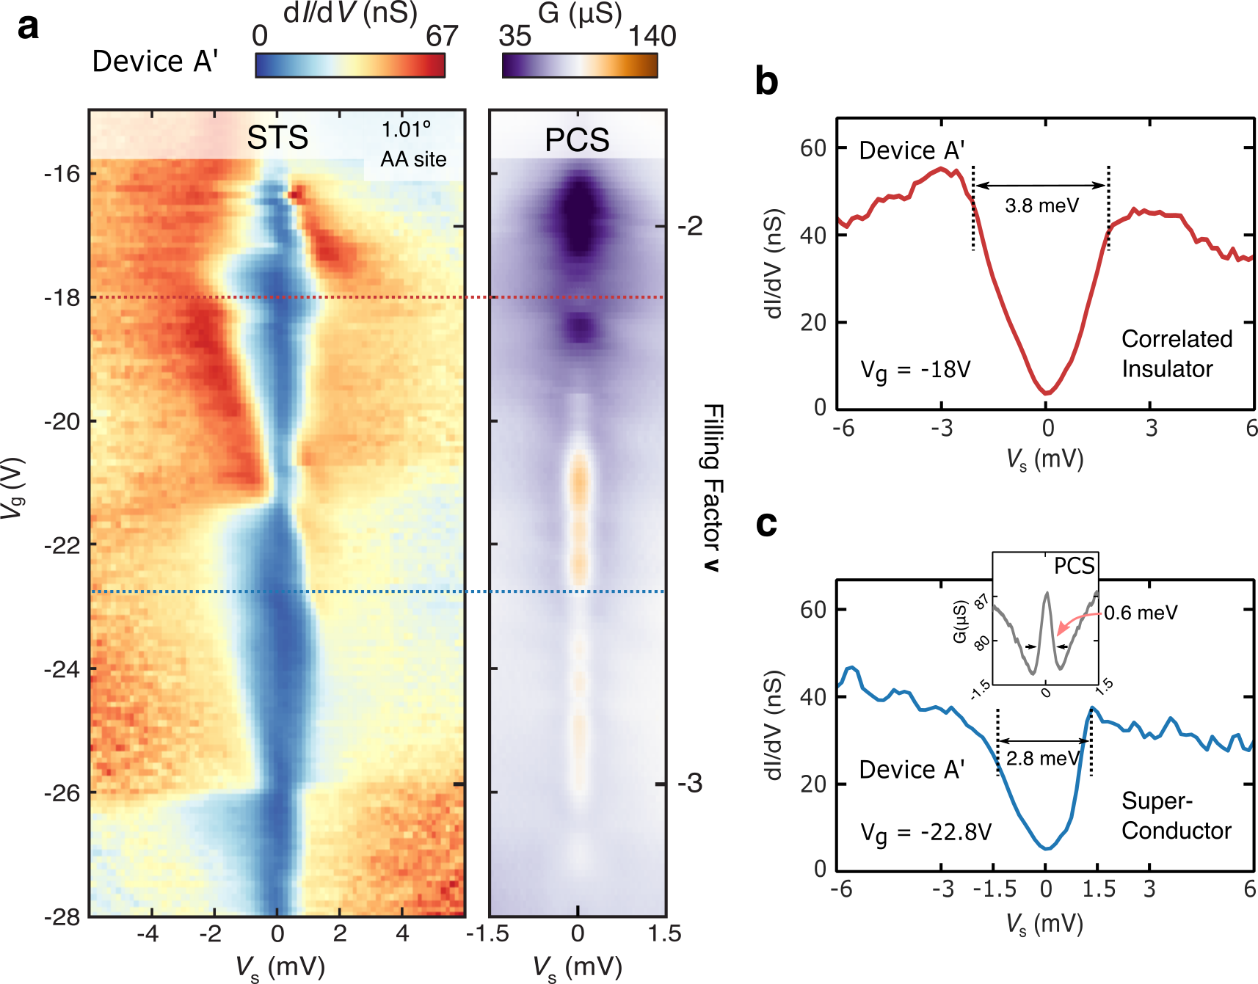

Figure S8 | Tunneling spectroscopy and point-contact spectroscopy at -3 < $ν$ < -2 in Device A’. a, Side-by-side tunneling dI/dV(V_{s}, V_{g}) into an AA site and point-contact G(V_{s}, V_{g}) in the same location in Device A’. dI/dV(V_{s}, V_{g}) shows the opening and closing of the correlated insulating and superconducting phases at the Fermi level. G(V_{s}, V_{g}) allows us to differentiate between the origins of these two tunneling gap region, where Andreev reflection (orange peak near E_{F}) occurs only in the superconducting phase, in contrast to the gapped spectroscopic feature (purple dip near E_{F}) that marks the onset of the correlated insulating phase. b, Tunneling spectroscopy of the correlated insulator gap at V_{g}= -18 V. c, Tunneling spectroscopy of the superconducting gap at V_{g}= -22.8 V. Point-contact spectrum (inset in c) of the corresponding tunneling gap of the superconducting phase shows a clear difference between the two energy scales $Δ_{AR}$ and $Δ_{T}$.

SUPPLEMENTARY FIGURE S9

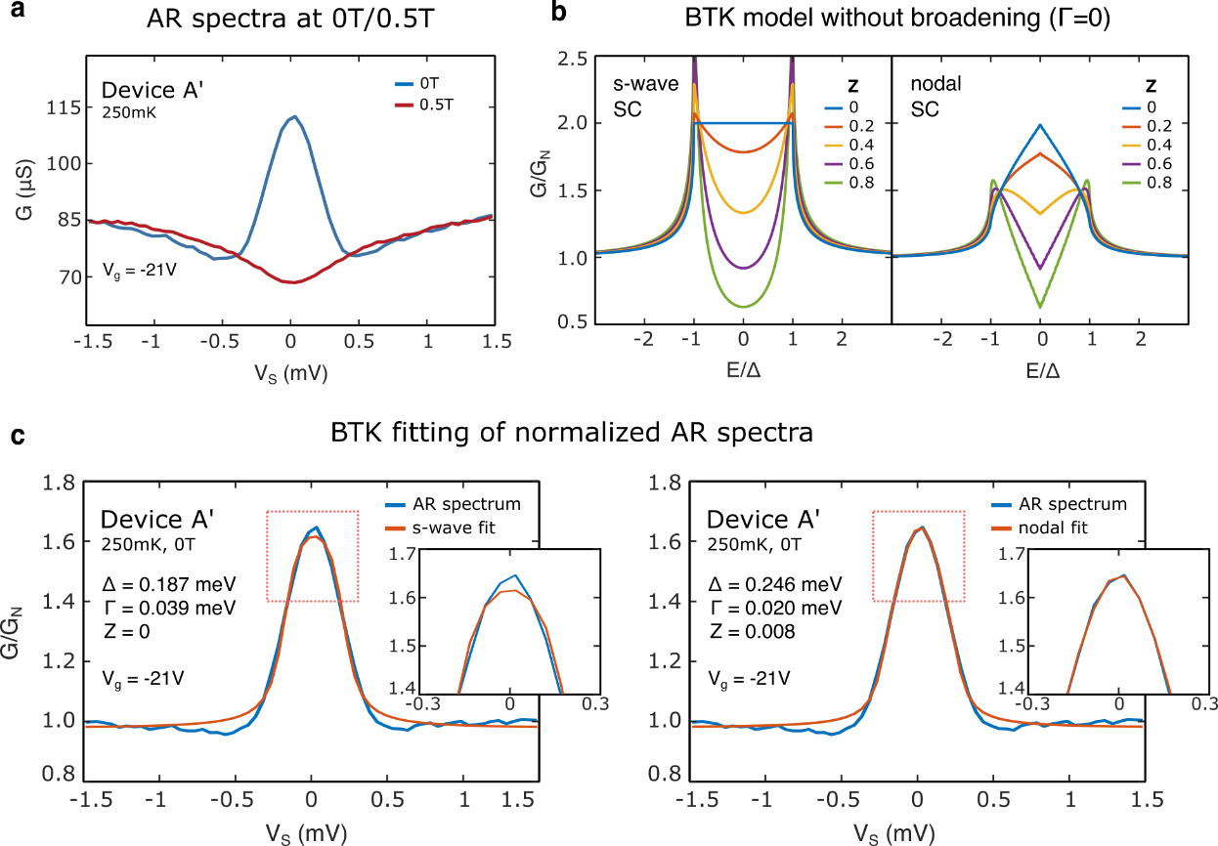

Figure S9 | Blonder-Tinkham-Klapwijk (BTK) fitting analysis of the Andreev reflection spectrum at -3 < $ν$ < -2. a, Point-contact spectrum G(V_{s}) at V_{g} = -21 V at B = 0 T (blue) and B = 0.5 T (red) in Device A’. The blue curve is peaked at zero-bias, indicative of the Andreev reflection process at B = 0 T. The red curve shows a weak minimum at zero-bias, indicative of residual resistance in the tip-sample junction or the sample contact, as the sample has entered the normal state at B = 0.5 T. Normalized data $G/G_{N}$ for the BTK model is obtained by dividing the 0 T superconducting-state data by the 0.5 T normal-state data. b, Comparison of BTK simulations of c-axis transport between a normal-metal tip and an s-wave (left) or nodal (right) superconducting sample, plotted for various barrier strength parameters $Z$. The s-wave model shows a flat-top-shaped spectrum when $E < Δ$ with a doubled conductance at $Z =0$, while the nodal-superconductor (nodal-SC) model shows a point-shaped spectrum with a doubled conductance only at $E=0$ and $Z=0$. c, BTK-model fitting of a normalized spectrum from the data in a, using an s-wave (left) and a nodal (right) superconducting order parameter. $Δ$, $Γ$, and $Z$ are free fitting parameters. Red dashed-line boxes highlight the apex of the peaks in each plot, where there is the largest discrepancy between the s-wave and the nodal fits (insets). In addition, the broadening in the s-wave scenario is large ($Γ>0.2Δ$), while the broadening in the nodal scenario is reasonable ($Γ≈0.08Δ$).
SUPPLEMENTARY FIGURE S10

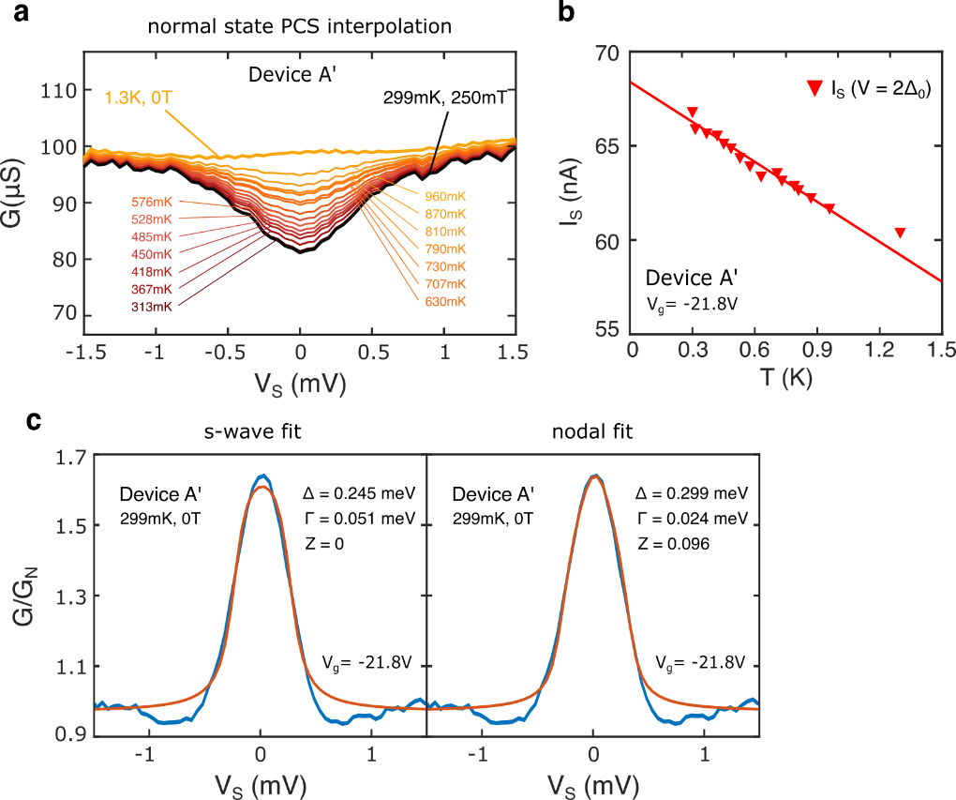

Figure S10 | Temperature-dependent (BTK) fitting analysis of the Andreev reflection spectrum at -3 < $ν$ < -2. a, Normal state point-contact spectra G(V_{s}) estimated via linear interpolation between a spectrum taken in Device A’ at T = 299 mK, B = 250 mT and a spectrum taken at T = 1.3 K, B = 0 T. The excess current depicted in main text Fig. 3d is calculated by subtracting the integral of each Andreev spectrum with respect to the bias voltage from the integral of these interpolated normal-state spectra. b, Temperature dependence of the superconducting-state current I_{s} at V = 2$Δ_{0}$, where $Δ_{0}$= 0.3 meV is the gap size extracted from the PCS data at 299 mK. This shows a linear relationship between I_{s} and T. c, BTK fits of the normalized PCS spectra at T = 299 mK, used to estimate the barrier strength parameter $Z$ in s-wave (left) and nodal (right) superconductor scenarios, with free fitting parameters $Δ$, $Γ$ and $Z$.
Nodal superconductor fits better than s-wave. Thus, we use nodal superconductor fits with Z ~ 0.1 extracted from this fit for temperature dependent BTK analysis in main text Fig. 3c.
SUPPLEMENTARY FIGURE S11

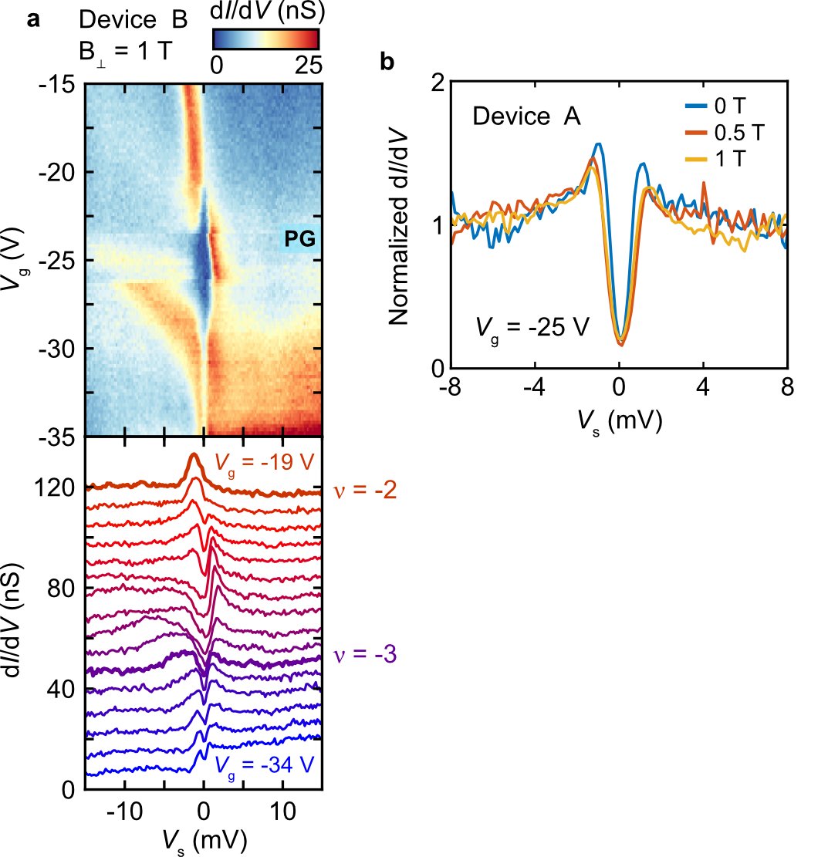

Figure S11 | Tunneling spectroscopy at 1 T in Device B and comparison of tunneling spectra at various magnetic fields. a, Tunneling dI/dV(V_{s}, V_{g}) and spectroscopy line cuts acquired at the center of an AA site in Device B for V_{g} = -19 V to V_{g} = -34 V and for B⊥ = 1 T. Curves are offset by 7.5 nS for clarity. Although this is above the critical magnetic field for superconductivity in MATBG, we observe a suppression of the zero-bias conductance, indicating the presence of the high-field pseudogap state discussed in the main text between -3 < $ν$ < -2. Initial tunneling parameters: V_{s} = -80 mV, I = 1500 pA, V_{rms} = 0.2 mV at 4.121 kHz, T = 200 mK. b, Direct comparison of tunneling spectra dI/dV(V_{s}), normalized for their linear background, observed in Device A at V_{g} = -25 V. Only the spectrum observed at B⊥= 0 T was acquired in the superconducting state.

SUPPLEMENTARY FIGURE S12

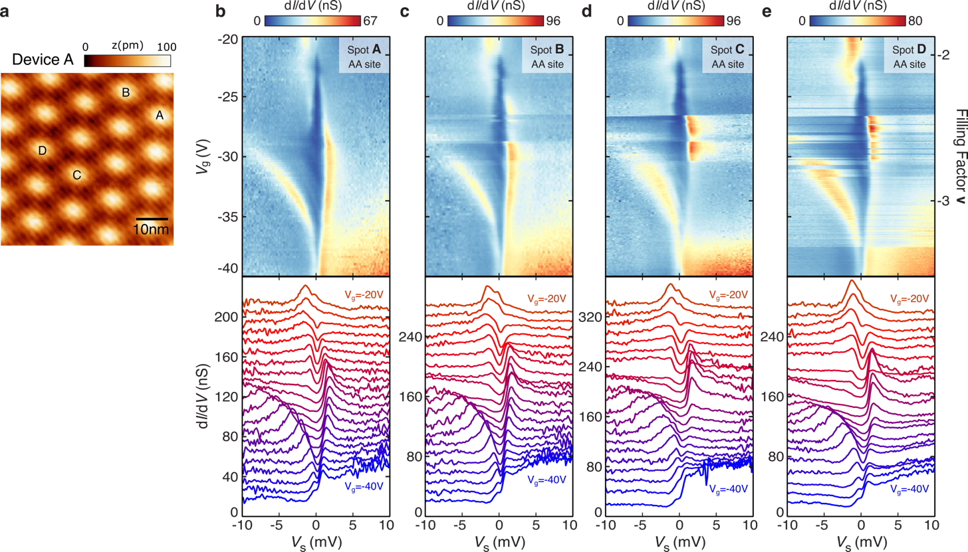

Figure S12 | Tunneling spectroscopy at the center of different AA sites. a, Topographic image of Device A. b, Tunneling dI/dV(V_{s}, V _{g}) and dI/dV(V _{s}) specra from an AA site, obtained at B = 0 T in Device A for V_{g} = -20 V to V_{g} = -40 V, obtained at the spot labeled “A” in a. c-e, same as b, but for spot B (c), spot C (d), and spot D (e) obtained at B⊥ = 0.5 T. In b-e, curves are offset for clarity by 10 nS, 12.8 nS,16 nS and 12.8 nS, respectively.

SUPPLEMENTARY FIGURE S13

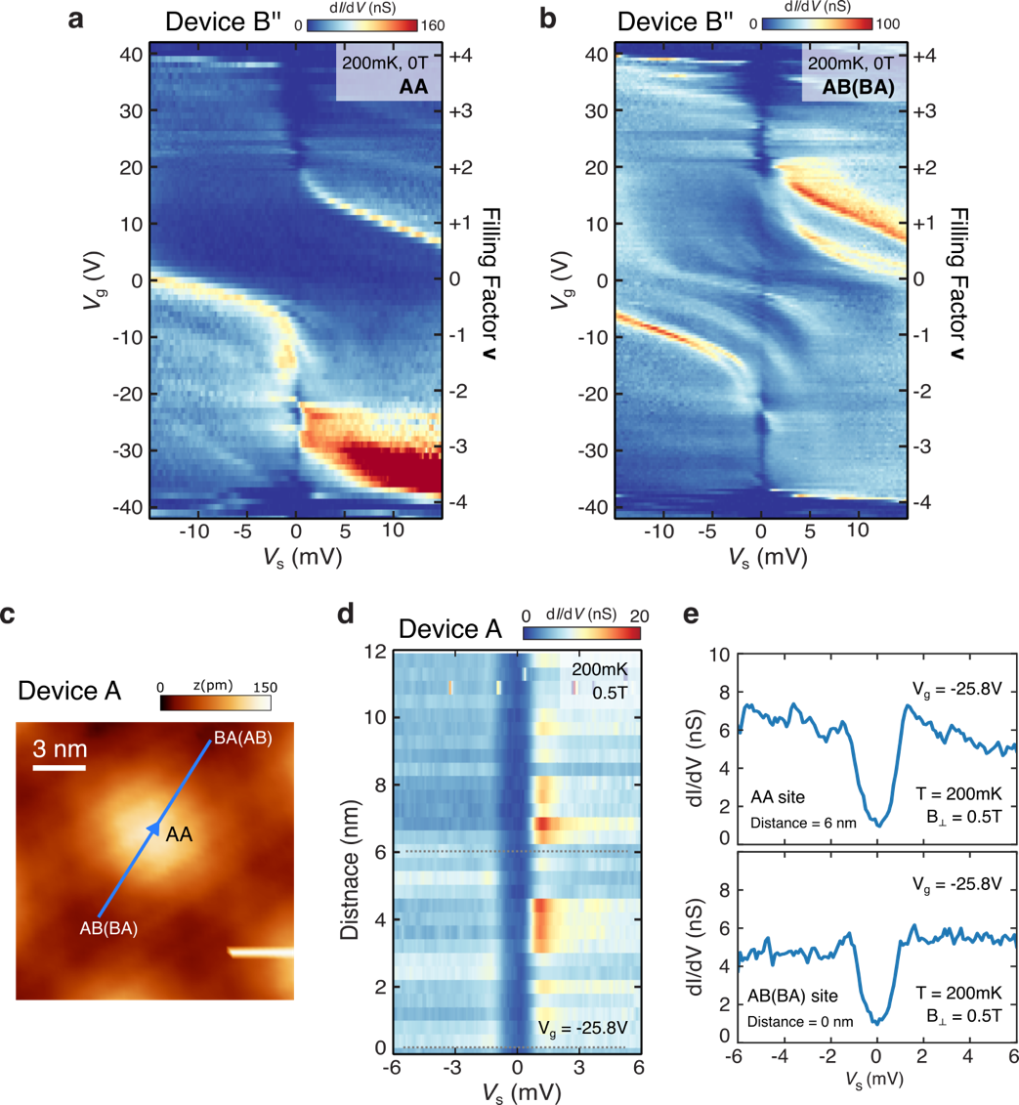

Figure S13 | Tunneling spectroscopy at AA and AB(BA) site, and spatial dependence of the -3 < $ν$ < -2 tunneling gap. a, Tunneling dI/dV(V_{s}, V _{g}) obtained from an AA site in Device B’’ (angle : 1.07°). b, same as a, but from an AB (or BA) site. Both show tunneling gaps at -3 < $ν$ < -2. c, Topographic image near AA site in Device A. d, Line cut of dI/dV(V_{s}) along the blue line drawn in c at V_{g} = -25.8 V at B⊥ = 0.5 T. Tunneling gap sizes are almost independent on the location. Gray dashed lines highlight the location of the AB(BA) site (distance = 0 nm) and the AA site (distance = 6 nm). e, dI/dV(V_{s}) spectra at AA site (top), and dI/dV(V_{s}) spectra at AB(BA) site (bottom).

SUPPLEMENTARY FIGURE S14

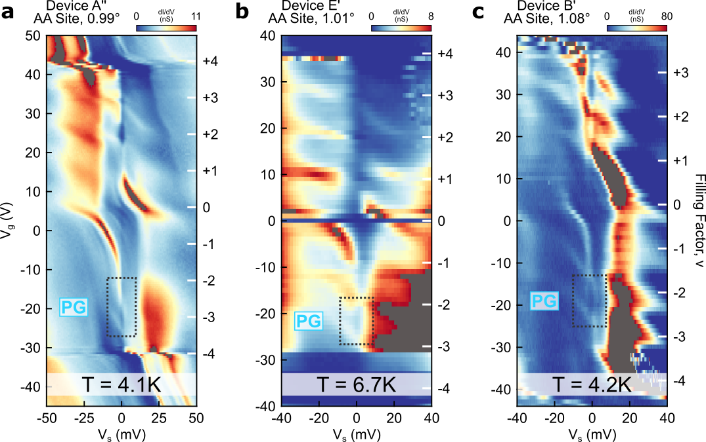

Figure S14 | Tunneling spectroscopy of the pseudogap phase at temperatures above 4 K. a, Tunneling dI/dV(V_{s},V_{g}) acquired at the center of an AA site in Device A'' (0.99°) at zero magnetic field and T = 4.1 K. A spectral suppression near E_{F} appears in the valence flat band around $ν$ < -2, which we attribute to a high-temperature pseudogap state at this temperature. b, Tunneling dI/dV(V_{s},V_{g}) acquired at the center of an AA site in Device E' (very nearly the same area as Device E millikelvin data; 1.01°) at zero magnetic field and T = 6.7 K. A spectral suppression near E_{F} appears in the valence flat band around -3 < $ν$ < -2, which we attribute to the pseudogap state. c, Tunneling dI/dV(V_{s},V_{g}) acquired at the center of an AA site in Device B' (different area in Device B; 1.08°) at zero magnetic field and T = 4.2 K. A gap-like spectral suppression near E_{F} appears in the valence flat band around -3 < $ν$ ≤ -2, which we attribute to the pseudogap state.

SUPPLEMENTARY FIGURE S15

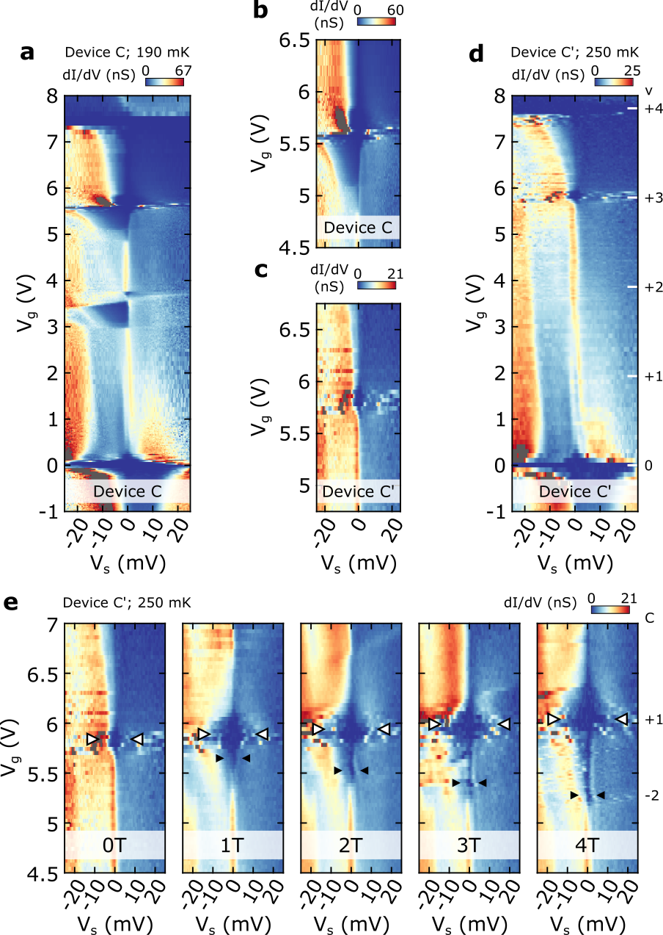

Figure S15 | Tunneling spectroscopy and Chern characterization of moiré-commensurate MATBG aligned to hBN. a, Tunneling dI/dV(V_{s},V_{g}) acquired at the center of an AAb site in a moiré-commensurate region of Device C (1.08° G-G twist angle, 0.1% G-G interlayer strain, 0.5 ± 0.1° G-hBN twist angle). A $C_{2}$-symmetry-broken gap, a correlated insulator gap, and a correlated Chern C = +1 gap appear near $ν$ = 0, +2, and +3, respectively. b, Zoomed-in dI/dV(V_{s},V_{g}) from a to highlight the observed zero-field Chern C = +1 gap. c, Zoomed in dI/dV(V_{s},V_{g}) from d to highlight the observed zero-field Chern C = +1 gap. d, Tunneling dI/dV(V_{s},V_{g}) acquired at the center of an AAb site in Device C’ (same as Device C, at a different sample location; 1.10°. A $C_{2}$-symmetry-broken gap and a correlated Chern C = +1 gap appear near $ν$ = 0 and +3, respectively. e, Tunneling dI/dV(V_{s},V_{g}) at five different magnetic-field strengths between 0 T and 4 T, at around $ν$ = +3. We observe a correlated Chern C = +1 state at and emanating from $ν$ = +3. We also observe weaker signatures of a topological gapped phase with Chern number -2, which is first resolved at 1 T.

SUPPLEMENTARY FIGURE S16

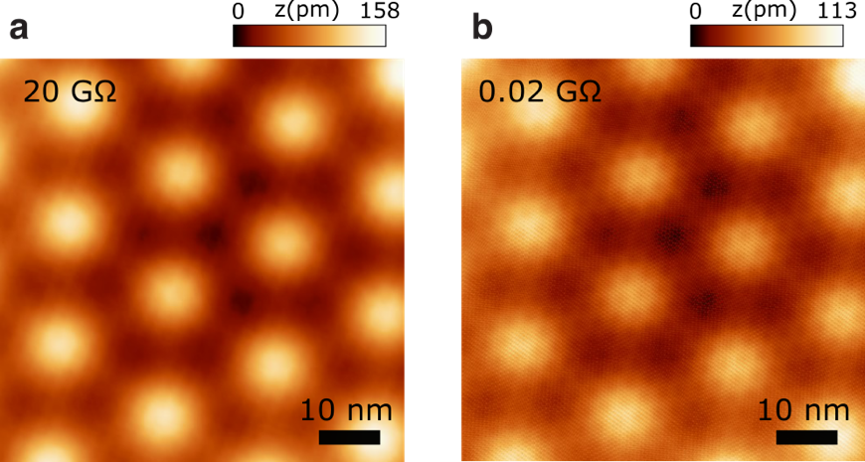

Figure S16 | Topographic images at different tunneling setpoints. a, Topographic image of Device G’ (1.18°) at I = 10 pA, V_{s} = -200 mV (20 GΩ tunnel resistance). b, Same as a except at I = 500 pA, V_{s} = -10 mV (0.02 GΩ tunnel resistance).

