Bat coronaviruses related to SARS-CoV-2 and infectious for human cells
Sarah Temmam* (1,2), Khamsing Vongphayloth* (3), Eduard Baquero Salazar* (4), Sandie Munier* (5), Massimiliano Bonomi* (6), Béatrice Regnault (1,2), Bounsavane Douangboubpha (7), Yasaman Karami (6), Delphine Chrétien (1,2), Daosavanh Sanamxay (7), Vilakhan Xayaphet (7), Phetphoumin Paphaphanh (7), Vincent Lacoste (3), Somphavanh Somlor (3), Khaithong Lakeomany (3), Nothasin Phommavanh (3), Philippe Pérot (1,2), Océane Dehan (5,8), Faustine Amara (5), Flora Donati (5,8), Thomas Bigot (1,9), Michael Nilges (6), Félix A. Rey (4), Sylvie van der Werf (5,8), Paul T. Brey (3), Marc Eloit + (1,2,10).
* co-first authors
+ corresponding author

SI guide
Supplementary Methods 2
Supplementary Tables 3
Table S1: Total number of bats collected and morphological identification. 3
Table S2: List of study sites in Laos with coordinates 5
Table S3: Results from pan-coronavirus RT nested PCR and Sanger sequencing 6
Table S4. Vertical coverage of BANAL genomes presented in the study 8
Table S5. Characteristics of the recombination breakpoints 9
Table S6. List of the MD simulations performed. 9
Table S8: Acknowledgment of sharing of SARS-CoV-2-related genome sequences from the GISAID database related to Figures 1-2 and Supp. Figures 1-4. 9
Supplementary Figures 9
Figure S1: Identity matrices at the genus level of representative sarbecoviruses. 9
Figure S2: Complete phylogenetic reconstructions of recombinant fragments, as described in Figure 2. 9
Figure S3: Alignment of the whole spike amino-acid sequences. 9
Figure S4: Western-Blot analysis of concentrated lentivral particles pseudotyped with Wuhan or BANAL-236 spike proteins. 9
Figure S5: Distribution of bats species from which SARS-CoV-2-like viruses were detected in this study. 9
References 9

Supplementary Methods

Additional analysis of the MD simulations of the BANAL-52/103 RBD/hACE2 complex. One of our 3 simulations of the BANAL-52/103 RBD/hACE2 complex (BANAL-52/103-CoV.1 in Extended data 5) showed large fluctuations of the RBD and RBD-hACE2 interface RMSDs. As a consequence of this larger conformational variability, the cluster analysis of BANAL-52/103-CoV.1 identified 2 major populated clusters (Extended data 5E). To exclude the possibility of having initialized the simulation from a poorly equilibrated structure, we performed a 10 times longer equilibration phase of the initial model followed by an additional 1 µs-long production simulation (BANAL-52/103-CoV.1*). The time series of the RBD-hACE2 interface RMSD in this additional simulation (Extended data 8, pink line) still displayed large RMSD fluctuations, especially towards the end of the simulation. After careful inspection of the trajectory, we concluded that the cause of the observed RMSD behavior in both BANAL-52/103-CoV.1 and BANAL-52/103-CoV.1* was the structural variability of the loop formed by RBD residues S443 to Y449 Extended data 8, insets, yellow residues). According to our definition, these residues were considered at the RBD/hACE2 interface; however, only a transiently formed hydrogen bond maintains this loop close to hACE2 (Extended data 7A). The removal of this stretch of 7 residues (out of 110 interfacial residues) from the calculation of the interface RMSD (Extended data 8, black and gray lines) clearly shows that the motion of the S443-Y449 loop was the cause of the large RMSD fluctuations observed in the BANAL-52/103-CoV.1 simulation.

Supplementary Tables

Table S1: Total number of bats collected and morphological identification.
Family | Genus | Species | Vientiane Province |  | Oudomxay Province |  | Total No. of bats
Family | Genus | Species | Fueng  (Site 1) | Meth  (Site 2) | Xay  (Site 3) | Na Mor  (Site 4)
Hipposideridae | Aselliscus | stoliczkanus | 5 | 5 | 30 |  | 40
 | Hipposideros | cineraceus | 14 | 3 |  |  | 17
 |  | khaokhouayensis | 12 | 4 |  |  | 16
 |  | larvatus | 47 |  |  |  | 47
 |  | gentilis | 55 | 7 | 1 |  | 63
 |  | rotalis | 1 |  |  |  | 1
Megadermatidae | Megaderma | spasma | 3 | 6 |  | 2 | 11
Molossidae | Chaerephon | plicatus | 45 |  |  |  | 45
Pteropodidae | Cynopterus | horsfieldii |  |  | 2 |  | 2
 |  | sphinx |  | 10 | 1 | 1 | 12
 | Eonycteris | spelaea | 1 | 9 |  | 1 | 11
 | Macroglossus | sobrinus | 5 | 45 | 7 | 3 | 60
 | Megaerops | niphanae |  | 1 |  | 1 | 2
 | Sphaerias | blanfordi |  | 1 |  |  | 1
Rhinolophidae | Rhinolophus | affinis | 2 |  |  |  | 2
 |  | coelophyllus | 10 | 2 |  |  | 12
 |  | luctus | 1 |  |  |  | 1
 |  | malayanus | 46 | 1 | 9 | 1 | 57
 |  | marshalli | 1 |  |  |  | 1
 |  | microglobosus | 5 | 1 | 1 |  | 7
 |  | pearsonii | 46 | 19 | 1 |  | 66
 |  | pusillus | 7 | 11 |  |  | 18
 |  | rex |  |  | 2 |  | 2
 |  | shameli |  |  | 1 |  | 1
 |  | siamensis |  |  | 6 | 4 | 10
 |  | sp. | 2 |  |  |  | 2
 |  | thomasi | 1 | 5 | 2 |  | 8
Vespertilionidae | Arielulus | aureocollaris |  |  | 1 |  | 1
 | Glischropus | bucephalus |  | 2 | 2 |  | 4
 | Ia | io |  |  | 1 |  | 1
 | Kerivoula | cf.hardwickii |  | 9 |  |  | 9
 |  | cf.titania |  | 1 |  |  | 1
 |  | depressa |  |  | 8 |  | 8
 |  | hardwickii | 5 |  |  |  | 5
 | Murina | feae | 1 | 1 | 1 |  | 3
 |  | sp1 |  | 4 | 2 |  | 6
 |  | sp2 |  | 1 | 2 |  | 3
 | Myotis | sp. | 7 |  |  |  | 7
 |  | sp1 |  |  | 45 |  | 45
 |  | sp2 |  |  | 3 |  | 3
 |  | sp3 |  |  | 1 |  | 1
 | Pipistrellus | sp. | 8 |  |  |  | 8
 | Scotomanes | ornatus |  |  | 1 |  | 1
 | Tylonycteris | fulvida |  | 3 |  |  | 3
 |  | malayana |  | 14 |  |  | 14
 |  | sp. | 5 |  | 2 |  | 7
Grand Total |  |  | 335 | 165 | 132 | 13 | 645

Table S2: List of study sites in Laos with coordinates
Province | District | Village | Locality | Latitude | Longitude
Vientiane Province | Site 1 :  Fueng | Na Ang | Pha Tong | 18° 32.879'N | 101° 58.938'E
 |  |  | Tham Nam cave | 18° 32.914'N | 101° 58.459'E
 |  |  | Tham Pha | 18° 34.018'N | 101° 58.338'E
 |  | Noon Hin Hae | Pha Nouk Kok | 18° 31.743'N | 101° 58.648'E
 |  | Pha Louang | Tham Pha Louang | 18° 30.495'N | 101° 57.421'E
 | Site 2 :  Meth | Had Yao | Pha Keo Phong Mon | 18° 54.426'N | 101° 58.789'E
 |  |  | Pha Khee Chear (Keo Tao) | 18° 54.898'N | 101° 59.048'E
 |  | Houay Pa Mak | Pha Mum | 18° 53.717'N | 101° 56.957'E
 |  |  | Pha Mum, Keo Tao | 18° 54.787'N | 101° 58.292'E
 |  |  | Pha Yao, Keo Tao | 18° 55.386'N | 101° 57.723'E
Oudomxay Province | Site 3 :  Xay | Chom Ong | Chom Ong Cave | 20° 43.071'N | 101° 45.811'E
 |  |  | Houay Om Loung | 20° 43.111'N | 101° 46.577'E
 |  |  | Houay Pak Veuk | 20° 41.647'N | 101° 47.179'E
 |  |  | Pa Noo Khom | 20° 44.143'N | 101° 46.770'E
 | Site 4 :  Na Mor | Na Thong | Nam Ook Hoo Cave | 20° 52.396'N | 101° 46.973'E
 |  |  |  | 20° 51.907'N | 101° 46.926'E

Table S3: Results from pan-coronavirus RT nested PCR and Sanger sequencing
Anal Swab ID | Bat Genus | Bat Species | Genus | Subgenus | Closest sequence | % blastN similarity | District | Village | Locality
BANAL-20-27 | Rhinolophus | pusillus | co-infection Alpha/Betacoronavirus | unclassified Decacovirus/ Sarbecovirus | Rhinolophus bat coronavirus HKU32 / SARS-CoV-2 | 80% | Feuang (Site 1) | Nonhinhae | Pha Nok Kok
BANAL-20-51 | Hipposideros | pomona | Alphacoronavirus | Decacovirus | Bat coronavirus HKU10 | 98% | Feuang (Site 1) | Nonhinhae | Pha Nok Kok
BANAL-20-52 | Rhinolophus | malayanus | Betacoronavirus | Sarbecovirus | SARS-CoV-2 | 99% | Feuang (Site 1) | Nonhinhae | Pha Nok Kok
BANAL-20-103 | Rhinolophus | pusillus | Betacoronavirus | Sarbecovirus | SARS-CoV-2 | 99% | Feuang (Site 1) | Na Ang | Tham Pha
BANAL-20-115 | Hipposideros | pomona | Alphacoronavirus | Decacovirus | Bat coronavirus HKU10 | 98% | Feuang (Site 1) | Pha Luang | Tham Pha Luang
BANAL-20-116 | Rhinolophus | malayanus | Betacoronavirus | Sarbecovirus | SARS-CoV-2 | 98% | Feuang (Site 1) | Pha Luang | Tham Pha Luang
BANAL-20-178 | Hipposideros | pomona | Alphacoronavirus | Decacovirus | Bat coronavirus HKU10 | 98% | Feuang (Site 1) | Pha Luang | Tham Pha Luang
BANAL-20-191 | Chaerephon | plicatus | Alphacoronavirus | Pedacovirus | Porcine epidemic diarrhea virus (PEDV) | 93% | Feuang (Site 1) | Pha Luang | Tham Pha Luang
BANAL-20-197 | Chaerephon | plicatus | Alphacoronavirus | Pedacovirus | Porcine epidemic diarrhea virus (PEDV) | 93% | Feuang (Site 1) | Pha Luang | Tham Pha Luang
BANAL-20-212 | Chaerephon | plicatus | Alphacoronavirus | Pedacovirus | Porcine epidemic diarrhea virus (PEDV) | 93% | Feuang (Site 1) | Pha Luang | Tham Pha Luang
BANAL-20-213 | Chaerephon | plicatus | Alphacoronavirus | Pedacovirus | Porcine epidemic diarrhea virus (PEDV) | 93% | Feuang (Site 1) | Pha Luang | Tham Pha Luang
BANAL-20-236 | Rhinolophus | marshalli | Betacoronavirus | Sarbecovirus | SARS-CoV-2 | 99% | Feuang (Site 1) | Na Ang | Pha Tong
BANAL-20-242 | Rhinolophus | malayanus | Betacoronavirus | Sarbecovirus | SARS-CoV-2 | 99% | Feuang (Site 1) | Na Ang | Pha Tong
BANAL-20-247 | Rhinolophus | malayanus | Betacoronavirus | Sarbecovirus | SARS-CoV-2 | 99% | Feuang (Site 1) | Na Ang | Pha Tong
BANAL-20-251 | Hipposideros | khaokhouayensis | Alphacoronavirus | Decacovirus | Bat coronavirus HKU10 | 97% | Feuang (Site 1) | Na Ang | Pha Tong
BANAL-20-273 | Rhinolophus | pusillus | Alphacoronavirus | unclassified Decacovirus | Rhinolophus bat coronavirus HKU32 | 92% | Feuang (Site 1) | Na Ang | Pha Tong
BANAL-20-289 | Rhinolophus | affinis | Alphacoronavirus | Rhinacovirus | Rhinolophus affinis bat coronavirus HKU2-related / Swine acute diarrhea syndrome related coronavirus (SADS-CoV) | 98% | Feuang (Site 1) | Na Ang | Pha Tong
BANAL-20-290 | Eonycteris | spelaea | Betacoronavirus | Nobecovirus | Rousettus bat coronavirus GCCDC1 | 99% | Maed (Site 2) | Had Yao | Keo tao + Had Yao
BANAL-20-390 | Eonycteris | spelaea | Betacoronavirus | Nobecovirus | Rousettus bat coronavirus GCCDC1 | 97% | Maed (Site 2) | Huay Pa Mak | Keo Tao
BANAL-20-395 | Eonycteris | spelaea | Betacoronavirus | Nobecovirus | Rousettus bat coronavirus GCCDC1 | 99% | Maed (Site 2) | Huay Pa Mak | Keo Tao
BANAL-20-398 | Eonycteris | spelaea | Betacoronavirus | Nobecovirus | Rousettus bat coronavirus GCCDC1 | 99% | Maed (Site 2) | Huay Pa Mak | Keo Tao
BANAL-20-403 | Eonycteris | spelaea | Betacoronavirus | Nobecovirus | Rousettus bat coronavirus GCCDC1 | 99% | Maed (Site 2) | Huay Pa Mak | Keo Tao
BANAL-20-416 | Cynopterus | sphinx | Betacoronavirus | Nobecovirus | Rousettus bat coronavirus GCCDC1 | 99% | Maed (Site 2) | Huay Pa Mak | Pha Moum
BANAL-20-497 | Myotis | sp. | Alphacoronavirus | Pedacovirus | Bat alphacoronavirus* | 99% | Xay (Site 3) | Chom-Ong | Near Chom-Ong Cave

- Due to the low genome coverage of BANAL-20-497 (< 1%), the taxonomic assignation is not robust.

Table S4. Vertical coverage of BANAL genomes presented in the study

BANAL sample | Average coverage for whole genome (SD) | Average coverage in Spike (SD) | Average coverage in RBD (SD)
BANAL-52 | 83720 X (89558) * | 75247 X (97210) * | 36623 X (64721) *
BANAL-103 | 43 X (47) * | 19 X (16) * | 0.42 X (0.74) *
BANAL-236 | 2872 X (2477) | 4100 X (2862) | 2847 X (1530)
BANAL-116 | 662 X (512) | 1038 X (511) | 679 X (309)
BANAL-247 | 15 X (13) * | 19 X (14) * | 7 X (3) *

The table above presents the average vertical coverage obtained after NGS for all BANAL samples. Of note, several key regions (noted by a * in the table) were obtained by Sanger sequencing after multiple overlapping PCRs, resulting in a lower vertical coverage of the region but with higher confidence of the consensus sequence. In addition, BANAL-52 was sequenced in three independent NGS runs, including one AmpliSeq, to achieve a good genome coverage. Therefore, the coverage presented here for BANAL-52 results from the combination of the three runs.

Table S5. Characteristics of the recombination breakpoints
Breakpoint no | Downstream fragment no | Coordinates of the fragment | Breakpoint located in coding region? | Breakpoint position in the codon | Sequences before (aa) | Breakpoint sequence | Sequences after  (aa)
1 | 2 | 1 – 1,820 | yes (ORF1a) | 3rd | GGTGGTGTTGTTCA (GGVVQ) | G | TTGACTTCGCAGTGG  (LTSQW)
2 | 3 | 1,821 – 2,689 | yes (ORF1a) | 2nd | CCACTGGGCATTG  (PLGID) | A | TTAGATGAGTGGAGT  (LDEWS)
3 | 4 | 3,971 – 7,176 | yes (ORF1a) | 2nd | GTGGTTATACCTA  (VVIPT) | C | TAAAAAGGCTGGTGGC  (KKAGG)
4 | 5 | 7,177 – 11,461 | yes (ORF1a) | 1st | ATGTGGTTAATAATT  (MWLIII) | A | ATCTTGTACAAATG  (NLVQM)
5 | 6 | 11,462 – 12562 | yes (ORF1a) | 2nd | TTTGGCCTCTTTT  (FGLFC) | G | TTTACTCAACCGCTAC  (LLNRY)
6 | 7 | 12,563 – 17694 | yes (ORF1a) | 2nd | ACTGCTTGCACTG  (TACTD) | A | TGACAATGCGTTAGCT  (DNALA)
7 | 8 | 17,695 – 19,791 | yes (ORF1ab) | 2nd | ACCACTGAAACAG  (TTETA) | C | AGCTCACTCTTGTAAT  (AHSCN)
8 | 9 | 19,792 – 21,204 | yes (ORF1ab) | 2nd | CTCACTGTCTTTT  (LTVFF) | T | TGATGGTAGAGTTGAT  (DGRVD)
9 | 10 | 21,205 – 22,388 | yes (ORF1ab) | 2nd | TTATTTGACATGA  (LFDMS) | G | TAAATTTCCCCTTAAA  (KFPLK)
10 | 11 | 22,389 – 24,229 | yes (S) | 3rd | ACAGAATCTATTGT  (TESIV) | T | AGATTTCCTAATATT  (RFPNI)
11 | 12 | 24,230 – 27,343 | yes (S) | 2nd | CAAGACTCACTTT  (QDSLS) | C | TTCCACAGCAAGTGCA  (STASA)
12 | 13 | 27,344 – 27,800 | yes (ORF7a) | 2nd | GAGTGTGTTAGAG  (ECVRG) | G | TACAACAGTACTTTTA  (TTVLL)
13 | 14 | 27,801 – 28,463 | yes (ORF8) | 1st | CTTGTTTTCTTAGGA  (LVFLG) | A | ATCATCACAACTGTA  (IITTV)
14 | 15 | 28,464 – 29,597 | yes (N) | 3rd | AGAGCTACCAGACG  (RATRR) | A | ATTCGTGGTGGTGAC  (IRGGD)

Table S6. List of the MD simulations performed.
The 3 production simulations of the SARS-CoV-2 RBD/hACE2 complex were initiated from the same equilibrated model with different random velocities. Production simulations of the BANAL-236 and BANAL-52/103 RBD/hACE2 complexes were initiated from different equilibrated models obtained, for each construct, from the top 3 scoring homology models.
ID | Construct | Initial model | # K/Cl ions | # waters | Total # atoms | Production time [µs]
SARS-CoV-2.1 | SARS-CoV-2 RBD/hACE2 | X-ray | 121/97 | 30621 | 104592 | 1
SARS-CoV-2.2 | SARS-CoV-2 RBD/hACE2 | X-ray | 121/97 | 30621 | 104592 | 1
SARS-CoV-2.3 | SARS-CoV-2 RBD/hACE2 | X-ray | 121/97 | 30621 | 104592 | 1
BANAL-236-CoV.1 | BANAL-236 RBD/hACE2 | Homology model (top1) | 121/97 | 30502 | 104228 | 1
BANAL-236-CoV.2 | BANAL-236 RBD/hACE2 | Homology model (top2) | 120/96 | 30140 | 103140 | 1
BANAL-236-CoV.3 | BANAL-236 RBD/hACE2 | Homology model (top3) | 120/96 | 30090 | 102990 | 1
BANAL-52/103-CoV.1 | BANAL-52/103 RBD/hACE2 | Homology model (top1) | 123/98 | 30808 | 105144 | 1
BANAL-52/103-CoV.2 | BANAL-52/103 RBD/hACE2 | Homology model (top2) | 121/96 | 30135 | 103121 | 1
BANAL-52/103-CoV.3 | BANAL-52/103 RBD/hACE2 | Homology model (top3) | 124/99 | 31307 | 106643 | 1

Table S7. Data collection and refinement statistics of the crystal structure of RBD-236 in complex with hACE2.
 | Crystal 1
Data collection
Space group | P 65 2 2
Cell dimensions  
a, b, c (Å) | 341.53 341.53 68.15
α, β, γ (°) | 90 90 120
Resolution (Å) | 48.63 - 2.94  (3.047 -2.94) *
R_{sym} or R_{merge} | 0.05642 (0.4364)
I / σI | 11.42 (1.50)
Completeness (%) | 86.98 (12.53)
Redundancy | 2.0 (2.0)
Refinement
Resolution (Å) | 48.63 - 2.94  (3.047 -2.94) *
No. reflections
R_{work} / R_{free} | 0.214/0.227
No. atoms | 6610
Protein | 6418
Ligand/ion | 184
Water | 8
B-factors | 64.68
Protein | 63.72
Ligand/ion | 99.31
Water | 42.82
R.m.s. deviations
Bond lengths (Å) | 0.004
Bond angles (°) | 0.65
*Values in parentheses are for highest-resolution shell.
Data processing was carried out using XDS⁶⁷. Molecular replacement and model refinement were performed using PHENIX^{68,70}. Model building was carried out using COOT⁶⁹. Structural figures were made using PYMOL (The PyMOL Molecular Graphics System, v.2.0 Schrödinger). We used 2 crystals for X-ray data collection. Each crystal resulted in one set of X-ray data. The best dataset (as judged by data statistics) was used for structure determination and refinement.
*Values in parentheses are for the highest-resolution shell.

Table S8: Acknowledgment of sharing of SARS-CoV-2-related genome sequences from the GISAID database related to Figures 1-2 and Supp. Figures 1-4.
We thank the authors listed in the table below for sharing their genomic sequences of coronaviruses analyzed in this study.
Accession ID | Virus name | Location | Host | Collection date | Originating lab | Submitting lab | Authors
EPI_ISL_529214 | hCoV-19/Wuhan/IME-WH02/2019 | Asia / China / Hubei / Wuhan | Human | 2019-12-30 | Beijing Institute of Microbiology and Epidemiology | Beijing Institute of Microbiology and Epidemiology | Fan, Hang; Qin, E.; Wu, Y.; Guo, Y.; Zhang, X.; Yong, Y.; Hou, J.; Xu, Z.; Mu, J.; Teng, Yue; Mi, Z.; Yang, R.; Song, Yajun.; Li, B.; Cui, Y.
EPI_ISL_529213 | hCoV-19/Wuhan/IME-WH01/2019 | Asia / China / Hubei / Wuhan | Human | 2019-12-30 | Beijing Institute of Microbiology and Epidemiology | Beijing Institute of Microbiology and Epidemiology | Fan, Hang; Qin, E.; Wu, Y.; Guo, Y.; Zhang, X.; Yong, Y.; Hou, J.; Xu, Z.; Mu, J.; Teng, Yue; Mi, Z.; Yang, R.; Song, Yajun.; Li, B.; Cui, Y.
EPI_ISL_402132 | hCoV-19/Wuhan/HBCDC-HB-01/2019 | Asia / China / Hubei / Wuhan | Human | 2019-12-30 | Wuhan Jinyintan Hospital | Hubei Provincial Center for Disease Control and Prevention | Bin Fang, Xiang Li, Xiao Yu, Linlin Liu, Bo Yang, Faxian Zhan, Guojun Ye, Xixiang Huo, Junqiang Xu, Bo Yu, Kun Cai, Jing Li, Yongzhong Jiang.
EPI_ISL_402123 | hCoV-19/Wuhan/IPBCAMS-WH-01/2019 | Asia / China / Hubei / Wuhan | Human | 2019-12-24 | Institute of Pathogen Biology, Chinese Academy of Medical Sciences & Peking Union Medical College | Institute of Pathogen Biology, Chinese Academy of Medical Sciences & Peking Union Medical College | Lili Ren, Jianwei Wang, Qi Jin, Zichun Xiang, Zhiqiang Wu, Chao Wu, Yiwei Liu
EPI_ISL_402119 | hCoV-19/Wuhan/IVDC-HB-01/2019 | Asia / China / Hubei / Wuhan | Human | 2019-12-30 | National Institute for Viral Disease Control and Prevention, China CDC | National Institute for Viral Disease Control and Prevention, China CDC | Wenjie Tan，Xiang Zhao, Wenling Wang，Xuejun Ma, Yongzhong Jiang, Roujian Lu, Ji Wang, Weimin Zhou，Peihua Niu，Peipei Li, Faxian Zhan，Weifeng Shi，Baoying Huang, Jun Liu, Li Zhao，Yao Meng，Xiaozhou He, Fei Ye，Na Zhu，Yang Li，Jing Chen, Wenbo Xu，George F. Gao，Guizhen Wu
EPI_ISL_406798 | hCoV-19/Wuhan/WH01/2019 | Asia / China / Hubei / Wuhan | Human | 2019-12-26 | General Hospital of Central Theater Command of People's Liberation Army of China | BGI & Institute of Microbiology, Chinese Academy of Sciences & Shandong First Medical University & Shandong Academy of Medical Sciences & General Hospital of Central Theater Command of People's Liberation Army of China | Weijun Chen, Yuhai Bi, Weifeng Shi and Zhenhong Hu
EPI_ISL_408515 | hCoV-19/env/Wuhan/IVDC-HBF13-21/2020 | Asia / China / Hubei / Wuhan | Environment (Huanan Seafood Market) | 2020-01-01 | Institute of Viral Disease Control and Prevention, China CDC | Institute of Viral Disease Control and Prevention, China CDC | William J. Liu, Peipei Liu, Xiang Zhao, Peihua Niu, Yingze Zhao, Wenwen Lei, Ziqian Xu, Shumei Zou, Wei Zhen, Beiwei Ye, Mengjie Yang, Weifeng Shi, Roujian Lu, Wenjie Tan, Zhixiao Chen, Yuchao Wu, Juan Song, Weimin Zhou, Dayan Wang, Jun Han, Wenbo Xu, George F. Gao, Guizhen Wu
EPI_ISL_408514 | hCoV-19/env/Wuhan/IVDC-HBF13-20/2020 | Asia / China / Hubei / Wuhan | Environment (Huanan Seafood Market) | 2020-01-01 | Institute of Viral Disease Control and Prevention, China CDC | Institute of Viral Disease Control and Prevention, China CDC | William J. Liu, Peipei Liu, Xiang Zhao, Peihua Niu, Yingze Zhao, Wenwen Lei, Ziqian Xu, Shumei Zou, Wei Zhen, Beiwei Ye, Mengjie Yang, Weifeng Shi, Roujian Lu, Wenjie Tan, Zhixiao Chen, Yuchao Wu, Juan Song, Weimin Zhou, Dayan Wang, Jun Han, Wenbo Xu, George F. Gao, Guizhen Wu
EPI_ISL_412977 | hCoV-19 /bat/Yunnan/RmYN02/2019 | Asia / China / Yunnan / Xishuangbanna | Rhinolophus malayanus | 2019-06-25 | Shandong First Medical University & Shandong Academy of Medical Sciences | Institute of Microbiology, Chinese Academy of Sciences | Weifeng Shi, Tao Hu, Hong Zhou, Juan Li, Xing Chen, Alice Catherine Hughes, Yuhai Bi
EPI_ISL_1699446 | hCoV-19 /bat/Yunnan/RpYN06/2020 | Asia / China / Yunnan / Xishuangbanna | Rhinolophus pusillus | 2020-05-25 | Shandong First Medical University & Shandong Academy of Medical Sciences | Shandong First Medical University & Shandong Academy of Medical Sciences | Weifeng Shi, Edward C. Holmes, Alice C. Hughes, Hong Zhou, Jingkai Ji, Xing Chen, Yuhai Bi, Juan Li, Tao Hu, Yanhua Chen
EPI_ISL_1098866 | hCoV-19 /bat/Yunnan/PrC31/2018 | Asia / China / Yunnan / Pu'er City | Rhinolophus sp. | 2018-08 | Yunnan Tropical and Subtropical Animal Viral Disease Laboratory, Yunnan Animal Science and Veterinary Institute | Diarrhea department, National Institute for Viral Disease Control and Prevention, China CDC | Lili Li
EPI_ISL_402131 | hCoV-19 /bat/Yunnan/RaTG13/2013 | Asia / China / Yunnan / Pu'er | Rhinolophus affinis | 2013-07-24 | Wuhan Institute of Virology, Chinese Academy of Sciences | Wuhan Institute of Virology, Chinese Academy of Sciences | Yan Zhu, Ping Yu, Bei Li, Ben Hu, Hao-Rui Si, Xing-Lou Yang, Peng Zhou, Zheng-Li Shi
EPI_ISL_852604 | hCoV-19 /bat/Cambodia/RShSTT182 /2010 | Asia / Cambodia / Steung Treng | Rhinolophus shameli | 2010-12-06 | Virology Unit, Institut Pasteur du Cambodge | G5 Evolutionary Genomics of RNA viruses, Virology Department, Institut Pasteur | Vibol Hul, Deborah Delaune, Erik A Karlsson, Ou Tey Putita, Alexandre Hassanin, Artem Baidaliuk, Fabiana Gámbaro, Vuong Tan Tu, Lucy Keatts, Jonna Mazet, Christine Johnson, Philippe Buchy, Philippe Dussart, Tracey Goldstein, Etienne Simon-Lorière, Veasna Duong
EPI_ISL_852605 | hCoV-19 /bat/Cambodia/RShSTT200 /2010 | Asia / Cambodia / Steung Treng | Rhinolophus shameli | 2010-12-06 | Virology Unit, Institut Pasteur du Cambodge | G5 Evolutionary Genomics of RNA viruses, Virology Department, Institut Pasteur | Vibol Hul, Deborah Delaune, Erik A Karlsson, Ou Tey Putita, Alexandre Hassanin, Artem Baidaliuk, Fabiana Gámbaro, Vuong Tan Tu, Lucy Keatts, Jonna Mazet, Christine Johnson, Philippe Buchy, Philippe Dussart, Tracey Goldstein, Etienne Simon-Lorière, Veasna Duong
EPI_ISL_410721 | hCoV-19 /pangolin/Guangdong/1/2019 | Asia / China / Guangdong | Manis javanica | 2019 | South China Agricultural University | South China Agricultural University | Yongyi Shen, Lihua Xiao, Wu Chen
EPI_ISL_471467 | hCoV-19 /pangolin/Guangdong/A22-2 /2019 | Asia / China / Guangdong | Manis javanica | 2019 | South China Agricultural University | South China Agricultural University | Yongyi Shen, Wu Chen
EPI_ISL_410541 | hCoV-19 /pangolin/Guangxi/P5E/2017 | Asia / China / Guangxi | Manis javanica | 2017 | Beijing Institute of Microbiology and Epidemiology | Beijing Institute of Microbiology and Epidemiology | Wu-Chun Cao; Tommy Tsan-Yuk Lam; Na Jia; Ya-Wei Zhang; Jia-Fu Jiang; Bao-Gui Jiang
EPI_ISL_410540 | hCoV-19 /pangolin/Guangxi/P5L/2017 | Asia / China / Guangxi | Manis javanica | 2017 | Beijing Institute of Microbiology and Epidemiology | Beijing Institute of Microbiology and Epidemiology | Wu-Chun Cao; Tommy Tsan-Yuk Lam; Na Jia; Ya-Wei Zhang; Jia-Fu Jiang; Bao-Gui Jiang
EPI_ISL_410539 | hCoV-19 /pangolin/Guangxi/P1E/2017 | Asia / China / Guangxi | Manis javanica | 2017 | Beijing Institute of Microbiology and Epidemiology | Beijing Institute of Microbiology and Epidemiology | Wu-Chun Cao; Tommy Tsan-Yuk Lam; Na Jia; Ya-Wei Zhang; Jia-Fu Jiang; Bao-Gui Jiang
EPI_ISL_410538 | hCoV-19 /pangolin/Guangxi/P4L/2017 | Asia / China / Guangxi | Manis javanica | 2017 | Beijing Institute of Microbiology and Epidemiology | Beijing Institute of Microbiology and Epidemiology | Wu-Chun Cao; Tommy Tsan-Yuk Lam; Na Jia; Ya-Wei Zhang; Jia-Fu Jiang; Bao-Gui Jiang
EPI_ISL_410542 | hCoV-19 /pangolin/Guangxi/P2V/2017 | Asia / China / Guangxi | Manis javanica | 2017 | Beijing Institute of Microbiology and Epidemiology | Beijing Institute of Microbiology and Epidemiology | Wu-Chun Cao; Tommy Tsan-Yuk Lam; Na Jia; Ya-Wei Zhang; Jia-Fu Jiang; Bao-Gui Jiang
EPI_ISL_1699444 | hCoV-19 /bat/Yunnan/RsYN04/2020 | Asia / China / Yunnan / Xishuangbanna | Rhinolophus stheno | 2020-04-18 | Shandong First Medical University & Shandong Academy of Medical Sciences | Shandong First Medical University & Shandong Academy of Medical Sciences | Weifeng Shi, Edward C. Holmes, Alice C. Hughes, Hong Zhou, Jingkai Ji, Xing Chen, Yuhai Bi, Juan Li, Tao Hu, Yanhua Chen
EPI_ISL_1699448 | hCoV-19 /bat/Yunnan/RmYN08/2020 | Asia / China / Yunnan / Xishuangbanna | Rhinolophus malayanus | 2020-07-14 | Shandong First Medical University & Shandong Academy of Medical Sciences | Shandong First Medical University & Shandong Academy of Medical Sciences | Weifeng Shi, Edward C. Holmes, Alice C. Hughes, Hong Zhou, Jingkai Ji, Xing Chen, Yuhai Bi, Juan Li, Tao Hu, Yanhua Chen
EPI_ISL_1699445 | hCoV-19 /bat/Yunnan/RmYN05/2020 | Asia / China / Yunnan / Xishuangbanna | Rhinolophus malayanus | 2020-05-25 | Shandong First Medical University & Shandong Academy of Medical Sciences | Shandong First Medical University & Shandong Academy of Medical Sciences | Weifeng Shi, Edward C. Holmes, Alice C. Hughes, Hong Zhou, Jingkai Ji, Xing Chen, Yuhai Bi, Juan Li, Tao Hu, Yanhua Chen
EPI_ISL_1699447 | hCoV-19 /bat/Yunnan/RmYN07/2020 | Asia / China / Yunnan / Xishuangbanna | Rhinolophus malayanus | 2020-06-03 | Shandong First Medical University & Shandong Academy of Medical Sciences | Shandong First Medical University & Shandong Academy of Medical Sciences | Weifeng Shi, Edward C. Holmes, Alice C. Hughes, Hong Zhou, Jingkai Ji, Xing Chen, Yuhai Bi, Juan Li, Tao Hu, Yanhua Chen
EPI_ISL_1699449 | hCoV-19 /bat/Yunnan/RsYN09/2020 | Asia / China / Yunnan / Xishuangbanna | Rhinolophus stheno | 2020-07-28 | Shandong First Medical University & Shandong Academy of Medical Sciences | Shandong First Medical University & Shandong Academy of Medical Sciences | Weifeng Shi, Edward C. Holmes, Alice C. Hughes, Hong Zhou, Jingkai Ji, Xing Chen, Yuhai Bi, Juan Li, Tao Hu, Yanhua Chen
EPI_ISL_1699443 | hCoV-19 /bat/Yunnan/RsYN03/2019 | Asia / China / Yunnan / Xishuangbanna | Rhinolophus sinicus | 2019-10-22 | Shandong First Medical University & Shandong Academy of Medical Sciences | Shandong First Medical University & Shandong Academy of Medical Sciences | Weifeng Shi, Edward C. Holmes, Alice C. Hughes, Hong Zhou, Jingkai Ji, Xing Chen, Yuhai Bi, Juan Li, Tao Hu, Yanhua Chen

Supplementary Figures
Figure S1: Identity matrices at the genus level of representative sarbecoviruses.
Amino-acid (lower) and nucleotide (upper) identity matrices of Laotian and representative human, bat, and pangolin sarbecoviruses. Individual genes and proteins were aligned with MAFFT, and identity matrices were constructed using CLC Main Workbench 21.0.4 (Qiagen). Matrices were colored according to the identity scale, from 25% (red) to 100% (green) of nucleotide or amino-acid identity.
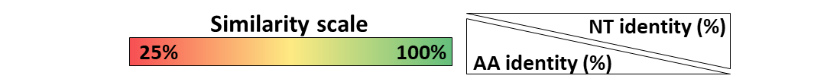
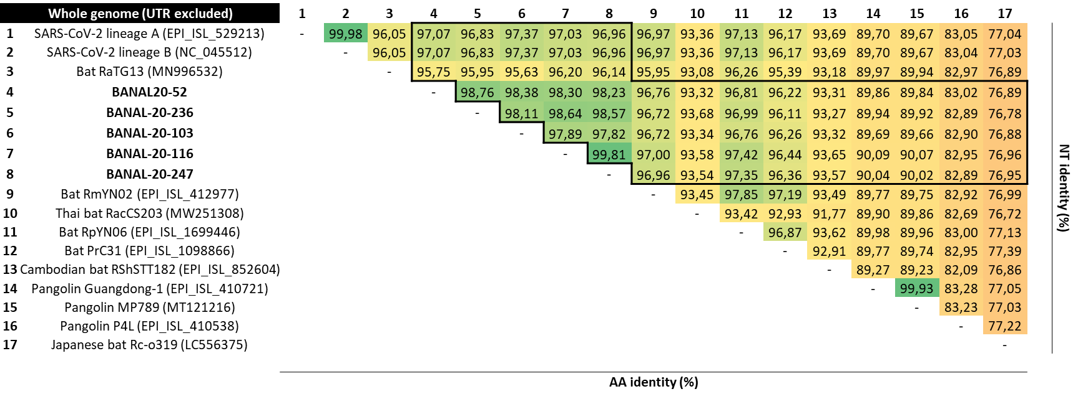
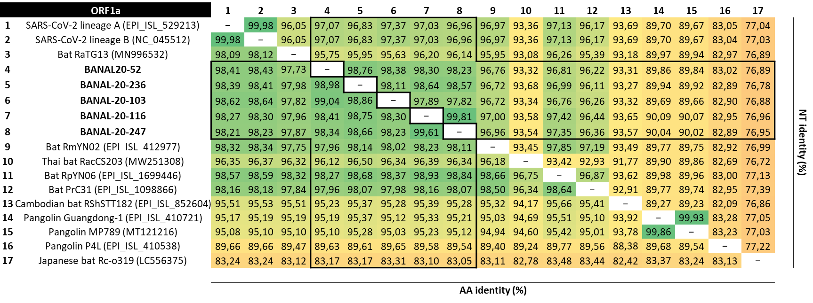
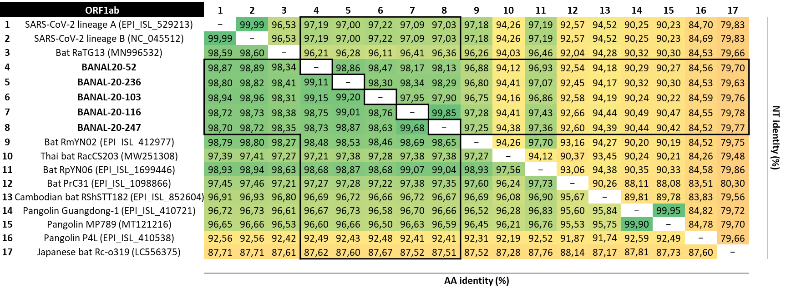
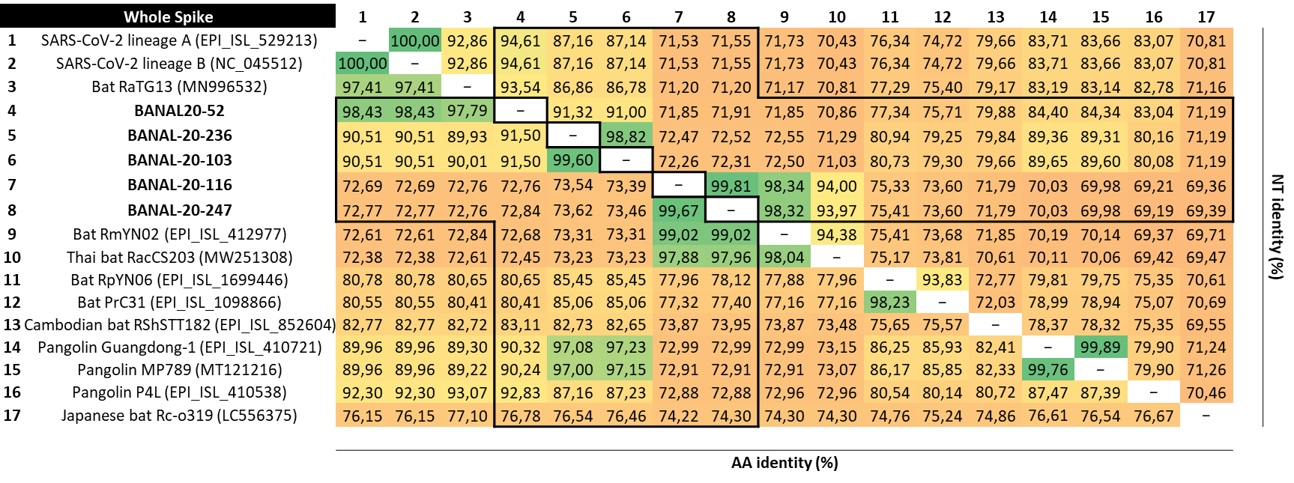
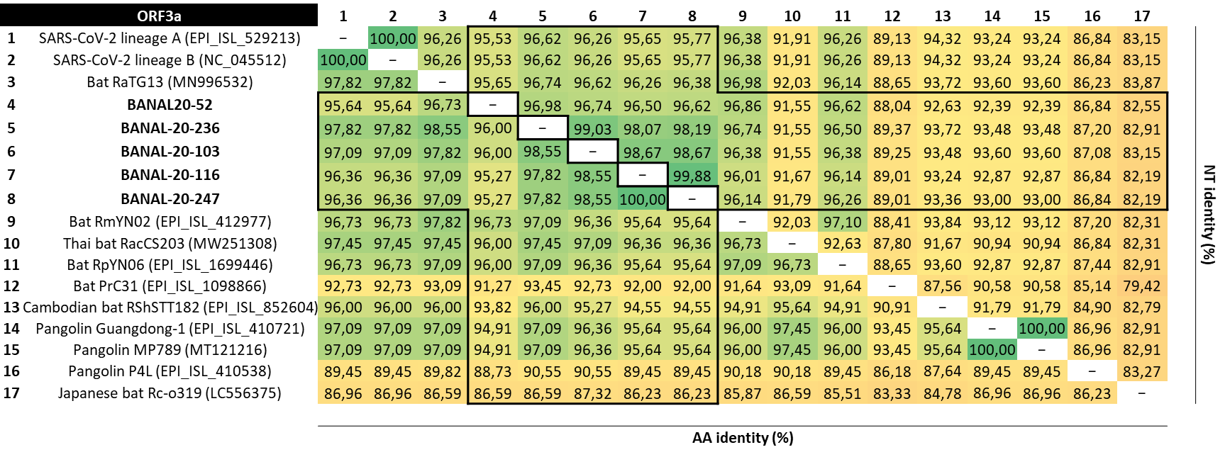
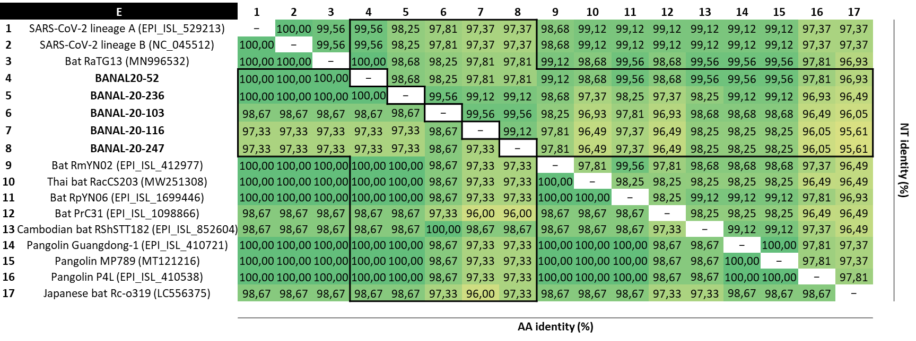
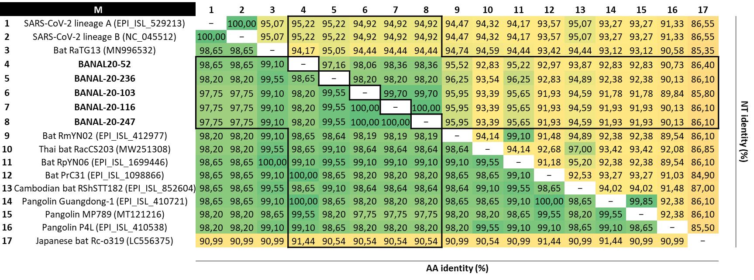
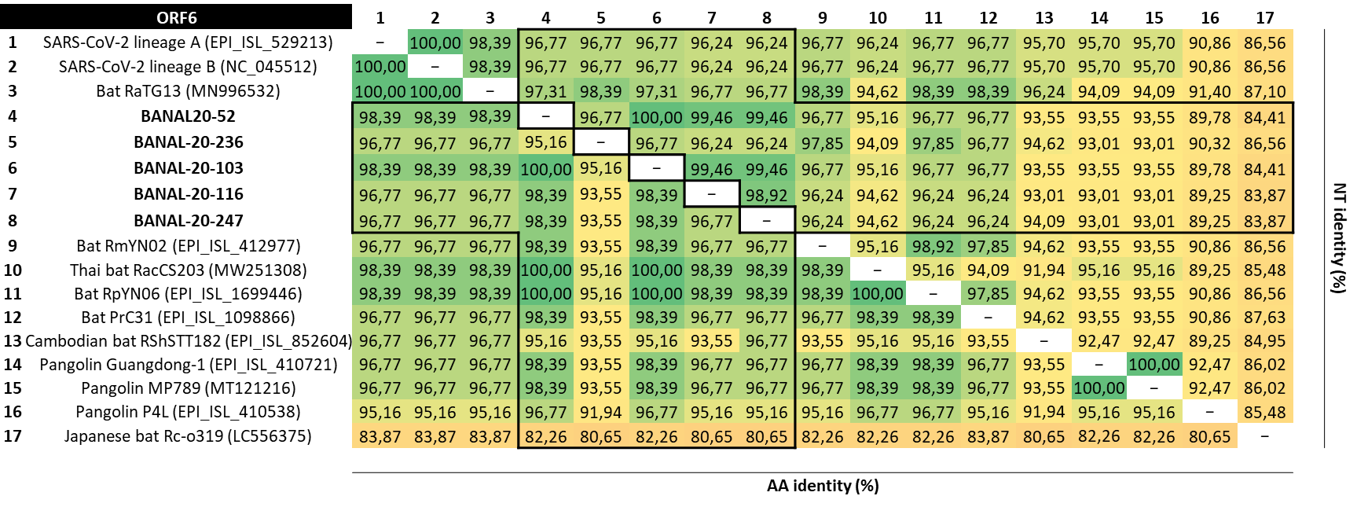
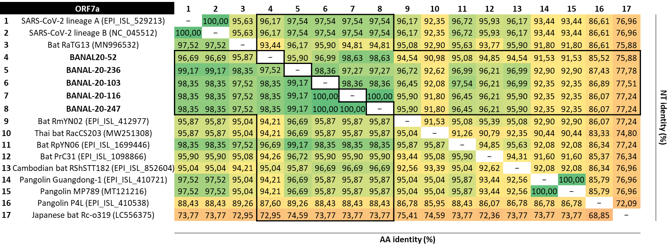
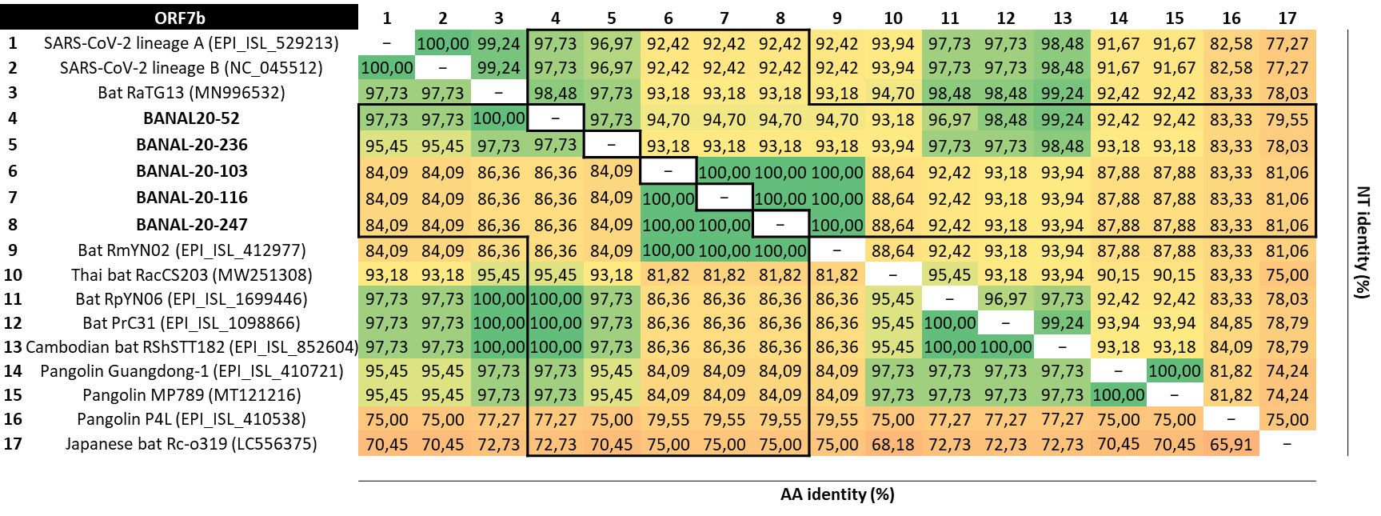
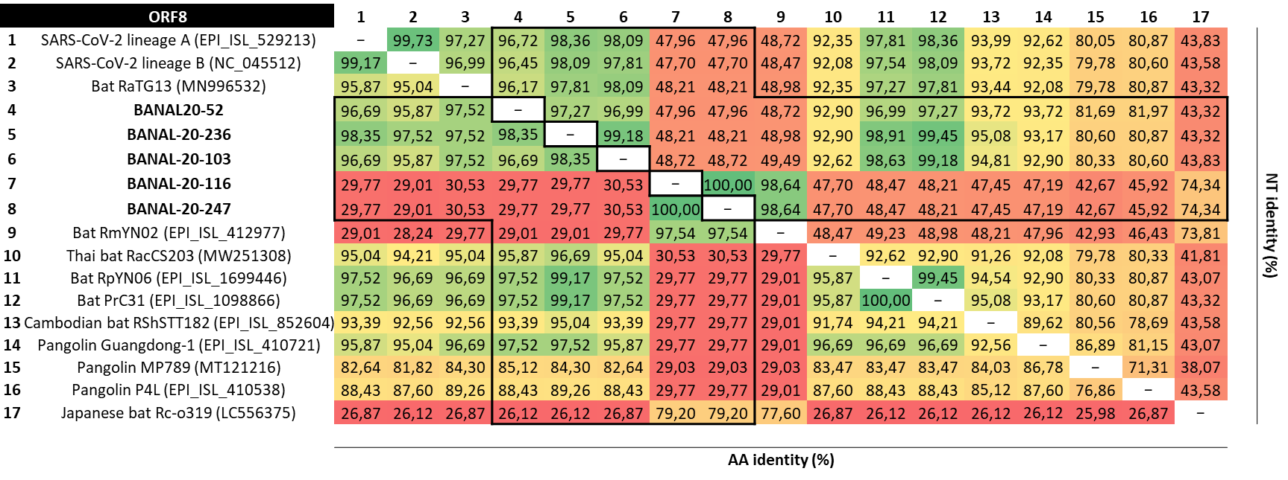
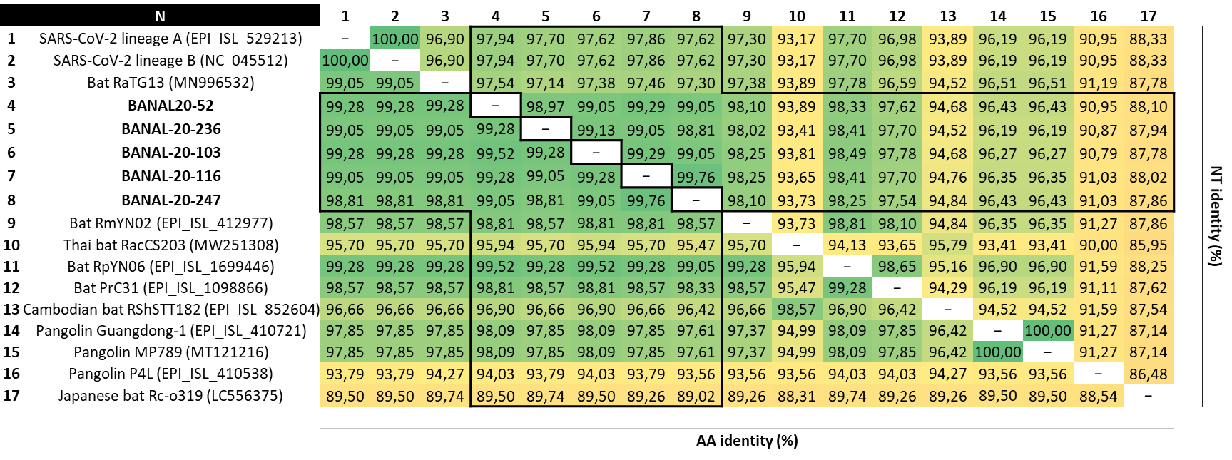
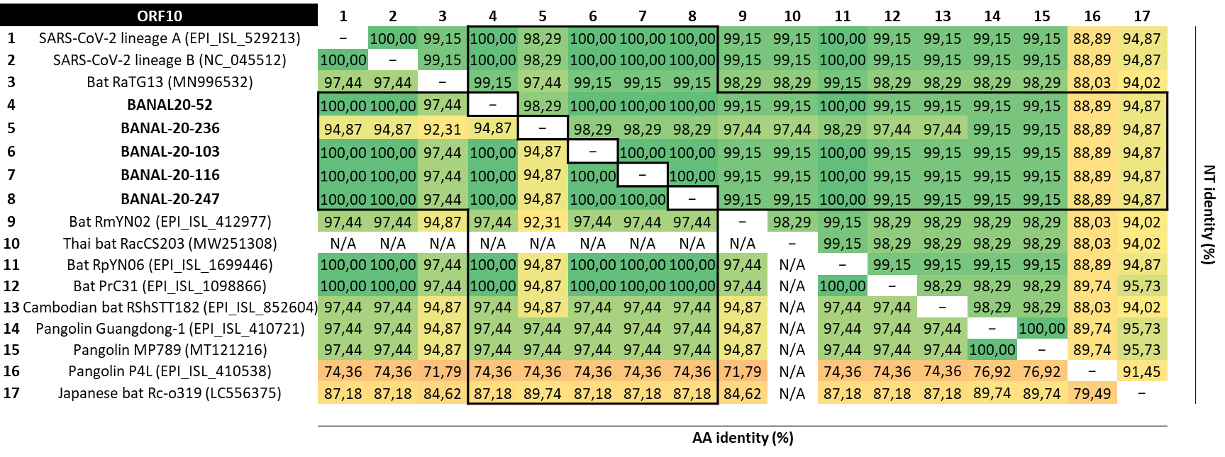

Figure S2: Complete phylogenetic reconstructions of recombinant fragments, as described in Figure 2.
The identification of the breakpoints is highly dependent on the programs used, the sequences datasets and the quality of the alignments, leading to difficulties in comparing independent studies performed with different tools. Phylogenetic analyses performed on different fragments are therefore necessary to confirm the identification of breakpoints, especially by confirming that the position of a given sequence differs between fragments bracketing the breakpoint. This is the strategy presented below: sequences are colored according to Figure 2.
The substitution model considered for all phylogenetic reconstructions presented below was GTR+G. PhyML was used to infer phylogenies both at the whole genome and at the breakpoints nucleotide level. The tree topology search was performed by selecting the best of NNI (Nearest Neighbor Interchange) and SPR (Subtree Pruning and Regraphing). The statistical test selected for branch support was the approximate Bayes parameter, as proposed in the NGPhylogeny portal. Only posterior probabilities >0.5 were considered.

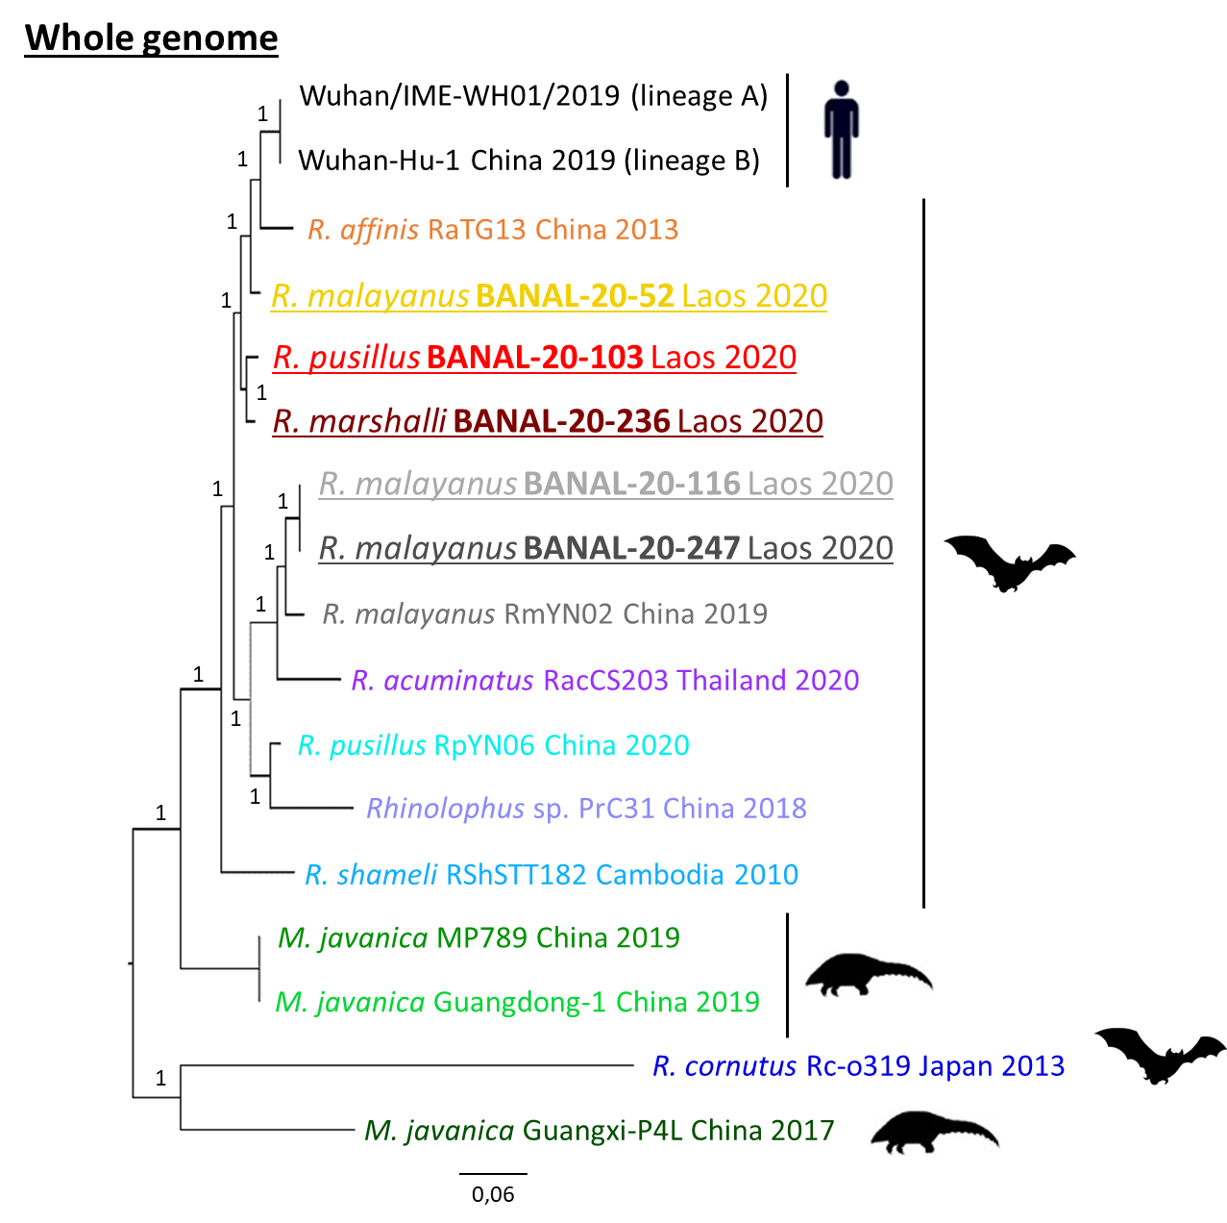

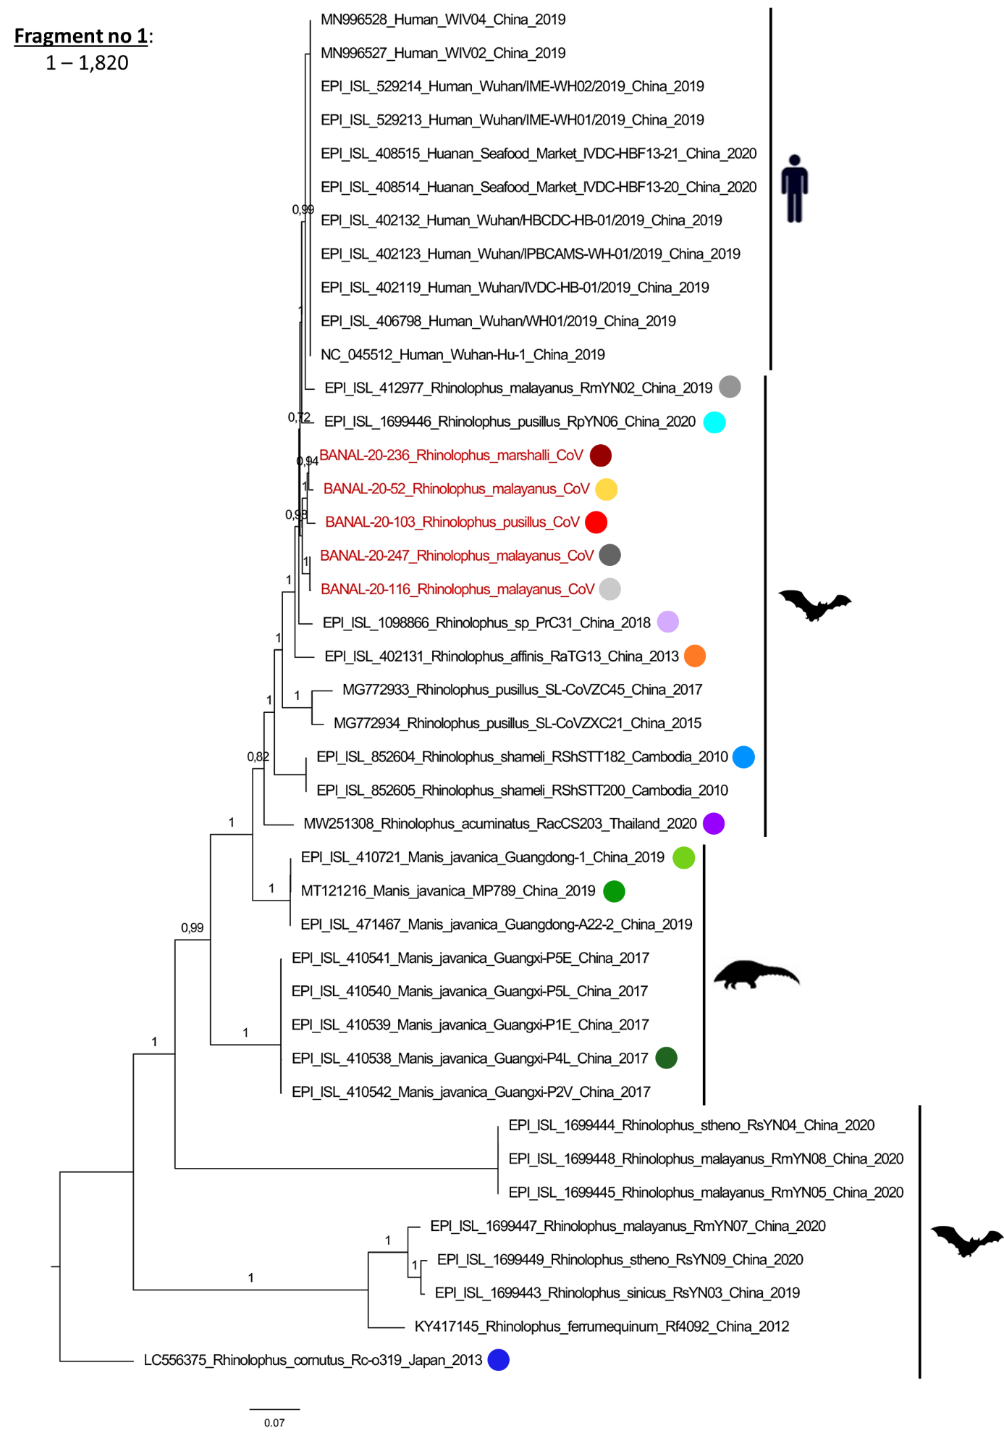
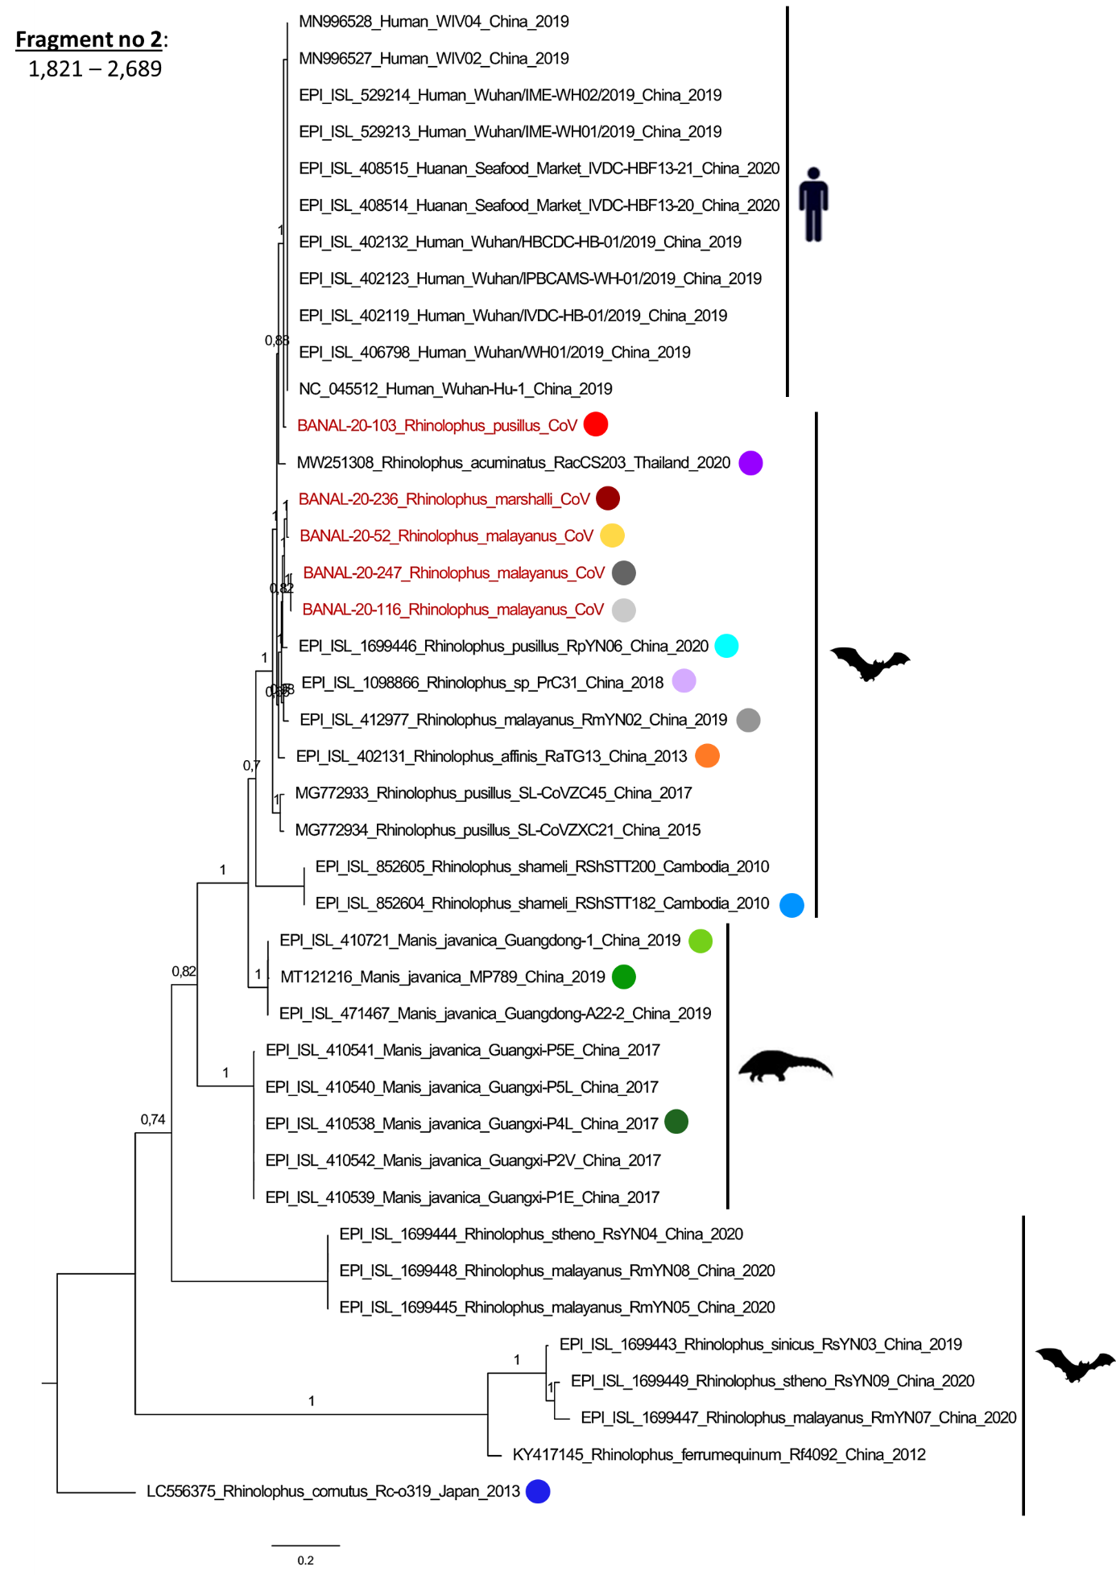
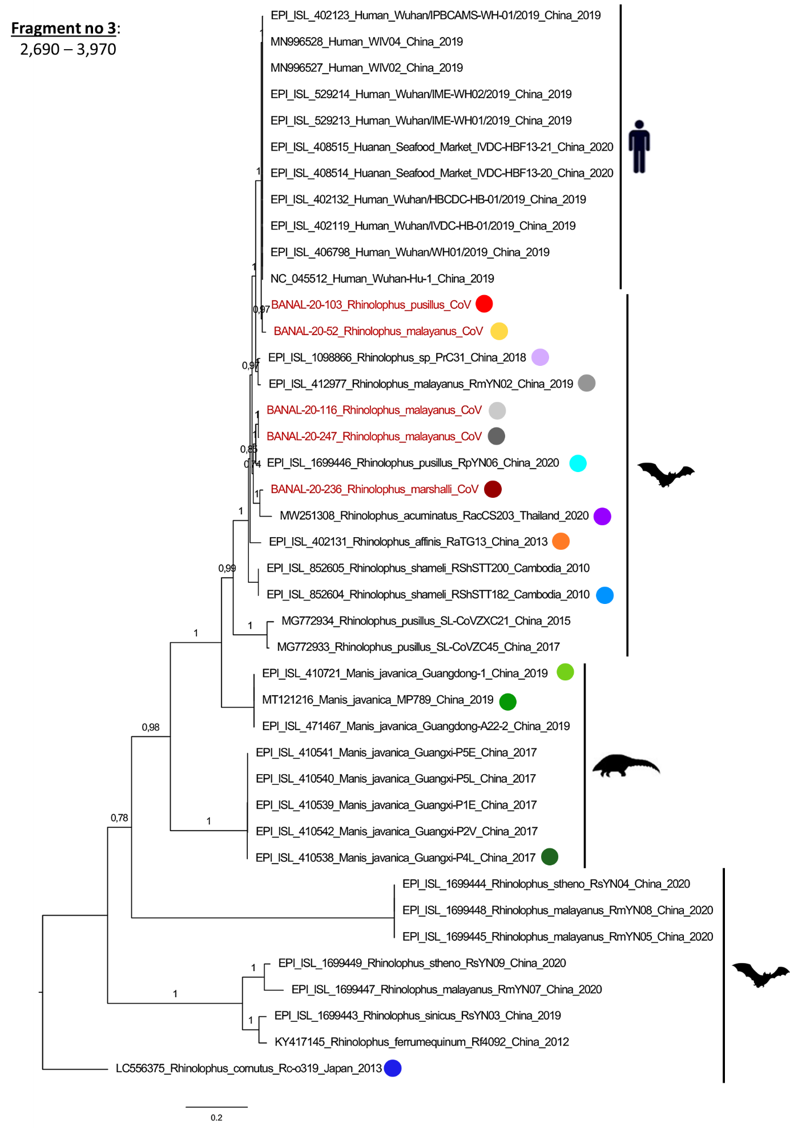
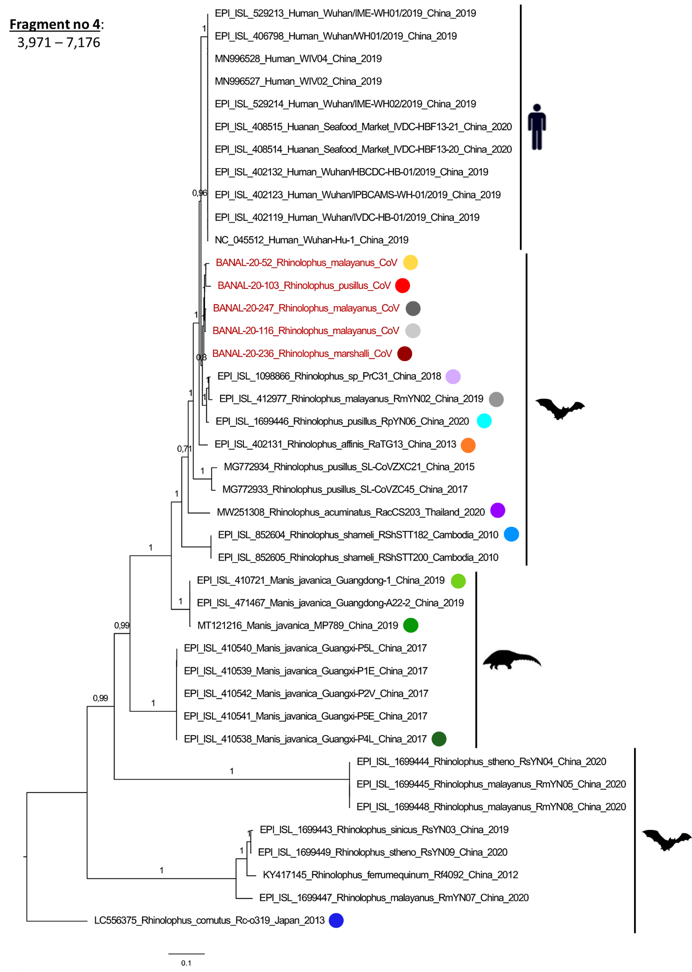
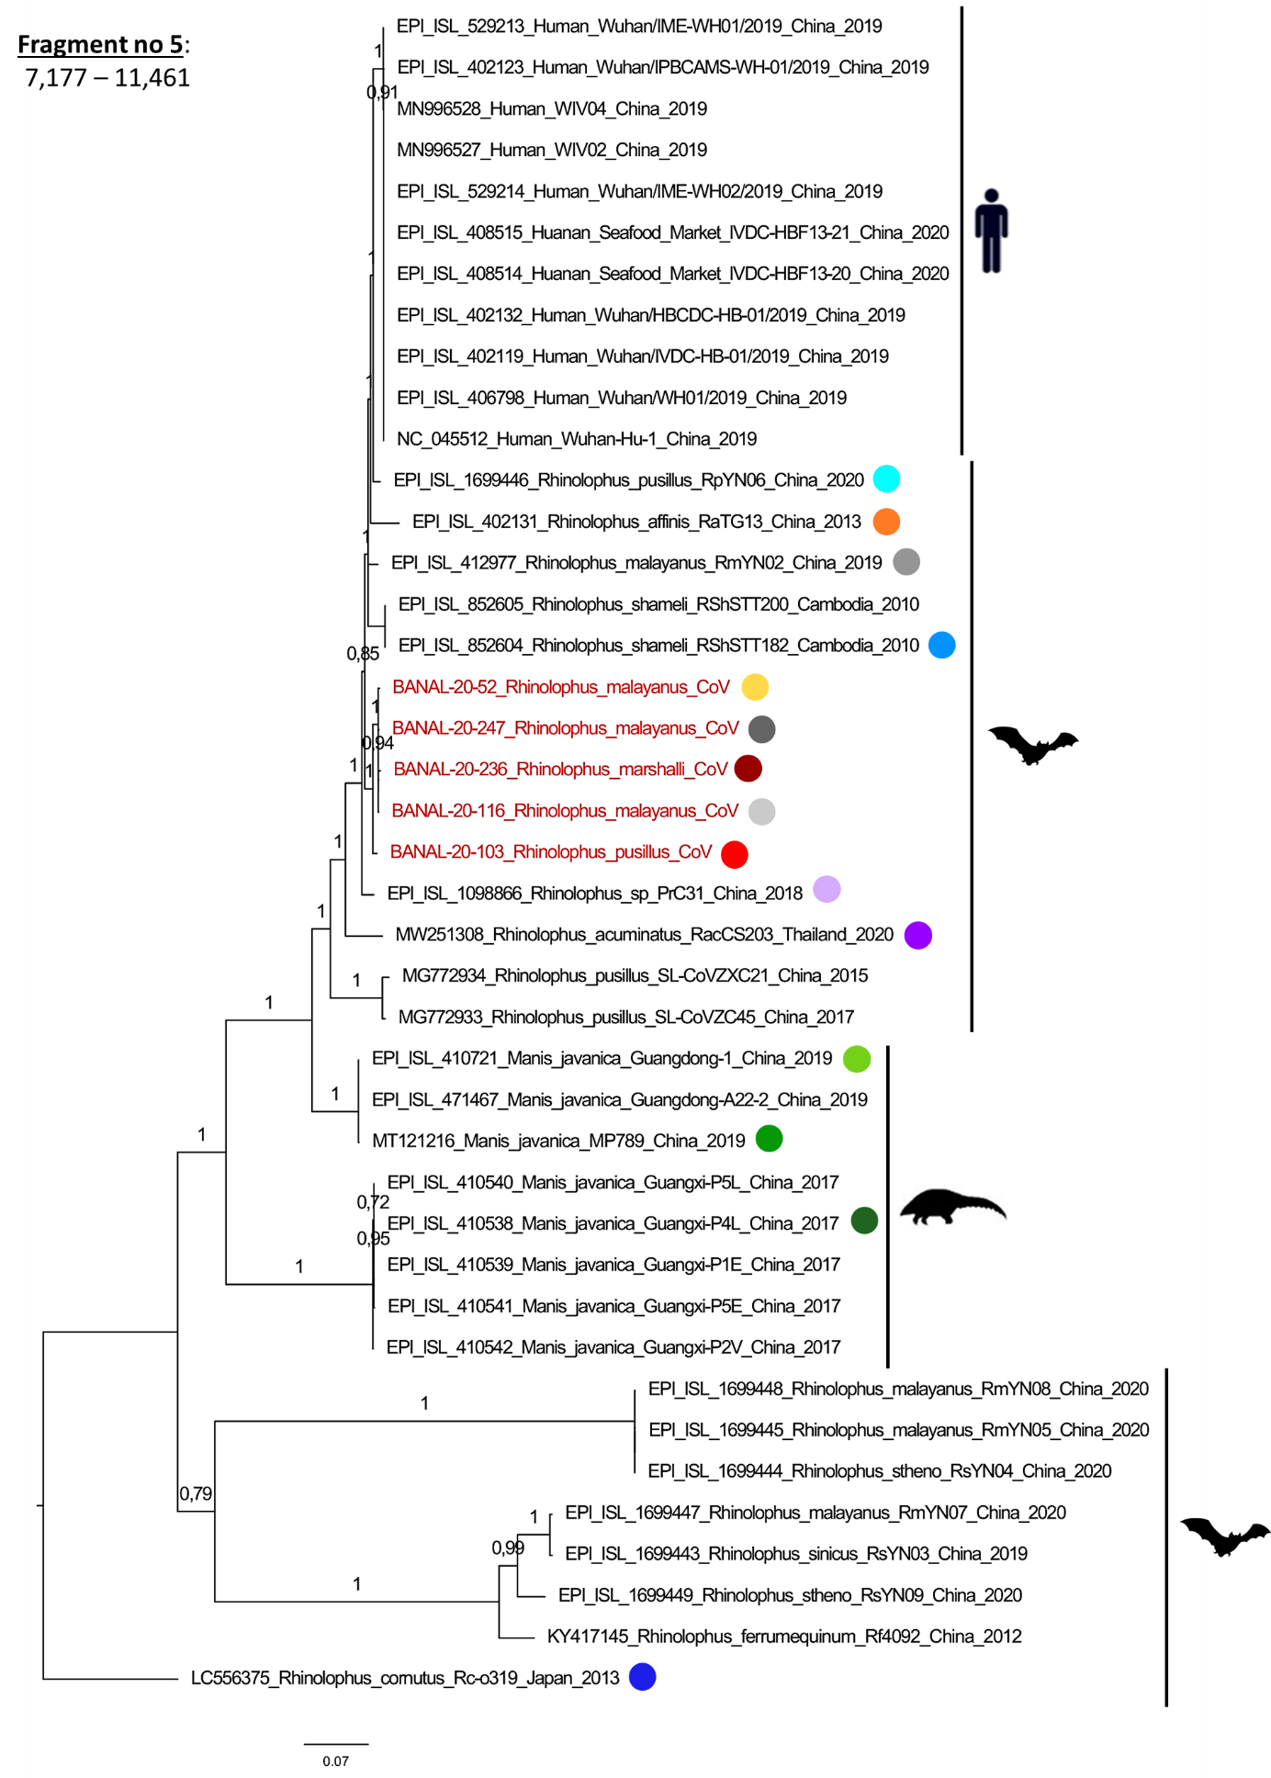
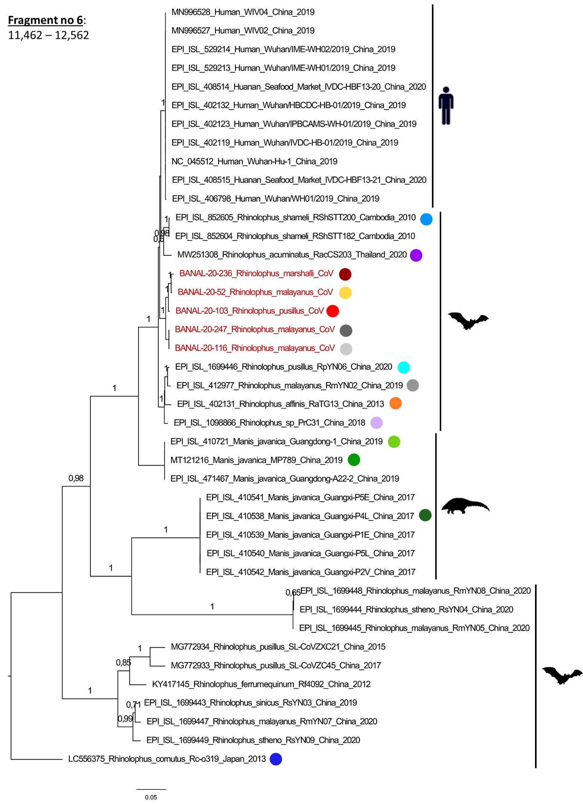
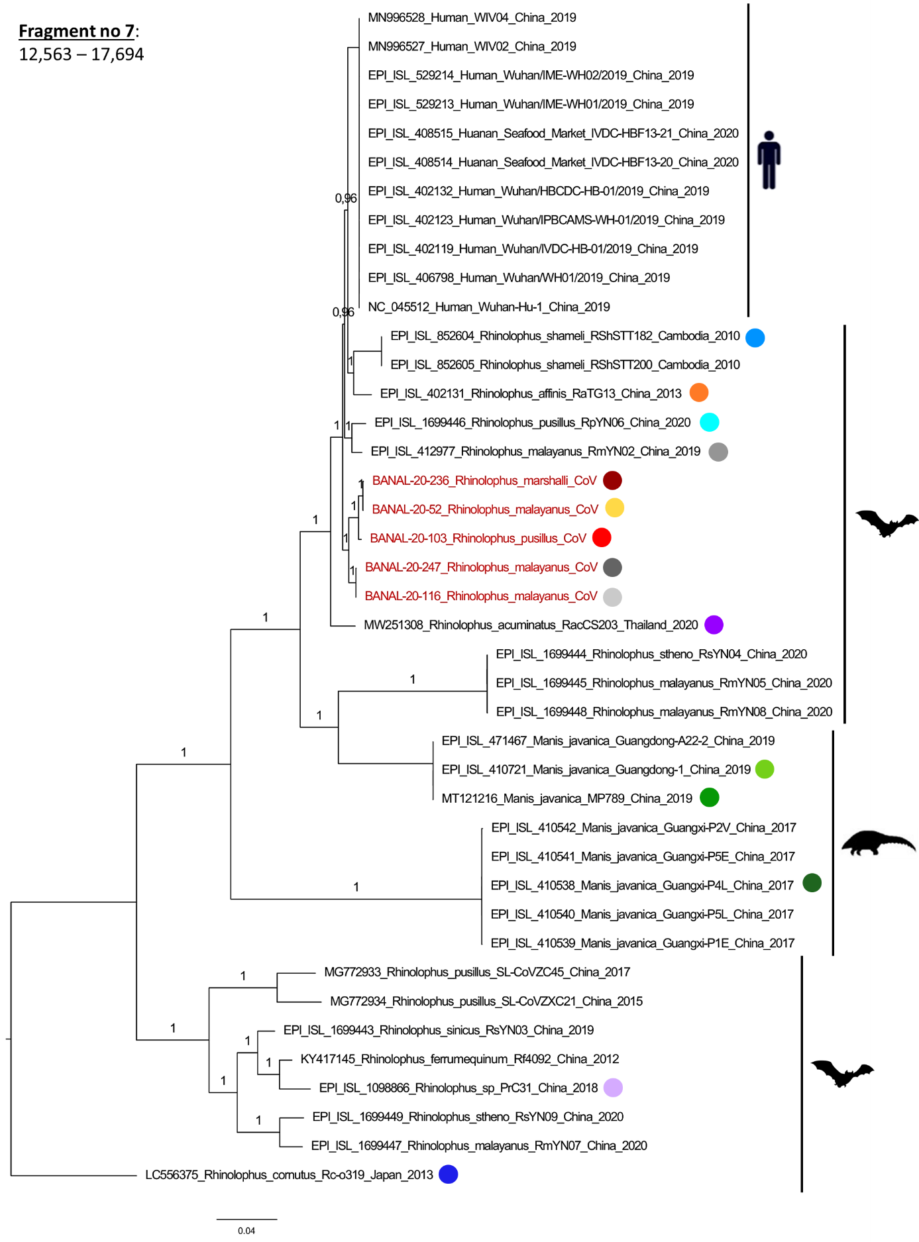
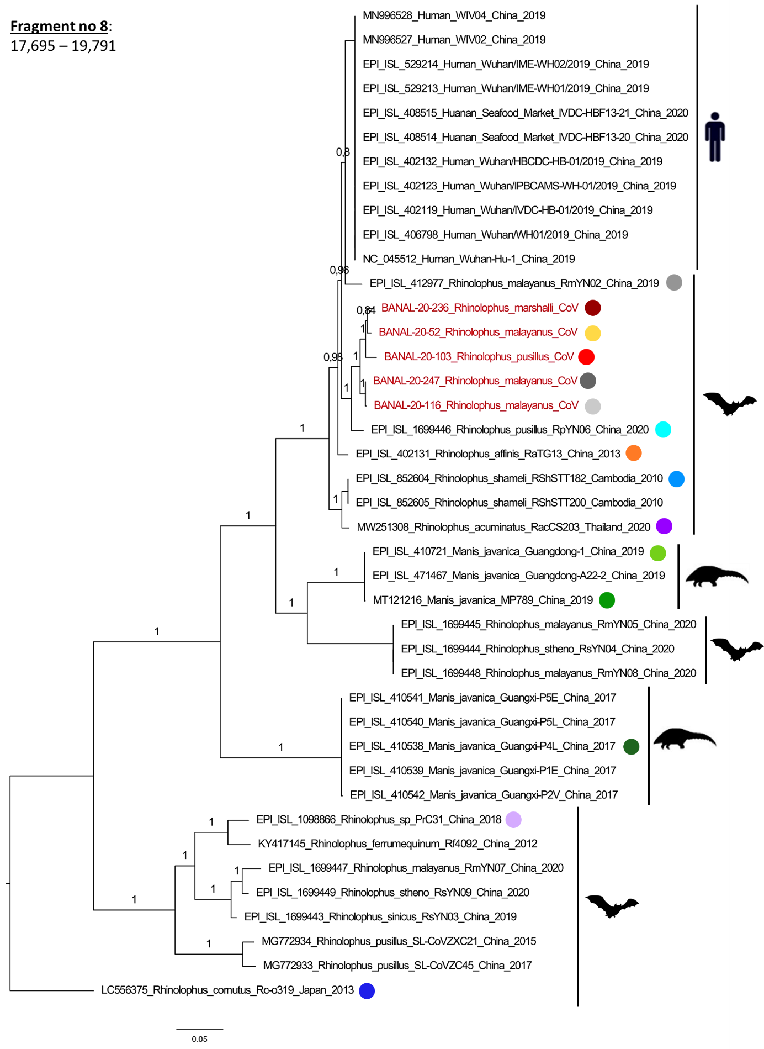
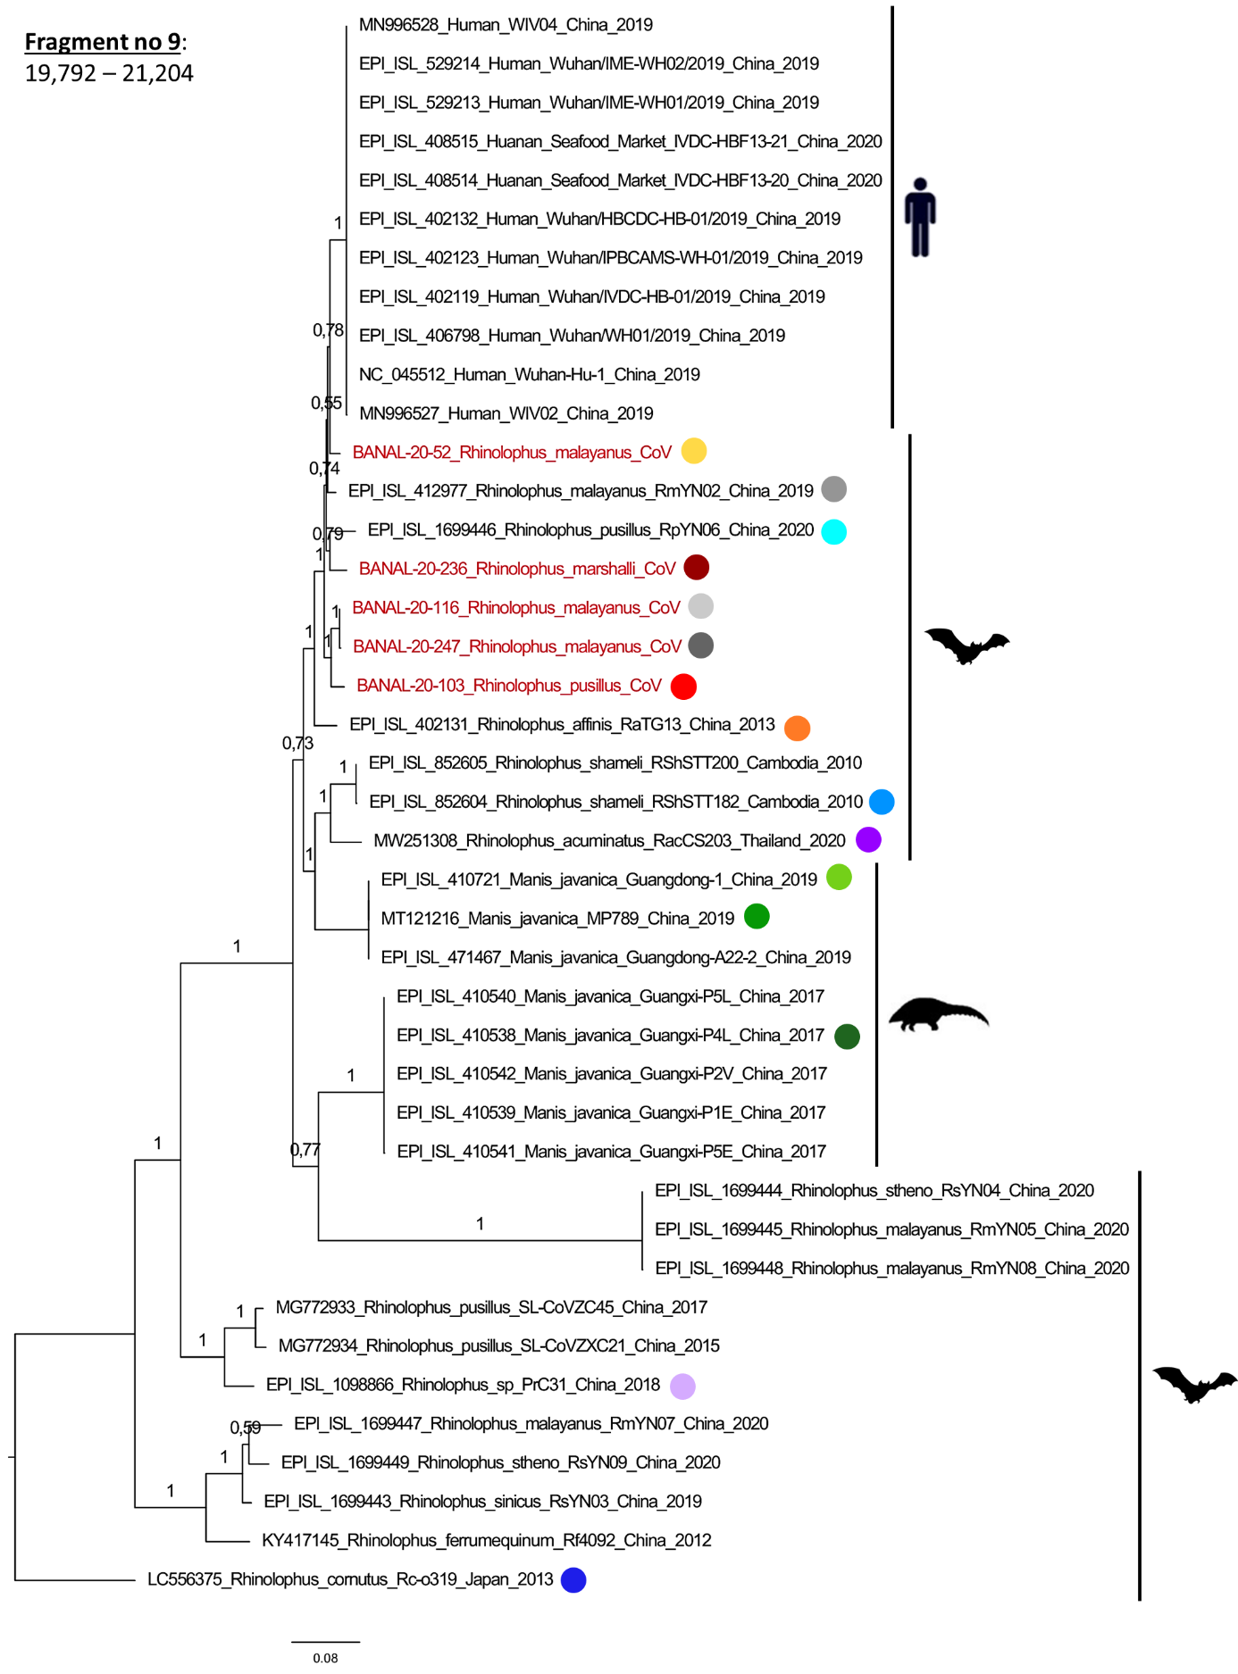
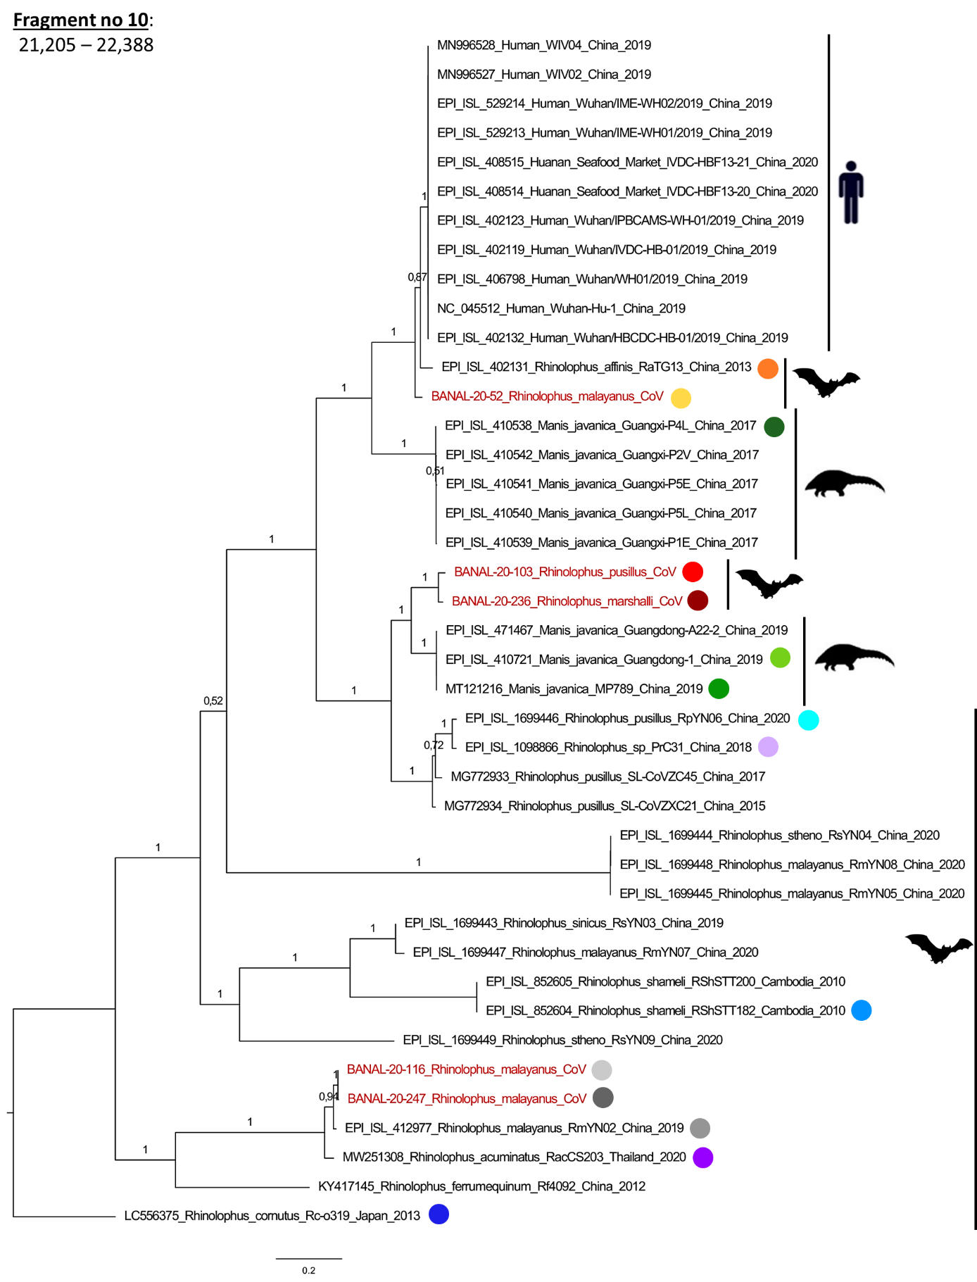
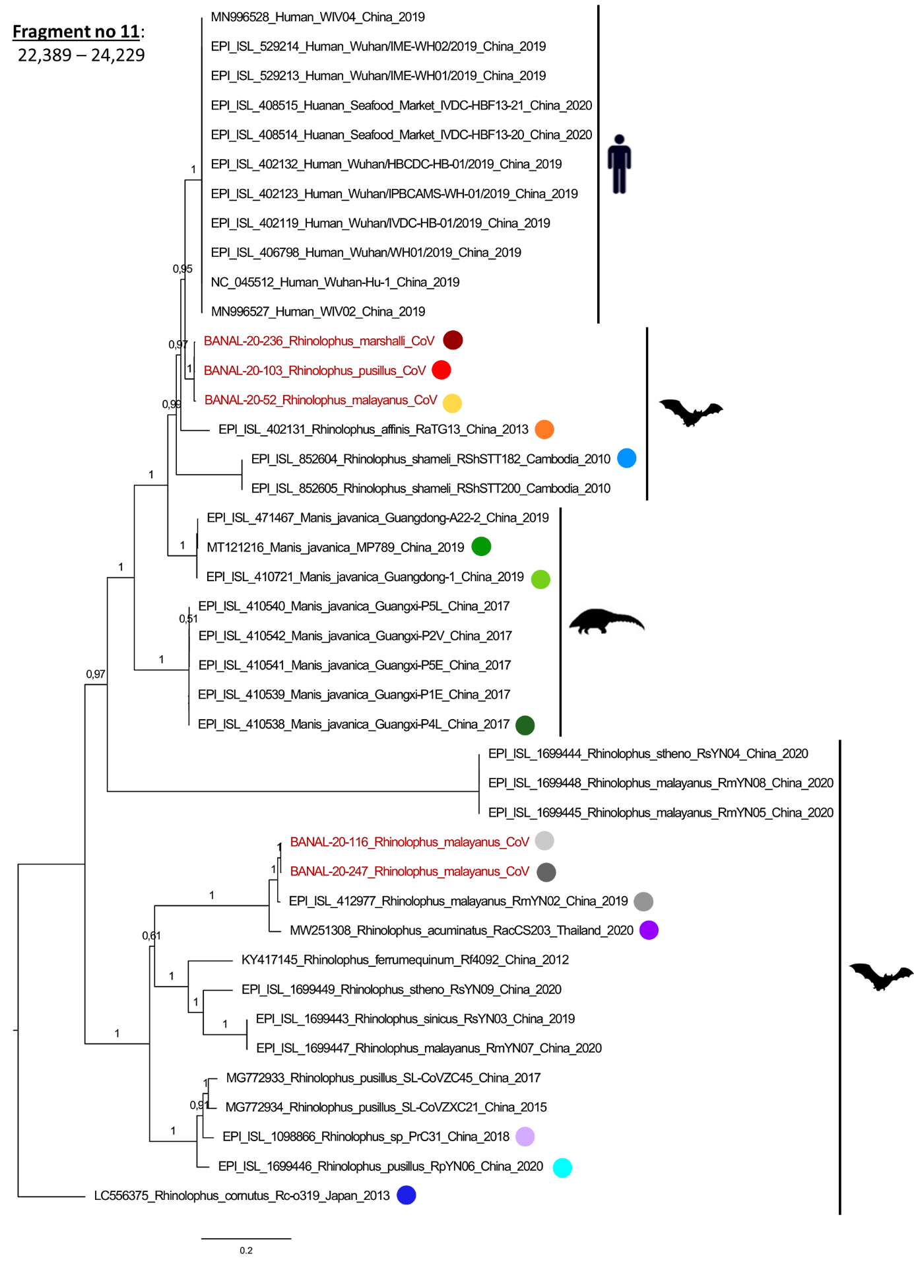
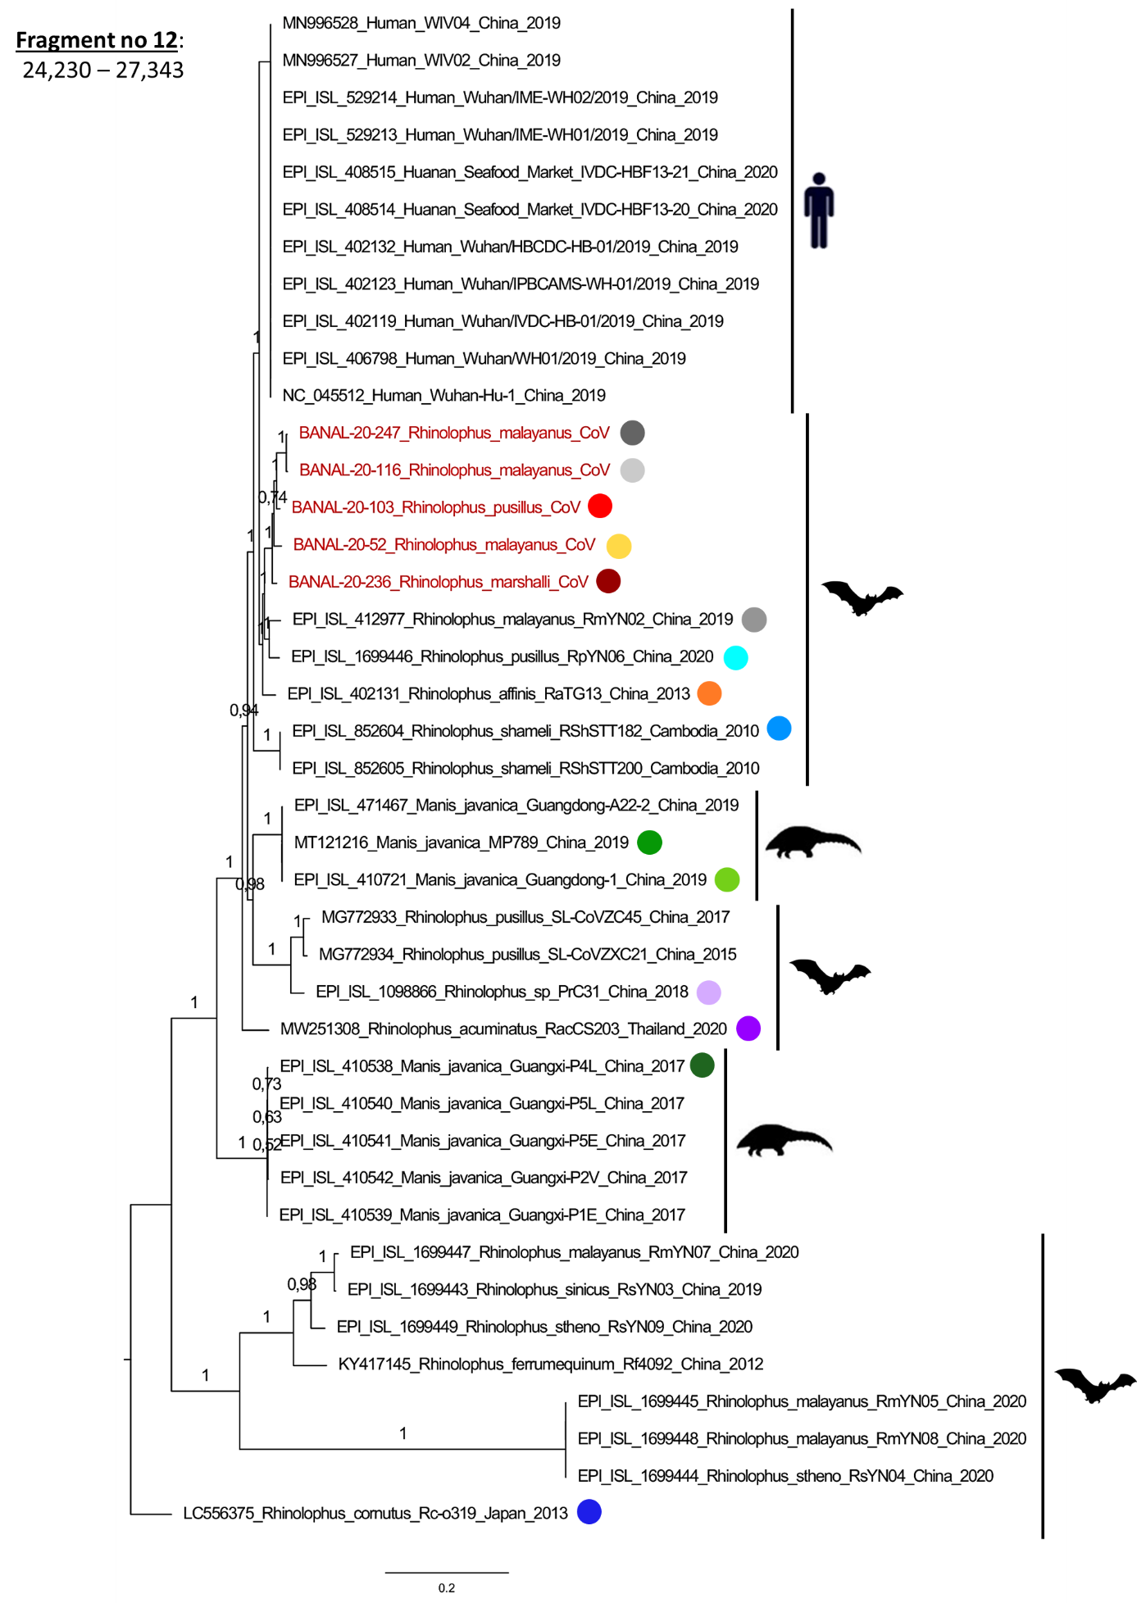
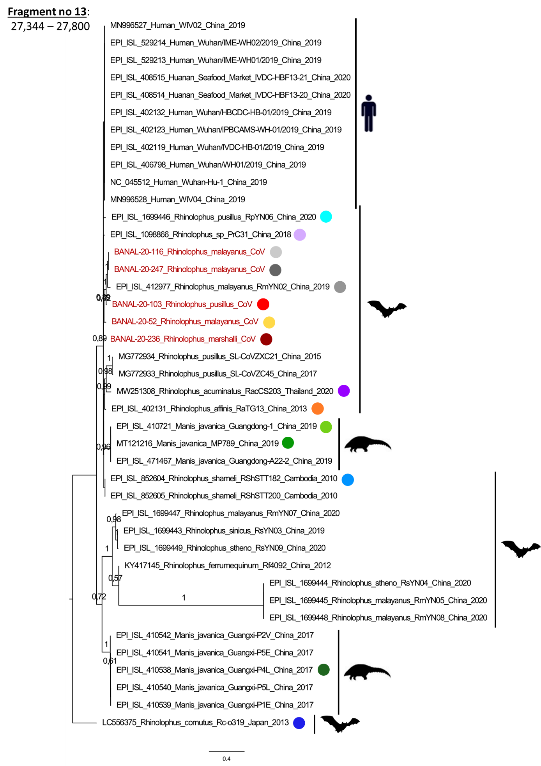
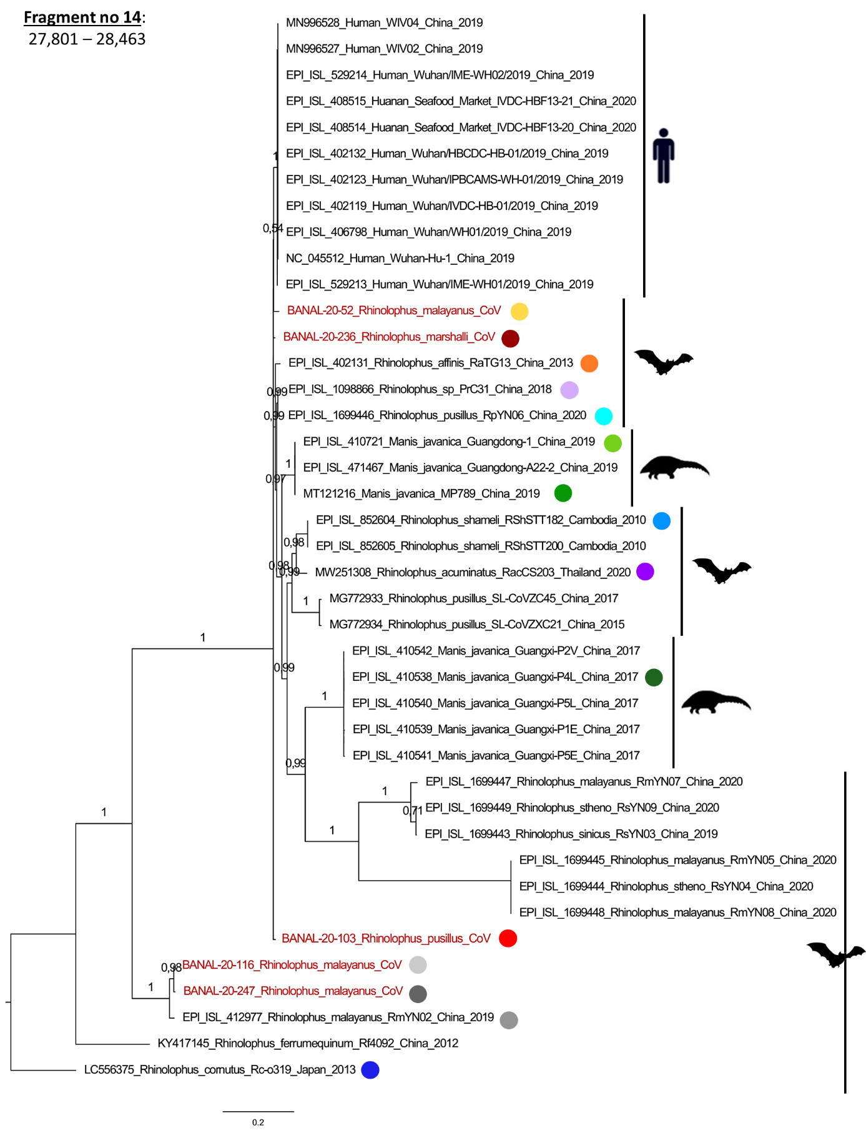
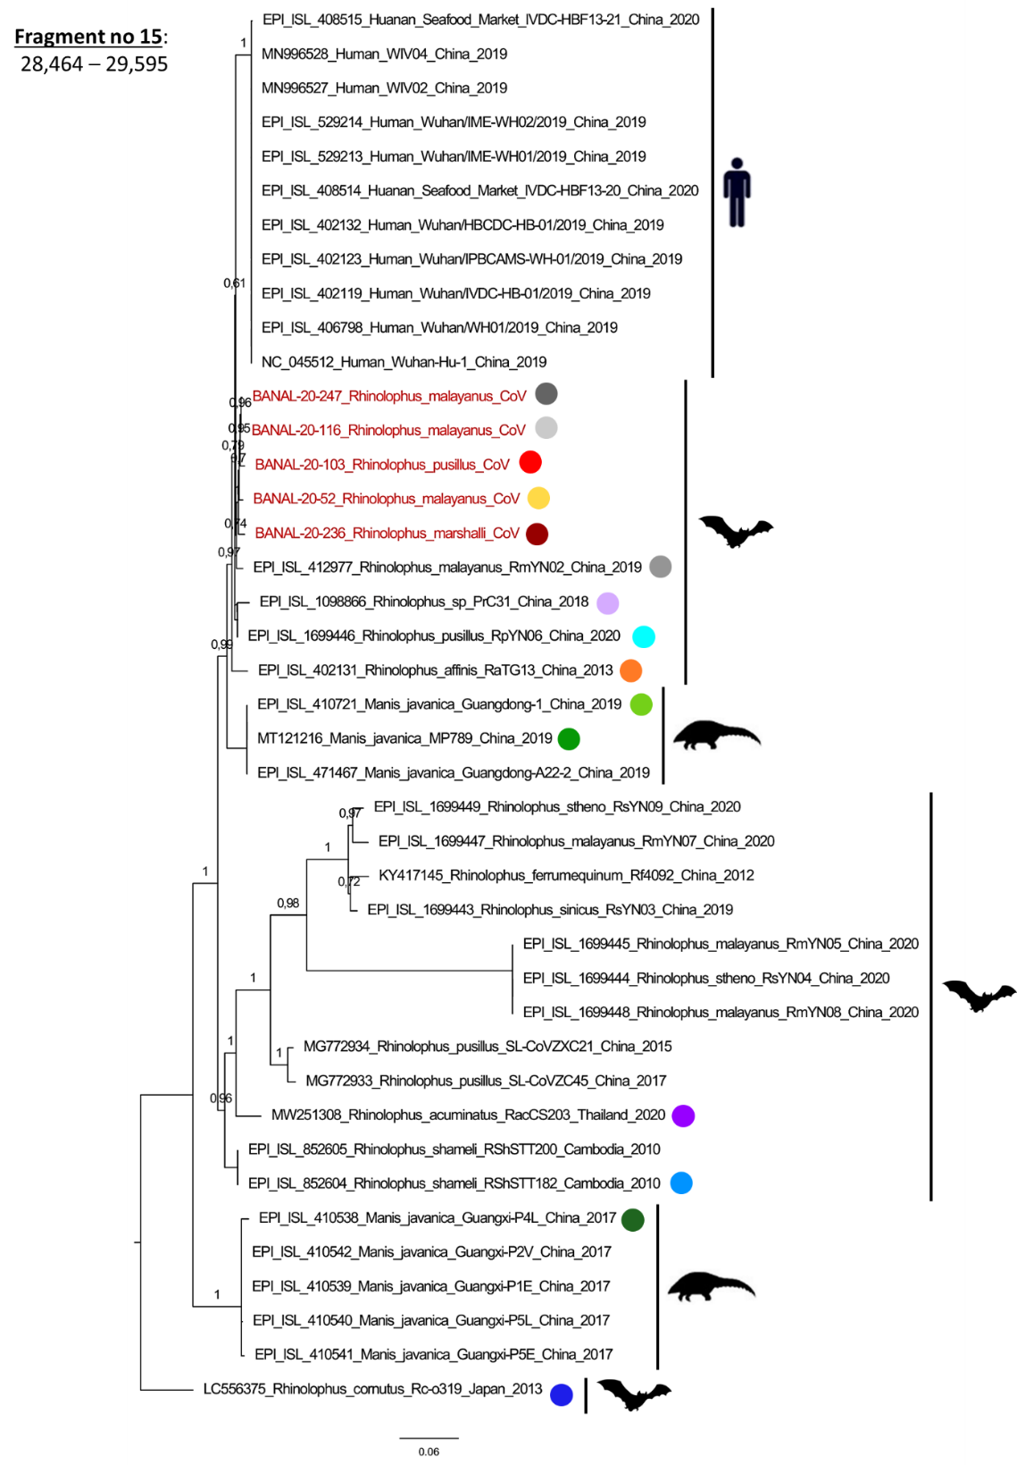

One should note that other studies have characterized the mosaicism of sarbecoviruses through recombination analysis. For example the program 3SEQ was used by to study the interlineage recombinations of SARS-CoV-2 variants¹. Boni et al. demonstrated using 3SEQ that Sarbecovirus evolution was shaped by multiple recombination events, including several at the beginning and within the spike, as we observed in our study². Forni et al. used 3SEQ and identified hotspots of recombination in sarbecoviruses, most of them located at the beginning of the spike³. Lytras et al. used (as in our study) GARD as a more conservative method than RDP5 (which includes a large set of programs) to identify breakpoints⁴. They identified 21 breakpoints through the genome of SARS-CoV-2, among which some are also found in our analysis (for example the one at the beginning of the spike, which seems to correspond to our breakpoint no 9).

Figure S3: Alignment of the whole spike amino-acid sequences.

Figure S4: Western-Blot analysis of concentrated lentivral particles pseudotyped with Wuhan or BANAL-236 spike proteins.
Pseudotyped lentivral particles were concentrated by ultracentrifugation at 40,000g for 2h through a 20% sucrose cushion (MLS-50 rotor in an Optima MAX-XP ultracentrifuge). Pellets were resuspended in 250 µL of DMEM for 30 min at 4°C. An equal amount of 2X NuPAGE LDS sample buffer was added and different volumes were loaded onto a 4-12% NuPAGE Bis-Tris gel (Thermofisher). PVDF membranes (Hybond®, Amersham) were incubated with primary antibodies directed against Spike (ABIN199984, 1/2,000) or p24 (NIH, 1/2000) and revealed with peroxidase-conjugated secondary antibodies (GE Healthcare) and the ECL2 substrate (Thermofisher). The chemiluminescence signals were acquired using a ChemiDoc Imager (Bio-Rad) (uncropped blot below). A single experiment was performed, and cropped and un-cropped blots are presented below.
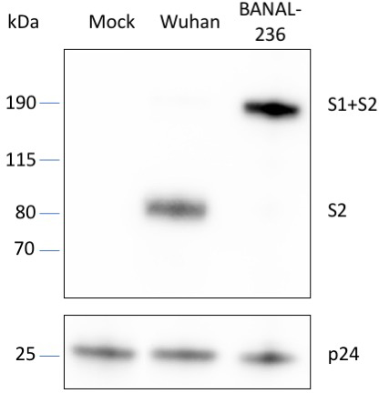
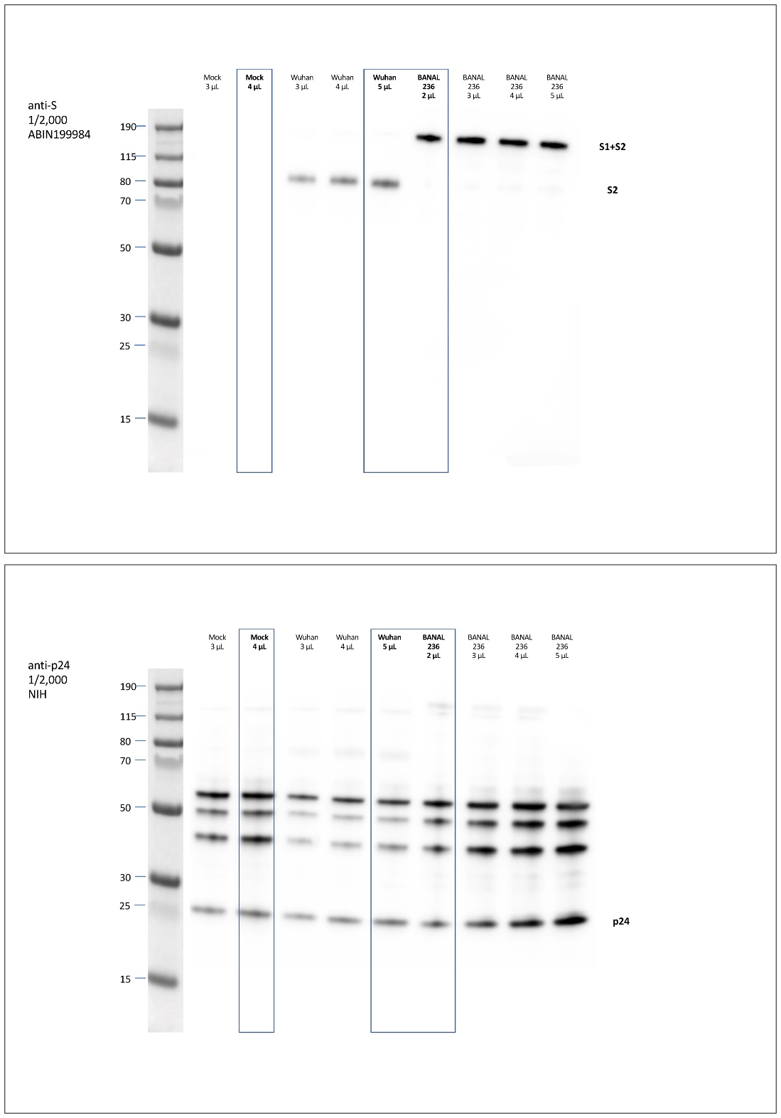

Figure S5: Distribution of bats species from which SARS-CoV-2-like viruses were detected in this study. Distribution of R. pusillus (green), R. marshalli (red), and R. malayanus (blue). Data were retrieved from the IUCN Red List of Threatened Species (https://www.iucnredlist.org/) and map was downloaded from https://www.diva-gis.org/gdata.
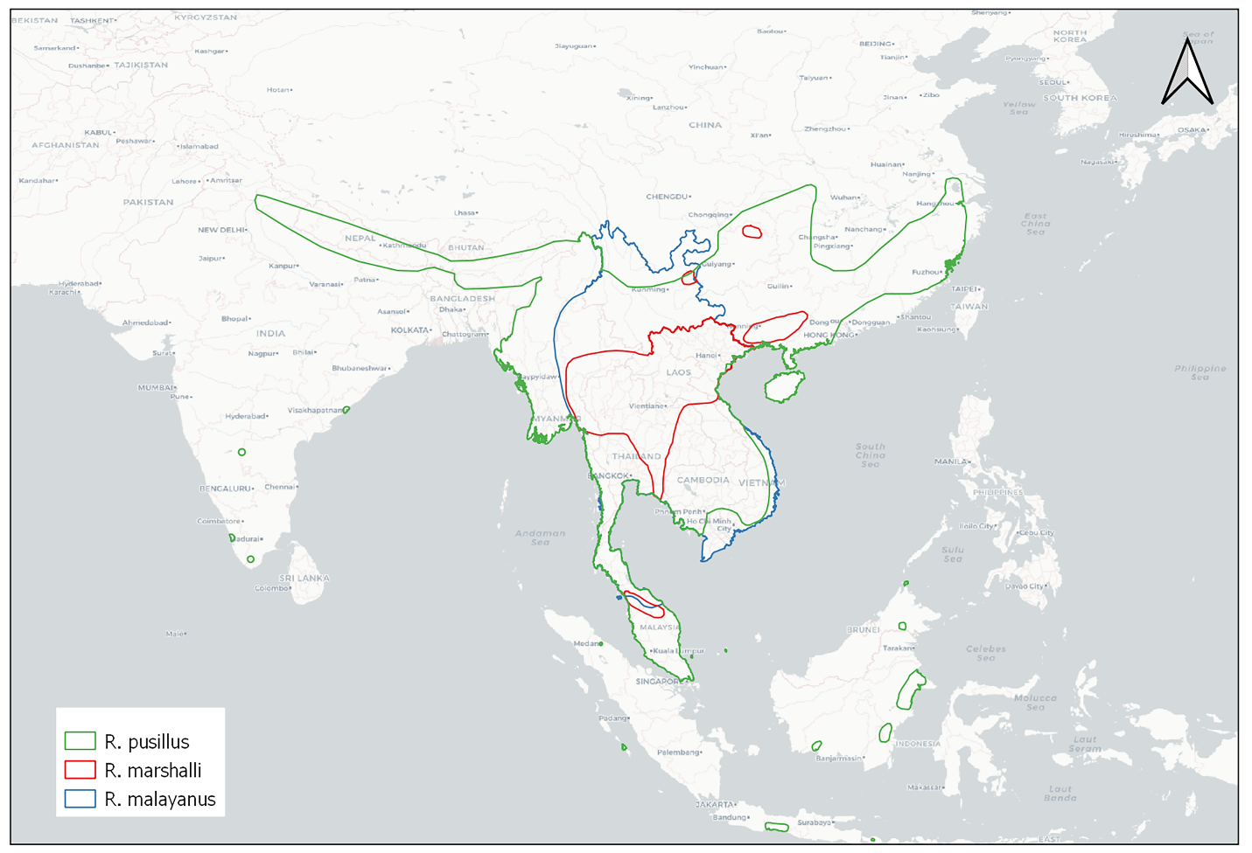

References

1. Jackson, B. et al. Generation and transmission of interlineage recombinants in the SARS-CoV-2 pandemic. Cell 184, 5179-5188.e8 (2021).
2. Boni, M. F. et al. Evolutionary origins of the SARS-CoV-2 sarbecovirus lineage responsible for the COVID-19 pandemic. Nat Microbiol 5, 1408–1417 (2020).
3. Forni, D., Cagliani, R. & Sironi, M. Recombination and Positive Selection Differentially Shaped the Diversity of Betacoronavirus Subgenera. Viruses 12, E1313 (2020).
4. Lytras, S. et al. Exploring the natural origins of SARS-CoV-2 in the light of recombination. 2021.01.22.427830 https://www.biorxiv.org/content/10.1101/2021.01.22.427830v3 (2021) doi:10.1101/2021.01.22.427830.

