Supplementary information

Separating water isotopologues using diffusion-regulatory porous materials

Yan Su¹, Ken-ichi Otake², Jia-Jia Zheng³, Satoshi Horike², Susumu Kitagawa²*, Cheng Gu^{1,4}*

*Corresponding to kitagawa@icems.kyoto-u.ac.jp; gucheng@scut.edu.cn

This PDF file includes:

Table of Contents
Supplementary Materials and methods
Supplementary Figures S1 to S89
Supplementary Tables S1 to S6
Captions for Crystallographic Data S1 to S4
Supplementary References (S1−S18)

Table of Contents

1. Supplementary Materials and methods........................................................................P3−P7
Section 1: Syntheses of ligands...........................................................................................................P3−P4
Section 2: Instruments and characterizations......................................................................................P4−P6
Section 3: Theoretical calculation.......................................................................................................P6−P7

2. Supplementary Figures S1 to S89................................................................................P8−P98
Section 1: ¹H and ¹³C NMR, mass spectra, and calculated flip-flop energies of the ligands............P8−P21
Section 2: Morphology, infrared spectra, and crystal structures of as-synthesized FDCs..............P22−P25
Section 3: ¹H NMR, TG, and PXRD of activated FDCs.................................................................P26−P29
Section 4: Kinetic sorption of H₂O and D₂O in small-sized materials (control experiments).................P30
Section 5: Crystal lattice parameters, DSC, and PXRD of FDCs...................................................P31−P33
Section 6: Infrared spectra of FDCs after H₂O and D₂O adsorption.......................................................P34
Section 7: H₂O and D₂O sorption curves of FDCs under different exposure time.................................P35
Section 8: Global pressure–temperature–diffusion-rate–adsorption amount curves for FDCs......P36−P37
Section 9: Variable-temperature PXRD and mechanism for H₂O and D₂O adsorption.................P38−P44
Section 10: Theoretical calculation of the diffusion energies and rates.........................................P45−P46
Section 11: Vapor separation experiments for FDCs.....................................................................P47−P87
Section 12: Vapor separation experiments for small-sized materials (control experiments).........P88−P96
Section 13: Static mixed-liquid co-adsorption experiments for FDCs...........................................P97−P98

3. Supplementary Tables S1 to S6...............................................................................P99−P104
Section 1: Structures and physicochemical properties of H₂O and D₂O.................................................P99
Section 2: Crystallographic data for as-synthesized and water-adsorbed FDCs.........................P100−P102
Section 3: Test calculations on the computational method....................................................................P103
Section 4: Calculated energies for H₂O and D₂O diffusions in FDCs...................................................P104

4. Captions for Crystallographic Data S1 to S4..................................................................P105

5. Supplementary References (S1−S18)...............................................................................P106

Materials and Methods
Section 1: Syntheses of ligands
Materials
Dimethyl 5-iodoisophthalate (98%, Jilin Chinese Academy of Sciences-Yanshen Technology Co., Ltd.), tris(dibenzylideneacetone)dipalladium(0) (75%, TCI), 5H-dibenzo[b,f]azepine (98%, TCI), 2,2'-iminodibenzyl (98%, TCI), cesium carbonate (98%, TCI), 2-dicyclohexylphosphino-2',4',6'-triisopropylbiphenyl (98%, TCI), sodium hydroxide (97%, Energy Chemical), anhydrous hexane (99.5%, Energy Chemical), anhydrous toluene (99.5%, Energy Chemical), anhydrous N,N-dimethylacetamide (99.5%, Energy Chemical), anhydrous tetrahydrofuran (99.5%, Energy Chemical), anhydrous methanol (99.5%, Energy Chemical), anhydrous ethyl acetate (99.5%, Energy Chemical), anhydrous magnesium sulfate (99.5%, Energy Chemical), 12 M HCl (Aldrich), 12 M DCl in D₂O (Aldrich), copper(II) nitrate pentahydrate (99.99%, Aldrich), deuterated water for vapor sorption (TCI) and deuterated solvents for nuclear magnetic resonance (NMR) spectroscopy (Cambridge Isotope Laboratories) were purchased and used without further purification.

Synthesis of DBAP-ipa and IDB-ipa ligands
Synthesis of dimethyl 5-(5H-dibenzo[b,f]azepin-5-yl)isophthalate (1): Dimethyl 5-iodoisophthalate (19.20 g, 60.0 mmol, 1.2 eq.), 5H-dibenzo[b,f]azepine (9.66 g, 50.0 mmol, 1.0 eq.), 2-dicyclohexylphosphino-2',4',6'-triisopropylbiphenyl (XPhos, 1.19 g, 2.5 mmol, 0.05 eq.), cesium carbonate (32.58 g, 100.0 mmol, 2.5 eq.), tris(dibenzylideneacetone)dipalladium(0) (1.37 g, 1.5 mmol, 0.03 eq.) and toluene (200 mL) were placed in a flask whose inner gas was replaced by N₂. The mixture was stirred at 115 °C for 48 h. After cooling down to room temperature, the reaction mixture was filtered through Celite®. The filtrate was diluted with AcOEt (200 mL) and washed with water. The organic phase was dried over MgSO₄, filtered and evaporated under reduced pressure. The residue was purified by column chromatography (SiO₂, AcOEt/n-hexane with the ratio changing from 3 to 6%) to give 1 (11.18 g, yield = 58%) as a light-yellow solid. ¹H NMR (500 MHz, DMSO-d₆): δ (ppm) = 7.78 (1H, s, Ph C₂-H), 7.61-7.67 (4H, m, DBAP C_{3,7}-H and DBAP C_{1,9}-H), 7.59 (2H, d, J = 7.4 Hz, DBAP C_{4,6}-H), 7.51 (2H, t, J = 7.4 Hz, DBAP C_{2,8}-H), 6.96 (2H, s, DBAP C_{10,11}-H), 6.93 (2H, d, J = 1.1 Hz, Ph C_{4,6}-H); 3.74 (6H, s, -CO₂CH₃); ¹³C NMR (126 MHz, DMSO-d₆): δ (ppm) = 165.94, 149.65, 141.86, 135.96, 131.27, 131.02, 130.96, 130.79, 130.15, 128.48, 119.44, 115.90, 52.82; ESI-MS (positive mode): calcd. for [M+Na]⁺, m/z = 408.1212; found m/z = 408.1210.
Synthesis of dimethyl 5-(iminodibenzyl)isophthalate (2): Dimethyl 5-iodoisophthalate (19.20 g, 60.0 mmol, 1.2 eq.), 2,2'-iminodibenzyl (9.76 g, 50.0 mmol, 1.0 eq.), 2-dicyclohexylphosphino-2',4',6'-triisopropylbiphenyl (XPhos, 1.19 g, 2.5 mmol, 0.05 eq.), cesium carbonate (32.58 g, 100.0 mmol, 2.5 eq.), tris(dibenzylideneacetone)dipalladium(0) (1.37 g, 1.5 mmol, 0.03 eq.) and toluene (200 mL) were placed in a flask whose inner gas was replaced by N₂. The mixture was stirred at 115 °C for 48 h. After cooling down to room temperature, the reaction mixture was filtered through Celite®. The filtrate was diluted with AcOEt (200 mL) and washed with water. The organic phase was dried over MgSO₄, filtered and evaporated under reduced pressure. The residue was purified by column chromatography (SiO₂, AcOEt/n-hexane with the ratio changing from 3 to 6%) to give 2 (10.85 g, yield = 56%) as a light-yellow solid. ¹H NMR (500 MHz, DMSO-d₆): δ (ppm) = 7.82 (1H, s, Ph C₂-H), 7.43-7.46 (2H, m, IDB C_{1,9}-H), 7.39 (2H, m, IDB C_{3,7}-H), 7.32-7.37 (4H, m, IDB C_{4,6}-H and IDB C_{2,8}-H), 7.27 (2H, s, Ph C_{4,6}-H), 3.78 (6H, s, -CO₂CH₃), 2.93 (4H, s, IDB C_{10,11}-H); ¹³C NMR (126 MHz, DMSO-d₆): δ (ppm) = 166.06, 149.60, 142.59, 138.17, 131.93, 131.42, 129.62, 128.48, 128.14, 118.97, 116.50, 52.85, 30.39; ESI-MS (positive mode): calcd. for [M+Na]⁺, m/z = 410.1368; found m/z = 410.1369.
Synthesis of 5-(5H-dibenzo[b,f]azepin-5-yl)isophthalic acid (DBAP-ipa): To the THF/MeOH (200 mL, 1/1 v/v) solution containing 1 (10.0 g, 25.9 mmol) was added 2 M NaOH aqueous solution (200 mL, 400 mmol) and the system was reflexed for 16 h. After cooling to 0 °C, the reaction mixture was acidified with concentrated HCl. The precipitate was collected by filtration, washed with water and then dried under reduced pressure at 60 °C to give DBAP-ipa (9.1 g, yield = 98%) as a white solid. ¹H NMR (500 MHz, DMSO-d₆): δ (ppm) = 12.9-13.1 (2H, br, -CO₂H), 7.77 (1H, s, Ph C₂-H), 7.60-7.65 (4H, m, DBAP C_{3,7}-H and DBAP C_{1,9}-H), 7.59 (2H, d, J = 7.2 Hz, DBAP C_{4,6}-H), 7.49 (2H, t, J = 7.2 Hz, DBAP C_{2,8}-H), 6.96 (2H, s, DBAP C_{10,11}-H), 6.93 (2H, d, J = 1.2 Hz, Ph C_{4,6}-H); ¹³C NMR (126 MHz, DMSO-d₆): δ = 167.18, 149.46, 142.11, 136.07, 132.00, 131.21, 130.90, 130.82, 130.31, 128.36, 120.03, 115.97; DART-orbitrap-MS (negative mode): calcd. for [M-H]⁻, m/z = 356.0923; found m/z = 356.0928.
Synthesis of 5-(iminodibenzyl)isophthalic acid (IDB-ipa): To the THF/MeOH (200 mL, 1/1 v/v) solution containing 2 (10.0 g, 25.8 mmol) was added 2 M NaOH aqueous solution (200 mL, 400 mmol) and the system was reflexed for 16 h. After cooling to 0 °C, the reaction mixture was acidified with concentrated HCl. The precipitate was collected by filtration, washed with water and then dried under reduced pressure at 60 °C to give IDB-ipa (9.1 g, yield = 98%) as a white solid. ¹H NMR (500 MHz, DMSO-d₆): δ (ppm) = 12.9-13.1 (2H, br, -CO₂H), 7.81 (1H, s, Ph C₂-H), 7.43-7.45 (2H, m, IDB C_{1,9}-H), 7.39 (2H, dd, J = 7.2 Hz, 1.6 Hz, IDB C_{3,7}-H), 7.30-7.36 (4H, m, IDB C_{4,6}-H and IDB C_{2,8}-H), 7.26 (2H, d, J = 0.77 Hz, Ph C_{4,6}-H), 2.93 (4H, s, IDB C_{10,11}-H); ¹³C NMR (126 MHz, DMSO-d₆): δ = 167.28, 149.47, 142.81, 138.23, 132.41, 131.84, 129.79, 128.33, 128.08, 119.56, 116.59, 30.43; DART-orbitrap-MS (negative mode): calcd. for [M-H]⁻, m/z = 358.1079; found m/z = 358.1088.

Section 2: Instruments and characterizations
General instrumental analysis
¹H and ¹³C NMR spectra were recorded at 25 °C on a Brucker models Ultrashild 500 Plus NMR spectrometer, operating at 500 and 126 MHz, respectively, where chemical shifts (δ in ppm) were determined with respect to tetramethylsilane (TMS) as an internal reference. Direct-analysis-in-real-time (DART)-orbitrap mass spectra were recorded on an Exactive Plus (Thermo Fisher Scientific) and DART ion source (ARM).
IR spectra were obtained with a Thermo Scientific Nicolet Summit FT-IR equipped with a diamond ATR accessory under an ambient atmosphere. Thermogravimetric analysis (TGA) was performed on a Rigaku Thermo plus EVO2 under a nitrogen atmosphere with a temperature ramp of 5 °C min⁻¹. Differential scanning calorimetry (DSC) was recorded on a DSC 3500 Sirius calorimeter (NETZSCH co.).

X-ray diffraction
Single-crystal X-ray crystal structure analyses were performed using a 1/4-chi goniometer (Rigaku, Japan) with a PILATUS3 X CdTe 1M photon-counting detector (Dectris, Switzerland) installed in the BL02B1 beamline of SPring-8 (λ = 0.41000 Å) under cold N₂ gas flow (100 K). The single crystal was coated with paratone oil and mounted onto MicroLoops (MiTeGen).
The structures were solved using intrinsic methods (SHELXT-2018/2) and refined by full-matrix least-squares cycles on F² (SHELXL-2018/3)^{S1}. The presence and ratio of the coordinating DMA and ligands were confirmed from ¹H NMR measurements (Supplementary Figure S19).
Powder X-ray diffraction (PXRD) measurements were performed on a Rigaku SmartLab X-ray diffractometer using Cu−Kα radiation (λ = 1.54178 Å) in the 2θ range of 5−40° with a scanning rate of 5° min⁻¹. Synchrotron powder X-ray diffraction measurements were conducted using high-resolution one-dimensional semiconductor (MYTHEN) detectors (Dectris, Switzerland) installed in the BL02B2 beamline of SPring-8 (λ = 0.80000 Å) at room temperature^{S2,S3}. The samples were introduced into a 0.5 mm diameter borosilicate glass capillary for the measurements. Le Bail fitting of the PXRD patterns of as-synthesized, activated, and water-adsorbed phases of the PCPs were carried out using TOPAS3 software (Bruker AXS). The unit-cell parameters of SCXRD results were used as the initial parameters for the refinement. The resulting cell parameters were summarized in Table S4. The Variable-temperature XRD measurements were also conducted at the BL02B2 beamline of SPring-8 using the above setup. The crystalline powders of FDC–1a and FDC–2a in a borosilicate glass capillary (0.5 mm inside diameter) were heated at 393 K in vacuum for 1 h to remove the water molecules. The samples of FDC–1a and FDC–2a were sealed in vacuum and those for the H₂O-adsorbed FDC–1a and FDC–2a were filled with H₂O at 298 K and sealed. The measurement temperature was changed from 373 to 273 K at the cooling rate of 10 K min^{–1} with nitrogen flow.

Quantification of the diffusion rate
The diffusion rate was measured on a BELSORP-max (BEL Japan, Inc.) automated volumetric sorption analyzers and was fitted automatically with BEL-Dyna software according to the Crank theory^{S4} described as follows:
Adsorption rate equation in consideration of in-particle diffusion (assuming spherical particle):
(1)
When boundary condition r = R, q = q_{0n}
Linear equilibrium equation:
(2)
Batch adsorption operating equation:
(3)
where
D_{s}: surface diffusion coefficient [cm² s⁻¹] H: equilibrium constant [cm³ g⁻¹]
P: pressure [Pa] P₀: initial pressure [Pa]
P_{e}: equilibrium pressure [Pa] q: adsorbed amount [cm³ g⁻¹]
q₀: initial adsorption amount [cm³ g⁻¹] R: radius of particle [cm]
t: time [s] V: gas phase volume [cm³]
W: adsorbent amount [g]
By solving simultaneous equations of the above (1), (2) and (3), the following solution is obtained:
(4)
Equation (4) is called the Crank equation.
(5)
Providing that P = CRT, equation (5) is as follows:
(6)
where
,
For the adsorption rate analysis program, equation (6) is used.
The diffusion rate was simultaneously measured with every plot in the adsorption curves and was quantified in the temperature range of 278 to 323 K.

Section 3: Theoretical calculation
Theoretical calculation
The energy barriers for H₂O and D₂O diffusions in FDC–1a and FDC–2a were calculated using the spin-polarised density functional theory (DFT) method with periodic boundary conditions as implemented in the Vienna Ab initio Simulation Package (VASP 5.4.4)^{S5,S6}. The primitive unit cell was used in these calculations (Supplementary Fig. S35). Based on the experimental adsorption data, we considered only adsorptions on the Cu open metal site of FDC–1a and FDC–2a. The Perdew-Burke-Ernzerhof functional^{S7} with Grimme’s semiempirical “D3” dispersion term^{S8} (PBE-D3) was employed. Plane wave basis sets with an energy cut-off of 600 eV were used to describe valence electrons, while core electrons were described by the projector-augmented-wave pseudopotentials^{S9,S10}. The Brillouin zone was sampled by a Γ-point. We have tested that the use of a Γ-point and an energy cut-off of 600 eV in our calculations is reliable to describe the adsorption and diffusion of H₂O in FDC–1a and FDC–2a (Supplementary Table S4). During the geometry optimization, both cell parameters and atomic positions were fully optimized until all atomic forces become smaller than 0.02 eV/Å. A Hubbard U correction^{S11} with the U value of 4.0 eV^{S12} was applied to the localized d electrons of the Cu²⁺ center.
The climbing-image nudged elastic band (CI-NEB) method^{S13} was used to evaluate the diffusion barrier of H₂O in FDC–1a and FDC–2a. We considered one possible pathway in which one H₂O molecule moves from one Cu site to another one passing through the small aperture. In these calculations, 6 images along the diffusion pathways were employed and the convergence criterion for geometry optimization was chosen to be 0.02 eV/Å. To estimate the difference in diffusion rate between H₂O and D₂O, vibrational frequency calculations were carried out. The diffusion rate constant (k) was then calculated with equation (7):
$\text{K}\text{ = }\text{κ}\frac{{\text{k}}_{\text{B}}\text{T}}{\text{h}}\text{exp(}{-\text{∆}\text{G}}^{\text{≠}}\text{/}\text{RT}\text{) }$ (7)
where κ is the tunneling transmission coefficient, k_{B}, h, and R represent the Boltzmann, Planck, and ideal gas constants, respectively, and ΔG≠ represents the activation energy for the diffusion process. Because the experiments of water isotopologue separation were carried out at near room temperature, the tunneling effect was neglected, namely κ = 1. Therefore, the kinetic isotope effect (KIE) was evaluated only by considering the difference in ΔG≠. To save computational cost, only the guest molecule (H₂O or D₂O) and ligand moieties along the diffusion pathway were allowed to move and others were fixed in the calculation of vibrational frequencies. The frequency analysis showed that there was no imaginary frequency in the initial state and one imaginary frequency in the transition state for H₂O/D₂O diffusion.
The energy changes for the flipping of DBAP and IDB rings in the free DBAP-ipa and IDB-ipa ligands were calculated using Gaussian 16 program^{S14}. Geometry optimizations and vibrational frequency calculations were carried out using the DFT method. The dispersion-corrected^{S15} B3LYP functional (B3LYP-D3) with the 6-311G(d,p) basis sets for all atoms were used in these calculations. The flipping barrier was estimated by scanning the potential energy surface (PES), in which one dihedral angle (C¹N¹C²C³, Supplementary Fig. S14) was changed from 100° to 160° with an interval of 10°.
Supplementary Figures
Section 1: ¹H and ¹³C NMR, mass spectra, and calculated flip-flop energies of the ligands
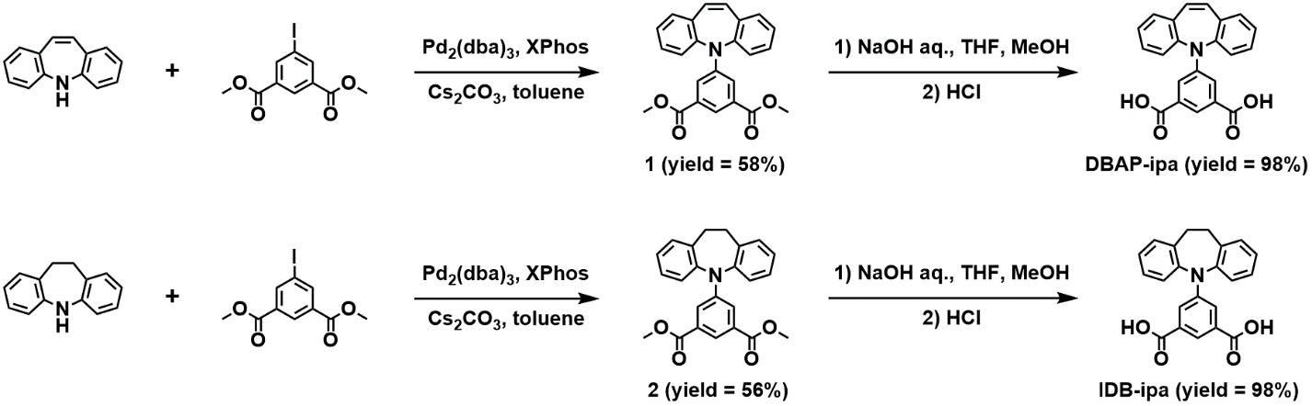
Supplementary Figure S1. Synthetic routes of DBAP-ipa and IDB-ipa.

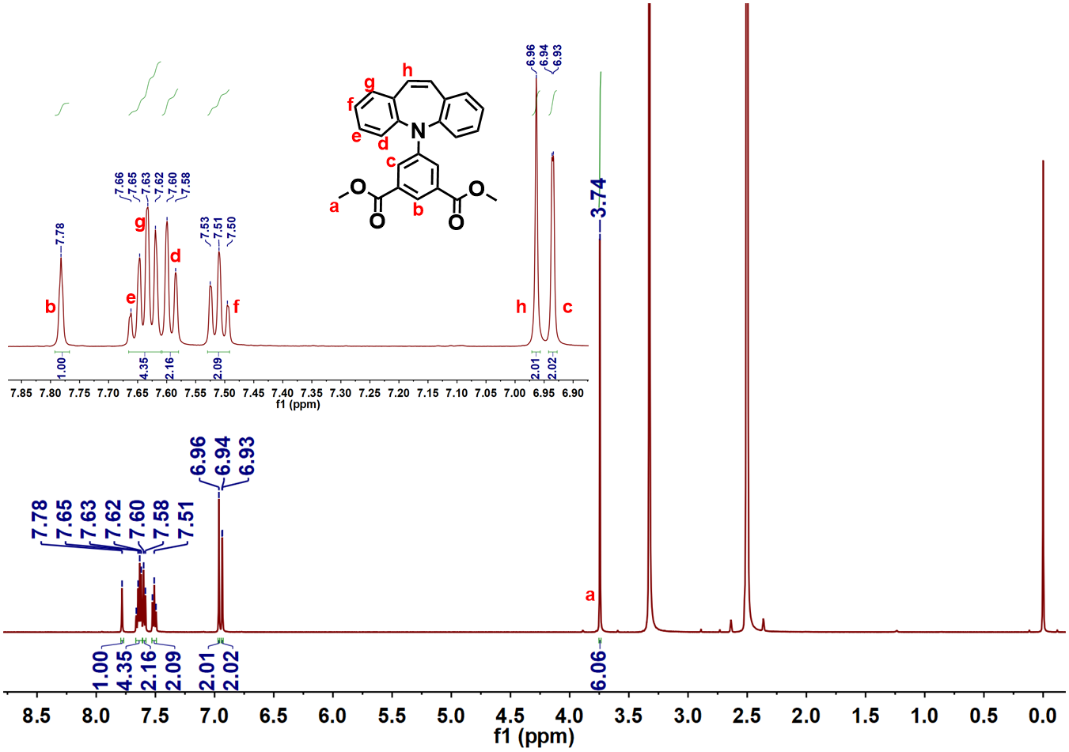
Supplementary Figure S2. ¹H NMR spectra of 1.

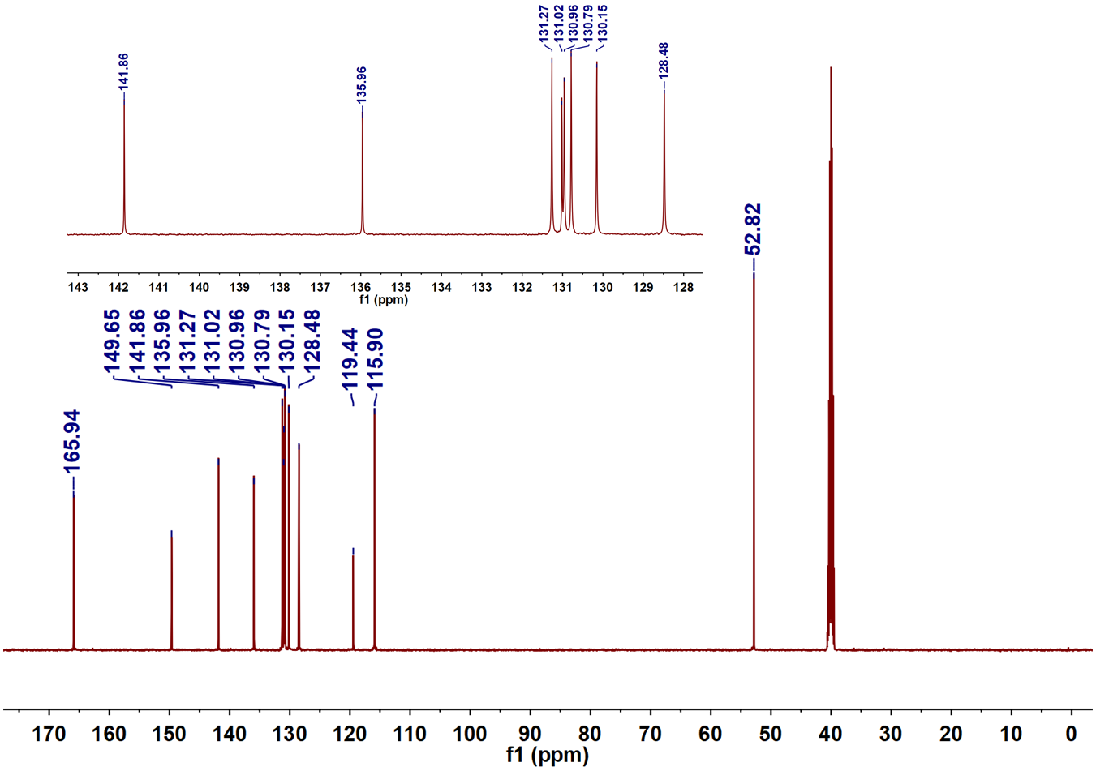
Supplementary Figure S3. ¹³C NMR spectra of 1.

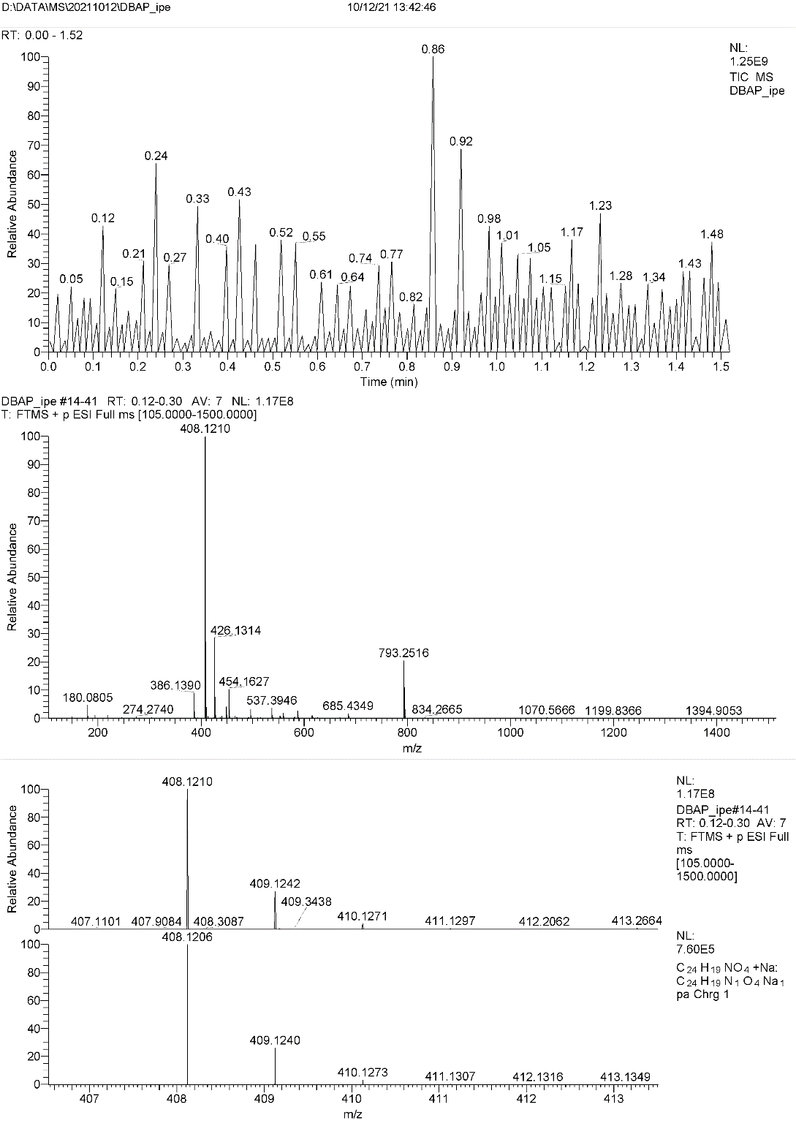
Supplementary Figure S4. ESI mass spectra of 1.

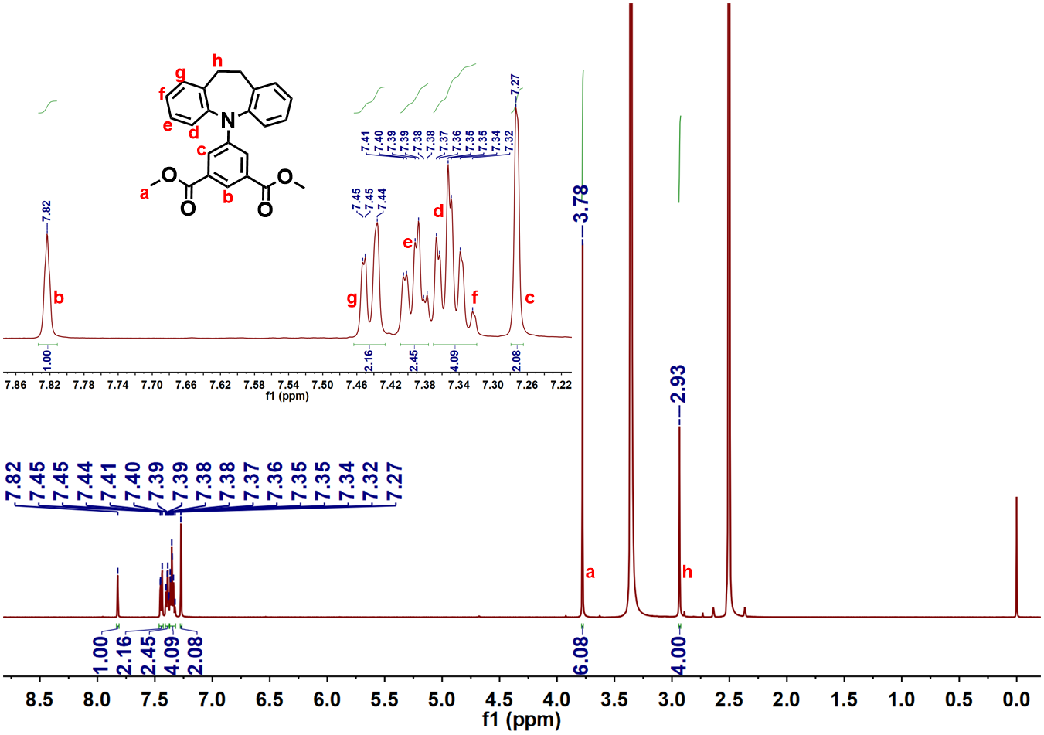
Supplementary Figure S5. ¹H NMR spectra of 2.

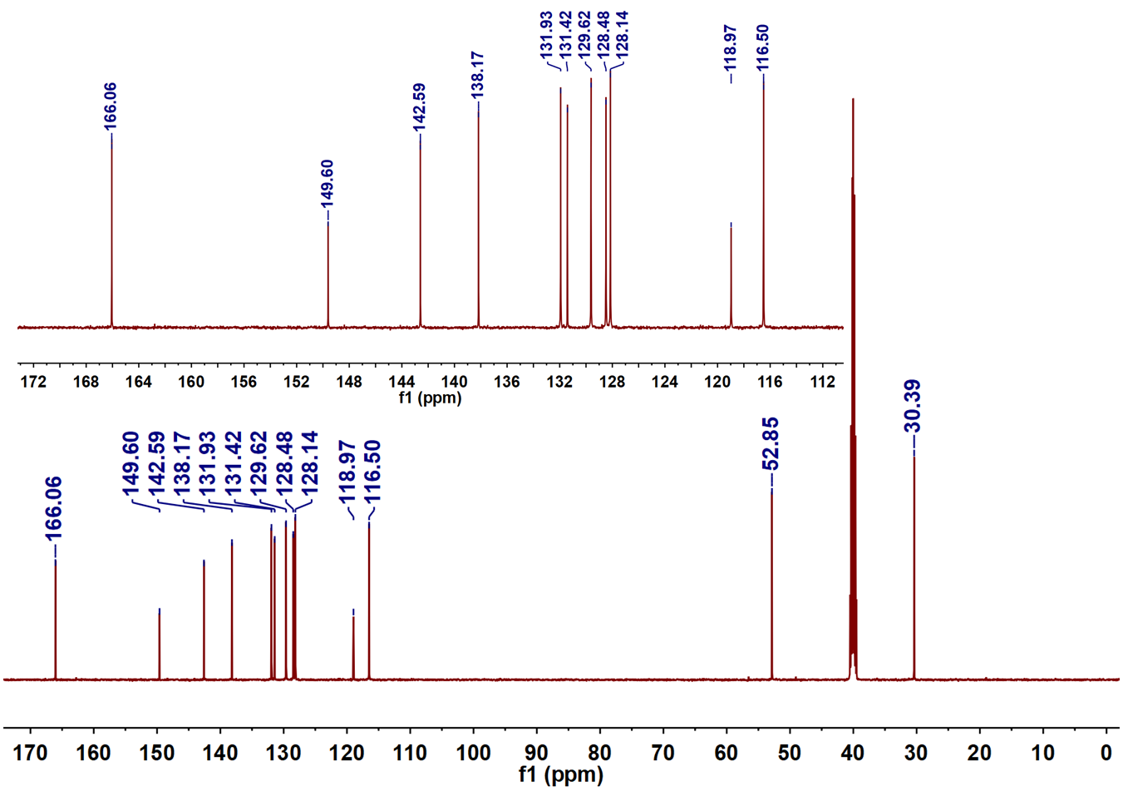
Supplementary Figure S6. ¹³C NMR spectra of 2.

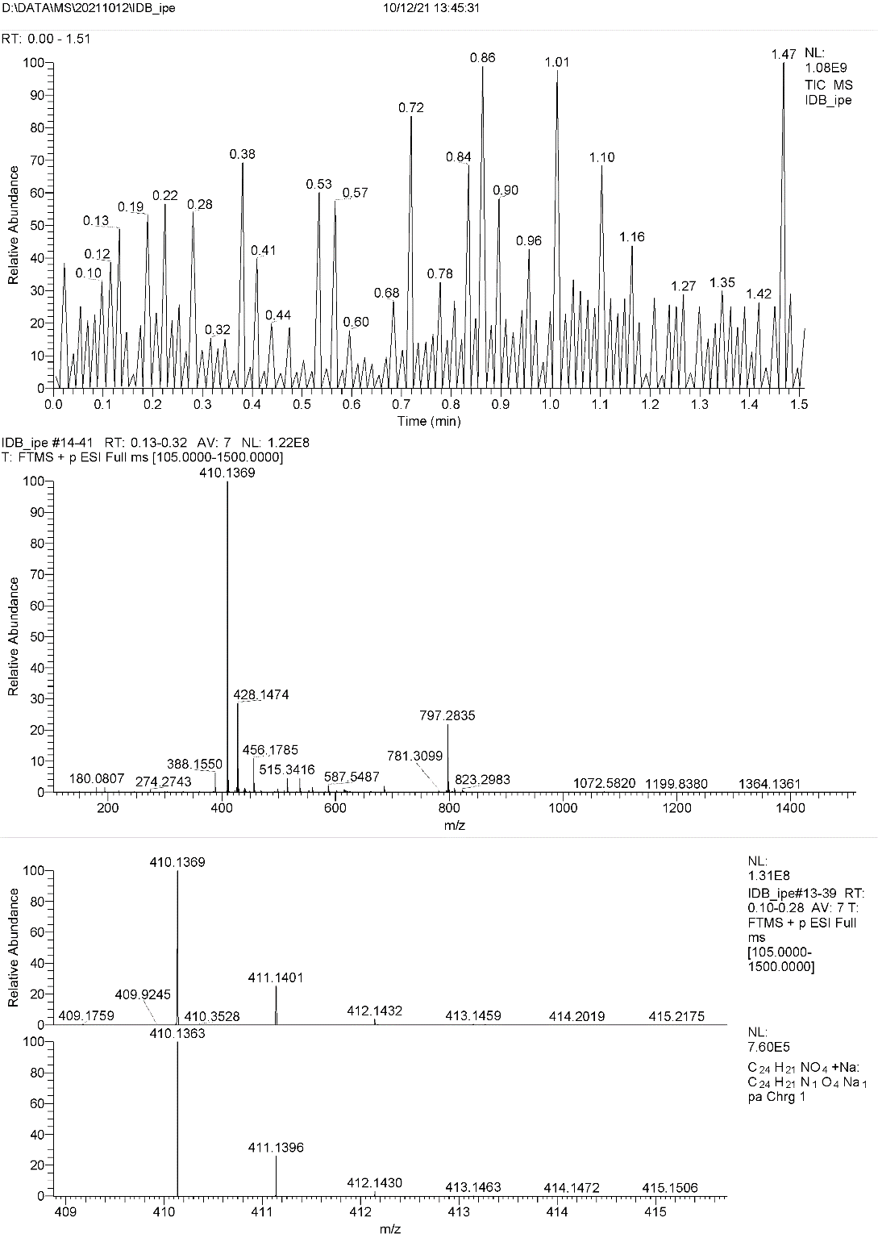
Supplementary Figure S7. ESI mass spectra of 2.

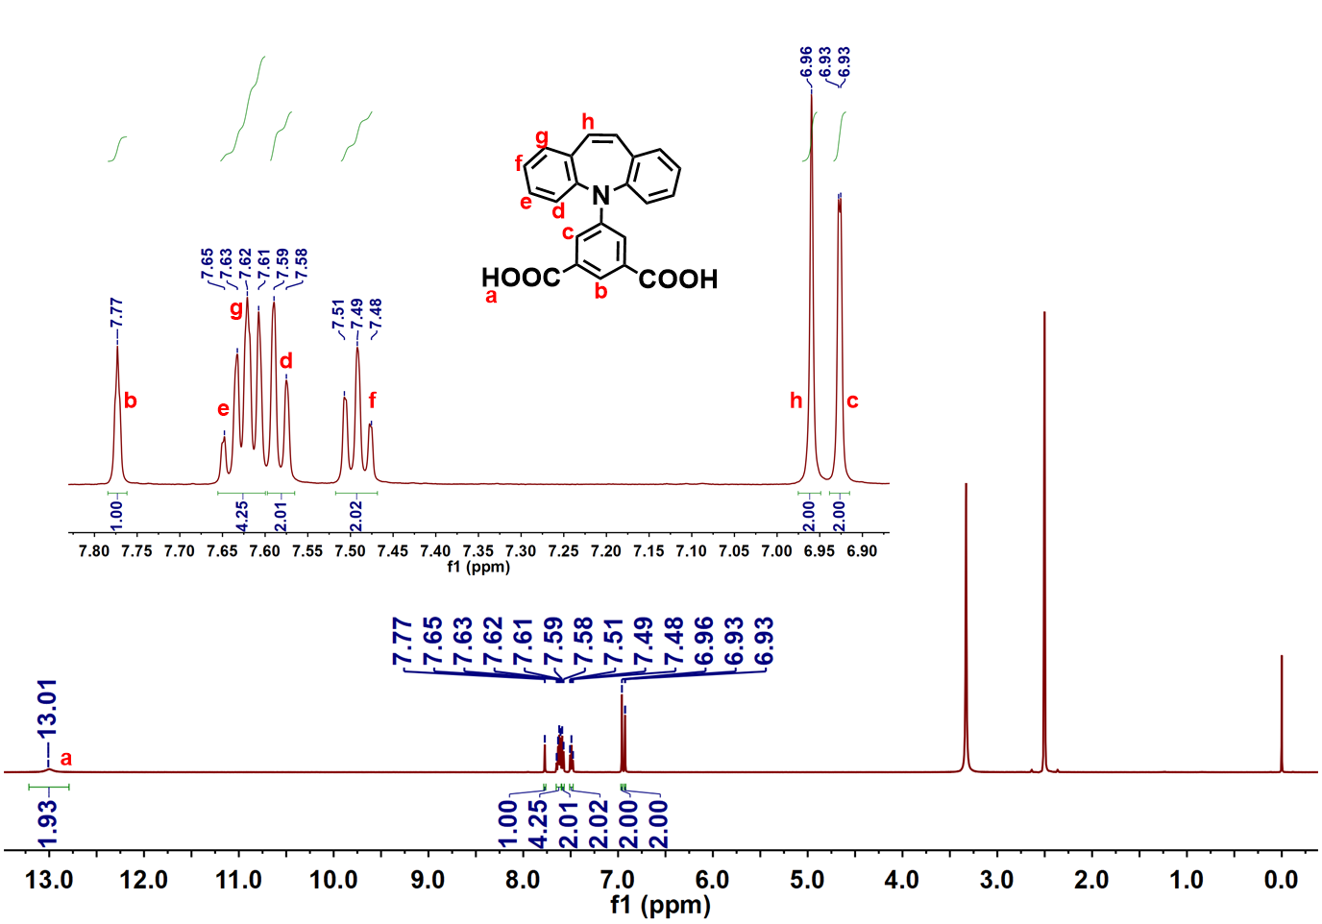
Supplementary Figure S8. ¹H NMR spectra of DBAP-ipa.

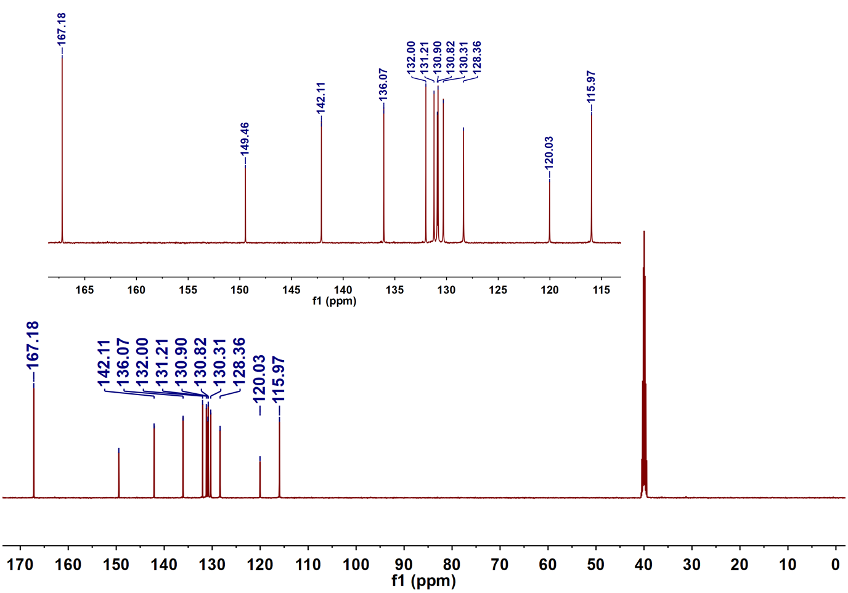
Supplementary Figure S9. ¹³C NMR spectra of DBAP-ipa.
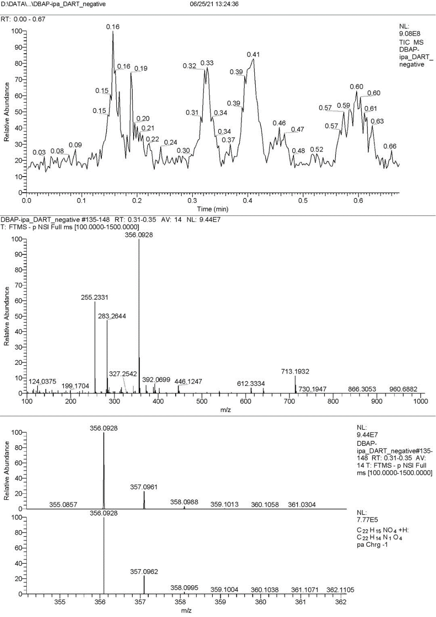
Supplementary Figure S10. DART-orbitrap mass spectra of DBAP-ipa.

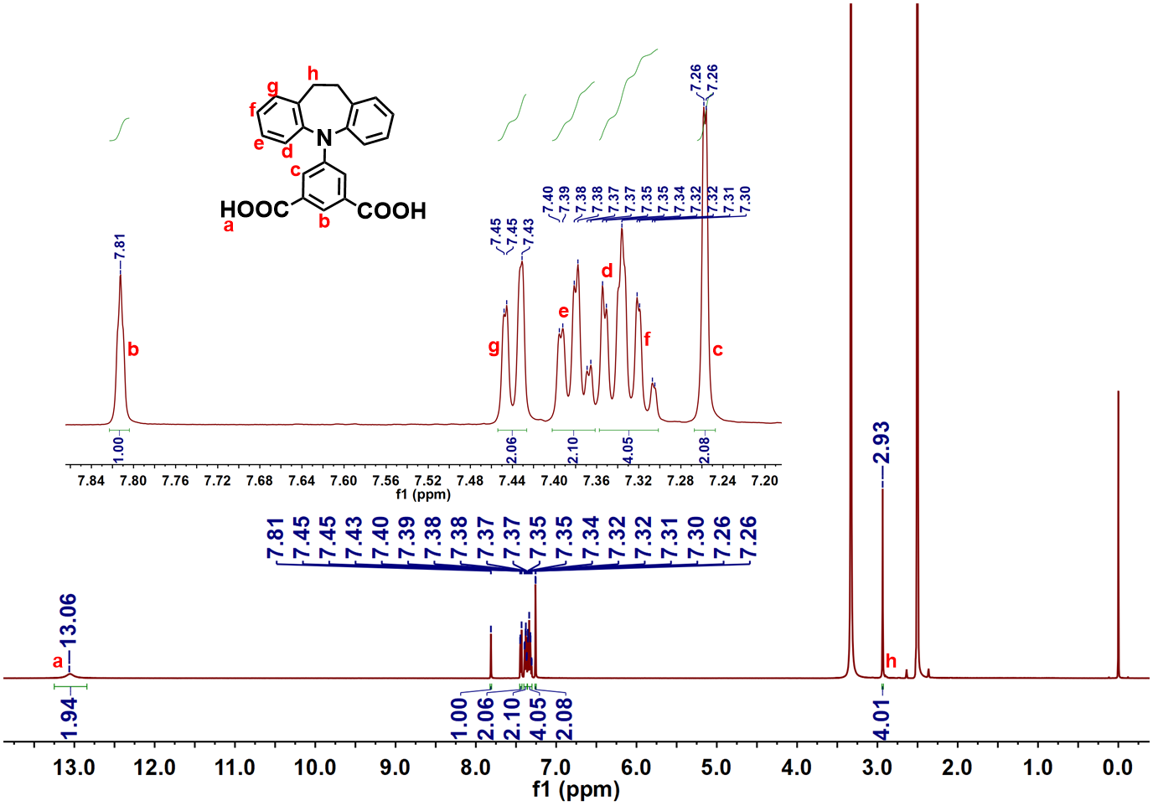
Supplementary Figure S11. ¹H NMR spectra of IDB-ipa.

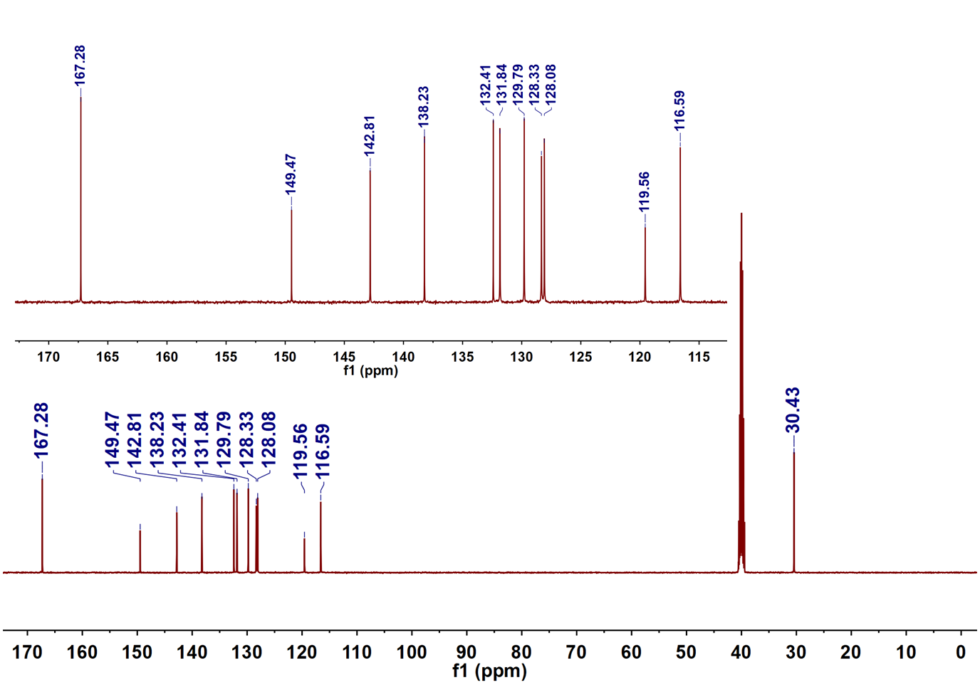
Supplementary Figure S12. ¹³C NMR spectra of IDB-ipa.
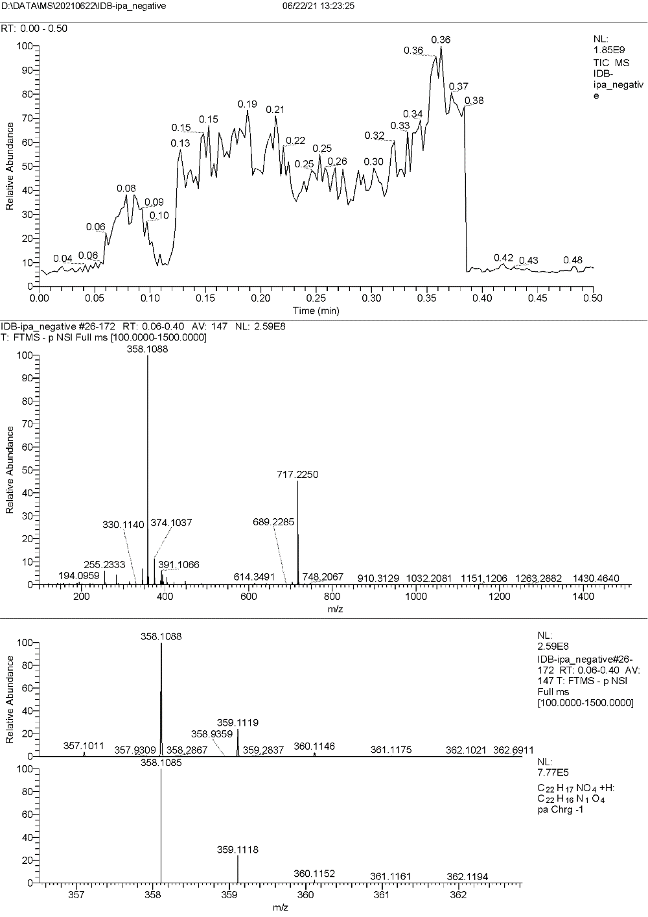
Supplementary Figure S13. DART-orbitrap mass spectra of IDB-ipa.

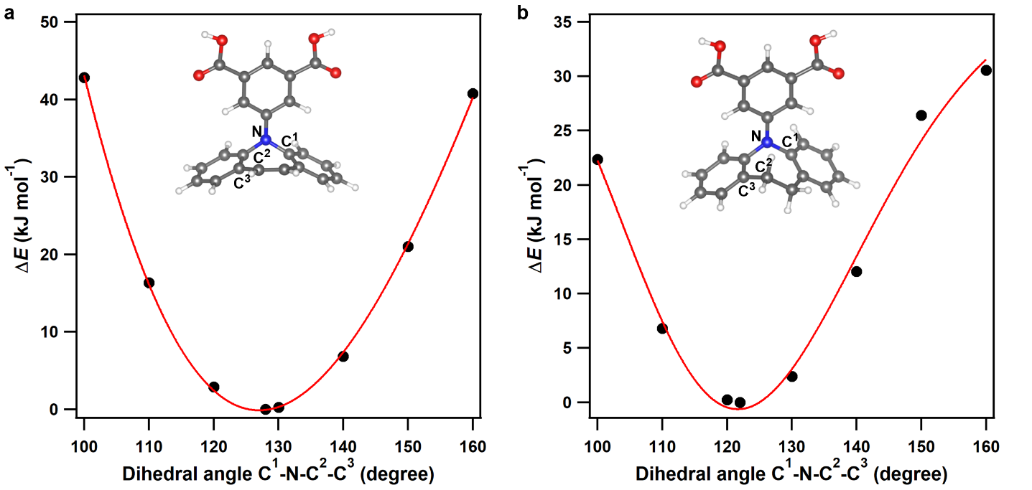
Supplementary Figure S14. Potential energy surface for the flip-flop of (a) DBAP and (b) IDB rings in free ligand molecules. The energy changes for the flipping of DBAP and IDB rings in the free DBAP-ipa and IDB-ipa ligands were calculated using Gaussian 16 program^{S14}. The dispersion-corrected^{S5} B3LYP functional (B3LYP-D3) with the 6-311G(d,p) basis sets for all atoms were used in these calculations. The flipping barrier was estimated by scanning the potential energy surface (PES), in which one dihedral angle (C¹N¹C²C³) was changed from 100° to 160° with an interval of 10°. For both DBAP and IDB, the energy change (ΔE) for ring flipping is not very large; ΔE is less than 20 kJ mol^{–1} with respect to a change of 20° in the dihedral angle. Therefore, the thermal flipping of the DBAP or IDB ring is feasible.

Section 2: Morphology, infrared spectra, and crystal structures of as-synthesized FDCs
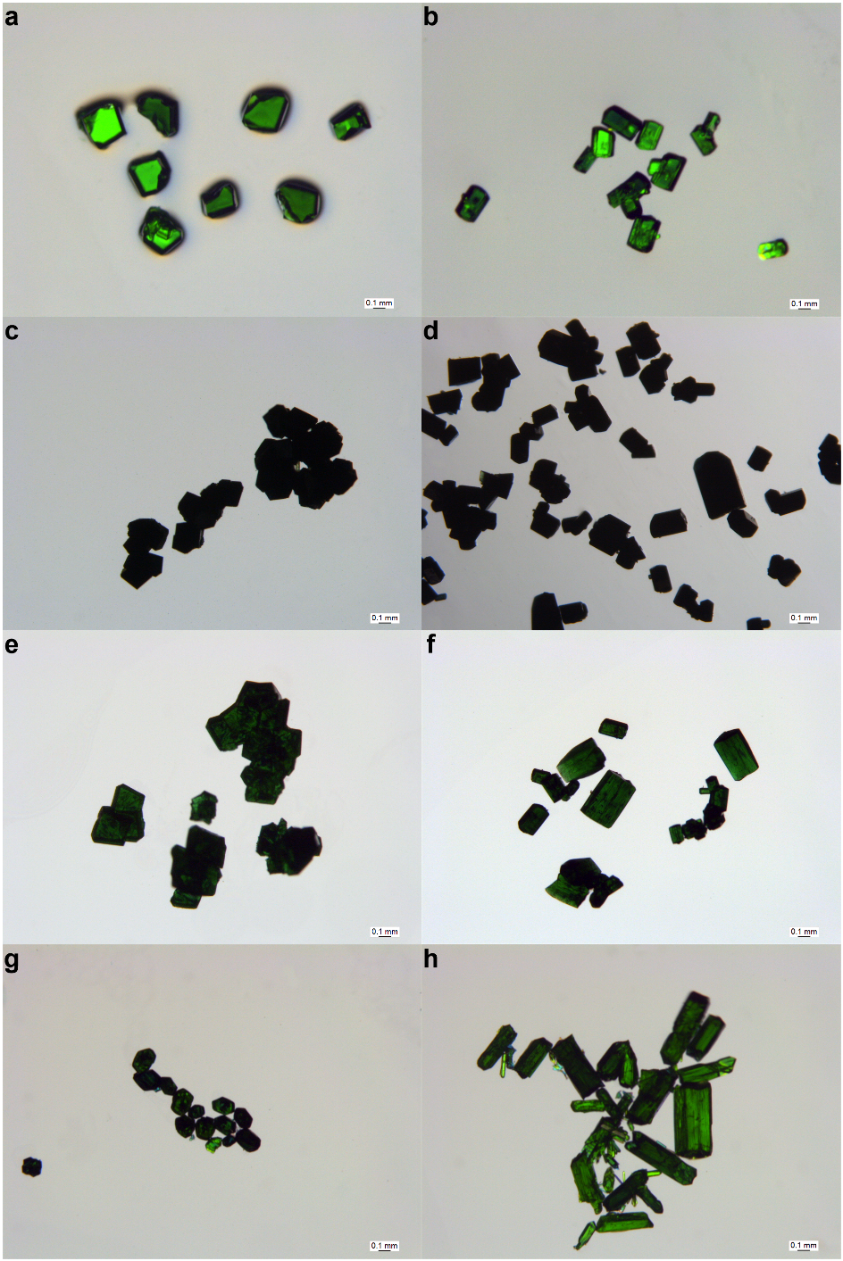
Supplementary Figure S15. Microscopy images of (a) as-synthesized FDC–1, (b) as-synthesized FDC–2, (c) activated FDC–1a, (d) activated FDC–2a, (e) water-adsorbed FDC–1a, (f) water-adsorbed FDC–2a, (g) FDC–1a after one-month continuous sorption experiments of water isotopologues, and (h) FDC–2a after one-month continuous sorption experiments of water isotopologues. After activation and long-term measurements, FDC–1a and FDC–2a retained the crystal shapes, suggesting the structural robustness upon activation and water isotopologues sorption.

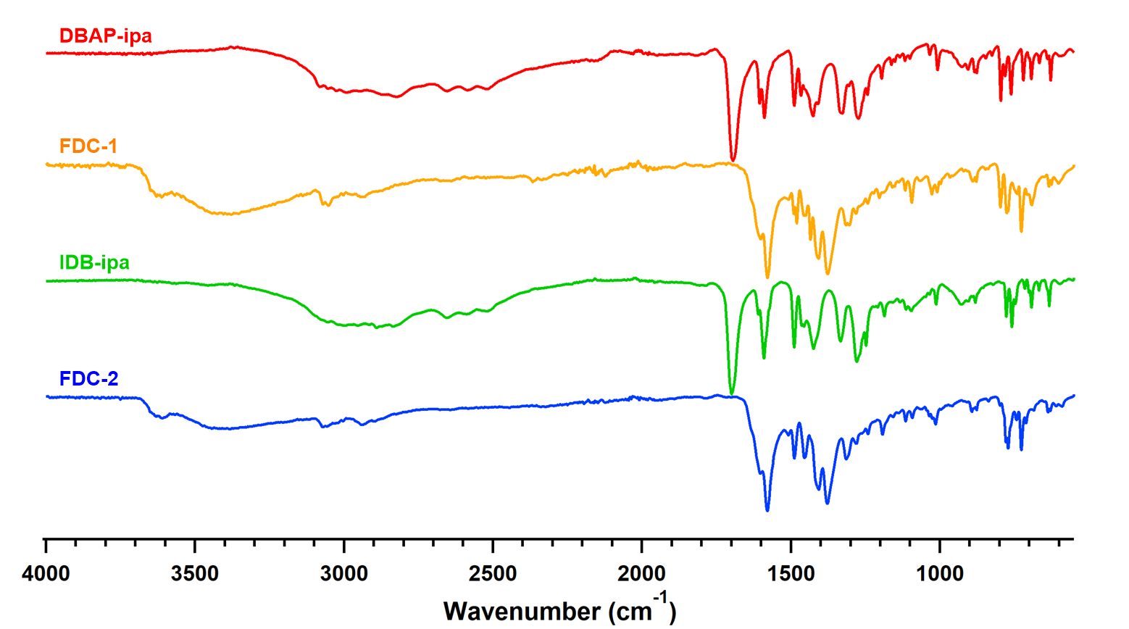
Supplementary Figure S16. Infrared spectra of the ligands and as-synthesized PCPs.

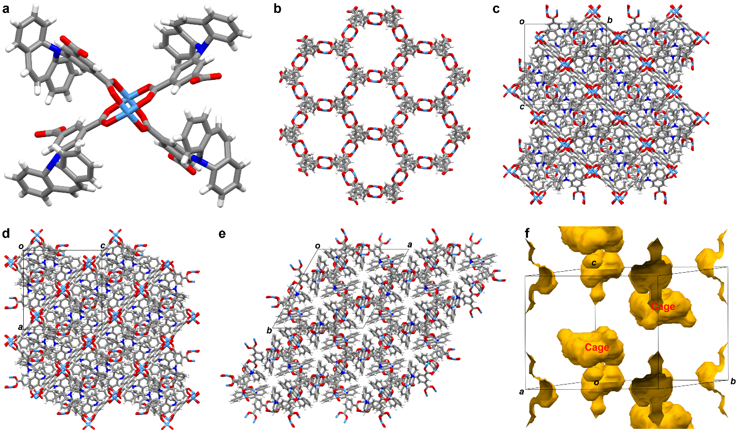
Supplementary Figure S17. Single-crystal structure of as-synthesized FDC–1. (a) Cu²⁺ paddle-wheel linked with DBAP-ipa ligands. (b) NbO framework structure of FDC–1. For clarity, the DBAP groups, the coordinated DMA, and H₂O are omitted. (c), (d) and (e) represent the view of the crystal structure along the a-, b-, and c-axis, respectively. For clarity, the coordinated DMA and H₂O are omitted. C: grey; N: blue; H: white; O: red; Cu: sky blue. (f) Cage structure of as-synthesized FDC–1.

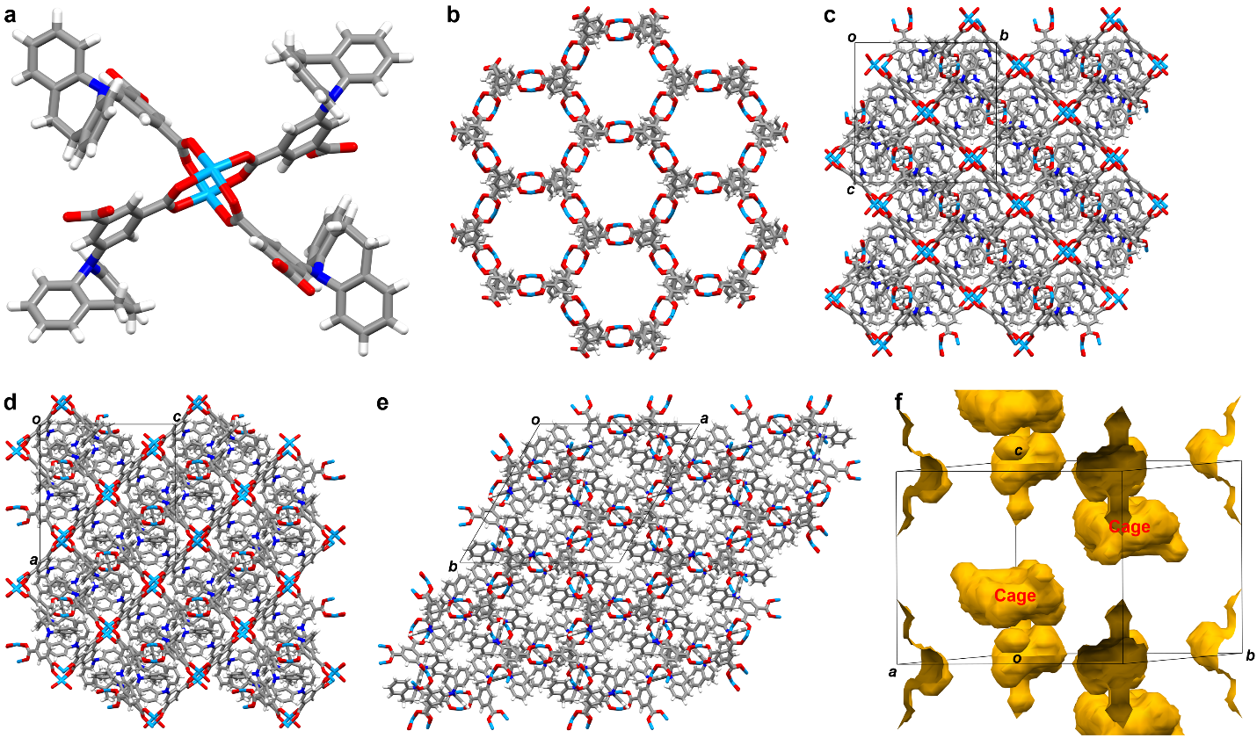
Supplementary Figure S18. Single-crystal structure of as-synthesized FDC–2. (a) Cu²⁺ paddle-wheel linked with IDB-ipa ligands. (b) NbO framework structure of FDC–2. For clarity, the IDB groups, the coordinated DMA, and H₂O are omitted. (c), (d) and (e) represent the view of the crystal structure along the a-, b-, and c-axis, respectively. For clarity, the coordinated DMA and H₂O are omitted. C: grey; N: blue; H: white; O: red; Cu: sky blue. (f) Cage structure of as-synthesized FDC–2.

Section 3: ¹H NMR, TG, and PXRD of activated FDCs
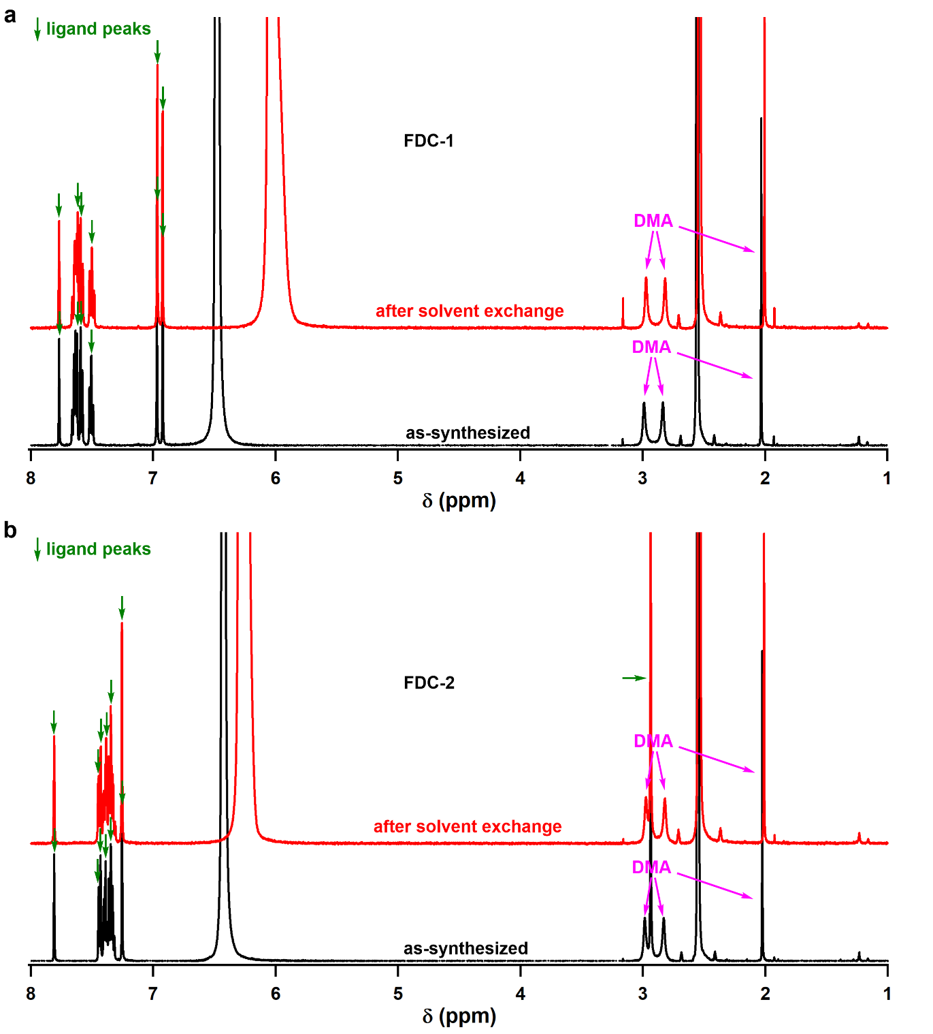
Supplementary Figure S19. ¹H NMR of the as-synthesized and solvent exchanged (a) FDC–1 and (b) FDC–2 dissolved in DMSO-d₆ containing deuterium chloride. The PCP samples were digested by deuterium chloride (1 drop) in DMSO-d₆. The black and red curves represented the as-synthesized and exchanged PCPs, respectively. The peaks pointed by green arrows were the peaks of DBAP-ipa and IDB-ipa ligands, whereas the peaks pointed by pink and blue arrows were the peaks of DMA and H₂O, respectively. The ratio of DMA and ligands is 2:3. The NMR clearly showed that the DMA and H₂O in the PCPs cannot be exchanged by methanol. Thus, we directly evacuated the PCPs at 393 K to remove the H₂O molecules and produce the activated phases.

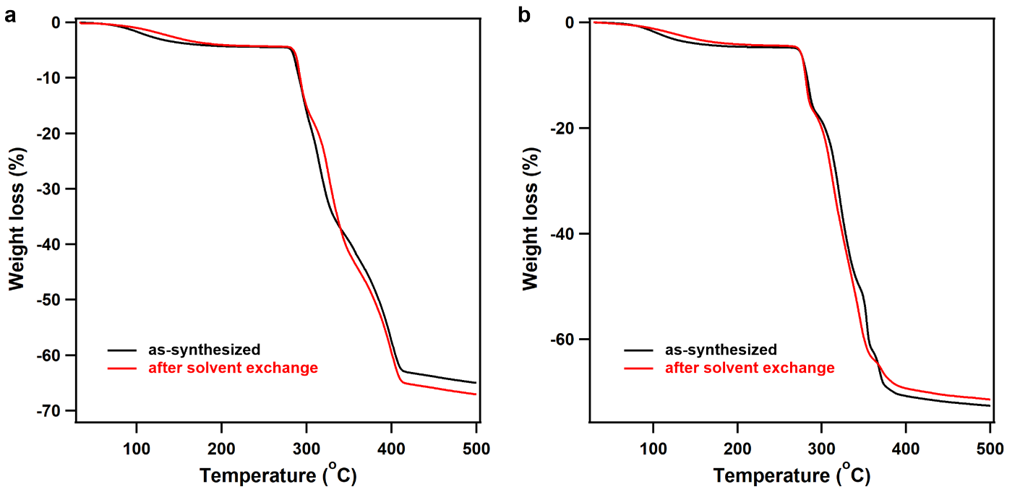
Supplementary Figure S20. TG curves of the as-synthesized and solvent exchanged (a) FDC–1 and (b) FDC–2. In the case of all the PCPs, the weight loss before 200 °C corresponded to the loss of water and DMA. FDC–1 and FDC–2 were thermally stable until 282 and 271 °C, respectively.

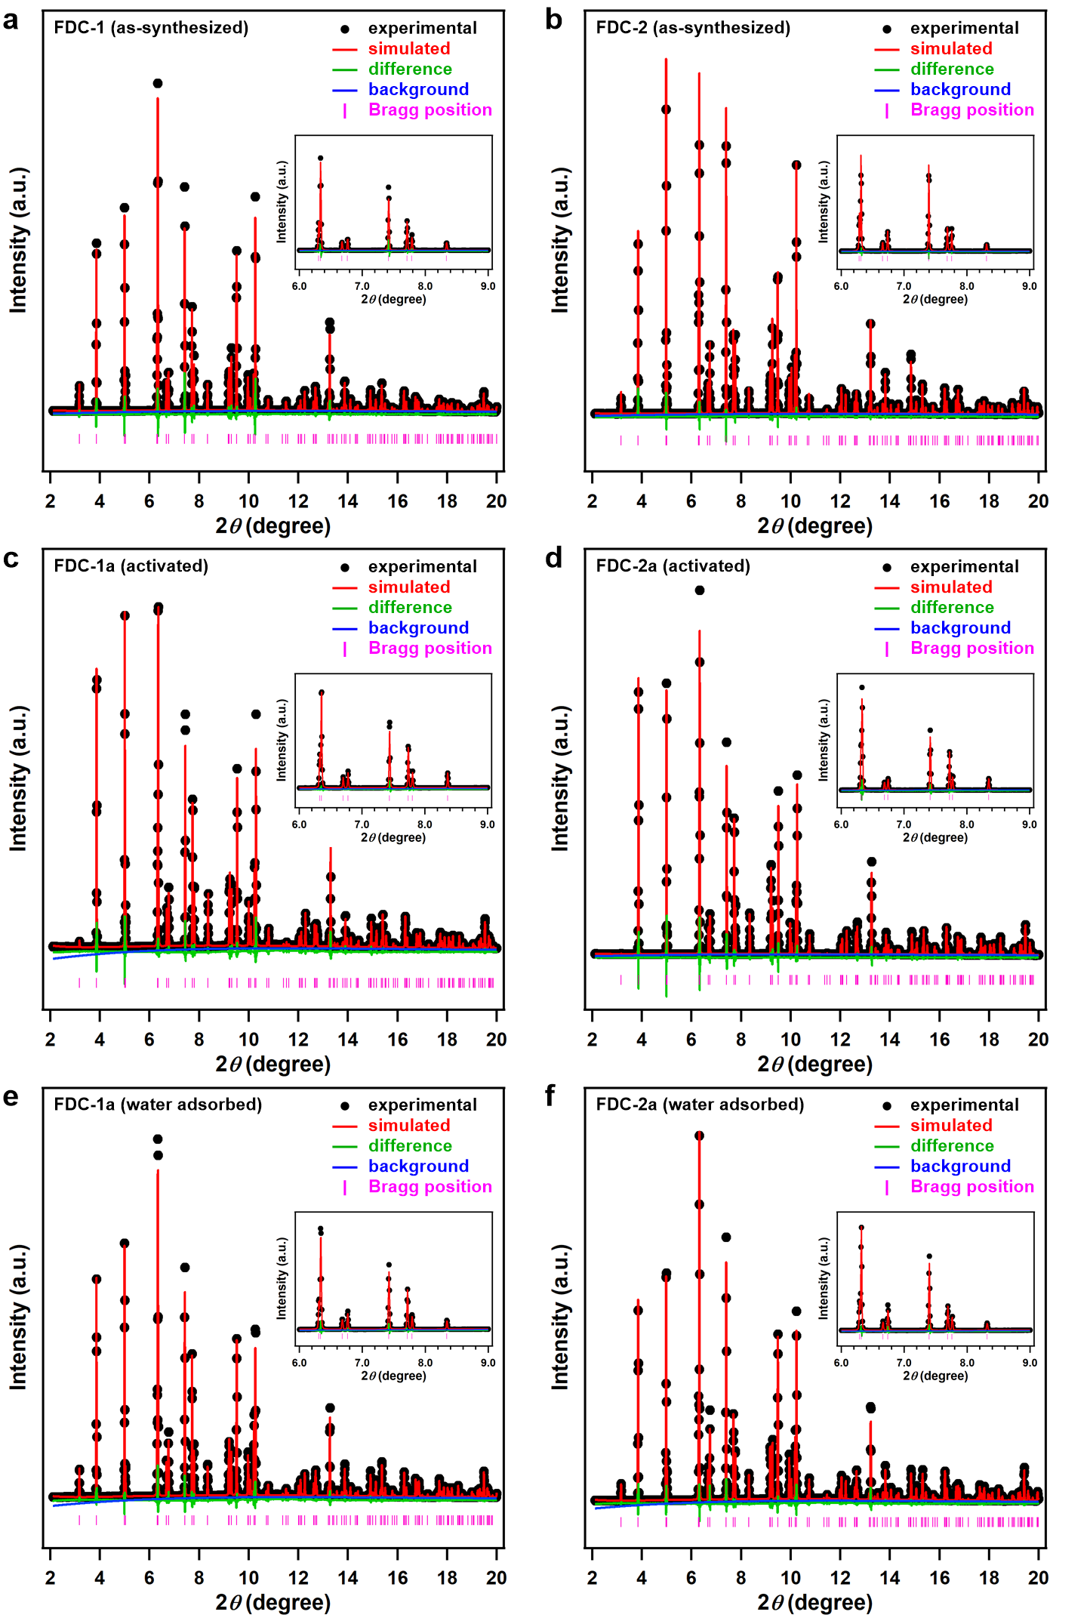
Supplementary Figure S21. Synchrotron PXRD patterns of (a) as-synthesized FDC–1, (b) as-synthesized FDC–2, (c) activated FDC–1a, (d) activated FDC–2a, (e) water-adsorbed FDC–1a, (f) water-adsorbed FDC–2a, and the Le Bail refinements. The PXRD patterns of activated and water-adsorbed FDC–1a and FDC–2a were the same as the as-synthesized FDC–1 and FDC–2, indicating the robustness of the frameworks during the activation.

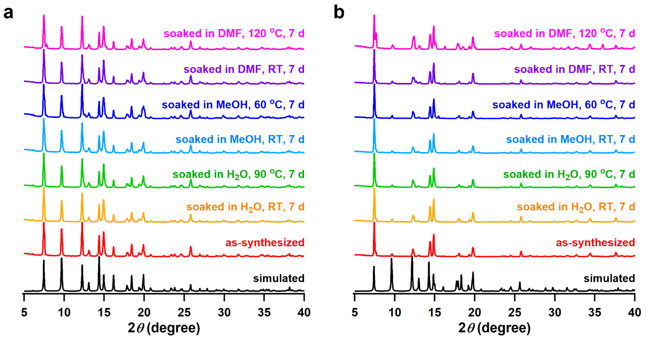
Supplementary Figure S22. PXRD patterns of (a) FDC–1a and (b) FDC–2a soaked in diverse solvents at different temperatures for 7 days. The simulated and as-synthesized patterns were also provided for comparison. Both FDC–1a and FDC–2a exhibited good stability upon soaking in H₂O and MeOH at high and low temperatures; they were also stable upon soaking in DMF at room temperature, whereas the structures slightly changed when heating up to high temperature for 7 d.

Section 4: Kinetic sorption of H₂O and D₂O in small-sized materials (control experiments)
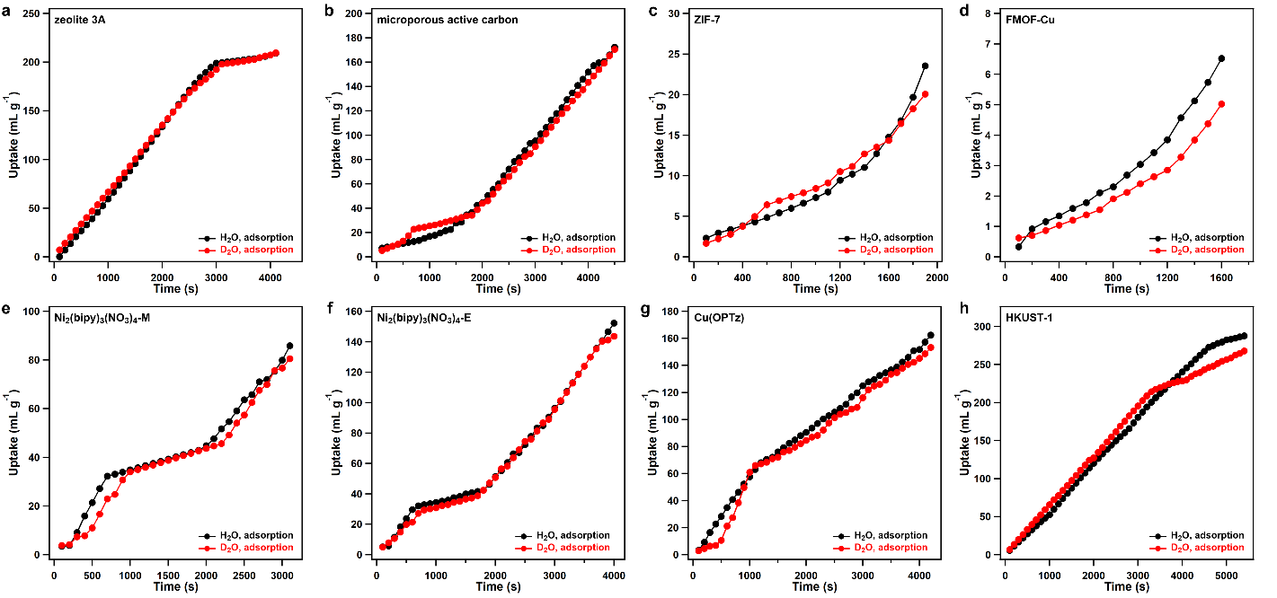
Supplementary Figure S23. Time-dependent H₂O and D₂O adsorption curves at 298 K for (a) zeolite 3A (pore aperture 3 Å), (b) microporous active carbon (pore aperture 3 Å), (c) ZIF-7 (pore aperture 3 Å), (d) FMOF-Cu (pore aperture 2.5 Å), (e) Ni₂(bipy)₃(NO₃)₄-M (pore aperture 2.4 Å), (f) Ni₂(bipy)₃(NO₃)₄-E (pore aperture 2.1 Å), (g) Cu(OPTz) (pore aperture 3 Å), and (h) HKUST-1 (pore aperture 9 Å).

Section 5: Crystal lattice parameters, DSC, and PXRD of FDCs
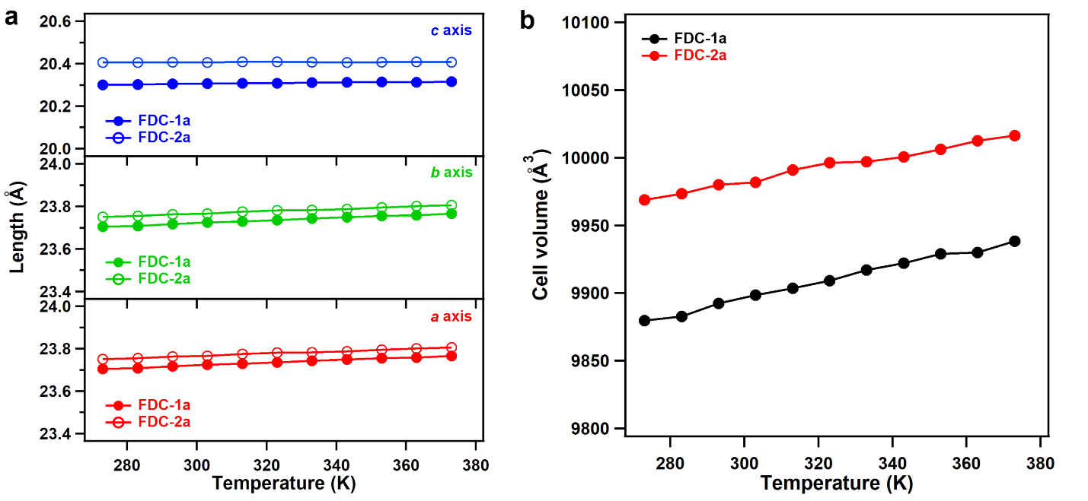
Supplementary Figure S24. (a) Crystal lattice parameters and (b) cell volumes of FDC–1a and FDC–2a under vacuum at diverse temperatures. As an indication of the relatively “rigid” nature of the frameworks, the unit cell parameters of FDC–1a and FDC–2a only showed negligible change in various temperatures. The cell volume only increased by 58.8 and 47.6 Å³ for FDC–1a and FDC–2a as increasing the temperature from 273 to 373 K. The negligible change of the cell parameters at diverse temperatures ruled out the possibility of thermal-induced structural expansion.

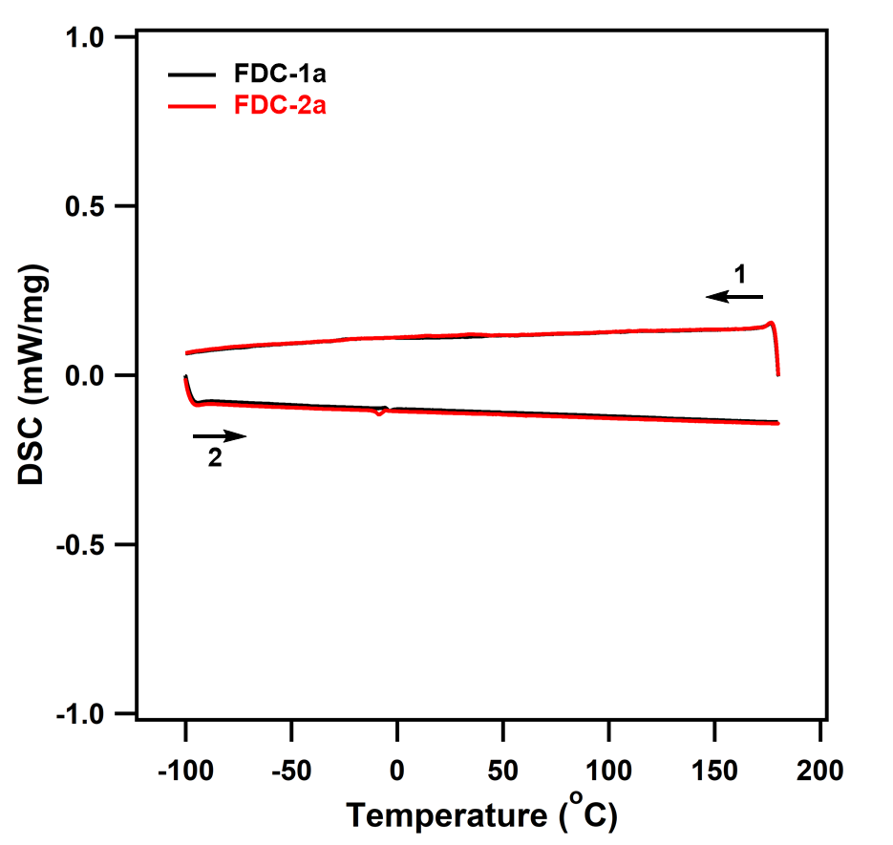
Supplementary Figure S25. Differential scanning calorimetry (DSC) curves of FDC–1a and FDC–2a in the temperature range from 173 to 453 K. No obvious endothermic and exothermic peaks were observed from the DSC curves, excluding the presence of the thermal-induced crystallographic phase transition.

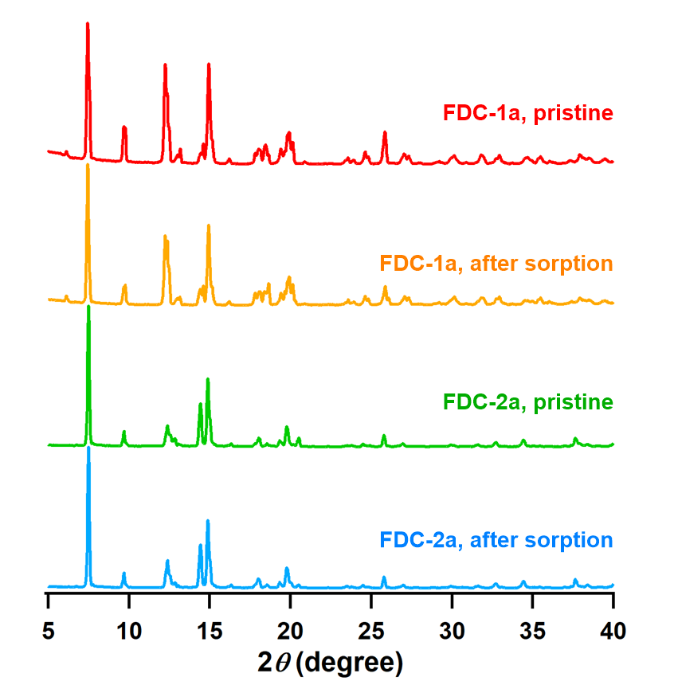
Supplementary Figure S26. PXRD patterns of FDC–1a and FDC–2a after sorption of water isotopologues for 100 times. Both FDC–1a and FDC–2a exhibited outstanding stability upon multiple sorptions of water isotopologues, excluding the possibility of the preferential adsorption behavior from structural decomposition.

Section 6: Infrared spectra of FDCs after H₂O and D₂O adsorption
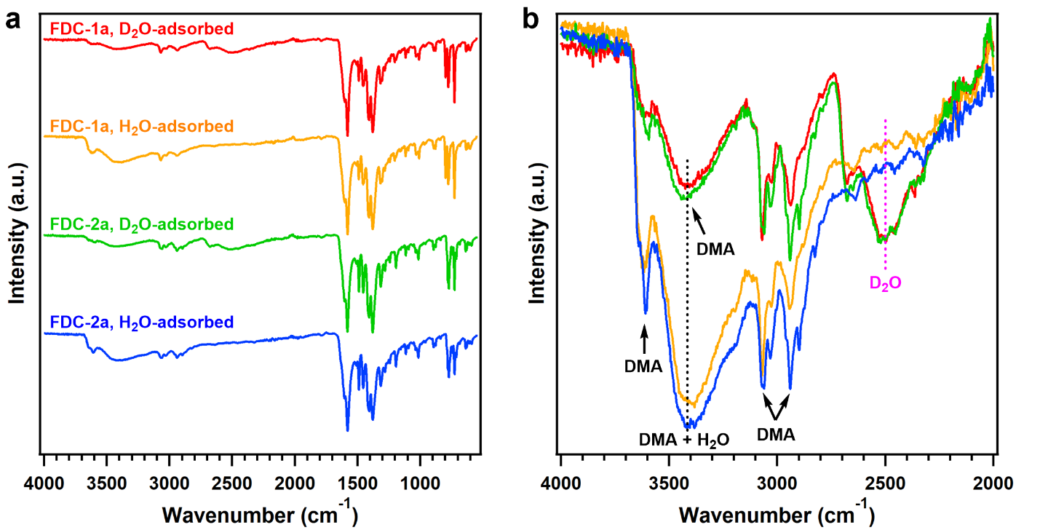
Supplementary Figure S27. Infrared spectra of FDC–1a and FDC–2a adsorbed with H₂O or D₂O, respectively, in the ranges of (a) 500 to 4000 cm^{–1} and (b) 2000 to 4000 cm^{–1}. FDC–1a and FDC–2a after adsorbing D₂O exhibited an emerging peak at 2497 cm^{–1}, which was attributed to the OD stretching vibration. By contrast, FDC–1a and FDC–2a after adsorbing H₂O showed enhanced relative intensity at 3417 cm^{–1}, whereas no peak at 2497 cm^{–1} was observed. This result indicated the OH stretching vibration peak at 3417 cm^{–1}, although it overlapped with the vibration peaks of guest DMA molecules (2898, 2940, 3031, 3069, 3406, and 3610 cm^{–1}). The position of OH stretching vibration could also be calculated from the equation $\frac{ν_{OH}}{ν_{OD}}=\sqrt{{\frac{m_{O}+m_{H}}{m_{O}m_{H}}}/{\frac{m_{O}+m_{D}}{m_{O}m_{D}}}}$ = 1.374^{S15}, where ν_{OD} denotes for the OD stretching vibration (2497 cm^{–1}), and m_{O}, m_{H}, and m_{D} refer to the mass of O, H, and D atoms, respectively. Therefore, the OH stretching vibration was calculated to be 3432 cm^{–1}, which matched well with the experimental result (3417 cm^{–1}). The resonant frequency of the OH or OD stretching region redshifts as the cluster size increases because of the directional nature of hydrogen bonds. The relationship between the differential frequency (Δω) of a monomer (ω_{OH, monomer} = 3611 cm^{–1} and ω_{OD, monomer} = 2657 cm^{–1}) and the associated molecular number n of a water cluster is as follows: Δω = –100(n–1) in the OH stretching region^{S16}. Even though the peak for OH or OD stretching band is broad owing to the hydrogen bond formation, the difference in the resonance shift upon the formation of the cluster is large enough to be distinguished. Therefore, even from the broad peaks, we can investigate the clustering behavior of water. The resonant frequencies (ω_{OH} = 3417 cm⁻¹ and ω_{OD} = 2497 cm⁻¹), which were taken from the peak-tops of the stretching bands, suggest that the restricted water molecules in FDC–1a and FDC–2a form the same trimer clusters.

Section 7: H₂O and D₂O sorption curves of FDCs under different exposure time
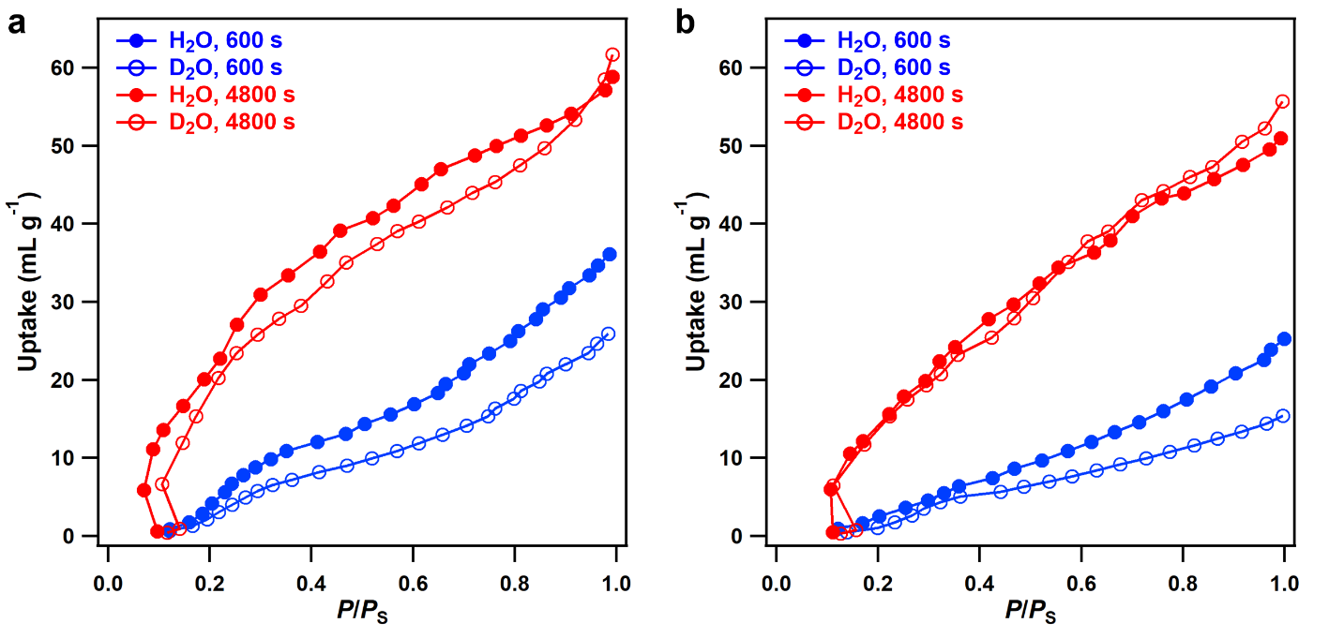
Supplementary Figure S28. H₂O and D₂O adsorption curves for (a) FDC–1a and (b) FDC–2a at 298 K using different exposure time. We measured the H₂O and D₂O sorption curves with the exposure time of each plot as 600 s and 4800 s, respectively, resulting in a total measurement time of 26.4 and 221.5 h, respectively. The adsorption amounts markedly increased with the prolonged exposure time, which importantly indicated that the diffusion kinetics of adsorbates was the determining factor for this thermoresponsive adsorption behavior. At an exposure time of 600 s, the adsorption amount differences for H₂O and D₂O were 10.2 and 9.9 cm³ g^{–1} for FDC–1a and FDC–2a, respectively. By contrast, no adsorption amount difference was observed at an exposure time of 4800 s, demonstrating that the diffusion-regulated preferential adsorption could only be achieved at a kinetically controlled non-equilibrium condition.

Section 8: Global pressure–temperature–diffusion-rate–adsorption amount curves for FDCs
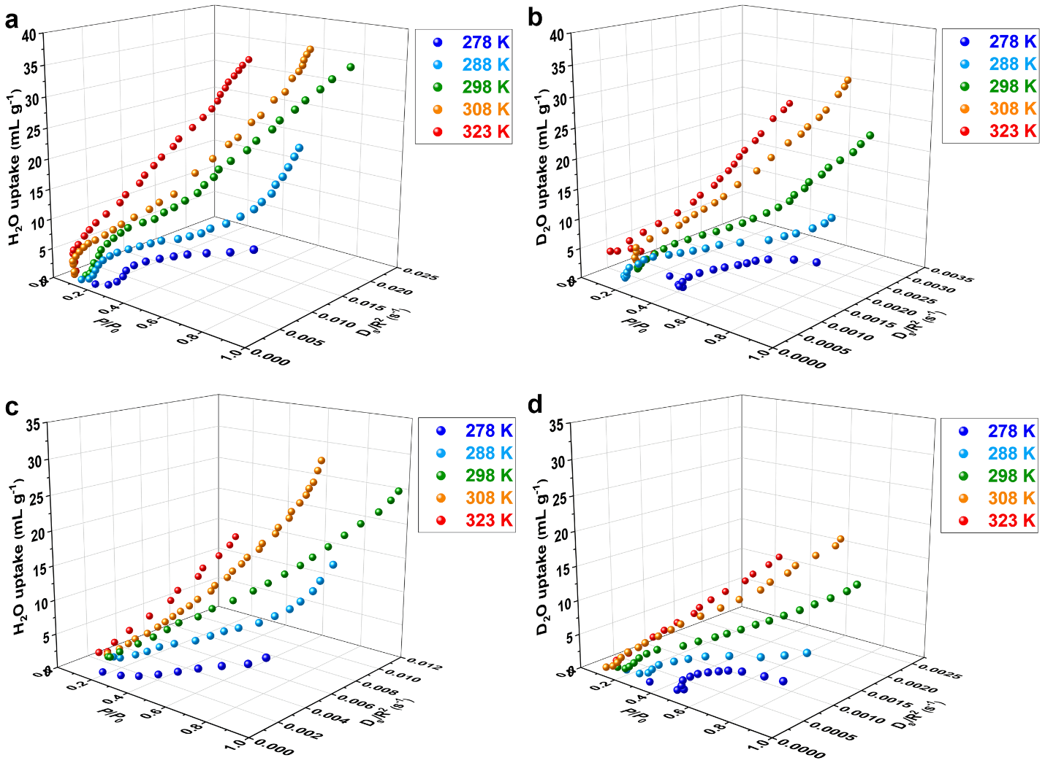
Supplementary Figure S29. (a) Global pressure–diffusion-rate–adsorption-amount (P–D_{s}/R²–V) landscape for FDC–1a adsorbing H₂O, where R denotes the radius of a PCP particle. (b) P–D_{s}/R²–V landscape for FDC–1a adsorbing D₂O. (c) P–D_{s}/R²–V landscape for FDC–2a adsorbing H₂O. (d) P–D_{s}/R²–V landscape for FDC–2a adsorbing D₂O.

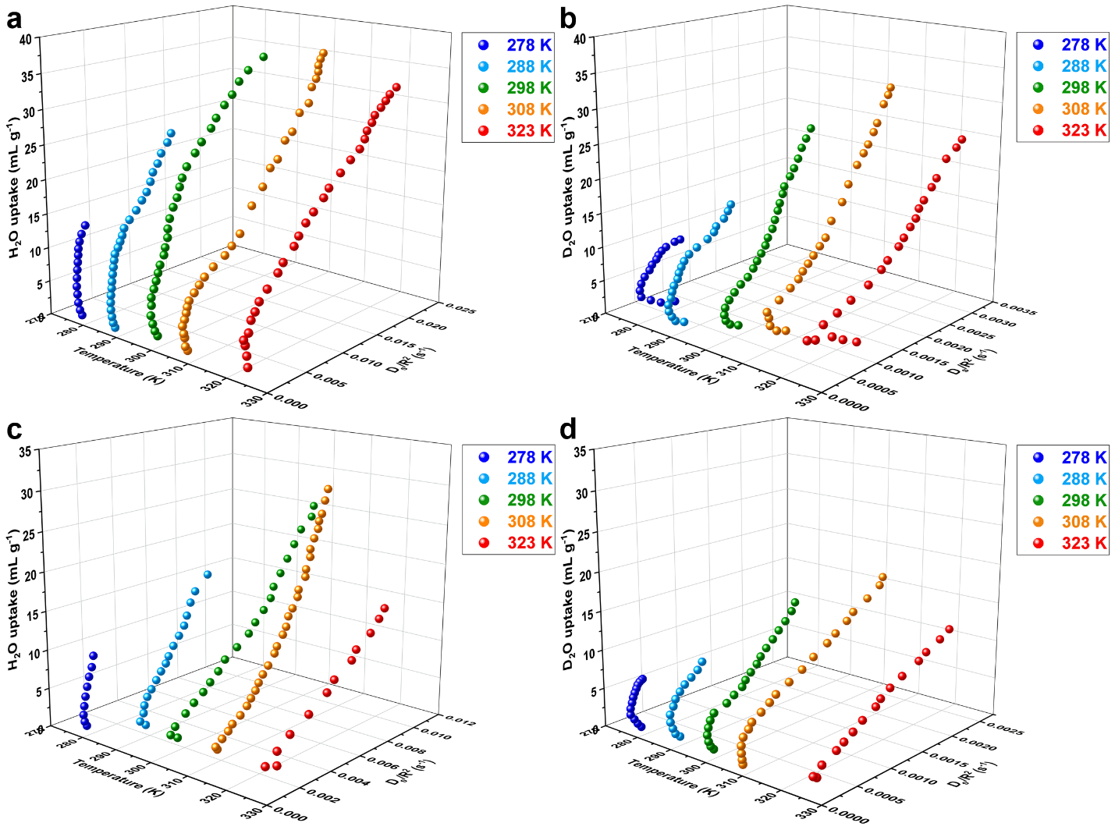
Supplementary Figure S30. Global temperature–diffusion-rate–adsorption amount (T–D_{s}/R²–V) landscape for (a) FDC–1a adsorbing H₂O, (b) FDC–1a adsorbing D₂O, (c) FDC–2a adsorbing H₂O, and (d) FDC–2a adsorbing D₂O, where R denotes the radius of a PCP particle.

Section 9: Variable-temperature PXRD and mechanism for H₂O and D₂O adsorption
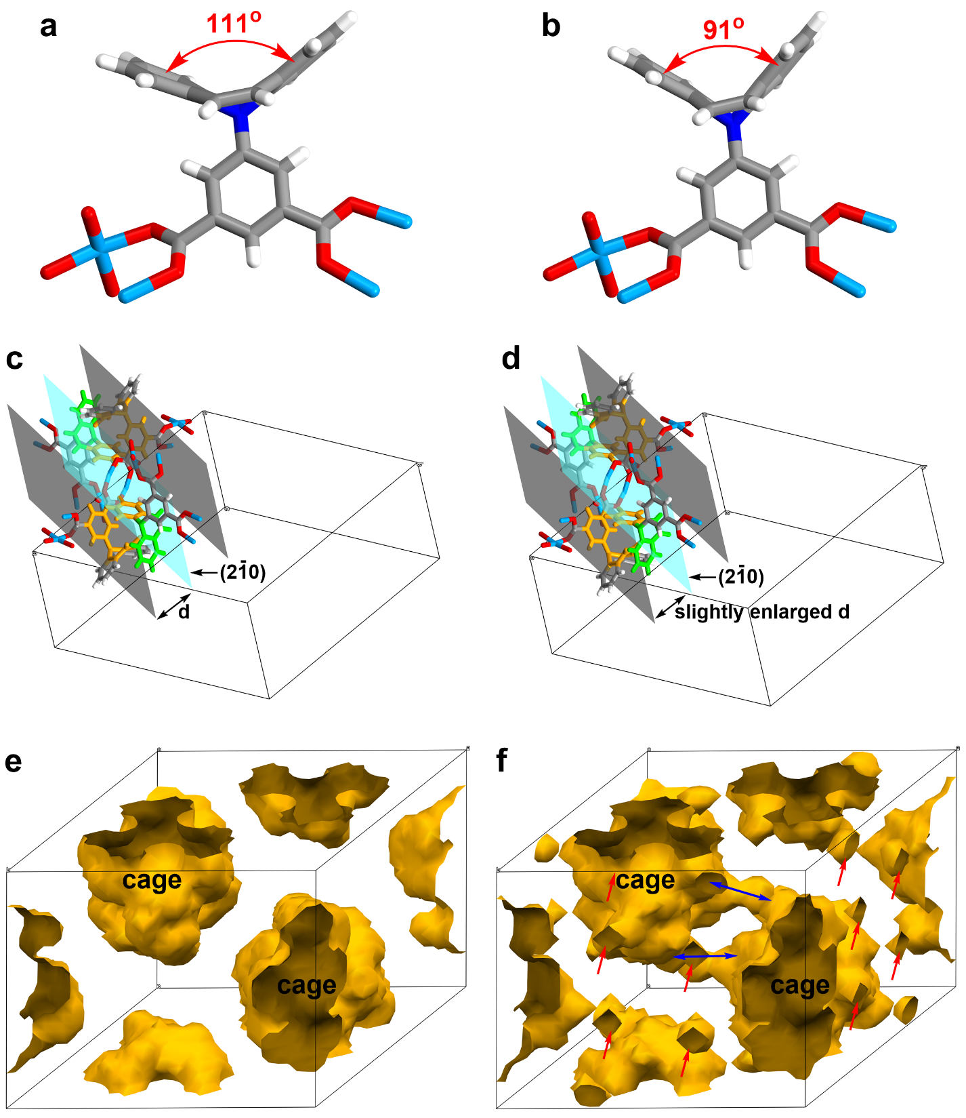
Supplementary Figure S31. Schematic diagram of the effects of the DBAP flipping on the crystal structure. Configuration of the DBAP-ipa with different phenyl_{(DBAP)}–phenyl_{(DBAP)} dihedral angles of (a) 111° (termed as “static”) and (b) 91° (termed as “flipping”), respectively. Structure related to (2$\overline{1}$0) facet in the unit cell of FDC–1a under (c) “static” and (d) “flipping” status, respectively. The DBAP ring in green color showed the DBAP moiety on (2$\overline{1}$0) facet (sky-blue plane), and the phenyl rings on DBAP and isophthalate in orange color showed the cage aperture. The change of cage aperture of FDC–1a under (e) “static” and (f) “flipping” status, respectively. The red and blue arrows indicate the cage apertures for diffusion and the diffusion pathways among the cages, respectively. To clearly show the effects of the DBAP flipping on the crystal structure, we manually changed the phenyl_{(DBAP)}–phenyl_{(DBAP)} dihedral angles on the DBAP ring from 111º to 91º, while keeping other parts of the crystal structure the same as the initial structure. In these two structures, the structure of the framework constructed with Cu²⁺ paddle-wheels and isophthalates kept the same, whereas the DBAP moieties showed different phenyl_{(DBAP)}–phenyl_{(DBAP)} dihedral angles. Thus, the two structures could stand for the non-flipping (static) and flipping modes of FDC–1a at low and high temperatures, respectively. The “flipping” structure revealed a slight expansion of the [2$\overline{1}$0] axis compared to the “static” structure, in good agreement with the VT-PXRD results that the peaks corresponding to the (2$\overline{1}$0) facet shifted to a lower angle. Since DBAP moiety is oriented parallel to the (2$\overline{1}$0) plane, this tiny expansion of [2$\overline{1}$0] distances could be correlated with the extent of thermal flipping of the DBAP moiety. Notably, the “flipping” structure showed a remarkable enlargement of cage aperture (2.76 Å in “flipping” structure vs. 2.2 Å in “static” structure) for the diffusion of water isotopologues compared to the “static” structure, which indicated that the “flipping” structure allowed accelerating the diffusion of water isotopologues in response to increasing temperature.

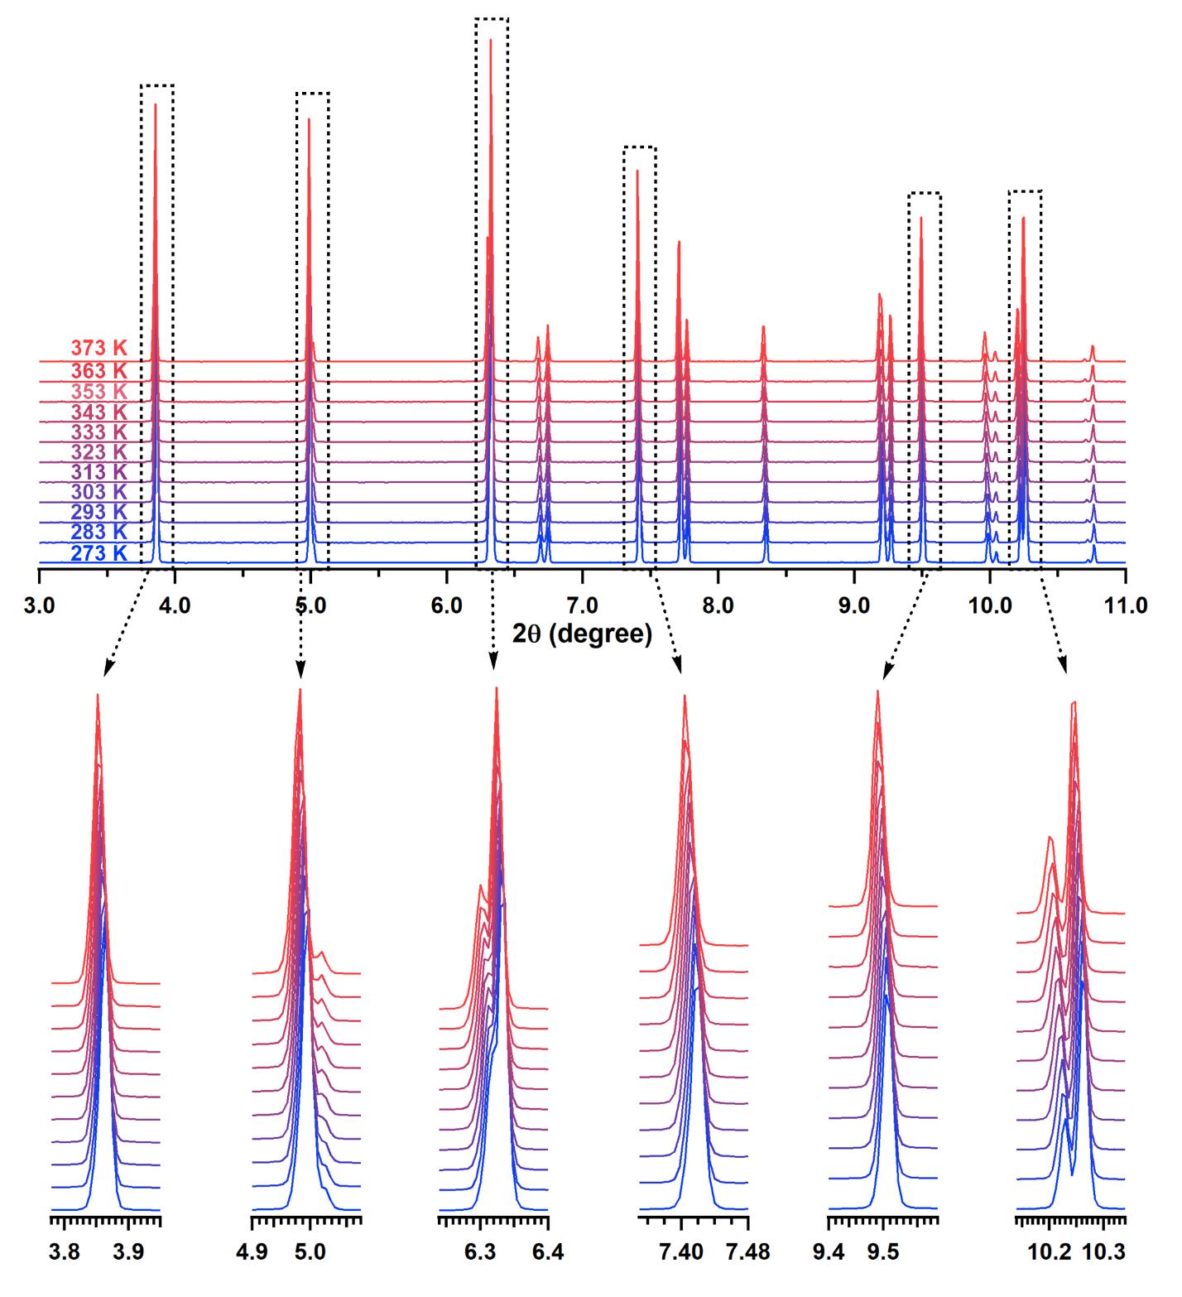
Supplementary Figure S32. Variable-temperature synchrotron PXRD of FDC–2a under vacuum conditions in the temperature range from 273 to 373 K.

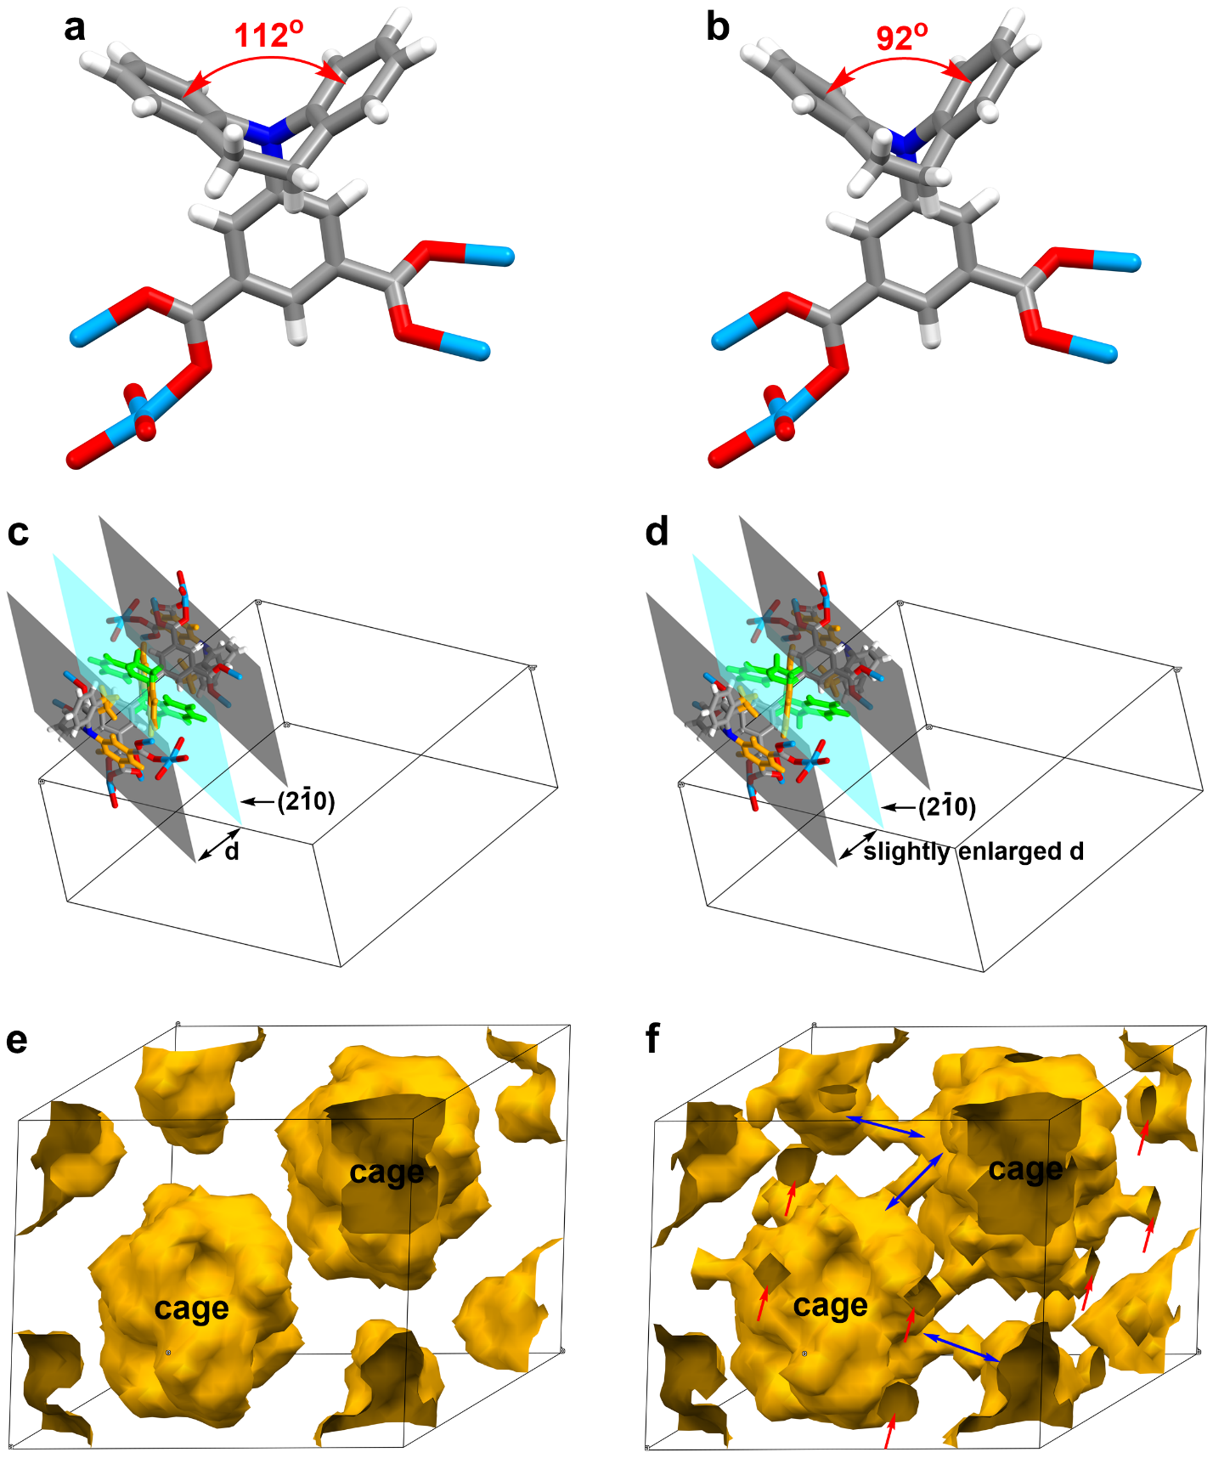
Supplementary Figure S33. Schematic diagram of the effects of the IDB flipping on the crystal structure. Configuration of the IDB-ipa with different phenyl_{(IDB)}–phenyl_{(IDB)} dihedral angles of (a) 112° (termed as “static”) and (b) 92° (termed as “flipping”), respectively. Structure related to (2$\overline{1}$0) facet in the unit cell of FDC–2a under (c) “static” and (d) “flipping” status, respectively. The IDB ring in green color showed the IDB moiety on (2$\overline{1}$0) facet (sky-blue plane), and the phenyl rings on IDB and isophthalate in orange color showed the cage aperture. The change of cage aperture of FDC–2a under (e) “static” and (f) “flipping” status, respectively. The red and blue arrows indicate the cage apertures for diffusion and the diffusion pathways among the cages, respectively. To clearly show the effects of the IDB flipping on the crystal structure, we manually changed the phenyl_{(IDB)}–phenyl_{(IDB)} dihedral angles on the IDB ring from 112º to 92º, while keeping other parts of the crystal structure the same as the initial structure. In these two structures, the structure of the framework constructed with Cu²⁺ paddle-wheels and isophthalates kept the same, whereas the IDB moieties showed different phenyl_{(IDB)}–phenyl_{(IDB)} dihedral angles. Thus, the two structures could stand for the non-flipping (static) and flipping modes of FDC–2a at low and high temperatures, respectively. The “flipping” structure revealed a slight expansion of the [2$\overline{1}$0] axis compared to the “static” structure, in good agreement with the VT-PXRD results that the peaks corresponding to the (2$\overline{1}$0) facet shifted to a lower angle. Since IDB moiety is oriented parallel to the (2$\overline{1}$0) plane, this tiny expansion of [2$\overline{1}$0] distances could be correlated with the extent of thermal flipping of the IDB moiety. Notably, the “flipping” structure showed a remarkable enlargement of cage aperture (2.68 Å in “flipping” structure vs. 2.0 Å in “static” structure) for the diffusion of water isotopologues compared to the “static” structure, which indicated that the “flipping” structure allowed accelerating the diffusion of water isotopologues in response to increasing temperature.

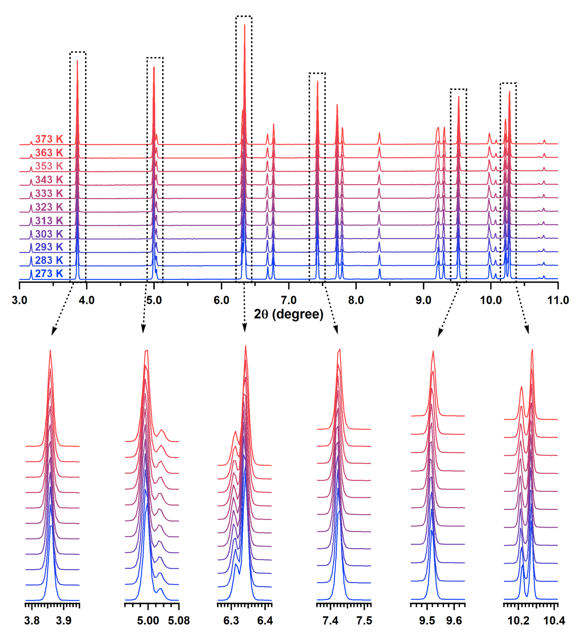
Supplementary Figure S34. Variable-temperature synchrotron PXRD of FDC–1a under water-adsorbed conditions in the temperature range from 273 to 373 K.

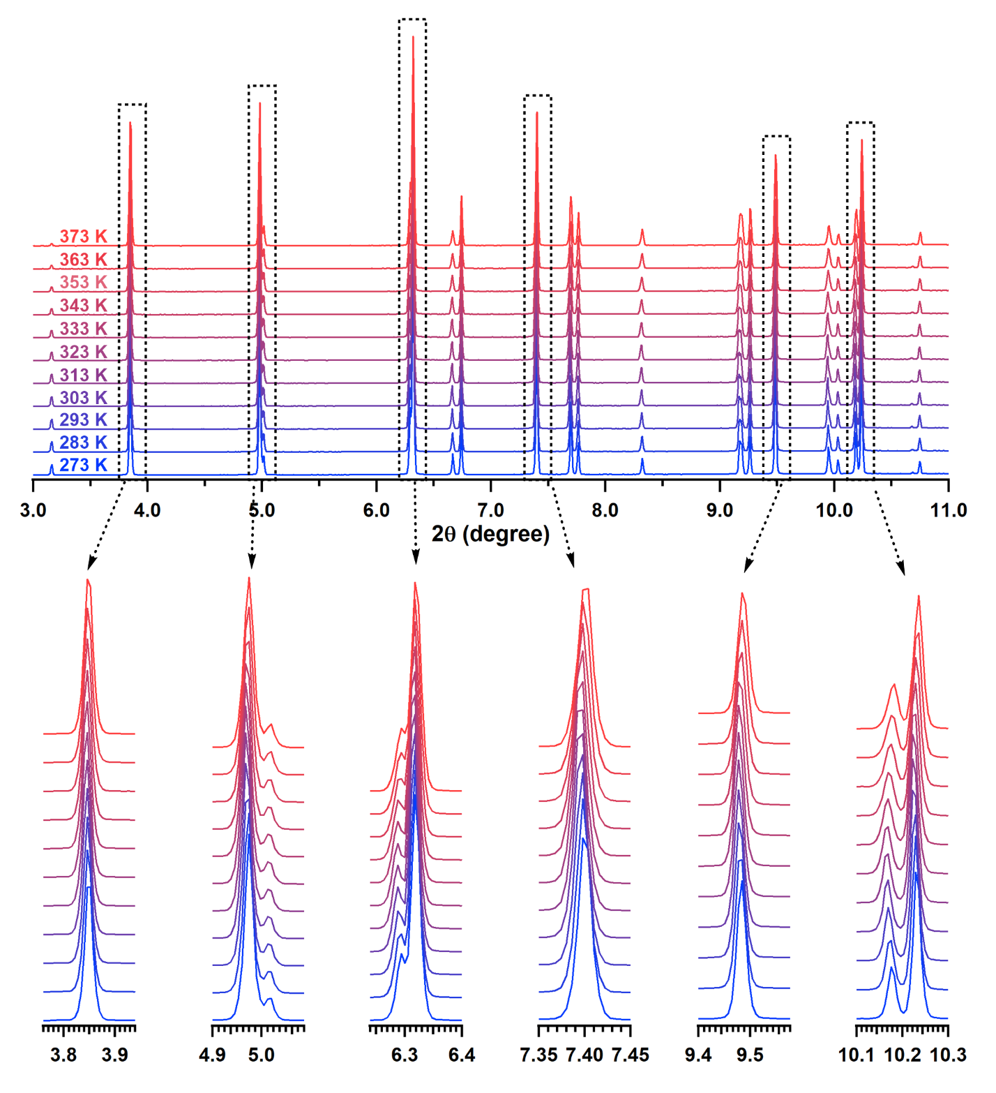
Supplementary Figure S35. Variable-temperature synchrotron PXRD of FDC–2a under water-adsorbed conditions in the temperature range from 273 to 373 K.

Section 10: Theoretical calculation of the diffusion energies and rates
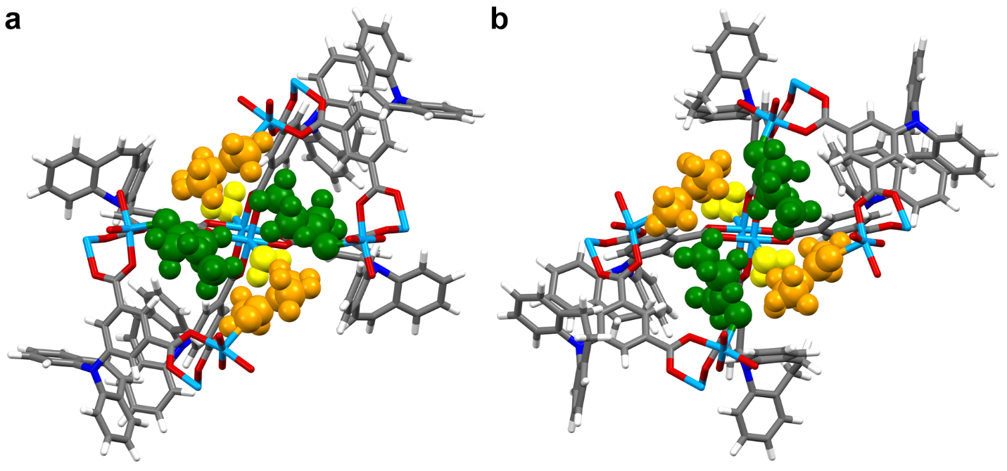
Supplementary Figure S36. Optimized crystal structures of (a) FDC–1a and (b) FDC–2a with adsorbed H₂O and DMA molecules. The crystal structures were optimized using the primitive unit cells. The golden models represent the H₂O molecules docking at the open-metal sites, whereas the orange and green models denote the DMA molecules docking at the open-metal sites in two different positions.

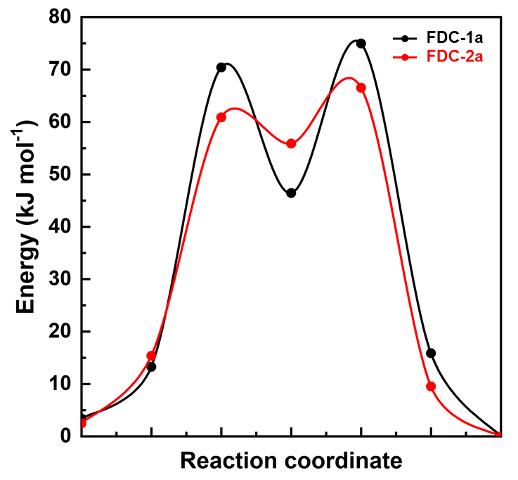
Supplementary Figure S37. Reaction coordinate–energy profile for the diffusion of one H₂O molecule through the small aperture connecting two neighboring cages.

Section 11: Vapor separation experiments for FDCs
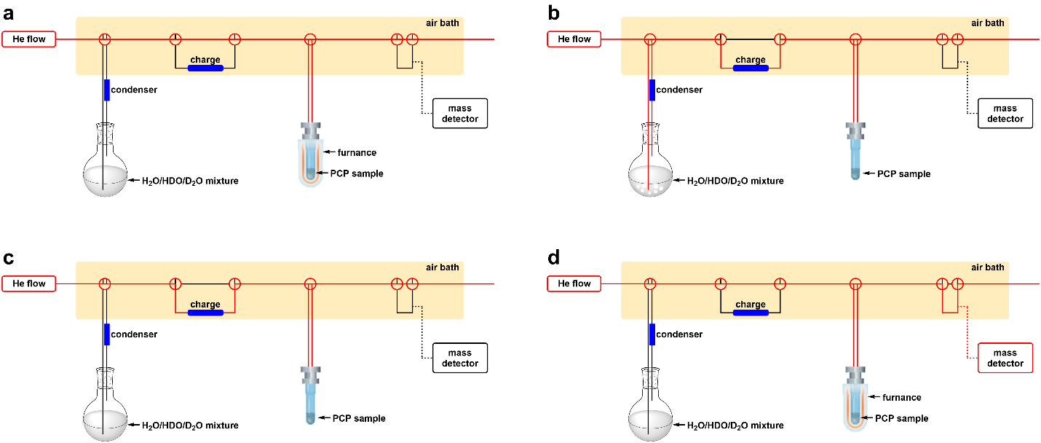
Supplementary Figure S38. Flow path diagram of TPD vapor separation experiment for the process (a) No. 1, (b) No. 2, (c) No. 3 (d) No. 4.
Note: Experimental procedure for vapor separation with flow diagrams:
No. 1. Activating the sample in the cell under He flow at 393 K for 2 h (a).
No. 2. Mixed vapor flowing at 298 K (b).
No. 3. Flowing away remained vapor in the gas line and sample tube with He flush (c).
No. 4. Heating to 393 K to desorb vapor from the sample and mass test (d).

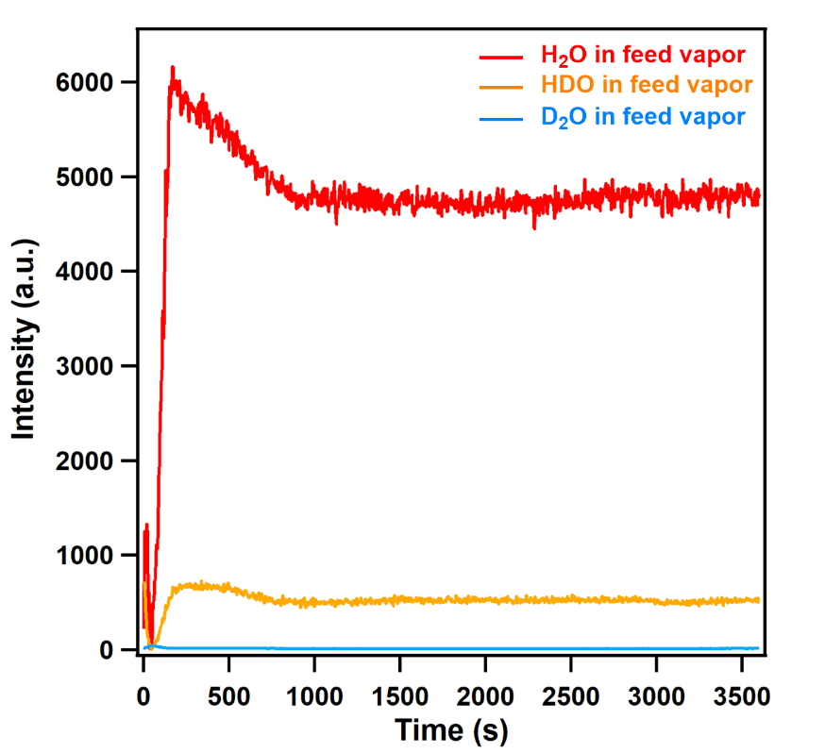
Supplementary Figure S39. TPD spectra of H₂O/HDO/D₂O mixture vapor as the feed vapor. The ratio of the liquid volume was H₂O:D₂O = 95:5 (v/v). From the intensity of the equilibrium curve, the ratio of H₂O:HDO:D₂O in the mixture vapor was 90.3:9.4:0.3.

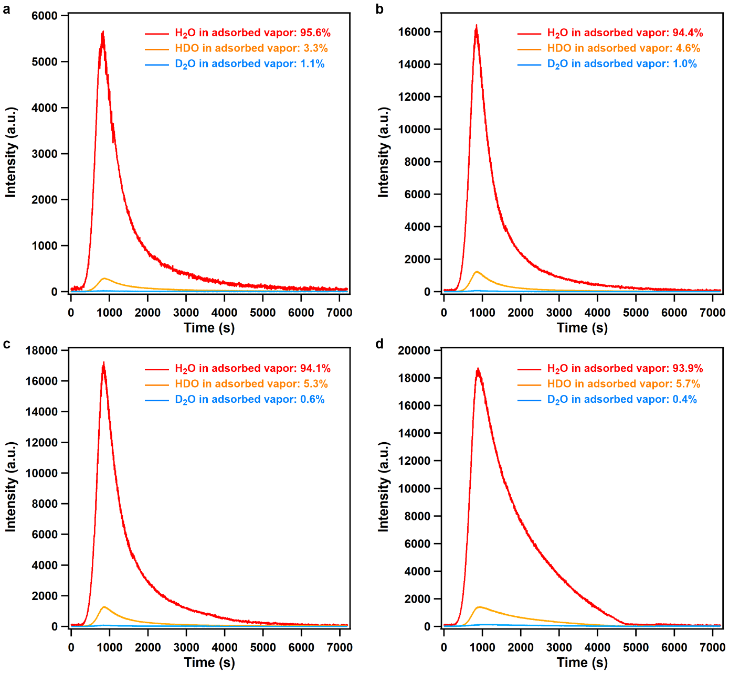
Supplementary Figure S40. TPD spectra of adsorbed vapor on FDC–1a at (a) 0.5 h, (b) 1 h, (c) 2 h, and (d) 4 h exposure time at 298 K. The feed-vapor ratio was H₂O:HDO:D₂O = 90.3:9.4:0.3.

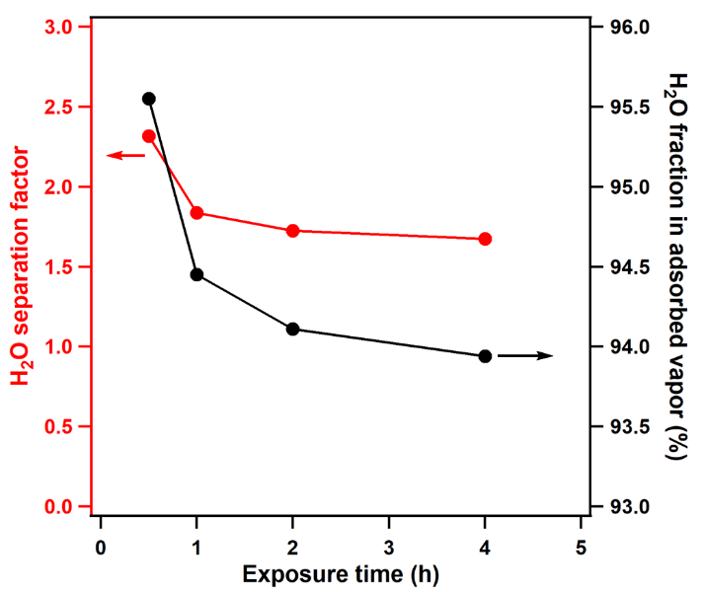
Supplementary Figure S41. Correlation of vapor exposure time, H₂O fraction in the adsorbed vapor, and H₂O separation factor for FDC–1a. A value of separation factor larger than unity means that the material preferentially adsorbs H₂O molecules. H₂O is preferentially adsorbed on FDC–1a over a wide range of exposure time.

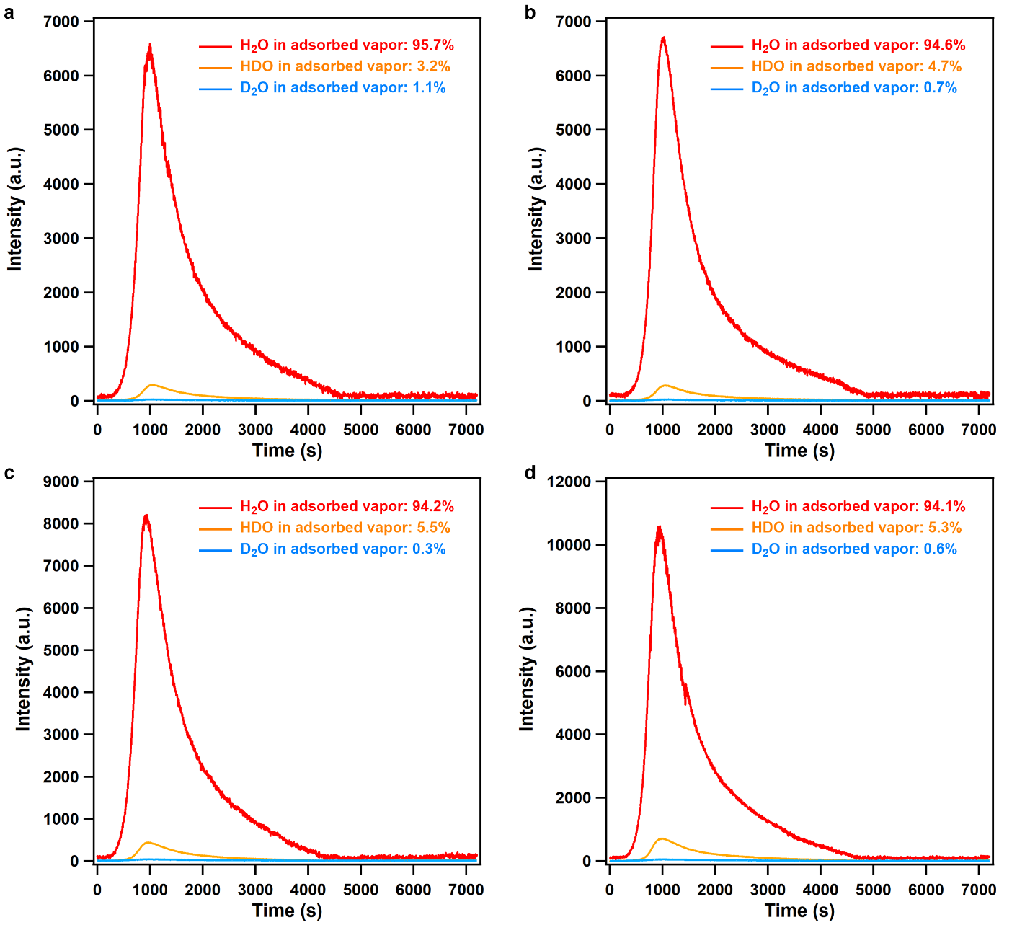
Supplementary Figure S42. TPD spectra of adsorbed vapor on FDC–2a at (a) 0.5 h, (b) 1 h, (c) 2 h, and (d) 4 h exposure time at 298 K. The feed-vapor ratio was H₂O:HDO:D₂O = 90.3:9.4:0.3.

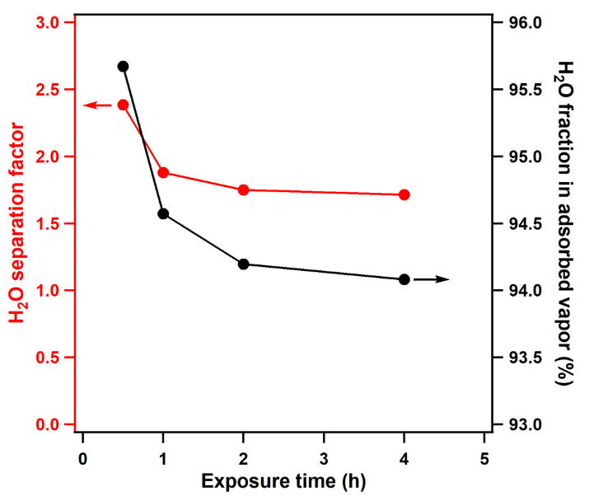
Supplementary Figure S43. Correlation of vapor exposure time, H₂O fraction in the adsorbed vapor, and H₂O separation factor for FDC–2a. A value of separation factor larger than unity means that the material preferentially adsorbs H₂O molecules. H₂O is preferentially adsorbed on FDC–2a over a wide range of exposure time.

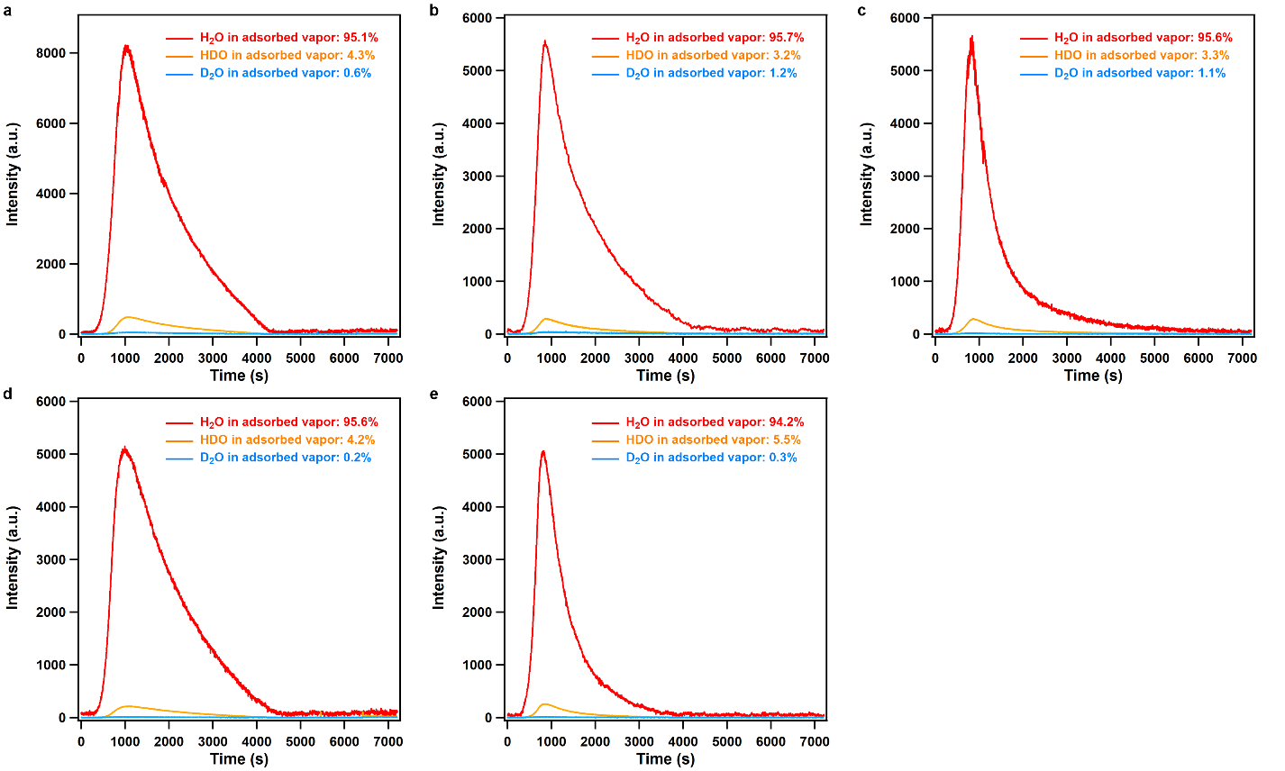
Supplementary Figure S44. TPD spectra of adsorbed vapor on FDC–1a at 0.5 h exposure time at (a) 278 K, (b) 288 K, (c) 298 K, (d) 308 K, and (e) 323 K. The feed-vapor ratio was H₂O:HDO:D₂O = 90.3:9.4:0.3.

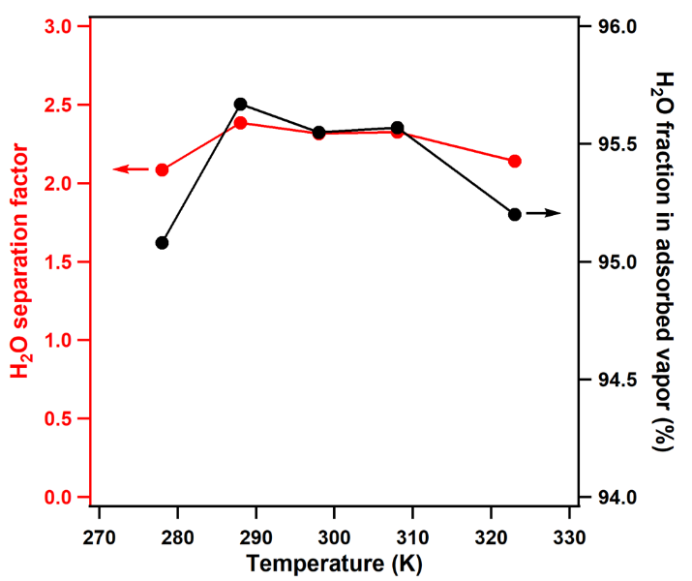
Supplementary Figure S45. Correlation of temperature, H₂O fraction in the adsorbed vapor, and H₂O separation factor for FDC–1a. A value of separation factor larger than unity means that the material preferentially adsorbs H₂O molecules. H₂O is preferentially adsorbed on FDC–1a over a wide range of temperatures.

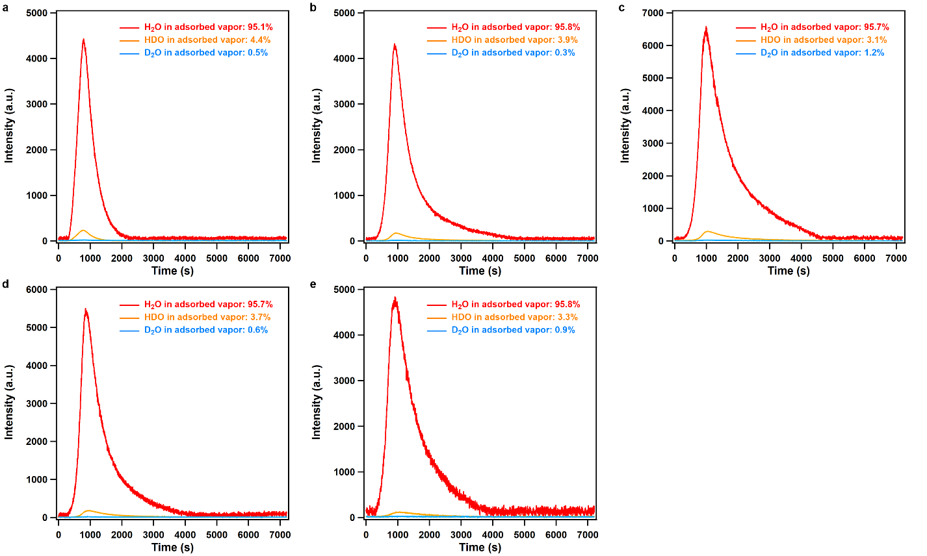
Supplementary Figure S46. TPD spectra of adsorbed vapor on FDC–2a at 0.5 h exposure time at (a) 278 K, (b) 288 K, (c) 298 K, (d) 308 K, and (e) 323 K. The feed-vapor ratio was H₂O:HDO:D₂O = 90.3:9.4:0.3.

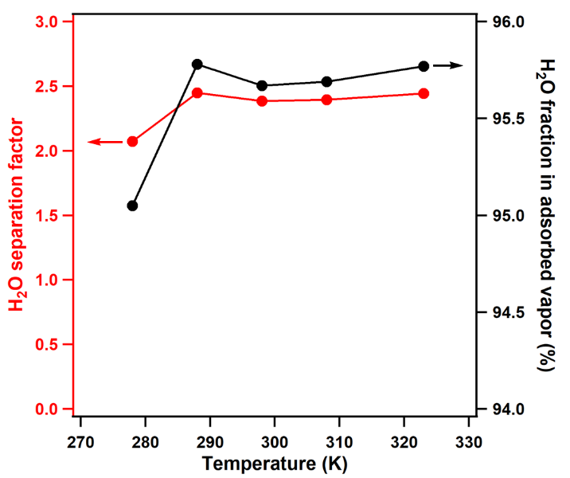
Supplementary Figure S47. Correlation of temperature, H₂O fraction in the adsorbed vapor, and H₂O separation factor for FDC–2a. A value of separation factor larger than unity means that the material preferentially adsorbs H₂O molecules. H₂O is preferentially adsorbed on FDC–2a over a wide range of temperatures.

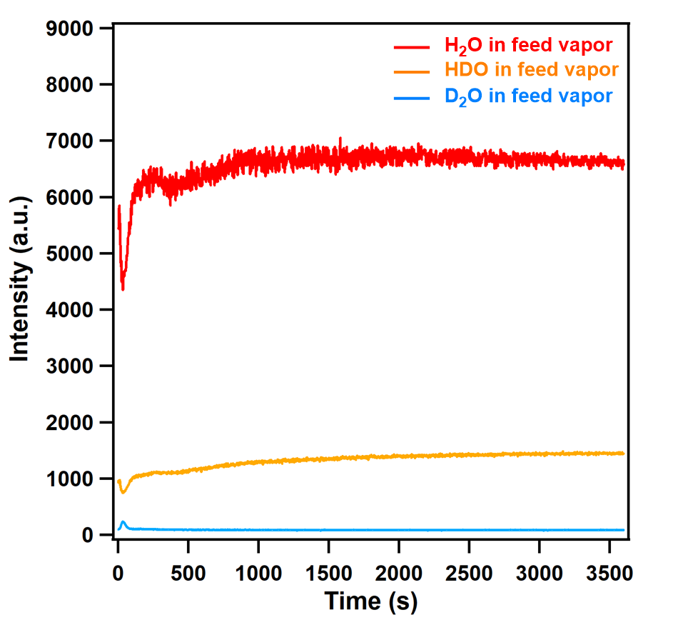
Supplementary Figure S48. TPD spectra of H₂O/HDO/D₂O mixture vapor as the feed vapor. The ratio of the liquid volume was H₂O:D₂O = 90:10 (v/v). From the intensity of the equilibrium curve, the ratio of H₂O:HDO:D₂O in the mixture vapor was 81.1:17.8:1.1.

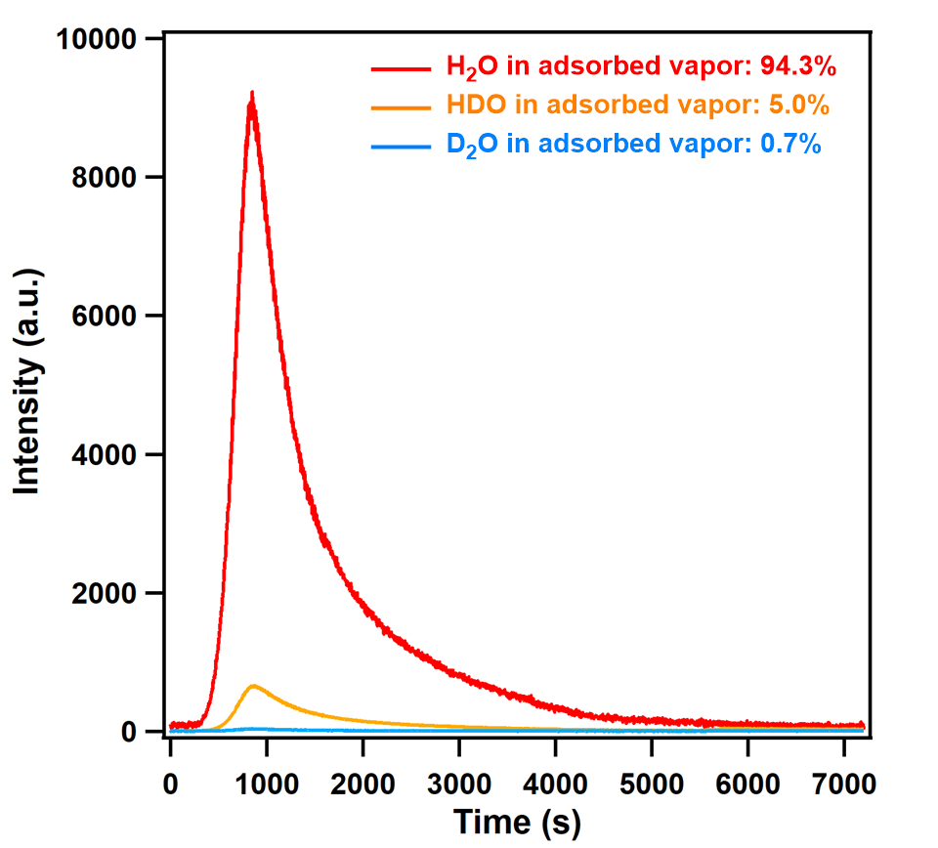
Supplementary Figure S49. TPD spectra of adsorbed vapor on FDC–1a at 0.5 h exposure time at 298 K. The feed-vapor ratio was H₂O:HDO:D₂O = 81.1:17.8:1.1.

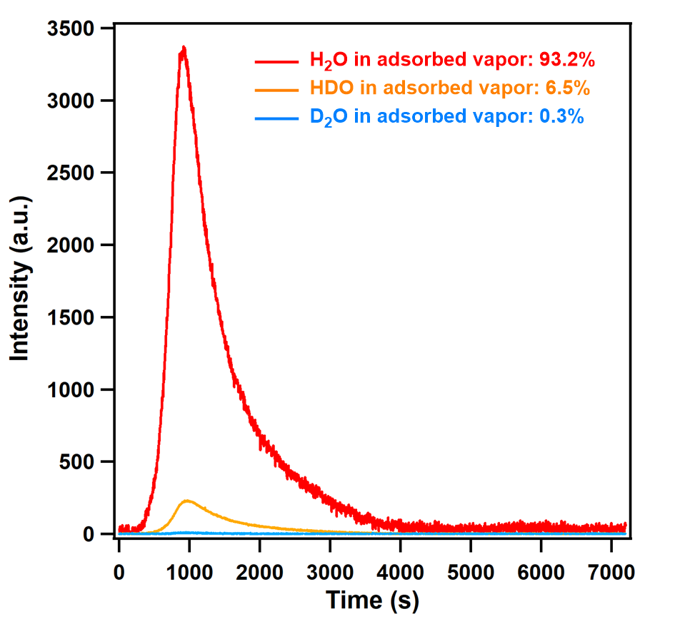
Supplementary Figure S50. TPD spectra of adsorbed vapor on FDC–2a at 0.5 h exposure time at 298 K. The feed-vapor ratio was H₂O:HDO:D₂O = 81.1:17.8:1.1.

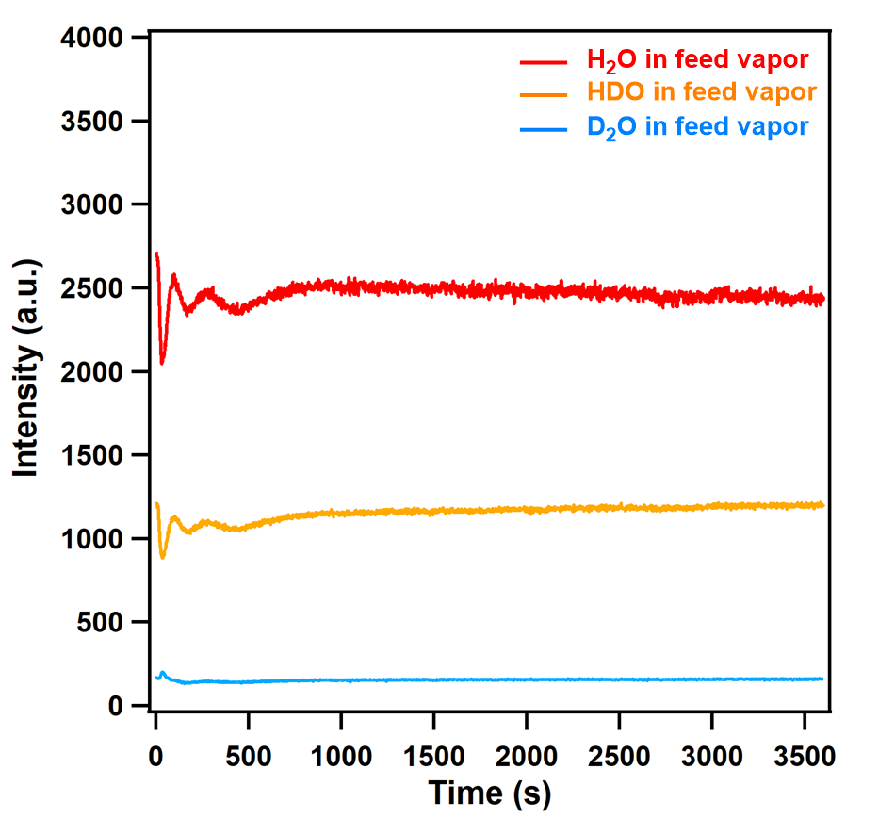
Supplementary Figure S51. TPD spectra of H₂O/HDO/D₂O mixture vapor as the feed vapor. The ratio of the liquid volume was H₂O:D₂O = 80:20 (v/v). From the intensity of the equilibrium curve, the ratio of H₂O:HDO:D₂O in the mixture vapor was 64.2:31.6:4.2.

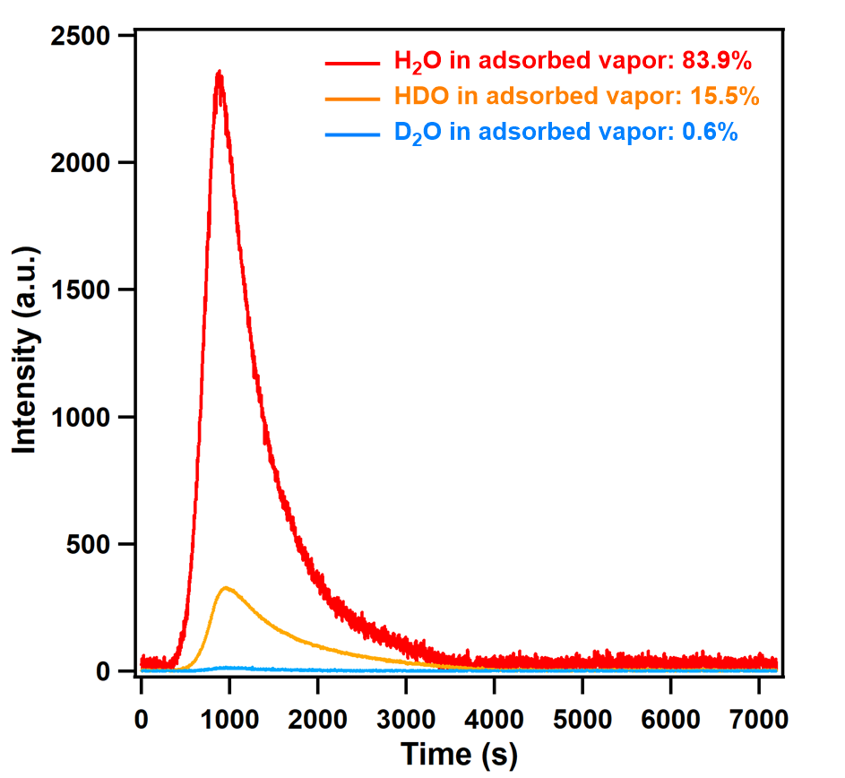
Supplementary Figure S52. TPD spectra of adsorbed vapor on FDC–1a at 0.5 h exposure time at 298 K. The feed-vapor ratio was H₂O:HDO:D₂O = 64.2:31.6:4.2.

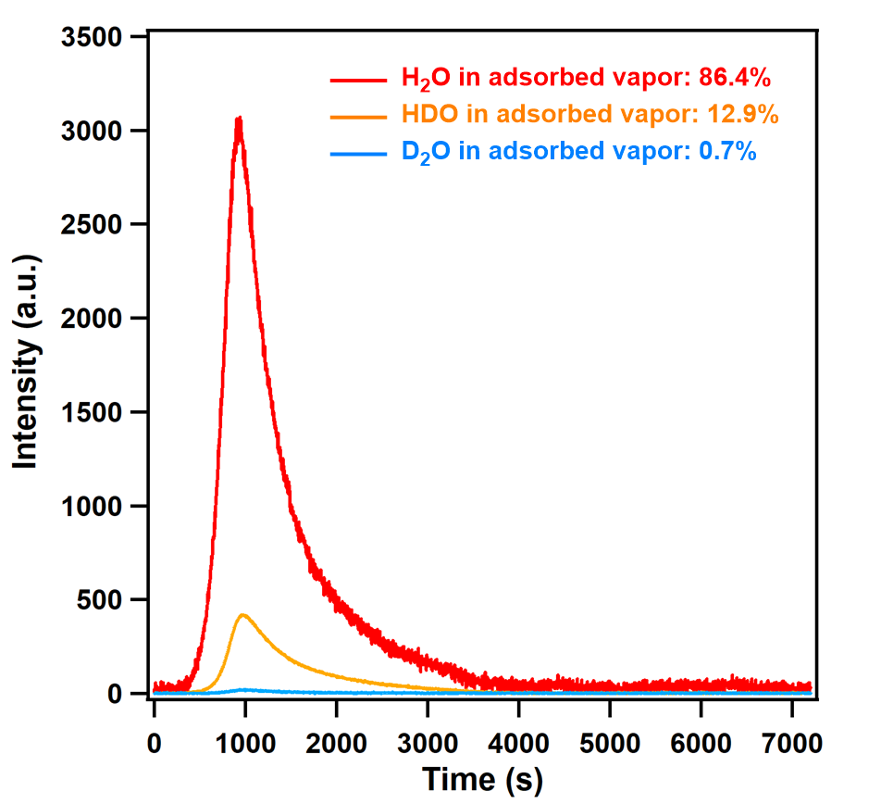
Supplementary Figure S53. TPD spectra of adsorbed vapor on FDC–2a at 0.5 h exposure time at 298 K. The feed-vapor ratio was H₂O:HDO:D₂O = 64.2:31.6:4.2.

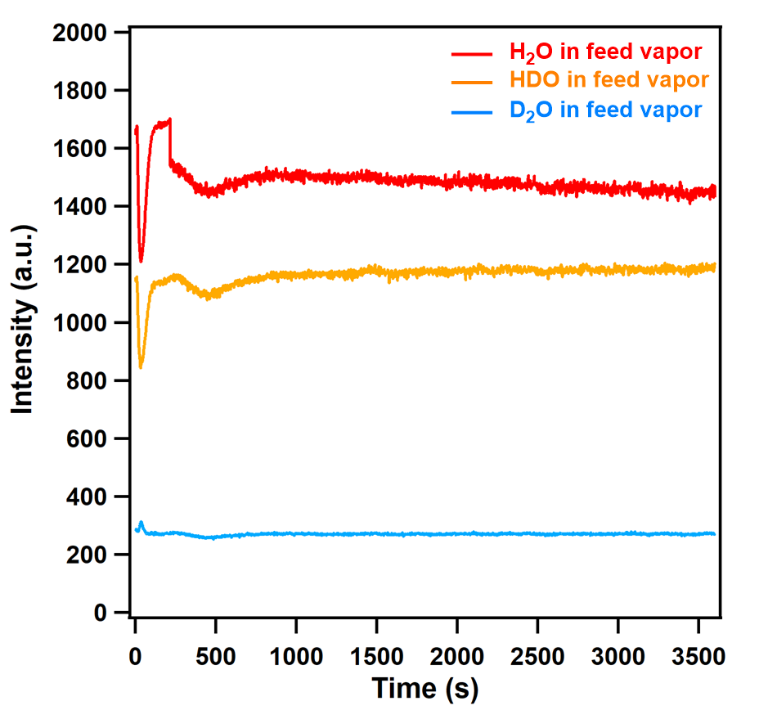
Supplementary Figure S54. TPD spectra of H₂O/HDO/D₂O mixture vapor as the feed vapor. The ratio of the liquid volume was H₂O:D₂O = 70:30 (v/v). From the intensity of the equilibrium curve, the ratio of H₂O:HDO:D₂O in the mixture vapor was 49.3:41.4:9.3.

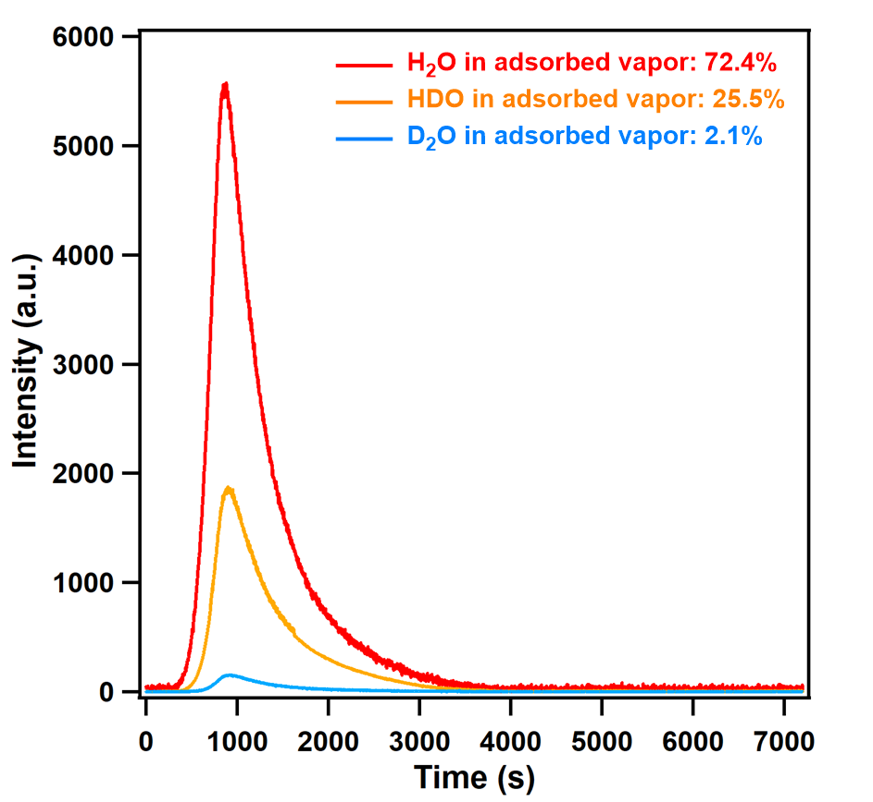
Supplementary Figure S55. TPD spectra of adsorbed vapor on FDC–1a at 0.5 h exposure time at 298 K. The feed-vapor ratio was H₂O:HDO:D₂O = 49.3:41.4:9.3.

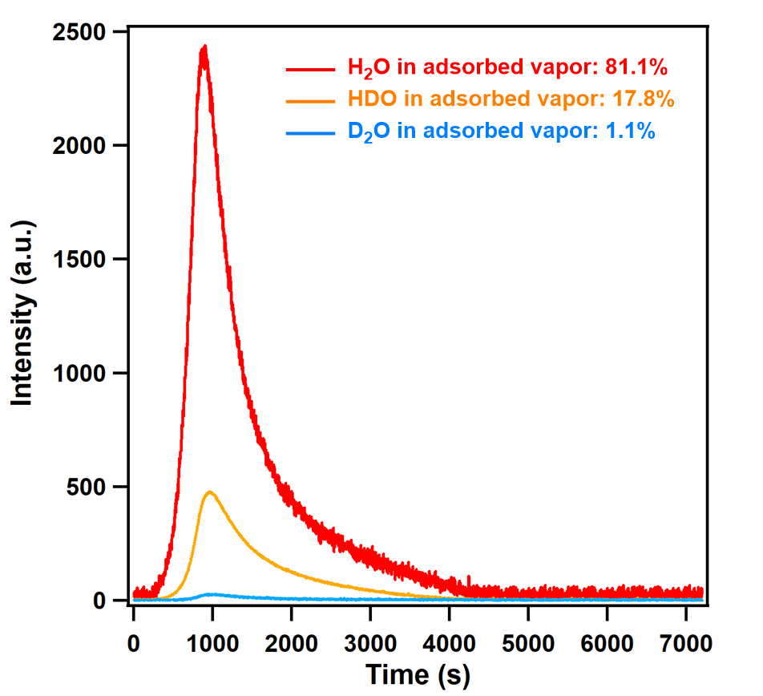
Supplementary Figure S56. TPD spectra of adsorbed vapor on FDC–2a at 0.5 h exposure time at 298 K. The feed-vapor ratio was H₂O:HDO:D₂O = 49.3:41.4:9.3.

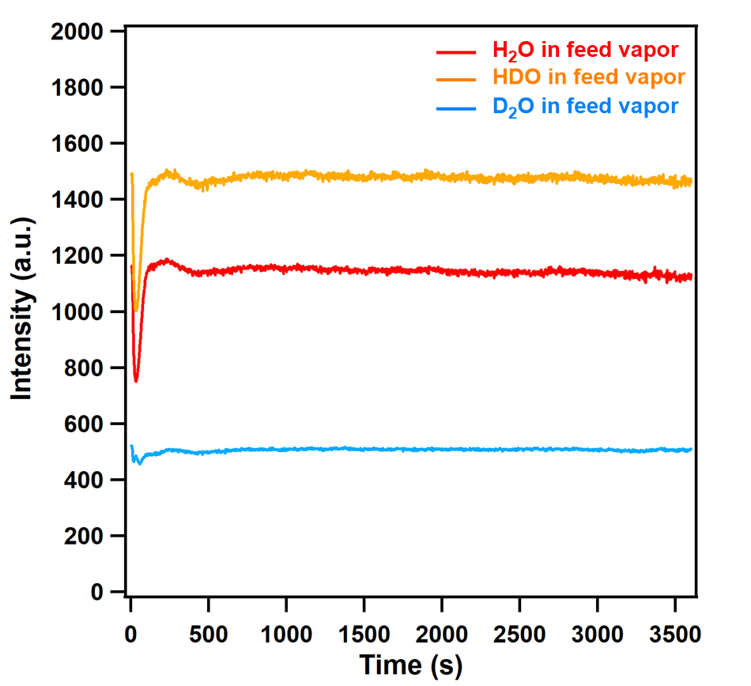
Supplementary Figure S57. TPD spectra of H₂O/HDO/D₂O mixture vapor as the feed vapor. The ratio of the liquid volume was H₂O:D₂O = 60:40 (v/v). From the intensity of the equilibrium curve, the ratio of H₂O:HDO:D₂O in the mixture vapor was 36.4:47.2:16.4.

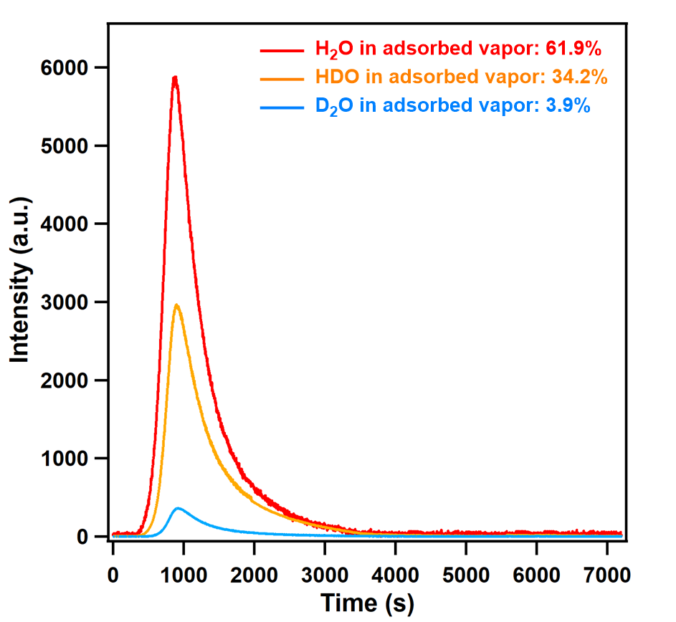
Supplementary Figure S58. TPD spectra of adsorbed vapor on FDC–1a at 0.5 h exposure time at 298 K. The feed-vapor ratio was H₂O:HDO:D₂O = 36.4:47.2:16.4.

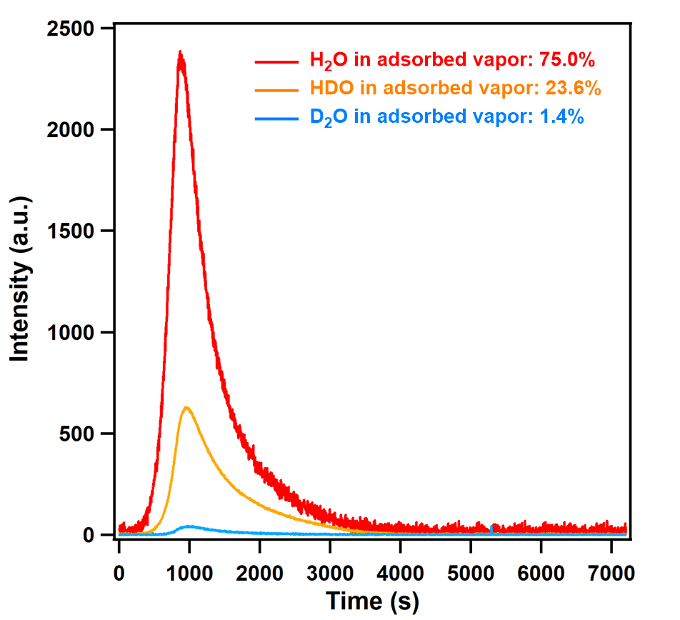
Supplementary Figure S59. TPD spectra of adsorbed vapor on FDC–2a at 0.5 h exposure time at 298 K. The feed-vapor ratio was H₂O:HDO:D₂O = 36.4:47.2:16.4.

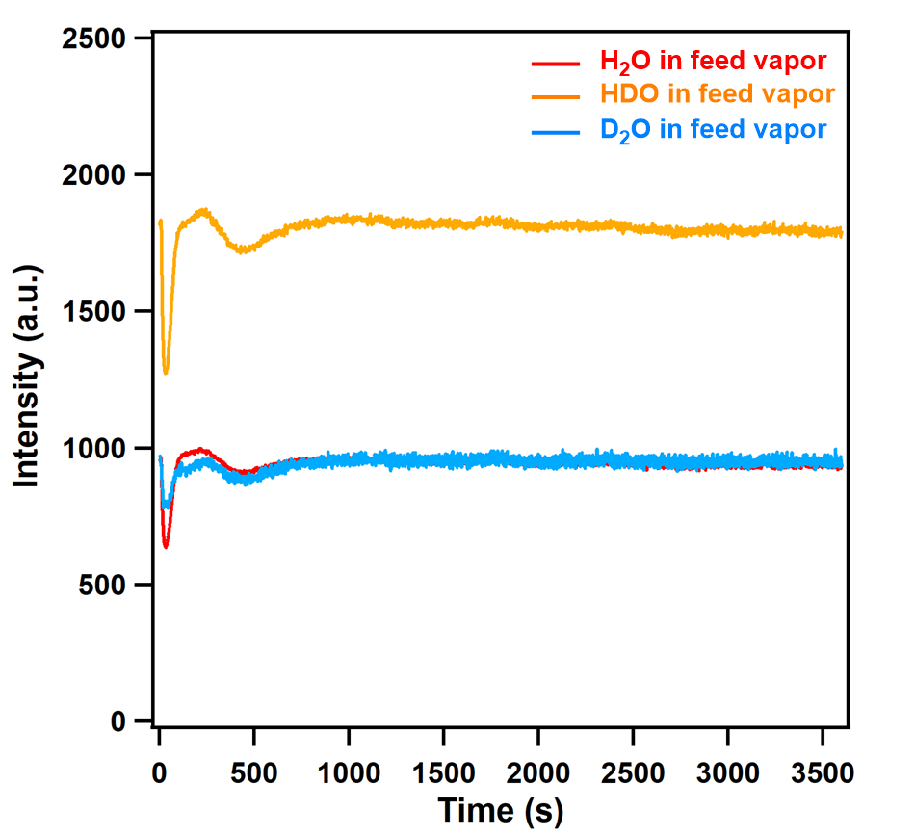
Supplementary Figure S60. TPD spectra of H₂O/HDO/D₂O mixture vapor as the feed vapor. The ratio of the liquid volume was H₂O:D₂O = 50:50 (v/v). From the intensity of the equilibrium curve, the ratio of H₂O:HDO:D₂O in the mixture vapor was 25.4:49.2:25.4.

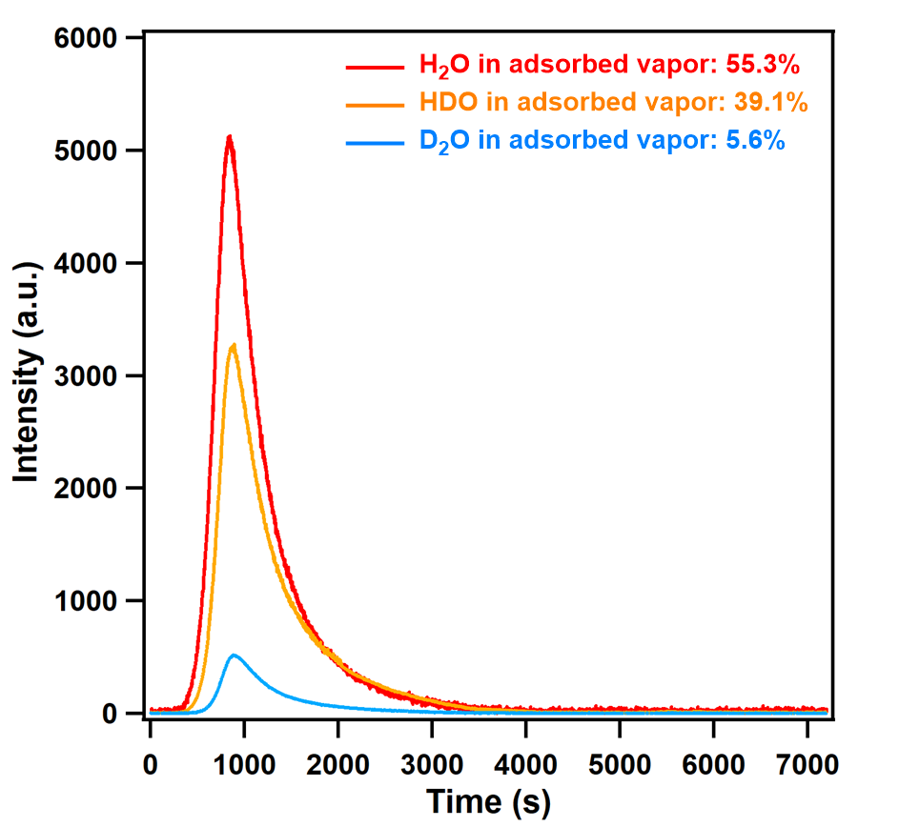
Supplementary Figure S61. TPD spectra of adsorbed vapor on FDC–1a at 0.5 h exposure time at 298 K. The feed-vapor ratio was H₂O:HDO:D₂O = 25.4:49.2:25.4.

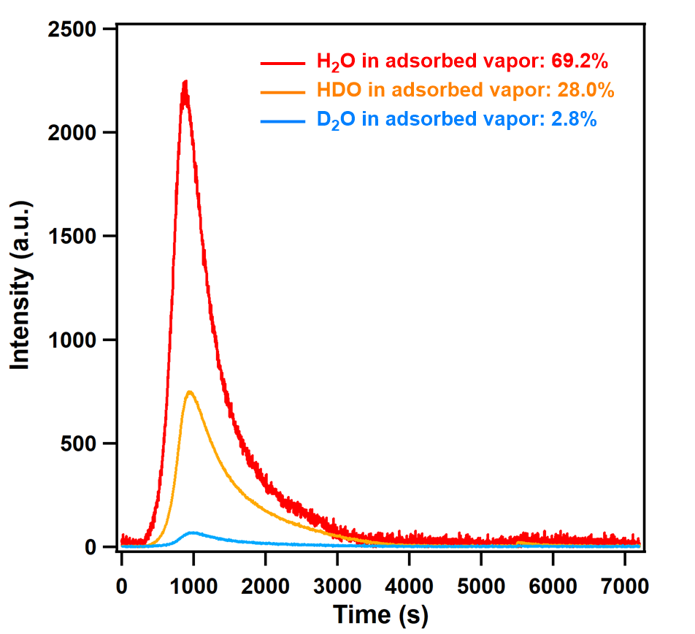
Supplementary Figure S62. TPD spectra of adsorbed vapor on FDC–2a at 0.5 h exposure time at 298 K. The feed-vapor ratio was H₂O:HDO:D₂O = 25.4:49.2:25.4.

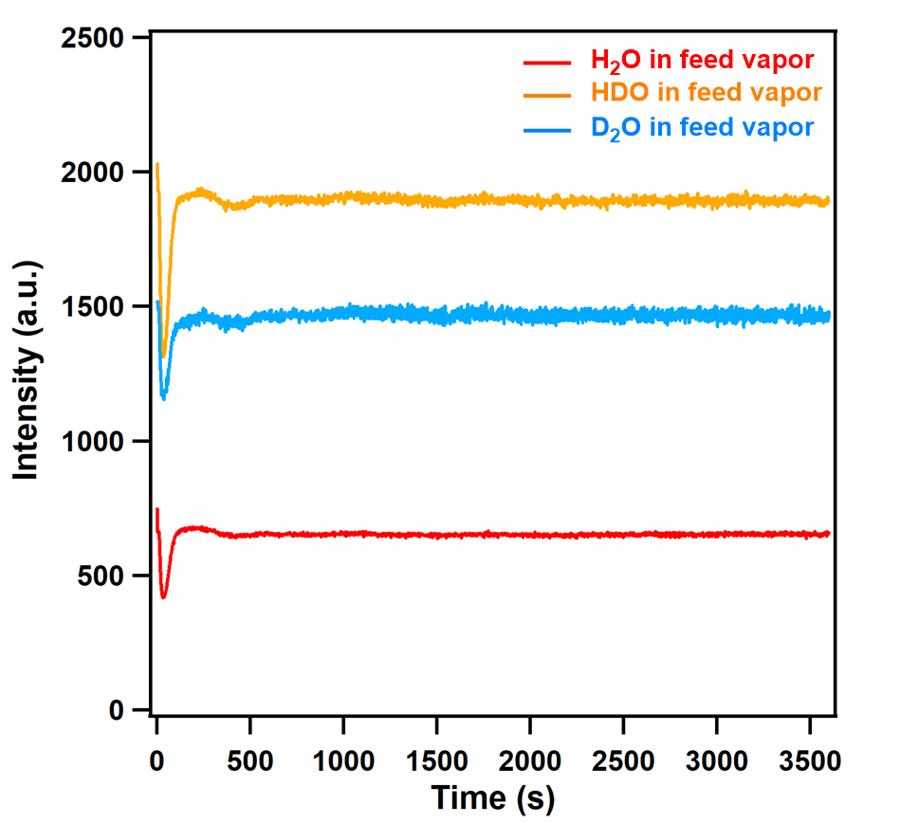
Supplementary Figure S63. TPD spectra of H₂O/HDO/D₂O mixture vapor as the feed vapor. The ratio of the liquid volume was H₂O:D₂O = 40:60 (v/v). From the intensity of the equilibrium curve, the ratio of H₂O:HDO:D₂O in the mixture vapor was 16.5:47.1:36.4.

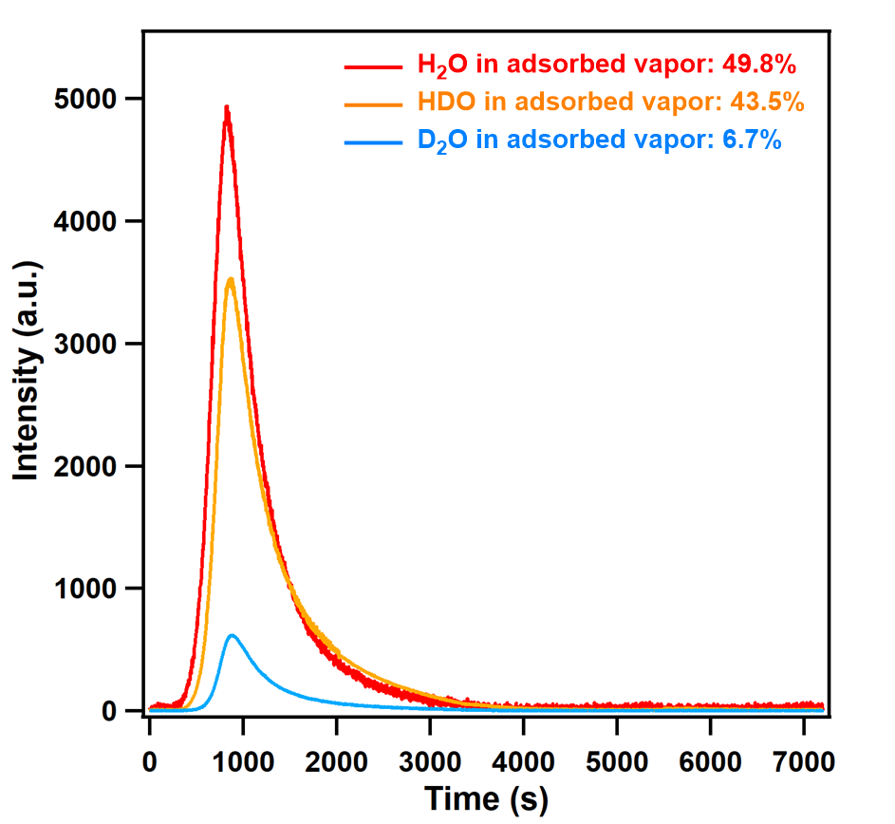
Supplementary Figure S64. TPD spectra of adsorbed vapor on FDC–1a at 0.5 h exposure time at 298 K. The feed-vapor ratio was H₂O:HDO:D₂O = 16.5:47.1:36.4.

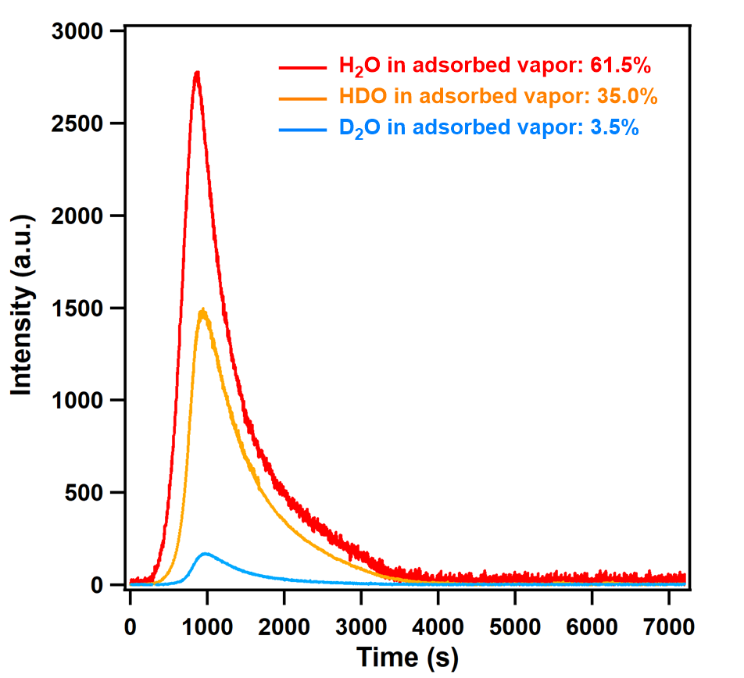
Supplementary Figure S65. TPD spectra of adsorbed vapor on FDC–2a at 0.5 h exposure time at 298 K. The feed-vapor ratio was H₂O:HDO:D₂O = 16.5:47.1:36.4.

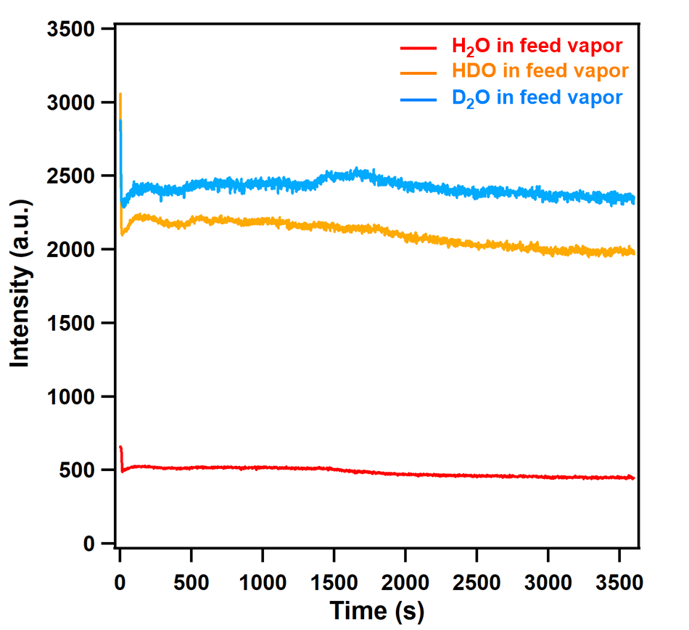
Supplementary Figure S66. TPD spectra of H₂O/HDO/D₂O mixture vapor as the feed vapor. The ratio of the liquid volume was H₂O:D₂O = 30:70 (v/v). From the intensity of the equilibrium curve, the ratio of H₂O:HDO:D₂O in the mixture vapor was 9.3:41.3:49.4.

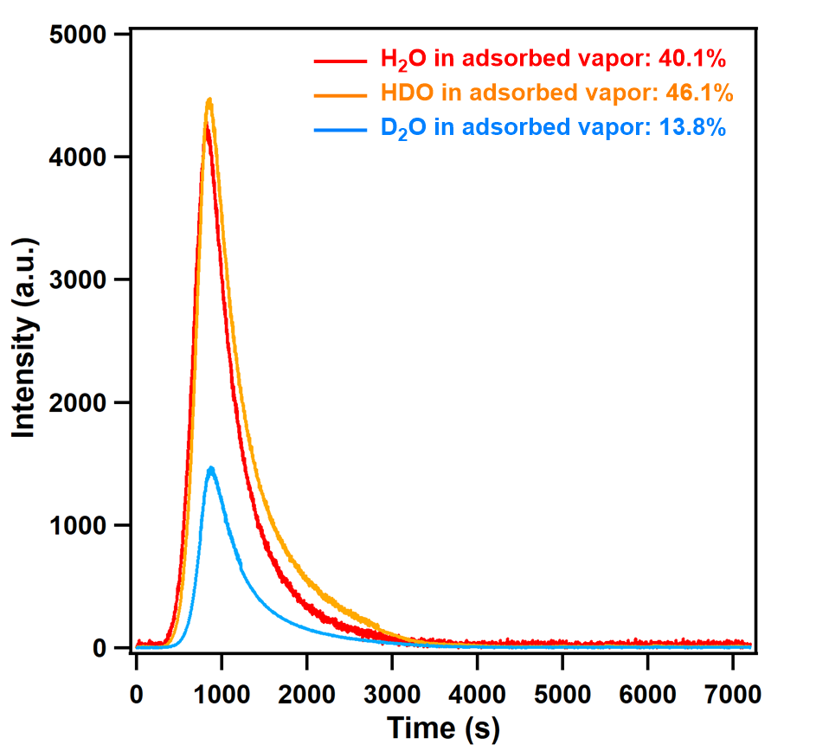
Supplementary Figure S67. TPD spectra of adsorbed vapor on FDC–1a at 0.5 h exposure time at 298 K. The feed-vapor ratio was H₂O:HDO:D₂O = 9.3:41.3:49.4.

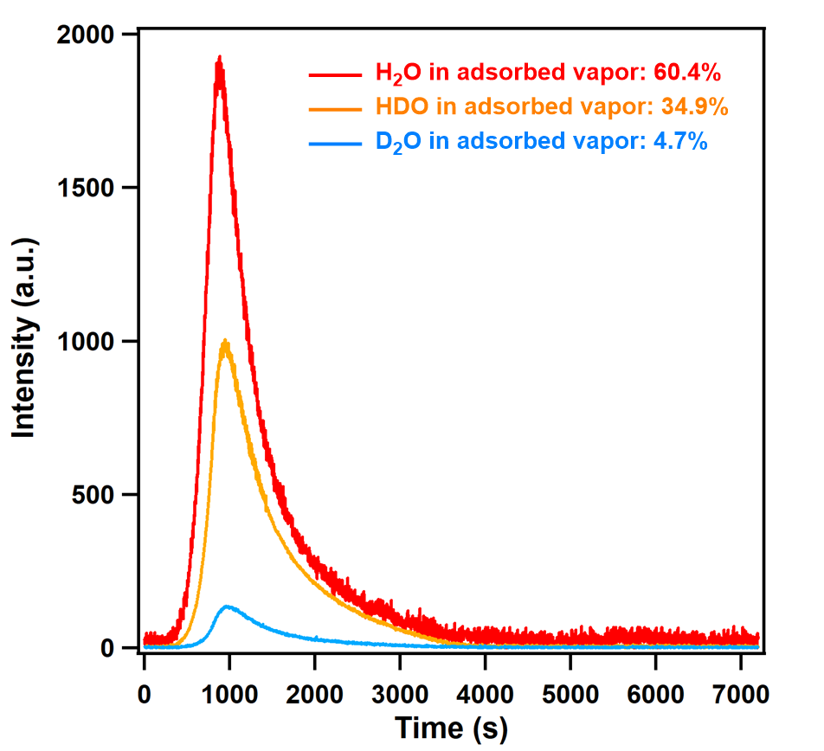
Supplementary Figure S68. TPD spectra of adsorbed vapor on FDC–2a at 0.5 h exposure time at 298 K. The feed-vapor ratio was H₂O:HDO:D₂O = 9.3:41.3:49.4.

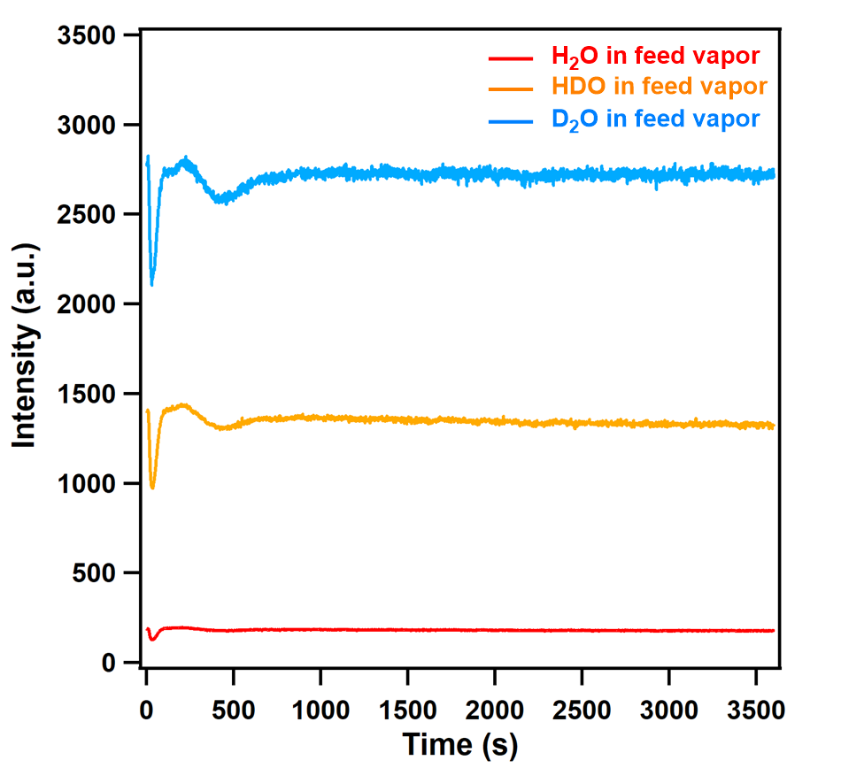
Supplementary Figure S69. TPD spectra of H₂O/HDO/D₂O mixture vapor as the feed vapor. The ratio of the liquid volume was H₂O:D₂O = 20:80 (v/v). From the intensity of the equilibrium curve, the ratio of H₂O:HDO:D₂O in the mixture vapor was 4.1:31.4:64.5.

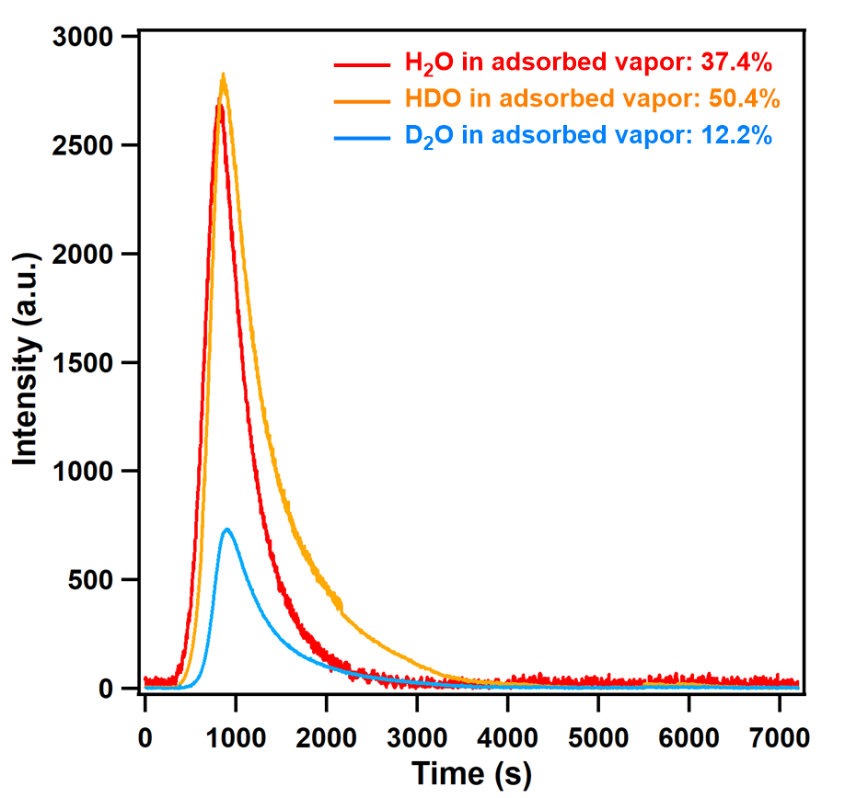
Supplementary Figure S70. TPD spectra of adsorbed vapor on FDC–1a at 0.5 h exposure time at 298 K. The feed-vapor ratio was H₂O:HDO:D₂O = 4.1:31.4:64.5.

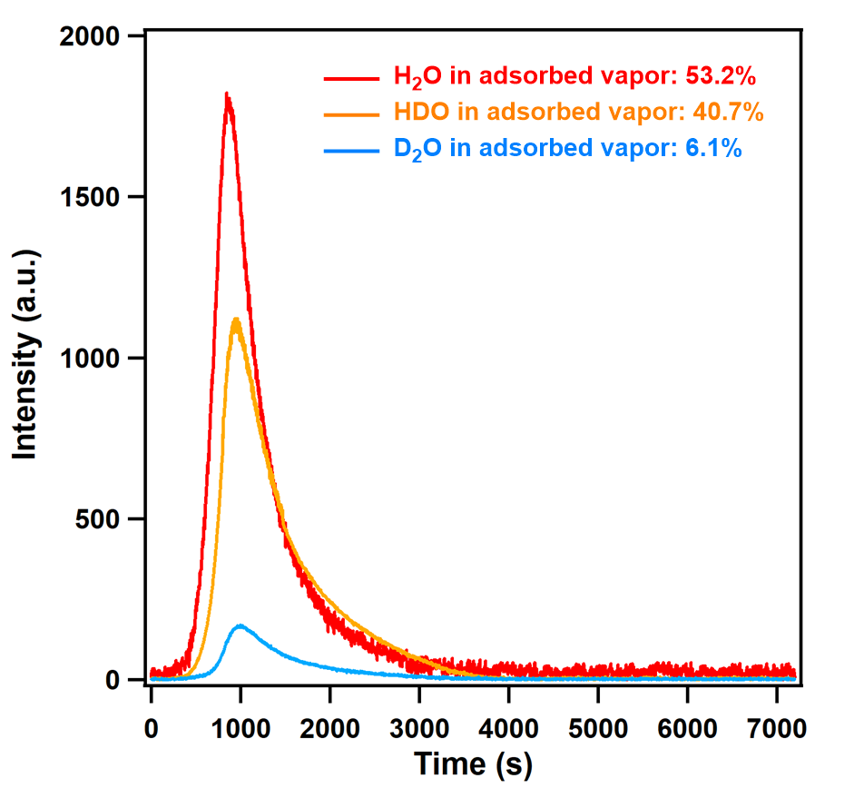
Supplementary Figure S71. TPD spectra of adsorbed vapor on FDC–2a at 0.5 h exposure time at 298 K. The feed-vapor ratio was H₂O:HDO:D₂O = 4.1:31.4:64.5.

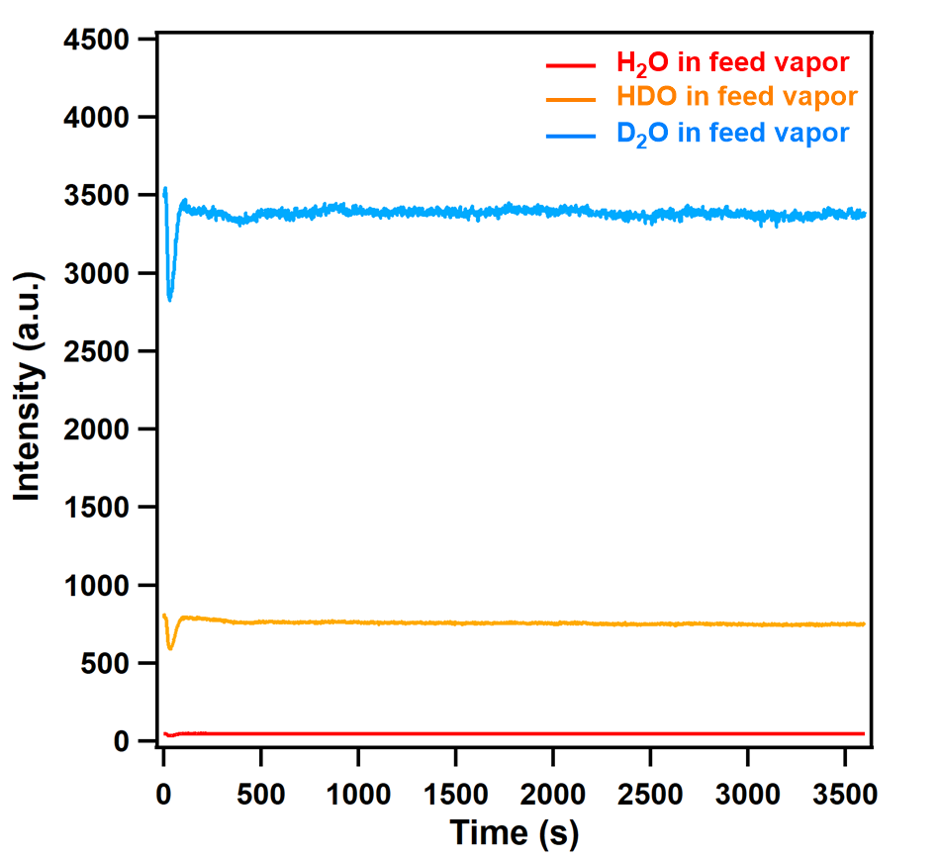
Supplementary Figure S72. TPD spectra of H₂O/HDO/D₂O mixture vapor as the feed vapor. The ratio of the liquid volume was H₂O:D₂O = 10:90 (v/v). From the intensity of the equilibrium curve, the ratio of H₂O:HDO:D₂O in the mixture vapor was 1.1:17.9:81.0.

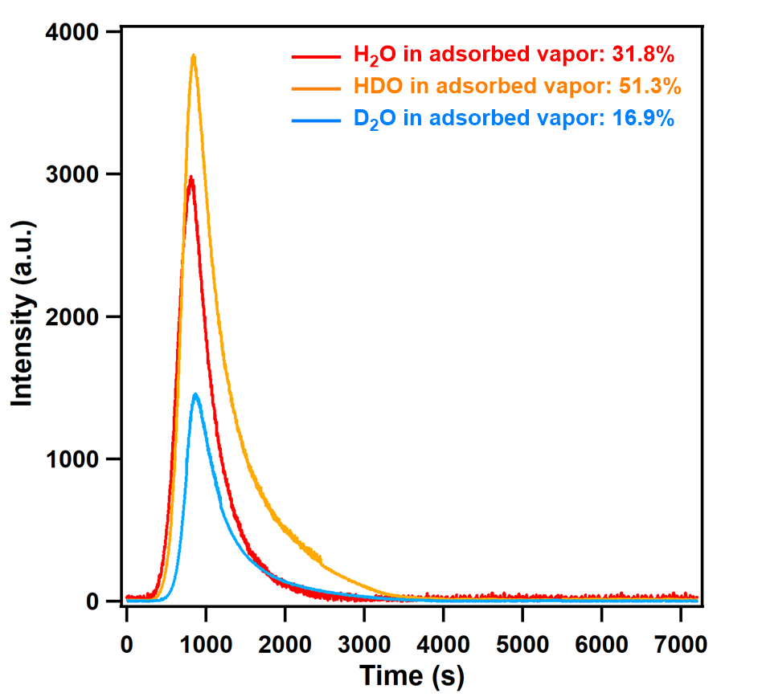
Supplementary Figure S73. TPD spectra of adsorbed vapor on FDC–1a at 0.5 h exposure time at 298 K. The feed-vapor ratio was H₂O:HDO:D₂O = 1.1:17.9:81.0.

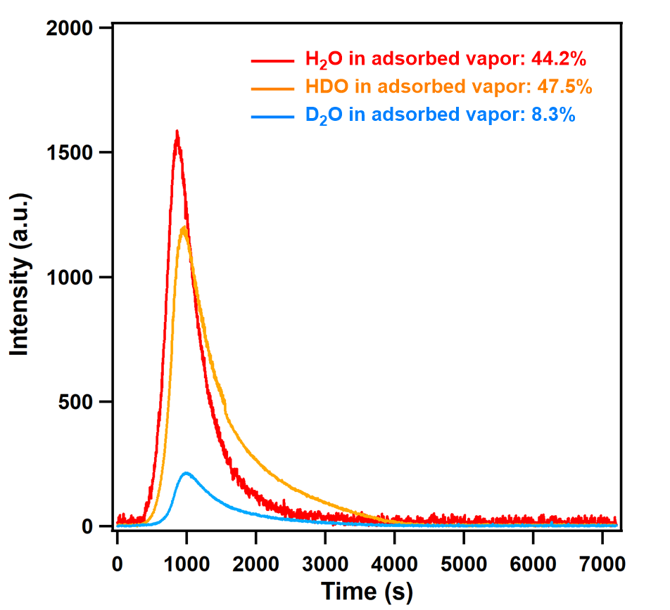
Supplementary Figure S74. TPD spectra of adsorbed vapor on FDC–2a at 0.5 h exposure time at 298 K. The feed-vapor ratio was H₂O:HDO:D₂O = 1.1:17.9:81.0.

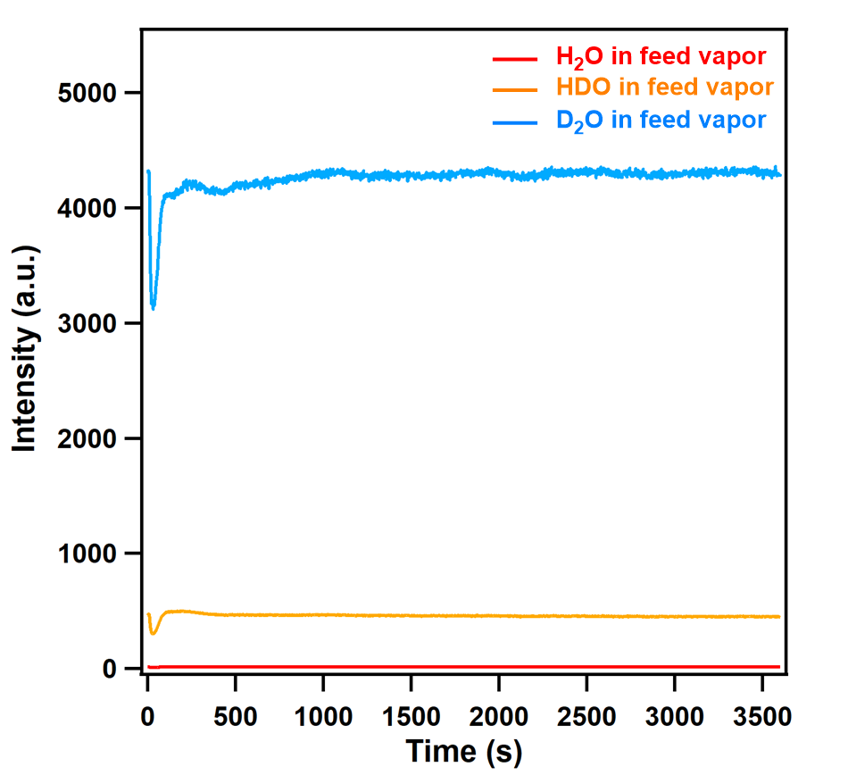
Supplementary Figure S75. TPD spectra of H₂O/HDO/D₂O mixture vapor as the feed vapor. The ratio of the liquid volume was H₂O:D₂O = 5:95 (v/v). From the intensity of the equilibrium curve, the ratio of H₂O:HDO:D₂O in the mixture vapor was 0.3:9.3:90.4.

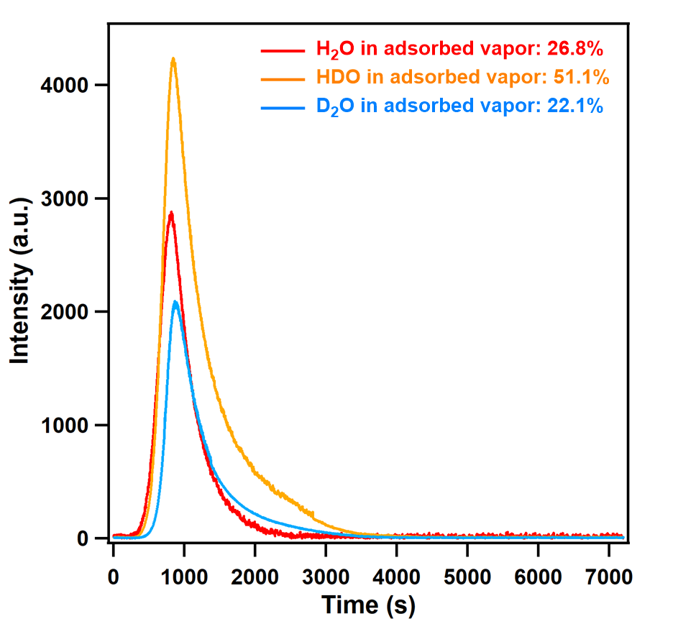
Supplementary Figure S76. TPD spectra of adsorbed vapor on FDC–1a at 0.5 h exposure time at 298 K. The feed-vapor ratio was H₂O:HDO:D₂O = 0.3:9.3:90.4.

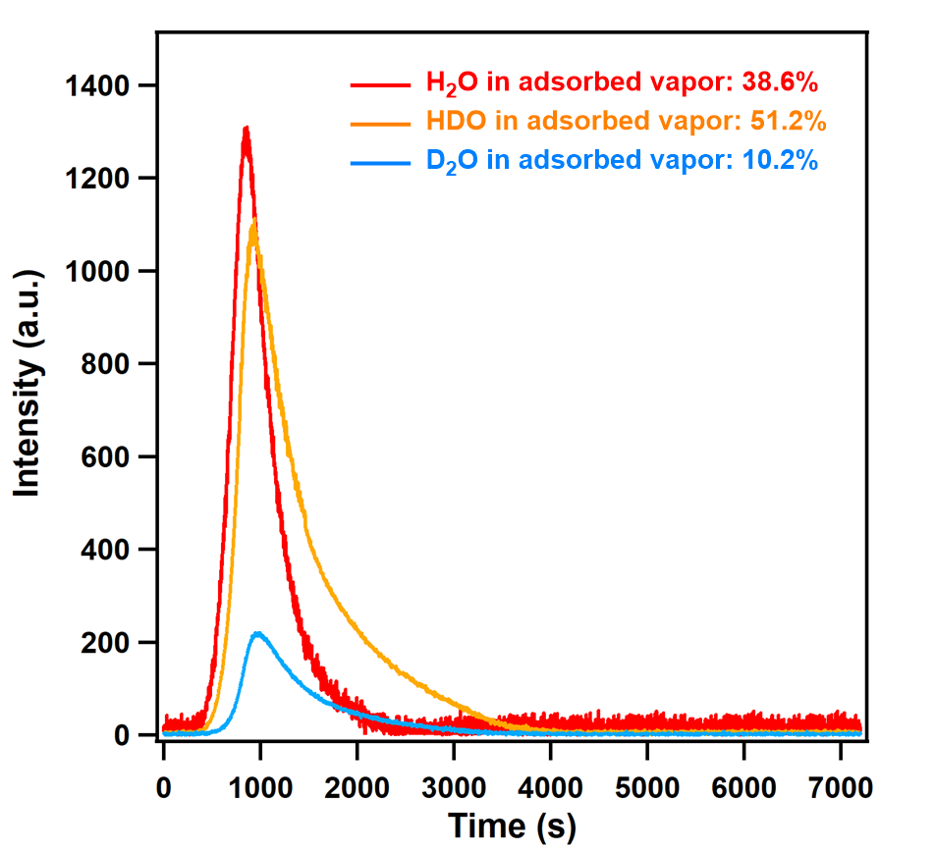
Supplementary Figure S77. TPD spectra of adsorbed vapor on FDC–2a at 0.5 h exposure time at 298 K. The feed-vapor ratio was H₂O:HDO:D₂O = 0.3:9.3:90.4.

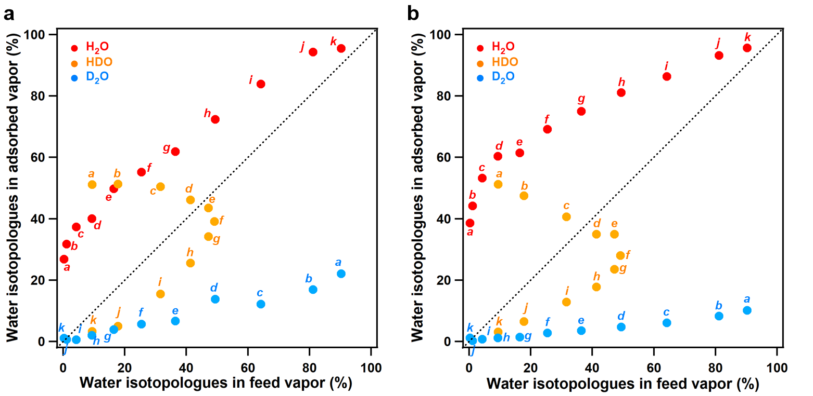
Supplementary Figure S78. McCabe–Thiele diagram for water isotopologues separation by (a) FDC–1a and (b) FDC–2a at 298 K, with the dashed line representing the theoretical behavior of showing no selectivity. The italic alphabets denote the same conditions.

Section 12: Vapor separation experiments for small-sized materials (control experiments)
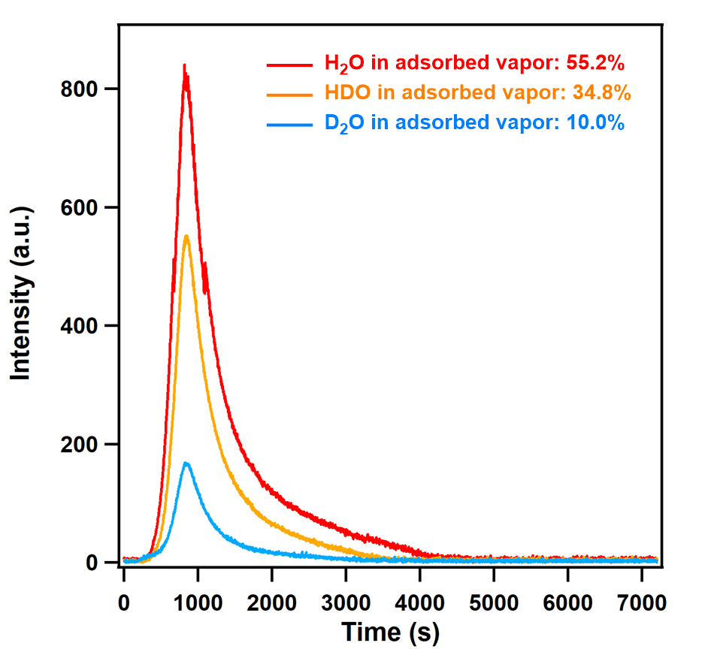
Supplementary Figure S79. TPD spectra of adsorbed vapor on zeolite 3A at 0.5 h exposure time at 298 K. The feed-vapor ratio was H₂O:HDO:D₂O = 49.3:41.4:9.3.

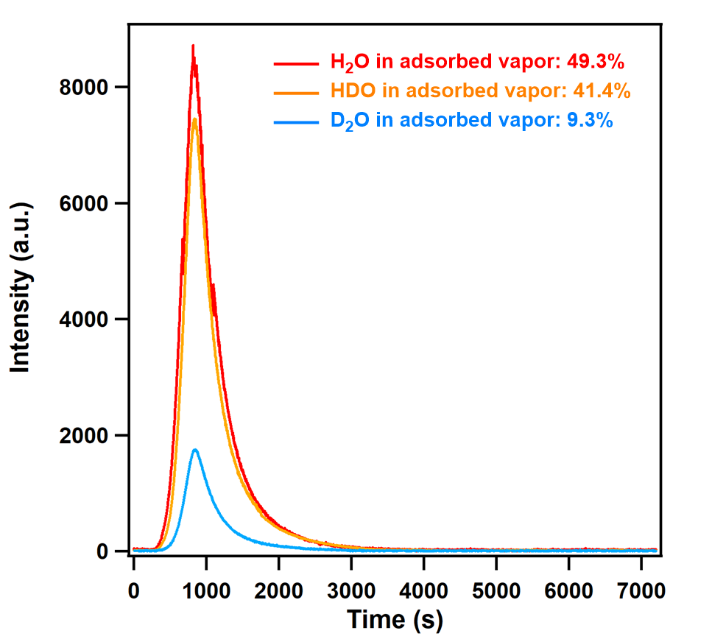
Supplementary Figure S80. TPD spectra of adsorbed vapor on microporous active carbon at 0.5 h exposure time at 298 K. The feed-vapor ratio was H₂O:HDO:D₂O = 49.3:41.4:9.3.

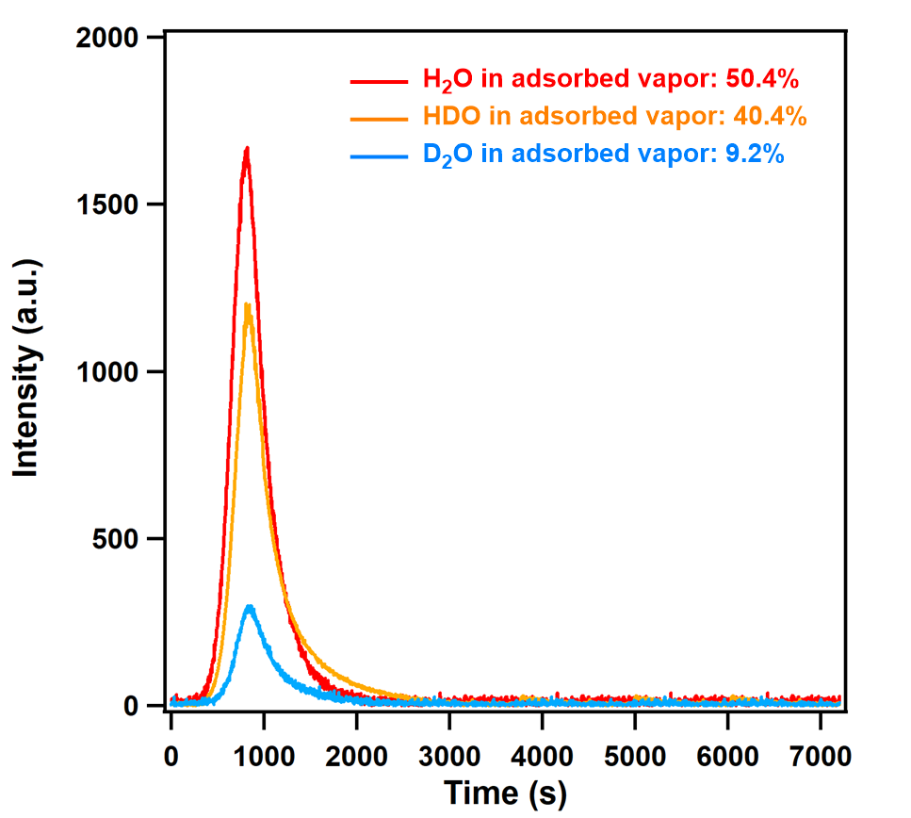
Supplementary Figure S81. TPD spectra of adsorbed vapor on ZIF-7 at 0.5 h exposure time at 298 K. The feed-vapor ratio was H₂O:HDO:D₂O = 49.3:41.4:9.3.

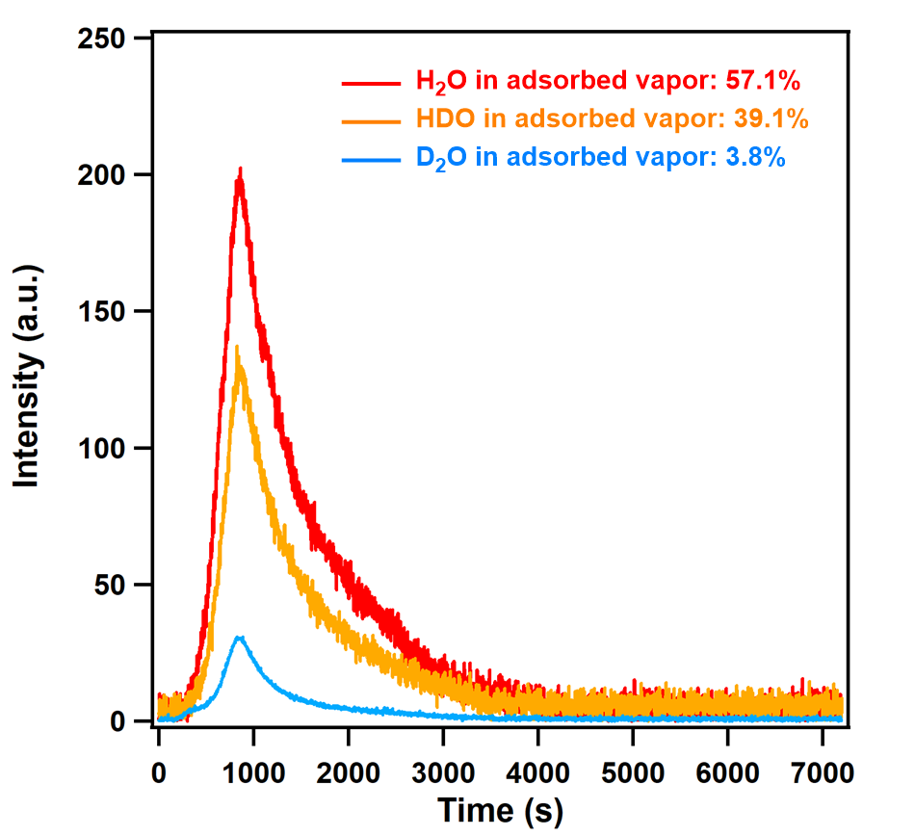
Supplementary Figure S82. TPD spectra of adsorbed vapor on FMOF-Cu at 0.5 h exposure time at 298 K. The feed-vapor ratio was H₂O:HDO:D₂O = 49.3:41.4:9.3.

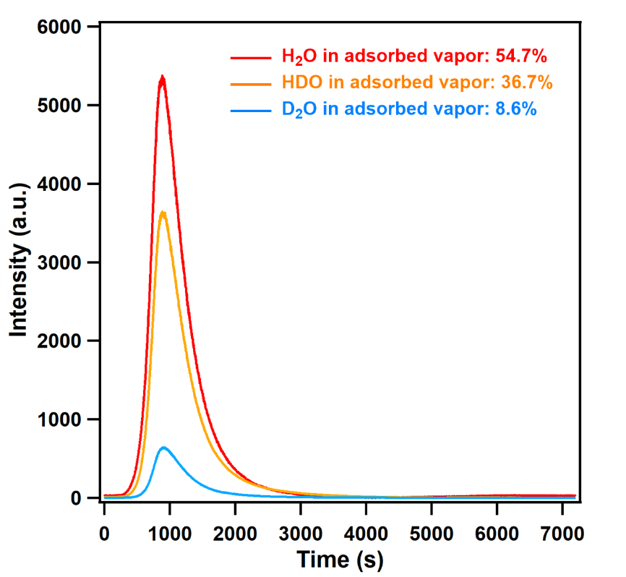
Supplementary Figure S83. TPD spectra of adsorbed vapor on Ni₂(bipy)₃(NO₃)₄-M at 0.5 h exposure time at 298 K. The feed-vapor ratio was H₂O:HDO:D₂O = 49.3:41.4:9.3.

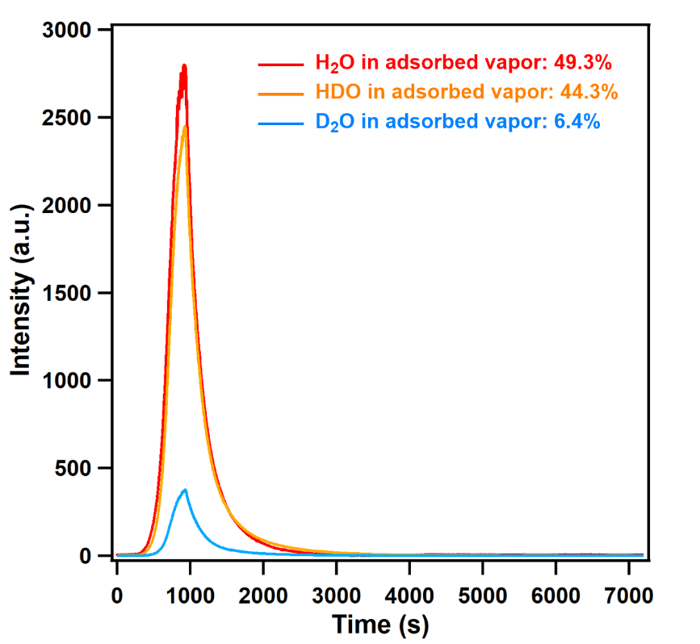
Supplementary Figure S84. TPD spectra of adsorbed vapor on Ni₂(bipy)₃(NO₃)₄-E at 0.5 h exposure time at 298 K. The feed-vapor ratio was H₂O:HDO:D₂O = 49.3:41.4:9.3.

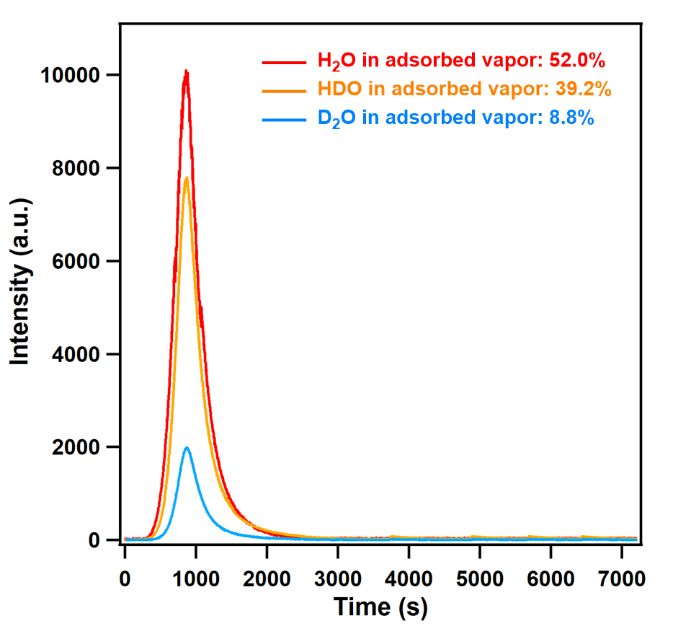
Supplementary Figure S85. TPD spectra of adsorbed vapor on Cu(OPTz) at 0.5 h exposure time at 298 K. The feed-vapor ratio was H₂O:HDO:D₂O = 49.3:41.4:9.3.

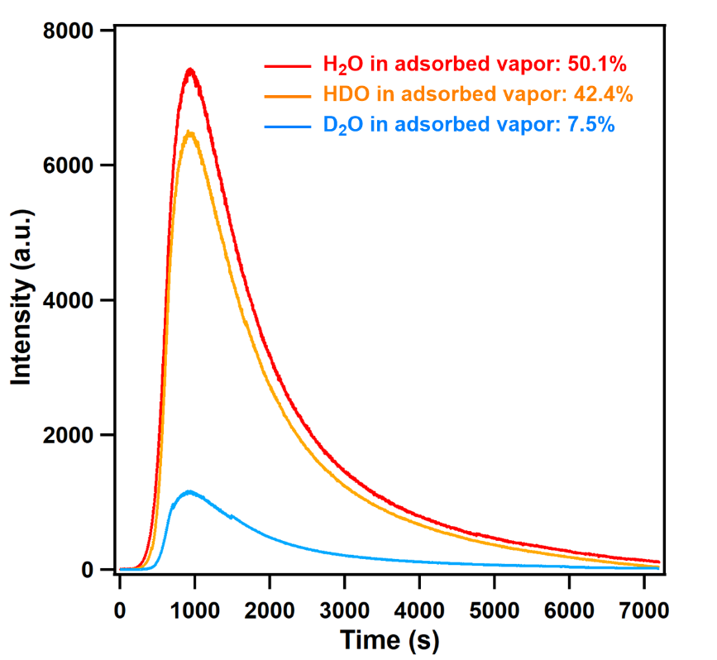
Supplementary Figure S86. TPD spectra of adsorbed vapor on HKUST-1 at 0.5 h exposure time at 298 K. The feed-vapor ratio was H₂O:HDO:D₂O = 49.3:41.4:9.3.

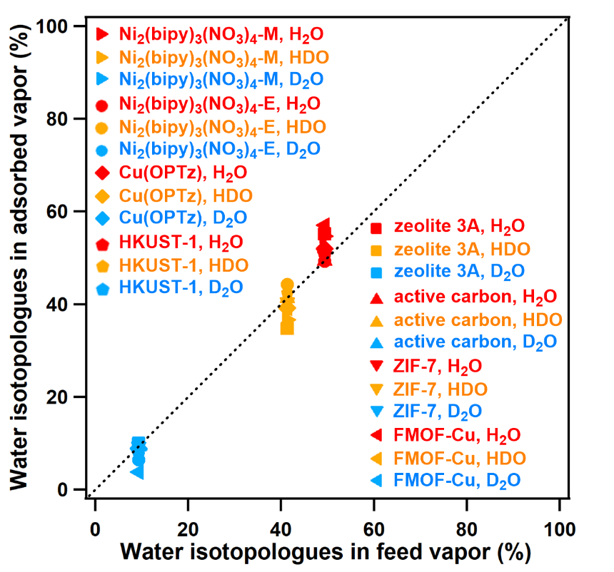
Supplementary Figure S87. McCabe–Thiele diagram for water isotopologues separation by zeolite 3A, microporous active carbon, ZIF-7, FMOF-Cu, Ni₂(bipy)₃(NO₃)₄-M, Ni₂(bipy)₃(NO₃)₄-E, Cu(OPTz), and HKUST-1 at 298 K, with the dashed line representing the theoretical behavior of a material showing no selectivity. All the points are on the dashed line showing almost no selectivity.

Section 13: Static mixed-liquid co-adsorption experiments for FDCs
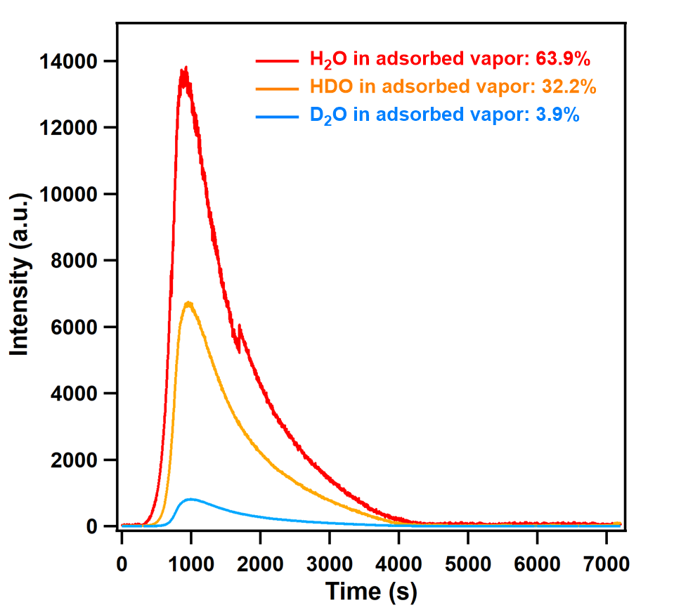
Supplementary Figure S88. TPD spectra of adsorbed liquid on FDC–1a at 7 d exposure time at 298 K. The feed-liquid ratio was H₂O:HDO:D₂O = 49.3/41.4/9.3.

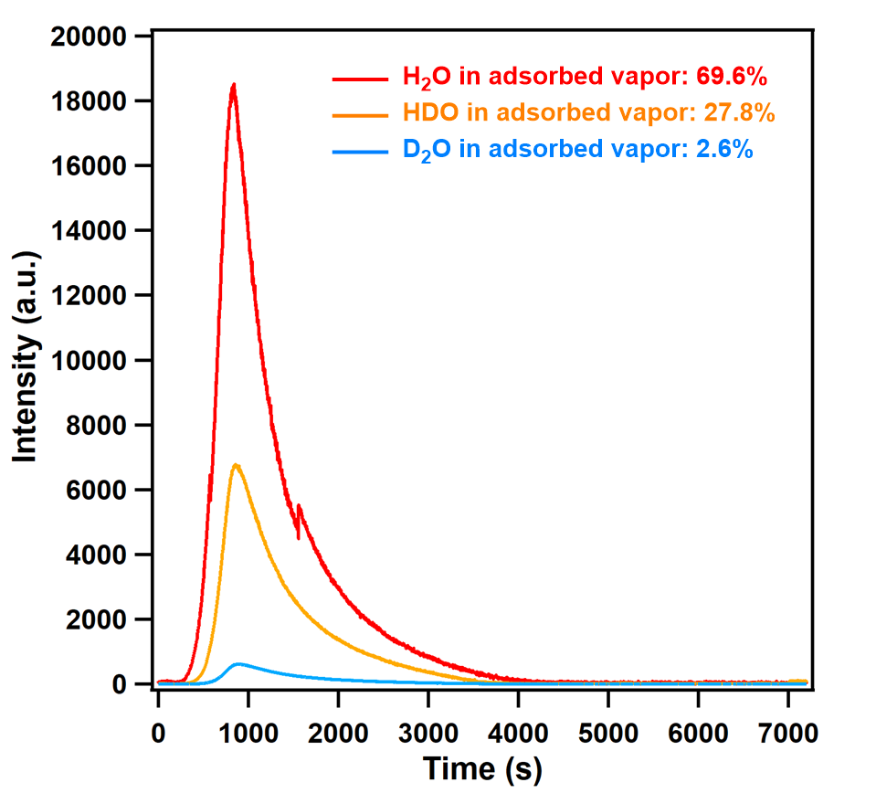
Supplementary Figure S89. TPD spectra of adsorbed liquid on FDC–2a at 7 d exposure time at 298 K. The feed-liquid ratio was H₂O:HDO:D₂O = 49.3/41.4/9.3.

Supplementary Tables
Section 1: Structures and physicochemical properties of H₂O and D₂O
Supplementary Table S1. Structures and physicochemical properties of H₂O and D₂O^{S17,S18}.
 | H₂O | D₂O
 | 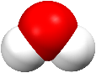 | 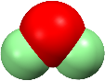
kinetic diameter (Å) | 2.641 | 2.641
relative density at 20 ºC (g cm^{–3}) | 0.997 | 1.108
standard freezing point (K) | 273.15 | 276.94
standard boiling point (K) | 373.15 | 374.56
melting heat (kJ mol^{–1}) | 6.008 | 6.276
heat of vaporization (kJ mol^{–1}) | 40.67 | 41.00
dipole moment (×10¹⁸ esu cm) | 1.85 | 1.90
critical temperature (K) | 647.14 | 643.89
critical pressure (bar) | 220.64 | 216.60
critical volume (m³ kg^{–1}) | 0.00274 | 0.00317
Polarizability (×10²⁵ cm³) | 16.5 | 16.2
O–H or O–D bond length (Å) | 1.01 | 0.98
O–H or O–D bond energy (kJ mol^{–1} bond^{–1}) | 458.9 | 466.4

Section 2: Crystallographic data for as-synthesized and water-adsorbed FDCs
Supplementary Table S2. Crystallographic data and structural refinement summary for as-synthesized FDC–1 and FDC–2.
 | as-synthesized FDC–1 | as-synthesized FDC–2
crystal system | trigonal | trigonal
space group | R$\overline{3}$ (#148) | R$\overline{3}$ (#148)
empirical formula | C_{49.30}H₃₈Cu₂N_{3.33}O_{10.30} | C_{49.30}H₄₂Cu₂N_{3.33}O₁₀
a (Å) | 23.555(2) | 23.5981(14)
b (Å) | 23.555(2) | 23.5981(14)
c (Å) | 20.1676(10) | 20.2803(6)
α (º) | 90 | 90
β (º) | 90 | 90
γ (º) | 120 | 120
V (Å³) | 9691.0(19) | 9780.5(12)
Z, d_{calcd} (g cm⁻³) | 9, 1.492 | 9, 1.479
diffractometer | Rigaku 1/4-chi goniometer | Rigaku 1/4-chi goniometer
μ (cm⁻¹) | 0.246 | 0.243
radiation type | synchrotron | synchrotron
radiation wavelength (Å) | 0.410 | 0.410
F(000) | 4470 | 4492
goodness of fit | 1.073 | 1.100
temperature (K) | 100(2) | 100(2)
number of reflections collected/unique | 4944/4558 | 4999/4867
R_{int} | 0.0323 | 0.0214
R₁ (I > 2.00σ(I))^{[a]} | 0.0314 | 0.0352
wR₂ (I > 2.00σ(I))^{[b]} | 0.0993 | 0.1104
CCDC deposition number | 2100317 | 2100318
^{[a]}R₁ = Σ||F_{o}|-|F_{c}||/Σ|F_{o}|, ^{[b]}wR₂ = [Σw|F_{o}²-F_{c}²|²/Σw(F_{o}²)²]^{1/2}
Supplementary Table S3. Crystallographic data and structural refinement summary for water-adsorbed FDC–1a and FDC–2a.
 | water-adsorbed FDC–1a | water-adsorbed FDC–2a
crystal system | trigonal | trigonal
space group | R$\overline{3}$ (#148) | R$\overline{3}$ (#148)
empirical formula | C_{49.33}H₃₈Cu₂N_{3.33}O_{11.50} | C_{49.30}H₄₂Cu₂N_{3.33}O₁₀
a (Å) | 23.5435(14) | 23.5399(12)
b (Å) | 23.5435(14) | 23.5399(12)
c (Å) | 20.1922(7) | 20.1746(5)
α (º) | 90 | 90
β (º) | 90 | 90
γ (º) | 120 | 120
V (Å³) | 9693.0(12) | 9681.5(10)
Z, d_{calcd} (g cm⁻³) | 9, 1.524 | 9, 1.511
diffractometer | Rigaku 1/4-chi goniometer | Rigaku 1/4-chi goniometer
μ (cm⁻¹) | 0.247 | 0.246
radiation type | synchrotron | synchrotron
radiation wavelength (Å) | 0.410 | 0.410
F(000) | 4566 | 4540
goodness of fit | 1.032 | 1.048
temperature (K) | 100(2) | 100(2)
number of reflections collected/unique | 4934/4737 | 4933/4733
R_{int} | 0.0332 | 0.0248
R₁ (I > 2.00σ(I))^{[a]} | 0.0327 | 0.0348
wR₂ (I > 2.00σ(I))^{[b]} | 0.0947 | 0.1012
CCDC deposition number | 2100319 | 2100320
^{[a]}R₁ = Σ||F_{o}|-|F_{c}||/Σ|F_{o}|, ^{[b]}wR₂ = [Σw|F_{o}²-F_{c}²|²/Σw(F_{o}²)²]^{1/2}

Supplementary Table S4. Le Bail fitting summary for as-synthesized FDC–1 and FDC–2, activated FDC–1a and FDC–2a, and water-adsorbed FDC–1a and FDC–2a.
 | FDC–1 | FDC–2 | FDC–1a | FDC–2a | FDC–1a⋅H₂O | FDC–1a⋅H₂O
a (Å) | 23.7899(69) | 23.8589(35) | 23.7109(45) | 23.7516(86) | 23.77691(31) | 23.8484(01)
b (Å) | 23.7899(69) | 23.8589(35) | 23.7109(45) | 23.7516(86) | 23.77691(31) | 23.8484(01)
c (Å) | 20.3349(5) | 20.4188(64) | 20.2997(18) | 20.3982(35) | 20.33311(25) | 20.4120(47)
α (º) | 90 | 90 | 90 | 90 | 90 | 90
β (º) | 90 | 90 | 90 | 90 | 90 | 90
γ (º) | 120 | 120 | 120 | 120 | 120 | 120
V (Å³) | 9966.9(32) | 10066.1(71) | 9883.6(73) | 9965.7(99) | 9955.0(95) | 10053.9(27)
R_{p} (%) | 5.84 | 5.47 | 6.20 | 5.16 | 5.97 | 5.99
R_{wp} (%) | 8.86 | 7.10 | 8.71 | 7.39 | 8.07 | 8.32

Section 3: Test calculations on the computational method
Supplementary Table S5. Dependence of binding energy (kJ mol^{–1}) of H₂O with FDC–1a and FDC–2a on k-point meshes and energy cut-offs used in the calculations.
k-point mesh | BE  (kJ mol^{–1}) |  | Energy cut-off  (eV) | BE  (kJ mol^{–1})
 | FDC–1a | FDC–2a |  | FDC–1a | FDC–2a
Gamma | -58.9 | -59.4 | 400 | -58.5 | -59.0
3×3×3 | -58.9 | -59.5 | 450 | -58.9 | -59.4
5×5×5 | -58.9 | -59.5 | 500 | -59.2 | -58.6
 |  |  | 550 | -59.3 | -59.7
 |  |  | 600 | -58.9 | -59.4
 |  |  | 650 | -58.9 | -59.4
 |  |  | 700 | -58.9 | -59.4
As shown in the table above, the BE of H₂O with FDC–1a or FDC–2a is almost the same by varying the k-points meshes. Because the difference in BE is negligibly small (less than 0.1 kJ mol^{–1}), we considered using only the Gamma point to sample the Brillouin zone in our calculation. For test calculations on the energy cut-off, it was noted that the BE values changed by 1 kJ mol^{–1} at different energy cut-offs but converged to -58.9 and -59.4 kJ mol^{–1} for FDC–1a and FDC–2a, respectively. The smallest energy-cut off of 600 eV was consequently used in our calculations.

Section 4: Calculated energies for H₂O and D₂O diffusions in FDCs
Supplementary Table S6. Calculated various energy terms (kJ mol^{–1}) for H₂O and D₂O diffusions in FDC–1a and FDC–2a at 298 K.
PCP | Diffusion  Species | ΔE≠ | ΔH≠ | –TΔS≠ | ΔG≠
All rotational and translational movements of H₂O or D₂O were changed to vibrational modes at the initial state
FDC–1a | H₂O | 75.0 | 71.7 | 6.0 | 77.8
FDC–1a | D₂O | 75.0 | 72.3 | 5.8 | 78.1
FDC–2a | H₂O | 66.5 | 63.5 | 7.9 | 71.4
FDC–2a | D₂O | 66.5 | 64.2 | 8.9 | 73.1
One rotational movement remains, and other rotational and translational movements of adsorbed H₂O or D₂O were changed to vibrational modes at the initial state
FDC–1a | H₂O | 75.0 | 73.0 | 3.4 | 76.4
FDC–1a | D₂O | 75.0 | 73.5 | 3.9 | 77.4
FDC–2a | H₂O | 66.5 | 64.7 | 5.9 | 70.6
FDC–2a | D₂O | 66.5 | 65.4 | 7.3 | 72.7
^{[a]}There is only one inter-cage diffusion pathway for the diffusion of a water molecule from one cage to its neighbor one in FDC–1a or FDC–2a. The energy barrier (ΔE≠) for the diffusion of H₂O or D₂O was taken as the energy difference between the initial state (IS), where H₂O or D₂O was adsorbed at the Cu site, and transition state (TS), which was located using the climbing-image nudged elastic band (CI-NEB) method^{S13}. Subsequent vibrational frequency calculations were carried out to estimate the activation energy (ΔG≠) for the diffusion process. To save computational cost, only the guest molecule (H₂O or D₂O) and ligand moieties along the diffusion pathway were allowed to move and others were fixed in the calculation of vibrational frequencies.
Crystallographic Data S1.

Crystallographic information file (CIF) of the as-synthesized PCP (FDC–1).

CCDC number: 2100317

Crystallographic Data S2.

Crystallographic information file (CIF) of the as-synthesized PCP (FDC–2).

CCDC number: 2100318

Crystallographic Data S3.

Crystallographic information file (CIF) of the water-adsorbed phase of FDC–1a (FDC–1a–water).

CCDC number: 2100319

Crystallographic Data S4.

Crystallographic information file (CIF) of the water-adsorbed phase of FDC–2a (FDC–2a–water).

CCDC number: 2100320

Supplementary References
- G. M. Sheldrick, A short history of SHELX. Acta Crystallogr. Sect. A: Found. Crystallogr. 64, 112−122 (2008).
- E. Nishibori, et al. The large Debye–Scherrer camera installed at SPring-8 BL02B2 for charge density studies. Nucl. Instrum. Methods Phys. Res. A 467/468, 1045−1048 (2001).
- M. Takata, et al. High resolution Debye-Scherrer camera installed at SPring-8. Advances in X-Ray Analysis 45, 377−384 (2002).
- J. Kärger, D. M. Ruthven & D. N. Theodorou, Diffusion in nanoporous materials (WILEY-VCH Verlag GmbH & Co. kGaA, 2012).
- G. Kresse & J. Furthmüller, Efficiency of ab-initio total energy calculations for metals and semiconductors using a plane-wave basis set. Comput. Mater. Sci. 6, 15−50 (1996).
- G. Kresse & J. Furthmüller, Efficient iterative schemes for ab initio total-energy calculations using a plane-wave basis set. Phys. Rev. B 54, 11169−11186 (1996).
- J. P. Perdew, K. Burke & M. Ernzerhof, Generalized gradient approximation made simple. Phys. Rev. Lett. 77, 3865−3868 (1996).
- S. Grimme, J. Antony, J. Ehrlich & J. Krieg, A consistent and accurate ab initio parametrization of density functional dispersion correction (DFT-D) for the 94 elements H-Pu. J. Chem. Phys. 132, 154104-1−154104-19 (2010).
- P. E. Blöchl, Projector augmented-wave method. Phys. Rev. B 50, 17953−17979 (1994).
- G. Kresse & D. Joubert, From ultrasoft pseudopotentials to the projector augmented-wave method. Phys. Rev. B 59, 1758−1775 (1999).
- S. L. Dudarev, G. A. Botton, S. Y. Savrasov, C. J. Humphreys & A. P. Sutton, Electron-energy-loss spectra and the structural stability of nickel oxide: an LSDA+U study. Phys. Rev. B 57, 1505−1509 (1998).
- L. Wang, T. Maxisch & G. Ceder, Oxidation energies of transition metal oxides within the GGA+U framework. Phys. Rev. B 73, 195107-1−195107-6 (2006).
- G. Henkelman, B. P. Uberuaga & H. Jónsson, A climbing image nudged elastic band method for finding saddle points and minimum energy paths. J. Chem. Phys. 113, 9901−9904 (2000).
- M. J. Frisch, et al. Gaussian 09, revision D.01; Gaussian, Inc: Wallingford, CT, 2013.
- P. J. Larkin, IR and Raman Spectroscopy: principles and spectral interpretation (ELSEVIER, 2017).
- S. S. Xantheas & T. H. Dunning, Ab-initio studies of cyclic water clusters (H₂O)_{n}, n = 1–6. I. Optimal structures and vibrational spectra. J. Chem. Phys. 99, 8774–8792 (1993).
- J. M. H. Levelt Sengers, J. Straub, K. Watanabe & P. G. Hill, Assessment of critical parameter values for H₂O and D₂O. J. Phys. Chem. Ref. Data 14, 193−207 (1985).
- P. G. Hill, R. D. Chris MacMillan & V. Lee, A fundamental equation of state for heavy water. J. Phys. Chem. Ref. Data 11, 1−14 (1982).

