Supplementary Information
Long-Range Ordered Porous Carbons Produced from C₆₀

Fei Pan^{1,15}, Kun Ni^{1,15}, Tao Xu^{2,15}, Huaican Chen^{3,4}, Yusong Wang⁵, Ke Gong⁵, Cai Liu^{6,7,8}, Xin Li⁵, Miao-Ling Lin⁹, Shengyuan Li¹, Xia Wang¹, Wensheng Yan¹⁰, Wen Yin^{3,4}, Ping-Heng Tan⁹,
Litao Sun², Dapeng Yu^{6,7,8}, Rodney S. Ruoff^{11,12,13,14,*} & Yanwu Zhu^{1,5,*}

¹ Department of Materials Science and Engineering, School of Chemistry and Materials Science, University of Science and Technology of China, Hefei 230026, China.
² SEU-FEI Nano-Pico Center, & Key Laboratory of MEMS of Ministry of Education, Southeast University, Nanjing 210096, China.
³ Institute of High Energy Physics, Chinese Academy of Sciences, Beijing, 100049, China.
⁴ Spallation Neutron Source Science Center, Dongguan 523803, China.
⁵ Hefei National Research Center for Physical Sciences at the Microscale, University of Science and Technology of China, Hefei 230026, China.
⁶ International Quantum Academy, Shenzhen 518048, China.
⁷ Shenzhen Institute for Quantum Science and Engineering, Southern University of Science and Technology, Shenzhen 518055, China.
⁸ Guangdong Provincial Key Laboratory of Quantum Science and Engineering, Southern University of Science and Technology, Shenzhen 518055, China.
⁹ State Key Laboratory of Superlattices and Microstructures, Institute of Semiconductors, Chinese Academy of Sciences, Beijing 100083, China.
¹⁰ National Synchrotron Radiation Laboratory, University of Science and Technology of China, Hefei 230029, China.
¹¹ Center for Multidimensional Carbon Materials, Institute for Basic Science, Ulsan, Republic of Korea.
¹² Department of Chemistry, Ulsan National Institute of Science and Technology (UNIST), Ulsan, Republic of Korea.
¹³ Department of Materials Science and Engineering, UNIST, Ulsan, Republic of Korea.
¹⁴ School of Energy and Chemical Engineering, UNIST, Ulsan, Republic of Korea.

¹⁵ These authors were equal major contributors to this work.
* Corresponding authors: rsuoff@ibs.re.kr (R.S.R.); zhuyanwu@ustc.edu.cn (Y.Z.)
1. Supplementary Methods

Experimental details

Chemicals
C₆₀ powder (99.5 at% by high performance liquid chromatography; Suzhou Dade Carbon Nano Technology Co., Ltd., China), lithium nitride (α-Li₃N, 99.5 wt%, metals basis, 80 mesh; Sigma-Aldrich, USA, or 99.4 wt%, metals basis, 60 mesh; Alfa Aesar, USA), and graphite powder (99.95 wt%, metals basis, 8000 mesh; Shanghai Macklin Biochemical Co., Ltd., China) were used without any additional treatment.

Purification details of LOPCs
The long-range ordered porous carbon (LOPC) samples were subjected to the following washing and heating steps for purification. 1) Washing: after preparation, the samples were washed successively with toluene by ultrasonic treatment and vacuum filtration (to remove unreacted C₆₀), then with ethanol by rinsing (to remove residual toluene) and finally deionized water by ultrasonic treatment and vacuum filtration (to remove α-Li₃N) till the filtrate became colorless, and then dried at 60 °C in air; 2) heating: washed samples obtained from 1) were heated in vacuum at 300 °C for 6 h. After each heating, all samples obtained from 2) were washed once more by repeating the procedures in 1). For LOPC made at 550 °C, the cycle of 1) washing and 2) heating was repeated 3-4 times. For LOPCs made at 560, 575 or 600 °C, the cycle of 1) washing and 2) heating was repeated 7 times.

Purification details of C₆₀ polymer crystal
The C₆₀ polymer crystal samples were also subjected to washing and heating for purification. 1) Washing: the same washing procedures as used for LOPCs, i.e., successively with toluene, ethanol and deionized water and then dried at 60 °C in air; 2) heating: washed samples obtained from 1) were heated in vacuum at 175 °C for 6 h. After each heating, all samples were washed again following the procedures in 1).

Detailed characterization parameters
All scanning electron microscopy (SEM) images were obtained from powder samples placed on silicon substrates, by a Schottky field emission scanning electron microscope (ZEISS GeminiSEM 500, operating at 3 kV, Germany). Before the SEM imaging, platinum was evaporated onto the samples. Powder X-ray diffraction (XRD) was performed with an X-ray diffractometer (Cu K_{α} radiation wavelength of 0.15418 nm, operating at 40 kV and 30 mA, Rigaku SmartLab 3kW, Japan) with a scan rate of 4 ° min⁻¹; data were collected in the angle range from 5 ° to 60 ° with a step of 0.02 °. Raman spectra of the original C₆₀, the polymer crystal and the LOPC were obtained by a Jobin-Yvon HR-Evolution micro-Raman system (France) equipped with a charge-coupled device detector (excitation wavelength of 532 nm or 633 nm, laser power of 60 μW (for the original C₆₀ and the polymer crystal) or 500 μW (for LOPC), integration time of 60 s, accumulation number of 3 for LOPC to enhance signal-to-noise ratio, 50x objective lens, grating of 1800 lines). Fourier transform infrared (FTIR) spectra from 4000 cm⁻¹ to 400 cm⁻¹ were obtained with a Nicolet 6700 (Thermo Fisher, USA), by diluting carbons with KBr powder (~ 12 MPa for 10 s). Thermogravimetric analysis (TGA) curves were obtained by thermogravimetry (NETZSCH TG 209 F1 Libra, Germany). Differential scanning calorimetry (DSC) curves were obtained by a differential scanning calorimeter (DSC Q2000 V24.10 Build 122, TA Instruments, USA). Matrix-assisted laser desorption/ionization time of flight (MALDI-TOF) mass spectra (MS) from 0 to 5000 were obtained with a mass spectrometer (Bruker, Autoflex Speed TOF/TOF, Germany). Transmission electron microscopy (TEM) imaging was carried out with an aberration-corrected TEM (FEI Titan 80-300 operating at 80 kV) and a high-resolution TEM (FEI Tecnai G20 operating at 200 kV). To prepare the TEM samples, all samples were dispersed in ethanol and sonicated. X-ray photoelectron spectroscopy (XPS) was performed on an XPS facility with Al K_{α} radiation (hν = 1486.6 eV, Thermo Scientific, ESCALAB 250, USA). ¹³C NMR spectra of all samples were acquired with magic-angle spinning using a superconducting solid-state nuclear magnetic resonance spectrometer (Avance III 400 MHz WB, Brucker, Germany) with a spinning rate of 12 kHz and a repetition time (d1) of 200 s, 16 scans for the original C₆₀, 1024 scans for LOPC and the polymer crystal at room temperature; in-situ ¹³C NMR measurement was performed with a repetition time (d1) of 6 s and 128 scans, spinning rate of ~ 3 kHz for original C₆₀ without α-Li₃N or 1.06-1.16 kHz for C₆₀ with α-Li₃N from room temperature to ~ 500 °C, in which temperatures were calibrated by the current applied. Electron spin resonance (ESR) spectra were obtained using a JEOL JES-FA200 ESR spectrometer (300 K, 9.063 GHz, X-band, Japan) and using 2,2-diphenyl-1-picrylhydrazyl (DPPH, 95%, Alfa Aesar; diluted in KCl crystal powder) as a reference. In ESR measurements the microwave power was 1 mW and the sweep width ranged from 314.5 to 334.5 mT; modulation frequency and modulation amplitude were 100 kHz and 0.35 mT, respectively. Specific surface areas (SSA) and pore size distributions of the LOPC samples were measured by Ar adsorption/desorption (87.3 K, 9 mm tube with rod, outgas under 300 °C for 6 h, Quantachrome Autosorb iQ₃, USA) using the Brunauer-Emmett-Teller (BET) method.
Due to the sample resistance being in the available measuring range of the DC resistance module of the Dynacool-9, no external power source or current and voltage meters were needed. The bulk samples for resistance measurements were made from LOPC powders, or graphite powder (2H and 3R mixed phases) and reduced graphene oxide powder (rGO, product model number SE1233, product batch number D160923C8A) powders using cold isostatic pressing (LOPC-550°C-5h, 35 MPa for 10s; LOPC-560°C-5h, 575°C for 5h; LOPC-600°C-5h, 20 MPa for 5 mins; graphite and rG-O, 30 MPa for 10s). The contacts between the gold electrodes and the samples were made using highly conductive silver colloid paste (Ausbond, model 3812), followed by heating at 80 °C for 5 minutes. The control samples (graphite and rGO powders) were first cooled to 2 K with stabilization for 10 minutes and then the resistance was probed while they were being heated to 300 K at rate of 2 K min⁻¹. The applied current for the LOPCs was 500 μA for LOPC-550°C-5h, 1 μA for LOPC-560°C-5h and 0.1 μA for both LOPC-575°C-5h and LOPC-600°C-5h as T was reduced from 300 K to 2 K. The applied current for the control samples (graphite and rGO powders) was 8000 μA from 2 K to 300 K. All the electrodes used were high purity (99.99%) gold wires with a diameter of 30 μm.

Simulation details

In order to get a description of the potential energy surface near fcc C₆₀ and to find the possible structures for LOPC, we performed the structural search described in the following workflow.

1) Starting from fcc C₆₀ in its primitive cell, we performed 2000 stochastic surface walking (SSW) steps running with the following LASP input setting, which yielded 2438 structures. This input gave a cyclic high SSW acceptance temperature and a very large max atom displacement, which allowed the structure to change from the original C₆₀, but the obtained structure could have high energy.

potential NN
explore_type ssw
Ewaldflag 0
%block netinfo
C C.pot
%endblock netinfo
PrintChg 0
Run_type 5
SSW.SSWsteps 2000
SSW.Temp 200
SSW.LowTemp 300 K
SSW.HighTemp 30000 K
SSW.TempCycle 50
SSW.quick_Setting 3
SSW.ftol 1E-2
SSW.ds_atom 2.2
SSW.output F
SSW.printevery F
SSW.printselect 0

2) We performed 2000 SSW steps each for 12 structures obtained from Step 1, which have acceptable XRD matching, using the following LASP input setting, and this yielded 31183 structures for the next step. This input has a relatively low acceptance temperature and a moderate max atom displacement, which would lead the algorithm going downwards along the potential energy surface, which means, the structure evolution is directed to graphene-based carbons.

potential NN
explore_type ssw
Ewaldflag 0
%block netinfo
C C.pot
%endblock netinfo
PrintChg 0
Run_type 5
SSW.SSWsteps 2000
SSW.Temp 300
SSW.quick_Setting 3
SSW.ftol 1E-2
SSW.ds_atom 1.0
SSW.output F
SSW.printevery F
SSW.printselect 0

3) 4 structures were considered for further exploration of the energy surface in the region between fullerene and graphene, consisting of 3 peanut-shaped tube structures, as shown in Figs. S1 D, E and J, and a 3D curved graphene structure, as shown in Fig. S1 G. We considered more atoms in a unit cell, from 60 to 70, thus there are 11 total configurations of the number of atoms. The additional atoms were randomly added to the cell. In addition, we considered that the cell parameter could increase slightly, from 10.0197 Å to 12.0197 Å, with step size of 0.1 Å, giving 21 total configurations of cell parameter. A total number of 11$×$21$×$4=924 configurations were considered. For each configuration, the LASP run was fixed at certain number of carbon atoms and fixed cell parameters and run 500 SSW steps, with input parameters as follows. A total number of 924$×$500= 462000 SSW steps were considered. The acceptance temperature was 300 K and the max atom displacement was 1.0 Å. Because some of the structures failed to calculate energy, eventually a total of 346516 structures were obtained for sampling the potential energy surface.

potential NN
explore_type ssw
Ewaldflag 0
%block netinfo
C C.pot
%endblock netinfo
PrintChg 0
Run_type 5
SSW.SSWsteps 500
SSW.Temp 300
SSW.quick_Setting 3
SSW.ftol 1E-2
SSW.ds_atom 1.0
SSW.output F
SSW.printevery F
SSW.printselect 0

The radiation source in XRD simulation was Cu K_{α} with a wavelength of 1.54180 Å. The pattern parameters of FWHM, NA, NB, line shift and background, sample parameters of crystallite size broadening are considered in the Rietveld refinement, which also considered: 1) pattern and sample parameters listed above; 2) 204 degree of freedom for 69 atoms in LOPC model; 3) energy calculated by the ‘Universal force field’ (referring to J. Am. Chem. Soc. 114, 10024-10035, 1992) with 0.5 weight parameter towards Rwp error. The Raman spectra calculator can be freely accessed at the following website as python script: https://github.com/afonari/raman-sc.

NEXAFS spectra were calculated by the ECH method, in which the core-excited carbon is replaced by nitrogen (therefore, also known as the Z + 1 approach), while the number of electrons is kept the same. This is a computationally economical method that is especially suitable for large size systems. A C₆₀ cage was chosen to represent the fcc C₆₀ lattice, while larger models (chains with five C₆₀ cages) were used for the C₆₀ polymer crystal or LOPC. The triple-ζ-quality individual gauge for the localized orbital (IGLO-III) basis set was chosen for the excited carbon atom and the 6-31G basis set for the rest. With the transition dipole moments provided, C 1s → π* and C 1s → σ* oscillator strengths were respectively calculated from the squared z component and the squared sum of the x and y components.

2. Supplementary Figures

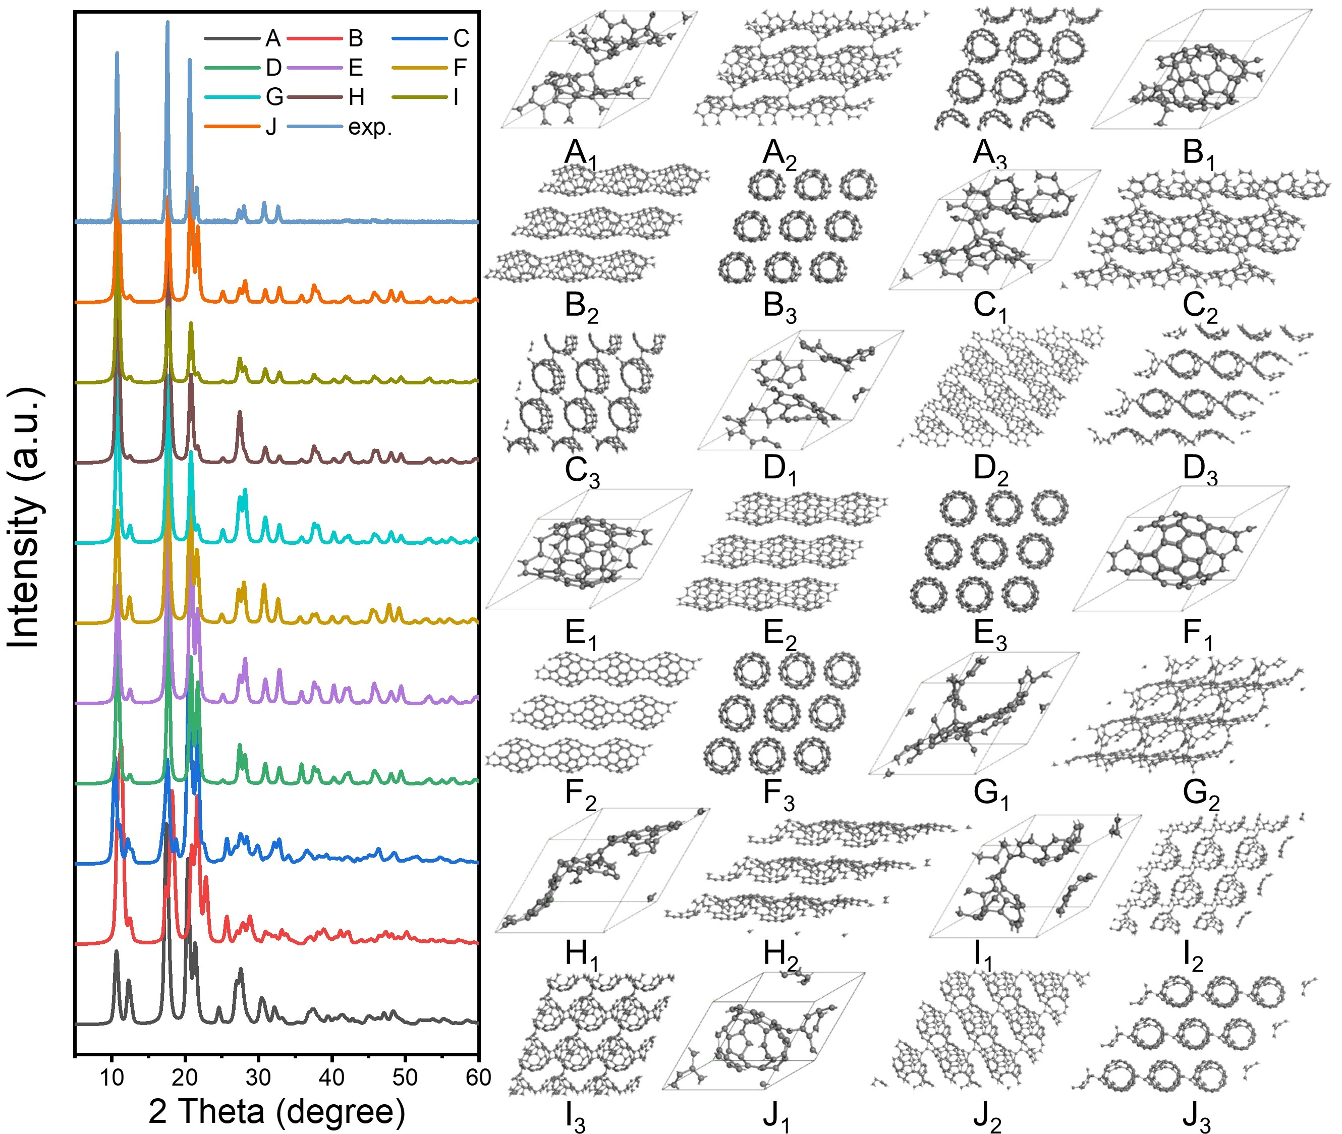

Fig. S1 | Some of simulated structures which show good agreement with the XRD data of LOPC. Insets A to J are the geometric structures and the subscript (e.g., A_{x} with x from 1 to 3) denotes the structures viewed from different directions. Among them, Structure A is shown in Fig. 1a as a representative of the LOPC structure.

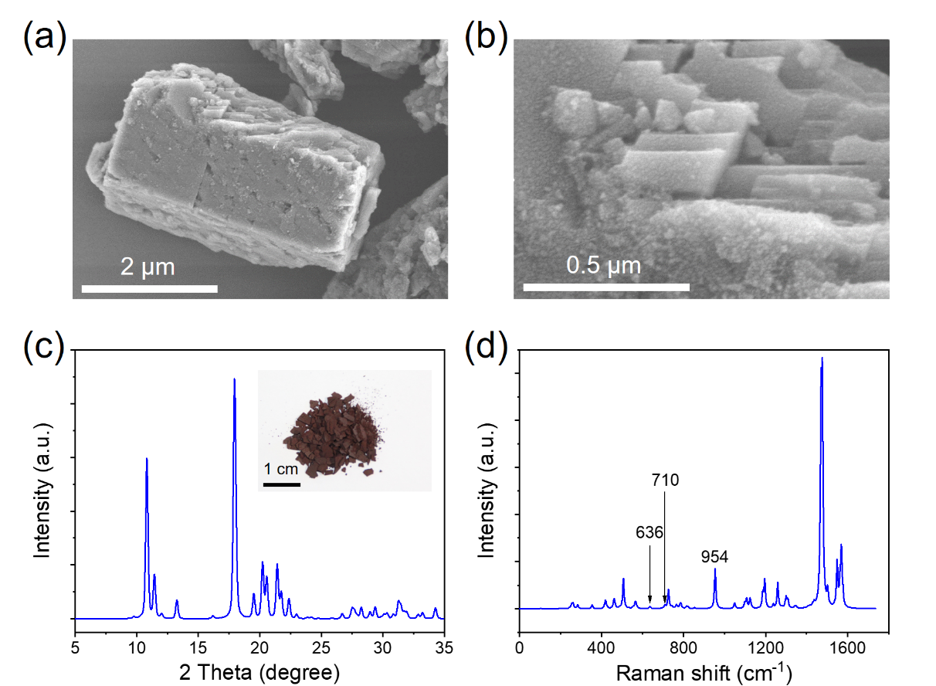
Fig. S2 | (a) SEM image; (b) Enlarged SEM image; (c) Cu K_{α} (λ = 0.15418 nm) XRD pattern simulation. Inset shows an optical image; (d) Raman spectra simulation of a C₆₀ polymer crystal.

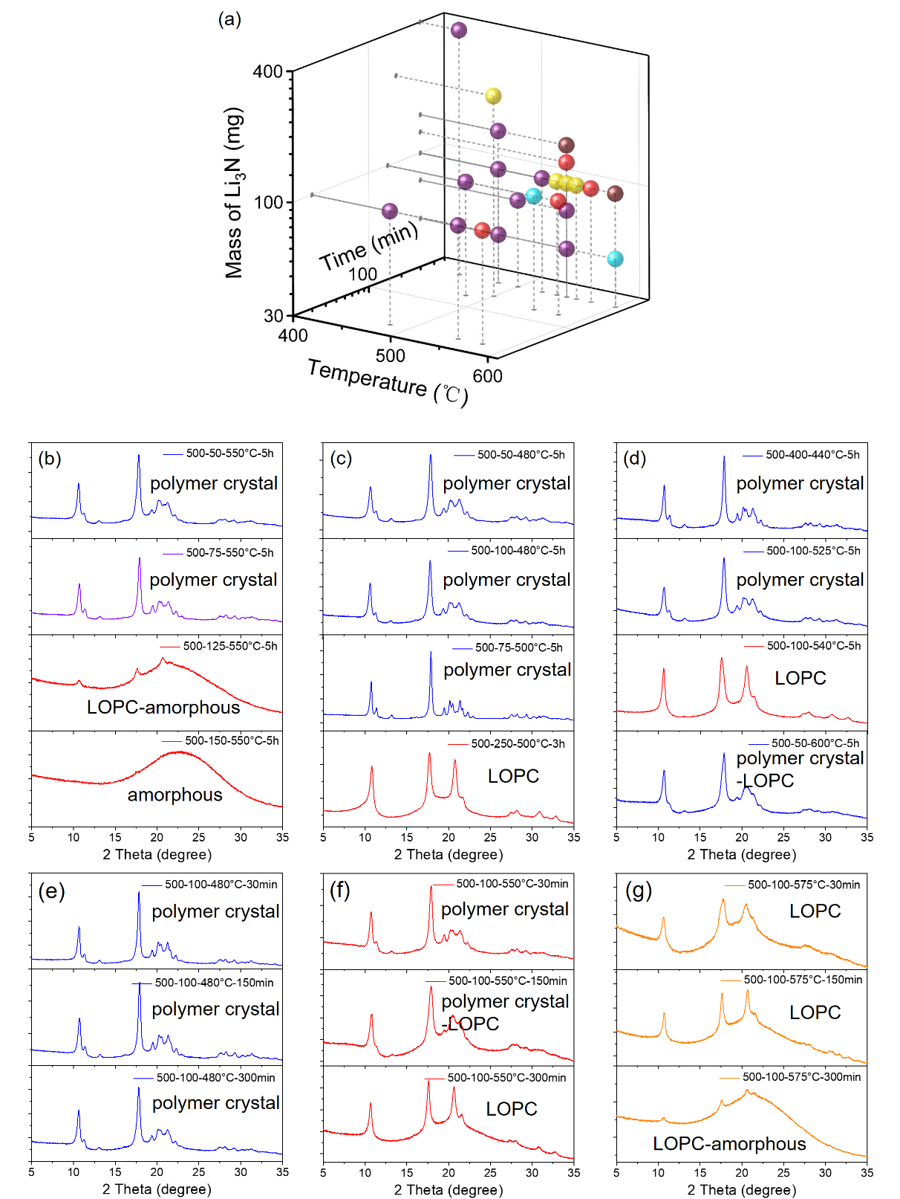
Fig. S3 | (a) Products depending on the preparation conditions for the C₆₀ polymer crystal (purple), polymer crystal-LOPC mixture (blue), LOPC (yellow), LOPC-amorphous mixture (red) and amorphous (brown). (b) to (g) show the powder XRD spectra of all samples with preparation parameters and structure type indicated in each.

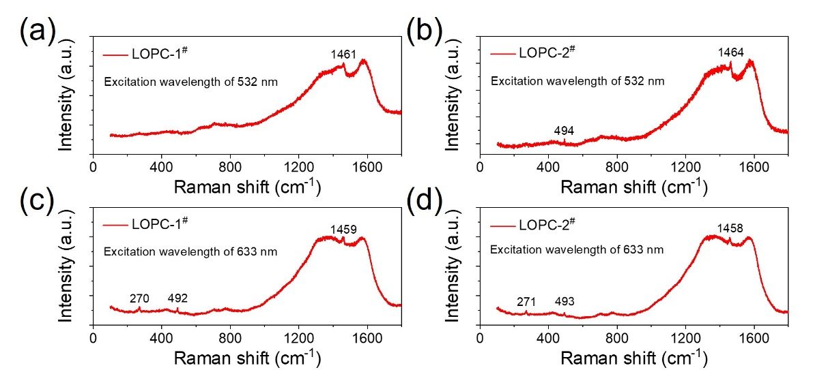
Fig. S4 | (a), (b) Raman spectra for LOPCs with an excitation wavelength of 532 nm (power of 500 μW, integration time of 60 s, accumulation number of 3, 50x objective lens, grating of 1800 lines); (c), (d) Raman spectra for LOPCs with an excitation wavelength of 633 nm (power of 650 μW, integration time of 60 s, accumulation number of 4 for (c) or 5 for (d), 50x objective lens, grating of 1200 lines).

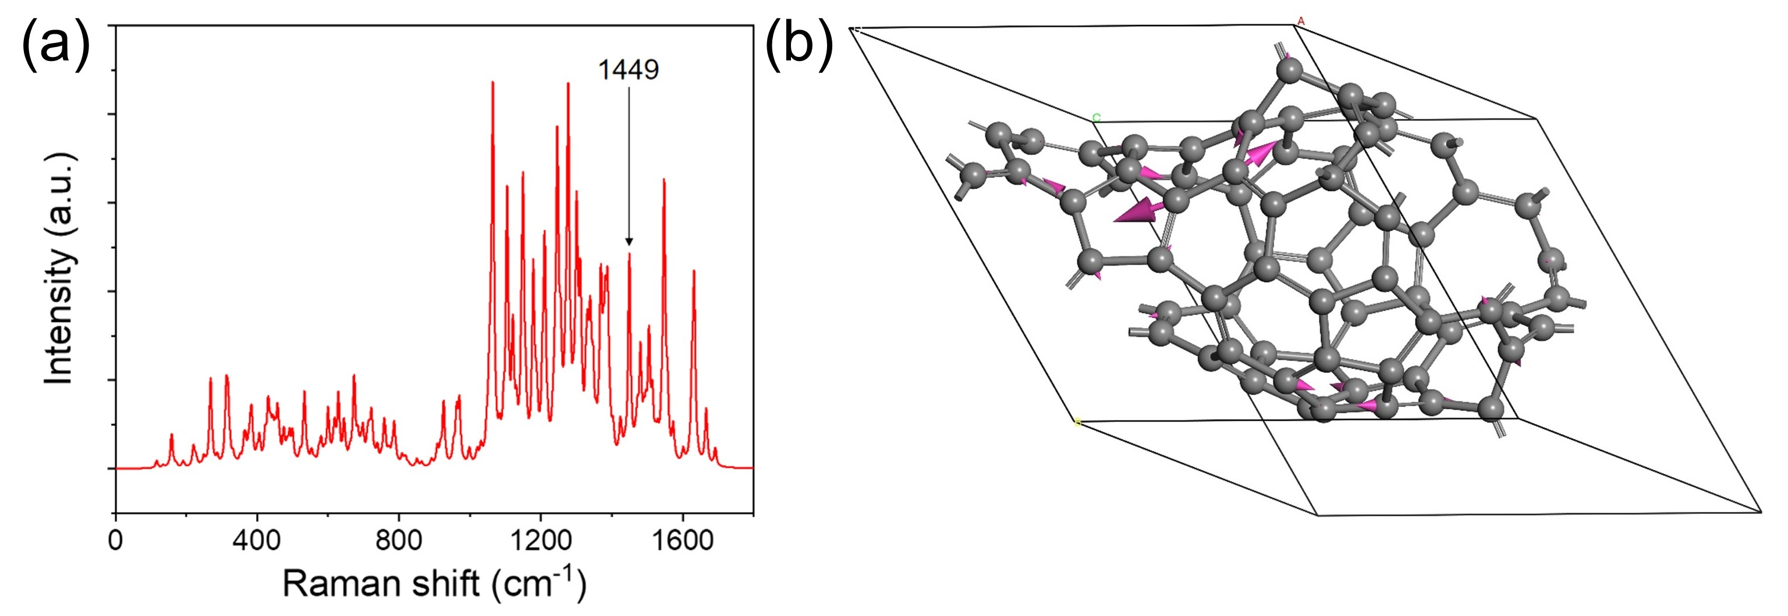
Fig. S5 | (a) Simulated Raman spectrum and (b) model of the 1449 cm⁻¹ vibration of LOPC based on the proposed structure A in Fig. S1.

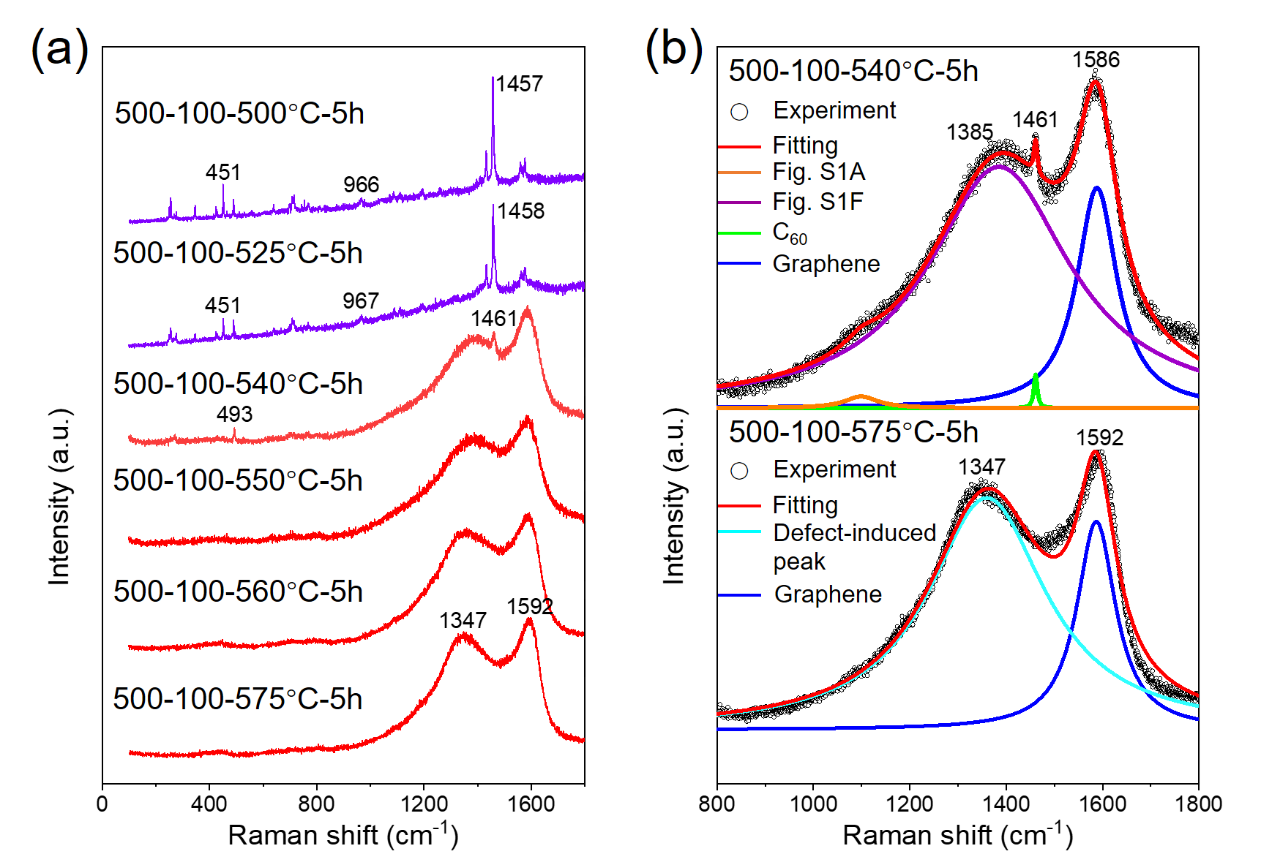
Fig. S6 | (a) Raman spectra for carbons prepared by annealing 500 mg C₆₀ with 100 mg α-Li₃N for 5 h at different temperatures ranging from 500 to 575 °C (testing conditions: excitation wavelength of 532 nm, for the samples of 500-100-500°C-5h and 500-100-525°C-5h, laser power of 55 μW, integration time of 40 s or 20 s, accumulation number of 1; for the samples of 500-100-540°C-5h, 500-100-550°C-5h, 500-100-560°C-5h and 500-100-575°C-5h, power of 450 μW, integration time of 10 s, accumulation number of 6, 50x objective lens, grating of 1800 lines). (b) Lorentz fitting of Raman spectra of samples prepared at 540 °C and 575 °C with the Raman spectra of C₆₀, graphene, defect-induced peak and LOPC structures shown in Fig. S1 A, Fig. S1 F.

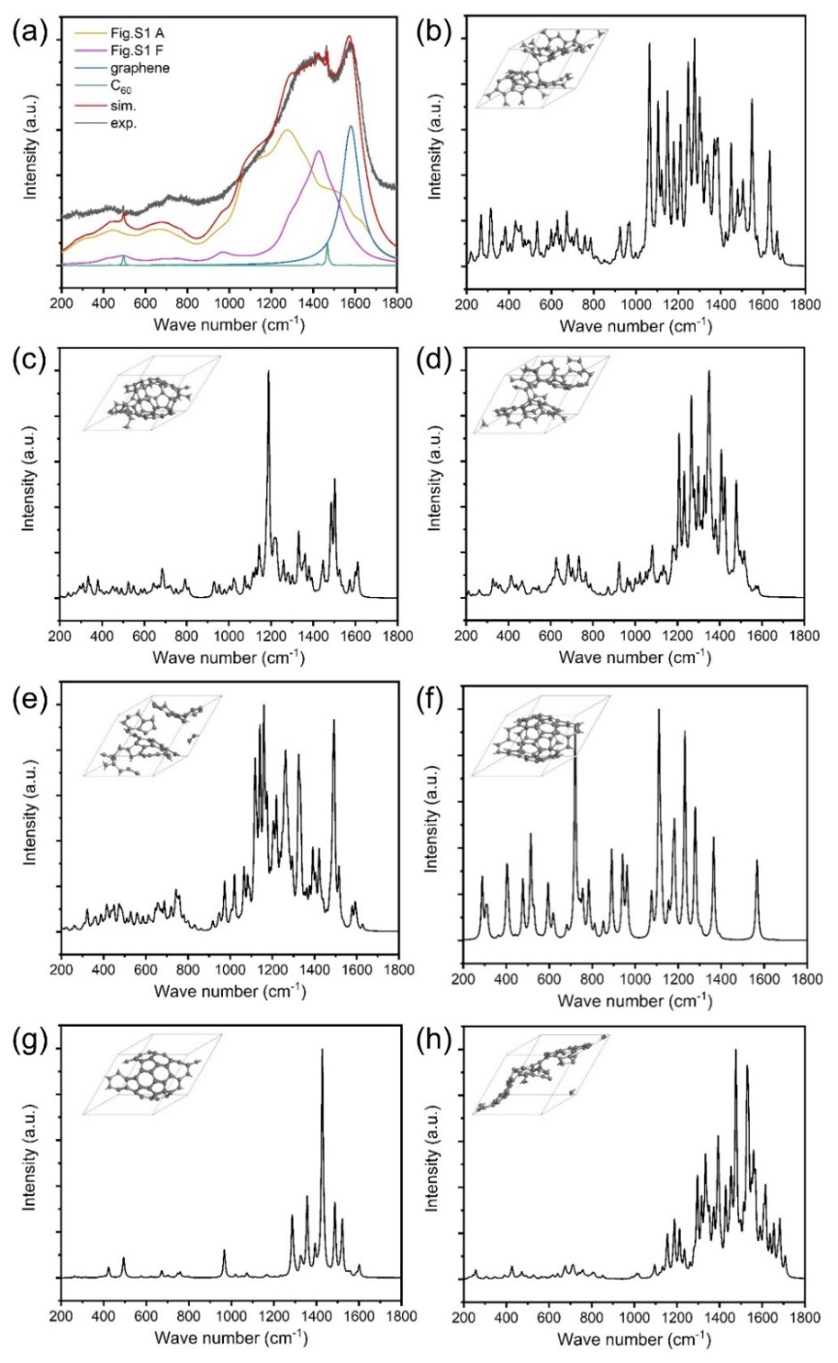
Fig. S7 | (a) Experimental Raman spectra fitted with the LOPC structures shown in Fig. S1 A and F, graphene and C₆₀, with σ value of 50 in Gaussian function for broadening peaks. The Raman spectra of LOPCs shown in Figs. S1 A and F are obtained by DFT simulation and that of C₆₀ was taken from experimental measurement. The Raman spectrum of graphene is calculated from DFT by considering only phonons at the gamma point, resulting in one peak. (b-h) Simulated Raman spectra of the LOPC structures shown in (b) Fig. S1 A, (c) Fig. S1 B, (d) Fig. S1 C, (e) Fig. S1 D, (f) Fig. S1 E, (g) Fig. S1 F and (h) Fig. S1 H, with σ value of 5 in Gaussian function for broadening peaks.

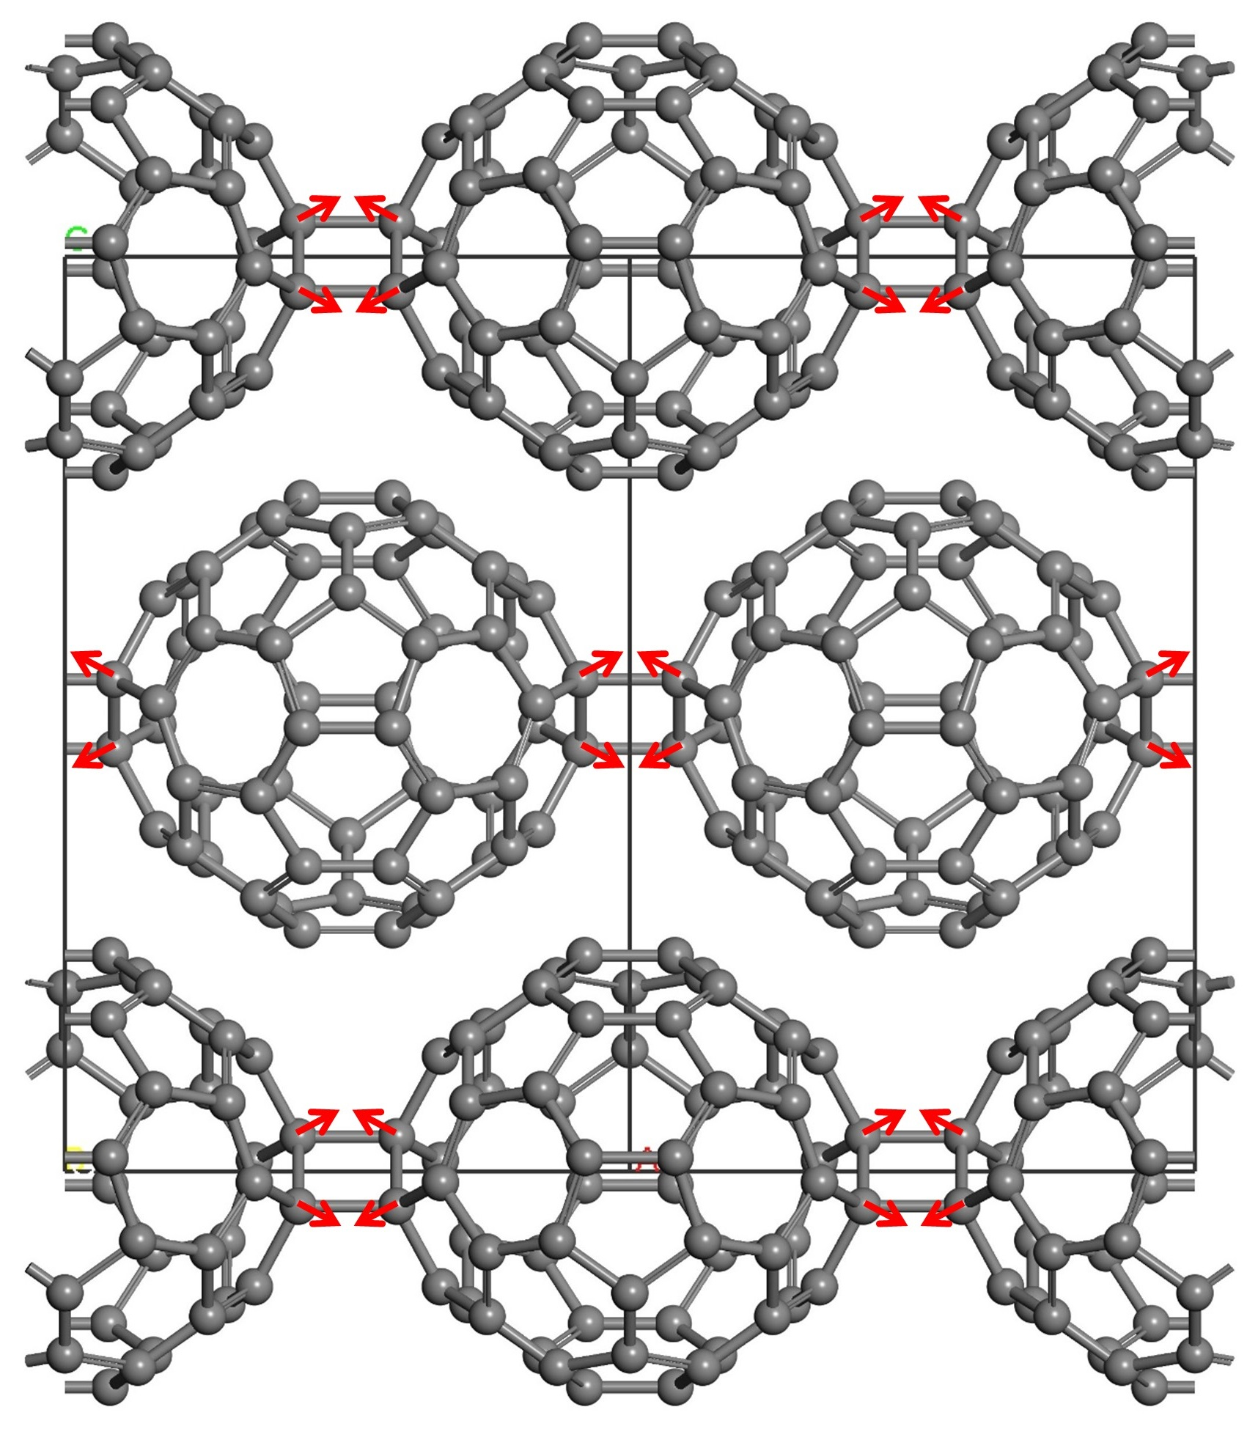
Fig. S8 | Schematic of atomic displacements of the Raman peak at 954 cm⁻¹ for the C₆₀ polymer crystal, which corresponds to the stretching of sp³ bonds between cages.

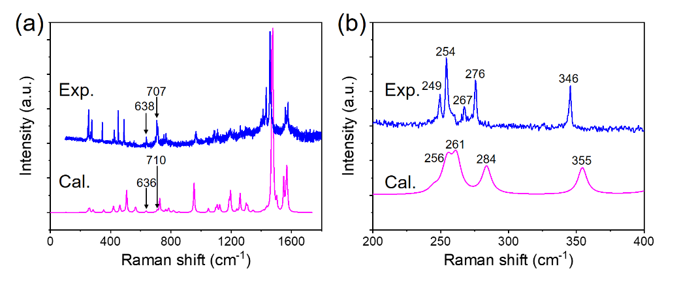
Fig. S9 | Experimental (Exp.) and calculated (Cal.) Raman spectra of the C₆₀ polymer crystal (a) 0 cm⁻¹ - 1800 cm⁻¹ and (b) 200 cm⁻¹ - 400 cm⁻¹.

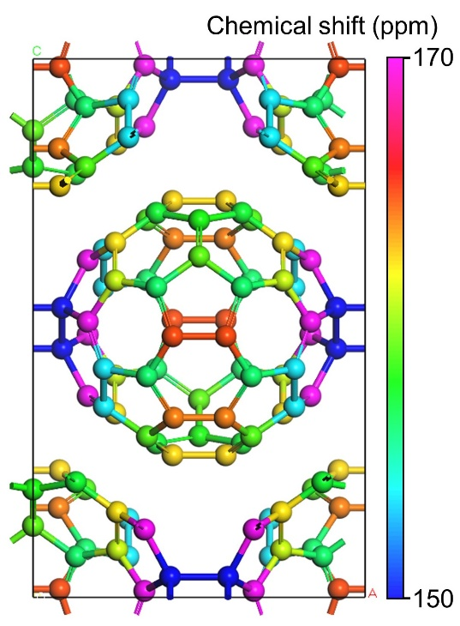
Fig. S10 | A C₆₀ polymer crystal model colored by calculated NMR chemical shift for each atom.

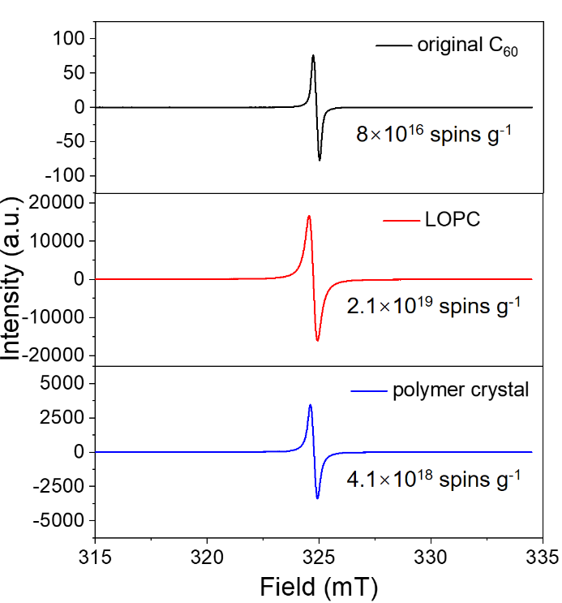
Fig. S11 | ESR spectra of the original C₆₀, LOPC and the polymer crystal, with the number of unpaired spins per gram labeled.

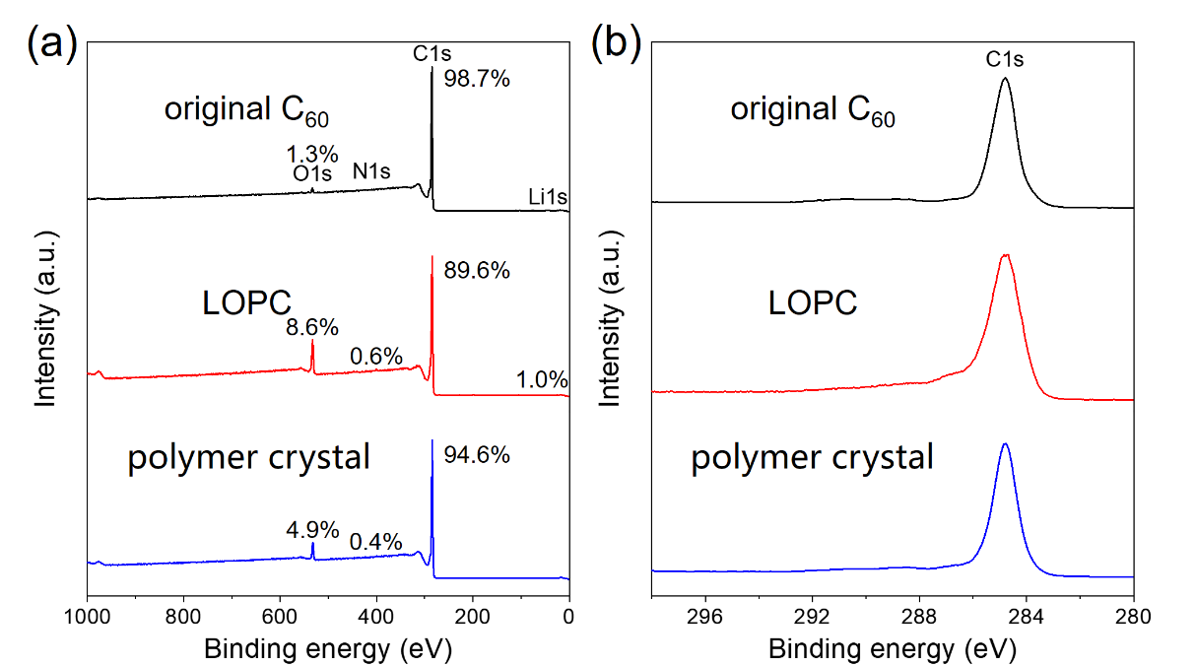
Fig. S12 | (a) XPS survey and (b) C 1s spectra of the original C₆₀, LOPC and the polymer crystal.

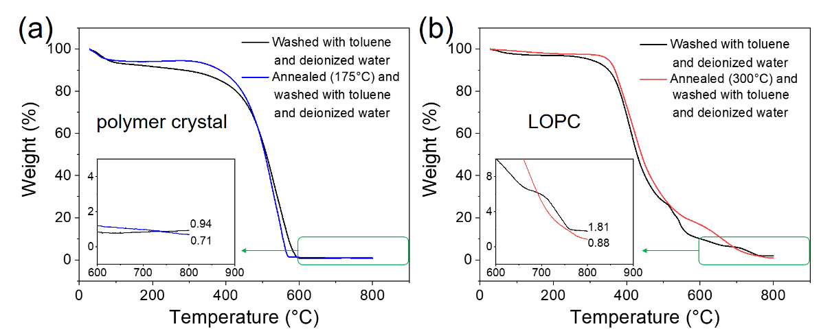
Fig. S13 | TGA curves of (a) the C₆₀ polymer crystal and (b) LOPC before or after annealing/washing under ambient atmosphere.

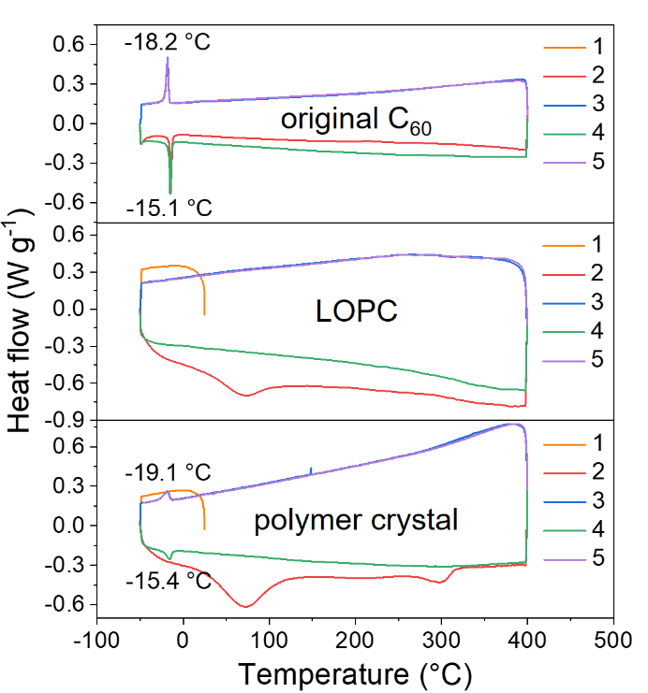
Fig. S14 | DSC curves of the original C₆₀, LOPC and the polymer crystal.

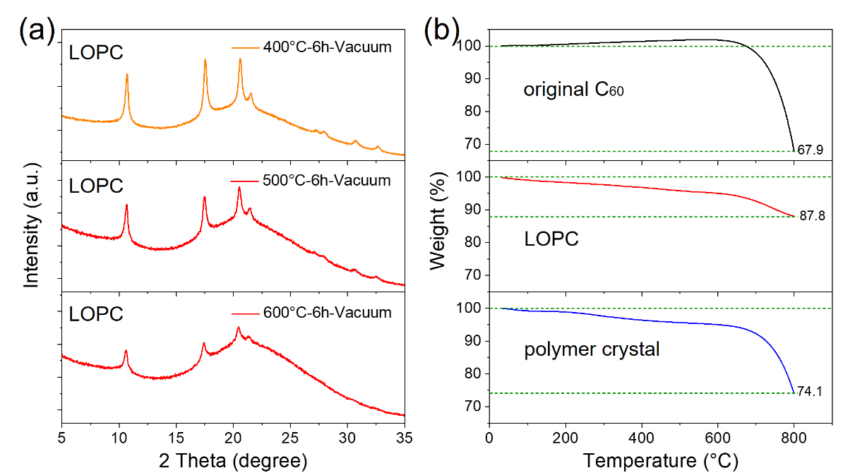
Fig. S15 | XRD patterns of LOPC made at 550 °C after post-annealing at various temperatures in vacuum and TGA curves of the original C₆₀, LOPC and the polymer crystal in nitrogen. We can see that LOPC has a higher stability than the original C₆₀ and the polymer crystal.

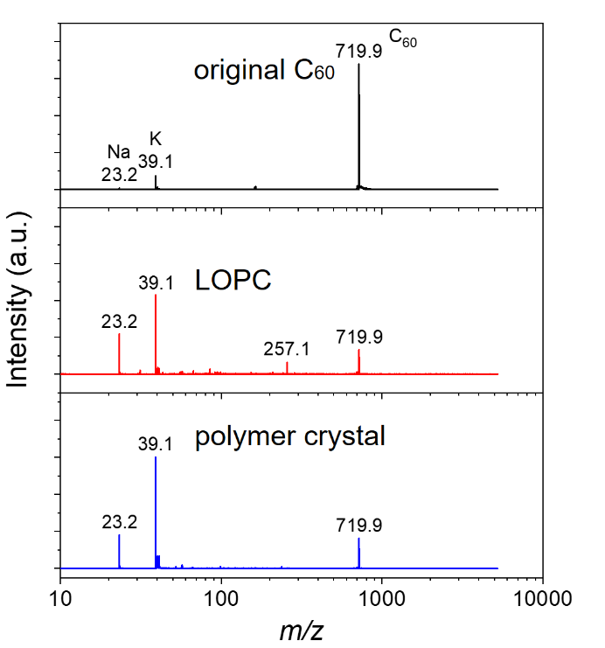
Fig. S16 | MS of the original C₆₀, LOPC and the polymer crystal using toluene as solvent with a MALDI-TOF. Note that the peaks at m/z positions 23.2 and 39.1 were caused by residual sodium (Na⁺) and potassium (K⁺) ions in the solvent. From MS, we can estimate that the relative amounts of residual C₆₀ molecules (719.9-signal) in LOPC and the polymer crystal are 3.35% and 2.98%. respectively, when calculated by comparing the intensities of the C₆₀ and K⁺ peaks, or 0.67% and 1.01% when calculated by comparing the intensities of the C₆₀ and Na⁺ peaks (It is assumed that the ionization efficiency of the three samples and the other test conditions are unchanged). The 257.1-signal in LOPC might come from the broken C₆₀ species.

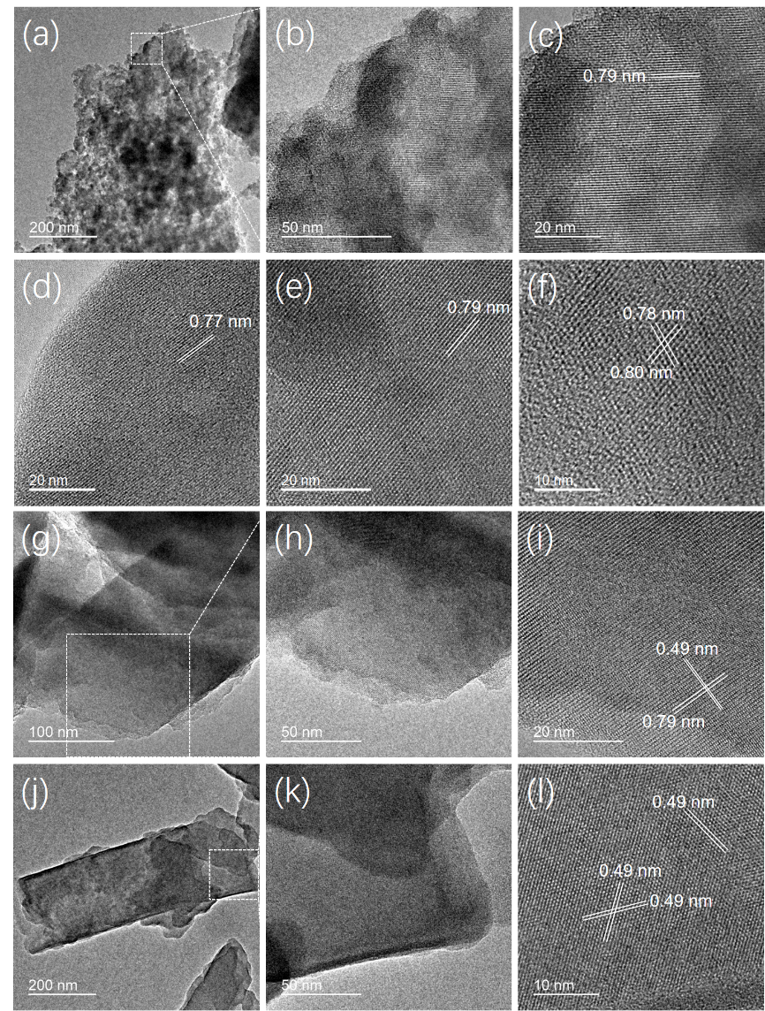
Fig. S17 | More TEM images of (a-f) LOPC and (g-l) the polymer crystal.

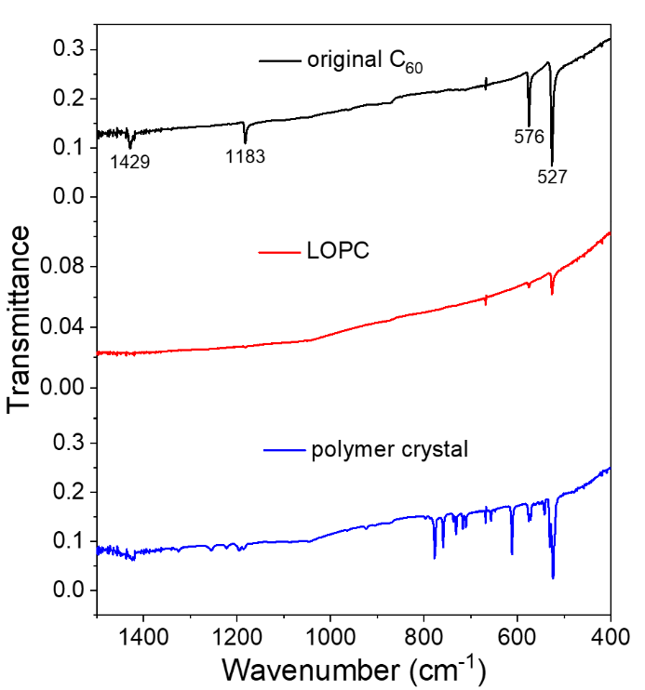
Fig. S18 | FTIR spectra of the original C₆₀, LOPC and the polymer crystal.

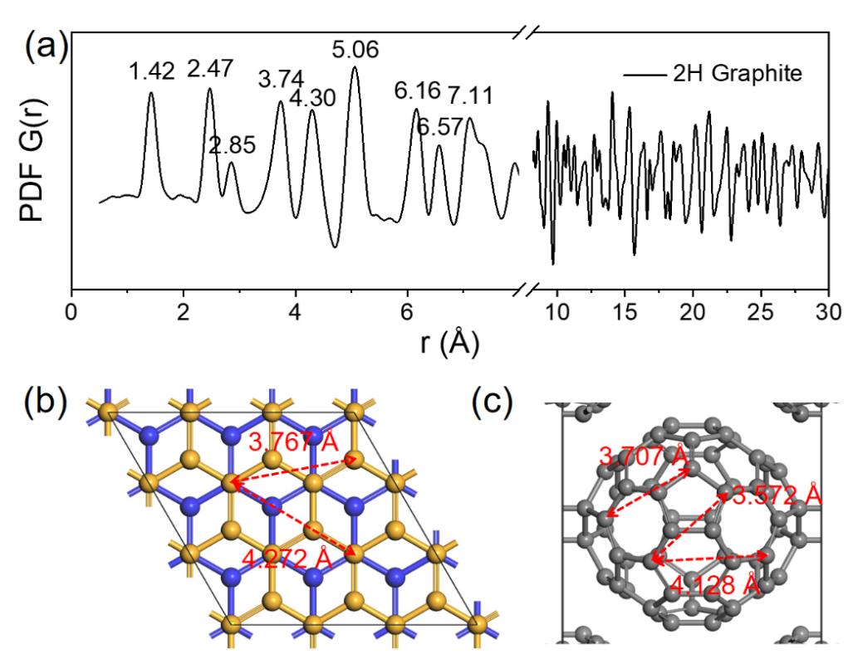
Fig. S19 | (a) Neutron PDF of 2H graphite obtained from 2000 mg graphite powder, which is mixture of 2H and 3R phases, annealed with 120 mg α-Li₃N at 600 °C for 10 h, then washed by deionized water and dried at 60 °C (please refer to our previous publication, Nano Lett. 21, 5648-5654, 2021 for the method used for purification of graphite). (b) Origin of the peaks at 3.74 Å and 4.30 Å in 2H graphite. (c) Origin of the peaks at 3.61 Å and 4.12 Å in C₆₀ polymer crystal.

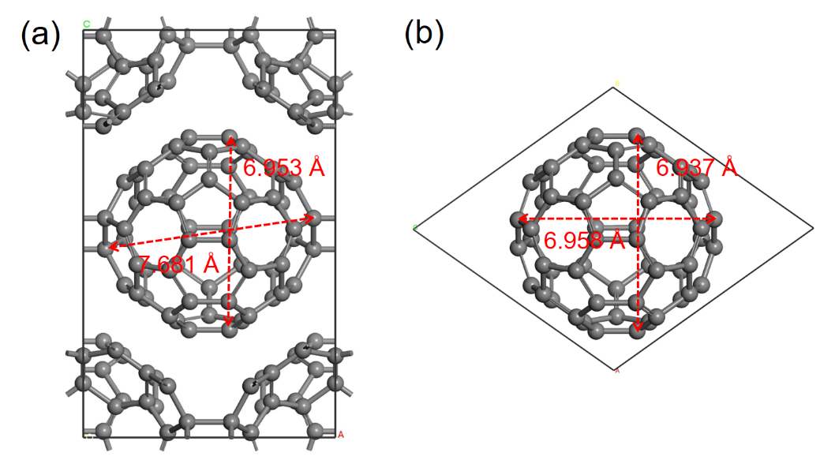
Fig. S20 | (a) Deformed C₆₀ with inter-atom distances labeled in the polymer crystal. (b) An original C₆₀ molecule with inter-atom distances labeled.

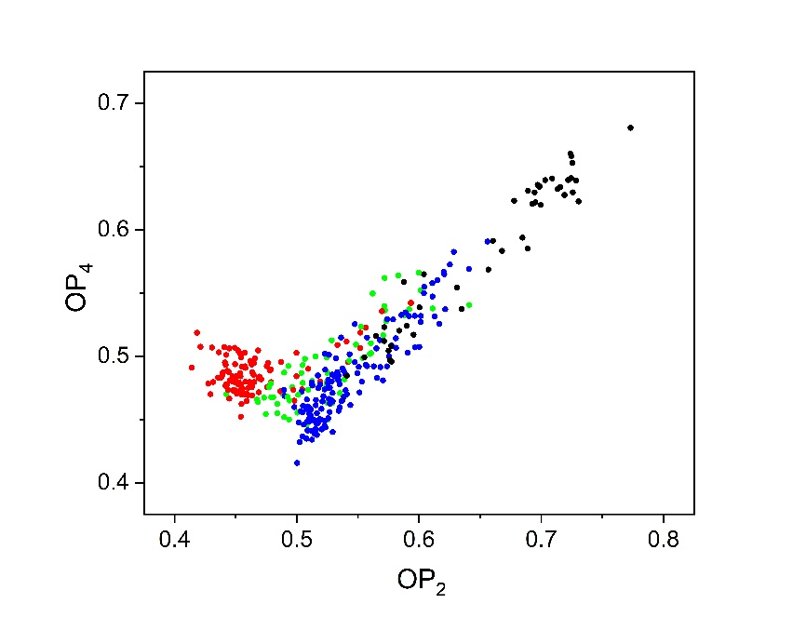
Fig. S21 | 347 structures with different colors for labeled structural types, coming from a total of 346,516 structures sorted by energy for every 1000 structures (please see the appendix for all 347 structures at the end of this file). Residual carbon and carbyne are denoted by black dots, fullerene type carbons are denoted by red dots, peanut-shaped carbons are denoted by green dots and graphene-type carbons are denoted by blue dots. The four types of carbon can be projected into distinct regions in the 2D expression of potential surface by OP₂ and OP₄ parameters, while a region of mixed types exists between the values 0.55 and 0.65 for the OP₂ parameter.

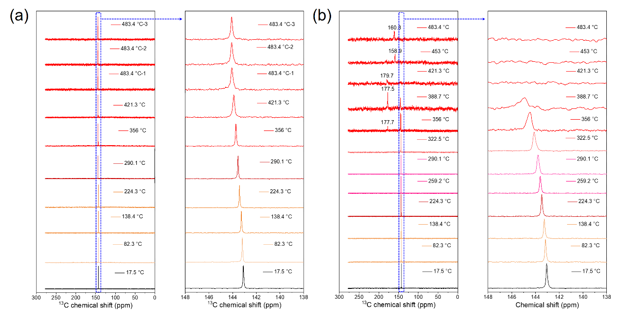
Fig. S22 | In-situ ¹³C MAS-SSNMR spectra of 500 mg C₆₀ (a) without or (b) in the presence of 100 mg α-Li₃N.

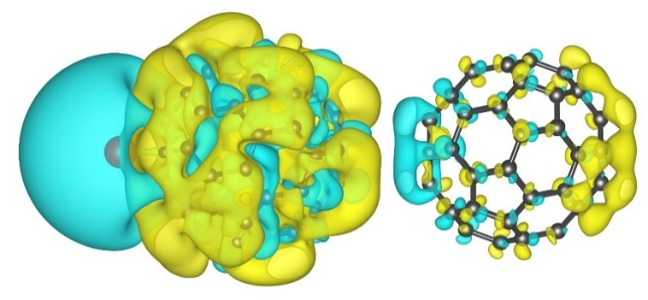
Fig. S23 | Density of charge deformation for a Li atom adsorbed on a C₆₀ molecule. The iso-surface value is 0.00004 electrons bohr⁻³, indicating that the other C₆₀ molecule (having no adjacent Li atom) also has an electron dipole due to electrostatic induction.

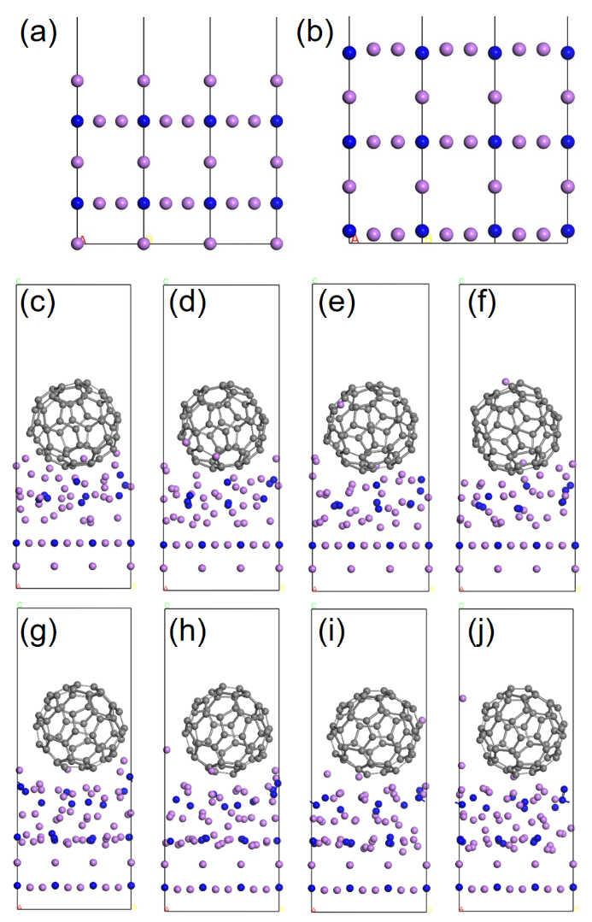
Fig. S24 | (a) Li and (b) LiN exposed surfaces of α-Li₃N crystal in the <001> direction; (c-f) show Li atom diffusion at 1500 K on a C₆₀ surface on an exposed Li surface; (g-j) show Li diffusion on a C₆₀ surface at 1000 K on an exposed LiN surface. A 3×3×1 supercell of α-Li₃N (001) surface is considered so as to match the lattice of a C₆₀ molecular crystal in the <111> direction. Two atomic layers at the bottom of Li₃N are fixed during the AIMD simulation.

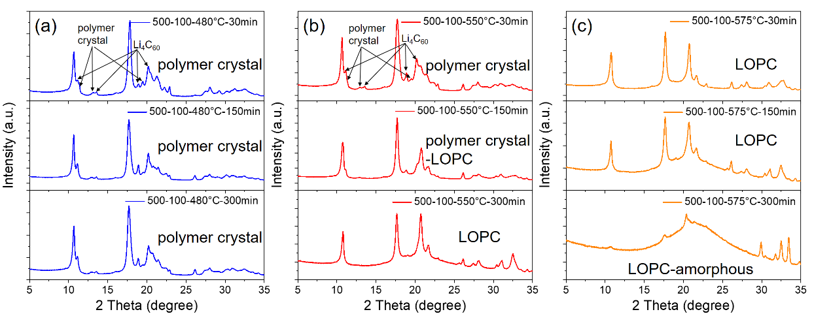
Fig. S25 | Cu K_{α} (λ = 0.15418 nm) XRD patterns of samples with annealing times of 30 min, 150 min and 300 min before washing, made by annealing 500 mg C₆₀ with 100 mg Li₃N at (a) 480 °C for the polymer crystal; (b) at 550 °C for LOPC; (c) at 575 °C for LOPC.

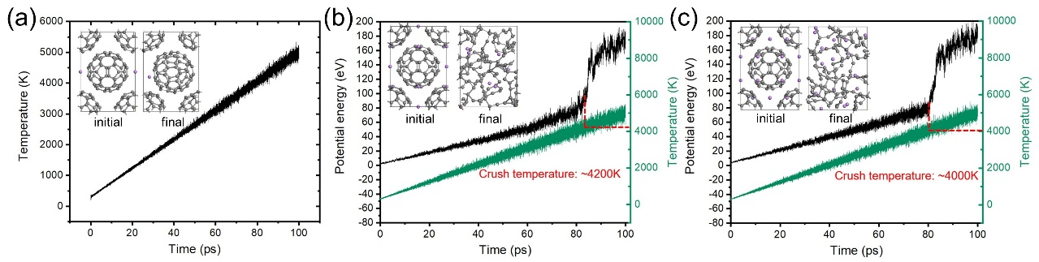
Fig. S26 | Change of temperature and potential energy over time for (a) LiC₁₂₀, (b) Li₆C₁₂₀ and (c) Li₁₆C₁₂₀ models. The insets show the initial and final structures during AIMD simulations. The grey balls denote C atoms and purple balls denote Li atoms.

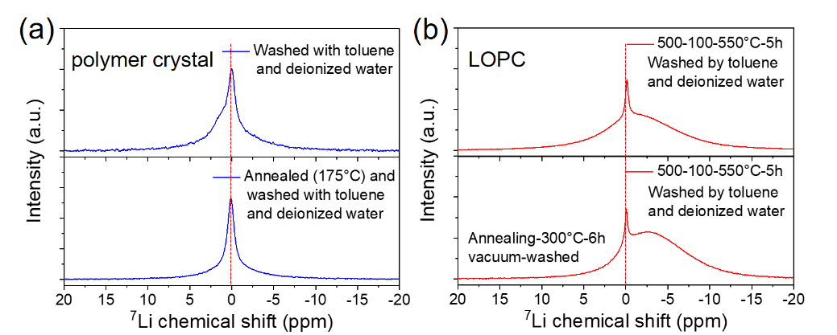
Fig. S27 | ⁷Li MAS-NMR spectra of samples (after washing by toluene and deionized water, and annealed after washing by toluene and deionized water) obtained by annealing 500 mg C₆₀ with 100 mg Li₃N at 480 °C (for the C₆₀ polymer crystal) or 550 °C (for LOPC). The spectrometer frequency was 155.51 MHz for ⁷Li. The 90 ° pulse was 1.9 μs for Li (spin rate of 12 kHz, a repetition time (d1) of 1 s, 512 scans). The NMR signals are externally referred to a 1.0 M LiCl aqueous solution.

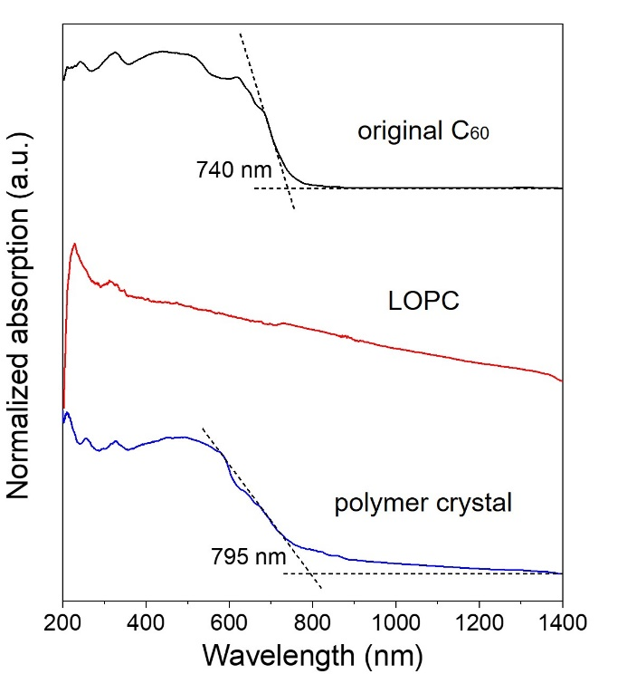
Fig. S28 | UV-Vis absorption spectra of the original C₆₀, LOPC and the polymer crystal powders on quartz substrates. Absorption edges of 1.68 eV and 1.56 eV can be identified for the original C₆₀ and the polymer crystal, respectively. In contrast, the LOPC shows no obvious absorption edge.

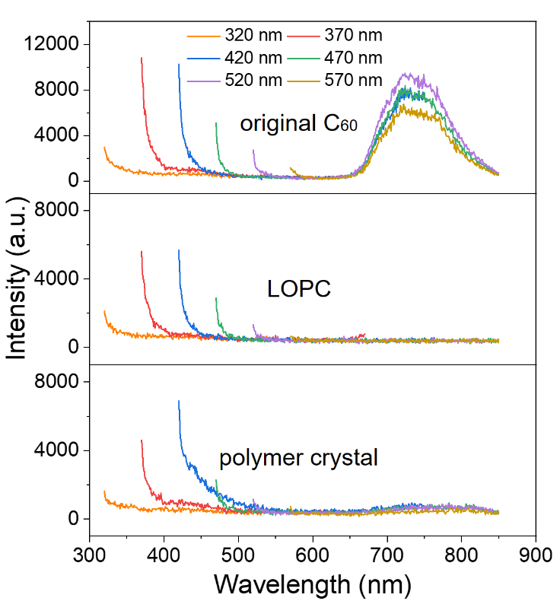
Fig. S29 | PL spectra of the original C₆₀, LOPC and the polymer crystal powders measured under laser excitations with wavelengths 320, 370, 420, 470, 520 and 570 nm. The original C₆₀ has a broad yet excitation-independent PL peak that is absent in the LOPC and largely suppressed in the polymer crystal.

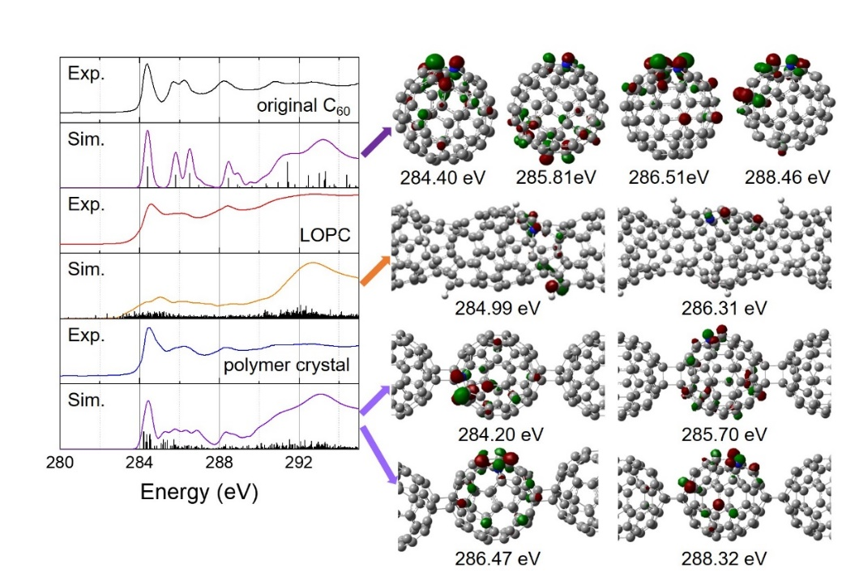
Fig. S30 | More simulations of K-edge NEXAFS spectra for the original C₆₀, LOPC and the polymer crystal (isovalue = 0.05).

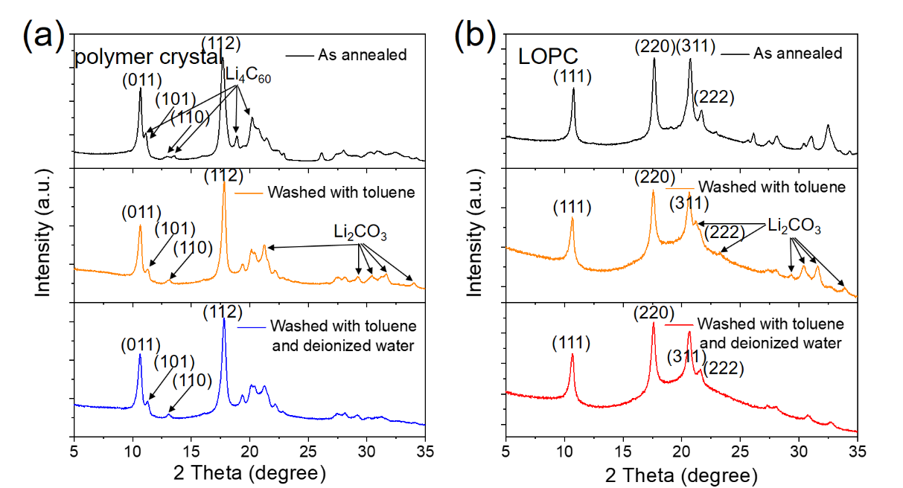
Fig. S31 | Cu K_{α} (λ = 0.15418 nm) XRD patterns of samples before and after washing, made by annealing 500 mg C₆₀ with 100 mg α-Li₃N (a) at 480 °C for the polymer crystal and (b) at 550 °C for LOPC.

3. Supplementary Tables
Table S1. Detailed Raman modes of the original C₆₀ and the polymer crystal. The peaks in experimental (Exp.) Raman spectra marked in blue are labeled in Fig. 1d. 4 peaks in the experimental Raman spectra of the polymer crystal marked in red were not reported in Ref. 2, but are in good agreement with our calculation results, as shown in Fig. S8.
original C₆₀ |  |  | polymer crystal
Raman mode | Exp. position/cm⁻¹ | Ref. 1 position/cm⁻¹ | Raman mode | Exp. position/cm⁻¹ | Ref. 2 position/cm⁻¹
A_{g}(1) | 495 | 495 | / | / | /
A_{g}(2) | 1468 | 1470 | / | 1458 | 1457
H_{g}(1) | 266, 272 | 267, 272 | / | 254 | 256
H_{g}(2) | 430 | 431 | / | 276 | 274
H_{g}(3) | 708 | 709 | / | 346 | 346
H_{g}(4) | 772 | 775, 778 | / | 424 | 427
H_{g}(5) | 1101 | 1102 | / | 450 | 452
H_{g}(6) | 1250 | 1252 | / | / | 471
H_{g}(7) | 1419, 1425 | 1418, 1425 | / | 489 | 488
H_{g}(8) | 1575 | 1567, 1576 | / | 556 | 556
F_{1g}(1) | 567 | 568 | / | 568 | 566
F_{1g}(2) | 969 | 973 | / | / | 577
F_{1g}(3) | 1480, 1482 | 1479, 1484 | / | / | 596
H_{g}(1)※H_{g}(7) | 1690 | 1693 | / | / | 614
H_{g}(1)※G_{g}(5) | 1618 | 1619 | / | / | 668
F_{2g}(1)※F_{1g}(2) | 1514 | 1516 | / | / | 676
F_{2u}(5) | 1311 | 1310 | / | 698 | 697
H_{g}(2)※H_{g}(2) | 860 | 862 | / | 714 | 714
H_{g}(1)※H_{g}(1) | 531 | 533 | / | 754 | 753
 |  |  |  | 768 | 770
 |  |  | / | / | 853
 |  |  | / | / | 945
 |  |  | / | 966 | 965
 |  |  | / | 1038 | 1040
 |  |  | / | 1089 | 1086
 |  |  | / | 1111 | 1109
 |  |  | / | 1195 | 1192
 |  |  | / | / | 1243
 |  |  | / | 1262 | 1260
 |  |  | / | / | 1297
 |  |  | / | / | 1310
 |  |  | / | / | 1350
 |  |  | / | 1398 | 1396
 |  |  | / | 1432 | 1432
 |  |  | / | 1561 | 1560
 |  |  | / | 1576 | 1572
 |  |  | / | 707 | /
 |  |  | / | 638 | /
 |  |  | / | 267 | /
 |  |  | / | 249 | /
Note: Ref. 1 is Phys. Rev. B 1994, 50, 173-183; Ref. 2 is Phys. Rev. B 2000, 61, 11936-11945.

Table S2. Lorentz deconvolution of ¹³C MAS-NMR peaks in experimental results and from calculations for the C₆₀ polymer crystal.
Experimental fitting/ppm | sp²/sp³ | Relative intensity | Calculated /ppm | sp²/sp³ | Relative intensity
149.3 | sp² | 2.37 | 171.0329 | sp² | 1
146.5 | sp² | 6.14 | 170.4294 | sp² | 1
143.9 | sp² | 6.43 | 165.0488 | sp² | 1
140.2 | sp² | 3.02 | 164.1651 | sp² | 1
 |  |  | 162.6580 | sp² | 1
76.0 | sp³ | 1 | 162.4282 | sp² | 1
 |  |  | 161.0797 | sp² | 1
 |  |  | 158.9835 | sp² | 1
 |  |  | 157.4475 | sp² | 1
 |  |  | 156.5427 | sp² | 1
 |  |  | 156.4949 | sp² | 1
 |  |  | 153.8134 | sp² | 1
 |  |  | 153.7263 | sp² | 1
 |  |  | 158.1156 | sp² | 0.5
 |  |  | 159.2344 | sp² | 0.5
 |  |  | 95.9155 | sp³ | 1
I_{(sp3)}/(I_{(sp2)}+I_{(sp3)}) = 1/18.96 = 5.27% |  |  | I_{(sp3)}/(I_{(sp2)}+I_{(sp3)}) = 1/15 = 6.67%

Video 1: A movie showing the pentagon stretching vibration mode corresponding to the Raman peak of 1449 cm⁻¹ for the proposed LOPC structure shown in Fig.1a.

Video 2: A movie showing the A_{g}(2) vibration mode of the original C₆₀ molecule.

Video 3: A movie showing a pentagon-related vibration mode corresponding to the Raman peak of 1470 cm⁻¹ of a C₆₀ polymer crystal, which contributes to the peak at 1473 cm⁻¹.

Video 4: A movie showing a pentagon-related vibration mode corresponding to the Raman peak of 1476 cm⁻¹ of a C₆₀ polymer crystal, which contributes to the peak at 1473 cm⁻¹.

Appendix
Geometric structures from a total of 346,516 structures sorted by energy for every 1000th structure. The label number indicates the energy position of the structure in 346,516 structures.

