Supplementary Information for

Visualization of translation and protein biogenesis at the ER membrane

Max Gemmer¹, Marten L. Chaillet¹, Joyce van Loenhout¹, Rodrigo Cuevas Arenas¹, Dimitrios Vismpas¹, Mariska Gröllers-Mulderij¹, Fujiet A. Koh², Pascal Albanese^{3,4}, Richard Scheltema^{3,4}, Stuart C. Howes¹, Abhay Kotecha², Juliette Fedry^{1,5}, Friedrich Förster^{1,5}

1: Structural Biochemistry, Bijvoet Center for Biomolecular Research, Utrecht University, 3584 CG Utrecht, The Netherlands
2: Thermo Fisher Scientific, Eindhoven, The Netherlands
3: Biomolecular Mass Spectrometry and Proteomics Group, Utrecht Institute for Pharmaceutical Sciences, Utrecht University, 3584 CH Utrecht, The Netherlands
4: Netherlands Proteomics Center, Utrecht University, Utrecht University, 3584 CH Utrecht, The Netherlands
5: Correspondence to: j.m.m.fedry@uu.nl and f.g.forster@uu.nl

Table of Contents
Supplementary Figures 3
Supplementary Tables 12
Supplementary Video Captions 23

Supplementary Figures
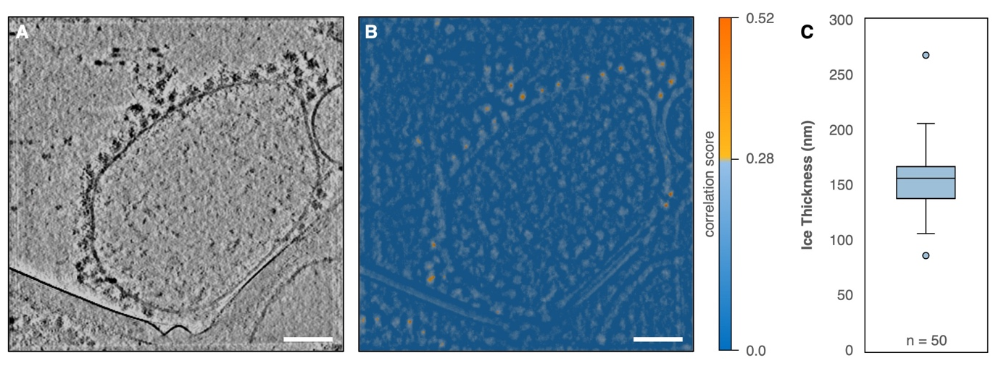
Supplementary Fig. 1: Cryo-tomograms of ER-derived vesicles from HEK-293 cells. (A) 2D slice (thickness 2.0 nm) of a representative tomogram. The scalebar corresponds to 100 nm. (B) PyTom correlation scores resulting from template matching ⁶⁹. Particles with scores of 0.28-0.56 were selected for subsequent subtomogram analysis. Scores are color-coded as indicated. (C) Distribution of ice thickness of n = 50 randomly selected tomograms. Median thickness (156 nm) is indicated, the box defines the lower (138 nm) and upper (167 nm) quartile, whiskers define the minimum (106 nm) and maximum (206 nm) thickness. Outliers are indicated.

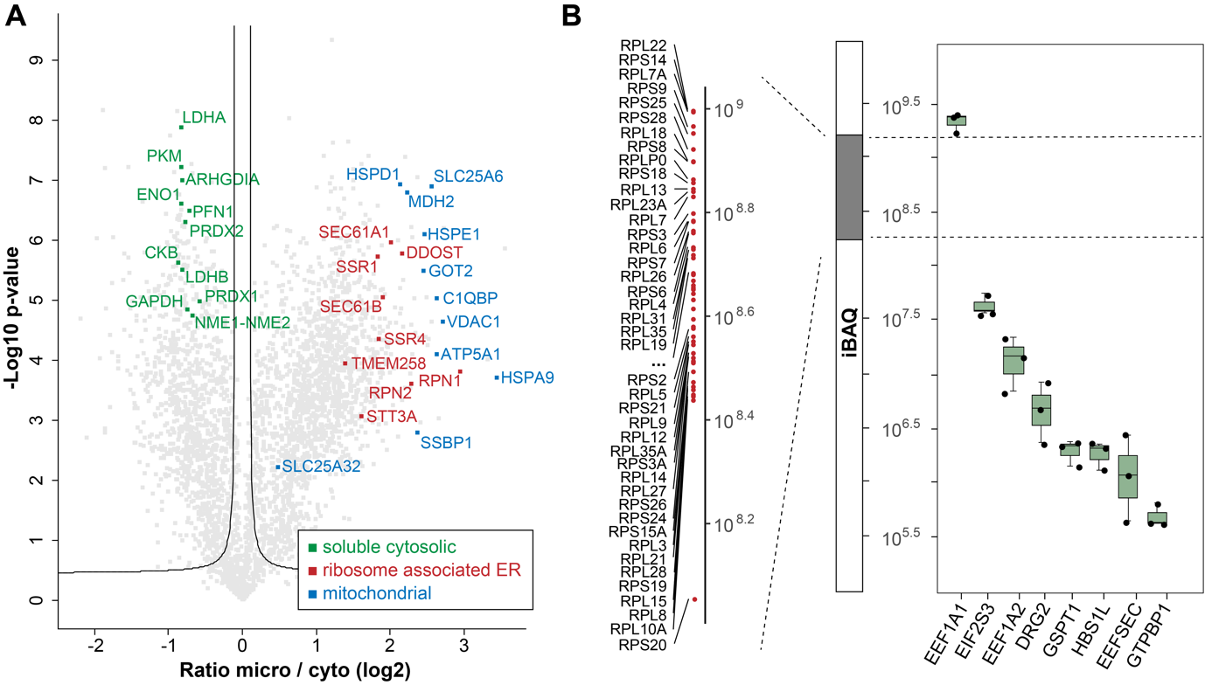
Supplementary Fig. 2: Proteomics characterization of microsome preparation. (A) Enrichment of ribosome-associated ER and mitochondrial proteins and depletion of cytosolic proteins when comparing microsome enriched samples to cytosolic supernatant. The y-axis of the volcano plot was made using a two-sided T-test, where the false positive rate was controlled to 5% based on 250 randomizations of the data. (B) Dynamic range of the detected absolute abundances for the measured proteome (central bar labeled with intensity-based quantification, iBAQ). Ribosomal proteins occupy a narrow band of absolute abundances (left bar). Among ribosome-binding GTPases, eEF1a the most abundant (right boxplot). Data points show n=3 technical replicates of 1 experiment. Median of logarithmic of IBAQ values is indicated, the box represents lower and upper quartile, whiskers represent minimum and maximum.
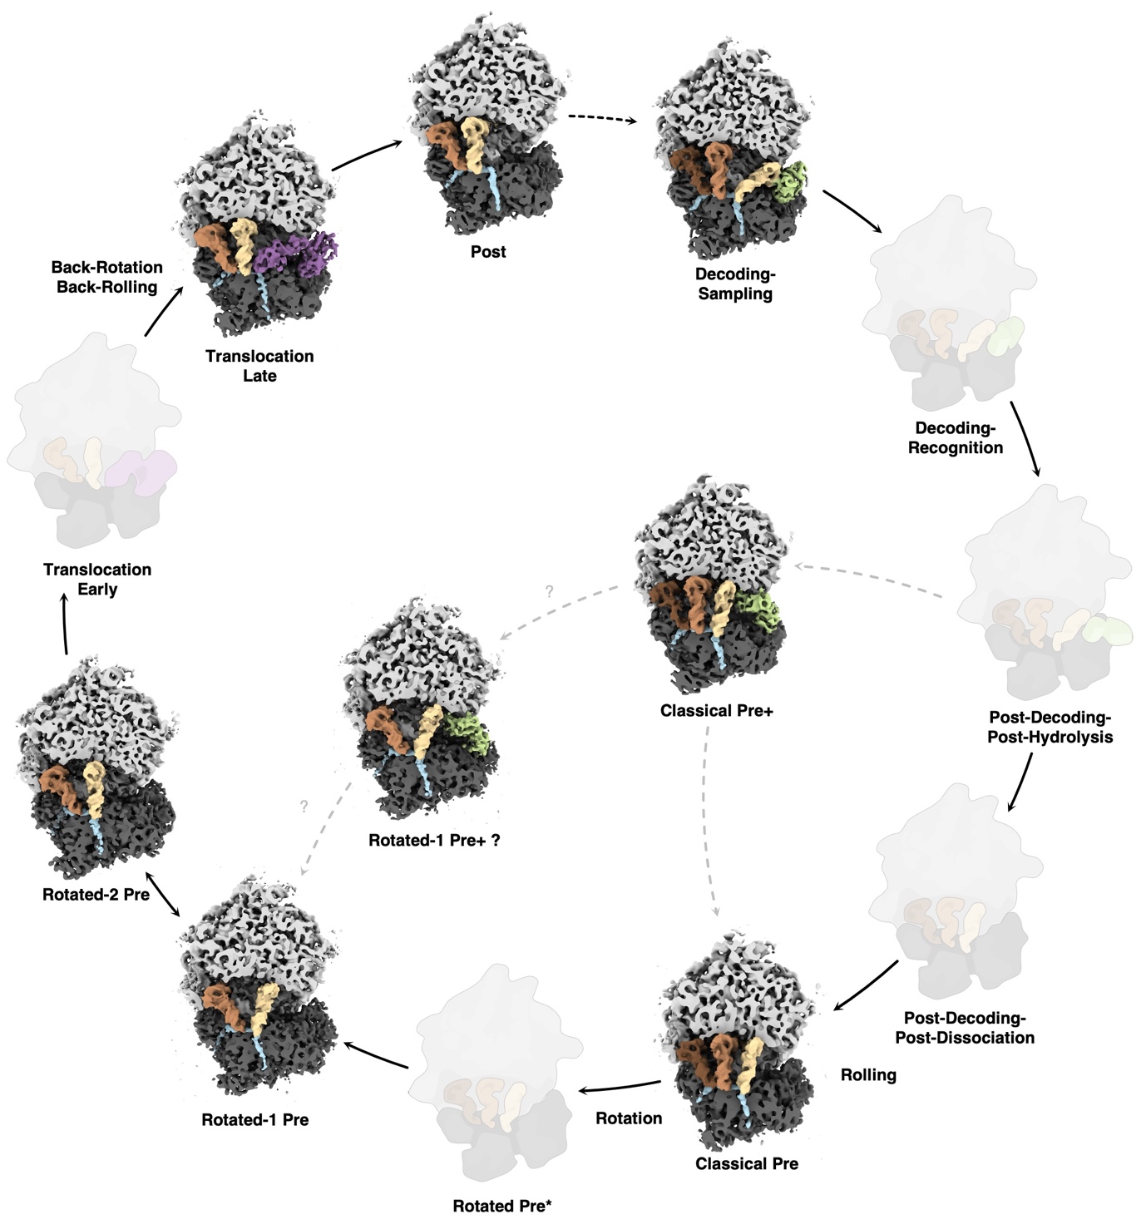
Supplementary Fig. 3: Observed active intermediates in the context of the complete model of human elongation cycle. Different from Figure 1D all observed ribosomal states are positioned in a model recapitulating structurally characterized states beyond the most abundant ones detected in our study. States that are not detected are grayed out. The solid arrows indicate the cycle from ²¹, while the transitions to states only detected in our study are broken lines. The Rotated-1 Pre+ state had not been assigned in Fig. 1D due to its missing support from in situ data.
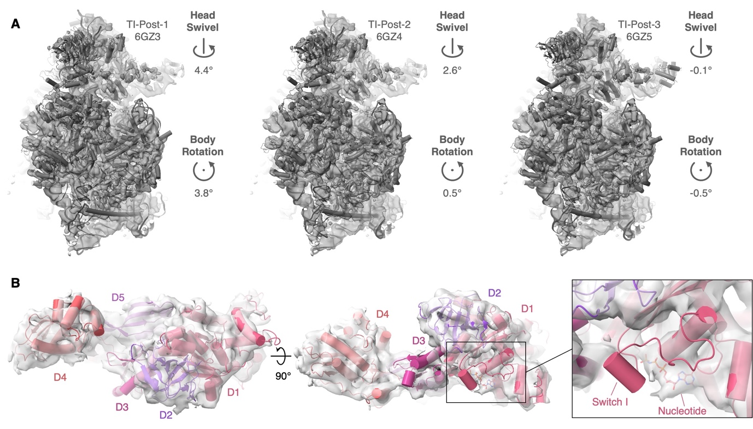 Supplementary Fig. 4: Identification of elongation factor-bound ribosomal translocation intermediate states. (A) Large ribosomal subunits of the TI (translocation intermediate)-Post-1 (6GZ3), TI-Post-2 (6GZ4) and TI-Post-3 (6GZ5) states were fitted into our reconstruction of the ‘translocation’ intermediate from Fig. 1A and the structure of the small ribosomal subunit was superposed onto our reconstruction. Rotational differences of the SSU head and body with respect to our reconstruction are indicated. (B) Domains of eEF2 (6GZ5) fitted into the translocation intermediate. Domains D1, D2, D4 and D5 fit well into the reconstruction, domain D3 is positioned slightly differently. The switch I loop is disordered in our reconstruction indicating a GDP-bound state.

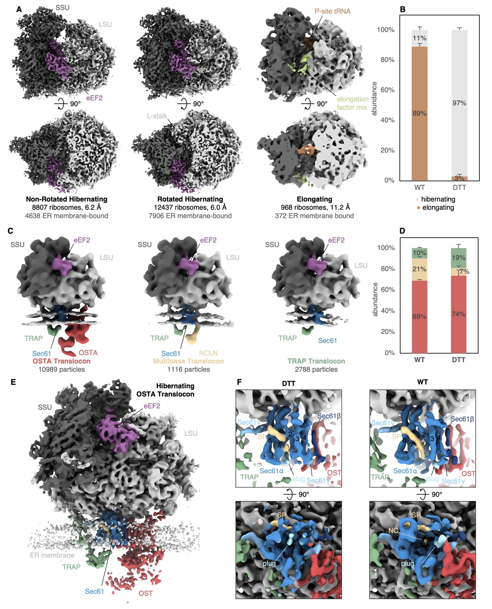
Supplementary Fig. 5: Cryo-ET analysis of ER membrane-bound ribosomes obtained from stressed cells. (A) Side views (top row) and top views (bottom row) of intermediate states of soluble and ER membrane-associated ribosomes under condition of oxidative stress. (B) Abundance of elongating and hibernating ER membrane-bound ribosomes in WT and DTT-treated vesicles. n(WT) = 132,371 particles in 869 tomograms from 1 experiment, n(DTT) = 26,512 particles in 212 (174 and 38) tomograms from 2 independent experiments. Stacked columns show the modelled mean with the 95% confidence interval as error bars. (C) Different populations of ER translocons from DTT-treated microsomes. (D) Distribution of ER translocon populations in WT and DTT-treated sample (C). n(WT) = 132,371 particles in 869 tomograms from 1 experiment, n(DTT) = 26,512 particles in 212 (174 and 38) tomograms from 2 independent experiments. Stacked columns show the modelled mean with the 95% confidence interval as error bars. (E) Structure of the hibernating ribosome-bound OSTA-translocon complex from DTT-treated samples at an overall resolution of 6.4 Å. (F) Side view (top row) and view from the ER lumen (bottom row) of the active WT (left) and inactive DTT-treated (right) OSTA-translocon. Both reconstructions were filtered to a resolution of 8 Å. SP: signal peptide, NC: nascent chain.

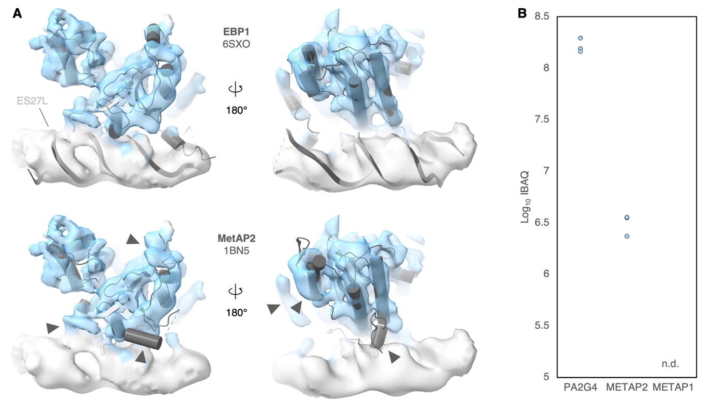Supplementary Fig. 6: Identification of ribosome-associated EBP1. (A) Structures of EBP1 (6SXO, SPA structure) and MetAP2 (1BN5, crystal structure) fitted into our segmented reconstruction of soluble ribosomes. Arrowheads indicate structural differences between EBP1 and MetAP2 that are not explained by the reconstruction. (B) Abundance of the structurally related proteins EBP1 (PA2G4), MetAP1 and MetAP2 in our ER-vesicle preparation determined by mass spectrometry. n.d. – not determined. Data points show n=3 technical replicates of 1 experiment.

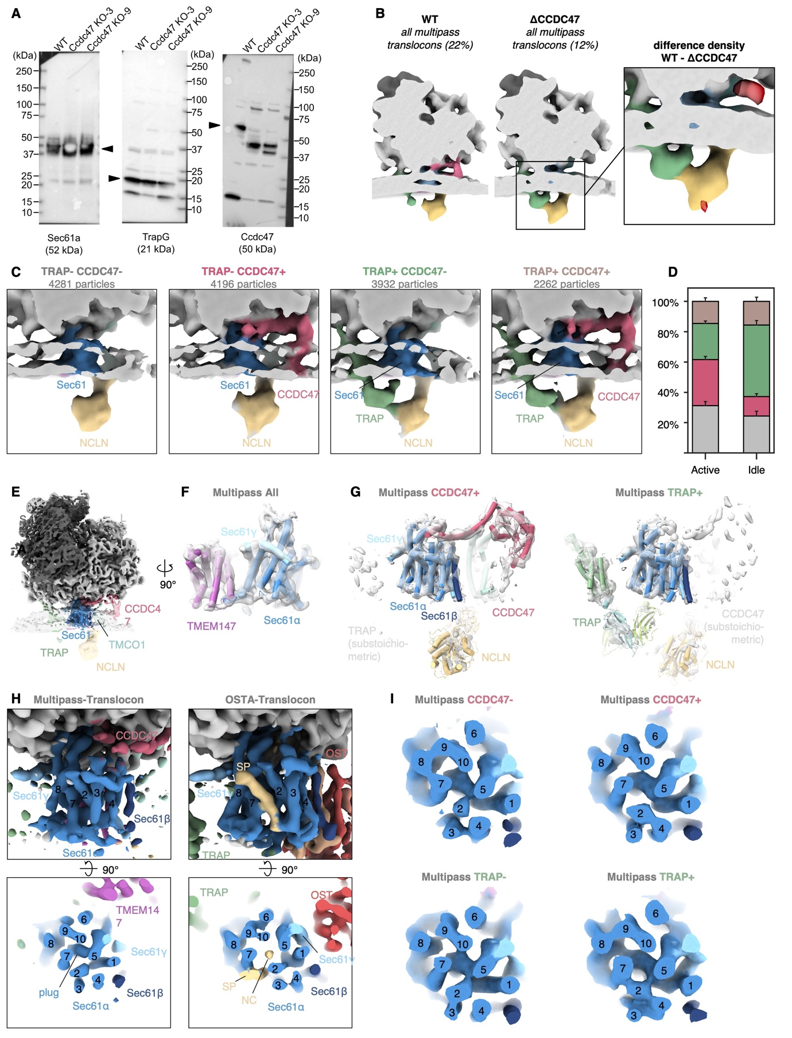
Supplementary Fig. 7: Reconstructions of multipass translocon populations. (A) Western blots of ER-derived vesicles prepared from HEK293F WT and ΔCCDC47 cells. Samples of WT and knock-out (KO) clones 3 and 9 in different lanes derive from the same experiment. The membrane was cut vertically after blotting and its fragments were processed in parallel. Sec61α (Sec61a) and TRAPγ (TrapG) were used as ER marker. The depicted Western blot is a representative of two independent experiments. (B) Comparison between the multipass translocon population from WT and ΔCCDC47. The difference density is displayed at 2σ (red). n(ΔCCDC47) = 555 particles in 60 tomograms from 1 experiment (C) Multipass translocon populations obtained by classification focused on the ER luminal densities of TRAP and NCLN or on CCDC47. (D) Quantification of multipass translocon populations associated with elongating or hibernating ribosomes. Color-code as in (C). n = 14781 particles in 869 tomograms from 1 experiment. (E) Overall structure of the entire multipass translocon-associated ribosome filtered to 8 Å (opaque) and 20 Å (transparent) resolution. Densities of TRAP, NCLN, CCDC47 are highly fragmented due to flexibility or compositional heterogeneity. (F) Close-up view of Sec61 and TMEM147 (PDB: 6W6L) fitted into the segmented reconstruction from (E). (G) Components of the multipass translocon (PDB: 6W6L) fitted into the segmented densities of CCDC47-containing or TRAP-containing populations. Densities that are distant from the ribosome are fragmented due to flexibility. (H) Close-up views of Sec61 from the entire multipass-translocon population (left) compared to the OSTA-translocon (right). Numbering of TMHs of Sec61α is indicated. SP– signal peptide, NC – nascent chain. (I) Segmented density of Sec61 shown as in (H) of reconstructions from populations lacking or containing CCDC47 and lacking or containing TRAP.

Supplementary Tables
Supplementary Table 1: Cryo-EM data collection, refinement and validation statistics of ribosome and translocon classes
 | #1  Decoding-Sampling State  (EMDB-15871) | #2  Classical Pre+ State  (EMDB-15872) | #3  Classical Pre State  (EMDB-15873) | #4  Rotated-1 Pre+ State  (EMDB-15874) | #5  Rotated-1 Pre State  (EMDB-15875)
Data collection and processing
Magnification | 79000 | 79000 | 79000 | 79000 | 79000
Voltage (kV) | 200 | 200 | 200 | 200 | 200
Electron exposure (e–/Å²) | <80 | <80 | <80 | <80 | <80
Defocus range (μm) | 3 | 3 | 3 | 3 | 3
Pixel size (Å) | 1.724 | 1.724 | 1.724 | 1.724 | 1.724
Symmetry imposed | - | - | - | - | -
Initial particle images (no.) | 134350 | 134350 | 134350 | 134350 | 134350
Final particle images (no.) | 26980 | 40035 | 3884 | 4196 | 5300
Map resolution (Å)  FSC threshold | 4.8  0.143 | 4.6  0.143 | 8.0  0.143 | 6.7  0.143 | 6.1  0.143
Map resolution range (Å) | 3.6-51.7 | 3.6-34.5 | 4.3-51.7 | 4.3-51.7 | 4.1-51.7
Refinement
Initial model used (PDB code)
Model resolution (Å)
FSC threshold
Model resolution range (Å)
Map sharpening B factor (Å²)
Model composition
Non-hydrogen atoms
Protein residues
Ligands
B factors (Å²)
Protein
Ligand
R.m.s. deviations
Bond lengths (Å)
Bond angles (°)
Validation
MolProbity score
Clashscore
Poor rotamers (%)
Ramachandran plot
Favored (%)
Allowed (%)
Disallowed (%)

 | #6  Rotated-2 State  (EMDB-15876) | #7  Translocation State  (EMDB-15877) | #8  Post State  (EMDB-15878) | #9  Non-Rotated Hibernating  (EMDB-15879) | #10  Rotated Hibernating  (EMDB-15880)
Data collection and processing
Magnification | 79000 | 79000 | 79000 | 79000 | 79000
Voltage (kV) | 200 | 200 | 200 | 200 | 200
Electron exposure (e–/Å²) | <80 | <80 | <80 | <80 | <80
Defocus range (μm) | 3 | 3 | 3 | 3 | 3
Pixel size (Å) | 1.724 | 1.724 | 1.724 | 1.724 | 1.724
Symmetry imposed | - | - | - | - | -
Initial particle images (no.) | 134350 | 134350 | 134350 | 134350 | 134350
Final particle images (no.) | 20560 | 5789 | 13511 | 7565 | 4551
Map resolution (Å)  FSC threshold | 4.8  0.143 | 6.8  0.143 | 5.9  0.143 | 6.5  0.143 | 6.7  0.143
Map resolution range (Å) | 3.6-51.7 | 3.6-51.7 | 3.6-51.7 | 4.3-51.7 | 4.1-51.7
Refinement
Initial model used (PDB code)
Model resolution (Å)
FSC threshold
Model resolution range (Å)
Map sharpening B factor (Å²)
Model composition
Non-hydrogen atoms
Protein residues
Ligands
B factors (Å²)
Protein
Ligand
R.m.s. deviations
Bond lengths (Å)
Bond angles (°)
Validation
MolProbity score
Clashscore
Poor rotamers (%)
Ramachandran plot
Favored (%)
Allowed (%)
Disallowed (%)

 | #11  Ribosome-Sec61-TRAP-OSTA  (EMDB-15884) | #12  Ribosome-Sec61-TRAP  (EMDB-15885) | #13  Ribosome-Sec61-TRAP-Multipass  (EMDB-15886) | #14  Ribosome-Sec61-Multipass  (EMDB-15887) | #15  Ribosome-EBP1  (EMDB-15888)
Data collection and processing
Magnification | 79000 | 79000 | 79000 | 79000 | 79000
Voltage (kV) | 200 | 200 | 200 | 200 | 200
Electron exposure (e–/Å²) | <80 | <80 | <80 | <80 | <80
Defocus range (μm) | 3 | 3 | 3 | 3 | 3
Pixel size (Å) | 1.724 | 1.724 | 1.724 | 1.724 | 1.724
Symmetry imposed | - | - | - | - | -
Initial particle images (no.) | 134350 | 134350 | 134350 | 134350 | 134350
Final particle images (no.) | 42215 | 6725 | 6194 | 8477 | 24577
Map resolution (Å)  FSC threshold | 4.5  0.143 | 6.5  0.143 | 7.5  0.143 | 6.7  0.143 | 5.0  0.143
Map resolution range (Å) | 3.6-51.7 | 4.1-51.7 | 4.5-51.7 | 4.3-51.7 | 3.8-51.7
Refinement
Initial model used (PDB code)
Model resolution (Å)
FSC threshold
Model resolution range (Å)
Map sharpening B factor (Å²)
Model composition
Non-hydrogen atoms
Protein residues
Ligands
B factors (Å²)
Protein
Ligand
R.m.s. deviations
Bond lengths (Å)
Bond angles (°)
Validation
MolProbity score
Clashscore
Poor rotamers (%)
Ramachandran plot
Favored (%)
Allowed (%)
Disallowed (%)

 | #16  Idle Ribosome-Sec61-TRAP-OSTA  (EMDB-15889) | #17  Sec61-TRAP-OSTA- Translocon (all)  (EMDB-15870)  (PDB 8B6L) | #18  Sec61-TRAP-OSTA- Translocon  (EMDB-15890) | #19  Sec61-TRAP-OSTA-L1-Translocon  (EMDB-15891) | #20  Sec61-TRAP-OSTA-L2-Translocon  (EMDB-15892)
Data collection and processing
Magnification | 79000 | 79000 | 79000 | 79000 | 79000
Voltage (kV) | 200 | 200 | 200 | 200 | 200
Electron exposure (e–/Å²) | <80 | <80 | <80 | <80 | <80
Defocus range (μm) | 3 | 3 | 3 | 3 | 3
Pixel size (Å) | 1.724 | 1.724 | 1.724 | 1.724 | 1.724
Symmetry imposed | - | - | - | - | -
Initial particle images (no.) | 134350 | 134350 | 134350 | 134350 | 134350
Final particle images (no.) | 9163 | 42215 | 4555 | 14541 | 14991
Map resolution (Å)  FSC threshold | 6.4  0.143 | 7.6  0.143 | 9.3  0.143 | 8.2  0.143 | 8.3  0.143
Map resolution range (Å) | 4.3-51.7 | 5.4-51.7 | 6.5-51.7 | 5.4-51.7 | 5.7-51.7
Refinement
Initial model used (PDB code) |  | AF and Colab models
Model resolution (Å)  FSC threshold |  | 6.0  0.5
Model resolution range (Å)
Map sharpening B factor (Å²)
Model composition  Non-hydrogen atoms  Protein residues  Ligands (RNA) |  | 29611  3798  0
B factors (Å²)  Protein  Ligand (RNA) |  | 328.57  -
R.m.s. deviations  Bond lengths (Å)  Bond angles (°) |  | 0.003  0.594
Validation  MolProbity score  Clashscore  Poor rotamers (%) |  | 1.26  2.19  0%
Ramachandran plot  Favored (%)  Allowed (%)  Disallowed (%) |  | 96.11%  3.81%  0.08%

#21
SPA reconstruction Classical Pre+ State

(EMDB-15893)
(PDB 8B6Z)
Data collection and processing
Magnification
Voltage (kV) | 300
Electron exposure (e–/Å²) | 40
Defocus range (μm)
Pixel size (Å) | 0.729
Symmetry imposed | -
Initial particle images (no.) | 66041
Final particle images (no.) | 19046
Map resolution (Å)  FSC threshold | 2.9  0.143
Map resolution range (Å) | 2.3-22.7
Refinement
Initial model used (PDB code) | 4C0S
Model resolution (Å)  FSC threshold | 3.2  0.5
Model resolution range (Å) | -
Map sharpening B factor (Å²) | 0
Model composition  Non-hydrogen atoms  Protein residues  Ligands (RNA) | 3581  442  8
B factors (Å²)  Protein  Ligand (RNA) | 47.78  51.17
R.m.s. deviations  Bond lengths (Å)  Bond angles (°) | 0.002  0.505
Validation  MolProbity score  Clashscore  Poor rotamers (%) | 0.70  0.59  0.27%
Ramachandran plot  Favored (%)  Allowed (%)  Disallowed (%) | 98.64%  1.36%  0%

Supplementary Table 2: Most abundant proteins determined by mass-spectrometry analysis of ER-derived microsomes and its supernatant from HEK293 cells (full dataset deposited on PRIDE database with identifier PXD035475).

Protein IDs | Gene names | iBAQ supernatent | iBAQ microsomes
P63261 | ACTG1 | 4.8E+09 | 8.39E+09
A0A0G2JIW1 | HSPA1B | 7.3E+09 | 3.46E+09
P68104 | EEF1A1 | 3.5E+09 | 2.47E+09
P10809 | HSPD1 | 1.2E+07 | 4.96E+09
P62937 | PPIA | 3.2E+09 | 1.36E+09
Q8N257 | HIST3H2BB | 1.3E+08 | 4.57E+09
P06733 | ENO1 | 3.6E+09 | 6.19E+08
P61604 | HSPE1 | 1.3E+07 | 4.26E+09
K7ERI7 | RPL22 | 6.4E+08 | 9.87E+08
P68363 | TUBA1B | 2.7E+09 | 5.48E+08
A0A5F9ZHM4 | LDHB | 2.6E+09 | 4.39E+08
P46781 | RPS9 | 4.8E+08 | 9.25E+08
P07900 | HSP90AA1 | 2.5E+09 | 4.31E+08
Q5JR95 | RPS8 | 5.8E+08 | 7.9E+08
Q06830 | PRDX1 | 1.9E+09 | 5.66E+08
P62263 | RPS14 | 5.8E+08 | 9.9E+08
P68371 | TUBB4B | 2.2E+09 | 4.16E+08
P04406 | GAPDH | 1.7E+09 | 3.83E+08
P62424 | RPL7A | 3.7E+08 | 9.85E+08
P14625 | HSP90B1 | 2.6E+08 | 2.17E+09
P23396 | RPS3 | 4.7E+08 | 6.28E+08
Q71DI3 | HIST2H3A | 0 | 2.35E+09
G3V203 | RPL18 | 2.1E+08 | 7.91E+08
C9J9K3 | RPSA | 4.2E+08 | 5.48E+08
P62701 | RPS4X | 4.8E+08 | 6.59E+08
Q71UI9 | H2AFV | 4.2E+07 | 2.1E+09
P05388 | RPLP0 | 4.2E+08 | 7.3E+08
P18124 | RPL7 | 2.7E+08 | 6.76E+08
P26641 | EEF1G | 1.2E+09 | 6.97E+08
Q02878 | RPL6 | 3.6E+08 | 6.08E+08
P62857 | RPS28 | 3.6E+08 | 8.35E+08
P08670 | VIM | 1.2E+09 | 7.93E+08
M0QZC5 | RPS11 | 5E+08 | 5.15E+08
P07737 | PFN1 | 1.6E+09 | 2.8E+08
P62899 | RPL31 | 2.5E+08 | 5.4E+08
P62269 | RPS18 | 2.4E+08 | 7.19E+08
Q16777 | HIST2H2AC | 1.5E+07 | 1.73E+09
P62753 | RPS6 | 2.8E+08 | 5.76E+08
P11021 | HSPA5 | 5.5E+07 | 1.65E+09
Q5VVC8 | RPL11 | 2.8E+08 | 4.79E+08
P62081 | RPS7 | 3.5E+08 | 6.06E+08
Q07021 | C1QBP | 1950200 | 1.68E+09
P62244 | RPS15A | 3.1E+08 | 3.23E+08
P36578 | RPL4 | 2.8E+08 | 5.39E+08
C9JXB8 | RPL24 | 2.3E+08 | 4.48E+08
P62851 | RPS25 | 1.1E+08 | 8.96E+08
P12277 | CKB | 1.4E+09 | 2.15E+08
P16403 | HIST1H1C | 4E+07 | 1.46E+09
Q04837 | SSBP1 | 0 | 1.6E+09
P46776 | RPL27A | 2.6E+08 | 4.4E+08
B5MDF5 | RAN | 1.1E+09 | 3.54E+08
P23284 | PPIB | 3.3E+07 | 1.44E+09
Q15084 | PDIA6 | 4.7E+07 | 1.45E+09
E7ETK0 | RPS24 | 2.6E+08 | 3.25E+08
P62249 | RPS16 | 2.7E+08 | 4.26E+08
P25705 | ATP5A1 | 0 | 1.49E+09
P62277 | RPS13 | 2.4E+08 | 4.8E+08
P06576 | ATP5B | 0 | 1.44E+09
P26373 | RPL13 | 1.6E+08 | 7E+08
E9PK54 | HSPA8 | 8.7E+08 | 4.36E+08
Q59GN2 | RPL39P5 | 1.7E+08 | 8.66E+08
P21796 | VDAC1 | 0 | 1.42E+09
B8ZZQ6 | PTMA | 1.2E+09 | 1.33E+08
P35232 | PHB | 0 | 1.42E+09
A0A2R8Y6J3 | RPL5 | 2.7E+08 | 3.93E+08
P12236 | SLC25A6 | 0 | 1.39E+09
P40429 | RPL13A | 2.3E+08 | 4.81E+08
P08238 | HSP90AB1 | 1.1E+09 | 1.97E+08
P27797 | CALR | 7.8E+07 | 1.24E+09
P61956 | SUMO2 | 6.3E+08 | 6.46E+08
P46778 | RPL21 | 2.7E+08 | 2.97E+08
P63244 | GNB2L1 | 2.6E+08 | 3.6E+08
F8VZJ2 | NACA | 7.1E+08 | 3.43E+08
P13639 | EEF2 | 8.3E+08 | 2.39E+08
P05387 | RPLP2 | 2.5E+08 | 4.79E+08
P42677 | RPS27 | 2.4E+08 | 4.66E+08
P25398 | RPS12 | 2.2E+08 | 4.28E+08
P0CG48 | UBC | 5.7E+08 | 5.31E+08
P62805 | HIST1H4A | 0 | 1.23E+09
J3KPX7 | PHB2 | 0 | 1.24E+09
P60174 | TPI1 | 1E+09 | 1.57E+08
P60842 | EIF4A1 | 6.6E+08 | 3.27E+08
D6RAN4 | RPL9 | 2.8E+08 | 3.77E+08
P23528 | CFL1 | 7.1E+08 | 5.13E+08
H0Y8D1 | PRSS1 | 0 | 2.51E+08
J3QRI7 | RPL26 | 1.2E+08 | 5.81E+08
P62829 | RPL23 | 2.1E+08 | 4.45E+08
P07437 | TUBB | 9.9E+08 | 1.99E+08
P38646 | HSPA9 | 0 | 1.21E+09
E7EQV9 | RPL15 | 1.3E+08 | 2.81E+08
E7EPB3 | RPL14 | 1.1E+08 | 3.38E+08
P15880 | RPS2 | 2E+08 | 4.11E+08
A0A3B3ITT5 | RPL29 | 1.7E+08 | 4.78E+08
P61353 | RPL27 | 1.4E+08 | 3.31E+08
P10599 | TXN | 9.5E+08 | 1.51E+08
P13667 | PDIA4 | 3.2E+07 | 1.1E+09
H7BY10 | RPL23A | 8.6E+07 | 6.92E+08
P30050 | RPL12 | 1.5E+08 | 3.63E+08
P00338 | LDHA | 9.6E+08 | 1.53E+08
P39023 | RPL3 | 2E+08 | 3.11E+08
P61247 | RPS3A | 1.8E+08 | 3.51E+08
P62917 | RPL8 | 1.3E+08 | 2.79E+08
P40926 | MDH2 | 1282100 | 1.09E+09
Q8WVC2 | RPS21 | 2.3E+08 | 3.8E+08
P18077 | RPL35A | 1.9E+08 | 3.56E+08
P84098 | RPL19 | 1.1E+08 | 5.22E+08
P53999 | SUB1 | 5.3E+08 | 4.42E+08
P07237 | P4HB | 2.9E+07 | 9.45E+08
P30101 | PDIA3 | 1.7E+07 | 9.46E+08
P14618 | PKM | 8.1E+08 | 1.01E+08
P51149 | RAB7A | 6.2E+07 | 8.66E+08
P17066 | HSPA6 | 5.5E+08 | 3.24E+08
K7ELL7 | PRKCSH | 4.9E+07 | 8.59E+08
P16989 | YBX3 | 2E+08 | 2.94E+08
H0YMF4 | RPL28 | 1.7E+08 | 2.91E+08
Q562R1 | ACTBL2 | 9.2E+08 | 0
P39019 | RPS19 | 1.7E+08 | 2.87E+08
Q32Q12 | NME1-NME2 | 7.3E+08 | 1.6E+08
P22626 | HNRNPA2B1 | 1.7E+08 | 4.89E+08
P62906 | RPL10A | 1.2E+08 | 2.74E+08
P11142 | HSPA8 | 5.6E+08 | 2.79E+08
P09211 | GSTP1 | 7.2E+08 | 1.3E+08
P27824 | CANX | 8759400 | 8.16E+08
Q8NC51 | SERBP1 | 1.3E+08 | 1.8E+08
P45880 | VDAC2 | 0 | 8.36E+08
P19338 | NCL | 4.2E+08 | 3.85E+08
H0Y8G5 | HNRNPD | 2.5E+08 | 2.5E+08
P38117 | ETFB | 0 | 8E+08
P14174 | MIF | 6.6E+08 | 1.29E+08
Q9UQ80 | PA2G4 | 2E+08 | 1.73E+08
E9PR30 | FAU | 9.3E+07 | 4.16E+08
Q00688 | FKBP3 | 1.3E+08 | 1.94E+08
P00403 | MT-CO2 | 0 | 7.39E+08
P62258 | YWHAE | 4.5E+08 | 2.53E+08
P09651 | HNRNPA1 | 1.6E+08 | 3.14E+08
F2Z388 | RPL35 | 4.3E+07 | 5.35E+08
P50990 | CCT8 | 4.9E+08 | 1.88E+08
F8W7C6 | RPL10 | 9.6E+07 | 2.26E+08
P13797 | PLS3 | 3.2E+08 | 3.47E+08
P63241 | EIF5A | 4.8E+08 | 1.25E+08
P30048 | PRDX3 | 0 | 6.78E+08
P52565 | ARHGDIA | 5.7E+08 | 85275000
P67809 | YBX1 | 1.6E+08 | 2.25E+08
A0A3B3IUA2 | NHP2L1 | 5E+08 | 96659000
P84077 | ARF1 | 4.2E+08 | 2.12E+08
P00505 | GOT2 | 0 | 6.25E+08
P00441 | SOD1 | 4.9E+08 | 1.07E+08
P32119 | PRDX2 | 4.8E+08 | 85405000
P09936 | UCHL1 | 5.7E+08 | 29213000
P62820 | RAB1A | 7.3E+07 | 5.17E+08
P13804 | ETFA | 0 | 5.92E+08
Q9NZI8 | IGF2BP1 | 1.1E+08 | 1.75E+08
P05386 | RPLP1 | 0 | 4.51E+08
P04075 | ALDOA | 4.7E+08 | 73747000
A6NLH6 | CNIH4 | 3.4E+07 | 5.49E+08
E5RI99 | RPL30 | 1.3E+08 | 1.93E+08
Q9Y3U8 | RPL36 | 3.4E+07 | 4.56E+08
P68032 | ACTC1 | 1.6E+08 | 4.13E+08
F8VNT9 | CD63 | 0 | 5.64E+08
P49411 | TUFM | 0 | 5.7E+08
Q13162 | PRDX4 | 1.6E+07 | 5.22E+08
P30041 | PRDX6 | 4.4E+08 | 72288000
M0R0F0 | RPS5 | 5.7E+07 | 2.2E+08
Q96AG4 | LRRC59 | 0 | 5.08E+08
P05141 | SLC25A5 | 0 | 5.03E+08
P48643 | CCT5 | 3.8E+08 | 1.13E+08
Q5W0H4 | TPT1 | 1.2E+08 | 2.53E+08
Q9H9B4 | SFXN1 | 0 | 4.97E+08
B4DDC6 | PTGES3 | 4.5E+08 | 38353000
P78371 | CCT2 | 3.4E+08 | 1.37E+08
R4GN19 | RPL36A | 0 | 0
F5GWH5 | TMEM258 | 0 | 4.89E+08
Q5H8X8 | UTS2 | 2E+07 | 4.47E+08
Q00325 | SLC25A3 | 0 | 4.72E+08
P12956 | XRCC6 | 2E+08 | 1.7E+08
P49207 | RPL34 | 5.8E+07 | 1.64E+08
P0DP25 | CALM2 | 2.7E+08 | 1.96E+08
P11940 | PABPC1 | 1.1E+08 | 1.05E+08
P26038 | MSN | 7.2E+07 | 3.88E+08
Q99832 | CCT7 | 3.5E+08 | 95201000
P04844 | RPN2 | 885160 | 4.52E+08
G3V4C1 | HNRNPC | 5.7E+07 | 2.67E+08
P61978 | HNRNPK | 1.8E+08 | 2.18E+08
P50454 | SERPINH1 | 1.3E+07 | 4.33E+08
Q04760 | GLO1 | 3.9E+08 | 51169000
P09429 | HMGB1 | 1.8E+08 | 2.51E+08
P62854 | RPS26 | 2.3E+07 | 3.26E+08
P40227 | CCT6A | 3.3E+08 | 1.07E+08
P51148 | RAB5C | 5E+07 | 3.98E+08
P00558 | PGK1 | 3.7E+08 | 54466000
Q00839 | HNRNPU | 1.5E+08 | 1.59E+08
Q15366 | PCBP2 | 2.2E+08 | 1.18E+08
Q14697 | GANAB | 1.9E+07 | 4.1E+08
P24534 | EEF1B2 | 2.5E+08 | 1.32E+08
D6R9P3 | HNRNPAB | 1E+08 | 1.75E+08
P30086 | PEBP1 | 3.7E+08 | 41781000
P04843 | RPN1 | 377820 | 4.17E+08
P29692 | EEF1D | 1.4E+08 | 2.15E+08
P35637 | FUS | 6.2E+07 | 1.72E+08
Q99497 | PARK7 | 2.9E+08 | 1.19E+08
O75390 | CS | 0 | 4.1E+08
Q15907 | RAB11B | 7.6E+07 | 3.32E+08
P06748 | NPM1 | 2E+08 | 1.69E+08
P17987 | TCP1 | 3E+08 | 97293000
B1AKQ8 | GNB1 | 1.4E+07 | 3.92E+08
P00387 | CYB5R3 | 4203100 | 3.96E+08
O43852 | CALU | 6999100 | 3.92E+08
P13073 | COX4I1 | 0 | 4.03E+08
P22234 | PAICS | 3.6E+08 | 24321000
P12004 | PCNA | 2.9E+08 | 95135000
P60468 | SEC61B | 0 | 3.82E+08
P18669 | PGAM1 | 3.1E+08 | 65956000
X6RJP6 | TAGLN2 | 2.5E+08 | 1.33E+08
P51659 | HSD17B4 | 0 | 3.62E+08
Q9NRW1 | RAB6B | 5.6E+07 | 3.18E+08
A0A087WXM6 | RPL17 | 4.6E+07 | 1.95E+08
P62834 | RAP1A | 1E+07 | 3.62E+08
A0A0C4DFV9 | SET | 3.3E+08 | 26553000
P62314 | SNRPD1 | 1.3E+08 | 2.25E+08
P29401 | TKT | 2.8E+08 | 50115000
P62942 | FKBP1A | 3E+08 | 50412000
P49368 | CCT3 | 2.6E+08 | 97512000
A0A087WY85 | UBE2D3 | 1.8E+08 | 1.64E+08
P50991 | CCT4 | 2.5E+08 | 1.01E+08
P29966 | MARCKS | 1.3E+08 | 2.21E+08
P30040 | ERP29 | 1.3E+07 | 3.35E+08
P04181 | OAT | 0 | 3.45E+08
P53396 | ACLY | 2.8E+08 | 54912000
O00571 | DDX3X | 7.4E+07 | 1.41E+08
O60506 | SYNCRIP | 7.8E+07 | 1.01E+08
P60866 | RPS20 | 7.5E+07 | 1.13E+08
Q02790 | FKBP4 | 3.1E+08 | 28772000
C9JFR7 | CYCS | 0 | 3.36E+08
Q12906 | ILF3 | 6.8E+07 | 86094000
A0A1B0GW44 | CTSD | 1567400 | 3.33E+08
P23526 | AHCY | 3E+08 | 31462000
Q12931 | TRAP1 | 0 | 3.32E+08
E9PEX6 | DLD | 0 | 3.25E+08
Q9P035 | HACD3 | 2176600 | 3.18E+08
P55209 | NAP1L1 | 2.7E+08 | 56073000
A0A0U1RRM4 | PTBP1 | 7E+07 | 1.07E+08
H7BZJ3 | PDIA3 | 1.3E+07 | 2.94E+08
P13010 | XRCC5 | 1.5E+08 | 75435000
P36542 | ATP5C1 | 0 | 3.14E+08
O96008 | TOMM40 | 0 | 3.13E+08
O75531 | BANF1 | 8463600 | 2.9E+08
Q15293 | RCN1 | 1.6E+07 | 2.95E+08
P23246 | SFPQ | 3.8E+07 | 98726000
M0R3D6 | RPL18A | 7.3E+07 | 92050000
P40925 | MDH1 | 2.5E+08 | 41965000
CON__P15636 |  | 1.1E+08 | 1.23E+08
P49755 | TMED10 | 7968600 | 3.01E+08
Q9NR28 | DIABLO | 0 | 3.01E+08
B4DY09 | ILF2 | 6.1E+07 | 66182000
Q99714 | HSD17B10 | 0 | 2.99E+08
P46783 | RPS10 | 4.8E+07 | 1.63E+08
P30049 | ATP5D | 0 | 2.98E+08
P22314 | UBA1 | 2.6E+08 | 32880000
P05023 | ATP1A1 | 1215200 | 2.95E+08
F8W1R7 | MYL6 | 1.4E+08 | 1.54E+08
E9PM31 | CD81 | 1.8E+07 | 2.76E+08
P16615 | ATP2A2 | 743610 | 2.88E+08
P06744 | GPI | 2.6E+08 | 15465000
Q9H3N1 | TMX1 | 0 | 2.89E+08
Q9Y230 | RUVBL2 | 2E+08 | 70724000
A0A087X0X3 | HNRNPM | 8.7E+07 | 1.03E+08
F8W1A4 | AK2 | 0 | 2.9E+08
P34897 | SHMT2 | 0 | 2.89E+08
Q14696 | MESDC2 | 5165600 | 2.84E+08
P26583 | HMGB2 | 2.8E+07 | 2.44E+08
Q9NPJ3 | ACOT13 | 0 | 2.88E+08
P24752 | ACAT1 | 0 | 2.88E+08
A0A1W2PQV2 | GCSH | 0 | 2.87E+08
P62266 | RPS23 | 6.1E+07 | 77398000
Q9HB71 | CACYBP | 2.1E+08 | 39760000
J3KTA4 | DDX5 | 5.8E+07 | 86928000
P22695 | UQCRC2 | 0 | 2.81E+08
Q9Y3I0 | RTCB | 4.5E+07 | 74147000
P31943 | HNRNPH1 | 9.1E+07 | 1.38E+08
Q13283 | G3BP1 | 6.2E+07 | 1.34E+08
Q7KZF4 | SND1 | 1.7E+07 | 1.65E+08
P43487 | RANBP1 | 2E+08 | 63585000
Q14974 | KPNB1 | 1.8E+08 | 90709000
P61088 | UBE2N | 2.3E+08 | 33374000
P52209 | PGD | 2.4E+08 | 18575000
P42704 | LRPPRC | 0 | 2.69E+08
Q15758 | SLC1A5 | 3911900 | 2.64E+08
P20674 | COX5A | 3359200 | 2.65E+08
P11586 | MTHFD1 | 1.4E+08 | 18997000
Q8NBS9 | TXNDC5 | 6971700 | 2.56E+08
P05455 | SSB | 2.3E+08 | 31974000
P50502 | ST13 | 1.9E+08 | 72698000
P09874 | PARP1 | 3.4E+07 | 1.82E+08
P84103 | SRSF3 | 1.4E+07 | 1.83E+08
Q07065 | CKAP4 | 0 | 2.65E+08
Q13263 | TRIM28 | 2.4E+08 | 17496000
Q9P1F3 | ABRACL | 2.6E+08 | 0
Q9Y237 | PIN4 | 4.1E+07 | 1.1E+08
P04264 | KRT1 | 8.2E+07 | 1.14E+08
P55072 | VCP | 5.3E+07 | 2.01E+08
Q13011 | ECH1 | 0 | 2.57E+08
P22307 | SCP2 | 0 | 2.51E+08
Q99613 | EIF3C | 7.5E+07 | 69566000
Q15125 | EBP | 0 | 2.52E+08
P34932 | HSPA4 | 2.2E+08 | 27847000
C9JL85 | MTPN | 2.1E+08 | 44610000
Q9UII2 | ATPIF1 | 0 | 2.53E+08
P07355 | ANXA2 | 3978600 | 2.49E+08
A0A286YF22 | PHGDH | 2.2E+08 | 33204000
Q14257 | RCN2 | 4021200 | 2.52E+08
P11177 | PDHB | 0 | 2.51E+08
Q15233 | NONO | 3.7E+07 | 55448000
Q16576 | RBBP7 | 2E+08 | 46074000
P39656 | DDOST | 0 | 2.4E+08
O95433 | AHSA1 | 2.4E+08 | 7015200
P49321 | NASP | 2.2E+08 | 16957000
Q9Y277 | VDAC3 | 0 | 2.41E+08
Q9NVJ2 | ARL8B | 8362100 | 2.3E+08
H0Y4R1 | IMPDH2 | 2.2E+08 | 18430000
Q96AY3 | FKBP10 | 3132400 | 2.32E+08
H0YLA2 | SRP14 | 6.4E+07 | 1.33E+08
Q13838 | DDX39B | 1.1E+08 | 65718000
A0A0A0MSE2 | HADH | 0 | 2.31E+08
P49006 | MARCKSL1 | 4.2E+07 | 1.87E+08
Q01130 | SRSF2 | 9.5E+07 | 1.3E+08
P61586 | RHOA | 5.3E+07 | 1.74E+08
O14818 | PSMA7 | 2E+08 | 20240000
B5MCS2 | SETD7 | 0 | 2.21E+08
Q14011 | CIRBP | 4.6E+07 | 67809000
Q49AN9 | SNRPG | 9.8E+07 | 1.05E+08
P35579 | MYH9 | 1.5E+08 | 72258000
P28070 | PSMB4 | 2E+08 | 10493000
Q9Y265 | RUVBL1 | 1.5E+08 | 47709000
P48047 | ATP5O | 0 | 2.16E+08
Q01581 | HMGCS1 | 2E+08 | 15410000
K7ELC2 | RPS15 | 5.7E+07 | 16145000
H0YJW7 | SLIRP | 0 | 2.13E+08
P50395 | GDI2 | 1.9E+08 | 19364000
Q15181 | PPA1 | 1.8E+08 | 29536000
Q53GQ0 | HSD17B12 | 0 | 2.12E+08
Q14444 | CAPRIN1 | 4.7E+07 | 92719000
P61009 | SPCS3 | 0 | 2.05E+08
A2A274 | ACO2 | 0 | 2.08E+08
D3YTB1 | RPL32 | 1.4E+07 | 1.09E+08
B4DR61 | SEC61A1 | 0 | 2.06E+08
A0A5F9YFS9 | SPCS1 | 0 | 2.07E+08
P49327 | FASN | 1.8E+08 | 20949000
Q02978 | SLC25A11 | 0 | 2.07E+08
P08559 | PDHA1 | 0 | 2.06E+08
Q9Y4L1 | HYOU1 | 3895700 | 2E+08
P62495 | ETF1 | 1E+08 | 71696000
P20042 | EIF2S2 | 7.9E+07 | 91589000
Q15363 | TMED2 | 8785700 | 1.95E+08
P52907 | CAPZA1 | 1.2E+08 | 78936000
P04179 | SOD2 | 0 | 2.03E+08
P47813 | EIF1AX | 1.3E+08 | 42226000
H0YN26 | ANP32A | 1.5E+08 | 33406000
Q9P0L0 | VAPA | 1268600 | 1.99E+08
P55884 | EIF3B | 7.4E+07 | 45193000
P10606 | COX5B | 0 | 2E+08
O95831 | AIFM1 | 0 | 2E+08
B1AK88 | CAPZB | 1.1E+08 | 77581000
P63104 | YWHAZ | 1.3E+08 | 65494000
P07741 | APRT | 1.8E+08 | 21610000
P08133 | ANXA6 | 2102000 | 1.96E+08
A0A3B3IRT8 | SSR1 | 0 | 1.98E+08
Q9NSD9 | FARSB | 3.2E+07 | 24193000
Q16891 | IMMT | 0 | 1.96E+08
Q3ZCQ8 | TIMM50 | 0 | 1.96E+08
O95881 | TXNDC12 | 2767900 | 1.91E+08
Q9Y5M8 | SRPRB | 0 | 1.92E+08
Q15836 | VAMP3 | 0 | 1.9E+08
Q9Y3F4 | STRAP | 1.2E+08 | 45035000
P49419 | ALDH7A1 | 6.1E+07 | 1.28E+08
Q08211 | DHX9 | 3.4E+07 | 56806000
P28066 | PSMA5 | 1.6E+08 | 21214000
P05091 | ALDH2 | 0 | 1.87E+08
O43707 | ACTN4 | 5.9E+07 | 1.27E+08
O00264 | PGRMC1 | 0 | 1.84E+08
P48735 | IDH2 | 7322200 | 1.75E+08
O60869 | EDF1 | 1.1E+07 | 42122000
P55060 | CSE1L | 1.5E+08 | 19759000
A0A087WVQ6 | CLTC | 9.1E+07 | 87789000
P50402 | EMD | 0 | 1.81E+08
P54727 | RAD23B | 1.5E+08 | 31959000
M0QXF7 | MYDGF | 6263800 | 1.75E+08
P21912 | SDHB | 0 | 1.81E+08
E9PES6 | HMGB3 | 2.7E+07 | 1.5E+08
P61019 | RAB2A | 2192800 | 1.79E+08
P25789 | PSMA4 | 1.6E+08 | 14969000
H0YFD6 | HADHA | 0 | 1.79E+08
M0QXH0 | TXN2 | 0 | 1.78E+08
O00303 | EIF3F | 7.6E+07 | 46181000
P61026 | RAB10 | 1E+07 | 1.67E+08
P51571 | SSR4 | 0 | 1.77E+08
O00299 | CLIC1 | 1.3E+08 | 48379000
Q9BVK6 | TMED9 | 3715800 | 1.69E+08
P05787 | KRT8 | 1.3E+08 | 47179000
P31948 | STIP1 | 1.4E+08 | 33068000

eEF1a
eEF2
other factors
ribosomal proteins
ER-resident proteins
mitochondrial proteins

Supplementary Video Captions

Supplementary Video 1. The elongation cycle. Experimentally observed elongation intermediates are arranged in the model of the human elongation cycle.

Supplementary Video 2. Conformational changes of eEF1a on ribosomes. Morph illustrating the conformational change of eEF1a from the compact conformation (decoding-recognition state, 5LZS) to the extended conformation (classical-pre+ state).

