SUPPLEMENTARY MATERIALS

Origination of the modern-style diversity gradient 15 million years ago

Isabel Fenton, Tracy Aze, Alexander Farnsworth, Paul Valdes, Erin E. Saupe*
Correspondence to: erin.saupe@earth.ox.ac.uk

1. Figures 2
1.1. Planktonic foraminifera data quality and quantity 2
1.2. Species richness by latitude 7
1.2.1. Constructing LDGs using point-level data 7
1.2.2. Constructing LDGs using subsampling 8
1.2.3. Comparison of LDG construction methods 11
1.3. Quantifying LDG gradients 12
1.3.1. Point-level gradients 12
1.3.2. Subsampled gradients 15
1.3.3. Comparison of gradients using point-level and subsampled data 23
1.4. Identifying LDG drivers through time 26
1.4.1. Climate model dataset 26
1.4.2. Identifying LDG drivers within time intervals 29
1.4.2.1. Sensitivity analyses for within-age-bin models 29
1.4.2.2. Univariate models for within time intervals 34
1.4.3. The effect of ocean area on species richness 35
1.4.4. Identifying LDG drivers through time 36
1.5. Speciation, extinction, and dispersal dynamics 38
2. TABLES 46
3. REFERENCES 50

Figures

Planktonic foraminifera data quality and quantity

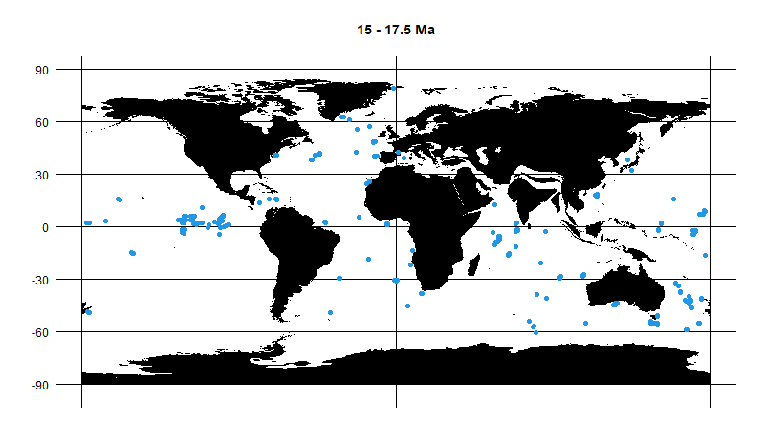
Fig. S1. Data from which to calculate LDGs for the 15–17.5 Ma time bin, reconstructed on palaeogeography. Maps were provided by the getmap function in the mapast R package v.0.1.¹. Maps for the other time bins are available in the supplementary data on Figshare: https://doi.org/10.6084/m9.figshare.21355467.

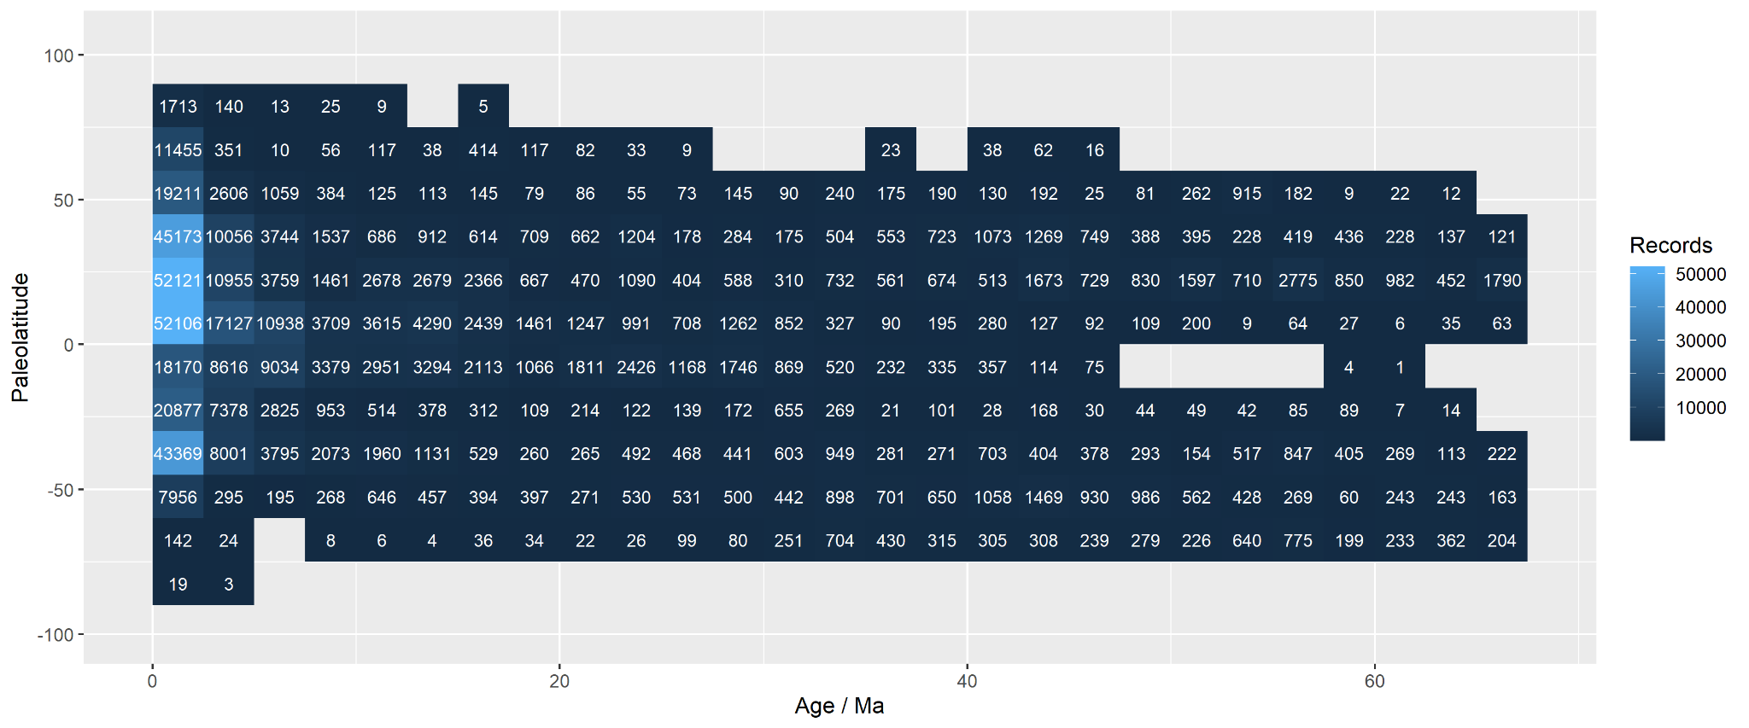
Fig. S2. The number of records (record = unique localities by time) contained within 2.5 Myr time bins and 15° latitude bins. Variation in the number of records by different latitude-by-age combinations can be found in the supplementary data on Figshare: https://doi.org/10.6084/m9.figshare.21355467.

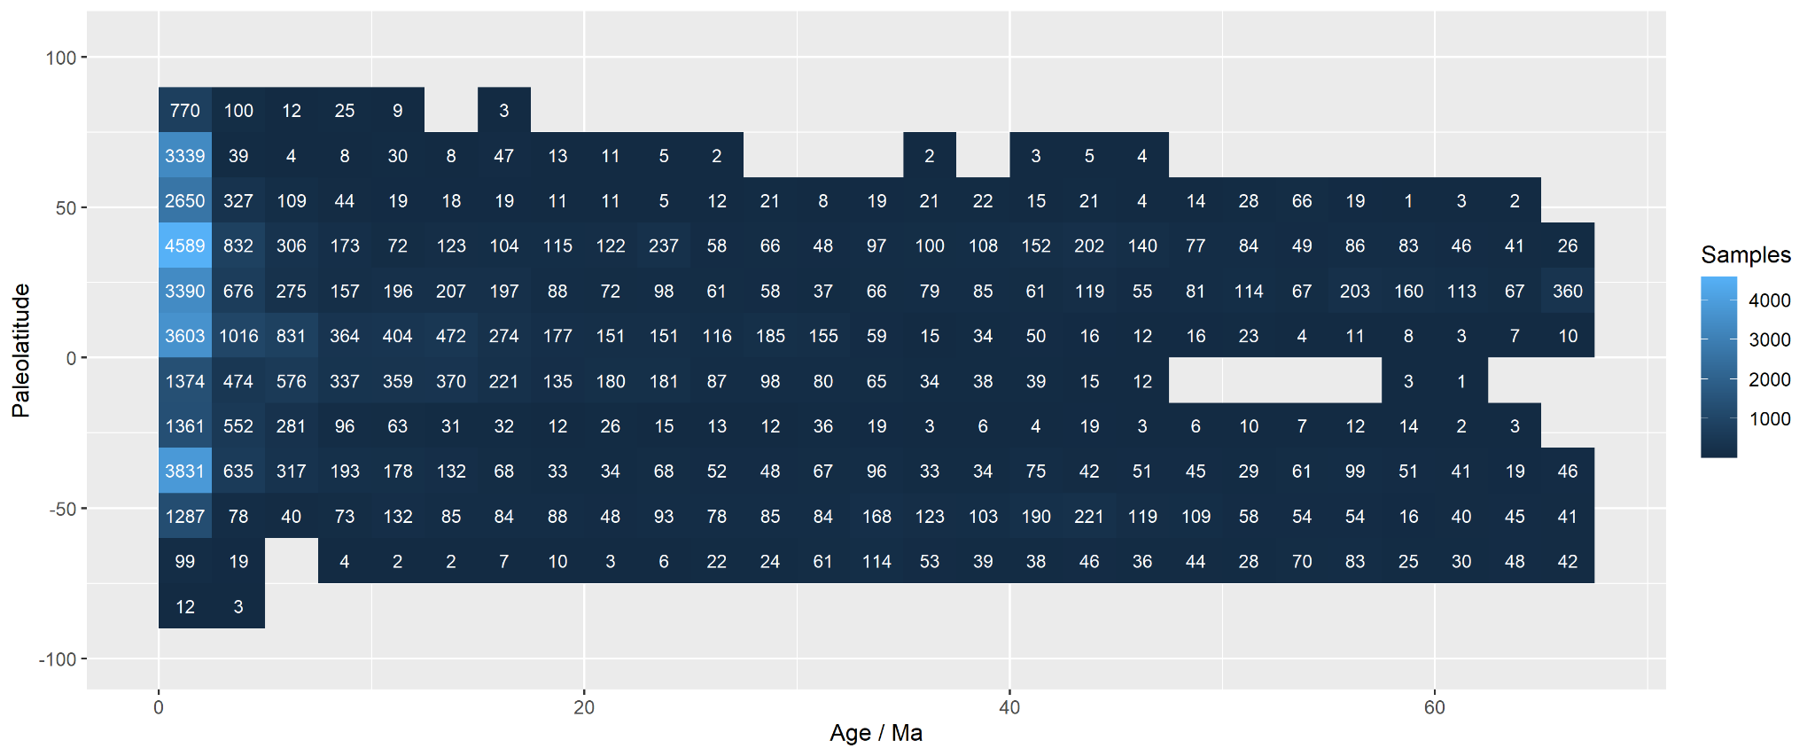
Fig. S3. The number of samples (samples = unique sites-by-ages) contained within 2.5 Myr time bins and 15° latitude bins. Variation in the number of samples by different latitude-by-age combinations can be found in the supplementary data on Figshare: https://doi.org/10.6084/m9.figshare.21355467.

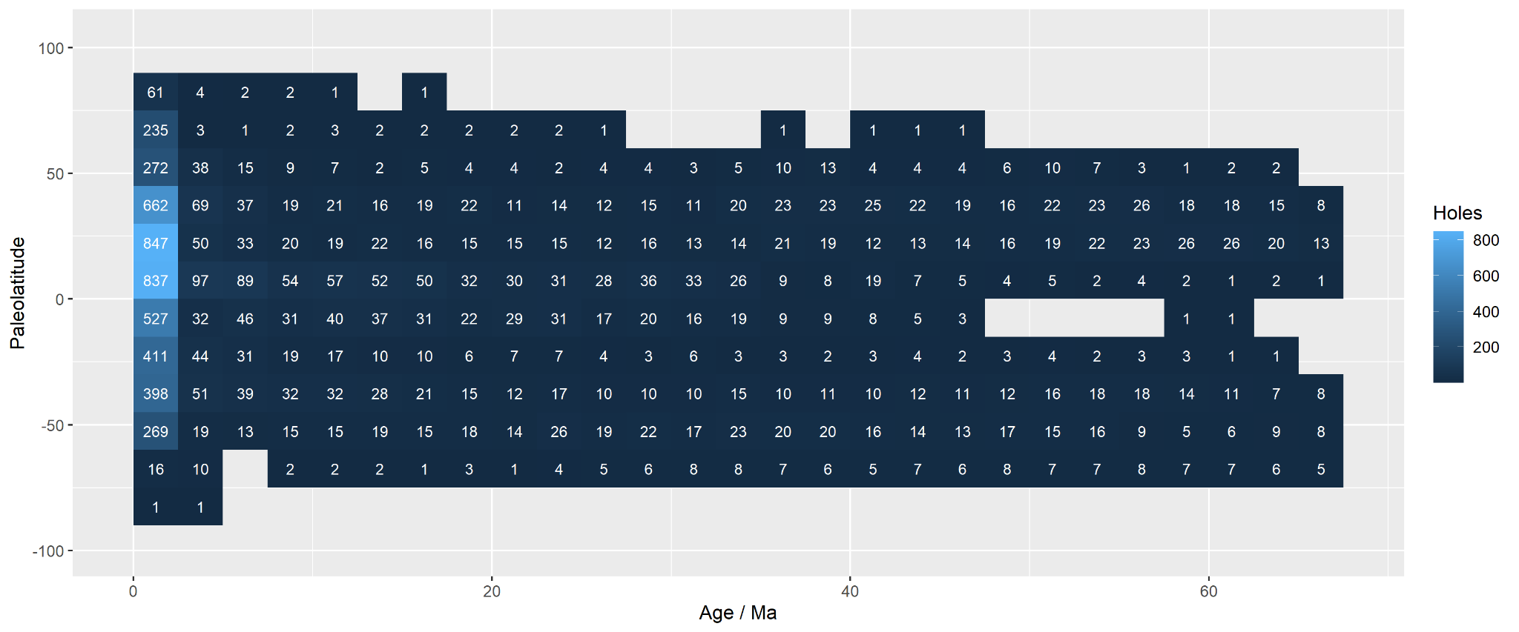
Fig. S4. The number of sites (i.e., unique localities) contained within 2.5 Myr time bins and 15° latitude bins. Variation in the number of sites by different latitude-by-age combinations can be found in the supplementary data on Figshare: https://doi.org/10.6084/m9.figshare.21355467.

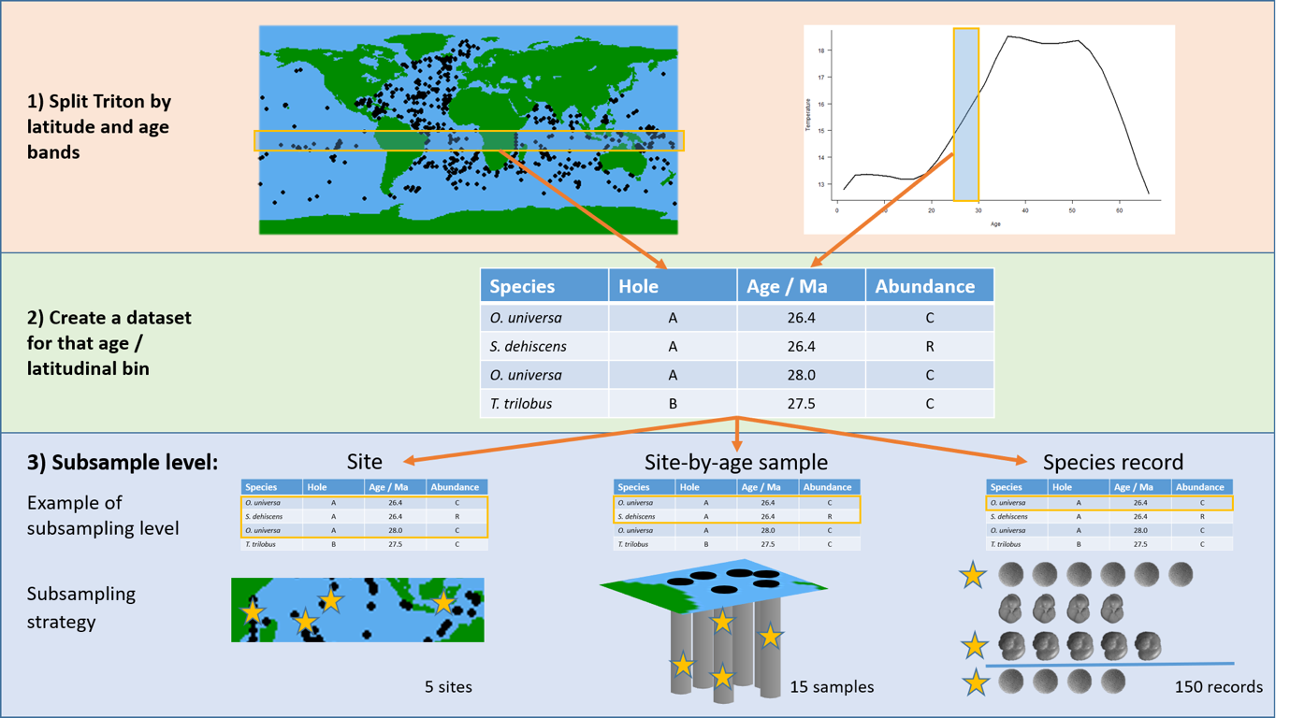
Fig. S5. LDGs were quantified using both point-level data and three subsampling approaches, which are detailed here: (i) by site, (ii) by sample, and (iii) by record. The ‘by site’ method divided the dataset based on locality (or site) and selected a set number of sites for a given latitude-by-age bin. The ‘by sample’ method divided the dataset based on both locality and age and selected a set number of unique site-by-age samples from a given latitude-by-age bin. The ‘by record’ method of subsampling divided the dataset based on locality, age, and species, and selected a set number of unique species records from any site or age within a given latitude-by-age bin. The maps derive from the ‘maps’ R package v.3.4.0.

Species richness by latitude

Constructing LDGs using point-level data
Fig. S6. Point-level richness data for the 0–2.5 Ma and 10–12.5 Ma time bins. Fitted curves show different percentile estimates based on latitudinal bins of 15°. Similar graphs for each time bin are available in the supplementary data on Figshare: https://doi.org/10.6084/m9.figshare.21355467.

Constructing LDGs using subsampling
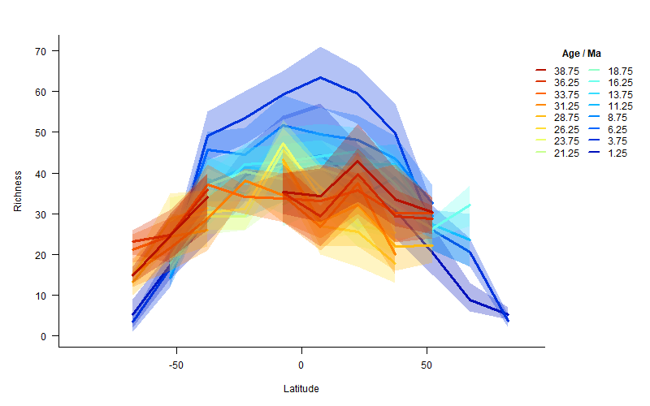
Fig. S7. LDGs constructed using the ‘by sample’ subsampling approach within 2.5 Myr and 15° latitude bins. Each subsampling iteration selected 15 samples. Dark lines represent the mean of 1000 iterations and shading the 95% confidence intervals. Gaps in LDGs for older time bins denote fewer than 15 samples for that latitude and time. Comparisons for different latitude-by-age combinations and subsampling intensities can be found in the supplementary data on Figshare: https://doi.org/10.6084/m9.figshare.21355467. Overall patterns were insensitive to methodological choice.

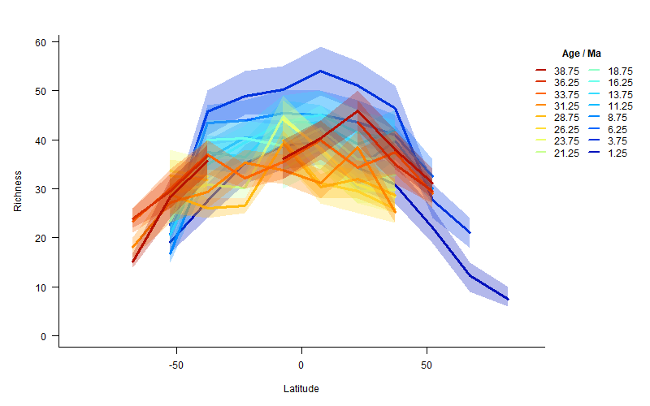
Fig. S8. LDGs constructed using the ‘by record’ subsampling approach in 2.5 Myr and 15° latitude bins. Each subsample iteration selected 150 records. Dark lines represent the mean of 1000 iterations and shading the 95% confidence intervals. Gaps in LDGs for older time bins denote fewer than 150 records at that latitude and time. Comparisons for different latitude-by-age combinations and subsampling intensities can be found in the supplementary data on Figshare: https://doi.org/10.6084/m9.figshare.21355467. Overall patterns were insensitive to methodological choice.

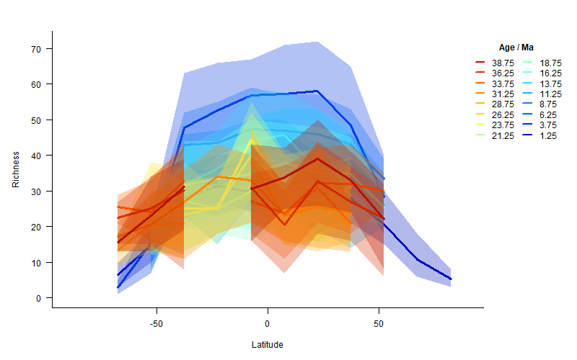
Fig. S9. LDGs constructed using the ‘by site’ subsampling approach in 2.5 Myr and 15° latitude bins. Each subsample iteration selected five sites. Dark lines represent the mean of 1000 iterations and shading the 95% confidence intervals. Gaps in LDGs for older time bins denote fewer than five sites at that latitude and time. Comparisons for different latitude-by-age combinations and subsampling intensities can be found in the supplementary data on Figshare: https://doi.org/10.6084/m9.figshare.21355467. Overall patterns were insensitive to methodological choice.

Comparison of LDG construction methods

Fig. S10. Comparison of LDGs constructed using different methods for 2.5 Myr and 15° latitude bins. Raw diversity represents the total number of species recorded in a latitude-by-age bin. Lines for site, sample, and record represent the mean subsampled LDG estimates using 5 sites, 15 samples, and 150 records, respectively, with associated 95% confidence intervals. Point-level LDGs for the 75th percentiles are shown. Point-level and subsampled LDGs show similar patterns, although subsampling tends to suggest higher richness. Higher richness in subsampled LDGs may reflect the influence of spatio-temporal averaging, which can inflate diversity estimates. Alternatively or additionally, incomplete sampling or dissolution might lower diversity in the point level estimates. Comparison plots for each time bin can be found in the supplementary data on Figshare: https://doi.org/10.6084/m9.figshare.21355467.

Quantifying LDG gradients

Point-level gradients

Fig. S11. Gradients estimated from linear models and associated data for the most recent 2.5 Ma time bin. Analyses used point-level richness estimates with a 75th percentile taken for sites that had multiple ages within a given time bin. Gradient estimates are shown for the Northern Hemisphere (black), Southern Hemisphere (red), and both hemispheres combined (dashed blue). Open gray circles indicate data outside 55° not used in the calculations (for consistency across time, since older time bins lacked high latitude data). We analyzed patterns for a range of percentiles (50th, 60th, 75th, and 90th) using both raw and rescaled diversity estimates, which can be found in the supplementary data on Figshare: https://doi.org/10.6084/m9.figshare.21355467. Patterns were consistent regardless of percentile choice or the use of raw or rescaled diversity.

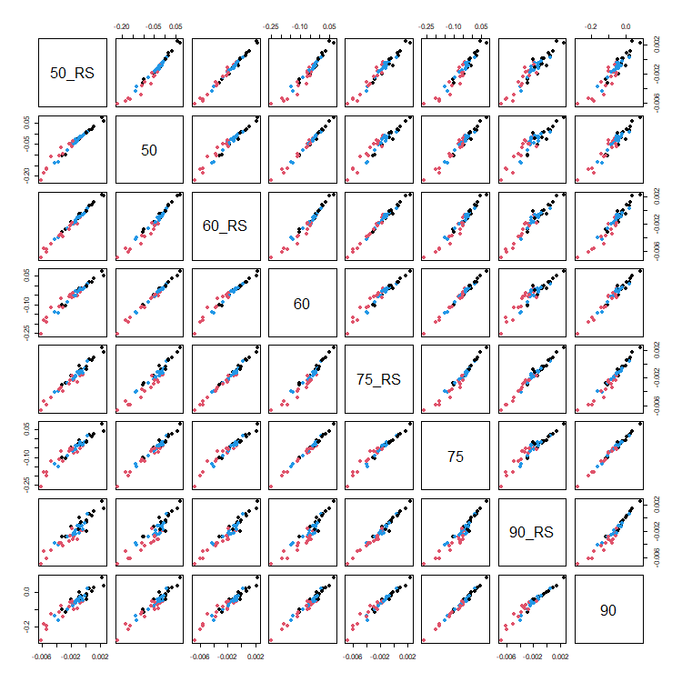
Fig. S12. The influence of percentile choice (50th, 60th, 75th, and 90th) on gradient estimates for point-level data. Black is the Northern Hemisphere, red is the Southern Hemisphere, and blue is both hemispheres combined. RS = rescaled diversity, where gradients were calculated for richness that was rescaled by setting the maximum diversity within a time bin to one. As can be seen, results were insensitive to percentile choice or rescaling.
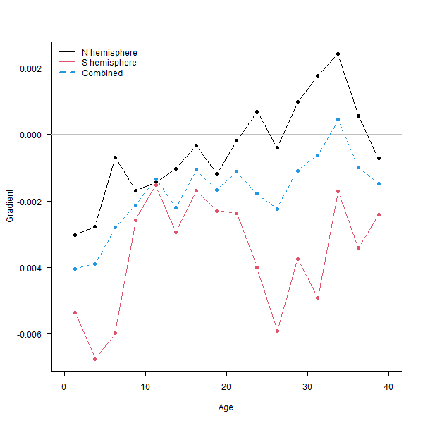
Fig. S13. LDG gradient estimates for rescaled richness using the point-level data, with the 75th percentile taken for sites that had multiple ages within a time bin. The gradient through time plot for rescaled richness show a similar pattern to raw richness, although peaks are less pronounced. Plots using other percentiles (50th, 60th, 75th, and 90th) to estimate richness, both raw and rescaled, can be found in the supplementary data on Figshare: https://doi.org/10.6084/m9.figshare.21355467.

Subsampled gradients
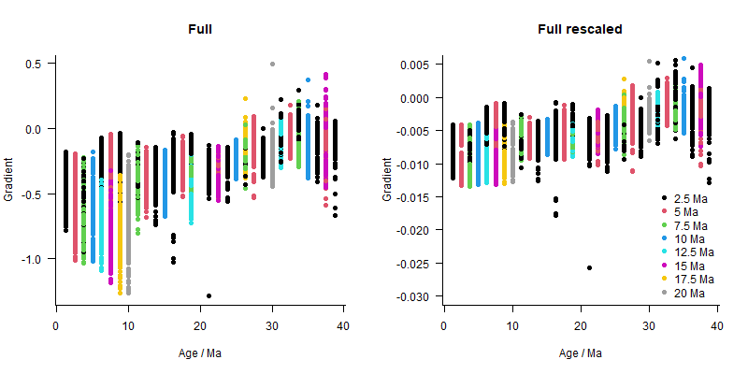
Fig. S14. The influence of time bin duration on LDG gradient estimates. Gradients are colored by the temporal duration of the time bin used to calculate richness (from 2.5–20 Ma, in 2.5 Myr increments). A single point represents the mean gradient derived from 300 subsampling iterations for a given latitude-by-age bin and sampling intensity. All three subsampling approaches are shown (‘by site’, ‘by sample’, and ‘by record’). The longer temporal bins tended to produce steeper gradient estimates, since broader age bins lead to more time averaging, exaggerating latitudinal differences. The rescaled panel show the gradients estimated from richness rescaled by setting the maximum diversity within a time bin to one.

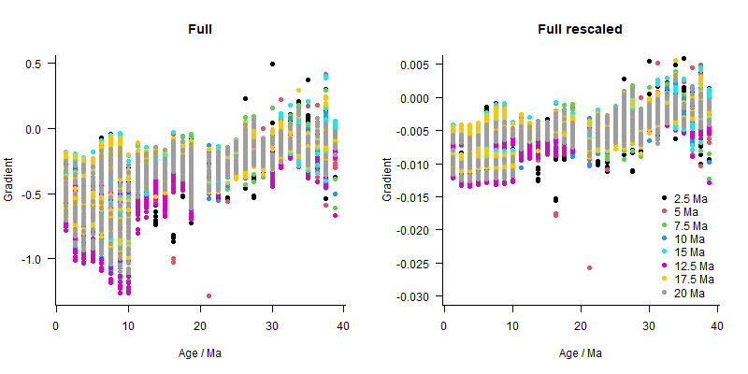
Fig. S15. The influence of latitudinal bin size on LDG gradient estimates. Gradients are colored by the latitudinal bin width used to calculate richness. A single point represents the mean gradient of 300 subsampling iterations for a given latitude-by-age bin and sampling intensity combination. All three subsampling approaches are shown (‘by site’, ‘by sample’, and ‘by record’). The rescaled panels show the gradients estimated for richness rescaled by setting the maximum diversity within a time bin to one.

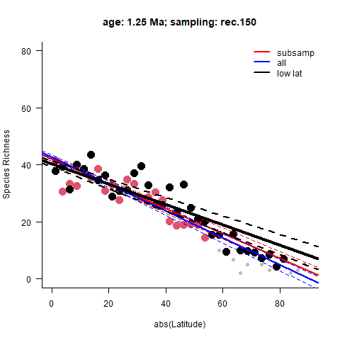

Fig. S16. The mean gradient for the most recent time bin (0–2.5 Ma) and mean estimated richness for each latitudinal bin (in this case 2.5°). Results are shown for the ‘by record’ subsampling approach, selecting 150 records for every latitude-by-age bin in each of 300 iterations. Points represent the mean richness for each latitude based on subsampling: black is the Northern Hemisphere, and red is the Southern Hemisphere. Gray points indicate a latitudinal bin that has fewer records than is required for a given subsampling intensity (i.e., 150 records in this plot). For these data-poor latitudinal bins, no variation in richness estimates is produced during subsampling. Lines represent the mean gradient (solid) and 95% confidence intervals (dashed). The red line (subsamp) shows the gradient when the data-deficient richness estimates (gray points) are excluded. The black line (low lat) shows the gradient based only on richness estimates calculated within 55° latitude and excluding estimates with insufficient records. The blue line (all) shows the gradient if latitudes with insufficient data are not excluded. For all latitude-by-age bin combinations and subsampling intensities, see the supplementary data on Figshare: https://doi.org/10.6084/m9.figshare.21355467. For most combinations, the Northern and Southern Hemispheres exhibit similar patterns.

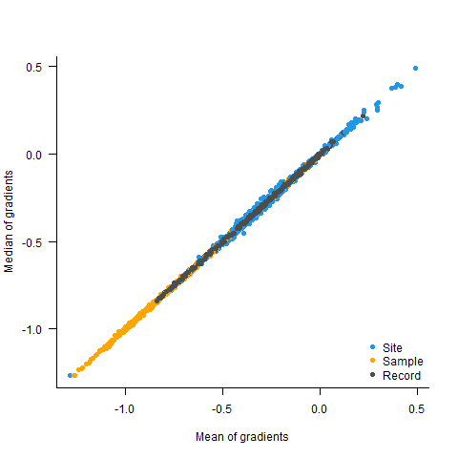
Fig. S17. Gradient estimates are insensitive to use of mean or median as the central tendency. We performed subsampling for each latitudinal-by-age bin to estimate richness, from which we calculated a gradient. This process was iterated 1000 times, such that 1000 gradients were obtained for every time bin. We summarised these gradients using either the mean or median of the 1000 estimates. Three subsampling approaches were used: ‘by site’ (blue), ‘by sample’ (orange), and ‘by record’ (gray). Results were insensitive to methodological choice.

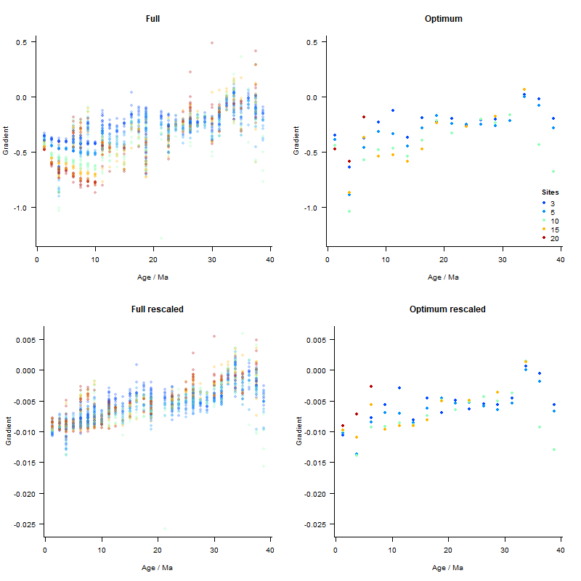
Fig. S18. The influence of subsampling intensity on gradient estimates for the ‘by site’ approach. Selecting more sites for each subsampling iteration tended to produce steeper gradients on the raw richness scale. However, rescaling richness removed most of this signal. The ‘optimum’ shows the influence of subsampling intensity on the optimal 15° latitude and 2.5 Myr age bins.

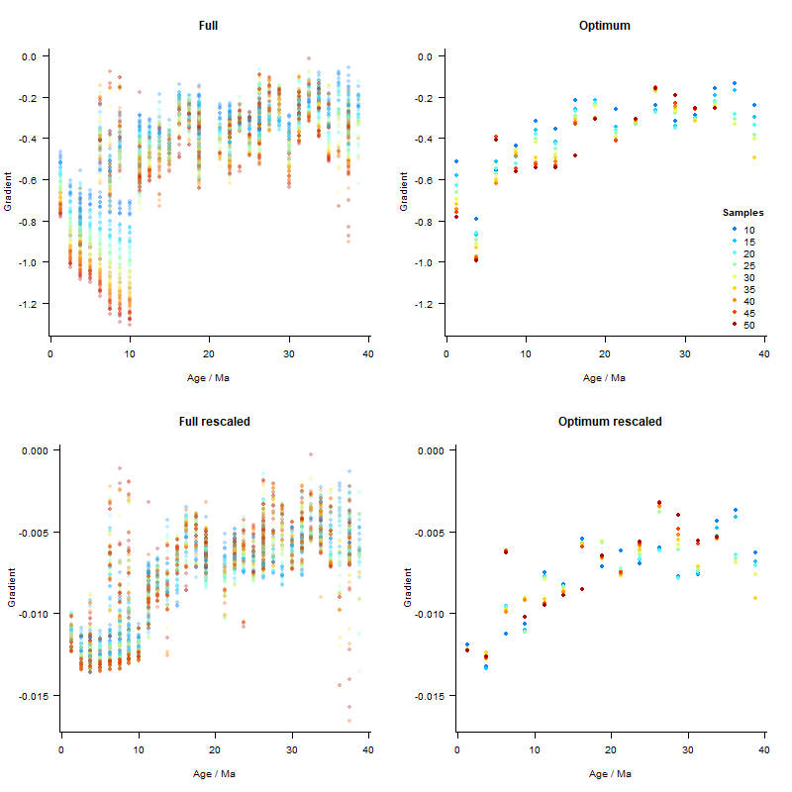
Fig. S19. The influence of subsampling intensity on gradient estimates for the ‘by sample’ approach. Larger numbers of selected samples for each subsampling iteration tended to produce steeper gradients on the raw richness scale. However, rescaling richness removed most of this signal. The ‘optimum’ intensity shows the influence of subsampling intensity on the optimal 15° latitude and 2.5 Myr age bins.
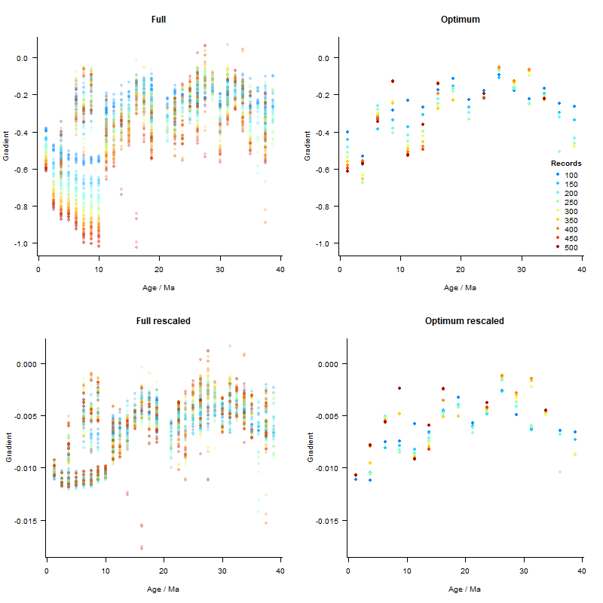
Fig. S20. The influence of subsampling intensity on gradient estimates for the ‘by record’ approach. Larger numbers of selected records for each subsampling iteration tended to produce steeper gradients on the raw richness scale. However, rescaling richness removed most of this signal. The ‘optimum’ intensity shows the influence of subsampling intensity on the optimal 15° latitude and 2.5 Myr age bins.
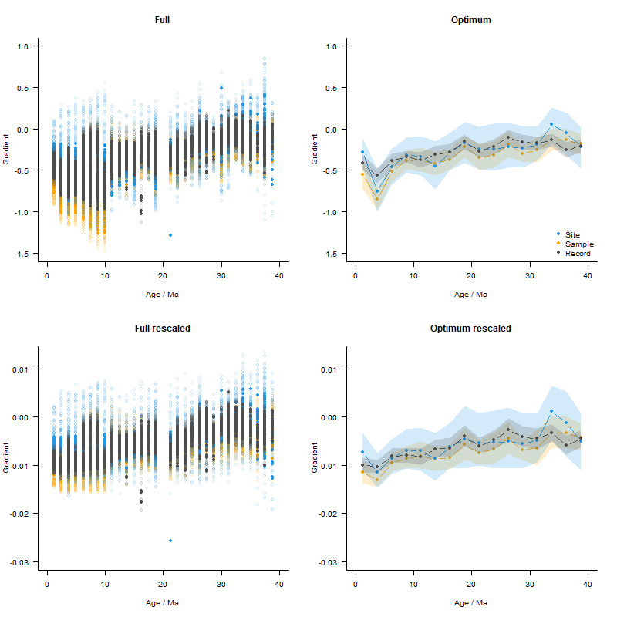
Fig. S21. The gradient estimates for different latitude-by-age bin combinations and subsampling intensities. The three colours indicate whether subsampling was done ‘by site’, ‘by sample’, or ‘by record’. Filled circles show the mean values for that bin combination, open circles are the individual subsampling iterations. The ‘optimal’ shows the gradient estimates using the selected subsampling levels of 150 records, 15 samples, and five sites for the 2.5 Myr and 15° latitude bins. The lines represent the mean and the shading the 95% confidence intervals on the optimal graphs.

Comparison of gradients using point-level and subsampled data
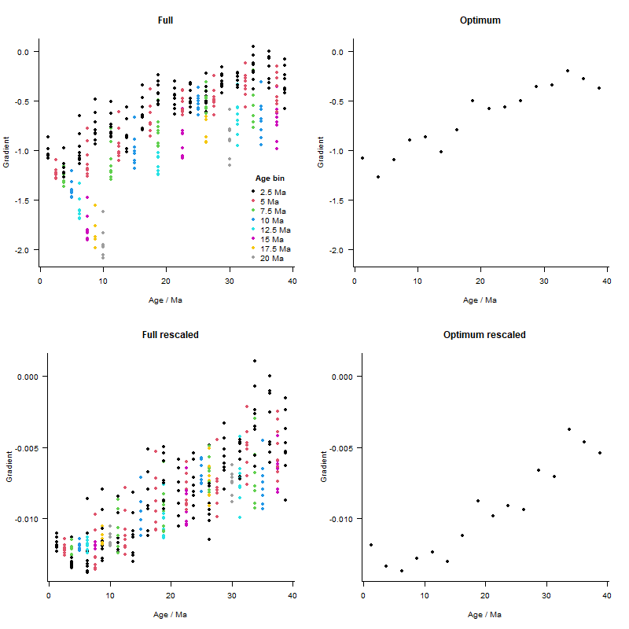
Fig. S22. Gradients estimated directly from the count of unique species for a latitude-by-age bin. The raw gradient estimates show a steepening over the last 40 Myr, with a moderate influence of time bin duration, which is removed using rescaled data. The ‘optimum’ shows 15° latitude and 2.5 Myr time bins. The rescaled panels show gradients estimated from richness that was rescaled by setting the maximum diversity within a time bin to one.

Fig. S23. Comparison of gradients estimated through time using different LDG construction methods for raw (above) and rescaled (below) richness. The gradients from subsampling relied on selecting 5 sites, 15 samples, or 150 records. The line represents the mean and the shading the 95% confidence intervals from subsampling. Point-level gradients used richness estimates from the 75th percentile. The pattern of gradient change over time was similar, regardless of methodological choice, although the steepness of the gradients varied.

Fig. S24. Comparison of LDG gradient estimates from different methods. Gradient estimates are colored by age, with red being older and blue younger. Results are shown on both the original richness scale (left) and with rescaled richness scale (right). Gradient estimates are similar regardless of methodological protocol.

Identifying LDG drivers through time

Climate model dataset

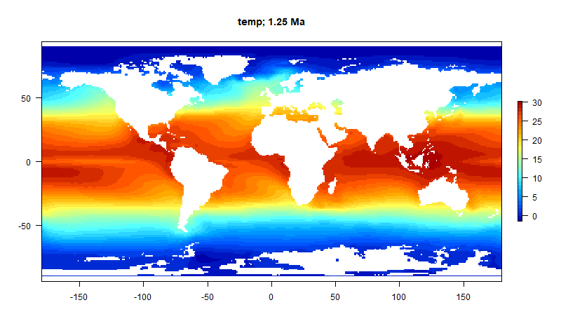
Fig. S25. Annual mean surface (5 m) temperature (°C) at 2.5 Ma from the HadCM3L atmosphere-ocean generalized circulation model ². Maps of the environmental variables at 2.5 Myr intervals can be found in the supplementary data on Figshare: https://doi.org/10.6084/m9.figshare.21355467.

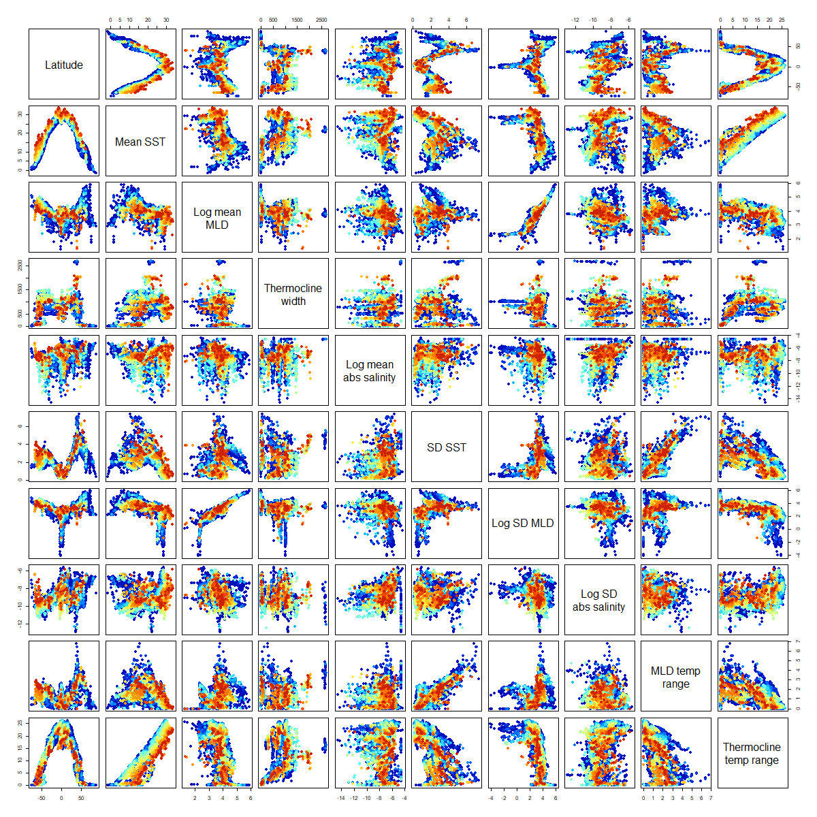
Fig. S26. Relationship between the environmental variables and paleolatitude. Colors indicate the age of the estimate, with red being older and blue younger. Environmental variables include mean sea surface temperature, log of mean annual mixed layer depth, thermocline width, log of mean annual salinity, seasonality of sea surface temperature, log of seasonality in salinity, log of seasonality of the mixed layer depth, temperature range of the mixed layer, and thermocline temperature range.

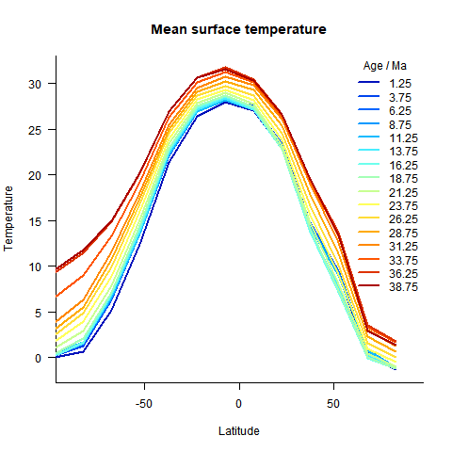
Fig. S27. Mean sea surface temperature by latitude and by age from the HadCM3 AOGCM models.

Identifying LDG drivers within time intervals

Sensitivity analyses for within-age-bin models
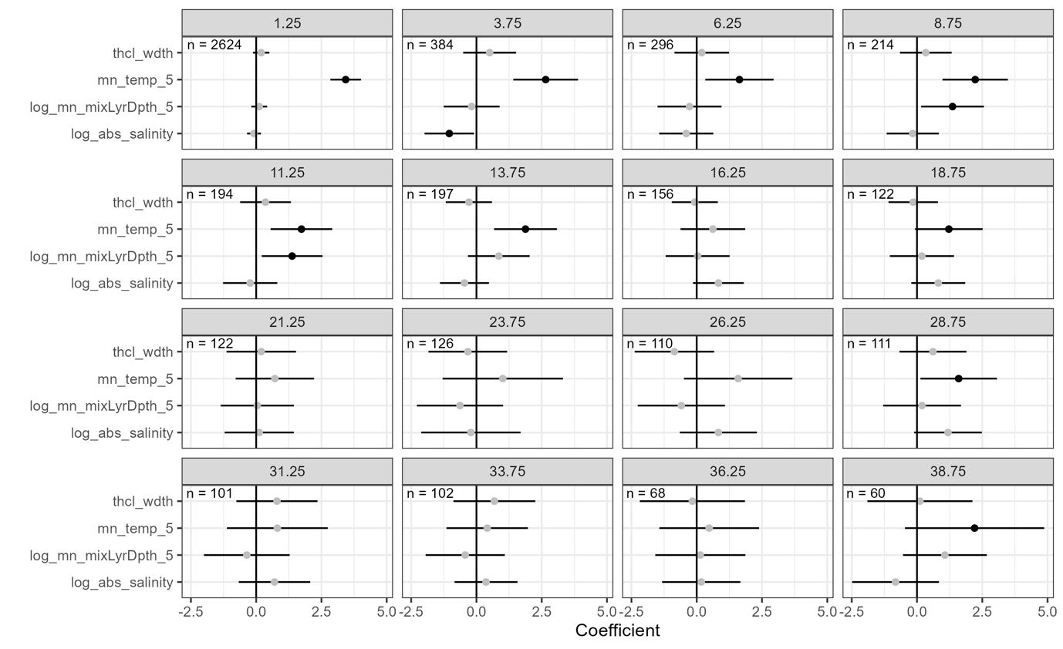Fig. S28. Spatial autoregressive model coefficients when including all latitudinal values, rather than restricting analyses to within 55° latitude. Models were run with the following four environmental predictors: width of the thermocline (thcl_wdth), mean annual sea surface temperature (mn_temp_5), log of the mean annual mixed layer depth (log_mn_mixLyrDpth_5), and log of mean annual salinity (log_abs_salinity). Coefficients are black if significant at an α of 0.05 using the Bejamini & Hochberg (BH) correction for multiple comparisons. Results were consistent with those from models using latitudinally restricted data (i.e., within 55° latitude). Error bars represent 95% confidence intervals around the model coefficient estimates.

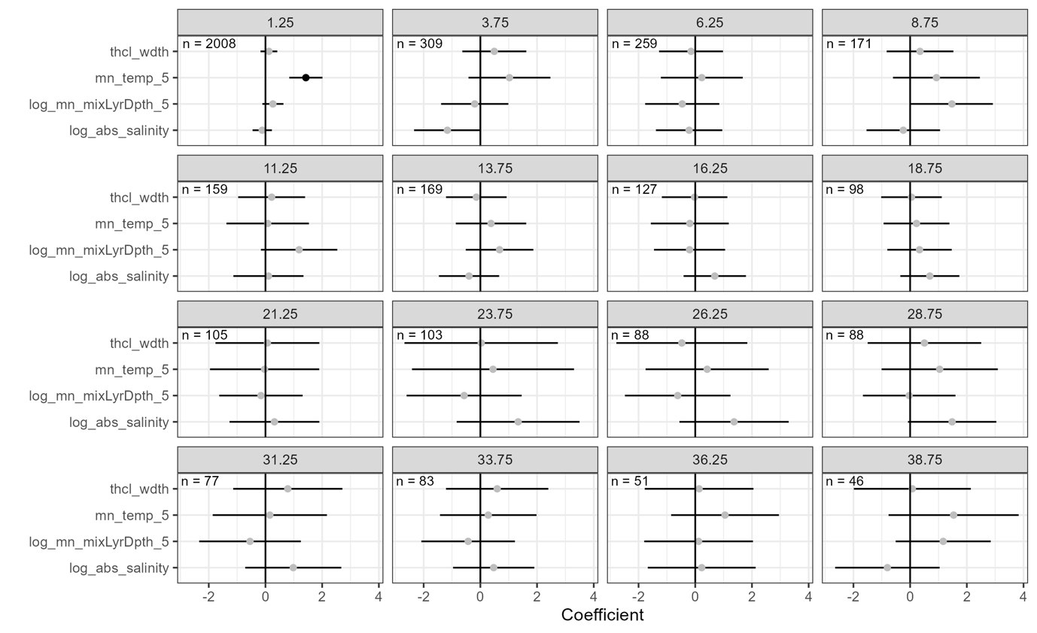
Fig. S29. Spatial autoregressive model coefficients when the temperature range was limited in each time bin. Four environmental predictors were tested: width of the thermocline (thcl_wdth), mean annual sea surface temperature (mn_temp_5), log of the mean annual mixed layer depth (log_mn_mixLyrDpth_5), and log of mean annual salinity (log_abs_salinity). Coefficients are black if significant at an α of 0.05 using the Bejamini & Hochberg (BH) correction for multiple comparisons. Error bars represent 95% confidence intervals around the model coefficient estimates.

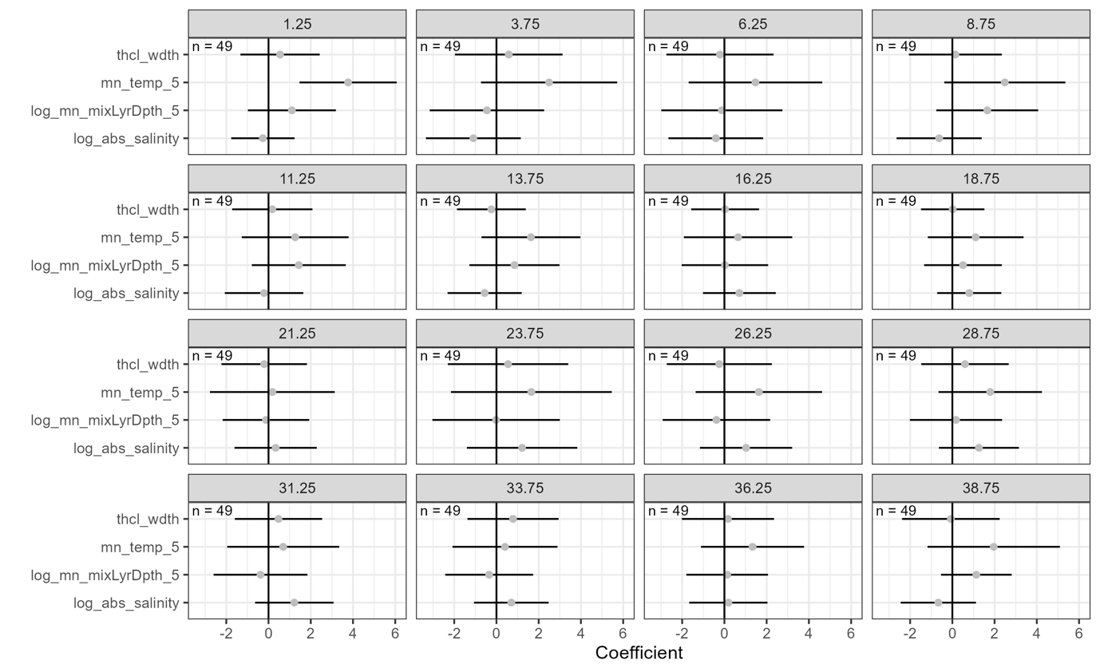
Fig. S30. Spatial autoregressive model coefficients using the same number of data points for all time periods (n=49, for 40 Ma). Four environmental predictors were tested: width of the thermocline (thcl_wdth), mean annual sea surface temperature (mn_temp_5), log of the mean annual mixed layer depth (log_mn_mixLyrDpth_5), and log of mean annual salinity (log_abs_salinity). Coefficients are black if significant at an α of 0.05 using the Bejamini & Hochberg (BH) correction for multiple comparisons. The relationship between temperature and richness is dampened but still present for more recent time bins. Error bars represent 95% confidence intervals around the model coefficient estimates.

Fig. S31. LDGs for the two most recent time bins (0–2.5 Ma and 2.5–5 Ma) constructed using limited data. For each time bin, data were subsampled down to the number of points in the most data-poor time bin (n=49, for 40 Ma) and a loess function fitted to species richness and latitude. Species richness was predicted from this loess smooth for latitudes within 55°. We repeated the process 100 times for each time bin. LDG patterns were insensitive to sample size. Even with reduced data, we were able to replicate the modern-day LDG with a dip near the equator.

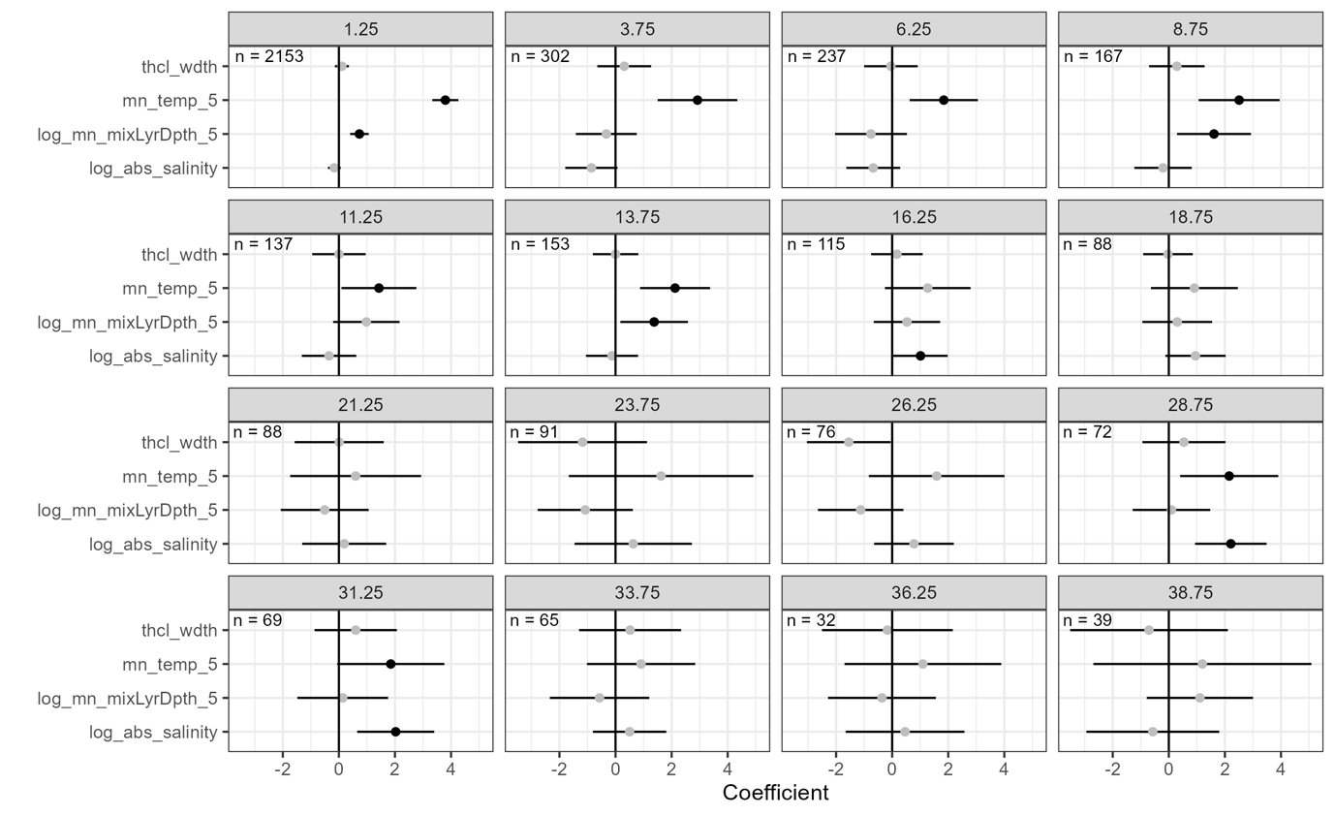
Fig. S32. Spatial autoregressive model results when excluding data that was likely subject to dissolution. Four environmental predictors were tested: width of the thermocline (thcl_wdth), mean annual sea surface temperature (mn_temp_5), log of the mean annual mixed layer depth (log_mn_mixLyrDpth_5), and log of mean annual salinity (log_abs_salinity). Coefficients are black if significant at an α of 0.05 using the Bejamini & Hochberg (BH) correction for multiple comparisons. Error bars represent 95% confidence intervals around the model coefficient estimates.

Univariate models for within time intervals

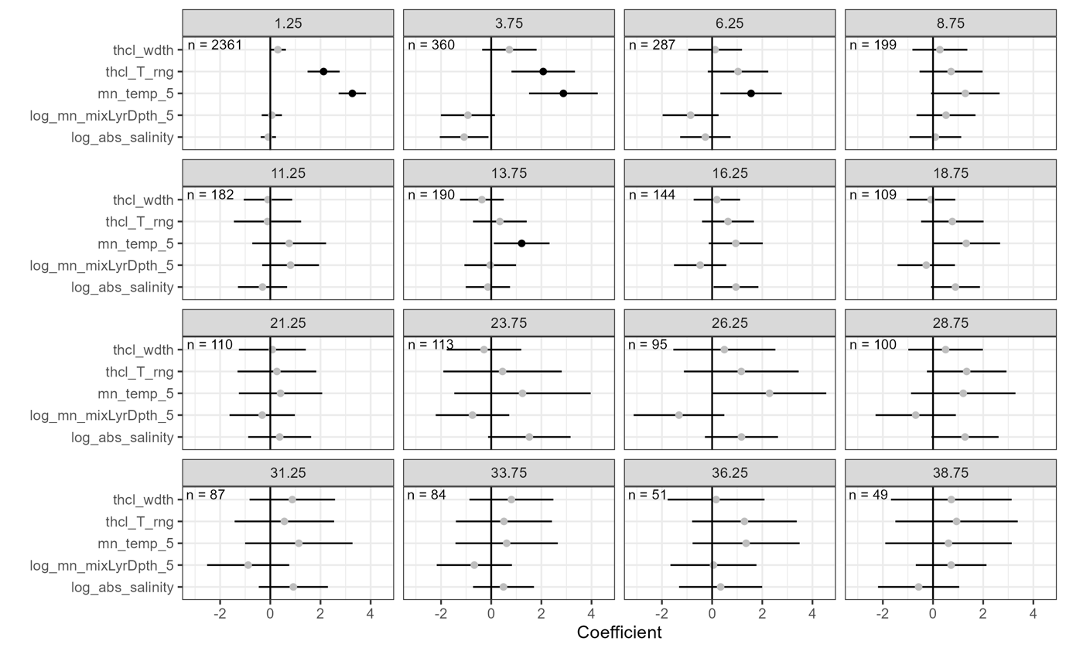
Fig. S33. Spatial autoregressive model coefficients for univariate models that included only one environmental predictor for each time bin. Five environmental predictors were tested: width of the thermocline (thcl_wdth), thermocline temperature range (thcl_T_rng), mean annual sea surface temperature (mn_temp_5), log of the mean annual mixed layer depth (log_mn_mixLyrDpth_5), and log of mean annual salinity (log_abs_salinity). We could not include thermocline temperature range for the multivariate model because it was highly correlated with mean annual sea surface temperature. Coefficients are black if significant at an α of 0.05 using the Bejamini & Hochberg (BH) correction for multiple comparisons. Error bars represent 95% confidence intervals around the model coefficient estimates.

The effect of ocean area on species richness
Fig. S34. The relationship between open ocean area and species richness within 15° latitude and 2.5 Myr time bins. Top plot: colors indicate the age of the sample. Bottom plot: coefficients from a model of species richness as a function of open ocean area for each time bin. No model is significant at an α of 0.05 using the Bejamini & Hochberg (BH) correction for multiple comparisons. Error bars represent 95% confidence intervals around the model coefficient estimates.

Identifying LDG drivers through time

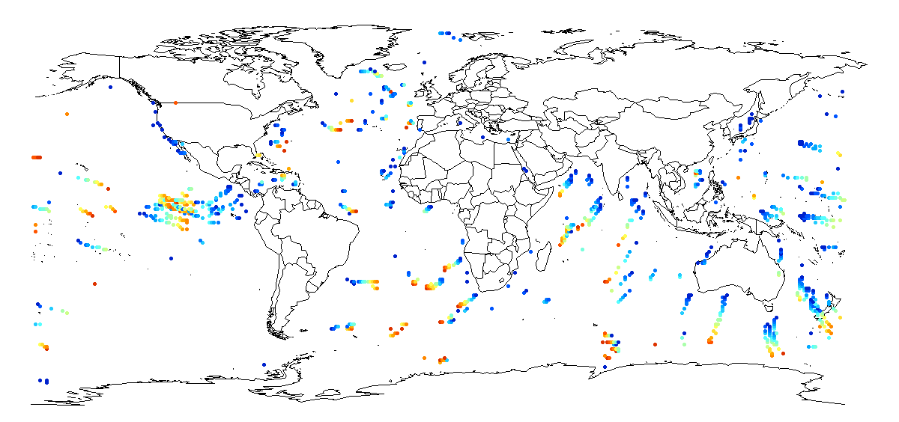
Fig. S35. Data used to examine whether change in environment correlates with change in species richness using 2.5 Myr age gaps for the full latitudinal extent. Colors indicate the starting age of the sample, with red being older and blue younger. Maps for other age gaps (from 2.5 Myr to 12.5 Myr, in 2.5 Myr steps) are provided in the supplementary data on Figshare: https://doi.org/10.6084/m9.figshare.21355467. The maps derive from the ‘maps’ R package v.3.4.0.

Fig. S36. The relationship between change in environment and change in species richness using a 2.5 Myr age gap. Data were limited to within 55° latitude. Each point represents the change between the time intervals for species richness, mean annual sea surface temperature, log of the mean annual mixed layer depth, log of mean annual salinity, width of the thermocline, and thermocline temperature range. Red points indicate older time bins and blue points younger time bins. Similar plots for the range of temporal gaps considered (2.5–12.5 Myr) and including higher latitudes are available in the supplementary data on Figshare: https://doi.org/10.6084/m9.figshare.21355467.

Speciation, extinction, and dispersal dynamics
Fig. S37. Speciation, extinction, extirpation, and dispersal dynamics for planktonic foraminifera over the last 40 Myr. The division between temperate and tropical regions was defined as 30° for all time periods. Data show results for the approach including all site-by-age records across latitudes (i.e., including data from outside of 55° latitude as well as within). Extinction includes a ‘both’ category, because the last occurrence for one species in our dataset occurs at exactly the same age in both tropical and temperate regions.

Fig. S38. Speciation, extinction, extirpation, and dispersal dynamics for planktonic foraminifera over the last 40 Myr. The division between temperate and tropical regions was defined as 30° for all time periods. Data show results for the approach excluding any species present in both temperate and tropical regions within a given 2.5 Myr time bin.

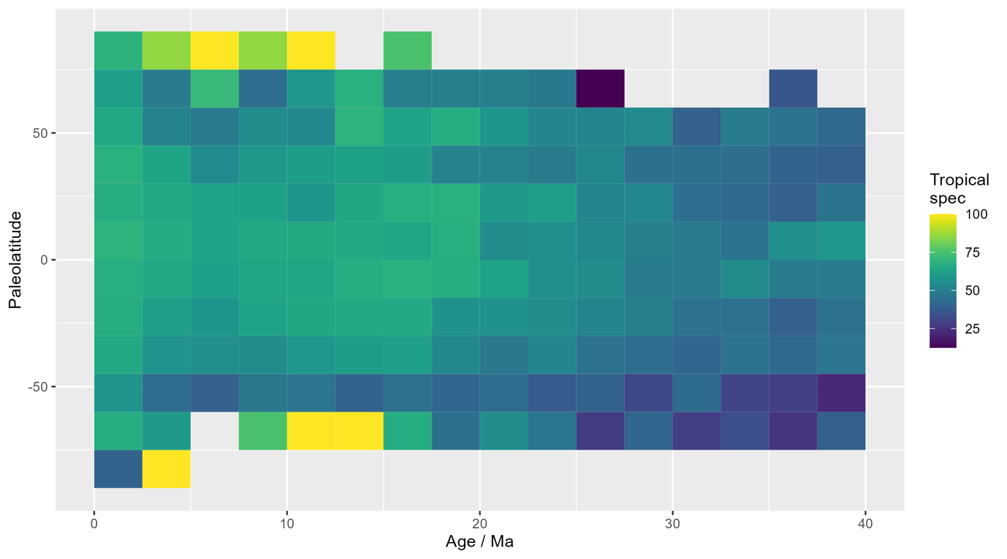
Fig. S39. The percentage of species that result from tropical speciation within each latitude-by-age bin. We used 30° latitude to define the division between high and low latitude regions. Data are based on the approach that used all site-by-age records, including from outside of 55° latitude.

Fig. S40. Per-capita rates of speciation, extinction, extirpation, and dispersal for planktonic foraminifera over the last 40 Myr. The division between temperate and tropical regions was defined as 30° for all time periods. Data show results for the approach including all site-by-age records across latitudes (i.e., including data from outside of 55° latitude as well as within).

Fig. S41. Bootstrapped speciation, extinction, extirpation, and dispersal dynamics for planktonic foraminifera over the last 40 Myr. 75% of occurrences for each species across its lifetime were selected in each of 100 bootstrap replicates, from which speciation, extinction, extirpation, and dispersal were calculated. The division between temperate and tropical regions was defined as 30° for all time periods. Data show results for the approach including all site-by-age records across latitudes (i.e., including data from outside of 55° latitude as well as within).

Fig. S42. Bootstrapped speciation, extinction, extirpation, and dispersal dynamics for planktonic foraminifera over the last 40 Myr. 75% of occurrences for each species across its lifetime were selected in each of 100 bootstrap replicates, from which speciation, extinction, extirpation, and dispersal were calculated. The division between temperate and tropical regions was defined as 30° for all time periods. Data show results for the approach excluding any species present in both temperate and tropical regions within a given 2.5 Myr time bin.

Fig. S43. Bootstrapped per-capita rates of speciation, extinction, extirpation, and dispersal for planktonic foraminifera over the last 40 Myr. 75% of the occurrences for each species across its lifetime were selected in each of 100 bootstrap replicates, from which speciation, extinction, extirpation, and dispersal were calculated. The division between temperate and tropical regions was defined as 30° for all time periods. Data show results for the approach including all site-by-age records across latitudes (i.e., including data from outside of 55° latitude as well as within).

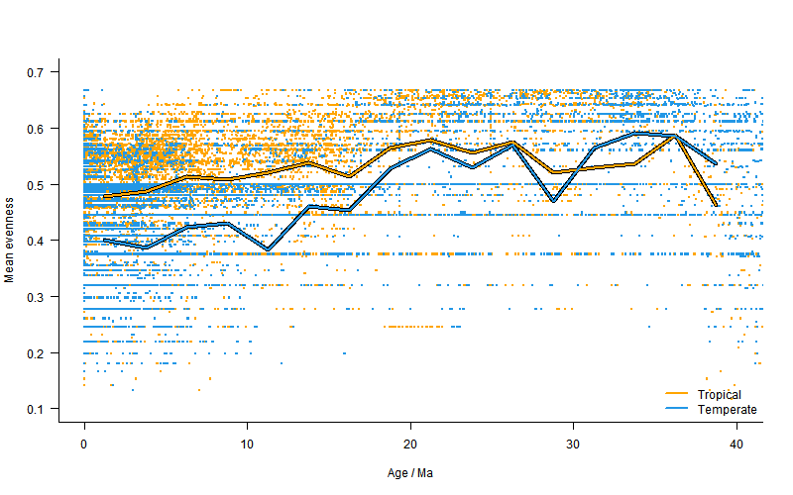
Fig. S44. Mean evenness (lines) using Simpson’s index, superimposed on the evenness value for each sample (i.e., unique site by age) represented by the dots. Each sample is coloured by low (orange) versus high (blue) latitudes using 30° latitude as the threshold.

TABLES

Table S1. Estimated gradients for the Northern and Southern Hemispheres using both separate models and a combined model for both hemispheres. Richness estimates were derived from point-level data using the 75th percentile for sites with multiple ages within a given time bin. Analyses were restricted to within 55° latitude. Models with ΔAICc > 4 are considered to have less support ³. For most time periods, AICc suggests a model combining the hemispheres (i.e., using absolute latitude) is preferred over a model with separate gradients for hemispheres. Bold values indicate the best supported model based on AICc.

Age (Ma) | Gradient Combined | Gradient N Hem | Gradient S Hem | AICc Combined model | AICc Seperate model | ΔAICc | Optimal model
1.250 | -0.137 | -0.103 | -0.182 | 24299.77 | 24238.70 | -61.07 | Sep
3.750 | -0.152 | -0.108 | -0.263 | 2443.84 | 2439.29 | -4.55 | Sep
6.250 | -0.094 | -0.023 | -0.200 | 1749.19 | 1741.81 | -7.37 | Sep
8.750 | -0.059 | -0.047 | -0.071 | 1080.20 | 1084.23 | 4.03 | Comb
11.250 | -0.035 | -0.038 | -0.039 | 1029.69 | 1033.66 | 3.97 | Comb
13.750 | -0.051 | -0.024 | -0.068 | 955.80 | 959.36 | 3.56 | Comb
16.250 | -0.033 | -0.010 | -0.053 | 829.71 | 833.17 | 3.46 | Comb
18.750 | -0.037 | -0.026 | -0.051 | 626.40 | 630.45 | 4.05 | Comb
21.250 | -0.037 | -0.006 | -0.078 | 614.23 | 616.03 | 1.80 | Comb
23.750 | -0.055 | 0.021 | -0.124 | 718.20 | 716.36 | -1.83 | Comb
26.250 | -0.069 | -0.012 | -0.182 | 582.06 | 571.78 | -10.28 | Sep
28.750 | -0.033 | 0.029 | -0.112 | 662.41 | 659.63 | -2.78 | Comb
31.250 | -0.015 | 0.043 | -0.120 | 573.16 | 565.77 | -7.40 | Sep
33.750 | 0.015 | 0.080 | -0.057 | 663.54 | 663.67 | 0.13 | Comb
36.250 | -0.020 | 0.011 | -0.068 | 521.63 | 522.57 | 0.95 | Comb
38.750 | -0.032 | -0.016 | -0.053 | 523.20 | 526.20 | 3.00 | Comb

Table S2. AICc comparisons between a polynomial and a linear model using point-level data. To test for bimodality, we fit both linear and second order polynomial models for absolute latitudes ≤ 55°. Bold values indicate the optimal model based on AICc. Similar analyses were not possible for subsampled LDGs because of the limited number of latitudinal points within each age bin.

Age (Ma) | AICc polynomial | AICc linear model | Optimal model
1.25 | 23593.10 | 24299.77 | poly
3.75 | 2441.31 | 2443.84 | lm
6.25 | 1749.80 | 1749.19 | lm
8.75 | 1081.36 | 1080.20 | lm
11.25 | 1030.55 | 1029.69 | lm
13.75 | 956.52 | 955.80 | lm
16.25 | 831.69 | 829.71 | lm
18.75 | 628.55 | 626.40 | lm
21.25 | 613.26 | 614.23 | lm
23.75 | 720.32 | 718.20 | lm
26.25 | 584.24 | 582.06 | lm
28.75 | 663.54 | 662.41 | lm
31.25 | 574.71 | 573.16 | lm
33.75 | 662.33 | 663.54 | lm
36.25 | 523.82 | 521.63 | lm
38.75 | 522.30 | 523.20 | lm

Table S3. Results for the linear models examining the degree to which change in environment drives change in richness at given sites, including all four environmental predictors. Analyses were run both with and without data from ≥ 55° latitude. P-values are bold if significant at an α of 0.05 using the Bejamini & Hochberg (BH) correction for multiple comparisons.

Temporal gap (Myr) used for differencing |  | 2.5 | 5 | 7.5 | 10 | 12.5
Analyses within 55° latitude only
N of points |  | 1144 | 861 | 650 | 520 | 394
VIFs | Mean annual SST | 1.01 | 1.01 | 1.04 | 1.04 | 1.08
VIFs | Mean annual MLD | 1.02 | 1.02 | 1.02 | 1.04 | 1.06
VIFs | Mean annual salinity | 1.01 | 1.03 | 1.05 | 1.06 | 1.08
VIFs | Thermocline width | 1.00 | 1.03 | 1.03 | 1.03 | 1.06
Model coefficient | Mean annual SST | 0.47 | 0.51 | 0.47 | 0.47 | 0.56
Model coefficient | Mean annual MLD | -1.05 | -0.65 | -1.00 | -1.10 | -1.70
Model coefficient | Mean annual salinity | 0.04 | -0.11 | 0.00 | -0.03 | 0.16
Model coefficient | Thermocline width | 0.00 | 0.00 | 0.00 | 0.00 | 0.00
P-value (BH corrected) | Mean annual SST | 0.00 | 0.00 | 0.00 | 0.00 | 0.00
P-value (BH corrected) | Mean annual MLD | 0.06 | 0.21 | 0.06 | 0.06 | 0.02
P-value (BH corrected) | Mean annual salinity | 0.97 | 0.83 | 0.97 | 0.97 | 0.83
P-value (BH corrected) | Thermocline width | 0.75 | 0.66 | 0.27 | 0.66 | 0.05
R² |  | 0.01 | 0.02 | 0.03 | 0.03 | 0.06
Analyses including all latitudinal data
N of points |  | 1269 | 960 | 734 | 597 | 456
VIFs | Mean annual SST | 1.01 | 1.00 | 1.01 | 1.01 | 1.03
VIFs | Mean annual MLD | 1.02 | 1.02 | 1.01 | 1.02 | 1.03
VIFs | Mean annual salinity | 1.00 | 1.01 | 1.01 | 1.02 | 1.03
VIFs | Thermocline width | 1.00 | 1.02 | 1.02 | 1.02 | 1.03
Model coefficient | Mean annual SST | 0.41 | 0.44 | 0.40 | 0.42 | 0.51
Model coefficient | Mean annual MLD | -1.00 | -0.58 | -0.72 | -0.85 | -1.51
Model coefficient | Mean annual salinity | 0.05 | -0.09 | -0.01 | -0.06 | 0.10
Model coefficient | Thermocline width | 0.00 | 0.00 | 0.00 | 0.00 | 0.00
P-value (BH corrected) | Mean annual SST | 0.00 | 0.00 | 0.00 | 0.00 | 0.00
P-value (BH corrected) | Mean annual MLD | 0.08 | 0.22 | 0.14 | 0.12 | 0.02
P-value (BH corrected) | Mean annual salinity | 0.82 | 0.82 | 0.95 | 0.82 | 0.82
P-value (BH corrected) | Thermocline width | 0.74 | 0.74 | 0.48 | 0.74 | 0.07
R² |  | 0.01 | 0.02 | 0.02 | 0.03 | 0.07

Table S4. Results for the linear models examining the degree to which change in environment drives change in richness at given sites for each environmental predictor individually (i.e., univariate models). Models were run including only one predictor for each temporal gap, both including and excluding data outside of 55° latitude. P-values are bolded if significant at an α of 0.05 using the Bejamini & Hochberg (BH) correction for multiple comparisons.

Temporal age gap (Myr) |  | SST |  | MLD |  | Salinity |  | Thermocline width |  | Thermocline temp range
 |  | All lat | 55° lat | All lat | 55° lat | All lat | 55° lat | All lat | 55° lat | All lat | 55° lat
2.5 | Coeff | 0.380 | 0.445 | -0.845 | -0.892 | 0.052 | 0.043 | 0.000 | 0.000 | 0.051 | 0.050
2.5 | P-value | 0.005 | 0.007 | 0.165 | 0.104 | 0.885 | 0.922 | 0.811 | 0.828 | 0.782 | 0.586
5 | Coeff | 0.428 | 0.481 | -0.480 | -0.601 | -0.081 | -0.081 | 0.000 | 0.000 | -0.003 | -0.016
5 | P-value | 0.000 | 0.001 | 0.305 | 0.245 | 0.885 | 0.922 | 0.811 | 0.828 | 0.954 | 0.952
7.5 | Coeff | 0.387 | 0.451 | -0.592 | -0.927 | 0.017 | 0.040 | 0.000 | 0.000 | -0.060 | -0.089
7.5 | P-value | 0.000 | 0.001 | 0.241 | 0.104 | 0.885 | 0.922 | 0.811 | 0.698 | 0.782 | 0.536
10 | Coeff | 0.409 | 0.459 | -0.766 | -1.079 | -0.018 | 0.013 | 0.000 | 0.000 | 0.022 | -0.004
10 | P-value | 0.000 | 0.001 | 0.180 | 0.093 | 0.885 | 0.927 | 0.811 | 0.895 | 0.898 | 0.952
12.5 | Coeff | 0.495 | 0.532 | -1.209 | -1.290 | 0.182 | 0.225 | -0.001 | -0.001 | -0.047 | -0.089
12.5 | P-value | 0.000 | 0.001 | 0.124 | 0.093 | 0.885 | 0.849 | 0.437 | 0.698 | 0.812 | 0.536

REFERENCES

1 Varela, S. & Rothkugel, K. S. mapast: combine paleogeography and paleobiodiversity. R package version 0.1. (2018).
2 Valdes, P. J. et al. The BRIDGE HadCM3 family of climate models: HadCM3@Bristol v1.0. Geoscience Model Development 10, 3715-3743 (2017).
3 Anderson, D. R. & Burnham, K. P. Avoiding Pitfalls When Using Information-Theoretic Methods. The Journal of Wildlife Management 66, 912-918, doi:10.2307/3803155 (2002).

