Supplementary Information

Photonically Active Bowtie Nanoassemblies
with Chirality Continuum

Prashant Kumar^{1,2}, Thi Vo^{1,2}, Minjeong Cha^{1,2}, Anastasia Visheratina^{1,2}, Ji-Young Kim^{1,2}, Wenqian Xu³, Jonathan Schwartz⁴, Alexander Simon¹, Daniel Katz¹, Valentin Paul Nicu⁵, Emanuele Marino^{6,7}, Wonjin Choi¹, Michael Veksler, Si Chen³, Christopher Murray⁶,
Robert Hovden⁴, Sharon Glotzer^{1,2,4*}, Nicholas A. Kotov^{1,2,4*}.

¹Department of Chemical Engineering, University of Michigan, Ann Arbor, MI, 48109, USA;
²Biointerfaces Institute, University of Michigan, Ann Arbor, MI, 48109, USA;
³X-ray Science Division, Advanced Photon Source, Argonne National Laboratory, Lemont, IL 60439, USA.
⁴Department of Materials Science and Engineering, University of Michigan, Ann Arbor, MI, 48109, USA;
⁵ Pro Vitam Ltd, Muncitorilor Street, Nr. 16, Sfantu Gheorghe, Romania
⁶Department of Chemistry, University of Pennsylvania, Philadelphia, PA 19104, USA;
⁷Dipartimento di Fisica e Chimica, Università degli Studi di Palermo, Via Archirafi 36, 90123 Palermo, Italy
Corresponding authors: sglotzer@umich.edu, kotov@umich.edu

METHODS

XRD data acquisition.
Preliminary structure evaluation was done using powder X-ray diffraction data acquired from a Rigaku Smartlab diffractometer with a source of Cu-Kα at 40 kV voltage and 44 mA current (λ = 1.54059 Å). The optics included a K-beta filter and Soller slit. The diffractometer was operated in Bragg-Bentano configuration, and the signal was collected on Scintillation Counter (SC-70), D/tex ultra 250 high speed silicon strip 1D. Data was acquired from 5º to 75º with a step size of 0.01º. Synchrotron X-ray powder diffraction data (λ = 0.45192 Å) was collected at Beamline 17-BM at the Advanced Photon Source at the Argonne National lab. Freeze dried powder sample of L-/D-/rac-bowties was loaded in a 1.0 mm diameter Kapton capillary tube, which was then measured using a VAREX XRD 4343CT amorphous silicon area detector in the Debye-Scherrer geometry. The resulting 2D diffraction pattern was integrated using the GSAS-II software¹ into an 1D pattern of intensity versus 2θ, which was then used for structure solution and refinement.
XRD structure solution and refinement
Structure solution was performed with the TOPAS software on the synchrotron powder XRD data. A total of 31 low angle peaks were used for indexing. The result indicated an orthorhombic unit cell with three edges of around 20.48 Å, 9.94 Å and 5.05 Å. Considering the chirality of the bowtie morphology of the material observed under electron microscope, the spaces group should be one of the Sohncke groups that have only symmetry operations of first kind. The extinction conditions of the space group P2₁2₁2₁ shows the best match with the observed PXRD data, though P2₁2₁2 was also tried in the structure solution process. Unit cell parameters, sample displacement, background and profile parameters were refined by Pawley refinement and fixed in the subsequent structure solution process, where the simulated annealing method built in TOPAS was used. The L-CST was modeled as rigid body with flexibilities on bond angles and torsion angles. Cd was treated as a free atom. Chemical analysis based on the EDX result and the titration measurements pointed to a Cd/S ratio of 1 to 2, equal to 1 Cd per L-CST molecule. Considering the cell volume, 1 Cd atom and 1 L-CST were employed per asymmetric unit. Hydrogen atoms were not modeled. The correct structure solution did not appear until after more than 50 attempts, mainly due to the low resolution of the data, which has a minimum d-space of 1.6 Å and shows severe peak overlap at below 2.5 Å as a result of the nanosized particles of the sample, as well as the low sensitivity of the data to different configurations of L-CST. After the correct structure model emerged, Rietveld refinement was performed. The atomic displacement parameter (ADP) of all the atoms in L-CST were constraint to be the same, while the ADP of Cd was refined independently. Other than the ADPs, fractional coordinates of the Cd site, translation and rotation of the L-CST rigid body, bond angles and torsion angles within the rigid body, unit cell parameters, the sample displacement parameter and the background were also refined. The background was modeled by Chebyshev polynomial of 3 coefficients. In the final cycle of refinement generating the crystallographic information file (CIF), the two ADP parameters, Cd atomic fractional coordinates, the L-CST rigid body translation, cell parameters and sample displacement were refined. Including other parameters in the final cycle did not visibly change the structure or the quality of the fitting, but greatly enlarged calculated errors of fractional coordinates of many atoms. This is due to the resolution of the diffraction data and ultimately attributed to the nanostructured nature of the material.

LIDAR measurements
The customized bench-top polarization LIDAR system was used for the measurement of the polarization effect of scattering light from the deposited L- and D-type bowtie particles. As shown in the scheme, 5 ns and 25 kHz pulsed 1550 nm laser (Bktel) was activated by pulse generator (Quantum composer 9200) and powered by 5 V/3 A power supply. The collimated laser beam can be modulated to any polarization state, linear to circular, by passing through the combination of a linear polarizer and a quarter wave plate. The polarized incident beam is directed by motorized X-Y galvo mirror steerer (Thorlabs) to scan the sample in the X-Y space. The servomotor is controlled by an NI DAQ instrument with 10 points/sec. The scattered light from the sample is collected with the large beam collecting lens system and detected by 400 MHz InGaAs photodetector (Femto) connected with the oscilloscope (picoscope) to capture the intensity and time of flight of pulse that hits the samples to capture the full 3D point cloud data. The pulse generator, DAQ motor controller, and intensity detecting oscilloscope are synchronized using in-lab written MATLAB code to save the XYZ 3D-coordinates of scanned area and its polarized intensity at each point.
Firstly, to measure the linear dichroism effect of the sample from the scattered light at 1550 nm, the linear polarizer at the incident beam needs to be set to 0 $°$ and 90 $°$ leaving the quarter wave plate at “off” state. At every scan point, the value of LD effect would be measured to see if there is linear difference in L- and D-bowties.

$$Linear Dichroism \left(LD\right) scattering effect= 2×\frac{Intensity\left(0 °\right)-Intensity\left(90 °\right)}{Intensity\left(0 °\right)+Intensity\left(90 °\right)}$$

Similarly, the circular dichroism would be measured by the following equation and the linear polarizer at the incident beam will be set to 0 $°$ and 90 $°$ , for the LCP and RCP respectively, leaving the quarter wave plate at “on” state (fast axis is 45$°$ off from the 0 $°$ ).

$$Circular Dichroism \left(CD\right) scattering effect= 2×\frac{Intensity\left(LCP\right)-Intensity\left(RCP\right) }{Intensity\left(LCP\right)+Intensity\left(RCP\right)}$$

If the sample is L-type, it should absorb LCP light more than RCP, as a result, RCP scattering would be dominant ($CD scattering effect <0)$. For the D-type sample, vice versa, and the $CD scattering effect >0$.
Simulation of Bowtie Growth
Coarse-Grained Modeling of Bowtie Growth. Structural analysis using XRD data suggests multiple possible solutions (i.e. structures) that can fit the crystallography results. As such, rather than directly mapping one particular structure to a coarse-grained model, we pick relevant features that are consistent across the possible solutions to construct a generalized building block that can reproduce the assembly behavior in our Monte Carlo growth simulations. The key features we chose to adapt are (SI Fig. 13): 1). Building blocks are rectangular prism-like and flat with rough dimensions of 20 x 10 x 5 as suggested from XRD. 2). Hydrogen bonding sites decorate the two largest and two smallest facets to reflect the bonding between the –COOH and –NH₂ groups. 3). The two intermediate facets exhibit specific, directional interaction to capture the disulfide bridge formation intrinsic to the CST used in the experimental system. These interactions sites only interact with themselves. For ease of notation, we refer to these sites as sulfur linkage sites. 4). Building block exhibit a slight shear on one facet to enforce chirality of L-CST vs R-CST. 5). Isotropic charge-charge repulsion between Cd²⁺ atoms embedded inside the rectangular building block. Each building block has a scaled net charge of +1 to reflect a net charge on building blocks indicated by experiemtanl zeta-potential measurements. This choice additionally builds in charge-driven, self-limiting behaviors. 6). All other surface sites not defined by hydrogen bonding or sulfur linkage exhibit steric repulsion.
Computing potentials of mean force (PMF) between our coarsed grained building blocks reveal that our proposed model exhibit the features necessary to capture the heirarchy of structural formation observed in experiments: that is, chains assembling into nanosheets that then stack to ultimately form the observed bowtie structures (Fig. 2g,h). PMFs computed for a mix of left-handed and racemic nanoclusters reveals a reduction of tendency in hiearchical structural formation, driving the transition from bowtie to pancake structure. We then employ the computed PMFs to perform Monte Carlo growth simulations to confirm the formation of both bowtie and pancake morphologies (Fig. 2i,j).
Modeling of Bowtie assembly. For the system of interest, there are three possible choices for CST enantiomers in the helical chains from Cd₂CST₂ units producing one racemic and two homochiral versions that can be abbreviated as LCD, LCL, and DCD. LCL and DCD are equal in energy when they do not interact with other chiral species. However, LCD differs from LCL (or DCD) by an energy quantity $ΔU$. Thus one can describe the probability of their formation in the mixture of CST enantiomers with different χ by writing the partition function $Z$ as $Z=1+e^{-βΔU}$, where $β=1/k_{b}T$. The probability $P_{LCD}$ of forming the LCD nanocluster is directly related to enantiomeric excess of CST, $χ$, used in experiments. Using classical statistical mechanics, we can equate the Boltzmann weighted energy difference to $P_{LCD}$ to give
 | $$1-\frac{1+χ}{2+χ}=\frac{e^{-βΔU}}{1+e^{-βΔU}}$$ | (1)
Solving for $ΔU$ gives the energy difference of LCD relative to LCL (or DCD) explicitly in terms of $χ$ to be $βΔU \sim \ln\left(1+χ\right).$ The average twist angle, given an excess fraction of enantiomer, can then be determined as $〈\cos\left(θ\left(χ\right)\right)〉=\int{\cos\left(θ\left(χ\right)\right)P\left(θ\left(χ\right)\right)dθ}$. For our system, there are only three possible choices for CST enantiomers – LCD, LCL, and DCD – enabling us to convert the integral to a sum over all 3 enantiomeric types.
 | $$〈\cos\left(θ\left(χ\right)\right)〉=\sum_{i ϵ \{LCL, LCD, DCD\}}{\cos\left(θ_{i}\left(χ\right)\right)P\left(θ_{i}\left(χ\right)\right)}$$ | (2)
Plugging in $P\left(θ\left(χ\right)\right)$ for each respective state and noting that $P_{LCL}=P_{DCD}$, we get
 | $$〈\cos\left(θ\left(χ\right)\right)〉=Z^{-1}\left\{{\left(1+χ\right)}^{-1}cos\left(θ_{LCD}\left(χ\right)\right)+2^{-1}\left[\cos\left(θ_{LCL}\left(χ\right)\right)+\cos\left(θ_{DCD}\left(χ\right)\right)\right]\right\}$$ | (3)
Let the angle between LCL be $θ_{c}$ and noting that LCL and DCD are mirror images (i.e. $θ_{LCL}=-θ_{DCD}$) gives
 | $$〈\cos\left(θ\left(χ\right)\right)〉=Z^{-1}\left\{{\left(1+χ\right)}^{-1}cos\left(θ_{LCD}\left(χ\right)\right)+χ\cos{θ_{c}}\right\}$$ | (4)
Additionally, we approximate the angle for LCD to be small (to reflect the “pancake” motif). Perturbation of $\cos\left(θ_{LCD}\left(χ\right)\right)$ about a small $θ_{LCD}$ and taking the first term gives
 | $$〈\cos\left(θ\left(χ\right)\right)〉=Z^{-1}\left\{{\left(1+χ\right)}^{-1}+χ\cos{θ_{c}}\right\}$$ | (5)
From earlier, we know $Z=\left[2+χ\right]{\left[1+χ\right]}^{-1}$, plugging $Z$ into Eq. 5 gives
 | $$〈\cos\left(θ\left(χ\right)\right)〉=\frac{χ\left(1+χ\right)\cos{θ_{c}}+1}{2+χ}$$ | (6)
We then employ Eq. 6 to predict the relevant dimensions of the resulting bowtie particles. The growth directions reflect end-to-end or top-bottom stacking of the coarse-grained building blocks. As such, a scaling model approach to computing the gain in surface area as a function of increasing number of nanoclusters can be written as follows. (SI Fig. 34)
 | $$A_{n1} \sim L^{2}\left[\frac{1+\left(n-1\right)\left(P_{1}γ_{2}+P_{2}\right)}{n}+2α+2α\left(n-1\right)\left(P_{1}γ_{1}y_{2}+P_{2}\right)+\left(n-1\right)P_{1}{\left(γ_{2}-1\right)}^{2}\right]$$ | (7a)
 | $$A_{n2} \sim L^{2}\left[1+\left(n-1\right)\left(P_{1}γ_{1}^{2}+P_{2}\right)+α+αn\left(P_{1}γ_{1}y_{2}+P_{2}\right)+α\left(n-1\right)P_{1}{\left(γ_{2}-1\right)}^{2}\right]$$ | (7b)

where $A_{n1}$ and $A_{n2}$ are the areas for edge-edge and top-bottom stacking directions respectively. $L$ is the characteristic length of the nanocluster along its long axis, $α$ is the aspect ratio measuring the amount of nanocluster elongation, $n$ is the number of nanoclusters in the assembly, and $γ_{1}$ and $γ_{2}$ are the local curvature of the nanoclusters along the long and short direction, respectively, that enables generalization of our model to differently shaped building blocks. $P_{1}$ and $P_{2}$ are defined as
 | $$P_{1}=P\left(LCL\right)P\left(LCD\right)={\left(2Z\right)}^{-1}{\left(2+χ\right)}^{-1}$$ | (8a)
 | $$P_{2}=P\left(LCL\right)P\left(LCL\right)={\left(2Z\right)}^{-2}$$ | (8b)
$P_{1}$ and $P_{2}$ can thus be interpreted as the probability of an LCL (or DCD) nanocluster adding to a LCD or LCL (DCD) surface nanocluster of the growing bowtie, respectively. The total surface area of the growing bowtie is then simply
 | $$A_{T}=P_{d1}A_{n1}+\left(P_{d2}+P_{d3}\right)A_{n2}$$ | (9)
where $P_{di}$ is the Boltzmann weighted growth probability in the $i^{th}$ direction using the computed PMFs. Results from simulation suggests that when electrostatics repulsion dominates over H-bonding, the bowtie particles cease to grow, creating a self-limiting size effect. Here, we assume that each nanocluster gains 4 hydrogen bond upon incorporation into the growing bowtie. Additionally, the Cd²⁺ moieties within each nanocluster also contributes to local coordination as well as repulsion with other Cd²⁺ moieties on neighboring nanoclusters. These effects are incorporated into the computed PMFs ($P_{di}$) employed in Eq. 9. We can explicitly compute the size of the self-limiting assembly by equating the electrostatic repulsion with attraction from short-range forces. In other words, we write $E_{Hbond} \sim E_{charge}$. Hydrogen bonds are generally on the order of $kT$, as such we take $E_{Hbond}$ to be of order unity ($E_{Hbond} \sim 1$). $E_{charge}$ is approximated to be the total surface charge $Q$ of the bowtie acting on the closest point on the surface of the growing front relative to the center of the bowtie. We define the distance to this proximal surface point as $R$, allowing us to write $E_{charge} \sim Q/R$. When $E_{Hbond} \sim E_{charge}$, this distance $R$ becomes the self-limiting size of the particle $R^{*}$. The total surface charge is simply the charge of the composite cluster distributed over the total surface area of the growing bowtie: $Q \sim nqA_{T}^{-1}$. As such, we have $1 \sim \left(nA_{T}^{-1}\right)qR^{-1}$, where $q$ is the charge of a nanocluster (taken to be of order unity). Rearranging for $R^{*}$ and taking the limit of $A_{T}$ for $n≫1$ to reflect experimental observations that bowtie dimensions are orders of magnitude large than their constitutive building blocks result in Eq. 10.
 | $$R^{*}\sim nA_{T}^{-1}\sim n{\left\{P_{1}\left[P_{d1}γ_{2}+\left(P_{d2}+P_{d3}\right)γ_{1}^{2}\right]+P_{2}+α\left(2P_{d1}+P_{d2}+P_{d3}\right)\left(P_{1}γ_{1}γ_{2}+P_{2}\right)+P_{1}\left[P_{d1}{\left(γ_{2}-1\right)}^{2}+α\left(P_{d2}+P_{d3}\right)\left(γ_{1}-1\right)\right]\right\}}^{-1}$$ | (10)
Eq. 10 defines the shortest radial distance from the center to the bowtie’s surface. Therefore, the thickness of the bowtie is $R_{t} \sim R^{*}〈\cos{θ}〉$. Similarly, the width is $R_{w} \sim R^{*}{〈\sin{θ}〉}^{-1}$ and length is $R_{l} \sim R_{w}{〈\sin{θ}〉}^{-1}$. Comparison of theoretical prediction with both experiments and simulations yields the results shown in SI Fig. 35. Lastly, we can explicitly determine the number of nanoclusters $n^{*}$ in the self-limiting bowtie via $∂R^{*}/∂n=0$ and solving for $n$. Doing so gives
 | $$n^{*} \sim \left\{Γ_{1}+Γ_{2}\right\}{\left\{∂_{n}A_{T,1}+∂_{n}A_{T,2}\right\}}^{-1}$$ | (11)
where
$$\begin{matrix}\begin{matrix}Γ_{1}=P_{d1}\left\{1-P_{1}\left[γ_{1}+{\left(γ_{2}-1\right)}^{2}\right]+P_{2}+2α\left[1-P_{1}γ_{1}γ_{2}-P_{2}\right]\right\} \\ Γ_{2}=\left\{P_{d2}+P_{d3}\right\}\left\{1-P_{1}γ_{2}^{2}-P_{2}-αP_{1}γ_{1}\right\}\end{matrix} \\ ∂_{n}A_{T,1}=P_{d1}\left[2α\left(P_{1}γ_{1}γ_{2}+P_{2}\right)+P_{1}\left(γ_{2}-1\right)+P_{1}γ_{2}P_{2}\right] \\ ∂_{n}A_{T,2}=\left\{P_{d2}+P_{d3}\right\}\left\{α\left[P_{1}\left(γ_{1}γ_{2}+γ_{1}-1\right)+P_{2}\right]+P_{1}γ_{1}^{2}+P_{2}\right\}\end{matrix}$$
Assembly of the Self-Assembly with Elastic Strain: Additionally, we recognize that geometric restrictions also play an important role in the formation of helicoidal bowties. As such, we introduce an alternative strained-based theory that incorporate ideas from strain-restricted self-limitting assembly of bowties. We start by taking advantage of a part of our previous scaling model that was purely geometrically driven – prediction of the average twisting angle $〈\cos\left(θ\left(χ\right)\right)〉$ (Eq. 6). Comparison of the angle prediction with experiments and Monte Carlo simulations yield good agreement, as shown in SI Fig. 35. For ease of notation, we note that the prediction from SI Fig. 35 is parabolic in nature, thus we can write $〈θ(χ)〉 \sim χ^{q}$ for use in our subsequent derivations. For a single sheet, the relative aspect ratio $A_{R}$between the length and width is then given by the $A_{R} \sim {\left[〈\sin\left(θ\left(χ\right)\right)〉\right]}^{-1},$ which also has a power law dependency. Similar to the average twisting angle, for simplicity of notation, we write $A_{R} \sim χ^{p}$.
The physical picture underlying our geometric scaling is one of a layer-by-layer strain energy build-up. In order words, we compute the net strain on the growing bowtie/pancake as a function of the number of layers (i.e. sheets). For a layer to “stack” on top of the layer below, there is a degree of conformational change in the geometry that is needed. Let $ε_{s}$ be the strain energy per unit area of deformation. We then require an expression for the area that the next layer has in contact with the growing interface. Assuming elliptical geometry for each layer, the total surface area for the face interacting with the bottom layer is
 | $$A_{S} \sim R_{A}R_{B} \sim R_{B}^{2}A_{R}^{-1} \sim R_{B}^{2}χ^{-p}$$ | (12)

where $R_{A}$ and $R_{B}$ are the minor and major axis of the ellipse, respectively. The second set of equality in Eq. 12 arises from introducing the aspect ratio $A_{R} \sim R_{B}/R_{A}$ and the last equality results from the definition of $A_{R} \sim χ^{p}$ from earlier.
Each layer, however, has a defined twist given by Eq. 6. Therefore, the out-of-plane area $A_{P}$ (area that must deform to align with the previous layer) can be expressed as follows
 | $$A_{P} \sim A_{S}〈\cos\left(θ\left(χ\right)\right)〉 \sim χ^{-p}\cos\left(χ^{q}\right)$$ | (13)

To determine the number of layers that can form before the net strain in the system exceeds a critical energy, we write $nε_{S}A_{P} \sim 1$, where $n$ is the number of layers. Plugging in terms and rearranging gives
 | $$n^{*} \sim ε_{s}^{-1}χ^{p}{\left[\cos\left(χ^{q}\right)\right]}^{-1}$$ | (14)

The critical number of layers, $n^{*}$, is related to the self-limiting dimensions of the bowties/pancakes. Since layers stack offset to each other, Eq. 14 defines the long dimensions of the final particle (length): $L \sim χ^{p}{\left[\cos\left(χ^{q}\right)\right]}^{-1}$. The thickness then simply accounts for the projection of the offset layer-by-layer stacking: $T \sim L\cos\left(χ^{q}\right) \sim χ^{p}$. By inspection, this is simply the in-plane ellipsoidal aspect ratio. Therefore, it represents the numbers of layers whose net strain is equivalent to bending the full width of the sheet so that it lies perfectly flat. Combining Eq. 14 with Eq. 12 gives the width to be: $W \sim χ^{p}{\left[\cos\left(χ^{q}\right)\right]}^{-1}A_{R}^{-1} \sim {\left[\cos\left(χ^{q}\right)\right]}^{-1}$. Utilizing the full functional forms for the shorthand notations of $χ^{p}$ (Eq. 6) and $χ^{q}$($χ^{q} \sim {\left[〈\sin\left(θ\left(χ\right)\right)〉\right]}^{-1}$) and comparing predictions to experiments/simulations yield slightly different results when compared to the electrostatics driven scaling theory, but overall good agreement (SI Fig. 35).
Merging Electrostatics and Strain-Based Geometric Restrictions: The similarities between the results of the electrostatics and geometric suggest that both forces contribute to the experimentally observed bowtie assembly behaviors. Here, we merge our electrostatics scaling theory from the main text with the geometric scaling theory developed here. The key physical picture is that electrostatics will be employed to determine the self-limiting dimensions of a single sheet and then geometric strain will dictate how many sheets can stack on top of each other given the strain. In other words, electrostatics will be employed to determine a relationship for Eq. 12 that then feeds into Eq. 13 – 14 for dimension predictions.

Earlier, we developed the gain in surface area as a function of increasing number of nanoclusters in each of the 3 growth directions and defined the total surface area of growing bowties as (Eq. 9, reproduced below):

 | $$A_{T}=P_{d1}A_{n1}+\left(P_{d2}+P_{d3}\right)A_{n2}$$ | (15)

where $A_{n1}$ and $A_{n2}$ are the areas for edge-edge and top-bottom stacking directions, respectively, and $P_{di}$ is the Boltzmann weighted growth probability in the $i^{th}$ direction using the computed. To limit theoretical prediction to a single sheet formation, growth in the sheet stacking layer is set to zero, reducing Eq. 15 to

 | $$A_{T}=P_{d1}A_{n1}+P_{d2}A_{n2}$$ | (16)

Similar to before, we determine the limiting size by writing $1 \sim \left(nA_{T}^{-1}\right)qR^{-1}$, where $q$ is the charge of a nanocluster (taken to be of order unity). Rearranging for $R^{*}$ and taking the limit of $A_{T}$ for $n≫1$ to reflect experimental observations that bowtie dimensions are orders of magnitude large than their constitutive building blocks result in:
 | $$R^{*}\sim n{\left\{P_{1}\left[P_{d1}γ_{2}+P_{d2}γ_{1}^{2}\right]+P_{2}+α\left(2P_{d1}+P_{d2}\right)\left(P_{1}γ_{1}γ_{2}+P_{2}\right)+P_{1}\left[P_{d1}{\left(γ_{2}-1\right)}^{2}+αP_{d2}\left(γ_{1}-1\right)\right]\right\}}^{-1}$$ | (17)
Note however that $R^{*}$ now defines the radius of the long dimension of the sheet (i.e. the major axis for the ellipse). Predictions of both the major and minor axis as well as the aspect ratio using the single sheet version of our electrostatics scaling theory are shown in SI Fig. 37. Employing the predictions shown in SI Fig. 37 to solve for the bowtie dimensions yields SI Fig. 38. These results suggest that bowtie assembly restrictions is a combination of both electrostatics and strain-based deformation energy of interacting layers of the self-assembled structures.

Extension to Incomplete Nanocluster Formation. The above derivations assumes that only perfect Cd₂CST₂ nanoclusters form during the assembly process. Here, we extend the theoretical construction to account for the possible formation of incomplete nanoclusters. More specifically, we consider the existence of 3 types of nanoclusters – Cd₂CST₂, Cd₂CST₁, and Cd₁CST₁. We first define the fraction of incomplete cluster in the system as $δ$. Rather than having a single $P_{LCD}$ to balance with the Boltzmann weighting (Eq. 1), we now have 6 probabilities corresponding to the each of Cd₂CST₂, Cd₂CST₁, and Cd₁CST₁ for both LCL (DCD) and LCD formations. Similar to Eq. 1, the reference state is taken to be that of $P_{LCL}$, reducing the problem to 5 coupled equations of the following form
 | $$δ^{2}g\left(χ\right)=Z^{-1}e^{-βΔU_{2}}$$ | (18a)
 | $$δg\left(χ\right)=Z^{-1}e^{-βΔU_{3}}$$ | (18b)
 | $$f\left(χ\right)=Z^{-1}e^{-βΔU_{4}}$$ | (18c)
 | $$δf\left(χ\right)=Z^{-1}e^{-βΔU_{5}}$$ | (18d)
 | $$δ^{2}f\left(χ\right)=Z^{-1}e^{-βΔU_{6}}$$ | (18e)
where $ΔU_{2}$, $ΔU_{3}$, $ΔU_{4}$, $ΔU_{5}$, and $ΔU_{6}$ are the energy difference a perfect Cd₂CST₂ formation and Cd₁CST₁ (LCL), Cd₂CST₁ (LCL), Cd₂CST₂ (LCD), Cd₂CST₁ (LCD), and Cd₁CST₁ (LCD), respectively. The functions $Z$, $f\left(χ\right)$, and $g\left(χ\right)$ are defined such that:
$$Z=1+\sum_{i = 2}^{6}{e^{-βΔU_{i}}}$$
$$g\left(χ\right)=\left(\frac{1+χ}{2+χ}\right){\left[\frac{3}{4}+\frac{1}{4} {\left(2δ+1\right)}^{2}\right]}^{-1}$$
$$f\left(χ\right)=\left(1-\frac{1+χ}{2+χ}\right){\left[\frac{3}{4}+\frac{1}{4} {\left(2δ+1\right)}^{2}\right]}^{-1}$$
Solving Eq. 18 gives the following set of general solutions
 | $$βΔU_{i}=-\ln\left(\left[1+Z_{i+1}\right]\frac{x_{i}}{1-x_{i}}\right)$$
 | $$x_{2}=δ^{2}g\left(χ\right)$$ | (19a)
 | $$x_{3}=\frac{1}{δ}\frac{x_{2}}{1-x_{2}}$$ | (19b)
 | $$x_{4}=f\left(χ\right)\left(δx_{3}+1\right)\left(1-\frac{x_{3}}{1-x_{3}}\right)$$ | (19c)
 | $$x_{5}=δx_{4}\left(1+\frac{x_{4}}{1-x_{4}}\right)$$ | (19d)
 | $$x_{6}=δx_{5}\left(1+\frac{x_{5}}{1-x_{5}}\right)$$ | (19e)
Eq. 19 can now be plugged into the governing equation for the twist angle (Eq. 2), but now the sum is over 6 enantiomeric states instead of 3. Solution for the twist angle directly plugs into subsequently equations to predict the dimensions of bowties outline in the previous section. Comparison of Monte Carlo growth simulation results incorporating the incomplete clusters with the theoretical extensions are shown in SI Fig. 31 ($δ$ is mapped to experimental Cys/Cd ratio).
Calculations Osipov-Pickup-Dunmur chirality measures (OPD)
Using a chirality gyration tensor, Osipov, Pickup and Dunmur have obtained generalized analytical expression for the universal chirality index² that can be applied to any objects defined as a group of N points in three-dimensional Euclidian space, ℝ³. The simplest chiral object in ℝ³ can be defined as four points that do not belong to the same plane, thus the chirality gyration tensor of a group of N points needs to be calculated based on all possible permutations of four points from the group of N points. For practical purposes, Osipov-Pickup-Dunmur chirality measure (OPD) needs a pseudo-scalar criterion, which is simply the trace of the chiral gyration tensor:
$OPD=\frac{1}{3}\left[\sum_{\begin{aligned}all permutations of \\ i, j,k,l=1⋯N\end{aligned}}{\frac{\left[\left(r_{ij}×r_{kl}\right)⋅r_{il}\right]\left(r_{ij}⋅r_{jk}\right)\left(r_{jk}⋅r_{kl}\right)}{{\left(r_{ij}r_{jk}r_{kl}\right)}^{2}r_{il}^{1}}}\right]$ (20)
Where the vectors $r_{ij}=r_{i}-r_{j}$ and analogous ones are the vectors connecting the two points (i.e. i and j) in the individual four-point sets, i, j, k, l. The r_{i ,} r_{j} r_{k ,} and r_{l} are the vectors of point i, j, k, l, respectively, with initial points at the origin from of Cartesian coordinates (0,0,0). Correspondingly, r_{ij} and analogous ones are the magnitude (scalar quantity) of connecting vectors, such as r_{ij}. Importantly, the chirality measure with this pseudoscalar method, defined here as OPD, incorporates one cross-product, thus should change its sign under space inversion.
OPD calculation of bowties: Bowties parameters (length, width, thickness, twist angle) were extracted from the experimental data – SEM images. Using the slightly modified method previously described,³ the eight secondary center of masses were extracted from different bowtie 3D models built with geometric parameters presented above. The mass center of each bowtie that will be referred to as the primary center of mass, was placed at the (0,0,0) point of the Cartesian coordinate system. Bowtie length was aligned along x-axis and width along y-axis. Then, the bowtie was sectioned into eight pieces according to octants of the Cartesian system. Coordinates from their center of masses of the eight sections, referred to as secondary centers of masses, have been calculated.⁵⁻⁷ Using the coordinates of the eight secondary centers of masses (note that the primary center of mass was not included in the calculations of OPD but only used them centered to origin of Cartesian system). All of the OPD calculation was conducted using in-house Python codes (included in SI and can be downloaded from GitHub at https://github.com/jyoukim/ScaledOPD_JKim_KotovGroup )./
Scaled OPD calculation of CST for chirality vector, Ξ: We calculated the OPD for four different scale of chirality of the system:
- CST ligand in the conformation that it is attached to the surface of the bowtie,
- constitutive nanocluster based on four CST ligands in the conformation present in the nanosheet,
- nanosheet as calculated from the X-ray diffraction and
- fully assembled bowtie.
For calculation of point-scaled OPD_{s} for CST ligand and constitutive nanocluster, we used exact atomic coordinates that creates geometric sets of 24 and 57 points, respectively. Note the free molecule of CST has 26 atoms and we used its CST bound to Cd²⁺ after abstraction of two hydrogen atoms on carboxyl groups. The similar atomistic approach can be applied to calculations of OPD and OPD_{s} of the nanosheets. It is related to a heavy computational load of calculating of permutations of all 4-atom combinations from dozens of atoms. Furthermore, the actual physicochemical advantage of the fully atomistic approach is not entirely transparent. Thus, to avoid heavy computational load, we applied coarse graining method used for OPD calculation of gold nanoparticles before to determine key points defining its geometry and optical properties. For the bowties we used 8 coarse-grained points placed on the geometrically critical parts of the bowties. The atomic structure of nanosheets was reduced to 36 coarse-grained points using k-means clustering method based on the number of cadmium atoms. The coordinates for centers of 36 sections including Cd²⁺ ions were extracted and presented in Table 2.
Since we used different number of total points to define these four types of structures, we normalized the OPD value above by 4!/N⁴, where N is the number of points used for calculation: OPD_{s} = $\frac{4!}{N^{4}}$ · OPD, where OPD is the point-unscaled chirality measure from Eq. 20.⁴ For example, OPD_{s} = 4!/8⁴ • OPD = 0.005859•OPD for 8 points geometric set defining bowties.
The resulting OPD_{s} values were used as ξ_{i} components of chirality vector Ξ(ξ_{1,} ξ₂, ξ₃, ξ₄), see SI Fig. 47. The full data set of OPD of bowties is included in Table 3.
For the bowties with the most pronounced twist (as in Fig. 2a), OPD = 4.7 and OPD_{s} = 4!/8⁴ •OPD = 0.0275 because we used 8 points to define the geometries of bowties. The OPD_{s} is included as ξ₄ = 0.0275 in Ξ_{bowties} along with other OPD_{s} values in Fig. SI 47 for smaller physical dimensions of chiral structures: ξ₁ = -1.1•10⁻³, ξ₂ = 1.4 •10⁻² and ξ₃ = 6.81•10⁻⁴. Note that the chirality of the nanosheets is small in this case, ξ₃ = 6.81•10⁻⁴, because the geometry used here originate from ‘flat’ atomic structure originating for refined X-ray diffraction solution.
Chirality vector Ξ(ξ_{1,} ξ₂, ξ₃, ξ₄...) may also be built from other chirality measures following the same principle with physical dimensions increasing for every next ξ_{i}. The most general form would be a chirality matrix that may include rows of ξ_{i,j,} calculated using different chirality measures. Such matrixes can be generally applicable and particularly useful to describe multiscale chirality transfer process that can be dependent on of ξ_{i,j,} of different physical dimensions. Standard tools of matrix algebra can be utilized in this case for description of chirality transfer process using matrix multiplication.

Single particle scattering measurements
Transmission dark field scattering spectra are collected by a microspectrophotometer (CRAIC 308 PV) integrated on an optical microscope (Olympus BX51). White light from a 100 W tungsten halogen lamp is focused onto the sample drop casted on a glass substrate by using a substage dark field condenser (Olympus U-DCD), and dark field scattering from the sample is collected by a 40x objective (Olympus Plan N, NA 0.65). At 40x magnification, the collection aperture of the microspectrophotometer corresponds to a sample region of 6.9 μm × 6.9 μm. The measured scattering intensity spectra is normalized by the lamp spectrum measured from a diffuse scattering reference (Labsphere) and using the expression I_{scat} = (I_{sample} – I_{sample, background})/(I_{ref} – I_{ref, background}). See SI Figure 42 for the corresponding data.
Simulation of vibrational circular dichroism spectra
The Amsterdam Modeling Suite (AMS) program package (developer version r78297, 2019-10-07) ⁸⁻¹⁰ was employed to compute IR and VCD spectra using Density Functional Theory (DFT). All calculations (i.e., IR¹¹, VCD^{12,13} and geometry optimizations¹⁴) were performed using the BP86 exchange-correlation functional^{15,16} and the AMS TZP¹⁷ basis set.
Since it is not possible to perform DFT calculations for the Cd-cystine nanoribbon, four representative smaller structures have been considered the lowest conformer of the isolated cystine (CST) molecule, the Cd₁-(CST)₄ structure consisting of one Cd²⁺ ion and four cysteine ligands, the Cd₄-(CST)₁₂ structure consisting of four Cd²⁺ ions and twelve cysteine ligands and the Cd₅-(CST)₁₆ structure consisting of five Cd²⁺ ions and sixteen cysteine ligands (see SI Figs. 9 and 10). To further speed up the calculations, the terminal S-H sites of the cysteine ligand were replaced by H atoms, viz. test calculations for the Cd₁-(CST)₄ and Cd₄-(CST)₁₂ structures have shown that the intense bands in the 1550-1650 cm⁻¹ frequency interval are not affected by this change. A net charge of -1 was used for each carboxyl group bonded to two Cd atoms, while a +2 charge was used for each Cd atom.

SI Fig 1. Self-assembly of bowtie particles. a, Photographs of the change in turbidity of the [L-CST] = 1 mM solution upon addition of [Cd²⁺] = 1 mM ions as time increases. The rate of change in turbidity is proportional to the [Cd²⁺] where higher concentration of metal ion causes a faster change in turbidity. b, CD spectra of bowtie particle dispersions acquired during their formation.

SI Fig 2. Vibrational spectroscopy of the bowtie particles. a, Raman spectra from two different bowtie morphologies assembled with different starting [L-CST] and [Cd²⁺]. Both synthetic conditions result in different macroscale morphology but same Raman spectra indicating that the molecular structure of smallest building blocks are same. b, FTIR spectra of L-cysteine (free amino acid, not cystine), L-CST, bowties from L-CST and D-CST in powder form.
Note: Presence of S-S disulfide stretches in Raman spectra around 500 cm⁻¹ is a confirmation that dipeptide bond is not broken in the self-assembled structure. As compared to L-CST bowties have a weak broad shoulder peak in 3000-3750 cm⁻¹ range with sharp peaks on top of it, indicating the presence of directional hydrogen bonding.

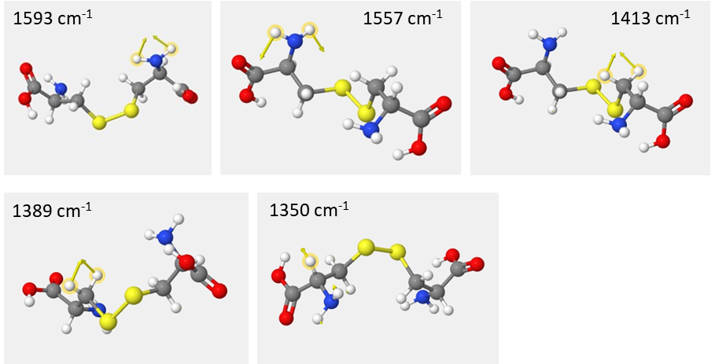
SI Fig 3. Simulated vibrational configurations of a Cystine molecule at which the Cd₂CST₂ bowties demonstrate chiral fingerprint in VCD spectrum. Note the -NH₂ scissoring inwards (1593 cm⁻¹) and outwards (1557 cm⁻¹) are the most intense in the VCD spectra.
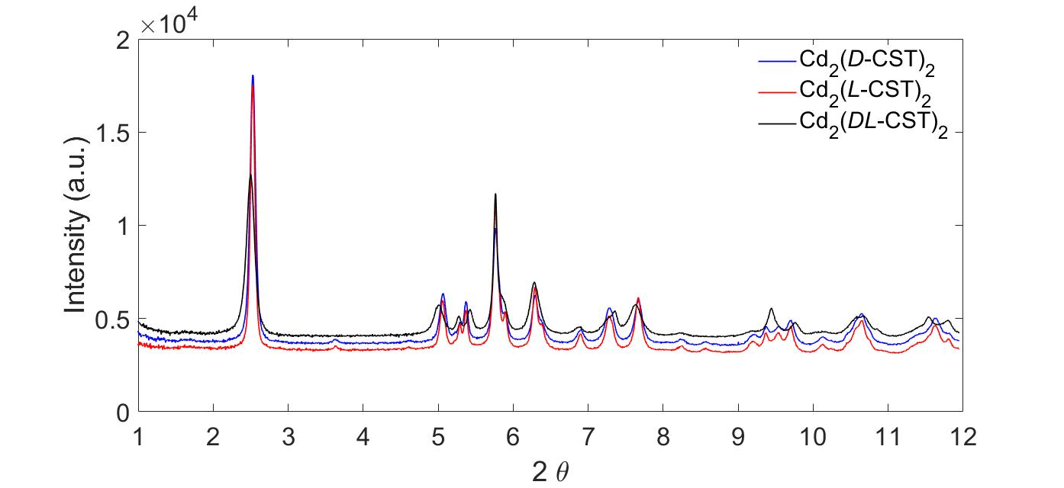

SI fig 4. Synchrotron XRD data for freeze-dried powders of Cd₂(L-CST)₂ (red), Cd₂(D-CST)₂ (blue) and Cd₂(DL-CST)₂ (black) bowties are plotted.

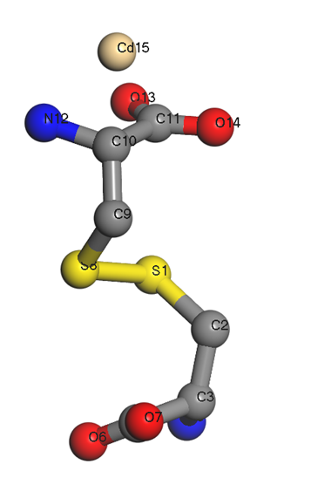
SI Fig. 5. Atomic structure of the atomic unit in the constituent nanocluster, comprising of L-CST molecule, Cd²⁺ used for the simulated annealing procedure in structure solution.

Table 1. Experimental details
Crystal data
Chemical formula | C₆CdN₂O₄S₂
M_{r} | 340.62
Crystal system, space group | Orthorhombic, P2₁2₁2₁
Temperature (K) | 298
a, b, c (Å) | 20.454 (2), 9.9230 (9), 5.0438 (4)
V (Å³) | 1023.68 (17)
Z | 4
Radiation type | Synchrotron mono-beam
Data collection
Diffractometer | Debye-Scherrer geometry  diffractometer with area detector at Beamline 17-BM
2θ values (°) | 2θ_{min} = 0.80 2θ_{max} = 16.82 2θ_{step} = 0.01
Refinement
R factors and goodness of fit | R_{p} = 0.021, R_{wp} = 0.027, R(F²) = 0.1333, χ² = 5.272
CCDC Deposition#2225277

Table 2. Coordinate (x,y,z) of the points group for constituitive nanocluster
x [x10¹] | y [x10¹] | z [x10¹]
1.47 | 1.68 | 0.6.91
2.21 | 0.591 | 0.4.87
0.473 | 1.05 | 0.2.71
2.40 | 1.70 | 0.3.55
0.380 | 0.791 | 1.30
0.593 | 1.28 | 1.11
1.87 | 1.07 | 1.19
2.70 | 1.28 | 1.27
1.48 | 0.493 | 1.32
0.595 | 0.288 | 1.03
1.90 | 1.17 | 1.59
2.67 | 0.292 | 1.07
0.474 | 1.77 | 0.838
2.38 | 1.68 | 1.27
1.45 | 0.618 | 0.732
0.637 | 0.281 | 0.314
2.55 | 0.991 | 0.222
0.349 | 1.69 | 0.342
2.37 | 0.667 | 1.24
0.246 | 0.644 | 0.633
2.55 | 0.985 | 0.901
1.79 | 0.181 | 0.408
2.61 | 0.264 | 0.339
1.30 | 0.968 | 1.15
1.73 | 0.176 | 1.05
2.6.9 | 1.36 | 0.491
1.75 | 1.22 | 0.593
1.57 | 0.611 | 0.193
0.829 | 1.49 | 0.416
0.376 | 1.69 | 1.29
0.534 | 0.877 | 0.786
1.33 | 1.91 | 1.06
1.22 | 0.925 | 0.332
1.43 | 1.70 | 0.207
1.53 | 1.43 | 1.23
2.52 | 1.77 | 0.838

Table 3. Values of point unscaled OPD for fully assembled bowties (i.e. ξ₄) calculated according to Eq. 20 based on 8-point set for bowties with different final geometries obtained varying enantiomeric excess χ and [Cd²⁺] = 0.6, 1, 2, 3, and 4 mM with [CST] = 4 mM.
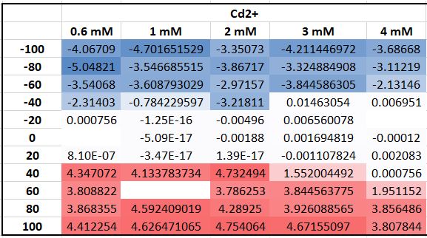

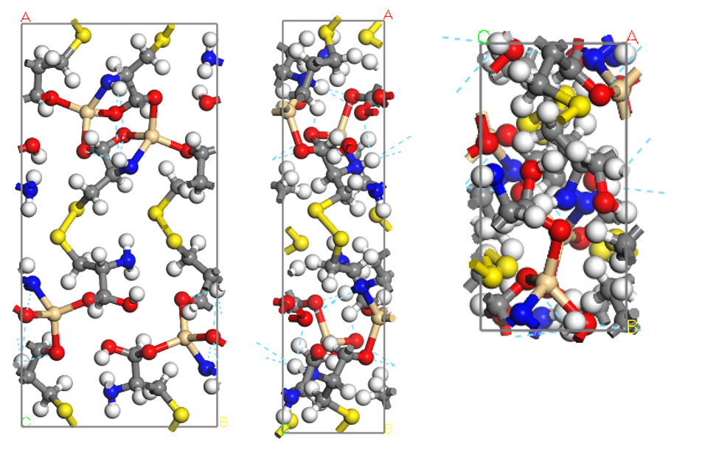
SI Fig 6. Three perpendicular projections of the atomic structure of the refined structure of Cd₂(L-CST)₂ unit cell. Atoms are represented as Oxygen (red), Carbon (black), Cadmium (Brown), Nitrogen (blue), Sulfur (yellow).

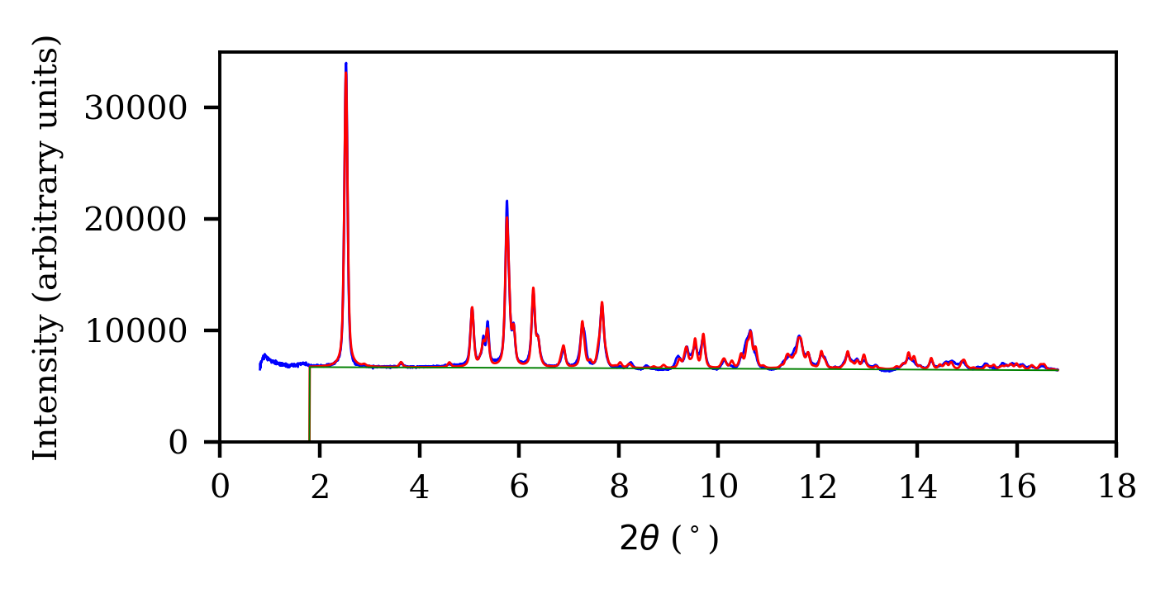

SI Fig 7. Comparison between the observed (blue) and calculated XRD spectra (red) obtained from the solved structure.

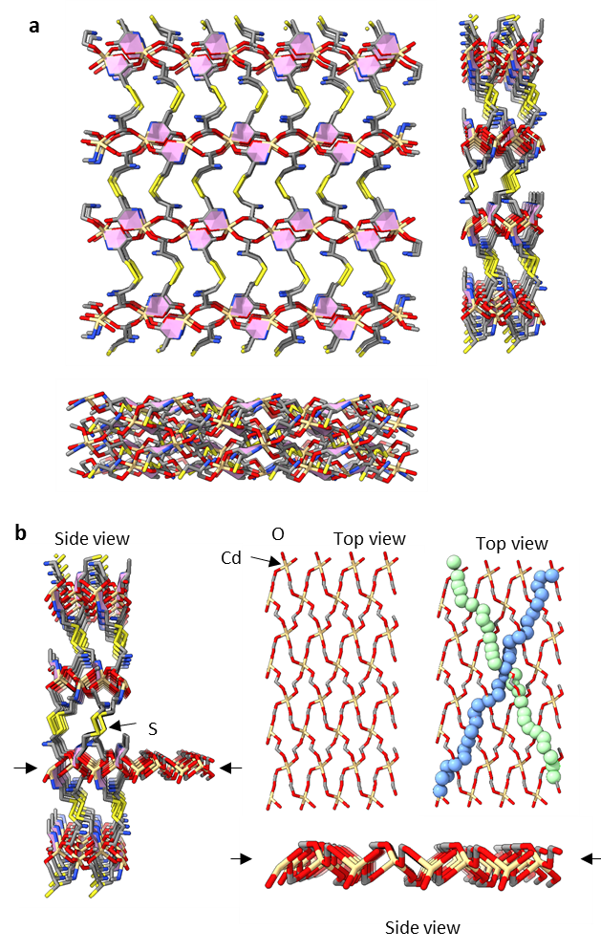
SI Fig 8. a, Atomic structure of 4x2x2 Cd₂(L-CST)₂ supercell of bow-ties is shown along [001], [010], and [100] zone axis. b, Side view of the supercell with the layer of Cd-O is extended out for clarity. The top view of the Cd-O layer is shown on the right with the helical chains are highlighted with spherical markers.

SI Fig. 9. IR and VCD spectra computed for the lowest conformer of the isolated cystine and the Cd₁-(CST)₄ and Cd₅-(CST)₁₆ structures. DFT VCD calculations confirm: 1) the enhancement of the VCD intensities, and 2) the increased number of intense VCD bands in the frequency interval between 1550 and 1650 cm⁻¹.

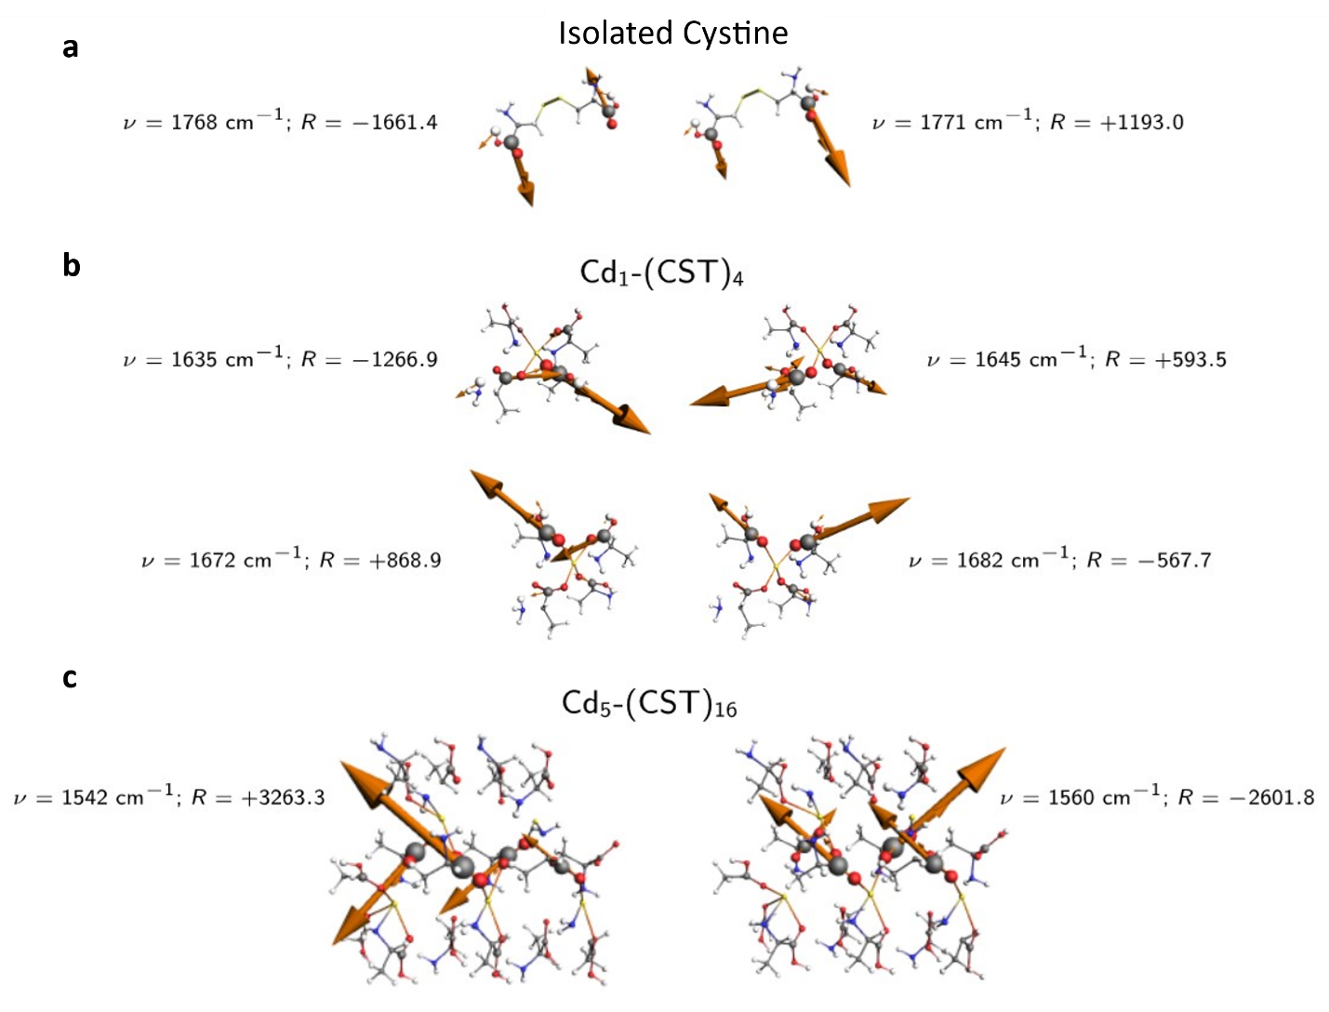
SI Fig 10. VCD oscillator modes in a, isolated cystine, b, Cd₁-(CST)₄ and c, Cd₅-(CST)₁₆ structures. The magnitude of the atomic radius indicates the magnitude of the associated nuclear displacement vector, while the orange arrows represent the electric dipole transition moments that couple through space yielding the large VCD intensities. Unit of the rotational strengths (R): 10⁻⁴⁴ esu²cm².

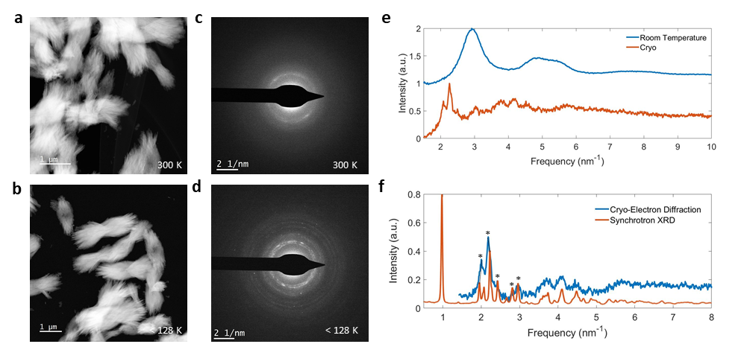
SI Fig 11. Electron dose sensitivity of bowties. a,b, Annular dark field scanning transmission electron microscopy (ADF-STEM) image and c,d, corresponding electron diffraction pattern (right) for bowties at room temperature (300 K) and cryogenic temperature (below 128 K). At room temperature the Cd-CST bowties convert into CdS chiral particles as evidenced by emergence of the broad peaks at 2.9 nm⁻¹ and 4.8 nm⁻¹ characteristic of CdS. e, Line spectra of the rotationally averaged electron diffraction pattern shown in panels c and d at 300 K (blue) and < 128 K (orange). f, Electron diffraction pattern obtained at <128 K (blue) and synchrotron XRD pattern (orange) confirming the transition of bowties into nanoparticles under the electron beam at room temperature. The primary peak in XRD pattern corresponding to inter-chain distance at 10.2 Å is blocked by the beam stopper in SAED pattern. Cryo-SAED patterns show characteristic reflections at 4.9 Å, 4.6 Å, and 4.1 Å, which are consistent with corresponding distances between planes in the orthorhombic Cd₂CST₂ structure at 5.1 Å, 4.5 Å, and 4.1 Å

SI Fig 12. Conversion of Cd-CST bowties into CdS bowties. a, ADF-STEM image and b, Electron diffraction pattern of bowties. c,d, High-resolution ADF-STEM image of bowtie shown in a, confirming the presence of 2-5 nm sized NPs of CdS. e, Rotationally averaged electron diffraction (blue) shown in panel b, with a modeled electron diffraction for 2.5 nm sized NPs (orange). The corresponding peaks of CdS from crystallographic database for PDF 10-0454.

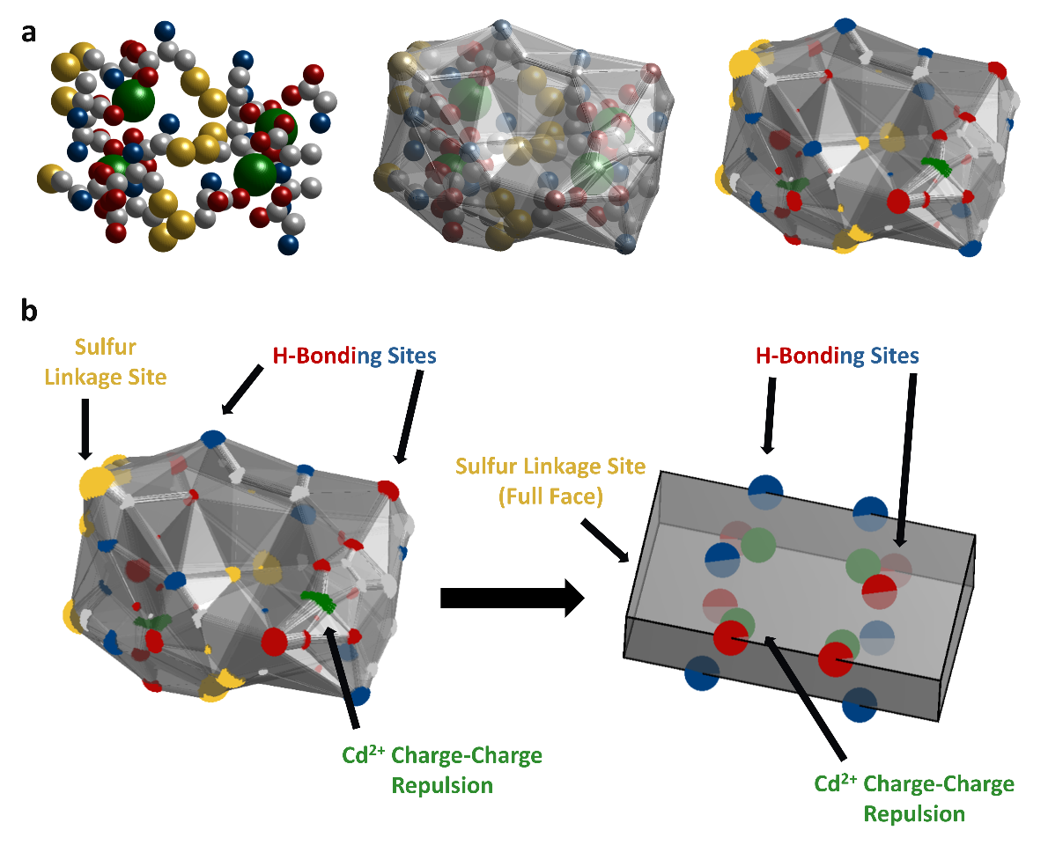
SI Figure 13. Coarse-grained model of the Cd-CST nanoclusters. a) (Left) XRD resolved structure of building block. (Middle) Convex hull around atoms. (Right) Patchy model of convex hull of the nanocluster. b) Construction of generalized building block. Relevant features such as sites for hydrogen bonding (H-bonding), charge-charge repulsion, and sulfur linkage sites are placed on the generalized building block to mimic their general location on the XRD resolved patchy convex hull of the nanocluster in a).

SI Fig 14. Monodispersity of the self-assembled bowties. SEM images of the a, Cd₂(L-CST)₂ and b, Cd₂(D-CST)₂ bowties formed from [L-CST] and [Cd²⁺] as 4 mM in 200 ml water.

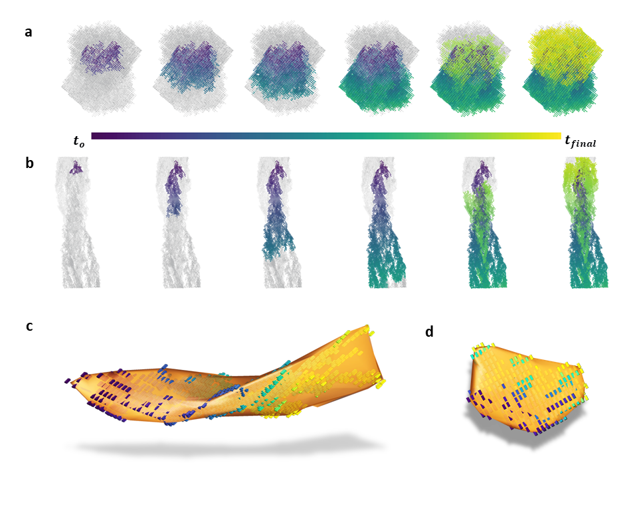
SI Fig 15. Monte-Carlo simulation of the growth of nanoribbons and their stacks. Snapshots of particle growth simulations for a, χ = 0 and b, χ = 1. Ordered domains are visible in both growth conditions. Smallest ordered domains during initial stages of growth are shown for c, χ = 1 and d, χ = 0. Colors of the individual units represent the normalized time at which the nanoribbons attach to the existing bowtie particle.

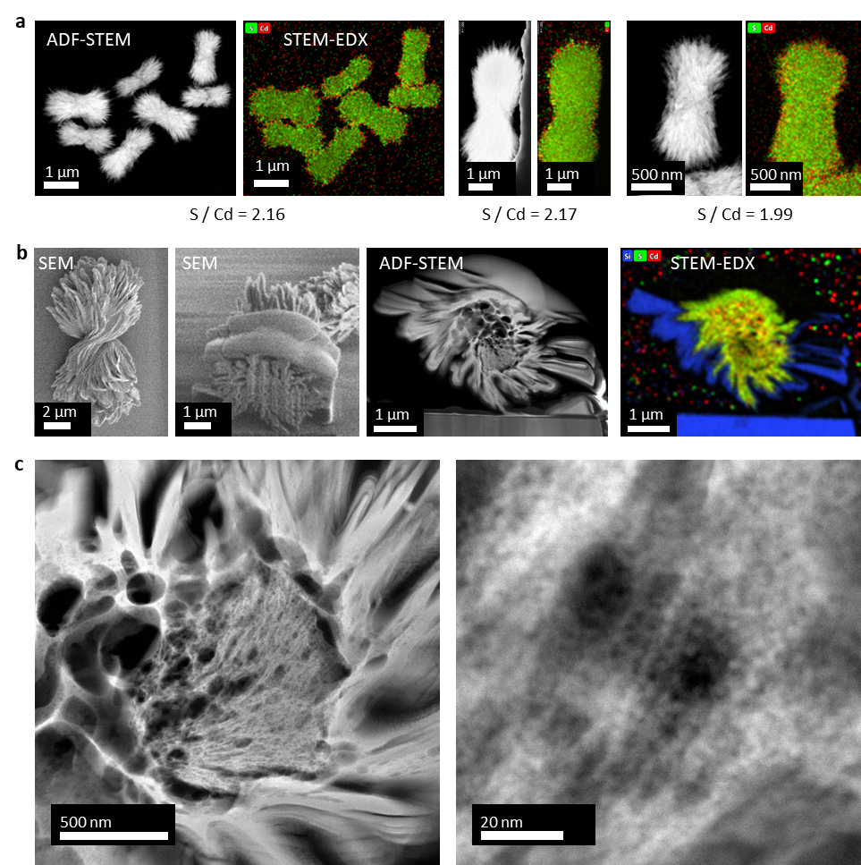

SI Fig 16. STEM-EDX based evaluation of atomic distribution. a, Spatially resolved energy dispersive X-ray spectroscopy for the bowties made with different [Cd²⁺], [L-CST] concentrations. Atomic concentration of S (green) and Cd (Red) was in the ratio 2:1, indicative of one CST molecule sharing one Cd atom. This ratio was used to construct a Cd-CST fragment as an input for atomic structure solution from 3D electron density maps obtained from powder XRD data.
The presences of extra Cd²⁺ at the interface indicates positive surface charge. b, Cross-sectional analysis of the bowtie at the center node was performed and revealed the S/Cd ratio of 1.67, which could occur due to transformation by Ga-ion beam during thinning or due to a difference in the core composition. c, High-resolution ADF-STEM images of the core of a right-handed bowtie indicate a fibrous structure made of polydisperse NPs.

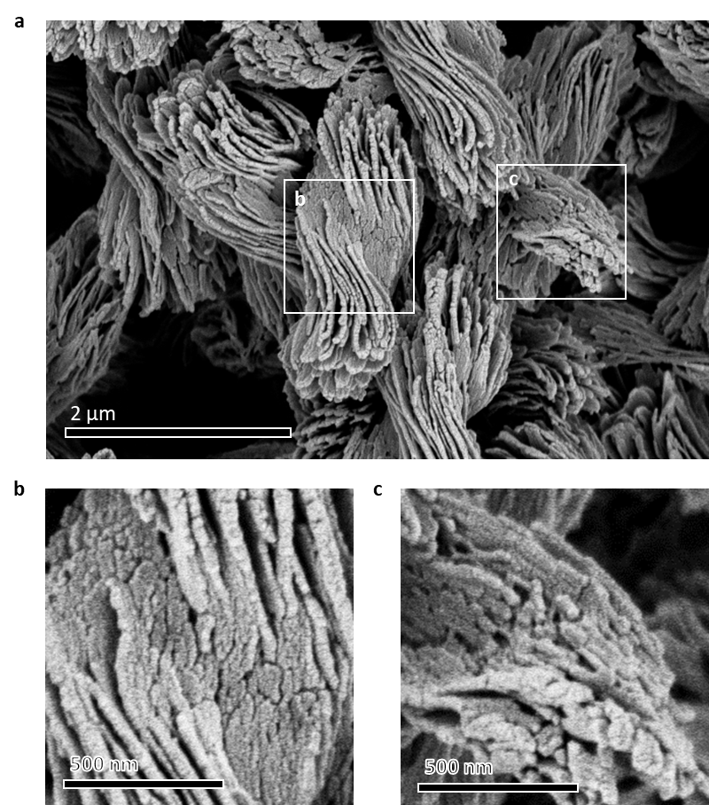
SI Fig 17. High magnification SEM images of bowtie particles. Shown here are the SEM images of a, fully formed bowtie, b, magnified region at the center of bowtie and c, magnified region at the edges of the bowtie. Synthesis conditions are [Cd²⁺] = 4 mM, [L-CST] = 4 mM, Water = 200 ml. Polydisperse nanoplatelets with diameters between 20-100 nm are assembled into nanoribbons. In turn, they are stacked into the bowties with the left twist. Smaller nanoplatelets lead to stronger twisting.

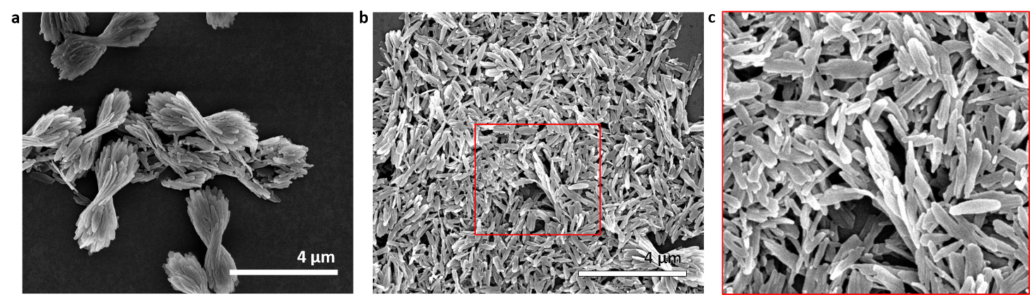
SI Fig 18. SEM image of a, bowtie structure and its b-c, disassembled counterpart into individual lamellae. While the bowties have a pronounced twist the individual sheets are less twisted as compared to the fully formed structure.

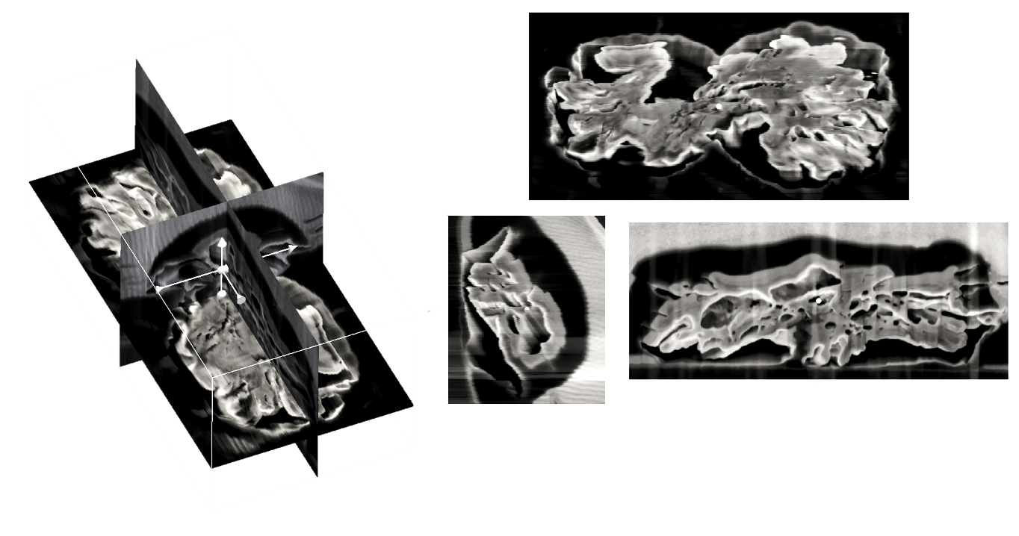
SI Fig 19. Cross-section of the reconstructed bowtie structure obtained by FIB cross-sectioning in the longitudinal direction. The material has to be confined by platinum layers to avoid Ga-ion beam damage.

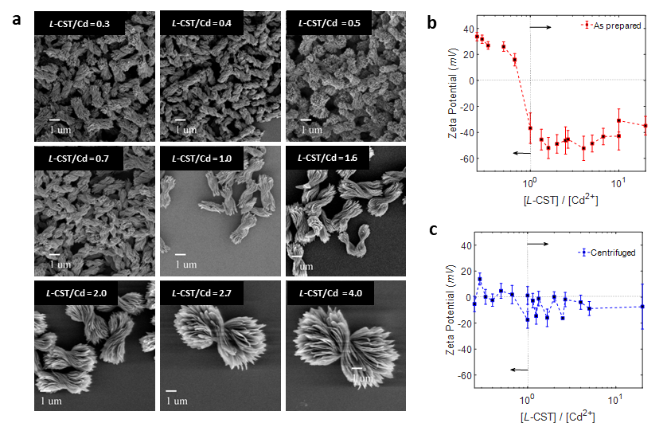

SI Fig 20. Geometry of the bowtie particles made with different L-CST/Cd ratios. Geometrical parameters characterizing length, width and thickness of the bowties, namely l, w, and t depicted in Fig. 3c, increase with the increase of [L-CST]/[Cd²⁺] ratio. b, Zeta potentials (red) of as-made bowtie particles made with different [L-CST]/[Cd²⁺] ratios in the original synthetic media increases with crossover at 0 potential occurring near [L-CST]/[Cd²⁺] = 1. c, Zeta potentials of bowtie particles made with different [L-CST]/[Cd²⁺] ratios after centrifugation and re-dispersion in DI water. Comparison with the zeta-potentials in original reaction media indicate that the charge of the bowtie surface is associate with adsorption of excess ions of L-CST or Cd²⁺ depending on the [L-CST]/[Cd²⁺] ratios. The excess positive and negative charge is depleted upon centrifugation.

Note: The dependence l, w, and t of the fully assembled particles is consistent with the dependence of thickness and width of individual nanoribbons on [L-CST] and L-CST/Cd ratio (see also Fig. SI 24,30).

SI fig 21. Change in pH of the solution as the ratio of [L-CST]/[Cd²⁺] is changed.

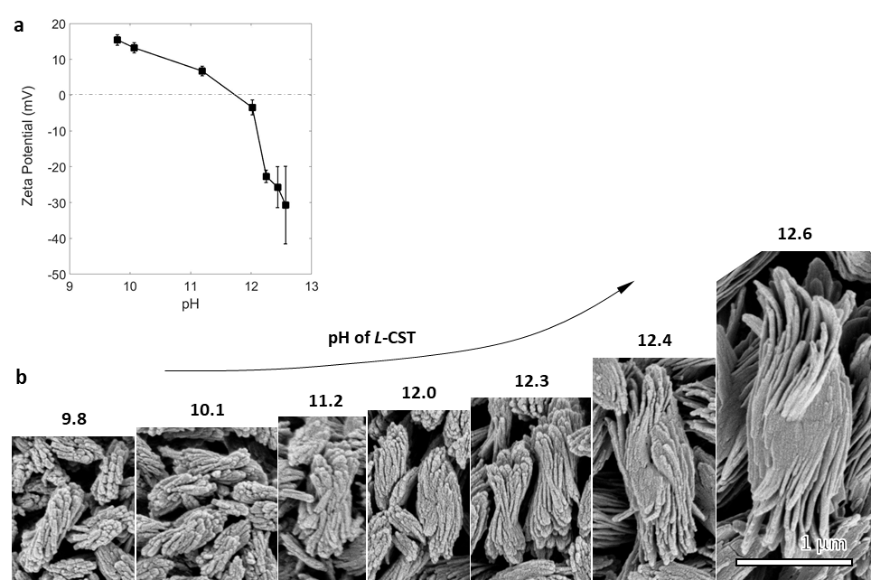

SI Fig. 22. Role of pH in self-assembly. a, Variation of zeta-potential of fully formed particles with increasing pH of [L-CST] = 4 mM solution before addition of [Cd²⁺] = 4 mM. pH was controlled by adding NaOH in the range of 0.7 to 1 ml volume to a 10 ml solution of L-CST. Cystine is typically soluble above pH 8 and below pH 2. b, SEM images of the self-assembled bowties after addition of Cd²⁺ ions to the corresponding L-CST solution. It is notable that the twisting of the self-assembly begins above pH 12, which also coincides with the negative zeta potential of the bowties. Scale bar across all images in 1 um.

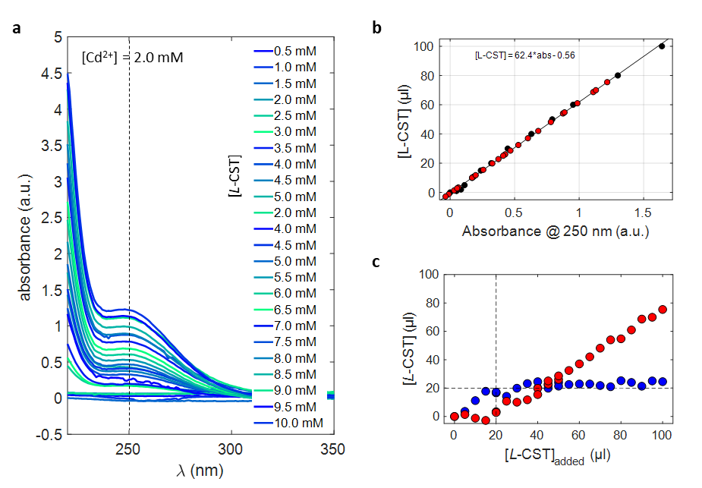
SI Fig 23. Quantification of the consumed L-CST during the bowtie synthesis. a, Absorbance of supernatant from reactions of [Cd²⁺] = 2 mM with varying [L-CST] (0.5 mM to 10 mM). b, Calibration chart for absorbance of [L-CST] vs absorbance at 250 nm is shown here with black circles representing absorbance from only [L-CST] and red-circles representing estimating [L-CST] in supernatant. c, [L-CST] vs [L-CST] added for samples shown in panel a. Up to 20 µl or (2mM) [L-CST], all added [L-CST] is consumed (blue curve) and the curve is linear. Beyond 20 µl added [L-CST], 21.7 ± 2.9 µl is consumed, indicating that the [Cd²⁺] and [L-CST] interact in 1:1 ratio to precipitate the bowties.

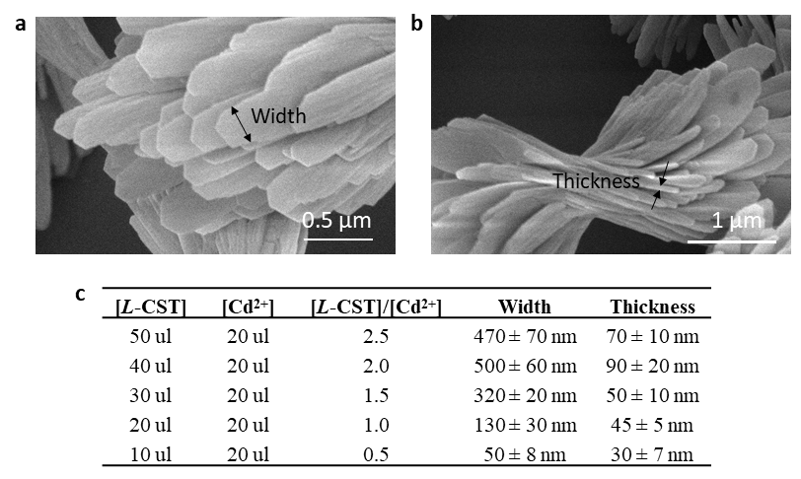
SI Fig 24. Geometry of the nanoribbons for various synthetic conditions. SEM image of the ribbons a, facing the electron beam and b, resting on the silicon wafer in edge-on orientation. c, Tabulated width and thickness for changing [L-CST] / [Cd²⁺] ratio. As [L-CST] and [L-CST] / [Cd²⁺] ratio decreases, the width and thickness of the nanoribbons also decrease.

Note: The correlation with [L-CST] and [L-CST]/[Cd] ratio is fully consistent with that of the length, width and thickness of the entire assembled particles (SI Fig. 26,30). Increasing the concentration of ions in the system for CST and Cd²⁺ is not the same. If we increase the CST we are increasing the number of –COO and –NH₂ groups which simply extend the long range order over several length scales. However, increasing the Cd²⁺ ion concentration changes the platelet charge to positive because they get adsorbed on the negatively charged surface. This creates a repulsion between positively charged platelets but they cannot form hydrogen bonds over long range, because carbonyl groups are limited and therefore the overall size of the bowtie decreases. In the figure above as [L-CST]/[Cd²⁺] ratio increases that means relative concentration of [Cd²⁺] ions are decreasing in number, so the sheets should be negatively charged.

SI Fig 25. Schematic of the different physicochemical parameters used to exert structural control over the bowtie assemblies. Changing one or two parameters (such as temperature, EE, counter-ions, solvents, and NaCl) with varying [Cd²⁺] and [L-CST] results in a wide range of continuously variable bowtie assemblies.

SI Fig 26. Phase diagram for the combinations of [L-CST] and [Cd²⁺] concentrations varying from 0.6 mM to 4 mM. Increase in [L-CST] with [Cd²⁺] constant (along the columns) results in increase in size of bowties. Increase in [Cd²⁺] while keeping [L-CST] constant (along the rows) results in decrease in size of bowties. Scale bar is 5 µm.

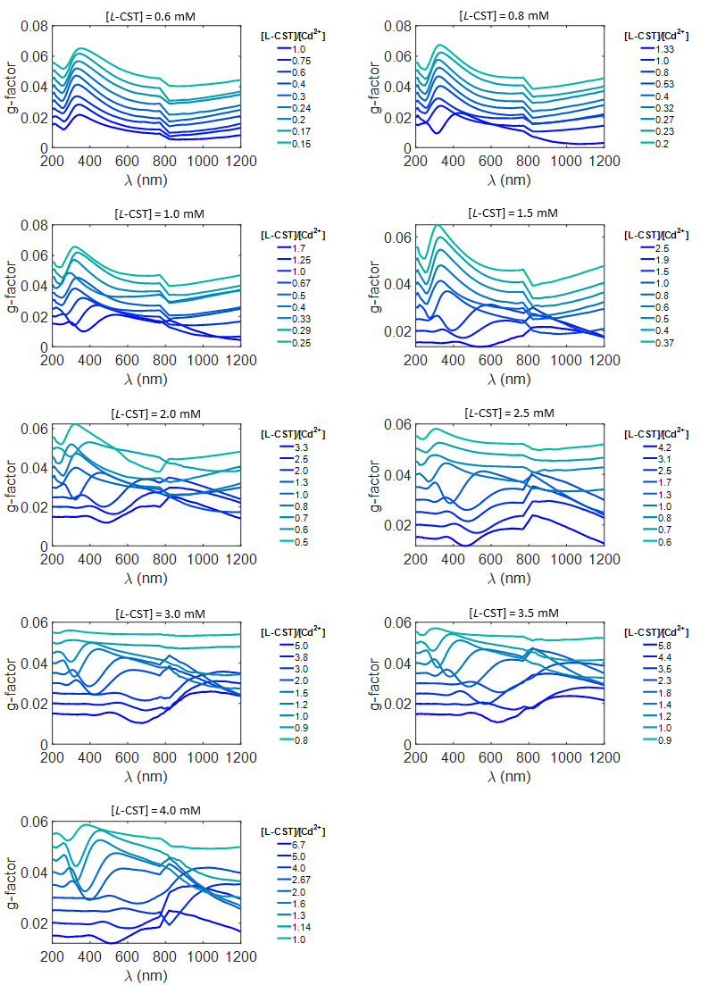

SI Fig 27. g-factor spectra from UV-vis to NIR region is plotted for fixed [L-CST] concentration corresponding to each row in phase diagram shown in SI Fig 26. As the [L-CST] concentration increases, the variations in g-factor spectra are amplified. From 800-1200 nm the detector changes resulting in a jump in the spectra due to gain correction differences between two detectors.
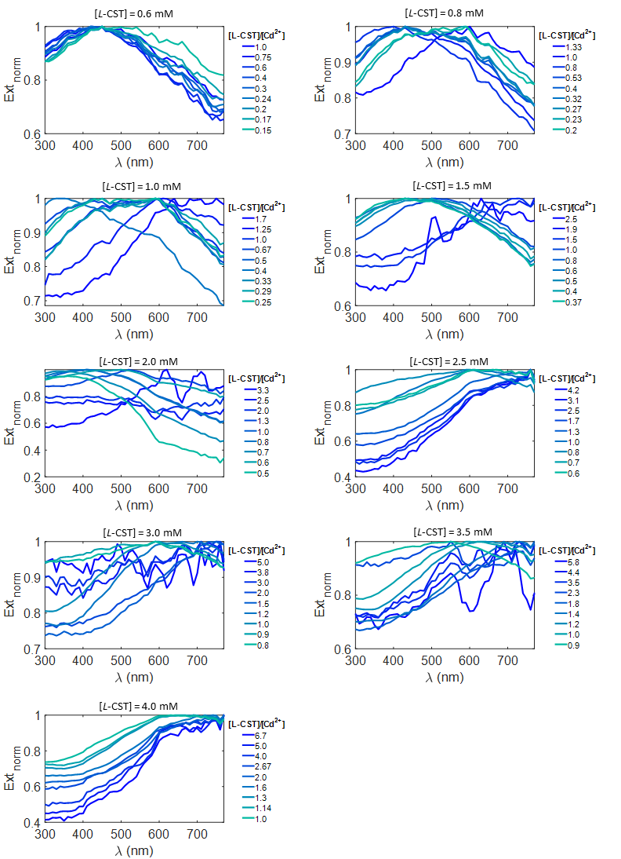
SI Fig 28. Normalized extinction spectra is plotted for fixed [L-CST] concentration corresponding to each row in phase diagram shown in SI Fig 26. As the [L-CST] concentration increases, the extinction peak red-shifts. Some extinction spectra have a lower signal to noise ratio because of lower particle concentration of larger sample in 1ml vial.

SI Fig 29. Phase diagram for the combinations of [L-CST] and [Cd²⁺] concentrations varying from 0.6 mM to 4 mM in the presence of added 0.25 M NaCl in water. Increase in [L-CST] with [Cd²⁺] constant (along the columns) results in increase in size of bowties. Increase in [Cd²⁺] while keeping [L-CST] constant (along the rows) results in decrease in size of bowties. Scale bar is 5 µm.
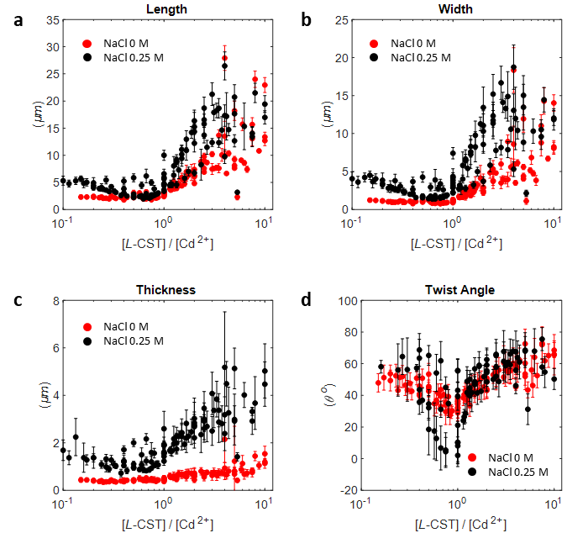

SI Fig 30. Measurements of Length (l), Width (w), Thickness (t) and Twist Angle (θ) of the stack of twisted sheets are plotted with respect to the ratio of [L-CST]/[Cd²⁺]. Red dots indicate the synthesis conditions without NaCl and blue dots are synthesized in the presence of 0.25 M NaCl. Error bars are calculated from 5-10 measurements of the respective quantity. Note the larger relative increase in thickness for bowties made in 0.25 M NaCl as compared to 0 M NaCl.

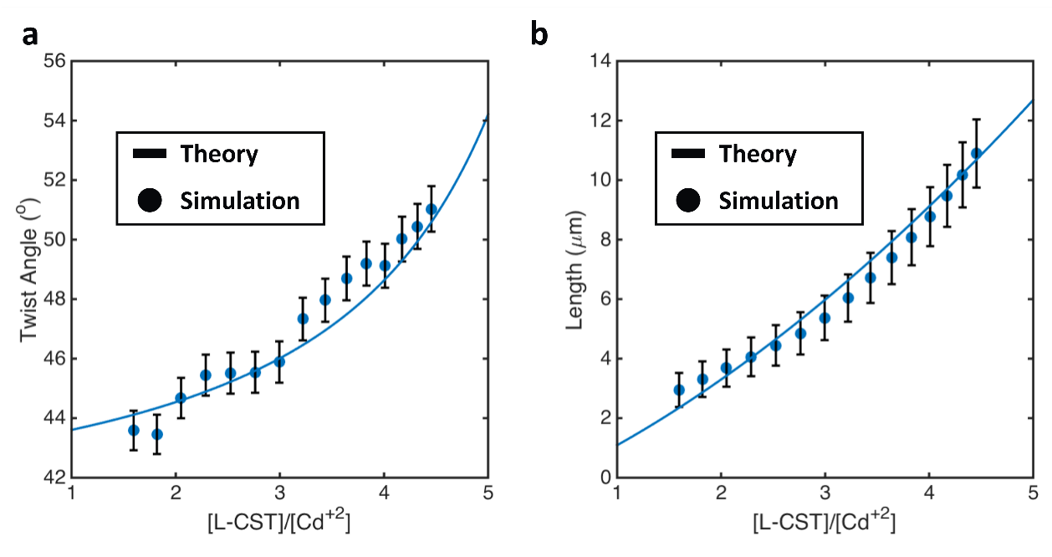

SI Figure 31. Comparison of theory vs Monte Carlo simulations for incomplete cluster formation. a) Twist angle and b) Length of bowties. Solid lines are theory predictions. Scatter points are MC growth simulation results.

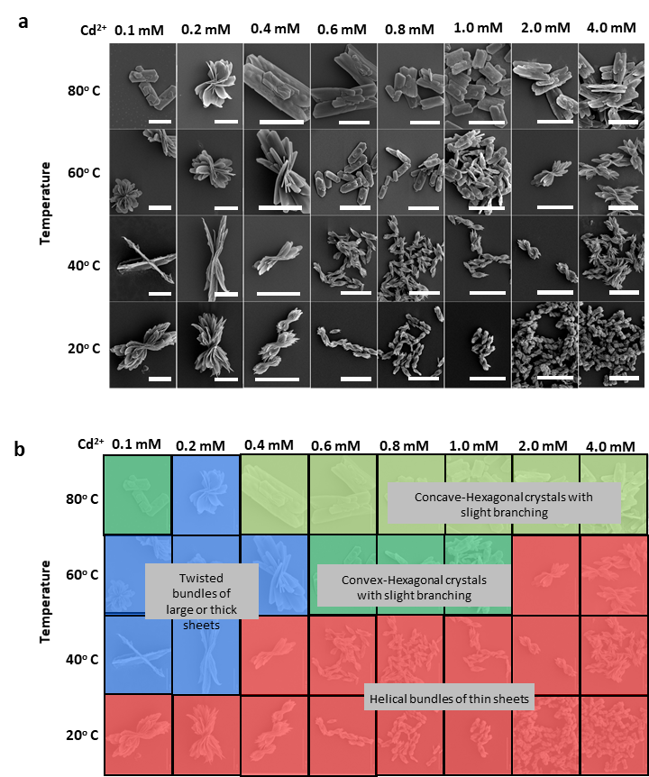

SI Fig 32. Temperature effect on the morphology of Cd₂CST₂ based nanostructured self-assembled particles. a, SEM micrographs of the final bowtie morphology when temperature is varied (along y-axis) from 20-80º C and [L-CST]/[Cd²⁺] ratio is decreased from 8 to 0.2 ([L-CST] = 0.8 mM). b, The morphologies are classified based on their curvature and stacking patterns. Tracing the y-axis from 20º C to 80º C at a fixed [L-CST]/[Cd²⁺] ratio indicates that the change in stacking and overall sizes. Scale bar in a is 5 µm.

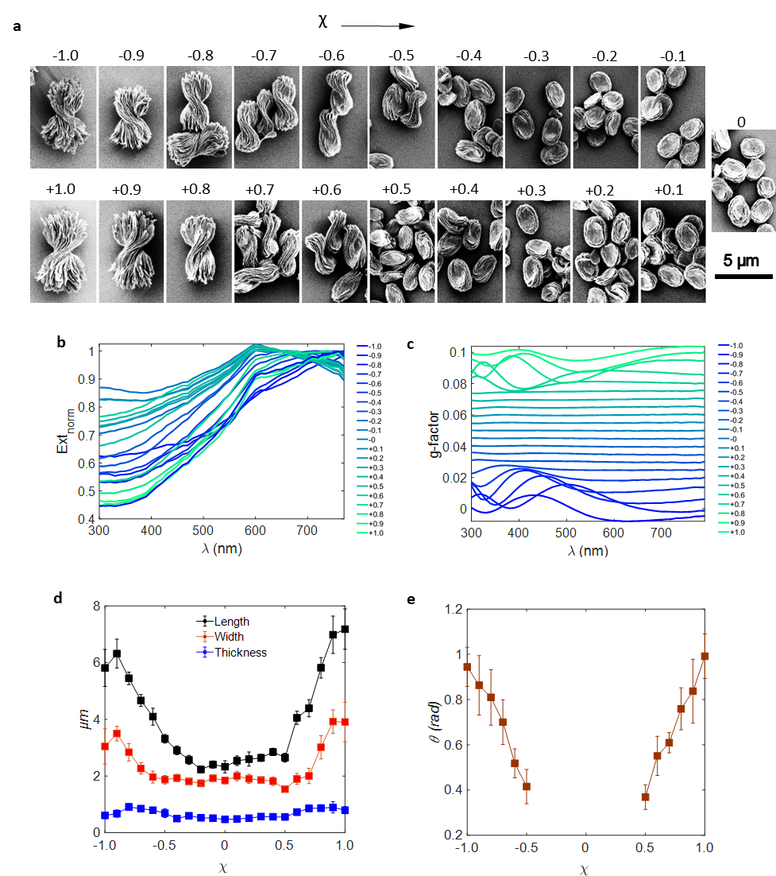

SI Fig 33. Effect of changing the enantiomeric excess. a, SEM images of bowties as enantiomeric excess (χ) defined as ([L-CST] – [D-CST]) / ([L-CST] + [D-CST]) is increased from -1 to 1. b, corresponding extinction and c, g-factor spectra for the morphologies shown above are plotted. d, measured morphology parameters of length, width, thickness and e, twist angle are plotted. The continuous change of twist angle coupled with a parabolic change in length, width and thickness is a clear indication of the competing mechanical, electrostatic and chemical energy penalties continuously changing with χ.

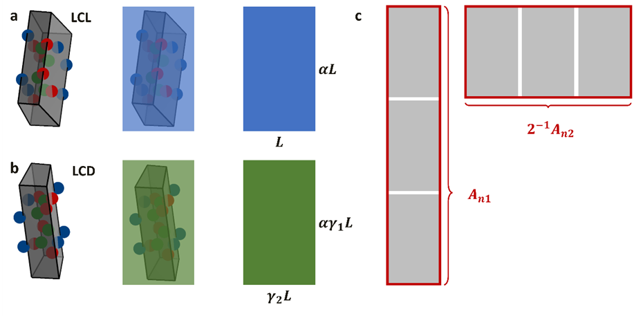
SI Figure 34. Representations of a) LCL and b) LCD building blocks. $L$ is the characteristic length of the monomeric building block nanocluster along its long axis, $α$ is the aspect ratio measuring the amount of nanocluster building block elongation, $n$ is the number of nanoclusters in the assembly, and $γ_{1}$ and $γ_{2}$ are the local curvature of the nanoclusters along the long and short direction, respectively. c) Schematic of configurations considered in derivation of $A_{n1}$ and $A_{n2}$. The $2^{-1}$ factor accounts for symmetry of the $A_{n2}$ configuration being the same going in the 3rd direction (in/out of page).

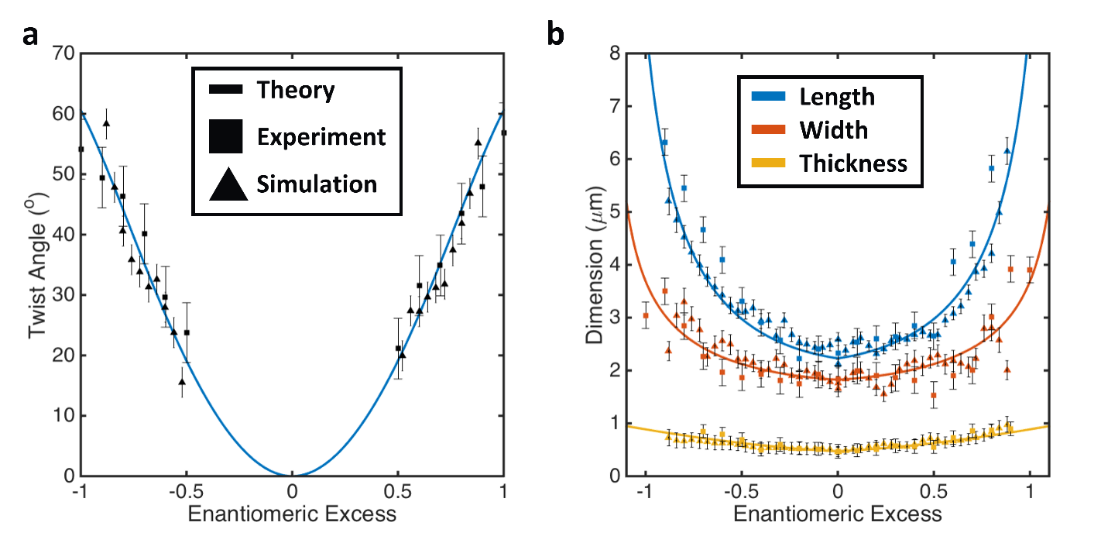

SI Figure 35. Comparison of Various Bowtie Dimensions. Comparison of theory, Monte Carlo growth simulation and experiments for a) twist angle and b) various bowtie dimensions.

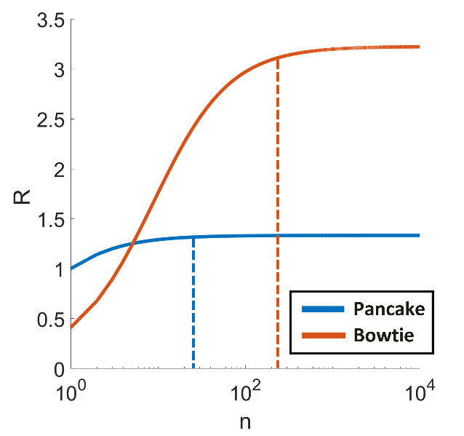
SI Figure 36. Self-Limited Assembly of Bowties. Theoretical prediction of self-limiting sizes (in scaling units) of pancake and bowtie particles as a function number of number of nanoclusters in the particle. Plateau indicates the self-limiting size $R^{*}$ of the growing particles. Dashed lines indicate the self-limiting number of nanoclusters in the growing particles as predicted from Eq. 11 (i.e. particle stops growing at location of dashed lines).
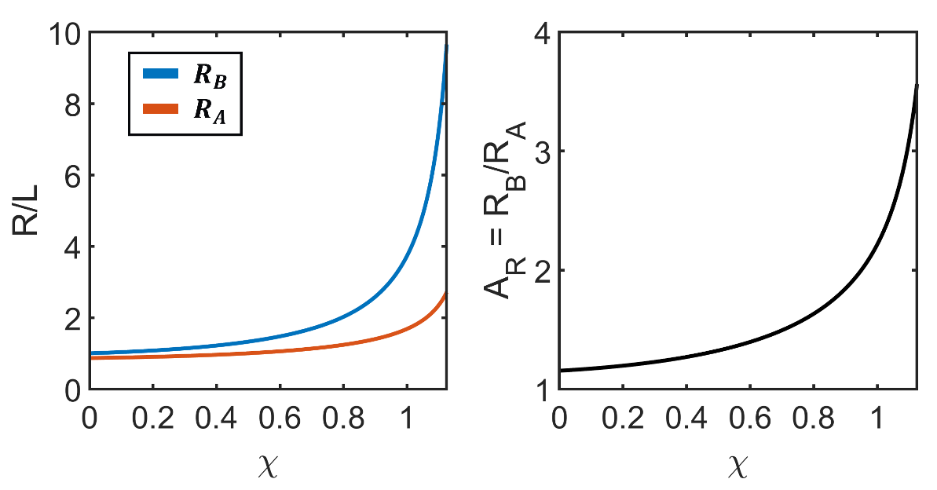
SI Figure 37. Single Sheet Electrostatics. (a) Major and minor axis prediction for single sheet scaled by the characteristic length $L$ of the monomeric unit. (b) Aspect ratio $A_{R}=R_{B}/R_{A}$ that now feeds into Eq. 13-14.

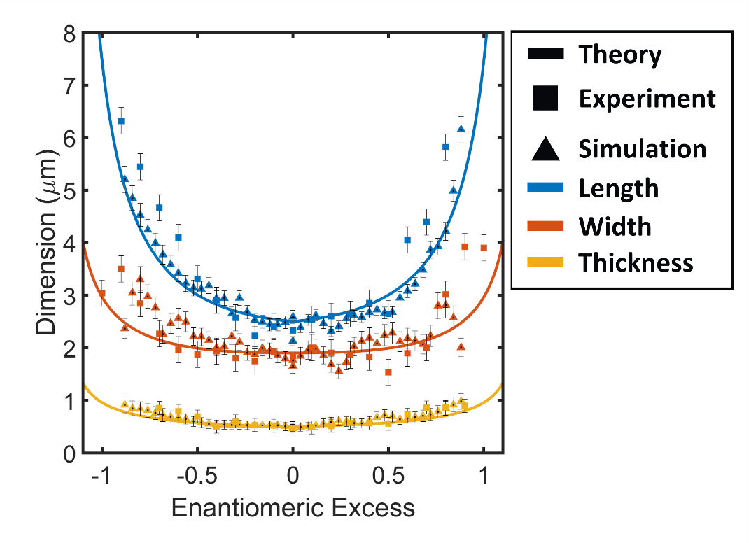
SI Figure 38. Comparison of various bowtie dimensions. Comparison of theory, Monte Carlo growth simulation and experiments for merged electrostatics and geometric scaling theory

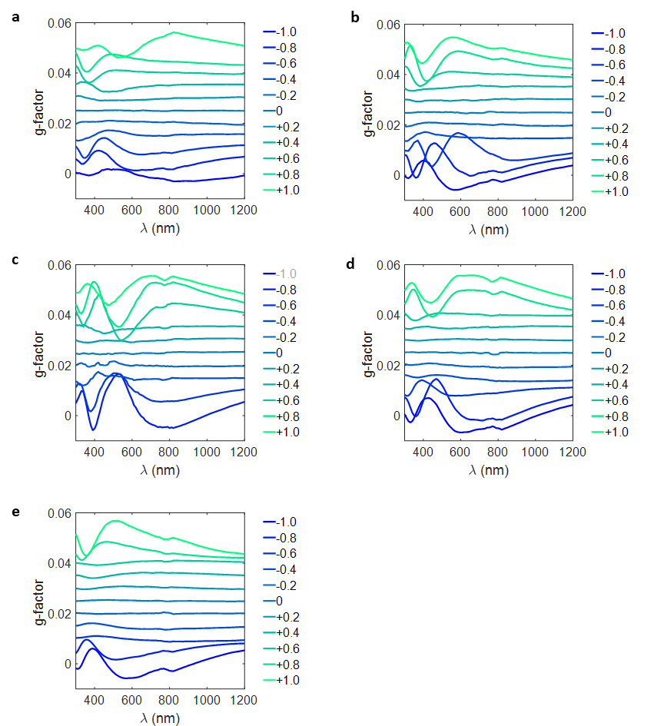
SI Fig. 39. Chiroptical spectra of bowtie particles with different enantiomeric excess. G-factor spectra for bowties with morphologies shown in main text Fig. 3b acquired for [Cd²⁺] equal to a, 0.6 mM, b, 1.0 mM, c, 2.0 mM, d, 3.0 mM, e, 4.0 mM while maintaining [L-CST] = 4 mM.

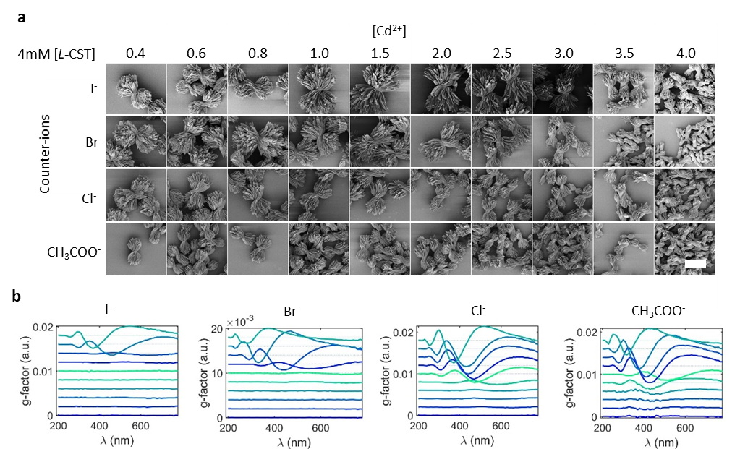
SI Fig 40. Effect of counter-ions on the hierarchical structure of bowties. a, SEM images indicating the changes in the morphology of bowties as the M+/CST ratio is increased for CdI₂. CdBr₂, CdCl₂, and Cd(CH₃COO)₂ as the starting metal salt. Same amount of twist in bowties is produced by different concentration of the metal salt in the following order [I⁻] > [Br⁻] > [Cl⁻] > [CH₃COO⁻]. This series is in some agreement with the typical Hofmeister series but whether this match is coincidental or significant finding will need to be evaluated further. b, Corresponding g-factor spectra for the morphologies shown above. Scale bar in (a) is 5 µm.
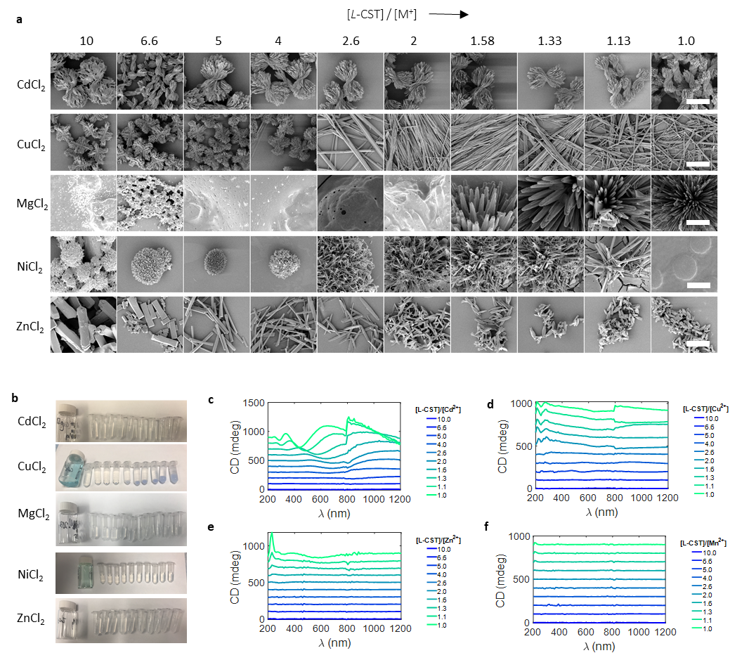
SI Fig 41. Effect of different metal-ions on macroscale morphology. a, Typical morphology of bowtie is shown in the first row which decreases in size as metal ion (M⁺) concentration increases. Copper shows a cross-stitched assembly of fibers which transitions in to long individual fibers upon increasing metal ion concentration. Mg²⁺ and Ni²⁺ result in spherical supraparticles, while Zn²⁺ results in a rod-like morphology. The pH of CST solution was fixed at 11 while metal ion concentration was increased. These results indicate that different metal ions coordinate in a different manner with the same CST at the molecular level, thereby affecting the overall macroscale morphology. b, Photographs of the as prepared samples in centrifuge tubes of 2 ml total volume shown in panel a. Corresponding CD spectra for c, Cd²⁺, d, Cu²⁺, e, Zn²⁺, and f, Mg²⁺ are shown here. Scale bar in a is 5 µm.

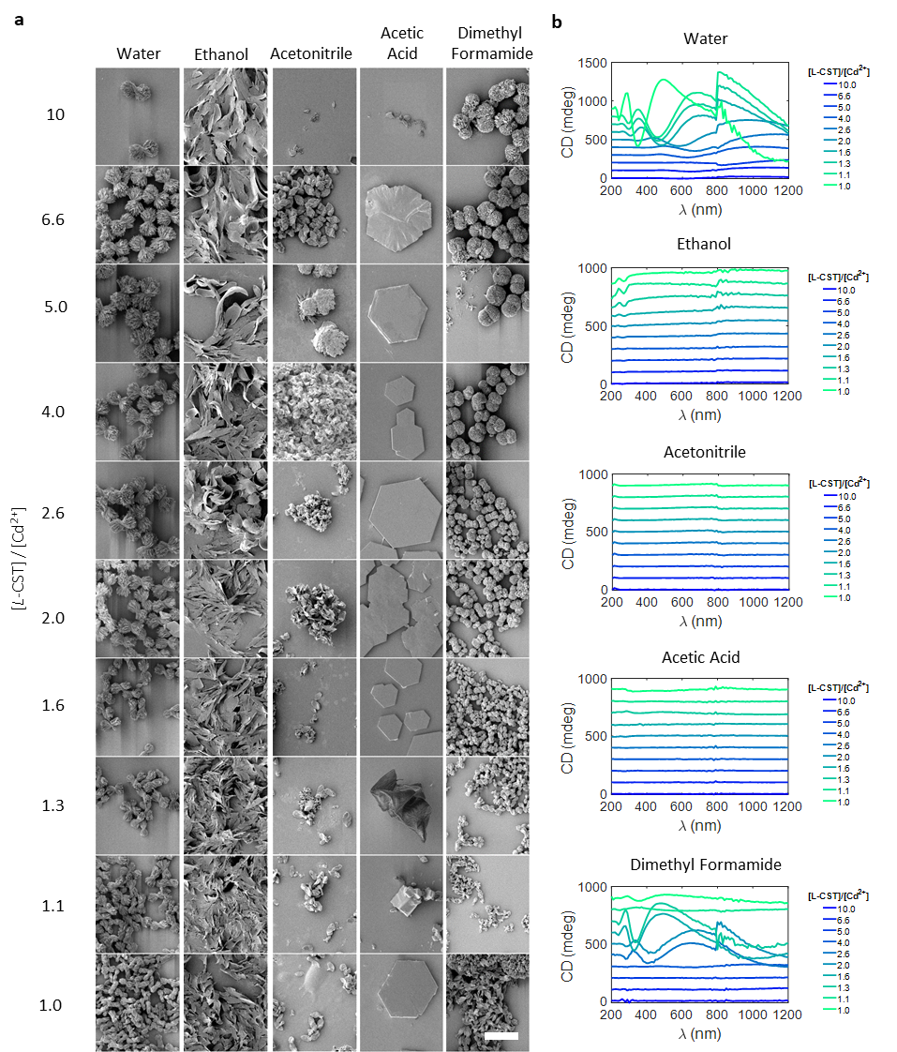
SI Fig 42. Effect of changing the solvent. a, SEM images of bowties self-assembled in 100% by volume of different solvents (x-axis) and the effect of varying [L-CST]/[Cd²⁺] ratio. b, Corresponding CD spectra are shown on the right. Scale bar in a is 10 µm.
Note. Solvent affects the interaction between the charged molecules by acting as a screening medium with an effective polarizability and permittivity. This in-turn affects the self-assembly where the transition from stacked bundles in water to individual twisted tapes in ethanol to smaller stacks of twisted bundles in DMF are observed. These morphologies can be further controlled by mixing water and solvent in different ratios.
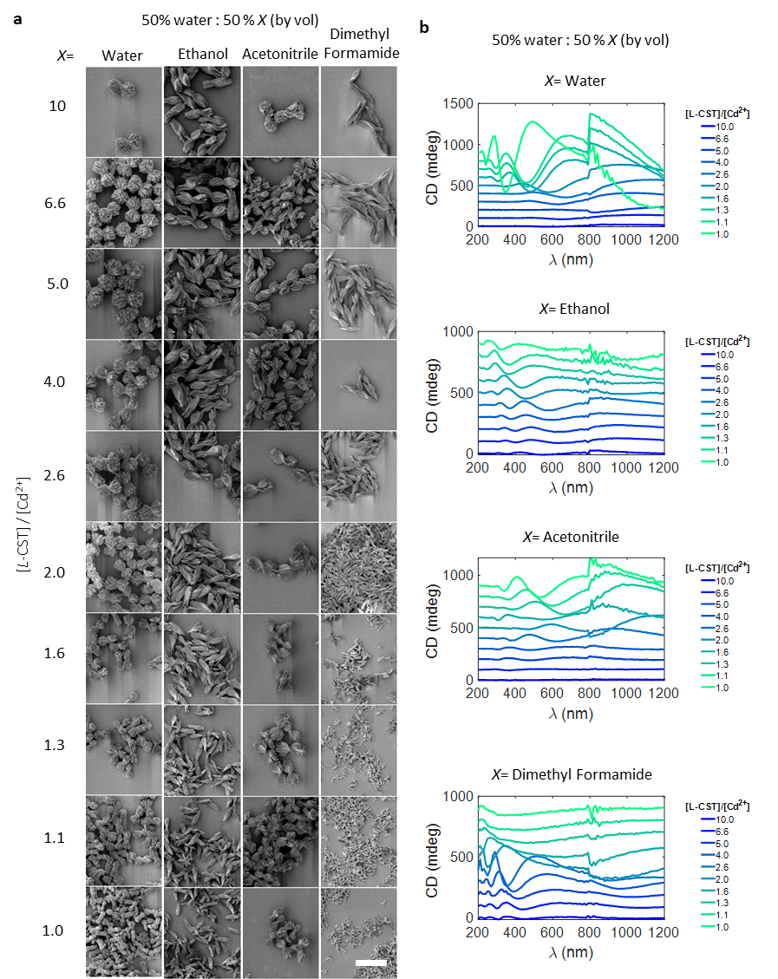
SI Fig 43. Effect of mixing different solvent with water. a, SEM images of the bowties self-assembled in a 50:50 mixture of water and solvents. Changing the solvent along x-axis results in a decrease in stacking thickness, while the overall size decreases along the y-axis as amount of [Cd²⁺] is increased. b, Corresponding CD spectra for the morphologies shown in a is plotted from UV-vis to NIR region. Scale bar in a is 10 µm.

Note. Water-solvent mixtures provide another handle to control the self-assembly pathway of nanoplatelets by changing the interactions between them.

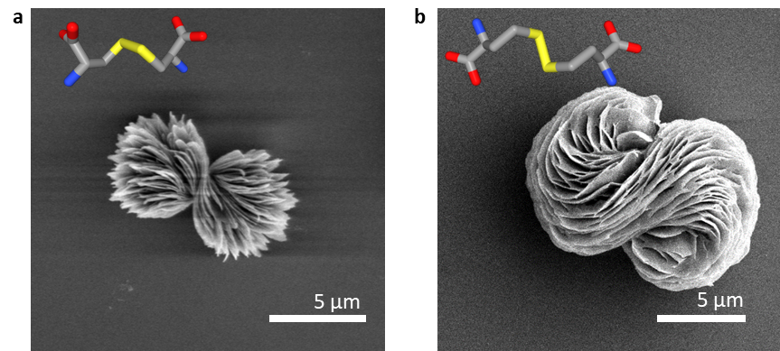

SI Fig 44. Effect of changing the surface ligands in the bowties. SEM image of bowtie made from a, L-CST and b, L-homocystine. The twist in the overall morphology increases as the chain length of L-CST molecule is increased by two carbon atoms to L-homocystine. The stick models of corresponding molecules are overlaid. Note that the reversal in handedness of molecules results in reversal in handedness of the bowtie.

SI Fig 45. Synthesis and optical properties of bowtie particles. . a, SEM images of bowtie assemblies synthesized with [Cd²⁺] = 2 mM and [L/D-CST] = 2 – 4 mM. As [L-CST]/[Cd²⁺] increases the size of bowtie assemblies increases and correspondingly the b, CD spectra red shifts.

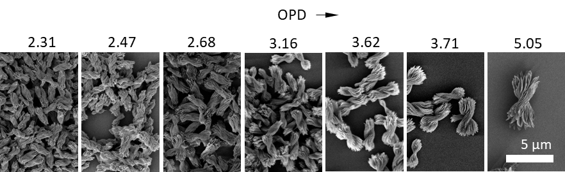
SI fig 46. SEM images and the corresponding OPD indices are shown here for bowties of different sizes for which the g-factor spectra is plotted in main text Fig 4a.

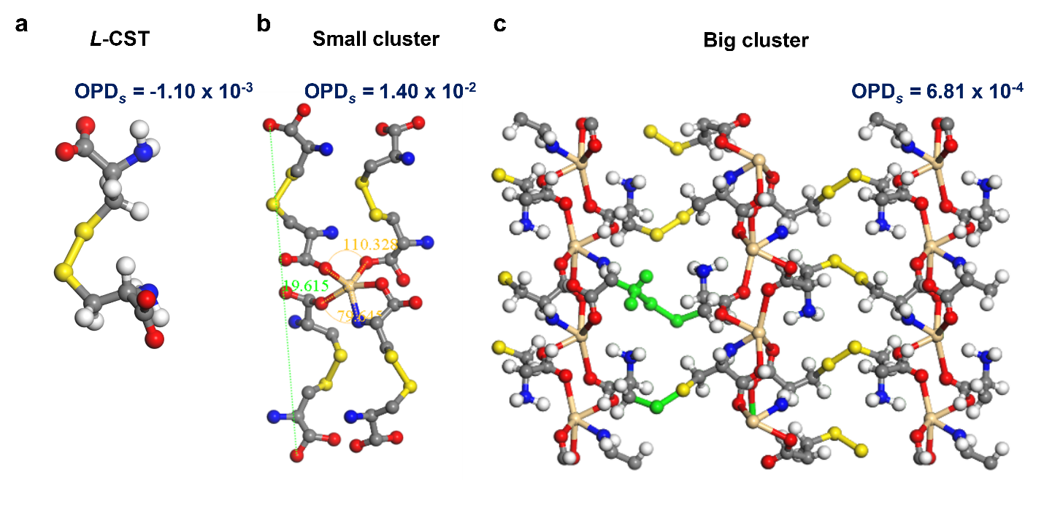
SI Fig 47. (a, b, c) The atomic structure and their point-scaled OPD_{s} for a, L-CST ligand in the conformation present in the nanosheet (i.e. ξ₁) , b, constitutive nanocluster (i.e. ξ₂), and c, nanosheet (i.e. ξ₃). d, e, Dependence of the standard (point-unscaled) OPD calculated for fully assembled bowties (i.e. ξ₄) based on 8-point set as described in Eq 20 on assembly conditions: d, varying [L-CST] and [Cd²⁺] concentrations; e, varying enantiomeric excess χ and [CST]/[Cd²⁺]. Color bars indicate the values of OPD. They are all positive for panel d. Red and blue color for panel e indicate the positive and negative values of OPD that are symmetrically opposite in respect to χ = 0 axis.
nanosheet
nanocluster
d
e
OPD
OPD
Note: Empirical relationship between different geometrical parameters of fully assembled bowies and point unscaled OPD calculated according to Eq. 20 (i.e. ξ₄):
$$l=0.014 {\left(OPD\right)}^{3.9}+1.7{ R}^{2}=0.63$$
$$w=0.00097 {\left(OPD\right)}^{5.2}+0.83{ R}^{2}=0.65$$
$$p=0.00041 {\left(OPD\right)}^{5.7}+2.7{ R}^{2}=0.44$$
$$t=0.064 {\left(OPD\right)}^{1.4}+0.18 R^{2}=0.32$$

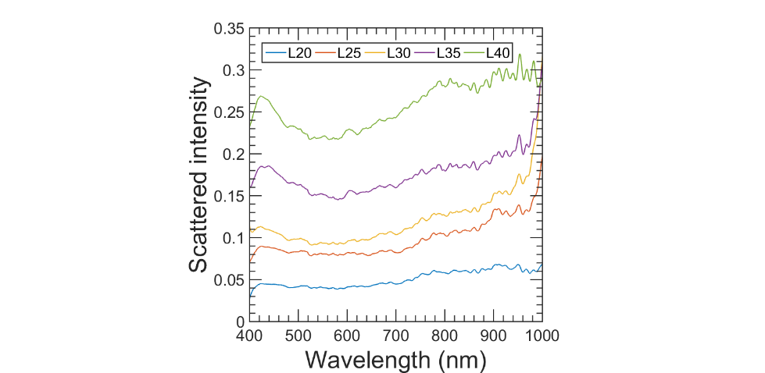
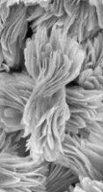
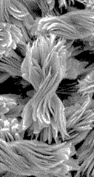
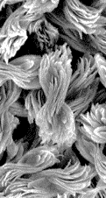
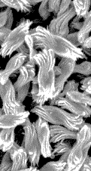
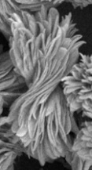
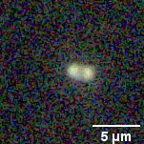
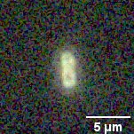
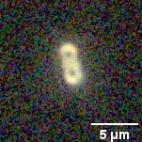
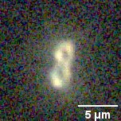
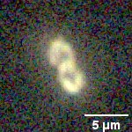
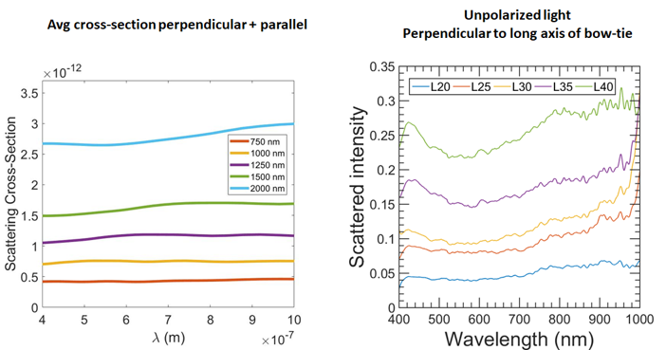
L-CST
3.5 mM
3 mM
2.5 mM
2 mM
4.0 mM
2 µm
a
L20
L25
L30
L35
L40
b
c
d
e
SI Fig 48. Single particle scattering. a, SEM images and b, the corresponding optical micrographs of bowties of increasing size. c, Scattering intensity spectra upon illumination of bowties with unpolarized light obtained from averaging data from 10 single particles of same size. d, Simulated real (n) and imaginary part (k) of refractive index for CdS and Cd₂(L-CST)₂. e, Simulated scattering cross-section for bowties of increasing sizes obtained as averages of polarized light incident in parallel and perpendicular orientation. The scattering intensity increases as the sizes of bowties increase. Overall, the scattering intensity is increased in the NIR regions as compared to visible region upon increase in size of bowties. Above trend is also observed upon simulations of bowties of different sizes.
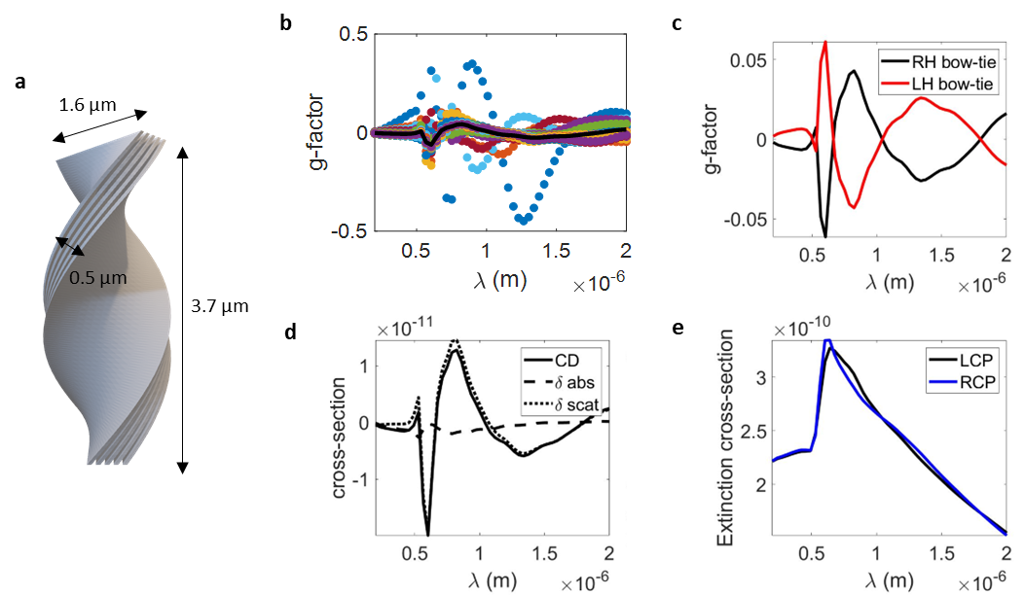
SI Fig 49. Calculated optical properties of bowties with geometry as l = 3772 nm, w = 1568 nm, t = 496 nm, p = 3247 nm. a, Model geometry of a bowties based on the particle geometry in Fig 1a. b, g-factor spectra from interaction of CPL with bowties along different orientations, and the averaged g-factor spectra shown in black. c, g-factor of left-handed vs right handed bowties. d, Differential scattering and absorbance contributions to the CD spectra of right handed bowties. e, Extinction cross-section for a right-handed bow-tie interacting with LCP and RCP. All the spectra are an average of 25 different orientations to mimic the experimental conditions of a freely rotating bowtie in water.
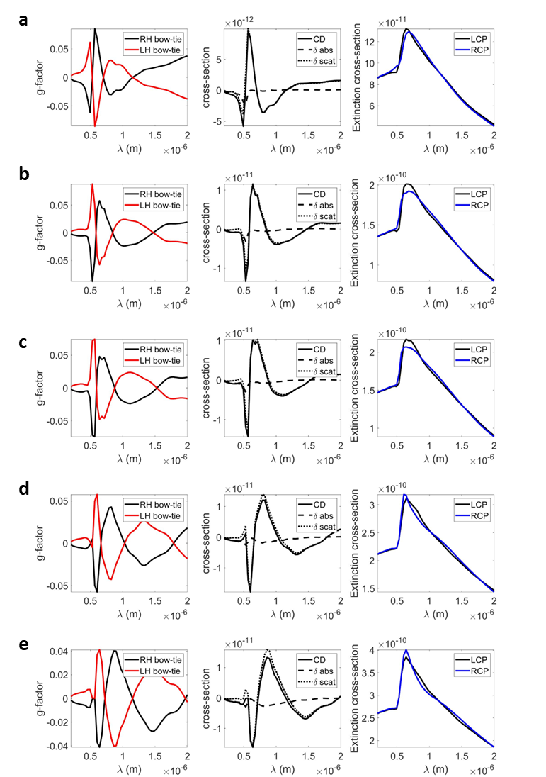
SI Fig 50. Simulated g-factor spectra for right handed twisted bowtie models. g-factor spectra for right vs left handed bowtie, differential contribution of scattering and absorbance, and extinction cross-section for LCP and RCP are plotted for bowtie models with point-unscaled OPD as a, 2.47 b, 2.68 c, 3.16 d, 3.62 e, 3.71 shown in Fig 4d,e in main text. All spectra are obtained by averaging 25 different orientations of bowtie with respect to incident beam.

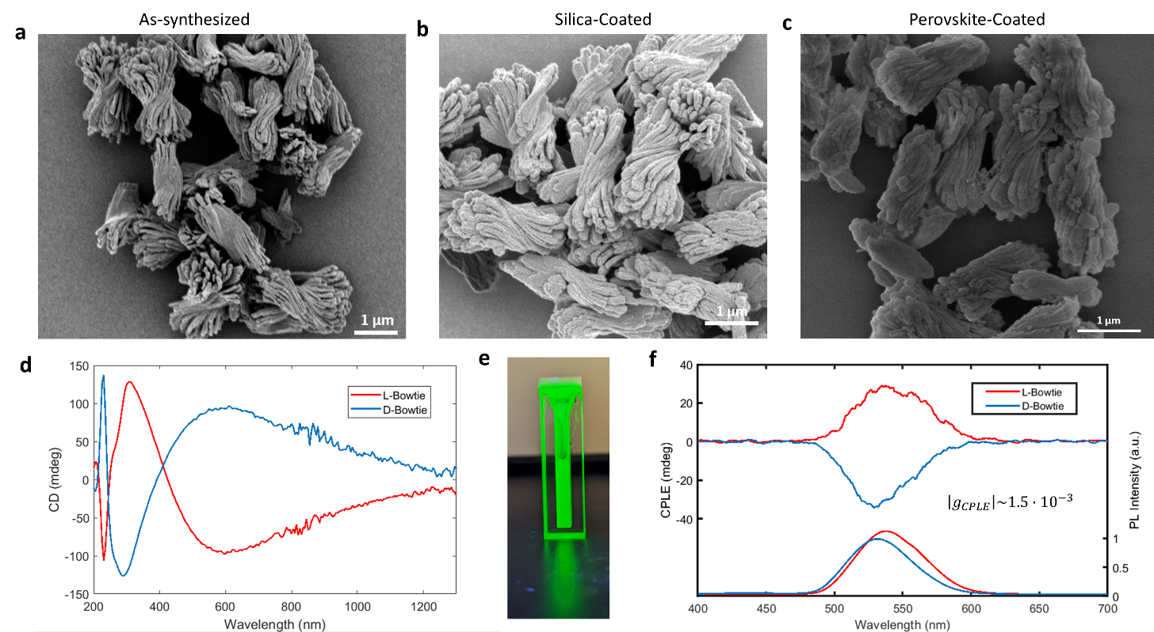
SI Fig. 51. SEM image of a, as synthesized bowtie, b, silica coated bowtie by Stöber process, c, formamidinium lead bromide perovskite nanocrystals coated atop the silica coated bowties. d, CD spectra of as-synthesized bowtie shown in panel a. e, photograph of a vial containing perovskite coated bowtie displaying green emission at 535 nm when excited with a UV lamp. f, Circularly polarized light emission spectra from perovskite coated bowtie with a g-factor of 1.5x 10⁻³.

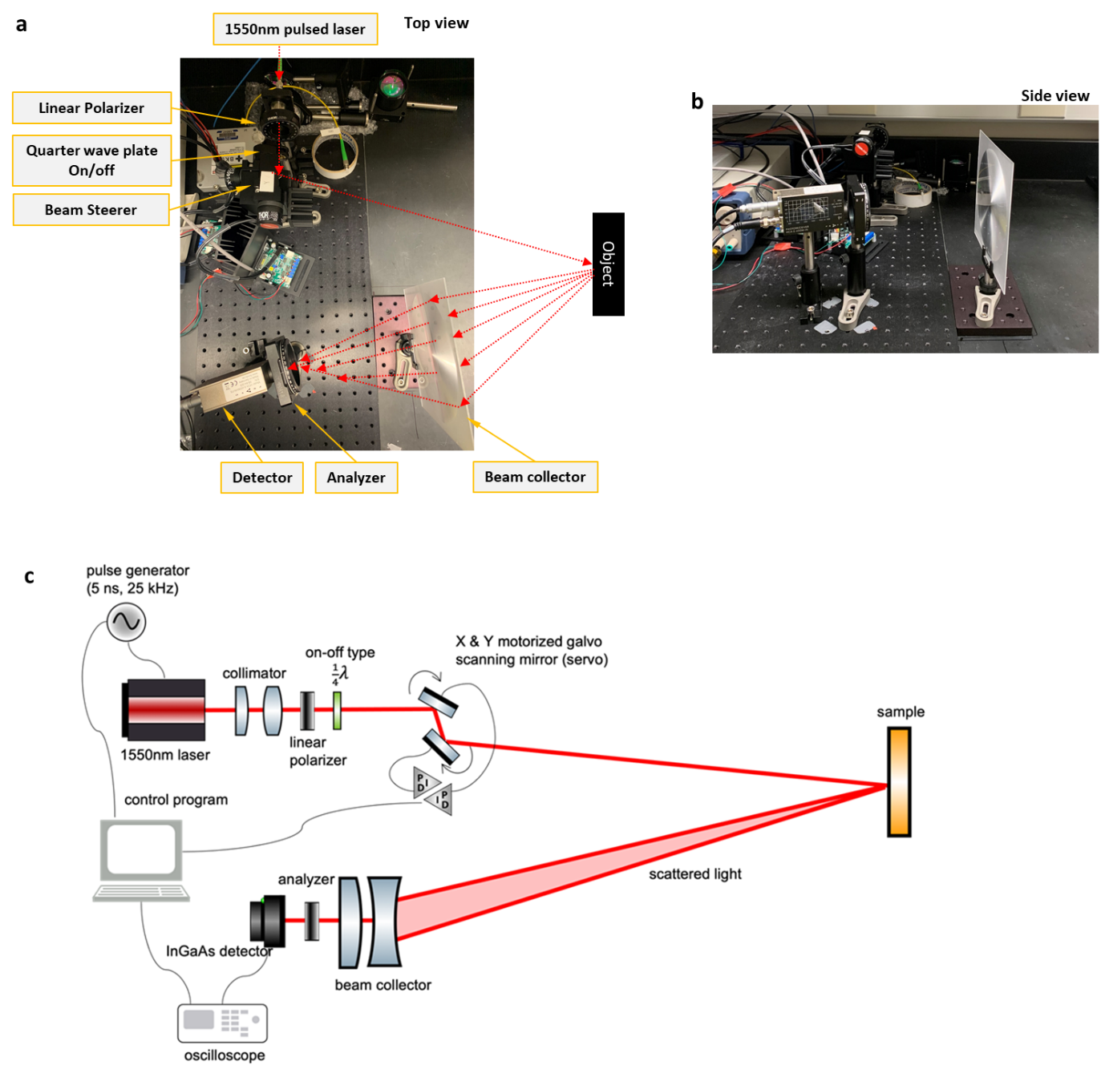

SI Fig 52. Polarization LIDAR setup for testing printed metasurfaces from bowties. Photographs of the optical arrangement for measuring the scattered rays from the bowtie coatings as seen from the a, top and b, side. c, Schematic of the polarization LIDAR setup with 1550 nm laser.

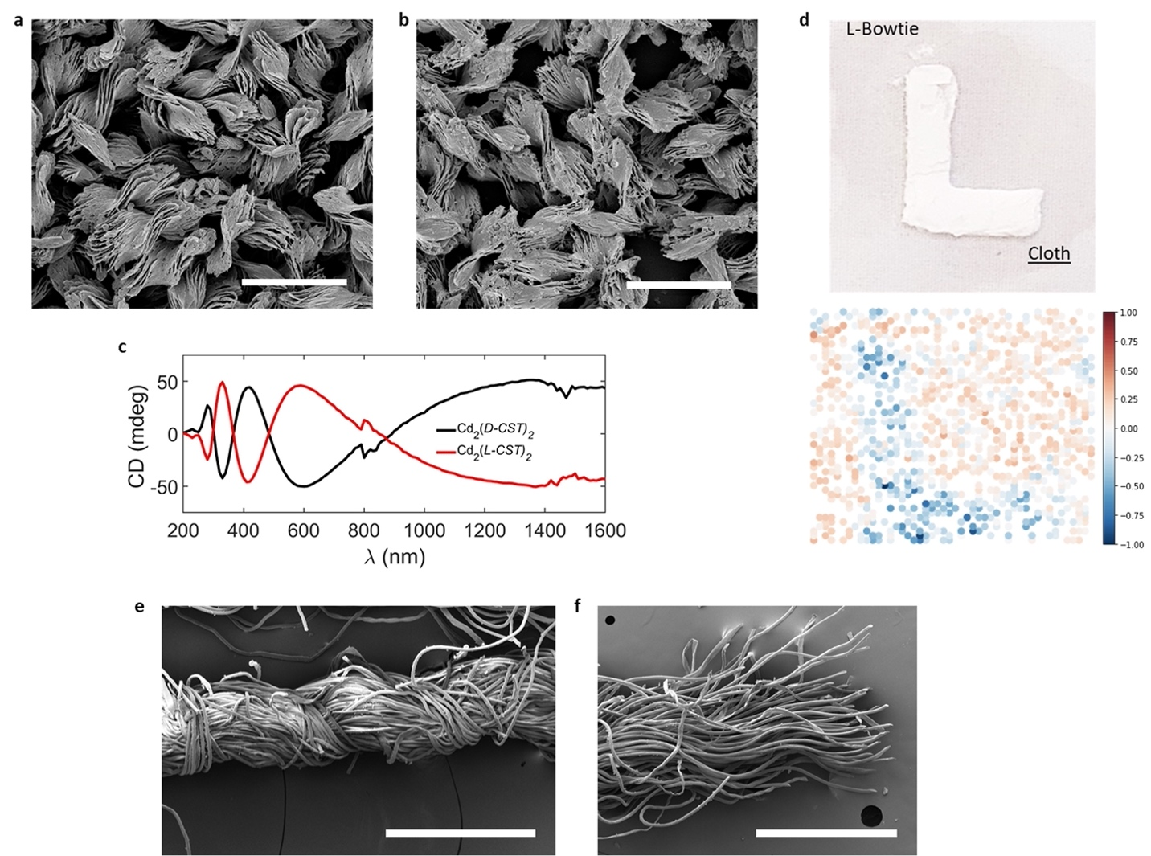
SI Fig 53. Bowties utilized in for printed metasurfaces tested by LIDAR with 1550 nm laser. SEM image of a, Cd₂(D-CST)₂ and b, Cd₂(L-CST)₂ bowties. c, CD spectra for the samples shown in panels a and b. d, Printed layer of L-bowties dispersed in PAA on cloth and the corresponding CD-LIDAR backscattered signal of 1550 nm wavelength. SEM image of e, fibers of cloth bundled together and f, individual fibers. Scale bars are in a,b are 5 µm and in e,f are 500 nm. The twist in fibers in the fabric results in the circular polarization of the back-scattered CD-LIDAR signal.

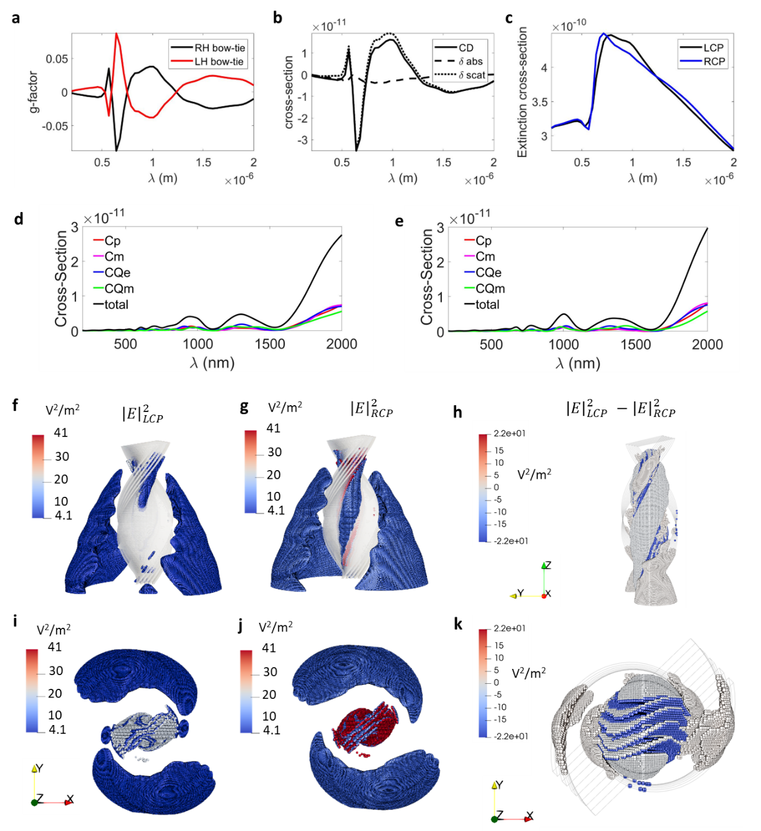
SI Fig 54. Simulated optical properties of bowtie morphology for LIDAR measurements. a, Averaged g-factor spectra of 25 orientations of bowties with respect to light beam. b, differential contribution of absorbance and scattering to CD spectra. c, Extinction cross-section for a right-handed model interacting with LCP vs RCP. Decomposition of scattering cross-section in to dipolar, quadrupolar electric and magnetic scattering contributions for d, RCP and e, LCP is plotted. Projections of twisted model and the point clouds of f,i, LCP, g,j, RCP and, h,k, differential scattered electric field of 1550 nm wavelength EM wave around it. Negative differential field colored in blue in panel h,k, (corresponding to negative g-factor and CD spectra in panel a,b respectively at 1550 nm) is concentrated in between the sheets that stack and twist together.

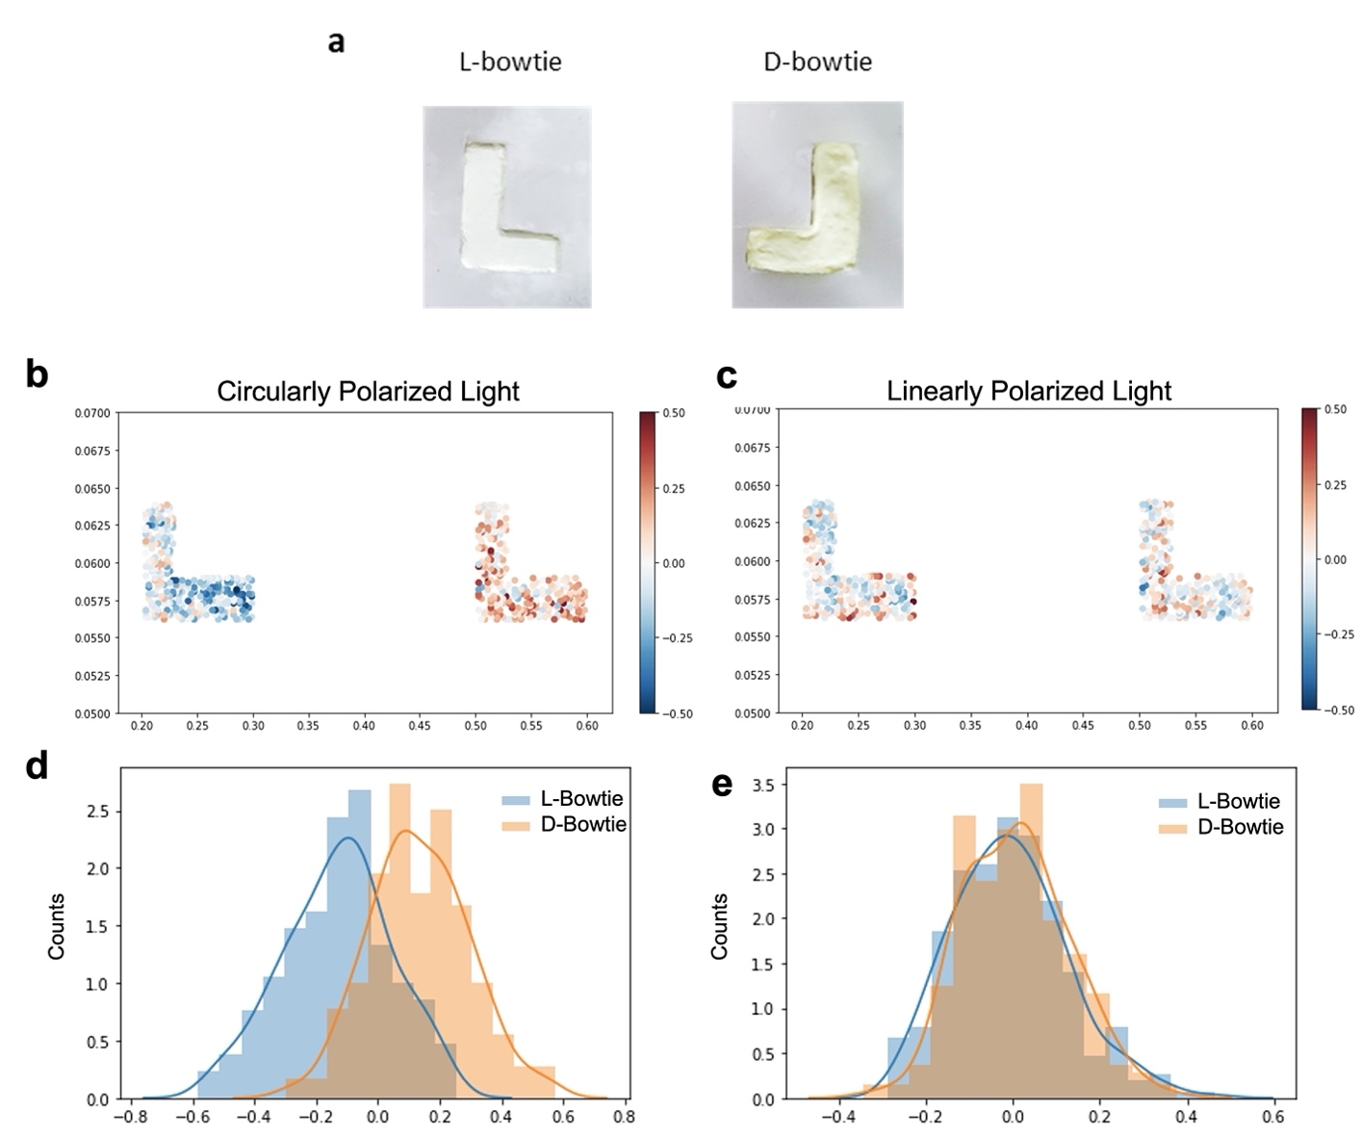

SI Fig 55. Comparison of LIDAR backscattered signal under circularly polarized light and linearly polarized light. A, Printed segment of L- and D-bowties on glass. b,c, The corresponding LIDAR backscattered signal at 1550 nm for b, circular dichroism and c, linear dichroism. d,e, The LIDAR backscattered signal intensity distribution for L- and D- bowties on glass under circularly (d) and linearly polarized light (e), respectively. The two peaks of L- and D- bowties are inseparable for linear dichroism signal from L- (mean is -0.0008) and D-bowties (mean is +0.0009). The two peaks of L- and D-bowties are separable for circular dichroism signal from L- (mean is -0.016) and D-bowties (mean is +0.017).

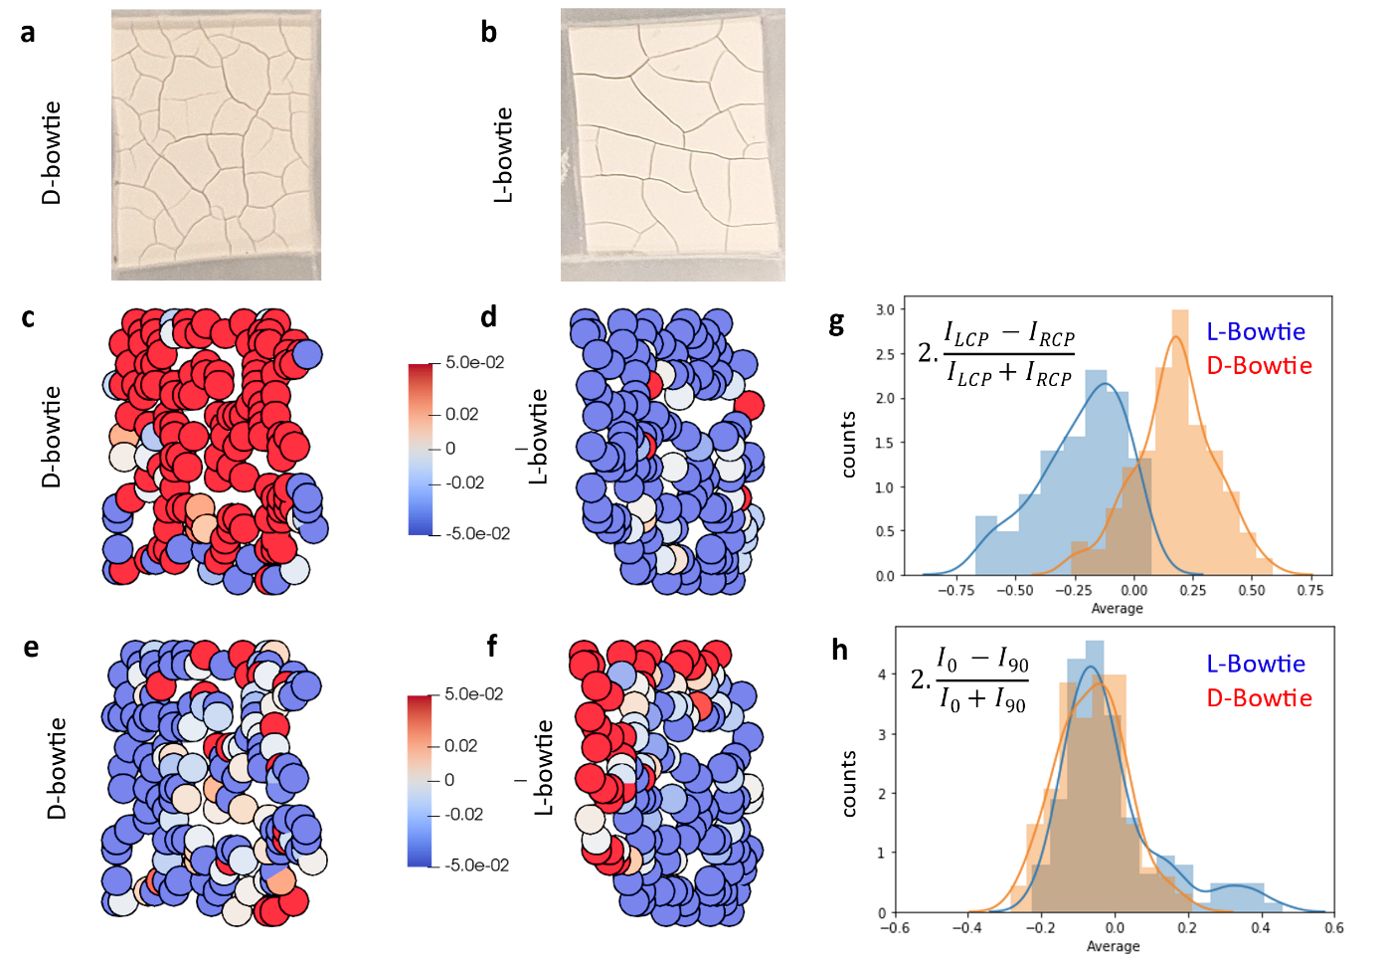
SI Fig 56. Coatings on glass and their chiral-LIDAR response. Photographs of dried coatings on glass for a, D- and b, L-bowties. Spatial c,d, circular dichroism and e,f, linear dichroism point clouds obtained upon scanning 1550 nm LCP and RCP over c,e D- and d,f, L-bowties. Histogram of g, CD and h, LD maps with a mean of -0.0009 (L) and -0.006 (D) for LD maps and -0.017 (L) and +0.017 (D) for CD maps.

SI REFERENCES
(1) Toby, B. H.; Von Dreele, R. B. GSAS-II: The Genesis of a Modern Open-Source All Purpose Crystallography Software Package. J. Appl. Crystallogr. 2013, 46 (2), 544–549. https://doi.org/10.1107/S0021889813003531.
(2) Osipov, M. A.; Pickup, B. T.; Dunmur, D. A. A New Twist to Molecular Chirality: Intrinsic Chirality Indices. Molec. Phys. 1995, 84 (August), 1193–1206. https://doi.org/10.1080/00268979500100831.
(3) Kim, J.-Y.; Yeom, J.; Zhao, G.; Calcaterra, H.; Munn, J.; Zhang, P.; Kotov, N. Assembly of Gold Nanoparticles into Chiral Superstructures Driven by Circularly Polarized Light. J. Am. Chem. Soc. 2019, 141 (30), 11739–11744. https://doi.org/10.1021/jacs.9b00700.
(4) Miklos Solymosi and Robert J. Low. A generalized scaling of a chiral index for molecules
J. Chem. Phys. 116, 9875, 2002, https://doi.org/10.1063/1.1476321
(5) Pettersen, E. F.; Goddard, T. D.; Huang, C. C.; Couch, G. S.; Greenblatt, D. M.; Meng, E. C.; Ferrin, T. E. UCSF Chimera--a Visualization System for Exploratory Research and Analysis. J. Comput. Chem. 2004, 25 (13), 1605–1612. https://doi.org/10.1002/jcc.20084.
(6) Kim, J.-Y.; Yeom, J.; Zhao, G.; Calcaterra, H.; Munn, J.; Zhang, P.; Kotov, N. Assembly of Gold Nanoparticles into Chiral Superstructures Driven by Circularly Polarized Light. J. Am. Chem. Soc. 2019, 141 (30). https://doi.org/10.1021/jacs.9b00700.
(7) Pettersen, E. F.; Goddard, T. D.; Huang, C. C.; Couch, G. S.; Greenblatt, D. M.; Meng, E. C.; Ferrin, T. E. UCSF Chimera--a Visualization System for Exploratory Research and Analysis. J. Comput. Chem. 2004, 25 (13), 1605–1612. https://doi.org/10.1002/jcc.20084.
(8) Amsterdam density functional program. URL: http://www.scm.com
(9) G. Te Velde, F. M. Bickelhaupt, E. J. Baerends, C. Fonseca Guerra, S. J. A. Van Gisbergen, J. G. Snijders, T. Ziegler. J. Comput. Chem. 2001, 22, 931–967.
(10) C. Fonseca Guerra, J.G. Snijders, G. te Velde, E.J. Baerends. Theor. Chem. Acc., 1998, 99, 391–403.
(11) S. K. Wolff, Int. J. Quant. Chem. 2005, 104, 645–659.
(12) V.P. Nicu, J. Neugebauer, S.K. Wolff, E.J. Baerends. Theor. Chem. Acc., 2008, 119, 245–263
(13) V.P. Nicu, Phys. Chem. Chem. Phys., 2016, 18, 21213–21225.
(14) Marcel Swart, F. Matthias Bickelhaupt, J. Comput. Chem., 2007, 29, 724–734.
(15) J. P. Perdew. Phys. Rev. B, 1986, 33, 8822–8824.
(16) A. D. Becke. Phys. Rev. A, 1988, 38, 3098–3100.
(17) E. van Lenthe, E.J. Baerends, J. Comput. Chem., 2003, 24, 1142–1156.

