Supplementary Information:

Thousands of conductance levels in memristors monolithically integrated on CMOS
Mingyi Rao^{1,2,5}, Hao Tang^{3,5}, Jiangbin Wu^{4,5}, Wenhao Song^{4,5}, Max Zhang¹, Wenbo Yin¹, Ye Zhuo⁴, Fatemeh Kiani², Benjamin Chen², Xiangqi Jiang¹, Hefei Liu⁴, Hung-Yu Chen⁴, Rivu Midya², Fan Ye², Hao Jiang², Zhongrui Wang², Mingche Wu¹, Miao Hu¹, Han Wang⁴, Qiangfei Xia^{1,2}, Ning Ge¹, Ju Li³, J. Joshua Yang^{1,2,4,*}

¹TetraMem Inc., CA, USA
²Department of Electrical and Computer Engineering, University of Massachusetts, Amherst, MA, USA
³Department of Materials Science and Engineering, Massachusetts Institute of Technology, Cambridge, MA, USA
⁴Ming Hsieh Department of Electrical and Computer Engineering, University of Southern California, Los Angeles, CA, USA
⁵ These authors contributed equally.
* email: jjoshuay@usc.edu

Index of Supplementary Figures and Notes
Fig. S1 The electron energy loss spectroscopy (EELS) elemental image of the memristor 3
Fig. S2 Statistics of reading standard deviation in an as-programmed memristor 4
Fig. S3 Readout currents with different sampling intervals of a memristor’s state by a constant 0.2V voltage 5
Fig. S4 The algorithm of high precision programming 7
Fig. S5 Programming result of Memristor at high conductance state 8
Fig. S6 Programming randomly chosen memristors on different dies of an 8-inch wafer 9
Fig. S7. The pattern programming and denoising in a 256 × 256 1-transistor-1-memristor (1T1M) array 10
Fig. S8. The testing environment and the schematic of the 1T1R array with its driving circuits 11
Fig. S10. The denoising effect of TaOx based device 15
Fig. S11 The relationship between the estimated contact radius and set point 16
Fig. S12 C-AFM denoise result in a device with material stack Pt/HfO2/Ta 17
Fig. S13 RTNs only appear when an incomplete filament exists 18
SI-14 Discussion on the likely RTN-responsible defect 19
Fig. S15. The band structure of HfO2 with an oxygen interstitial defect with/without a trapped electron 22
SI-17 The analysis of electronic/atomic noise effect 24

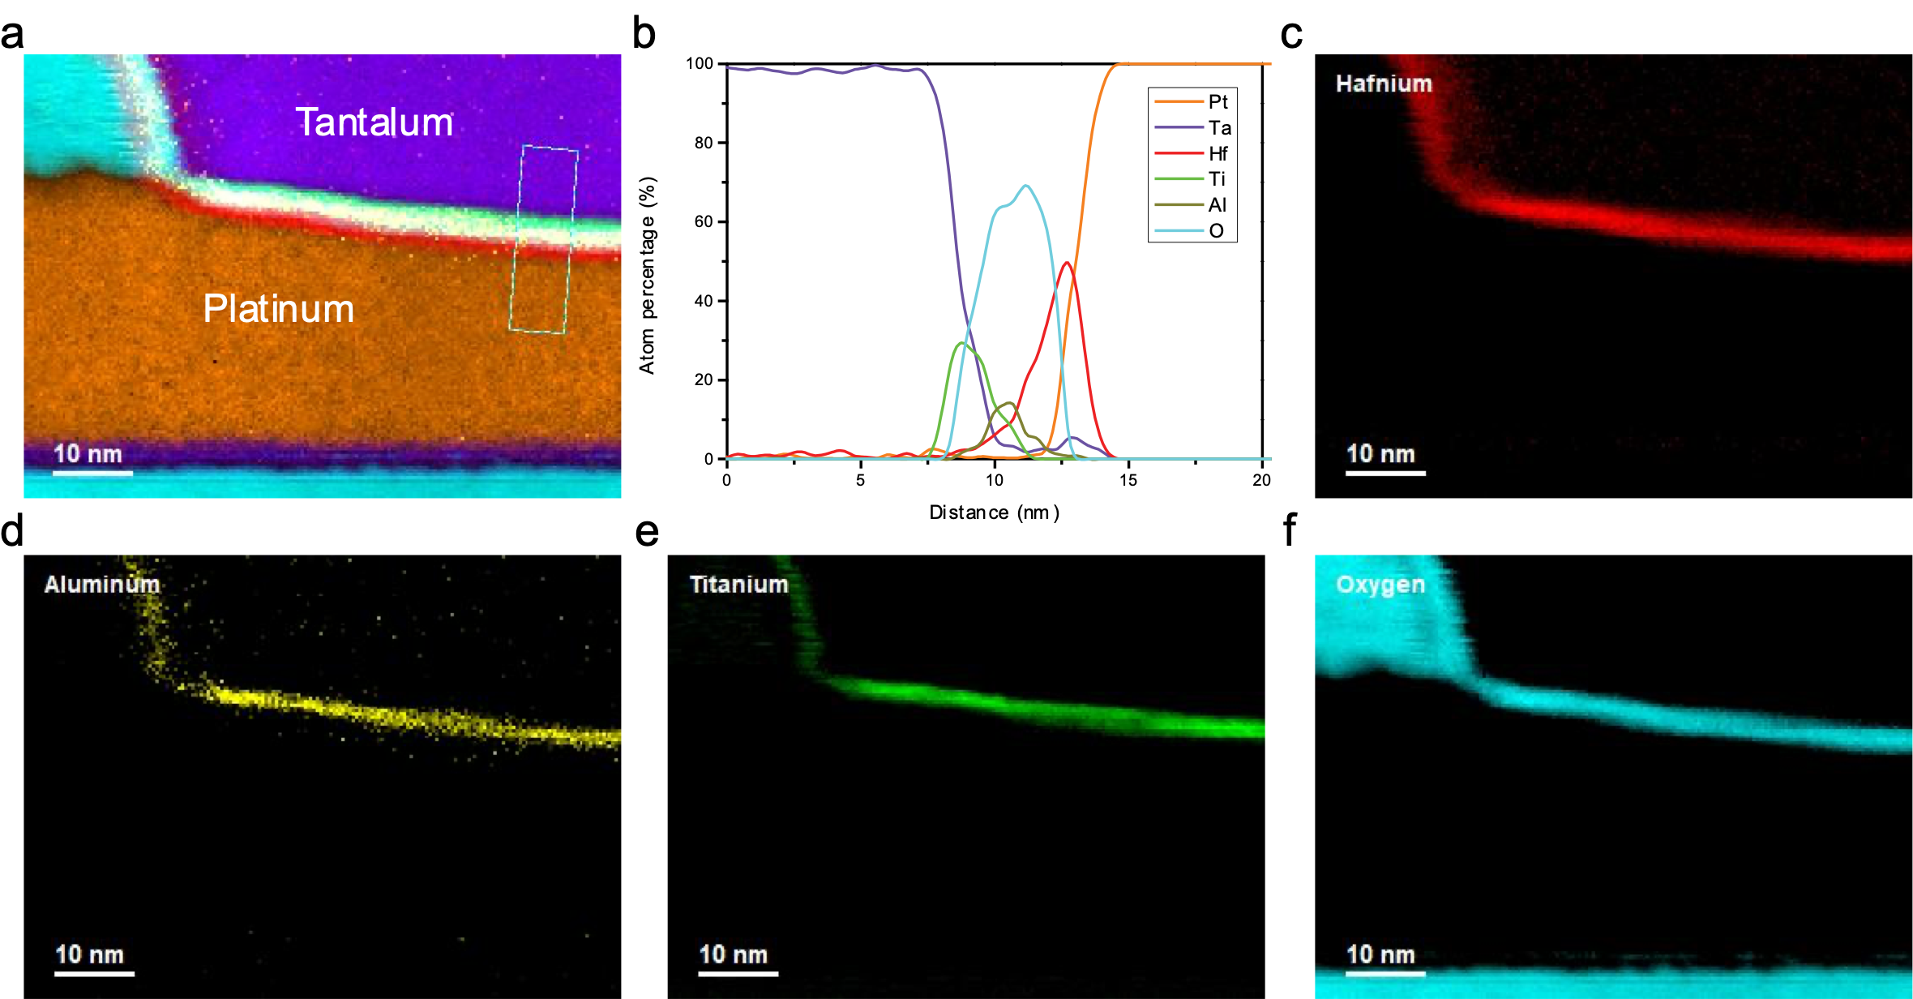
Fig. S1 The electron energy loss spectroscopy (EELS) elemental image of the memristor shown in Fig. 1. a) The stacked profile of all elements. b) Atomic percentage in the rectangle marked in a). c) to f) The elemental distribution of c) Hafnium, d) Aluminum, e) Titanium, f) Oxygen.

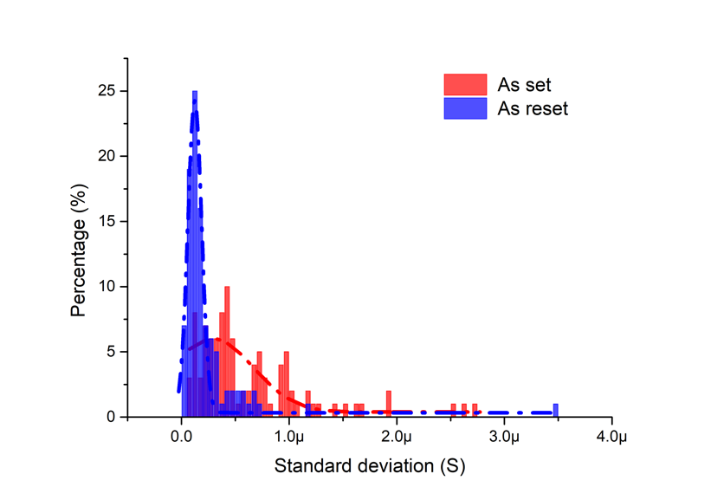
Fig. S2 Statistics of reading standard deviation in an as-programmed memristor. A single memristor was programmed 200 times, in which 100 programming operations ended with a SET operation and the other 100 programming operations ended with a RESET operation. Small voltages were applied so that the device only slightly SET/RESET within a small conductance range within ±10 µS of 100 µS. After each programming operation, the device was read by a constant -0.2V voltage for 5s and the standard deviation of each reading was recorded, which showed a wide distribution from less than 0.2µS to 3.5 µS.

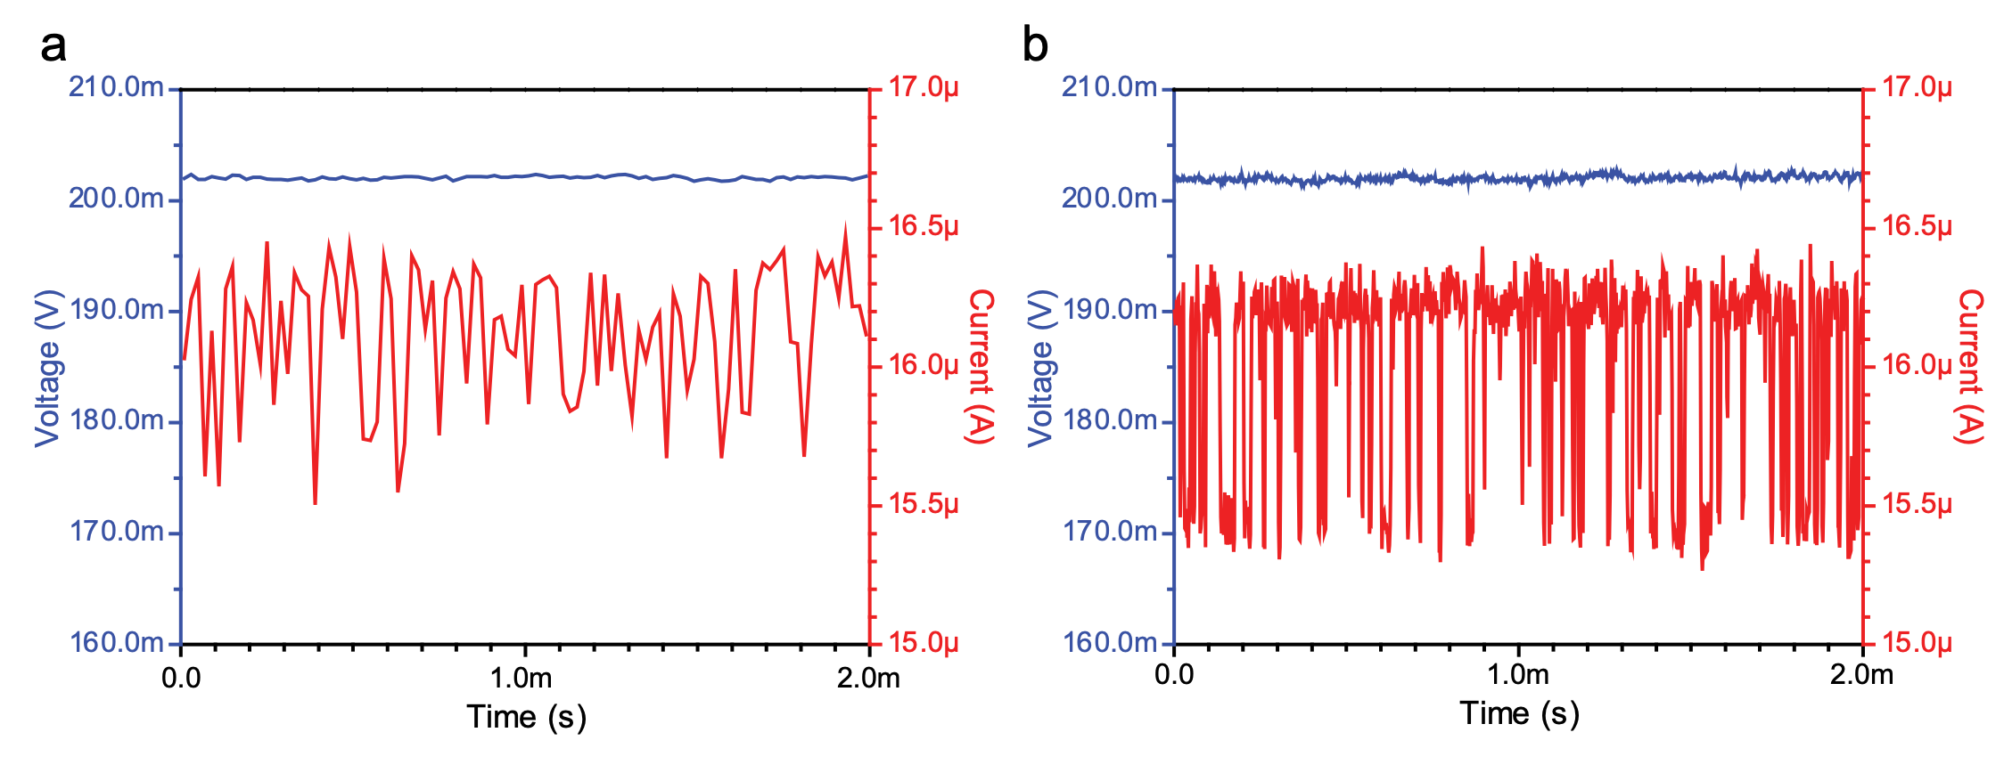
Fig. S3 Readout currents with different sampling intervals of a memristor’s state by a constant 0.2V voltage. a) Sampling interval at 20 µs. b) Sampling interval at 2 µs. When the sampling rate is comparable or lower than the frequency of the RTNs, the waveform is distorted, as shown in a). Although being distorted, the noise amplitude is similar to that of the RTNs in b), suggesting that RTN is the main contributor to large amplitude noise in memristors.

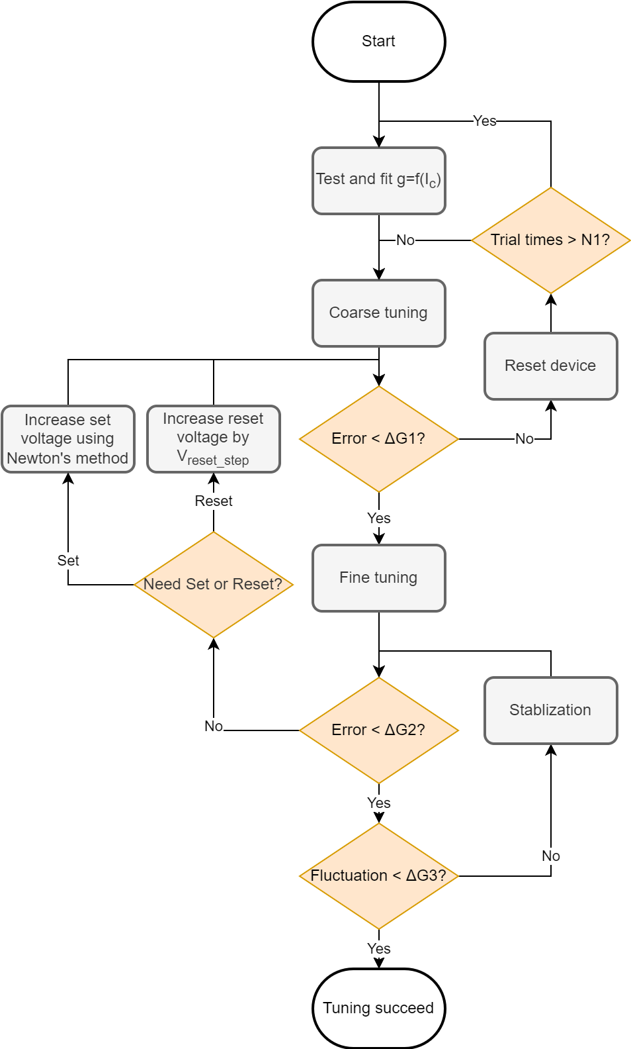
Fig. S4 The algorithm of high precision programming. The algorithm was implemented using C# language which could control a Keysight B1500 Semiconductor Device Analyzer by controlling the programming voltage with customized parameters.
We first constructed a model for the device and used it to coarsely tune the device. The device was gradually set by a 2V DC signal using different compliance currents with an increment of 50 µA from 50 µA to 2 mA. After each set operation, the device was read by a 0.2V voltage. After the 2 mA set current compliance was reached, the device was reset by -1.5V to the initial state. That set/read data collection process was repeated for 5 times to minimize the effect of cycle-to-cycle variation. After all the compliance current-conductance pair data (Ic, g) were collected, they were fitted into a linear model g = f (I_{c}). When using a transistor as the current limiter, the gate voltage of the transistor could be calculated according to its transfer curve. The device was then set to each target conductance using the compliance current predicted by the model. This was called coarse tuning. If the resulted conductance was within a tolerance $∆G1$ of the target, the coarse tuning was successful and the fine tuning was applied next. If the deviation was larger than $∆G1$, the device was reset and coarsely tunned again. If the coarse tuning failed after N1 attempts, the estimated model g = f (I_{c}) was no longer correctly representing the current status of the device, so we re-calibrated it and started over again. The typical value of $∆G1$ was 50 µS and N1 was 5.
During the fine tuning, we set/reset the device if the current conductance was smaller/larger than the target. For the set operation, the voltage for the next set operation was calculated using the Newton’s method where the gradient was extracted from coarse tuning result, and for the reset operation, the reset voltage amplitude was increased by a fixed step each time. After each set/reset operation, the device conductance was read by a 0.2V DC voltage and compared to the target conductance. If the difference was larger than a predefined tolerance $∆G2$ (typically 1 µS), another round of set/reset was performed. Once the difference was smaller than $∆G2$, the device current was read at a constant 0.2V signal for a constant of time to measure its fluctuation over time. That fluctuation measurement was done multiple times and each fluctuation measurement was conducted within 10s to save time. If the conductance fluctuation was larger than a predefined value $∆G3$ (typically 2µS), a stabilization process took place, which typically used one or more one-positive-one-negative pulse pair (until the noise level is within the tolerance range) at 0.35V. The stabilization voltage may sometime change the average conductance of the device. If the actual-target conductance mismatch was larger than $∆G1$ or $∆G2$, a corresponding coarse tuning or fine tuning process was applied again.

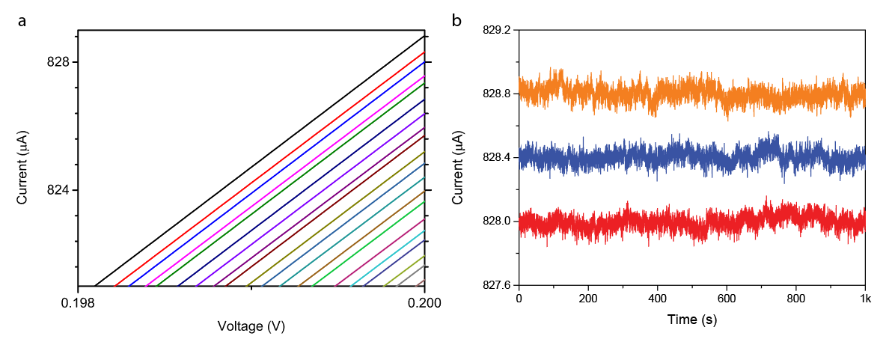
Fig. S5 Programming result of Memristor at high conductance state. a) Zoom-in image of Fig. 1g near 4144 µS. b) Zoomed-in view of three nearest neighboring states near 4144 µS after denoising. The current of each state was read by a constant 0.2V voltage. No large-amplitude RTN was observed, and all the states can be clearly distinguished.

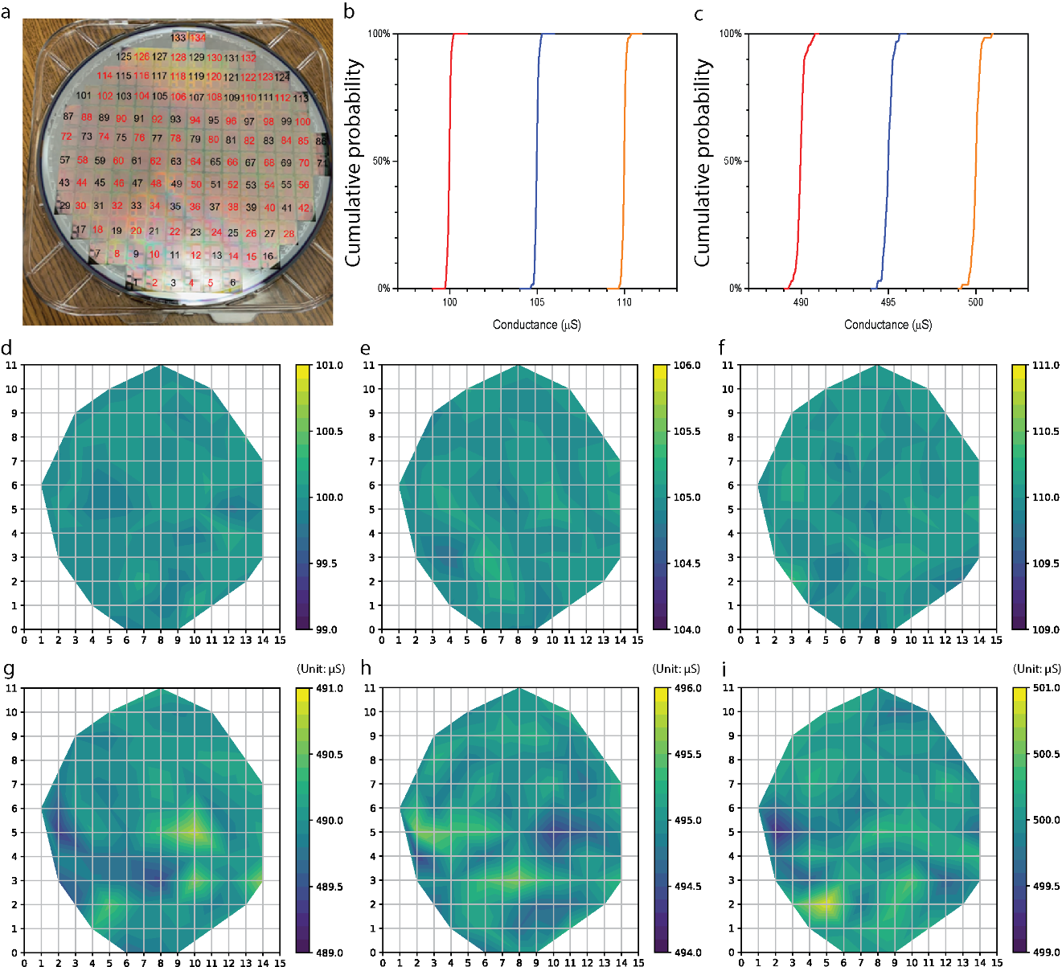
Fig. S6 Programming randomly chosen memristors on different dies of an 8-inch wafer. a) The photo of wafer used for testing. red numbers marked the dies that were measured. b) Cumulative probability curve of conductance as a result of memristors being programmed into 100 µS, 105 µS, 110 µS. c) Cumulative probability curve of conductance as a result of memristors being programmed into 490 µS, 495 µS, 500 µS. d) to i) The contour map of conductance as a result of memristors on the same wafer but different dies being programed into 6 different conductance state. In the 15 by 11 matrix, each block that has color other than white correspond to a die used in the measurements.

Fig. S7. The pattern programming and denoising in a 256 × 256 1-transistor-1-memristor (1T1M) array. The algorithm is similar to Fig.S4 but performed in a 256 × 256 array. Each array-programming operation is followed by an array denoising operation. In all subplots 1 Least Significant Bit (LSB) is 2.34 µS. a) The target weight map of the programming. b) The programmed weight map. c) The reading noise of devices in the array after the initial programming before the first denoising operation. d) The final reading noise of devices in the array after 7 iterations of programming-denoising, the number of noisy devices significantly decreased compared to those in c). e) The histogram of all device noise level. The inset is a zoomed-in view of the histogram in the range of 0-2%. f) The trend of average reading noise in all 65536 devices in the 7 iterations of programming / denoising.

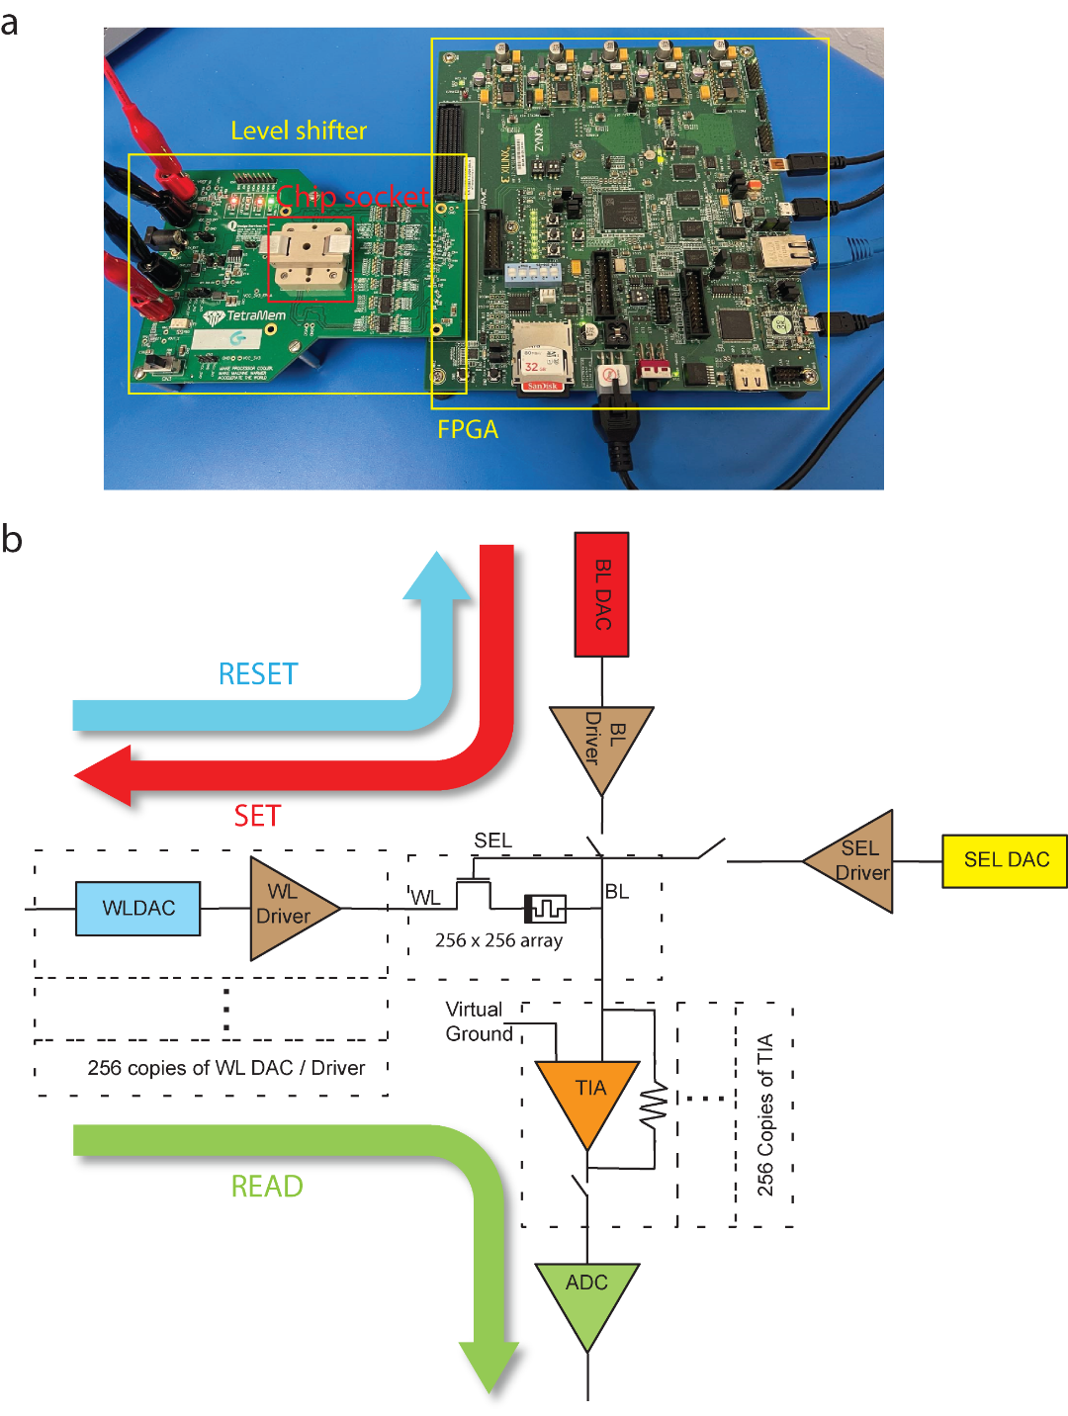
Fig. S8. The testing environment and the schematic of the 1T1R array with its driving circuits. a) The testing set up. The 1T1R array and its driving circuits are controlled by a field programmable gate array (FPGA) through a voltage level shifter. b) The schematic of the 1T1R array and its on-chip driving circuits. Device reading and writing voltage are controlled by on-chip digital-analog-converters (DACs). Current reading is realized by a transimpedance amplifier (TIA) and an analog-digital-converter (ADC). The current flow direction in the three basic operations (SET, RESET and READ) are marked by arrows.

SI-9 Estimation of system cost of denoising and comment
Based on the algorithm of high precision programming in Fig. S4, the total process can be divided into 3 phases: tuning (gradually switch the device to target value), fluctuation scan (scan to verify whether the fluctuation of the target value is acceptable or not), and stabilization (denoising operation using subthreshold voltage pulses).
The energy consumption is calculated as follows:
// INPUT: the target matrix $W_{target }$, the error history matrix $W_{err}$ and the set and reset voltage history matrices $V_{set}$ and $V_{reset}$ of the whole array during 200 tuning cycles. All scalars are known parameters.
For $i←1…200$ do
Calculate conductance matrix $G_{i}$ from $W_{target }$and $W_{err,i}$
Calculate mean $P_{read, i},P_{set, i} and P_{reset, i}$ from known $V_{read}, V_{set, i}$ and $V_{reset, i}$ and then averaging over all devices.
End for
$E_{tune}←sum\left(P_{read, i}+P_{set, i}{+P}_{reset, i}\right)*t_{pulse}$
$E_{scan}←P_{read, 200}*n_{scan}*t_{pulse}$
$P_{stab}←mean(V_{stab}^{2}*G_{200})$
$E_{stab}←P_{stab}*n_{stab}*t_{pulse}$
Energy of different tuning cycles are estimated from the mean tuning energy $\frac{E_{tune}}{200}*n_{tune}$.
The time estimation is counting the number of pulses of each phase as the pulse width is fixed (10 us here).
The energy and time consumption of the high precision programming algorithm is summarized in Fig. S9.
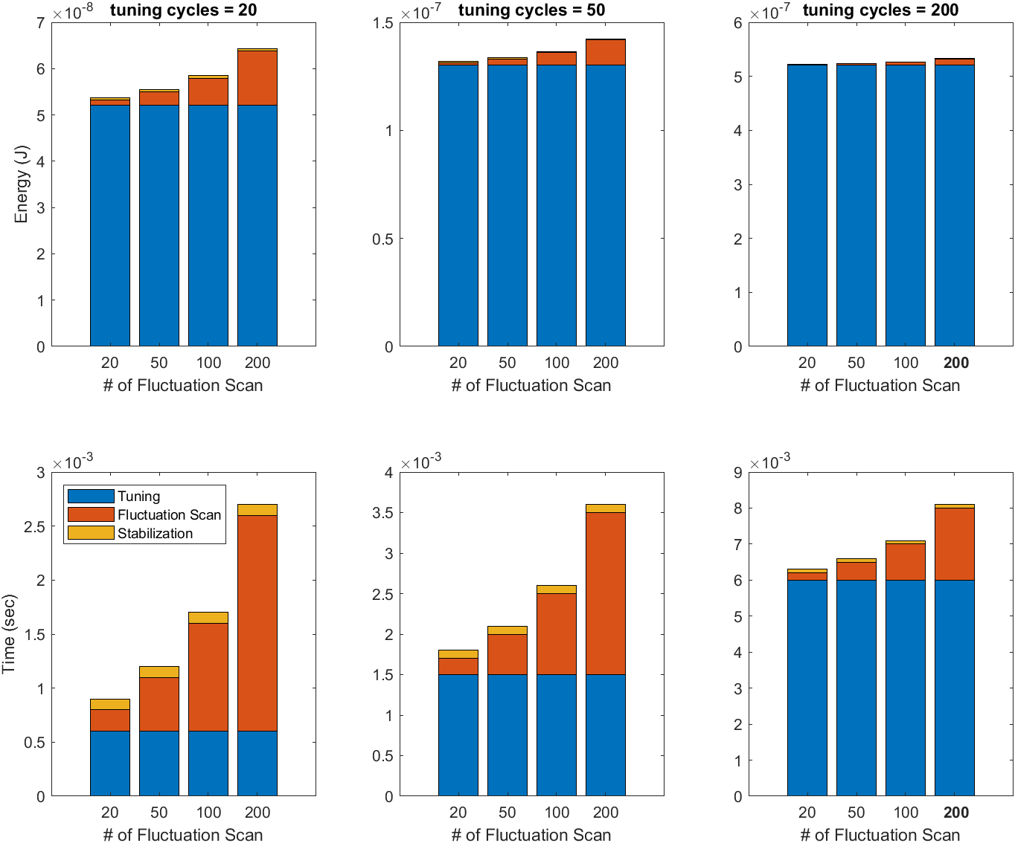
Fig. S9. The energy and time consumption per cell of different phases of the high precision programming algorithm. Different tuning cycles from 20, 50 to 200 and different fluctuation scan times from 20, 50, 100 to 200 are calculated based on the experimental data with 200 tuning cycles and 200 fluctuation scans.

In the experiments reported in here, we used 200 tuning cycles and 200 fluctuation scans, corresponding to the right most bar of the right most subplot. In more optimized algorithms, we could shorten the cycle numbers needed by combining coarse and fine-tuning processes. It can be seen that the extra energy added by the denoising processing (fluctuation scan and stabilization) is actually a relatively small fraction of the energy needed to switch the device to the target value anyway. The time needed for each cell is a few milliseconds, which make the total time needed for a large array (e.g., 1000x1000) a few seconds in semi-parallel operation schemes (row by row).
In addition, there are other reasons that make the denoising process necessary for reliable computing:
- The device and protocols are mainly for edge computing. The advantage of analog memristive crossbar array mainly lies in fast and energy efficient inference. It is rare to frequently train the arrays distributed on the edge. The infrequent training makes the extra time and energy affordable and worthy for a high inference performance.
- The existence of incomplete channels is detrimental for the array. They result in reading accuracy degradation; furthermore, because they are sensitive to sub-threshold voltage, they are also at higher risks in unpredictable re-shaping / re-composition by inference operations. The denoising process, not only reduces the immediate reading error, but also removed those unstable incomplete channels which reduces long-term risks for applications. So we believe it is an essential process to suppress those RTNs for long term reliabilities, which cannot be achieved by other approaches, including the Write-Verify approach.

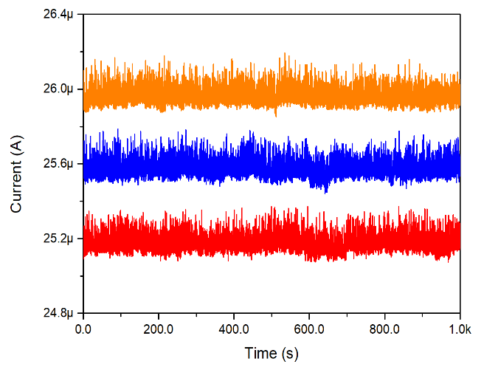
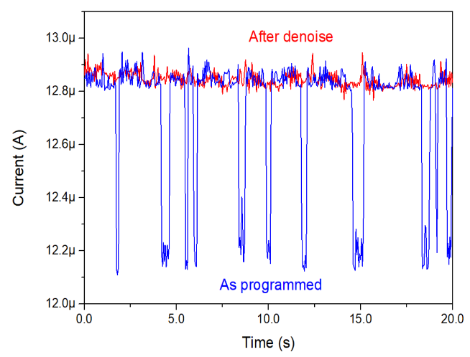
a
b

Fig. S10. The denoising effect of TaOx based device. The device was fabricated by a similar process to the device as shown in Fig.1 except that the HfO₂ layer was replaced by TaO_{x} layer. The device was read at a constant 0.2V voltage. a) By using a similar denoise operation, the device reading fluctuation can be reduced to below 2 µS. b) A comparison between the device reading when it is as-programmed (blue) and after denoise b).

Fig. S11 The relationship between the estimated contact radius and set point. The contact radius for the scanning of the shape of the conduction channels and the in situ denoising of the conduction channels are controlled to be different by tuning the set point, which is corresponding to the applied force of the AFM tip. In detail, When the set point was set to 10 nm, which was used for the conduction channel scanning, the contact radius is about 1.2 nm, which is small enough to resolve the details of the channel. When the set point was set to 80 nm, which was used for the in situ denoising, the contact radius is about 64.4 nm, which is large enough to cover entire the channel area (with a diameter around 20 nm here).

Fig. S12 C-AFM denoise result in a device with material stack Pt/HfO2/Ta. a) The current readings by 0.1V voltage before (red) and after (blue) a successful denoise process by “below switching threshold” RESET voltage. b) The current readings by -0.1V voltage before (red) and after (blue) a successful denoise process by “below switching threshold” SET voltage. c) Conductance map measured by C-AFM scanning corresponding to the before-denoise state (red) in a). d) Conductance map corresponding to the after-denoise state (blue) in a). e) Conductance map measured by C-AFM scanning corresponding to the before-denoise state (red) in b). f) Conductance map corresponding to the after-denoise state (blue) in b). All scale bar: 10 nm.

Fig. S13 RTNs only appear when an incomplete filament exists. a) the current reading by C-AFM of a noisy resistance state (state 1, plotted in orange solid line), the state reset from state 1 (state 2, plotted in red solid line) and the stabilized state 2 (plotted in blue dashed line). b) Conductance map scanning of the filament region at state 1. c) Conductance map scanning of the filament region at state 2 before stabilization. d) Conductance map scanning of the filament region at state 2 after stabilization.

SI-14 Discussion on the likely RTN-responsible defect
The RTN amplitude and frequency offer important clues for detailed understanding of its mechanism in our devices. Without changing the atomic structure, the likely reason for changes in electronic structure is charge trapping/de-trapping, as the RTN mechanism established in ref. [IEEE Transactions on Electron Devices, vol. 61, no. 8, pp. 2920-2927, 2014]. For verification, three different reading voltages are sequentially applied to a memristor (with no denoising process applied, see Fig. S14a). The RTN is observed at each plateau with an amplitude proportional to the amplitude of the total current. The observed RTNs have an evident bistable character, suggesting that only one incomplete channel is being modulated between ‘blocked’/’unblocked’ states. The residence time at the higher current level of the bistable states of each RTN event, $τ_{1}$, is statistically inversely related to the absolute value of the applied voltage, while the residence time at the lower current level, $τ_{0}$, shows no significant relation with the applied voltage, as shown in the solid curves in Fig. S14b. The statistical analysis of RTN and the atomistic simulation results suggest that interstitial oxygen defects may be responsible for the observed RTNs (defect structure and electronic structure shown in the insets to Fig. S14b).
In this hypothesis (where interstitial oxygen defects are RTN-responsible), a close-shell interstitial oxygen ion $O_{i}^{''}$ attracts two holes $h^{•}$ to compensate its charge and form an interstitial oxygen defect in neutral states, $O_{i}^{×}$ [Physical Review B, vol. 81, no. 16, p. 161201, 2010]. $O_{i}^{×}$ hosts a localized empty $σ^{*}$ state in the upper band gap, [Microelectronic engineering, vol. 80, pp. 408-411, 2005] acting as a trap for electrons. The trap state is an antibonding orbital of the interstitial oxygen and the adjacent oxygen. After capturing an electron that annihilates one $h^{•}$ in the $O_{i}^{×}$, the defect becomes negatively charged $O_{i}^{'}$, [Microelectronic engineering, vol. 80, pp. 408-411, 2005] and the trap state is occupied by a spin-up electron (Fig. S15). As the occupation of the antibonding orbital significantly weakens the bond between the interstitial oxygen ion and its adjacent oxygen ion, evident atomic relaxation happens during the electron trapping (Fig. S14b). This leads to a large atomic relaxation energy of 2.62 eV and a long characteristic time of the RTN. The potential energy of electrons in the conduction channel is raised by the electrostatic repulsion, giving rise to an energy barrier. Therefore, the conduction channel can be partially or entirely blocked by the charged defect, depending on the conduction channel size and oxygen vacancy concentration. Therefore, the neutral state and negatively charged state correspond to the high current level and low current level in the RTN, respectively. With this picture, $τ_{1}$ and $τ_{0}$ are simulated by the electron capture rate (1/$τ_{c}$, $τ_{c}=τ_{1}$) and emission rate (1/$τ_{e}$, $τ_{e}=τ_{0}$) of the defects.
Fig. S14 Statistics of trapping/detrapping time and possible RTN-responsible defect. (a) Applied electric voltage and measured current in the device as a function of time. Three voltage plateaus (-0.15, -0.20 and -0.25 V) are applied, and two-level RTNs are observed. (b) Simulation results of the probability density of the lifetime of the oxygen interstitial defect at neutral ($f\left(τ_{1}\right)$) and -1 charged states ($f\left(τ_{0}\right)$) at the three-voltage plateaus, which agree well with the experimentally observed statistical distributions of $τ_{1}$and $τ_{0}$. The insets show the charge density function of the electron trap orbital by the grey-scale map (color from grey to white plotted as the background) and the iso-surface of $ρ=0.015 e/Å^{3}$ is marked cyan. The balls represent atoms: the green ball is the interstitial oxygen ion, red balls are other oxygen ions, and light-yellow balls are Hf ions.

The value of $τ_{c}$ and $τ_{e}$ are computed in a similar method as reported in ref.[IEEE Transactions on Electron Devices, vol. 62, no. 8, pp. 2606-2613, 2015], where the material-specific parameters were chosen according to our device information and first principle calculation results. It can be observed the distribution curves of $τ_{0}$ and $τ_{1}$ first increase with the time then decrease. We defined an empirical coefficient $τ_{d}$ and modified the distribution function as:
$$f_{c}\left(t\right)=\frac{1}{(τ_{c}-τ_{d})}e^{-\frac{t}{τ_{c}}}(1-e^{-\frac{τ_{c}-τ_{d}}{τ_{c}τ_{d}}t})$$
$$f_{e}\left(t\right)=\frac{1}{(τ_{e}-τ_{d})}e^{-\frac{t}{τ_{e}}}(1-e^{-\frac{τ_{e}-τ_{d}}{τ_{e}τ_{d}}t})$$
Where $τ_{c}, τ_{e}$ are the average intrinsic capture time and emission time, respectively, of the oxygen interstitial defects, functions f_{c,} and f_{e} are the simulated distribution functions of the capture time and emission time, respectively, $τ_{d}$ is the time delay, which is set as 1 ms and 0.5 ms for f_{e} and f_{c}, respectively.
The simulated distributions are consistent with those extracted from the experimental RTN measurements. The large E_{REL} is the primary reason for the long $τ_{0}$ and $τ_{1}$. In comparison, the characteristic time of oxygen vacancy and Ta substitution defects are both on the order of nanoseconds because of their small E_{REL}. As a result, their capture rate and emission rate are much faster than oxygen interstitial defects, which is why they do not induce noticeable RTNs in the measurements of memristors. The trend of $τ_{0}$ and $τ_{1}$ can be intuitively understood as follows: Because the electron capture rate of the defect is positively related to the electric current density through the defect, $τ_{1} (τ_{c})$ is inversely related to the absolute value of the reading voltage. In comparison, the electron emission process is not substantially influenced by the current level, so $τ_{0}$ ($τ_{e}$) is approximately independent of the applied voltage, which is inconsistent with atomic motion induced RTNs (see SI-17).

Fig. S15. The band structure of HfO2 with an oxygen interstitial defect with/without a trapped electron. (a) The band structure without a trapped electron. The red dots represent the projection weight to the interstitial oxygen atom. (b) and (c) Spin-polarized electronic band structure of the defect with one trapped electron. (b) Spin up. (c) Spin down.

Fig. S16 The formation of O-rich region accompanying O-deficient region during electroforming process. Left figure: our previous experimental observation that in the as-prepared Ta₂O_{5-x} film, after electroforming, O concentration decreased in the electroformed conduction channel region (Ta₂O_{5-nx} , n>1) but increased in the neighboring region, where a single crystal Ta₂O₅ is unambiguously identified (circled white region in panel a) with a higher O concentration than that of the as-prepared film). These results clearly show that O atoms migrated towards the neighborhood of conduction channel. At certain point (~7 nm) the concentration of oxygen even slightly exceeds stoichiometric Ta₂O₅, leading to the existence of Ta₂O_{5+δ} at that point. (Result adapted from Advanced materials 23.47 (2011): 5633-5640.) Right figure: Schematic of a possible scenario in electroformed HfO₂ system. Under a high electrical bias during electroforming, some stoichiometric HfO₂ region is electroformed, which creates oxygen vacancies to form electrical conduction channels. Some of the oxygen atoms removed from this region escaped from the film as oxygen gas with a high pressure and others migrate to the neighboring region, establishing a O rich region that makes O interstitial defects possible, which can serve as charge trapping sites to make their neighboring conduction channels fluctuate in conduction.

SI-17 The analysis of electronic/atomic noise effect
Atomic effect cannot explain the following experimental observation in our measurement as shown in Fig. S14b, $τ_{1}$ is negatively related to the reading voltage while $τ_{0}$ is almost independent of the reading voltage.
This is well explained if we assume the RTN is of electronic origin. But if we assume the RTN has an atomic origin, the lifetime of each state should be determined by the transition state theory:
$$\frac{1}{τ_{1}}=ν_{1}^{'}\exp\left(-\frac{E_{s}-E_{1}+qV_{s1}}{k_{B}T}\right), \frac{1}{τ_{0}}=ν_{0}^{'}\exp{(-\frac{E_{s}-E_{0}+qV_{s0}}{k_{B}T})}$$
where $E_{1}, E_{2}, E_{s}$ are the 1 state, 0 state, and saddle point energy; $ν_{1}^{'}$ and $ν_{0}^{'}$ are the effective oscillation frequency of 1 and 0 states; $V_{s1}$ and $V_{s0}$ are the electric voltage between the saddle point and 1 and 0 states, respectively. Therefore, we expect that when the voltage increases, both $τ_{1}$ and $τ_{0}$ should change because of the change of $V_{s0}, V_{s1}$ (electric effect), and T (temperature effect of electric current). It is hard to explain why $τ_{0}$ is almost constant and exhibits a sharp contrast with $τ_{1}$. Therefore, we think the data indicates that the RTN in our experiment is unlikely to be an atomic effect.

