Supplementary Information

Supplementary Table 1. Summary distance statistics of propionate-bound OR51E2 MD simulations. Minimum distances between propionate heavy atoms and OR51E2 residue side chain heavy atoms from 5 independent simulation runs started at different velocities. Data are presented as mean ± standard deviation of distances in Ȧ.

 | Run
OR51E2 residue: | 1 | 2 | 3 | 4 | 5
R262 | 2.63 ± 0.07 | 2.64 ± 0.07 | 2.64 ± 0.07 | 2.63 ± 0.07 | 2.63 ± 0.07
S258 | 3.71 ± 0.37 | 2.80 ± 0.28 | 2.72 ± 0.14 | 2.71 ± 0.12 | 2.70 ± 0.12
I202 | 3.97 ± 0.29 | 4.06 ± 0.37 | 3.87 ± 0.36 | 3.91 ± 0.35 | 3.93 ± 0.34
G198 | 3.87 ± 0.26 | 3.68 ± 0.31 | 3.69 ± 0.29 | 3.57 ± 0.23 | 3.59 ± 0.23
Q181 | 3.21 ± 0.37 | 3.20 ± 0.49 | 3.35 ± 0.34 | 3.46 ± 0.34 | 3.39 ± 0.38
H180 | 5.35 ± 0.61 | 3.17 ± 0.71 | 3.38 ± 0.38 | 3.28 ± 0.45 | 3.53 ± 0.25
L158A | 4.04 ± 0.53 | 4.31 ± 0.70 | 4.10 ± 0.54 | 4.00 ± 0.46 | 4.06 ± 0.48
H104 | 3.58 ± 0.30 | 3.90 ± 0.43 | 3.53 ± 0.26 | 3.57 ± 0.30 | 3.58 ± 0.29

Supplementary Table 2. Summary deviation statistics of propionate-bound OR51E2 MD simulations. Root-mean-square deviation (RMSD) values of production simulation runs for propionate calculated with reference to the equilibrated structure of OR51E2 prior to 1 µs production simulation from 5 independent runs at different velocities. Data are shown as mean ± standard deviation of RMSD in Å.

Run
1 | 2 | 3 | 4 | 5
0.6 ± 0.3 | 0.7 ± 0.3 | 0.65 ± 0.3 | 0.7 ± 0.3 | 0.6 ± 0.3

Supplementary Table 3. Summary statistics for F250 𝟀1 angle in MD simulations. 𝟀1 angle of F250 for WT OR51E2 with and without ligand, and Q181D OR51E2 from 5 independent MD runs at different velocities. Data are presented as mean ± standard deviation of rotation in degrees.

 | Run
Simulation condition: | 1 | 2 | 3 | 4 | 5
WT OR51E2 (No Ligand) | 205.8 ± 45.9 | 258.6 ± 61.4 | 302.5 ± 11.7 | 304.6 ± 8.1 | 301.9 ± 20.9
WT OR51E2 (+propionate) | 172.4 ± 9.3 | 177.5 ± 7.4 | 177.3 ± 8.2 | 176.6 ± 8.3 | 176.7 ± 7.6
OR51E2 Q181D (No Ligand) | 205.4 ± 53.0 | 179.6 ± 17.1 | 177.1 ± 7.9 | 188.1 ± 44.4 | 173.3 ± 10.5

Supplementary Table 4. Summary statistics for S111-Y251 distance in MD simulations. Minimum distance between S111 and Y251 from 5 independent runs at different velocities. Minimum distance was measured between oxygen atoms of the hydroxyl groups in the side chains of S111 and Y251. Data are presented as mean ± standard deviation of distances in Å.

 | Run
Simulation condition: | 1 | 2 | 3 | 4 | 5
WT OR51E2 (No Ligand) | 3.1 ± 0.7 | 7.0 ± 1.3 | 4.5 ± 0.8 | 4.4 ± 0.7 | 3.6 ± 0.8
WT OR51E2 (+propionate) | 2.9 ± 0.2 | 2.8 ± 0.1 | 2.9 ± 0.2 | 2.9 ± 0.2 | 2.8 ± 0.1
OR51E2 Q181D (No Ligand) | 2.8 ± 0.1 | 2.9 ± 0.2 | 2.8 ± 0.1 | 2.8 ± 0.2 | 2.8 ± 0.2

Supplementary Table 5. Summary statistics for R262-G198 distance in MD simulations. Minimum distance between R262 and G198 from 5 independent runs at different velocities. The minimum distance was measured between R262 sidechain atoms and G198 mainchain atoms (excluding the hydrogens). Data are presented as mean ± standard deviation of distances in Å.

 | Run
Simulation condition: | 1 | 2 | 3 | 4 | 5
WT OR51E2 (No Ligand) | 7.4 ± 1.3 | 3.8 ± 0.5 | 7.9 ± 1.5 | 8.8 ± 1.8 | 8.2 ± 1.6
WT OR51E2 (+propionate) | 3.6 ± 0.2 | 3.7 ± 0.2 | 3.6 ± 0.2 | 3.6 ± 0.2 | 3.6 ± 0.2
OR51E2 Q181D (No Ligand) | 3.8 ± 0.2 | 3.8 ± 0.2 | 3.9 ± 0.7 | 3.7 ± 0.2 | 3.7 ± 0.2

Supplementary Table 6. Summary deviation statistics for simulations. Root-mean-square deviation (RMSD) values for TM backbone atoms in the transmembrane helices calculated with reference to the equilibrated structure of WT OR51E2 with and without ligand, and Q181D OR51E2 prior to 1 µs production simulation from 5 independent MD runs at different velocities. Data are shown as mean ± standard deviation of RMSD in Å.

 | Run
Simulation condition: | 1 | 2 | 3 | 4 | 5
WT OR51E2 (No Ligand) | 2.1 ± 0.3 | 2.1 ± 0.2 | 2.2 ± 0.2 | 2.3 ± 0.2 | 2.2 ± 0.2
WT OR51E2 (+propionate) | 1.8 ± 0.1 | 1.8 ± 0.1 | 2.1 ± 0.3 | 1.9 ± 0.2 | 1.7 ± 0.1
OR51E2 Q181D (No Ligand) | 1.9 ± 0.3 | 1.6 ± 0.2 | 1.6 ± 0.2 | 1.6 ± 0.2 | 1.6 ± 0.2

Supplementary Table 7. Unsupervised Clustering of the MD ensemble of snapshots. The aggregated trajectories of each system were clustered by applying the single linkage method on the transmembrane helix backbone atoms (see Methods for more details). A root-mean squared deviation cutoff of 0.8 Å was used for clustering the propionate-bound OR51E2 MD simulations, 0.85 Å for no-ligand OR51E2 simulations and 0.85 Å for no-ligand Q181^{45x53}D OR51E2 simulations. The representative structures of the clusters that together add up to >90% of the population are shown below. The remainder population (i.e., to get a 100% of the MD snapshots) for each system was distributed among the remaining clusters (<1%).

Cluster (number) | Percentage of simulation frames in each conformational cluster
 | WT OR51E2 (+propionate) | WT OR51E2 (No Ligand) | Q181D  (No Ligand)
1 | 96 | 37 | 100
2 | 3 | 28
3 |  | 28
4 |  | 2
5 |  | 2

Supplementary Table 8. Structural comparison of OR51E2 to active Class A GPCRs. Representative active-state Class A GPCR structures obtained from GPCRdb were aligned to OR51E2 using Cealign to determine root mean squared deviation (RMSD). Only structures with <3.5 Å resolution were used for this analysis.

Uniprot name | PDB ID: | RMSD (Å)
5ht1d_human | 7E32 | 2.696
5ht1f_human | 7EXD | 2.759
mtr1a_human | 7VGZ | 2.903
gp139_human | 7VUG | 2.917
5ht1a_human | 7E2X | 2.924
5ht1e_human | 7E33 | 3.024
mshr_human | 7F4H | 3.030
hrh1_human | 7DFL | 3.056
drd1_human | 7JVQ | 3.089
5ht4r_human | 7XT8 | 3.104
adrb2_human | 3SN6 | 3.114
5ht6r_human | 7XTB | 3.126
acm1_human | 6OIJ | 3.171
adrb3_canlf | 7DH5 | 3.193
adrb1_melga | 6H7N | 3.220
drd3_human | 7CMV | 3.262
mc4r_human | 7F54 | 3.276
ghsr_human | 7NA7 | 3.300
5ht5a_human | 7UM5 | 3.316
gpr88_human | 7EJX | 3.363
ada2a_human | 7EJ8 | 3.366
5ht2b_human | 5TUD | 3.382
opsd_bovin | 3CAP | 3.391
mrgx4_human | 7S8P | 3.392
drd2_human | 7JVR | 3.424
mrgx2_human | 7VDL | 3.434
ox2r_human | 7L1V | 3.471
cckar_human | 7EZM | 3.475
galr2_human | 7WQ4 | 3.492
5ht2c_human | 6BQG | 3.517
5ht7r_human | 7XTC | 3.549
mtr1b_human | 7VH0 | 3.569
gasr_human | 7F8W | 3.584
ssr2_human | 7T10 | 3.616
gp183_human | 7TUZ | 3.634
oprm_mouse | 7U2L | 3.647
fpr2_human | 7WVX | 3.664
fpr1_human | 7WVU | 3.676
pe2r3_human | 6AK3 | 3.677
galr1_human | 7WQ3 | 3.679
pe2r4_human | 7D7M | 3.710
cnr1_human | 7V3Z | 3.718
5ht2a_human | 6WHA | 3.722
ntr1_human | 6OSA | 3.727
cnr2_human | 6PT0 | 3.734
oprk_human | 6B73 | 3.738
q80km9_hcmv | 5WB1 | 3.776
pe2r2_human | 7CX2 | 3.780
s1pr2_human | 7T6B | 3.790
bkrb2_human | 7F2O | 3.884
s1pr1_human | 7TD4 | 3.885
agtr1_human | 6DO1 | 3.955
q3ksp2_ebvg | 7JHJ | 3.958
agtr2_human | 5UNG | 3.976
npy1r_human | 7VGX | 3.982
lt4r1_human | 7VKT | 3.999
ccr1_human | 7VL9 | 4.036
gpbar_human | 7CFN | 4.052
s1pr3_human | 7EW4 | 4.073
ccr5_human | 7O7F | 4.082
cxcr2_human | 6LFO | 4.109
s1pr5_human | 7EW1 | 4.128
lpar1_human | 7TD0 | 4.169
nk1r_human | 7P00 | 4.184
ccr6_human | 6WWZ | 4.208
aa2ar_human | 4UHR | 4.252
bkrb1_human | 7EIB | 4.283
oprd_human | 6PT2 | 4.360
v2r_human | 7KH0 | 4.680
oxyr_human | 7RYC | 4.742
gpr52_human | 6LI3 | 5.522
Supplementary Fig. 1. Conformations of each cluster compared to cryo-EM structure of OR51E2. The conformation of the representative snapshot from each cluster is shown compared to the experimental structure of propionate-bound OR51E2. These representative structures from each cluster show the same structural changes as seen in the 1000th ns snapshots displayed in the main manuscript in Figure 4. For example, the residues R262^{6x59} and Y251^{6x48} in the connector region are more flexible in the OR51E2 simulations without propionate compared to the simulations with propionate or Q181D mutant without propionate.

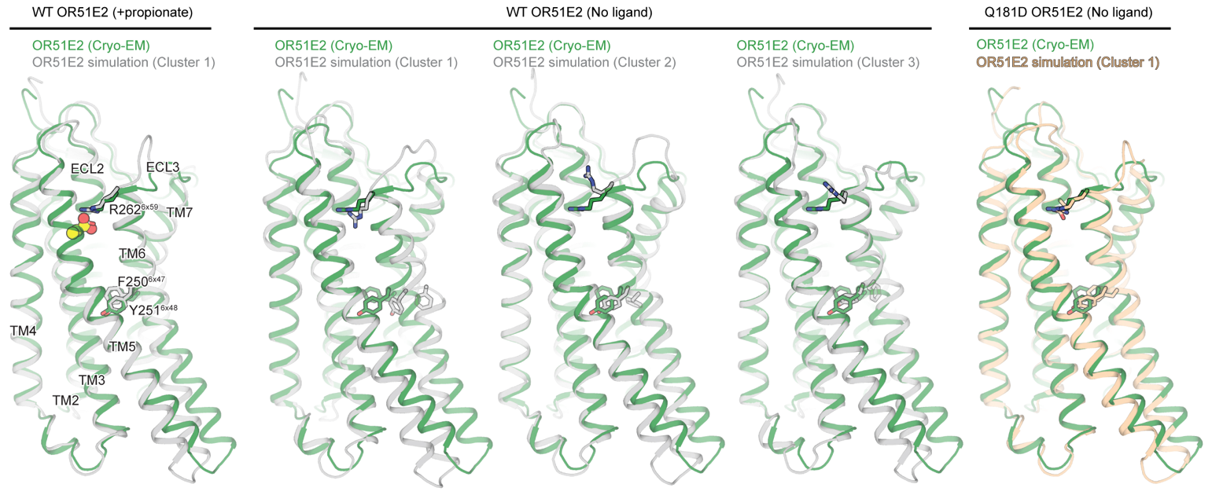

Supplementary Fig. 2. Uncropped SDS-PAGE gel for Extended Data Fig. 2. The region used for Extended Data Figure 2 is highlighted in red.

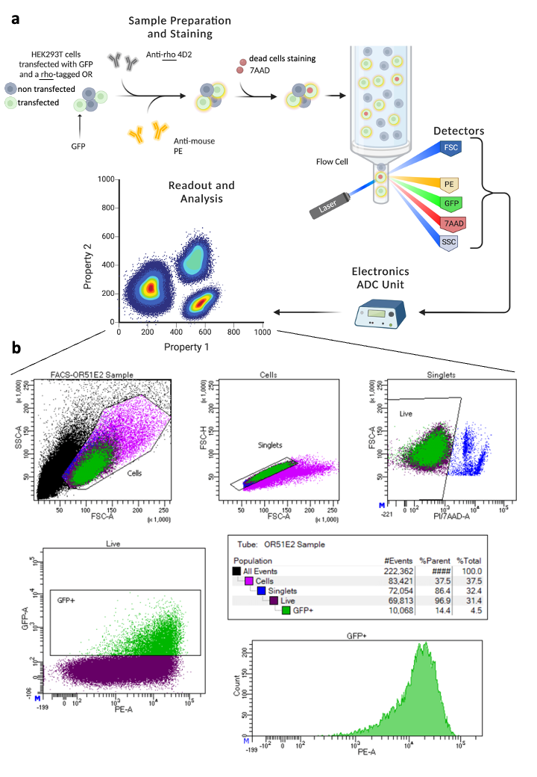
Supplementary Fig. 3. Flow cytometry protocol and gating strategy. a) Flow cytometry protocol. HEK293T cells are transfected with a vector for GFP and a rho-tagged OR and stained with an anti-rho and an anti-mouse PE antibodies. Dead cells are stained with 7AAD before being analyzed in flow cytometry. The detectors signal is integrated in an electronic ADC Unit which deliver the data that are analyzed. b) Gating strategy. The detectors FSC and SSC are used to select the single cells from which only the living cells are taken thanks to the 7AAD fluorescence. Within the living cells, only the transfected cells (GFP positive) are selected for PE fluorescence measurement, which translate for OR cell surface expression level.

