Supplementary Information

This document includes:

Supplementary table legends
Sequences for RNA interference and genome editing experiments
Flow cytometry gating strategies
Full western blots
NMR spectra

Supplementary Table 1 | Quantitative metabolomics analysis of mitochondrial cell extracts

Supplementary Table 2 | Quantitative metabolomics analysis of total cell extracts

Supplementary Table 3 | RNA-seq analysis of MDM
Differential gene expression was assessed with the limma/voom framework. P values were corrected for multiple testing with the Benjamini-Hochberg procedure.

Supplementary Table 4 | RNA-seq analysis of inflammatory macrophages
Differential gene expression was assessed with the limma/voom framework. P values were corrected for multiple testing with the Benjamini-Hochberg procedure.

Supplementary Table 5 | GO terms of RNA analysis of genes upregulated in inflammatory macrophages
GO enrichment was assessed with the enrichGO method from clusterProfiler. P values were corrected for multiple testing with the Benjamini-Hochberg procedure.

Supplementary Table 6 | Quantitative mass-spectrometry-based proteomics in MDM

Supplementary Table 7 | ChIP-seq analysis of MDM

Supplementary Table 8 | GO terms of RNA analysis of genes downregulated in MDM treated with LCC-12 during activation
GO enrichment was assessed with the enrichGO method from clusterProfiler. P values were corrected for multiple testing with the Benjamini-Hochberg procedure.

Supplementary Table 9 | RNA-seq analysis of aMDM under CD44 knock out conditions

Supplementary Table 10 | RNA-seq analysis of SPM

Supplementary Table 11 | RNA-seq analysis of lung tissues from SARS-CoV-2-infected mice
Differential gene expression was assessed with the limma/voom framework. P values were corrected for multiple testing with the Benjamini-Hochberg procedure.

Supplementary Table 12 | GO terms of RNA analysis of genes downregulated in lung tissues from SARS-CoV-2-infected mice treated with LCC-12
GO enrichment was assessed with the enrichGO method from clusterProfiler. P values were corrected for multiple testing with the Benjamini-Hochberg procedure.

SMARTpools used for RNA interference:

Target gene: CD44 (protein: CD44)
L-009999-00-0020, ON-TARGETplus Human CD44 (960) siRNA (Dharmacon)
Sequence 1: | GAAUAUAACCUGCCGCUUU
Sequence 2: | CAAGUGGACUCAACGGAGA
Sequence 3: | CGAAGAAGGUGUGGGCAGA
Sequence 4: | GAUCAACAGUGGCAAUGGA
Target gene: SLC31A1 (protein: CTR1)
L-007531-02-0020, ON-TARGETplus Human SLC31A1 (1317) siRNA (Dharmacon)
Sequence 1: | CGAGAGAGCCUGCUGCGUA
Sequence 2: | CUCUAGAUGUGAUACGUUA
Sequence 3: | UCGCAUGUCUAGUAUAUUA
Sequence 4: | UGGCGUGGCCUUAUCGAUU
Target gene: SLC31A2 (protein: CTR2)
L-007532-01-0020, ON-TARGETplus Human SLC31A2 (1318) siRNA (Dharmacon)
Sequence 1: | UUGUAAGCUUUGGGAAUUA
Sequence 2: | UUACUGAGCCCAUGACAAU
Sequence 3: | GAGCAUCGCCCAUUGGACU
Sequence 4: | GUAUGAAGGCAUCAAGGUU
Target gene: SLC11A2 (protein: DMT1)
L-007381-00-0020, ON-TARGETplus Human SLC11A2 (4891) siRNA (Dharmacon)
Sequence 1: | GGACUAGGCUGGCGGAUUG
Sequence 2: | AGGAGUACUUCGCCACUUA
Sequence 3: | GAUUUAAGUUGCUCUGGAU
Sequence 4: | GCUCAGCCAUUGCUAUCAA
Target gene: SLC25A3 (protein: SLC25A3)
L-007484-00-0020, ON-TARGETplus Human SLC25A3 (5250) siRNA (Dharmacon)
Sequence 1: | GGGCAUAUUUAACGGAUUC
Sequence 2: | UGGCGCACAUCACUAUAUU
Sequence 3: | GCAAUUGUUUCUCACCCUG
Sequence 4: | GCCAACACUUUGAGGGAUG
Target gene: SLC25A37 (protein: SLC25A37/Mitoferrin-1)
L-007369-01-0020, ON-TARGETplus Human SLC25A37 (51312) siRNA (Dharmacon)
Sequence 1: | CCACCUAGCCAACGGGAUA
Sequence 2: | CAUGACAGCAGGAGCGAUG
Sequence 3: | GUACACAAGUAUCUACGGA
Sequence 4: | GGUCGGAGGACUACGAGAA
Target gene: TFRC (protein: TFR1)
Sequence 1: | GAAUGGAUCUAUAGUGAUU
Sequence 2: | GAUAAGAACGGUAGACUUG
Sequence 3: | GUAAACUGGUCCAUGCUAA
Sequence 4: | CUGAAUGGCUAGAGGGAUA

Sequences used for genome editing:

CD44 sgRNA ((Edit-R Human Synthetic CD44, set of 3, target sequences)

CGTGGAATACACCTGCAAAG
CAATAGCACCTTGCCCACAA
TTGCAGTCAACAGTCGAAGA

Protein size markers from a protein ladder (PageRuler or PageRuler plus, Thermo Fisher Scientific, 26616 and 26620) are indicated in kilodalton (kDa). Boxes with dotted lines indicate the cropping used for generating the illustrations in the figures.

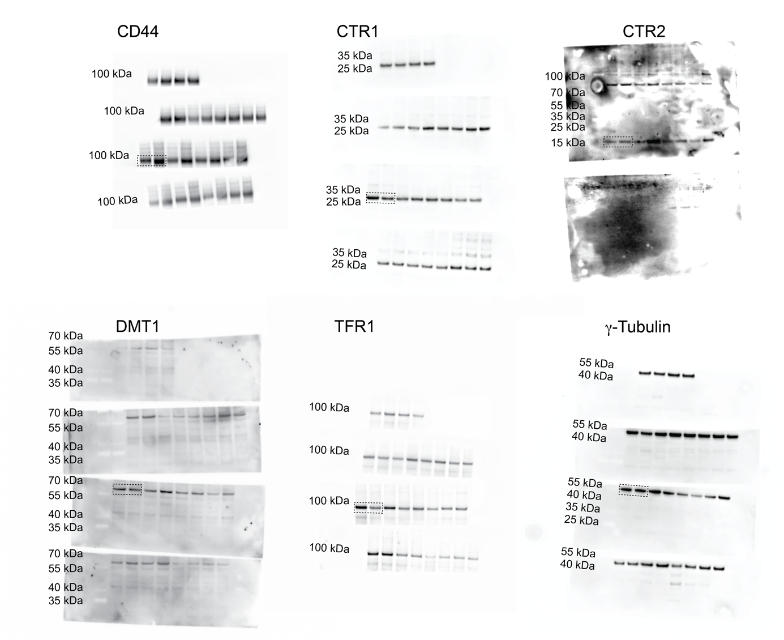
Figure 1e

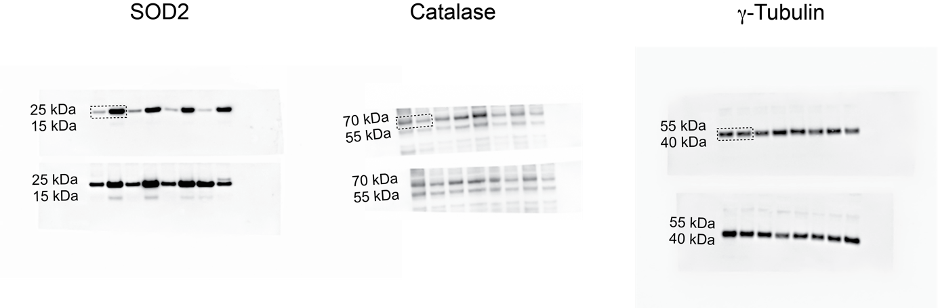
Figure 3b

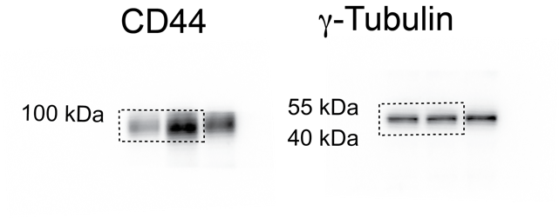 | 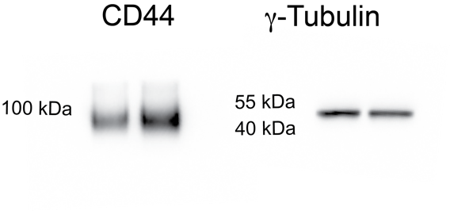
Figure 5b – LPS model | Figure 5b – CLP model

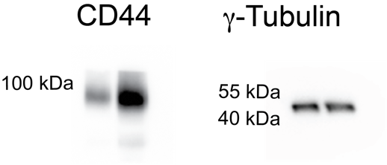

Figure 5b – SARS-CoV-2 model

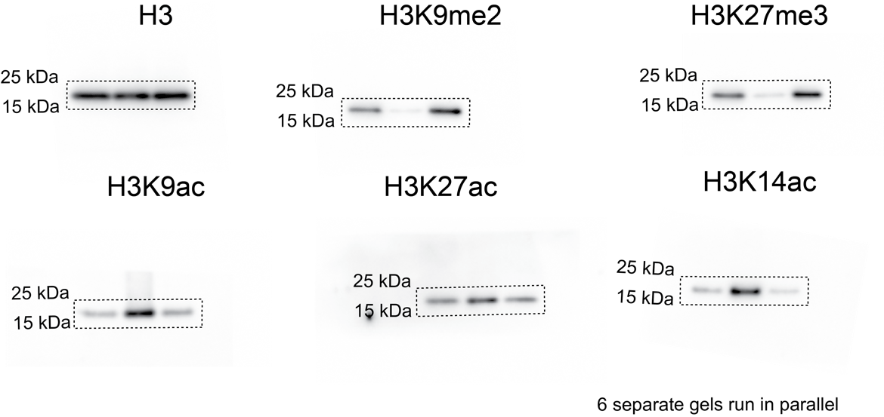
Figure 5d
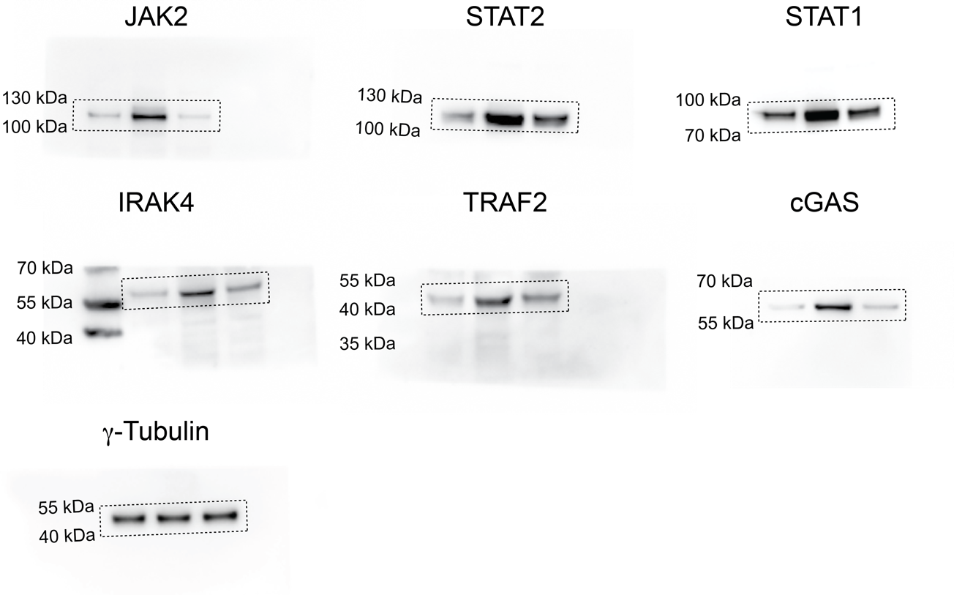
Figure 5f

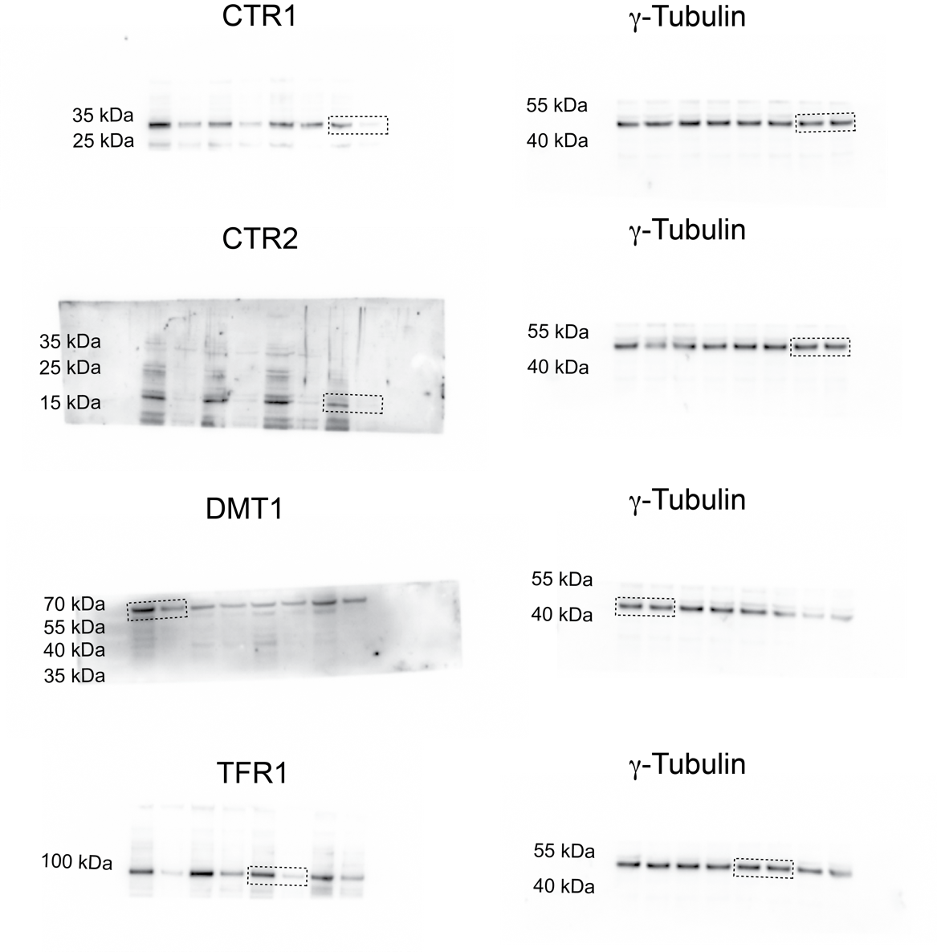
Extended Data Figure 1f
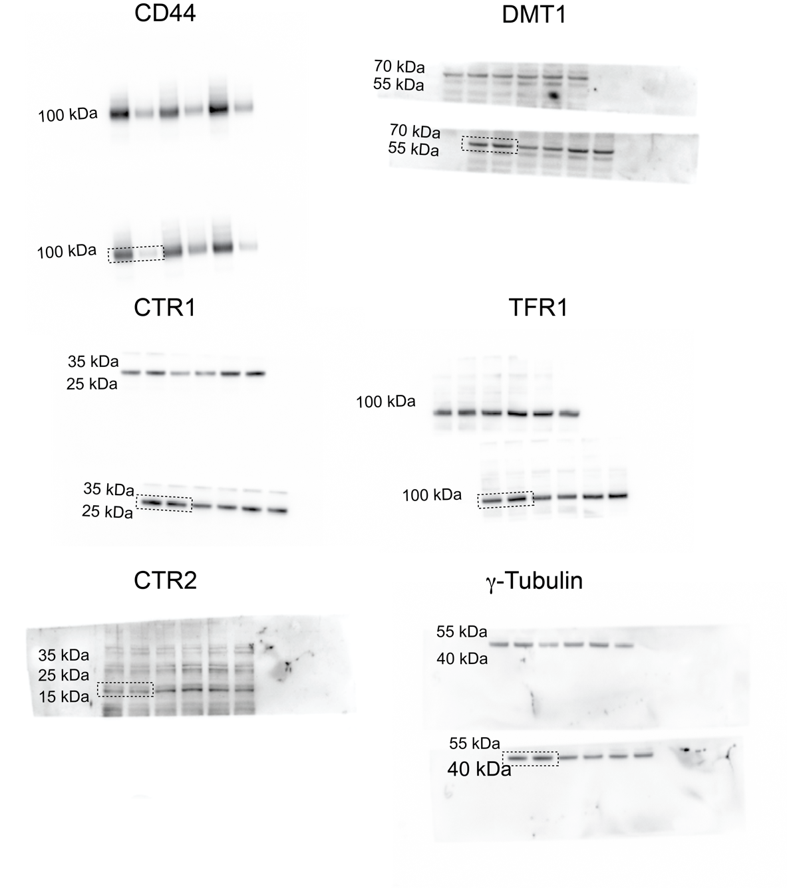
Extended Data Figure 1g

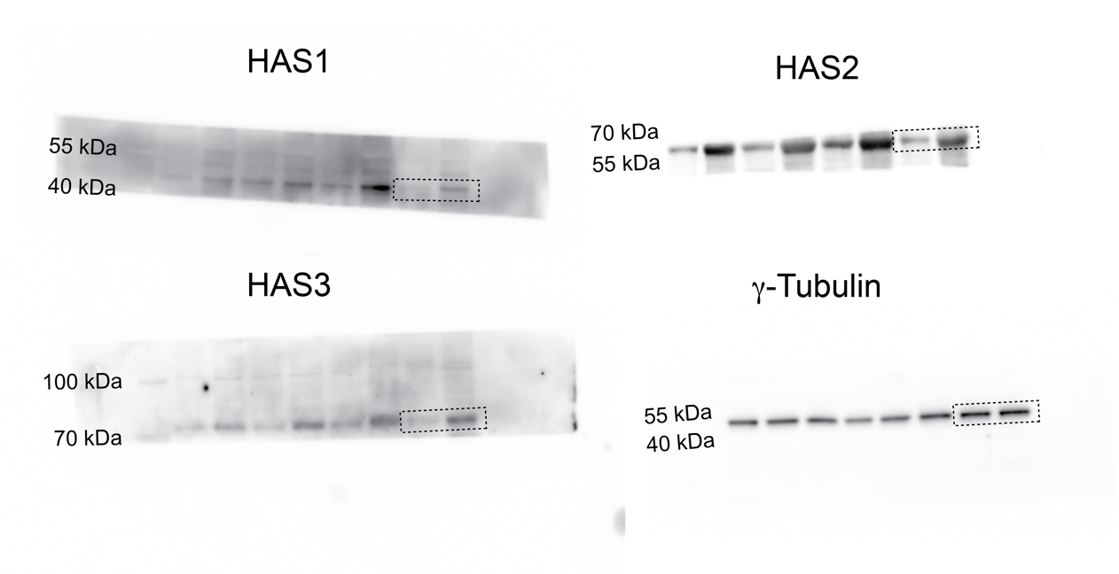

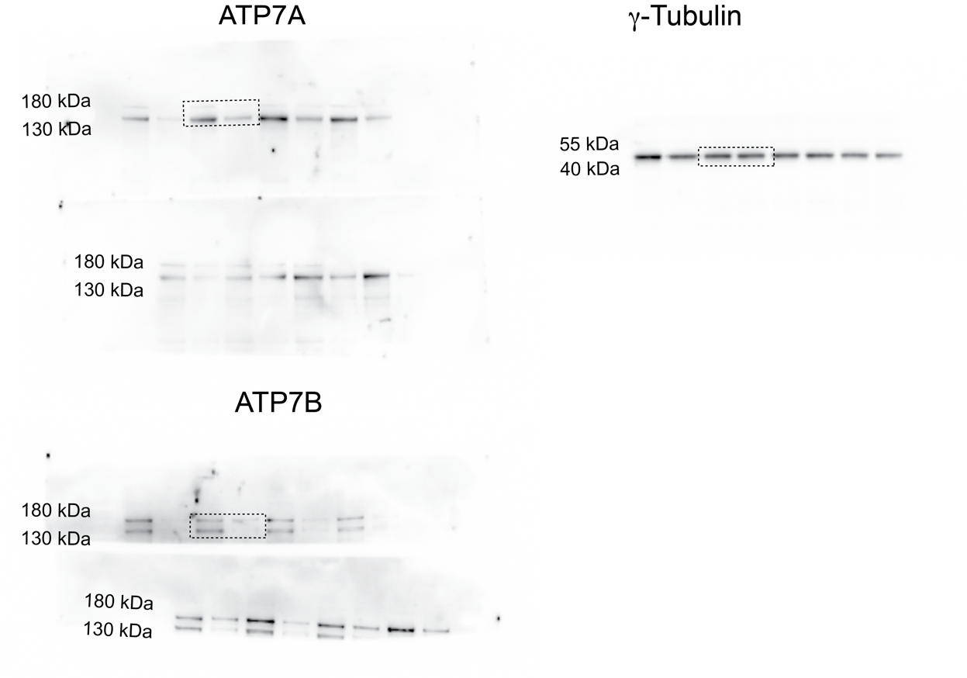
Extended Data Figure 2c

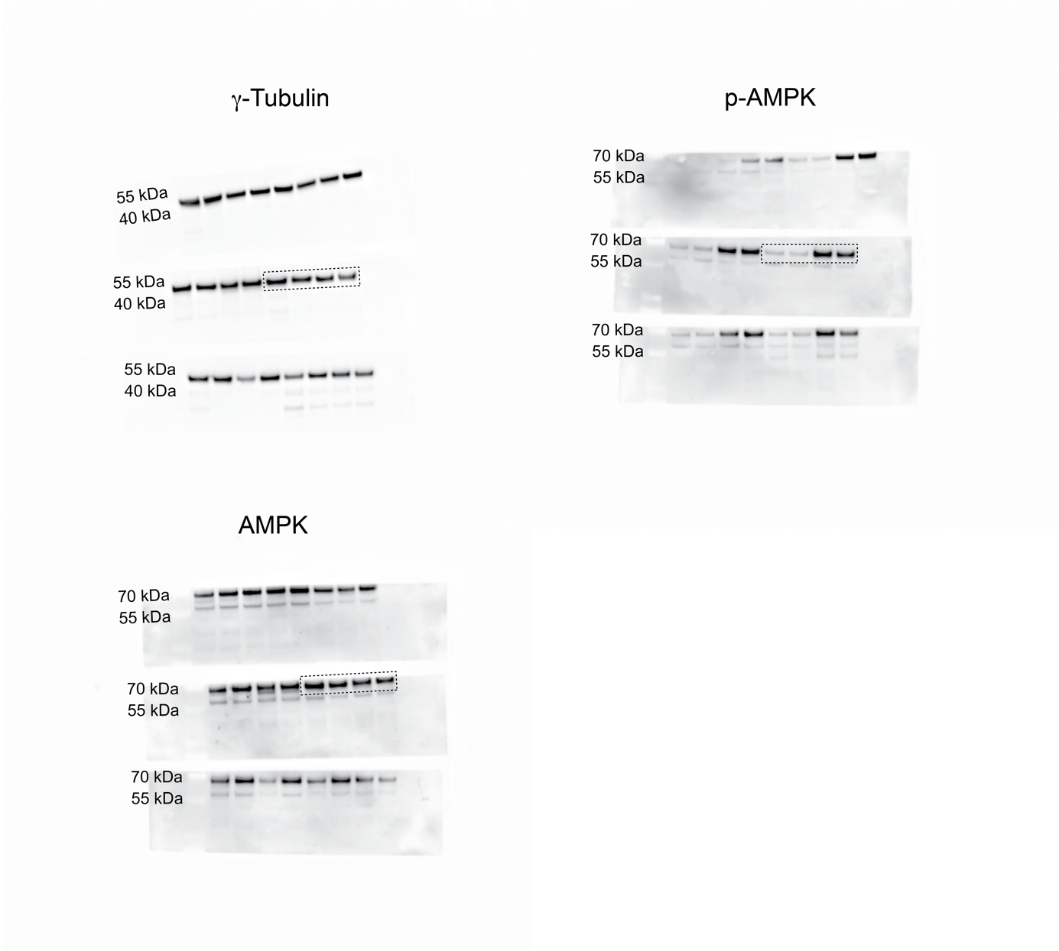
Extended Data Figure 3g

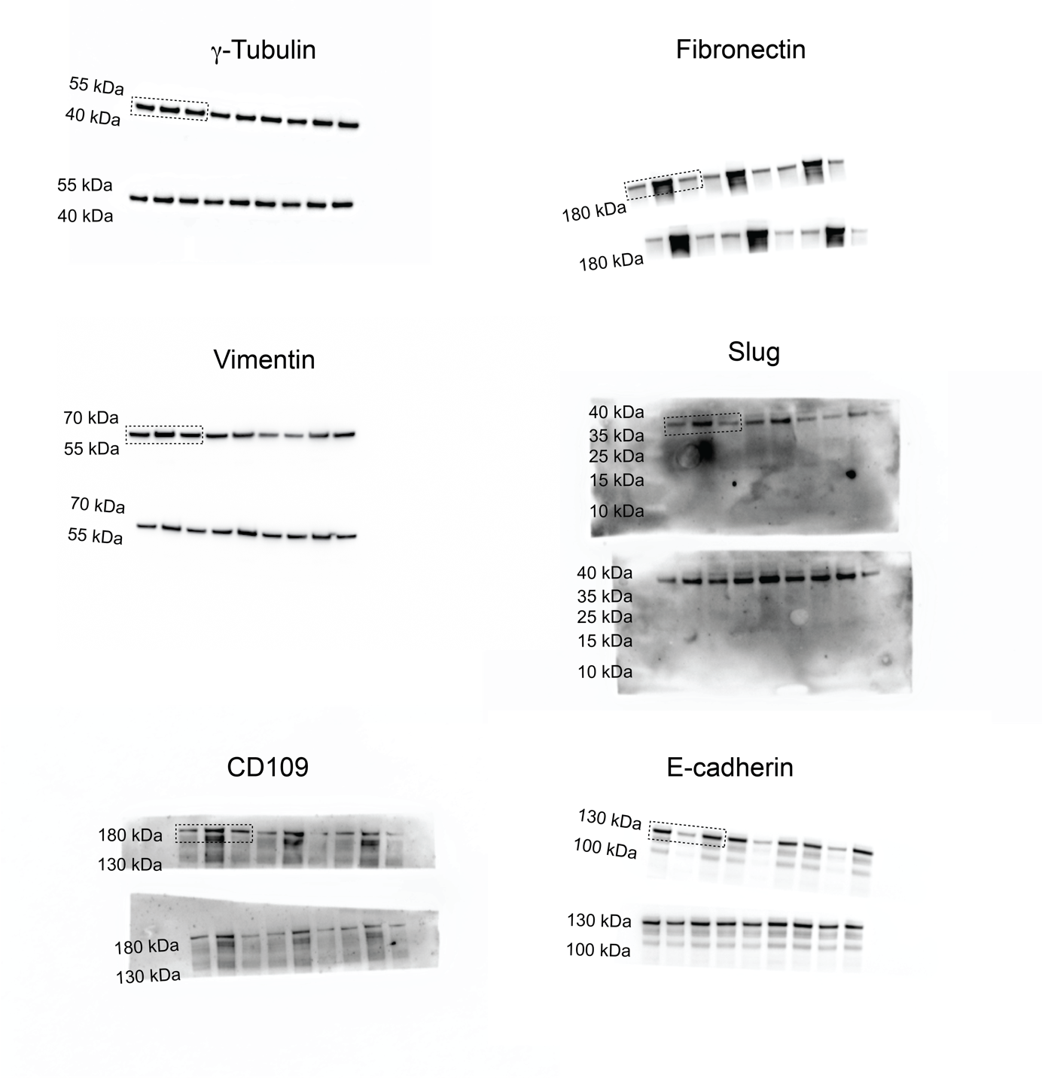
Extended Data Figure 4c
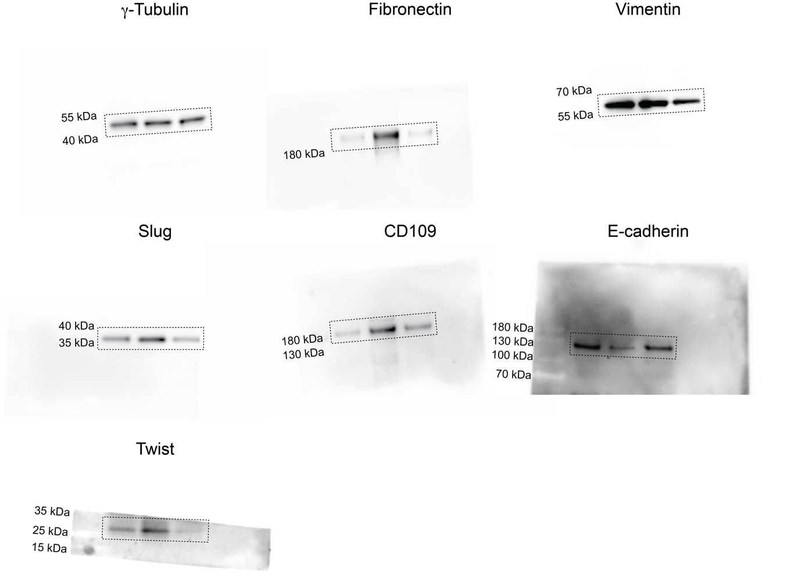
Extended Data Figure 4d

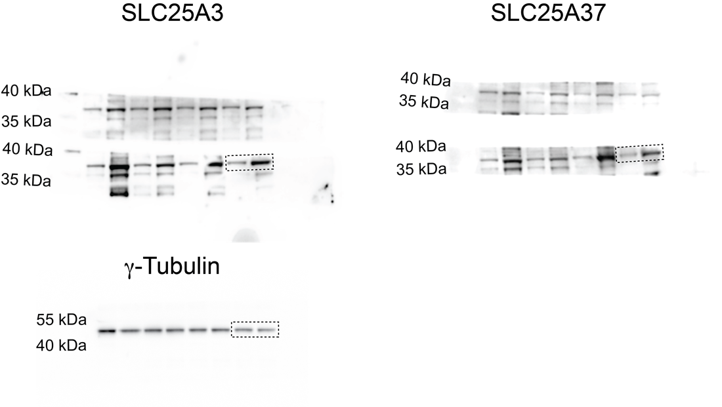
Extended Data Figure 5k
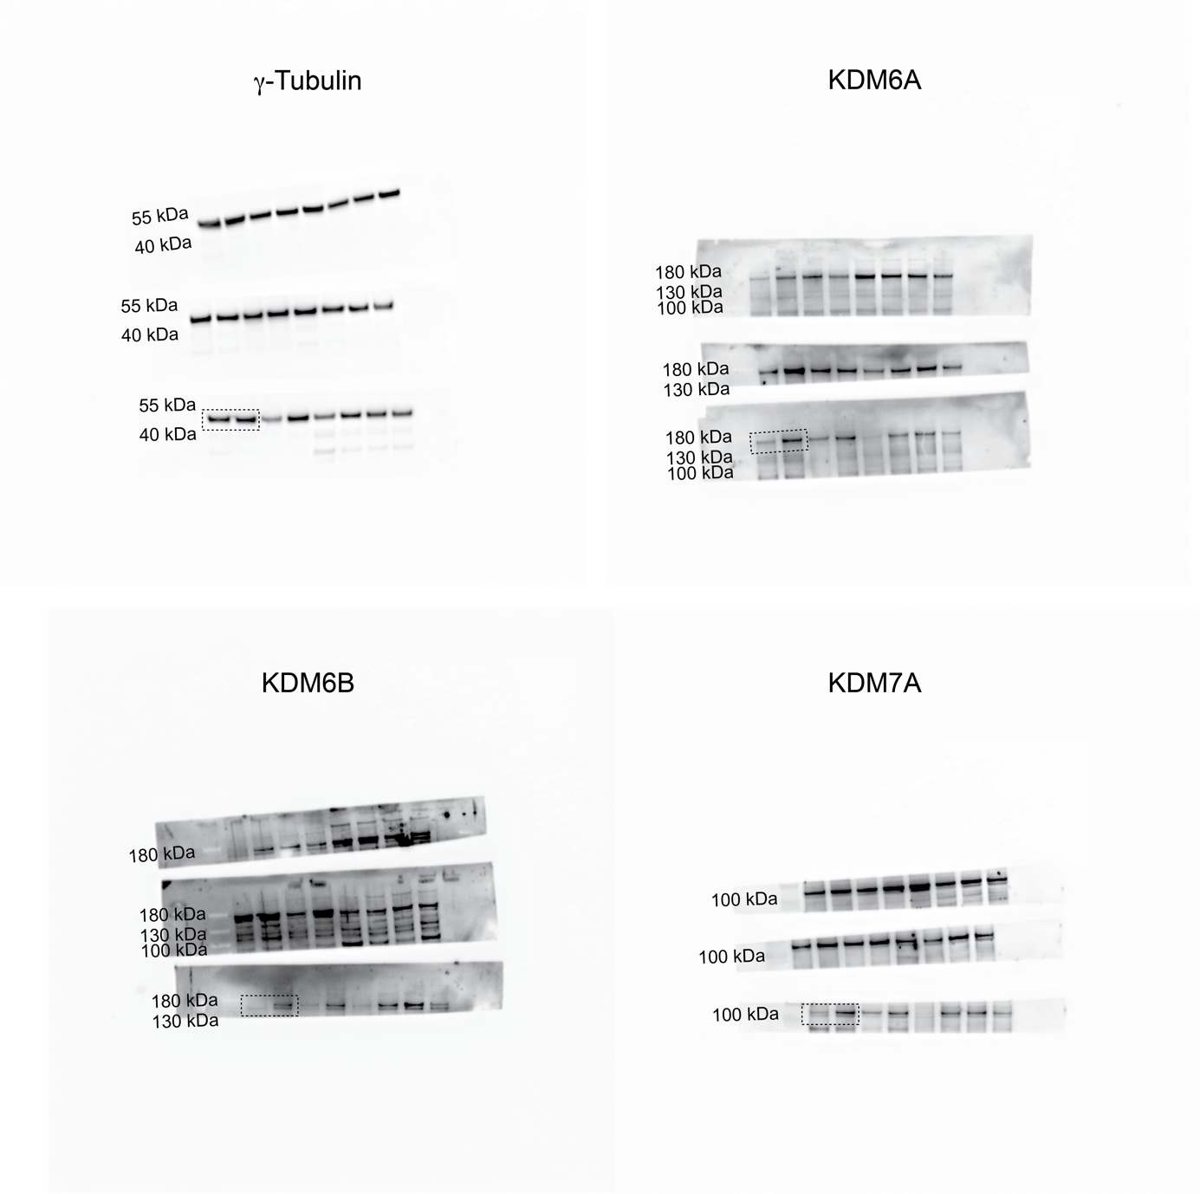Extended Data Figure 8b
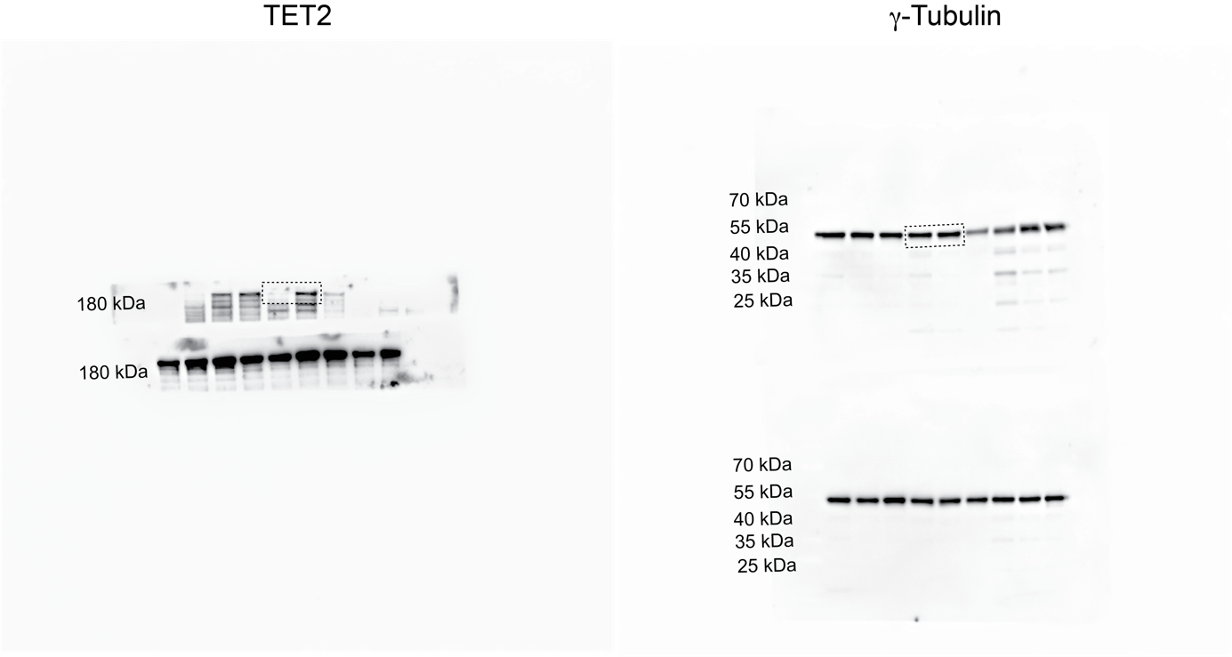
Extended Data Figure 8b – continued
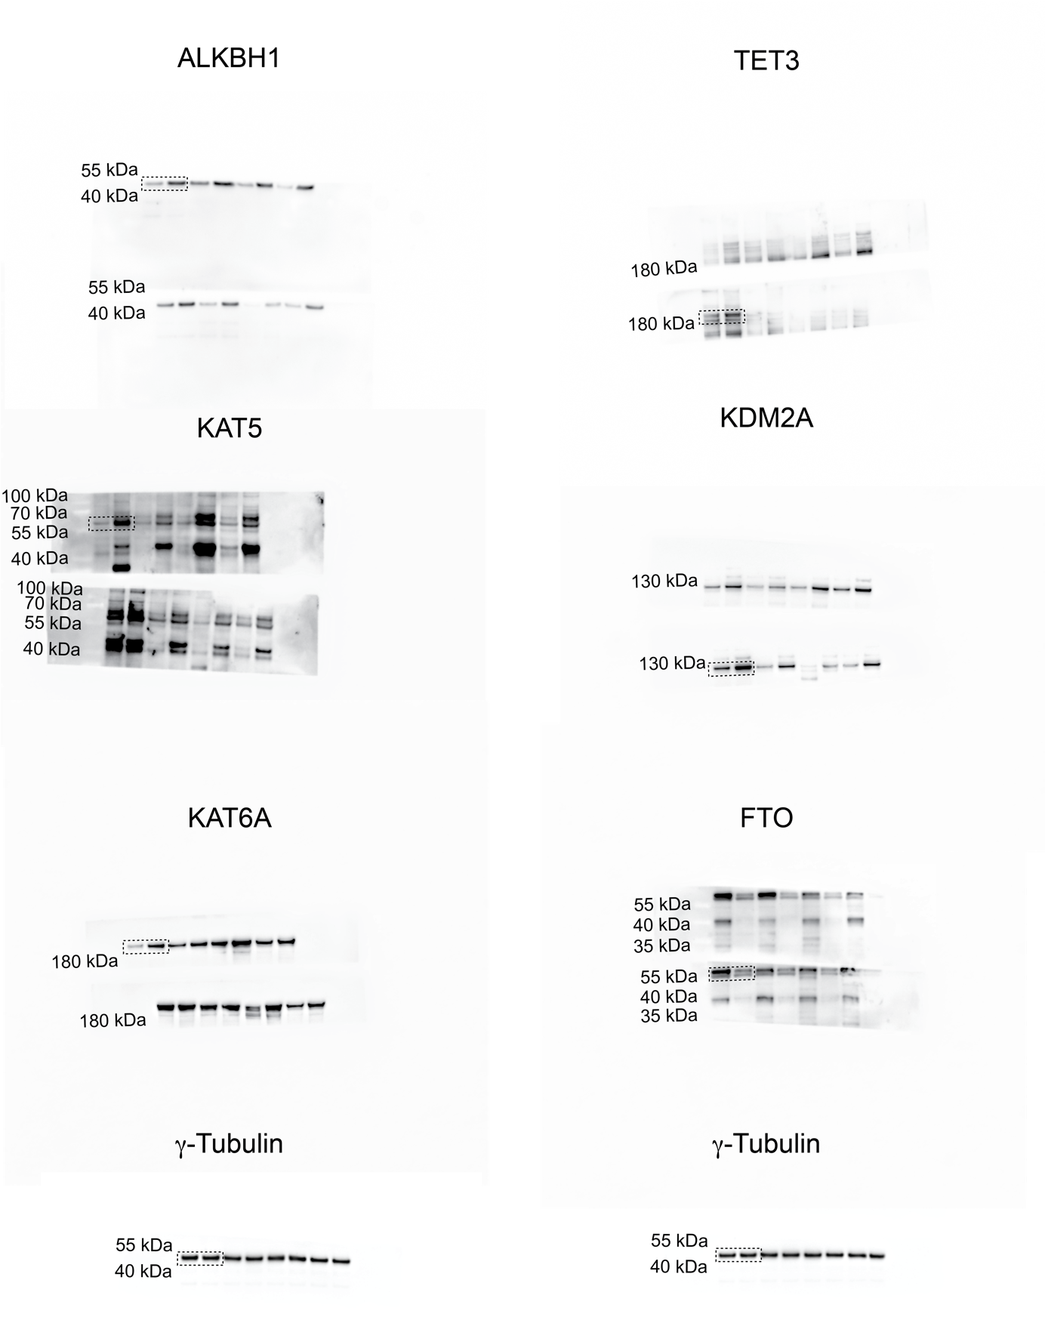
Extended Data Figure 8b – continued
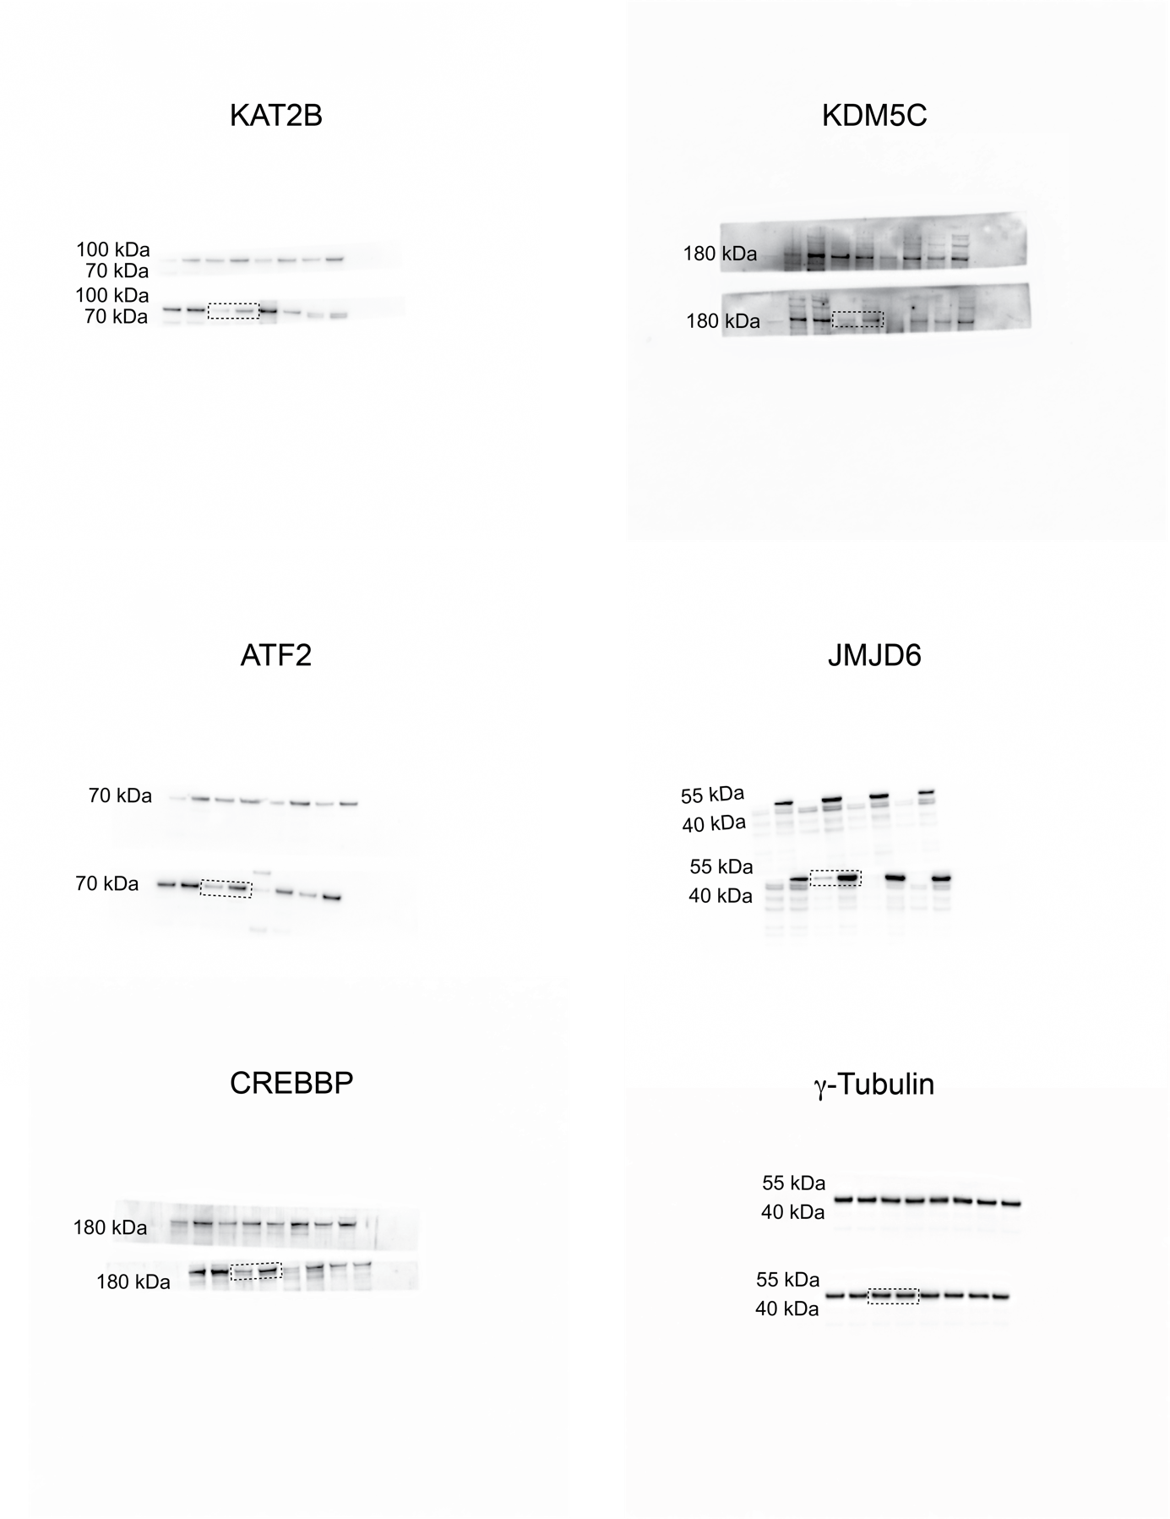
Extended Data Figure 8b – continued
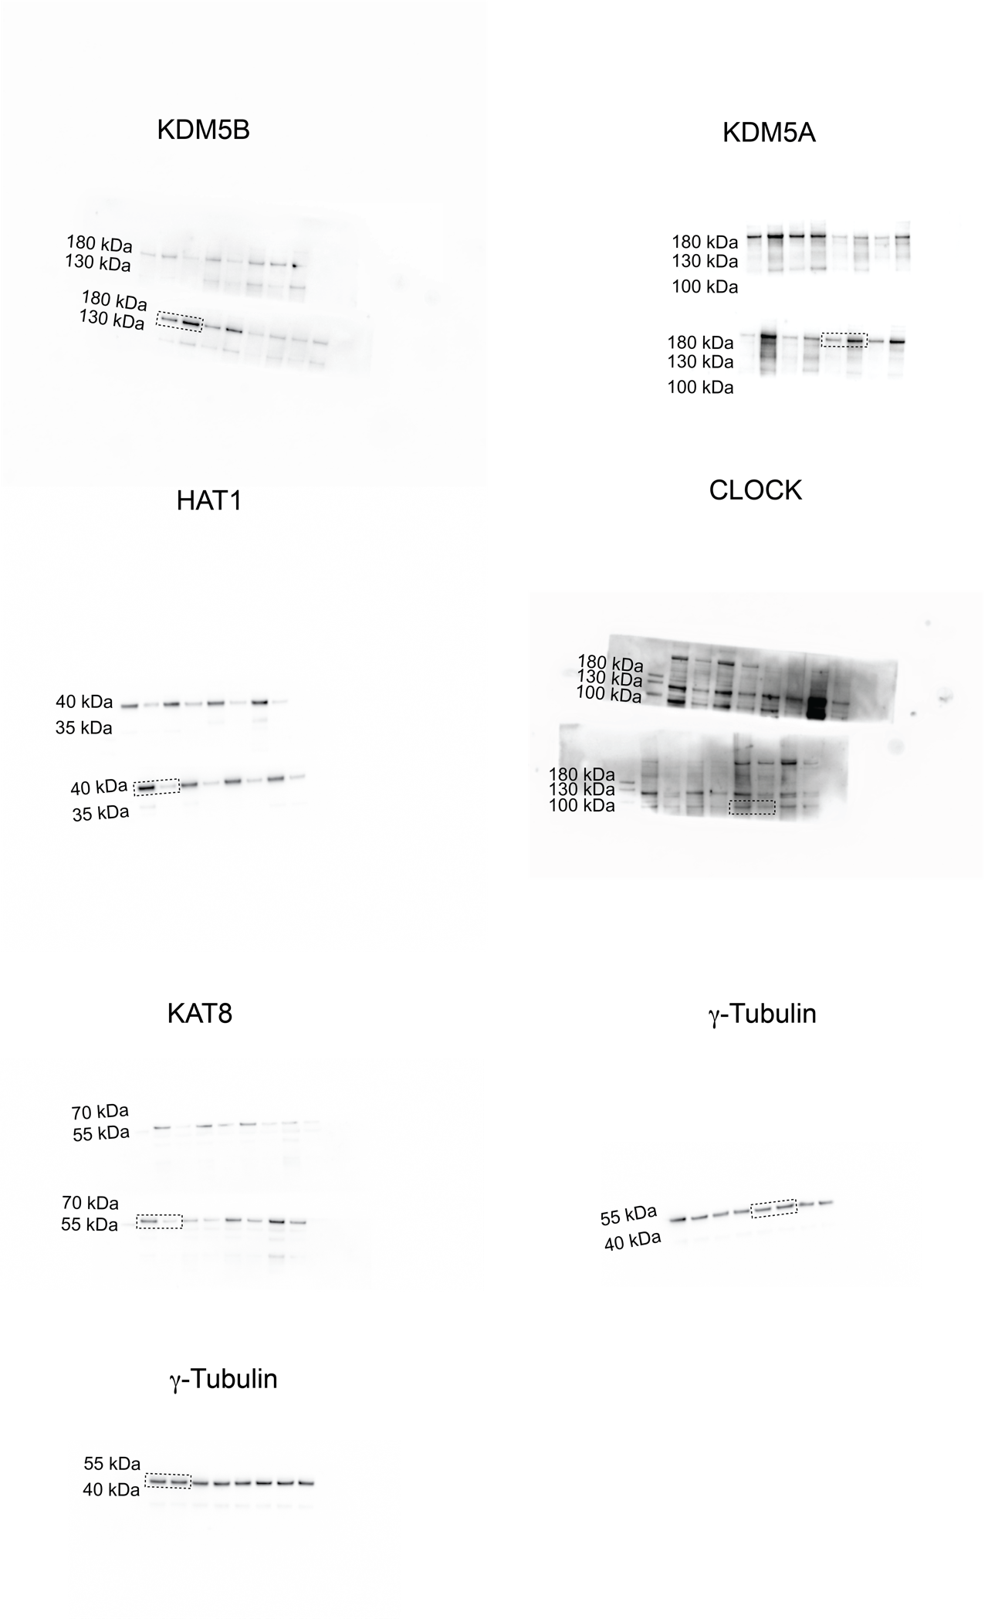
Extended Data Figure 8b – continued
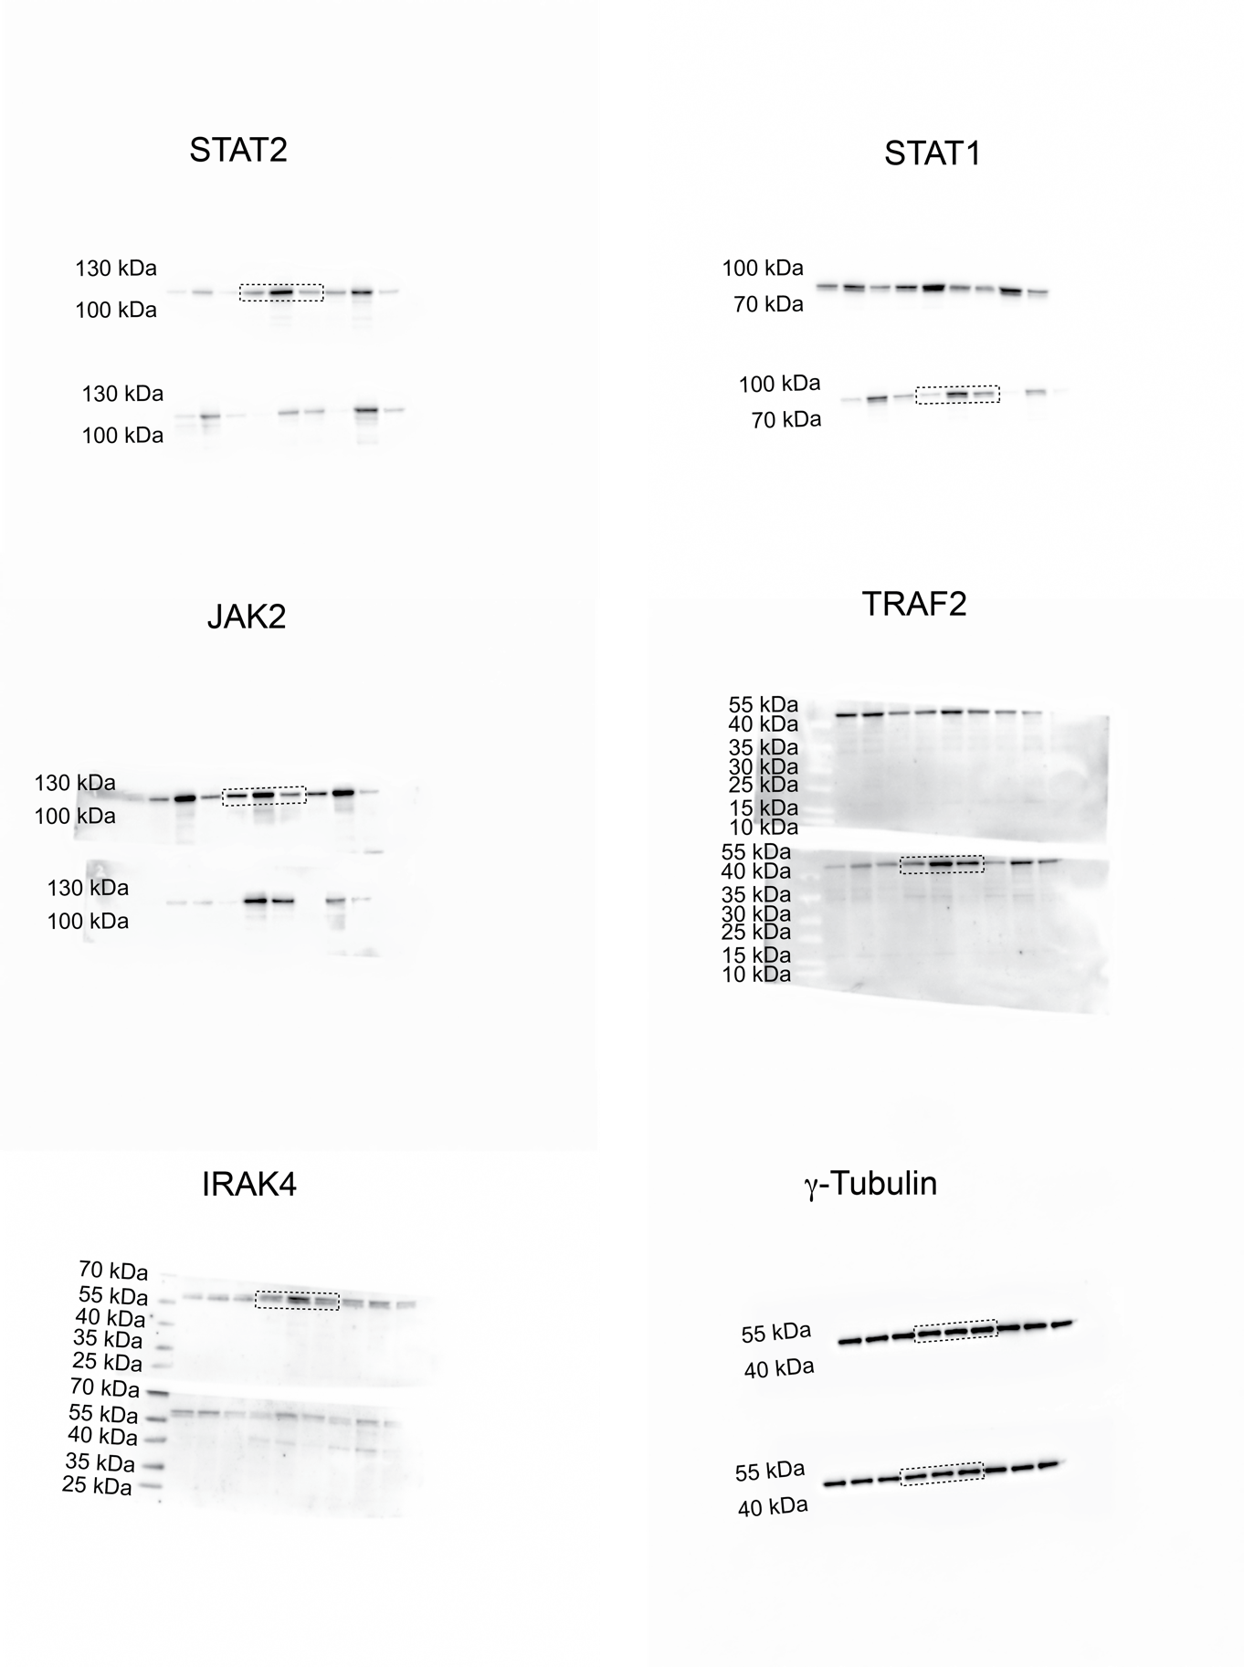
Extended Data Figure 9a
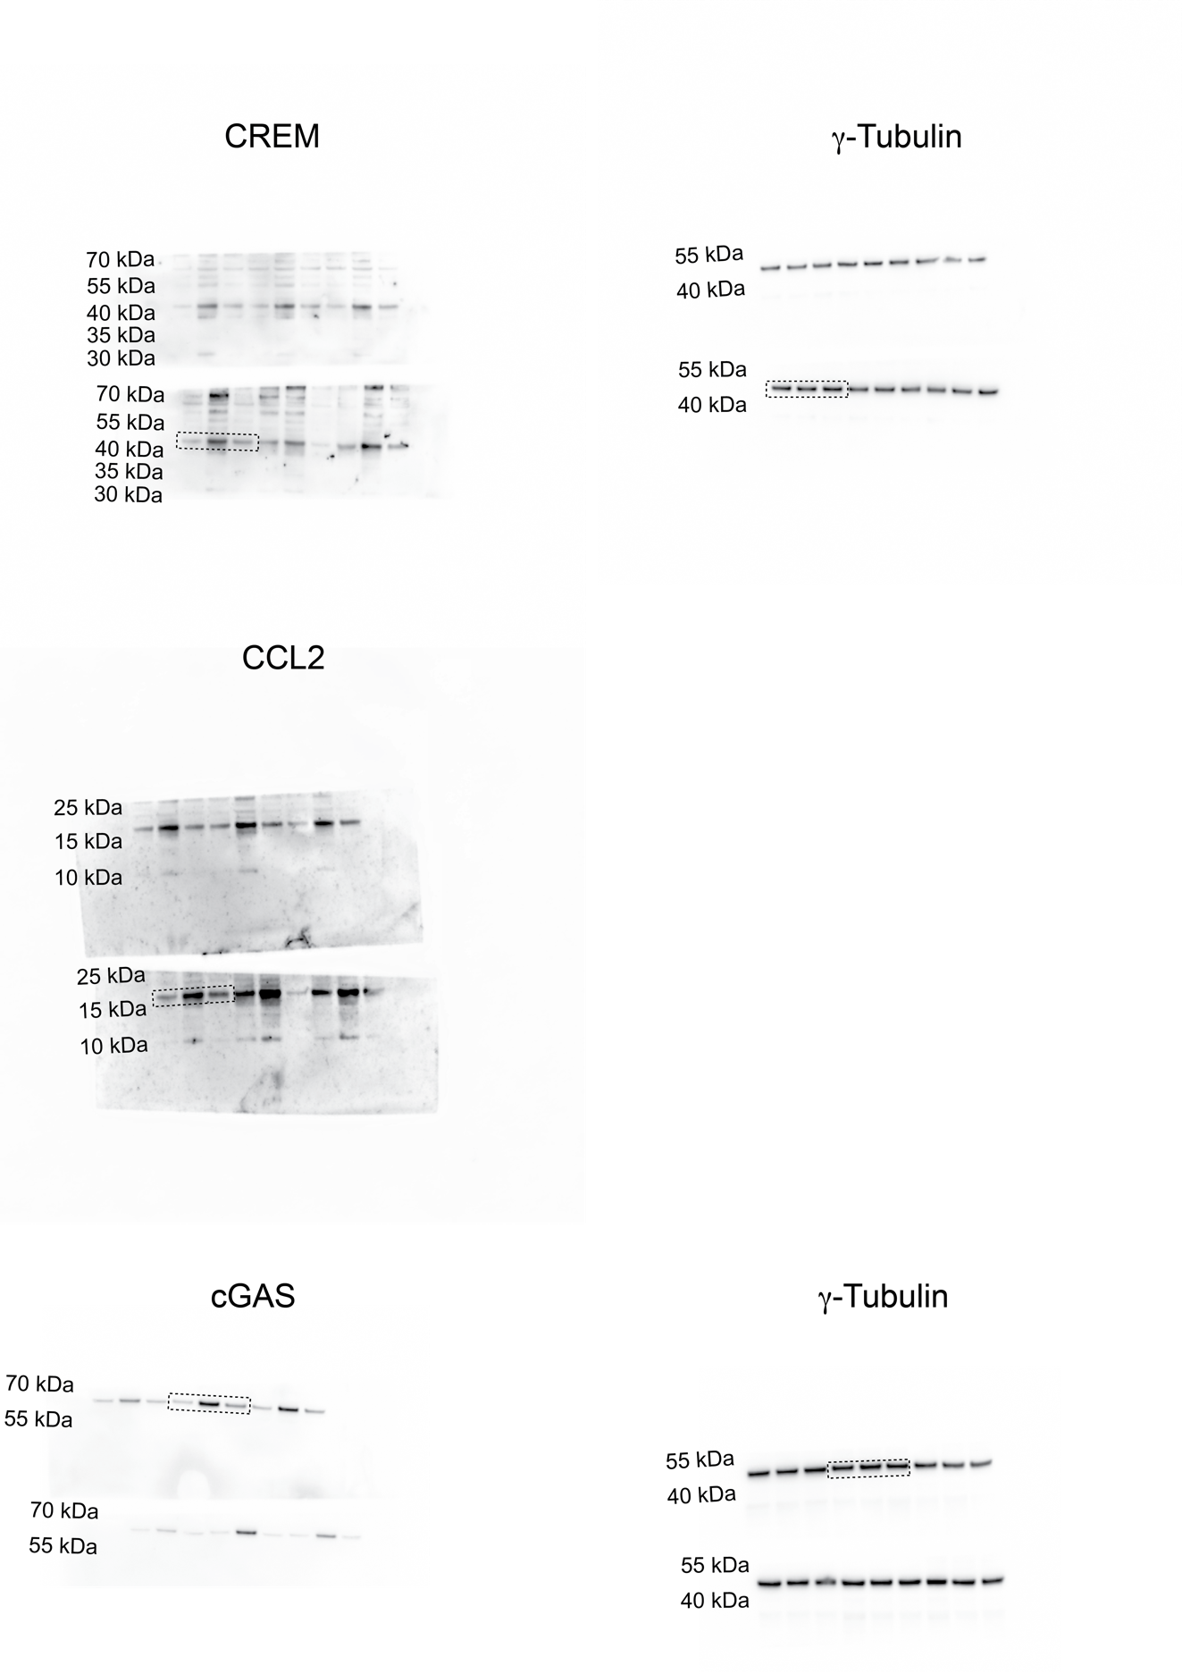
Extended Data Figure 9a - continued

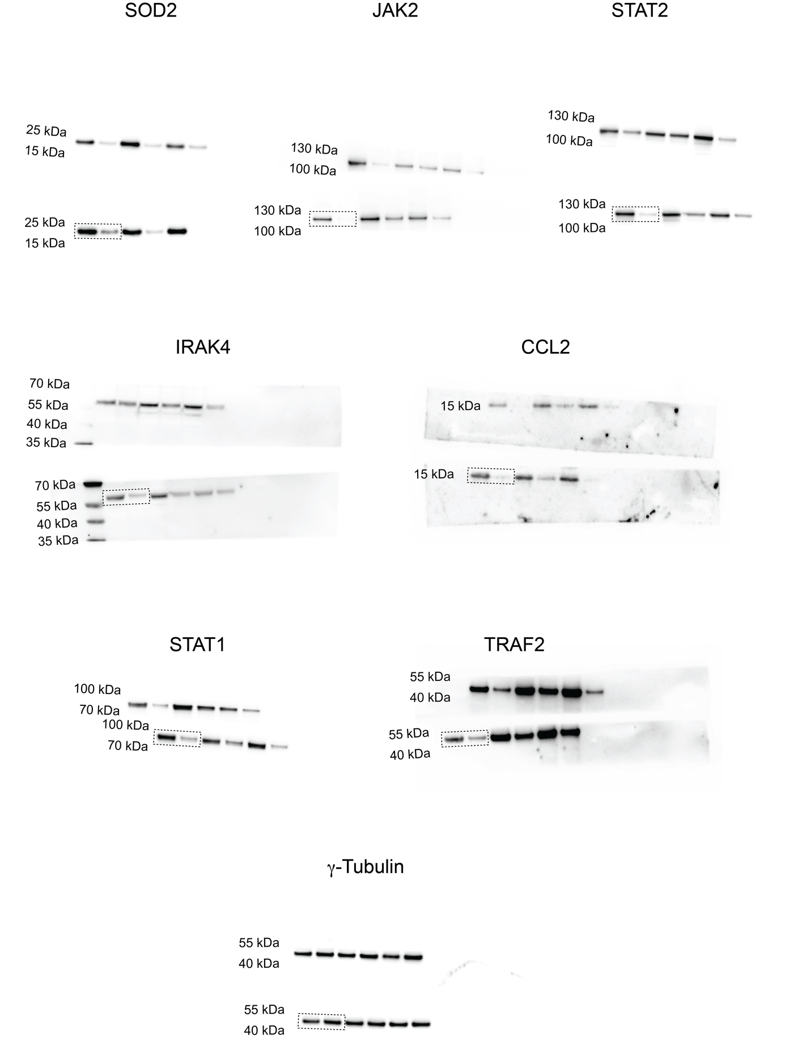
Extended Data Figure 9g
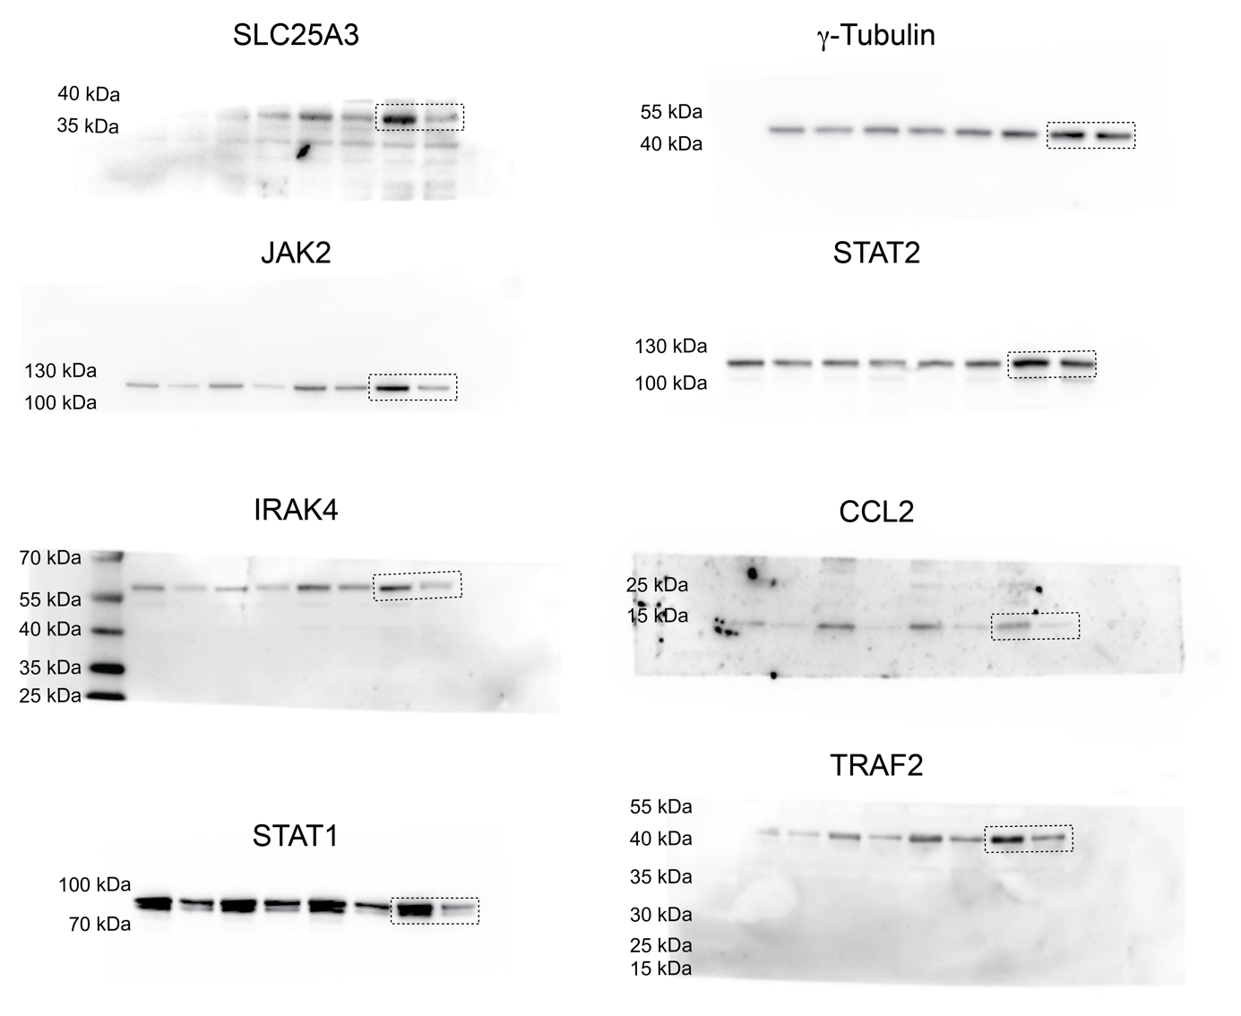
Extended Data Figure 9h

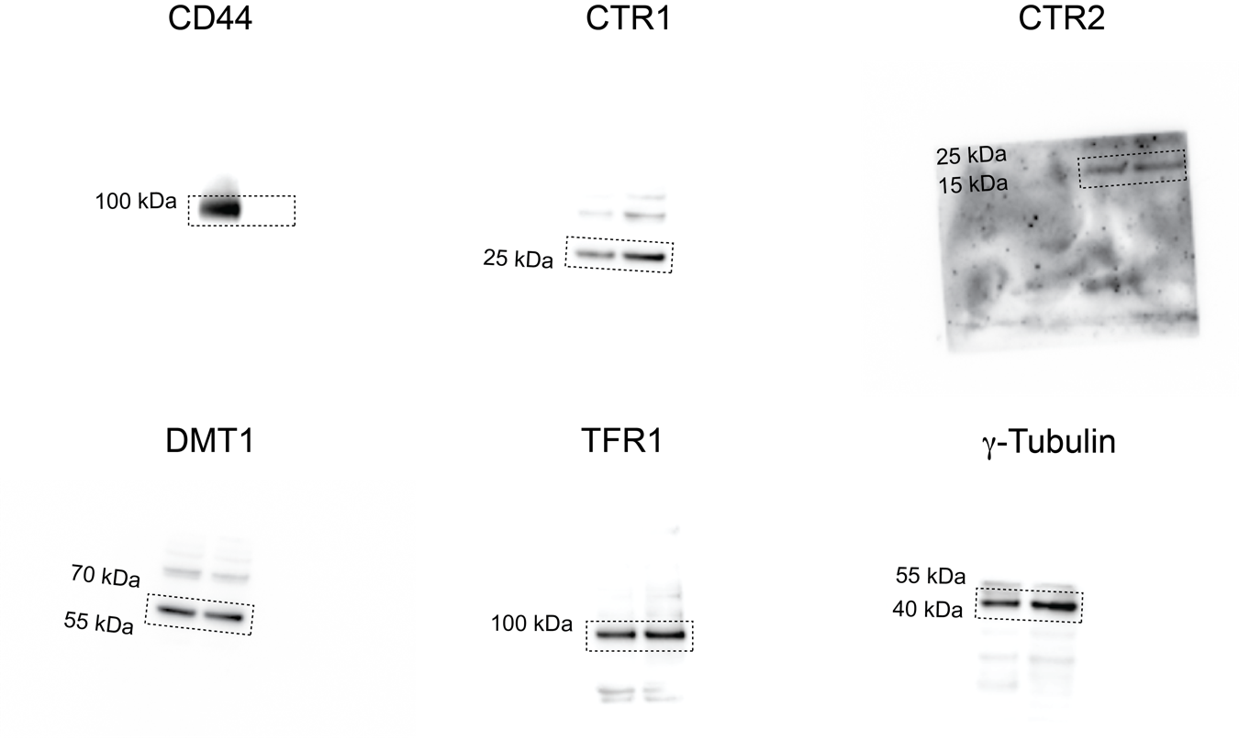
Extended Data Figure 9j
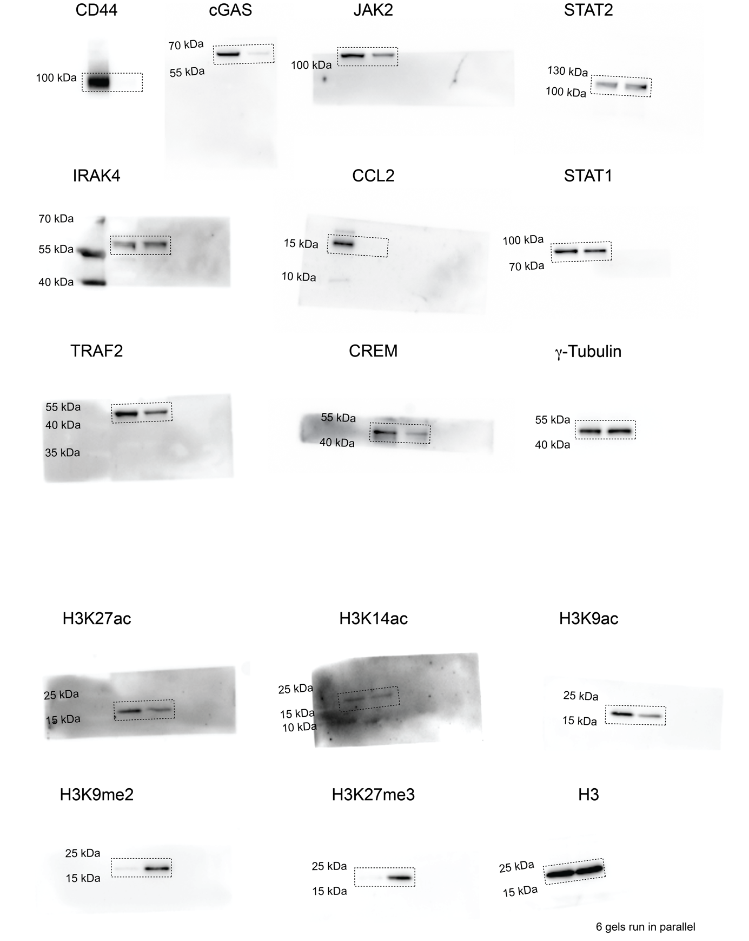
Extended Data Figure 9k (Donor 1)
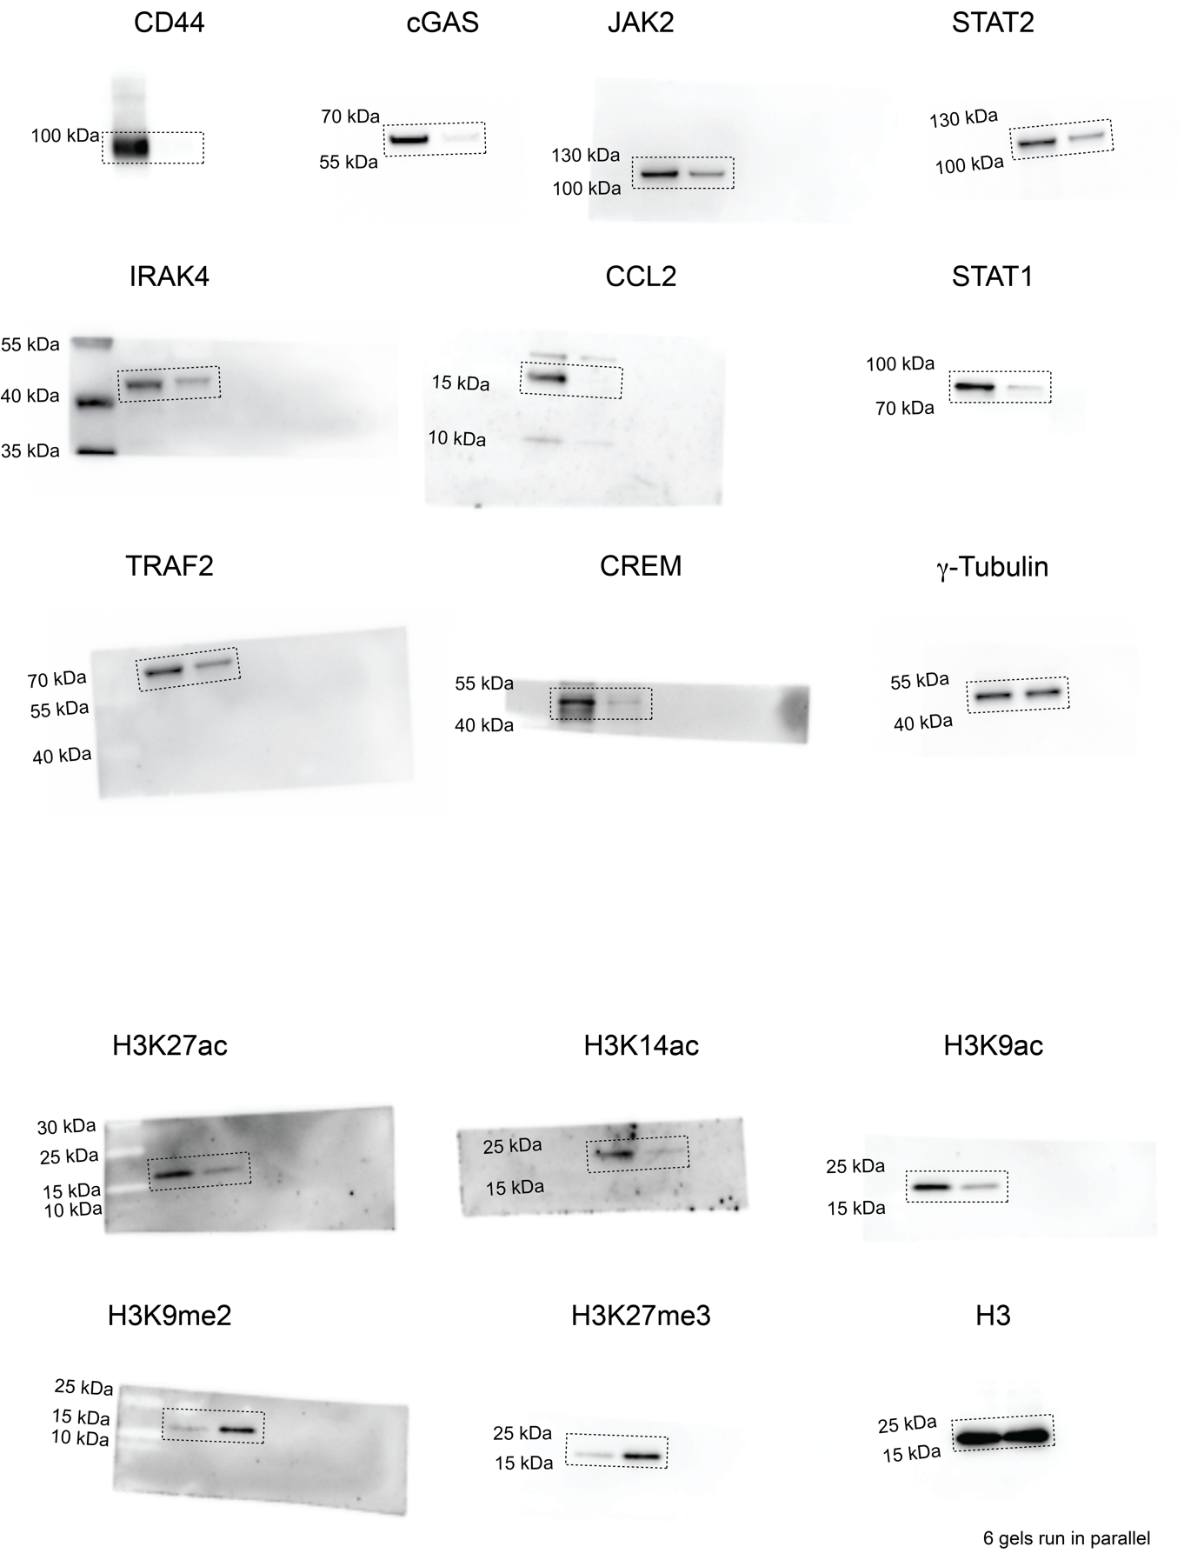
Extended Data Figure 9k (Donor 2)
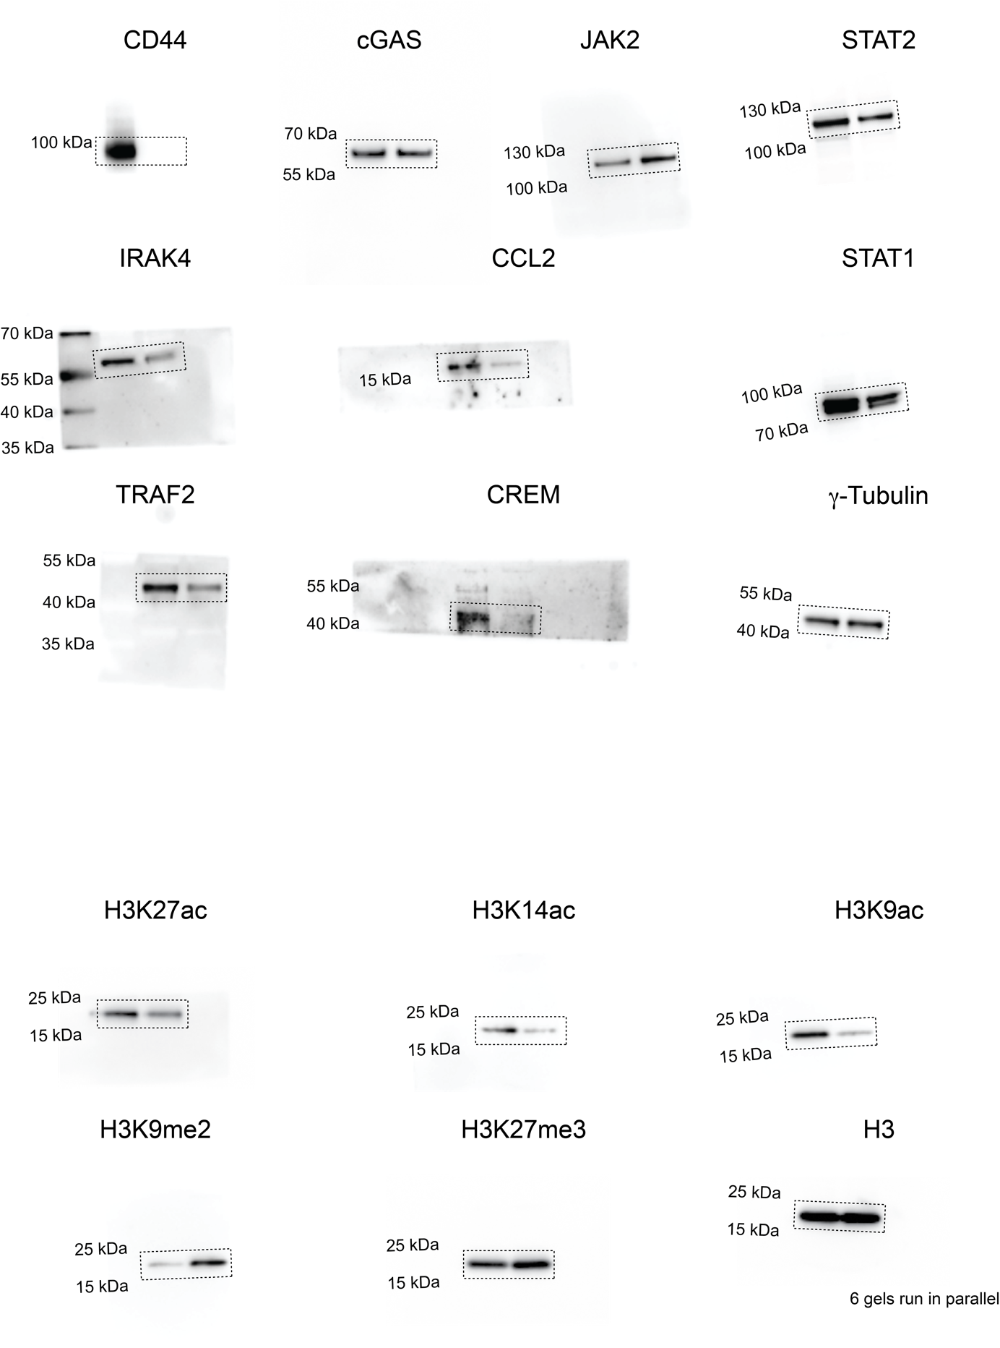
Extended Data Figure 9k (Donor 3)

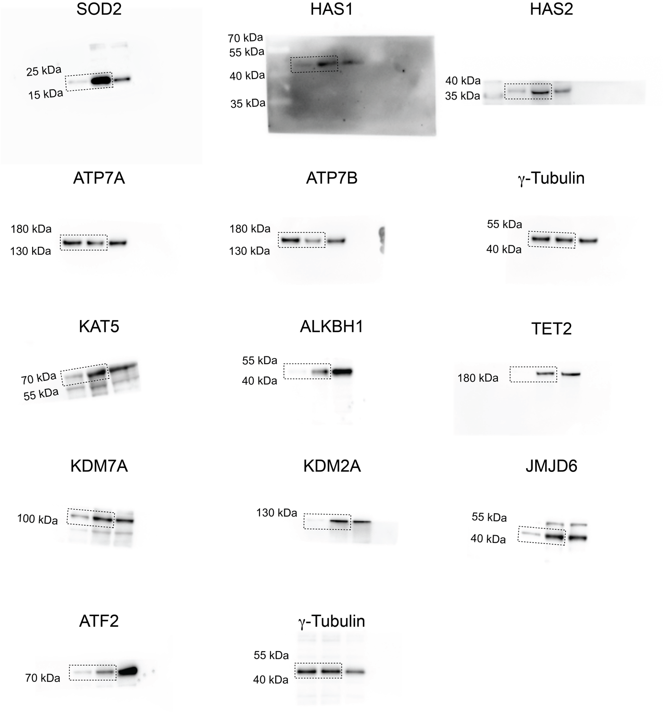
Extended Data Figure 10a
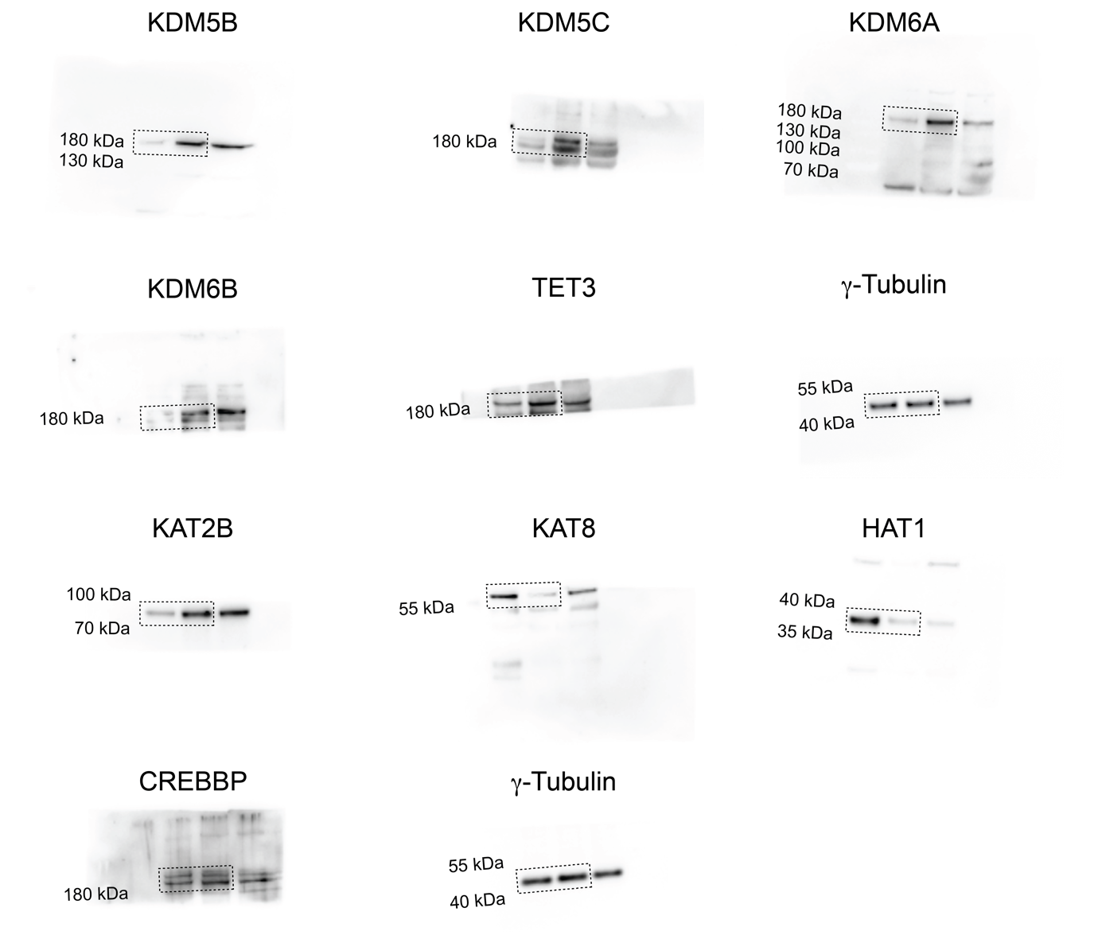
Extended Data Figure 10a – continued
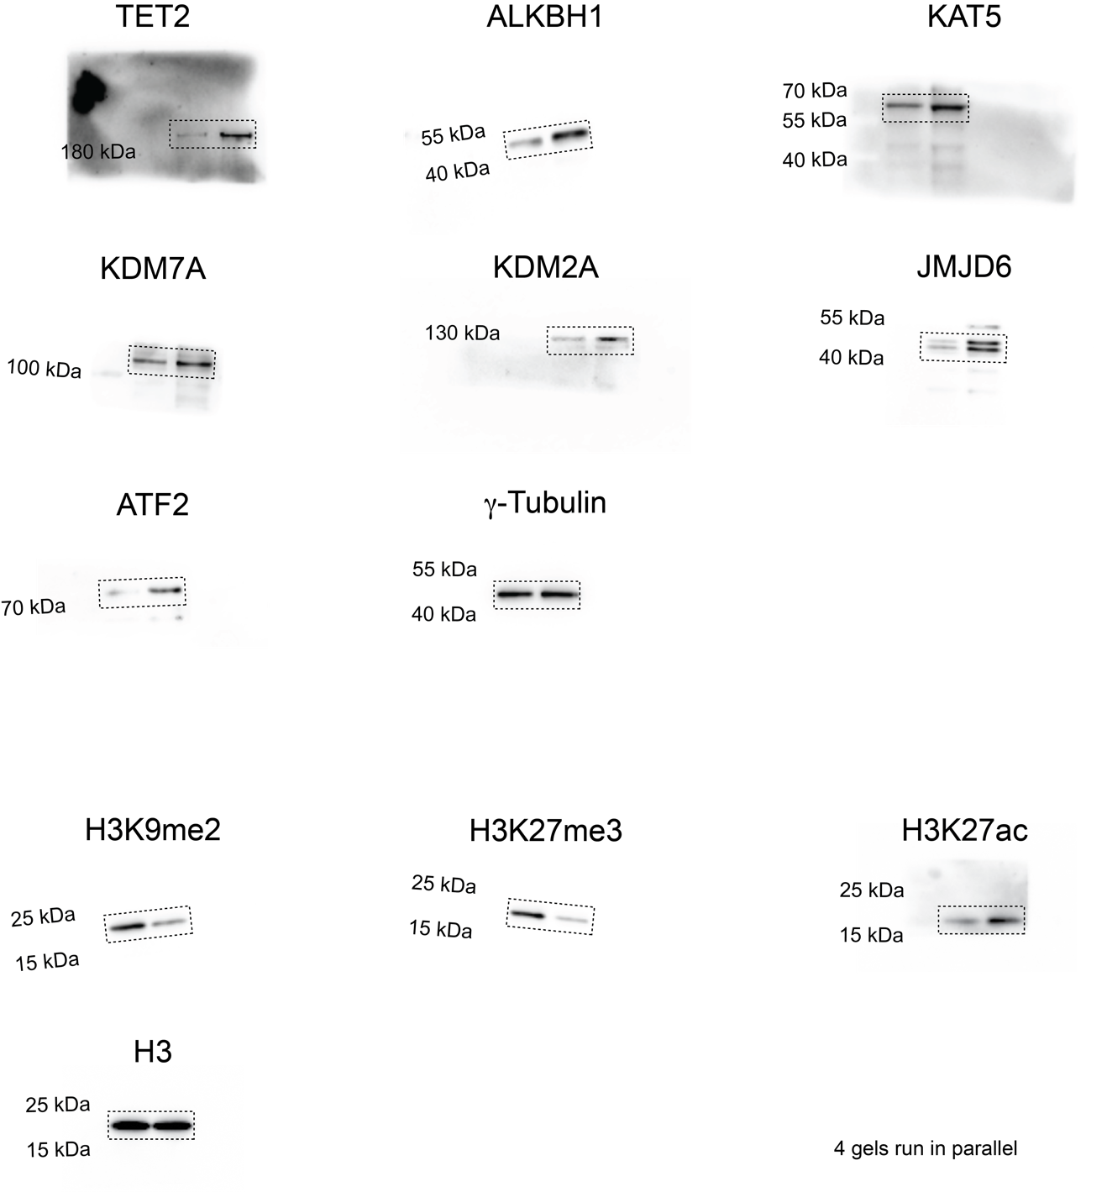
Extended Data Figure 10b
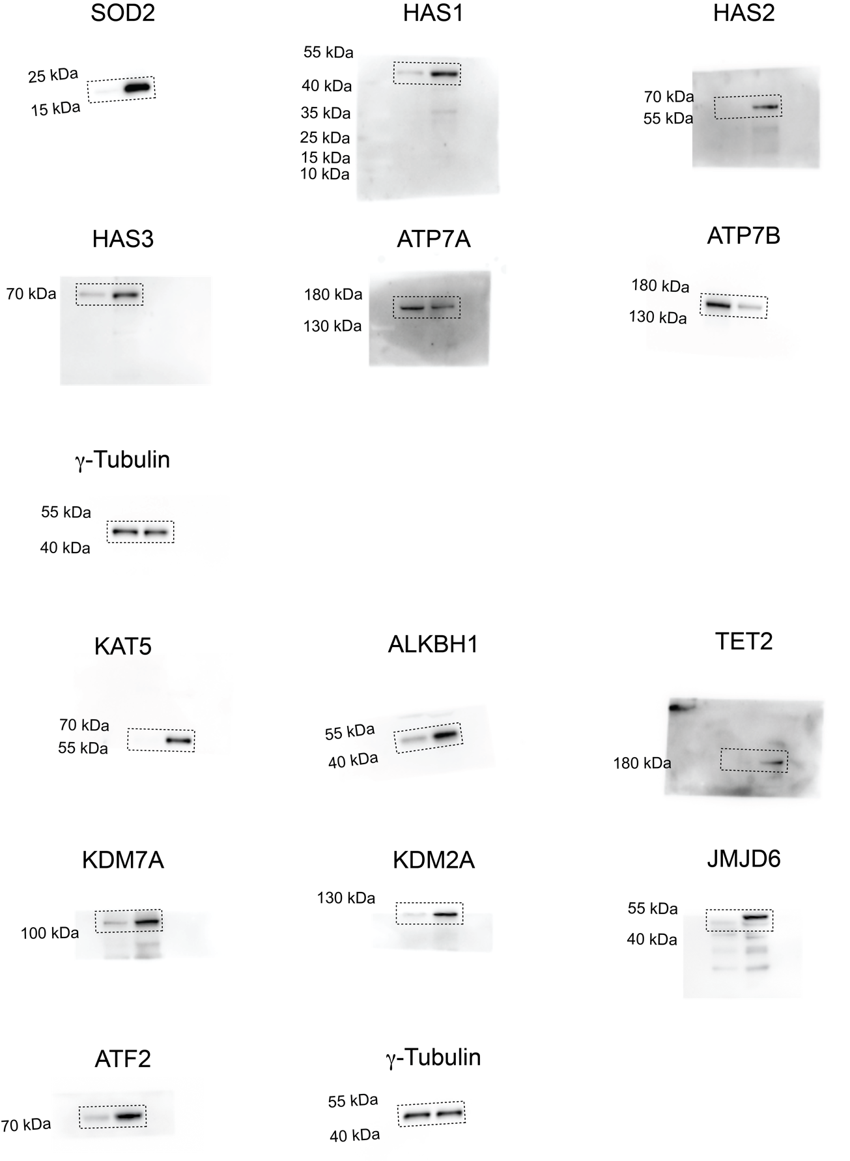
Extended Data Figure 10c
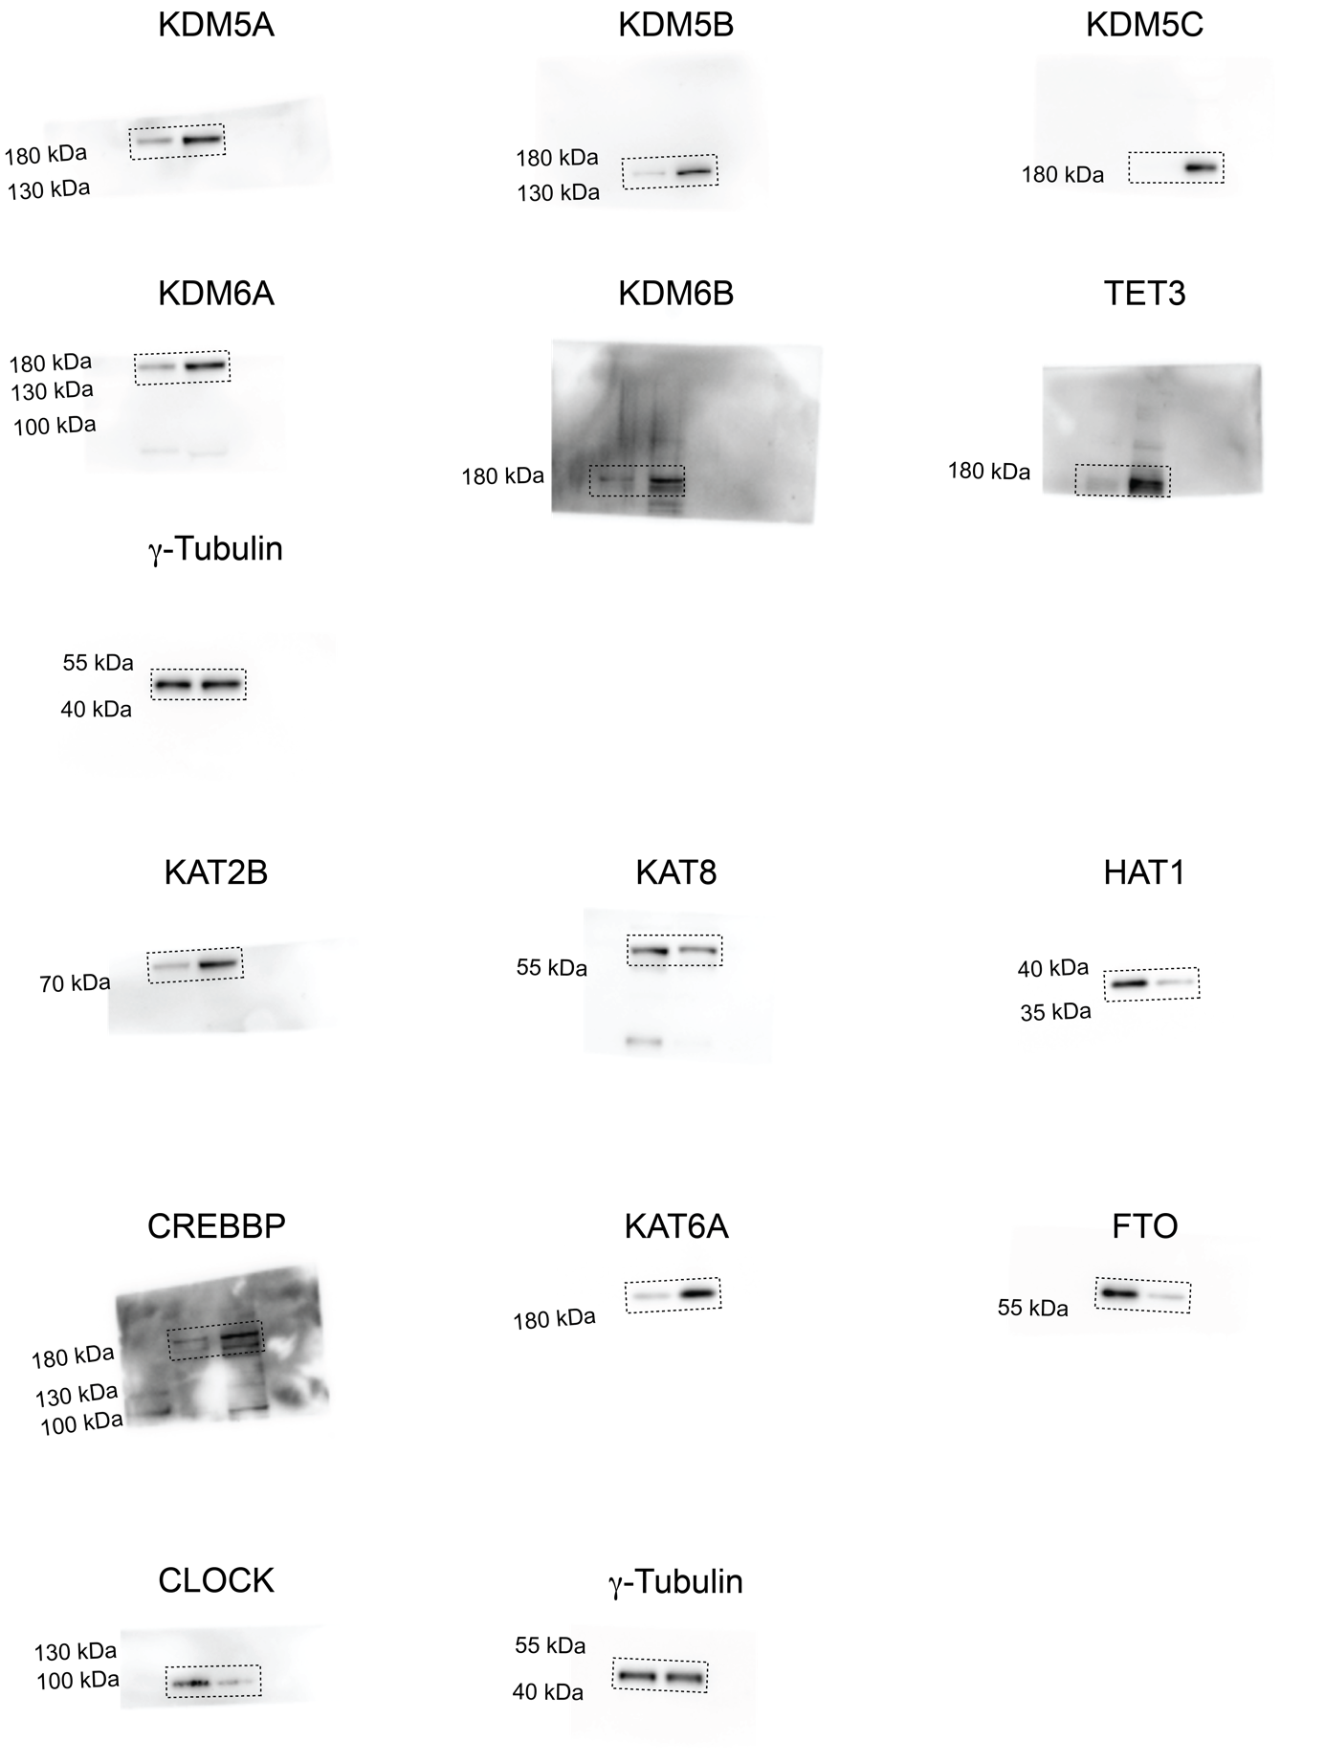
Extended Data Figure 10c – continued
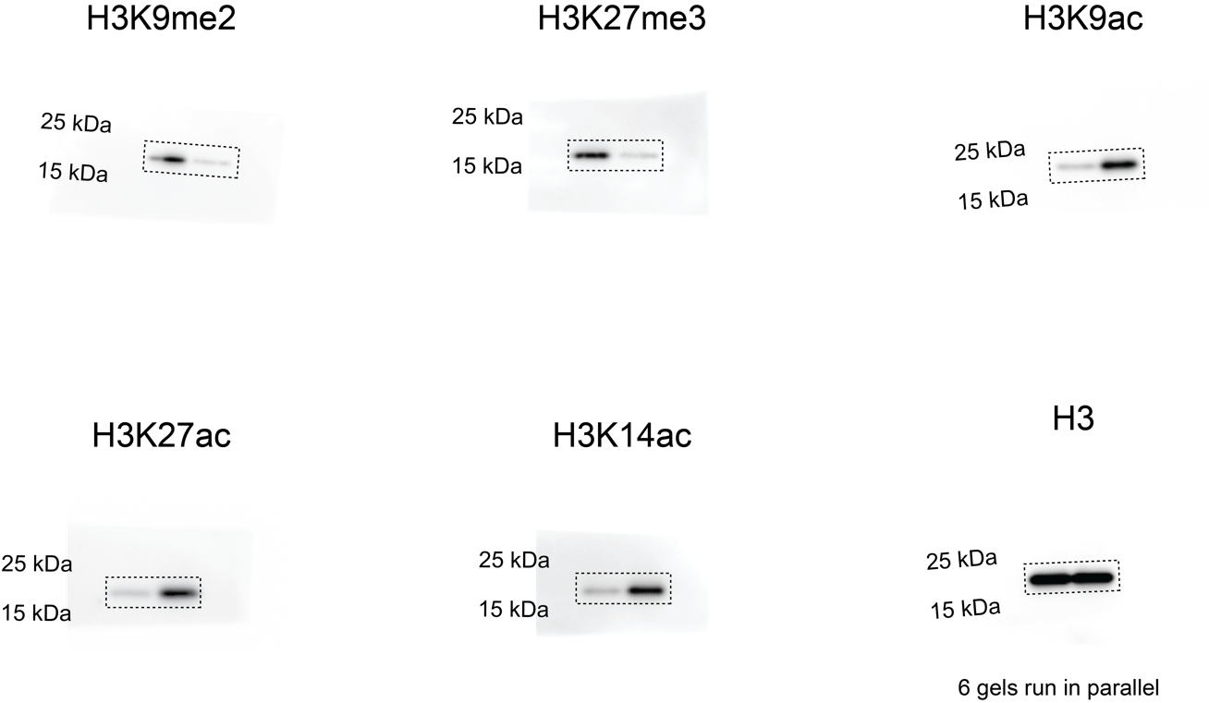
Extended Data Figure 10c – continued

¹H NMR spectrum of LCC-12 in DMSO-d₆

¹³C NMR spectrum of LCC-12 in DMSO-d₆

¹H NMR spectrum of LCC-4,4 in DMSO-d₆

¹³C NMR spectrum of LCC-4,4 in DMSO-d₆

¹H NMR spectrum of LCC-12,4 in DMSO-d₆

¹³C NMR spectrum of LCC-12,4 in DMSO-d₆

¹H NMR spectrum of isotopically labelled LCC-12 in DMSO-d₆

¹³C NMR spectrum of isotopically labelled LCC-12 in DMSO-d₆

¹⁵N NMR spectrum of isotopically labelled LCC-12 in DMSO-d₆

¹H NMR spectrum of HA, TBA-HA and meth-HA in D₂O (0.125 M NaOD)

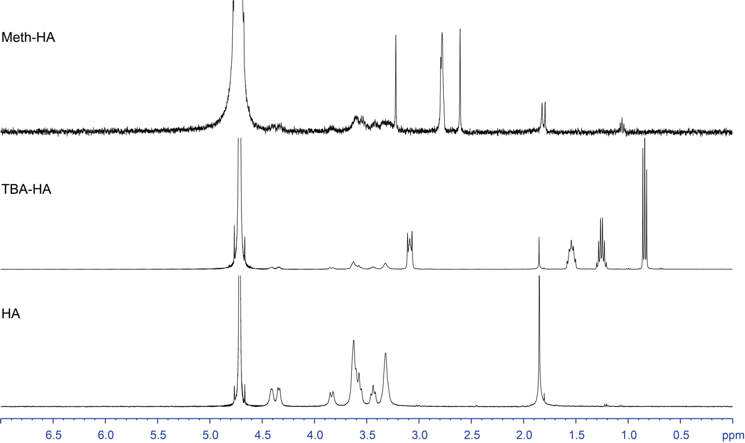
¹H NMR spectrum of trientine alkyne in methanol-d₄

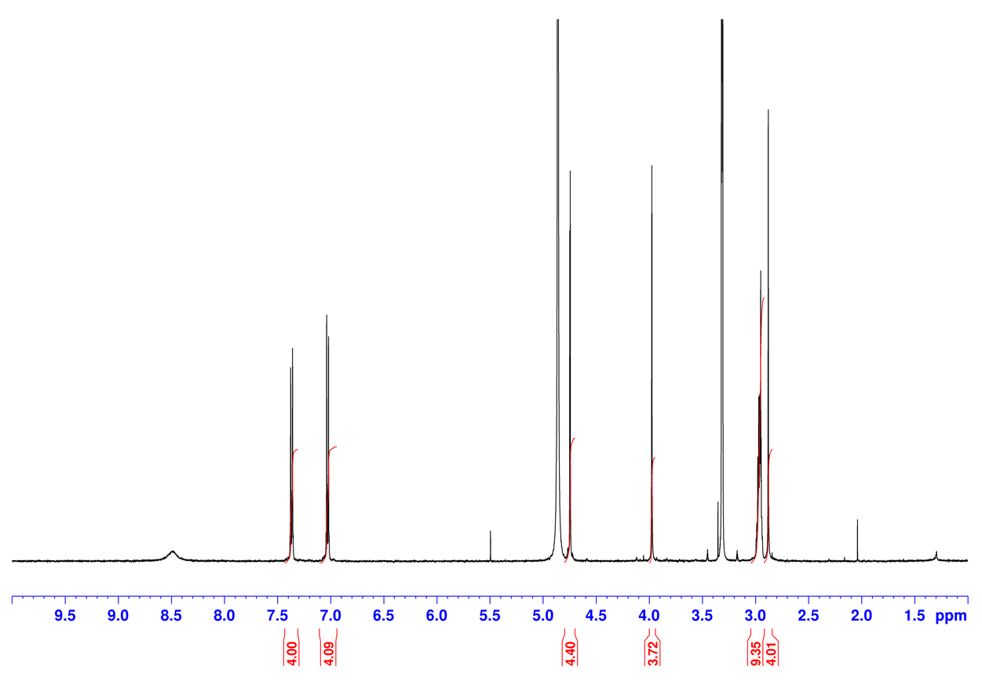

¹³C NMR spectrum of trientine alkyne in methanol-d₄

