Supplementary Information

Liquid metal for high entropy alloy nanoparticles synthesis
Guanghui Cao,^{1†} Jingjing Liang,^{2†} Zenglong Guo,^{3†} Kena Yang,^{1†} Gang Wang,³ Huiliu Wang,¹ Xuhao Wan,⁵ Zeyuan Li,⁶ Yijia Bai,⁷ Yile Zhang,¹ Junlin Liu,¹ Yanpeng Feng,⁸ Zhenying Zheng,¹ Cai Lu,⁹ Guangzhi He,¹ Zeyou Xiong,¹ Ze Liu,⁹ Shengli Chen,¹ Yuzheng Guo,^{5*} Mengqi Zeng,^{1*} Junhao Lin,^{3,4*} Lei Fu,^{1,2*}
¹College of Chemistry and Molecular Sciences, Wuhan University, Wuhan 430072, China. ²The Institute for Advanced Studies, Wuhan University, Wuhan, 430072, China. ³Department of Physics and Shenzhen Key Laboratory of Advanced Quantum Functional Materials and Devices, Southern University of Science and Technology, Shenzhen 518055, China. ⁴Quantum Science Center of Guangdong-Hong Kong-Macao Greater Bay Area (Guangdong), Shenzhen 518045, China. ⁵School of Electrical Engineering and Automation, Wuhan University, Wuhan 430072, China. ⁶School of Power and Mechanical Engineering, Wuhan University, Wuhan 430072, China. ⁷College of Chemical Engineering, Inner Mongolia University of Technology, Hohhot 010051, China. ⁸Bay Area Center for Electron Microscopy, Songshan Lake Materials Laboratory, Dongguan 523808, China. ⁹Department of Engineering Mechanics, School of Civil Engineering, Wuhan University, Wuhan 430072, China.
*E-mail: leifu@whu.edu.cn; linjh@sustech.edu.cn; zengmq_lan@whu.edu.cn; yguo@whu.edu.cn.
†These authors contributed equally to this work.
This file includes:
Supplementary Figures 1–34, Tables 1–10, refs. 35–44
Supplementary Fig. 1 | The cooling rate curve of the cooling process.
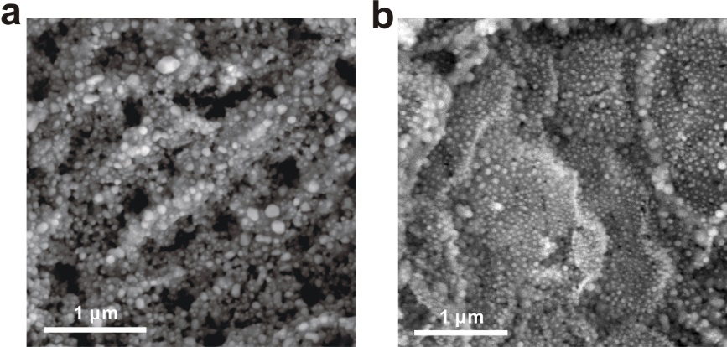
Supplementary Fig. 2 | Scanning electron microscope (SEM) image of the obtained quinary (GaFeMnNiCu) (a) and novenary (GaCaCuPdCoNiAlMnRu) (b) high entropy alloy nanoparticles (HEA-NPs) in a large area.
Supplementary Fig. 3 | The tunable Ga content in HEA-NPs (GaFeMnMgCu). a–d, SEM images of HEA-NPs (GaFeMnMgCu) with different Ga atomic percentages. e, The variation of Ga content of four HEA-NPs systems in (a–d).
Supplementary Fig. 4 | Morphology and size distribution of dispersed Ga nanoparticles with different ultrasound time. a, c, SEM images of Ga nanoparticles at different sample areas with ultrasound time of 2 h and 4 h, respectively. b, d, The statistical histogram of particle size in (a) and (c), respectively. The size distribution of Ga NPs exhibits the log-normal distribution with an asymmetric bell shape and a long tail towards larger diameters, which is consistent with the previous study²⁹.
Supplementary Fig. 5 | Morphology and size distribution of HEA-NPs (GaCuNiMnCaMg) synthesized at 893 K from Ga nanoparticles with different sizes. a, b, SEM images of the HEA-NPs at different sample areas synthesized by Ga nanoparticles with ultrasound time of 2 h and 4 h, respectively. c, The statistical histogram of particle size in (a) and (b).
Supplementary Fig. 6 | Morphology and size distribution of HEA-NPs (GaCuNiMnCaMg) under the reaction temperature of 773 K. a, b, SEM images of HEA-NPs at different sample areas. c, The statistical histogram of particle size in (b). The average value of the particle size is 17.87 ± 2.83 nm.
Supplementary Fig. 7 | Morphology and size distribution of HEA-NPs (GaCuNiMnCaMg) under the reaction temperature of 833 K. a, b, SEM images of HEA-NPs at different sample areas. c, The statistical histogram of particle size in (b), displaying an average size of 21.77 ± 4.39 nm.
Supplementary Fig. 8 | Morphology and size distribution of HEA-NPs (GaCuNiMnCaMg) under the reaction temperature of 893 K. a, b, SEM images of HEA-NPs at different sample areas. c, The statistical histogram of particle size in (b), displaying an average size of 25.39 ± 3.87 nm.
Supplementary Fig. 9 | Morphology and size distribution of HEA-NPs (GaCuNiMnCaMg) under the reaction temperature of 953 K. a, b, SEM images of HEA-NPs at different sample areas. c, The statistical analysis of the particle size in (b), displaying an average size of 34.30 ± 5.87 nm.
Supplementary Fig. 10 | Morphology and size distribution of HEA-NPs (GaCuNiMnCaMg) under the reaction temperature of 1013 K. a, b, SEM images of HEA-NPs at different sample areas. c, The statistical histogram of particle size in (b), displaying an average size of 41.49 ± 8.51 nm.
Supplementary Fig. 11 | Morphology and size distribution of HEA-NPs (GaCuNiMnCaMg) synthesized at 893 K with different reaction time. a–c, SEM images of HEA-NPs at different sample areas with the reaction time of 6 h, 8 h, and 10 h, respectively. d, The statistical histogram of particle size in (a–c).
Supplementary Fig. 12 | Comparison of the element inclusiveness between the refs^{3,5,6,9,12,13,25,35–41} and our work.
Supplementary Fig. 13 | X-ray diffraction (XRD) pattern of GaFeMnNiCu system. The standard XRD pattern (PDF# 50-1296) is also shown for comparison. The peaks matched with that of the standard XRD pattern, indicating the alloy can be regarded as the single-phase solid solution structure.
Supplementary Fig. 14 | XRD pattern of GaCuNiMnCaMg system. The standard XRD pattern (PDF# 50-1518) is also shown for comparison. The presence of only one set of diffraction patterns suggested it can be regarded as the single-phase solid solution alloy.
Supplementary Fig. 15 | XRD pattern of GaAlInCoNiCuMnMgRhPdPt system, featuring one set of diffraction patterns. The standard XRD pattern (PDF# 29-0499) is also shown for comparison. The shift in characteristic diffraction peak with respect to standard XRD was attributed to the change in lattice parameters. The alloy structure can be regarded as the single-phase solid solution structure.
Supplementary Fig. 16 | XRD pattern of GaMnNiCuRuRhFeCo system. The standard XRD pattern (PDF# 19-0636) is also shown for comparison. It suggested the alloy can be regarded as the single-phase solid solution.
Supplementary Fig. 17 | XRD pattern of GaCuPdNiMnInRhPtCo system. The standard XRD pattern (PDF# 42-0913) is also shown for comparison. The characteristic peaks can be ascribed to the XRD standard pattern, demonstrating the alloy structure can be regarded as the single-phase solid solution structure.
Supplementary Fig. 18 | XRD pattern of GaCuMgPdW system. The standard XRD pattern (PDF# 50-1451) is also shown for comparison. Since the XRD profile was analogous to the standard XRD pattern, the alloy can be regarded as the single-phase solid solution.
Supplementary Fig. 19 | XRD pattern of GaCaCoNiCu system. The standard XRD pattern (PDF# 40-1207) is also shown for comparison. The structure can be regarded as the single-phase solid solution structure.
Supplementary Fig. 20 | XRD pattern of GaFeMnMgCu system. The standard XRD pattern (PDF# 50-1296) is also shown for comparison. The peaks can be indexed to that of the standard XRD pattern, confirming the alloy can be regarded as the single-phase solid solution.
Supplementary Fig. 21 | The original high-resolution XRD (HRXRD) data.
Supplementary Fig. 22 | The fitting of HRXRD data. The inset shows a bcc structure of GaCaCuPdCoNiAlMnRu.
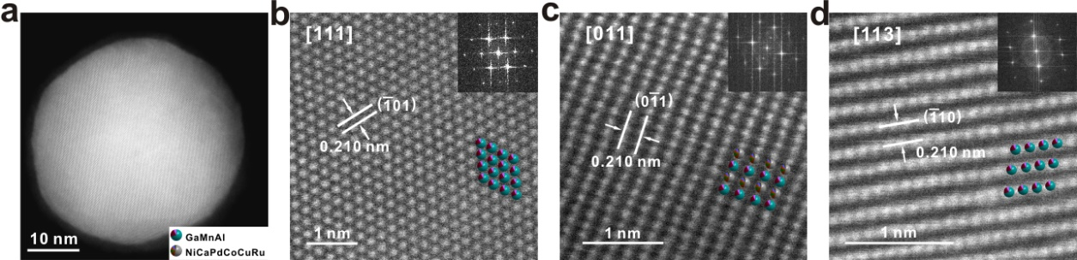
Supplementary Fig. 23 | The high-angle annular dark-field scanning transmission electron microscope (HAADF-STEM) images of HEA-NPs (GaCaCuPdCoNiAlMnRu). a, Low magnification STEM image of a HEA-NP supported on a carbon film. b–d, The atomic-scale HAADF-STEM images from [111], [011], and [113] direction of bcc structure. The insets depicted the related two-dimensional projections of the atomic model based on the XRD refinement result.
Supplementary Fig. 24 | ICP-AES results of quinary GaFeMnMgCu precursor and the final HEA product. Considering Mg has the relatively highest vapor pressure at our synthesis temperature (Supplementary Table 7), the Mg-based GaFeMnMgCu system was selected to investigate the effect of vapor pressure on the composition of the product. The compositional ratio of the HEA product showed a small variation from the starting ratio of the precursor.
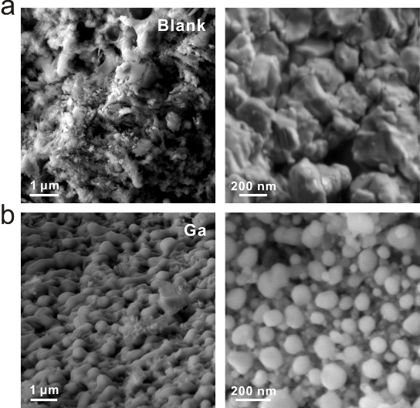
Supplementary Fig. 25 | The effect of liquid environment in the precursor. a, SEM images of FeMnNiCu precursor (left) and the corresponding product without nanoparticles (right). b, SEM images of GaFeMnNiCu precursor prepared by liquid metal Ga, and the corresponding HEA-NPs obtained after the alloying reaction.
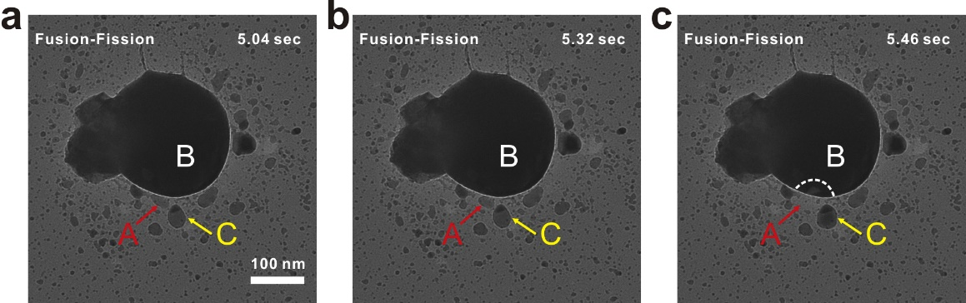
Supplementary Fig. 26 | TEM images captured at 5.04 s (a), 5.32 s (b), and 5.46 s (c) from Supplementary Video 2, illustrating the fusion-fission behavior of three marked nanoparticles during the heating process. The process contains three key snapshots in the Supplementary Video 2: (i) the A NP merged partially into the B NP at the initial state (a); (ii) the residual then fused completely into the B NP (b); (iii) portion of B NP turned into C NP, resulting in the volume increase of the C NP (c).
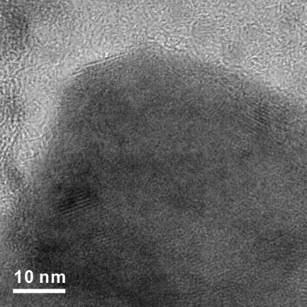
Supplementary Fig. 27 | HRTEM of GaFeMnNiCu precursor at 873 K during the in situ experiment, where crystal fringes began to appear at the partial region of the NP.
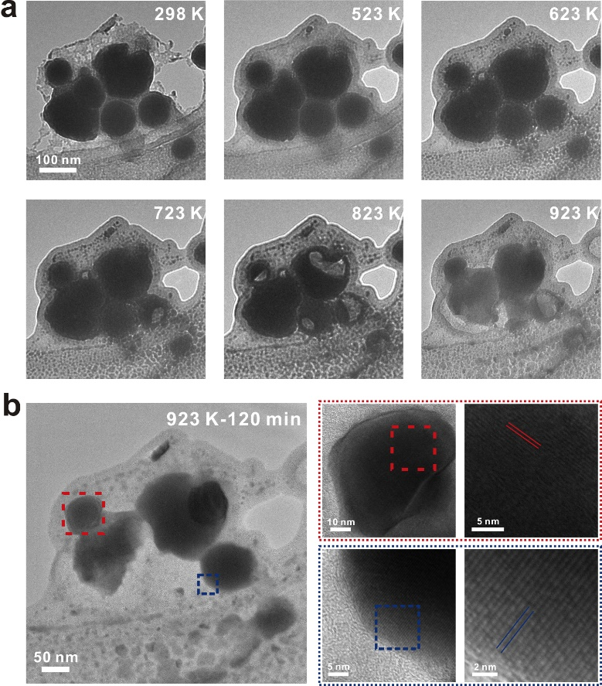
Supplementary Fig. 28 | In situ HRTEM characterization during the heating process. a, Sequential TEM images captured at 298 K, 523 K, 623 K, 723 K, 823 K, and 923 K, illustrating an evolution of GaFeMnNiCu from precursor to alloy nanoparticles. b, Low magnification TEM (left) and HRTEM (right) images of GaFeMnNiCu sample after heating 120 minutes at 923 K, indicating the sample occurred crystallization.
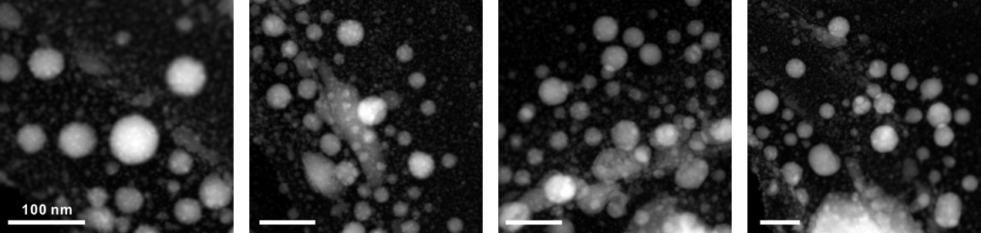
Supplementary Fig. 29 | STEM images of large-area GaFeMnNiCu nanoparticles after the in situ experiment.
Supplementary Fig. 30 | The ex situ XRD pattern of GaPtRhPdIr HEA-NPs for confirming the in situ synchrotron radiation XRD (SRXRD) pattern.
Supplementary Fig. 31 | Exploration of the alloy formation mechanism by in situ SRXRD characterization. a, Diagram of an in situ heating reaction chamber. b, In situ SRXRD spectra of GaPtRhPdIr HEA under different reaction time. c, The magnified profile around the characteristic peaks in (b). The target peaks were maintained until the cooling process finished, reflecting a relatively stable crystal structure.
Supplementary Fig. 32 | Comparison between the GaMnFeNiCu deep learning potential (DLP) model prediction and DFT results for the x-component of the force over different datasets.
Supplementary Fig. 33 | The dynamic simulation for the cooling process of GaFeMnNiCu HEA. The volume phase fraction of the bcc structure evolves with the simulation step, in which the other phase is the amorphous phase structure.
Supplementary Fig. 34 | The STEM EDS mapping of HEA-NPs synthesized on carbon black (a) and silicon substrate (b), respectively.
Supplementary Table 1 | Mixing enthalpy (KJ/mol) between two different elements²⁴. The mixing enthalpy between Ga and other elements is relatively negative, indicating preferable chemical compatibility.
 | Ga | Fe | Co | Ni | Cu | Mn | Mg | Al | Ru | Rh | Ca | Pd | Pt | Ag | In | W
Fe | −2
Co | −11 | −1
Ni | −15 | −2 | 0
Cu | 1 | 13 | 6 | 4
Mn | −13 | 0 | −5 | −8 | 4
Mg | −4 | 18 | 3 | −4 | −3 | 10
Al | 1 | −11 | −19 | −22 | −1 | −19 | −2
Ru | −11 | −5 | −1 | 0 | 7 | −11 | 0 | −21
Rh | −25 | −5 | −2 | −1 | −2 | −16 | −17 | −32 | 1
Ca | −28 | 25 | 2 | −7 | −13 | 19 | −6 | −20 | −4 | −28
Pd | −42 | −4 | −1 | 0 | −14 | −23 | −40 | −46 | 6 | 2 | −63
Pt | −38 | −13 | −7 | −5 | −12 | −28 | −35 | −44 | −1 | −2 | −55 | 2
Ag | −5 | 28 | 19 | 15 | 2 | 13 | −10 | −4 | 23 | 10 | −28 | −7 | −1
In | 3 | 19 | 7 | 2 | 10 | 3 | −4 | 7 | 10 | −8 | −35 | −31 | −21 | −2
W | 11 | 0 | −1 | −3 | 22 | 6 | 38 | −2 | −10 | −9 | 57 | −6 | −20 | 43 | 38
Cr | −1 | −1 | −4 | −7 | 12 | 2 | 24 | −10 | −12 | −13 | 38 | −15 | −24 | 27 | 20 | 1

Supplementary Table 2 | The element inclusiveness in refs.^{3,5,6,9,12,13,25,35–41}, and our work.
Reference | Atomic Radius Variation Range (Å) | Melting points Variation Range (K)
(3) | 1.24–1.51 | 505–2042
(5) | 1.24–1.44 | 1234–2883
(6) | 1.24–1.39 | 1356–2883
(9) | 1.24–1.51 | 505–2713
(12) | 1.24–1.39 | 1356–2042
(13) | 1.34–1.39 | 1823–2773
(25) | 1.24–1.36 | 1726–2773
(35) | 1.24–1.51 | 505–2713
(36) | 1.24–1.37 | 1356–2773
(37) | 1.24–1.47 | 1356–2173
(38) | 1.34–1.44 | 1234–3273
(39) | 1.24–1.39 | 1726–2243
(40) | 1.24–1.60 | 505–3683
(41) | 1.34–1.39 | 1823–2773
This work | 1.24–1.97 | 303–3683
Note: The values of atomic radius and melting point of elements were referred to the reference⁴², obtained using the newest edition of LANGE’S HANDBOOK OF CHEMISTRY (Seventeenth edition, McGraw Hill Education, 2016).
Supplementary Table 3 | Crystal data and structure refinement for Ga_{0.70}Ca_{0.12}Cu_{0.08}Pd_{0.10}Co_{0.10}Ni_{0.55}Al_{0.08}Mn_{0.22}Ru_{0.05}.
Empirical formula | Ga_{0.70}Ca_{0.12}Cu_{0.08}Pd_{0.10}Co_{0.10}Ni_{0.55} Al_{0.08}Mn_{0.22}Ru_{0.05}
Temperature | 298 K
Wavelength | 1.5406 Å
Crystal system | Cubic
Space group | P m m (221)
Unit cell dimensions | a = b = c = 2.9382(2) Å;  α = β = γ = 90°
R_{ωp} | 0.0893
R_{p} | 0.0488
χ² | 1.683
θ range for data collection | 10 to 120°

Supplementary Table 4 | Atomic coordinates, occupancy factors (f_{occ}), and isotropic displacement parameters (U_{iso}) for Ga_{0.70}Ca_{0.12}Cu_{0.08}Pd_{0.10}Co_{0.10}Ni_{0.55}Al_{0.08}Mn_{0.22}Ru_{0.05}.
Atoms | Wyckoff sites | x | y | z | f_{occ} | U_{iso} / Å²
Ga | 1b | 0.5 | 0.5 | 0.5 | 0.70 | 0.0074
Ca | 1a | 0.0 | 0.0 | 0.0 | 0.12 | 0.0156
Cu | 1a | 0.0 | 0.0 | 0.0 | 0.08 | 0.0156
Pd | 1a | 0.0 | 0.0 | 0.0 | 0.10 | 0.0156
Co | 1a | 0.0 | 0.0 | 0.0 | 0.10 | 0.0156
Ni | 1a | 0.0 | 0.0 | 0.0 | 0.55 | 0.0156
Al | 1b | 0.5 | 0.5 | 0.5 | 0.08 | 0.0074
Mn | 1b | 0.5 | 0.5 | 0.5 | 0.22 | 0.0074
Ru | 1a | 0.0 | 0.0 | 0.0 | 0.05 | 0.0156

Supplementary Table 5 | The extracted diffraction data by Rietveld refinement⁴³.
2θ | (hkl) | d (Å) | Intensity (f) × 10³
30.397 | (001) | 2.9382 | 45.0
43.525 | (011) | 2.0776 | 304.3
54.012 | (111) | 1.6964 | 8.1
63.247 | (002) | 1.4691 | 41.6
71.779 | (012) | 1.3140 | 7.3
79.908 | (112) | 1.1995 | 72.2
95.722 | (022) | 1.0388 | 21.8
103.719 | (122) | 0.9794 | 2.0
112.001 | (013) | 0.9291 | 35.1

Supplementary Table 6 | The ICP-AES (at. %) results of samples.
Element | Al | Co | Cu | Ga | In | Mg | Mn | Ni | Pd | Pt | Rh | Fe | Ru | Ca | Sn | W
5 |  |  | 17.83 | 22.95 |  | 24.05 | 11.42 |  |  |  |  | 23.74
5 |  |  | 19.63 |  | 21.13 | 25.17 | 10.28 |  |  |  |  | 23.80
5 |  |  | 20.01 |  |  | 24.82 | 12.78 |  |  |  |  | 21.64 |  |  | 20.76
5 |  | 23.05 | 16.25 | 18.10 |  |  |  | 20.68 |  |  |  |  |  | 21.93
5 |  |  | 19.76 | 17.33 |  | 26.77 |  |  | 27.65 |  |  |  |  |  |  | 8.49
8 |  | 11.81 | 12.79 | 13.45 |  |  | 14.45 | 15.83 |  |  | 11.50 | 11.67 | 8.50
9 |  | 11.00 | 11.00 | 12.20 | 9.11 |  | 8.63 | 15.13 | 12.20 | 15.37 | 5.34
11 | 5.31 | 8.29 | 7.99 | 15.57 | 7.42 | 7.02 | 3.38 | 9.02 | 8.22 | 17.24 | 8.19

Supplementary Table 7 | Theoretical vapor pressures of the involved metal at 923 K.
Element | Vapor pressure (Pa) | Element | Vapor pressure (Pa)
Ga | 3.95×10⁻⁵ | Rh | 2.28×10⁻¹⁹
Co | 2.98×10⁻¹² | Al | 2.12×10⁻⁷
Mg | 436 | Ca | 4.59
Mn | 1.41×10⁻⁴ | W | 1.71×10⁻³⁶
In | 1.20×10⁻³ | Fe | 2.57×10⁻¹¹
Pt | 7.67×10⁻²⁰ | Sn | 4.54×10⁻⁷
Cu | 5.38×10⁻⁸ | Ru | 2.58×10⁻²⁴
Pd | 1.88×10⁻¹⁰ | Ni | 3.06×10⁻¹²
Cr | 3.65×10⁻¹⁰
Note: Calculated using an online tool: https://www.iap.tuwien.ac.at/www/surface/vapor_pressure.
 | Fe | Co | Ni | Cu | Mn | Mg | Al | Ru | Rh | Pd | Pt | Ag | W | Cr
Ga | −2 | −11 | −15 | 1 | −13 | −4 | 1 | −11 | −25 | −42 | −38 | −5 | 11 | −1
In | 19 | 7 | 2 | 10 | 3 | −4 | 7 | 10 | −8 | −31 | −21 | −2 | 38 | 20
Sn | 11 | 0 | −4 | 7 | −7 | −9 | 4 | 4 | −13 | −34 | −25 | −3 | 27 | 10
Supplementary Table 8 | Mixing enthalpy (KJ/mol) between liquid metal elements (Ga, Sn, and In) and other elements.

Supplementary Table 9 | Mixing enthalpy (KJ/mol) between elements of binary alloy systems (GaFe/InFe/SnFe and GaRh/InRh/SnRh).
 | Ga | In | Sn
Fe | −2 | 19 | 11
Rh | −25 | −8 | −13

Supplementary Table 10 | The RMSE value of the DLP model of GaMnFeNiCu, close to the standard⁴⁴.
Dataset | Energy RMSE  (meV/atom) | Force RMSE  (meV/Å∙atom)
300 K Dataset 1 | 0.469 | 55.3
300 K Dataset 2 | 1.61 | 102
1000 K Dataset 3 | 0.878 | 83.2
1000 K Dataset 4 | 1.36 | 120

References
- Wang, B. et al. General synthesis of high-entropy alloy and ceramic nanoparticles in nanoseconds. Nat. Synth. 1, 138–146 (2022).
- Mori, K. et al. Hydrogen spillover-driven synthesis of high-entropy alloy nanoparticles as a robust catalyst for CO₂ hydrogenation. Nat. Commun. 12, 3884 (2021).
- Li, Y. et al. High-entropy-alloy nanoparticles with enhanced interband transitions for efficient photothermal conversion. Angew. Chem. Int. Ed. 60, 27113–27118 (2021).
- Wu, D. et al. Noble-Metal High-Entropy-Alloy Nanoparticles: Atomic-Level Insight into the Electronic Structure. J. Am. Chem. Soc. 144, 3365–3369 (2022).
- Feng, G. et al. Sub-2 nm ultrasmall high-entropy alloy nanoparticles for extremely superior electrocatalytic hydrogen evolution. J. Am. Chem. Soc. 143, 17117–17127 (2021).
- Yao, Y. et al. Extreme mixing in nanoscale transition metal alloys. Matter 4, 2340–2353 (2021).
- Minamihara, H. et al. Continuous-flow reactor synthesis for homogeneous 1 nm-sized extremely small high-entropy alloy nanoparticles. J. Am. Chem. Soc. 144, 11525–11529 (2022).
- James G. Speight. LANGE'S HANDBOOK OF CHEMISTRY, Seventeenth edition. McGraw Hill Education (2016).
- Peterson, VK. Lattice parameter measurement using Le Bail versus structural (Rietveld) refinement: A caution for complex, low symmetry systems. Powder Diffr. 20, 14−17 (2005).
- Wen, T., Zhang, L., Wang, H., E, W. & Srolovitz, D. Deep potentials for materials science. Mater. Futures 1, 022601 (2022).

